Original Research Article
Analyzing Coastal Dynamics and Erosion Susceptibility in Kasaragod Coast, Kerala Using DSAS-Based Shoreline Metrics
ABSTRACT
The shoreline, which serves as the boundary between land and water, is inherently dynamic and plays a crucial role in providing economic and social stability to coastal communities. As one of the most rapidly transforming landforms in coastal regions, it necessitates precise detection and continuous monitoring to effectively understand the processes and dynamics of various coastal features. The present study is to investigate the shoreline changes along the coast of Kasaragod by the application of 5.0 version of Digital Shoreline Analysis System (DSAS). Demarcation of coastline accretion and erosion were performed utilizing the Landsat images for 1991,2001,2011 and 2021. The shoreline changes were calculated using Net Shoreline Movement, End Point Rate, Linear Regression Rate and Shoreline Change Envelope. Based on the results, the maximum distance of shoreline change is 331.02 meters which is found at North of Kasargod harbour and the minimum distance of 0.44 m is found at Valiyaparamba beach. It was discovered throughout the study that erosion had affected most of the study region. Both natural and man-made activities are said to have contributed to shoreline modification in this study. Furthermore, it indicates that the rate of erosion is comparatively higher in the coastal areas where sand mining occurs than in other areas. According to the report, erosion problems in these areas may get much worse as a result of unsustainable sand mining activities. The study could be beneficial for disaster management projects and also for future planning and development plans.
Keywords: Coastal Zone; Digital Shoreline Analysis System; Erosion and Accretion; Shoreline Change

INTRODUCTION
The Rising sea levels and increased human activity have made coastal dynamics and erosion vulnerability serious issues. Examining these procedures aids in locating weak points and putting mitigation plans into action. Shoreline alterations are caused by a variety of factors, including anthropogenic effects, sediment movement and wave action (Sekar L. G., Androws X., Annaidasan K., Kumar A., Kannan R., Muthusankar G., & Balasubramani K. 2024). In order to determine vulnerability, this study uses erosion models and GIS technologies to analyze coastal dynamics. By recognizing these trends, infrastructure and ecosystems can be protected through sustainable coastal management. Policymakers can prioritize conservation efforts and ensure long-term resilience against natural hazards and climate change by assessing risk zones.
According to Pajak and Leatherman (2002) and Cui and Li (2011), the coastline is generally regarded to be the unstable barrier that divides a landmass from a body of water. Shorelines, which mark the boundary between land and sea, are constantly shifting due to their natural setting (Mentaschi et al., 2018). Numerous phenomena, such as storm surges, high tides, and sea level rise, can cause changes to the shoreline. The changes in the coast are largely caused by activities that occur in the vicinity of the beach (Ahmed A., Nawaz R., Drake F., & Woulds C. 2018). The accretion and erosion of the coast causes changes. Accretion is the movement of land forward; erosion is the movement of land backward in reaction to work of natural agents like wind, wave, current, tide, etc. Globally, there is widespread recognition that coastal erosion poses a serious threat to society and the environment (Amin M. K., Rahaman K. M. A., & Nujhat M. 2024). Because they depend on the abundant resources found along the coast, massive populations are usually seriously at risk from coastal erosion.
Analyzing shoreline changes is a crucial initial step in understanding the dynamics and development of coastal regions, helping to reduce social, physical, and economic impacts as well as mitigate the risk of coastal erosion (Fuad and F, 2017). As shorelines represent a transition between marine and terrestrial ecosystems and are often sensitive areas, a comprehensive understanding of coastal processes is necessary for effective shoreline change analysis (Dwived, C. S., Pampattiwar S. T., Pandey A. C., Parida B. R., Mitra D., & Kumar N. 2023). This understanding is vital for the assessment of shorelines and the implementation of integrated coastal zone management (ICZM).
Conventional field survey techniques along with aerial photographs were historically utilized to monitor the shoreline changes (Cendrero 1989). Remote sensing has recently improved by offering enhanced synoptic coverage of target areas, making it a valuable tool for users. It continues to be an effective approach for analyzing multitemporal satellite images, enabling consistent estimation of shoreline changes (Saravanan et al., 2015).
The major objectives of the study are:
(1) divide the coastal area into shoreline change rates based on high erosion, Moderate erosion, almost no change, moderate accretion and high accretion.
(2) identify the areas of noteable shoreline changes and enumerate the rate of shoreline change
(3) analyse the reasons caused for the shoreline changes.
STUDY AREA
Kasaragod, the northernmost district of Kerala, is recognized as one of India's most dynamic coastal regions (Sheela Nair et al., 2018). Among the coastal districts of Kerala, the district ranks 8th in area. For the study, the coastal stretch of Kasaragod has been selected (fig 1) and it includes panchayaths Manjeswar, Mangalpady, Mogralputhur, Kumbala, Chemnad, Uduma, Pallikkere, Ajanur, Cheruvathur, Padanne, Valiyaparambu, Thrikkaripur and three municipalities includes Kasaragod, Kanhangad and Nileswaram. The study area lies between 12˚12’ and 12˚48’N latitudes and 74˚50’ and 75˚26’E longitudes. It is bordered by Kodagu in the east and Dakshin Kannada districts of Karnataka, Arabian sea in the west, Mangalore in the north and Kannur in the south. Kasaragod coast is blessed with extensive water resources, rich in sunshine, wide variety of aquatic life and average annual rainfall is above 3500mm and average annual temperature is 26. 5˚c. During south west monsoon from June to September, the coastal areas received high amount of rainfall and experiences sea encroachment caused severe devastation along the coastal areas of Kasaragod.

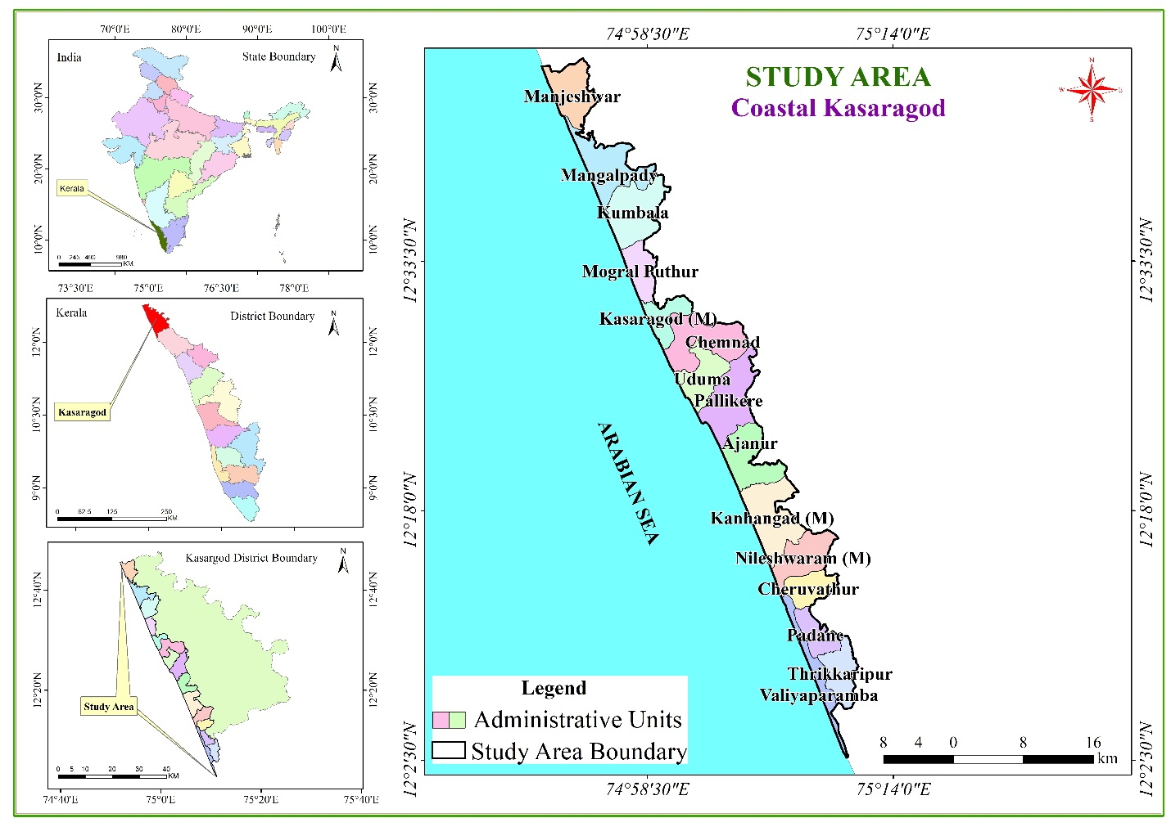
Figure 1. Locational Map of Study area.
MATERIALS AND METHODOLOGY
The shoreline changes along the Kasaragod coast have been monitored over the period spanning from 1991 to 2021. Four shorelines derived from satellite photos taken at various times are compared in order to assess shoreline changes. The Kasaragod coast's shoreline change was delineated in the current study using Landsat satellite data from 1991, 2001, 2011, and 2021. Studies on coastal change often combine geospatial methods with Landsat satellite imagery (Ahammed and Pandey, 2022). Table 1 lists the data sources used to detect shoreline changes.

Table 1: Data Sources
Sl. No. | Satellite/ Sensor | Used Bands | Date of Image Acquisition (DD/MM/YYYY) | Path/Row | Spatial Resolution  (m) | Year
1 | Landsat 5 (TM) | B2 & B5 | 19/02/1991 | 145/051 | 30 | 1991
1 | Landsat 5 (TM) | B2 & B5 | 03/02/1991 | 145/052 | 30 | 1991
2 | Landsat 7 (ETM+) | B2 & B5 | 26/03/2001 | 145/051 | 30 | 2001
2 | Landsat 7 (ETM+) | B2 & B5 | 26/03/2001 | 145/052 | 30 | 2001
3 | Landsat 7 (ETM+) | B2 & B5 | 17/01/2011 | 145/051 | 30 | 2011
3 | Landsat 7 (ETM+) | B2 & B5 | 17/01/2011 | 145/052 | 30 | 2011
4 | Landsat 8 (OLI) | B3 & B6 | 09/03/2021 | 145/051 | 30 | 2021
4 | Landsat 8 (OLI) | B3 & B6 | 09/03/2021 | 145/052 | 30 | 2021

The Digital Shoreline Analysis System (DSAS) tool has been widely adopted by national and state governments worldwide for resource management, essential coastal decision-making, and developmental activities (Himmelstoss et al., 2018). By analyzing a time series of coastline positions over multiple years, DSAS allows users to derive statistical information on shoreline changes (Gopinath et al., 2023). The tool comprises three primary components: generating a baseline, implementing orthogonal transects at user-defined intervals along the coast, and producing multiple shoreline datasets to assess changes in the shoreline.
The EPR, NSM, and LRR are used in this study to figure out how fast the shoreline is changing. The Digital Shoreline Analysis System (DSAS) version 5.0 and ArcGIS 10.8 software were used together to look at changes along the Kasaragod coastline. We used the satellite images, which were all in UTM projection with WGS 1984 UTM Zone 43N, for the analysis. Using 30m orthogonal transects along the coastline, we figured out the erosion and accretion regimes based on shoreline and baseline data. There were five groups of rates of erosion and accretion on the Kasaragod coast: High Erosion, Moderate Erosion, Almost No Change, High Accretion, and Moderate Accretion. Negative numbers mean erosion, and positive numbers mean accretion.
Shoreline Extraction
The HighWater Line (HWL) was used as a reference point when using the Modified Normalized Difference Water Index (MNDWI) method to find the coastline. The Normalized Difference Water Index (NDWI) is meant to make the water reflect more light at the green wavelength and less light at the low NIR wavelength. It also makes use of the strong reflectance properties of soil and plants, which give water bodies positive reflectance values, while plants and soil usually give negative or near-zero values. The technique has been updated by substituting SWIR for NIR in order to achieve more improved water features by removing noise reflectance of soil and vegetation. The Modified Normalized Difference Water Index (MNDWI) was also used to locate and extract water features. To ascertain the amount of water present on the ground surface, MNDWI is frequently utilized in conjunction with remote sensing data. This is how it is computed:

$MNDWI=\frac{(pGreen-pSWIR)}{(pGreen+pSWIR)}$
pGreen is the reflectance value of the Green band (0.49–0.577 m), and pSWIR is the reflectance value of the Shortwave Infrared band (1.55–1.75 mm). The Modified Normalised Difference Water Index (MNDWI) was used to find the line between land and water features along the shoreline. The values of the pixels that show land are close to -1, while the values of the pixels that show water are close to 1. A local threshold value might work better than a global threshold value because it can distort images and can't find some local coastal boundaries (Liu & Jezek, 2004). Otsu thresholding has worked well for extracting shorelines (Tang et al., 2022). To obtain the shorelines of the study years 1991, 2001, 2011, and 2021, Otsu thresholding was performed to the generated MNDWI picture, and the achieved land water boundary was manually digitized (fig 2).

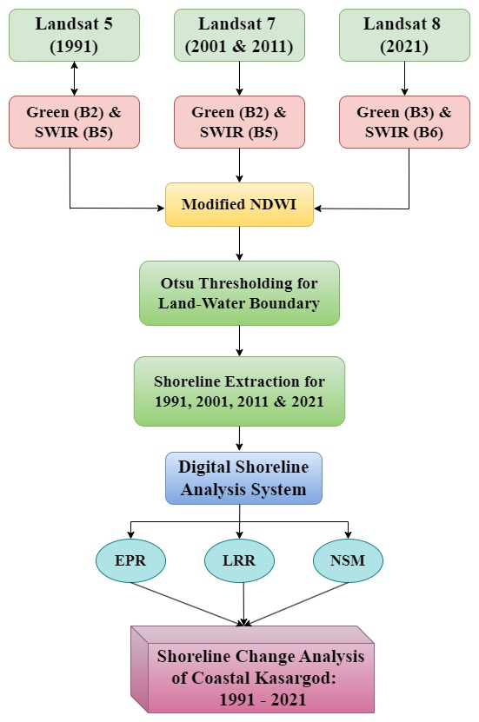
Figure 2 Methodology Chart.
Shoreline Change Analysis
Net Shoreline Movement (NSM)
The distance of shoreline movement between the earliest and latest shorelines at each transect's intersection point is measured statistically by the NSM (Himmelstoss et al., 2018). Net shoreline changes in long term can be identified using this. The following equation is used to calculate NSM: (1)
NSM= (d₂₀₂₁ ―d₁₉₉₁)
End Pont Rate (EPR)
In order to calculate EPR, the total shoreline displacement is divided by the time interval between the first and most recent shoreline measurements, which correspond to the oldest and most recent shorelines ever recorded. Because of its ease of use and low data requirements, EPR is regarded as one of the best techniques for evaluating shoreline changes. It can be computed using the following formula (2)
EPR=d₂₀₂₁ꟷd₁₉₉₁/t₂₀₂₁―t₁₉₉₁ m/yr
Linear Regression Rate (LRR)
LRR is a widely used statistical technique applied to estimate shoreline change rates and shoreline movement. It is calculated by applying a least squares regression line to the set of shoreline points along a specific transect (Himmelstoss et al.,2018). This method provides a robust and reliable means of quantifying shoreline changes over time.
RESULTS AND DISCUSSION
Net Shoreline Movement
It measures the distance between the oldest shoreline (1991) and the recent shoreline (2021) at the point of intersection in each transect. In NSM, the positive and negative values show accretion and erosion respectively. The highest level of erosion reported in study area is -126.74 meters and accretion is 280.05 metres. Areas such as North of Uduma Panchayat and the Shiriya river mouth exhibited high erosion rates, Highest accretion is reported along the breakwaters constructed at the Kasargod harbour. Another region was 199m accretion happened is at Manjeshwaram fishing Harbour. The average erosion distance is -38.47 meters and average positive distance is 47.26. The overall net shoreline movement is -21.44 meters, which indicates study area is prone to erosion. The maximum negative Distance: -126.74 and maximum positive Distance is 280.05. Fig.3 shows the net shoreline movement in the study area between 1991 and 2021.
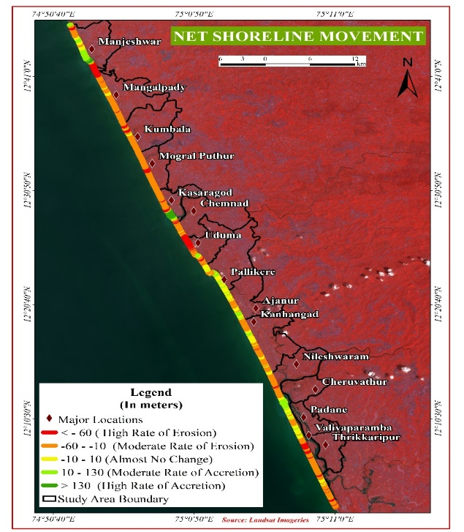

Figure 3. Net Shoreline Movement of study area.
Significant portions of the coastline show retreats of more than -50 meters, and during the 30year period, losses in several important erosion hotspots exceeded -100 meters. Significant erosion is seen along Mangalpady, Uduma, and portions of Manjeshwar, where the retreat is close to or greater than -120 meters (fig 3) Long-term sediment depletion, high wave energy exposure, and possibly human-induced alterations in coastal dynamics are all suggested by this ongoing land loss.
Although there are fewer accretion zones, some of them exhibit significant coastline progress. With coastline advances of more than 100 meters and in the case of Mogral Puthur, almost 300 meters, the most notable deposition hotspots are located close to Nileshwaram, Mogral Puthur, and Manjeshwar. Estuarine processes, sediment deposition at river mouths, and sediment trapping by artificial structures like groynes or breakwaters are probably responsible for these increases. Although smaller, dispersed pockets of deposition may also be seen between Valiyaparamba and Ajanur.
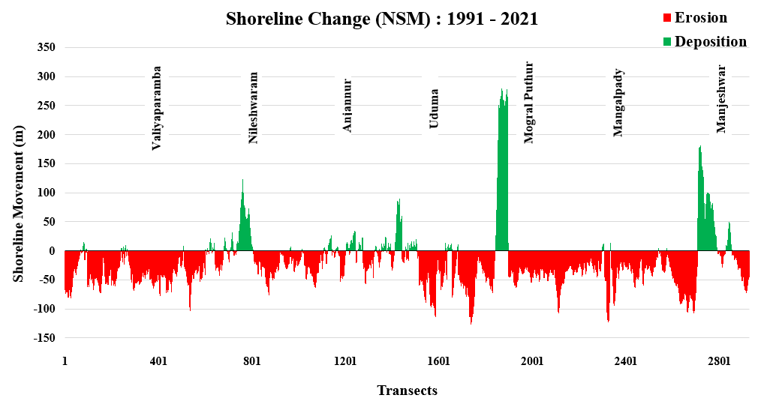

Fig. 4 Shoreline Change (NSM)

Shoreline Change Rate by End Point Rate Method
Among the total 2,929 transects analyzed using the End Point Rate (EPR) method, 2,347 are identified as erosional and 582 as accretional. The highest erosion rate recorded is -4.13 meters/year in the northern part of Uduma Panchayat. An erosion rate of -4 m/year is also observed at the Shiriya river mouth in Kumbala Panchayat, and -3.34 m/year south of Manjeshwar Harbour. Mean rate of erosion rate over the coast is -1.25 m/year. This indicates that 80.13% of the transects are experiencing erosion, highlighting the high erosion susceptibility of this coast. Conversely, the maximum deposition rate of 9.13 meters/year is recorded in the northern part of Kasaragod Harbour. The average accretion rate is 1.54 m/year, with 19.87% of the transects showing deposition. This suggests that while there is some coastal deposition, the area remains highly vulnerable to erosion in the future. Figure 5 illustrates the erosion and accretion trends in the study area between 1991 and 2021 as determined by EPR.

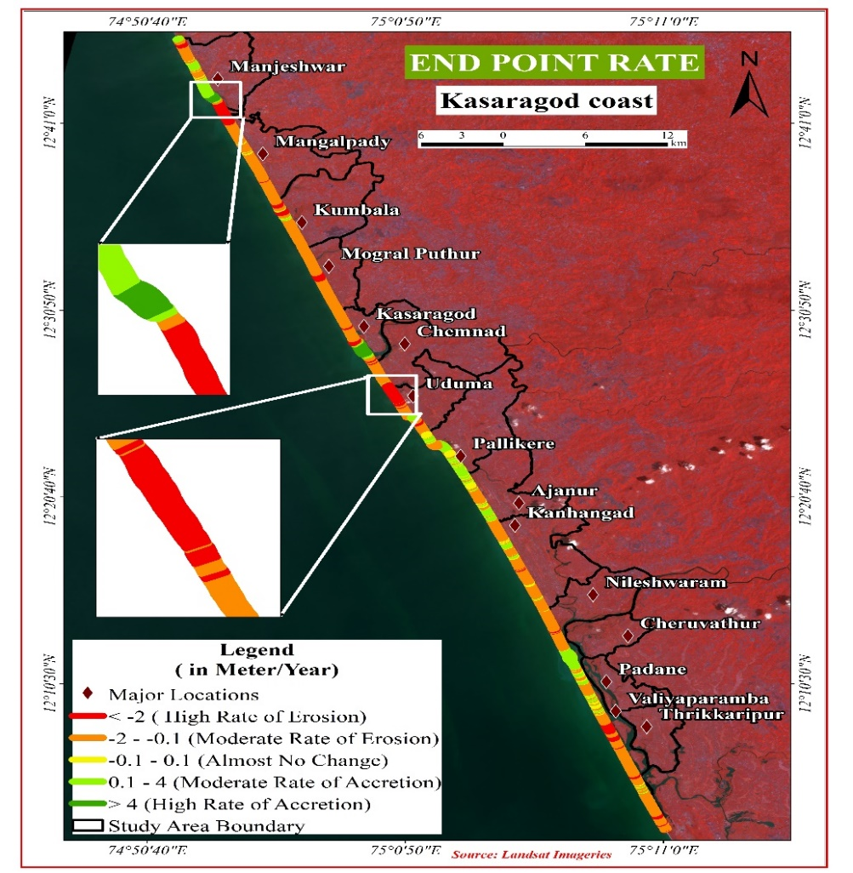
Figure 5 EPR rate of Study area

The majority of the coastline is dominated by erosion, as the chart shows, with long stretches of transects displaying consistently negative change rates. The average erosion rate is between -1 and -4 m/yr, while some isolated hotspots have rates as low as -5 m/yr (fig 6). Long-term coastline retreat is shown by the persistent appearance of these eroding parts along most coastal locations, particularly between Uduma and Manjeshwar.
Deposition zones, on the other hand, are more extreme in some places but still quite localised. Significant accretion hotspots can be seen close to Nileshwaram, Mogral Puthur, and Manjeshwar. At Mogral Puthur, peak deposition approaches +9 m/yr, and positive change rates surpass +4 m/yr. Although they are not as noticeable as the main deposition zones, there are smaller areas of mild accretion between Valiyaparamba and Ajanur.
The chart illustrares shoreline dynamics reveal alternating areas of deposition and erosion, indicating intricate coastal processes impacted by human activities, riverine inputs, wave action, and sediment transport. While the wide erosion zones suggest either greater wave energy or sediment starvation, the concentration of high deposition rates close to particular coastal communities may be associated with river mouths or constructed structures that trap sediments.

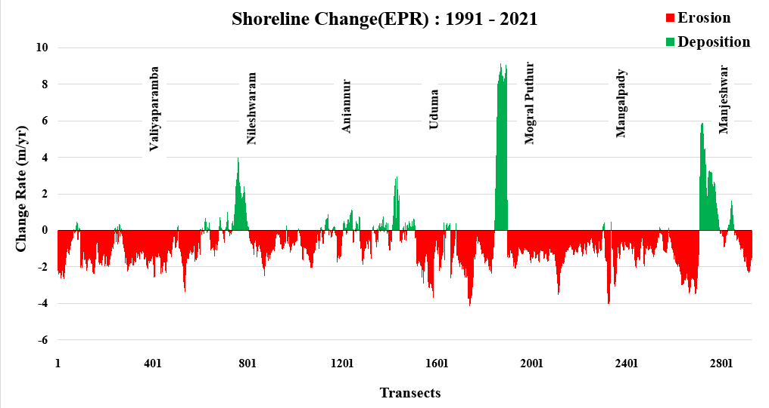
Fig. 6 Shoreline Change EPR
Shoreline Change Rate by Linear Regression Method
The Linear Regression Rate (LRR) method is a systematic and reliable technique for assessing shoreline change. This method involves fitting a least squares regression line to all shoreline points along a specific transect. Out of 2,929 transects analyzed, 2,296 are categorized as erosional and 632 as accretional. The maximum erosion rate recorded is -4.34 meters/year, while the highest accretion rate is 9.41 meters/year. Erosional transects account for 78.42% of the total, and accretional transects make up 21.58%. The average erosion rate for all erosional transects is -1.12 m/year, while the average accretion rate for accretional transects is 1.41 m/year. Figure 4 shows the different levels of erosion and accretion in the study area from 1991 to 2021, as estimated using the LRR method.
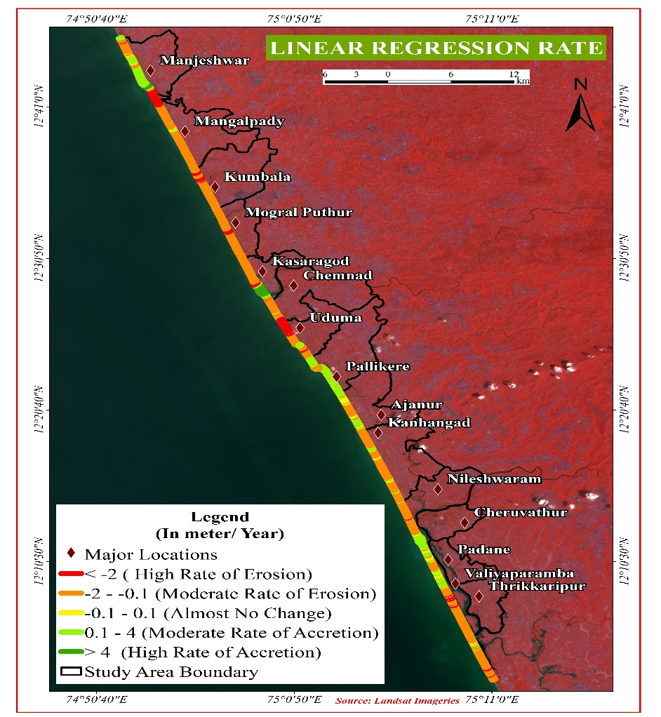

Figure 7. LRR rate of study area

According to the LRR results, erosion is the primary process throughout the majority of the coastline, with long, continuous lengths showing negative change rates, often ranging from -1 to -4 m/yr. Some erosion hotspots exhibit more extreme retreat, sometimes surpassing –4 m/yr, (fig 8) especially in sections close to Uduma, Mangalpady, and portions of Manjeshwar. These extensive erosional patterns point to ongoing coastal retreat, which may be caused by anthropogenic activities, high-energy wave action, and a decline in the sediment supply. Although accretion is extremely localised and deposition is generally limited, it is substantial in some places. Near Nileshwaram, Mogral Puthur, and Manjeshwar, there are notable accretion zones where coastline advance rates exceed +4 m/yr, with the Mogral Puthur sector peaking at about +9 m/yr.

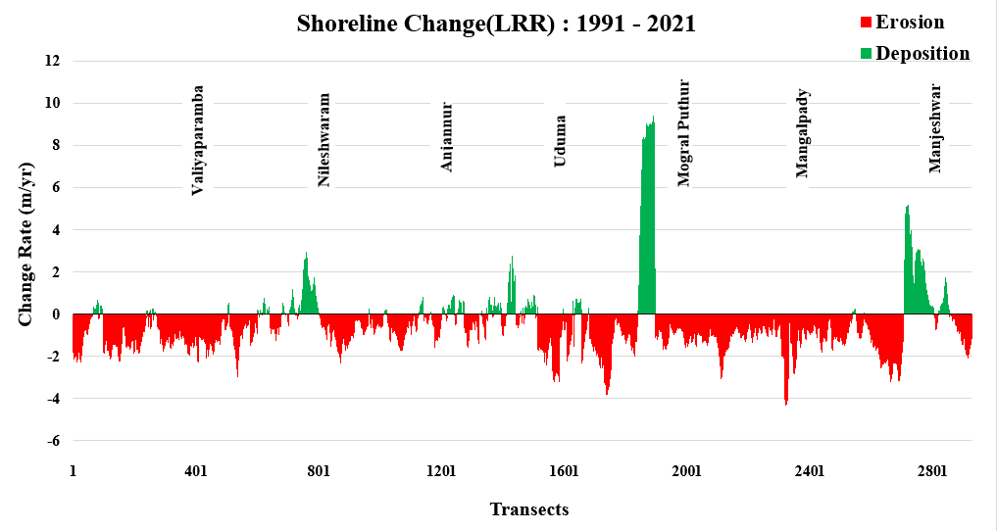
Fig. 8 Shoreline Change LRR

CONCLUSION
The study of shoreline changes along the Kasaragod coast using remote sensing and digital analysis tools has revealed significant patterns of erosion and accretion over the past three decades. The study unequivocally reveals that erosion is a pervasive phenomenon affecting the Kasaragod coastline. With significant negative Net Shoreline Movement (NSM) values averaging -21.44 meters, it is evident that coastal areas are consistently retreating and highlighting net loss of coastal land. This erosion is exacerbated by natural factors like wave action and sea level rise, compounded by human activities such as coastal development and sand mining. Both EPR and LRR methods consistently highlight erosional trends across the majority of transects analyzed (80.13% erosional transects by EPR and 78.42% by LRR respectively). This underscores the vulnerability of the Kasaragod coast to ongoing erosion processes. The findings underscore the urgent need for proactive coastal management strategies. The high erosion rates observed, especially in sensitive areas, highlight the vulnerability of coastal communities and ecosystems. Sustainable development practices, stricter regulations on sand mining, and enhanced disaster management strategies are recommended to mitigate future risks associated with coastal erosion.

Disclaimer (Artificial intelligence):
Author(s) hereby declare that NO generative AI technologies such as Large Language Models (ChatGPT, has been used in the manuscript.

REFERENCES
- Ahmed, A., Nawaz, R., Drake, F., & Woulds, C. (2018). Modelling land susceptibility to erosion in the coastal area of Bangladesh: A geospatial approach. Geomorphology, 320, 82-97.
- Amin, M. K., Rahaman, K. M. A., & Nujhat, M. (2024). Assessment of erosion-accretion patterns, land dynamics, and climate change impacts on the islands of the south-central coastal zone of Bangladesh using remote sensing techniques. Marine Geodesy, 47(6), 469-502.
- Baig, M. R. I., Ahmad, I. A., Shahfahad, Tayyab, M., & Rahman, A. (2020). Analysis of shoreline changes in Vishakhapatnam coastal tract of Andhra Pradesh, India: An application of digital shoreline analysis system (DSAS). Annals of GIS, 26(4), 361–376. https://doi.org/10.1080/19475683.2020.1815839
- Basheer Ahammed, K. K., & Pandey, A. C. (2022). Assessment and prediction of shoreline change using multi-temporal satellite data and geostatistics: A case study on the eastern coast of India. Journal of Water and Climate Change, 13(3), 1477–1493.
- Bouchahma, M., & Yan, W. (2014). Monitoring shoreline change on Djerba Island using GIS and multi-temporal satellite data. Arabian Journal of Geosciences, 7, 3705–3713.
- Cendrero, A. (1989). Mapping and evaluation of coastal areas for planning. Ocean and Shoreline Management, 12(5–6), 427–462.
- Cui, B.-L., & Li, X.-Y. (2011). Coastline change of the Yellow River estuary and its response to the sediment and runoff (1976–2005). Geomorphology, 127(1–2), 32–40.
- Dev, S. G. D., Deepchand, V., Anoop, M. S., Krishnaprasad, P. K., Nazeer, M. N., Singh, Y., Arjun, S., & Prasanth, R. S. (2023). Influence of a fishing harbour on coastal geomorphology of the southwest coast of India and predictions of its future trends. Geosystems and Geoenvironment, 2(2), 100179. https://doi.org/10.1016/j.geogeo.2023.100179
- Dwivedi, C. S., Pampattiwar, S. T., Pandey, A. C., Parida, B. R., Mitra, D., & Kumar, N. (2023). Characterization of the coastal vulnerability in different geological settings: a comparative study on kerala and tamil nadu coasts using FuzzyAHP. Sustainability, 15(12), 9543.
- Fuad, M. A. Z., & DA, M. F. (2017). Automatic detection of decadal shoreline change on northern coastal of Gresik, East Java–Indonesia. IOP Conference Series: Earth and Environmental Science, 98(1), 012001. https://iopscience.iop.org/article/10.1088/1755-1315/98/1/012001/meta
- Gopinath, G., Thodi, M. F. C., Surendran, U. P., Prem, P., Parambil, J. N., Alataway, A., Al-Othman, A. A., Dewidar, A. Z., & Mattar, M. A. (2023). Long-Term Shoreline and Islands Change Detection with Digital Shoreline Analysis Using RS Data and GIS. Water, 15(2), 244.
- Himmelstoss, E. A., Henderson, R. E., Kratzmann, M. G., & Farris, A. S. (2018). Digital Shoreline Analysis System (DSAS) version 5.0 user guide. In Open-File Report (2018–1179). U.S. Geological Survey. https://doi.org/10.3133/ofr20181179
- Islam, M. K., Hasan, M., Rahman, M., Fayyaz, R., Chowdhury, M., & Hamid, T. (2022). Shoreline Dynamics Assessment of Moheshkhali Island of Bangladesh using Integrated GIS-DSAS Techniques. The Dhaka University Journal of Earth and Environmental Sciences, 11(1), 1–14.
- Jayakumar, K., & Malarvannan, S. (2016). Assessment of shoreline changes over the Northern Tamil Nadu Coast, South India using WebGIS techniques. Journal of Coastal Conservation, 20(6), 477–487. https://doi.org/10.1007/s11852-016-0461-9
- Kongeswaran, T., & Karikalan, R. (2019). Assessment of Shoreline Changes between Cuddalore and Nagapattinam Coast, East Coast of Tamilnadu, India using Geospatial Techniques. Disaster Adv, 12(2), 28–36.
- Liu, H., & Jezek, K. C. (2004). Automated extraction of coastline from satellite imagery by integrating Canny edge detection and locally adaptive thresholding methods. International Journal of Remote Sensing, 25(5), 937–958. https://doi.org/10.1080/0143116031000139890
- Mentaschi, L., Vousdoukas, M. I., Pekel, J.-F., Voukouvalas, E., & Feyen, L. (2018). Global long-term observations of coastal erosion and accretion. Scientific Reports, 8(1), 12876.
- Nandi, S., Ghosh, M., Kundu, A., Dutta, D., & Baksi, M. (2016). Shoreline shifting and its prediction using remote sensing and GIS techniques: A case study of Sagar Island, West Bengal (India). Journal of Coastal Conservation, 20(1), 61–80. https://doi.org/10.1007/s11852-015-0418-4
- Natesan, U., Parthasarathy, A., Vishnunath, R., Kumar, G. E. J., & Ferrer, V. A. (2015). Monitoring longterm shoreline changes along Tamil Nadu, India using geospatial techniques. Aquatic Procedia, 4, 325–332.
- Pajak, M. J., & Leatherman, S. (2002). The High Water Line as Shoreline Indicator. Journal of Coastal Research, 18(2), 329–337.
- Parthasarathy, K. S. S., & Deka, P. C. (2021). Remote sensing and GIS application in assessment of coastal vulnerability and shoreline changes: A review. ISH Journal of Hydraulic Engineering, 27(sup1), 588–600. https://doi.org/10.1080/09715010.2019.1603086
- Roy, S., Mahapatra, M., & Chakraborty, A. (2018). Shoreline change detection along the coast of Odisha, India using digital shoreline analysis system. Spatial Information Research, 26(5), 563–571. https://doi.org/10.1007/s41324-018-0199-6
- Saravanan, S., Parthasarathy, K. S. S., Kumaresan, P. R., Vishnu Prasath, S. R., & Vasanth Kumar, T. (2015). Shoreline Change Detection for Chennai Coast Using Geospatial Techniques. Proceedings of the HYDRO, International Conference Held at IIT, Roorkee, India, 17–19.
- Sekar, L. G., Androws, X., Annaidasan, K., Kumar, A., Kannan, R., Muthusankar, G., & Balasubramani, K. (2024). Assessment of shoreline changes and associated erosion and accretion pattern in coastal watersheds of Tamil Nadu, India. Natural Hazards Research, 4(2), 231-238.
- Sheela Nair, L., Prasad, R., Rafeeque, M. K., & Prakash, T. N. (2018). Coastal Morphology and Long-term Shoreline Changes along the Southwest Coast of India. Journal of the Geological Society of India, 92(5), 588–595. https://doi.org/10.1007/s12594-018-1072-x
- Sheik, M. & Chandrasekar. (2011). A shoreline change analysis along the coast between Kanyakumari and Tuticorin, India, using digital shoreline analysis system. Geo-Spatial Information Science, 14(4), 282–293. https://doi.org/10.1007/s11806-011-0551-7
- Tang, S., Song, L., Wan, S., Wang, Y., Jiang, Y., & Liao, J. (2022). Long-time-series evolution and ecological effects of coastline length in Coastal Zone: A case study of the Circum-Bohai Coastal Zone, China. Land, 11(8), 1291.
- Thieler, E. R., Himmelstoss, E. A., Zichichi, J. L., & Ergul, A. (2009). The Digital Shoreline Analysis System (DSAS) version 4.0-an ArcGIS extension for calculating shoreline change. US Geological Survey. https://pubs.usgs.gov/publication/ofr20081278

