Highlighting of landslides in the
Cap Rouge series, Late Cretaceous, Western part of the Senegalo-Mauritanian Basin

Abstract
The Cap Rouge series, of terminal Cretaceous age, is located in the western part of the Senegalo-Mauritanian Basin, more precisely in the Diass horst. The geological cross-section of this series and the interpretation of its mega intersecting structures are the subject of debate to which this publication attempts to make a contribution. To this end, we have carried out cross-sections of the Cap Rouge cliff during the rainy season, when marine erosion exposes its basal parts. Six sedimentary units were identified, from bottom to top: unit 1, made up of fine sandstone; unit 2, made up of variegated clay alternating with fine sandstone levels; unit 3, made up of fine sandstone; unit 4, made up of fine sandstone alternating with argillite; unit 5, made up of massive fine sandstone with horizontal bedding; finally, unit 6, made up of alternating fine sandstone and ferruginized argillite. This last unit is topped by a lateritic cuirass. Unit 4 is incised by large structures that have been regarded for over seven decades as cross bedding or megachennals. Our structural and microtectonic analyses have shown that these are failure surfaces where translational landslides have occurred. To the south of the cliff, landslides are responsible for the sinking of units 1 and 2, as well as the truncation and bevelling of unit 3. To the north of the cliff, landslides are associated with drag microfolds, sigmoidal structures and microfractures. The main triggering factor of these landslides could be the marine erosion responsible for the subsidence of the Cap Rouge cliff. Weathering in fracture planes due to run-off water is also a triggering parameter, having induced a reduction in shear strength and landslides.

Keywords: Cap Rouge, Diass horst, Maastrichtian, Senegal, cross-bedding, landslides
1.INTRODUCTION

The Cap Rouge is a coastal cliff located approximately 60 km from Dakar. It is a part of the western domain of the Senegalo-Mauritanian basin of Meso-Cenozoic age (Fig. 1) considered as a passive margin basin developed in response to the opening of the central Atlantic from 180 Ma [1]. This basin extends over 1,400 km, from Mauritania in the north to Guinea Bissau in the south. It appears as a monoclinal structure with a slight dip towards the West. Different formations have been described in the western part of the Senegal-Mauritanian basin (Fig. 1):
- The terminal Cretaceous only outcrops in the Diass horst where it constitutes the Cap Rouge-Cap de Naze series, clayey-sandy and sandy dated from the Campano-Maastrichtian [2];
- The Lower Paleocene or Danian is represented by the Ndayanemarly-calcareous formation and its lateral equivalent, the Nditakh clays.
- The Upper Paleocene is discordant and transgressive on the Diass horst and its immediate borders. It is made up of karstified zoogenic limestones dated to the Thanetian;
- The Lower Eocene (Ypresian) begins with a limestone or clayey level, sometimes sandstone, with flint, phosphate and glauconite. Then come laminated attapulgites with flint which are sometimes surmounted by a level of silicified limestone. Marls and limestones form the upper part. Generally speaking, the Lower Eocene corresponds to the paroxysmal phase of transgression throughout the Senegal-Mauritania basin [3, 4, 5, 6];
- The Middle Eocene (Lutetian and Bartonian) consists of flinty limestone and frequent phosphate with microfaunas containing nummulites and daucines. The upper part of the Middle Eocene or Bartonian is sometimes marked by the deposition of phosphate lateroids;
- The Upper Eocene (Priabonian) is represented by a small part of the phosphate formations of Taïba and Lam-Lam;
- The Lower Oligocene (Stampian) is represented in Taïba by alumina phosphates and in Dakar by Lepidocycline limestones. The latter are present in the form of blocks packed in a volcanic breccia [7];
- The Miocene is characterized by detrital deposits of marine origin later continentalized [8] and by significant volcanic activity [9];
- The Pliocene is essentially marked by a ferruginous cuirass known as “Tertiary finish”, a more or less coarse detrital level, very rich in iron oxide, which fossilizes an erosion surface shaped during the terminal Miocene and the Pliocene;
- The Quaternary occurs in various forms and constitutes the majority of outcrops in the Senegalese basin. The marine Quaternary is represented to the south-east of Bargny by beach rocks dating from the Inchirian and around Lake Tanma by accumulations of Anadarasenilis shells of Nouakchottian age. The continental Quaternary is mainly represented in the Cape Verde peninsula by an eolian deposits. The Quaternary is also marked by volcanic manifestations centered in the regions of Dakar and Thiès.
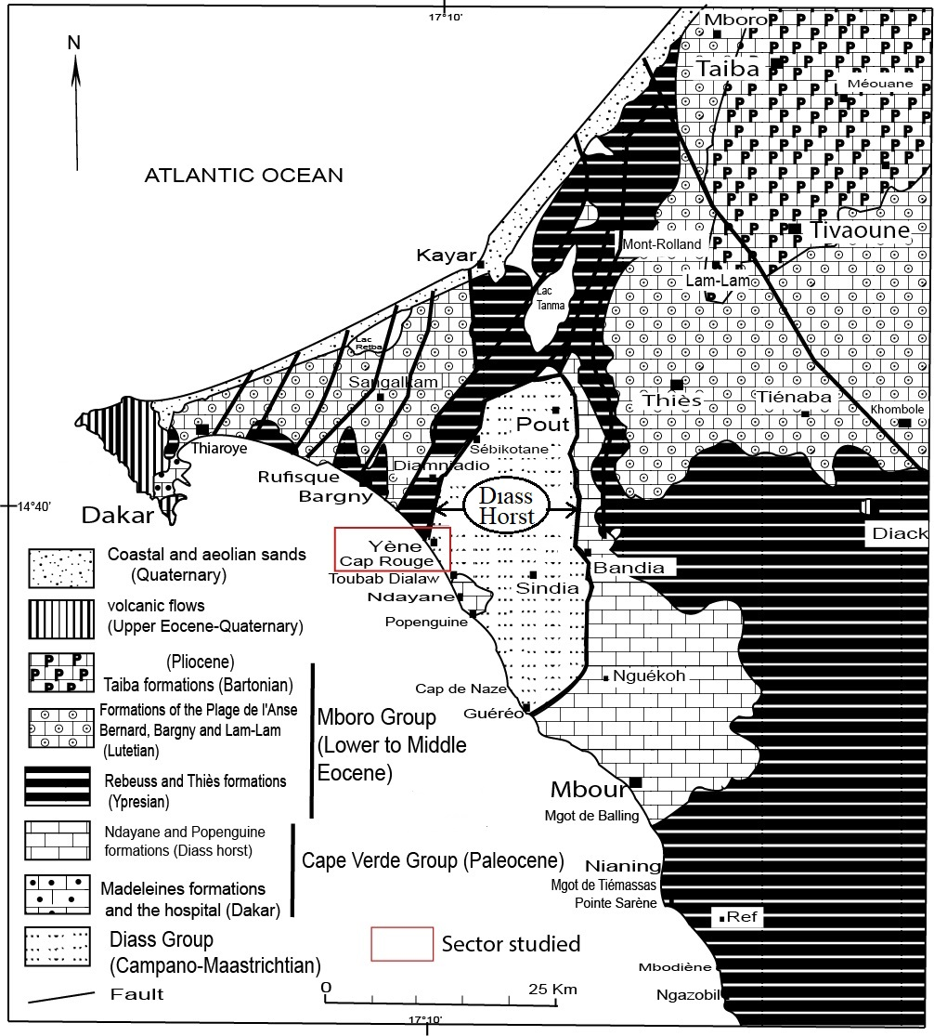

Fig. 1. Geological map of the western part of the Senegal-Mauritanian Basin [10, modified].

Several tectonic episodes have affected these formations of the Senegal-Mauritanian basin since the Cretaceous. But two of thesetectonicepisodes are oftendescribed :
- The first, major one, appeared at the end of the Middle Eocene, affects the entire basin. It is linked to the collision of the African and European plates and is responsible for a generalized regression [5,11]. This tectonic episode is also marked in the continental shelf series by a sedimentary discontinuity [12] of probably late Eocene age [13]. This tectonic episode is responsible for the appearance of normal faults and strike-slip faults sometimes intersected by volcanic tuffs of Oligocene, Miocene or Pliocene age [14];
- The second episode, more local to the Neogene, is characterized by tectonic replays in distension. It is marked in the Cape Verde peninsula by a double distension with NE-SW and NW-SE elongation directions attested by normal faults with strike-slip components [15]. In the continental shelf series, Gomez and Barusseau [13] report sedimentary discontinuities linked to this tectonic episode.
The Cap Rouge which is the subject of our work, belongs to a larger group called the Cap Rouge-Cap de Naze series, which extends over an altitude of around thirty meters. But curiously, it is only at Cap Rouge that we observe large structures criss-crossed interpreted as megachannels [10, 16]. The objective of this work is to contribute to the understanding of the significance of these megastructures criss-crossed in the light of new microtectonic studies.

2. Materials and MethodS

Cap Rouge is a coastal cliff located on Senegal’s Petite Côte and is easily accessible throughout the year. This study is mainly based on field observations. To obtain the most complete stratigraphic section, several excursions were conducted using available maps and geological cross-sections. Low tide periods during the rainy season were selected, as sedimentary regression is significant and outcrops are well exposed at that time. The cliff was subdivided into five sectors, where detailed lithological, structural, and microtectonic analyses were carried out. These analyses enabled the creation of well-illustrated synthetic sections.
This fieldwork was facilitated by the use of Google Earth to determine the altitudes of inaccessible areas. Meteorological data were regularly consulted to identify low tide periods. We used various instruments, including a GPS to locate observation points, a compass to measure structures and microstructures, a tape measure, and mobile applications to measure the thicknesses of the units.

3. Results and Discussion

3.1. Lithological Analysis of the Cap Rouge Cliff

Cap Rouge forms a coastal cliff that extends for approximately 400 meters. The base of the series is observed in the southern part during periods of heavy erosion, especially during the rainy season. The most recent terrain is obscured by buildings in the southern part and is only visible to the north of the cliff. A complete cross-section of Cap Rouge reveals 6 units (Fig.2 and 3), from bottom to top:

- Unit 1 consists of fine yellow to ochre-red sandstones; its lower limit has not been observed, but it can be up to 2 m thick;
- Unit 2, with an averagethickness of one meter, consists of variegated clayalternatingwith fine yellowsandstone;
- Unit 3 is made up of very fine sandstone, yellow at the base and ochre-red at the top; itsthickness can exceed 5 m towards the south, whereas on the northside, this unit istruncated and bevelled.
- Unit 4 forms a stratifiedwhole, around 25 m thick; its base, made up of breccias, isonly visible in the southern part of the cliffduringperiods of strongsedimentaryregression. The bedding planes are generally subhorizontal, but maybeinclined in the vicinity of large fracture surfaces.
- Unit 5 is made up of very fine yellow to redochresandstones, 2 m thick; its stratification is subhorizontal, but can alsobetransposedparallel to the sliding surfaces;
- Unit 6 consists of a 20 cm-thickferruginizedsiltyclay, topped by a lateriticarmour.

Fig. 2. Main units of Cap Rouge cliff.
A) Units 1, 2, 3 and 4. (B) Units 1, 2, 3 (strongly reduced). (C) Units 3 and 4 separated by a breccia level. (D) Units 2, 3 (strongly reduced) and 4. The base of the latter is made up of breccias. (E) Units 4, 5 and 6. (F) Units 5, 6 and the lateritic cover (L).

3.2. Structural Analysis of the Cap Rouge Cliff

The structural organization of Cap Rouge is not homogeneous. From southeast to northwest, we have distinguished five differently structured sectors (Fig. 3).

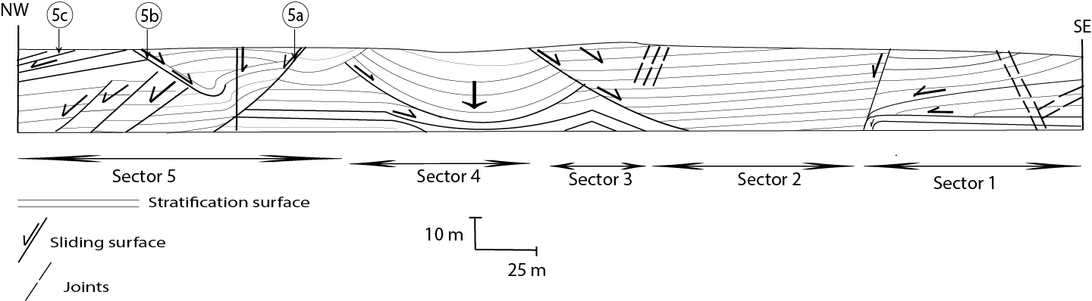

Fig. 3. Cross-section of the Cap Rouge cliff showing the main landslides.

3.2.1. Sector 1

This sector is affected by landslides towards the NW (Fig. 3 and 4A) involving units 1, 2, 3, and 4. These landslides were facilitated by fractures and by unit 2, which consists of variegated clay. Two fractures oriented N50 and inclined 75° to the NW acted as normal faults with a throw of approximately 150 cm. The fracture located further south is responsible for the sinking of units 1, 2, 3, and 4 (Fig. 4C) as well as the bevelling of units 2 and 3 (Fig. 4B). The variegated clay unit, for its part, served as a soap layer. Beyond the faults and up to approximately 75 m to the NW, only unit 4 outcrops in sector 1, showing an apparent dip of 20° to the NW. Sector 1 is marked by the presence of tectonic breccias in unit 4 (Fig. 4D). It is also affected by four families of joints (Fig. 4E and 4F): N120-vertical, N100-63NE, N50-30SE and N20-80NW.

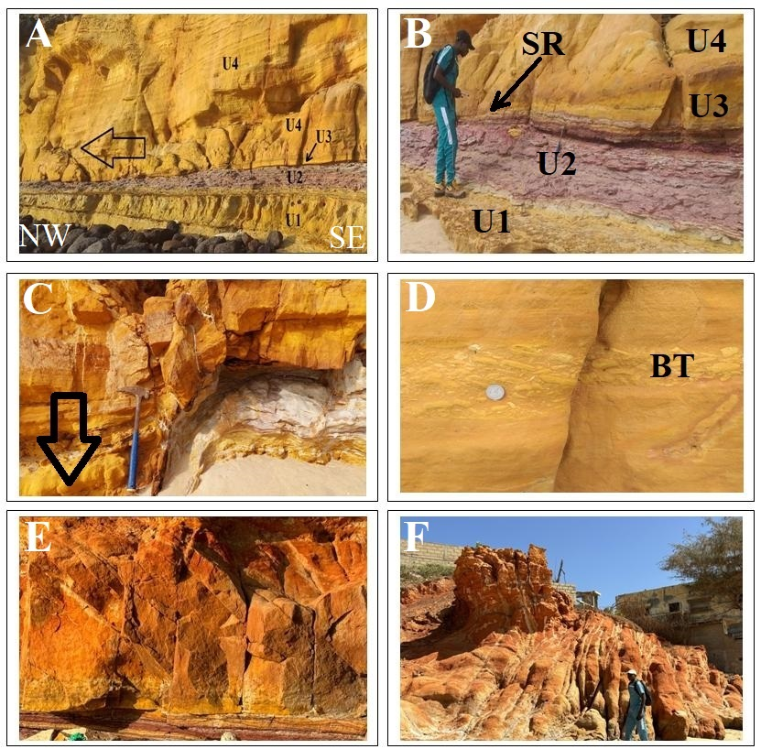

Fig. 4.Structure of sector 1.
(A): Gravity slide of unit 4 facilitated by unit 2 (variegated clay) which served as a soap layer;this slide is at the origin of the beveling of unit 3, the fracturing of unit 4 and the formation of a tectonic breccia (Fig. 3D); (B): Rupture surface incising unit 3 and causing the sliding of unit 4; (C): Sliding and disappearance at depth of units 2 and 3; this sliding is triggered by the normal play of a fracture with a steep dip towards the NW; (D): Tectonic breccia (BT) within unit 4 formed by the sliding of this unit; (E): N50-30SE and N20-80NW fractures intersecting unit 3; (F): N120-vertical fractures intersecting unit 3.

3.2.2. Sector 2

Extending over approximately 40 m, this sector is the convergence point of landslides that affected sectors 1 and 3 (Fig. 3 and 5A). Only units 4 and 5 outcrop there, showing subhorizontal to horizontal stratification surfaces (Fig. 5B).

Fig. 5. Structure of sector 2.
(A and B): Convergence sector of the landslidesthatoccurred in sectors 1 and 3; the layers of unit 4 are subhorizontal.

3.2.3. Sector 3

This sector extends over approximately sixty meters. It contains the same units as the previous sector, but they are inclined 45° to the SE. This inclination is due to a major landslide (Fig. 3 and 6). The slip surfaces are parallel (Fig. 6B) or intersecting (Fig. 6A and 6D) to the bedding planes. Fig. 4C illustrates the detachment of a block and its sliding via a fracture plane intersecting the bedding (Fig. 6D). 3.2.3. The downstream part of the slippedlayersisintersected by numerous N120-vertical fractures.This highly fractured downstream part has undergone significant marine erosion. During the SE-directed slide, some underlying levels were brecciated.

3.2.4. Sector 4

It extends over approximately 75 m and is characterized by the absence of unit 5; the lateritic crust therefore rests directly on unit 4. This sector is marked by a collapse leading to bending and the formation of a pseudosyncline with a large radius of curvature (Fig. 3, 7A and 7B). The rupture surfaces, numerous draw circular arcs (Fig. 7A and 8B). The left flank (NW) of this pseudosyncline recorded the largest displacements. At this level, the rupture surfaces, numerous are oblique or parallel to the bedding planes, which are deflected and pulled downward (Fig. 7C). In the middle of the pseudosynclinal structure, the layers of unit 4 have undergonesignificant compaction due to vertical stress shown as a large arrow in figures 7a and 7b.

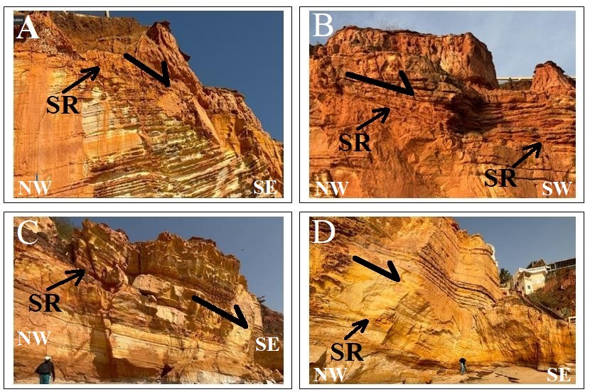

Fig. 6. Structure of sector 3.
(A and B): Southeastward sliding of units 4 and 5; (C): Southeastward sliding of a detached block of unit 4; (D): Detail of the previous photo showing the sliding surface (SR) incising unit 4; the most downstream part of the displaced block is highly fractured and has undergone significant marine erosion.
.

Fig. 7. Structure of sector 4.
(A and B): Large pseudosynclinal structure associatedwith subsidence (highlighted by large arrow). The layers of Unit 4 have flexed and are incised by numerous fracture surfaces (SR) (C): Breaks and slides on the leftflank of the pseudosynclinecausing the layers of Unit 4 to deviate.

3.2.5. Sector 5

This sector can be subdivided into three subsectors (Fig. 3) designated: 5a, 5b, and 5c. Displacements in sectors 5a and 5b appear to be conjugate. Subsector 5a is delimited by two vertical fractures. Displacements along these fractures induced subsidence and gravity slip toward the northwest. This subsidence led to compaction and bending of the layers of Unit 4 (Fig. 8A and 8B). The slippage caused the formation of drag microfolds above the fracture surface (Fig.8D and 9A) and sigmoid structures below it (Fig. 9B). These microstructures clearly indicate northwesterly transport. The sub-sector 5b recorded one of the most significant landslides. The displacements occurred towards the SE. The rupture surface inclined at about 45° can be followed over tens of meters. The SE direction of the slide isindicated by the curvature of the strata (Fig. 8A and 8C). The landslide in sub-sector 5b is conjugate with that of sub-sector 5a. The subsidence of the cliff at this level is obvious and also well illustrated by numerous fractures having the same direction of dip as the main landslide surface (Fig. 8C). Subsector 5c is marked by numerous slips towards the NW associated withthe normal displacement of fractures. The conjugate actions of the displacements induced subsidence and slippage (Fig. 10A, 10B, 10C and 10D). During the subsidence, new fractures appeared (Fig. 10C). The rupture planes can be oblique or parallel to the bedding planes (Fig. 10A and 10D). In Fig. 10B we note that the compartment located to the right of the man has undergone subsidence and tilting of the layers compared to the compartment on the left where the bedding planes are subhorizontal.

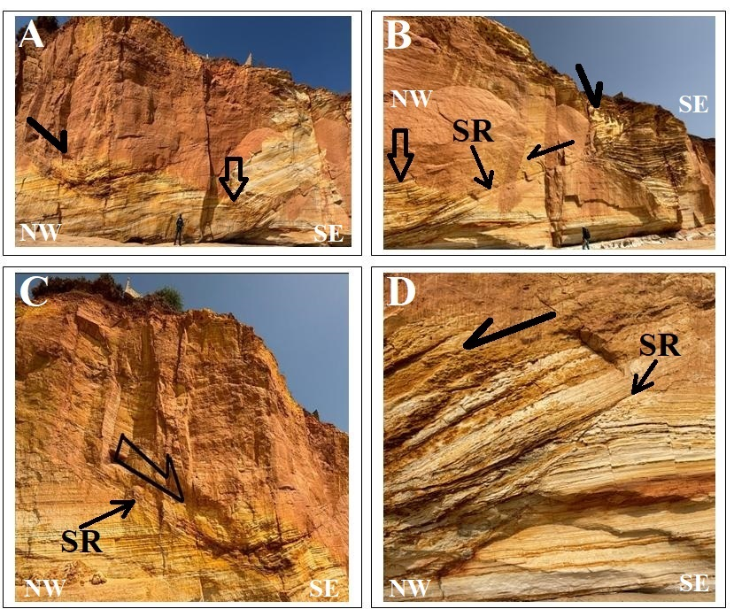

Fig. 8. Structures of sub-sectors 5a and 5b.
(A): Landslides in subsectors 5a (right) and 5b (left). The large arrowindicates a collapsed block causing compaction of the layers in unit 4; (B): Detail of landslide in sub-sector 5a; (C): In sub-sector 5b, the direction of landslide (arrow) isindicated by the curvature of the strata; (D): Normal micro-faults (at middle and lower right) and drag micro-fold (at middle left) in sub-sector 5a linkedrespectively to stress induced by collapsed block and landslide.
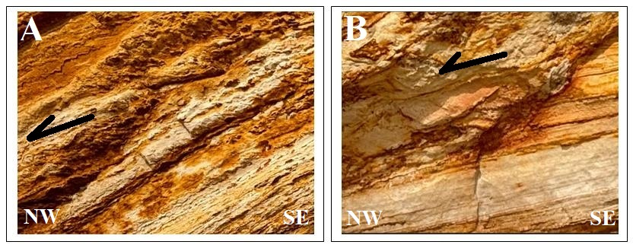
Fig. 9: Microstructures associated with the landslide in sub-sector 5a.
(A): Deformation of the slid block, marked by drag micro-folds indicating leftward (NW) displacement. (B): Deformation of the block below the landslide surface marked by sigmoidal structures indicating leftward (NW) displacement.

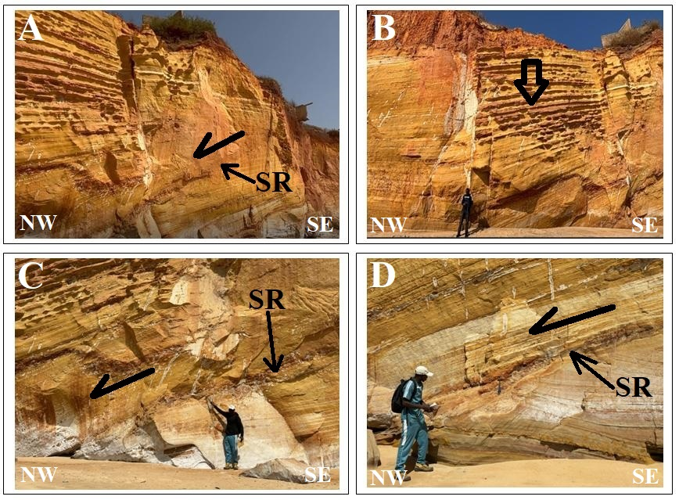

Fig. 10: Microstructures in sub-sector 5c.
(A): Fracture and NW sliding; (B): Subsidence (indicated by arrow) leading to layer tilting; (C): Fracture and NW slidingindicated by arrow. The sliding surface (SR) isassociatedwithmicrofractures; (D): Gravity slidingtowards the NW indicated by the arrow.

3.3. Discussion

In Table 1, we compared the Cap Rouge section carried out in this work with those carried out by Tessier [3], Sow and Diène [16], and Roger et al. [10]. These authors distinguished respectively, three, four, and five units capped by lateritic cuirass, respectively.

Table 1. Comparison of the Cap Rouge section carried out as part of this work with those of Tessier [3], Sow and Diène [16] and Roger et al [10].

Lithological units (from top to bottom) | Tessier 1952  [3] | Sow et Diène  [16] | Roger et al  [10] | This work
7 |  |  |  | Ferruginous cuirass
6 |  |  | Ferruginous cuirass | Silty argillite
5 |  |  | Silty argillite | Fine massive, bioturbated sandstones with subhorizontal bedding
4 | 3-4m  of laterite | laterite | Very fine bioturbated sandstone with a massive appearance and subplane stratification | Breccias at base overlain by fine bedded sandstones alternating with argillites. Unit intersected by criss-crossing slide surfaces.
3 | 25-30m of sandy sandstone with cross-bedded stratifications | Mega-channels filled with very fine, pinkish-yellow bedded arenites with intraformational breccia levels; slumps are present in certain channels. | Unit organized in mega-channels filled with fine bedded sandstonealternating with clayey levels | Fine sandstone, red-ochre at the base and yellow at the top; the thickness can reach 5m towards the South; unit beveled towards the NW by a sliding surface
2 | 10 m of red clayey sandstone | 2 m of variegated clays topped by 10 m of very fine, massive, ochre-red arenites | Variegated  clays topped by massive bioturbated red-ochre sandstone | 2 m of variegated clay alternating with yellow sandstone beds. This unit sinks and disappears following a landslide
1 | 10 m of gray clay | Fine to very fine yellow to red-ochre arenites with intraformational breccia levels. This unit ends with a 2 m thick clay level. | Very fine yellow to ochre sandstones which may contain intraformational breccias | Unit visible only during low tide, consisting of massive fine sandstone, yellow to red-ochre, ferruginized at the top

The geological cross section (Tab.1 and Fig. 11a) presented in this work was carried out during the rainy season when erosion is very significant and allows us to see the lower parts of the cliff. We identified six sedimentary units and one lateritic cuirass. Our units 1 and 2 were grouped by Sow and Diène [16] into a unit that they named unit 1 (fine to very fine reddish-yellow to ochre arenite topped by 2 m of variegated clay). Roger and al [10] grouped our units 2 and 3 into a single unit called unit 2 (variegated clay topped with massive fine red ochre bioturbated sandstone). In unit 1, Sow and Diène [16] described breccias that we observed at the base of our unit 4. The latter, made up of fine sandstone alternating with argillites, corresponds to: unit 3 of Tessier [3], unit 2 of Sow and Diène [16] and unit 3 of Roger et al [10]. All these authors have recognized the presence in this sandstone-argillic unit of large cross-bedding interpreted as megachannels (Fig. 11b).

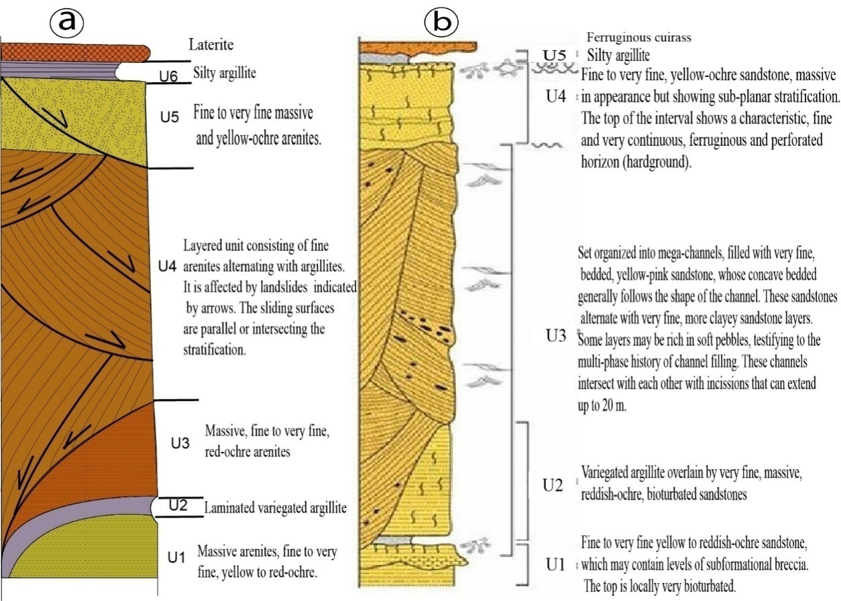

Fig. 11. Geological cross sections of Cap Rouge. (a): This work; (b): Roger and al. [10]

The structural analysis that we carried out in the framework of this work showed that these large structures are, in fact, rupture surfaces on which displacements have occurred (Fig. 3 and 11a). Each structure is characterized by kinematic markers present in the units located above and below the transport surfaces. From a typological point of view, according to the most used classifications [17, 18] the observed ground movements are essentially translational landslide with a flat rupture surface. Such landslides are considered to have a very slow displacement speed. They are different from rotational slides characterized by a circular fracture surface. Onlysector 4 has subcircular slip surfaces linked to a significant collapse causing the bending of unit 4 (Fig. 7a and 7b).
The question that can be asked is what is the origin of landslides at Cap Rouge? To answer this question, we can refer to the numerous geotechnical studies and particularly those of [19, 20, 21, 22, 23]. A ground movement results from the action of preparation factors which have a role of degradation and weakening of the ground. Then, the ground movement is initiated by the action of triggering factors [24].
The preparatory factors are geological, geomorphological, physical and anthropological [25, 26, 27]. The triggering factors correspond to the natural or anthropic action necessary to trigger a landslide. This triggering action can be linked to one or more things: intense rain, earthquake, sudden regressive erosion [28]. Among all the triggering factors, water occupies a major place; whether it is runoff or infiltration water or water table movements, it causes variations in interstitial pressures in the massif, thus inducing significant mechanical constraints within a massif [29, 30, 31, 32].
Regarding Cap Rouge, observation of the section in Fig.3 and images from the 5 sectors allows us to understand the main causes of the landslides. The first striking thing is the convergence at sector 2 of the slip from sectors 1 and 3. The numerous N120 fractures affecting it have been the site of significant alteration linked to rainwater and marine erosion. These modifications are at the origin of a collapse of the cliff leading to landslides on both sides. Sector 1 contains three major slip surfaces, some of which followed old joints that acted as normal faults. Also in sector 1, unit 2, made up of variegated clay, behaved like a soap layer, which facilitated the movements. The sinking of this clay layer (Fig. 4C) is indisputable proof of the landslide. In sector 3, units 4 and 5 are involved in the movements towards sector 2. Two subparallel slip surfaces are inclined towards the SE. The most basal slip is responsible for the deformation of the layers below the sliding surface. The upper landslide has a sliding surface parallel to the stratification on the upstream side but becoming secant to it towards the downstream side.
Sector 4 is marked by several subcircular sliding surfaces that mainly affect unit 4. This unit has undergone flexure following subsidence. On the left flank of the pseudosyncline structure, the initially horizontal bedding planes are deflected downwards by the free-falling sediment mass. This downward displacement is the cause of a settlement of unit 4 in the middle of the pseudosyncline hinge and on the right flank. Subsidence and sliding in sector 4 are linked to strong marine erosion.
Sector 5 is first marked by two major conjugate translational landslides: one towards the NW and the other towards the SE. These landslides are associated with a collapse of the cliff which, as in sector 4, is caused by marine erosion. Their rupture surfaces intersect the bedding planes. The other landslides towards the NW are due to subsidence linked to marine erosion and alteration in the fractures induced by runoff water.
Furthermore, it should be noted that unit 4, which recorded the majority of landslides, is a water reservoir (Maastrichtian aquifer) as it is mainly made up of fine sandstone. The increase in the degree of saturation results in a reduction in the cohesion of the rocks, leading to a reduction in the shear resistance that causes ruptures and landslides.

4. Conclusion

The Cap Rouge cliff, located in the western part of the Senegal-Mauritania Basin and more precisely in the Diass horst, is made up of six sedimentary units of terminal Cretaceous age surmounted by a lateritic crust. Starting from the bottom, the first two units (U1 and U2), respectively sandy and clayey, are only visible to the south and during periods of strong regression in the rainy season. They were carried to depth along a fracture that acted as a normal fault following a landslide. The displacements were facilitated by unit 2, which acted as a soap layer. Unit 3, sandstone, is beveled by a slip surface downstream of the displacements, while its thickness increases toward the south. Unit 4, sandstone, is omnipresent over the entire extent of the Cap Rouge cliff, while units 5 and 6, sandstone and clay respectively, disappear to the north of the cliff.
Megastructures incising unit 4 and considered for seven decades as cross-stratifications are, according to our structural analyses, rupture surfaces where slips have occurred. These are well illustrated by microfaults, micro-drag folds and sigmoid microstructures. From a typological point of view, this is a translational slip with a vertical displacement component.
The main cause of the landslides is subsidence in several locations of the cliff caused by marine erosion and weathering by runoff waters occurring in the fracture planes, leading to a reduction in shear strength.
Extended studies covering the entire Diass horst, focusing particularly on the shear strength of the Maastrichtian sandstone-pelitic formations, will allow for a better characterization of landslides, the consequences of which can affect buildings.

ACKNOWLEDGEMENTS
The authors express their sincere gratitude to the reviewers. They also thank Mr. Fall for improving the quality of the English translation of the manuscript.

COMPETING INTERESTS
Authors have declared that no competing interests exist.
Disclaimer (Artificial intelligence)
Author(s) hereby declare that NO generative AI technologies such as Large Language Models (ChatGPT, manuscript.

REfErences
[1] Bellion, Y. (1987) Post-Paleozoic geodynamic history of West Africa based on the study of some sedimentary basins (Senegal, Taoudéni, Iullemmeden, Chad). Thesis, University of Avignon, 292p.
[2] Khatib, R., Ly, A., Sow, E. H., Sarr, R. (1990) Sedimentary rhythms linked to global eustatic variations in the Campanian and Maastrichtian periods of Senegal. Stratigraphic revision of the Late Cretaceous series of Cape Naze. C. R. Acad. Sci., Paris, 311, (2), 1089-1095.
[3] Tessier, F. (1952) Contributions to the stratigraphy and paleontology of the western part of Senegal (Cretaceous and Tertiary). Thesis in Sciences, University of Marseille, 566 p.
[4] Castelain, J., Jardine, S., Monciardini, C. (1965) Geological Excursions in Western Senegal. In: International Conference on Micropaleontology (Dakar). BRGM Dissertation, 32, pp. 357-365.
[5] Dillon, W. P. and Sougy, J. (1974) Geology of West Africa and Canary and Cape Verde Islands. In: Nairn, A. E. M., Stehli, F. G. Eds. The Ocean Basins and Margins. Plenum Press Publication. Corp., New York, pp. 315-390. [6] Sarr, R., Ndiaye, P.M., Diop, I.N., Gueye, M. (2000) Dating by Planktonic Foraminifera of a Lutetian Volcanic Activity at Toubab Dialaw (Western Senegal). Bulletin of the Geological Society of France, 171 (2), pp.197-205.
[7] Castelain, J. (1965) Stratigraphic and Micropaleontological Overview of the Western Senegal Basin. History of the Paleontological Discovery. In: “International Colloquium of Micropaleontology” (Dakar). B.R.G.M. Memoir, 32, pp.135-159.
[8] Lappartient, J. R. and Monteillet, J. (1980) The Upper Senonian Fossiliferous Deposit of the Paki Quarries (Senegal). Bulletin of the Fundamental Institute of Black Africa, Series A, 42 (3), pp. 431-439.
[9] Crevola, G., Cantagrel, J.M., Moreau, C. (1994) Cenozoic volcanism of the Cape Verde Peninsula (Senegal): Chronological and geodynamic framework. Bulletin of the Geological Society of France, 165, pp. 437-446.
[10] Roger J., Banton O., Barusseau J.P., Castaigne P., Comte J-C., Duvail C., Nhlig P., Noël B.J., Serrano O., Travi Y. (2009) Explanatory note on the multi-layer mapping at 1:50,000 and 1:20,000 of the Cape Verde activity zone. Ministry of Mines, Industry and SMEs, Directorate of Mines and Geology, Dakar, 245p.
[11] Van Der Linden W. J. M. (1981) The Crustal Structure and Evolution of theContinental Margin of Senegal and the Gambia, from Total Intensity Magnetic Anomalies. Geol. Mijnb., 60, 257-266 pp.
[12] Seibold, E., Hinz, K. (1974) Continental Slope Construction and Destruction, West Africa. In: Burk, C.A. and Drake, C.L., Eds., The Geology of Continental Margins, Springer Verlag, Berlin, 179-196pp. http://dx.doi.org/10.1007/978-3-662-01141-6_13
[13] Gomez, R., Barusseau, J.P. (1984) Dispositions of the post-Eocene formations of the Senegalese continental margin. Bulletin of the Geological Society of France, 26, pp. 1107-1116.
[14] Bellion, Y., Guiraud, R. (1984) The sedimentary basin of Senegal: synthesis of current knowledge. In: Mineral plan of the Republic of Senegal. B.R.G.M. and D.M.G. Dakar, Eds., vol. 1, pp. 4-63. [15] Lompo, M. (1987) Methods and study of fracturing and veins; example of the Cape Verde region (Senegal)». D.E.A. thesis in Applied Geology, Cheikh Anta Diop University of Dakar, 59p.
[16] Sow E. and Diène M. (1997-1998) Highlighting giant subtidal channels in the Cap Rouge series, Late Cretaceous of the Diass horst (Western Senegal). Bulletin of the FAN Ch. A. Diop, Dakar, T. 49, series A, n°2, pp.79-101

[17] Colas G. and Pilot G. (1976) Description and classification of landslides. Bull. Liaison des Laboratoires des Ponts et Chaussées, Special No. II, pp. 21-30.
[18] Dikau R., Brunsden D., Schrot L., Ibsen M. L. (1996) Landslide recognition: identification, movement and courses. Report no. 1, European Commission Environment Program, John Wiley and Sons, 247 p.
[19] Millies-Lacroix A. (1981) Classification of unstable slopes and slopes. Bull. Liaison des Laboratoires des Ponts et Chaussées, Special X, pp. 55-62
[20] Sassa K. (1985) The geotechnical classification of landslides. Proc. 4th Int. Conf. Field Workshop on Landslides, Tokyo, 1, 31-40pp. [21] Fabre R., Denis J., Riss J., Clément B. t (1996) Structural analysis of the Triassic cover on the slopes of the Jarra and Arradoy mountains in the Basque Country (Pyrénées-Atlantiques): geological mapping and landslide typology. C.R. Ac. Sci, Paris, series IIa, vol. 324, pp. 461-468.
[22] Fabre, R., Desreumaux, Ch., Lebourg Th. (2000) Rockslides on the southern slope of the Layens (Aspe Valley, Western Pyrenees). Bulletin of the Geological Society of France, 171, (4), pp. 407-418. https://doi.org/10.2113/171.4.407
[23] Gunzburger Y., Merrien-Soukatchoff V. &Guglielmi Y. (2005) Influence of daily surface temperature fluctuations on rock slope stability: case study of the Valabres slope rocks (France). International Journal of Rock Mechanics and Mining Sciences, Vol 42, Issue 3, 331-349pp. https://doi.org/10.1016/j.ijrmms.2004.11.003.
[24] Azimi C., Desvarreux P. (1996) Some aspects of ground movement prediction. Revue française de géotechnique, No. 76, pp. 63-71.
[25] Antoine P. (1992) The problems posed by the instability of large-scale slopes: geological aspects. Bulletin of the International Association of Engineering Geology, No. 45, pp. 9-24. https://doi.org/10.1007/BF02594900.
[26] Antoine P., and Giraud A. (1993) Aid to the recognition of the main types of ground movements known in the Northern Alps. Commission of the European Communities, EPOCH Programme, Part No. 3, Vol. 2.
[27] Pollet N. (2004) Rapid gravitational movements of large rock masses: Contributions of field observations to the understanding of propagation and deposition processes: Application to the cases of La Madeleine (Savoie, France), Flims (Grisons, Switzerland) and Kofels (Tyrol, Austria). Doctoral thesis Marne-la-vallée, ENPC, 252p. [28] Durville J.L. &Seve G. (1996) Slope stability - Landslides in soft ground. Soil mechanics and geotechnics, 1, pp. 1-17. https://doi.org/10.51257/a-v2-c254.
[29] Cojean R. (1994) Role of water as triggering factor for landslides and debris flows. In International conference and field workshop on floods, Trento, Italy, pp. 31-39.
[30] Flageollet J.C. (1988) Ground movements and their prevention. Paris, Masson, 224 p.
[31] Martins-Campina B. (2005) The role of geological and mechanical factors in the triggering of gravitational instabilities: example of two landslides in the Atlantic Pyrenees (Ossau Valley and Aspe Valley). Doctoral thesis, University of Bordeaux 1, 268p.
[32] Bourenane H., Braham M. et Bouhadad Y. (2021) - Spatial distribution, controlling factors and failure mechanisms of the large-scale landslides in the urban area of Azazga city (northern Algeria). Environmental Earth Sciences, vol. 80: 313. https://doi.org/10.1007/s12665-021-09607-5

