Review Article
A Comprehensive Assessment of Conventional and Emerging Desalination Methods for Treating Marine Water Supplies

.
ABSTRACT

Freshwater scarcity, intensified by population growth, urbanization, and industrial development, has positioned desalination as a critical solution for augmenting global water supplies. This paper presents a comprehensive review of desalination technologies, covering both mature processes—such as Reverse Osmosis (RO), Multi-Stage Flash (MSF), and Multi-Effect Distillation (MED)—and emerging methods, including Forward Osmosis (FO), Nanofiltration (NF), Electrodialysis (ED), Capacitive Deionization (CDI), Hydration (HY), and Secondary Refrigerant Freezing (SRF). Each technology is described in terms of its operating principles, energy requirements, advantages, limitations, and readiness level. Schematic diagrams are provided for all processes, accompanied by a comparative table summarizing key parameters such as feedwater type, energy consumption, and development status. The analysis highlights the dominant role of RO in the global market, accounting for nearly 70% of total installed capacity, and underscores the growing interest in hybrid and renewable-powered systems as promising pathways for improving efficiency and sustainability. In addition, environmental concerns associated with brine disposal are recognized as a major challenge influencing technology choice and future research priorities. The review identifies significant opportunities for innovation in desalination, particularly in integrating renewable energy sources, improving brine management, and developing low-energy processes. Future research should focus on enhancing energy recovery, optimizing hybrid configurations, and scaling up promising emerging technologies to achieve cost-effective and environmentally sustainable desalination solutions.

Keywords: Desalination, Reverse Osmosis, Thermal Processes, Emerging Technologies, Renewable Energy Integration, Water Treatment

1. INTRODUCTION

Freshwater scarcity has emerged as one of the most pressing global challenges due to population growth, urbanization, and industrial expansion. This situation has intensified the need for alternative water sources, with desalination playing a pivotal role in securing potable water supplies from saline and brackish sources (Al-Othman et al., 2019). While small-scale distillation methods for seawater date back to the 18th century, large-scale desalination only became commercially viable in the mid-20th century. (Cipollina, Micale and Rizzuti, 2005).
Early industrial desalination relied heavily on thermal processes such as Multi-Stage Flash (MSF) and Multi-Effect Distillation (MED), enabled by the low cost of fossil fuels in the 1950s and 1960s (Moossa et al., 2022). These methods dominated the sector for decades, particularly in the Middle East and North Africa (MENA) region, where energy resources were abundant. Incremental improvements, such as increasing the number of MSF stages, enhanced thermal efficiency and reduced water production costs (Moossa et al., 2022).
The term desalination refers to the process of extracting potable water from saline or brackish sources, with seawater being the most common feedwater. Historically, the concept of desalination can be traced back to the late 18th century when the British Royal Navy adopted simple distillation methods aboard steam-powered ships to extend voyages without carrying additional freshwater (Rognoni, 2010). The sector underwent a major transformation with the introduction of membrane-based technologies, particularly Reverse Osmosis (RO) (Amy et al., 2017). The development of synthetic semipermeable membranes in the 1950s and 1960s, followed by advances in asymmetric membrane structures and energy recovery devices in the 1980s and 1990s, significantly improved process efficiency (Maletskyi, 2020). These innovations positioned RO as the leading desalination method globally, offering lower energy requirements compared to traditional thermal systems (Shabib et al., 2025).
Today, RO accounts for nearly 70% of global desalination capacity, followed by MSF, MED, and a smaller share of emerging processes (Tayeh, 2024). The MENA region remains the largest user, hosting almost half of global capacity, with seawater representing the dominant feedwater source (Al-Addous et al., 2024). In addition to mature technologies, several emerging and hybrid systems are under active development. These include Forward Osmosis (FO), Nanofiltration (NF), Electrodialysis (ED), Capacitive Deionization (CDI), Hydration (HY), and freezing-based methods such as Secondary Refrigerant Freezing (SRF) (Honarparvar et al., 2021). Many of these innovations aim to reduce energy consumption, integrate renewable energy sources, and minimize environmental impacts such as brine disposal.
This review presents a comprehensive and structured overview of the desalination sector, which has evolved over more than a century and continues to undergo rapid development. The authors provide a detailed summary of both established and emerging technologies, explaining their operating principles, energy requirements, and global distribution patterns. Special attention is given to innovative approaches currently under investigation, including freezing-based methods, capacitive deionization, and hydration-based processes. As energy efficiency and renewable integration are central to desalination’s future, each technology is analyzed in terms of its potential for coupling with sustainable energy sources.
The authors have also prepared schematic diagrams for all processes discussed and developed a comparative table that synthesizes key operational parameters, advantages, limitations, and technology readiness levels.

2. Current Landscape of Desalination Technologies

Modern desalination employs a range of technological solutions, each defined by unique operating principles, infrastructure requirements, and energy demands. Regardless of the approach, most plants follow a similar multi-stage configuration, with the desalination unit itself accounting for the highest proportion of total energy consumption (Alkaisi et al., 2013). The general sequence of operations includes:
- Water intake – Seawater or brackish water is drawn into the facility through pumps and pipelines.
- Pre-treatment – Suspended solids are removed via filtration, while chemical dosing prevents scaling, fouling, and corrosion in downstream equipment.
- Desalination – The separation of fresh water from saline feedwater, achieved through thermal, membrane, or hybrid technologies.
- Post-treatment – pH adjustment and remineralization ensure that the product water meets drinking, industrial, or agricultural standards.
Because the desalination stage consumes the most energy, improving its efficiency remains a key focus of current research and innovation efforts.

3. CLASSIFICATION OF DESALINATION TECHNOLOGIES BASED ON PHYSICAL PROCESS
To enable meaningful comparisons between different approaches, desalination processes are typically grouped into broad categories (Elsaid et al., 2020). One widely adopted framework identifies three main classes:
- Evaporation and condensation
- Filtration (membrane-based systems)
- Crystallization processes
Recent developments have expanded this classification to include new and hybrid technologies that integrate elements from more than one category (Curto et al., 2021). Figure 1 presents an updated structure incorporating both mature commercial methods and experimental systems under active development.

3.1 Evaporation and Condensation Methods
These represent the earliest form of large-scale desalination and remain a significant part of global capacity (Curto et al., 2021). They work by heating seawater to generate vapor, which is subsequently condensed into distilled water. Heat sources can include waste heat recovery, combustion, or solar thermal input. Key commercial processes include Multi-Effect Distillation (MED), Multi-Stage Flash (MSF), Thermal Vapor Compression (TVC), and Membrane Distillation (MD). Research has also advanced solar-assisted designs such as Solar Still Distillation (SSD), Solar Chimney (SC), and Humidification–Dehumidification (HDH), along with mechanical approaches like Mechanical Vapor Compression (MVC) (Mudhar Al-Obaidi et al., 2024).
3.2 Filtration (Membrane-Based) Technologies
Membrane processes rely on selective barriers that permit the passage of water molecules while rejecting dissolved salts and other impurities (Zhao and Wang, 2021). An exception is the Ion Exchange Resin (IXR) method, which removes ions through chemical exchange rather than size-based exclusion (Zhao and Wang, 2021). Reverse Osmosis (RO) is now the leading desalination process worldwide, having overtaken thermal methods in installed capacity due to its relatively lower specific energy consumption and adaptability to different salinity levels (Lejarazu-Larrañaga et al., 2020). Other notable membrane-based approaches include Electrodialysis (ED) for low-salinity sources, Forward Osmosis (FO) in pilot-scale use, Nanofiltration (NF) for partial desalination and water softening, Capacitive Deionization (CDI) as an emerging electrochemical method, and IXR systems for high-purity applications. (Lejarazu-Larrañaga et al., 2020)
3.3 Crystallization-Based Processes
Crystallization approaches separate fresh water by freezing the saline feedwater, forming ice as an intermediate phase that is later melted to produce potable water (Zhao et al., 2024). These processes are generally in early research stages, with examples including Secondary Refrigerant Freezing (SRF), Hydration (HY), and Vacuum Freezing (VF). While their theoretical energy demands can be lower than some thermal processes, technical and cost barriers have so far limited large-scale deployment (Zhao et al., 2024).

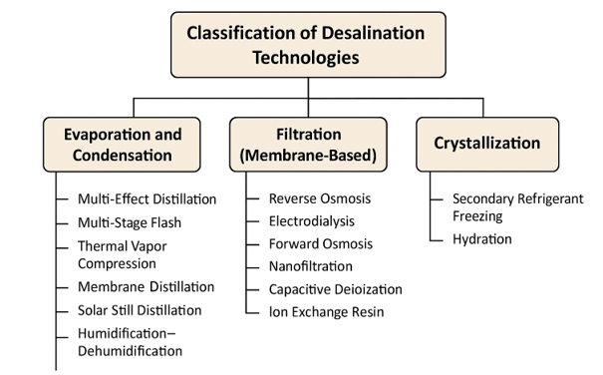
Fig 1: Classification of Desalination technologies based on physical process

4. CLASSIFICATION OF DESALINATION TECHNOLOGIES BASED ON PRIMARY ENERGY SOURCE
Desalination technologies can also be grouped by the main type of energy they require. This approach is particularly useful when evaluating the potential for coupling with renewable energy systems (Bundschuh et al., 2021). The four broad categories are thermal, mechanical, electrical, and chemical energy–driven processes.
Thermal energy–driven systems operate using heat, which can be supplied by solar thermal collectors, geothermal reservoirs, or waste heat from industry (Madhuri et al., 2025). Examples include Multi-Stage Flash (MSF), Multi-Effect Distillation (MED), Thermal Vapor Compression (TVC), Membrane Distillation (MD), Solar Chimney (SC), Humidification–Dehumidification (HDH), and Solar Still Distillation (SSD) (Madhuri et al., 2025. The last three are specifically designed to harness solar radiation directly.
Mechanical energy–driven processes depend on pumps or compressors, which often account for most of their energy consumption ((Curto et al., 2021). This group includes Mechanical Vapor Compression (MVC), Reverse Osmosis (RO), Nanofiltration (NF), Secondary Refrigerant Freezing (SRF), and Hydration (HY) (Curto et al., 2021).
Electrical energy–driven processes use an electric field to transport ions through charged membranes (Curto et al., 2021). The main representatives are Electrodialysis (ED) and Capacitive Deionization (CDI).
Chemical energy–driven processes achieve desalination through ion-exchange or solute-replacement reactions. Ion Exchange Resins (IXR) and Forward Osmosis (FO) are the key examples (Curto et al., 2021).
Mechanical and electrical energy can be converted between each other with minimal efficiency losses, allowing mechanically driven systems to operate on electricity (Thiel and Stark, 2021). Thermal energy can also be produced from electricity using resistive heating or heat pumps; however, converting heat back into mechanical or electrical power is generally less efficient due to thermodynamic constraints (Thiel and Stark, 2021). When considering renewable energy integration, it is useful to distinguish between sources that mainly produce electricity—such as wind, hydropower, tidal, and wave energy—and those that can provide both heat and electricity, including solar, geothermal, and biomass (Curto et al., 2021). Mapping these resources against compatible desalination technologies helps identify the most effective pairings for different locations.

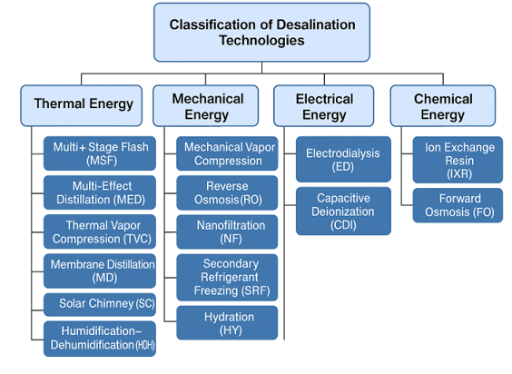
Fig 2: Classification of Desalination Technologies Based on Energy Source.

4.1 Multi-Effect Distillation (MED)
Multi-Effect Distillation is among the earliest commercial-scale desalination technologies, with its first large installation built in Kuwait in the 1950s using a triple-effect submerged-tube evaporator (Le Quesne et al., 2021). Although it demonstrated technical feasibility, MED initially faced limited deployment due to operational issues such as scaling on heat transfer surfaces, which proved more severe than in some other thermal desalination processes (Le Quesne et al., 2021). By the 1980s, renewed interest emerged as studies focused on operating at lower temperatures to reduce scaling and corrosion risks (Le Quesne et al., 2021). Today, MED is not confined to seawater desalination but is also applied in juice concentration, such as sugarcane processing, and in the production of salt from seawater.
An MED plant operates through a series of “effects,” each functioning at a progressively lower pressure. The vapor produced in one effect is used as the heating medium for the next, enabling significant heat recovery (Chorak et al., 2017). Configurations vary from linear sequences of effects to parallel arrangements designed to optimise thermal performance. Based on top brine temperature (TBT), MED units are classified as low-temperature systems (TBT < 90 °C) or high-temperature systems (TBT > 90 °C) (Chorak et al., 2017). Energy efficiency can be improved by sourcing heating steam from turbine extractions or industrial waste heat. Because the steam is kept separate from the saline feedwater, the resulting condensate can be returned to the boiler, reducing fresh boiler feedwater demand. To prevent calcium sulphate scaling, brine temperatures are usually kept below 120 °C (Chorak et al., 2017).
A standard MED system (Figure 3) comprises a steam generation section, multiple effects, a condenser, and a venting system. Feedwater is often split into two streams to recover residual heat from both the brine and the product water before being routed to the condenser. From there, the feedwater is progressively preheated in heat recovery exchangers using vapor from each effect, maximizing overall energy utilization (Rostamzadeh et al., 2020). The process begins with preheated seawater sprayed over the heat exchange surfaces of the first effect, forming a thin film for rapid evaporation under reduced pressure and external heat input. The generated vapor passes through transfer tubes to the next effect, where a lower operating pressure causes it to condense inside the heat exchanger tubes, releasing latent heat to evaporate part of the incoming feedwater. This stepwise condensation–evaporation cycle continues across all effects, with each stage operating at a lower pressure than the previous one.
In the final effect, any remaining vapor is condensed using incoming feedwater, which in turn gains heat before entering the first stage. The brine is transferred sequentially between effects to maximize water recovery. A vacuum system maintains the sub-atmospheric pressures essential for efficient operation. Typical MED plants have between four and twenty-one effects, with freshwater production capacities ranging from 2,000 m³/day to 20,000 m³/day (Rostamzadeh et al., 2020). To further enhance performance, MED units are often integrated with Thermal Vapor Compression (TVC) or Mechanical Vapor Compression (MVC) systems. The largest operational MED plants are located in China and the Middle East, reflecting their suitability for large-scale, energy-efficient desalination in regions with high water demand (El-Sayed et al., 2024).

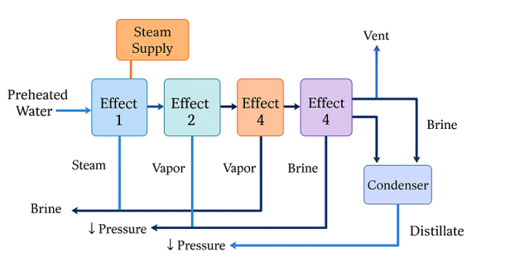
Fig 3: Schema of a Multi-Effect Distillation Desalination unit.

4.2 Multi-Stage Flash (MSF)
Multi-Stage Flash distillation (figure 4) is one of the most established large-scale desalination methods, widely used in the Middle East for municipal water supply (Taha Sayed et al., 2022). Its commercial adoption began in the late 1950s, with rapid expansion in the decades that followed due to its high reliability and ability to operate on large capacities (Taha Sayed et al., 2022). The MSF process operates by heating seawater under pressure to a temperature close to its boiling point. The heated water is then introduced into a series of stages, each maintained at progressively lower pressures. In each stage, the sudden drop in pressure causes a portion of the water to evaporate instantly—a phenomenon known as “flashing.” The vapor produced in each stage condenses on heat exchanger tubes, producing freshwater, while releasing latent heat that pre-warms incoming feedwater.
According to Mudhar Al-Obaidi et al. (2024), a typical MSF system consists of:
- A brine heater, where feedwater is brought to the top brine temperature (TBT), usually between 90 °C and 120 °C.
- Multiple flash chambers arranged in series, typically ranging from 15 to 25 stages in large plants.
- Condensers in each stage to recover heat from the vapor and transfer it to cooler incoming seawater.
- A vacuum system to maintain sub-atmospheric pressures and facilitate flashing.
Feedwater is often split into two streams: one directed to the brine heater for flashing, and another routed through the condensers for preheating. This design improves thermal efficiency and reduces the amount of external heat required. MSF plants are energy-intensive but highly robust, capable of continuous operation for extended periods. They are often integrated with power plants in dual-purpose configurations, where waste steam from electricity generation is used to heat the brine. This cogeneration approach reduces operating costs and improves overall energy utilization. Freshwater production in MSF facilities can exceed 50,000 m³/day in large-scale installations, with some units producing over 75,000 m³/day (Al-Mutaz, 2020). Despite the high thermal energy requirement, MSF remains favored in regions with abundant low-cost fossil fuels or waste heat availability, particularly in the Gulf States.
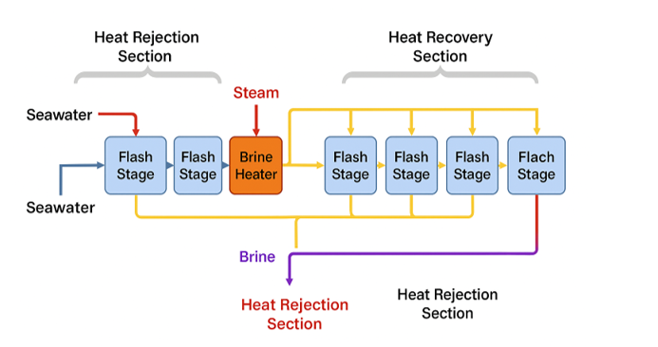
Fig 4: Schema of a Multi-Stage Flash Desalination unit.
4.3 Vapor Compression
Vapor Compression (VC) is a widely applied desalination method that relies on the liquid–vapor phase change of water (Prado et al., 2023). In this process, the latent heat from compressed vapor is reused to drive further evaporation, significantly improving energy efficiency (Prado et al., 2023). In the case of Mechanical Vapor Compression (MVC), illustrated in Figure 5, a mechanical compressor extracts the vapor generated inside the evaporation chamber. Compression increases the vapor’s pressure and temperature, allowing it to pass through a heat exchanger where it transfers thermal energy to incoming saline water (Shamet and Antar, 2023). This contact promotes further evaporation within the chamber. To reduce operational energy demands, MVC systems typically incorporate a heat recovery exchanger. This component recovers residual heat from the discharged brine and condensed distillate, using it to preheat the feedwater before it enters the main system (Al-Karaghouli and Kazmerski, 2013) . The preheated feedwater is then blended with a portion of recirculated brine and sprayed across the primary heat exchanger to enhance evaporation efficiency (Al-Karaghouli and Kazmerski, 2013).
Since MVC units are powered almost entirely by electricity, they are well suited for small-scale or stand-alone installations, with production capacities typically between 100 and 3,000 m³/day (Gohil et al., 2023). A similar concept is applied in Thermal Vapor Compression (TVC) systems, shown in Figure 6, where vapor is compressed using high-pressure steam rather than mechanical power (Curto et al., 2021).
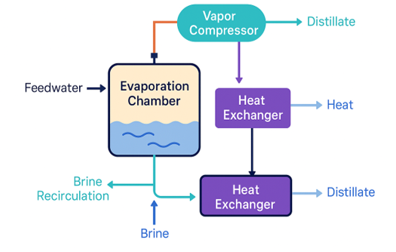
Fig 5: Schema of a Vapor Compression Desalination unit.

4.4 Thermal Vapor Compression (TVC)
Thermal Vapor Compression operates on the same general principle as Mechanical Vapor Compression, with one key distinction: the vapor is compressed using a steam ejector rather than a mechanical compressor (Klute et al., 2024). In this setup (Figure 6), high-pressure steam—often sourced from a nearby power plant—is used to entrain and compress the vapor produced in the evaporator (Klute et al., 2024).
The pressurized vapor is then routed through a heat exchanger, where it transfers thermal energy to the feedwater, initiating further evaporation. TVC systems require both thermal energy (to drive the steam ejector) and electrical energy (to operate circulation pumps). TVC technology is frequently paired with Multi-Effect Distillation units to create MED-TVC hybrid plants, combining the advantages of both systems (H.T. El-Dessouky et al., 2000). This configuration is widely adopted in large-scale desalination facilities to improve thermal efficiency and reduce operating costs. While MVC is typically chosen for small, standalone plants with production capacities of 100–3,000 m³/day (Gohil et al., 2023), TVC is more suited for larger installations where waste steam or low-cost thermal energy is readily available (Gohil et al., 2023).

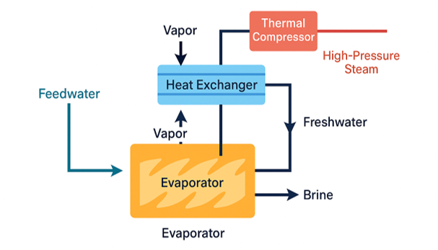
Fig 6: Schema of a Thermal Vapor Compression Desalination unit.

4.4 Reverse Osmosis (RO)
Reverse Osmosis is a pressure-driven separation process that uses specially engineered semipermeable membranes to remove salts and other dissolved substances from water (Gugliuzza and Basile, 2014). These membranes allow water molecules to pass while blocking most solutes. In a natural osmosis process, water moves from a dilute solution toward a more concentrated solution through the membrane, driven by the difference in chemical potential (Sadrzadeh and Mohammadi, 2020). This movement continues until the osmotic pressure is balanced. If external pressure greater than the osmotic pressure is applied to the concentrated side, the natural flow is reversed—forcing freshwater through the membrane and leaving salts behind (Sadrzadeh and Mohammadi, 2020).
For seawater at 25 °C, with salinity levels between 0.51 and 0.68 mol/L, the osmotic pressure is typically between 25 bar and 33 bar (Chang, 2016). Brackish water requires much lower pressures, while highly saline sources, such as the Dead Sea, can reach around 290 bar. In desalination practice, operating pressures usually range from 15–25 bar for brackish water and 54–80 bar for seawater (Chang, 2016).
4.4.1 Process Configuration
According to Tayeh (2024) standard RO desalination system includes:
- Pre-treatment: Removal of suspended solids and conditioning of feedwater to protect membranes.
- High-Pressure Pump (HPP): Increases feedwater pressure above the osmotic threshold.
- Membrane Modules: Perform the actual separation of water and salts.
- Post-treatment: Adjusts final water chemistry for distribution and use.
The performance of an RO plant is often expressed as the Recovery Ratio (RR) (Kucera, 2015) —the percentage of feedwater converted to freshwater. Typical RR values are between 35% and 50%, meaning the rest is discharged as brine (Kucera, 2015). This brine exits at nearly the same pressure as the feedwater, with only minor losses (around 2–3 bar), making it a valuable source of recoverable energy (Qasim et al., 2019).
4.4.2 Energy Recovery Solutions
Because pressurization is the most energy-intensive stage in RO, plants often incorporate Energy Recovery Devices (ERDs) Table 1 to transfer energy from the brine back into the feedwater stream (Das et al., 2024).
1. Centrifugal Energy Recovery Devices
- Pelton Turbines (introduced in the 1980s): Use the kinetic energy of brine to assist the HPP. While simple, efficiency is limited to about 70% due to multiple energy conversions. (Gude, 2011)
- Turbochargers: Combine a hydraulic turbine and pump in a single unit, directly boosting feedwater pressure with improved efficiency (Gude, 2011).
- Dual Turbine Systems: Integrate both turbochargers and Pelton turbines, reducing the electrical load on the main pump (Gude, 2011).
- HEMI Systems (Hydraulic Energy Management Integration): Include motorized control to fine-tune the final feedwater pressure for optimal operation (Gude, 2011).
2. Isobaric Energy Recovery Devices
These systems transfer pressure directly from the brine to the feedwater without converting it to another form of energy first, minimizing losses. The most widely used design is the Rotary Pressure Exchanger (RPX), which uses a rotating ceramic core to alternately connect high- and low-pressure streams. The rapid rotation and multiple internal channels allow nearly continuous pressure transfer with minimal drop. (Gude, 2011)
4.4.3 Operational Trends
Advances in membrane design, high-efficiency pumps, and energy recovery technology have significantly reduced the specific energy consumption of RO plants over the last few decades (Qasim et al., 2019). Modern large-scale facilities can supply municipal and industrial water demands while maintaining competitive operational costs and improved sustainability compared to earlier systems (Kyriakarakos et al., 2022).

Table 1. Summary of Energy Recovery Devices for RO Desalination
ERD Type | Working Principle | Main Components | Typical Efficiency | Advantages | Limitations | Common Applications | Ref
Pelton Turbine (Centrifugal) | Brine jet drives turbine wheel; mechanical energy assists HPP | Turbine runner, nozzle, coupling to pump/motor | ~70% | Simple, proven design; low maintenance | Double energy conversion reduces efficiency; best for high-head systems | Early RO plants, retrofits | Gude, 2011).
Turbocharger (Centrifugal) | Brine turbine directly powers a booster pump | Hydraulic turbine, pump, shaft coupling | 80–85% | Compact, direct energy transfer; low cost | Fixed ratio between turbine and pump speeds | Medium- to large-scale plants | Gude, 2011).
Dual Turbine System (Centrifugal) | Combines turbocharger with Pelton turbine for load sharing | Turbocharger, Pelton turbine, control valves | 80–85% | Flexible load management; improved part-load efficiency | More complex; higher capital cost | Large-scale plants with variable load | Gude, 2011).
HEMI System (Centrifugal) | Motorized turbocharger allows variable feedwater pressure | Turbocharger, electric motor, control system | 85–90% | Precise pressure control; adaptable to varying salinity | More moving parts; higher cost | Plants with seasonal or variable feedwater | Gude, 2011).
Pressure Exchanger (Isobaric) | Direct pressure transfer from brine to feedwater | Rotary ceramic core, high/low pressure ports | 95–98% | Very high efficiency; minimal pressure loss | Requires high water quality to prevent wear | Modern large-scale RO plants | Gude, 2011).
Rotary Pressure Exchanger (RPX) (Isobaric) | Rotating channels alternately connect high- and low-pressure. | Ceramic rotor, housing, seals | 95–98% | Continuous operation; low maintenance | Sensitive to solids and fouling | Widely used in new installations | Gude, 2011).

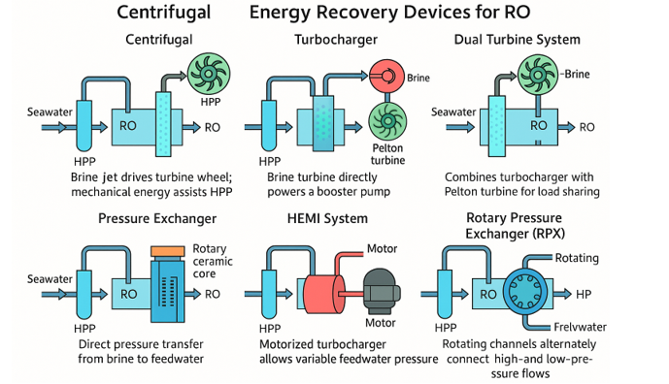
Fig 7. Working principles and Schema of a reverse osmosis unit

4.5 Forward Osmosis (FO)
Forward Osmosis (FO) is a membrane-based process where water naturally moves from a lower-salinity solution to a higher-salinity one, driven by the osmotic pressure difference across a semipermeable membrane (Akther et al., 2015). Unlike Reverse Osmosis, FO does not require the application of external pressure to initiate the flow (Palenzuela et al., 2021).
According to Praene et al. (2012) When two solutions have identical osmotic pressures—determined by their equivalent solute concentration and temperature, as described by the van’t Hoff equation—the net water transfer between them stops. In practical terms, this means that if a concentrated solution is placed on one side of a semipermeable membrane and a less concentrated solution on the other, water will migrate toward the concentrated side until equilibrium is reached. One example of FO in practice is the use of concentrated glucose solutions in hydration bags. These emergency devices contain sugar behind a semipermeable barrier. When placed in contact with available water sources—such as seawater, rivers, or ponds—freshwater diffuses into the bag while pathogens and contaminants are blocked. The resulting diluted glucose solution is safe for direct consumption in survival situations.
FO can also operate as part of a continuous desalination process. In 2005, researchers at Yale University demonstrated the use of ammonia–carbon dioxide as a thermolytic draw solution. In this system, FO extracts freshwater from seawater, which dilutes the ammonia–carbon dioxide mixture ((Curto et al., 2021). The diluted solution is then regenerated using low-temperature distillation, enabling the reuse of the draw solutes. The energy demand in this configuration is primarily thermal, making it compatible with renewable heat sources like solar or geothermal energy (Curto et al., 2021). However, this method is unsuitable for potable water production due to residual ammonia levels. The World Health Organization sets the maximum allowable ammonia concentration for drinking water at 1.5 mg/L, a target not achievable with this approach (World Health Organization, 2017).
According to Abounahia et al. (2023) research in FO desalination is focused on:
- Developing alternative draw solutions with safer chemical profiles.
- Designing higher-performance FO membranes.
- Minimizing the energy required for draw solution recovery using techniques such as temperature or pH shifts, electromagnetic fields, or light-driven separation.
One commercial concept under development is by Trevi Systems (Webley et al., 2024). In this design, pre-filtered seawater enters the FO unit, where it passes along one side of the membrane. A concentrated draw solution on the opposite side pulls freshwater across, becoming diluted in the process. This diluted solution is then heated to separate it into two streams: regenerated draw solution, which is recirculated to the FO unit, and a freshwater stream, which undergoes final filtration before storage (Webley et al., 2024). FO technology remains in the developmental stage for large-scale desalination, but it offers potential advantages in energy efficiency and integration with renewable heat sources.

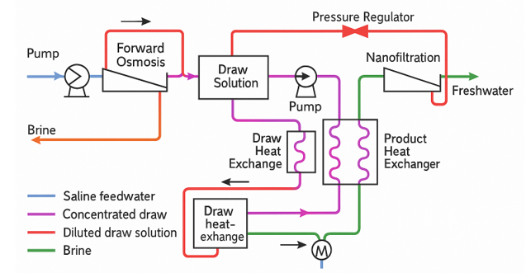
Fig 8. Working principles and Schema of a Forward Osmosis unit

4.6 Nanofiltration (NF)
Nanofiltration is a membrane-based filtration process primarily used to soften water by removing divalent ions such as calcium (Ca²⁺) and magnesium (Mg²⁺), which are responsible for scaling (Dupont.com, 2024). It operates in a similar way to reverse osmosis (RO), but with a key distinction — NF membranes are more porous, allowing certain dissolved solids to pass through (Dupont.com, 2024). These membranes typically have pore sizes between 1 and 10 nanometers, making them smaller than those used in microfiltration and ultrafiltration, but larger than in RO (Ajitha et al., 2021). This size range enables NF to achieve a removal efficiency of 90–98% for divalent ions, while monovalent ions (e.g., sodium) are removed at a lower efficiency of about 60–85% (Ajitha et al., 2021).
Because the treated water from NF retains more ions compared to RO, the process requires a lower operating pressure — generally between 34 and 48 bar. This lower pressure translates to reduced energy consumption, making NF a candidate for dual-stage seawater desalination systems currently under investigation (Ajitha et al., 2021). Beyond desalination, NF has applications in wastewater treatment, pharmaceuticals, and the food industry. However, its direct use for seawater desalination is limited due to partial salt passage through the membrane (Poirier et al., 2023).
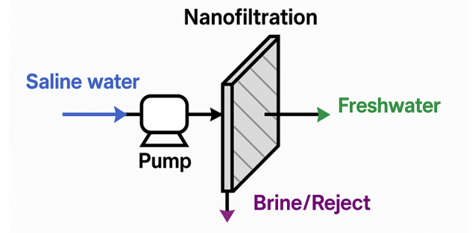
Fig 9. Working principles and Schema of a Nanofiltration unit
4.7 Electrodialysis (ED)
Electrodialysis is an electrochemical desalination method that removes dissolved ions using a combination of an electric field and ion-selective membranes (Yaghoubi et al., 2023) . The system consists of alternating cation-exchange membranes (allowing only positively charged ions to pass) and anion-exchange membranes (allowing only negatively charged ions to pass), positioned between two electrodes connected to a direct current source (Yaghoubi et al., 2023).
When voltage is applied:
- Positively charged ions (e.g., Na⁺, Ca²⁺) migrate toward the negatively charged cathode.
- Negatively charged ions (e.g., Cl⁻, HCO₃⁻, CO₃²⁻) migrate toward the positively charged anode.
Because each membrane type blocks the opposite ion charge, ions become concentrated in specific channels (brine streams), while other channels become progressively deionized (freshwater streams) (Strathmann, 2004). To prevent scale buildup on membranes, ED systems periodically reverse electrode polarity, temporarily switching freshwater and brine channels. This technology is widely used for brackish water desalination with salinity levels up to about 2000 ppm, and commercial units have been in operation since the early 1970s (Strathmann, 2004).
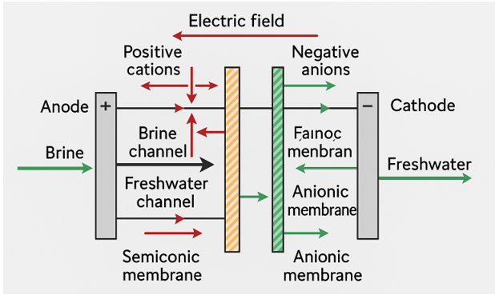
Fig 10. Working principles and Schema of a Electrodialysis Desalination unit

4.8 Capacitive Deionization (CDI)
Capacitive Deionization (CDI) is a desalination method that removes dissolved salts from water using electrostatic forces (Porada et al., 2012). Two porous carbon electrodes are connected to a direct current power supply, creating an electric field between them. When saline water passes through the cell, positively charged ions (cations) migrate toward the negatively charged electrode, while negatively charged ions (anions) move toward the positively charged electrode (Porada et al., 2012). These ions are trapped in the micropores of the carbon material, resulting in deionized water flowing out. Once the electrodes reach their storage capacity, they must be regenerated. This is done by reversing or short-circuiting the voltage, which releases the stored ions back into a concentrated brine stream (Porada et al., 2012).
A key limitation of CDI is the co-ion effect, where ions with the same charge as the electrode surface are also attracted and occupy space, reducing efficiency (McNair et al., 2020). To address this, an advanced configuration called Membrane Capacitive Deionization (MCDI) incorporates a cation-exchange membrane in front of the cathode and an anion-exchange membrane in front of the anode (McNair et al., 2020). These membranes selectively allow only the opposite-charged ions to pass, preventing co-ion adsorption and improving salt removal performance.

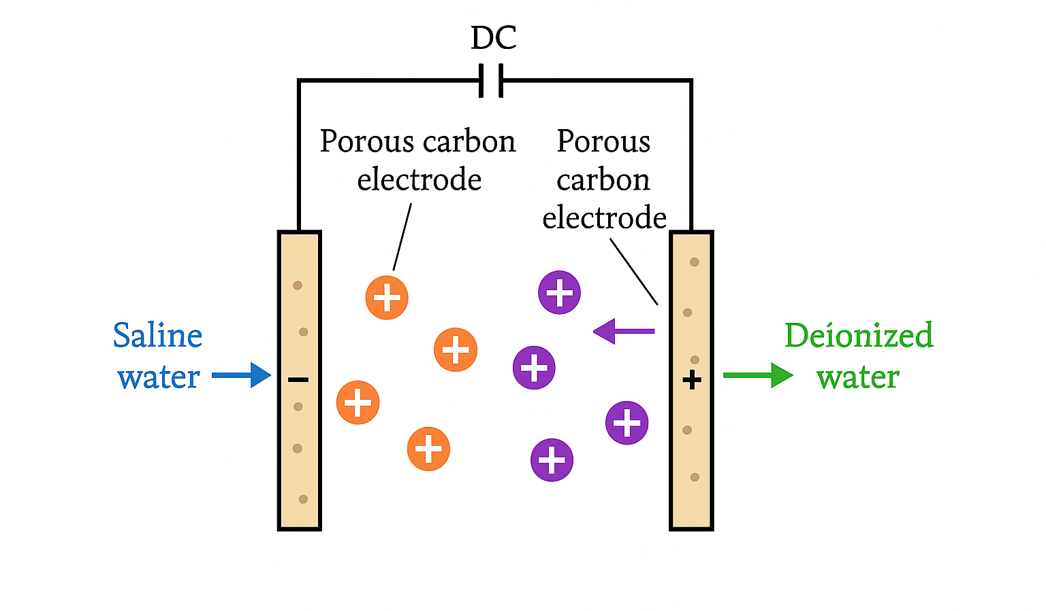
Fig 11. Working principles and Schema of a Capacitive Deionization Desalination unit

4.9 Hydration (HY)
Hydration-based desalination relies on the formation of gas hydrates—crystalline compounds where water molecules act as the host lattice, enclosing guest gas molecules such as nitrogen, carbon dioxide, or methane (Nallakukkala et al., 2022). Under standard conditions, the breakdown of 1 m³ of hydrates can yield approximately 0.8 m³ of water and 164 m³ of gas (Nallakukkala et al., 2022). Compared to other phase-change desalination methods, hydrate formation occurs under milder thermodynamic requirements, typically at temperatures below 20 °C and pressures above 30 bar (Nallakukkala et al., 2022). The process involves generating hydrates from seawater and later separating them into their constituent gas and water.
In a typical HY system, seawater undergoes initial cooling before being combined in a reactor with a gas mixture, often propane and carbon dioxide (Subramani and Jacangelo, 2015). This mixture then enters a crystallizer, where the low temperature and high pressure promote hydrate formation. The resulting hydrate slurry is separated from the brine and transferred to a decomposer. There, heat is applied to release fresh water and recover the gas, which is recycled back into the hydrate production cycle. While HY desalination has the potential for lower energy consumption compared to technologies such as Multi-Stage Flash (MSF) and Reverse Osmosis (RO), it remains at the experimental and pilot stage (Subramani and Jacangelo, 2015). The absence of large-scale commercial plants is primarily due to high capital investment requirements.
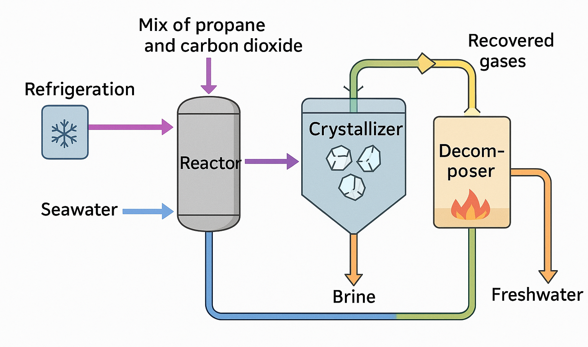
Fig 12. Working principles and Schema of a Hydration Desalination unit

4.10 Secondary Refrigerant Freezing (SRF)
Secondary Refrigerant Freezing is a desalination method that relies on the phase change from liquid to solid (Kujawa et al., 2017). Since ice crystals exclude most dissolved salts during formation, the process can be used to obtain freshwater from seawater. In this method, a refrigerant is employed to freeze the saline water (Kujawa et al., 2017). The main operational challenge lies in efficiently separating the ice from the brine.
One approach, proposed by Lin et al. (2017)., suggests harnessing the low temperatures generated during the regasification of Liquefied Natural Gas (LNG) to freeze seawater and form ice. Another configuration, illustrated in Figure 13, involves two tanks connected to a reversing heat pump and a set of solenoid valves (Sharon & Reddy, 2015).
In this setup, the system alternates between producing ice and melting ice to yield freshwater. For example, when tank L is in freezing mode, seawater is introduced into it, and the heat pump transfers heat from tank A to tank B. This causes the seawater in tank A to freeze into an ice–brine slurry, while the ice stored in tank B from the previous cycle melts to produce freshwater (Sharon & Reddy, 2015). At the end of the cycle, the brine in tank A is drained via a bottom valve, and tank B is refilled with fresh seawater. The heat pump’s operation is then reversed: tank A receives heat to melt the ice into freshwater, while tank B begins freezing seawater to form ice. This cycle repeats continuously. While SRF shows promise for energy-efficient desalination, especially when integrated with LNG regasification or other low-temperature sources, it remains in the developmental stage due to engineering and economic challenges.
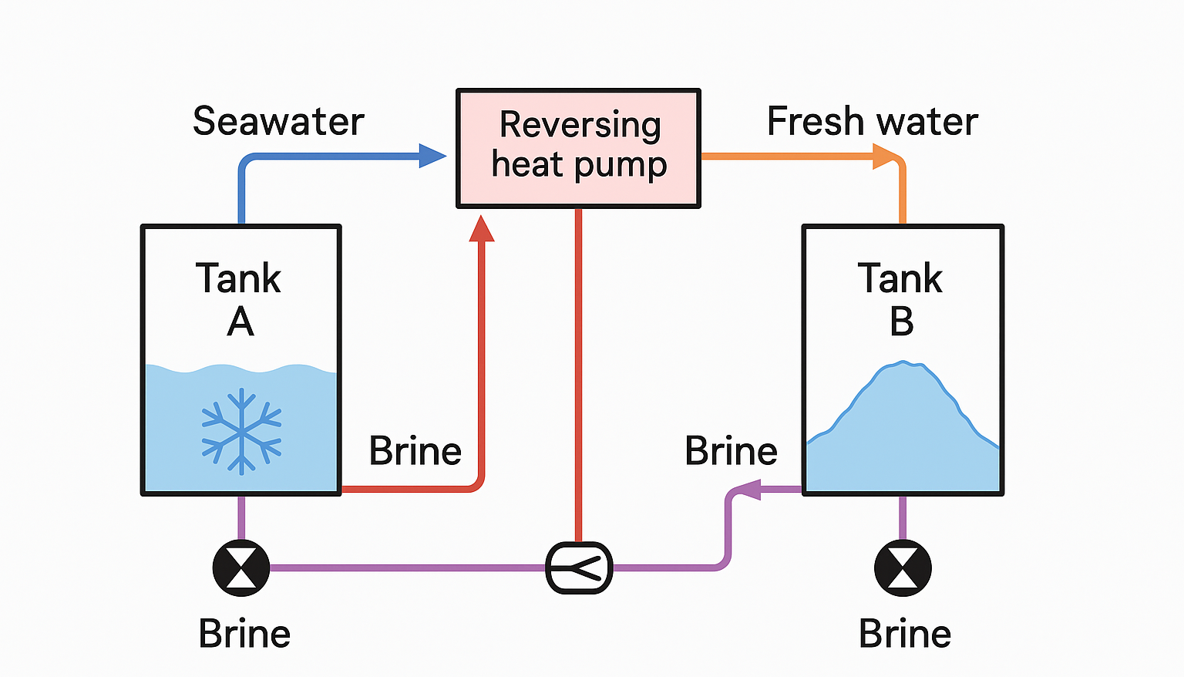
Fig 13. Schema of a Secondary Refrigerant Freezing Desalination unit

11. CONCLUSION
This review examined the principles, operational characteristics, and development status of major desalination technologies (Table 2), including thermal processes (MED, MSF, TVC, MVC, HY, SRF), membrane-based processes (RO, NF, FO, ED, CDI), and hybrid systems. Each method presents unique advantages and limitations depending on feedwater salinity, energy availability, and intended application. Thermal processes remain important in regions with abundant low-cost thermal energy, while Reverse Osmosis (RO) continues to dominate global capacity due to lower energy consumption and modular design. Emerging technologies such as Forward Osmosis, Capacitive Deionization, and Hydrate-based methods show potential in reducing energy use and environmental impacts but remain at the pilot stage.
Looking ahead, desalination must be evaluated not only for technical performance but also for its contribution to sustainable development. The sector directly supports SDG 6 (Clean Water and Sanitation) by providing reliable freshwater supplies, and SDG 7 (Affordable and Clean Energy) through the integration of renewable energy-powered systems. Effective brine management and energy recovery further align with SDG 12 (Responsible Consumption and Production) by promoting resource efficiency and reducing waste. Embedding desalination within circular economy frameworks offers new opportunities, including the recovery of valuable salts and minerals from brine, the use of renewable or waste heat sources, and the coupling of desalination with wastewater reuse and energy generation systems. Such approaches can reduce environmental footprints while enhancing economic viability. Future advancements should prioritize:
- Improving energy efficiency through advanced membranes and energy recovery devices.
- Integrating renewable energy sources at both pilot and large scales.
- Developing circular brine management strategies.
- Scaling up promising emerging technologies to commercial readiness.
By combining mature large-scale solutions with innovative methods, desalination can evolve into a cornerstone of sustainable water supply while contributing to global goals for climate resilience, environmental stewardship, and equitable resource distribution.

Table 2. Advantages, limitation and status of the main desalination technologies

Technology | Principle | Energy Source | Typical Capacity Range | Advantages | Limitations | Commercial Status | Estimated Cost (USD/m³) | Ref
Reverse Osmosis (RO) | Pressure-driven membrane filtration separating water from salts | Electrical (high-pressure pumps) | 500–600,000 m³/day | High salt rejection (>99%), widely available, modular design | High energy use for seawater, membrane fouling, pretreatment required | Fully commercial | 0.5 – 1.5 | (Buros, 2000), (Helfer et al., 2014)
Multi-Stage Flash (MSF) | Sequential flashing of heated seawater in stages of decreasing pressure | Thermal + electrical (pumps) | 4,000–57,000 m³/day | Long lifespan, robust, tolerant to feedwater quality | High thermal energy demand, scaling | Fully commercial | 1.0 – 1.75 | (Cipollina et al., 2005), (El-Ghonemy, 2018), (Jones et al., 2019)
Multi-Effect Distillation (MED) | Multiple evaporator stages reusing latent heat | Thermal + electrical (pumps) | 600–30,000 m³/day | Lower thermal energy than MSF, good for waste-heat use | Sensitive to scaling, higher capital cost than RO | Fully commercial | 0.8 – 1.5 | (Cipollina et al., 2005), (Al-Shammiri & Safar, 1999), (Karagiannis & Soldatos, 2008)
Vapor Compression (MVC/TVC) | Vapor recompression to heat incoming feedwater | Electrical (MVC) / Thermal + electrical (TVC) | 100–3,000 m³/day (MVC) | Compact, suitable for small units | Limited capacity, higher cost per m³ | Commercial for niche use | 0.8 – 2.0 | (Al-Karaghouli & Kazmerski, 2013)
Forward Osmosis (FO) | Osmotic gradient across semipermeable membrane draws water | Electrical (pumps) + possible thermal for draw recovery | Pilot to small scale | Low fouling potential, can use low-grade energy | Draw solution regeneration required, limited commercial scale | Pilot / early commercial | ~1.5–2.5 (projected, not standardized) | (Sharon & Reddy, 2015), (Kessler & Moody, 1976)
Nanofiltration (NF) | Membrane filtration removing divalent ions | Electrical (pumps) | Varies | Produces soft water, lower energy than RO | Does not fully desalinate seawater | Commercial (non-seawater focus) | 0.5–1.0 | (Wetterau, 2011), (Buros, 2000), (Fritzmann et al., 2007)
Electrodialysis (ED) | Ion migration under electric field via ion-exchange membranes | Electrical (DC supply) | 1,000–20,000 m³/day | Efficient for brackish water | Not efficient for seawater | Commercial (brackish water) | 0.6 -1.2 | (Shatat & Riffat, 2012), (Buros, 2000).
Capacitive Deionization (CDI) | Ion adsorption on charged electrodes | Electrical (DC supply) | Small-scale | Low energy for low-salinity water | Limited for seawater | Emerging technology | 0.3–0.8 (projected) | (Hassanvand et al., 2017), (Porada et al., 2013).
Hydration (HY) | Gas hydrate formation and decomposition | Thermal + pressurization | Pilot scale | Low thermal demand | High capital cost, no large-scale plants | Research stage | Not available (experimental) | (Lv et al., 2019), (Park et al., 2011)
Secondary Refrigerant Freezing (SRF) | Ice formation to separate salts | Thermal (refrigeration) | Pilot scale | Can integrate with LNG regasification | Ice separation challenge, high cost | Research stage | Not available (experimental) | (Sharon & Reddy, 2015), (Kujawa et al., 2017)

Competing interests

Authors have declared that no competing interests exist.

COMPETING INTERESTS DISCLAIMER:
Authors have declared that they have no known competing financial interests OR non-financial interests OR personal relationships that could have appeared to influence the work reported in this paper.

Disclaimer (Artificial intelligence)
Author(s) hereby declare that NO generative AI technologies such as Large Language Models (ChatGPT, COPILOT, etc.) and text-to-image generators have been used during the writing or editing of this manuscript.

References

Abounahia, N., Ibrar Ibrar, Tayma Kazwini, Altaee, A., Samal, A. K., Syed Javaid Zaidi, & Hawari, A. H. (2023). Desalination by the forward osmosis: Advancement and challenges. 886, 163901–163901. https://doi.org/10.1016/j.scitotenv.2023.163901
Ajitha, V., Park, J. C., Lee, J.-S., & Puthumana, J. (2021). Current physicochemical treatment technologies available for remediation of different types of heavy metals from wastewater. Elsevier EBooks, 301–322. https://doi.org/10.1016/b978-0-12-822965-1.00012-x
Akther, N., Sodiq, A., Giwa, A., Daer, S., Arafat, H. A., & Hasan, S. W. (2015). Recent advancements in forward osmosis desalination: A review. Chemical Engineering Journal, 281, 502–522. https://doi.org/10.1016/j.cej.2015.05.080
Al-Addous, M., Bdour, M., Rabaiah, S., Boubakri, A., Schweimanns, N., Barbana, N., & Wellmann, J. (2024). Innovations in Solar-Powered Desalination: A Comprehensive Review of Sustainable Solutions for Water Scarcity in the Middle East and North Africa (MENA) Region. Water, 16(13), 1877–1877. https://doi.org/10.3390/w16131877
Al-Karaghouli, A., & Kazmerski, L. L. (2013). Energy consumption and water production cost of conventional and renewable-energy-powered desalination processes. Renewable and Sustainable Energy Reviews, 24(2), 343–356. https://doi.org/10.1016/j.rser.2012.12.064
Al-Mutaz, I. S. (2020). MSF challenges and survivals. DESALINATION and WATER TREATMENT, 177, 14–22. https://doi.org/10.5004/dwt.2020.24908
Al-Othman, A., Darwish, N. N., Qasim, M., Tawalbeh, M., Darwish, N. A., & Hilal, N. (2019). Nuclear desalination: A state-of-the-art review. Desalination, 457, 39–61. https://doi.org/10.1016/j.desal.2019.01.002
Al-Shammiri, M., & Safar, M. (1999). Multi-effect distillation plants: state of the art. Desalination, 126(1-3), 45–59. https://doi.org/10.1016/s0011-9164(99)00154-x
Alnajdi, O., Wu, Y., & Kaiser Calautit, J. (2020). Toward a Sustainable Decentralized Water Supply: Review of Adsorption Desorption Desalination (ADD) and Current Technologies: Saudi Arabia (SA) as a Case Study. Water, 12(4), 1111. https://doi.org/10.3390/w12041111
Amy, G., Ghaffour, N., Li, Z., Francis, L., Linares, R. V., Missimer, T., & Lattemann, S. (2017). Membrane-based seawater desalination: Present and future prospects. Desalination, 401, 16–21. https://doi.org/10.1016/j.desal.2016.10.002
Bundschuh, J., Kaczmarczyk, M., Ghaffour, N., & Tomaszewska, B. (2021). State-of-the-art of renewable energy sources used in water desalination: Present and future prospects. Desalination, 508, 115035. https://doi.org/10.1016/j.desal.2021.115035
Buros, O. K. (2000). The ABCs of Desalting: International Desalination Association: Topsfield, MA, USA.
Chang, Q. (2016). Colloid and interface chemistry for water quality control. Elsevier Academic Press.
Chorak, A., Palenzuela, P., Palenzuela, P., & Abdellatif Ben Abdellah. (2017). Experimental characterization of a multi-effect distillation system coupled to a flat plate solar collector field: Empirical correlations. Applied Thermal Engineering, 120, 298–313. https://doi.org/10.1016/j.applthermaleng.2017.03.115
Cipollina, A., Micale, G., & Rizzuti, L. (2005). A critical assessment of desalination operations in Sicily. Desalination, 182(1-3), 1–12. https://doi.org/10.1016/j.desal.2005.03.004
Curto, D., Franzitta, V., & Guercio, A. (2021). A Review of the Water Desalination Technologies. Applied Sciences, 11(2), 670. https://doi.org/10.3390/app11020670
Das, T. K., Frost, C., Folley, M., & Brewster, P. (2024). Application of an energy recovery device with RO membrane for wave powered desalination. Desalination, 592, 118064. https://doi.org/10.1016/j.desal.2024.118064
Desai, R. (2024). Desalination. Drrajivdesaimd.com. https://drrajivdesaimd.com/2024/05/07/desalination/
El-Ghonemy, A. M. K. (2018). Performance test of a sea water multi-stage flash distillation plant: Case study. Alexandria Engineering Journal, 57(4), 2401–2413. https://doi.org/10.1016/j.aej.2017.08.019
El-Sayed, M., El-sayed, H. S., El-kholy, E. E., Amer, M., Mahmoud Elsisi, Sajjad, U., Hamid, K., & Awad, H. E. (2024). Developments in solar-driven desalination: Technologies, photovoltaic integration, and processes. Energy Conversion and Management X, 100861–100861. https://doi.org/10.1016/j.ecmx.2024.100861
Elsaid, K., Kamil, M., Sayed, E. T., Abdelkareem, M. A., Tabbi Wilberforce, & A. Olabi. (2020). Environmental impact of desalination technologies: A review. The Science of the Total Environment, 748, 141528–141528. https://doi.org/10.1016/j.scitotenv.2020.141528
Fritzmann, C., Löwenberg, J., Wintgens, T., & Melin, T. (2007). State-of-the-art of reverse osmosis desalination. Desalination, 216(1-3), 1–76. https://doi.org/10.1016/j.desal.2006.12.009
Gohil, P. P., Desai, H., Kumar, A., & Kumar, R. (2023). Current Status and Advancement in Thermal and Membrane-Based Hybrid Seawater Desalination Technologies. Water, 15(12), 2274–2274. https://doi.org/10.3390/w15122274
Gude, V. G. (2011). Energy consumption and recovery in reverse osmosis. Desalination and Water Treatment, 36(1-3), 239–260. https://doi.org/10.5004/dwt.2011.2534
Gugliuzza, A., & Basile, A. (2014). Membranes for Clean and Renewable Power Applications. Woodhead Publishing.
H.T. El-Dessouky, H.M. Ettouney, & F. Al-Juwayhel. (2000). Multiple Effect Evaporation—Vapour Compression Desalination Processes. Process Safety and Environmental Protection, 78(4), 662–676. https://doi.org/10.1205/026387600527626
Hassanvand, A., Wei, K., Talebi, S., Chen, G., & Kentish, S. (2017). The Role of Ion Exchange Membranes in Membrane Capacitive Deionisation. Membranes, 7(3), 54. https://doi.org/10.3390/membranes7030054
Helfer, F., Lemckert, C., & Anissimov, Y. G. (2014). Osmotic power with Pressure Retarded Osmosis: Theory, performance and trends – A review. Journal of Membrane Science, 453, 337–358. https://doi.org/10.1016/j.memsci.2013.10.053
Honarparvar, S., Zhang, X., Chen, T., Alborzi, A., Afroz, K., & Reible, D. (2021). Frontiers of Membrane Desalination Processes for Brackish Water Treatment: A Review. Membranes, 11(4), 246. https://doi.org/10.3390/membranes11040246
Jones, E., Qadir, M., van Vliet, M. T. H., Smakhtin, V., & Kang, S. (2019). The state of desalination and brine production: A global outlook. Science of the Total Environment, 657, 1343–1356. https://doi.org/10.1016/j.scitotenv.2018.12.076
Karagiannis, I. C., & Soldatos, P. G. (2008). Water desalination cost literature: review and assessment. Desalination, 223(1-3), 448–456. https://doi.org/10.1016/j.desal.2007.02.071
Kessler, J. O., & Moody, C. D. (1976). Drinking water from sea water by forward osmosis. Desalination, 18(3), 297–306. https://doi.org/10.1016/s0011-9164(00)84119-3
Klute, S., Budt, M., Mathias van Beek, & Doetsch, C. (2024). Steam generating heat pumps – Overview, classification, economics, and basic modeling principles. Energy Conversion and Management, 299, 117882–117882. https://doi.org/10.1016/j.enconman.2023.117882
Kucera, J. (2015). Reverse Osmosis (3rd ed.). John Wiley & Sons.
Kujawa, J., Cerneaux, S., Kujawski, W., & Knozowska, K. (2017). Hydrophobic Ceramic Membranes for Water Desalination. Applied Sciences, 7(4), 402. https://doi.org/10.3390/app7040402
Kyriakarakos, G., Papadakis, G., & Karavitis, C. A. (2022). Renewable Energy Desalination for Island Communities: Status and Future Prospects in Greece. Sustainability, 14(13), 8176. https://doi.org/10.3390/su14138176
Le Quesne, W. J. F., Fernand, L., Ali, T. S., Andres, O., Antonpoulou, M., Burt, J. A., Dougherty, W. W., Edson, P. J., El Kharraz, J., Glavan, J., Mamiit, R. J., Reid, K. D., Sajwani, A., & Sheahan, D. (2021). Is the development of desalination compatible with sustainable development of the Arabian Gulf? Marine Pollution Bulletin, 173, 112940. https://doi.org/10.1016/j.marpolbul.2021.112940
Lee, K. P., Arnot, T. C., & Mattia, D. (2010). A review of reverse osmosis membrane materials for desalination—Development to date and future potential. Journal of Membrane Science, 370(1-2), 1–22. https://doi.org/10.1016/j.memsci.2010.12.036
Lejarazu-Larrañaga, A., Ortiz, J. M., Molina, S., Zhao, Y., & García-Calvo, E. (2020). Nitrate-Selective Anion Exchange Membranes Prepared using Discarded Reverse Osmosis Membranes as Support. Membranes, 10(12), 377. https://doi.org/10.3390/membranes10120377
Lin, W., Huang, M., & Gu, A. (2017). A seawater freeze desalination prototype system utilizing LNG cold energy. International Journal of Hydrogen Energy, 42(29), 18691–18698. https://doi.org/10.1016/j.ijhydene.2017.04.176
Lior, N. (2012). Advances in Water Desalination. John Wiley & Sons, Inc.: Hoboken, NJ, USA.
Lv, Q., Li, X., & Li, G. (2019). Seawater Desalination by Hydrate Formation and Pellet Production Process. Energy Procedia, 158, 5144–5148. https://doi.org/10.1016/j.egypro.2019.01.684
Madhuri, R. V. S., Said, Z., Ihsanullah, I., & Sathyamurthy, R. (2025). Solar energy-driven desalination: A renewable solution for climate change mitigation and advancing sustainable development goals. Desalination, 118575. https://doi.org/10.1016/j.desal.2025.118575
Maletskyi, Z. (2020). Advances in Membrane Materials and Processes for Water and Wastewater Treatment. ACS Symposium Series, 3–35. https://doi.org/10.1021/bk-2020-1348.ch001
McNair, R., Szekely, G., & Dryfe, R. A. W. (2020). Ion-Exchange Materials for Membrane Capacitive Deionization. ACS ES&T Water, 1(2), 217–239. https://doi.org/10.1021/acsestwater.0c00123
Moossa, B., Trivedi, P., Saleem, H., & Zaidi, S. J. (2022). Desalination in the GCC countries- a review. Journal of Cleaner Production, 357, 131717. https://doi.org/10.1016/j.jclepro.2022.131717
Mudhar Al-Obaidi, Alsarayreh, A. A., Rashid, F. L., Md Tanvir Sowgath, Salih Alsadaie, Ruiz-García, A., Khayet, M., Noreddine Ghaffour, & Mujtaba, I. M. (2024). Hybrid membrane and thermal seawater desalination processes powered by fossil fuels: A comprehensive review, future challenges and prospects. Desalination, 583, 117694–117694. https://doi.org/10.1016/j.desal.2024.117694
Nallakukkala, S., Rehman, A. ur, Zaini, D. B., & Lal, B. (2022). Gas Hydrate-Based Heavy Metal Ion Removal from Industrial Wastewater: A Review. Water, 14(7), 1171. https://doi.org/10.3390/w14071171
Nanofiltration. (2024). Dupont.com. https://www.dupont.com/water/technologies/nanofiltration-nf.html#:~:text=Nanofiltration%20(NF)%20is%20a%20membrane,monovalent%20ions%2C%20such%20as%20chloride.
Palenzuela, P., Andrés-Mañas, J. A., Bartolomé Ortega-Delgado, & Zaragoza, G. (2021). Solvent extraction regeneration technologies. Elsevier EBooks, 163–196. https://doi.org/10.1016/b978-0-08-102847-6.00008-5
Park, K., Hong, S. Y., Lee, J. W., Kang, K. C., Lee, Y. C., Ha, M.-G., & Lee, J. D. (2011). A new apparatus for seawater desalination by gas hydrate process and removal characteristics of dissolved minerals (Na+, Mg2+, Ca2+, K+, B3+). Desalination, 274(1-3), 91–96. https://doi.org/10.1016/j.desal.2011.01.084
Poirier, K., Lotfi, M., Garg, K., Kumar Patchigolla, Anthony, E. J., Nadimul Haque Faisal, Vinay Mulgundmath, Sahith, K., Prashant Jadhawar, Ling, L., Morosuk, T., & Al-Mhanna, N. M. (2023). A comprehensive review of pre- and post-treatment approaches to achieve sustainable desalination for different water streams. Desalination, 566, 116944–116944. https://doi.org/10.1016/j.desal.2023.116944
Porada, S., Weinstein, L., Dash, R., van der Wal, A., Bryjak, M., Gogotsi, Y., & Biesheuvel, P. M. (2012). Water Desalination Using Capacitive Deionization with Microporous Carbon Electrodes. ACS Applied Materials & Interfaces, 4(3), 1194–1199. https://doi.org/10.1021/am201683j
Porada, S., Zhao, R., van der Wal, A., Presser, V., & Biesheuvel, P. M. (2013). Review on the science and technology of water desalination by capacitive deionization. Progress in Materials Science, 58(8), 1388–1442. https://doi.org/10.1016/j.pmatsci.2013.03.005
Prado, A., Ángel Molina‐García, Juan Pascual García, & F. Vera-García. (2023). Desalination, minimal and zero liquid discharge powered by renewable energy sources: Current status and future perspectives. Renewable & Sustainable Energy Reviews, 187, 113733–113733. https://doi.org/10.1016/j.rser.2023.113733
Praene, J. P., David, M., Sinama, F., Morau, D., & Marc, O. (2012). Renewable energy: Progressing towards a net zero energy island, the case of Reunion Island. Renewable and Sustainable Energy Reviews, 16(1), 426–442. https://doi.org/10.1016/j.rser.2011.08.007
Qasim, M., Badrelzaman, M., Darwish, N. N., Darwish, N. A., & Hilal, N. (2019). Reverse osmosis desalination: A state-of-the-art review. Desalination, 459, 59-104.
Rognoni, M. (2010). La dissalazione dell’acqua di mare. Descrizione, analisi e valutazione delle principali tecnologie. Flaccovio Editore s.r.l.: Palermo, Italy.
Rostamzadeh, H., Ghiasirad, H., Amidpour, M., & Amidpour, Y. (2020). Performance enhancement of a conventional multi-effect desalination (MED) system by heat pump cycles. Desalination, 477, 114261. https://doi.org/10.1016/j.desal.2019.114261
Sadrzadeh, M., & Mohammadi, T. (2020). Nanocomposite membranes for water and gas separation. Amsterdam, Netherlands Elsevier.
Shabib, A., Tatan, B., Elbaz, Y., Aly Hassan, A., Hamouda, M. A., & Maraqa, M. A. (2025). Advancements in reverse osmosis desalination: Technology, environment, economy, and bibliometric insights. Desalination, 598, 118413. https://doi.org/10.1016/j.desal.2024.118413
Shamet, O., & Antar, M. (2023). Mechanical vapor compression desalination technology – A review. Renewable and Sustainable Energy Reviews, 187, 113757. https://doi.org/10.1016/j.rser.2023.113757
Sharon, H., & Reddy, K. S. (2015). A review of solar energy driven desalination technologies. Renewable and Sustainable Energy Reviews, 41, 1080–1118. https://doi.org/10.1016/j.rser.2014.09.002
Shatat, M., & Riffat, S. B. (2012). Water desalination technologies utilizing conventional and renewable energy sources. International Journal of Low-Carbon Technologies, 9(1), 1–19. https://doi.org/10.1093/ijlct/cts025
Strathmann, H. (Ed.). (2004). Overview of Ion-Exchange Membrane Processes. Membrane Science and Technology, 1–22. https://doi.org/10.1016/s0927-5193(04)80032-9
Subramani, A., & Jacangelo, J. G. (2015). Emerging desalination technologies for water treatment: A critical review. Water Research, 75, 164–187. https://doi.org/10.1016/j.watres.2015.02.032
Taha Sayed, E., Olabi, A. G., Elsaid, K., Al Radi, M., Alqadi, R., & Ali Abdelkareem, M. (2022). Recent Progress in Renewable Energy Based-Desalination in the Middle East and North Africa MENA Region. Journal of Advanced Research, 48. https://doi.org/10.1016/j.jare.2022.08.016
Tayeh, Y. A. (2024). A Comprehensive Review of Reverse Osmosis Desalination: Technology, Water Sources, Membrane Processes, Fouling, and Cleaning. Desalination and Water Treatment, 320, 100882–100882. https://doi.org/10.1016/j.dwt.2024.100882
Thiel, G. P., & Stark, A. K. (2021). To decarbonize industry, we must decarbonize heat. Joule. https://doi.org/10.1016/j.joule.2020.12.007
Webley, J., Greene, M., & Yong, J. S. (2024). Delivery of a Solar-Powered Forward Osmosis Seawater Desalination Plant: Trevi’s 500 m3/day Zero-Carbon FO Seawater Desalination Plant at NELHA. Academic Journal of Research and Scientific Publishing, 05(58), 35–60. https://doi.org/10.52132/ajrsp.e.2024.58.2
Weir, W. (2008). The Weir Group: The History of a Scottish Engineering Legend. Profile Books Limited.
Wetterau, G. (2011). Desalination of seawater. American Water Works Association.
World Health Organization. (2017). Guidelines for drinking-water quality : fourth edition incorporating the first addendum. (4th ed.). Geneva: World Health Organization. https://iris.who.int/bitstream/handle/10665/254637/9789241549950-eng.pdf
Yaghoubi, S., Babapoor, A., & Seyfaee, A. (2023). Thermal energy optimization using salt-based phase change materials obtained from the desalination of saline water. Renewable & Sustainable Energy Reviews, 183, 113463–113463. https://doi.org/10.1016/j.rser.2023.113463
Zhao, S., Zhu, R., Song, J., & Yuan, H. (2024). An Overview of Sustainable Desalination with Freezing Crystallization: Current Development, Future Challenges, and Prospects. Sustainability, 16(22), 10138–10138. https://doi.org/10.3390/su162210138
Zhao, Z., & Wang, X. (2021). Application of AnMBR Ion Exchange Technology in Water Treatment. IOP Conference Series Earth and Environmental Science, 791(1), 012180–012180. https://doi.org/10.1088/1755-1315/791/1/012180

