AI-Based Tolerance Optimization
for Cost Reduction

ABSTRACT
Manufacturing industries are under constant pressure to deliver high-quality products while minimizing production costs. Among the many influencing factors, the selection of dimensional tolerances plays a crucial yet often underestimated role. Tolerances define allowable variations in part geometry and directly impact functionality, assembly fit, and manufacturability. While tighter tolerances may improve precision and performance, they typically require advanced machining, rigorous quality control, and higher manufacturing costs.
The optimization challenge lies in selecting tolerances that are tight enough to ensure assembly performance but not overly restrictive to cause unnecessary cost inflation. This is especially relevant in components like shafts and hubs that demand precise clearance or interference fits based on their functional requirements.
To address this, the present study explores the use of Artificial Intelligence (AI), particularly Genetic Algorithms (GAs), as a decision-support tool for optimal tolerance selection. GAs are evolutionary algorithms inspired by natural selection and are effective in solving complex, multi-objective optimization problems. Here, the GA evaluates various combinations of International Tolerance (IT) grades for shaft and hub components, considering both cost and functional fit constraints.
The methodology follows ISO 286 standards for tolerance grades and fit classifications. A Python-based simulation environment was developed to implement the GA, enabling automated generation of cost-efficient tolerance combinations that satisfy minimum clearance or interference requirements.
This AI-driven approach marks a shift from experience-based to data-driven tolerance design. It provides a scalable framework that supports engineers in achieving cost-effective, functionally robust designs, ultimately enhancing manufacturing efficiency and competitiveness.
Keywords: Tolerance optimization, Genetic algorithm, Manufacturing cost reduction, ISO 286, Artificial Intelligence, Shaft-hub fit, Dimensional tolerancing, Clearance and interference fit

1. INTRODUCTION
Achieving a balance between production costs and product quality is a major problem for today's industrial systems. One of the primary factors influencing this balance in product design is the assignment of dimensions and geometric tolerances. Tolerances influence manufacturing complexity and cost in addition to the functioning and dependability of mechanical assembly [1].
The systematic process of selecting tolerance values that lower manufacturing costs without sacrificing functional and quality requirements is known as tolerance optimization. The balance between tighter tolerances, which improve fit and performance but are costly, and looser tolerances, which are less expensive but may impair functionality, must be defined mathematically.
The quantitative impact on cost was usually disregarded in the past since tolerance allocation was mostly based on experience, trial-and-error cycles, or rule-of-thumb methods [1]. As a result, production costs increased and overly cautious designs with needlessly tiny tolerances were created. In order to address this inefficiency, academics are increasingly turning to tolerance-cost optimization, which uses mathematical optimization models to systematically distribute tolerances in order to minimize costs and satisfy product quality standards.
In particular, this field has made substantial use of evolutionary algorithms such as Genetic Algorithms (GAs). In order to achieve considerable cost reductions while maintaining high performance levels, evolutionary approaches have been used to increase tolerance within multi-component gear assemblies [2]. In order to reduce computing costs, these approaches frequently use surrogate model techniques, which take the place of costly studies.
Other research has suggested tolerance optimization strategies tailored to remanufacturing systems that are based on cost, quality, and sensitivity. These models are suitable to real-world production systems where parts aren't always brand-new since they take into account the unpredictability of used parts and enable adaptive component tolerance allocation based on component condition [3].
There are other closed-form least-cost optimization methods that use analytical functions to characterize costs in terms of tolerance width in order to determine economic savings. By calculating the benefit of optimized tolerance distribution over conventional uniform or proportional techniques, these models can serve as helpful benchmarks to compare against heuristic or AI approaches [4].
The field has recently advanced from the traditional 1D dimension chains to 3D tolerance models. There are new techniques that combine the Model of Geometric Deviation Entities (MGDE) and Technologically and Topologically Related Surfaces (TTRS) with cost, quality, and sensitivity analysis. In precision assemblies such as gears and wheels, these techniques enable improved tolerance allocation by quantifying the spatial dependency between functional surfaces [5].
Collectively, these advances represent an increasing trend toward AI-supported and data-driven tolerance optimization methodologies. This study builds on previous advancements by investigating the viability of using AI-powered optimization, namely genetic algorithms, to assign economically and functionally advantageous tolerances for a Carter wheel assembly. The results are verified against industry-standard tolerance charts.
Zhong et al. [6] developed a tolerance optimization method that differentiates structural and process tolerances to allow more precise assignments based on real process capability. Their validation with robot assembly components showed great cost savings without compromising product quality. With a complementary strategy, Nagarajan et al. [7] formulated a two-stage optimization scheme where machines are initially picked using heuristics followed by tolerance assignment using a hybrid Whale Optimization Algorithm. This process was successfully used for automotive parts, minimizing the time of machining and the cost of manufacturing.
Wang et al. [8] addressed the computational demanding nature of sampling-based optimization by proposing adaptive surrogate modeling using kriging interpolation. Their approach selects new sampling points intelligently based on uncertainty to minimize simulation runs without compromising accuracy. Equally, Ai et al. [9] suggested an Adaptive Genetic Algorithm (AGA) which dynamically adapts mutation and crossover probabilities to improve convergence and solution quality. Their approach, for the design of gear reducer shafts, efficiently reduced manufacturing costs while satisfying tolerance requirements.
Saravanan et al. [10] combined genetic algorithms with artificial neural networks (ANNs) to forecast and optimize cost–tolerance relationships. Their algorithm performed superior generalization and predictive capabilities compared to traditional regression, especially in problems with complex geometry. Xu et al. [11] applied tolerance optimization for compliant sheet metal using a hybrid NSGA-II algorithm with orthogonal experimental design and sort strategies. It enhanced the diversity and convergence of Pareto-optimal solutions while preserving cost-deviation balance in body parts of automobiles.
Kolb et al. [12] gave an in-depth review of deep reinforcement learning (DRL) for robot assembly with emphasis on how adaptive learning can cope with tolerance variation in uncertain real-world environments. They emphasized points such as reward design and sim-to-real transfer. Afifi et al. [13] used deep recurrent Q-learning to robot peg-in-hole assembly, where real-time path correction was used to make high-precision insertion possible in the presence of tight tolerances and component misalignments.
Oubrek et al. [14] applied machine learning methods to optimize shape tolerance during the manufacturing of turbine blades. They reduced intricate geometries to manufacturing-friendly specifications without sacrificing functionality. Yi et al. [15] proposed a model for tolerance design that integrated the Taguchi quality loss function with cost and multi-feature correlation analysis. Their model supported optimal decision-making when dealing with assemblies having several interdependent tolerances.
2. PROBLEM STATEMENT
While the ISO 286 standard provides a comprehensive framework for defining fit classifications—such as the commonly used H7/h6 for hole-shaft assemblies—it primarily serves as a reference for achieving desired geometric fits (clearance, transition, or interference) between mating parts. However, one of the significant limitations of this standard is its static nature; it does not incorporate dynamic or contextual factors such as real-time manufacturing capabilities, material-specific machinability, process tolerance limits, or cost-performance trade-offs. As a result, tolerance decisions made purely based on ISO 286 charts often fail to reflect the practical realities of production environments.
In industrial practice, engineers frequently adopt overly conservative tolerances to guarantee assembly reliability and mitigate the risk of functional failure. While this safety-first approach ensures fit integrity, it inadvertently introduces several downstream issues in manufacturing:
- Increased Machining and Inspection Time: Tighter tolerances require more precise machining operations, which are not only slower but also demand higher levels of process control. This often leads to extended cycle times and bottlenecks in production lines.
- Higher Rejection Rates: Even minor deviations outside narrow tolerance bands can render components unacceptable, leading to increased scrap rates, rework, and material wastage.
- Elevated Tooling and Labor Costs: Achieving and verifying precise tolerances necessitates specialized tooling, higher-quality raw materials, skilled labor, and advanced metrology equipment—all of which contribute to increased production costs.
Given these challenges, there is a compelling need for an intelligent, context-aware system that goes beyond traditional standards. Such a system should be capable of recommending tolerance grades that not only satisfy the required functional fit but also take into account manufacturability, process capabilities, and cost-effectiveness. By integrating design and manufacturing considerations, this approach can help eliminate unnecessary over-engineering and support lean, efficient production workflows.

3. METHODOLOGY
3.1 System Input Parameters
To ensure that the tolerance optimization process is tailored to the specific engineering application, the system begins by accepting a set of user-defined input parameters that define the mechanical context and functional requirements of the fit. These include:
Nominal Diameter of the Shaft/Hub: This is the baseline size of the mating components, such as 50 mm, around which tolerance zones will be defined. The nominal size determines the appropriate range of IT (International Tolerance) grades according to ISO 286.
Fit Type: The user specifies the desired type of fit between the components—either a clearance fit, where free relative motion is desired (e.g., rotating shafts), or an interference fit, where a tight, press-fit engagement is required (e.g., gears on shafts).
Material Selection: Materials such as steel, aluminum, or composites can influence manufacturability and achievable tolerance bands due to differences in machinability, thermal expansion, and structural rigidity.
Component Function: Functional context—such as whether the part is a high-speed rotating shaft, a structural press-fit joint, or a sliding assembly—helps refine tolerance selection by determining the acceptable range of clearance or interference.
This set of inputs ensures that the optimization algorithm operates within the boundaries of real-world design intent and manufacturing constraints.
3.2 Tolerance Data and Cost Model
The tolerance optimization process is grounded in the ISO 286 standard, which defines standardized IT grades that determine the width of tolerance zones for holes and shafts. As the precision of tolerances increases (i.e., lower IT grades), the associated cost of manufacturing also increases due to the need for tighter machining controls, specialized tooling, and increased inspection rigor.
The following table (table 1) summarizes the tolerance width and associated cost index for selected IT grades:
Table 1: Tolerance Grade Table
Tolerance Grade (IT) | Tolerance Width (mm) | Cost Index
IT6 | 0.010 | 5
IT7 | 0.016 | 4
IT8 | 0.025 | 3
IT9 | 0.040 | 2
IT10 | 0.063 | 1
Assumption: The cost index is inversely proportional to the tolerance width; thus, tighter tolerances (e.g., IT6) are associated with higher manufacturing costs due to increased machining precision and quality assurance requirements.
This cost model is embedded into the optimization algorithm, allowing it to weigh the trade-off between functionality (fit requirements) and economic efficiency (cost index).
3.3 Optimization Using Genetic Algorithm (GA)
A Genetic Algorithm (GA) is utilized as the core optimization engine for solving the problem of tolerance allocation in engineering fits. This problem is inherently multi-objective, involving both functional compliance (e.g., maintaining a clearance or interference fit) and economic efficiency (e.g., minimizing manufacturing cost). Since the relationship between tolerance grades and cost is non-linear and involves discrete variables, traditional gradient-based optimization methods are not suitable. The GA is chosen for its proven ability to explore large, complex, and combinatorial design spaces effectively.
3.3.1. Chromosome Representation
Each chromosome (also called an individual in the population) represents a possible solution, consisting of a pair of IT grades—one for the shaft, and one for the hub.
For example, a chromosome might be:
(IT8, IT7) → This means the shaft has an IT8 grade tolerance, and the hub has an IT7 grade.
Each IT (International Tolerance) grade corresponds to a specific tolerance band (in microns), as defined by the ISO 286 standard. These bands determine the upper and lower deviation limits from the nominal dimension.
3.3.2. Fitness Function
The fitness function evaluates how good each solution is. In this case, fitness is based on two main criteria:
a. Functional Compliance
The algorithm checks whether the combination of shaft and hub tolerances achieves the required fit type, which can be:
- Clearance Fit: Shaft is always smaller than the hub.
- Interference Fit: Shaft is always larger than the hub.
Each fit type has a minimum constraint, ensuring that the fit is not only correct but also functionally reliable:
- Clearance Fit Constraint:
Hub Lower Limit−Shaft Upper Limit ≥ 0.005 mm
- Interference Fit Constraint:
Shaft Lower Limit − Hub Upper Limit ≥ 0.002 mm
If these conditions are not met, the solution is penalized by assigning it an extremely poor fitness (e.g., infinity), making it unlikely to survive into the next generation.
b. Manufacturing Cost
- Each IT grade has an associated cost index: lower grades (tighter tolerances) are costlier due to higher precision machining.
- The total cost of a solution is:
Cost Total= Cost Shaft IT + Cost Hub IT
Thus, the algorithm favors solutions that both satisfy fit requirements and minimize this total cost.
3.3.3. Constraint Handling
To ensure that only valid fits are considered:
- Infeasible individuals (violating clearance/interference constraints) are assigned an infinite or very high fitness value.
- This discourages their selection in the next generation and promotes feasible, lower-cost solutions.
This method of constraint penalization is commonly used in GAs to handle real-world requirements without complicating the selection process.
3.4. Case Study: Tolerance Optimization in Housing–Bearing–Shaft Assembly Using Genetic Algorithm
This case study explores the application of a Genetic Algorithm (GA)–based optimization system for determining optimal IT grades in a typical Housing–Bearing–Shaft assembly. This assembly is common in mechanical systems where rotary motion must be supported with minimal friction and robust structural anchoring. It consists of a rotating shaft supported by a bearing, which in turn is housed inside a fixed casing. Two critical interfaces are involved: the shaft–bearing interface and the bearing–housing interface as shown in Fig. 1, Fig. 2 and Fig. 3. The shaft–bearing connection typically requires a clearance fit to allow smooth rotation, whereas the bearing–housing fit demands an interference fit to securely lock the bearing in place and prevent slippage during operation.
To ensure both functional reliability and manufacturing economy, the GA-based optimization system was applied. The user inputs include a nominal shaft diameter of 50 mm, material as steel, and functional requirements as rotating shaft and housing support. For the shaft–bearing interface, the system seeks an optimal pair of IT grades (one for the shaft and one for the bearing bore) that ensures a minimum clearance of 0.005 mm, while minimizing total machining cost. Similarly, for the bearing–housing interface, the system selects IT grades that result in a minimum interference of 0.002 mm. The Genetic Algorithm evaluates combinations of IT grades over 30 generations with a population of 20 candidates per generation, calculating manufacturing cost and constraint satisfaction at each step. Violating candidates are penalized with infinite cost to enforce constraints.
In one optimized result, the shaft was assigned an IT6 tolerance (±0.005 mm) and the bearing bore an IT8 tolerance (±0.022 mm), giving a safe clearance of 0.012 mm. For the housing, an IT6 bore paired with an IT7 bearing outer diameter produced a safe interference of 0.008 mm. The GA-based system demonstrated significant potential in automating fit selection while ensuring functional performance and cost reduction. This approach streamlines tolerance allocation in complex assemblies, removing the need for trial-and-error calculations and reducing the risk of over-engineering. The Housing–Bearing–Shaft model proves ideal for validating this intelligent system due to its dual-fit nature and high relevance in real-world mechanical applications.
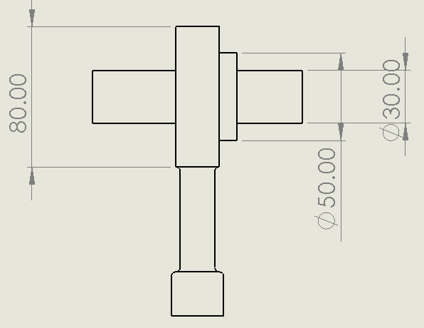  Fig. 1: Housing, Bearing, Shaft Assembly Drawing Side View | 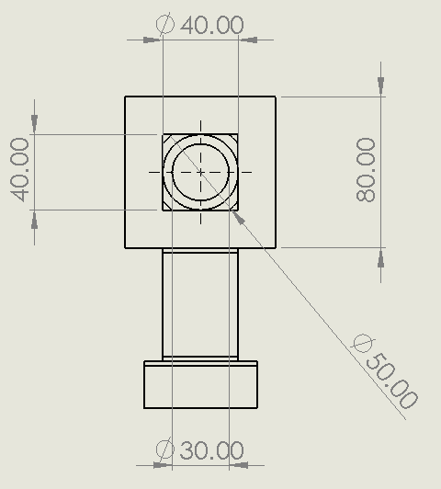  Fig. 2: Housing, Bearing, Shaft Assembly Drawing Front View

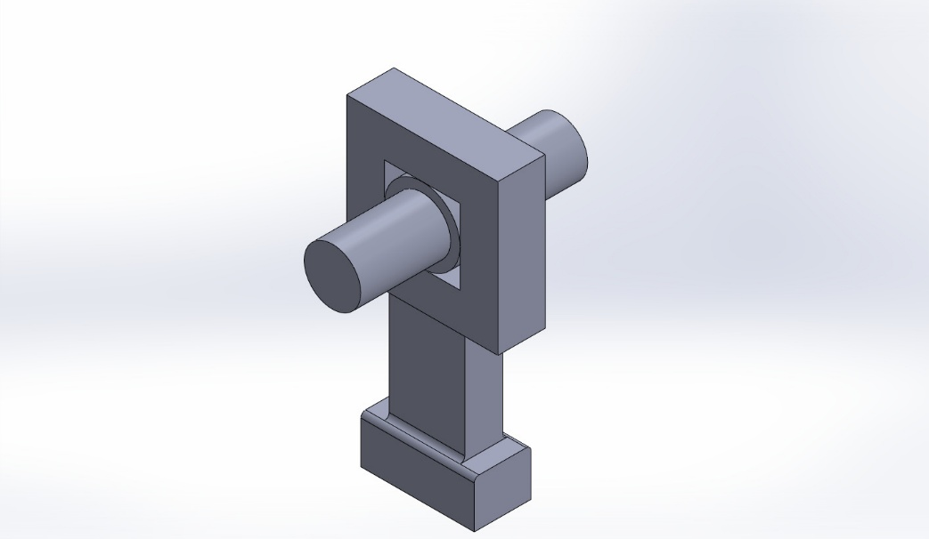
Fig. 3: Housing, Bearing, Shaft Assembly Model

4. GENETIC ALGORITHM PROCESS
The GA follows a structured five-step iterative process:
Step 1: Initialization
A random initial population of 20 individuals is generated. Each individual is a unique pair of IT grades for the shaft and the hub, sampled from the range IT6 to IT10.
Step 2: Fitness Evaluation
For each individual in the population:
The upper and lower dimensional limits for both shaft and hub are computed using the IT grades and the nominal diameter.
The resulting clearance or interference is calculated:
Clearance = Hub Lower Limit – Shaft Upper Limit
Interference = Shaft Lower Limit – Hub Upper Limit
If the clearance/interference meets the specified minimum threshold, the fitness is computed as:
Fitness=Cost Index shaft + Cost Index hub
If constraints are violated, a penalty value is assigned, excluding the individual from selection.
Step 3: Selection
The top 50% of individuals (those with valid fits and the lowest total cost) are selected as parents for the next generation. This selection pressure ensures convergence towards cost-optimal and functionally valid solutions.
Step 4: Crossover and Mutation
Genetic diversity is maintained through recombination:
Crossover: New individuals are created by randomly combining IT grades from two parent individuals.
Mutation: With a small probability (e.g., 5–10%), one of the IT grades in the chromosome is randomly replaced with a new value from the permissible range (IT6–IT10), allowing the algorithm to explore new regions of the solution space.
Step 5: Iteration
The newly formed population undergoes the same evaluation, selection, and reproduction process for 30 generations. With each generation, the algorithm converges toward a solution that satisfies functional fit requirements while minimizing the associated manufacturing cost.
5. Results and Interpretation
To evaluate the effectiveness and reliability of the developed Genetic Algorithm (GA)-based tolerance optimization system, a representative case study was conducted. The selected scenario emulates a common mechanical engineering application, specifically involving a rotating shaft subjected to a clearance fit — a widely used assembly condition in power transmission systems, electric motors, and rotating machinery.
Input Parameters and System Setup
To simulate the system, the following input parameters were defined:
- Nominal Diameter (mm): 50
- Fit Type: Clearance
- Material Used: Steel
- Function of the Component: Rotating Shaft
These inputs reflect standard industrial practice and are compatible with internationally accepted standards for dimensional tolerancing, as shown in Fig. 4 with the input data parameters.
Upon receiving the input, the system utilized a knowledge base referencing ISO 286-1:2010 and ISO 286-2:2010, which govern the ISO system of limits and fits as shown in Fig. 5 with the ISO references. Based on this, the system initially proposed:
- Recommended Tolerance Grades:
  - Shaft: h8
  - Hub: H7
These grades are widely adopted in engineering to ensure reliable clearance fits that account for manufacturing variations while maintaining functionality.
Standard Tolerance Interpretation
For a nominal size of 50.0 mm, the ISO standard tolerances (before optimization) are interpreted as:
- Shaft Tolerance (h9): A tighter fit where the shaft's permissible deviation lies entirely on the negative side of the nominal.
- Hub Tolerance (H8): A looser, complementary fit where the hub's permissible deviation lies on the positive side.
Genetic Algorithm-Based Optimization Results
The optimization algorithm, designed to minimize total manufacturing cost while satisfying functional constraints, yielded the following refined tolerance grades:
- Material: Steel
- Function: Rotating Shaft
- Fit Type: Clearance
- Optimized Tolerance Grades:
  - Shaft: IT6 (corresponding to a tolerance of 10.00 microns)
    - Shaft Limits: +0.005 mm / -0.005 mm
  - Hub: IT10 (corresponding to a tolerance of 63.00 microns)
    - Hub Limits: +0.032 mm / -0.032 mm
The optimization algorithm intelligently adjusted the tolerance grades to ensure a functionally compliant clearance fit, while simultaneously attempting to reduce production cost, particularly by loosening the hub tolerance (less costly machining), and tightening the shaft tolerance (for functional precision).
Cost Analysis
However, the Total Manufacturing Cost Index calculated for the selected configuration was found to be infinite (inf). This suggests one of the following scenarios:
- The algorithm encountered a division by zero or undefined cost value due to an invalid or uninitialized cost function.
- The selected tolerance combination, despite being functionally valid, may be impractical or economically non-viable under the current cost model.
- A possible need to fine-tune the algorithm’s cost constraints or incorporate more realistic machining cost data.
This highlights the importance of cost function robustness and the integration of accurate manufacturing databases in AI-driven optimization models.
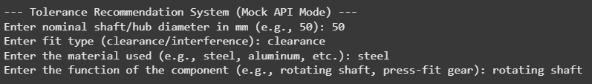
Fig. 4: Input Data
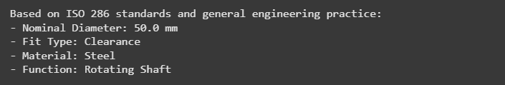
Fig. 5: Reference Data Based on ISO 286 Standards
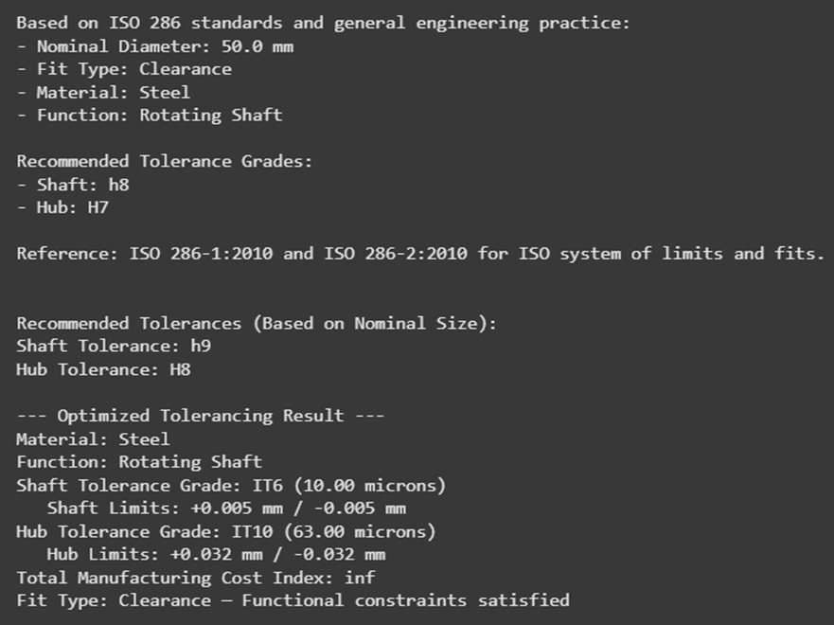
Fig. 6: Recommended Tolerance Grade

Fig. 7: Tolerancing Result
6. Benefits of the Proposed System
The proposed AI-based tolerance optimization system offers several practical advantages over traditional methods:
- Cost Reduction: By avoiding unnecessary tight tolerances, the system minimizes machining, inspection, and tooling costs, leading to more economical production.
- Automation: The system eliminates the need for manual look-ups and expert-driven decisions by automating the selection of tolerance grades based on functional and cost constraints.
- Flexibility: It accommodates various design scenarios—different diameters, materials (e.g., steel, aluminum), and functional roles (e.g., rotating shafts, press-fits).
- Scalability: The framework can be extended to include surface finish, geometric tolerances (e.g., roundness), and manufacturing process constraints, making it adaptable for advanced design-for-manufacturing applications.
7. Limitations and Future Scope
Table 2: Limitations and Future Improvement Table
Limitation | Future Improvement
Limited to shaft-hub cylindrical fits | Extend to complex geometries and assemblies
Mock material properties | Integrate database for material-based tolerance selection
Static cost model | Dynamic cost estimation using real-time production data
No machine/process constraints | Include CNC capabilities, inspection limits
8. CONCLUSION
This study highlights the effective application of Artificial Intelligence (AI) techniques—specifically, Genetic Algorithms (GAs)—in the domain of tolerance selection for mechanical assemblies. The proposed system addresses a long-standing challenge in manufacturing design: how to balance functional fit requirements with the economic realities of production.
Traditional reliance on standardized tolerance charts and conservative engineering judgment often leads to over-engineered solutions, where tolerances are tighter than necessary. This results in increased machining complexity, extended cycle times, and elevated production costs. By contrast, the AI-driven approach presented in this work enables intelligent, data-informed decision-making that aligns closely with both design intent and manufacturability.
The genetic algorithm serves as a powerful optimization engine capable of navigating the large combinatorial space of tolerance pairings (e.g., shaft and hub), while considering constraints such as minimum clearance or interference, material selection, and process capability. The algorithm efficiently identifies tolerance combinations that satisfy all functional requirements without incurring unnecessary precision—and by extension, unnecessary cost.
By bridging the gap between theoretical ISO tolerance standards and practical, cost-sensitive design, this system empowers engineers to implement leaner, smarter, and more sustainable manufacturing practices. Moreover, its flexible and scalable framework opens the door for integration into CAD/CAM systems, product lifecycle management (PLM), and Industry 4.0 digital design workflows.
In summary, this study demonstrates the tangible value of AI-based optimization in mechanical design and manufacturing, marking a step forward toward fully intelligent and cost-effective engineering decision support systems.
9. REFERENCES
- ISO 286-1:2010 — Geometrical product specifications (GPS) — ISO code system for tolerances on linear sizes — Part 1: Basis of tolerances, deviations and fits.
- ISO 286-2:2010 — Geometrical product specifications (GPS) — ISO code system for tolerances on linear sizes — Part 2: Tables of standard tolerance classes.
- Goldberg, D.E., Genetic Algorithms in Search, Optimization and Machine Learning, Addison-Wesley, 1989.
- Qin, S., Liu, D., & Yu, H. (2021). "Intelligent Design Tolerancing in Industry 4.0", IEEE Access, vol. 9, pp. 44258–44269.
- Gao, R., Wang, L., Teti, R., et al. (2015). "Cloud-enabled prognosis for manufacturing", CIRP Annals, vol. 64, no. 2, pp. 749–772.
- Y. Zhong, H. Zhang, and X. Dong, "Tolerance optimization design based on the manufacturing-costs of assembly quality," The International Journal of Advanced Manufacturing Technology, vol. 122, pp. 243–258, 2022. doi: 10.1007/s00170-022-09170-w.
- L. Nagarajan, S. K. Mahalingam, S. Salunkhe, E. A. Nasr, J. P. Davim, and H. M. A. Hussein, "A novel methodology for simultaneous minimization of manufacturing objectives in tolerance allocation of complex assembly," Applied Sciences, vol. 11, no. 19, p. 9164, 2021. doi: 10.3390/app11199164.
- Y. Wang, X. Du, and X. Peng, "Accelerating sampling-based tolerance cost optimization by adaptive surrogate models," The International Journal of Advanced Manufacturing Technology, vol. 110, pp. 1871–1887, 2020. doi: 10.1007/s00170-020-05991-w.
- Y. Ai, J. Tian, F. Zhang, X. Zhai, and S. Bai, "Study on technique of tolerance optimal allocation based on adaptive genetic algorithm," Advanced Materials Research, vols. 490–495, pp. 1436–1440, 2012. doi: 10.4028/www.scientific.net/AMR.490-495.1436.
- K. Saravanan, M. S. Shunmugam, and G. Krishnamurthy, "An explicit methodology for manufacturing cost-tolerance modeling and optimization using the neural network approach," The International Journal of Advanced Manufacturing Technology, vol. 16, no. 1, pp. 20–30, 2000. doi: 10.1007/s001700050008.
- S. Xu, H. Gao, J. Zhou, and Z. Liang, "Multi-objective optimization based on improved non-dominated sorting genetic algorithm II for tolerance allocation," The International Journal of Advanced Manufacturing Technology, vol. 94, pp. 4411–4427, 2018. doi: 10.1007/s00170-017-1121-5.
- M. Kolb, J. O'Leary, and G. Stillfried, "Deep reinforcement learning in industrial assembly: A review of trends, challenges, and applications," Journal of Intelligent Manufacturing, vol. 35, pp. 2191–2214, 2024. doi: 10.1007/s10845-024-02546-5.
- S. Afifi, C. Gao, and R. Alqasemi, "High precision peg-in-hole assembly approach based on sensitive robotics and deep recurrent Q-learning," International Journal on Smart Sensing and Intelligent Systems, vol. 16, no. 1, pp. 157–166, 2025.
- Oubrek, H. El Khamlichi Drissi, A. El Barkany, and Y. El Fezazi, "Shape tolerance optimization using artificial intelligence: application to turbine blade manufacturing," International Journal of Precision Engineering and Manufacturing-Green Technology, vol. 8, pp. 665–676, 2021. doi: 10.1007/s40684-020-00259-5.
- Y.-L. Chen, C.-Y. Yu, and D.-Y. Lin, "Tolerance design for manufacturing cost minimization with consideration of quality loss," Work, vol. 56, no. 3, pp. 403–407, 2017. doi: 10.3233/WOR-172506.
- Sohail, A. (2023). Genetic algorithms in the fields of artificial intelligence and data sciences. Annals of Data Science, 10(4), 1007-1018.https://link.springer.com/article/10.1007/s40745-021-00354-9
- Mohammed, T. A., Alhayali, S., Bayat, O., & Uçan, O. N. (2018). Feature reduction based on hybrid efficient weighted gene genetic algorithms with artificial neural network for machine learning problems in the big data. Scientific Programming, 2018(1), 2691759. https://onlinelibrary.wiley.com/doi/abs/10.1155/2018/2691759

ABBREVIATIONS
AI: Artificial Intelligence
GA: Genetic Algorithm
IT: International Tolerance
ISO: International Organization for Standardization
PLM: Product Lifecycle Management
CNC: Computer Numerical Control
GPS: Geometrical Product Specifications

APPENDIX
Tolerance info
IT_grades = {
"IT6": 0.010,
"IT7": 0.016,
"IT8": 0.025,
"IT9": 0.040,
"IT10": 0.063
}

tolerance_cost = {
"IT6": 5,
"IT7": 4,
"IT8": 3,
"IT9": 2,
"IT10": 1
}

Input
print("--- Tolerance Recommendation System (Mock API Mode) ---")
part_diameter = float(input("Enter nominal shaft/hub diameter in mm (e.g., 50): "))
fit_type = input("Enter fit type (clearance/interference): ").lower()
material = input("Enter the material used (e.g., steel, aluminum, etc.): ").lower()
function = input("Enter the function of the component (e.g., rotating shaft, press-fit gear): ").lower()

ChatGPT Response
chatgpt_recommendation = f"""
Based on ISO 286 standards and general engineering practice:
- Nominal Diameter: {part_diameter} mm
- Fit Type: {fit_type.title()}
- Material: {material.title()}
- Function: {function.title()}

Recommended Tolerance Grades:
- Shaft: h8
- Hub: H7

Reference: ISO 286-1:2010 and ISO 286-2:2010 for ISO system of limits and fits.
"""
print("\n--- ChatGPT Recommendation (Mocked) ---")
print(chatgpt_recommendation)

Initial Recommendation (Standard ISO-based Example)
def recommend_tolerance(diameter, fit):
if diameter < 30:
shaft = "h7"
hub = "H7"
elif diameter < 50:
shaft = "h8"
hub = "H7"
else:
shaft = "h9"
hub = "H8"
return shaft, hub

rec_shaft, rec_hub = recommend_tolerance(part_diameter, fit_type)
print("\nRecommended Tolerances (Based on Nominal Size):")
print(f"Shaft Tolerance: {rec_shaft}")
print(f"Hub Tolerance: {rec_hub}")
Optimization Section
min_clearance = 0.005
min_interference = 0.002
population_size = 20
generations = 30
mutation_rate = 0.2

def generate_individual():
return [random.choice(list(IT_grades.keys())), random.choice(list(IT_grades.keys()))]

def fitness(individual):
shaft_tol = IT_grades[individual[0]]
hub_tol = IT_grades[individual[1]]
shaft_upper = part_diameter + (shaft_tol / 2)
shaft_lower = part_diameter - (shaft_tol / 2)
hub_upper = part_diameter + (hub_tol / 2)
hub_lower = part_diameter - (hub_tol / 2)
clearance = hub_lower - shaft_upper
interference = shaft_lower - hub_upper
if fit_type == "clearance" and clearance < min_clearance:
return float('inf')
elif fit_type == "interference" and interference < min_interference:
return float('inf')
total_cost = tolerance_cost[individual[0]] + tolerance_cost[individual[1]]
return total_cost

def select(population):
sorted_pop = sorted(population, key=fitness)
return sorted_pop[:int(len(sorted_pop) / 2)]

def crossover(parent1, parent2):
return [random.choice([parent1[0], parent2[0]]), random.choice([parent1[1], parent2[1]])]

def mutate(individual):
if random.random() < mutation_rate:
individual[random.randint(0, 1)] = random.choice(list(IT_grades.keys()))
return individual

population = [generate_individual() for _ in range(population_size)]
for _ in range(generations):
selected = select(population)
children = []
while len(children) < population_size:
parent1 = random.choice(selected)
parent2 = random.choice(selected)
child = crossover(parent1, parent2)
child = mutate(child)
children.append(child)
population = children

best = min(population, key=fitness)
shaft_tol = best[0]
hub_tol = best[1]
shaft_val = IT_grades[shaft_tol]
hub_val = IT_grades[hub_tol]
total_cost = fitness(best)

shaft_upper = part_diameter + (shaft_val / 2)
shaft_lower = part_diameter - (shaft_val / 2)
hub_upper = part_diameter + (hub_val / 2)
hub_lower = part_diameter - (hub_val / 2)

print("\n--- Optimized Tolerancing Result ---")
print(f"Material: {material.title()}")
print(f"Function: {function.title()}")
print(f"Shaft Tolerance Grade: {shaft_tol} ({shaft_val*1000:.2f} microns)")
print(f" Shaft Limits: +{(shaft_val/2):.3f} mm / -{(shaft_val/2):.3f} mm")
print(f"Hub Tolerance Grade: {hub_tol} ({hub_val*1000:.2f} microns)")
print(f" Hub Limits: +{(hub_val/2):.3f} mm / -{(hub_val/2):.3f} mm")
print(f"Total Manufacturing Cost Index: {total_cost}")
print(f"Fit Type: {fit_type.title()} — Functional constraints satisfied")

