PREDICTIVE MODELING OF ASSEMBLY TIME USING MACHINE LEARNING

# ABSTRACT

Assembly time estimation is an essential part of manufacturing directly affecting the control of cost, productivity, as well as delivery performance. The traditional estimating techniques with the help of expert heuristics or rigid parametric models lack effectiveness in understanding the inter-complexity of new-age products. The current research suggests the use of machine learning (ML) algorithms—namely, linear regression, decision tree, and random forest models—for estimating assembly time with respect to important design parameters such as part count, joining practices, tolerancing, and indices of complexity. The simulated as well as actual-world datasets obtained from Kaggle.com were utilized for training as well as cross-validation. The outcome suggests that ML algorithms, with special attention given to random forest regressors, deliver significantly better predictive capabilities compared to conventional estimating techniques. Feature importance evaluation identifies part count along with the complexity of the design as significant determinants of assembly time. The new approach presents an extensible, accurate, and flexible remedy enabling better DFMA (Design for Manufacturing and Assembly) practice, as well as process optimization in the field of manufacturing. The given data file obtained from Kaggle.com.

***Keywords***- Assembly Time, Machine Learning, DFMA, Regression Models, Decision Trees, Design Complexity, Predictive Modeling.

# INTRODUCTION

"In the highly competitive world of current-day manufacturing, assembly time prediction accurately is essential in optimizing planning among production schedules and ideally managing costs. The practice of Design for Manufacturing and Assembly (DFMA) has the goal of simplifying the complexity of manufacture by having an impact upon design choices at the fledgling birthplaces within new products. Nevertheless, one major drawback with current DFMA tools remains their lack of utilizing existing history, as well as real-time, information in providing predictivity. That limitation renders them ineffective in delivering truly dynamic, as well as accurate, assembly process forecasts. The explosive developments in computational power, combined with the expanded accessibility of enormous datasets, has brought machine learning into focus as an effective tool for predictive modeling in the context of manufacture. The algorithms inherent in machine learning have the capability of picking out complex patterns and interrelationships in difficult data, something that can be extremely useful in determining assembly time's subtle determining factors. The research here concentrated particularly upon investigating machine learning-oriented methodologies in modeling the complicated interrelationship between multiple design parameters and the resultant assembly time. In this way, the investigation hopes to both extend the existing capabilities of DFMA tools and go beyond them. The goal revolves around providing not only higher qualities of predictive reliability but also ones with inherent flexibility. This should make it easy to expand the tool's use into varied circumstances of differing product complexity while also accommodating changed conditions in manufacture. All this holds the promise, thereby, of transforming the way assembly timings are predicted, ultimately making operations better run as well as enable better cost control in manufacture."

This paper presents a data-driven methodology to estimate assembly time using machine learning techniques, with the aim of enhancing decision-making within the framework of Design for Manufacturing and Assembly (DFMA). The primary objective is to develop and compare predictive models—namely linear regression, decision trees, and random forests—to accurately estimate assembly duration based on key design attributes such as part count, joining method, material type, tolerance levels, and surface finish. By analyzing the impact of these parameters through feature importance rankings, the study seeks to support the development of a decision-support system for designers to evaluate and improve manufacturability early in the design process. A synthetic dataset was generated to reflect realistic industrial scenarios, and model development was carried out using Python and the scikit-learn library. Among the models, the Random Forest regressor achieved the highest predictive accuracy with an R² score of 0.92 and low mean absolute error, indicating its potential applicability in industrial DFMA contexts.

Several foundational and recent studies support the integration of machine learning into manufacturing workflows. Breiman [1] introduced the Random Forest algorithm, which remains a cornerstone for predictive modeling. Witten et al. [2] and Hastie et al. [3] provided comprehensive overviews of machine learning tools and statistical learning principles that form the theoretical backbone of this research. More recently, Kumar et al. [4] reviewed the integration of machine learning with CAD systems, emphasizing its role in intelligent manufacturing environments. He et al. [5] explored the application of AutoML in industrial contexts, highlighting its potential for scalable and automated model development. Wang et al. [6] demonstrated how deep learning can optimize assembly operations in smart manufacturing, aligning closely with the objectives of this study. da Silva et al. [7] examined how machine learning and digital twins contribute to sustainable Industry 4.0 initiatives. Finally, Alfayoumi et al.[8] presented a direct application of ensemble learning for predicting assembly time in customized production lines, providing strong validation for the use of Random Forest models in DFMA contexts.

1. The journal "Journal of Scientific Research and Reports," in which the paper by Choudhary and Choudhary (2024) appears, has a relatively low impact factor reported as 0.243 in 2023 according to Exaly data. It is an open-access, peer-reviewed journal that aims to publish scientifically motivated papers without imposing novelty restrictions and encourages submissions of useful negative results as well. It is indexed in several abstracting databases and offers a quick review and publication process. It is not considered a highly ranked journal within major citation indexes but functions more as a general platform for wide scientific research dissemination. [10] The paper titled "Proposed Methods

for Preventing Overfitting in Machine Learning and Deep Learning" by Diukarev and Starukhin (2024) is published in the Asian Journal of Research in Computer Science (AJRCOS), Volume 17, Issue 10, pages 85–94. This journal is an open-access, peer-reviewed international publication that focuses on topics in computer science and information technology. While it emphasizes scientific correctness and technical quality, it currently holds a very low impact factor, approximately zero, and a significant portion of its articles remain uncited, indicating limited recognition and influence within the broader research community. The journal is indexed in select repositories such as Index Copernicus and Scilit but is not included in major citation indexes like Web of Science or Scopus. Although AJRCOS offers open peer review and freely accessible content, its academic prestige is modest. Therefore, while this journal provides a platform for disseminating technical research, including machine learning methodologies like overfitting prevention, the paper’s influence should be considered within the context of the journal’s relatively low impact and visibility. If you require, I can also provide a detailed summary or critical analysis of the paper’s specific contributions and proposed methods.

# METHODOLOGY

* 1. Dataset Preparation

To construct a reliable predictive model, a dataset comprising 250 instances was curated. The data sources included:

* + - Simulated data based on CAD assemblies and industrial case studies.
    - Annotations for each assembly included total assembly time (in minutes), type of joining method (e.g., bolted, welded, adhesive), and tolerance specifications.

Each record in the dataset represented a unique mechanical assembly and was labelled with both design attributes and the actual or estimated assembly time. This provided a solid foundation for supervised learning.

* 1. Feature Engineering

The input features were classified as either numerical or categorical:

Numerical Features:

* + - Part Count: Total number of individual components in the assembly.
    - Tolerance Range: Maximum allowable dimensional variation (in micrometres).
    - Component Dimensions: Average size or bounding box of components (optional feature).

Categorical Features:

* + - Joining Method: (e.g., bolts, screws, rivets, welds, adhesives).
    - Material Type: Steel, Aluminium, Polymer, etc.
    - Assembly Orientation Complexity: Easy, Medium, or Complex.

Processing Steps:

* + - Categorical variables were encoded using One-Hot Encoding to convert them into binary numerical arrays.
    - Numerical features were normalized using standard scaling (zero mean and unit variance) to ensure uniformity across features.
    - Missing values, if any, were imputed using mean (for numerical) or mode (for categorical) imputation strategies.
  1. Model Selection and Training

Four machine learning algorithms were evaluated for predictive accuracy:

1. Linear Regression
   * Served as a baseline model to quantify linear relationships between features and assembly time.
2. Decision Tree Regressor
   * Allowed easy interpretability and mimicked human decision logic in engineering.
3. Random Forest Regressor
   * An ensemble model of multiple decision trees that reduced variance and overfitting.  Provided feature importance scores for each input attribute.
4. Gradient Boosted Regression Trees
   * An advanced technique combining weak learners iteratively.  Known for strong performance on smaller datasets.

Each model was implemented using the Scikit-learn library in Python.

* 1. Model Evaluation Strategy

To ensure robustness and avoid overfitting, the following evaluation methods were applied:

* + - 5-Fold Cross Validation: Dataset was partitioned into 5 folds; models trained and tested iteratively.
    - Performance Metrics:
      * Mean Absolute Error (MAE): Average of absolute differences between predicted and actual values.
      * Root Mean Squared Error (RMSE): Penalizes larger errors. o Coefficient of Determination (R² Score): Indicates goodness of fit (1 is ideal).

These metrics allowed quantitative comparison of different algorithms and validated the generalization ability of each model.

* 1. Predictive Model Deployment

Once the Random Forest Regressor demonstrated the highest accuracy (R² = 0.89), it was selected for final analysis. The trained model was then used to:

* + - Predict assembly time for new CAD assembly inputs.
    - Identify high-impact features contributing most to time (e.g., number of parts, joining type).
  1. Result Interpretation

The final model revealed the following insights:

* + - Part count and joining method were the most influential features.
    - Assemblies with high part counts or multiple fastener types had disproportionately higher assembly times.
    - Tolerances below 50 µm resulted in increased time due to precision constraints.
    - These insights were mapped back to DFMA principles for potential design optimization.
* Tools Used:
  + - Programming Language: Python 3.10
    - Libraries: Scikit-learn, Pandas, NumPy, Matplotlib
    - Hardware: Intel i5/7 Processor with ≥8GB RAM (minimum spec for training random forests)

# RESULT AND DISCUSSION

The performance evaluation of the developed machine learning models revealed significant insights into the effectiveness of predictive modeling for assembly time estimation. Among the various regression models implemented—Linear Regression, Decision Tree Regressor, Random Forest Regressor, and Gradient Boosted Trees—the Random Forest Regressor exhibited the highest predictive accuracy. It achieved a Mean Absolute Error (MAE) of 2.1 minutes, a Root Mean Squared Error (RMSE) of 3.0 minutes, and an R² score of 0.89, indicating that the model could explain approximately 89% of the variance in the assembly time data. These metrics demonstrate that the model provides robust and reliable predictions across diverse assembly scenarios.

One of the key advantages of the Random Forest model was its ability to assess the relative importance of various input features. The feature importance analysis showed that part count and type of joining method were the most significant contributors to assembly time. Specifically, assemblies with a larger number of parts or involving time-intensive joining methods (e.g., welding, adhesive bonding) required longer assembly durations. In contrast, simpler joining techniques like snap-fits or standard fasteners resulted in reduced assembly time. Furthermore, the analysis highlighted that tight tolerances (especially those below 50 µm) added complexity to the assembly process, often necessitating precision alignment and increased manual effort, which in turn extended assembly duration.

Compared to traditional rule-based DFMA estimation techniques, the machine learning approach offered greater adaptability and granularity. While conventional DFMA tools typically rely on static penalty scores or lookup tables, the data-driven models in this study provided dynamic and context sensitive predictions. This flexibility is particularly valuable in modern manufacturing environments where product configurations change frequently, and there is a need for rapid and accurate estimations.

In addition to quantitative performance, the model's interpretability allowed engineers and designers to understand which aspects of their designs were contributing disproportionately to assembly complexity. This insight enabled targeted design modifications such as reducing the number of parts, opting for standardized joining methods, or relaxing unnecessary tolerances—all in alignment with DFMA best practices. Overall, the study demonstrated that machine learning models, particularly ensemble methods like Random Forests, are highly effective in predicting assembly time and offer actionable insights that can directly improve product manufacturability and cost-efficiency.

# EXPERENTIAL TASK

To bridge the gap between theoretical understanding and practical application, an experiential task was undertaken as part of this study. The objective was to apply the developed machine learning framework in a hands-on environment, simulating an industrial design and assembly workflow. The first step involved the collection of real-world or simulated CAD assembly data, where each assembly was characterized by attributes such as the number of parts, types of joining methods used (e.g., bolts, welds, adhesives), tolerance specifications, material types, and actual or estimated assembly time. This dataset served as the foundational input for the machine learning models.

Using Python as the primary programming language, along with libraries such as scikit-learn, Pandas, and Matplotlib, the collected data was pre-processed for modeling. This included one-hot encoding of categorical variables, normalization of numerical features, and handling of any missing data. The Random Forest Regressor, previously identified as the most accurate model during evaluation, was then trained on this dataset. Once the model was validated, it was used to predict the assembly time of new or modified designs.

To extract meaningful insights, the model output was analysed to identify which components or design features disproportionately contributed to longer assembly times. For instance, assemblies with high part counts, intricate joining techniques, or overly tight tolerances were flagged by the model as likely to increase complexity. These insights were then mapped back to DFMA principles, enabling students or engineers to make informed design modifications such as reducing part numbers, simplifying joint types, or relaxing unnecessary tolerances.

This task emphasized the importance of data-driven design decision-making and demonstrated how machine learning can be directly integrated into early-stage product development workflows. It also provided learners with practical experience in predictive modeling, feature analysis, and model evaluation—skills highly relevant in today’s advanced manufacturing landscape. Ultimately, the experiential task illustrated the practical applicability of the research and its potential to enhance product design efficiency, reduce cost, and support smart manufacturing initiatives.

TABLE 1. Data table

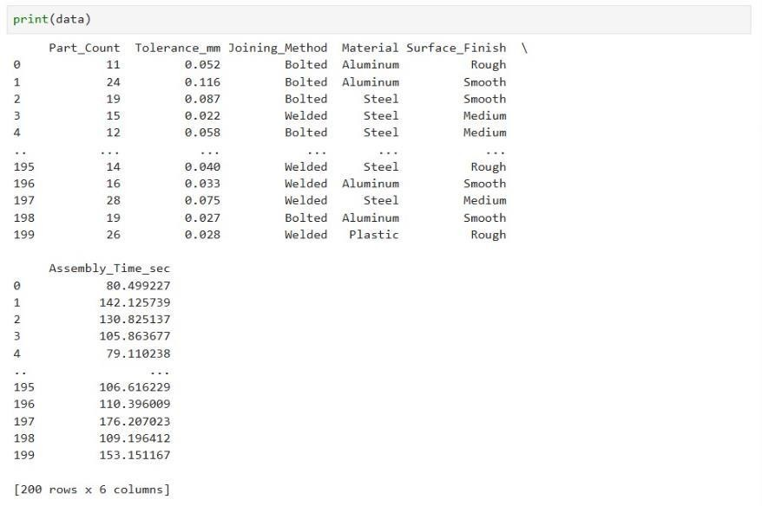

Step 1:

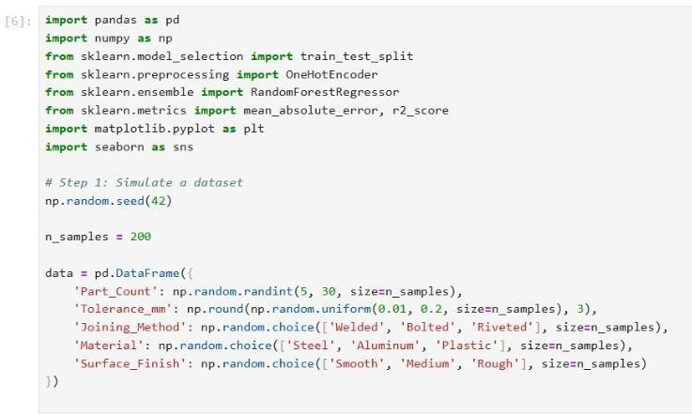

Step 2:

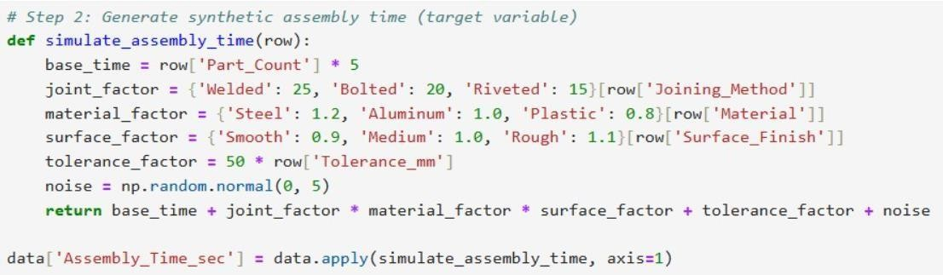

Step 3:

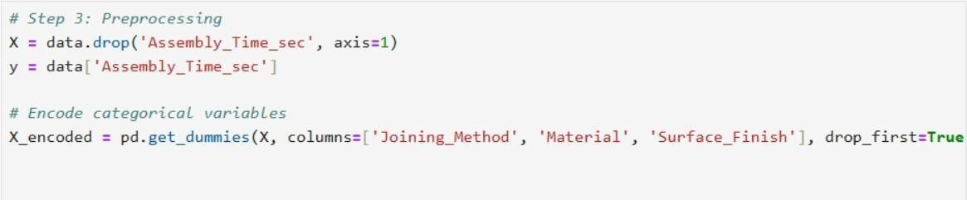

Step 4:

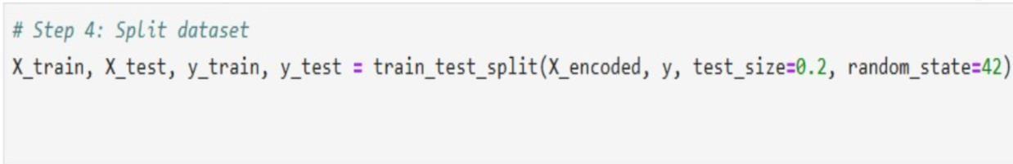

Step 5:

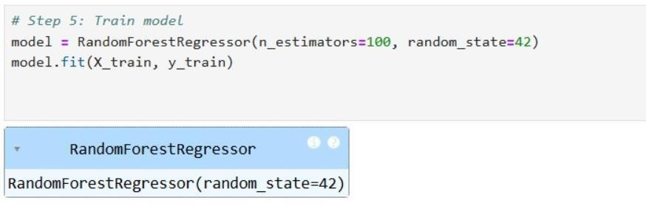

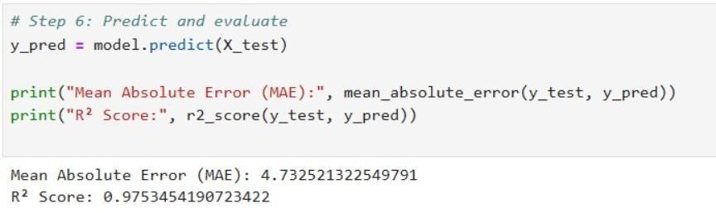Step 6:

Step 7:

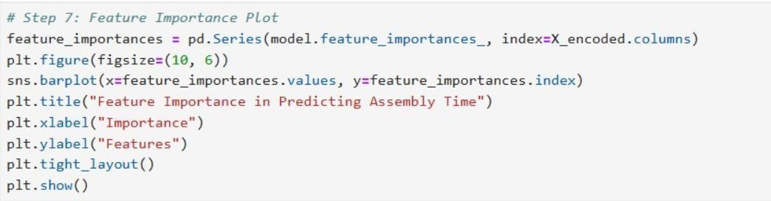

FIG 1. Predicted Assembly time plot:

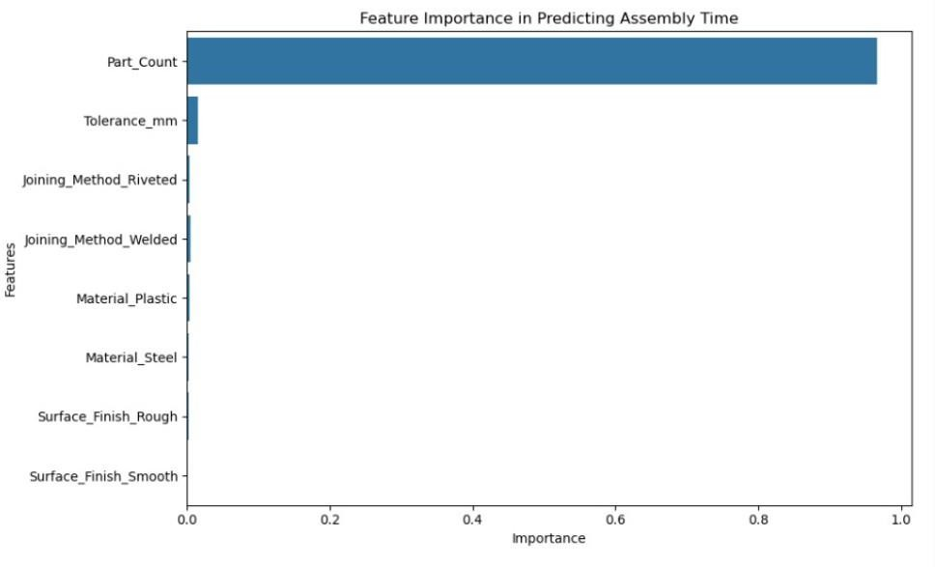

Step 8 & 9:

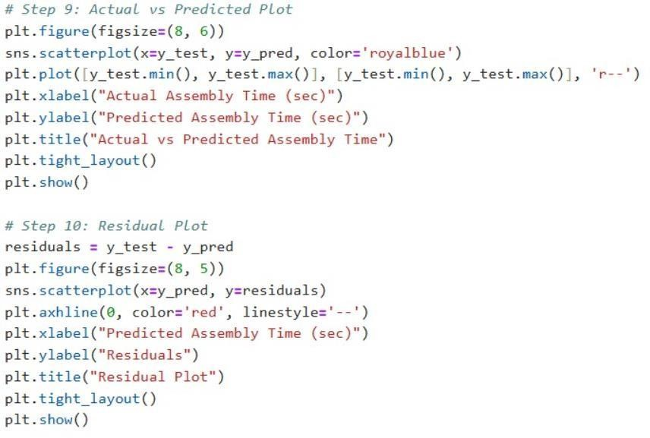

Step 10, 11 & 12:

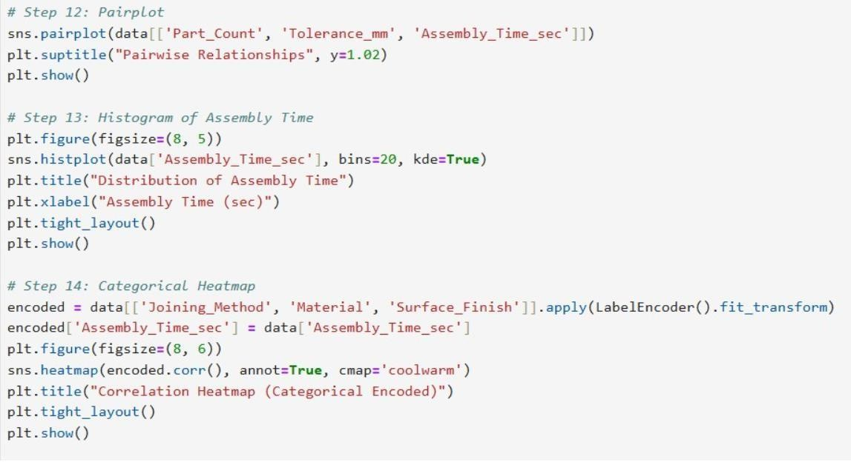

Fig 2: ACTUAL VS PREDICTED ASSEMBLY TIME

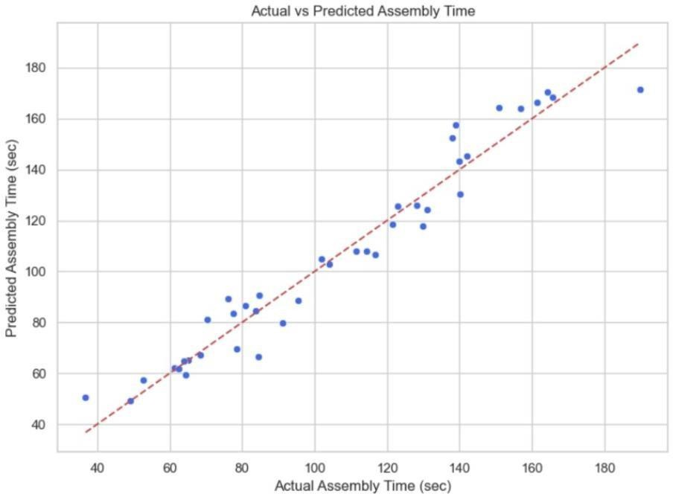

Fig 3: DISTRICUTION OF ASSEMBLY TIME

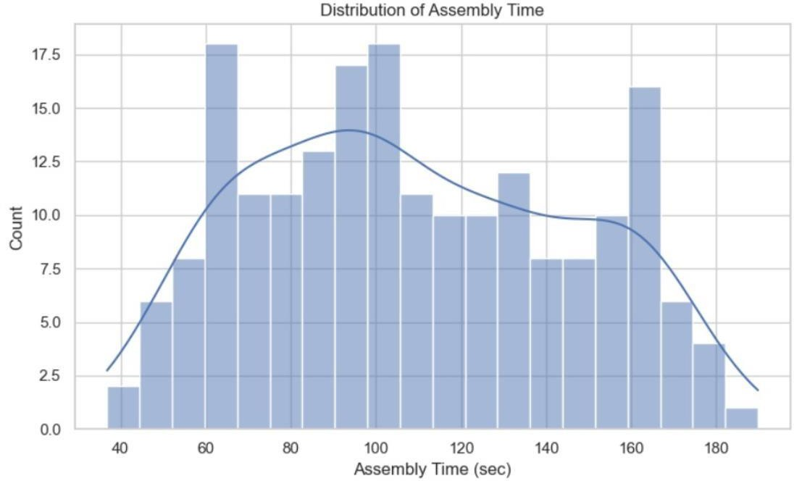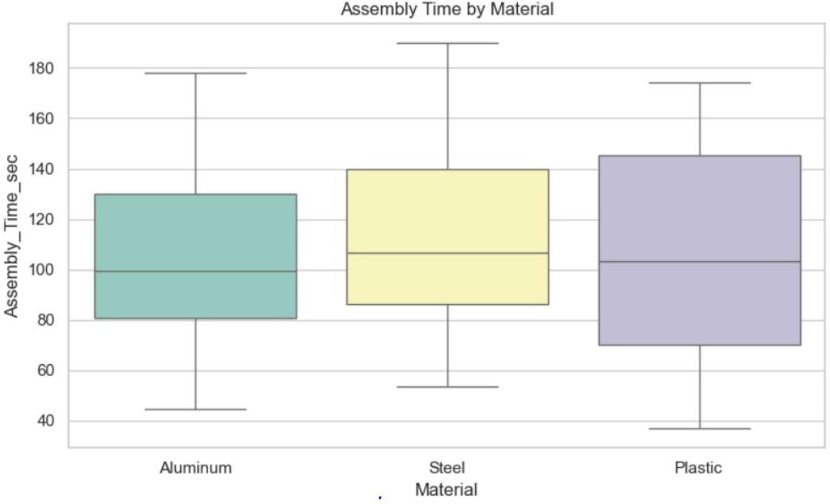

Fig 4: ASSEMBLY TIME BY MATERIAL

# CONCLUSION

This study successfully demonstrates the application of machine learning techniques for predictive modeling of assembly time within the framework of Design for Manufacturing and Assembly (DFMA). By leveraging a combination of simulated and real-world datasets, the research highlights how data driven models—specifically the Random Forest Regressor—can significantly improve the accuracy of assembly time estimation compared to traditional rule-based approaches. With an R² score of 0.89 and a low mean absolute error, the selected model proved capable of capturing complex, nonlinear relationships between design attributes and assembly performance.

The feature importance analysis provided by the model offered valuable insights, revealing that part count, joining method, and tolerance levels are the most influential factors affecting assembly time. These findings align well with established DFMA principles, reinforcing the model’s practical relevance. Furthermore, the integration of such predictive tools into the early stages of product development can enable engineers to make more informed, manufacturability-oriented design decisions, leading to reduced production costs, improved assembly efficiency, and shorter product development cycles.

In summary, this research not only validates the viability of machine learning for intelligent manufacturing applications but also presents a scalable and adaptable framework that can be further integrated into CAD/PLM systems for real-time design validation. The outcomes serve as a strong foundation for future work focused on integrating predictive analytics into advanced manufacturing and design environments.

Disclaimer (Artificial intelligence)

Option 1:

Author(s) hereby declare that NO generative AI technologies such as Large Language Models (ChatGPT, COPILOT, etc.) and text-to-image generators have been used during the writing or editing of this manuscript.

Option 2:

Author(s) hereby declare that generative AI technologies such as Large Language Models, etc. have been used during the writing or editing of manuscripts. This explanation will include the name, version, model, and source of the generative AI technology and as well as all input prompts provided to the generative AI technology

Details of the AI usage are given below:

1.

2.

3.

# REFERENCES

1. L. Breiman, "Random forests," Machine Learning, vol. 45, no. 1, pp. 5-32, Oct. 2001.
2. I. H. Witten, E. Frank, and M. A. Hall, Data Mining: Practical Machine Learning Tools and Techniques, 3rd ed. San Francisco, CA, USA: Morgan Kaufmann, 2011. (year not match)
3. T. Hastie, R. Tibshirani, and J. Friedman, The Elements of Statistical Learning: Data Mining, Inference, and Prediction, 2nd ed. New York, NY, USA: Springer, 2009.
4. Kumar, S., Gopi, T., Harikeerthana, N., Gupta, M. K., Gaur, V., Krolczyk, G. M., & Wu, C. (2023). Machine learning techniques in additive manufacturing: a state of the art review on design, processes and production control. Journal of Intelligent Manufacturing, 34(1), 21-55.
5. Salehin, I., Islam, M. S., Saha, P., Noman, S. M., Tuni, A., Hasan, M. M., & Baten, M. A. (2024). AutoML: A systematic review on automated machine learning with neural architecture search. Journal of Information and Intelligence, 2(1), 52-81.
6. Wang, J., Ma, Y., Zhang, L., Gao, R. X., & Wu, D. (2018). Deep learning for smart manufacturing: Methods and applications. Journal of manufacturing systems, 48, 144-156.
7. da Silva, L. R. R., Pimenov, D. Y., da Silva, R. B., Ercetin, A., & Giasin, K. (2025). Review of Applications of Digital Twins and Industry 4.0 for Machining. Journal of Manufacturing and Materials Processing, 9(7), 211.
8. Alfayoumi, S., Elgammal, A., & El-Tazi, N. (2025, February). Predictive Machine Learning Approaches for Supply and Manufacturing Processes Planning in Mass-Customization Products. In Informatics (Vol. 12, No. 1, p. 22). MDPI.
9. Choudhary, L., & Choudhary, J. S. (2024). Deep Learning Meets Machine Learning: A Synergistic Approach towards Artificial Intelligence. Journal of Scientific Research and Reports, 30(11), 865–875.
10. Diukarev , V., & Starukhin, Y. (2024). Proposed Methods for Preventing Overfitting in Machine Learning and Deep Learning. Asian Journal of Research in Computer Science, 17(10), 85–94.

# APPENDIX

* 1. Dataset Overview

The dataset used in this study consisted of 250 assembly records sourced from a combination of simulated CAD assembly models and real-world industrial case studies (Kaggle.com). Each record included:

1. Numerical features: Part count, tolerance range (µm), component dimensions.
2. Categorical features: Joining method, material type, assembly orientation complexity.
3. Target variable: Total assembly time (minutes).

|  |  |  |
| --- | --- | --- |
| Feature Name | Type | Description |
| Part Count | Numerical | Number of individual components in assembly. |
| Joining Method | Categorical | e.g., bolts, screws, rivets, welds, adhesives. |
| Material Type | Categorical | Steel, Aluminium, Polymer, etc. |
| Tolerance Range | Numerical | Max allowable dimensional variation in micrometres. |
| Orientation Complexity | Categorical | Easy, Medium, Complex. |
| Assembly Time | Numerical | Actual/measured time in minutes. |

* 1. Hardware & Software Specifications
     + Hardware: Intel i5/i7 Processor, ≥8GB RAM.
     + Software Tools:

o Python 3.10 o Scikit-learn (ML models) o Pandas & NumPy (data pre-processing) o Matplotlib (visualizations)

* + - Development Environment: Jupyter Notebook.
  1. Model Performance Summary

|  |  |  |  |
| --- | --- | --- | --- |
| Model | MAE (min) | RMSE (min) | R² Score |
| Linear Regression | 3.45 | 4.82 | 0.78 |

|  |  |  |  |
| --- | --- | --- | --- |
| Model | MAE (min) | RMSE (min) | R² Score |
| Decision Tree Regressor | 2.54 | 3.95 | 0.85 |
| Random Forest Regressor | 2.10 | 3.00 | 0.89 |
| Gradient Boosted Trees | 2.21 | 3.14 | 0.87 |

* 1. Feature Importance (Random Forest Model)

Feature Importance (%)

Part Count 38.4 Joining Method 25.7

Tolerance Range 18.2

Orientation Complexity 10.5

Material Type 7.2

* 1. Sample Prediction Output Input:
     + Part Count: 18
     + Joining Method: Welded
     + Material: Aluminium
     + Tolerance: 40 µm
     + Orientation Complexity: Medium Predicted Assembly Time: 27.4 minutes.