Original Research Article

Design and SolidWorks-Based Simulation of an Automated Robotic Cleaning System for Diesel Storage Tanks

ABSTRACT
This study presents the design and analysis of a robotic cleaning system tailored for diesel storage tanks, utilizing SolidWorks as the primary design and simulation tool. The project aims to address the challenges associated with the manual cleaning of large-scale storage tanks, particularly focusing on improving efficiency, safety, and overall cleaning performance. The robotic system was carefully designed to navigate and clean the internal surfaces of diesel tanks, employing advanced mechanisms to ensure thorough coverage and reliability. SolidWorks was instrumental in the design process, enabling detailed visualization and optimization of robotic components. Various analytical tools within SolidWorks, such as stress analysis and motion studies, were employed to simulate the system's performance under different operational conditions, ensuring the robustness and efficiency of the design. Key challenges encountered during the development, including design constraints and simulation complexities, were overcome through iterative design strategies. The analysis demonstrated that the robotic cleaning system effectively meets the established performance criteria, offering significant improvements in cleaning efficiency and safety compared to traditional manual methods. The system’s design also allows for adaptability, making it suitable for a wide range of industrial applications where similar storage solutions are used.

Keywords: Solid works, storage tanks, diesel, robotic, cleaning, automated, manual cleaning

1 INTRODUCTION
Diesel storage tanks are primarily used to store diesel for consumptive purposes in industries and are of great importance in telecommunication cell sites as they are typically a part of every industrial installation being used for temporary storage of diesel before transferring into various facilities through pipes for use. More than ten million liters of diesel is consumed per day in Nigeria majority of which are utilized by telecommunication infrastructure providers which make use of diesel generators in providing power to telecommunication active equipment. Diesel is transported daily to and from these storage tanks for consumption and over time heavier elements contained in diesel product settle in the tank. These residues occupy space, reduce capacity, and alter the quality of the products in the tanks (Kyzas, 2020). Also, storing diesel for a long period of time accumulates sludges and debris which can lead to long term damage of diesel engine injectors (Desai et al, 2015). They affect the injector more than any other part of the diesel engine as diesel fuel injectors demand a certain degree of fuel thermal oxidative stability to maintain proper and expected spray quality. Injector nozzle deposits have adverse effects on engine fuel efficiency. The performance of diesel engines is heavily influenced by their injection system. In fact, the most notable advances achieved in diesel engines resulted from superior fuel injection system designs (Shatri et al, 2016).
These challenges led to the development of manual ways of cleaning these storage tanks as seen in (Kyzas, 2020). However, a lot of discomfort and inefficiencies are associated with manually cleaning diesel storage tanks. The effects of such inefficiencies reduce the quality of diesel stored in the tanks and lead to a great deal of frustration as sometimes this diesel stored over a period becomes adulterated if not properly cleaned (Himanth, 2017). Recently, automatic cleaning device have been proposed and developed in mitigating these inefficiencies in the manual cleaning of storage tanks. This has led to automation-based machines such as seen in (Acunna et al, 2016). An automated diesel storage tank washing machine system is an electrical/electronic washing machine that senses when the diesel tank is dirty and automatically starts the cleaning process. The automated washing machine has a pump which normally pumps soapy water at high pressure into the tank, the pressure enables the peeling off dirt which complements the work of the brush. However, recent studies have shown that no automation-based machine have been developed and utilized in cleaning diesel tanks at telecommunication cell sites in Nigeria due to the challenge of irregularity in shape and diverse heights of tanks in various locations (Dabhade et al, 2018)
This paper presents an automated diesel storage tank washing machine which concentrates on a conceptual design of a device which can be adopted for usage in cleaning diesel storage tanks on a periodic basis irrespective of irregularity of shape, size, and height of tanks in various locations. This paper majorly focuses on industries that store and consume large volumes of diesel to ensure optimal safety and efficiency. The paper implements an automatic cleaning of the storage tank whenever the tank is dirty, with the design taking into consideration both real and practical situations and for this purpose, a prototype is designed and simulated to automatically carry out cleaning.

1.1 LITERATURE REVIEW
Over the years, dirty diesel storage tanks in telecommunication base stations have brought down the quality of diesel which has also resulted to DG injector failures. Research has been carried out to automate the cleaning process of diesel storage tanks by putting some factors in place to reduce the stress of manual cleaning. This section presents a summary of related literature that is available regarding automated diesel storage cleaning process.
According to (Kyzas, 2020) research on applied cleaning methods of oil residues from industrial tank was carried out. This research study was targeted at reviewing the applied cleanup methods available in the world market and identifying the most efficient one. A total of five automatic, manual and robotic tank cleaning systems were analyzed and evaluated. The study showed that the automatic sludge extractor cleaning system was able to clean the tank faster than other methods with an output of 14.8$m^{3}/h$.
(Acunaa, 2016) designed a robot for cleaning storage tank. The method adopted took into consideration the mechanical design, control design, electronic system design and electrical design. The algorithm for controlling the robot was also factored into this design as this determines the behavior of the cleaning robot and enables synchronization of all signals received from the embedded sensors and motion of the motors. Findings from this research showed that the robot could be utilized on wooden surfaces, concrete and glass surfaces with an efficiency of 80%. However, the limitation of this design is that the robot is not flexible and cannot scrub the edges of the tank accurately.
Also (Dabhade, 2018) implemented an automatic overhead cylindrical water tank cleaning system. This research adopts the rack and pinion gear mechanism and the reciprocating four bar linkage mechanism for the purpose of moving the automatic cleaning device up and down while cleaning the cylindrical tank. This device was designed in such a way that the rack was fixed on the motor, and the four bars were attached to the motor shaft while the whole operation was controlled by a circuit made up of relay switches, buttons, and PIC microcontroller. The drawback was that this cleaning system cannot be applied in the case of diesel storage tank because it was designed to fit in a water tank cleaning system.
(Kumar et al, 2006) assessed sludge formation in diesel storage tanks with measures put in place to eradicate the sludges from the diesel storage tank due to the problems such as clogging of suction pipe that accumulated sludge cause. Two experimental analysis was done to reveal the effects of sludge. Findings showed that sludge growth is less in the sample that was agitated by 20% while putting it side by side with the sample without agitation.
In (Niekorzystnych, 2019) studies on the changes in diesel products during storage over a long period of time were carried out. In this work, the impact of a storage process on diesel quality made up of about 7% FAME was conducted and six stands for storing fuel were designed and constructed within the scope of the work. The target of the researcher was to identify unfavorable changes that can happen during diesel storage taking some ambient conditions into consideration for simulations. The findings from this research after simulations and analysis showed that the test conducted based on PN-EN 12662 revealed that all diesel samples were characterized by a tendency to precipitate deposits and their quantity significantly increased during storage, but no tendency to sedimentation was shown.
In the study conducted by (Jachaket, 2016), a computerized robot was designed specifically for the purpose of cleaning water tanks. This development was motivated by the monotonous and physically demanding nature of manually cleaning water tanks, which can also be hazardous due to factors such as the depth of the tanks and the risk of oxygen deficiency. The need for robotic systems to perform underwater tasks like cleaning has become increasingly evident. To address this need, the researchers created a program that allows the user to remotely control the robot and perform various tasks such as washing, brushing, and sucking. This program also enables monitoring of the robot's activities during the cleaning process. By utilizing this computerized robot, the aim was to overcome the challenges associated with manual cleaning of water tanks and improve efficiency and safety in this task.
In the work carried out by (SmitaGourkhede, 2015), a drain cleaning machine was designed and constructed with a simple cleaning mechanism specifically for cleaning building channels. The design aimed to keep the required hardware minimal, consisting mainly of an electric motor, bearings, belt pulleys, and other small materials such as a precision bar. The purpose of the machine was to effectively remove debris from drains using the equipment. The cleaning mechanism of the machine was designed to efficiently and thoroughly clean the trash present in the drains. Overall, the drain cleaning machine developed by the researcher provided a cost-effective solution for cleaning building channels. By utilizing a basic cleaning mechanism and utilizing readily available hardware components, the machine proved to be a practical and efficient tool for removing debris from drains.
As In (Amin et al, 2025) carefully delineates the various prevalent cleaning methodologies employed for the maintenance of greenhouse roofs, which notably encompasses both manual and automatic cleaning techniques, thereby providing a thorough overview of the spectrum of available options. In a complementary manner, it also elucidates the diverse types of greenhouses, their architectural designs, and the multifaceted factors that significantly influence the quality and intensity of lighting within these environments. The research underscores the paramount significance of maintaining cleanliness in greenhouse settings and delves into the myriad challenges associated with different robotic designs, while simultaneously exploring their prospective advancements in the future.
Finally (Nkinvam et al, 2025) implemented a groundbreaking, water-free, and economically viable automatic cleaning system specifically designed for the maintenance of small solar panels, which are integral to renewable energy solutions. The underlying motivation for this innovative approach arises from the pressing need to address and alleviate the efficiency reductions that are commonly induced by the accumulation of dirt and various contaminants that adversely affect the surfaces of solar panels. This advanced automated cleaning system utilizes an Arduino microcontroller that is further augmented by the inclusion of a real-time clock, thereby allowing for the optimization of cleaning schedules that are responsive to the varying environmental conditions encountered in different settings. The architecture of this system is composed of a sophisticated two-stage mechanism, which features an ejector blower capable of generating a powerful jet of air, in conjunction with a flexible brush that proficiently dislodges not only dust particles but also more adhesive forms of dirt that may adhere to the panels.

Over time, the conventional method of washing diesel tanks has always involved human beings having to climb and enter the tank and scrub the wall and base of the tank manually from the inside. This process is however not safe, and it involves much labour. Too much energy is expended in climbing, entering, and washing the tank. Also, the human body could be injured while entering the tank. Pressure washing devices, however, perform the cleansing action to a certain performance ratio; however, the clogs on the walls are not completely removed as the wall is not scrubbed with hard brushes.

2. MATERIAL AND METHODS
In this research, a computer-aided design software that allows the development of sophisticated 3D models and simulations was considered. The computer-aided design software adopted was SolidWorks (2018-w). SolidWorks was chosen because it has the advantage of creating system parts in 3D and simulating their physics and motion. SolidWorks has been widely used in the development of sophisticated machinery and has been used in creating fast and accurate designs. This Computer aided design (CAD) software prides itself on its strong internal structure and design techniques, which allow it to develop a robust and fully functioning mechatronics system from start to finish. The initial stage of development involves preliminary research to identify the initial requirements, which are then simulated and tested. The research design is the process of structuring the system understudy following specifications of processing requirements. The objectives are to enable the adequate cleaning of diesel storage tanks. Figure 1 below presents the block diagram which describes the diesel storage tank cleaning robotic system. It is made up of several system components used in making the whole project functional and this includes the design of the diesel tank, robotic cleaning system and development of a virtual model.

DIESEL STORAGE TANK
TANK MONITORING SYSTEM
CLEANING ALGORITHM

AUTOMATED WASHING DEVICE

Figure 1: Matrix diagram

2.1 Requirement specifications and Designs
The system requirements analysis is an important phase which ensures that the design aligns with the specific needs of diesel storage tank cleaning. An investigation of tank dimensions, material compatibility, safety regulations, and environmental considerations was conducted. This section details the considerations and constraints encountered during this analysis, providing insight into the foundational aspects shaping the robotic cleaning system's design.

2.1.1 Tank Dimension Requirements
At the beginning of this project, the dimensions of diesel storage tanks were considered. This elaborates a top-to-bottom investigation of industry guidelines, administrative necessities, and variations in tank sizes and shapes. The part frames how the plan represents different tank designs to guarantee the mechanical cleaning framework's versatility across a range of true situations.

2.1.2 Material Compatibility and Safety Regulations
Considering the harsh and often corrosive nature of materials present in diesel storage environments, an evaluation of material compatibility was conducted. This involves assessing the potential impact of cleaning mechanisms on the tank materials, ensuring longevity, and compliance with industry safety standards. The section details the specific materials selected for the cleaning components and the rationale behind these choices.

2.1.3 Environmental Considerations
Environmental factors play an important role in the operational efficiency and longevity of the robotic cleaning system. This section explores the impact of environmental conditions, such as temperature variations, humidity, and potential exposure to hazardous substances. It outlines design features implemented to withstand these conditions, ensuring the system's reliability and longevity in diverse operational environments.

2.2 Principle of Operation
For this project, a brush holding mechanism that is folded to allow easy entrance of the brush into the diesel storage tank was considered. Upon entrance, the two arms of the brush are released to make an angle of 180 ^{degrees} with each other, therefore stretching across the diameter of the tank. Once the switch is turned on, the arm of the brush moves in a circular direction, washing the sides of the tank and ultimately the base of the tank as well. However, while the rotation of the brush is taking place, light soapy water is pumped at high pressure into the tank, the pressure enables the peeling of dirt, which complements the work of the brush. The water is transferred in through a spray nozzle that’s inserted into the tank from the water inlet, which is connected to pipes and has its source from a high-pressure pumping machine. This inlet is different from the one through which a fresh quantity of diesel is pumped into the diesel tank for storage. The cleaning action continues for a while. After a while, an outlet at the base of the tank is opened to allow free flow of the dirty water to escape the tank. This cleaning action can be repeated about two times before the light; soapy water being pumped at high pressure into the tank is stopped. The cleaning equipment can then be contracted and pulled out of the tank. Clean water is still pumped in to rinse away all possible dirt with the outlet still open. Once the tank is cleaned to satisfaction, the outlet can be closed, and the diesel is supplied for storage.
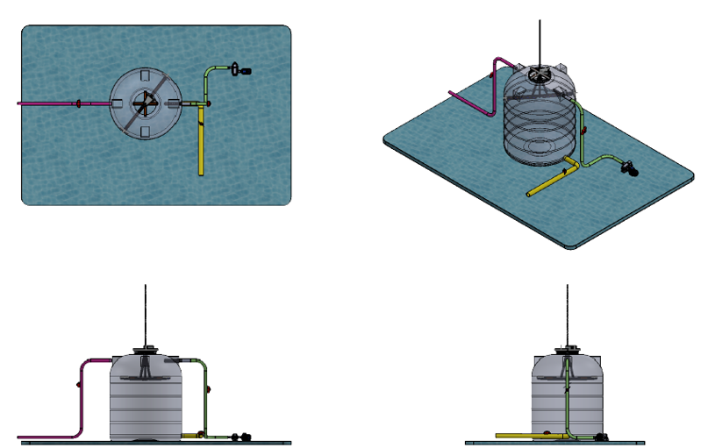
Figure 2: 3D model of diesel storage tank
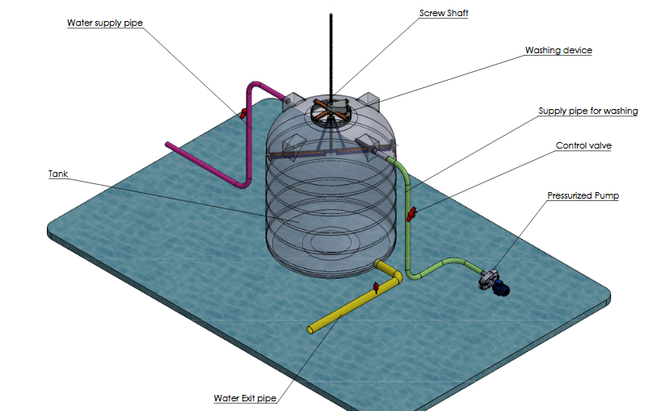
Figure 3: Components of designed diesel storage tank

2.3 Automated washing device design
The automated washing device, which serves as the robot, executes the cleaning task inside the diesel storage tank. This device is an important component of the diesel storage tank cleaning system, responsible for executing the cleaning tasks within the tank. It consists of several interconnected parts, including joints, links, and end-effectors. The design of this device is crucial for ensuring effective and precise cleaning operations. The washing device is designed in such a way that it maneuvers its way through every part of the tank. This was made possible by adopting articulated joints that mimic the range of motion of the two human arms. The function of the device is to extend the reach of the cleaning system. Its links are configured to provide optimal reach, ensuring that it can access all corners and surfaces of the tank. This is particularly important for removing sediment, sludge, or contaminants that may accumulate in hard-to-reach areas with the help of brushes.
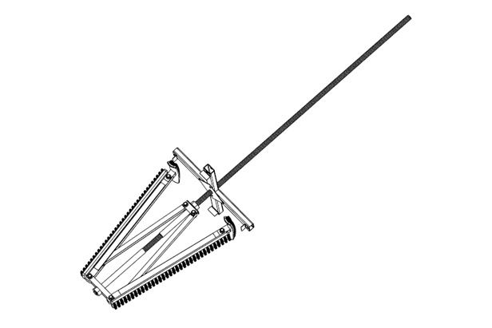
Figure 4: Designed flexible automated washing device
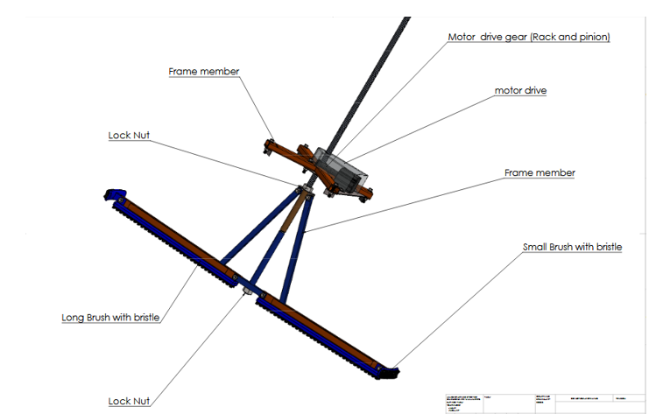

Figure 5: CAD model of the automated washing device functional components

2.3.1 Motor Drive
The motor drive is an important component of the automated washing device that pulls out the washer from the diesel storage tank. The motor drive serves as the actuation system for the robotic arm, converting electrical energy into mechanical motion. It is responsible for driving the joints and links of the arm, enabling it to perform a range of movements required for effective cleaning operations. The motor drive is designed in such a way that it is connected to the joints of the washing arm, providing the necessary torque and rotational movement. The joints, typically actuated by motors, allow the arm to achieve various degrees of freedom, such as rotation, elevation, and extension.

2.4 Simulation Study
A Finite Element analysis using the SolidWorks simulation module was performed on the frame member of the washing device setup. The frame member was selected as one of the main parts under study as all other components are assembled to it and its reliability and functionality has a direct proportion on the total system performance. The reason why the FEA on the frame member of the washing device setup was adopted in this research is to assess its structural integrity, strength, and behavior under different mechanical loads. This analysis helps in identifying potential areas of stress concentration, deformation, and factors that may affect the overall performance and safety of the frame. In this project, a detailed 3D model of the diesel storage tank and washing device was created using solid works and it involves the representation of the frame shapes, joints, dimensions, and other important features. The approach of the simulation study involves dynamic simulation within SolidWorks to evaluate the system's response to external forces, accelerations, and variations. The specific parameters adjusted during the simulation to optimize performance and functionality are discussed, and this phase ensures that the robotic cleaning system can effectively navigate the complexities of cleaning within different tank environments.

2.4.1 SolidWorks Software Integration
SolidWorks was selected as the primary software platform for its robust capabilities in 3D modeling, simulation, and design. This section explains the rationale behind choosing SolidWorks, elaborating on its features that directly contribute to the project's goals. Additionally, any customization or special configurations made within the software to suit the unique requirements of the diesel storage tank robotic cleaning system are discussed.

2.4.2 3D modelling for system visualization
SolidWorks' 3D modeling capabilities enable us to create intricate and accurate representations of the robotic cleaning system. This is particularly beneficial in visualizing the complex components of the system, including the robotic arm, cleaning mechanism, and other integrated parts. The detailed 3D models enhance our understanding of the system's structure, aiding in effective design and communication.
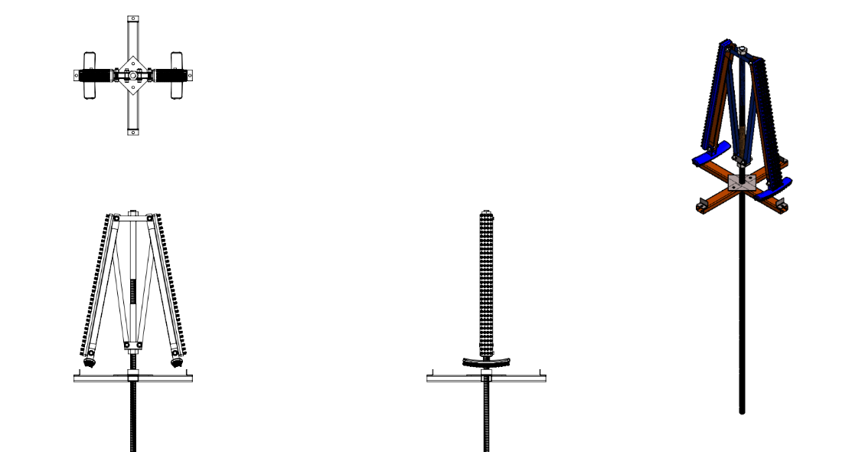
Figure 6: Device assembly of the automated washing device.

2.4.3 Parametric Design for Flexibility and Optimization
SolidWorks' parametric design approach proves invaluable in our iterative design process. This feature allows us to make quick adjustments and modifications to the design, facilitating optimization based on simulation results and feedback from the validation phase. The parametric design approach ensures that the robotic cleaning system remains adaptable to changing requirements and evolving design constraints.
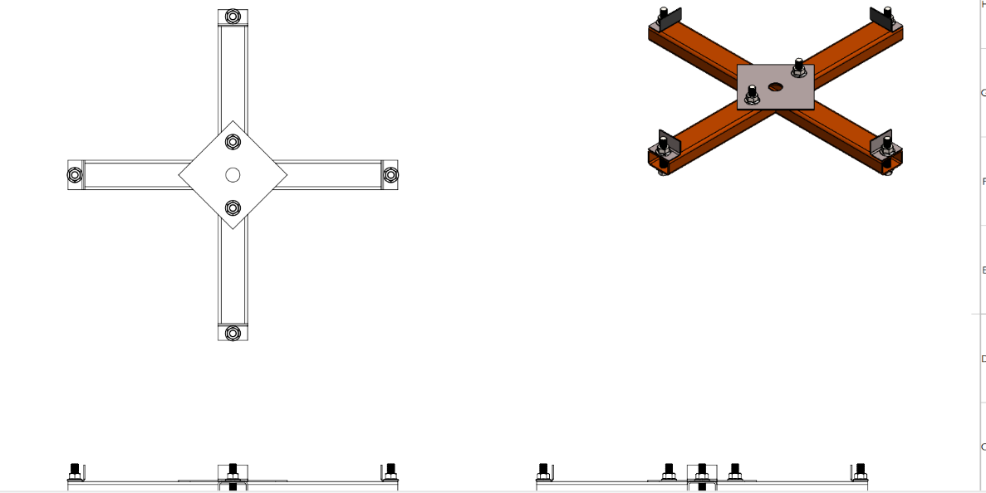

Figure 7: Device assembly of the motor drive gear

2.5 Kinematic Analysis
Kinematic analysis is a fundamental aspect of our methodology, aiming to understand and optimize the movement and actions of the robotic system. We delve into the mathematical models, algorithms, and simulations employed for kinematic analysis, emphasizing how SolidWorks facilitated this critical phase. The section provides insight into the dynamic behavior of the robotic cleaning system, laying the groundwork for subsequent design considerations.
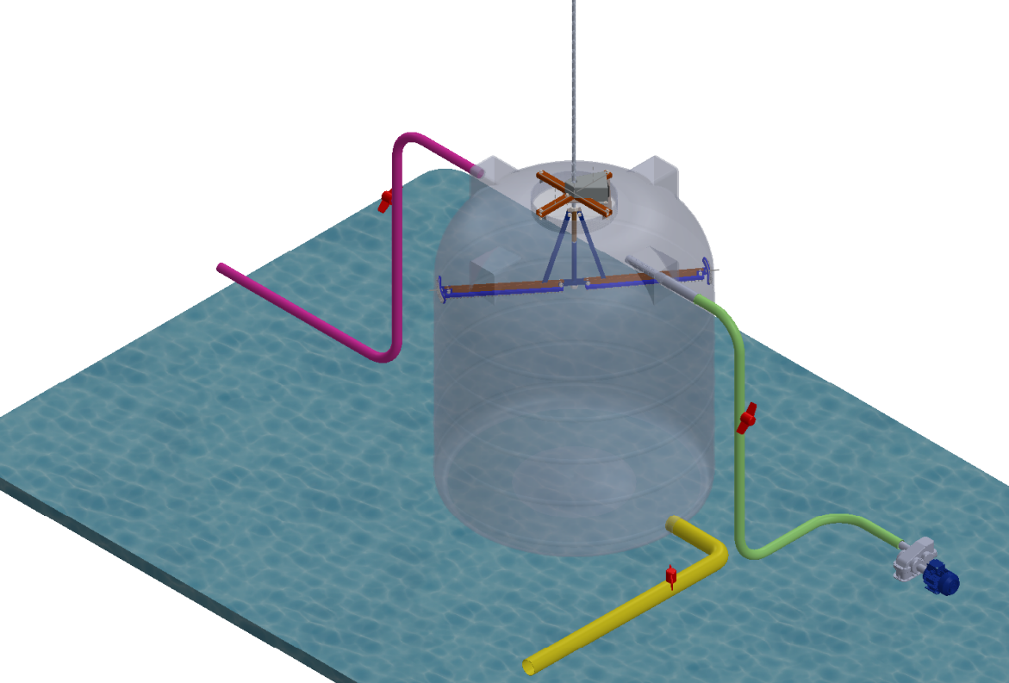
Figure 8: Complete set up of the automated washing device
2.6 Workflow of the design

The designed automated washing device using SolidWorks according to the process flow below: Figure 9 below shows the flow chart of the system. The details of the system are highlighted below:
- Step 1: The user approaches the dirty storage tank with the automated cleaning device and inserts it into the tank, after which it is switched on.
- Step 2: The automated cleaning system in the form of a robotic arm folds itself into the tank and stretches its arm at an angle of 180º across the diameter of the tank.
- Step 3: After the arm has been stretched, the device keeps moving forward as it cleans the edges of the tank to the base of the tank.
- Step 4: At this point, a slight soap water is pumped into the tank to allow proper cleaning of dirt.
- Step 5: The system gets to the base of the tank and continues the process one more time to ensure the tank is properly cleaned.
- Step 6: If the base of the tank is covered, an outlet at the base of the tank is opened for outflow of dirty water, but if not, the process continues until the base of the tank is fully covered and properly cleaned.

Start
Fold brush to allow easy entrance into the tank.

Release the arm at an angle of 180 degree across the diameter of the tank.

Move forward.

Continue process for a while again.
Apply slight soapy water at high pressure.

Wall detected.

Covered the base area?
NO

YES
Open an outlet at the base of the tank to allow dirty water flow out.

End

Figure 9: Process flow of the automated cleaning device
3 RESULTS AND DISCUSSION
In the achievement of the set objectives, this project was implemented to inform a simulation using SOLIDWORKS software. The SolidWorks simulation tool was used to analyze the structural integrity of the robot. This analysis factors in the assessment of how long the robot can withstand repeated use. Solid work motion analysis tool was also utilized in simulating the robot’s movement to ensure it can navigate the tank interior effectively, operate the cleaning mechanism, and deploy the computer-aided designed robotic system to act as a single tool, and this robotic cleaning system has been completely modeled with different frame members. And it performed optimally on testing.

3.1 Simulating the tank cleaning device
After the components of the storage tank cleaning device have successfully been modelled and assembled on the SolidWorks layout, there is a need to apply a rotary motor to simulate the movement of the motor drive gear and see how it moves inside the diesel storage tank while cleaning.
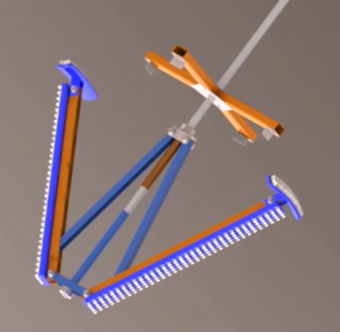

Figure 10: Application of Rotary motion to simulate the movement of the motor drive

This application allows the brush to make an angle of 180 degree with each other as it slides into the tank gradually and cleans the storage tank by stretching across the diameter of the tank as shown in the figure below.
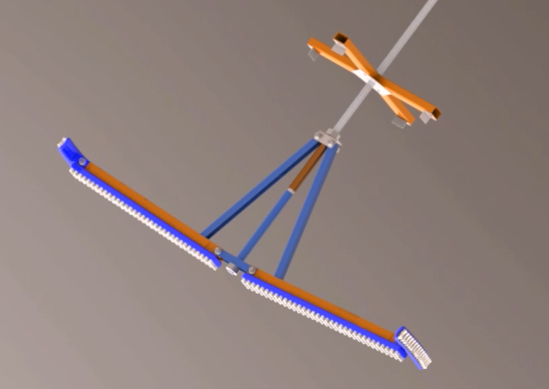

Figure 11: Cleaning device at the point of stretching

3.2 Testing
The testing of this project was done after the cleaning device had been assembled and simulated. At this point the properties of the materials, the stress of the materials chosen for the frame members. The frame member was selected as one of the main parts under study as all other components are assembled to it and its reliability and functionality have a direct proportion on the total system performance. Under this section, the yield strength, tensile strength, elastic modulus, Poisson's ratio, mass density, shear modulus and thermal expansion coefficients were all considered respectively in the design.

3.2.1 Test: Stress
Type: Von Misses
The material chosen for the frame members is AISI 1035 Stainless Steel. The frame was loaded with an angular velocity of 14 rad/s, and a load of 35N is uniformly distributed on the horizontal frame member. VON MISES SIMULATION RESULT OBTAINED shows that the maximum stress occurred on the (hinge) part of the frame body with a Value of 2.02157+006 N/m^{2.} Looking at the yield strength of the material that will be used for the construction, the stress is termed as a PERMISSIBLE STRESS VALUE

Figure 12: Test Stress result obtained from simulation

3.2.2 Test: Strain
Type: Equivalent Strain
The material chosen for the frame members is AISI 1035 Stainless Steel. The frame was loaded with an angular velocity of 14 rad/s Load of 35N is uniformly distributed on the horizontal frame member. SIMULATION RESULT OBTAINED shows that the maximum strain obtained from the frame body structure is 7.85371e-006

Figure 13: Test strain result obtained from simulation

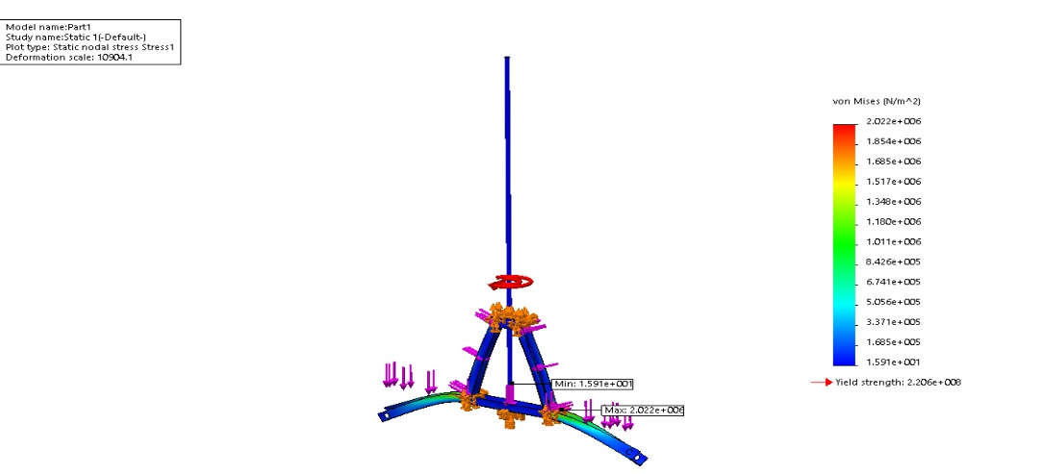

Figure 14: Fatigue test result

3.3 Analysis
In the analysis of this work, the results obtained from the simulation of this project while in use in a storage tank clearly indicate that the way it behaved was the way it will behave in real real-life scenario. These results show that the actual module of the navigation of the various movements of the Robot was concerned with the switch in avoiding collision with obstacles. The following factors were taken into consideration to achieve movement stability, and these include the diameter of the storage tank, ground elevation, terrain texture, the tank structure, and the level of dirt in the tank. The switch must always be in good working condition for optimal performance of the device, which can take an input voltage of 5V.

4. CONCLUSION
Conclusively, this paper successfully achieved its objective of designing and analyzing a robotic cleaning system for a diesel storage tank using SolidWorks. The design process focused on creating a system that is not only functional and efficient but also prioritizes safety. Using SolidWorks, we were able to visualize and optimize the design, ensuring that each component and mechanism worked seamlessly to achieve the desired performance. The analytical tools within SolidWorks, including stress analysis and motion studies, provided critical insights into the system's reliability and efficiency under various operational conditions. These simulations were instrumental in refining the design, allowing us to address potential weaknesses and optimize the system's overall functionality. From the simulation results, looking at the yield strength of the material to be used for the construction, stress is termed as a PERMISSIBLE STRESS VALUE, thereby making the frame body design a workable mechanism. This value further confirms that the design is appropriately done.

DISCLAMER (ARTIFICIAL INTELLIGENCE)
Author(s) hereby declares that NO generative AI technologies such as Large Language Models (CgatGPT, COPILOT, etc) and text to image generators have been used during writing or editing of this manuscript.

REFERENCES
Amin, A., Wang, X., Chen, Y., Guoxiang, S., Xuekai, H., Rottok, L. T., ... & Hassanien, R. H. E. (2025). Enhancing Greenhouse Performance Through Robotic Roof Cleaning Solutions: A Review. Journal of Field Robotics, 42(4), 1401-1426. https://doi.org/10.1002/rob.22459
A. Shatri, S. B. (2016). FUEL INJECTION TESTING EQUIPMENT. International Journal of Research in Advent Technology (IJRAT), pp. 335.
Al-Dousary, S. D. (2015). G.P.T. Implementation Of Non-man Entry Technology—An Automated Technology for De-sludging & Cleaning of Tanks. In SPE Kuwait Oil and Gas Show and Conference; Society of Petroleum Engineers: Mishref,, (p. PP.9 ). Kuwait.
B. Narayani, S. R. (2019). Design and Simulation of a Tank Floor Cleaning Mechanism for Mobile Robots used in Storage Tanks. Proceedings of the 2019 4th international conference on Advances in Robotics (pp. pp. 1-6). ACM Digital Library.
B. niekorzystnych. (2019). The study of adverse changes in diesel fuel during its storage. Oil and Gas Institute – National Research Institute, pp. 640-648.
Chiu, A. S. (2008). THE DEVELOPMENT OF A PIEZOELECTRIC FUEL INJECTOR FOR DIESEL ENGINE. Toronto, Ontario, Canada,: Ryerson University.
D. Sanpeng, X. X. (2010). Research on the oil tank sludge cleaning robot system. In Proceedings of the 2010 International Conference on Mechanic Automation and Control Engineering. Wuhan, China.
H.G. Acunaa, F. S. (2016). Design of a Service Robot to Clean Storage Tanks. 2012 2nd International Conference on Materials, Mechatronics and Automation, (p. pp. 502).
Himanth, B. L. (2017). Review on the Detection of Fuel Adulteration through Sensor based Techniques. International Journal of Scientific and Research Publications,, Volume 7, Issue 9, pp. 447-451.
L.N Komariah, S. A. (2022). Microbial contamination of diesel-biodiesel blends in storage tank; an analysis of colony morphology. Heliyon Journal, pp. 1-8.
Nkinyam, C. M., Ujah, C. O., Nnakwo, K. C., Ezeudu, O., Kallon, D. V., & Ezema, I. I. E. C. (2025). Design and implementation of a waterless solar panel cleaning system. Unconventional Resources, 5, 100131. https://doi.org/10.1016/j.uncres.2024.100131
N.G. Malunjkar, P. N. (2020). Semi-Automatic Overhead Water Tank Cleaning System. International journal of advanced research and innovative ideas in education, Vol-6 Issue-5, pp. 824-827.
O. Mehta, M. s. (2021). AUTOMATIC TANK CLEANER. Journal of Emerging Technologies and Innovative Research, Volume 8, Issue 5, pp. 685-689.
Oliveira, A. (2014). Design of a mobile application for eye signs screening (Masters Thesis). Instituto superior de engenharia d0 porto.
P. B Jachaket. (2016). Computerized Underwater Robot to Clean Water Tank. Volume:2, Issue: 4, pp. 201.
P. Kumar, L. D. (2006). Assessment of sludge formation in diesel storage tanks and eradication measures. IOP Conf. Series: Materials Science and Engineering. IOP Publishing.
P. S.Desai, H. R. (2015). Fuel Injector Testing Machine. International Journal of Engineering Research and General Science, 100.
R. R. Dabhade, S. L. (2018). Automatic Overhead Water Tank Cleaning System: A Review and an Approach. International Journal of Advanced Engineering Research and Science, Vol-5, Issue-10, pp. 186.
S.A. Sirsat, Y. S. (2016). Fuel Injection Testing Equipment-A Review. International Journal of Research in Advent Technology (IJRAT), 344-347.
SmitaGourkhede, M. (2015). Design and Fabrication of Drain Cleaning Machine.
T. Mahmudi, K. R. (2014). Comparism of macular OCTs in right and left eyes of normal people . Proceedings SPIE9038 medical imaging 2014: Biomedical applications in molecular, structural and functional imaging, 90381K. San diego, califonia, United states .
TRADEBE TRADITIONAL TANK CLEANING. (2020, March 3). Retrieved from https://www.tradebeindustrialservices.com/traditional-tank-cleaning
Y. Kumar, N. K. (2020). Fabrication of Water Tank Cleaning Machine. International Journal of Scientific & Engineering Research, Volume 11, Issue 6, pp. 577-582.

