Original Research Article
Numerical Simulation of Hemodynamics Blood Flow Through Single and Double Stenotic Coronary Arteries

ABSTRACT
In this study, we present a computational model utilizing a Newtonian fluid assumption to investigate blood flow characteristics in arteries with single and double stenosis. We have used COMSOL Multiphysics software with a suitable validation to evaluate the hemodynamic parameters. The geometry of the arterial segment with single and double stenosis has been considered to analyze their effects on flow patterns, wall shear stress distribution, velocity, and pressure gradients. Results reveal the significant alterations in flow velocity profiles and pressure gradients downstream of the stenotic regions, leading to changes in wall shear stress distribution along the arterial wall for the higher severity. Greater stenosis severity results in higher wall shear stress at the constricted region; and in the case of double stenosis, the wall shear stress is slightly lower for the second stenosis than that of the first. For single stenosis with severity levels of 45%, 60%, and 75%, the results of inlet pressures are 773.49 Pa, 1001.1 Pa, and 2041.9 Pa, respectively. In the double stenosis configuration, inlet pressures have been increased to 874.57 Pa, 1304.5 Pa, and 3055.6 Pa for the same severity levels. The study has shown that both increasing stenosis severity and the presence of multiple stenoses significantly elevate inlet pressure. Further, for single stenosis, results indicate that as stenosis severity increases, the separation point moves upstream, the reattachment point shifts downstream, and the recirculation length expands significantly (0.99 mm for 45% stenosis, 3.20 mm for 60%, and 9.30 mm for 75%). In the double stenosis case, a second recirculation zone is observed, with larger and more prolonged disturbed flow regions compared to single stenosis. The first and second stenoses exhibit distinct separation and reattachment points, with recirculation lengths increasing as severity progresses (e.g., 4.76 mm and 10.44 mm for 75% severity). These findings highlight the hemodynamic significance of stenosis severity and location, as larger recirculation zones and flow disturbances may contribute to vascular complications, endothelial damage, and plaque progression.
Keywords: Stenosis; CFD; Hemodynamics; Wall shear stress (WSS); Velocity and pressure gradients; Recirculation length.
1. Introduction
Analyzing blood flow through stenosed arteries is crucial because blood flow characteristics and blood vessel geometry are closely associated with the development and progression of numerous arterial diseases that result in cardiovascular system dysfunction. The formation of atherosclerotic plaques that push into the lumen narrows arteries, causing stenosed arteries. One of the most troubling consequences of an arterial blockage is the resulting increase in resistance and consequent decrease in blood flow to the specific vascular bed that the artery supplies. Additionally, the constant blood flow may cause the plaques' outer layer to shear, with pieces of the sheared layer possibly depositing in another blood vessel to produce a thrombus. Therefore, major circulation disease may result from the existence of a stenosis.
Stenoses are particularly concerning because cardiovascular diseases have risen to the third-largest cause of death worldwide in recent decades [1, 2]. Arterial stenosis occurs when fats and other lipid substances deposit beneath the artery, causing an abnormal reduction of the artery's cross-sectional area. Arterial stenosis leads to a large variation in blood flow parameters, i.e., alterations in the velocity gradients and flow structure. Mohajan et al., [3] presented that the flow is commonly described by the Navier-Stokes equations in cylindrical coordinates. Tyfa et al., [4] illustrated the high blood flow velocity at the stenosis throat may result in high shear stress, which can significantly damage the arterial walls. The results showed that the velocity profile and the wall shear stress distribution are affected by eccentricity, while the peak value is affected by severity. Shear layer instability is caused by large distances between blockages investigated by Rajmane et al., [5]. Zaperi et al., and Jaafar et al., [6] examined the effect of electric fields on blood flow. One of the most common conditions affecting the cardiovascular system worldwide is atherosclerosis [7-9], which is brought on by artery stenosis. For a variety of reasons, such as elevated blood pressure or high wall shear stress (WSS), these epithelial cells may burst, exposing the fatty core that activates the platelets and ultimately forming a clot inside the conduit [10-11].
Numerical simulations of the sophisticated physical processes that take place inside the human body, such as blood flow in the cardiovascular system, are now possible due to the wide availability of computational fluid dynamics (CFD) tools and devices with high computational efficiency [12-13]. CFD has already established itself as a popular and trustworthy method in biomedical applications for the virtual investigation of blood flow patterns, in addition to the other fluid dynamics areas [14]. This method is used in practical settings to guarantee higher-quality products and more durable designs. However, these are not the only applications for CFD. The use of CFD in investigations of the cardiovascular system has increased significantly in recent years, as shown by Lee et al., [15]. According to Sherwin et al., [16] numerous computational and experimental techniques related to vascular stenosis are available in the literature for blood flow modeling. The simulation's accuracy is mostly determined by realistic model geometry, boundary conditions, and an appropriate numerical technique. In order to comprehend atherosclerosis, Lee et at., and Fung et al., [15] performed a numerical simulation on a locally constricting circular tube early in the seventieth decay. The flow was regarded as Newtonian viscous, homogeneous, and steady. Diagnosing and treating patients with cardiovascular disease requires a basic understanding of local hemodynamic factors in blood flow in the human artery [17-18].
The effects of double stenoses and the impact of stenose spacing on pressure declines in constant and Newtonian flows through the solid artery were examined in an in vitro investigation by Talukder et al., [19]. A healthy artery's cross-sectional area was reduced by 50% in the stenosis under consideration. The investigation used a Reynolds number between 30 and 280. According to their findings, the number of stenoses has a linear relationship with the pressure drop. The laminar and Newtonian blood flows in a solid artery with many stenoses were analytically investigated by Kumar et al., and Awasthi et al., [20]. Additionally, they looked into how hemodynamic parameters like pressure drop and wall shear stress (WSS) were affected by the hematocrit %. An analytical review of laminar and Newtonian blood flows in solid arteries with numerous stenoses was carried out by Verma et al., and Saraswat et al., [21]. They looked at the maximum WSS as well as pressure declines in the first and second stenoses. The turbulence brought on by stenosis was disregarded in the previously described investigations. When stenosis is not present, artery blood flow is typically laminar. Nonetheless, a turbulent flow zone downstream of the stenosis may be the consequence of moderate or severe stenosis [22]. More precise diagnostic techniques for determining the location of severe stenosis may result from a better understanding of the flow and turbulence of flow in the post-stenotic zone [23]. Double stenoses in a solid artery were examined by Bernard et al., [24]. They analyzed blood flows using FLUENT software. They used the k-ɛ turbulence model after assuming that blood flows were Newtonian and turbulent. They were able to get maximum blood velocities that closely matched clinical observations. Sohn et al., [25] experimentally tested the turbulent pulsatile airflow in a curved tube. Newtonian and turbulent flow fields in twin stenoses were quantitatively investigated by Lee et al., [26, 27] with Reynolds numbers ranging from 100 to 4000. Different stenose distances and constriction ratios were assumed. After the turbulent flow was solved using a k-ω turbulence model, flow fields and reversed flow zones were examined. In the first piece, the artery was thought to be inflexible, and in the second, it was thought to be flexible.
In this study, the effects of steady, single, and double stenosis on the Newtonian behavior of blood are analyzed using computational simulation. The problem arises mathematically with boundary conditions are solved using the software of COMSOL Multiphysics. The software uses different solvers to solve Newtonian flow problems. The estimation of hemodynamic factors such as velocity, pressure, shear stress, central line velocity, central line pressure, velocity contour, pressure contour, inlet pressure, stream line velocity and recirculation length are presented with the effects of stenosis variations on arterial vascular diseases.

2. Simulation Methodology
2.1 Geometrical Simulation Domain

The area of space where the CFD simulation's solution is computed is known as a computational fluid dynamics (CFD) domain. Based on the finite elimination method, the blood phenomena on the 2D rectangular structure are simulated using computational fluid dynamic (CFD) analysis. The computational domain is 2 mm in width and 32 mm in height with a 2D rectangular shape, and a 2 mm long stenosis with a severity of 45%, 60%, and 75%, respectively, is located at the center, as shown in Figure 2.
Fig. 1. Human coronary artery.
Fig. 2. Computational domain of CFD simulation (Single stenosis).
Two stenoses of equivalent severity are shown in Figure 3 to be located 3 millimeters apart.
The stenosis profile can be described as follows:
$\frac{r}{r_{0}}=1-\frac{h}{{2r}_{0}} (1+\cos{\frac{πz}{z_{0}})}$ ; ${-z}_{0}≤z≤z_{0}$; where $z_{0}=1.$
Fig. 3. Computational domain of CFD simulation (Double stenosis).
And, $h=$ 0.26, 0.37, 0.50 are the parameter that controls the reduction of the cross-sectional area of stenosis for the severity of 45%, 60%, and 75% respectively. In this case, $z$ and $r$ are used to represent the streamwise and radial coordinates, respectively.
2.2 Governing Equations and Boundary Conditions

A collection of partial differential equations that control fluid motion makes up the vector form of the Navier-Stokes equation. It explains how a fluid's velocity varies across space and time. Let's define the terms in the equation:
2.2.1 Continuity Equation

The continuity equation in differential form for an incompressible flow is referred to as:
$ρ∇.u=0$
Here's the interpretation and significance of this equation:
$ρ$: Represents the density of the fluid.
$∇$: Gradient operator.
$u$: Velocity vector field of the fluid.
$∇.u$: Denotes the divergence of the velocity field $u$, which measures the flow's expansion or contraction at a certain location in space.
This equation states that for an incompressible fluid, the net flow of mass into or out of any small volume element in the fluid must be zero. In other words, the rate at which fluid enters a small volume must be balanced by the rate at which it's leaving.
2.2.2 Momentum Equation

$ρ\left(u.∇\right)u=∇.\left[-pl+K\right]+F$
Convective Term $ρ\left(u.∇\right)u$:
$ρ$: Represents the density of the fluid.
$\left(u.∇\right)u$: Represents the convective acceleration term, which describes how the velocity of the fluid field changes with respect to time due to changes in velocity at different points in the fluid.
Pressure and Viscous Terms $\left(∇.\left[-pl+k\right]\right)$:
$p$: Pressure.
$l$: Identity matrix.
$K$: Viscous stress tensor.
$∇$: Divergence operator.
$\left[-pl+K\right]$: Represents the total stress tensor, which combines the effects of pressure and viscous forces.
$∇.\left[-pl+K\right]$: Represents the divergence of the stress tensor, describing the rate of change of momentum within the fluid due to pressure and viscous forces.
External forces $\left(F\right)$:
$F$: Represents any external body force acting on fluid.
The equation basically says that any external forces acting on the fluid, convective acceleration, pressure and viscous forces, and balance determine the rate of change of velocity (acceleration) of a fluid element.
In summary, this equation serves as a fundamental governing equation in fluid dynamics, providing insights into the complex behavior of fluids under various conditions and influences.
The expression $K=μ(∇u+{\left(∇u\right)}^{T})$ represents the viscous stress tensor $(K)$ in terms of the velocity gradient tensor $\left(∇u\right)$ for a Newtonian fluid. Here's the breakdown:
$K$: Viscous stress tensor.
$μ$: Dynamic viscosity of the fluid.
$∇u$: Velocity gradient tensor, which represents how the velocity of the fluid changes with respect to position in space.
${ (∇u)}^{T}$ : Transpose of the velocity gradient tensor.
This expression for the viscous stress tensor is particularly applicable to Newtonian fluids, which exhibit a linear relationship between the shear stress and the rate of deformation (given by the velocity gradient).
Here we have used $ρ=1050 kg/m^{3}$ and $μ=0.00525 pa.s$
The pressure outlet boundary condition is used as outlet $0 pa$, and the inlet velocity boundary condition is used to introduce the flows into the domain at the inlet boundary, where the average velocity is $0.5 m/s$. The computational domain's top and side walls have symmetry conditions applied to them, whereas the surface of the rectangular structure and the bottom of the domain have no-slip wall conditions.

2.3 Numerical Techniques

COMSOL Multiphysics is a software program that simulates and solves a wide range of engineering and physics issues using the finite element method. For the purpose of simulating constant Newtonian blood flow, COMSOL Multiphysics offers a powerful platform with extensive features, such as contour visualization. With the use of physical interfaces like the CFD Module, users may create precise meshes, specify complicated blood artery structures, and solve the Navier-Stokes equations that control fluid flow. It is possible to define boundary conditions that correspond to physiological circumstances, and the governing equations can be solved efficiently with adaptable solver settings. Wall shear stress can be calculated and contours showing flow parameters including velocity magnitude, pressure distribution, wall shear stress, and concentration profiles can be seen with post-processing tools. Through validation against experimental data or analytical solutions, the accuracy and reliability of the simulations can be ensured. Overall, COMSOL empowers researchers and engineers to delve into the complexities of blood flow dynamics, aiding in medical device design and disease understanding.
2.4 Grid Test

In COMSOL simulation under fluid analysis, a phenomena known as meshing occurs when the entire geometry is selected to be split into smaller pieces in order to get accurate results. Accurate meshing is needed in order to get a legitimate CFD result. The mesh configuration is the most important part of a CFD simulation. As a result, more accurate outcomes can be simulated by the numerical model. The usual meshing tool in COMSOL Multiphysics is utilized for this modern investigation. In COMSOL Multiphysics, the unstructured mesh types are selected at a finer level. Data moves across systems in a mesh network until it reaches its destination.

Fig. 4. A portion grid system.

Using COMSOL Multiphysics software, a mix of prism layers and tetrahedral mesh is applied for each model, as shown in Figure 4. Boundary conditions are determined using a prism layer consisting of four levels. A more powerful function is used as close as possible to the original design. The high is the set selected for the smoothing function, and the fine is the center and span angle level. Conversely, the level used for the transition angle is slow.
The axial velocity profile has been examined in detail and is demonstrated using meshes that are coarser, coarser, normal, fine, and finer, respectively. The entire test is discussed using the finite element method.
(a) | (b)
(c)
Fig. 5. Axial velocity profile for the single stenosis with different meshes (a) Stenosis = 45% (b) Stenosis = 60% (c) Stenosis = 75%.

The difference in the axial velocity calculated via the artery (case study: single stenosis degree of 45%, 60%, and 75% at constant blockage length) is what drives the mesh independence investigation, which assesses the mesh resolution. The above three figures show the percentage difference between the coarse, coarser, normal, fine, and finer meshes plotting axial velocity curves at constant stenosis length. Figure 5(a), Figure 5(b), and Figure 5(c) show that the velocity obtained from these models and all meshes produce almost similar results, with a few tiny variations around the stenosis in the artery. Nonetheless, this local disparity results from the border layer's resolution at particular points in time.
There is validation for the existing CFD model. A comparison of the designated meshes is displayed in each of the five axial velocity curves. Figure 5 illustrates how the coarser mesh's axial velocity curve reaches its lowest point and the finer mesh's highest position. The difference between fine and finer mesh, however, is not discernible.

2.5 Methodology Validation

The numerical outcomes of the current investigation were compared with Chauhan et al., [28] computational findings to ensure the validity of the solution. The findings demonstrated a perfect match between the current study's numerical results with Chauhan et al., [28]. The illustration in Figure 6 illustrates how well the outcomes correlate with one another. We are pleased with the outcomes and continue our investigation.
Fig. 6. Radial velocity profiles validation with [28].

3. Results and Discussion
The shape of arteries significantly influences the way of blood flows through them. A narrow passage within the artery, known as stenosis, can disrupt the pressure and velocity of the blood flow. Vortex production and propagation, as well as the distribution of wall shear stress (WSS), are particularly interesting phenomena in stenotic flows. These features are deemed the most significant for blood flow due to their connection to atheroma development in arteries. A detailed description of hemodynamic factors such as wall pressure, centerline velocity in the streamwise direction, and wall shear stress can enhance comprehension of the relationship between fluid dynamics in steady blood flow and arterial diseases like stenosis.
This section presents charts illustrating the outcomes of the numerical analysis of blood flow in a single and double stenoses model under Newtonian conditions. The main characteristics extracted from the ongoing simulation are the velocity distribution of blood and the shear stresses in the arterial stenosis. A series of isolated different area stenosis are included in the present investigation: 45%, 60%, and 75%, respectively.

3.1 Central Line Velocity
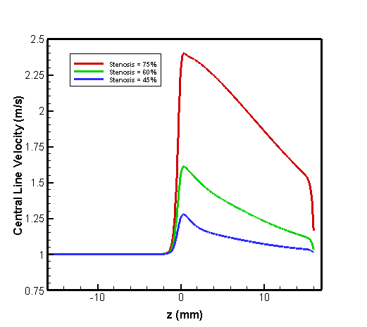 | 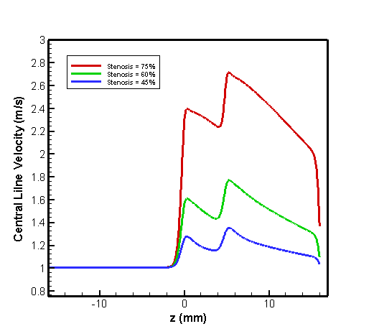
(a) | (b)
Fig. 7. Central line velocity for (a) Single stenosis (b) Double stenosis.

The central line velocity distribution at various section severity levels with regard to 75%, 60%, and 45% is displayed in Figure 7(a) and Figure 7(b) by Newtonian model. Here the stenosis length is fixed which is 2mm. The finding in the current figure indicates that the velocity at the center of the stenosis increased in magnitude as the degree of the stenosis increased. Figure 7(a) shows the central line velocity’s variety for the single stenosis with blockage of 45%, 60%, and 75% respectively.
Figure 7(b) displays the variation of velocity with respect to the z-axis for double stenoses when the distance between two stenoses is 3mm. We’ve seen that for the first stenosis, the graph is almost identical to Figure 7(a) but in the second stenotic region, the velocity is slightly higher than the first one. That means the central line velocity varies on stenosis severity and double or multiple stenosis. Thus, the severity of the stenosis and double or multiple stenosis are proportional to the central line velocity.

3.2 Central Line Pressure

Central line pressure is an important parameter in fluid dynamics, particularly in the context of stenosis in blood vessels. When considering stenosis, whether single or double, and the severity of the stenosis (45%, 60%, or 75%), the central line pressure can be affected differently based on whether the fluid is Newtonian or not. In Figure 8(a) and Figure 8(b), we can see the central line velocity graph for single stenosis and double stenosis, respectively, for Newtonian fluid. In the case of Newtonian fluids such as blood under normal physiological conditions, the relationship between pressure and flow rate is linear and follows the principles of classical fluid mechanics. When there's stenosis in a vessel, pressure drop across the stenotic region increases due to the stenosis, and this leads to changes in the central line pressure. The severity of stenosis affects the pressure drop across the stenotic region. Generally, as the severity of stenosis increases (from 45% to 60% to 75%), the pressure drop also increases, as we can see in Figure 8(a). This is due to the increased resistance to flow caused by the more severe stenosis, which requires higher pressure to maintain adequate flow downstream.
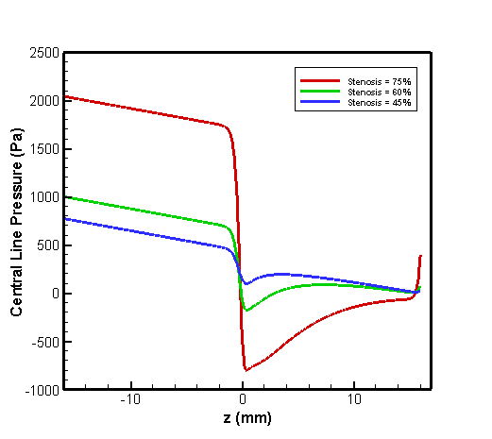  (a) | 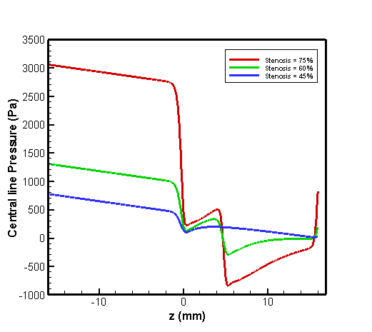  (b)
Fig. 8. Central line pressure for (a) Single stenosis (b) Double stenosis.

In the case of double stenosis, the effects are more complex, as the interaction between the two stenoses can influence the pressure distribution along the vessel. As we can see from Figure 8(b), for the first stenosis in two stenoses, the pressure drop is comparatively highest for the severity of 60%. But for the second stenosis, Figure 8(b) is slightly similar to Figure 8(a), where the pressure drop is highest for severity at 75%. As severity increases, central line pressure exhibits a proportional collapse due to heightened resistance to flow. Specifically, at 45% severity, central line pressure elevation is moderate, while at 75% severity, pressure elevation is more pronounced.

3.3 Wall Pressure

The investigation into wall pressure dynamics across single and double stenosis scenarios, with severities of 45%, 60%, and 75% in a Newtonian fluid, reveals nuanced hemodynamic responses. The wall pressure profile at various stenosis severity sections is displayed in Figure 9(a) at 75%, 60%, and 45%, with the blockage length remaining at 2 mm for single stenosis. For the 45% severity stenosis, the pressure distribution exhibited a gradual decrease in pressure within the stenotic region, peaking at the narrowest point, before gradually decreasing downstream. Similarly, for the 60% severity stenosis, we have observed a more pronounced decrease in pressure within the stenotic region, reflecting the heightened obstruction to flow. The 75% severity of stenosis displayed the most significant pressure drop within the stenotic region, indicative of severe flow restriction. Comparing these profiles, it is clear that pressure gradients along the vessel wall decrease in proportion to the severity of the stenosis.
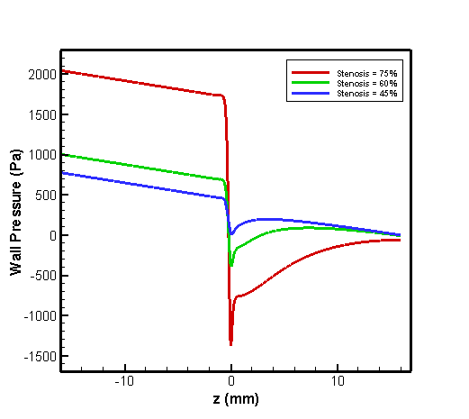 | 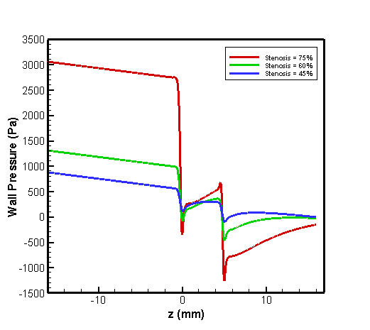
(a) | (b)
Fig. 9. Wall pressure for (a) Single stenosis (b) Double stenosis.

Figure 9(b) shows us the wall pressure distribution for double stenosis configurations with severity levels of 45%, 60%, and 75%, consistent blockage lengths of 2mm, and a fixed distance of 3mm between the two stenotic regions, for Newtonian fluid. We found clear pressure decreases in the vicinity of each stenosis at the 45% severity level, with a discernible increase in pressure in the space between the two stenotic regions. This surge may be explained by the flow recovering between the stenoses, but at a lower pressure because of the blockages' combined influence. As severity increased to 60%, the pressure gradients within and immediately downstream of each stenosis became more pronounced. The pressure drop between the stenoses remained evident, indicating the persistence of flow recovery despite heightened obstruction to flow. Additionally, the distance between the stenotic regions appeared to influence the pressure distribution, with pressure levels gradually recovering further downstream of the second stenosis. And, for 75%, the pressure drop seemed to be the maximum compared to other severity at the center of both stenoses.
Consequently, the pressure within the artery gradually lowers until it reaches the center of the stenosis, then sharply decreases in the middle of the stenosis, and then gradually increases until the end of the artery. Atherosclerotic processes are likely to occur in this regime, as indicated by the minimal pressure that occurs proximally downstream of the stenosis.

3.4 Wall Shear Stress

Vascular physiology and pathology are significantly influenced by the wall shear stress (WSS) profile. Shear stress is one of the key elements influencing the hydrodynamics of the artery coronary. Due to its direct correlation with the development of atherosclerosis, the distribution of the WSS is one of the most important hemodynamic characteristics. In the framework of a Newtonian fluid model, we investigated the finer details of wall shear stress distribution in single stenosis configurations, carefully looking at severity levels of 45%, 60%, and 75%, each in stenosis with a 2mm blockage length. Our investigation revealed a complex interaction between stenosis severity and the shear stress patterns along the artery wall. As shown in Figure 10(a), the pressure levels in the pre-stenotic region are nearly equal for each severity. The pre-stages of the obstruction do not cause significant changes to the values. We can see the shift in value as the pressure value moves toward the center of the stenosis. The figure
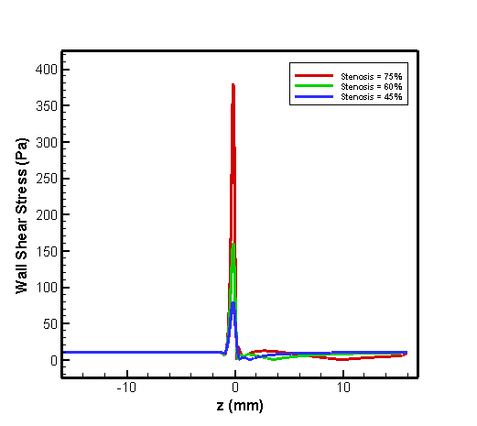 | 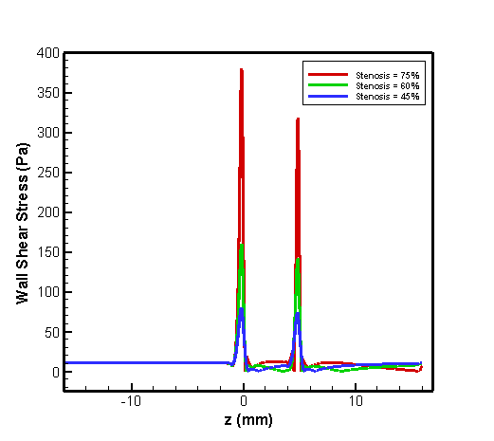
(a) | (b)
Fig. 10. Wall shear stress for (a) Single stenosis (b) Double stenosis.

shows that the wall shear stress reaches its highest value in the center of the stenosis. Observing the pressure readings outward from the center reveals a progressive decrease in the pressure value. According to the three curves shown in Figure 10(a), the wall shear stress is at its highest when the severity level is at its highest. Figure 10(a), thus reveals that the wall shear stress has reached its maximum of 75% and its minimum of 45%. The wall shear stress is directly proportional to the severity of stenosis when the length of the blockage remains constant.
From Figure 10(b), we can see that in the case of double stenosis, the wall shear stress graph of the first stenosis is almost identical to Figure 10(a). However, for the second stenosis, the wall shear stress profile seemed a bit lower compared to the first stenosis.
Hence, wall shear stress is proportionate to stenosis severity when blockage length is constant and inversely proportional to the double or more stenoses when the distance between two stenoses is fixed.

3.5 Inlet Pressure

Blood flow within arteries is determined by inlet pressure, sometimes referred to as upstream pressure. It affects the distribution of shear stress throughout the artery walls, as well as the direction and speed of blood flow. Flow patterns may be changed by variations in inlet pressure, which may have an impact on artery segments that are more likely to develop plaque and become blocked. Wall Shear Stress (WSS) is generated along the artery endothelium in part by inlet pressure.
Keeping the blockage length at 2 mm, Figure 11(a) displays the inlet pressure at various stenosis severity sections about 75%, 60%, and 45%. Every time, the inlet pressure is carefully assessed at the position (0, -16) to ensure a precise interpretation. The observation indicates that the pressure values at the inlet for 45%, 60%, and 75% stenosis severity are 773.49 pa, 1001.1 pa, and 2041.9 pa, respectively.
As shown in Figure 11(b), the simulation is repeated with identical severity for double stenosis at 45%, 60%, and 75%, respectively. Two stenoses are separated by 3 mm. For double stenosis, the corresponding inlet pressure results are 874.57 pa, 1304.5 pa, and 3055.6 pa.
It follows that when the number of stenoses increases and the stenosis severity value rises, pressure climbs progressively.
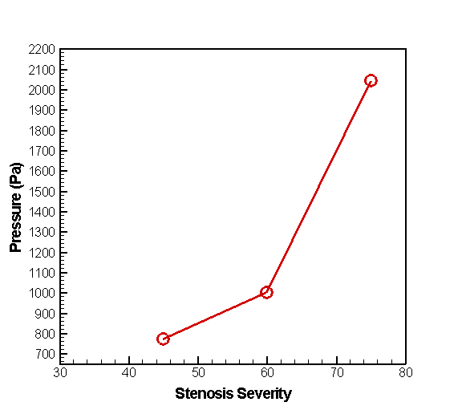 | 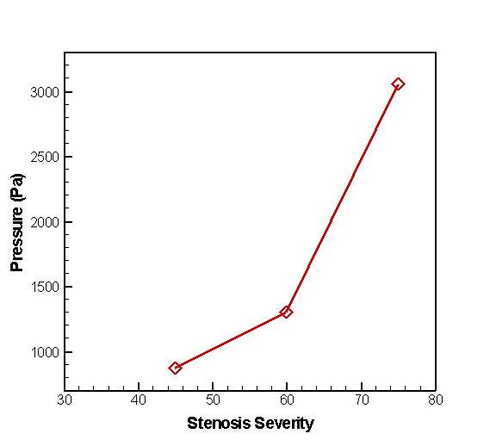
(a) | (b)
Fig. 11. Inlet pressure for (a) Single stenosis (b) Double stenosis.

3.6 Velocity Contour

A fluid's velocity field represented graphically is called a velocity contour. The fluid's variation in velocity at various sites in space is described by the velocity field in fluid dynamics. Velocity contours can be used to depict this variation. In this case, the specified velocity contours are plotted in two dimensions as colors, with each color denoting a distinct velocity value. It is simple to identify flow x denoting a distinct velocity value. It is simple to identify flow patterns by looking at their contours. Here, using computational fluid dynamics, these velocity contours are created at various sections for stenosis severity regarding 45%, 60%, and 75%, respectively, maintaining blockage length at 2 mm, and for double stenosis with the same severity at 45%, 60%, and75%, respectively, maintaining a constant distance of 3 mm between the two stenoses. Every diagram illustrates how the blockage reduces the blood flow region. The velocity value for this reduction is greater than twice the average velocity, as indicated by the red hue in each image's scale. The average velocity in this case is 0.5 m/s.

Fig. 12. Velocity contour (For single and double stenosis).

3.7 Pressure Contour

The distribution of pressure across the surface of an item submerged in a liquid is referred to as contour pressure. Blood flow can be interfered with by artery blockages. The pressure gradient along the artery alters as a result. The six illustrations and scales that follow illustrate how an upstream blockage causes the heart to pump blood at a higher pressure while a downstream blockage causes a drop in pressure because of a reduction in blood flow. Diagnosing and treating illnesses like coronary artery disease and atherosclerosis require an understanding of the impact of pressure contours caused by arterial obstruction.
The process of raising arterial pressure is explained by these six diagrams and each profile results in a lower blood flow to the tissues downstream. Blood flows away from the center, causing a high blood pressure restriction. Insufficient blood flow, or ischemia, can result in symptoms like pain, numbness, or tissue damage in the tissues that the obstruction artery supplies.
Fig. 13. Pressure contour (For single and double stenosis).

3.8 Axial Velocity

Blood flow through the coronary arteries can be measured using axial velocity measurement. To comprehend blood flow dynamics, it is essential to review coronary artery axial velocity. The axial velocity of the artery at various axial locations from the center to -8 mm, -6 mm, -4 mm, -2 mm, 0 mm, 2 mm, 4 mm, 6 mm, and 8 mm is displayed in the graphs below, which are derived using the Newtonian model. In axisymmetric situations, the velocity in the x direction is referred to as the axial velocity.
When there is a blockage or stenosis in the coronary artery, the graphs shown above at the given spot display distinct patterns that suggest the existence of the obstruction. Nevertheless, the forms of each graph might differ based on parameters such as the intensity and placement of the obstruction. In this experiment, the severity is set at 75% and the length of the blockage in the artery is 2 mm. A typical feature of a blockage in the coronary artery is a decrease in the speed of blood flow in the direction of the obstruction. Therefore, each graph above illustrates how the blood flow is affected by the narrowing in the artery, resulting in a drop in the velocity of the blood as it passes through the constricted route. The presence of blockage in the coronary artery can cause disturbed flow patterns, leading to irregular fluctuations in axial velocity over the length of the channel, as seen in the picture above. In general, the axial velocity graphs seen above when there is a blockage in the coronary artery usually demonstrate changes that reflect the hemodynamic effects of the obstruction, such as reduced velocity at specific regions away from the center.
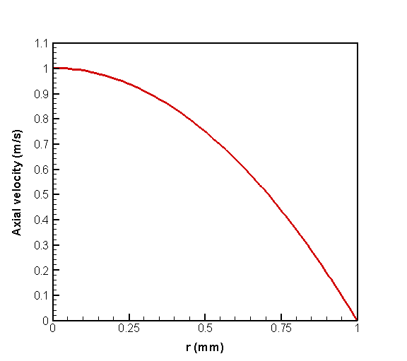 | 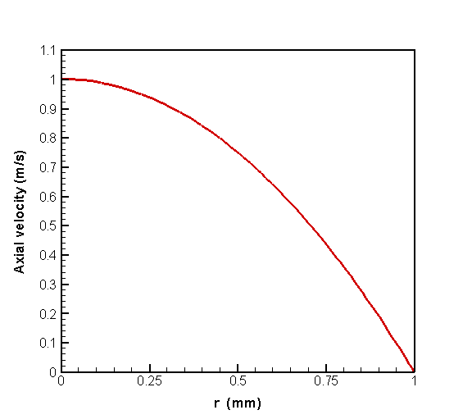
(a) | (b)
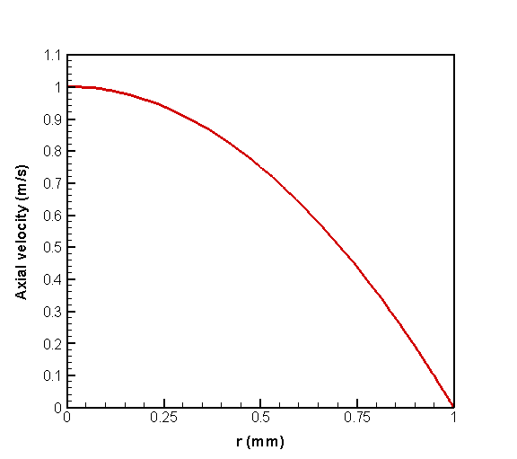 | 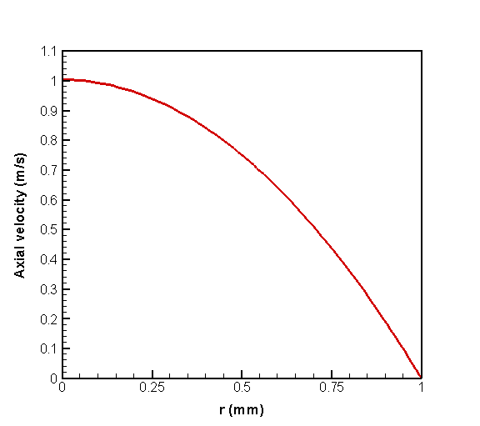
(c) | (d)
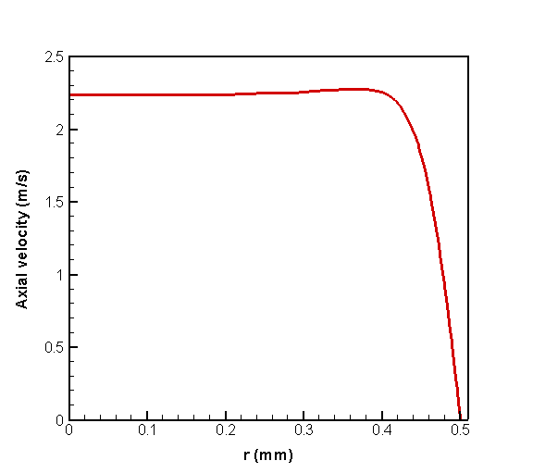 | 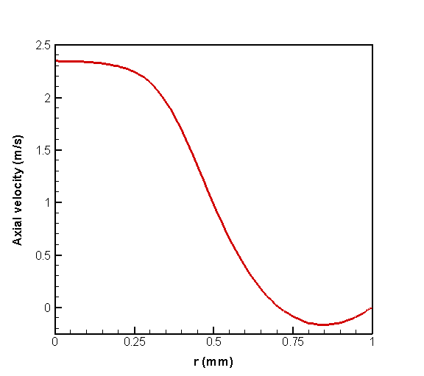
(e) | (f)
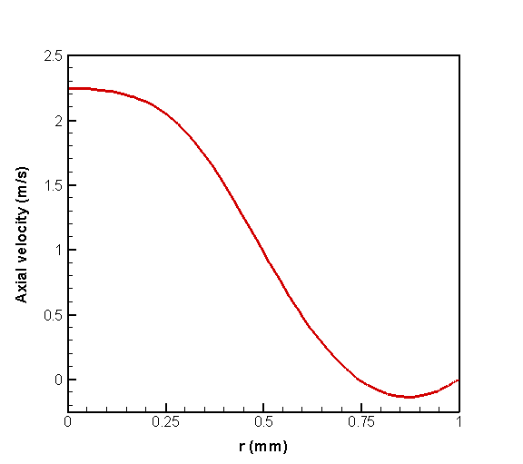 | 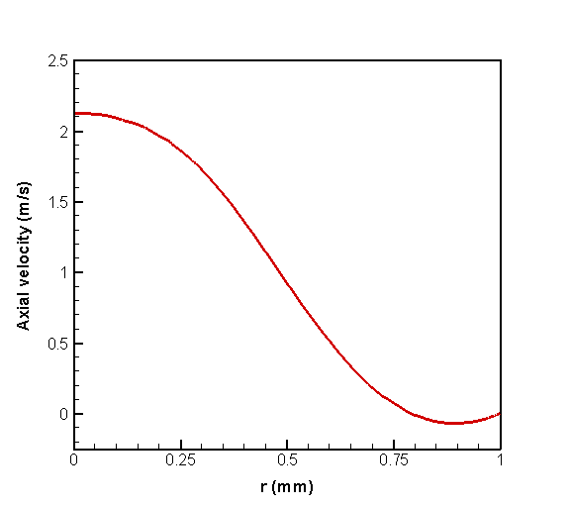
(g) | (h)
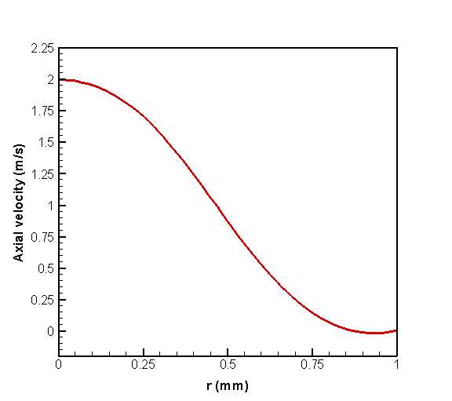
(i)
Fig. 14. Axial velocity at various points for severity 75% and length of the blockage is 2 mm (a) x = -8 (b) x = -6 (c) x = -4 (d) x = -2 (e) x = 0 (f) x = 2 (g) x = 4 (h) x = 6 (i) x = 8.

3.9 Streamline Velocity Indicating the Recirculation Zone

The velocity streamlines for a single stenosis of 75% severity are shown in Figure 15. The fluid's color changes from red to blue as it moves through the confined area, indicating a considerable increase in velocity. The continuity equation and Bernoulli's principle cause the highest velocity to occur at the narrowest portion of the stenosis. Downstream of the stenosis, a recirculation zone where reverse flow takes place is apparent. The reattachment point is further
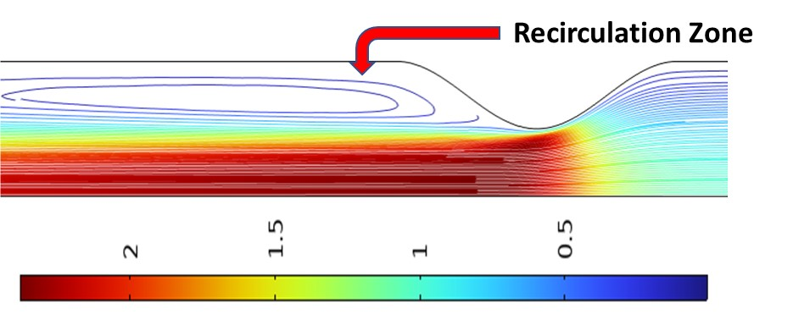
Fig. 15. Stream Line (Sigle Stenosis)

downstream, while the separation point is before the stenosis exit. The recirculating flow zone, which is frequently seen in cases of high-severity stenosis, is highlighted by the blue contour lines. In the downstream area, turbulent flow and vortex formation are caused by the restriction brought on by stenosis. Damage to the artery wall and subsequent plaque development can be caused by high shear stress at the stenosis and disrupted flow in the post-stenotic area. The velocity streamline plot for double stenosis with 75% severity in both stenoses from Figure 16
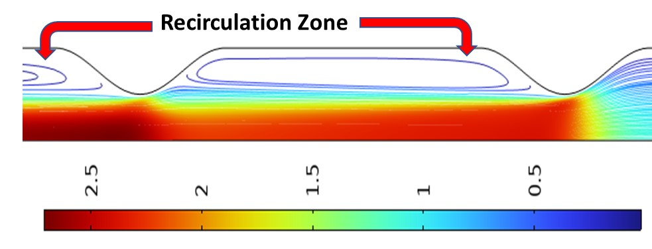
Fig. 16. Stream Line (Double Stenosis)

illustrates significant flow acceleration, multiple recirculation zones, and turbulent regions due to the presence of two constrictions. As the fluid enters the first stenosed region, velocity increases sharply, forming a high-velocity jet at the throat, followed by flow separation and a recirculation zone downstream. The second stenosis further accelerates the flow, generating another high-velocity region and a larger recirculation zone beyond it, as indicated by the blue contour lines. Compared to a single stenosis, the presence of two consecutive constrictions intensifies flow disturbances, leading to prolonged turbulence, higher shear stress variations, and a more extended disturbed flow region, which can increase the risk of endothelial damage and cardiovascular complications.

3.10 Separation Point, Reattachment Point and Recirculation Length

Separation point, reattachment point, and recirculation length are key concepts used to describe flow separation and reattachment, often observed in boundary layer flows over stenosis. For single stenosis with 45% severity, the disturbed flow dynamics lead to flow separation at 0.48 mm and reattachment at 1.47 mm, resulting in a recirculation length of 0.99 mm. This localized flow disturbance, caused by the narrowing, induces a recirculation region that can alter shear stress distribution and contribute to hemodynamic changes which is shown in Figure 17(a). Higher flow disruption is indicated by a longer recirculation region and an upstream shift in the separation point as the degree of stenosis increases. The recirculation length increases to 3.20 mm with 60% severity, as illustrated in Figure 17(b), while the separation point shifts upstream to 0.30 mm and the reattachment point extends to 3.50 mm. For 75% stenosis, the flow splits even earlier at 0.20 mm in Figure 17(c), and it reattaches far downstream at 9.50 mm, resulting in a recirculation length of 9.30 mm. Higher stenosis severity appears to cause recirculation zones to be much wider and separate early, which can raise turbulence, shear stress fluctuations, and the risk of additional vascular problems. Figure 17(d) illustrates how the existence of two stenotic sections results in two separate recirculation zones, each of which affects the local flow dynamics in the case of double stenosis with 45% severity. The recirculation length for the first stenosis is 0.98 mm, with flow separation occurring at 0.48 mm and reattaching at 1.46 mm. The second stenosis has a recirculation length of 1.01 mm because detachment happens significantly later at 5.48 mm and reattachment at 6.49 mm. Double stenosis introduces more disturbed flow regions than a single stenosis, which may increase turbulence and flow instability. In Figure 17(e), the case of double stenosis with 60% severity, two distinct recirculation zones form, significantly altering the flow dynamics. For the first stenosis, separation occurs at 0.30 mm, with reattachment at 3.45 mm, leading to a recirculation length of 3.15 mm. In the second stenosis, flow separates at 5.31 mm and reattaches at 8.79 mm, creating a recirculation length of 3.48 mm. Compared to double stenosis with 45% severity, the recirculation regions are longer
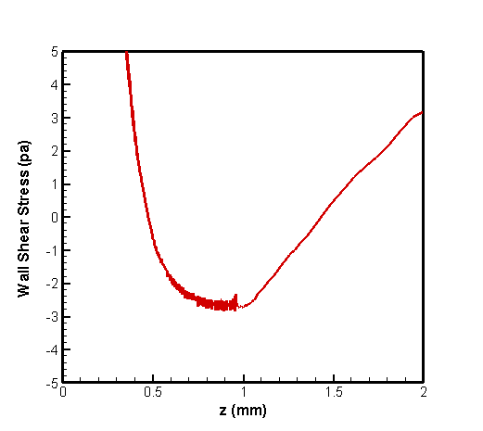 | 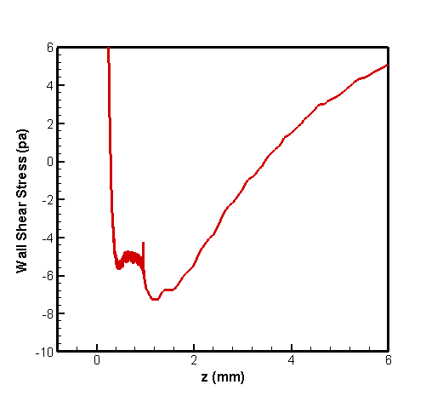
(a) | (b)
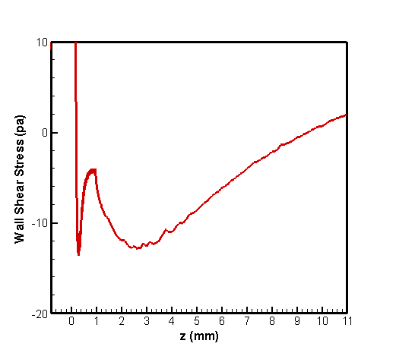 | 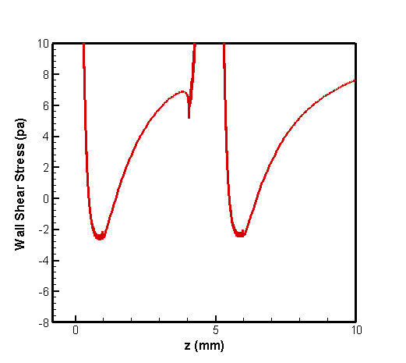
(c) | (d)
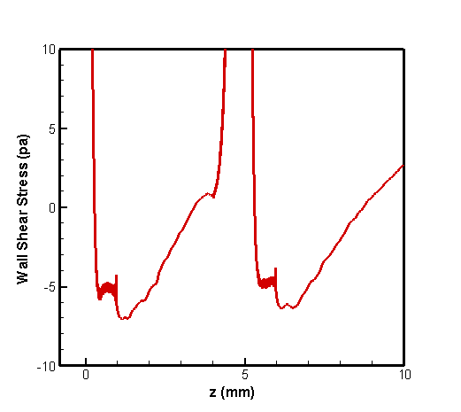 | 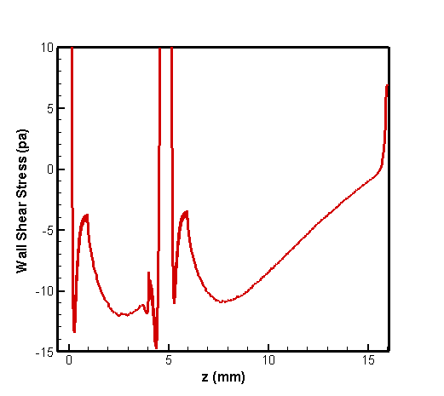
(e) | (f)
Fig. 17. Separation point and reattachment point (a) single stenosis with 45% severity (b) single stenosis with 60% severity (c) single stenosis with 75% severity (d) double stenosis with 45% severity (e) double stenosis with 60% severity (f) double stenosis with 75% severity

and more pronounced, indicating greater flow disruption. The increased separation length suggests a higher degree of turbulence and shear stress variations, which may contribute to more severe hemodynamic consequences, such as endothelial damage and potential plaque progression. For double stenosis with 75% severity, the flow experiences significant disturbances with larger recirculation regions due to the severe narrowing. From Figure 17(f), we have seen In the first stenosis, separation occurs at 0.20 mm, and reattachment happens at 4.56 mm, resulting in a recirculation length of 4.36 mm. In the second stenosis, flow separates at 5.21 mm and reattaches at 15.65 mm, leading to a recirculation length of 10.44 mm. Compared to 60% and 45% stenosis, these recirculation zones are much longer, indicating increased turbulence and flow instability. The extended disturbed flow regions may elevate shear stress variations and pressure drops, which could contribute to endothelial damage, thrombus formation, and a higher risk of cardiovascular complications.

Table 1
Separation point, reattachment point and recirculation length for single and double stenosis at various stenotic intensity
Cases | Separation point | Reattachment point | Recirculation length
45% (Single Stenosis) | 0.48 | 1.47 | 0.99
60% (Single Stenosis) | 0.30 | 3.50 | 3.20
75% (Single Stenosis) | 0.20 | 9.50 | 9.30
45% (Double Stenosis) | For First Stenosis
45% (Double Stenosis) | 0.48 | 1.46 | 0.98
45% (Double Stenosis) | For Second Stenosis
45% (Double Stenosis) | 5.48 | 6.49 | 1.01
60% (Double Stenosis) | For First Stenosis
60% (Double Stenosis) | 0.30 | 3.45 | 3.15
60% (Double Stenosis) | For Second Stenosis
60% (Double Stenosis) | 5.31 | 8.79 | 3.48
75% (Double Stenosis) | For First Stenosis
75% (Double Stenosis) | 0.20 | 4.56 | 4.76
75% (Double Stenosis) | For Second Stenosis
75% (Double Stenosis) | 5.21 | 15.65 | 10.44

4. Conclusions
The investigation into the steady laminar flow of Newtonian fluid through single and double stenosis, with severities of 45%, 60%, and 75%, unfolds a complex relationship between the shape of blood vessels and the movement of fluid. This relationship is fundamental to understanding the development of arterial disorders. As the severity of stenosis varies, the flow dynamics show minimal variations that become more noticeable as the obstruction severity increases. The changes can be observed in complex velocity profiles, where areas of flow acceleration and deceleration form near and far from the narrowed region, respectively. These changes affect the pressure gradients and wall shear stresses along the vessel wall. An especially noteworthy phenomenon is the presence of flow separation occurring downstream of the stenosis. The constricted portion experiences a higher wall shear stress when the constriction is more severe than a smaller constriction. In the event of double stenosis, the second stenosis experiences quite lower wall shear stress than the first. This is when the flow disconnects from the vessel wall, leading to the formation of recirculation zones, and then reattaches farther downstream. Additionally, for single stenosis, the results show that the recirculation length increases dramatically (0.99 mm for 45% stenosis, 3.20 mm for 60%, and 9.30 mm for 75%), the detachment point moves upstream, and the reattachment point shifts downstream as the severity of the stenosis increases. Compared to single stenosis, a second recirculation zone with bigger and longer disrupted flow areas is seen in the case of double stenosis. As severity increases, the recirculation lengths of the first and second stenoses show clear separation and reattachment sites which include 4.76 mm and 10.44 mm for 75% severity. This phenomenon is exacerbated by more severe stenosis, resulting in increased hemodynamic stresses that may contribute to endothelial dysfunction and the development of plaque. In addition, the presence of double stenosis intensifies these disruptions in blood flow. The interaction between neighboring narrowed regions creates intricate flow patterns consisting of secondary vortices and flow jets. This adds another layer of complexity to the comprehension of the local blood flow dynamics. Inlet pressures are 773.49 Pa, 1001.1 Pa, and 2041.9 Pa for single stenosis with severity levels of 45%, 60%, and 75%, respectively. For the same severity levels, inlet pressures have been expanded to 874.57 Pa, 1304.5 Pa, and 3055.6 Pa in the double stenosis design. According to the study, inlet pressure is considerably raised by both the existence of numerous stenoses and the severity of stenosis. These observations emphasize the significance of thorough hemodynamic analysis in understanding the causes of vascular diseases and guiding the creation of advanced diagnostic tools and personalized treatment plans for patients. This research investigates the complex connection between geometric variables and flow dynamics. It aims to develop better methods for assessing risk and individualized management strategies to slow down the evolution of cardiovascular diseases and improve patient outcomes.

Disclaimer (Artificial Intelligence)

Authors hereby declare that no generative AI technologies such as Large Language Models (ChatGPT, COPILOT, etc.) and text-to-image generators have been used during the writing or editing of this manuscript.

Competing Interests
Authors have declared that no competing interests exist.
References
- Sulženko, Jakub, and Piotr Pieniazek. "The cardiovascular risk of patients with carotid artery stenosis." Cor et Vasa 60, no. 1 (2018): e42-e48. https://doi.org/10.1016/j.crvasa.2017.09.006
- Bit, Arindam, Adel Alblawi, Himadri Chattopadhyay, Qurratul Ain Quais, Ali Cemal Benim, Mohammad Rahimi-Gorji, and Hoang-Thinh Do. "Three dimensional numerical analysis of hemodynamic of stenosed artery considering realistic outlet boundary conditions." Computer Methods and Programs in Biomedicine 185 (2020): 105163. https://doi.org/10.1016/j.cmpb.2019.105163
- Mohajan, Devajit, and Haradhan Kumar Mohajan. "A Mathematical Modeling of Newtonian Blood Flow Through Arterial Mild Stenosis." Innovation in Science and Technology 3, no. 6 (2024): 12-22.
- Tyfa, Zbigniew, Damian Obidowski, Piotr Reorowicz, Ludomir Stefańczyk, Jan Fortuniak, and Krzysztof Jóźwik. "Numerical simulations of the pulsatile blood flow in the different types of arterial fenestrations: Comparable analysis of multiple vascular geometries." Biocybernetics and Biomedical Engineering 38, no. 2 (2018): 228-242. https://doi.org/10.1016/j.bbe.2018.01.004
- Rajmane, Swapnil Narayan, and Shaligram Tiwari. "Numerical simulation of pulsatile blood flow through eccentric double stenosed carotid artery." International Journal of Numerical Methods for Heat & Fluid Flow 34, no. 3 (2024): 1323-1350. https://doi.org/10.1108/HFF-07-2023-0373
- Zaperi, Nur Husna Amierah Mohd, and Nurul Aini Jaafar. "Solute Dispersion in Casson Blood Flow through an Artery with the Effect of Electric Field." Journal of Research in Nanoscience and Nanotechnology 9, no. 1 (2023): 13-34. https://doi.org/10.37934/jrnn.9.1.1334
- Song, Peige, Zhe Fang, Hanyu Wang, Yutong Cai, Kazem Rahimi, Yajie Zhu, F. Gerald R. Fowkes, Freya JI Fowkes, and Igor Rudan. "Global and regional prevalence, burden, and risk factors for carotid atherosclerosis: a systematic review, meta-analysis, and modelling study." The Lancet Global Health 8, no. 5 (2020): e721-e729.
- Khalil, A. A., Alaarag, A. F., Elshedoudy, S. A., & Eldein, S. M. S. “Speckle tracking as predictor of coronary artery disease in diabetic female with acute chest pain.” Cardiology and Angiology: An International Journal 11, no. 4 (2022): 55–67.
https://doi.org/10.9734/ca/2022/v11i430207
- Awan, Aziz Ullah, Muhammad Hasnain Shahzad, Sohail Nadeem, Haneen Hamam, N. Ameer Ahammad, and Aleeza Arshad. "Investigation of Sutterby fluid flow through elliptic multi-stenosed artery: analytical solutions of blood flow problem." Multidiscipline Modeling in Materials and Structures 21, no. 1 (2025): 199-216. https://doi.org/10.1108/MMMS-07-2024-0209
- Bellien, Jérémy, Michele Iacob, Vincent Richard, Julien Wils, Veronique Le Cam-Duchez, and Robinson Joannidès. "Evidence for wall shear stress-dependent t-PA release in human conduit arteries: role of endothelial factors and impact of high blood pressure." Hypertension Research 44, no. 3 (2021): 310-317.
- Ku, David N., Don P. Giddens, Christopher K. Zarins, and Seymour Glagov. "Pulsatile flow and atherosclerosis in the human carotid bifurcation. Positive correlation between plaque location and low oscillating shear stress." Arteriosclerosis: An Official Journal of the American Heart Association, Inc. 5, no. 3 (1985): 293-302. https://doi.org/10.1161/01.ATV.5.3.293
- Zhong, Liang, Jun-Mei Zhang, Boyang Su, Ru San Tan, John C. Allen, and Ghassan S. Kassab. "Application of patient-specific computational fluid dynamics in coronary and intra-cardiac flow simulations: Challenges and opportunities." Frontiers in physiology 9 (2018): 742. https://doi.org/10.3389/fphys.2018.00742
- Azizan, Farah Liyana, Saratha Sathasivam, Muraly Velavan, Nur Rusyidah Azri, and Nur Iffah Rafhanah Abdul Manaf. "Prediction of drug concentration in human bloodstream using Adams-Bashforth-Moulton method." Semarak Engineering Journal 4, no. 1 (2024): 29-46. https://doi.org/10.37934/sej.4.1.2946b
- Morris, Paul D., Andrew Narracott, Hendrik von Tengg-Kobligk, Daniel Alejandro Silva Soto, Sarah Hsiao, Angela Lungu, Paul Evans et al. "Computational fluid dynamics modelling in cardiovascular medicine." Heart 102, no. 1 (2016): 18-28. https://doi.org/10.1136/heartjnl-2015-308044
- Lee, Jen-Shih, and Yuan-Cheng Fung. "Flow in locally constricted tubes at low Reynolds numbers." Journal of Applied Mechanics 37, no. 1 (1970): 9-16. https://doi.org/10.1115/1.3408496
- Sherwin, Spencer J., and Hugh M. Blackburn. "Three-dimensional instabilities and transition of steady and pulsatile axisymmetric stenotic flows." Journal of Fluid Mechanics 533 (2005): 297-327. https://doi.org/10.1017/S0022112005004271
- Buradi, Abdulrajak, and A. Mahalingam. "Numerical simulation of pulsatile blood flow in an idealized curved section of a human coronary." Int. J. Mech. Prod. Eng 2016 (2016): 15-19.
- M. Slim, A., Fentanes, E., M. Thomas, D., N. Slim, J., Triana, T., R. Ahmadian, H., J. McDonough, R., Saucedo, J., J. Suarez, N., Pearce-Moore, D., Kirchner, H. L., Hulten, E., C. Cury, R., & Branch, K. “Aspirin and plavix following coronary artery bypass grafting (ASAP-CABG): A randomized, double-blind, placebo-controlled pilot trial.” Journal of Advances in Medicine and Medical Research 14, no. 3 (2016): 1–10.
https://doi.org/10.9734/BJMMR/2016/24386
- Talukder, N., P. E. Karayannacos, R. M. Nerem, and J. S. Vasko. "An experimental study of the fluid dynamics of multiple noncritical stenoses." (1977): 74-82. https://doi.org/10.1115/1.3426276
- Kumar, Adarsh, and Usha Awasthi. "A mathematical model for blood flow in a multiple stenosis artery." Int. J. Math. Analysis 4, no. 50 (2010): 2465-2472.
- Verma, Vipin Kumar, and Praveen Saraswat. "Effect of multiple stenosis on blood flow through a tube." International Journal of Biology and Biomedical Engineering 7 (2013): 753-756.
- Wei, L. "Numerical study of steady and pulsatile flow through stenosed tube." Ph. D. Thesis (2004).
- Mittal, R., S. P. Simmons, and H. S. Udaykumar. "Application of large-eddy simulation to the study of pulsatile flow in a modeled arterial stenosis." J. Biomech. Eng. 123, no. 4 (2001): 325-332. https://doi.org/10.1115/1.1385840
- Bernad, Sandor I., Elena S. Bernad, Marius Craina, Izabella Sargan, Alin Totoran, and Cosmin Brisan. "Particle depositions and related hemodynamic parameters in the multiple stenosed right coronary artery." Journal of clinical medicine research 4, no. 3 (2012): 177. https://doi.org/10.4021/jocmr843w
- Sohn, Hyun-Chull, Haeng-Nam Lee, and Gil-Moon Park. "A study of the flow characteristics of developing turbulent pulsating flows in a curved duct." Journal of mechanical science and technology 21 (2007): 2229-2236. https://doi.org/10.1007/BF03177484
- Lee, T. S., Wei Liao, and H. T. Low. "Numerical simulation of turbulent flow through series stenoses." International journal for numerical methods in fluids 42, no. 7 (2003): 717-740. https://doi.org/10.1002/fld.550
- Lee, T. S., Wei Liao, and H. T. Low. "Numerical study of physiological turbulent flows through series arterial stenoses." International journal for numerical methods in fluids 46, no. 3 (2004): 315-344. https://doi.org/10.1002/fld.755
- Chauhan, A., and C. Sasmal. "Effect of real and whole blood rheology on flow through an axisymmetric stenosed artery." International Journal of Engineering Science 169 (2021): 103565. https://doi.org/10.1016/j.ijengsci.2021.103565

