Multi-scale sedimentological and structural characterization of Triassic Siliciclastic systems in the Tim Mersoï Basin, Northern Niger)
Abstract: The present study on the Triassic siliciclastic systems of the Tim Mersoï basin aims to characterize the sandstones of this formation from a sedimentological and structural perspective. The study area covered by this work corresponds to the central part of the basin and extends from the Goufat sector (Agadez) to the Dajy-Azélik zone. This area is very interesting because it corresponds to the part where the Téloua formation is most exposed. The methodology used in this study consisted of fieldwork to map this formation, followed by laboratory work combining microscopic analysis (optical, SEM, and microprobe). The mapping showed that the Téloua formation outcrops discontinuously in a generally NS direction. Three recognized lithological units were identified (Téloua1, Téloua2, and Téloua3). Sedimentological analysis carried out through boreholes revealed significant variations in thickness and facies. Macroscopic and microscopic examination made it possible to identify the different petrographic facies of each lithological unit. For the Téloua 1 unit: three (3) facies have been identified. These are Quartzarénite, Arkose, and arkose-lithics. For Téloua 2: two (2) facies have been identified, namely quartzarenite and litharenite. And for Téloua 3: three facies have been identified, corresponding to quartzarenite, litharenite, and analcimolite. From a structural point of view, the Téloua formation has shown the existence of brittle and mixed tectonics. The microstructural analysis carried out showed that the Téloua sandstones exhibit bands of cataclastic and non-cataclastic deformation, with reactivation phenomena that may promote fluid circulation and mineralization trapping.
Keywords: Siliciclastic systems, Multiscale analysis, Teloua Formation, Tim Mersoï Basin.
1. Introduction
The Paleo-Mesozoic Tim Mersoï Basin is located in the northeastern part of the Iullemmeden Basin and is bounded to the east by the Aïr Mountains (Figure 1). According to [1], the thickness of the Tim Mersoï Basin fill is approximately 1,800 m. Detrital materials were deposited during the period from the Devonian (410 Ma) to the Lower Cretaceous (96 Ma) [2]. This basin, located on a stable lithosphere, could be a very good example of an intracratonic basin with a low average subsidence rate preserved over a long period [3]-[4]. For several years, the Tim Mersoï basin has been the subject of uranium exploration and mining campaigns. This basin has undergone several cycles of filling that have 0r. The main studies concerning the geological formations of this basin have focused on the main host formations of Carboniferous uranium mineralization (Guézouman, Tarat, and Madaouéla) [1, 3, 4, 6, 7, 8, 9] and Jurassic (Tchirezrine2) [2, 4, 9]. In recent years, new research undertaken in the Dajy sector has revealed very high-grade uranium mineralization in Triassic sediments. Given that significant uranium potential remains to be evaluated within the Tim Mersoï basin, but also the need to understand the sedimentological and structural mechanisms involved in the genesis of mineralization in this basin, it is imperative to carry out more specific studies. This is the focus of the present research. This study aims to carry out a multi-scale sedimentological and structural characterization of the siliciclastic systems of the Triassic-Jurassic sediments of this basin. This, therefore, involves studying sedimentary rocks composed mainly of quartz particles and other silicate minerals at different scales of observation (microscopic, field, and regional). This characterization will enable us to understand the origin, transport, and deposition of these sediments, as well as the geological processes that have affected them. This work, therefore, requires an integrated approach to sedimentology and structural geology, combining field observations, laboratory analysis, and interpretation of available geological data.
The purpose of this study is to provide an overview of the mechanisms or factors that explain the tectono-sedimentary history of this basin during this period. Concerning the sedimentary infilling, emphasis is placed on the outcropping series. Then, the tectono-sedimentary study requires the use of appropriate methods to access subsurface information. To answer all these questions, we adopted a multidisciplinary approach by integrating geological mapping, borehole and well log data analysis, tectonic, and microtectonic analysis. In a specific way, it involves:
- a structural analysis that will allow us to characterize Triassic tectonic events;
- a characterization of the syn-sedimentary and post-tectonic markers;
- Geological setting
The Paleo-Mesozoic Tim Mersoï basin geological history begins as early as the Cambrian in the Tin Séririne Syncline [10]. Subsequently, the sedimentation areas moved southward, resulting in the deposition of continental and marginal-littoral detrital formations ranging from Cambrian to Miocene (Figure 1). Along the western edge of the Aïr, these detrital formations exhibit stratigraphic bevels (Figure 2) from the Devonian to the Jurassic [11]. The Tim Mersoï basin is characterized by a sedimentary infilling, resting unconformably on the ante-Cambrian basement (Figure 2). The basin was infilled during three successive cycles, including: Carboniferous cycle, the Permo-Triassic to Jurassic one, and the Lower Cretaceous.
The first sedimentary cycle is characterized by the continental shelf facies, directly delivered from the NE from the Aïr, while the second, also platform-dominated, received contributions from the SSW.
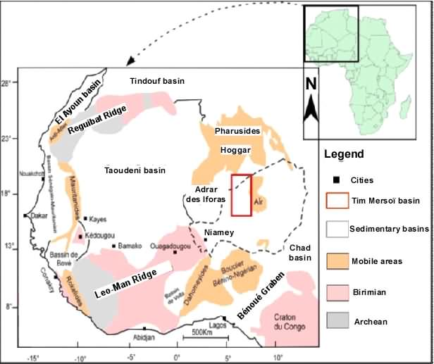
Figure 1: Geological map of West Africa showing the position of the Tim Mersoï basin (from [12], modified).
The third cycle is represented by a clayey to sandy-clayey floodplain extending from the west to the center of the previous deposition area, which was gradually uprising in size [6]-[11].
According to [13], several deformations affect the sedimentary infilling. These reflect the attenuation in the sedimentary deposits of the setback sets of the underlying basement. Three main directions of faults have been highlighted:
a) The N0° trending Lineament of In-Azaoua-Arlit and the N30° trending fault system of Madaouéla. All exploited uranium deposits are located on the eastern compartment of the Arlit Fault; however, uranium deposits have also been recently discovered in the western compartment [4].
The Madaouéla N30° fault system is expressed in the basement and in the sedimentary cover in the form of flexure. These accidents are spaced twenty kilometers apart. The most important are the Madaouéla (sector of Arlit) and Adrar-Emoles (sector of DASA) trending faults.
b) The N130° to N140° trending faults represent the main fault system that affects the Aïr Mountain. In the sedimentary series, these directions are more or less expressed. The Arlit fault is associated with several N150° striking faults in the Arlit mining area [4].
c) The N70° to N80° trending faults cut the basement intensively and also spread into the sedimentary deposits. The N70° trending faults are reactivated in dextral strike-slip movement during the Upper Cretaceous [14]. At the regional scale, the N70° trending faults network plays a fault-damping role on the N30° faults [3].
The DASA graben, which means "Dajy Surface Anomaly", is located within the Adrar Emoles 3, claim block in the Eastern part of the Azélik dome. Adrar Emoles 3 covers an area of 121,3 km². It is located between latitudes 7°40'00 "and 7°53'00" and longitudes 17°51'14 "and 17°45'30". From a stratigraphic point of view, all known sedimentary series in the Tim Mersoï basin are represented in the study area as well. These are Carboniferous, Permian, Triassic, Jurassic, and Cretaceous series (Figure 2). The main faults observed are the N70° fault, the N30° fault, and secondary faults N130° to N150° trending and E-W striking (Figures 2 and 3).
The two N70° major faults observed in the study area belong to the same system as the Tin Adrar N70° striking fault system, which is well represented in the Arlit region [14]. Most of the works carried out in the Tim Mersoï basin so far have focused on the tectono-sedimentary evolution of the basin and the uranium metallogeny [1, 4, 5, 6, 14, 15, 16, 17]. The troughs formed in this Tim Mersoï basin have been very little studied [14, 16].
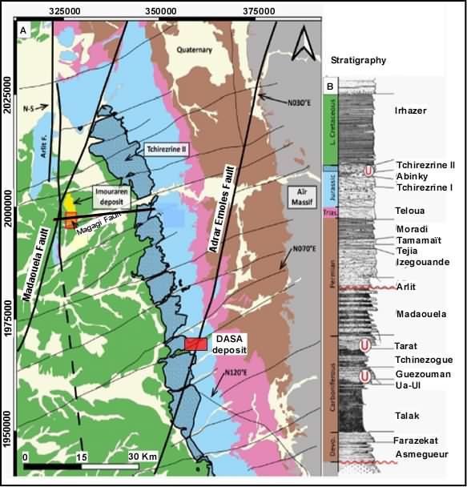
Figure 2: Geological map of the Tim Mersoï basin showing the main faults and the extent of the Triassic formations ([17], modified).
- Methodological approach
A multidisciplinary approach has been implemented in this study. It is based on:
(1) Geological mapping of the DASA sector is based on the combined use of satellite imagery and field observations. Ten sections were made along the axis of the study area. The use of the MapInfo software enabled the correlation of the collected data, resulting in a geological map of this sector.
(2) Tectono-sedimentary analysis is based on core drilling, cross sections, and well log data analysis. We have used some of the borehole data to perform a model of the structural evolution of the study area.
(3) To conduct the microtectonic analysis, we have chosen on the satellite imagery the stations where outcrops are well preserved. The microtectonic station is characterized by a population of microfaults, including 8 to 10 measurements. Nearly 150 striated microfault planes were analyzed.
(4) Microscopic analysis, cathodoluminescence analysis, and MEB analysis were made based on the feel works.
- Results
The formations covered by this study are located higher up in the stratigraphic column of the Tim Mersoï basin. These are the formations of the Agadès series, which range from the Triassic (Téloua sandstone) to the Jurassic (Assaouas clay-sandstone). The results of this study consist of:
- Sedimentological analysis,
- And structural analysis.
- Sedimentological analysis of Triassic sediments
4.1.1 fieldwork
From a sedimentological point of view, the Triassic formations of the Tim Mersoï basin are represented by the Téloua formations (Téloua 1, 2, and 3) and the Mousseden formation, with varying thicknesses (approximately 180 m for Téloua and 10 to 30 m for Mousseden). Sedimentological analysis was carried out by observing outcrops, core samples, and thin sections. It should be noted that the Triassic formations belong to two sedimentary series:
- The Aguelal series (60 m thick), formed by Téloua I sandstones, which are fine sandstones from an aeolian environment (desert environment). These foreshadow the thick sandstone series of the Agadès group, which fills the basin during the Triassic and Jurassic periods.
- The Goufat series (130 m thick), consisting at the base of feldspathic sandstones (Téloua II), overlain by variegated sandstones (Téloua III) rich in analcime, then by a final clayey layer containing conglomerate intercalations (Mousseden). The Goufat series was deposited in a fluvial-lacustrine environment, characterized by aerial volcanic inputs (the source of the analcime).
In order to better understand the sedimentological characteristics of Triassic sediments, geological mapping was carried out (Fig. 3). Analysis of the geological map of the Dajy area shows that, like the other underlying formations in the basin, the Triassic formations are oriented more or less NS with areas of outcrop and disappearance linked to the functioning of various tectonic accidents that affected the basin (Fig. 3).
It should be noted that a macroscopic analysis was first carried out, both in the field and on core samples, which enabled thin sections to be prepared for microscopic studies. The various thin sections were studied under an optical microscope and using cathodoluminescence. Subsequently, the sections of interest were studied using SEM.
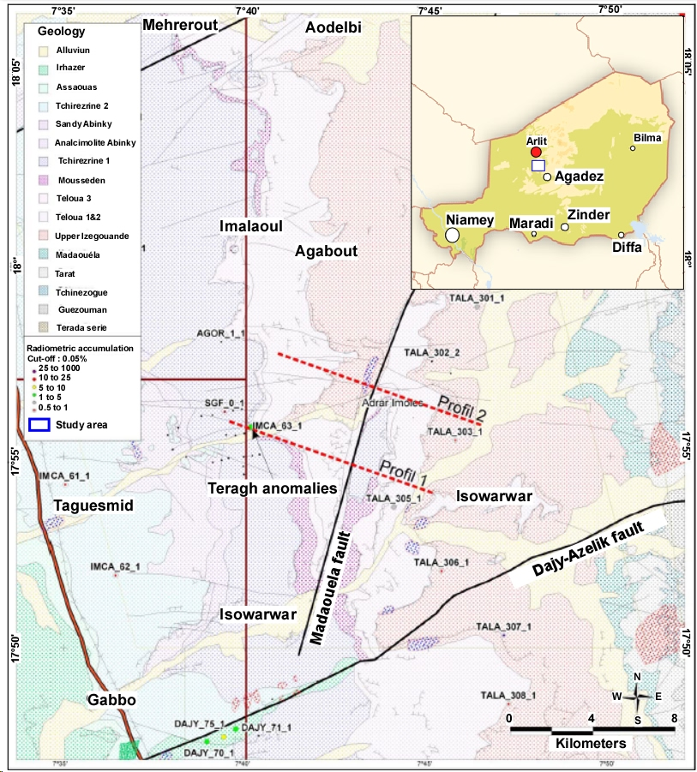
Figure 3: Geological map showing the distribution of Triassic formations and the study area located on the Niger map.
Fieldwork has shown that this formation, known as Téloua, consists of medium to coarse continental sandstone, begins with a conglomerate level (Anou Mélé conglomerate), and is subdivided into three units:
- Téloua 1: Observation of an outcrop of this unit in the Dajy sector shows that it consists of medium to coarse, isogranular, light gray, sometimes reddish sandstone with siliceous cement. From the point of view of the sedimentological organization of the deposits, a succession of fine to medium-grained white or yellow sandstone levels without cement and coarse red sandstone with analcime cement overlying conglomerate levels has been observed. This forms a positive sequence of deposits. From a mineralogical composition perspective, this unit consists mainly of quartz, rare feldspars, and analcime. In the Dajy sector, this unit shows the presence of black spots (possibly organic matter). The top of the unit consists of fine isogranular sandstone with dull, rounded quartz grains and heterogeneous grain sizes. Oblique stratification in overlapping spoon shapes has been observed. Scattered quartz pebbles have also been observed towards the base of this unit (Fig. 4).
(ii) Teloua 2: Within the Tim Mersoï basin, the Teloua 2 unit is identified in the southern zone, north of the Tchililt fault and the Togga ridge. To the north, this unit barely extends beyond the Ibadanan flexure, the Arlit fault, and the Madaouéla fault. The thick layers observed are generally NS and NE-SW. The maximum thickness thus identified is found in the axis of the Adrar Emolès structure near the Arlit lineament. The isopachs of this unit clearly show the N70° directions affecting this unit. From a petrographic facies perspective, this unit consists of medium to coarse, feldspathic, greenish-gray to yellowish sandstone with clay and analcime cement. The description of the core samples revealed that this unit contains greenish lenses of analcime (Fig. 5).
(iii) Teloua 3: This unit overlies the underlying Téloua 2 (Fig. 4) unit (consisting of feldspathic sandstone). It consists of colorful sandstone rich in analcime (Fig. 5), followed by a final clayey layer containing conglomerate intercalations (Mousseden). The sediments of this unit are characterized by aerial volcanic deposits (source of the analcime).
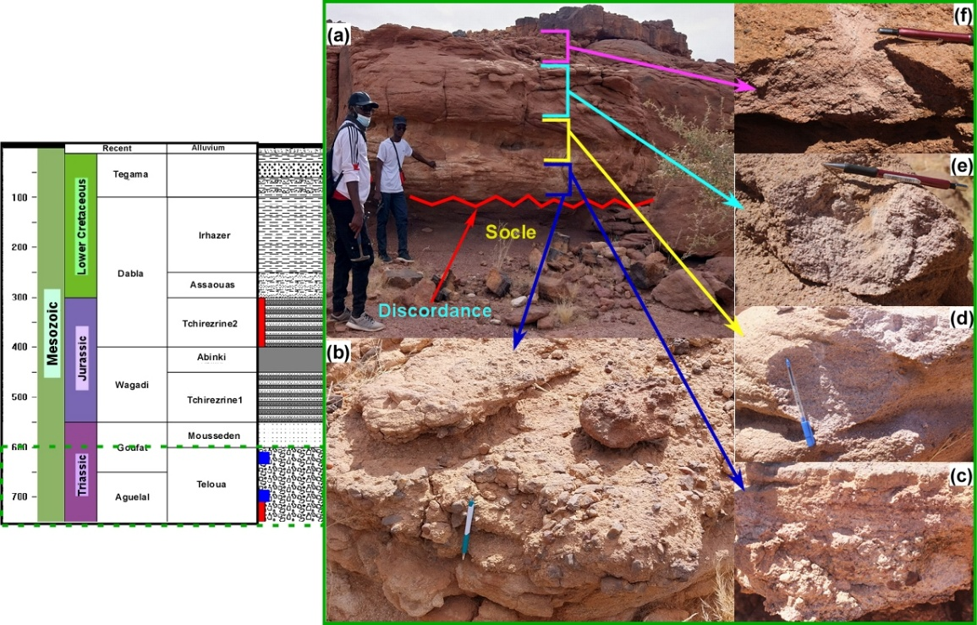
Figure 4: Lithological succession of the Téloua Formation. (a) Outcrop of the Téloua showing the different levels. (b&c) Base conglomerate level, (d) Téloua 1, (e) Téloua 2, and (3) Téloua 3. The green dashed lines indicate the concerned formations.

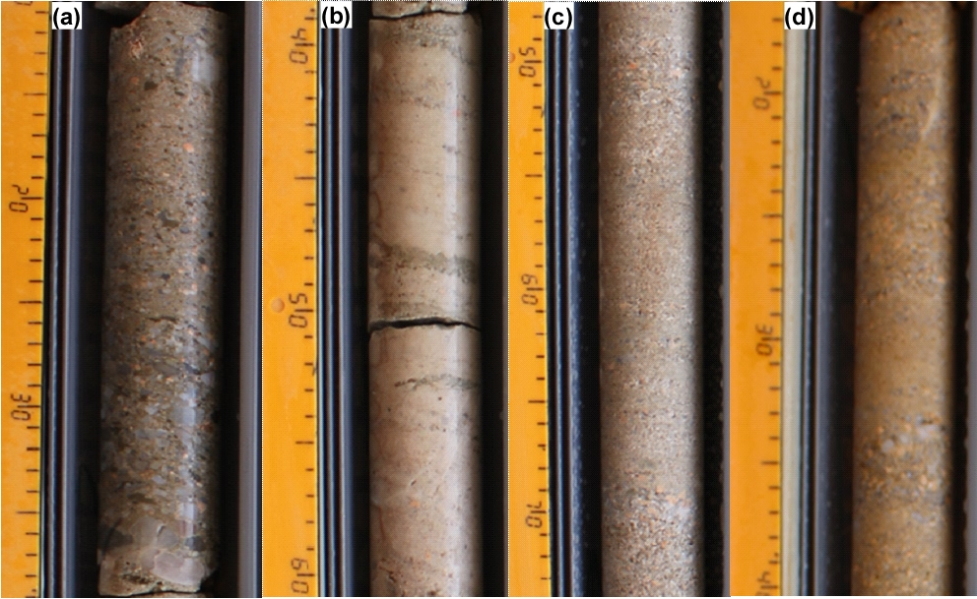
Figure 5: Photographs of the different units of the Téloua. (a) Base of Téloua 1, (b) Téloua 1, (c) Téloua 2, and (d) Téloua 3.
From a structural point of view, analysis of the geological map reveals that the formation of Téloua is affected by the main faults highlighted in the Tim Mersoï basin. In the Téloua 1 unit, intense fractures have been observed, highlighting brittle and sometimes mixed tectonics.
This brittle tectonics is expressed in the form of fractures filled with calcite, silica, clays, or sometimes oxides. Dry joints have also been observed, as well as, more rarely, cataclases and tectonic brecciation. These fractures can be dextral or sinistral strike-slip faults, normal microfaults, reverse faults, or diaclases, depending on the case.
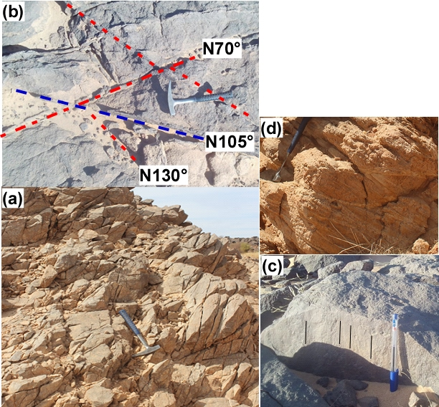
Figure 6: Photographs showing the outcrops of Téloua 1, highlighting brittle tectonics.
    - Core analysis
To better characterize the Triassic sediments, fifteen (15) core samples distributed throughout the study area were examined. The following sequence emerged from this study:
Teloua 1, Teloua 2, and Teloua 3, as revealed by fieldwork. For each unit, five samples were collected for sedimentological and microstructural characterization.
- Thin section analysis
The purpose of observing rock under a microscope is not simply to describe its petrographic characteristics, such as mineralogical composition and classification. It is also to analyze the sedimentological characteristics of the constituents of sandstone (Table 1). This process provides information about the origin and depositional environment of the sediment, as well as the mode and duration of particle transport. Microscopic study provides insight into diagenetic evolution and sediment maturity.
In this work, the following classifications are used: (i) the classification of [18], which incorporates the terminology of the different types of sandstone, the nature of the cement, and exceptional minerals; (ii) the classification of [19, 20], which uses a ternary diagram whose vertices correspond to the proportions of quartz, feldspar, and lithic fragments in the sediment.
Table 1: Description sheet of petro-sedimentary characteristics used in this study.
Petrography | Nature of components | Detrital grains, mineral species, cement, voids, rock fragments
Petrography | Mineralogy | Quartz, feldspaths, micas, analcime…
Petrography | Type of cement | Siliceous, clayey, analcimolitic, ferruginous
Petrography | Classification | Quartzarenite, arkose, litharenite, arkose-lithics, analcimolite
Sedimentology | Appearance of grains | Monocrystalline, polycrystalline, poorly consolidated, stylolitic contact
Sedimentology | Grain size | Very fine, fine, medium, coarse, very coarse, microconglomeratic, conglomeratic.
Sedimentology | Grain shape | Angular, sub-angular, sub-rounded, rounded
Sedimentology | Ranking | Very good, good, moderate, poor
Sedimentology | Jointing phase | Siliceous cement, carbonate, clay matrix, sandstone
Summary | Interpretation of all petro-sedimentary characteristics by reconstructing the geological history of rocks (provenance, impact of transport, mode and duration of transport, depositional environment, diagenesis, and maturity).
However, from a sedimentological point of view, the main facies identified are:
- For the Téloua 1 unit: three (3) facies have been identified.
  - Quartzarenite,
  - Arkose,
  - And lithic arkose.
- For Téloua 2: two (2) facies were identified:
  - Quartzarenite,
  - Litharenite.
- For Téloua 3: three facies were identified:
  - Quartzarenite,
  - Litharenite,
  - Analcimolit
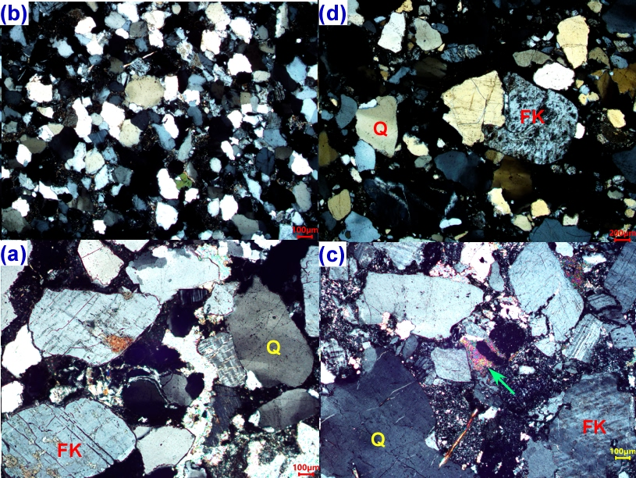
Figure 7: Microscopic photograph of samples from the Teloua units. (a) Base of Teloua, (b) Teloua 1, (c) Teloua 2, and (d) Teloua 3. Q = quartz, Fk = potassium feldspars, green arrow = calcite cement.
Microscopic analysis shows that samples from the Teloua Formation are composed of alternating layers of coarse to medium-grained sandstones with some silt and conglomerate beds. Sandstones are poorly to well consolidated and pore filling is dominated by clay minerals, and to less extent iron oxides and siliceous cement (secondary quartz), and calcitic ciment (fig. 7). Detrital grains are poorly sorted and heterogeneous in size and shape; fine to very coarse in size and sub-angular to sub-rounded (fig. 7). Finally, analcime is very abundant at the top of the Téloua formation and has probably formed during early diagenesis as it is coating detrital quartz grains. This analcime probably resulted from the alteration of volcanic materials that have dissolved due to their high reactivity.
- Microdeformation analysis
Field observations revealed that the formation of the Téloua was affected by both brittle and mixed tectonics. Analysis of core samples identified slumps, numerous local angular unconformities, and the presence of sealed faults (Fig. 8). A close relationship between tectonic events and sedimentary structures was also demonstrated. Analysis of samples from the Teloua Formation shows the existence of vertical and lateral changes in texture, mineralogy, and chemistry in the studied drill holes, which can be attributed to two main geological events: burial diagenesis and late-stage alteration related to fault-controlled fluid circulations (Fig. 9). The detrital grains in the Teloua Sandstone, which are poorly sorted and heterogeneous in size and shape, indicate a relatively short transportation distance (i.e., transported from the AÏR Mountains to the east).
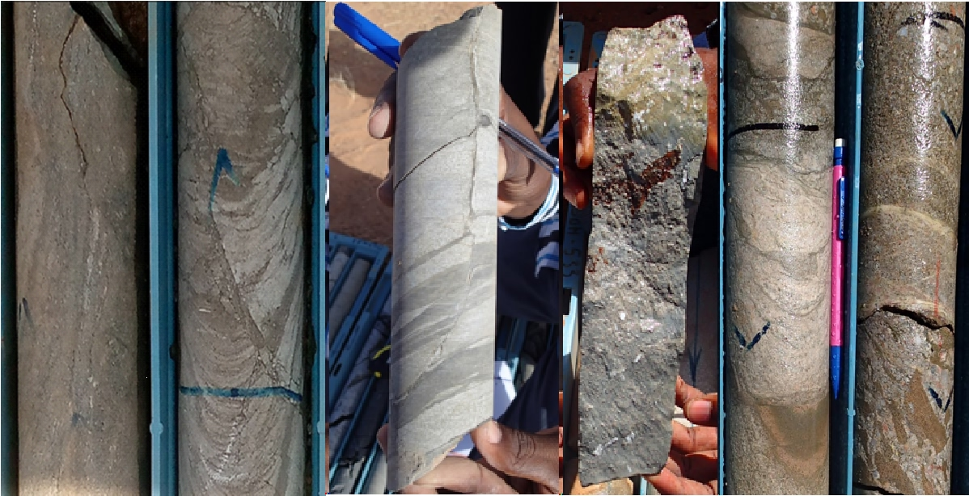
Figure 8: Photographs of core samples showing the type of deformation that affected the sediments of the Téloua units.
After sedimentation, Teloua formation sediments underwent burial diagenesis characterized by (1) compaction of quartz grains marked by the concavo-convex mutual grain contacts, (2) dissolution of detrital feldspars, and (3) recrystallization of secondary quartz (overgrowth). Moreover, the fragmentation of quartz or feldspar grains and the presence of a microfracture network in the matrix (fig. 9) suggest that the sediments have also been affected by a brittle deformation event related to the fault activity. Also, abundant calcite has been observed in some drilling holes, infilling the pore spaces.
According to [3], before rupture occurs on faults in poorly or unconsolidated siliciclastic sediment (such as sand or poorly consolidated sandstone), various deformation processes occur at the grain level. According to [21], deformation bands include different types of fracturing in poorly consolidated sand or sandstone [22, 23]. They are structures in which deformation is continuous (unlike joints, which are planar structures). Analysis of samples from Téloua, in the area studied, reveals cataclastic and non-cataclastic deformation bands (Figs. a, b, c, and d). In the deformation bands identified, not only was a preferential orientation of quartz grains observed, but also dissolution and micro-stylolites (Figs. a, b, c, and d). The width of the deformation bands generally ranges from 1 mm to 1 cm, and they accommodate a displacement of several centimeters [3]. Deformation bands are rarely isolated and sometimes form extensive networks that can accommodate displacements of several meters [24].
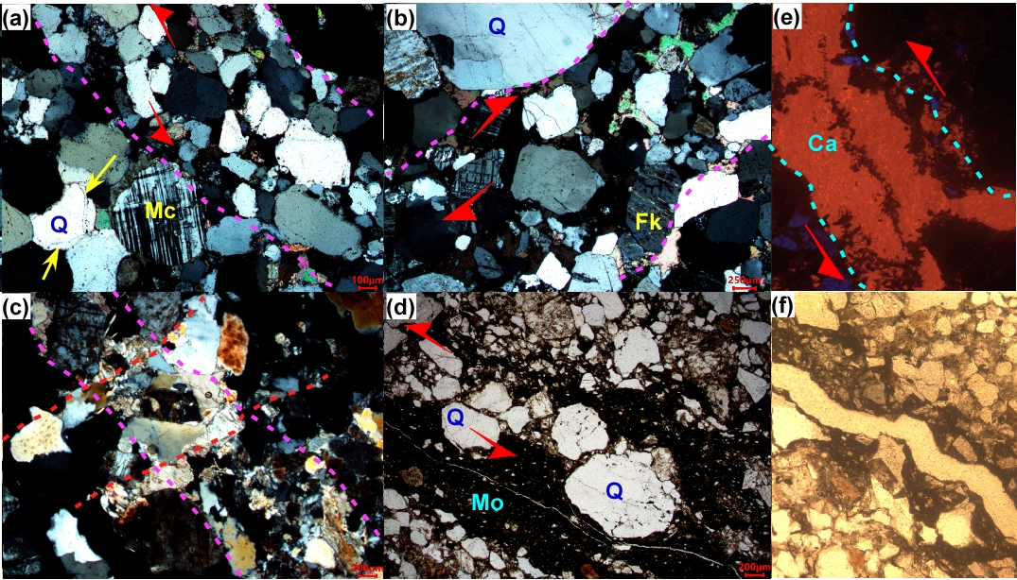
Figure 9: Microphotographs showing deformation bands within thin sections of samples from the Teloua Formation. (a&d) dextral microfracture, (b) sinistral microfracture, (c) cataclastic deformation band, (e&f) deformation band seen in cathodoluminescence with carbonate filling (calcite in (e) and dolomite in (f)).
Non-cataclastic deformation bands (BDnc) that involve only processes of rotation, displacement, and mixing of detrital grains. These processes are similar to compaction that would occur in this type of structure. These bands develop under surface conditions and affect unlithified hydroplastic sediment [22, 25]. Figures 9d, e, and f show reactivation in the opening of non-cataclastic deformation bands with the formation of calcite, dolomite, and/or black cement (probably organic matter).
Cataclastic deformation bands (BDc) are created in sediment that has already lithified but is not very cohesive (poorly consolidated sandstone). The bands involve cataclasis of detrital grains (Fig. 9c), in which confining pressure plays a role [26, 27].
It should also be noted that observations of certain thin sections were made using reflected light and SEM to provide details on the sedimentological and structural characteristics of the Téloua sandstones. This also revealed the abundance of quartzarenite facies and the intense microfracturing of quartz grains, as well as the dissolution of potassium feldspars in particular. (Fig. 10).
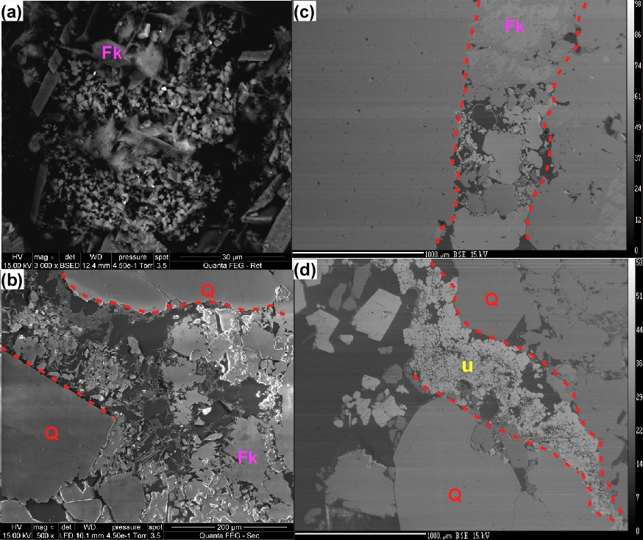
Figure 10: SEM and BSE micrographs of samples from Téloua showing microdeformation. (a) Cataclastic potassium feldspar, (b, c, and d) microfracturing with (d) uranium mineralization.
- Discussion
Geological mapping of the Téloua Formation has shown that this formation outcrops in a generally north-south direction, in line with the structure of the Tim Mersoï basin. Within the sector, the outcrop areas show variations in thickness, but also and above all in facies. These phenomena have also been highlighted in the Arlit sector by [1, 4, 5] for the Guézoumane and Tarat formations, and also by [2, 4, 28] for the Jurassic formations in the Imouraren and DASA sectors.
The study of deformations affecting the formation of Teloua has shown the existence of a diversity of deformation structures. Both brittle and mixed deformations have been identified. In outcrops, it is mainly brittle deformations that have been observed. However, in the samples, both macroscopically and microscopically, both brittle and mixed deformations were observed. These observations are consistent with the work of [3] for the Carboniferous formations in the Arlit area, as well as that of [29, 30] for the Carboniferous and Jurassic formations in the DASA area. Thus, the sedimentological and structural characterization of the silico-clastic sandstones of the Tim Mersoï basin, carried out through a multi-scale study (from outcrops to the microscopic scale), has shown that the Triassic sandstones of the Tim Mersoï basin, in addition to exhibiting a diversity of facies, also show the existence of areas strongly affected by tectonic structures. These tectonic structures played an important role in the formation of uranium mineralization.
Textural and petrographic observations of the samples studied in this study (Figs. 9e and f) show that the cementation of clay-carbonate veins occurred in successive stages and is characterized by a diversity of inputs, which may be linked to a chemical diversity of fluid circulations during the different stages of cementation.
In the case of quartz microfracturing, relatively high-pressure conditions are required [26, 27], which can be achieved during burial (lithostatic pressure) or a compressive tectonic episode (pressure related to tectonic stress). These are structures that develop in sediment that is already lithified but poorly consolidated (low cohesion) [21, 22]. Deformation bands are low-permeability structures and are generally considered unfavorable to fluid circulation. Authors generally attribute to them a role as permeability barriers to fluids [31, 32, 33]. However, these structures constitute areas of weakness which, when reactivated by opening (as is the case in Figure 9e), correspond to areas of fluid circulation and even mineralization trapping [3].
- Conclusion
This research work on the sedimentological and structural characterization of siliciclastic sediments has shown that the Téloua Formation outcrops in the Tim Mersoï Basin in a north-south direction, in line with the structure of the basin. This formation is affected by both brittle and mixed tectonic disturbances. Brittle and non-brittle deformation bands, open fractures filled with carbonates (calcite and dolomite), and even uranium mineralization have been identified.
It has also been demonstrated that, in addition to analcimolitic cement, the sandstones of Téloua also contain black cement (probably organic matter) on the one hand, and on the other hand, recent work has highlighted the existence of uranium mineralization. It would therefore be important to pay particular attention to the Téloua sandstones in the Tim Mersoï basin. They may constitute new targets for uranium exploration. To this end, further work is needed to characterize the cements in these sandstones, as well as the clays.
Authors’ contributions
Corresponding author is responsible for conceptualization, methodology, investigation, writing of the original draft, data curation, formal analysis, validation, and review and editing. All authors read and approved the final manuscript.
Declarations Competing interests
The authors declare that they have no competing interests.
Disclaimer (Artificial intelligence)
Option 1:
Author(s) hereby declare that NO generative AI technologies such as Large Language Models (ChatGPT, COPILOT, etc.) and text-to-image generators have been used during the writing or editing of this manuscript.
Option 2:
Author(s) hereby declare that generative AI technologies such as Large Language Models, etc. have been used during the writing or editing of manuscripts. This explanation will include the name, version, model, and source of the generative AI technology and as well as all input prompts provided to the generative AI technology
Details of the AI usage are given below:
1.
2.
3.
References

[1] Yahaya M., 1992. Dynamique sédimentaire du Guézouman et des formations viséennes sous-jacentes en liaison avec la tectonique, le volcanisme et le climat, paléomilieux des gîtes uranifères d’Arlit (Niger). Thèse Doctorat troisième cycle, Université de Dijon, 357 p.

[2] Billon S., 2014. Minéraux argileux dans le gisement uranifère d’Imouraren (Bassin de Tim Mersoï, Niger): implications sur la genèse du gisement et sur l’optimisation des processus de traitement du minerai. Thèse Terre solide et enveloppes superficielles. Poitiers: Université de Poitiers, 2014. http://theses.univ-poitiers.fr

[3] Gerbeaud, O., 2006. Evolution structurale du Bassin de Tim Mersoï : Déformations de la couverture sédimentaire, Relations avec la localisation des gisements d’uranium du secteur d’Arlit (Niger). Thèse de doctorat Université de Paris-Sud UFR scientifique d’Orsay, 270 pages.

[4] Mamane, M., 2016. Le système métallogénique des gisements d’uranium associé à la faille d’Arlit (Bassin de Tim Mersoï, Niger): diagenèse, circulation de fluides et mécanismes d’enrichissement en métaux (U, Cu, V). Thèse de doctorat Université de Lorraine, 402p.

[5] Elhamet, M.O., 1983. Analyse géologique et pétrographique de la formation de Tarat dans les carrières Somaïr (Paléozoïque supérieur). Essai d’interprétation paléoclimatique à la lumière de l’épisode glaciaire dévono-carbonifère (Région d’Arlit – Niger septentrional) [PhD. thesis]: Université de Dijon (France) et Université de Niamey (Niger), 279 p.

[6] Forbes P., 1989. Rôles des structures sédimentaires et tectoniques, du volcanisme alcalin regional et des fluides diagénétiques-hydrothermaux pour la formation des minéralisations à U-Zr- Zn-V Mo d'Akouta (Niger). Thèse du CREGU, Nancy, 375p.

[7] Cavellec, S. (2008). Evolution diagénétique du bassin de Tim Mersoï et conséquences pour la genèse des minéralisations uranifères dans les formations du Guézouman et du Tarat (district Arlit-Akokan, Niger). Thèse de Doctorat de l’Université de Paris-Sud, 463 p.

[8] Sani, A., 2020. Rôle des accidents N70° dans la mise en place des minéralisations uranifères du bassin de Tim Mersoï : cas du graben de DASA, bordure occidentale de l’Aïr (Nord Niger). Thèse de Doctorat, UAM.

[9] Konaté, M and al., 2007. Structuration extensive au devono-dinantien du bassin de Tim Mersoï (Bordure occidentale de l’Aïr, Nord Niger). Publié dans: Université de Ouagadougou, Annales, Série C, v. 005, 32p.

[10] Joulia, F., 1963. Carte géologique de reconnaissance de la bordure sédimentaire occidentale de l'Aïr au 1/500 000. Éditions du BRGM, Orléans, France.

[11] Clermonté J. et al., 1991. Un bassin paléozoïque et mésozoïque dans une zone en décrochement : le Tim Mersoï dans la région d'Arlit, à l'Ouest de l'Aïr (Niger). - C.R. Acad. Sc. Fr., Paris, t.312, Série II, p.1189-1195.

[12] BOUBE-DOBI F. 2024. Modélisation de l’évolution piézométrique des eaux souterraines en environnement minier : Cas de la zone minière d’Arlit-Akokan (bassin de Tim Mersoï, Nord du Niger), PhD thesis, INPH of Ivory Coast.

[13] Tauzin, P., 1981. Cadre géologique des gisements d'uranium de la bordure orientale du bassin sédimentaire du Tim Mersoï. - Rapport interne Minatome, 15 p.

[14] Guiraud, R., Boureïma O. et Robert J.-P., 1981. Mise en évidence de déformations traduisant un raccourcissement dans le Mésozoïque de la périphérie de l'Aïr (Niger). Comptes-Rendus Académie des Sciences, Paris, t. 292, série II, p.753-756.

[15] Wright, L. I., Branchet, M., ET Alisso, I., 1993. Notice explicative de la carte géologique du bassin houillier d'Anou Araren/Solomi. Ministère des Mines et de l'Énergie, Niger, 20 pages.

[16] Valsardieu, C., 1971. Etude géologique et paléogéographique du bassin de Tim Mersoï, région d'Agadès (République du Niger). Thèse de doctorat, université de Nice, 518p.

[17] Sempéré T., 1981. Le contexte sédimentaire du gisement d’uranium d’Arlit (République du Niger). Thèse de l’école nationale supérieure des sciences de Paris, 392p.

[18] Jamet, M., Ballas, G., Soliva, R., Gerbeaud, O., Lefebvre, T., Leredde, C., and Loggia, D. 2024. Naturally fractured reservoir characterization in heterogeneous sandstones: insight for Uranium In Situ Recovery (Imouraren, Niger), EGUsphere [preprint], https://doi.org/10.5194/egusphere-2024-435, 2024.

[19] Wagani I., 2007. Potentialités uranifères des sources volcaniques envisageables pour la formation des minéralisations de la région d'Arlit (Niger). Thèse de l’université de Paris Sud.

[20] Konaté, M and al., 2019. Structural evolution of the Téﬁdet trough (East Aïr, Niger) in relation with the West African Cretaceous and Paleogene rifting and compression épisodes, Comptes rendus - Geoscience, https://doi.org/10.1016/ j. crte.2018.11.009.

[21] Cailleux, A. (1947). Distinction des galets marins et fluviatiles. Bulletin de la Société Géologique de France, 5, 375-404. https://doi.org/10.2113/gssgfbull.s5-xv.7-8.375

[22] Pettijohn. F, J., Potter. P. E and Siever, R. (1972). Sand and Sandstone. Springer-Verlag, Berlin.

[23] Nagtegaal, 1978. Sandstone-framwork instability as a function of burial diagenesis. Journal of Geological Society. Vol 135, PP 101-105. https://doi.org/10.1144/gsjgs.135.1.0101
[24] Aydin, A., 1978. Small faults formed as deformation bands in sandstone. Pure applied Geophysics, 116: 913-930.
[25] Antonellini, M., Aydin, A., Pollard, D.D., 1994. Microstructure of deformation bands in porous sandstones at Arches National Park, Utah. Journal of Structural Geology, 16 (7): 941-959.
[26] Du Bernard, X., 2002. Deformation Bands in Sandstones : Fluid Pathways or Barriers? AAPG Annual Meeting, 10-13 mars, 2002, Houston, Texas.
[27] Aydin, A., Johnson, A.M., 1983. Analysis of faulting in porous sandstones. Journal of Structural Geology, 5 (1): 19-31.
[28] Swierczewska, A., Tokarski, A.K., 1998. Deformation bands and the history of folding in the Magura nappe, Western Outer Carpathians (Poland). Tectonophysics, 297: 73-90.
[29] Zhang, J., Wong, T.F., Davis, D.M., 1990. Michromecanics of Pressure-Induced Grain Crushing in Porous Rocks. Journal of Geophysical Research, 95 (B1): 341-352.

[30] Wang, K and Davis, E. E., 1992. Thermal effects of marine sedimentation in hydrothermally active areas. Geophysical Journal International, Vol 110, Issue 1. PP 70-78, https://doi.org/10.1111/j.1365-246X.1992.tb00714.x
[31] Ngwenya, B.T., Elphick, S.C., Main, I.G., Shimmield, G.B., 2000. Experimental constraints on the diagenetic self-sealing capacity of faults in high porosity rocks. Earth and Planetary Science Letter, 183: 187-199.
[32] Ogilvie, S.R., Glover, P.W.J., 2001. The petrophysical properties of deformation bands in relation to their microstructure. Earth and Planetary Science Letter, 193: 129-142.
[33] Davatzes, N.C., Aydin, A., Eichbubl, P., 2003. Overprinting faulting mechanisms in high porosity sandstones of SE Utah. Journal of Structural Geology, 25 (11): 1795-1813.

