BIBLIOMETRIC ANALYSIS OF TRAFFIC MANAGEMENT IN INDUSTRIAL AREA

.
ABSTRACT

Aims: This study aims to analyze the global research trends on traffic management in industrial areas through a bibliometric approach. The research identifies publication patterns, key themes, and influential contributors within this topic.
Study design: Descriptive bibliometric research.
Place and Duration of Study: Batam International University, Indonesia, from November to December 2023.
Methodology: A total of 1000 relevant documents were retrieved using the Publish or Perish software with Crossref as the data source, covering the period from 2000 to 2023. The data were filtered using keywords such as "Traffic Management," "Road Infrastructure," "Traffic Congestion," and "Vehicle." Visualization and analysis were conducted using VOSviewer to map keyword connections and density. The research types, annual publication trends, and most influential authors were also identified and evaluated.
Results: The findings indicate that the highest number of related studies occurred in 2022, with 100 publications. Journal articles were the dominant publication type, with 657 entries, while books ranked second with 197. The most influential authors in the field were Falcocchio, John C., and Levinson, Herbert S., both contributing to 27 publications. Keyword analysis revealed strong associations between traffic data, road safety, and traffic management, while terms such as urban areas and smart cities showed lower relevance.
Conclusion: This study reveals a growing global interest in traffic management within industrial areas, especially in recent years. This bibliometric study gives us vital information about how traffic management is changing in industrial places around the world. It also demonstrates that there are gaps in study, especially when it comes to how smart city ideas may be applied with traffic management systems and how emerging technologies like AI and the Internet of Things can make traffic go more smoothly. Researchers could investigate into how these technologies could be applied in real-world industrial settings, especially in countries with emerging economies. Also, a closer examination into traffic bottlenecks in countries that are increasingly becoming cities, like Southeast Asia, might help us understand the unique issues and opportunities that come with living there. Cross-disciplinary studies that look at urban planning, environmental impact assessments, and traffic management all at once are especially crucial for addressing the growing concerns about sustainability and mobility in industrial locations. This might give city planners and lawmakers vital information that could help them make better choices about how to manage traffic without harming the environment as much.

Keywords: Traffic management; Road infrastructure; Traffic congestion; Vehicle

1. INTRODUCTION

This manuscript presents a bibliometric analysis of traffic management in industrial areas, focusing on trends from 2000 to 2023 using data from CrossRef and tools like Publish or Perish and VOSviewer. It provides valuable insights into research patterns, keyword density, publication types, and key contributors in this domain. Such an analysis is useful for identifying gaps and guiding future research, especially in developing countries like Indonesia where traffic issues are critical. The work is particularly important as it aligns with the increasing global interest in sustainable transportation and urban mobility planning. The fundamental elements of human societies and economic development are mobility and the movement of people and goods within and across geographical areas. It allows individuals to access essential services, employment opportunities, and social connections. Mobility is to be seen holistically and integrated into the broader context of development strategy (Okraszewska et al., 2018). However, significant problems such as traffic congestion, environmental pollution, and social inequities have also arisen due to an increasing demand for mobility. To overcome this problem, a sound system of transportation is needed. One of the factors to overcome this is by creating efficient traffic management.
To enhance efficiency and safety, traffic management is a process that controls and monitors traffic flow. It is a complex and demanding task involving many factors, such as road infrastructure, Vehicle demand, and driver behavior. Expanding road infrastructure is the easiest way to ease traffic congestion (Pi et al., 2019). The roads are a significant link in every city of the world and an essential link between populations and physical movements, and undoubtedly, the planning of the streets is the most essential thing that should be the attention of developers of urban plans (Elaiab & Al). Therefore, road infrastructure must have a predetermined standard. When a road infrastructure is well-built or maintained, it can positively impact society, the economy, and the environment.
Traffic management has become an essential component of transport systems today. The demand for effective and efficient traffic management is increasing; the number of motor Vehicles proliferates as the urban scale increases (Lu et al., 2021). However, some cities in the world are experiencing an uncontrolled growth of traffic volume that causes significant problems such as road congestion, rising fuel costs, increasing CO2 emissions, Vehicle accidents, emergencies, and deteriorating quality of life in current society (Guerrero-Ibáñez et al., 2018). The effects of congestion on the economy, passengers, and quality of life are widely felt. Indonesia, which has more than 270 million people, is faced with a growing problem of traffic congestion in its vast archipelago. Rapid urbanization, increasing Vehicle ownership, and inadequate transportation infrastructure have created complex traffic management problems that hinder economic growth, endanger public safety, and worsen the quality of life for millions of Indonesians. Congestion occurs especially in Jakarta, Surabaya, Bandung, and Makassar (Suryani et al., 2021). Traffic congestion is a severe problem. Indonesia is estimated to suffer annual economic losses of around 1% of its GDP in terms of congestion. Traffic congestion also causes air pollution, which has negative health impacts on residents.
Batam, the largest city of the Riau island province, Indonesia, is facing a growing traffic congestion problem. Batam is an attractive destination for migrants from other parts of Indonesia, and it has proliferated over the last few years. This has led to a significant increase in Vehicles on the road. This means there is severe traffic congestion, especially during the extended peak hours, due to the city's infrastructure being unable to keep up with this demand (Rajé et al., 2018).
The city’s roads cannot handle the current traffic volume, and more public transportation options must be available. This result in congestion is mainly caused by a desire for people to drive their cars, especially those related to increasing road capacity (Onyeneke et al., 2018). The study was carried out with a systematic literature review using bibliometric analysis.
2. Literature Review
  - Traffic management
Traffic management is an integral part of urban planning, directly impacting cities' efficiency and sustainability worldwide. This literature review examines a wide range of traffic management strategies and problems faced in urban areas. Even with the help of congestion charges and investment in public transport, traffic is getting out of hand simply because the demand for motor Vehicles needs to improve the capacity of these responses to cope with it (Wen et al., 2019). A new era of dynamic and resilient traffic management has emerged thanks to advanced traffic control systems focusing on synchronized signal timing. It is also due to developments in adaptive traffic control systems and their integration with intelligent transport systems.
The evolution of traffic management over the past decades is characterized by a shift from simple signal coordination to more complex control systems. Traditional traffic management systems often relied on fixed signal timings, which proved inflexible in the dynamic change of traffic situations. It was a significant milestone when the development of adaptive traffic control systems enabled real-time adjustments based on road conditions. Moreover, technology such as dynamic message boards and traffic cameras have been introduced in the integration of Intelligent Transport Systems (ITS), which aims to help reduce waste of time and energy through optimal routes, reducing congestion, improving the performance of Vehicles and driving to promote more efficient management of transport systems. (Guevara & Auat Cheein, 2020). To appreciate the complexity of today’s traffic management strategies, it is necessary to understand this evolution.
Traditional traffic management strategies include a range of approaches to optimize traffic flows and reduce congestion. Such strategies involve developing and operating traffic control systems, congestion pricing, route planning, transit guidance systems, traveler information packages, or vehicle communications systems to manage and control traffic to achieve the general objective (Ahmad et al., 2023). The flow of traffic, intersection management, and efficient allocation of road space can be regulated in cities through such strategies. In addition, the role of historical information derived from past traffic patterns and incidents becomes a critical factor in informing decision-making processes and improving the effectiveness of traditional traffic management.
Because of urbanization and technological advances, traditional traffic strategies have proven effective but still need help. Developing effective and robust congestion control techniques as an alternative approach to conventional controls, which requires creative solutions that are different from traditional systems, still needs help dealing with these challenges (Pitsillides & Sekercioglu, 2018). Moreover, both opportunities and challenges are associated with integrating new technologies like bright traffic lights or automatic Vehicle systems. Privacy issues related to the collection and utilization of traffic data also need attention.

2.2 Road Infrastructure
Road infrastructure plays a vital role in providing mobility for the effective movement of people and goods and accessibility to a broad range of business and societal activities, and road infrastructure plays a vital role (Ng, Law, Jakarni, & Kulanthayan, 2019). Road infrastructure and traffic management are essential for urban planning, shaping transportation systems' efficiency and sustainability. This literature review aims to explain the complex relationship between road infrastructure and traffic management to explore historical development, modern challenges, and future trends in these symbiotic interactions. Combining these elements is critical as cities face increasing urbanization, dynamic mobility patterns, and the importance of creating resilient and adaptive transportation networks. By exploring the multifaceted of this relationship, this review seeks to contribute to a differentiated understanding that can inform innovative strategies to optimize urban mobility.
The historical evolution of road infrastructure and traffic management is a journey proved by innovation and adaptation to society’s needs. The development of road networks is closely related to the evolution of traffic management strategies from the ancient trade routes to modern times. The development of traffic signals in the 20th century has made it possible to organize movements with more sophisticated techniques, thus setting a precedent for other approaches. Further innovations, including integrating intelligent transportation systems (ITS), reflect ongoing efforts for better control, safety, and efficiency. ITS are designed to exploit appropriate technology to create more intelligent roads, Vehicles, and users. (Mandhare, Kharat, & Patil, 2018).
There are many challenges faced by the modern road infrastructure that require innovative solutions for effective traffic management. When a system and user behavior are so complex that it is impossible to model and predict travel patterns, this creates problems with transport (Abduljabbar et al., 2019). Traffic congestion, limited capacity, and environmental considerations highlight the necessity of strategic approaches. The deployment of smart infrastructure, the use of real-time data analysis, and the integration of intelligent traffic management systems are needed to address these challenges. Sustainable road design, multimodal transportation planning, and adopting new technologies such as interconnected transport systems are critical elements in enhancing synergy between road infrastructure and traffic management. This section explores the current landscape in an evolving city environment and discusses its challenges and strategies.
Technology plays a vital role in shaping the dynamics of road infrastructure and traffic management. Real-time monitoring and a large volume of data can be gained by integrating intelligent transport systems with sensors embedded in Internet of Things devices, which enable Physical Transport Systems. (Zhu et al., 2019). To keep pace with the growth in innovative city initiatives, building interconnected data-driven ecosystems that optimize traffic flows and improve overall urban mobility is a crucial element of road infrastructure development. This section explores the transformative impact of these advances, indicating a future in which technology will serve as an anchor for sustainable, efficient, and resilient road infrastructure that responds to evolving urban needs.

2.3 Traffic congestion
One of the most significant challenges for urban transport is congestion. (Lee et al., 2019). Mobility is the key to a turnaround in the world, both in the economy and human movement. Today's urban mobility is characterized by traffic congestion, pollution, time wastage, noise, and capacity and space consumption inefficiencies on a scale necessary for the modern urban economy to function productively. (Ceder, 2021). Mobility has also been a challenge for urban authorities, burdened by limited resources and the ability to invest to meet growing demand with increased pressures from city population growth (Lyons G. , 2018)
Due to its significant impact on human lives, traffic congestion has been given much attention over the last few years (Di et al., 2019). Traffic congestion has also become a severe problem in many cities worldwide, and it is a challenge that is not easy to manage (Koźlak & Wach, 2018). So far, there is still much traffic congestion whose problems have not been resolved, especially in growing areas, resulting in significant delays, multiplied gasoline wastage, and economic losses (Atta et al., 2020). Congestion is one of the factors that the government uses to encourage sustainable city progress.
Congestion occurs when many Vehicles are on the road, slowing normal traffic flow (Afrin & Yodo, 2020). One of the primary causes of traffic congestion is poor traffic management systems. Inadequate road infrastructure is also one of the many factors causing traffic congestion. Congestion is also caused by several things that can be unexpected or happen suddenly, such as traffic accidents, floods, and road repairs.
There are many solutions to overcome traffic congestion, but not all can be implemented, and the results are ineffective. For example, not all countries can afford to make mass rapid transit (MRT), so this is not the best option because the costs are very high. One efficient option is implementing a sound traffic management system so Vehicle mobility can run smoothly. Another way to overcome the congestion problem is by stopping the building of infrastructure for private Vehicles and moving the road space to public transport and other modes of mobility (Abdel et al. Monem, 2020).

2. material and methods

Explore maps based on network data (Arruda et al., 2022). One of the methods used in this research is bibliometric analysis. Bibliographic analysis is a research approach that looks at global trends in academic publications relating to their outputs (ALSHARIF, 2020). Topics associated with this research are mapped and filtered through Public or Perish software on November 4, 2023, using crossref sources. The data topic obtained is from a maximum total of 1000 papers from 2000 to 2023. Then, the data obtained is imported into Microsoft Excel for processing.

3. results and discussion

This research uses the publish or perish application to process the data that has been obtained. The resulting data is processed and sorted directly by the author. This data uses Traffic management, Road infrastructure, Traffic Congestion, and Vehicles. The data was obtained from a total of 1000 papers covering a period from 2000 to 2023. Then, the data is mapped into graphs, tables, or images.
4.1 Keyword Connection
The visualization of the keyword connection was processed through the VOSviewer application. After going through the VOSviewer application, the keywords connection can be displayed with publish or perish. The keyword connections show how solid and relevant the research topics are to each other. The figure below shows five colors in each link: green, blue, purple, yellow, and red.
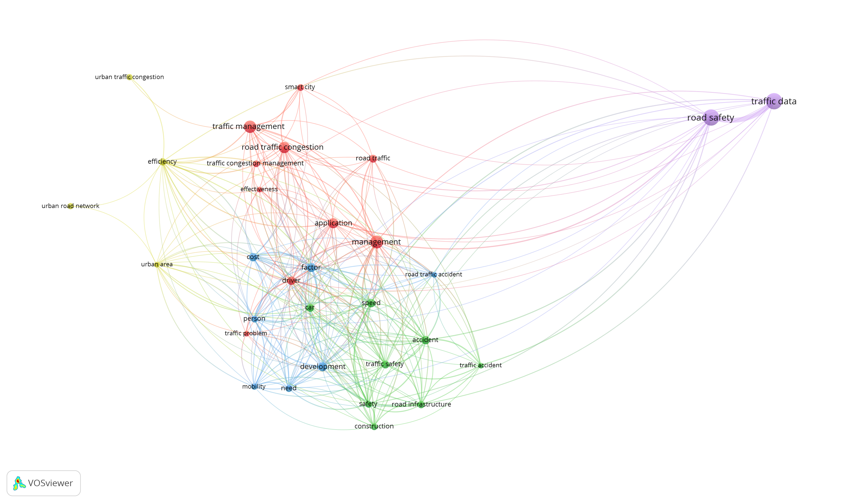
Figure 1. Research Keyword Connection

The (figure 1) above shows that the research topics traffic data, road safety, traffic management, and management are the most relevant. The figure above shows that the research topics of urban road networks and urban areas are the most irrelevant.

4.2 Research Keyword Density
Results of reviewing density between keywords using the VOSviewer application. The results below are visualizations of keywords that have been selected one by one. The keywords included are road infrastructure, traffic congestion, traffic management, and Vehicle. The image below shows the keywords traffic data, road safety, traffic management, and the densest road traffic congestion.
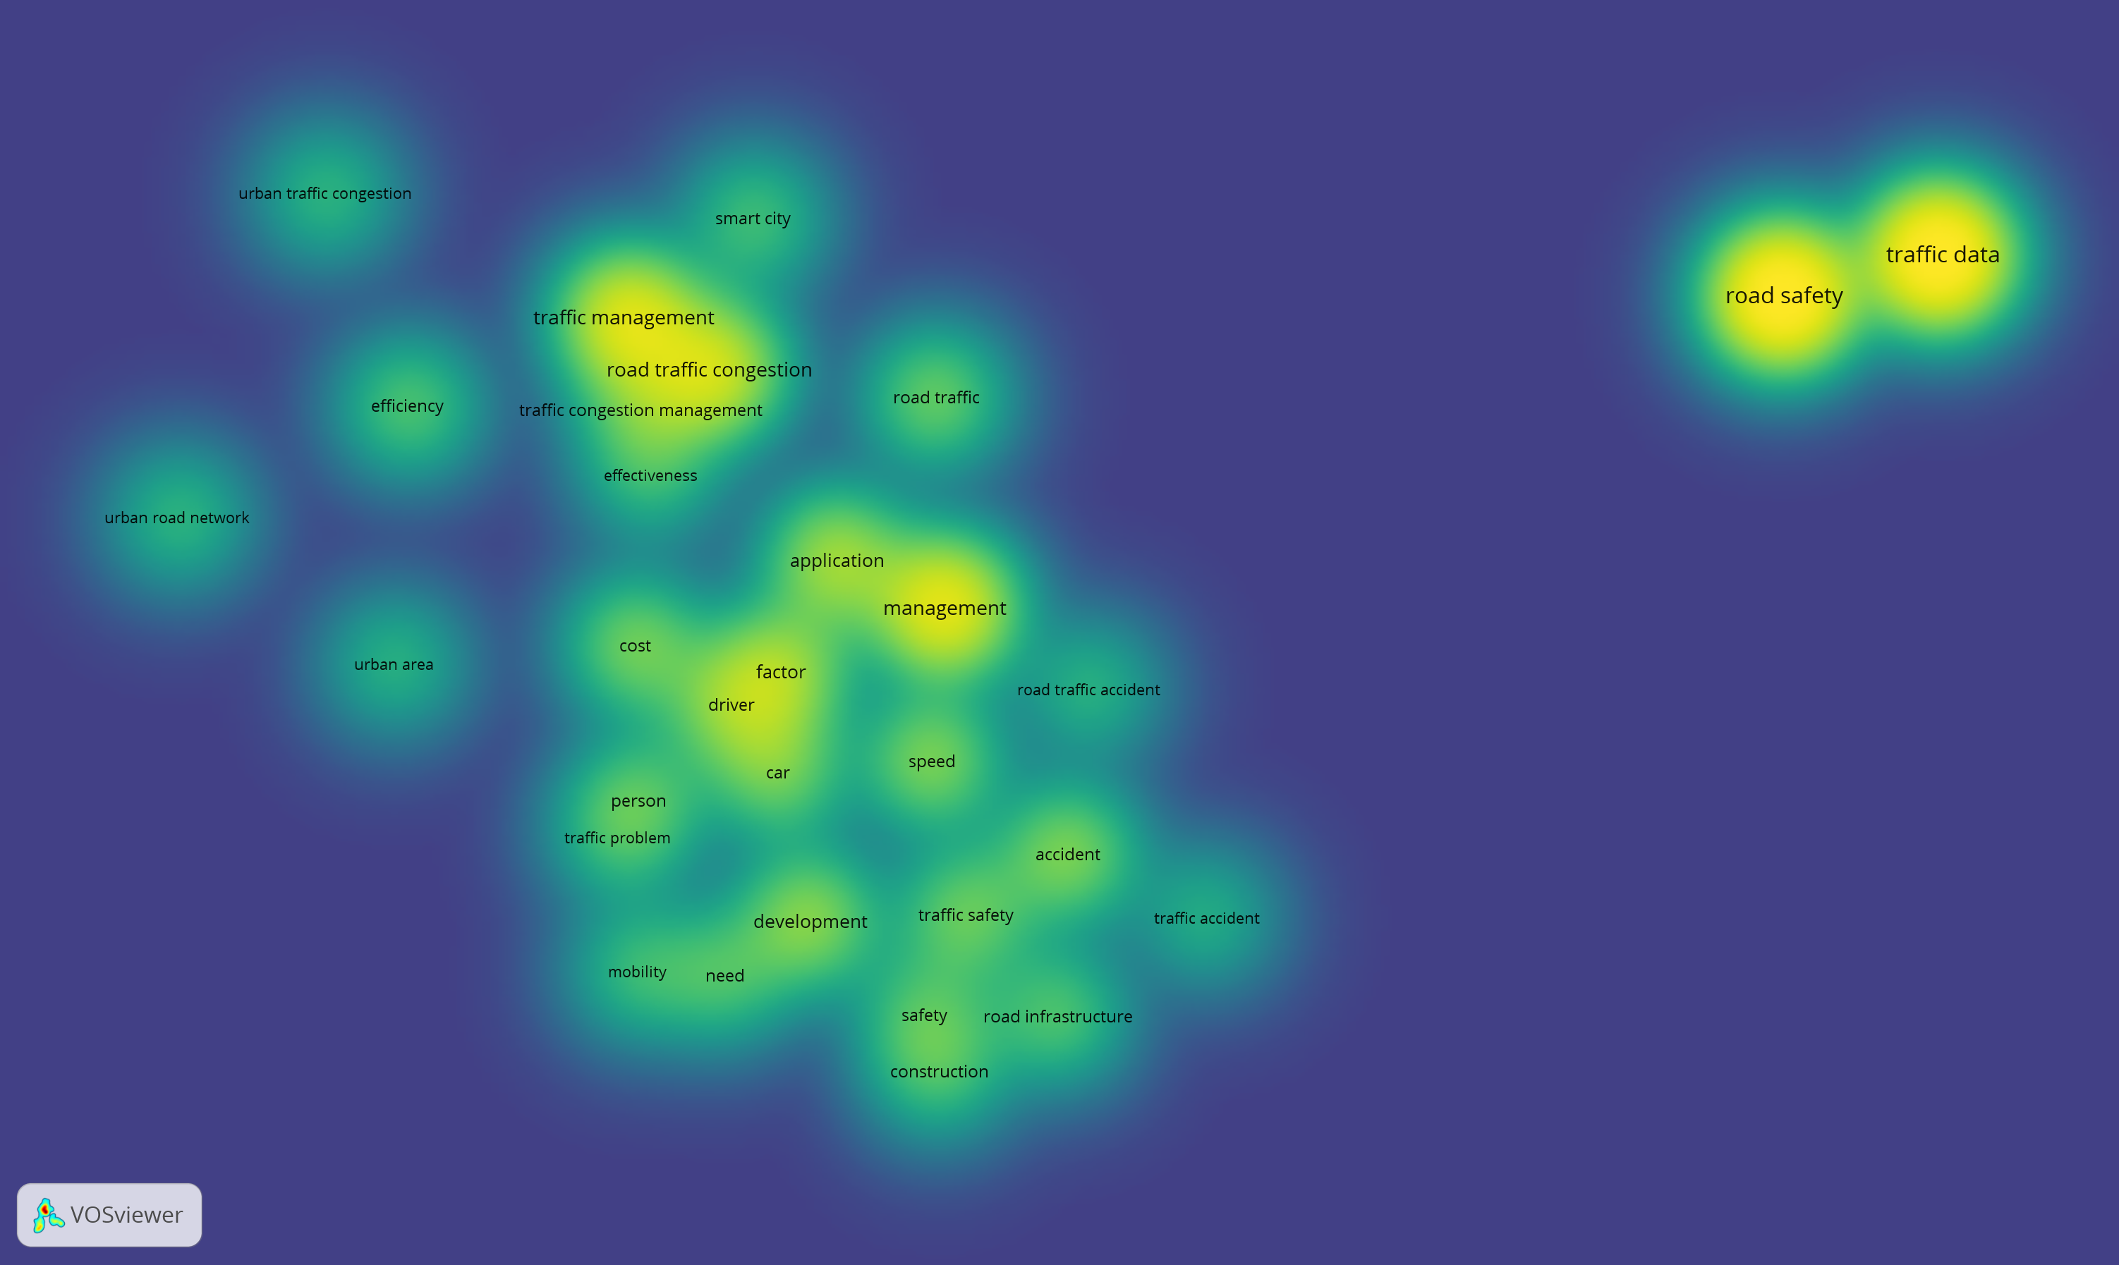
Figure 2. Research Keyword Density

The figure above shows how related these keywords are in this research. The figure above shows that urban areas, urban road networks, smart cities, and urban traffic congestion are the least relevant research topics, with colors having the lowest density.

4.3 Research Type
The figures below have been ordered from the most to least used researcher types. The data obtained shows substantial differences between the types of research that are most widely used in the first and second order. The most frequently conducted research was journal articles with 657 users. Meanwhile, in second place, there is a book with 197 users with a difference of 478 users.

Figure 3. Research Type

The data obtained in (figure 3) shows that the fewest users are in the dataset, which only has two users. Furthermore, the second least is peer review, which only has four users. This shows that the difference between the fewest is not significant. However, the difference between the most and the fewest has a vast difference, with a difference of 655 users.

4.4 Research Per Year
One of the features produced by Publish or Perish is that you can find out what research is carried out every year. In this case, data collected in a database is used to calculate the number of studies published on an annual basis around the world. The data obtained below is from 2000 to 2023.

Figure 4. Research Data Yearly

The data (figure 4) above shows that the most research on this topic will be in 2022, reaching 100 studies per year. At the same time, the least amount of research was in 2003. The data above also shows that the research carried out was unstable or fluctuating; for example, from 2022 to 2023, there was a decline.

4.5 Influential Authors
One of the features that can be done by publish or perish is the author's name. The resulting author's name also contains the number of similar research results that have been studied. The researcher took a summary of the ten researchers obtained and sorted them from the most research to the least.

Rank | Name | Documents
1 | Falcocchio, John C. | 27
2 | Levinson, Herbert s. | 27
3 | Wu, Bing. | 10
4 | Sun, Ying | 9
5 | Wang, yan li | 9
6 | Harrou, fouzi | 9
7 | Li, linbo | 8
8 | Zeroual, abdelhafid | 8
9 | Raj, krishna | 8
10 | Djahel, soufiene | 7
TABLE 1. Influential Authors

the data (TABLE 1) obtained shows that researcher falcocchio, john c, is in the first place, and researcher levinson, herbert s, has the same number of research results of 27. moreover, in third place, the author got the results of 10 similar studies. while in last place, there are researchers djahel, soufiene with the number of similar researchers being 7.

4. Conclusion

This research uses bibliometric analysis of traffic management in industrial areas. This research uses keywords related to the topic of this research. The keywords used are Traffic management, Road infrastructure, Traffic Congestion, and Vehicle. Publish or publish to obtain 1000 articles related to this topic from 2000 to 2023. This research on traffic management concludes that there are unstable ups and downs every year. The research results show that the most significant number of studies similar to this topic will be in 2022, with 100 studies. The research type results section shows that most of the research was done through journal articles, totaling 657. The result of the influential authors shows that Falcocchio, John C, and Levinson Herbert S conducted the most research related to this topic with 27 studies. There are certain problems with this study that you should know about. First, the bibliometric study only looked at articles that were available on CrossRef, thus it might not include all of the important research that was published on that platform or elsewhere. Second, although the examined time period spans two decades, the data acquired is still confined to publications published up to 2023, which may not fully reflect the latest trends that have arisen since then. Third, this study only looked at a few phrases, such "traffic management," "road infrastructure," and "traffic congestion." Because of this, it might not have looked at other related topics, like how transportation policy affects traffic or the newest technological advances. Also, even if this study names important contributors in this subject, just looking at the number of publications might not give a clear picture of the quality or effect of the research done by these researchers. So, more study is needed that looks at a larger range of data sources and takes into consideration other elements that could give a fuller picture of this topic.

COMPETING INTERESTS DISCLAIMER:
Authors have declared that they have no known competing financial interests OR non-financial interests OR personal relationships that could have appeared to influence the work reported in this paper.

Disclaimer (Artificial intelligence)

Option 1:

Author(s) hereby declare that NO generative AI technologies such as Large Language Models (ChatGPT, COPILOT, etc.) and text-to-image generators have been used during the writing or editing of this manuscript.

Option 2:

Author(s) hereby declare that generative AI technologies such as Large Language Models, etc. have been used during the writing or editing of manuscripts. This explanation will include the name, version, model, and source of the generative AI technology and as well as all input prompts provided to the generative AI technology

Details of the AI usage are given below:
1.
2.
3.

References

Abduljabbar, R., Dia, H., Liyanage, S., & Bagloee, S. A. (2019). Applications of artificial intelligence in transport. An overview. Sustainability, 11(1), 189.
Ahmad, F., Shah, Z., & Al-Fagih, L. (2023). Applications of evolutionary game theory in urban road transport network: A state of the art review. Sustainable Cities and Society.
Abdel Wahed Ahmed, M. M., & Abd El Monem, N. (2020). Sustainable and green transportation for better quality of life case study greater Cairo–Egypt. HBRC Journal, 16(1), 17-37.
Afrin, T., & Yodo, N. (2020). A survey of road traffic congestion measures towards a sustainable and resilient transportation system. Sustainability, 12(11).
ALSHARIF, A. H. (2020). Bibliometric analysis. Journal of Theoretical and Applied Information Technology, 98(15), 2948-2962.
Arruda, H., Silva, E. R., Lessa, M., Proença Jr, D., & Bartholo, R. (2022). VOSviewer and bibliometrix. Journal of the Medical Library Association: JMLA, 110(3), 392.
Atta, A., Abbas, S., Khan, M. A., Ahmed, G., & Farooq, U. (2020). An adaptive approach: Smart traffic congestion control system. Journal of King Saud University-Computer and Information Sciences, 32(9), 1012-1019
Ceder, A. (2021). Urban mobility and public transport: Future perspectives and review. International Journal of Urban Sciences, 25(4), 455-479.
Di, X., Xiao, Y., Zhu, C., Deng, Y., Zhao, Q., & Rao, W. (2019). Traffic congestion prediction by spatiotemporal propagation patterns. In 2019 20th IEEE international conference on mobile data management (MDM), 298-303.
Elaiab, F. M., & Al, O. (n.d.). The Need for Developing our Urban Streets
Guerrero-Ibáñez, J., Zeadally, S., & Contreras-Castillo, J. (2018). Sensor technologies for intelligent transportation systems. Sensors, 18(4), 1212.
Guevara, L., & Auat Cheein, F. (2020). The role of 5G technologies: Challenges in smart cities and intelligent transportation systems. Sustainability, 12(16), 6469.
Koźlak, A., & Wach, D. (2018). Causes of traffic congestion in urban areas. Case of Poland. In SHS Web of Conferences. EDP Sciences, 57.
Lee, C., Kim, Y., Jin, S., Kim, D., Maciejewski, R., Ebert, D., & Ko, S. (2019). A visual analytics system for exploring, monitoring, and forecasting road traffic congestion. IEEE transactions on visualization and computer graphics, 26(11), 3133-3146.
Lu, J., Li, B., Li, H., & Al-Barakani, A. (2021). Expansion of city scale, traffic modes, traffic congestion, and air pollution. Cities, 108, 102974
Lyons, G. (2018). Getting smart about urban mobility–aligning the paradigms of smart and sustainable. Transportation Research Part A: Policy and Practice, 115, 4-14.
Mandhare, P. A., Kharat, V., & Patil, C. Y. (2018). Intelligent road traffic control system for traffic congestion: a perspective. International Journal of Computer Sciences and Engineering, 6(07).
Ng, C. P., Law, T. H., Jakarni, F. M., & Kulanthayan, S. (2019). Road infrastructure development and economic growth. In IOP conference series: materials science and engineering, 512, 012045.
Okraszewska, R., Romanowska, A., Wołek, M., Oskarbski, J., Birr, K., & Jamroz, K. (2018). Integration of a multilevel transport system model into sustainable urban mobility planning. Sustainability, 10(2), 479.
Onyeneke, C., Eguzouwa, C., & Mutabazi, C. (2018). Modeling the effects of traffic congestion on economic activities-accidents, fatalities and casualties. Biomedical Statistics and Informatics, 3(2), 7-14.
Pi, M., Yeon, H., Son, H., & Jang, Y. (2019). Visual cause analytics for traffic congestion. IEEE transactions on visualization and computer graphics, 27(3), 2186-2201..
Pitsillides, A., & Sekercioglu, A. (2018). Congestion control. In Computational intelligence in telecommunications networks CRC Press, 109-158.
Rajé, F., Tight, M., & Pope, F. D. (2018). Traffic pollution: A search for solutions for a city like Nairobi. Cities, 82, 100-107.
Suryani, E., Hendrawan, R. A., Adipraja, P. F., Wibisono, A., & Dewi, L. P. (2021). Urban mobility modeling to reduce traffic congestion in Surabaya: a system dynamics framework. Journal of Modelling in Management, 16(1), 37-69.
Wen, L., Kenworthy, J., Guo, X., & Marinova, D. (2019). Solving traffic congestion through street renaissance: A perspective from dense Asian cities. Urban Science, 3(1), 18.
Zhu, F., Lv, Y., Chen, Y., Wang, X., Xiong, G., & Wang, F. Y. (2019). Parallel transportation systems: Toward IoT-enabled smart urban traffic control and management. IEEE Transactions on Intelligent Transportation Systems, 21(10), 4063-4071.

