**Numerical Performance Characteristic of Embedded Convex Rigid-ring**

**Baffle in Long Moving Vessels**

**ABSTRACT**

Slosh-induced instability arising from oscillations of their fluid content often occur in Long Moving Vessels (LMV). Flat Rigid-ring Baffle (FRB) often used as a slosh-suppression device in LMV but due to unappreciable performance of this suppression device hence, quest to research into other baffle configurations is a necessity. In this work, investigation of sloshing characteristics numerically ofLMV equipped with two types of Rigid-ring baffles of varying geometries namely: Convex Rigid-ring Baffle-1, 0.04m pitch (CVRB1) and Convex Rigid-ring Baffle-2, 0.04m pitch (CVRB2).and Flat Rigid-ring Baffle (FRB) as baseline at gravity (g = 9.81 m/s2).

Continuity and Navier-Stokes Equations were used as model governing equations which were developed and solved using Finite Element Analysis technique, to obtain pressure and velocity which were used to evaluate forces at the cylinder’s wall. These parameters were used to evaluate Damping Ratio (DR) of each baffle at (72, 66 and 59) % standard positions, in a 75% Water-filled Cylinder (WCC) having slenderness ratio of 1.5 excited at frequency of 2 *Hz*. Data were analysed using descriptive statistics and ANOVA at α 0.05

The results showed that, Convex baffles exhibited better damping characteristics than other baffles geometries with highest DRs at (72 and 59) % water-filled positions of the cylinder. Also, the shape of the baffle enhances the reduction of hydrodynamic pounding on the tank’s wall consequently lessens the negative effect of fluid-structure interaction.

*Keywords:* Sloshing, Damping-ratio, Dynamic-System, Instability, Tank.

1. **Introduction**

Sloshing of liquid poses lots of challenges to the safety of liquid transportation in a long vessels’ systems undergoing a motion. However, a container that is partially-filled with liquid has tendency to oscillate from its free surface within the boundary’s wall. Sloshing can be defined as oscillatory motion from back to front in a partially - filled container subjected to a motion or disturbed by way of perturbations. Long Moving Vessel is a good illustration of where the response of liquid in a tank may be of important factor to be considered by designers of dynamic systems (DS): such as fuel tanks of aircrafts, liquid rocket engine, ships, automotive vehicles, etc. Holistic study of sloshing captures oscillations of water in lakes and harbours which results in earthquakes, illustrates typical example of this phenomenon further.

Slosh magnitude of fluid depends on the container’s geometry, fluid properties, fluid-filled level, perturbing motion of the container, acceleration field and damping capability of the system (NASA SP-8009).The problem of liquid sloshing majorly involves the estimation of hydrodynamic pressure distribution, forces, moments and natural frequencies of the free-liquid surface. These parameters is directly proportional to the dynamic stability and performance of moving vessels. To avoid serious damage by liquid slosh in LMVs, their natural frequencies must be widely separated from the sloshing-fluid frequencies (Ibrahim, 2005). Nonlinearity of sloshing phenomenon is a serious challenge hence, analytical or computational approach to solve the problem may cause deviations in the actual values of the solution due to several assumptions (Eswaran, 2011). Experimental and Computational Fluid Dynamic (CFD) analysis offers an important tools to analyse liquid dynamics and the resulting sloshing forces and moments which are the critical quantities in modelling control and stability of dynamic systems (Kim, *et a*l).

Propellant management device such as baffles are usually secured within a container to obstruct and consequently supress slosh impact on both container and the system. Obstruction of slosh in the course of its oscillatory motion breaks up its waves and dies out which reduces the impact of Hydrodynamic Pressures (HP) on the system. Cruciform baffles, Vertical baffles and Horizontal (Ring) baffles are common baffles that are often used with their dimensions obtained from the analysis of the vehicle (NASA SP-8031 1969).

Investigation of the effect of Convex Rigid - ring Baffles (CVRB) on sloshing characteristics in a LMVs is the basic objective of this study.

II Literature Review

Said, M.A. & Elshafey, A. (2022) employed Computational Fluid Dynamics (CFD) to analyze liquid sloshing in partially filled tanks, their investigation focused on the effectiveness of modern turbulence models in simulating sloshing phenomenon.

Chen, L., Zhang, Y., et al. (2021) studied the effectiveness of baffles in suppressing parametric sloshing and the damping mechanism. The result of their investigations showed that vertical baffles performed well in parametric slosh suppression. They also reported that the optimal number and position of baffles to suppress sloshing depended on sloshing modes. They concluded that the closer the position of the baffles to the nodes of sloshing modes, the more powerful the [damping effect](https://www.sciencedirect.com/topics/engineering/damping-effect) of baffles.

**Shan, X., Li, X., et al. (2020)** studied the stability and the behaviour of the dynamics of vehicles’ tanks with liquid fuel cargo subjected to a motion. They employed Navier–Stokes equations and the simulation results show a good correlation under single or double lane change and turning manoeuvres

Jing-Han *et al.* (2019) studied sloshing and the effect of vertical baffle attached to the bottom of a tank. Linear Velocity Potential Theory (LVPT) was employed in the study. Their conclusion was that, motion of the baffle, both magnitude and phase can be adjusted simultaneously in reducing the FS elevation and significant reduction of sloshing wave.

Jing-Han et al. (2019) studied sloshing and the effect of vertical baffle attached to the bottom of a tank. LVPT was employed in the study. Their conclusion was that, motion of the baffle, both magnitude and phase can be adjusted simultaneously in reducing the FS elevation and significant reduction of sloshing wave.

Chia Chu et al. (2018) employed both experimental and numerical simulation to investigate sloshing with embedded multiple baffles fixed at bottom of a rectangular tank containing water. Volume of Fluid (VOF) method was employed in solving FS equation. Validation of the simulation results was performed with shaking-table experiment. Determination of the impact of baffle’s height and the space between them on slosh suppression was the objective of the study. Simulation results affected the Natural Frequency of the tank significantly, as a result of the present of multiple baffles. The reduction of the hydrodynamic force HF by the multiple baffle is much than a single baffle also, forces from the tank’s sidewall due to integrated pressure can be represented by slosh-wave amplitude. Frequency, and water depth. Slosh-wave amplitude and HF reduced while, baffles height and its numbers increased hence, there was reduction in impact of baffles on slosh suppression when this equation holds: hd/hw ≥ 0.75 holds.

Mi-AnXue *et al.* (2017) studied four types of baffles and its effectiveness in slosh suppression under a forcing frequencies of 0.4 ω1 to 1.4 ω1.Effectiveness of the baffle of vertical geometry near the FS is significant in slosh suppression than the one fixed at the bottom of the container. Slosh suppression of perforated baffle of vertical geometry is more significant than surface-piercing counterpart of vertical geometry mounted at the bottom of the tank at broad band frequency region. It was observed that the tank-liquid system first-mode NF was changed with the present of the vertical baffles. The result of the experiment showed that alteration of flow fields and NF may significantly damp HF on the tank walls.

Wenjing et al. (2017) studied prediction of sloshing characteristic in a tank undergoing a motion using numerical approach, and the results was compared with measurements of a model test. Four numerical techniques namely Finite Volume-of-Fluid (VoF) technique, none-compressible VoF technique, compressible VoF method and none-compressible coupled Level-Set (clsVoF) were investigated. Obtained results showed that method of compressible VoF was better in obtaining more precise predictions of sloshing.

Mi-An Xue *et al.* (2012) investigated sloshing characteristic using double-phase fluid to solve the governing Navier-Stokes equations. Horizontal, perforated-vertical and their combination excited harmonically were considered. The results, shows that serious dynamic impact pressures often occurred at the neighbourhood of FS. The result also showed that the nonconventional combinatorial baffles possess better damping characteristics than conventional baffles. Perforated baffle reduced weight without compromising the rigidity.

Rakheja *et al.* (2010) investigated impact of different baffle geometries on liquid sloshing. Conventional lateral baffle perform better than oblique baffle in damping the slosh under longitudinal acceleration excitation but, oblique baffle minimised longitudinal, lateral forces and moment when the tank accelerated longitudinally and laterally.

Takabatake *et al.* (2008) studied structural failure caused by liquid sloshing. Their observation was that, some petroleum tanks were damaged due to fuel slosh during 2003 Tokachi-oki, Japan. There was a prediction of occurrence of severe earthquake within 50 years, likely to cause another havoc hence, splitting wall was developed as a novel technique to supress slosh. Experiments were performed to validate numerical simulation for the study. Results obtained from the experiment indicated that the technique will reduce sloshing excited by sinusoidal force effectively. The results of both investigations modes agreed and they concluded that the proposed device could be effective in preventing ground motion.

Panigrahy (2006) investigated sloshing experimentally in a rectangular tank with pressure as varying parameter with time. The result of the investigation showed that ring baffle is much more effective in reducing slosh.

Cole (1966) investigated the effect of baffle thickness on slosh suppression experimentally in a cylindrical tank. In his conclusion, baffle effectiveness decreases by fifty percent (50 %) with increase of baffle thickness using.

Zhou, D., Wang, J. D., & Liu, W. Q. (2014). Investigated nonlinear sloshing of liquid in rigid cylindrical container with a rigid annular baffle: The results of his investigations shows that the damping effect of the baffles is significant when the dimensions of the inner radius of the baffles are small and near the free surface.

III. Computational Modelling Tool

A convex baffle was selected for numerical set up, dimension was selected to ensure geometrical similarity with the numerical equivalent hence, the concave baffle set up characteristics are listed below:

Baffle pitch: 0.0200 m and 0.0400 m

Tank is 75 % filled with water

Baffle positions: 72%, 66%, 59% respectively)

Tank size: 0.6 m (height); 0.4 m (diameter).

Figure 1 is the algorithm for drawing the tank and the baffles with ANSYS Workbench,

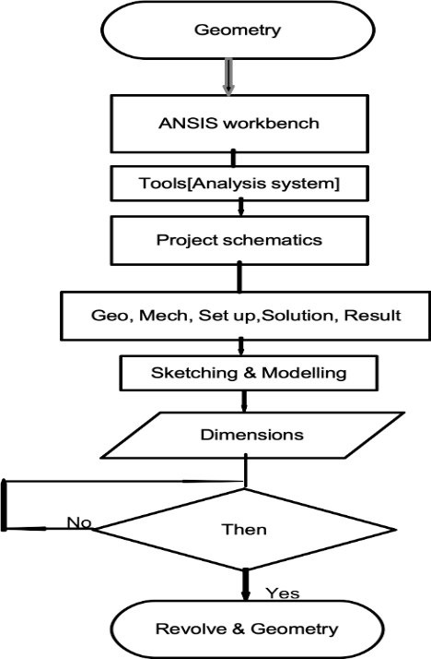

**Figure 1:** Algorithms

Figures 2 and 3 show the Tank-Baffles geometries drawn in ANSYS representing graphical illustration of Concave Rigid-ring Baffle (CVRB1and CVRB2) of 0.1m of thickness and pitch of 0.02m and 0.04m.

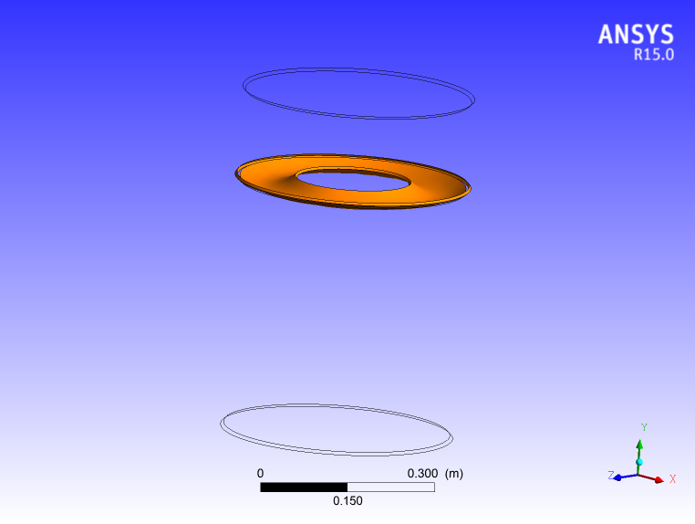 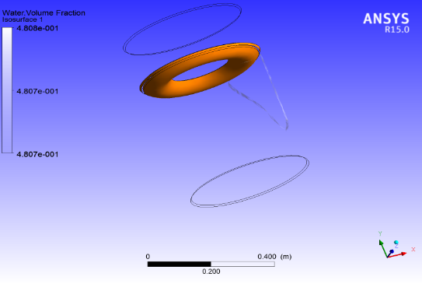

**Figure 2:** CVRB1 (0.02m pitch) **Figure 3:** CVRB2 (0.04m pitch)

Figure 4 is a graphical illustration of geometrical representation of Flat Rigid-ring Baffle (FRB) as the control.

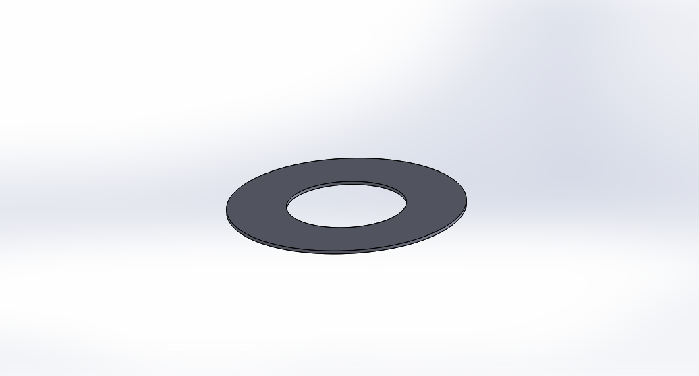

**Figure 4:** CAD of Flat Rigid-ring Baffle of 0.1 m width

Figure 5 is the algorithm for generating Finite Element Model of the Tank--water system.

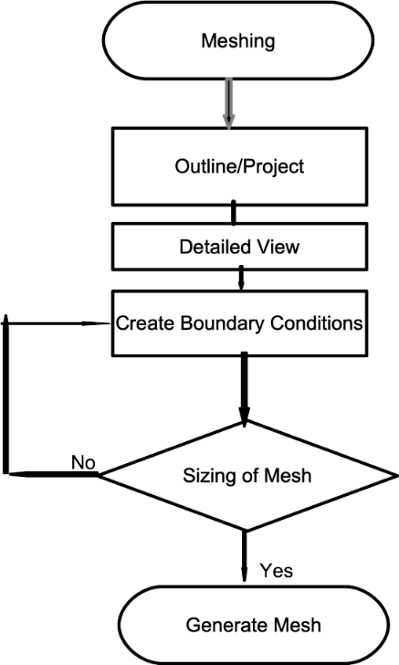

**Figure 5:** Meshing Algorithms

Figure 6 illustrates a sample of finite element of the tank, baffle and the test fluid (water) while.

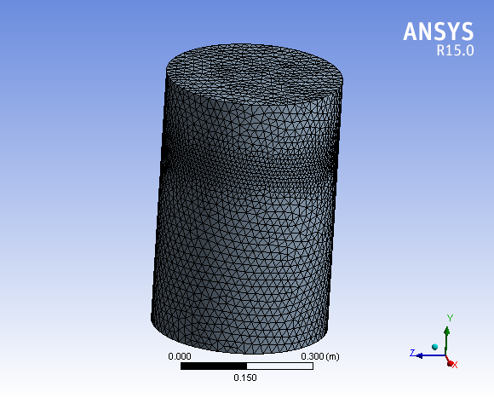

**Figure 6:** Finite Element Mesh of the Computational Domain

Figure 7 shows algorithms for problem set-up.

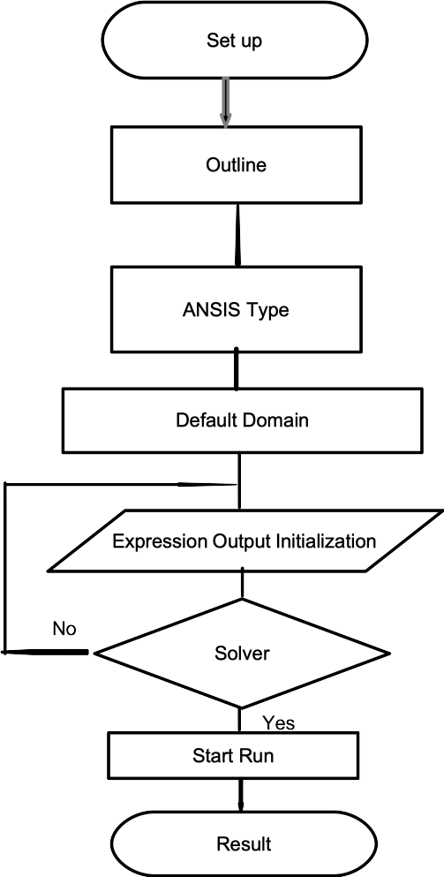

**Figure 7**: Set-up Algorithm

**Equation of Motion**

The dynamic of fluid while in motion could be represented mathematically by equations derived from conservation of mass and NSE. Çengel, Y.A. and Cimbala, J., M. (2006). These equations were solved using commercially available software, ANSYS solver to obtain pressure and velocity which are used to evaluate the forces at the walls of the tank.

The basic differential equation that a velocity potential must satisfy everywhere in the

liquid volume is the condition of liquid incompressibility, which is given by:

+ = 0 (1)

This equation is also known as Continuity Equation, where Eq. (2) represents general differential and compressible form of this equation.

$\frac{∂ρ}{∂t}+\vec{V}.\left(p\vec{V}\right)=0$ (2)

Where $\vec{∇}$ is the component of velocity vector in *x, y, z* axes respectively.

Momentum Equation (incompressible Navier–Stokes equation in vector form)

$ρ\frac{D\vec{V}}{Dt}=-\vec{∇}p+ρ\vec{g}+μ∇^{2}\vec{V }$ (3)

$∇^{2}=\frac{∂^{2}}{∂x^{2}}+\frac{∂^{2}}{∂y^{2}}+\frac{∂^{2}}{∂z^{2}}$ (4)

Where, $∇^{2}$ is the Laplacian operator, in Cartesian coordinate, $\vec{g}$ is acceleration due to gravity in vector form.

Integration of these governing equations yields non-steady version of Bernoulli’s equation for a potential flow without vorticity as:

$\frac{∂ϕ}{∂t}+\frac{p}{ρ}+gz+\frac{1}{2}\left(u^{2}+v^{2}+w^{2}\right)=f\left(t\right)$ (5)

where, *Φ*. P*,* ρ and *g* are the velocity potential, fluid pressure, fluid density and effective gravity acting in the negative *z* direction (this is equivalent to laboratory value but in opposite direction to the axial acceleration for a space vehicle) respectively. Small values of velocities *u, v, and w* were assumed, for the squared and higher power terms of these values to be negligible in comparison to those terms that are linear for linearization of the equation. Existence of the derivative of the velocity potential with physical meaning facilitates addition of time function to the definition of *Φ*. Hence, constant of integration *f (t)* in Eq. (5) is absorbed into the definition of *Φ,* linearised form of the equation (5) is in the form of Eq. (6), as detailed by Franklin (2000)

hence,

$\frac{∂∅}{∂x}+\frac{p}{ρ}+gz=0$ (6)

**Boundary Conditions (BC) at the Free Surface**

The walls BC and FS of the tank could be satisfied by solution of any mathematical function that satisfy equation (1). Also, Equation (6) is used to derive one of the BC at the FS. There is a free movement of the surface hence, insignificant values of the gas density in comparison to the liquid pressure at the surface, makes it equal to gas static pressure $p_{0}$ at the FS. Nonsteady Bernoulli’s equation at the FS is given by Franklin (2000) in the form

$\frac{∂ϕ\left(x, y, z, t\right)}{∂t}+gδ\left(x, y, t\right)=\frac{p_{0}}{ρ}$,

for $z=\frac{h}{2}$ (7)

FS small displacement is represented by *δ(x, y, and t)* and the height above FS is given in the form

*z = h/2* (8)

Unlinearised Eq. (7) would be solved at the point of displacement, therefore

z *= h/2 + δ* (9)

of the FS instead of equilibrium position i.e., *z = h/2.*

The difference between the two conditions *(z = h/2 and z = h/2 + δ)* results in higher order term of *δ,* which could be neglected. For small value of *g*, surface tension effect is significant to be considered in Equation (7). Gas pressure retains its value as ${ p}_{0}$ but, pressures values of liquid and gas are not the same at the FS and the adjacent side, this difference is a function of surface curvature and tension. Equation (7) represents the “dynamic” state at the FS. Relationship between displacement at the surface *δ* and the component of the velocity along vertical axis of the liquid at the FS requires kinematic analysis. In a linearised form, this condition is simply.

$\frac{∂δ}{∂t}=w=\frac{∂φ}{∂z }$, for $\frac{h}{2}$ (10)

Combining Equations (7) and (10) and writing it in terms of $φ (or δ)$ and differentiate with respect to *t* and z respectively, combine both equations to eliminate $φ (or δ)$ output to be,

$\frac{∂^{2}φ}{∂t^{2}}+\frac{∂φ}{∂z}=0$ for $\frac{h}{2}$ (11)

Natural frequency of the sloshing is an integral part of the time derivative of $φ$ in Eq. (11) which shows a direct relationship to the imposed gravitational field, earlier mentioned.

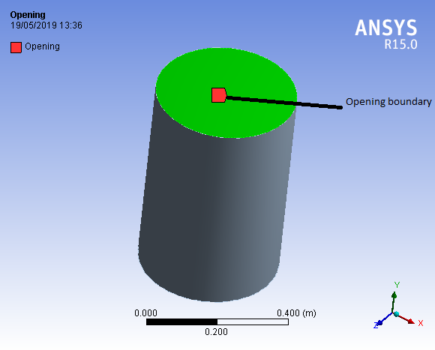

**Figure 8:** Opening Boundary conditions

**Boundary Conditions at the Tank Walls**

Assumption of negligible values of viscosity and viscous stresses render these quantities unsuitable for defining boundary condition at the wall hence, the value of velocity perpendicular to the wall’s plane of the tank, which is equal to $V_{n}$ is more appropriate, (*n* stands for normal direction) and condition of “no-slip” is not applicable hence slipping is allowed in the direction parallel to the wall. For a stationary tank, the BC at the wall is the normal velocity component of the liquid to the wall and is equal to zero. The value represents the standard type of BC value problem. Assumption of oscillation of the liquid–tank system, leads to a problem of non-standard boundary value, solvable by employing Fourier series. Problem that involves non-oscillatory motion of tank which results to none standard problem could be transform to standard boundary value mathematically by representing liquid motion in two parts. Rigid body motion similar to tank’s motion, and liquid motion relative to the RB motion. This approach is similar to what is obtainable in solid dynamics to analyse particle’s motion relative to a coordinate system in motion as detailed by Franklin (2000) hence, transformation in term of velocity potential is cast in this form;

${Φ=∅}_{c}+∅$ (12)

**w**here $Φ$ is the velocity potential, $∅_{c}$ and $∅$ are the potential for the tank’s rigid body motion and a motion of the liquid relative to the rigid body motion respectively hence, BC for Φ at the wall of the tank’s wall reduces to.

$\frac{∂∅_{c}}{∂n}=V_{n}$ (13)

$\frac{∂∅}{∂n}=0$ (14)

Where, $V_{n}$ is the liquid velocity perpendicular to the plane of the wall, and *n* stands for the normal or perpendicular direction.

This could not be applied to tank in rotational motions as velocity potential of the tank motion would have a non-zero value of vorticity. Sloshing problem is linear hence, it requires solving problems of different tank motion based on their configurations and integrate the results to obtain velocity potential for the whole motion (Franklin, 2000).

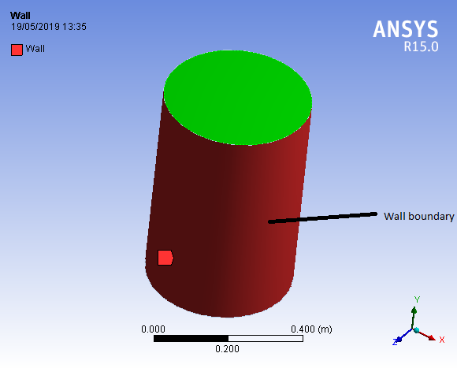

**Figure 9:** Wall boundary conditions

$F_{x}= \sum_{c}^{wetted area}{\left(p_{c}* {\vec{A}}_{cx}\right)}$ (15)

${ F}_{y}=\sum_{c}^{wetted area}{\left(p_{c}* {\vec{A}}_{cy}\right)}$ (16)

$F_{z}=\sum_{c}^{wetted area}{\left(p_{c}* {\vec{A}}_{cz}\right)}$ (17)

Eqs. 15 to 17 are the force application obtained from the force aggregate at the wall of the cylinder.

**Miles’ equation (Performance Evaluation Index)**

For a flat rigid-ring baffle in a cylindrical tank, the damping ratio as a function of baffle depth d should be estimated from Miles’ equation. The damping ratio which is a measure of the baffle performance is then estimated from:

$ξ=\frac{δ}{2π}=2.83e^{-4.60\frac{d}{R} {\left[\frac{2W}{R}-{\left(\frac{W}{R}\right)}^{2}\right]}^{\frac{2}{3}}}{\left(\frac{η}{R}\right)}^{\frac{1}{2}}$ (18)

$ξ ,$ damping ratio; $w ,$ baffle width; $η,$ maximum slosh-wave height at the wall and $δ$, the damping factor (or logarithmic decrement) and R, tank radius. The term in brackets is the fraction of the tank area covered by the baffle (Miles, 1958).

**IV. Comparison and Validation Study**

Numerical results of the three baffles with pitch values of 0.0200 m and 0.0400 m respectively were carried out to compare the variations of damping coefficients.

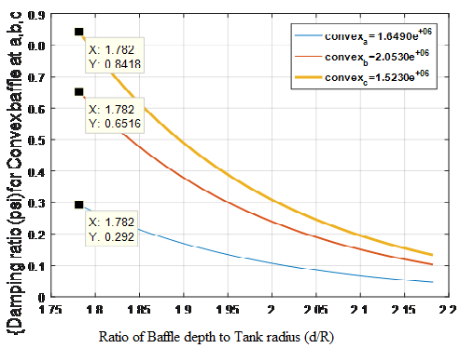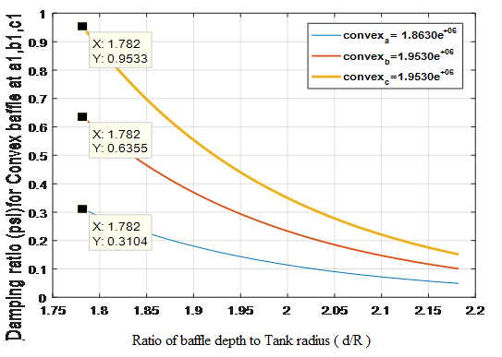

Figure 10. CVRB1 and CVRB2 are the graphs showing DR values at different positions of the tank-water along the tank depth

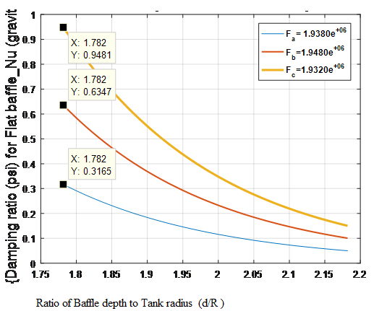

Figure 11. FRB graphs showing DR values at different position of the tank-water along the tank depth.

**The effect of pitch variation on the damping ratio of the baffles numerical results**

Figures 10 and 11 are the graphs of CVRB1 and CVRB2, increment of the pitch from 0.02m to 0.040m showed increase in the DR at (72 and 59)% standard positions of the tank and reduction of DR at 62% baffle position. ln comparism, CVRB has higher DR at 62 % water-filled position than FRB at the same position when the pitch has not increased. When the pitch increased from 0.02m to 0.04m, CVRB has higher values of DR than FRB at (62 and 59) % water-filled position of the tank

**Table:** 1.Values of Slosh-Wave Amplitude and DR for CVRB.

|  |  |  |
| --- | --- | --- |
| Baffle config-  urations | Slosh-Wave Amplitude  Numerical | Damping  Ratio |
| CVRB 1  0.020m  Numerical | 1.6490e+06  2.0530e+06  1.5230e+06 | 0.2920  0.6516  0.8418 |
| CVRB 2  0.040m  Numerical | 1.8630e+06  1.9530e+06  1.9530e+06 | 0.3104  0.6355  0.9533 |

**Table:** 2. Values of Slosh-Wave Amplitude and DR for SRB.

|  |  |  |
| --- | --- | --- |
| Baffle config-  urations | Slosh-Wave Amplitude  Numerical | Damping  Ratio |
| FRB  Numerical | 1.9380e+06  1.9480e+06  1.9320e+06 | 0.3165  0.6347  0.9481 |

**(V) Conclusion**

In this research, numerical investigation of damping effects of three type of baffles was carried out, in this regard CVRB shows some improvement in damping effectiveness, when the pitch was increased at (72 and 66) % standard baffle positions in the tank than FRB (baseline) at gravity. Also, the shape of the baffle enhances the reduction of hydrodynamic pounding on the tank’s wall consequently lessens the negative effect of fluid-structure interaction.

Disclaimer (Artificial intelligence)

Option 1:

Author(s) hereby declare that NO generative AI technologies such as Large Language Models (ChatGPT, COPILOT, etc.) and text-to-image generators have been used during the writing or editing of this manuscript.

Option 2:

Author(s) hereby declare that generative AI technologies such as Large Language Models, etc. have been used during the writing or editing of manuscripts. This explanation will include the name, version, model, and source of the generative AI technology and as well as all input prompts provided to the generative AI technology

Details of the AI usage are given below:

1.

2.

3.

**References**

Abramson, H.N., (1966). The dynamic behaviour of liquids in moving containers. NASA SP-106. NASA Special Publication, 106.

Abramson, H.N., (1969). Slosh suppression report. NASA, Washington DC, SP-8031.

Adebayo, M. A. (2009). Bending modes Control of Aerospace Vehicles. International Institute for advance Aerospace Technologies, At. Petersburg State University of Aerospace Instrumentation, 67, Bolshaya Morskaya, St. Petersburg, 190000, Russia.

Adebayo, M. A. (2010). Algorithms of bending modes Control of Aerospace Vehicles. International Institute for advance Aerospace Technologies, At. Petersburg State University of Aerospace Instrumentation, 67, Bolshaya Morskaya, St. Petersburg, 190000, Russia.

Shan, X., Li, X., et al. (2020). “Deep learning for modeling sloshing-induced forces

in tank vehicles.” *Physics of Fluids.*

Adebayo, M., Dare, A. A. and Salau, T. O., (2022). Numerical Investigation of Sloshing

Characteristics in Long Moving Vessels with Embedded Concave Rigid-ring Baffle in

Gravity Environment *a Department of Mechanical Engineering, University of Ibadan,*

*Nigeria.*

Said, M.A. & Elshafey, A. (2022) – “CFD analysis of sloshing in partially filled tanks

using modern turbulence models.” *Ocean Engineering.*

Chen, L., Zhang, Y., et al. (2021) – “Parametric study of liquid sloshing

suppression using different baffle types.” Journal of Fluids and Structures.

Akyildiz, H. and Unal, E., (2004). Experimental studies on liquid sloshing. Technical Report, Department of Ocean Engineering and Hydraulics Division, Istanbul Technical University.

Anon, (1968). Propellant Slosh Loads. NASA Space Vehicle Design Criteria (Structures), NASA SP-8009.

ANSYS CFX Reference Guide, November (2013). User’s Guide Release 15.0, ANSYS Inc. USA.

ANSYS CFX-Solver Modelling Guide, November (2013). User’s Guide Release 15.0, ANSYS Inc. USA.

ANSYS CFX-Solver Theory Guide, November (2013). User’s Guide Release 15.0, ANSYS Inc. USA.

Bauer, H.F., (1962). The Damping Factor Provided by Flat Annular Ring Baffles for Free Fluid Surface Oscillations. MSFC, Rept. No. MTP-AER0-62-81, (Nov. 13, 1962).

Bauer, H.F., (1964). Fluid oscillations in the containers of a space vehicle and their influence upon stability. National Aeronautics and Space Administration;[For sale by the Office of Technical Services, Department of Commerce, Washington, DC 20230].

Çengel, Y.A. and Cimbala, J., M. (2006). Fluid mechanics fundamentals and applications.

Chen, K.H., Kelecy, F.J. and Pletcher, R.H., (1994). Numerical and experimental study of three-dimensional liquid sloshing flows. *Journal of thermophysics and heat transfer*, *8*(3), pp.507-513.

Chia Chu. (2018) .Slosh-induced hydrodynamic force in a water tank with multiple baffles National Central University. Article in Ocean Engineering.

Chintalapati, S., Faure, J., Zhou, R., Vergalla, M., Kirk, D. and Gutiérrez, H., (2010).Enhanced Numerical Modeling in Simulation of a Generic Propellant Tank Slosh Baffle. In *46th AIAA/ASME/SAE/ASEE Joint Propulsion Conference & Exhibit* (p. 6976).

Vergalla, M., Kirk, D. and Gutiérrez, H., (2010).Enhanced Numerical Modeling in Simulation of a Generic Propellant Tank Slosh Baffle. In 46th AIAA/ASME/SAE/ASEE Joint Propulsion Conference & Exhibit (p. 6976).

Chu CR, Wu YR, Wu TR, Wang C-Y (2018) Slosh-induced hydrodynamic force in a water tank with multiple baffles. Ocean Eng 167:282–292

Cole Jr, H.A. and Gambucci, B.J., (1961). Measured two-dimensional damping effectiveness of fuel-sloshing baffles applied to ring baffles in cylindrical tanks.

Eswaran, M. and Saha, U.K., (2011) .Sloshing of liquids in partially filled tanks–a review of experimental investigations. *Ocean Systems Engineering*, *1*(2), pp.131-155.

pp.198-205.

Evans, D.V. and McIver, P., (1987). Resonant frequencies in a container with a vertical baffle. Journal of Fluid Mechanics, 175, pp.295-307.

Gordon D. Stubley ‘’Computational Fluid Dynamics for Fluids Engineering Design’’ ANSYS CFX STUDENT USER MANUAL Version 11, Department of Mechanical Engineering, University of Waterloo ©G.D. Stubley 2008.UDF user defined functions ANSYS MP4 Video

Hastings, L.J., Platt, G.K. and Swalley, F.E., (1965). Saturn V low gravity fluid mechanics problems and their investigation by full-scale orbital experiment.

Heng Jin, Yong Liu, Ruiyin Song and Yi Liu (2020). Analytical study on the effect of a horizontal perforated plate on sloshing motion in a rectangular tank Journal of Offshore Mechanics and arctic Engineering

Jiadong Wang et. al (2019). Coupled Responses in a Partially Liquid-Filled Cylindrical Tank with the Single FB under Pitching Excitations. Journal of Shock and Vibration

Jing-Han Wang and Shi-Li Sun (2019). Study on liquid sloshing characteristics of a swaying rectangular tank with a rolling baffle. [Journal of Engineering Mathematics](https://link.springer.com/journal/10665) volume 119, pages23–41

Kandasamy, T., Rakheja, S. and Ahmed, A.K.W., (2010). An analysis of baffles designs for limiting fluid slosh in partly filled tank trucks. The Open Transportation Journal, 4(1).

Khezzar, L., Seibi, A. and Goharzadeh, A., (2009). Water sloshing in rectangular tanks–an experimental investigation & numerical simulation. International Journal of Engineering (IJE), 3(2), p.174.

Konstantin Tsiolkovsky (1857-1935): Russian Father of Rocketry

Kumar, N., (2013). Study of Sloshing Effects in a Cylindrical Tank with and without Baffles under Linear Acceleration (Doctoral dissertation).

Kundu, P.K., Cohen, I. and Dowling, D., 20. Fluid Mechanics. (1990). Academic Press, 77, p.108.

Laura Battaglia, Marcela Cruchaga, Mario Storti, Jorge D’Elía Jonathan NúñezAedo , Ricardo Reinoso (2018). Numerical modelling of 3D sloshing experiments in rectangular tanks, Applied Mathematical Modelling journal

Lecture 1 - The Fourier Transforms and its Applications MP4 video, Stanford Engineering Stanford University.

Leuva, D., (2011). Experimental investigation and CFD simulation of active damping mechanism for propellant slosh in spacecraft launch systems.

M. L. Turner, ‘‘Rocket and Spacecraft Propulsion’’, Principles, Practice and New Developments (Second Edition) CBE Department of Physics and Astronomy University of Leicester, UK

Maleki, A. and Ziyaeifar, M., (2008). Sloshing damping in cylindrical liquid storage tanks with baffles. *Journal of Sound and Vibration*, *311*(1-2), pp.372-385.

Masica, W.J. and Salzman, J.A., (1965). An experimental investigation of the dynamic behaviour of the liquid-vapour interface under adverse low-gravitational conditions.

Miles, J.W., (1956). On the Sloshing of Liquid in a Cylindrical Tank. Rep. No.AM 6-5. GM-TR-18, Guided Missile Res. Div., The Ramo-Wooldridge Corp.

Miles, J.W., (1958). Ring damping of FS oscillations in a circular tank. J. Appl. Mech, 25(2), pp.274-276.

Michael, R. Hatch. ‘‘Vibration using MATLAB and ANSYS. ’’Chapman & Hall/ CRC USA.

NASA Space Vehicle design criteria (Guidance and Control), 2001, pp.36-41.

Modaressi-Tehrani, K., Rakheja, S. and Stiharu, I., (2007). Three-dimensional analysis of transient slosh within a partly-filled tank equipped with baffles. Vehicle System Dynamics, 45(6), pp.525-548.

Mohan, A., (2014). Finite element analysis on trapezoidal tank to suppress sloshing effect. International Journal of Innovative Research in Advanced Engineering, 1(10), pp.121-125.

Moiseyev, N.N. and Rumyantsev, V.V., (2012). Dynamic stability of bodies containing fluid (Vol. 6).Springer Science & Business Media.

Nema, P.K., (2014). Computational study of sloshing behaviour in 3-D rectangular tank with and without baffle under Seismic Excitation (Doctoral dissertation).

Nebylov, A.V., A.I. Panferov and S.A. Brodsky (2005a), ‘’Flexible aerospace vehicles simulation and

nonlinear control synthesis’’, Proceedings of 16th IFAC World Congress, Prague.

Panferov, A.I., Nebylov A.V. and Brodsky, S.A., (2008), ‘‘Theory and software for simulation of complex aerospace vehicles and smart control.’’

Peng D, Mi-AnXue and Jinhai Z., (2020). Numerical and experimental study of tuned liquid damper effects on suppressing nonlinear vibration of elastic supporting structural platform

Release 12.0 c ANSYS, Inc. March 12, (2009)

Sakai, F., Nishimura, M. and Ogawa, H., (1984).Sloshing behaviour of floating-roof oil storage tanks. *Computers & Structures*, *19*(1-2), pp.183-192.

Scholl, H.F. and Stephens, D.G., (1967). Effectiveness of flexible and rigid ring baffles for damping liquid oscillations in large-scale cylindrical tanks.

Silveira, M.A., Stephens, D.G. and Leonard, H.W., (1961). An experimental investigation of the damping of liquid oscillations in cylindrical tanks with various baffles (No. TN D 715).national aeronautics and space administration washington dc.

Simple and Easy Tutorial on FFT Fast Fourier Transform Matlab Part 1 (1) item type MP4 Video

Simple and Easy Tutorial on FFT Fast Fourier Transform Matlab Part 2(2) Item type MP4 Video. Reynolds Transport theorem

Simple FFT and Filtering Tutorial with Matlab – Code Project

Simulation of kerosene-liquid tank sloshing with baffles using Fluent, MP4 Video

Takabatake, D., Sawada, S., Yoneyama, N. and Miura, M., (2008), October. Sloshing reduction effect of splitting wall in cylindrical tank. In The 14th World Conference on Earthquake Engineering” October (pp. 12-17).

The Focus Video Tips- Multiphysics Simulation with ANSYS Maxwell and ANSYS Mechanical - Part 2 mP4 Video

TUTORIAL 10: Simulation of Multiphase problem with ANSYS CFX-Sloshing in a Tank

Tutorial: Fuel Tank Sloshing ANSYS, Inc. February 9, (2011).

Wang WY, Peng Y, Zhou Y, Zhang Q (2016). Liquid sloshing in partly-filled laterally-excited

cylindrical tanks equipped with multi baffles. Appl Ocean Res 59:543–563

Xue, M.A., Zheng, J. and Lin, P., (2012). Numerical simulation of sloshing phenomena in cubic tank with multiple baffles. Journal of Applied Mathematics, (2012).Pp.8-16.

Zhao DY, Hu ZQ, Chen G, Lim S, Wang S (2018) Nonlinear sloshing in rectangular tanks under forced excitation. Int J Nav Arch Ocean Eng 10:545–565

Zhou, D., Wang, J. D., & Liu, W. Q. (2014). Nonlinear sloshing of liquid in rigid cylindrical

container with a rigid annular baffle: free vibration. Nonlinear Dynamics, 78(4), 2557-

2576.