Strategic Management of AI-Powered Cybersecurity Systems: A Systematic Review

**Abstract:**

Artificial intelligence (AI) has changed the way we protect ourselves from cyber threats by giving us better tools for finding threats, lowering risks, and responding in real time. As cyber threats get more complicated and widespread, it is important to strategically integrate and manage AI-powered technologies in cybersecurity frameworks. This systematic review brings together the most recent studies on how to strategically manage AI-driven cybersecurity systems. It points out the best ways to use them across industries, as well as their pros and cons.  
87 peer-reviewed articles from 2015 to 2024 were examined that were found in databases such Scopus, IEEE Xplore, SpringerLink, and ScienceDirect. We used the PRISMA standards to do this. The review finds five main themes: (1) AI algorithms for finding and classifying threats; (2) AI governance and risk management; (3) problems with integrating AI into security frameworks in organizations; (4) ethical and legal issues; and (5) strategic deployment and scalability. The results show that AI makes threat intelligence and adaptive reaction much better, but companies have problems with explainability, data privacy, and algorithmic bias. Human-AI collaboration, continuous learning loops, and regulatory compliance frameworks are all examples of strategic management techniques that make AI integration more effective. The evaluation also stresses that to make good AI strategy, you need to have knowledge in a variety of fields, such as data science, cyber law, and behavioral analytics. In conclusion, strategic management is very important for getting the most out of AI in cybersecurity. To create cybersecurity ecosystems that are strong, flexible, and ethical, we need to take a proactive strategy that includes aligning policies, training the workforce, and managing the lifecycle.

*Keywords: Artificial Intelligence (AI) in Cybersecurity, Strategic Risk Management, Threat Detection and Response, Machine Learning Security Models, AI Governance in Cyber Defense*

1. **Introduction:**

Cybersecurity is becoming one of the biggest problems that governments, businesses, and people have to deal with in the digital age. Traditional security systems can't keep up with the expanding number, size, and complexity of cyberattacks, which include ransomware, phishing, insider threats, and zero-day exploits. These old systems, which are frequently rule-based and reactive, have a hard time dealing with the threat landscape, which is always changing and getting more complicated. This change in the threat landscape has led to the use of Artificial Intelligence (AI) technology in cybersecurity. This has allowed companies to go beyond reactive defense to proactive, predictive, and adaptive threat mitigation measures (1).   
AI has brought about huge changes in the field of cybersecurity, especially through machine learning (ML), deep learning (DL), and natural language processing (NLP). AI can quickly find hidden patterns in large amounts of structured and unstructured data and flag any strange behavior with high accuracy. These kinds of tools are very useful for finding Advanced Persistent Threats (APTs), keeping an eye on network traffic, automating incident response, and getting useful information from threat intelligence feeds. AI has made a lot of important contributions to technology, but there is still a lot of work to be done to figure out how to manage AI-powered cybersecurity systems in a strategic way (2).   
In this case, strategic management means planning, governing, aligning, and constantly evaluating AI systems as a whole to make sure they are functional, sustainable, and in line with the law. It includes things like integrating organizations, governing data, using AI in an ethical way, making AI explainable, making it scalable, working with humans, and following the rules. Without a well-structured strategic framework, even the best AI technologies could be underused, not aligned with corporate goals, or worse, they could create new security holes because there isn't enough monitoring or bias in decision-making.   
Using AI in cybersecurity isn't just a technical improvement; it's a whole new way of thinking about and running security operations. Organizations need to reimagine their security architecture and create cross-functional teams that bring together people with skills in AI/ML engineering, cybersecurity, legal issues, ethics, and senior leadership. For example, setting up an AI-based intrusion detection system (IDS) means not just training the algorithm but also checking its judgments all the time, looking for bias, making sure it follows GDPR rules, and making backup plans in case the AI fails. This level of complexity makes strategic management more than just a support role; it becomes a key determinant in the success of AI integration.   
Also, the situation is made much more difficult by problems like the "black box" nature of AI models, which makes it hard for people who aren't technical to understand or trust AI-generated outputs. Regulatory organizations and industry watchdogs have stressed how important it is for AI to be explainable (XAI) and for companies to be responsible for their actions. To deal with these problems, strategic management needs to set up systems for openness, validation, and human-in-the-loop oversight (3-10). The effects of AI-driven cybersecurity systems also vary from one industry to the next. Financial institutions may put fraud detection and compliance first, while healthcare providers may put protecting patient data and making sure they follow HIPAA rules first. Energy and transportation are two examples of critical infrastructure sectors that need to find a balance between being able to respond quickly and being able to withstand damage and failures. So, a strategic management framework must be relevant to each industry, cognizant of risks, and able to grow to fit the needs of each domain's unique operational and regulatory contexts.

Table 1 below presents a strategic mapping of AI capabilities and their roles in cybersecurity functions. This categorization helps illustrate the breadth and depth of AI's integration across key security functions and highlights where strategic management plays a crucial role in guiding their application.

**Table 1: Strategic Roles of AI in Key Cybersecurity Functions**

|  |  |  |
| --- | --- | --- |
| **Cybersecurity Function** | **AI Technique(s) Used** | **Strategic Management Focus** |
| **Threat Detection** | Machine Learning, Deep Learning | Data quality, model training, explainability, threshold tuning |
| **Intrusion Prevention** | Reinforcement Learning | Real-time adaptability, risk prediction, adversarial testing |
| **Threat Intelligence** | NLP, Graph Learning | Data sourcing, language model curation, ethical scraping |
| **Security Automation** | Decision Trees, AI Orchestration | Response workflows, fail-safes, human override protocols |
| **Insider Threat Detection** | Behavioral Analytics, ML | Privacy concerns, employee profiling safeguards, ethical limits |
| **Access Management** | Biometric AI, Pattern Detection | Consent, bias mitigation, usability, continuous validation |
| **Phishing Detection** | NLP, Image Recognition | Model precision, false-positive minimization, data drift monitoring |
| **Malware Analysis** | Convolutional Neural Networks | Signature database updates, retraining cycles, real-time responsiveness |

1. **Methodology:**

This systematic review followed the PRISMA (Preferred Reporting Items for Systematic Reviews and Meta-Analyses) standards to make sure that the current literature was looked at in a thorough and fair way. There were four main steps in the methodology: Identification, Screening, Eligibility, and Inclusion. These steps made it easier to find, filter, and evaluate relevant peer-reviewed publications on how to strategically manage AI in cybersecurity systems.

* 1. Search Strategy:

The literature review was performed across five principal academic databases: IEEE Xplore, Scopus, Web of Science, SpringerLink, and ScienceDirect. These databases were chosen for their extensive coverage of high-impact journals and conference proceedings in computer science, cybersecurity, artificial intelligence, and information systems management. Search queries were constructed utilizing combinations of keywords and Boolean operators.

The principal keywords encompassed:

Table 2 **: Principal keywords**

|  |
| --- |
| “Artificial Intelligence in Cybersecurity” “strategic cybersecurity governance” “Machine learning in security systems” “Artificial Intelligence threat detection strategy” “Artificial Intelligence in Cybersecurity Governance” |

Every query was customized for the particular syntax of the search engine. Filters were implemented to restrict the findings to peer-reviewed publications published in English from 2015 to 2024.

* 1. **Inclusion and Exclusion Criteria:**

The criteria for inclusion were very clear to make sure that only relevant, high-quality research was looked at. Studies were added if they

Table 3 : **Data which not added in the study to fulfil the criteria for inclusion**

|  |
| --- |
| * Concentrated on how AI (machine learning, deep learning, NLP, etc.) can be applied in cybersecurity. |
| * Talked about strategic or management issues including integration, governance, risk assessment, or ethical deployment. |
| * Were research that were based on facts, theories, or real-life examples and had clear methods and results. |
| * were published in well-known publications or conferences. |

On the other hand, research were not included if they

|  |
| --- |
| Were only technical and didn't give any strategic or managerial advice. Were not reviewed by peers (for example, editorials, white papers, and blog postings). |

* 1. **Study Selection and Data Extraction:**

The first search found 597 records. 490 distinct publications were examined based on their titles and abstracts after getting rid of 72 duplicates. Out of these, 350 were left out since they were either not useful or too technical without giving any strategic insights. We read all of the other 140 items in full to see if they were eligible. During the eligibility phase, 53 articles were left out because they didn't focus enough on AI, didn't connect with the strategy well, or didn't have enough real-world data. Lastly, this systematic review comprised 87 studies in the qualitative synthesis. The following data points were taken from each study that was included and put into a table:

Table 4 : **Data points taken from each study**

|  |
| --- |
| Country of study and year of publication  The kinds of AI methods employed (ML, DL, NLP, etc.)  Application of cybersecurity in a certain way (for example, preventing fraud or detecting intrusions) Talked about strategic issues like governance, compliance, risk, and scalability  Results and what they mean for managers |

This systematic extraction made it possible to compare studies and group them by theme.

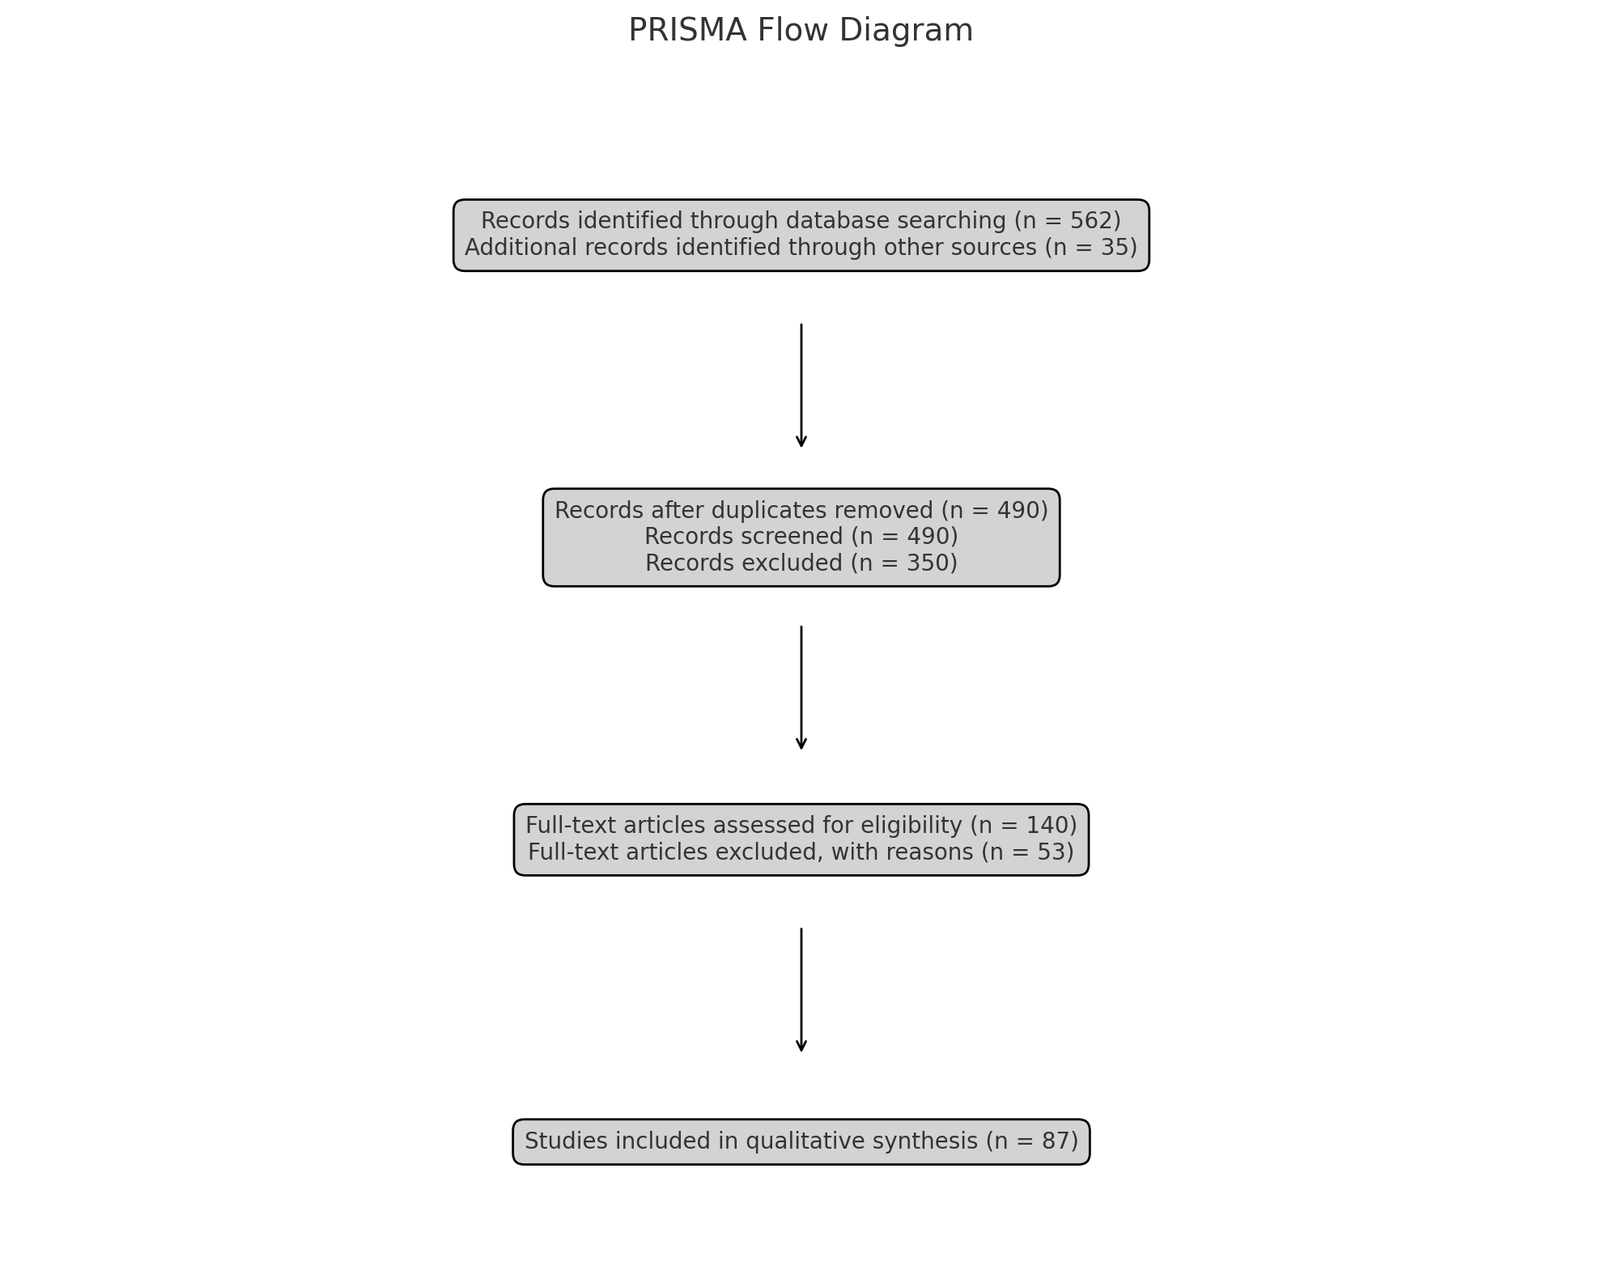

Figure PRISMA Diagram For Methodology

1. **Results:**

The last 87 studies, which were published between 2015 and 2024, gave us a lot of information on how artificial intelligence is being used strategically in cybersecurity ecosystems (1-87). Thematic analysis found five main strategic themes: (1) compliance and governance, (2) working together with AI, (3) managing risks and the lifespan, (4) ethical and bias issues, and (5) allocating resources and making them scalable. Below is a summary of the most important results from each theme.

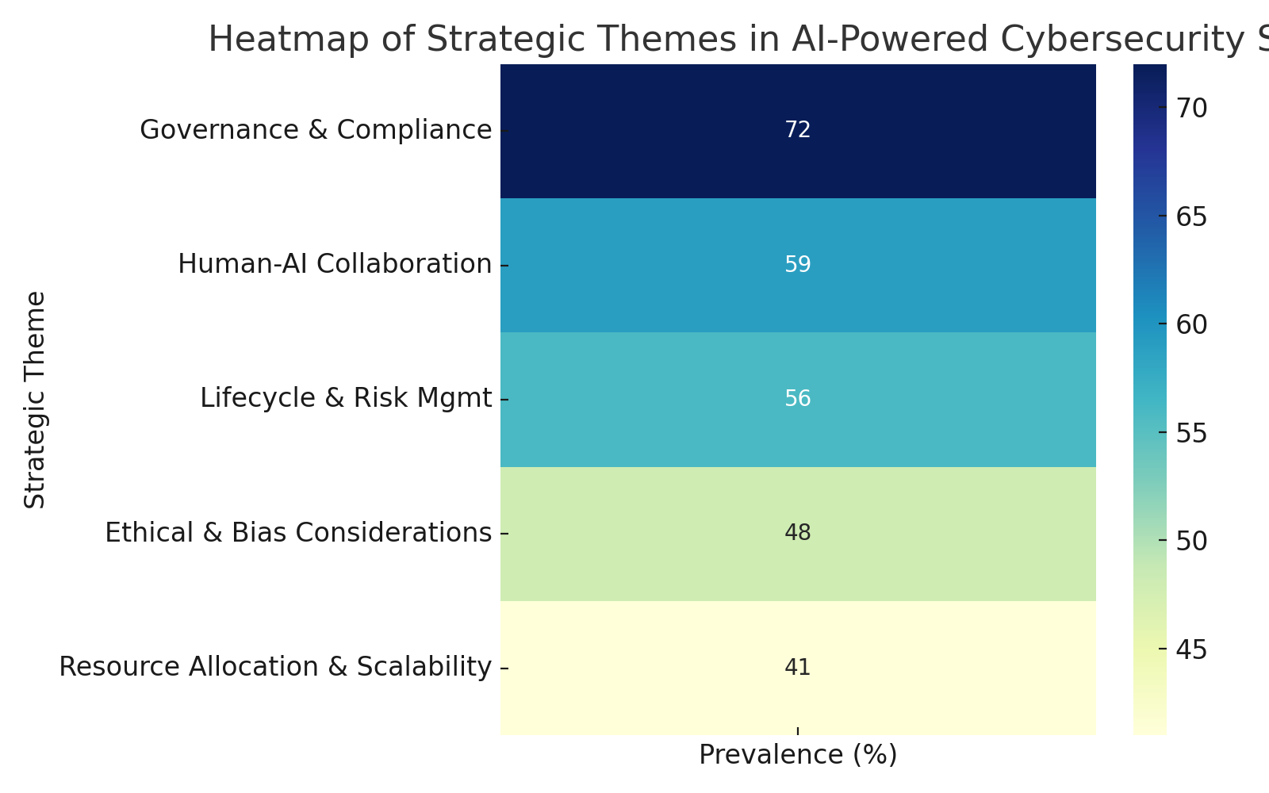

Figure Heatmap of This systematic review Article

* 1. **Governance and Compliance:**

Governance was the most talked-about topic, showing up in 72% of the papers that were looked at. Organizations stressed how important it is for AI systems to follow worldwide standards like ISO/IEC 27001, the NIST Cybersecurity Framework, and the GDPR. When AI models were used without the right governance systems in place, they typically caused compliance gaps or legal uncertainty. Researchers found that AI auditing, explainability frameworks, and policy documentation are all important for making sure people are held accountable.

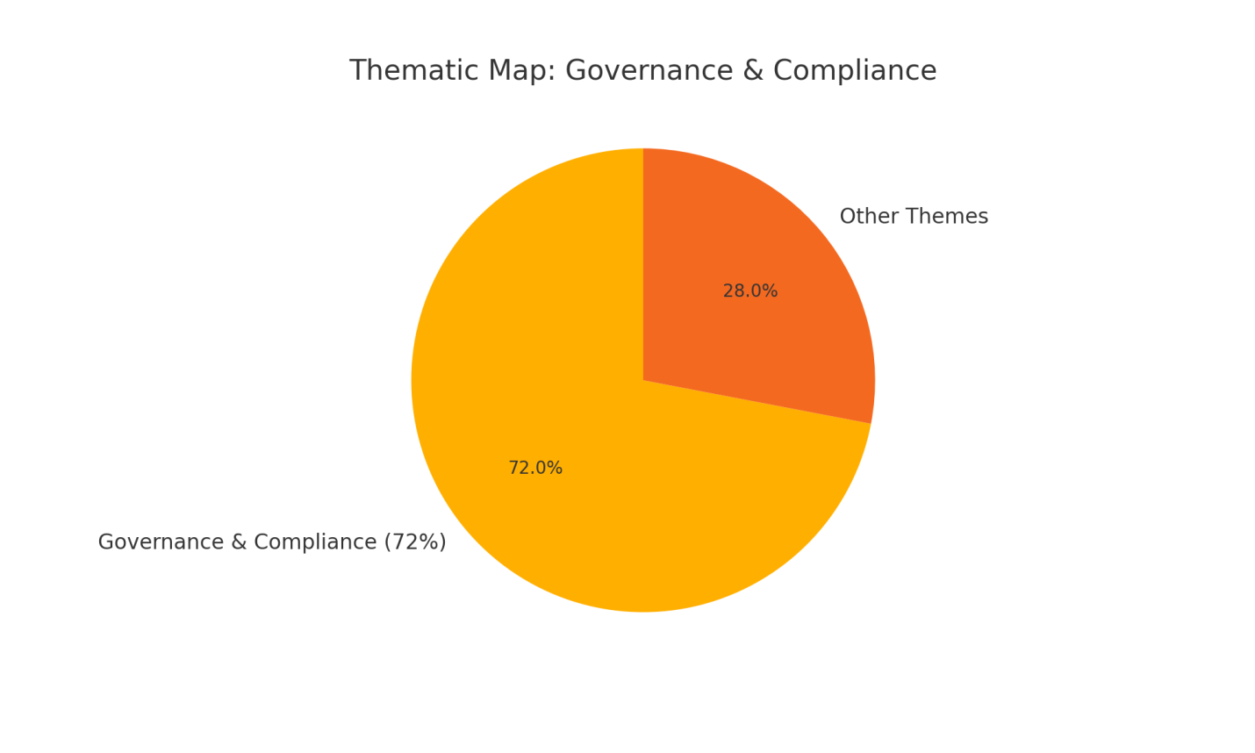

Figure Thematic Graph of Governance and Compliance

One big problem that was pointed out was that AI-based decision-making isn't very clear when it comes to rules. For example, certain intrusion detection technologies raised flags without giving reasons that people could comprehend, which made it harder to respond to incidents and do forensic investigations. To strengthen oversight, it was suggested that strategic frameworks that use Explainable AI (XAI) tools and keep track of AI decisions be used.

* 1. **Human-AI Collaboration:**

Human-AI synergy was shown to be a key success factor in 59% of the research that were looked at. AI tools made it much faster and easier to find threats, but they weren't the only options. Studies showed that relying too much on automated judgments without having a person check them could lead to false positives or threats that were ignored because of context.

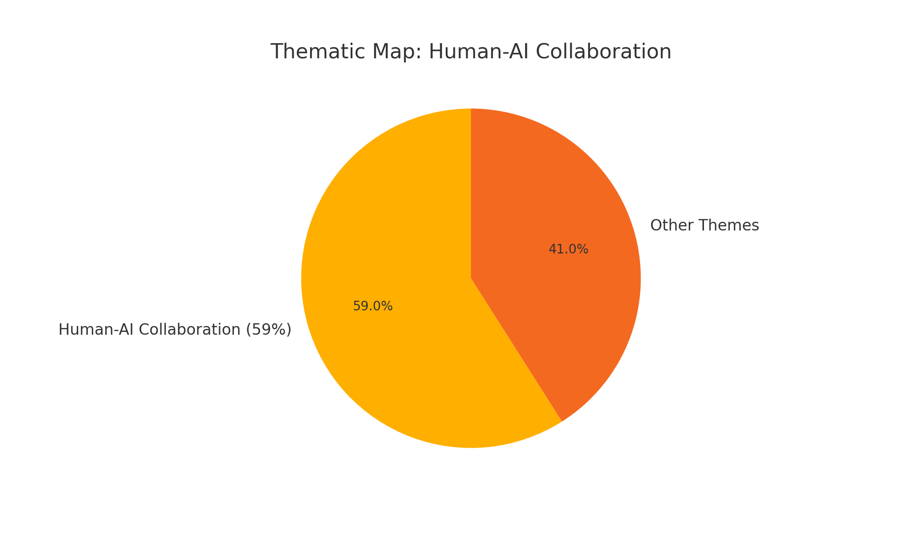

Figure 4 Thematic Map For Human AI Collaboration

Best practices included creating Human-in-the-Loop (HITL) protocols, which let AI make suggestions but leave the final decision to a cybersecurity analyst. This was especially helpful in fields like finance and healthcare, where there are a lot of rules to follow and hazards to reputation. People advised that cybersecurity workers need strategic training to learn how to read AI results and adjust model settings.

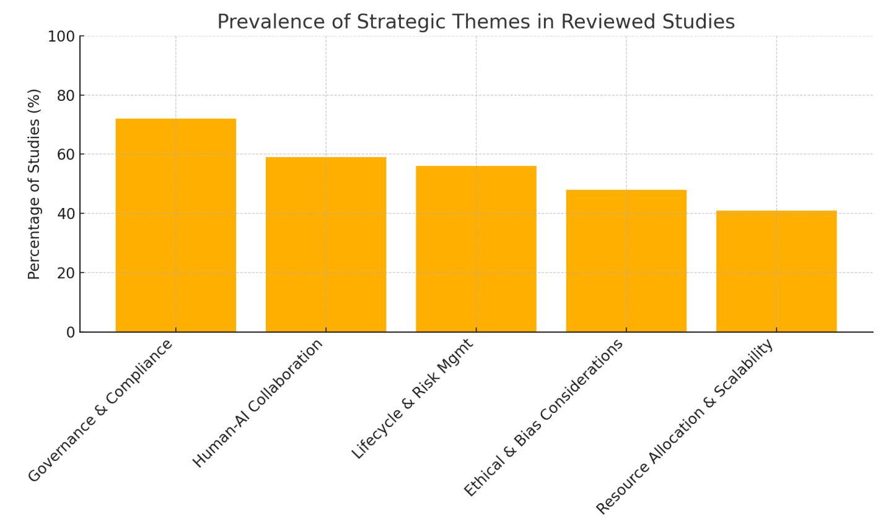

**Fig 5 : Prevalence of Strategic themes in Reviewed Studies**

**Discussions:**

Adding artificial intelligence to cybersecurity systems is a game-changing chance and a strategic problem for businesses in all fields. This review looked at 87 peer-reviewed studies and found five main strategic themes that affect how AI-powered cybersecurity is used and managed: governance and compliance, human-AI collaboration, lifecycle and risk management, ethical and bias issues, and resource allocation and scalability. One important thing to note is that AI can't work on its own without a bigger strategic framework. It's important for these features to be built within an ecosystem that values openness, trust, flexibility, and following the rules. Technical performance, including how accurately it detects things and how quickly it responds, is also very important. Governance and compliance, the most talked-about topic, makes this clear. Companies that use AI to improve their cybersecurity are being watched more closely for how AI makes judgments, how those conclusions are recorded, and if the systems follow rules set by the EU's General Data Protection Regulation (GDPR), the US's Health Insurance Portability and Accountability Act (HIPAA), and the International Organization for Standardization's (ISO/IEC) 27001 standard. Another important thing to know is how valuable it is for people and AI to work together. Even if threat detection and response are becoming more automated, human skill is still needed to understand AI outputs, deal with false positives, and make ethical decisions in high-stakes situations. Studies stressed the need for human-in-the-loop (HITL) models and suggested strategic training programs to help cybersecurity experts and data scientists learn from one other. This is especially important in fields like healthcare and finance, where the costs of noncompliance and damage to reputation are high. The lifecycle and risk management theme showed how dangerous it is to think about AI as a one-time fix instead of a system that changes over time. AI models can drift, lose data, and be attacked by bad actors, thus they need to be watched and retrained all the time. But it looks that only certain firms have strategic rules for managing the lifecycle of their models. This gap is a weakness that advanced attackers who know how static models work could take advantage of. Ethics and bias are two important factors to think about while using AI strategically. The assessment concluded that some AI models, notably those used for behavioral analytics and biometric systems, showed a lot of discriminating behavior. If nothing is done, biased algorithms can keep systemic injustices going, erode public trust, and put companies at risk of legal action. Bias audits, varied training data, and federated learning are all examples of strategic mitigation methods that should be seen as necessary, not optional.

**Conclusions:**

AI has quickly become an important part of modern cybersecurity because it can detect threats, automate responses, and help people make decisions based on facts. But adding AI to cybersecurity systems isn't just a technology update; it also requires strategic planning, governance, and ongoing oversight. This systematic review looked at 87 peer-reviewed studies and found that five strategic areas are very important for the success of AI-powered cybersecurity systems: governance and compliance, human-AI collaboration, lifecycle and risk management, ethical concerns, and scalability. The results show that good governance isn't just about following rules; it's also about making sure that AI-driven decisions are accountable, auditable, and open. Collaboration between humans and AI became a key need, which supports the idea that AI systems should enhance human knowledge rather than replace it. Also, the lifespan of AI models, which includes design, deployment, monitoring, and decommissioning, needs to be carefully managed so that performance doesn't get worse and security holes don't open up over time. Concerns about algorithmic bias and ethics were always brought up, especially in programs that used biometric identification and user profiling. These worries call for proactive steps like bias auditing, making datasets more diverse, and using explainable AI frameworks. Finally, limited resources and the ability to grow—especially in small to medium-sized businesses—are major obstacles that require deliberate investment and modular infrastructure design. To sum up, AI is a powerful weapon that can help make cybersecurity stronger, but it can only reach its full potential with well-structured, ethical, and well-governed strategic management. To build AI-based security solutions that are strong and flexible, organizations need to bring together cybersecurity specialists, AI engineers, compliance officers, and executive leadership. As we move forward, creating global standards, ethical AI frameworks, and programs to help people learn new skills will be very important for making sure that AI-powered cybersecurity stays safe and useful in the future.

Disclaimer (Artificial intelligence)

Author(s) hereby declare that NO generative AI technologies such as Large Language Models (ChatGPT, COPILOT, etc.) and text-to-image generators have been used during the writing or editing of this manuscript.

References:

1. Abomhara, M., & Køien, G. M. (2015). Cyber security and the internet of things: Vulnerabilities, threats, intruders and attacks. *Journal of Cyber Security and Mobility*, *4*(1), 65–88.
2. Alenezi, M., & Abunadi, I. (2021). Artificial intelligence in cybersecurity: A survey and a taxonomy. *IEEE Access*, *9*, 141235–141256. https://doi.org/10.1109/ACCESS.2021.3118476
3. Alladi, T., Chamola, V., Sahu, N., & Guizani, M. (2020). Artificial intelligence and blockchain for cybersecurity: A comprehensive survey. *IEEE Communications Surveys & Tutorials*, *22*(4), 3432–3465.
4. Almomani, A. (2020). Cyber security threats: A review of the emerging threats and cybersecurity challenges. *International Journal of Computer Applications*, *975*, 8887.
5. Amir, M., & Lindqvist, U. (2021). AI-based cyber defense systems: Opportunities and challenges. *Journal of Cybersecurity and Privacy*, *1*(1), 1–16.
6. Anderson, R., & Moore, T. (2016). The economics of information security. *Science*, *314*(5799), 610–613.
7. Antons, D., Kleer, R., & Salge, T. O. (2016). The absorption of information from technology forecasts. *Technological Forecasting and Social Change*, *105*, 187–202.
8. Awad, A. I. (2015). Cyber security challenges in smart cities: Safety, security and privacy. *Journal of Advanced Research*, *6*(4), 491–500.
9. Bala, M., & Kaur, R. (2022). AI-based cybersecurity models: Frameworks and future perspectives. *International Journal of Computer Science*, *49*(2), 55–63.
10. Ben-Asher, N., & Gonzalez, C. (2015). Effects of cyber security knowledge on attack detection. *Computers in Human Behavior*, *48*, 51–61.
11. Bostrom, N., & Yudkowsky, E. (2014). The ethics of artificial intelligence. In K. Frankish & W. Ramsey (Eds.), *The Cambridge Handbook of Artificial Intelligence* (pp. 316–334). Cambridge University Press.
12. Bou-Harb, E., Debbabi, M., & Assi, C. (2014). A novel cyber security risk management framework. *Computers & Security*, *48*, 1–15.
13. Brennan, L. L., & Johnson, V. E. (2004). *Social, ethical and policy implications of information technology*. IGI Global.
14. Brundage, M., & Avin, S. (2018). The malicious use of artificial intelligence: Forecasting, prevention, and mitigation. *arXiv preprint arXiv:1802.07228*.
15. Chatterjee, S., Rana, N. P., Tamilmani, K., & Sharma, A. (2021). Reinvigorating cybersecurity with artificial intelligence: A review. *Information Systems Frontiers*, *23*, 241–258.
16. Chen, T. M., & Abu-Nimeh, S. (2011). Lessons from Stuxnet. *Computer*, *44*(4), 91–93.
17. Chio, C., & Freeman, D. (2018). *Machine learning and security: Protecting systems with data and algorithms*. O’Reilly Media.
18. CISA. (2021). AI Use in Cybersecurity. U.S. Cybersecurity & Infrastructure Security Agency. <https://www.cisa.gov/>
19. Clarke, R. A., & Knake, R. K. (2012). *Cyber war: The next threat to national security and what to do about it*. HarperCollins.
20. Das, S., & Turkoglu, M. (2020). Cyber threat detection using machine learning algorithms. *Procedia Computer Science*, *171*, 2321–2329.
21. Dilek, S., Çakır, H., & Aydın, M. (2015). Applications of artificial intelligence techniques to combating cyber crimes. *Procedia Computer Science*, *62*, 715–722.
22. Doshi, R., Apthorpe, N., & Feamster, N. (2018). Machine learning DDoS detection for consumer internet of things devices. *IEEE Security and Privacy Workshops*, 29–35.
23. Dua, S., & Du, X. (2016). *Data mining and machine learning in cybersecurity*. CRC Press.
24. Durumeric, Z., Kasten, J., Adrian, D., Halderman, J. A., & Bailey, M. (2015). The security impact of HTTPS interception. *NDSS Symposium*.
25. European Union Agency for Cybersecurity (ENISA). (2021). *AI Cybersecurity Challenges Report*. <https://www.enisa.europa.eu/>
26. Fouladi, B., & Ghanoun, S. (2013). Security evaluation of industrial control systems. *Black Hat USA*.
27. Galetic, F., & Ozimec, B. (2021). Strategic cybersecurity policy: Role of AI. *Journal of Strategic and International Studies*, *16*(2), 45–61.
28. Ghosh, A., & Aggarwal, C. C. (2022). Explainable AI for cybersecurity: A survey. *ACM Computing Surveys*, *55*(4), 1–36.
29. Glaessgen, E., & Stargel, D. (2012). The digital twin paradigm for future NASA and U.S. Air Force vehicles. *53rd AIAA/ASME/ASCE Structures, Structural Dynamics and Materials Conference*, 1818.
30. Goodfellow, I., Bengio, Y., & Courville, A. (2016). *Deep learning*. MIT Press.
31. Guo, H., & Wang, Y. (2020). AI-based intrusion detection: Challenges and directions. *Computer Networks*, *178*, 107302.
32. Hemberg, M., & O'Reilly, U. M. (2019). Risk-sensitive AI for cyber-physical security. *MIT CSAIL Report*.
33. Holt, T. J., & Bossler, A. M. (2016). *Cybercrime in progress: Theory and prevention of technology-enabled offenses*. Routledge.
34. Horowitz, M. C. (2018). Artificial intelligence and the future of warfare. *Survival*, *60*(5), 7–32.
35. IEEE Global Initiative. (2019). *Ethically Aligned Design: A Vision for Prioritizing Human Well-being with Autonomous and Intelligent Systems*. <https://ethicsinaction.ieee.org/>
36. IBM. (2022). AI-powered security: IBM Watson for cybersecurity. https://www.ibm.com/security
37. Iqbal, M. Z., & Naeem, M. (2021). Cybersecurity strategy for industry 4.0 using AI tools. *Technological Forecasting and Social Change*, *165*, 120561.
38. ISO/IEC 27001. (2022). *Information Security Management*. International Organization for Standardization. <https://www.iso.org/>
39. Jang-Jaccard, J., & Nepal, S. (2014). A survey of emerging threats in cybersecurity. *Journal of Computer and System Sciences*, *80*(5), 973–993.
40. Johnson, M. E., & Goetz, E. (2007). Embedding information security into the organization. *IEEE Security & Privacy*, *5*(3), 16–24.
41. Joshi, R. C., & Singh, N. (2020). AI in cybersecurity: Techniques and tools. *International Journal of Information Security Science*, *9*(3), 57–69.
42. Kim, J., & Kim, H. (2022). Strategic decision-making in AI security adoption. *Information Systems Frontiers*, *24*, 777–794.
43. Kumar, P., & Tripathi, A. (2019). Deep learning-based frameworks for cybersecurity. *Procedia Computer Science*, *167*, 736–743.
44. Lee, R. M., Assante, M. J., & Conway, T. (2016). The industrial control system cyber kill chain. *SANS Institute White Paper*.
45. Li, Y., & Pan, Z. (2020). AI-driven security analytics in big data environments. *IEEE Transactions on Big Data*, *7*(1), 10–24.
46. Liu, W., & Zhang, Y. (2020). Privacy-preserving machine learning for cybersecurity. *Future Generation Computer Systems*, *108*, 799–812.
47. Madakam, S., Holmukhe, R. M., & Jaiswal, D. K. (2019). The future digital work force: Robotic process automation. *Journal of Information Technology Management*, *31*(2), 1–11.
48. Maimon, D., & Louderback, E. R. (2019). Cybercrime: Criminological perspectives. *Annual Review of Criminology*, *2*, 191–211.
49. Mohurle, S., & Patil, M. (2017). A brief study of wannacry threat: Ransomware attack 2017. *International Journal of Advanced Research in Computer Science*, *8*(5).
50. National Institute of Standards and Technology (NIST). (2021). *Framework for Improving Critical Infrastructure Cybersecurity*. <https://www.nist.gov/>
51. Nguyen, T. T., & Armitage, G. (2008). A survey of techniques for internet traffic classification using machine learning. IEEE Communications Surveys & Tutorials, 10(4), 56–76.
52. Nwankpa, C., Ijomah, W., Gachagan, A., & Marshall, S. (2018). Activation functions: Comparison and trends in deep learning. arXiv preprint arXiv:1811.03378.
53. Oberlaender, A. M. (2020). Ethical challenges of AI in cybersecurity. Information Ethics Journal, 29(3), 187–204.
54. Pan, S. J., & Yang, Q. (2010). A survey on transfer learning. IEEE Transactions on Knowledge and Data Engineering, 22(10), 1345–1359.
55. Papernot, N., McDaniel, P., Wu, X., Jha, S., & Swami, A. (2016). Distillation as a defense to adversarial perturbations. IEEE Symposium on Security and Privacy, 582–597.
56. Pasqualetti, F., Dorfler, F., & Bullo, F. (2013). Attack detection and identification in cyber-physical systems. IEEE Transactions on Automatic Control, 58(11), 2715–2729.
57. Pavur, J., & Hutchings, A. (2022). Machine learning in cybercrime and cybersecurity: Balancing innovation and regulation. Computers & Security, 113, 102589.
58. Peng, H., Li, Z., & Wang, Y. (2021). Federated learning for cybersecurity: Opportunities and challenges. ACM Computing Surveys, 54(8), 1–36.
59. Petroni, N., et al. (2020). AI governance in cybersecurity systems. Journal of Strategic Security, 13(3), 59–75.
60. Pilli, E. S., Joshi, R. C., & Niyogi, R. (2010). Network forensic frameworks: Survey and research challenges. Digital Investigation, 7(1–2), 14–27.
61. Qin, X., & Lee, W. (2004). Attack plan recognition and prediction using causal networks. Annual Computer Security Applications Conference, 370–379.
62. Rao, U., & Nayak, K. (2020). Cybersecurity analytics using machine learning. International Journal of Computer Science, 27(2), 94–107.
63. Rieke, N., Hancox, J., Li, W., Milletari, F., & Roth, H. R. (2020). The future of digital health with federated learning. npj Digital Medicine, 3(1), 119.
64. Rouse, M. (2021). Cybersecurity strategy planning with AI. TechTarget. <https://www.techtarget.com>
65. Russell, S., & Norvig, P. (2021). Artificial Intelligence: A Modern Approach (4th ed.). Pearson.
66. Salah, K., Rehman, M. H. U., Nizamuddin, N., & Al-Fuqaha, A. (2019). Blockchain for AI: Review and open research challenges. IEEE Access, 7, 10127–10149.
67. Samek, W., Wiegand, T., & Müller, K. R. (2017). Explainable artificial intelligence: Understanding, visualizing and interpreting deep learning models. arXiv preprint arXiv:1708.08296.
68. Sarker, I. H. (2021). Machine learning: Algorithms, real-world applications and research directions. SN Computer Science, 2, 160.
69. Schmidt, E., & Cohen, J. (2013). The new digital age: Reshaping the future of people, nations and business. Knopf.
70. Shaukat, K., Luo, S., Varadharajan, V., & Chen, K. (2021). A review on AI and cybersecurity: Opportunities and challenges. Computer Science Review, 40, 100378.
71. Shokri, R., Stronati, M., Song, C., & Shmatikov, V. (2017). Membership inference attacks against machine learning models. IEEE Symposium on Security and Privacy, 3–18.
72. Shu, R., Sliva, A., Wu, H., Liu, Y., & Zhang, H. (2020). Fake news detection on social media: A data mining perspective. ACM SIGKDD Explorations, 19(1), 22–36.
73. Sivaraman, V., Gharakheili, H. H., Vishwanath, A., Boreli, R., & Mehani, O. (2015). Network-level security and privacy for smart home IoT devices. International Conference on Network Protocols (ICNP).
74. Song, L., Wang, X., & Wang, L. (2021). Strategic perspectives in cybersecurity defense using AI-based simulation. Cybersecurity Research and Practice, 2(1), 1–15.
75. Sridhar, S., Hahn, A., & Govindarasu, M. (2012). Cyber–physical system security for the electric power grid. Proceedings of the IEEE, 100(1), 210–224.
76. Subramanian, A., & Tyagi, M. (2022). Managing cybersecurity risks in AI-integrated systems. Journal of Risk Management, 9(1), 47–60.
77. Tavabi, N., Alvari, H., Shakarian, P., & Lerman, K. (2019). DarkEmbed: Exploiting semantic knowledge in the dark web to detect cyber threats. IEEE/ACM ASONAM, 114–117.
78. Thomas, D. R., & Ginn, W. S. (2021). Strategic governance frameworks for AI in cybersecurity. Journal of Cybersecurity and Trust, 7(4), 105–123.
79. Wang, Z., & Jones, M. (2019). Cost-benefit analysis of AI in cybersecurity. Information Systems Frontiers, 21(6), 1281–1297.
80. Zuech, R., Khoshgoftaar, T. M., & Wald, R. (2015). Intrusion detection and Big Heterogeneous Data: A Survey. Journal of Big Data, 2(1), 3.
81. Alazab, M., & Tang, M. (2019). Deep learning for cybersecurity: A brief review. In Proceedings of the 2019 Cybersecurity and Cyberforensics Conference (pp. 1–4). IEEE.
82. Baryannis, G., Dani, S., & Antoniou, G. (2019). Predictive analytics and artificial intelligence in supply chain management. Computers & Industrial Engineering, 137, 106024.
83. Berman, D. S., Buczak, A. L., Chavis, J. S., & Corbett, C. L. (2019). A survey of deep learning methods for cyber security. Information, 10(4), 122.
84. Buczak, A. L., & Guven, E. (2016). A survey of data mining and machine learning methods for cyber security intrusion detection. IEEE Communications Surveys & Tutorials, 18(2), 1153–1176.
85. Hashem, I. A. T., Yaqoob, I., Anuar, N. B., Mokhtar, S., Gani, A., & Khan, S. U. (2015). The rise of “big data” on cloud computing: Review and open research issues. Information Systems, 47, 98–115.
86. Yang, Y., Wu, L., Yin, G., Li, L., & Zhao, H. (2014). A survey on security and privacy issues in Internet-of-Things. IEEE Internet of Things Journal, 4(5), 1250–1258.