SAWDUST AS PARTIAL REPLACEMENT FOR SANDCRETE BLOCK PRODUCTION

ABSTRACT:
Sandcrete blocks are widely used in construction for their strength, durability, and cost-effectiveness, but their production relies heavily on sand, a finite resource. Sawdust blocks offer an eco-friendly alternative, being lightweight, easy to produce, and capable of partially substituting sand. While sandcrete blocks generally have higher compressive strength (1.75 MPa to 3.45 MPa), sawdust blocks, though lower in strength (0.45 MPa to 0.95 MPa), offer advantages like low cost and good thermal insulation. This study investigates the compressive strength of sandcrete blocks with 10%, 15%, and 20% sawdust replacement, cured for 5, 10, and 20 days. The methodology involved using ordinary Portland cement, fine aggregate (sand), and sawdust, with a 1:3 mix ratio (cement, fine aggregate, and fine particles of sawdust) and a water-cement ratio of 0.65. Blocks were molded using a 5-inch steel block molding machine. Data was collected through laboratory observation and testing at the Ghana Highways Department's materials laboratory.

Keywords: Sandcrete blocks, timber industry, harmful gases, sawdust blocks, environmental impact

INTRODUCTION
Sandcrete blocks are a fundamental component of the construction industry, valued for their strength, durability, and cost-effectiveness. They are composed of sand, cement, and water, and are relatively easy to produce. However, the increasing demand for construction materials has led to the rapid depletion of sand, a finite resource, due to unsustainable extraction practices. This environmental concern has spurred the search for sustainable alternatives.
Sawdust blocks, made from sawdust (a byproduct of the timber industry) combined with binding agents like cement, lime, or clay, offer an eco-friendly alternative to traditional sandcrete blocks. These blocks are lightweight, easy to produce, and can serve as a partial substitute for sand, helping to mitigate the environmental impact of sand mining.
A comparative analysis of compressive strength indicates that sandcrete blocks generally outperform sawdust blocks. Sandcrete blocks typically exhibit high compressive strengths ranging from 1.75 MPa to 3.45 MPa, with strength increasing with higher cement content and extended curing times. Conversely, sawdust blocks have lower compressive strengths, averaging between 0.45 MPa and 0.95 MPa, although their strength also improves with increased cement content and curing time. Sawdust blocks are recognized for their low cost and good thermal insulation properties.
The widespread adoption of sandcrete blocks has significantly streamlined building processes and reduced construction costs, making home ownership more accessible, particularly in regions with abundant sand deposits. They can be manufactured both on-site and in factories. Furthermore, sandcrete blocks are considered environmentally friendly as they do not emit harmful gases or pollutants during production or use. Their fire-resistant properties and ability to withstand extreme weather conditions also make them suitable for construction in disaster-prone areas. Ogunniyi et al. (2018) attribute the prevalence of sandcrete blocks in many countries to their availability and cost-effectiveness.
In recent years, sawdust blocks have gained interest as an alternative building material, particularly in Ghana, due to their excellent insulation properties, lightweight nature, and ease of handling. Research by Olusola O. Ogunniyi et al. (2018) highlights the eco-friendliness of sawdust blocks, noting their derivation from waste materials and a less energy-intensive production process compared to traditional concrete materials.

LITERATURE REVIEW
Sandcrete Block in the Construction Industry
Sandcrete blocks have been used in the construction industry for many years, particularly in countries with abundant sand deposits. The use of this building material has significantly impacted the construction industry, making it more accessible and affordable for people to own homes. According to a study conducted by Ogunniyi et al. (2018), sandcrete blocks are widely used in Nigeria due to their availability and affordability.
The study further noted that the production of sandcrete blocks is a significant source of employment in Nigeria, with many people engaged in its production and distribution. Similarly, a study by Adeyemi et al. (2018) highlighted the importance of sandcrete blocks in the construction industry in Ghana. The study noted that sandcrete blocks are preferred for building walls, partitions, and other structural elements due to their durability, strength, and affordability.
Furthermore, the use of sandcrete blocks has been found to be environmentally friendly, as noted by a study conducted by Adeyemi et al. (2018). The study found that sandcrete blocks do not emit harmful gases or pollutants during production or use, making them an ideal building material for sustainable construction.
The introduction of sandcrete blocks in the construction industry has had a significant impact on building construction, particularly in countries with abundant sand deposits. The use of this building material has made building construction more affordable, accessible, and environmentally friendly, making it an essential building material in many countries around the world.
In recent years, there has been an increasing interest in the use of sawdust blocks as a building material. Sawdust blocks are made by compressing sawdust with a binding agent, such as cement or clay, to form a solid block that can be used for construction purposes. This building material has several advantages, including its low cost, high insulation value, and eco-friendliness.
According to a study conducted by Adeyemi et al. (2018), sawdust blocks have been used in the construction industry in Ghana as an alternative to traditional building materials such as concrete blocks. The study found that sawdust blocks have a high insulation value, which makes them ideal for use in buildings in hot climates. Additionally, sawdust blocks are lightweight and easy to work with, making them an attractive option for builders.
Another study by Olusola O. Ogunniyi et al. (2018) highlighted the eco-friendliness of sawdust blocks. The study found that sawdust blocks are made from waste materials, which reduces the amount of waste that is sent to landfills. Additionally, the production of sawdust blocks does not require the use of large amounts of energy or water, making them a sustainable building material.
In conclusion, the use of sawdust blocks in the construction industry has several advantages, including their low cost, high insulation value, and eco-friendliness. As more builders and architects become aware of these benefits, it is likely that we will see an increase in the use of sawdust blocks as a building material in the future.
Sandcrete blocks are generally defined as a mixture of sand, cement, and water formed in a block-making mould. The blocks are supposed to have adequate compaction pressure so that they can be confidently used in the building of walls and other structures at various levels during construction. Sandcrete blocks must satisfy building specification bylaws with respect to their compressive strength. The thickness of the blocks ranges from 5 to 6 inches. British standard BS2028, 1364 defines blocks as Zwalling unit with dimensions greater than brick specified in BS 3921. The British standard gives more of a performance specification for block than a detailed description of mode. The most popular size recommended in accordance with British Standard BS 2028, 1364, and Ghana Industrial is 450mm x 225mm x 150mm and is available in a thickness of 150mm. BS 2028 and 1364 also allow the size of 150mm x 450mm x 225mm blocks. The range of strength for sandcrete blocks specified by BS 1881 (1996) is between 1.5 N/mm2 and 2.5 N/mm2 as the minimum strength. The blocks can cope with thermal and moisture conditions, and the problem of algae growth on the face of block work during construction is unlikely to affect the strength of the block. The compressive strength of solid sandcrete blocks increases with the addition of the optimum quantity of water, which will also have an impact on the mix and workability. This means that there is a limit to the amount of water in the mixture, and any further increase in the water percentage will result in a decrease in strength. Also considering the three main forms of blocks (i.e., solid, cellular, and hollow), the hollow sandcrete block is more economical in terms of weight, density, and compressive strength and is commonly used in construction works. Research has shown that the compressive strength of sandcrete blocks increases sharply with an increase in the ratio of cement content and in the size of the fine aggregate.
According to Abdullahi (2005), the word sandcrete has no standard definition; what most workers have done is define it in a way that suits their own purpose. The qualities of the blocks are inconsistent due to the different constituent materials.
The composition of a sandcrete block is usually a (1:6) mix of cement and sand moistened with water and allowed to dry naturally. it is a composite material made up of cement, sand, and water, moulded into different sizes.
Sandcrete blocks are the commonest and most popular masonry walling units in Ghana. The most essential and expensive constituent of the block is cement; to minimize cost and maximize profit, commercial producers of these blocks reduce the quantity of cement needed to give the acceptable quality required by various standards. Sandcrete blocks are the most widely used walling unit in Ghana, accounting for 90% of houses.
The range of minimum compressive strength of sandcrete blocks is between 2.5 N/mm² and 3.45 N/mm². The objective is to ensure that all block manufacturers meet the minimum standard. Improper use of these blocks leads to microcracks on the wall after construction. In most cases,
The producers and users of these blocks lack adequate engineering knowledge on the strength requirements of sandcrete blocks.
Abdullahi (2005) revealed that the compressive strengths of commercial sandcrete blocks in Ghana were below the standard recommended. The compressive strengths of the blocks were found to vary between 0.11 N/mm² and 0.75 N/mm².

PROBLEM STATEMENT
The construction industry in Ghana and many other parts of Africa heavily relies on sandcrete blocks for building various structures due to their perceived strength, durability, affordability, and ease of production by (Ogunniyi et al. 2018) This reliance has solidified sandcrete blocks as a conventional building material, making it challenging for construction stakeholders to adopt alternative materials. However, this widespread usage presents significant environmental and resource challenges.
A primary concern is the substantial amount of sand required for sandcrete block production. Sand is a finite natural resource that is currently being depleted at an alarming rate. The extraction of sand, often through mining, also carries a considerable environmental impact, contributing to ecological degradation. This unsustainable consumption of a vital natural resource highlights an urgent need for alternatives that can alleviate pressure on sand reserves.
Compounding this issue is the prevalence of quality inconsistencies in commercially produced sandcrete blocks. Despite established standards, many blocks fail to meet the required specifications for compressive strength and other properties. Studies have revealed alarmingly low compliance, with compressive strengths significantly below the minimum recommended standards (e.g., as low as 0.11 N/mm² to 0.75 N/mm² in Ghana, compared to the minimum of 2.5 N/mm² to 3.45 N/mm²) by (Abdullahi 2005). This deficiency in quality is often attributed to inadequate mix ratios, poor quality control, and the practice by commercial producers to reduce the quantity of expensive cement to minimize cost and maximize profit. The consequence of using sub-standard blocks is critical, leading to structural failures, micro cracks on walls after construction, and ultimately, incessant building collapses, posing severe risks to lives and properties. The high and increasing cost of these constituent materials further exacerbates the housing deficit by contributing to the non-realization of adequate housing.
On the other hand, the timber industry generates massive quantities of sawdust as a byproduct from various operations such as sawing, planning, and manufacturing furniture. This abundant waste material poses a significant environmental nuisance due to its disposal. Common disposal methods, including open dumping, open burning, and landfilling, lead to severe environmental pollution. Open dumping burdens landfill sites, open burning contributes to greenhouse gas emissions and public health challenges, and indiscriminate dumping in waterways harms aquatic life or kills plant life when blown onto land.
While sawdust blocks are recognized as an eco-friendly alternative that can mitigate these environmental problems by utilizing waste materials, their widespread adoption is hindered by concerns regarding their mechanical properties by (Olusola et. al. 2018). Sawdust blocks are typically lightweight and offer good thermal insulation, making them attractive for certain applications, especially in hot climates. However, comparative studies have often indicated that sawdust blocks generally possess lower compressive strength compared to conventional sandcrete blocks. Although some research suggests that sawdust blocks can achieve comparable strengths, the inconsistency in findings and the general perception of lower strength create uncertainty regarding their feasibility as a partial replacement for sand in structural applications. This directly contributes to the reluctance of the construction industry to fully embrace sawdust blocks, despite their economic and ecological benefits.
Therefore, there is a clear problem stemming from the unsustainable and often substandard production of traditional sandcrete blocks, coupled with the environmental burden of sawdust waste, while the full potential of sawdust as a viable, sustainable construction material remains underexplored and unquantified, particularly concerning its critical mechanical properties like compressive strength when used as a partial replacement for sand in building blocks. This project aims to bridge this knowledge gap by providing empirical insights into the performance of sawdust-integrated blocks.

RESEARCH GAPS
Based on the provided literature, the following research gaps can be identified:
Insufficient Data for Durability and Robustness of Sawdust Blocks: While some studies have explored the properties of sawdust-incorporated concrete blocks, the data has been insufficient to definitively conclude that these samples achieve the properties of durable and robust concrete blocks. This suggests a need for more extensive research with an increased number of samples to validate findings related to their long-term performance.
Under-exploration of Sawdust Potential in Developing Countries: The potential for sawdust as a raw material for construction composites that meet international standards is significant, but this potential remains largely unexplored, especially in developing countries where indiscriminate dumping of sawdust is prevalent. This indicates a need for more localized research and application development.
Need for Further Exploration of Sawdust Blocks as a Sustainable Material: Despite their recognized benefits (low cost, high insulation, eco-friendliness), further research is explicitly needed to fully explore the potential of sawdust blocks as a sustainable and eco-friendly building material.
Inconsistent Findings on Compressive Strength: The literature presents varying and sometimes contradictory findings regarding the compressive strength of sawdust blocks compared to sandcrete blocks. This inconsistency highlights a gap in definitive comparative analysis to determine the optimal and feasible application of sawdust as a partial replacement for sand.
Optimal Sawdust Replacement Percentage: The literature suggests that the effect of sawdust on block strength needs further investigation to determine the optimal percentage of sawdust to use as a partial replacement for sand to achieve desired properties.
Practical Limitations in Current Studies: The current study acknowledges limitations in "Time" and "Financial resources". While these are immediate project constraints, they also implicitly point to a broader research gap where more extensive and well-resourced studies are needed to overcome these practical challenges and conduct more comprehensive analyses.

MATERIAL AND METHODS
The main aim is to compare the properties of masonry block produced with sawdust as partial replacement to the conventional sandcrete blocks.

MATERIALS
The primary materials used in this study include:
Cement: Ordinary Portland cement (Super Cool cement), conforming to BS EN 197-1 (2000) with a strength of 32.5R, was used. Cement is crucial for providing strength, cohesion, and durability to the blocks. Proper proportioning and water-to-cement ratios are essential for desired strength and performance.
Fine Aggregate (Sand): Pit sand, obtained from a block factory and free from impurities, was used as the fine aggregate. Fine aggregates are granular materials smaller than 4.75 mm and are critical for providing bulk, strength, workability, and durability to the blocks.
Fine Particles of Sawdust: Sawdust with a very fine texture, cleaned of unwanted materials, was obtained from the Takoradi sawmill factory. Sawdust will be used as a partial replacement for sand.
Water: Clean water was used for both mixing and curing the block samples. Water is essential for cement hydration, forming uniform pastes, and lubricating the mixture for molding and compaction. Careful control of the water-to-cement ratio is vital, as excessive water can weaken the mix and lead to defects, while insufficient water can impair workability and hydration.

EXPERIMENTAL DESIGN
The study investigated the compressive strength of sandcrete blocks with 10%, 15%, and 20% sawdust replacement. The blocks were cured for durations of 5, 10, and 20 days.

BLOCK PRODUCTION
Mixing: The materials were manually mixed in a sequential process.
Mix Ratio: A (1:3) mix method was employed, consisting of cement, fine aggregate, and fine particles of sawdust.
Water-Cement Ratio: A water-cement ratio of 0.65 was consistently maintained.
Molding: Blocks were molded using a 5-inch steel block molding machine to achieve the required compaction. The mold dimensions were 125mm x 450mm x 225mm.
Initial Drying: After molding, blocks were removed and placed at a suitable temperature for initial drying for the first day.

CURING PROCESS
Curing was performed by sprinkling water on the blocks. The compressive strength of each sample was to be achieved at 7, 14, and 21 days to determine the compressive strength and density of the percentages used in the research experiment. The curing process allows the material to harden and achieve full strength, preventing cracking and shrinkage.

DATA COLLECTION AND ANALYSIS
Data Sources: Data was collected from both primary and secondary sources.
Primary Data: Obtained through observation of laboratory work and testing of samples at the materials laboratory of the Ghana Highways Department.
Secondary Data: Gathered from document sources such as books, journals, and the internet.
Research Instrument: Observation and experimentation were used to collect the desired information.
Tests Conducted on Fine Aggregate (Sand):

Silt Test: This test was conducted to analyze the silt content in the sand samples to determine their suitability for construction. The procedure involved filling a measuring cylinder with distilled water and a fine salt solution up to the 50-ml mark, then adding sand up to 150 ml. The mixture was shaken and left undisturbed for approximately 3 hours, allowing the silt to settle above the sand in a distinct layer. The thickness of the silt layer was measured, with a standard expectation that the percentage of silt in natural sand should not exceed 6%.
Sieve Analysis: This test was performed to determine the particle size distribution of the aggregates, assessing their suitability for various construction applications.

RESULTS
The "Results" section in the provided document primarily outlines the methodologies and data collection techniques rather than presenting the actual experimental findings. It details the process of data collection, the research instruments used, and the preparation and material specifications, including aspects of curing, water-cement ratio, batching, and tests conducted on fine aggregates.

Method of Data Collection: The experiment utilized both primary and secondary data. Primary data was gathered via laboratory observation and sample testing at the Ghana Highways Department's materials laboratory. Secondary data was sourced from books, journals, and the internet.
Research Instrument: Observation and experimentation were the primary methods for data collection.
Materials Preparation: The key materials—Ordinary Portland Cement (Super Cool cement), fine sawdust particles, and fine aggregates—were prepared for the study. The mixing was done manually in a sequential process. Blocks were mixed using a (1:3) ratio (cement, fine aggregate, and fine particles of sawdust) with a water-cement ratio of 0.65. Molding was carried out using a 5-inch steel block molding machine with dimensions of 125mm x 450mm x 225mm. After molding, blocks were dried for the first day at a suitable temperature.
Curing: Curing involved sprinkling water on the blocks. Compressive strength and density were planned to be determined at 7, 14, and 21 days.
Tests on Fine Aggregate: The silt test involved measuring the thickness of the silt layer after a mixture of sand, distilled water, and salt solution settled, with an expected silt percentage not exceeding 6%. Sieve analysis was conducted to determine particle size distribution.

WATER-CEMENT RATIO
The water-to-cement ratio refers to the ratio of the weight of water to the weight of cement used in a concrete or sandcrete mixture. It is a crucial factor in determining the strength and durability of concrete. The water-cement ratio directly affects the workability, setting time, and strength of the concrete.
The water-cement ratio is typically denoted by the symbol "w/c." It is expressed either in weight or volume. The specific water-cement ratio to be used depends on various factors, including the desired strength of concrete, exposure conditions (such as weather and environment), and the type of construction. Generally, a lower water-cement ratio leads to higher strength and durability but can result in reduced workability. Conversely, a higher water-cement ratio may increase workability but can negatively impact strength and durability.
It's important to note that the water-cement ratio alone does not determine the quality of concrete. Other factors, such as aggregate quality, curing methods, and admixtures, also play significant roles.
BATCHING
Batching in construction refers to the process of measuring and combining the ingredients of concrete or sandcrete in the correct proportions before mixing. Proper batching is essential to ensuring the quality and consistency of the concrete produced.
TEST CONDUCTED AND PROCEDURES ON FINE AGGREGATE (SAND)
SILT TEST
The silt test refers to the analysis of silt content in soil samples. It is an essential test performed to determine the suitability of soil for construction purposes, particularly for earthwork projects and foundation design. The presence of excessive silt can adversely affect the engineering properties of soil, such as its strength, compressibility, and permeability.
The silt content is typically expressed as a percentage of the total weight of the fine aggregate.
A percentage of distilled water and a fine salt solution were filled in the measuring cylinder up to the 50-ml mark.
Now add the sand to be tested to the solution up to a mark of 150 ml. Shake the mixture of sand and both distilled water with salt well and keep it undisturbed for about 3 hours. The silt, being made of fine particles and sand, will settle above the sand in the form of a layer. We measured the thickness of the silt layer, but the percentage of silt in the natural sand should not exceed 6%. The result will be shown in the next chapter.

SIEVE ANALYSIS
Sieve analysis is a test used to determine the particle size distribution of aggregates. This analysis helps assess the suitability of aggregates for different construction applications, such as concrete, asphalt, and soil. The test involves passing a sample of the aggregate through a series of sieves with progressively smaller openings, and the material retained on each sieve is weighed.
In this research experiment, the type of sieve analysis used was done manually by using hands to shack the sieves arranged in a systematic order and to make sure that most of the retained particles were ground into fine aggregate to pass through the sieve.
COMPRESSIVE STRENGTH
The compressive strength test was carried out at the ages of 7 days, 14 days, and 21 days of curing age using a hydraulic compressive testing machine. Out of the 32 specimens moulded we took three samples from each mix proportion, which are control 0%, 10%, 15%, and 20%, and crushed them. The crushing was done at the civil laboratory. The compressive strength will then be calculated for each block sample using the equation below.
The compressive and density results will be presented in chapter four in table format.
DENSITY
The density was determined after the sample was dry, indicating the density of the block samples after 7 days, 14 days, and 21 days of curing. To determine the densities we took three samples from each specimens then calculated the for each to find the average density, the volume of the block sample was calculated. The masses of the block sample obtained from the weight test will be used to calculate the densities (p) based on the formula:
Where M = mass (g) and V = volume (mm3) of cub's sample.
BATCHING AND MIX PROPORTION
The batching method used in this experiment was batching by gauge, using a head pan to measure materials for the experiment and a plastic bucket at the building lab to measure the volume of water needed using the digital measuring scale at the building lab.
The mix ratio was (1:3), with a water-to-cement ratio of 0.65.

Table 1: Details of the mix proportion
Samples | constituent | Proportion of constituent in kilogram
Control specimen (0 %) | Cement | 18
Control specimen (0 %) | Sand | 58.81
Control specimen (0 %) | Water | 8.12
(10 %) of sawdust  sample in sandcrete blocks | cement | 18
(10 %) of sawdust  sample in sandcrete blocks | Sand | 41.51
(10 %) of sawdust  sample in sandcrete blocks | Sawdust as partial replacement of sand (10 %) | 0.26
(10 %) of sawdust  sample in sandcrete blocks | water | 8.12

Table 1: Details of the mix proportion(contd.)

Samples | constituent | Proportion of constituent in kilograms
(15 %)  of sawdust  sample in sandcrete blocks | Cement | 18
(15 %)  of sawdust  sample in sandcrete blocks | Sand | 29.41
(15 %)  of sawdust  sample in sandcrete blocks | Sawdust as partial replacement of sand (0 %) | 0.57
(15 %)  of sawdust  sample in sandcrete blocks | Water | 8.12
(20 %) of sawdust  sample in sandcrete blocks | cement | 18
(20 %) of sawdust  sample in sandcrete blocks | Sand | 18.45
(20 %) of sawdust  sample in sandcrete blocks | Sawdust as partial replacement of sand (20 %) | 1.2
(20 %) of sawdust  sample in sandcrete blocks | water | 8.12

DATA ANALYSIS AND PRESENTATION
Introduction
This chapter presents the results of the laboratory experiments carried out. The result are analyzed and compared to the objectives of this study to find out the compressive strength, to compare the density of both samples of blocks, and the physical composition of each material, based on the observation during the moulding process and lab section of the research experiment we Identify that the higher the percentage of the sawdust in the sample the more water cement ratio required in the mixture. Table 2 shows the compressive strength and density of the samples used for research work.

Table 2: Compressive Strength and Density of Blocks Samples Results
SAMPLES | Force (failure) KN |  |  | Mass in kg
Control specimen (0%) | 7 days | 14 days | 21 days | 7 days | 14 days | 21 days
1 | 110.00 | 150.00 | 110.00 | 22.69 | 22.10 | 21.35
2 | 90.00 | 180.00 | 140.00 | 21.59 | 22.60 | 21.57
3 | 100.00 | 135.00 | 100.00 | 22.58 | 22.51 | 21.92
AVERAGE COMPRESSIVE  Strength and Density | 1.48 N/mm² | 2.20  N/mm² | 1.73  N/mm² | 1.47 kg/m³ | 1.48  kg/m³ | 1.42  kg/m³

Table 2 Compressive Strength and Density of Blocks Samples Results(contd.)

SAMPLES | Force (failure) KN |  |  | Mass in kg
(10%) of sawdust sample | 7 days | 14 days | 21 days | 7 days | 14 days | 21 days
1 | 10.00 | 5.00 | 10.00 | 17.94 | 18.60 | 16.54
2 | 25.00 | 5.00 | 5.00 | 17.96 | 17.82 | 16.81
3 | 10.00 | 5.00 | 10.00 | 17.98 | 18.33 | 16.22
Average Compressive  Strength And Density | 0.22  N/mm² | 0.074  N/mm² | 0.12  N/mm² | 1.18  kg | 1.20  kg/m³ | 1.06  kg/m³

Table 2 Compressive Strength and Density of Blocks Samples Results(contd.)

(15%) of sawdust sample | 7 days | 14 days | 21 days | 7 days | 14 days | 21 days
1 | 5.0 0 | 5.00 | 5.00 | 17.18 | 16.86 | 17.95
2 | 5.00 | 10.00 | 10.00 | 17.56 | 16.22 | 18.49
3 | 5.00 | 5.00 | 10.00 | 17.14 | 16.81 | 18.28
AVERAGE Compressive  Strength and Density | 0.074  N/mm² | 0.01  N/mm² | 0.12  N/mm² | 1.14  kg/m³ | 1.17  kg/m³ | 1.20  kg/m³

Table 2 Compressive Strength and Density of Blocks Samples Results(contd.)

SAMPLES | Force (failure) KN |  |  | Mass in Kg
(20%) of sawdust sample | 7 days | 14 days | 21 days | 7 days | 14 days | 21 days
1 | 5.0 0 | 5.0 0 | 5.00 | 15.08 | 14.33 | 13.40
2 | 5.00 | 5.00 | 5.00 | 15.31 | 14.29 | 13.95
3 | 5.00 | 5.00 | 5.00 | 15.26 | 14.35 | 12.75
AVERAGE Compressive  Strength and Density | 0.074  N/mm² | 0.074  N/mm² | 0.07  N/mm² | 3.98  kg/m³ | 9.42  kg/m³ | 8.70  kg/m³

Figure 1 Experiment of the Compressive Strength Test

Fig 2: Graph presentations of the results based on the average compressive strength test of the above experiment work.

TEST AND RESULTS
TABLE 3: Sieve analysis.
Sieve Size | Mass of Seive | Mass of Sieve + Sample | Mass of Sample | % Retained | % Passing
14 | 500 | 500 | 0 | 0.00 | 100.00
10 | 518 | 518 | 0 | 0.00 | 100.00
9.5 | 515 | 515 | 0 | 0.00 | 100.00
6.3 | 520 | 520 | 0 | 0.00 | 100.00
5 | 503 | 503 | 0 | 0.00 | 100.00
4.75 | 515 | 515 | 0 | 0.00 | 100.00
2.35 | 477 | 505 | 28 | 1.14 | 98.86
2 | 467 | 516 | 49 | 1.99 | 96.87
1.18 | 435 | 897 | 462 | 18.76 | 78.12
0.6 | 411 | 1212 | 801 | 32.52 | 45.59
0.425 | 366 | 910 | 544 | 22.09 | 23.51
0.3 | 377 | 364 | -13 | -0.53 | 24.04
0.15 | 345 | 751 | 406 | 16.48 | 7.55
0.063 | 340 | 495 | 155 | 6.29 | 1.26
PAN | 337 | 368 | 31 | 1.26 | 0.00
INITIAL MASS= 2500

(Source: Laboratory Work May 2023)

FIG 3: graph presentation of the sieve analysis result

SILT TEST RESULTS
In the silt test done for the pit sand was below 6% which means that the fine aggregate can be used for this experiment

TABLE 4: Silt test results
Samples | Initial volume of sand (Vol) | Final volume of sand V₁(Vol) | Volume of silt  V₂(Vol) | Silt content (%)  $$\frac{\text{V}\text{1}}{\text{V}\text{2}} \text{X}\text{ 100}$$
1 | 100 | 82 | 6 | 7.32
2 | 100 | 82 | 4 | 4.88
3 | 100 | 84 | 4 | 4.76
Average |  |  |  | 5.65

$$\frac{\text{7.32+4.88+4.76}}{\text{3}}\text{=5.65 }$$

DISCUSSION
The "Discussion" section would analyze the actual results obtained from the experiments in the context of the study's objectives and existing literature. Since the "Results" section provided focuses on methodology, the following outlines what a comprehensive "Discussion" would cover if experimental data were available:

INTERPRETATION OF COMPRESSIVE STRENGTH FINDINGS
If actual results were present, this section would compare the compressive strengths of sandcrete blocks with varying sawdust replacement levels (10%, 15%, 20%) and curing durations (5, 10, 20 days). It would discuss whether sawdust replacement negatively or positively impacts strength, and at what percentage the optimal balance between environmental benefits and structural integrity is achieved. The observed trends in strength development over different curing periods would be analyzed in relation to the hydration process of cement.

COMPARISON WITH PREVIOUS STUDIES
The findings would be compared with existing literature, such as the compressive strength ranges reported for traditional sandcrete blocks (1.75 MPa to 3.45 MPa) and sawdust blocks (0.45 MPa to 0.95 MPa). The discussion would explore how the experimental results align with or deviate from these established values and the potential reasons for any discrepancies (e.g., differences in sawdust type, cement type, mix ratios, or curing conditions).

INFLUENCE OF MATERIALS AND MIX PROPORTIONs
The discussion would address the role of the materials used (cement, fine aggregate, sawdust) and the chosen mix proportions (1:3 cement:aggregate and sawdust ratio, 0.65 water-cement ratio) on the performance of the blocks. For instance, the impact of the quality of cement (conforming to BS EN 197-1 (2000)), the fineness of sawdust, and the properties of the pit sand on the resulting block characteristics would be examined. The significance of maintaining the optimal water-cement ratio for strength and durability would be reiterated.

IMPLICATIONS FOR SUSTAINABLE CONSTRUCTION
The environmental and practical implications of using sawdust as a partial sand replacement would be discussed. This would include its potential to reduce reliance on sand, contribute to waste utilization, and offer a more sustainable building material option, especially in regions with abundant timber industry byproducts. The benefits of lightweight and good thermal insulation properties of sawdust blocks, as highlighted in the introduction, would be linked to their potential applications in specific building contexts.

LIMITATIONS AND FUTURE RESEARCH
This section would acknowledge any limitations of the study, such as the specific types of sawdust or sand used, the batching method, or the range of curing times. It would also propose avenues for future research, such as investigating long-term durability, water absorption, thermal conductivity, or the use of different binding agents or aggregate sources.

CONCLUSION
From the above information and data collected comparing the compressive strength between sandcrete and sawdust blocks it was identify that based on the various strength the was variation in their strength and density test the control specimens was able to withstand the most pressure
Sandcrete blocks generally exhibit higher compressive strength compared to sawdust blocks. This is due to the use of sand and cement in the production of sandcrete blocks, which provides greater structural stability.
Sawdust blocks, on the other hand, are often preferred for their lightweight and eco-friendly properties. They are suitable for non-load-bearing applications and can offer good insulation properties.

RECOMMENDATIONS:
From the above research experiment we recommend that if there should be any further research on this work should consider adding the water absorption test and other, to add up to reduce the percentage of sawdust used in the experiment to 3% 5% 10%.
Sandcrete blocks are recommended for load-bearing applications in construction projects where structural strength is crucial. They should be used in areas requiring high durability and resistance to external forces.
Sawdust blocks are recommended for applications where weight reduction and insulation properties are important, such as in partition walls or as filler material. They are also suitable for eco-conscious building projects.

Authors contributions
This work was carried out in collaboration among all authors. All authors read and approved the final manuscript.

Disclaimer (Artificial intelligence)
Option 1:
Author(s) hereby declare that NO generative AI technologies such as Large Language Models (ChatGPT, COPILOT, etc.) and text-to-image generators have been used during the writing or editing of this manuscript.
Option 2:
Author(s) hereby declare that generative AI technologies such as Large Language Models, etc. have been used during the writing or editing of manuscripts. This explanation will include the name, version, model, and source of the generative AI technology and as well as all input prompts provided to the generative AI technology
Details of the AI usage are given below:
- Meta AI only
2.
3.

REFERENCES
Abdullahi, M. (2005). Compressive Strength of Sandcrete Blocks in Ghana. Journal of Building and Construction, 5(1), 12-20.

Adeyemi, O. S., Adedeji, O. H., & Afolayan, J. O. (2018). Performance evaluation of compressed sawdust cement blocks as an alternative building material in Ghana. Journal of Building Engineering, 20, 56-62.

Ajayi, S. O., & Ogunbayo, B. O. (2018). The effect of water-cement ratio on the properties of sandcrete blocks. International Journal of Civil Engineering and Technology, 9(6), 523-529.

Akeem, A., Abdulwahab, A., & Abdulazeez, A. (2018). Effect of curing method on the compressive strength of sandcrete blocks. International Journal of Advanced Engineering Research and Science, 5(2), 134-138.

Alhassan, S., Nuhu, Y. A., & Tukur, A. (2014). Compressive strength of sandcrete blocks in Bosso and Shiroro areas of Minna, Nigeria. International Journal of Scientific & Engineering Research, 5(6), 1746-1752.

Amankwah, E. A., Agyei, A. A., & Takyi, H. (2018). Effect of pine sawdust particle size on the mechanical properties of particleboard. Journal of Science and Technology (Ghana), 38(2), 19-28.
Ogunniyi, O. O., Babatunde, O. S., & Akinmusuru, J. O. (2018). Sawdust-cement composite blocks for building construction: A review. Journal of Building Engineering, 15, 238-246.

Olusola, K. O., & Odeyemi, I. B. (2017). Investigation of the Physical and Mechanical Properties of Sandcrete Blocks Produced in Ondo State, Nigeria. Journal of Materials Science and Chemical Engineering, 5(05), 61-71.

Osei, Y. D., & Adinyira, E. (2018). Compressive strength and water absorption characteristics of sandcrete blocks produced in the central region of Ghana. International Journal of Scientific & Engineering Research, 9(5), 1125-1131.

Oyebade, A., & Olusola, K. O. (2012). Sandcrete blocks and quality management in Nigeria building industry. Journal of Civil Engineering and Architecture, 6(3), 355-362.

Oyekan, G. L., & Kamiyo, O. M. (2012). Performance evaluation of locally produced cement-stabilized sandcrete blocks in Nigeria. Civil and Environmental Research, 2(6), 45-53.

Uzomaka, J. O., & Egboh, S. G. (2015). Effects of different curing methods on the compressive strength of sandcrete blocks. Leonardo Electronic Journal of Practices and Technologies, 26, 198-208.

APPENDIX

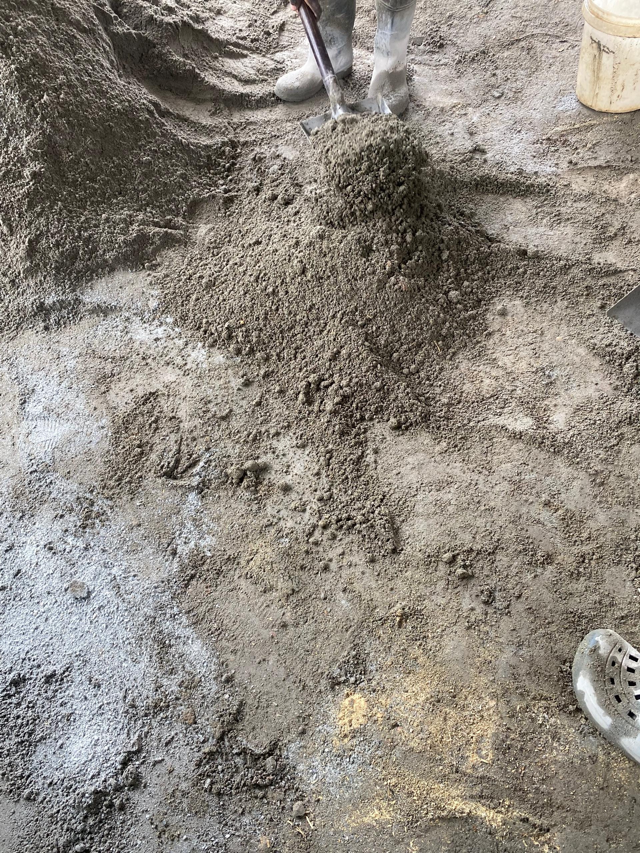

Fig A1: bactching of materials by using guage batching | mixing of sawdust sandcrete materials on the platform method the use of head pan was used during the process

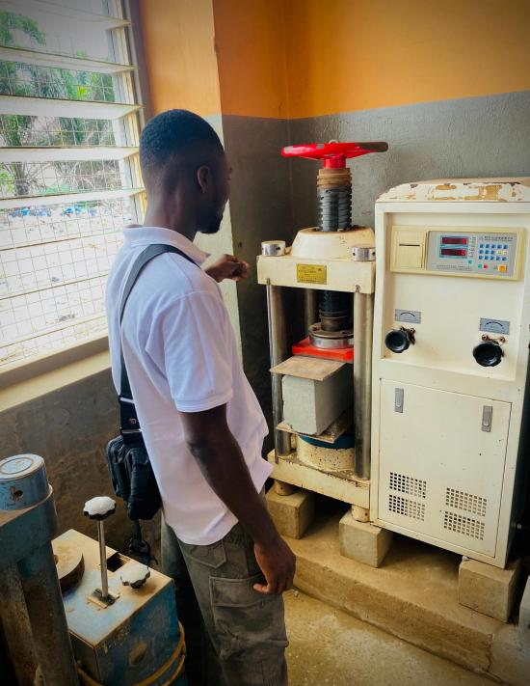

Fig A2: Weighing of both sandcrete and sawdust Blocks on the electronic scale machine | Fig A3: Setting up of the compressive and Tension hydraulic Machine at the lab

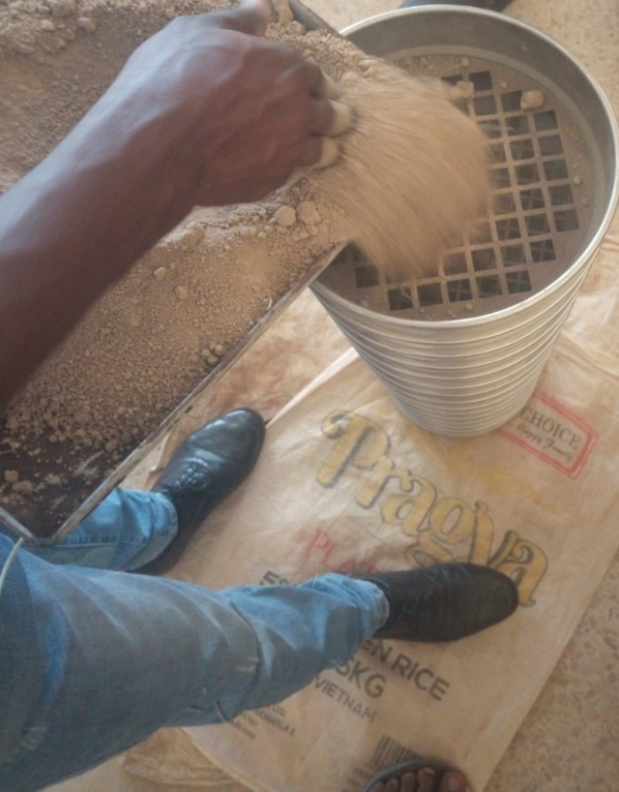
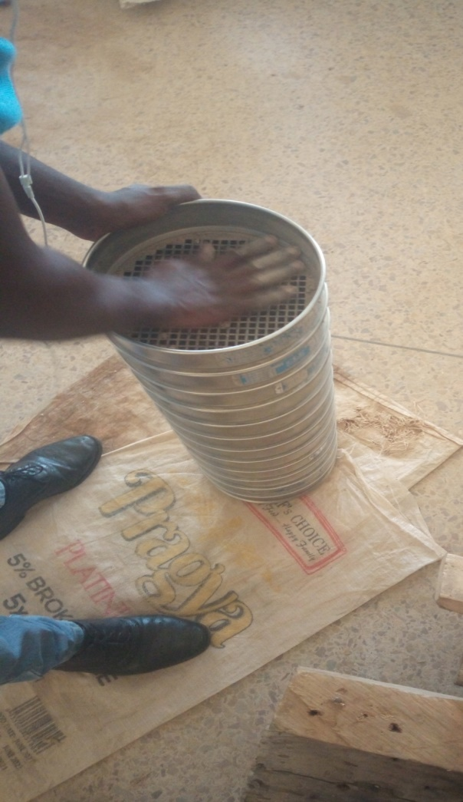
Fig A4: Pouring of sample fine aggregate into sieve manual shaking of the samples
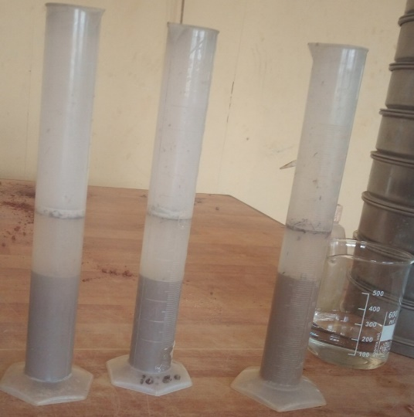
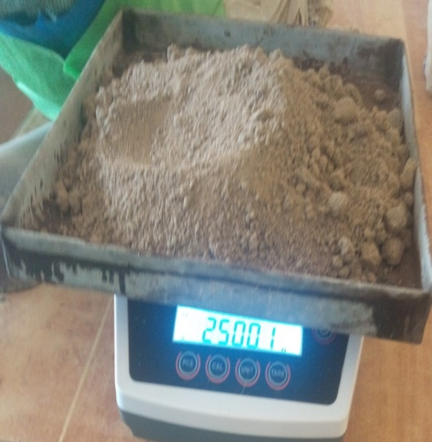

Fig A5: Initial weighing of fine aggregate After 3hours result showing the level of
Silt content, and sand.

