Critical Cultural Factors of Construction Project-Based Organisation in Nigerian Industry for Project Performance

ABSTRACT
Background: Understanding the cultural indices of construction project-based organisation (CPBO) do not only guide the conducts and behaviours of team members; but also dictate the mode of interaction among one another and those outside. Research had shown that procedure for the apportionment of project resources is influenced by Organizational Culture with attendant impact on assessment of team’s performance.
Aim: The attention of construction stakeholders is drawn to cultural factors within a construction project-based organisation (CPBO), considering its significance to realising project goal. Hence, the study determines how these cultural factors influence project efficiency in Nigerian construction industry through selected states of Lagos, Rivers and FCT (Abuja), Nigeria.

Methodology: A survey design approach through questionnaire for eliciting feedback was adopted. Data from 975 respondents comprising project managers; project team members; supervisors was analysed descriptively using percentages/averages and inferentially through Structural Equation Modelling. Stratified random sampling was employed for the firms’ selection because of their diverse nature while participants within the firms were picked purposively based on their job experience, educational background and professional affiliation as attested by the firm’s PM. Survey instrument has three divisions with questions asked on nominal and interval scales on participants’ demographic information.
Results: Findings reveal innovative and supportive cultural factors of “This company openly recognises innovative employees”; “This firm motivates creativity”; and “The management provides fair conditions of service to employees” with standard regression weight (SRW) and square multiple correlations (SMC) above 0.5 and 0.25 (the minimum threshold) respectively impacts “Resulted in project team satisfaction”; “Productivity level enhanced”; and “Ensure firms’ talent are retained” dimensions of efficiency significantly (also with SRW and SMC above the minimum threshold). The SMC of 0.344 means the variance in project efficiency of about 34.4% is accounted for by organisational cultural factors, thus, implying contributing to increased efficiency in project delivery by about 34.4% in Nigerian industry.
Conclusion: The CPBO analyses and harnesses her inherent beneficial cultural indices to the advantage of project delivery; not always organisation performance. The theoretical implication of the study is the enabler giving the CPBO to analyze and harness her inherent beneficial cultural indices and employ same to the advantage of project delivery; not always organization performance as had been widely done in Nigeria. Additionally, its contribution to the robustness of discourse on this aspect of construction project management is novel and desire being embraced by project management practitioners.
Implications: Trained and motivated staff of CPBO is committed to the organisation’s course by giving his/her best without any reservation. Again, while the best of employees among the ranks are retained through organisation’s commitment to staff welfare, employees’ resentment is evaded. The novel contribution of the survey to the robustness of discourse on project management deserves embracement by project management practitioners.

Keywords: Organisation culture, Cultural factors, Project efficiency, Project success, Construction management, Structural Equation Modelling.
1. INTRODUCTION
Culture primarily concerns the differences in people's conduct in all aspects of the construction industry's operations. Employee attitudes, organizational effectiveness, market performance, and financial success are influenced by organizational culture. Organizational strategy and structure affect knowledge management and organizational efficiency. Regardless of the diversity of the employees, the company culture governs their collective conduct. Culture is a pattern of fundamental assumptions dealing with external adaption and internal integration difficulties. Cultural phenomena in organizational cultures include artifacts and behaviors, visible organizational processes, espoused values, goals and philosophies, assumptions, feelings, and attitudes (Akıner et al., 2024). Cultural factor is a necessary tool for driving the cardinal objective and targeted goal of a construction project-based organisation (CPBO); its relevance in enhancing the construction process and project delivery within the industry cannot be overemphasised (Olasunkanmi et al., 2024). Organisation culture (OC) in a local parlance could be described as the “way of life or doing things” in a particular organisation. Schein (2010) described OC as the fundamental principles and approaches to issues within an organisation. Understanding the cultural indices of CPBO do not only guide the conduct and behaviours of team members; but also dictate the mode of interaction among one another and those outside (Simoneaux and Stroud, 2014). Assigning appropriate personnel with sound decision-making prowess for a specific assignment is a product of existing culture as it wields so great an influence on performance. Human traits such as emotions, thoughts, reaction to threats, acceptance of opportunities and all such that are responsible for choices and decisions are affected by culture. Moreover, the strategic influence of OC around the work place is exhibited in the manner objectives are formed; tasks assigned and implemented; and the mode of directing employees towards the path of goal accomplishment (Ochiel et al., 2017). Excerpt from PMI (2021) shows culture to be responsible for individual’s attitude based on background characteristics of age, sex, social status, educational attainment, religious inclination, professional stand, including being teachable and impactful to others. CPBOs are the custodian of project resources (human and material), with Yirdaw (2016) regarding OC as their binding agents; and therefore, must be well managed for building teamwork that leads to realisation of goal. Research had shown that procedure for the apportionment of project resources is influenced by OC with attendant impact on the assessment of team’s performance. Managing OC therefore becomes imperative enthused Tsai et al. (2017), as it may bring consequential actions of organisational instability due to reactions of team members to these shared values.
Researchers have linked project success to organisation cultural factors (Tahir, 2015; Nguyen and Watanabe, 2017), hence, total compliance with OC in an establishment enhances not only organisation’s effectiveness and efficiency but also employees and project performance. Especially if already proven to be beneficial to project success (Teravainem et al., 2021). However, both success and performance used in evaluating efficient and effective projects are subjective though with sole aim of accomplishing specified project objective, opinionated Oviedo-Trespalacios et al. (2019) and Sehnem et al. (2019). While efficiency is viewed from the perspective of meeting project estimated cost, timely delivery and to a desired quality or specification; effectiveness stems from project stakeholders’ satisfaction. Moreso, a successfully delivered project must be efficient and effective by fulfilling the intention of its conception and satisfaction of construction stakeholders (El Khatib et al., 2022). OC had also proven to wield great impact on firm’s performance, concluded Olanipekun et al. (2013). Other authors concluded on how cultural indices positively influence workers’ performance (Sopiah et al., 2021; Luthans, et al., 2021), just as it did on contextual and job performance (Bhardwaj and Kalia (2021). Researchers’ efforts in Nigerian on OC had mostly been tailored towards enhancing success of construction organisation without any recourse to efficient project delivery. Ogbadu and Saidu (2019); Alao and Aina (2020); Bamgbade et al. (2020); Ibrahim and Tsado (2022) all dwelled on impact of OC within or on constructing or consulting firms. Moreover, superior performance of construction organisation by implication, will lead to the successful delivery of her output (construction projects). Recent study by Olasunkanmi et al. (2024) identified the dominant culture in Nigeria construction industry without ascertaining the level and significance of their impacts on project efficiency. Also, Unegbu et al. (2023) observed lack of sufficient empirical investigation of relationship between cultural factors and project performance considering the multicultural nature of Nigeria. Hence requirement of further survey to fill these gaps. Over the years, several projects in the Nigerian construction industry have failed to meet various indicators of project success due to communication breakdown among construction project stakeholders in Nigeria. In this regard, communication pattern was considered as a determinant of construction project success in Nigeria. This lack of effective communication has led to infrequent interactions, resulting in project members not having the necessary information to act promptly. The communication patterns within a project structure, including the level of formality, such as formal or informal communication, play a crucial role in project success (Olatinwo et al., 2025).
Based on the aforementioned, this survey intends to establish the connection of OC and with efficiency of Nigerian construction projects. The main objective determines the cultural indices that culminate in efficient delivery of projects in Nigeria through SEM approach. Adopting this survey result shall reposition the organisations for more efficient delivery as beneficial factors are maximised while improving upon detrimental ones to the overall enhancement of the construction process. Additionally, literature on association of OC with project efficiency shall be enriched as the existing deficit is reduced by the result of this survey.

1.1 Empirical review of OC and project efficiency
The dominant cultural factors in CPBO have contributed immensely to the efficiency of her output by defining and molding the operational process. Researchers have studied dimensions of performance influenced by cultural indices that has formed the ethos of organisations. Understanding of how researchers portray OC with respect to project success helps to connect its narration to the contemporary study. Therefore, a summary of review of few researches on OC, the attendant effect, types, context and the method or approach is presented in this piece.
Cultural typologies of construction organisations in Ghana were identified by Atuahene and Baiden (2018) through a quantitative research approach. Analysis of perception by the 212 respondents from two locations was done inferentially in Ghana industry. The study emphasized only the classification of cultural types in Ghana without stating its impact on either the firms or their output. While Ackon et al. (2022) still in Ghanaian industry surveyed the association of OC and project planning with 375 employees of both large and medium-scale through quantitative approach but ostracized small scale construction firm thereby limiting the acceptability of the research outcome as they have a far-reaching effect on the sectorial growth and economy of any nation including the construction industry. Strengthening and widening the credibility of the research outcome will require extending the scope to cover small-scale firms; gaps created for further studies.
The interaction of OC with project success in Nigeria focusing on beverages firm was investigated by Daniel and Inim (2019). With about 139 respondents and descriptive analysis used to arrive at study conclusion. This study is lagging not only in depth and scope (one beverage company) but also approach and therefore cannot be relied upon to have done justice to association of OC with project success. While Alao and Aina (2020) examined OC profile of construction firms in Lagos Nigeria to procure information that would ultimately lead to their improved performance. Data from 140 valid respondents who are professionals and administrative staff sourced from 98 firms through questionnaires were analysed descriptively and through factor analysis. The study is limited in scope, as the findings is too narrow for generalization. Moreover, the study targeted firm performance against their output which is the core area of this current effort. Ibrahim and Tsado (2022) assessed the influence of OC on construction organisation performance in Abuja Nigeria, through a qualitative design approach by interviewing 80 management staff of chosen construction firms. The study found almost all major elements of organisational value yielding a positive effect on corporate performance. However, the study is lagging in scope, though with a better approach, hence propels the need for further study. The deployment of multivariate approach to analyse the relationship among constructs using SEM is the prime focus of this research. A departure from conventional methodology and approach widely published on most topical issues in construction and project management shall stand the current piece out of the crowd.
Khalid and Janjua (2021) in Pakistan assessed various dimensions of project success - efficiency, using about 293 employees of private and public telecom organisation, mostly project manager and directors as respondents. Though the moderating role of top echelon of organisation was considered in achieving success in Telecom industry of Pakistan but the importance of developing the right culture to drive project cannot be discarded. The survey emphasised the place of OC in enhancing efficient project delivery and encourage project team for better output. The study did not have a robust outlook as it was limited to opinions from a section of telecom industry and therefore suggested extension to other sectors including construction.
Li (2022) adopted both Scientometric and content analysis for journals indexed in Web of Science and Scopus to access articles for review so as to analyse OC peculiarity in construction projects in some locations. Scientometric literature on culture dwelled on 12 journals with 173 articles over a period of 1989 – 2022, Peoples Republic of China, Australia, the USA, England, and Singapore has high numbers of authors with research method, originating institutions, article citation, co-occurrence of keyword, cluster analysis and research interest being considered. While content analysis method measured OC through models or framework. Quantitative design approach through questionnaire or qualitative through interviews were used to unravel cultural factors in construction. No mention of any country in Africa either due to dearth of literature or inappropriate quality of work based on reviewer’s expectation. However, Nigeria; a giant of Africa and domiciliary location of this current research shall fill the gap and offer a different research method on the discourse. The use of SEM; a hybrid approach of determining causal effect or relationship among the constructs, shall add a new lexicon to literatures on OC in Africa and Nigeria in particular.
Ghumiem et al. (2023) investigated a dimension of organisation culture – corporate culture within the energy sector in Libya through quantitative data from 408 respondents and analysis done using structural equation modeling approach. Structural equation modeling approach gives credence to the study outcomes because of its multiple advantages but the narrow scope of consideration hampered the generalisation of findings though centered on developing countries only. Larger sample size recommended is a gap to be explored while also incorporating other factors alongside the underlying ones.
Mohammed and Ishak (2024) used work practices at the level of project for the interaction of OC with project success within the construction industry in UAE. A mixed design approach was employed with interviews on 13 and then questionnaires administered to about 200 project managers and engineers of contracting, consulting firms as well as those of clients’ organizations and had participated in about 124 construction projects. Descriptive and inferential data analysis revealed contractor’s commitment as the most significant among the eight cultural factors identified that positively and significantly influence project outcomes. Building on the study findings in this research shall consolidate the knowledge gained.

The cultural types and their features are shown in Appendix 1.

1.2 Theoretical framework and hypothesis

The summary and characteristics of cultural factors attributed to CPBOs and as found in reviewed literature accounted for the theoretical model adopted by this study. Although, OC in other industries such as financial, telecom and allied industries that are tailored towards service delivery share some similar traits with construction industry but cannot be wholly integrated as model in this piece. CPBOs are also run as business concern but basically engage in construction activities where employees rarely interface with the customer otherwise known as client. This singular trait differentiates construction industry from others and as such would wield a significant input into cultural factors and coloration. Aforementioned in review are various typologies of culture; clan, adhocracy, hierarchy and market cultures (Fiordelisi, 2014; Sok et al., 2014 and Wiewiora et al., 2014). Such factors that propel smooth project delivery and boost performance are contained in clan culture also called supportive culture (SPC). Features as collective effort, cooperation, encouraging participation, employee-centric leadership and shared confidence are all embedded in clan or supportive culture (Han, 2012). Encouragement of ingenuity, unlocking potentials, motivation, driving force, capacity building and creation of workplace that promotes flexibility are contained in adhocracy, otherwise called innovative culture (IVC) (Veiseh et al., 2014). Bureaucratic culture (BCC) or Hierarchical concluded Sok et al. (2014), regulates organizational operations and workers’ behaviour by establishing standard and procedures for team compliance. Though with effective rapport that foster stability and consistency without competitive tendency as the core value.
Innovative, bureaucratic and supportive cultures described therefore form the basis for the model of this study, they encompass all the features of CPBO cultural indices. These cultural attributes significantly influence the success or otherwise of project delivery. Except the omission of market or competition culture, the model is similar to Cameron and Quinn (1999) CVF. Moreover, researchers have argued in favour of the applicability of CVF. Ackon et al. (2022) enthused about its appropriateness during examination of OC at planning stage of project stemming from the validation by Atuahene (2016) in Ghana and evaluation by Yazici (2011) with respect to performance of project. The favourable argument notwithstanding, careful analysis of features of market culture that emphasize competition; gathering of competitors’ and customers’ information; task-focused leadership; rewards only on achievement of goals do not fit into the setting of construction project environment. Uniqueness of every construction project doesn’t permit rivalry and competition as opposed to the cardinal feature of market culture, hence the decision to alienate it from the model.
The conceptual framework for the study based on the cultural dimensions discussed in Figure 1. reveals the relationship between constructs of OC measured as FOC with manifest variables FOC1 to FOC24 divided into cultural dimensions of bureaucratic (BCC); supportive (SPC); innovative (IVC) and project efficiency measured as PPI with performance indicators PPI1 to PPI12 representing time, cost, quality (QTY) and stakeholders’ expectation (STE).

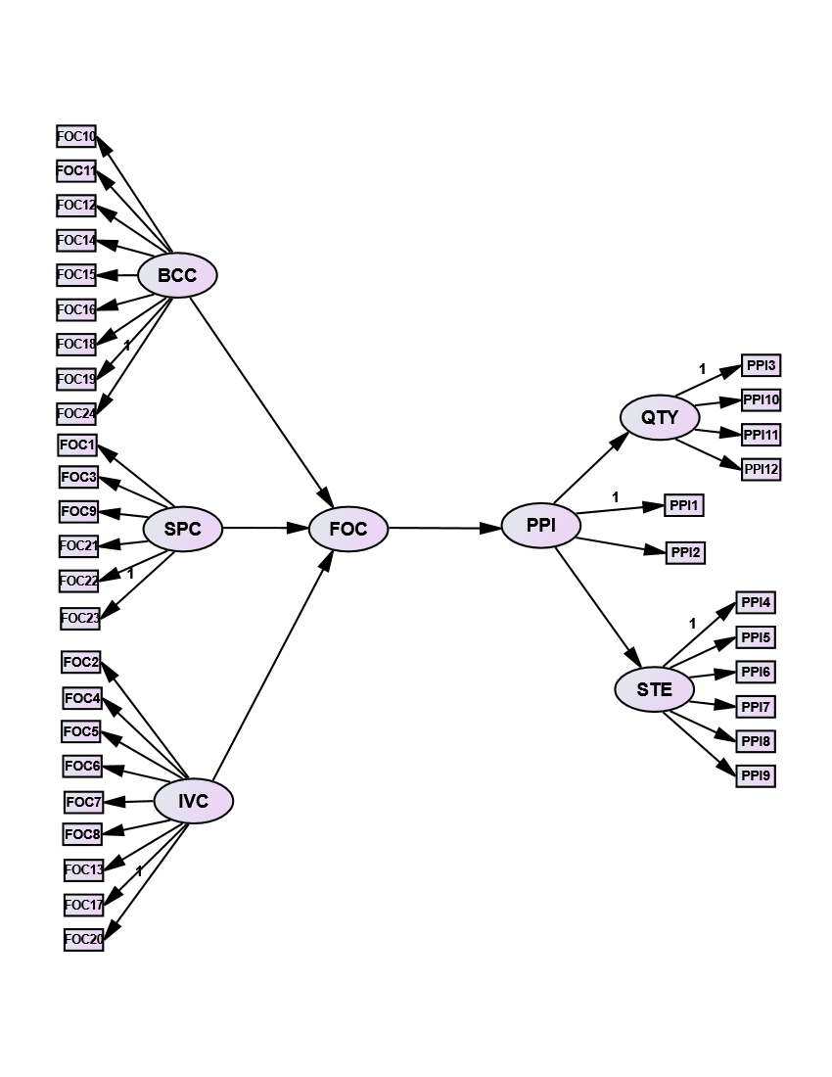
Figure 1. Conceptual hypothesised model for relationship between OC and project efficiency

Hence, the study hypothesis postulated that OC impacts efficiency of construction projects significantly.

2. RESEARCH METHOD
2.1 Data collection and measures

The association of OC with efficiency of Nigerian projects was empirically established by the study through rigorous review exercise. Questionnaire survey approach with positivist paradigm methodology was adopted for hypothesis testing. A total of 1233 respondents’ opinion comprising Project managers (PMs); core construction professionals designated as project team members (PTM); project supervisors (SUP) from FCT (Abuja), Lagos and Rivers were sought at once. The quantum of projects, types and spread of CPBO informed the choice of study areas. Moreover, they are among the important cities in Nigeria as previously used by Ikediashi and Ogwueleka (2014); Olasunkanmi and Belonwu (2023) in their studies. Federal Inland Revenue Service (FIRS); a Nigerian tax generating agency supplied the frame for survey population due to availability of numerous registered firms that suits the high level of response rate demanded. The criteria for chosen the firms was a prove of operational existence as certified by company tax payment five years before the conduct of the investigation. Stratified random sampling was employed for the firms’ selection because of their diverse nature while participants within the firms were picked purposively based on their job experience, educational background and professional affiliation as attested by the firm’s PM. Survey instrument has three divisions with questions asked on nominal and interval scales on participants’ demographic information in section A with about ten items. Section B and C have the measuring indices of OC containing twenty-four variables and project efficiency with twelve variables on a five point-Likert ordinal scale. Scale 5 indicates very high and 1 very low in section B while in section C, 5 represent a great deal and 1 not at all. The knowledge and job experience of participants eliminated neutral response as canvassed by Nowlis et al. (2022). Respondents were asked to rank their level of agreement to the extent at which factors of OC influence project efficiency and also the extent at which their delivered project satisfy project objectives in B and C respectively. Distribution and retrieval of questionnaires were done directly through research agents and some electronically. Research ethics was complied with by letters accompanying questionnaires stating the survey purpose and guaranteeing the confidence of respondents without disclosure of their information.
Taro Yamane formula helped to arrive at the sample size as presented in Figure 2. It is represented by equation (1)

n= N/(1+N) (e)2 . . . . . . . . . . . . . . . . . . . . . . . . . . . . . . . (eq.1)

Where n = sample size; N = study population; e = marginal error of 0.05.

The study sample size from 637 firms was 411 with the breakdown showing Lagos (148); Rivers (105) and FCT (Abuja) (158) firms making a total number of 1233 participants with 3 per firm. The research instrument has a high return rate of 79.8% as 975 were returned duly filled and used for the survey.

Figure 2. Sample size and frame

2.2 Measurement variables and data analysis

Organisation culture index (OCI) based on three cultural dimensions; bureaucratic, innovative and supportive culture, earlier used by Oyaya (2017) was extracted, modified into twenty-four items through a pilot testing and adopted as variables coded FOC in the study questionnaire. Through same process of pilot study, twelve measurement indices of efficiency relevant to Nigerian construction industry coded as PPI and already used by Olasunkanmi and Belonwu (2023) was also adopted. The measurement indices of OC and PPI are then separated into components for easy coding as required by SEM (Appendix 2).
Respondents’ characteristics were descriptively analyzed using simple percentages while factor analysis (FA) and SEM were engaged for causal effect of OC on project efficiency.

3. RESULTS

The outcome of analysis of participants’ demographic features, the adopted model fit threshold and indices, structural equation modeling output are presented in both Figures and Tables

3.1 Respondents’ profile

The descriptive analysis of respondents’ sex, shows the distribution of male to female participants in the ratio of 7 to 1 (Figure 3); 87.5% male participants compared to 12.5% female counterparts. A male dominated sector construction sector just like in other regions of the world (Rotimi et al., 2024). The culture of CPBO could be rejig to allow for gender inclusiveness by apportioning certain percentage of the workforce for females at recruitment stage of any operation.

Figure 3. Respondents’ Sex

The prerequisite knowledge of participants as shown in Figure 4 are perceived adequate to match the requirement of the survey. The minimum educational level possessed by the respondents is OND which is about 7.4% of the total aggregate. This implies possession of reasonable understanding of research purpose as portrayed in the questionnaire.

Figure 4. Educational qualification of respondents

The cognate job experience of the respondents in Figure 5 shows 98% with above 5 years in the industry. This level of experience is indeed valuable and give credence to the quality of feedback received from the survey instrument.

Figure 5. Respondents’ job experience

The respondents’ professional body; project stake; membership status and construction type are displayed in Table 1. Project supervisors (SUP) who are non-professionals (11.4%), others are member of professional body. Membership status ranges from Technicians (0.7%) to Fellows (1.4%), while majority is corporate member. The implies that most respondents have undergone requisite academic and professional training to position them for proper project execution in the industry, hence, their judgement of the survey purpose couldn’t be faulted. Project executed and assessed are building construction (45.4%); road (26.1%); allied infrastructure and others (28.6%). Each stake of respondents has equal distribution of 33%.

Table 1. Descriptive results of other respondents’ characteristic
Characteristics | Percentages
Professional affiliation | NIA (15.4); NIOB (21.1); NSE (36.5); NIQS (15.7); None (11.4)
Stake in the project | Project manager (33.0%); Project team members (33.6%); Supervisor (33.4%)
Membership status | Technician(0.7%); Licentiate(0.7%); Associate(3.4%); Graduate(26.5%); Corporate(51.9%); Fellow(1.44%); None(15.3%)
Construction type | Building(45.4%); Road(26.1%); Hospitals(6.1%); Sport complex(1.9%); Others(20.6%)

3.2 Data screening, biases, reliability and validity

Data screening was conducted as a preliminary test to forestall the possibility of features such as missing values and outliers. Cases of missing values were handled by removing items with response rate that were below 95% and subjected to further treatment using the expectation maximisation technique (Hair et al., 2019). Outlier on the other hand, was dealt with by combining Mahalanobis distance method with graphical illustration to ascertain absence of outliers. Data biases were eliminated methodologically and statistically. Methodologically by ensuring that a few disenchanted and resented respondents were briefed to have proper understanding of survey concept, while also assuring of secrecy of their anonymity in response, thereby removing survey bias. Common method bias was handled by examining the variation explained in each component of the data, which was found to be far lesser than the approved value. Statistically, bias was removed through comparison of features of participating firms to those who declined; no statistical difference was found in their mode of operations, coverage, nature and complexities of project executed; non-response bias was thus eliminated.
Reliability and validity check in form of convergent and discriminant validity were also carried out. The outcome of Cronbach’s Alpha values of .89 to .93 obtained in Table 2 shows high reliability and internal consistency as compared to .7 threshold stipulated for statistical procedure (Kline, 2016).

Table 2. Confirmation of instrument for reliability and validity
Respondents | No of items | Cronbach’s Alpha
Project managers | 83 | 0.924
Project Team Member | 83 | 0.885
Supervisor | 83 | 0.894
Kaiser-Meyer-Olkin Measure of Sampling Adequacy. |  | .925
 | Approximate Chi-Square | 17876.707
Bartlett's Test of Sphericity | Degree of freedom | 630
 | Significant | .000

While Kaiser-Meyer-Olkin value for authenticating adequacy of sample is above .6 suggested minimum value. Therefore, .925 gotten from PCA as shown in Table 2 was more than sufficient for adequacy confirmation. Then, with Bartlett’s test of sphericity significant at p ≥ 0.000, suitability of data for factor analysis is thus justified.

3.3 Exploratory factor analysis (EFA) and factor extraction model
Principal component analysis (PCA), a major requirement for CFA/SEM was performed to determine the factor structure of measurement variables. The Kaiser’s criterion of factors with eigenvalue ≥ 1 adjudged to be significant was deeply employed on all the 36 variables. EFA led to extraction of eight factor structures which satisfied the eigenvalue criteria of ≥ 1 and were responsible for 63.24% of the total variance in the model. Varimax rotation method through principal axis factoring was used to validate the envisaged factor structure. Byrne (2010) opined that variables with factor loading less than 0.5 should be dropped as they are weak and may likely tamper with the result of the analysis. The pattern matrix (Table 3.) of factor analysis shows the factor loading of measurement indicators on their structure. They represent the factors that contribute to the first attempt in the measurement model with reasonably high loading of variables, any factor loading of ≤ 0.5 is dropped. Out of the eight components extracted, only four components have factor loadings of variables greater than 0.5, hence, total removal of four components with such factor loading less than 0.4.

Table 3. Results of factor analysis on OC and PPIs showing factor loading on structures
Measurement indices of organizational culture | Code | FS | FS | FS | FS
 |  | 1 | 2 | 3 | 4
Lead to improved project team satisfaction | PPI4 | .500
Increase the level of productivity | PPI5 | .578
Innovative employees are openly acknowledged by this organization. | FOC2 | .731
Innovations are motivated by the reward system here | FOC3 | .788
This company assigns sufficient resources to innovation | FOC8 | .638
Help is easily available to develop new ideas | FOC9 | .711
This company is flexible and adaptive to change | FOC13 | .791
Flexibility and continuous adaptation to change is the best way to describe this place | FOC17 | .828
Leadership has great regard for individual’s ability to do things creatively | FOC21 | .810
This place encourages creativity | FOC22 | .819
The condition of service in this organization is fair to the staff | FOC23 | .692
Finish project within the budget | PPI1 |  | .521
Enhanced quality standard | PPI3 |  | .529
Enhance client satisfaction | PPI9 |  | .538
Project specifications were met by the time of handover to the target | PPI12 |  | .583
This company prefer to hold on to tried and proven true ways | FOC11 |  | .529
Aligning one’s thought with others is the surest way of getting along in this company | FOC15 |  | .617
Given the problem for which it was developed, the project seems to do the best | PPI11 |  |  | .513
Inadequate funding is a barrier to search for creative ideas in this place | FOC6 |  |  | .552
Retain talents with the company | PPI6 |  |  |  | .565
Enable competitive advantages to the company | PPI7 |  |  |  | .547
Eigenvalue greater than one |  | 10.963 | 3.104 | 2.254 | 1.899
Kaiser-Meyer-Olkin measure of sampling adequacy | .925
Bartlett’s test of sphericity | 630
Approx. chi-square | 17876.707
dif.  Sig | .000

3.4 Measurement model specification, estimation and CFA for latent constructs

CFA for latent constructs was carried out to ensure measurement models are valid and reliable in other to arrive at sound and tenable conclusion (Field, 2017). The model consists of variables of organization culture coded FOCs and measurement indices of project efficiency coded PPIs. After factor extraction through PCA, only twenty-one factors loaded above 0.5 on the four factor structures in Table 4. And constitute the survey initial structural model as shown in Figure 6. There are twelve variables of OC, FOC2, FOC3, FOC8, FOC9, FOC13, FOC17, FOC21, FOC22, FOC23, FOC11, FOC15 and FOC6; while project efficiency has nine indicators, PPI4, PPI5, PPI1, PPI3, PPI9, PPI12, PPI11, PPI6, PPI7. Because the relationship between latent constructs of OC and project success were specified a priori by a hypothesised model, the model fit between the constructs and their measurement data was established by CFA through recommended goodness-of-fit (GOF) indices (Byrne, 2010). The approved minimum threshold is contained in Table 4.

Table 4. Adopted fit indices for the study
Model Fit Indices | Minimum threshold | Remarks | References
Parsimonious fit indices |  |  | Hair et al. 2018
CMIN/DF | 1.0 ≤ x²/df ≤ 5.0 | Lower limit - 1.0, upper limit - 3.0 to 5.0
Absolute fit indices
GFI | 0 – 1 | Close to 1 - a perfect fit | Hair et al. 2018
RMSEA | ≤0.1 | 0.05 – 0.08 acceptable
Incremental fit indices |  |  | Hair et al. 2018
CFI | > 0.9 | Close to 1 - a perfect fit
TLI | ≥ 0.90 | Close to 1 - a perfect fit
NFI | 0 – 1
IFI | 0 – 1
RFI | 0 – 1
Factor loading | >0.5; >0.7 | acceptable; good | Hair et al., 2018.
Critical ratio (t-value) | >1.96
Standard residuals | 2.8
Standard regression weight (SRW) | >0.5 | minimum required | Byrne (2010), Kline (2016).
Square multiple correlation (SMC) | >0.25 | minimum required | Byrne (2010), Kline (2016)

Assessment of GOF were based on parsimonious fit, absolute fit and incremental fit indices as the three major fit parameters in evaluation of indices in SEM. SEM-AMOS output for the initial model shows statistical significance of P-value at less than .05 but data fit to the model (through GFI, AGFI, CFI, NFI, RMSEA) and other test statistic estimate were below and inconsistent with minimum threshold in Table 4., hence not a satisfactory model.
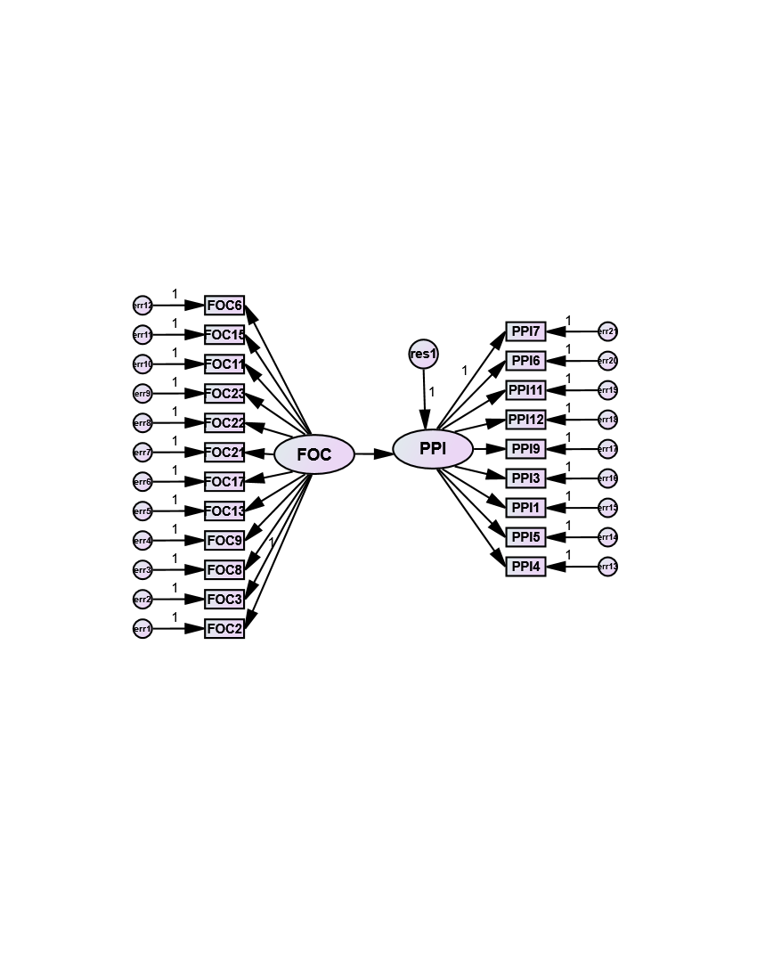
Figure 6. Initial structural model for the study

Thus, the inconsistency of initial model fit indices warranted further review for refinement and specification to improve the model for better fit. Doing this requires dropping variables with SRW and SMC $˂$0.5 and 0.25 respectively as stipulated in Table 4. (Kline, 2016).
Final structural model for the study (Figure 7) is a product of a review of initial model for improvement and enhancement of fit indices. Figure 7 has three variables FOC23, FOC22 and FOC2 representing OC and PPI4, PPI5 and PPI6 for project efficiency as the final fit structural model. These are the factors that satisfy the GOF indices requirement as an output of AMOS 23, with test statistics estimates meeting the required threshold in Table 4. The minimum number of factors needed for an acceptable model fit in SEM is two each for both exogenous and endogenous latent constructs (Byrne, 2010).

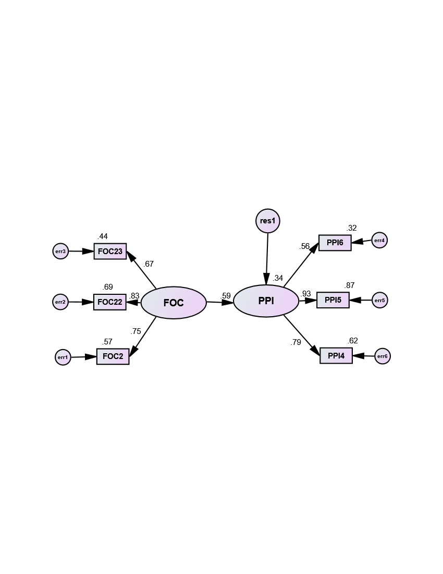
Figure 7. Final structural model for the study

Final structural model in Figure 7 depicts a path diagram where each manifest variable is connected with its latent construct by an arrow showing the SRW on it, also with SMC on top of the measurement rectangle. These are already extracted and presented in Table 5. FOC2 – This company openly recognises innovative employees (Innovative culture); FOC22 – This firm motivates creativity; FOC23 – The management provides fair conditions of service to employees are (both supportive cultures); PPI4, PPI5 and PPI6 with factors – Resulted in project team satisfaction; Productivity level enhanced; Ensure firms’ talent are retained respectively (representing stakeholders’ expectation) are the factors that contributed significantly to the model. The strength of impact of OC on project efficiency is explained by each factor’s SMC. SMC simply predicts the extent at which variability of endogenous manifest factors is directly or indirectly explained by predictor variables of the model.

Table 5. Results of SRW, SMC, SE, CR and Reliability of Constructs
Code | SRW | SMC | SE | CR | P-value | Cronbach’s alpha
FOC23 | .666 | .444 | .054 | 18.787 | 0.000 | 0.901
FOC22 | .832 | .693 | .036 | 29.227 | -
FOC2 | .752 | .565 | - | - | 0.000
PPI4 | .790 | .624 | .078 | 17.709 | 0.000
PPI5 | .934 | .872 | .094 | 17.728 | 0.000
PPI6 | .565 | .319 | - | - | -
PPI ˂--- FOC | .587 | .344 | .037 | 12.263

The SEM-AMOS output PPI having SMC 0.344 weight assigned suggest that the variance in efficiency of construction project which amounts to 34.4% is accounted for by cultural factors that contributed significantly to the model. Thus, increased efficiency in project delivery to the tune of 34.4% is contributed by those cultural factors (FOC2, FOC22 and FOC 23).
Table 6. Final SEM output Vs approved threshold
Model fit indices | Minimum threshold | Initial Model | Final model
χ²/df | 1.0 < χ²/df < 3.0  1.0<χ²/df<5.0 (Acceptable fit) | 16.982 | 4.933
GFI | >0.90 | .713 | .981
RMSEA | <0.05 good fit  <0.08acceptable Fit | .128 | .068
NFI | >0.90 | .716 | .976
CFI | >0.90 | .728 | .979
TLI | >0.90 | .696 | .962
AGFI | >0.90 | .647 | .951
IFI | >0.90 | .729 | .980
RFI | >0.90 | .683 | .955

3.5 Validation of measurement model and hypothesis testing

Having confirmed the factors of OC and PPI in the model to be statistically significant with 95% confidence level at P-values less than .05 for all factors in Table 5., and the parameters of GOF indices complying with the minimum threshold in Table 4.; the measurement model is thereby validated and the model in Figure 7 is adjudged satisfactory and a model fit for the study. All the GOF indices shown in Table 6. for the final model were within the approved limit after subjecting the initial model to review for improvement through refinement and further specification. This process led to better discriminant validity that yielded the best model fit (Byrne, 2010; Kline, 2016). This statistical significance affirms the existence of strong relationship between OC and the efficiency of construction project in Nigeria.
The study hypothesized that factors of OC impact efficiency of construction projects significantly; examination, validation and/or rejection of this statement is a function of the output of SEM analysis as presented in Tables 5. and 6. The measurement model indices and estimates of test statistics in both tables having satisfied the approved minimum values stated in Table 5. gives credence for validation and acceptance. The model with CR of all variables greater than 1.96; SRWs and SMCs above 0.5 and 0.25 respectively, the hypothesis is thus supported and accepted. Most especially CR value of 12.263 and SMC of 0.344 show clearly the existence of positive relationship between OC and project efficiency. Furthermore, the output of final model (Figure 7) shows all factors to be statistically significant at high confidence near 99% with P-values almost equal .01, a strong basis for hypothesis validation and acceptance. Therefore, factors of OC significantly impact project efficiency within Nigerian construction industry.

3.6 Discussion

If OC is being regarded as the fundamental principles and approaches to issues within CPBO according to Schein (2010), then, realising her topmost priority of delivering project with greater efficiency is a function of how well the identified beneficial factors of OC had been utilised to drive greater performance as suggested by Teravainem et al. (2021). This will entail making the right choice of personnel for executing task promptly and accurately to yield optimum performance. Certain factors within the organization determine the choice and whether the choice is right or not. A CPBO that invests in human capacity building of the workforce through training and refresher courses can stand tall and make such a choice without any iota of doubt or confusion.
The survey outcome reveals three factors of OC that contributed significantly to the model to be both innovative and supportive cultural factors. The factors are “This company openly recognizes innovative employees” (FOC2); “This firm motivates creativity” (FOC22); and “The management provides fair conditions of service to employees” (FOC23). While PPI4 (Resulted in project team satisfaction); PPI5 (Productivity level enhanced); and PPI6 (Ensure firms’ talent are retained) are measurement of project efficiency in the model. These are dimension of stakeholders’ expectation factors. A supportive CPBO that encourages innovative personnel is surely on a mission of delivering efficient project. Additionally, where employees’ welfare is paramount to the organisation (through fair condition of service), earning the satisfaction of project team with enhanced productivity level will be a natural occurrence. The dimension of performance is significantly influenced by these innovative and supportive cultural factors directly focused on stakeholder’s expectation. The dimension of project team satisfaction, improved level of productivity and retaining organisations’ best talent or workforce are pivotal for organisation success or performance as they promote teamwork. A successful organization is the one whose cardinal aim, goal or objective is realized as planned. Yirdaw (2016) regarded organisational cultural factors as the binding agents for teamwork among construction employees.
Previous researchers across the globe had positively correlated cultural factors to workers’ performance (Sopiah et al., 2021; Luthans, et al., 2021); contextual and job performance (Bhardwaj & Kalia, 2021). However, those in Nigeria established interaction of OC with firm performance (Olanipekun et al., 2013; Ogbadu and Saidu 2019; Alao and Aina, 2020; Bamgbade et al., 2020; Ibrahim and Tsado, 2022) without a mention of the efficiency of these organizations or firms’ output/product. The novelty of this survey stems from this perspective and its contribution to the robustness of discourse on this aspect of project management. Moreover, the submission of this finding has lent credence to findings of El Khatib et al. (2022) that until a project meets its conceptual purpose through satisfaction of both project team and end users, it can’t be said to be effective and efficient.

4. CONCLUSION

The efficient delivery of construction projects is a concern to all stakeholders across all strata; nations, climes and languages, regardless of nature, types and complexities as long it possesses those features attributed to project. This survey outcome had reminded the CPBO of her responsibility in ensuring that mechanism to facilitate the process of effective and efficient delivery are enhanced for realization of the goal and objectives. It should however, be noted that a compromising act of negligence or dilly-dallying has a consequential effect on the stakeholders especially the clients.
A highly trained and motivated staff is committed to the course of the organization by giving his/her best without any reservation. CPBO’s commitment to staff welfare evades resentment and retains the best talent within her ranks. Project team satisfaction as a result of cultural factors inherent in the organization leads to workers' enchantment and obligation to continue in all such effort that promote achievement of team purpose.
The theoretical implication of the study is the enabler giving the CPBO to analyze and harness her inherent beneficial cultural indices and employ same to the advantage of project delivery; not always organization performance as had been widely done in Nigeria. Additionally, its contribution to the robustness of discourse on this aspect of construction project management is novel and is desire being embraced by project management practitioners.

COMPETING INTERESTS DISCLAIMER:
Authors have declared that they have no known competing financial interests OR non-financial interests OR personal relationships that could have appeared to influence the work reported in this paper.

Disclaimer (Artificial intelligence)

Option 1:

Author(s) hereby declare that NO generative AI technologies such as Large Language Models (ChatGPT, COPILOT, etc.) and text-to-image generators have been used during the writing or editing of this manuscript.

Option 2:

Author(s) hereby declare that generative AI technologies such as Large Language Models, etc. have been used during the writing or editing of manuscripts. This explanation will include the name, version, model, and source of the generative AI technology and as well as all input prompts provided to the generative AI technology

Details of the AI usage are given below:
1.
2.
3.

REFERENCES
Alao, T.O., & Aina, O.O. (2020). Organizational culture of construction companies in Lagos State, Nigeria. Organization, Technology and Management in Construction, 11, 2158–2169, DOI 10.2478/otmcj-2020-0012
Atuahene, B. T., & Baiden, B. K. (2018). Organizational culture of Ghanaian construction firms, International Journal of Construction Management. 18(2), 177-188, DOI: 10.1080/15623599.2017.1301043
Bamgbade, A. A., Jimoh, R. A., Oyewobi, L. O., & Anifowose, M. (2020). Organizational culture characterization of construction firms in Nigeria. CSID Journal of Infrastructure Development, 3(2), 198-213. https://doi.org/10.32783/csid-jid.v3i2.150
Bhardwaj, B., & Kalia, N. (2021). Contextual and task performance: role of employee engagement and organizational culture in hospitality industry. Vilakshan - XIMB Journal of Management, 18( 2), 187-201. DOI 10.1108/XJM-08-2020
Byrne, B.M. (2010). Structural Equation Modelling with Amos: Basic Concepts, Applications and Programming, 3rd Edition, Routledge, New York, 460p.
Daniel, C. O., & Inim, V. E. (2019). Influence of organizational culture on project success in Nigeria: a case of Nestle Nigeria PLC. IJISET - International Journal of Innovative Science, Engineering and Technology, 6 (5) ISSN (Online) 2348 – 7968
El Khatib, M., Kherbash, A., Al Qassimi, A., & Al Mheiri, K. (2022). How can collaborative work and collaborative systems drive operational excellence in project management? Journal of Service Science and Management, 15(3), 297-307.
Fiordelisi, F., & Ricci, O. (2014). Corporate culture and CEO turnover. Journal of Corporate Finance, 28, 66-82.
Ghumiem, S. H., Alawi, N. A. M., Al-Refaei, A. A., & Masaud, K. A. R. (2023). Corporate culture and its effects on organizational performance: multi-group analysis evidence from developing countries. European Journal of Business and Management Research, 8(2), DOI: http://dx.doi.org/10.24018/ejbmr.2023.8.2.1890
Hair, J. F., Risher, J. J., Sarstedt, M., & Ringle, C. M. (2019). When to use and how to report the results of PLS-SEM. European Business Review, 31(1), 2-24.
Han, H. (2012). The relationship among corporate culture, strategic orientation, and financial performance. Cornell Hospitality Quarterly, 53, 207-219.
Hartnell, C. A., Ou, A. Y., & Kinicki, A. (2012). Organizational culture and organizational effectiveness: a meta-analytic investigation of the competing values framework's theoretical suppositions. Journal of Applied Psychology, 96(4), 677-694.
Ibrahim, A. O., & Tsado, A. J. (2022). Analysis of the effects of organization culture on the performance of construction firms in Abuja. African Scholar Journal of Built Environment and Geological Research (JBEGR-4), 24(4), 159 - 170
Kline, R. B. (2016). Principles and Practices of Structural Equation Modeling, fourth edtn. Retrieved from www.guilford.com Retrieved date: October 18, 2022
Li, J. (2022). Review of culture in construction projects: status quo and challenges. Hindawi Advances in Civil Engineering, https://doi.org/10.1155/2022/5463083
Luthans, F., Luthans, B. C., and Luthans, K. W. (2021). Organizational Behavior: An Evidence-Based Approach, fourteenth Edition. IAP.
Mohammed, A. K., & Ishak, M. S. (2024). Identification of project cultural factors affecting the performance of UAE construction projects. Alexandria Engineering Journal, 86, 205–216, https://doi.org/10.1016/j.aej.2023.11.064
Nguyen, L. H., & Watanabe, T. (2018). Project organizational culture framework in construction industry. Provisional chapter, available online at book.department@intechopen.com or www.intechopen.com, DOI: 10.5772/intechopen.78628
Nguyen, L. H., & Watanabe, T. (2017). The impact of project organizational culture on the performance of construction projects. Sustainability (MPDI), 9, 781-801 DOI: 10.3390/su9050781
Nowlis, S., Kahn, B.E., & Dhar, R. (2022). Coping with ambivalence: the effect of removing a neutral option on consumer attitude and preference judgments. Journal of Consumer Research, 29(3), 319-34, DOI:10.1086/344431
Ochiel, D., Iravo, M., & Wandera, R. (2017). Effect of organizational culture on project performance of Airtel Kenya limited. International Journal of Management and Commerce, 4(2), 17-26.
Ogbadu, D. O. S., & Saidu, I. (2019). Influences of organizational culture on effective transfer of knowledge in construction firms. Third International Engineering Conference (IEC), Federal University of Technology, Minna, Nigeria
Olanipekun, A.O., Aje, I.O., & Abiola-Falemu, J.O. (2013). Effects of organization culture on the performance of quantity surveying firms in Nigeria. International Journal of Humanities and Social Science, 3(5), 207 – 215.
Olasunkanmi, F. O., Edogha, C. O., & Ufia, V. D. (2024). Organizational culture and success of construction projects in Nigeria. Wilberforce Journal of the Social Science, 8(10), 274-289.
Olasunkanmi, F. O., & Belonwu, C. C. (2023). The perceived level of compliance of construction projects with performance indicators in Nigeria. International Journal of Research and Innovation in Social Science, 7(8), 1348-1363.
Oviedo-Trespalacios, O., Truelove, V., Watson, B., & Hinton, J. A. (2019). The impact of road advertising signs on driver behavior and implications for road safety: a critical systematic review. Transportation Research Part A: Policy and Practice, 122, 85-98.
Project Management Institute (PMI). (2021). A Guide to the Project Management Body of Knowledge (PMBOK), 4th Edition, Pennsylvania, Project Management Institute.
Rotimi, F. E., Brauner, M., Burfoot, M., Naismith, N., Silva, C., & Mohaghegh, M. (2024). Challenges faced by women in new Zealand’s construction industry and the impact of demographic factors. Construction Economics and Building, 24(4/5), 114–141. https:// doi.org/10.5130/AJCEB. v24i4/5.8911
Schein, E. H. (2010). Organizational culture and leadership. John Wiley & Sons.
Sehnem, S., Jabbour, C. J. C., Pereira, S. C. F., & de Sousa Jabbour, A. B. L. (2019). Improving sustainable supply chains performance through operational excellence: circular economy approach. Resources, Conservation and Recycling, 149, 236-248.
Simoneaux, S., & Stroud, C. (2014). A strong corporate culture is key to success. Journal of Pension Benefits, 22(1), 51-55
Sok, J., Blomme, R., & Tromp, D. (2014). Positive and negative spillover from work to home: the role of organizational culture and supportive arrangements. British Journal of Management, 25, 456-472.
Sopiah, S., Kamaludin, M., Sangadji, E. M., & Narmaditya, B. S. (2021). Organization culture and employee performance: an empirical study of Islamic banks in Indonesia. The Journal of Asian Finance, Economics and Business, 8(6), 395-406.
Tahir, I. (2015). The relationship between organizational culture and project performance. Retrieved from 32TUhttp://umpir.ump.edu.my/id/eprint/15474/1/ibecpdf.pdf
Teravainem, V., Junnonen, J., Salopaa, T., & Subolev, A. (2021). Relationship between organizational culture and efficiency in Finnish construction projects. International Journal of Construction Management, 12(1).
Tsai, W. H., Chen, H. C., Chang, J. C., & Lee, H. L. (2017). The internal audit performance: the effectiveness of ERM and its environments. In Proceedings of the 50th Hawaii International Conference on System Sciences. https://doi.org/10.24251/hicss.2017.595
Unegbu, H. C. O., Yawasa, D.S., & Dan-asabe, B. (2023). An assessment of the literature on the performance of construction projects in Nigeria. Jurnal Mekanikal, 46, 27-38
Veiseh, S., Mohammadi, E., Pirzadian, M., & Sharafi, V. (2014). The relation between transformational leadership and organizational culture. Journal of Business Studies Quarterly, 5, 113-124.
Wiewiora, A., Murphy, G., Trigunarsyah, B., & Brown, K. (2014). Interactions between organizational culture, trustworthiness, and mechanisms for inter-project knowledge sharing. Project Management Journal, 45(2), 48-65.
Yirdaw, A. (2016). Quality of education in private higher institutions in Ethiopia: the role of governance. SAGE Open, 6(1), 1-12.
Yazici, H.J. (2011). Significance of organization culture in perceived project and business performance. Engineering Management Journal, 23(2), 20-29.
Akıner, M. E., Akıner, İ., & Yitmen, İ. (2024). Predicting the critical organizational behavior and culture of the Turkish construction industry's occupational groups for determining the success of the construction business. Heliyon, 10(12).

Olatinwo, I. A., Ogedengbe, F. A., Bakare, A. A., & Gambo, N. (2025). Effect of Communication Pattern on the Construction Project Success in North Central, Nigeria. Open Journal of Business and Management, 13(2), 870-886.

APPENDIX

Appendix I. Characteristics of various OC
Culture | Features | Source
Clan culture (Supportive) | Collaboration and attachment | Fiordelisi, 2014
 | Loyalty, trust and mutual respect | Fiordelisi, 2014
 | Support and people-oriented leadership
 | Clear communication and team engagement | Pinto et al., 2014
 | Inspiration and employee motivation | Miguel, 2015
 | Teamwork and employees’ empowerment | Yirdaw, 2014
 | Employees’ engagement and commitment | Mango and Ikyanyon, 2012
Adhocracy culture (Innovative) | Promotes innovation and change | Fiordelisi, 2014
 | Devotion of resources for research and development | Sok et al., 2014
 | Inspires subordinate for innovative ideas | Sok et al., 2014
 | Creativity, growth, risk taking and diversity encouraged | Hartnell et al., 2012
 | Independence and adaptability as core values | Hartnell et al., 2012
Hierarchy culture (Bureaucratic) | Establishment of sound control mechanism
 | Obedience to rules and regulations | Hartnell, 2012
 | Promotes consistency and stability
 | Efficient and effective system | Fiordelisi, 2014
Competition culture (Market-driven) | Emphasis on competence and capabilities for achieving goals | Miguel, 2015
 | Gathering of competitors’ and customers’ information
 | Setting goals and objectives; planning and decision-taking
 | Task-focused leadership
 | Reward only on achievement of goal | Han, 2012

Appendix 2. Summary of latent and observed variables used in the study.
Latent variables | Measurement indices | Observable variable (indicator) | Code Name
Organizational culture | Bureaucratic culture (BCC) | Maintaining status quo than change seem to be a priority here | FOC10
 |  | This company prefer to hold on to tried and proven true ways | FOC11
 |  | Those in management cadre always take credit for other’s idea here | FOC12
 |  | The employees in this place are expected to handle same problems same way | FOC14
 |  | Aligning one’s thought with others is the surest way of getting along in this company | FOC15
 |  | Attempting to do things differently from others incite angers here | FOC16
 |  | Trying to be different attracts a lot of problems in this organization | FOC18
 |  | Following orders through the channel as it comes is the sole duty of employee here | FOC19
 |  | Personnel can leave the project before closure as provided by statutory requirement | FOC24
 | Innovative culture (IVC) | Innovative employees are openly acknowledged by this organization | FOC2
 |  | Opportunity is created for pursuing creative ideas during working hours in this place | FOC4
 |  | Shortage of staff hinders innovation in this company | FOC5
 |  | Inadequate funding is a barrier to search for creative ideas in this place | FOC6
 |  | Enough time is given in pursuit of creative ideas in this organization | FOC7
 |  | This company assigns sufficient resources to innovation | FOC8
 |  | This company is flexible and adaptive to change | FOC13
 |  | Flexibility and continuous adaptation to change is the best way to describe this place | FOC17
 |  | In this place, people are permitted to find solution to same issues in different manners | FOC20
 | Supportive culture (SPC) | Only the cooperative ones benefit from the reward system here | FOC1
 |  | Innovations are motivated by the reward system here | FOC3
 |  | Help is easily available to develop new ideas | FOC9
 |  | Leadership has great regard for individual’s ability to do things creatively | FOC21
 |  | This place encourages creativity | FOC22
 |  | The condition of service in this organization is fair to the staff | FOC23
Project performance indicators | Cost | Finish project within the budget | PPI1
 | Time | Finish project on time | PP12
 | Quality | Enhanced quality standard | PPI3
 |  | Enable continuous improvement | PPI10
 |  | Given the problem for which it was developed, the project seems to do the best | PPI11
 |  | Project specifications were met by the time of handover to the target | PPI12
 | Stakeholder expectation | Lead to improved project team satisfaction | PPI4
 |  | Increase the level of productivity | PPI5
 |  | Retain talents with the company | PPI6
 |  | Enable competitive advantages to the company | PPI7
 |  | Enhance the image of the company | PPI8
 |  | Enhance client satisfaction | PPI9

