Average Braking Energy for a Vehicle without trailer on a horizontal plane and Downhill

Abstract

The braking system is a main method for the safety of the Vehicle. The braking event is an aspect of vehicle stopping achievement where the kinetic energy due to speed of the vehicle converts to thermal energy via two or more friction surfaces. The average braking energy is the main point in our study. Some parameters of road structure impact on the vehicles braking performance. The article has analysis for the influence of road grade, tire rolling resistance coefficients, and tire slip during decelerate a vehicle without complete its wheel stop on the average braking energy at three different beginning speeds for the vehicle moving once on horizontal plane and other downhill by using two equations for the average braking energy.

Keywords: brake, braking energy, average braking energy, kinetic energy, braking efficiency.

Nomenclature
q₀= average braking energy of a vehicle without trailer.
a = vehicle deceleration, g-unit(d’less).
d’less= without dimensions
S = tire slip, defined by the ratio of difference between vehicle forward speed and circumferential tire speed to vehicle forward speed, d'less.
V₁= initial vehicle speed, m/s.
V₂ = final vehicle speed, m/s.
W = vehicle weight, N.
1Joule/h=3.725*10⁻⁷ Mechanical Horse Power (hp).
G = road gradient, d'less.
R_{r} = tire rolling resistance coefficient, d'less.
V = vehicle speed, m/s.
$q_{R}^{"}$ = heat flux into rotor, joule/(h*m²) or N.m/h.m² or kgf/s³.
$q_{P}^{"}$ = heat flux into pad, joule/(h*m²) or N.m/h.m² or kgf/s³.
R_{p} = thermal resistance to conductive heat flow in pad, h·ºc/joule or h·ºc/joule or h·ºc/N.m or h³·ºc/kgf.m².
R_{R} = thermal resistance to conductive heat flow in rotor, h·ºc/joule or h·ºc/joule or h·ºc/N.m or h³·ºc/kgf.m².
Cp = pad specific heat, KJ/Kg·ºc.
C_{R} = rotor specific heat, KJ/Kg·ºc.
K_{P} = pad thermal conductivity, KJ/h·ºc·m.
K_{R} = rotor thermal conductivity, KJ/h·ºc·m.
ρ_{P} = pad density, Kg/m³.
ρ_{R} = rotor density, Kg/m³.
A_{R} = rotor surface area, m².
h_{R} = convective heat transfer coefficient of the rotor, KJ/h·ºc·m².
A_{P} = pad surface area, m².
h_{P} = convective heat transfer coefficient of the pad, KJ/h·ºc·m².
K_{S} = thermal conductivity of pad support, KJ/h·ºc·m.
δ_{P} = pad thickness, m.
δ_{S} = pad support thickness, m.
d = differential operator, d'less.
$q_{0}^{"}$ = time-varying heat flux into rotor at time.
t = 0, KJ/h.m².
q"(T) = time-varying heat flux, KJ/h.m².
t = time, h.
$θ_{0}\left(z,t\right)=T_{0}\left(z,t\right)-T_{∞}$ relative temperature of brake resulting from constant heat flux, °c.
T = time, h.
k = thermal conductivity of ventilated rotors, KJ/h·ºc·m.
L = rotor thickness, m.
z = distance measured from friction surface, m.
n_{a}=number of brake application.
t_{c}=cooling time≈cycle time, h.
v_{R}=rotor volume, m³.
T∞=ambient Temperature, °C.

- Introduction

This research concentrates on studying and analyzing the thermal value when use different friction surfaces size for automotive disc brakes which are linked by single caliper, twin or dual calipers, and full-contact disc brakes. The automotive brakes become active when a friction material pushing against other material to create a friction force to absorb the energy of motion and slow the vehicle speed down. The friction couples that form the core of any road vehicle traditional braking system. The brake rotor which attached to the wheel with stator unit which joined to the vehicle body, chassis or axle has been designed to dissipate the heat converted from the kinetic energy of the moving vehicle through the process of friction to the environment as quickly and effectively as possible [1,4].
The heat which is results from the relative motion between the brake friction combinations to decelerate a vehicle is the main parameter which should be analyzed. At the wheel: 1.without complete lockup with braking tire near the maximum braking; the vehicle tire has slip which is reflected on the vehicle linear speed; so the average braking energy q₀ of the vehicle (without trailer) can be earned from the summation of the forces in a horizontal plane. 2.At applied the brake during downhill q₀ of the vehicle will be changed.
A theoretical study was done to focus on the store and/or dissipate the thermal energy generated at the pad and rotor (friction surfaces of the brake) for many cases of applied a vehicle brake. From that; 2.1.short brake application times, 2.2.steady state conditions, 2.3.continued or repeated brake applications, and 2.4.single stop [5].
Understand the regularities of the influence of speed, acceleration of deceleration, and vehicle mass on the power of the regenerative braking system, which was make it possible to determine the optimal characteristics of an electric propulsion drive and ensure high fuel energy and environmental safety of vehicles used in the road network [6].
Average braking power reduced by the motion resistance power is a key piece of information about how much energy can be used in practice by means of a recuperation system. Of course, not all of the energy is actually recoverable due to the limitations inherent in the constructional characteristics of modern vehicles. This gives some idea about the design of recuperation systems that are installed more and more often in cars [7].
Studying the levels of energy recovered during the braking of an electric vehicle in different driving conditions is the subject of many studies. the highest value of recovered energy per 1 km was registered when driving during the afternoon rush hour. When driving in the afternoon hours, the level of recovered energy per 1 km was about 2% lower than when driving in rush hour conditions.The amount of energy recovered by an electric vehicle per 1 km on an urban route was 68% higher than on a suburban route and 86% higher than the energy recovered on an express road. [8].
The aim of this research is studying the effect of the cases of applied a vehicle braking ways on the brakes’ average braking energy. Also this article is prepared to study the temperature, thermal resistance, and absorbed or dissipated heat generation for the mating friction surfaces of the vehicle brake.
- Material and Methods
Through the braking process q₀ is coming from the forces summation in the horizontal plane and it is mentioned in Equation (1). But during a continued downhill brake application, the energy per hour q₀ absorbed by the vehicle brakes is calculated by equation (2) (Darcom Pamphlet, 1976).
$q_{0}=3600Wa\left(1-S\right)\left(V_{1}+V_{2}\right)/2$, N.m/h or Joule/h (1)
$q_{0}=WV\left(G-R_{r}\right)*3600$, N.m/h or Joule/h (2)

The thermal energy is coming from the heat transfer into the rotor and the stator when applied the brake. For the steady-state conditions the relation between the heat flux into both rotor and pad, and thermal resistance for both pad and rotor can be found from Equation (3).
$\frac{q_{R}^{"}}{q_{P}^{"}}=\frac{\sum{R_{P}}}{\sum{R_{R}}}$ , d’less (3)
Application the brake for short times, the indication temperatures at the interface and the total heat generation equals the heat generation absorbed by the rotor and the pad as indicated in Equation (4).
$\frac{q_{R}^{"}}{q_{P}^{"}} = {\left(\frac{ρ_{R}C_{R}K_{R}}{ρ_{P}C_{P}K_{P}}\right)}^{1/2 },$ d’less (4)

Using the continued or repeated brake, the high brake temperatures results from the convective heat transfer. For steady-state no energy will be stored in the rotor but R_{R} which will be associated with the rotor is given by Equation (5) while R_{p} for the pad is given by Equation (6).
$\sum{R_{R}}=\frac{1}{h_{R}A_{R}}$ , h.°c/KJ (5)
$\sum{R_{P}}=\frac{1}{h_{P}A_{P}}+\frac{δ_{P}}{K_{P}A_{P}}+\frac{δ_{S}}{K_{S}A_{P}}$ , h.°c/KJ (6)
Brake Temperature in the cases:
a. continued Braking, Equation (7) indicates an analytical solution for a solid rotor.
$θ_{0}\left(z,t\right) = \frac{q_{0}^{"}}{h_{R}} \left[2\left(\frac{θ_{i}h_{R}}{q_{0}^{"}}-1\right)x\sum_{n=1}^{∞}{\frac{sin\left(λ_{n} L\right)}{λ_{n} L +sin\left(λ_{n} L\right)cos\left(λ_{n} L\right)}e^{-a_{t}λ_{n}^{2}t} x cos\left(λ_{n}z\right)+ 1 }\right]$, °c (7)
b. During a Single Stop, the temperature of the brake rotor may be obtained directly from the temperature solution associated with the time independent heat flux $q_{0}^{"}$ by application of Duhamel's theorem. The application of Duhamel's superposition integral results in Equation (8) for the temperature change resulting from a time-varying heat flux.
$θ(z,t)=\frac{q_{\left(0\right)}^{"}}{q_{0}^{"}}θ_{0}\left(z,t\right)+\frac{1}{q_{0}^{"}}\int_{0}^{t}{\frac{dq^{"}\left(τ\right)}{d\left(τ\right)}θ_{0}\left(z,t-T\right)dT}$ , °c (8)
Equation (9) also may be used for computing the brake temperatures of ventilated rotors when the convective heat transfer at the friction surfaces is negligible as in the case of a shielded rotor. A few roots of the supreme Equation (9) are presented in Table (1).
$θ_{0}\left(z,t\right)=\frac{q_{0}^{"} L}{k}\left\{1-\frac{z}{L}+\frac{k}{h_{R}L}-2\sum_{n=i}^{∞}{ \frac{e^{-a_{1}λ_{n}^{2}t} cos\left(λ_{n} z\right)}{\left(λ_{n} L\right)\left[λ_{n}L + sin\left(λ_{n} L\right)cos\left(λ_{n} L\right)\right]}}\right\},$ °c (9)
Table (1) Roots of Equation (9)
$$h_{R}L/K$$ | $$λ_{1}L$$ | $$λ_{2}L$$ | $$λ_{3}L$$ | $$λ_{4}L$$ | $$λ_{5}L$$ | $$λ_{6}L$$
0.01 | 0.0998 | 3.1448 | 6.2848 | 9.4258 | 12.5672 | 15.7086
0.02 | 0.1410 | 3.1479 | 6.3864 | 9.4269 | 12.5680 | 15.7092
0.04 | 0.1987 | 3.1543 | 6.2895 | 9.4290 | 12.5696 | 15.7105
0.06 | 0.0774 | 3.1435 | 6.2841 | 9.4254 | 12.5668 | 15.7085

c. Repeated Braking,
Equations (10 and 11) may be used in many implementation for esteeming the brake temperatures expected during repeated braking.
${\left(T\left(t\right)-T_{∞}\right)}_{b}=∆T \left(1-exp〈\left\{-\left[n_{a}-1\right]h_{R}A_{R}/\left[ρ_{R}C_{R}v_{R}\right]\right\}t_{c}〉×exp〈\left\{-h_{R}A_{R}/\left[ρ_{R}C_{R}v_{R}\right]\right\}t_{c}〉\right)÷\left(1-exp〈\left\{-h_{R}A_{R}/\left[ρ_{R}C_{R}v_{R}\right]\right\}t_{c}〉\right)$, °C (10)
${\left(T\left(t\right)-T_{∞}\right)}_{a}=∆T\left(1-exp〈\left\{-n_{a}h_{R}A_{R}/\left[ρ_{R}C_{R}v_{R}\right]\right\}t_{c}〉\right)÷\left(1-exp〈\left\{-h_{R}A_{R}/\left[ρ_{R}C_{R}v_{R}\right]\right\}t_{c}〉\right)$, °C (11)
Case Study (1) is Application for Equation (1)
A definite vehicle weighs (W)=88964.4323 N moves by speed (V₁) = 27 m/s on a horizontal plane. it is a case study to investigate the value of q₀ which is coming from the summation forces in the horizontal plane during brake the vehicle by a = 0.6g-unit(d'less), start speed (V₁)=27 m/s until V₂=0 (from a definite start speed until complete stop of the vehicle wheels).
a. With keep W, V₁, V₂, a; all constant; but S values are varied between (0.01 to 0.13) with step 0.02. b. Also, studied q₀ with keep W, V₂, and a all constant; but using an increment of V₁ at a rate of 3 m/s and S variation between (0.01 to 0.13) with step 0.02.
Results and Discussion for Case Study (1)
From Table (2) to Table (4) are the results from the Excel Program of Equation (1) for a specific medium truck moves on a horizontal plane. The three table have the average braking energy (q₀ (J/h and hp)) of the truck brake with different slip percentages. The result registered in Table (2) when the truck speed was 27 m/s while recorded in Table (3) when the truck speed was 30 m/s and listed in Table (4) at speed equal 33 m/s for the same values of the percentage slips. Table (5) collects the all results of the above three tables.
The results for each Table from Table (2) to Table (5) drawn by excel program. The Figures from Figure (1) to Figure (3) drawn for Tables (2), (3), and (4) respectively. The Slope of the q_{o} (hp) with V₁ lines for: a. Figure (1)= 84° 5' 30", b. Figure (2)=87° 15' 14", and Figure (3)=85° 9' 36" which are collected in Table (6) and drawn in Figure (19) . The notes from that table the value of q₀ increased with increase the starting vehicle speed then decreased but still larger than the first value at the same range values of the slip. Table (5) shows the results of Tables (2) to (4). The results of this table have been plotted in Figure (4) with the vehicle's speed written on each curve. This Figure shows the difference in the values ​​of the average braking energy (q₀) of the vehicle on the road with increasing speed, and the marks on the three curves are located in the same positions with respect to the horizontal axis, which represent the vehicle’s slip ratio with the change in the vehicle’s values ​​of q₀ with respect to the vertical axis.
From the results of case study (1): the notes that when the driver starts applied a vehicle brake, the requires of braking energy increases with the initial vehicle's speed increase. Furthermore, increased wheel slip dissipates the braking energy, which can lead to accidents. This is because the vehicles perform well when operating in a wheel slip range of 0 to less than 12%. So, at the highest traction effort and when the vehicle brakes are applied, the ABS (Anti-lock Braking System) must engage to allow the vehicle to operate in a range of 0 to 12% wheel slip.
Table (2) Variations of S with q₀ results Table (3) Variations of S with q₀ results
at V₁=27 m/s at V₁=30 m/s
SN | S% | S/100 | q₀ J/h | q₀ hp
1 | 1 | 0.01 | 2568260751 | 956.68
2 | 3 | 0.03 | 2516376695 | 937.35
3 | 5 | 0.05 | 2464492640 | 918.02
4 | 7 | 0.07 | 2412608584 | 898.69
5 | 9 | 0.09 | 2360724529 | 879.36
6 | 11 | 0.11 | 2308840473 | 860.04
7 | 13 | 0.13 | 2256956418 | 840.71
SN | S% | S/100 | q₀ J/h | q₀ hp
1 | 1 | 0.01 | 2853623057 | 1062.97
2 | 3 | 0.03 | 2712094883 | 1010.25
3 | 5 | 0.05 | 2601408898 | 969.02
4 | 7 | 0.07 | 2493028870 | 928.65
5 | 9 | 0.09 | 2386954801 | 889.14
6 | 11 | 0.11 | 2283186690 | 850.49
7 | 13 | 0.13 | 2181724537 | 812.69

Table (4) Variations of S with q₀ results Table (5) Variations of S with q₀ results
at V₁=33 m/s at V₁=27, 30, and 33 m/s
SN | S% | S/100 | q₀ J/h | q₀ hp
1 | 1 | 0.01 | 3,138,985,362.35 | 1169.27
2 | 3 | 0.03 | 3,075,571,516.64 | 1145.65
3 | 5 | 0.05 | 3,012,157,670.94 | 1122.03
4 | 7 | 0.07 | 2,948,743,825.24 | 1098.41
5 | 9 | 0.09 | 2,885,329,979.53 | 1074.79
6 | 11 | 0.11 | 2,821,916,133.83 | 1051.16
7 | 13 | 0.13 | 2,758,502,288.12 | 1027.54
SN | S% | S/100 | q₀ hp | q₀ hp | q₀ hp
SN | S% | S/100 | V₁=27m/s | V₁=30m/s | V₁=33 m/s
1 | 1 | 0.01 | 956.68 | 1062.97 | 1169.27
2 | 3 | 0.03 | 937.3 | 1010.26 | 1145.65
3 | 5 | 0.05 | 918.02 | 969.02 | 1122.03
4 | 7 | 0.07 | 898.7 | 928.65 | 1098.41
5 | 9 | 0.09 | 879.37 | 889.14 | 1074.79
6 | 11 | 0.11 | 860.04 | 850.49 | 1051.16
7 | 13 | 0.13 | 840.72 | 812.69 | 1027.54

Table (6) lines' slope of q₀ (hp) with S% at start
speeds 27, 30, and 33m/s
V₁ m/s | 27 | 30 | 33
Slope | 84° 5' 30'' | 87° 15' 18'' | 85° 9' 37''

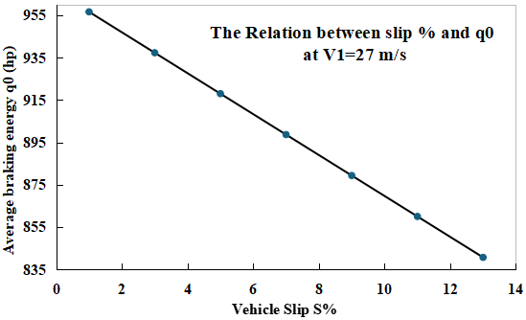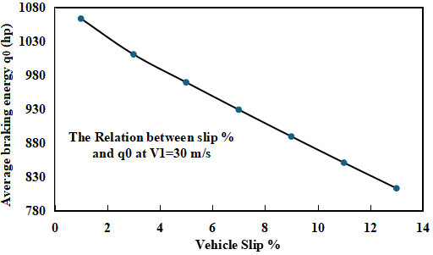
Figure (1) Relation between q0 and S% Figure (2) Relation between q0 and S%
when V₁=27 m/s when V₁=30 m/s
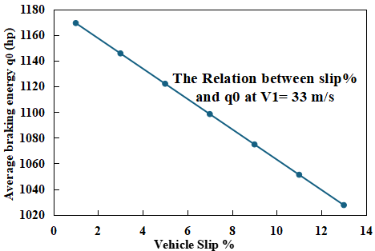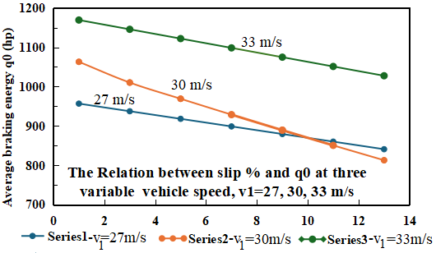
Figure (3) Relation between q0 and S% Figure (4) Relation between q0 and S%
when V₁=33 m/s at V₁=27, 30 and 33 m/s

Case Study (2) is Application for Equation (2)
The same vehicle in case study (1) was taken as case study (2) to investigate the value of q0 in terms of J/h and hours power coming from the summation forces while the brakes are applied and the vehicle moves down the hill so equation (2) was used. The calculation of q0 was studied keeping W = 88964.4323 N.
The results involved to groups of calculations: a. The starting vehicle speeds V = 15, 18 and 20 m/s with two tests of calculations; 1. road slope (G) = 7% and tire rolling resistance coefficient (Rr) varied as (0.015, 0.017, 0.045 and 0.2) with each starting vehicle speed. 2. then G=10% and Rr varied as (0.015, 0.017, 0.045 and 0.2) with each starting vehicle speed. and tire rolling resistance coefficient (Rr) varied as (0.015, 0.017, 0.045 and 0.2).
b. Two other examine for find q0 with the group of starting vehicle’s speed equal the same starting vehicle’s speed in case study (1), as V=27, 30, 33 m/s, 1- first one without change in G% and change the vehicle starting speed each raw with fix the variation of Rr as (0.015, 0.017, 0.045 and 0.2) values for all the rows .This means that to find the value of q₀ in first row the value of the vehicle starting speed=27 m/s with R_{r} as (0.015, 0.017, 0.045 and 0.2), then the second row for V= 30 m/s with the variation of Rr and the third row has different vehicle staring speed V=33 m/s than the first row with the same variation of Rr, and three rows for the values of q₀ are calculated with one G%=7. 2. The first calculations of item (b) are repeated here but with G=10%.
Results and Discussion for Case Study (2)
Table (7), Table (9), and (11) includes the values of q₀ (J/h, hp) with G=7% while V=15, 18, and 20 m/s respectively. Table (8), Table (10) and Table (12) comprise the values of q₀ (J/h, hp) with G=10% while V=15, 18, and 20 m/s respectively. Table (13) is other recognize for the data of Tables (7, 8, 9, 10, 11, and 12). The first row has three speeds 15, 18, and 20 m/s respectively. The second row has repetition for the tire rolling resistance coefficient (R_{r}) with each vehicle speed. In this case, q₀ (hp) values in rows third and fourth calculated at the three variable speeds with repeated the same values of R_{r} for each speed and all the above calculations was done once with G=0.07 and others for G=0.1 respectively. All Tables (7, 8, 9, 10, 11 and 12) have a negative result value at R_{r}=0.2.
All the Figures from (5) to (16) represent the relation between q₀ on the vertical axis with R_{r} on the horizontal axis with different value for G and V. This relation gives linearity in all the Figures. Table (14) indicates no big effect on the lines’ slope with changes in the vehicle’s speed, or road grade.
Figure (17) comes from Table (13). In Figure (17); q₀ (hp) has all the results for the vehicle's three speeds (15, 18, and 20 m/s) with two values of G (Series1-G=0.07, and Series2-G=0.1) and four values of Rr (0.015, 0.017, 0.045, 0.2) into each a speed group. Into all the groups of speed; q₀ results value less with decreases in G and increases with the increases in them. Also, at the same value of G; q₀ results increases with increases R_{r}, especially with the biggest Rr but has minus sign.
Figure (18) comes from Table (15) which has fixed G=7% and each raw represents a line between q₀ and Rr varied as (0.015, 0.017, 0.045 and 0.2) at the same value of the vehicle’s starting speed. This Figure was drawn at the same three vehicle speeds for Figure (4).
Figures (19) and Figure (20) is aimed to clarification the characters relations between a specific parameter and the value of q0 at definite vehicle speed. Figure (19) is drawn from Table (6). It has three groups for V₁ equals 27, 30, and 33 m/s respectively. Each group has two series; Blue one for definite values of V₁ and the other is orange for the slope value for q₀’s line with seven different values of tire slip (S%) which the relation between q₀ and S% coming from Equation (1). But Figure (20) is drawn from Table (16). Figure (20) has six groups; first three groups from the left hand for G=7%, and the second three groups for G=10 %. Each group has three series, the blue color for G, Orange color for V, and gray for the slope of q₀ range over R_{r} range. From Figure (20) the slope of the q₀ line hasn’t response with the change in G but it is increases with increases the vehicle speed. Equation (2) has the relations between q₀ and the operation condition parameters which used for Figure (20).

Table (7) variations of Rr with q₀ results Table (8) Variations of Rr with q₀ results
at V=15 m/s and G=7% at V=15 m/s and G=10%
SN | R_{r} | q₀ J/h | q₀ hp
1 | 0.015 | 264224366 | 98.43
2 | 0.017 | 254616207.2 | 94.85
3 | 0.045 | 120101984.6 | 44.74
4 | 0.2 | -624530319.7 | -232.64
SN | R_{r} | q₀ J/h | q₀ hp
1 | 0.015 | 408346747.5 | 152.11
2 | 0.017 | 398738588.7 | 148.53
3 | 0.045 | 264224366 | 98.43
4 | 0.2 | -480407938.2 | -178.95

Table (9) variations of Rr with q₀ results Table (10) q₀ results with variate of Rr
at V=18 m/s and G=7% at V=18 m/s and G=10%
SN | R_{r} | q₀ J/h | q₀ hp
1 | 0.015 | 317069239.2 | 118.11
2 | 0.017 | 305539448.7 | 113.82
3 | 0.045 | 144122381.5 | 53.686
4 | 0.2 | -749436383.6 | -279.17
SN | R_{r} | q₀ J/h | q₀ hp
1 | 0.015 | 490016097 | 182.53
2 | 0.017 | 478486306.4 | 178.24
3 | 0.045 | 317069239.2 | 118.11
4 | 0.2 | -576489525.8 | -214.75

Table (11) values of q₀ with variations Rr Table (12) values of q₀ with changing Rr
at V=20 m/s and G=7% at V=20 m/s and G=10%
SN | R_{r} | q₀ J/h | q₀ hp
1 | 0.015 | 352299154.7 | 131.23
2 | 0.017 | 339488276.3 | 126.46
3 | 0.045 | 160135979.4 | 59.65
4 | 0.2 | -832707092.9 | -310.19
SN | R_{r} | q₀ J/h | q₀ hp
1 | 0.015 | 544462330 | 202.82
2 | 0.017 | 531651451.6 | 198.04
3 | 0.045 | 352299154.7 | 131.23
4 | 0.2 | -640543917.6 | -238.61

R_{r}  G  q₀  hp | V m/s | 15 |  |  |  | 18 |  |  |  | 20
R_{r}  G  q₀  hp |  | 0.015 | 0.017 | 0.045 | 0.2 | 0.015 | 0.017 | 0.045 | 0.2 | 0.015 | 0.017 | 0.045 | 0.2
R_{r}  G  q₀  hp | 0.07 | 98.43 | 94.85 | 44.74 | -233.64 | 118.11 | 113.82 | 53.69 | -279.17 | 131.23 | 126.46 | 59.65 | -310.19
R_{r}  G  q₀  hp | 0.10 | 152.11 | 148.53 | 98.43 | -179.95 | 182.53 | 178.24 | 118.11 | -214.75 | 202.82 | 198.04 | 131.23 | -238.61
Table (13) Summary for all the Data of Tables (7, 8, 9, 10, 11 and 12)

Table (14) Link Between the vehicle’s speed, Road Grade, and Line’s Slope in Figures (5 to 16)
V m/s | 15 |  | 18 |  | 20
G | 0.07 | 0.10 | 0.07 | 0.10 | 0.07 | 0.10
Slope angle | 89° 58' 4'' | 89° 58' 4'' | 89° 58' 23'' | 89° 58' 23'' | 89° 58' 33'' | 89 58' 33''

Table (15) The relation between R_{r} and q₀ (hp) Table (16) slope of q₀ (hp) with R_{r} difference
at three variable speeds at two G and three variable speeds
R_{r} | 0.015 | 0.017 | 0.045 | 0.2 | V m/s
q₀  hp | 177.17 | 170.72 | 80.53 | -418.75 | 27
q₀  hp | 196.85 | 189.69 | 89.48 | -465.28 | 30
q₀  hp | 216.54 | 208.66 | 98.43 | -511.81 | 33
Grade | 7 % |  |  | 10 %
V m/s | 27 | 30 | 33 | 27 | 30 | 33
Slope | 3221 | 3579 | 3937 | 3221 | 3579 | 3937

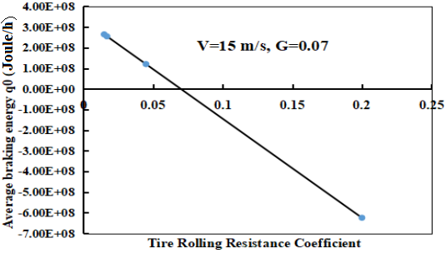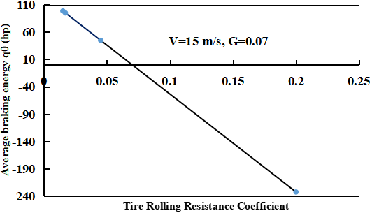
Figure (5) q₀ (Joule/h) with R_{r} on G=0.07, V=15 m/s Figure (6) q₀ (hp) with R_{r} on G=0.07, V=15 m/s

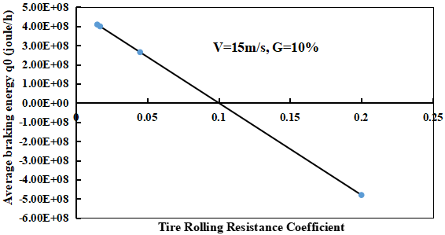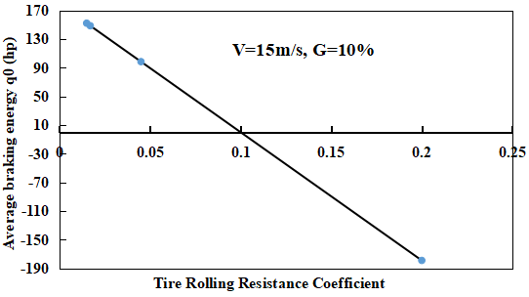
Figure (7) q₀ (Joule/h) with R_{r} on G=0.1, V=15 m/s Figure (8) q₀ (hp) with R_{r} on G=0.1, V=15 m/s

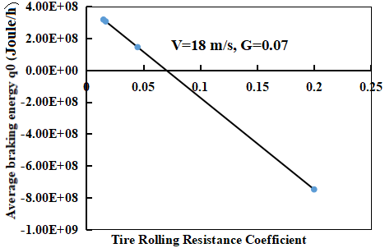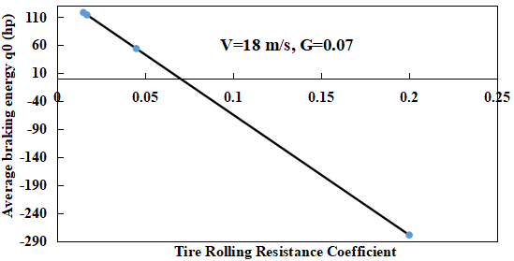
Figure (9) q₀ (Juole/h) with R_{r} on G=0.07, V=18 m/s Figure (10) q₀ (hp) with R_{r} on G=0.07, V=18 m/s
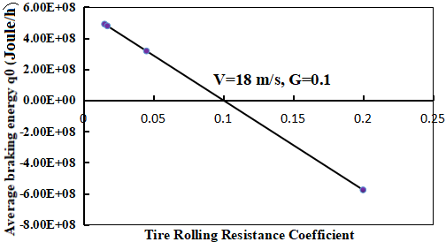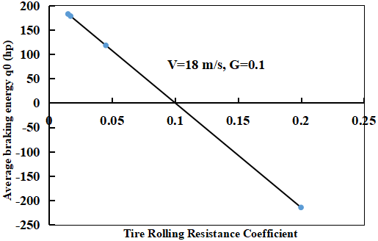
Figure (11) q₀ (Joule/h) with R_{r} on G=0.1, V=18 m/s Figure (12) q₀ (hp) with R_{r} on G=0.1, V=18 m/s
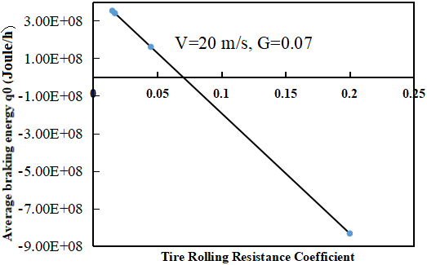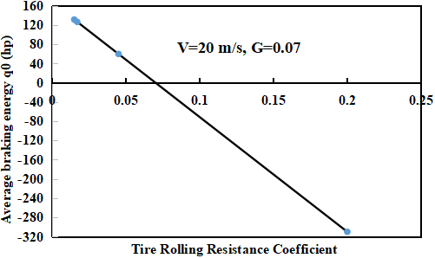
Figure (13) q₀ (Joule/h) with R_{r} on G=0.07, V=20 m/s Figure (14) q₀ (hp) with R_{r} on G=0.07, V=20 m/s
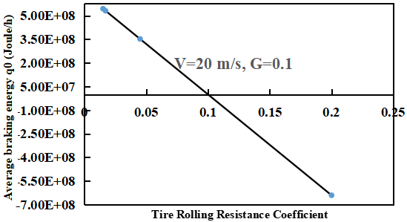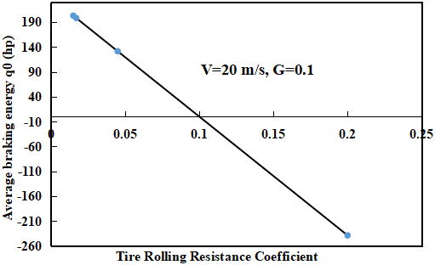
Figure (15) q₀ (Joule/h) with R_{r} on G=0.1, V=20 m/s Figure (16) q₀ (hp) with R_{r} on G=0.1, V=20 m/s

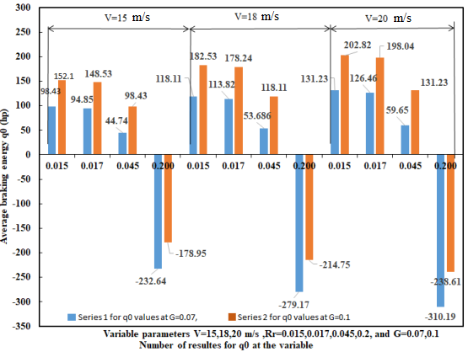
Figure (17) q0 (hp) with Number of results for Vehicle's Three Speeds (15, 18, and 20 m/s) with Two Values of G (Series1-G=0.07, Series2-G=0.1) and Four Values for Rr (R_{r}=0.015, 0.017, 0.045, 0.2) into Each Speed group

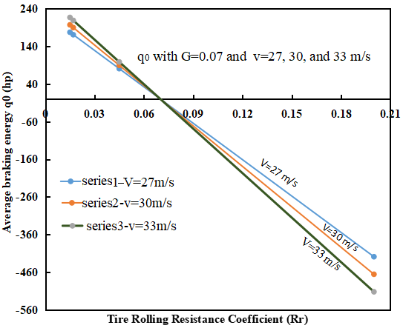
Figure (18) q₀ (hp) with R_{r} at the three variable speeds 27, 30, and 33 m/s and fixed G=7%
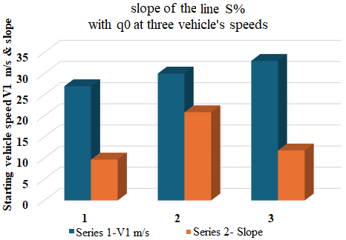
Figure (19) Slope of line of q₀ (hp) with S% at starting V₁= 27, 30,& 33 (m/s)

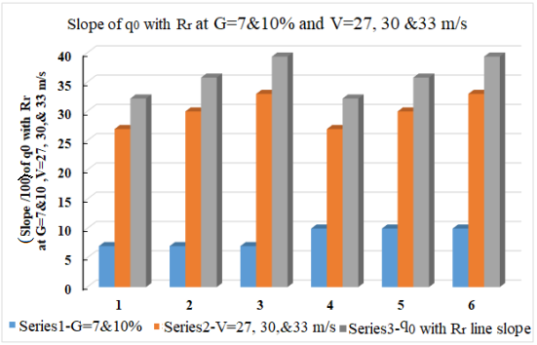
Figure (20) slope of line of q₀ (hp) with R_{r} at G=7,10% and V= 27, 30, 33 (m/s)

Conclusion

The good vehicle braking performance comes from that the average braking energy (q0) remains constant value. The theoretical study during this paper appears that the vehicle’s brake performance not well during the vehicle braking period, where decreasing of q0 during the vehicle braking which may cause some road accidents.
The appearance of a minus sign in the results for the second case study, in which the vehicle moves on a grade with a rolling coefficient of 0.2, means, from my point of view, that the brakes have lost their effectiveness.
Using the percentage change formula to analyze the effect of the road's grade and the starting speed of the vehicle, as well as tire rolling resistance coefficient on the average braking energy, the results concluded that the change in the tire rolling resistance coefficient has the greatest effect (336.351 % decrease) on the value of the vehicle’s average braking energy.
From results of some tables the slope of the q₀ line hasn’t effect with the change in G but it is increases with increases the vehicle speed.
Disclaimer (Artificial intelligence)
Option 1:
Author(s) hereby declare that NO generative AI technologies such as Large Language Models (ChatGPT, COPILOT, etc.) and text-to-image generators have been used during the writing or editing of this manuscript.
Option 2:
Author(s) hereby declare that generative AI technologies such as Large Language Models, etc. have been used during the writing or editing of manuscripts. This explanation will include the name, version, model, and source of the generative AI technology and as well as all input prompts provided to the generative AI technology
Details of the AI usage are given below:
1.
2.
3.

References
- Ali Belhocine, Oday Ibraheem Abdullah. Thermomechanical Model for the Analysis of Disc Brake Using the Finite Element Method in Frictional Contact, Multiscale Science and Engineering. 2020; 2:27–41.
https://doi.org/10.1007/s42493-020-00033-6
- Ali Belhocine, Asif Afzal. Finite element modeling of thermomechanical problems under the vehicle braking process, Multiscale and Multidisciplinary Modeling, Experiments and Design. 2020; 3:53–76. https://doi.org/10.1007/s41939-019-00059-w
- Ali Belhocine, Asif Afzal. A predictive tool to evaluate braking system performance using a fully coupled thermo‑mechanical finite element model, International Journal on Interactive Design and Manufacturing (IJIDeM). 2020; 14:225–253.
https://doi.org/10.1007/s12008-020-00650-3
- Ali Belhocine, Oday Ibraheem Abdullah. Design and Thermomechanical Finite Element Analysis of Frictional Contact Mechanism on Automotive Disc Brake Assembly, J Fail. Anal. and Preven. 2020; 20:270–301, https://doi.org/10.1007/s11668-020-00831-y
- Darcom Pamphlet. Enginering Design Handbook Analysis and Design of Automotive Brake Systems, HQ, US Army Materiel Development & Readiness Command. December 1976.
- Vyacheslav Rakov. Determination of optimal characteristics of braking energy recovery system in vehicles operating in urban conditions, XIV International Conference 2020 SPbGASU “Organization and safety of traffic in large cities”, Transportation Research Procedia 50 (2020) 566–573. 10.1016/j.trpro.2020.10.068, https://creativecommons.org/licenses/by-nc-nd/4.0
- Tomasz SZCZEPAŃSKI, Anna SKARBEK-ŻABKIN, Paweł DZIEDZIAK. Impact of the road conditions on the amount of braking energy, 2017, 171(4), 265-268. DOI: 10.19206/CE-2017-445
- Emilia M. Szumska and Rafał Jurecki. The Analysis of Energy Recovered during the Braking of an Electric Vehicle in Different Driving Conditions, Energies 2022, 15, 9369.
https://doi.org/10.3390/en15249369
- Enguo Dong, Yajuan Li, Boli Sun and Xiaojun Zhang. Vehicle Braking Stability Analysis Considering Vehicle Structure Parameters Based on CarSim, Journal of Physics: Conference Series 2501 (2023) 012006. doi:10.1088/1742-6596/2501/1/012006
- I.H. Shanono, A. Muhammad, Hybrid Electric Vehicles: A mini Overview, Journal of Modern Manufacturing Systems and Technology (JMMST), 26th February 2021, VOL. 5, ISSUE 1, 27 – 36, DOI: https://doi.org/10.15282/jmmst.v5i1.6055.
- David C. Barton, John D. Fieldhouse, Automotive Chassis Engineering, 2nd edition: © The Editor(s) (if applicable) and The Author(s), under exclusive license to Springer Nature Switzerland AG 2024.

Appendix (1) for Figure (17)

Percentage Change Formula (A-1)
Percentage change Formula which is Derived from the Formula for the percentage difference of two numbers. The Percentage change equals the change in value divided by the absolute value of the original value, multiplied by 100.
$Percentage Change=\frac{\left(Second value-First value\right)}{\left|First value\right|}*100$ (A-1)

Solution for two points from the results in Figure (17) :
Calculation for percentage change in q₀ for case study two from q₀ at (R_{r}=0.015) = 98.43 hp to q₀ at (R_{r}=0.2) = -232.64 hp with v=15 m/s, and G=7%
$$Percentage change for q_{0}=\frac{\left(q0 at (Rr=0.015) -q0 at (Rr=0.2)\right)}{\left|q0 at (Rr=0.015)\right|}*100$$
$=\frac{\left(-232.64-98.43\right)}{\left|98.43\right|}*100$
=−3.36351×100
=−336.351 % change
=336.351 % decrease

Percentage Change in q₀ = 19.994 % increase
When q₀ at (v=15 m/s) = 98.43 hp to q₀ at (v=18 m/s)=118.11 hp with G=7% , and R_{r}=0.015

Percentage Change in q₀ = 54.5261% increase
When q₀ at (G=7%) = 98.43 hp to q₀ at (G=10)=152.1 hp with V=15 m/s , and R_{r}=0.015

Every researcher can find the percentage change between two points by use Percentage Change Calculator from Google.

