**Marketing Agricultural Products in Tanzania: A Review of Strategies, Gaps, and Policy Implications**

ABSTRACT

|  |
| --- |
| Agricultural marketing is a critical factor influencing the economic landscape of Tanzania, where agriculture forms the backbone of the economy. Despite its central role in supporting rural livelihoods, contributing to food security, and boosting export potential, Tanzania's agricultural marketing system faces significant challenges. These include inadequate infrastructure, inefficient supply chains, lack of market access, and insufficient farmer education. Such inefficiencies have resulted in substantial post-harvest losses, estimated at 30-40%, particularly for perishable products, while rural farmers face low prices due to the dominance of middlemen. This paper explores these challenges and examines the potential for improved marketing strategies to enhance food distribution, increase rural incomes, and boost Tanzania's agricultural exports. We conducted a thorough literature review from quality databases (Scopus, Web of Science, and PubMed) and one search engine (Google Scholar) whereby literatures published in high quality journals were examined. Key interventions proposed include infrastructure development, strengthening market linkages, and the use of technology to improve market information systems. Additionally, enhancing farmer education on marketing practices is crucial to empowering farmers to navigate modern agricultural markets successfully. Moreover, the role of consumer trust in agricultural products is emphasized, highlighting the need for transparency and quality control. This review aims to provide a comprehensive understanding of the agricultural marketing landscape in Tanzania and suggest actionable recommendations for overcoming existing barriers. By optimizing agricultural marketing, Tanzania can harness its agricultural sector's full potential, ensuring sustainable growth, poverty reduction, and food security. |

*Keywords:* Marketing, Agricultural products, Agricultural sector, Market access, Agricultural infrastructure, Climate change

1. INTRODUCTION

Marketing agricultural products is essential for connecting farmers and consumers, guaranteeing food security, and promoting rural development on a global scale (Bateman, 1976). Infrastructure, value chain efficiency, and farmer empowerment gaps still exist despite policy changes that support market access and trade liberalization. In developing countries like Tanzania, where insufficient systems impede agricultural commercialization and sustainable economic growth, these issues are especially noticeable. In Tanzania agricultural marketing is also crucial for shaping the future of agricultural production as the agricultural sector remains the backbone of the economy (Chegere & Stage, 2020). Over the past few decades, the importance of marketing agricultural products has grown exponentially, influencing key aspects of food security, rural incomes, and export potential (Figure 1). The role of agricultural marketing in driving sustainable economic growth, improving livelihoods, and facilitating food distribution cannot be overstated (Mhagama & Mmasa, 2022). In Tanzania, agriculture remains central to both the national economy and the well-being of rural populations, with the sector providing direct or indirect employment to more than 70% of the population (Slavchevska, 2015). However, despite its critical role, agricultural marketing in Tanzania faces a series of challenges that undermine its full potential. These challenges range from inadequate infrastructure and inefficient supply chains to a lack of market access and insufficient farmer education, all of which constrain the growth of rural economies and food security (Slavchevska, 2015).

One of the most crucial areas where agricultural marketing impacts Tanzania is food security. Efficient marketing systems are vital to ensure that surplus food reaches areas in need, thus stabilizing food prices and ensuring availability (Ochieng et al., 2022). However, Tanzania’s poor marketing infrastructure often leads to significant post-harvest losses, exacerbating food insecurity. Factors such as inadequate storage facilities, poor transportation networks, and ineffective wholesale and retail systems disrupt the flow of agricultural products from rural areas to urban centers (Mtembeji & Singh, 2021). Consequently, even when adequate food is produced, logistical bottlenecks prevent its effective distribution, leading to food shortages in certain regions. A more effective agricultural marketing system is essential for ensuring that food is not only produced but also distributed efficiently across the country, reducing food insecurity (Djoumessi Tiague, 2023).

Beyond food security, agricultural marketing also has a direct impact on rural incomes. In Tanzania, most rural households rely on agriculture as their primary source of income, with the sale of crops providing a significant portion of their livelihood (Djoumessi Tiague, 2023). However, many farmers face challenges in obtaining fair prices for their produce due to the dominance of middlemen, price volatility, and a lack of direct market access. These factors lead to a situation where farmers are forced to sell their products at lower prices, contributing to a cycle of poverty in rural areas (Chegere & Stage, 2020). A well-organized agricultural marketing system would allow farmers to access formal markets, set fair prices, and improve their income levels, thus increasing their ability to invest in better farming practices and access essential services such as education and healthcare (Bateman, 1976). Improving rural incomes through better marketing practices is crucial for reducing poverty and enhancing overall rural development (Israel, Majaliwa, & Kinala, 2022).

On a broader scale, agricultural marketing influences Tanzania’s potential for agricultural exports. The country’s agricultural sector holds considerable promise for increasing export revenue, particularly in cash crops such as coffee, tea, and horticultural products (Huka, Kilima, & Mchopa, 2024). However, Tanzania struggles to compete in global markets due to the inefficiencies in its marketing systems. International buyers often demand higher-quality products, standardized packaging, and transparent certification processes, which are often lacking in Tanzania’s agricultural exports (Johansson, Martin, & Mapunda, 2023). Enhancing marketing strategies such as improving value chains, promoting product branding, and ensuring product certification could enable Tanzanian farmers to better access international markets, boost export revenues, and improve the country’s economic standing on the global stage (Dey & Singh, 2025).

An essential component of improving agricultural marketing is the education of farmers (Huka et al., 2024). In many rural areas, farmers often lack the knowledge and skills necessary to navigate the complexities of the modern agricultural marketplace (Mawazo M Magesa, Michael, & Ko, 2020). Enhancing farmer education through training programs, extension services, and community-based initiatives can empower farmers with the knowledge of market trends, pricing mechanisms, and consumer preferences (Marson, 2022). This, in turn, would help them better market their produce and increase profitability. Education can also enable farmers to adopt new marketing techniques, improve production efficiency, and understand sustainable practices that are increasingly demanded by consumers and international markets (Mayaya, Mpogole, & Dede, 2022).

Equally important is the role of consumer trust in agricultural marketing. In Tanzania, a significant portion of the population still lacks confidence in the safety and quality of locally produced agricultural goods, especially due to the informal nature of the sector (Mgale & Yunxian, 2020). This lack of trust can limit demand and hinder market growth. To overcome this, a focus on transparency in the marketing of agricultural products is needed. Building consumer trust requires more stringent quality control measures, product certifications, and transparent marketing practices (Mlay, 2021). Government initiatives, collaborations with farmer organizations, and private sector partnerships can all play a role in fostering consumer confidence, thus increasing demand for Tanzanian agricultural products (Mdemu & Tatu, 2024).

This review seeks to explore the current strategies, gaps, and policy implications related to agricultural marketing in Tanzania. It underscores the influence of effective marketing on food security, rural incomes, and export potential, while also focusing on the role of farmer education and consumer trust. By identifying the existing challenges and opportunities, this review aims to offer a comprehensive understanding of the agricultural marketing landscape in Tanzania and suggest practical steps for improving marketing systems. In a globalized economy, optimizing agricultural marketing is essential for sustainable growth in Tanzania’s agricultural sector, ultimately contributing to poverty reduction, enhanced food security, and greater export competitiveness.

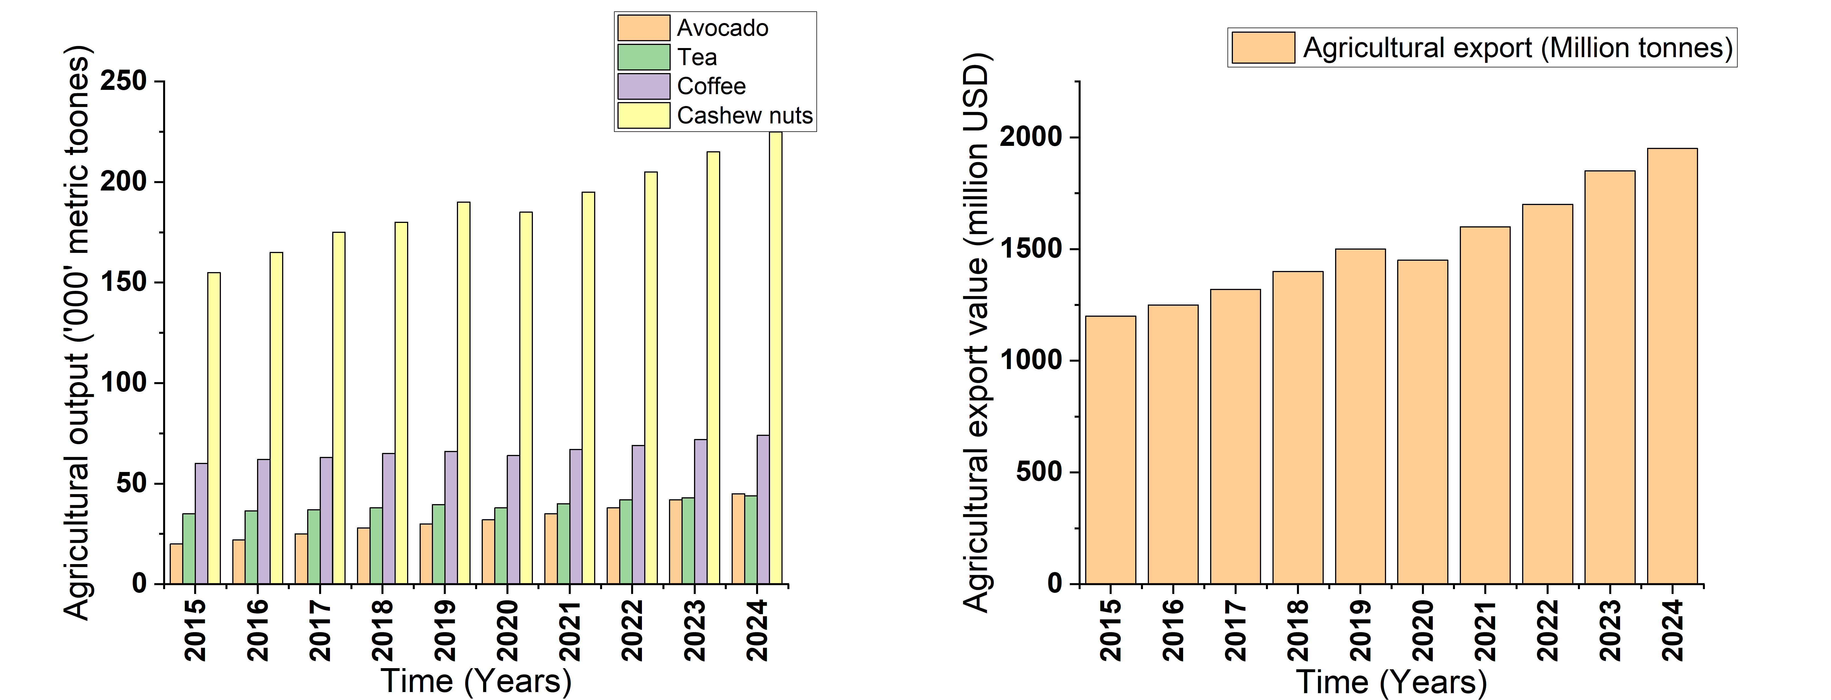

Figure 1: Trend in agricultural output and export value of main commercial crops in Tanzania from 2015 to 2024.

1. **THE STATUS OF AGRICULTURAL MARKETING IN TANZANIA**

The agricultural sector in Tanzania has long been characterized by an informal and fragmented marketing structure, with smallholder farmers being the backbone of the economy (Mauki, Jeckoniah, & Massawe, 2023). Previous studies have pointed out that despite the country’s agricultural potential, its marketing system remains underdeveloped, contributing to inefficiencies and market failures (Mlay, 2021; Mlozi, 2019; Mudimu, Brüntrup, & Mutabazi, 2025). The majority of farmers, especially in rural areas, lack access to modern marketing infrastructure such as cold storage facilities, processing plants, and transportation systems, making it difficult for them to reach lucrative markets or export channels (Figure 2). The inefficiencies in the supply chain lead to significant post-harvest losses, which are estimated to range between 30-40% for certain crops, especially perishables like fruits, vegetables, and dairy (Mwinyiheri, Salin, Zhang, Lin, & Chewe, 2023).

Several studies highlight the critical gaps in Tanzania's agricultural marketing, such as inadequate road networks, limited storage facilities, and the dominance of middlemen who exploit farmers (Sanka, Malima, Nkilijiwa, & Ruttajama, 2024). Middlemen, who control the distribution and sale of agricultural products, often pay farmers low prices for their produce and then sell them at much higher rates to consumers. This results in lower rural incomes, stifles rural development, and hampers food security (Sekiya et al., 2020).

Research has also focused on the role of technology and modernization in improving agricultural marketing. For instance, mobile phone technology has shown promise in facilitating information dissemination, allowing farmers to access market prices, weather forecasts, and technical advice (Malima, Bukaza, & Faustine, 2015). Additionally, the growth of digital platforms and e-commerce solutions has made it easier for farmers to connect directly with buyers, thereby bypassing intermediaries and improving price transparency. However, these technological advancements are still in their infancy and are not widely accessible to all farmers, particularly those in remote areas (Nyagango, Sife, & Kazungu, 2023).

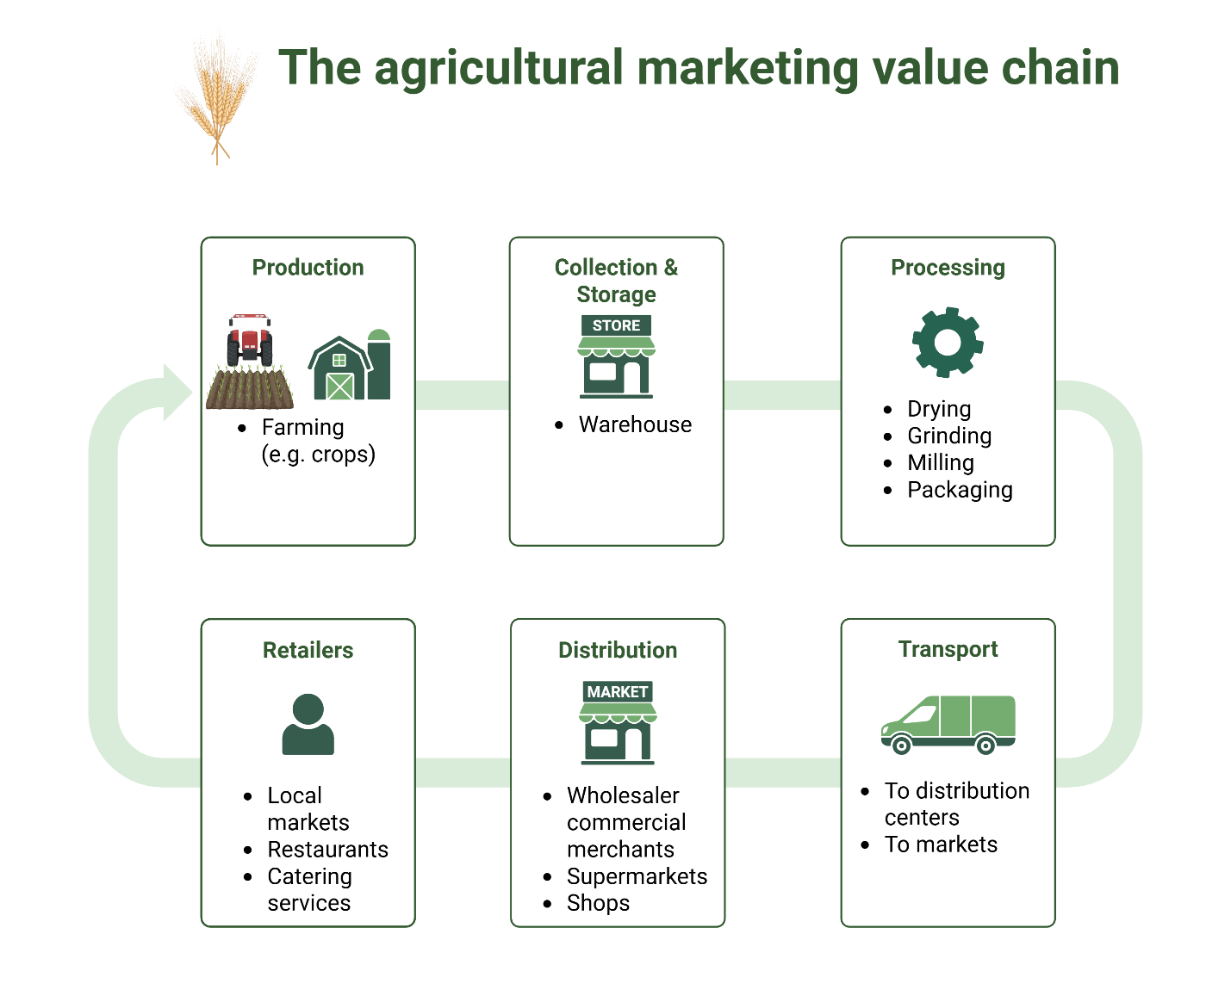

Figure 2: The agricultural marketing value chain (created in: biorender.com)

1. **CHALLENGES FACING AGRICULTURAL MARKETING IN TANZANIA**
   1. **Inadequate infrastructure**

Tanzania's agricultural sector suffers from poor infrastructure, including roads, storage facilities, and transportation systems (Mayaya et al., 2022). According to (Figure 3), the lack of adequate roads limits farmers’ access to urban markets and causes delays in getting products to consumers. Storage facilities are scarce, contributing to high post-harvest losses, especially for perishable goods like fruits and vegetables (Bisheko & Rejikumar, 2024). Insufficient cold storage options also hinder value addition processes. This lack of infrastructure creates inefficiencies in the supply chain, increasing the cost of marketing agricultural products and reducing farmers' income (Rutta, 2024).

* 1. **Limited market access**

Access to markets remains a significant challenge for Tanzanian farmers, especially in rural areas. Farmers often struggle to reach larger urban centers or export markets due to geographic isolation and poor transport networks (Ayenew, 2023). This lack of market access leads to farmers selling at lower prices to middlemen, who control the pricing (Mtembeji & Singh, 2021). Farmers also face uncertainty due to fluctuating market demand, which further limits their ability to engage in consistent and profitable trading. Strengthening market access would empower farmers and enhance their bargaining power (Kimaro & Nnko, 2024; Mawazo M Magesa et al., 2020).

* 1. **Dominance of middlemen**

Middlemen play a dominant role in Tanzania’s agricultural marketing system, acting as intermediaries between farmers and buyers (Ng’ombe et al., 2023). While they provide an essential function, they often exploit farmers by buying at low prices and selling at high margins. The absence of direct market linkages for smallholder farmers means they are vulnerable to price manipulation and receive only a fraction of the final selling price (Panda & Sreekumar, 2012). This exacerbates rural poverty and reduces farmers’ incentives to increase production. Reducing the role of middlemen through better market information and direct linkages would benefit farmers financially (Siwandeti & Israel, 2024).

* 1. **Lack of market information**

One of the critical challenges facing agricultural marketing in Tanzania is the absence of timely and accurate market information (Tilumanywa, 2021). Farmers often have limited access to real-time data on market prices, demand trends, and consumer preferences. This information gap leads to poor decision-making, such as producing crops that are in low demand or selling at unfavorable prices (Nyamboga, Mgale, Rwela, & Mpasa, 2023). Lack of transparency also opens the door for price exploitation by traders. Implementing technology-driven solutions, such as mobile apps and market information systems, can bridge this gap and provide farmers with the necessary tools to make informed decisions (Mawazo Mwita Magesa & Mkasanga, 2021; Mushi, Serugendo, & Burgi, 2023).

* 1. **Limited access to credit**

Access to credit is another major challenge for farmers in Tanzania (Kandi, Ma, Xu, & Dooley, 2025). Limited access to financial resources restricts farmers’ ability to invest in modern farming practices, such as purchasing seeds, fertilizers, and equipment, which are essential for increasing productivity and quality (Maleko & Ukpong, 2025). The lack of credit options also hampers their ability to scale their operations and improve market readiness. Without access to finance, many smallholder farmers are stuck in low-productivity cycles, unable to take advantage of marketing opportunities. Encouraging financial institutions to offer affordable and accessible credit options can stimulate growth in the agricultural sector (Kuzilwa, Daniel, Larsen, & Fold, 2017).

* 1. **Poor post-harvest handling**

Post-harvest handling practices in Tanzania are generally poor, contributing to significant losses and reduced quality of agricultural produce. Inadequate storage facilities, lack of refrigeration, and improper transportation methods lead to spoilage, especially for perishable crops (Rutta, 2024). These losses are particularly high for fruits, vegetables, and dairy products. The lack of training in proper handling techniques further exacerbates this issue (Rwela, 2023). Developing better storage infrastructure and educating farmers on efficient post-harvest handling techniques are crucial steps to minimize losses, improve product quality, and increase market competitiveness (Sandy, Salehe, & Magesa, 2024).

* 1. **Inconsistent government policies**

The agricultural marketing system in Tanzania is significantly affected by inconsistent government policies (Stanslaus, Ngaruko, & Mutasa, 2024). Frequent changes in regulations, taxes, and subsidies create uncertainty, making it difficult for farmers to plan and invest in their businesses. Inconsistent policy support, such as fluctuating export bans or shifting import taxes, disrupts market stability (Tilumanywa, 2021). This volatility not only affects farmers' incomes but also discourages investment in the agricultural sector. To create a conducive environment for growth, the government must implement stable and predictable policies that foster long-term agricultural development (Bamwenda, 2021).

* 1. **Climate change**

Climate change has exacerbated the challenges facing agricultural marketing in Tanzania, as erratic weather patterns disrupt both production and supply chains (Gwambene, Liwenga, & Mung’ong’o, 2023). Droughts, floods, and unseasonable rains affect crop yields, making it difficult to meet market demand consistently (Kangalawe, Mung’ong’o, Mwakaje, Kalumanga, & Yanda, 2017). The unpredictable nature of weather also complicates planning for marketing and pricing. Farmers are often left with unsold products due to market instability caused by climate-induced shortages (Sanka et al., 2024). Developing climate-resilient agricultural practices and providing insurance for farmers can help mitigate these risks and ensure more reliable production and marketing (Mafie, 2022).

* 1. **Limited farmer education**

Many Tanzanian farmers lack the necessary skills and knowledge to navigate modern agricultural marketing effectively (Rutta, 2024). This includes understanding market trends, quality standards, packaging, and branding. Limited education also extends to the use of digital tools for market access and price comparison (Mdemu & Tatu, 2024). Without the knowledge to optimize production and marketing techniques, farmers miss opportunities to increase their profitability. Providing training in agricultural marketing, business management, and digital literacy can empower farmers to make more informed decisions and strengthen their position in the market (Mawazo M Magesa et al., 2020; Mushi et al., 2023).

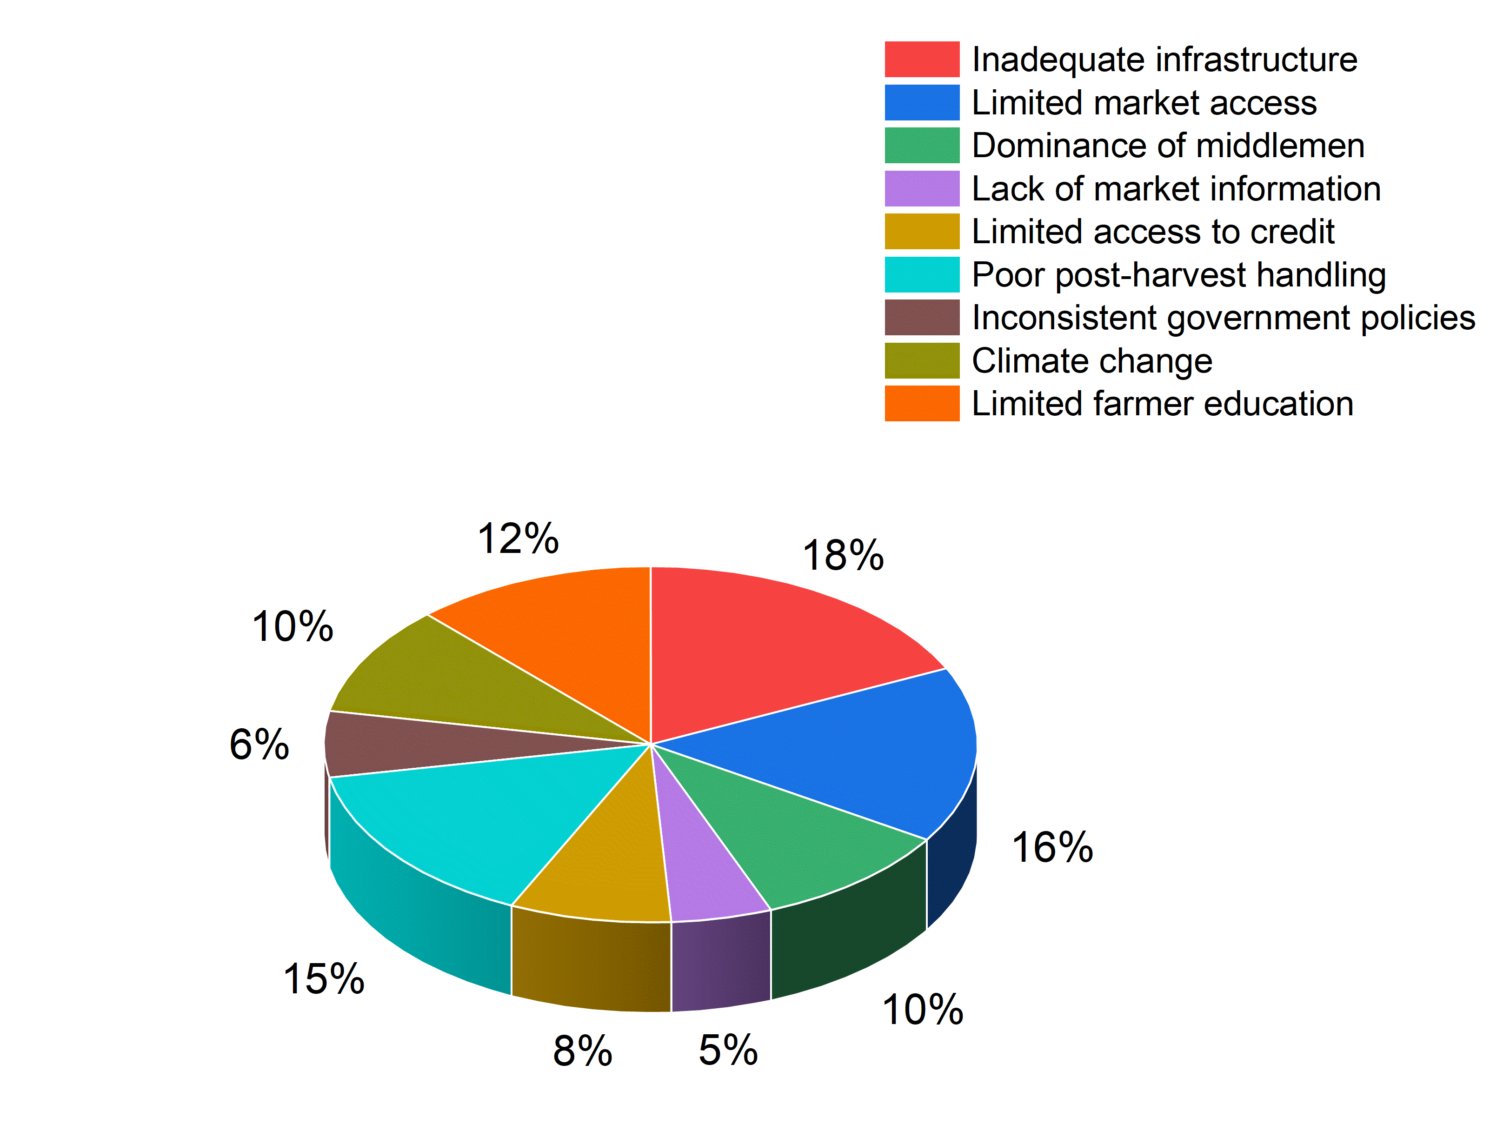

Figure 3: Agricultural marketing challenges perceived by farmers in Tanzania

1. **FUTURE PERSPECTIVES FOR IMPROVING AGRICULTURAL MARKETING IN TANZANIA**

Several strategies have been proposed to improve the agricultural marketing landscape in Tanzania. These include infrastructure development, strengthening market linkages, enhancing market information systems, and improving farmers' education on marketing practices as demonstrated in figure 4.

* 1. **Infrastructure development**

Investment in infrastructure such as roads, storage facilities, and market structures is fundamental for improving agricultural marketing in tanzania (changalima & ismail, 2022). Proper storage facilities can reduce post-harvest losses, especially for perishable goods, by extending the shelf life of agricultural products (siwandeti, israel, & mahuwi, 2023). Additionally, improved transportation networks would facilitate the timely delivery of goods to markets, reducing the chances of spoilage or delays that often result in losses (mlay, 2021). Government initiatives to invest in rural infrastructure and public-private partnerships are crucial for addressing these systemic gaps (coulson, 1977).

* 1. **Market linkages and value chains**

Strengthening market linkages is vital for connecting smallholder farmers to larger markets, both locally and internationally (Dey & Singh, 2025). Enhancing the value chain for agricultural products allows for the addition of value at different stages, from production to processing and marketing (Changalima & Ismail, 2022). One promising model is contract farming, which can offer farmers better access to markets, higher prices, and timely payments. These linkages also help farmers improve the quality of their produce, as buyers often provide training on quality standards and product specifications (Ng’ombe et al., 2023).

* 1. **Market linkages and value chains**

The establishment of robust market information systems that provide real-time data on market prices, demand trends, and weather conditions is critical (mramba & msuya, 2024). These systems allow farmers to make informed decisions about when and where to sell their produce, helping them to avoid selling at a loss during periods of glut. Mobile-based platforms and digital tools are increasingly being adopted, with organizations like tigopesa and kilimo salama offering services that help farmers access current market data (kitole, mkuna, & sesabo, 2024).

* 1. **Farmer education and capacity building**

A well-educated and skilled farmer base is essential for improving agricultural marketing. Educational programs focusing on basic business practices, market dynamics, and digital literacy can help farmers improve their marketing strategies and increase their incomes (Pauw & Thurlow, 2011). Extension services that train farmers on best practices for post-harvest handling, quality control, and direct marketing are critical. Government agencies and NGOs must prioritize training programs for smallholder farmers to ensure that they are well-equipped to participate in the formal market system (Mauki et al., 2023; Sandy et al., 2024).

* 1. **Policy implications**

Effective agricultural marketing requires strong policies and frameworks that encourage investment, promote market access, and support rural development (Isinika, Mibavu, & VanSickle, 2016). Tanzania’s current agricultural policies, such as the Agricultural Sector Development Strategy (ASDS) and the National Agriculture Policy, have made strides in addressing these issues. However, there is a need for more focused and comprehensive policies that consider both short-term and long-term challenges faced by farmers (Kuzilwa et al., 2017).

* 1. **Supporting farmers’ access to credit**

Access to finance remains one of the biggest constraints for smallholder farmers in Tanzania. Government-backed loan schemes and financial products tailored to agricultural needs can help farmers invest in better tools, seeds, and fertilizers to improve production (Tilumanywa, 2021). Policies that encourage financial institutions to develop agricultural loan products with favorable terms for farmers are crucial for scaling up production and market participation (Tilumanywa, 2021).

* 1. **Strengthening public-private partnerships**

Public-private partnerships (PPP) can play a pivotal role in improving agricultural marketing by leveraging both government resources and private sector expertise (Nathaniel, Kweka, & Deogratius, 2023). PPPs could help build infrastructure such as storage and processing facilities, promote agribusiness development, and offer platforms for knowledge exchange. These collaborations are essential for creating an enabling environment that encourages market integration and sustainability (Sanka et al., 2024; Slavchevska, 2015).

* 1. **Creating enabling policies for export growth**

To enhance Tanzania's export potential, policies must prioritize quality control, certification, and international marketing strategies (Coulson, 1977; Isinika et al., 2016). Export-oriented strategies that align with global demand trends, such as organic certification and value-added processing, can help Tanzanian farmers tap into higher-value markets. Recently Tanzania agricultural export value has increased Agricultural exports grew from USD 500 million (2005) to USD 3.22 billion contributing to 20% of USD 16.1 billion total exports in 2024 (Mlozi, 2019). Cashew nuts and tobacco export increased in the fourth quarter of 2024 with cashew exports (USD 300 million) boosted by the Tanzania mercantile exchange. However, policies should also focus on reducing export barriers such as tariffs and non-tariff barriers that prevent agricultural goods from entering international markets (James, Sharma, Dev, & Sharma, 2021; Johansson et al., 2023).

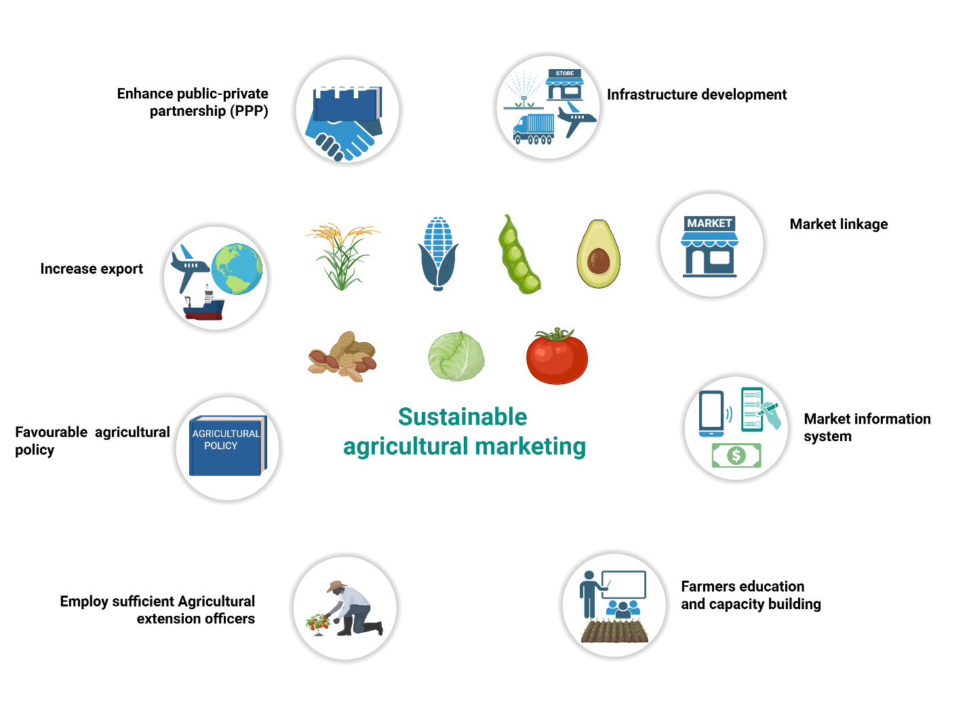

Figure 4: Future perspectives for sustainable agricultural marketing

1. Conclusion

Agricultural marketing in Tanzania holds tremendous potential to improve food security, boost rural incomes, and increase export earnings. However, the existing gaps in infrastructure, market access, and farmer education must be addressed through targeted interventions. By improving marketing systems, building better value chains, and investing in digital technologies, Tanzania can unlock the full potential of its agricultural sector. The government's role in creating an enabling policy environment, coupled with private sector involvement and farmer empowerment, is crucial for the success of these strategies. In the long run, improving agricultural marketing systems will not only foster economic growth but also contribute to achieving sustainable development goals such as food security, poverty reduction, and inclusive economic development.

**Disclaimer (Artificial intelligence)**

Author(s) hereby declare that NO generative AI technologies such as Large Language Models (ChatGPT, COPILOT, etc.) and text-to-image generators have been used during the writing or editing of this manuscript.

References

Ayenew, Y. Y. (2023). Challenges of agricultural marketing in East Africa developing countries. *Journal of World Economic Research, 12*(2), 47-58.

Bamwenda, E. (2021). The agricultural sector marketing policy in Tanzania: the value added to economic growth. *Zeszyty Naukowe. Organizacja i Zarządzanie/Politechnika Śląska*.

Bisheko, M. J., & Rejikumar, G. (2024). Mitigating postharvest losses: a policy-driven approach to empowering smallholder farmers in Tanzania. *Scientific African, 23*, e02119.

Bateman, D. I. (1976). Agricultural marketing: A review of the literature of marketing theory and of selected applications. Journal of Agricultural Economics, 27(2), 171-226.

Changalima, I., & Ismail, I. (2022). Agriculture supply chain challenges and smallholder maize farmers’ market participation decisions in Tanzania. *Tanzania journal of agricultural sciences, 21*(1), 104-120.

Chegere, M. J., & Stage, J. (2020). Agricultural production diversity, dietary diversity and nutritional status: Panel data evidence from Tanzania. *World Development, 129*, 104856.

Coulson, A. (1977). Agricultural policies in mainland Tanzania. *Review of African Political Economy, 4*(10), 74-100.

Dey, S., & Singh, P. K. (2025). Market participation, market impact and marketing efficiency: an integrated market research on smallholder paddy farmers from Eastern India. *Journal of Agribusiness in Developing and Emerging Economies, 15*(2), 311-332.

Djoumessi Tiague, B. (2023). Floods, agricultural production, and household welfare: evidence from Tanzania. *Environmental and Resource Economics, 85*(2), 341-384.

Gwambene, B., Liwenga, E., & Mung’ong’o, C. (2023). Climate change and variability impacts on agricultural production and food security for the smallholder farmers in Rungwe, Tanzania. *Environmental Management, 71*(1), 3-14.

Huka, H. A., Kilima, F. T., & Mchopa, A. D. (2024). Impact of high-value market participation on income, saving and assets among smallholder vegetable farmers in Arumeru District, Tanzania. *Cogent Food & Agriculture, 10*(1), 2398767.

Isinika, A., Mibavu, G., & VanSickle, J. (2016). Agricultural policy analysis studies in Tanzania: A historical and thematic perspective with implications on future policy research for crop production and marketing. *Tanzania journal of agricultural sciences, 15*(1).

Israel, B., Majaliwa, D., & Kinala, M. (2022). Contribution of agricultural marketing co-operatives in commercialisation among smallholder maize farmers in Mbozi district, Tanzania. *Journal of Studies in Social Sciences and Humanities, 8*(1), 98-111.

James, N., Sharma, R., Dev, K., & Sharma, S. (2021). Challenges for small scale rice farmers-A case study from Tanzania.

Johansson, E., Martin, R., & Mapunda, K. M. (2023). Participatory future visions of collaborative agroecological farmer-pastoralist systems in Tanzania. *Agroecology and Sustainable Food Systems, 47*(4), 548-578.

Kandi, L. P., Ma, S., Xu, Z., & Dooley, K. E. (2025). Women in agricultural marketing: A systematic review of motivations, opportunities, and challenges. *Outlook on Agriculture, 54*(1), 3-15.

Kangalawe, R. Y., Mung’ong’o, C. G., Mwakaje, A. G., Kalumanga, E., & Yanda, P. Z. (2017). Climate change and variability impacts on agricultural production and livelihood systems in Western Tanzania. *Climate and Development, 9*(3), 202-216.

Kimaro, P. J., & Nnko, E. E. (2024). Analysis of the Current Marketing Channels among Small-Scale Coffee and Cashew Nut Farmers’ Households in Tanzania: A Case of Selected Co-Operatives in Coffee and Cashew Nuts Farming Districts. *Journal of Management and Science, 14*(3), 23-35.

Kitole, F. A., Mkuna, E., & Sesabo, J. K. (2024). Digitalization and agricultural transformation in developing countries: Empirical evidence from Tanzania agriculture sector. *Smart agricultural technology, 7*, 100379.

Kuzilwa, J. A., Daniel, M., Larsen, M. N., & Fold, N. (2017). Strategies and policies for agricultural development in Tanzania *Contract Farming and the Development of Smallholder Agricultural Businesses* (pp. 34-48): Routledge.

Mafie, G. K. (2022). The impact of climate change on agricultural productivity in Tanzania. *International Economic Journal, 36*(1), 129-145.

Magesa, M. M., Michael, K., & Ko, J. (2020). Access and use of agricultural market information by smallholder farmers: Measuring informational capabilities. *The Electronic Journal of Information Systems in Developing Countries, 86*(6), e12134.

Magesa, M. M., & Mkasanga, N. N. (2021). Smallholder farmers’ willingness to pay for access to agricultural market information in Tanzania. *Agrekon, 60*(4), 424-444.

Maleko, A. G., & Ukpong, I. G. (2025). Farmers’ Perspectives on Agricultural Marketing Information in Developing Countries: The Case of Tanzania. *Turkish Journal of Agriculture-Food Science and Technology, 13*(4), 907-913.

Malima, G., Bukaza, C., & Faustine, K. (2015). Farmers’ acceptance behaviour in using mobile phones for agricultural marketing in Iringa Region, Tanzania. *Int. J. Manag, 4*, 20-45.

Marson, M. (2022). Direct access to markets by farmers and the role of traders: insights from Kenyan and Tanzanian leafy vegetables markets. *Studies in Agricultural Economics, 124*(2), 66-73.

Mauki, C., Jeckoniah, J., & Massawe, G. D. (2023). Smallholder rice farmers profitability in Agricultural Marketing Co-operative Societies in Tanzania: A case of Mvomero and Mbarali districts. *Heliyon, 9*(6).

Mayaya, H., Mpogole, H., & Dede, K. (2022). Enhancing Rural Development through Agricultural Transformation. *Continuity with Vision: The Roadmap to Success for President Samia Suluhu Hassan, 12*, 198-220.

Mdemu, M., & Tatu, L. (2024). Agriculture Sector Policy Frameworks and Performance Indicators for Poverty Reduction among Youths in Tanzania. *Uganda Journal of Agricultural Sciences, 22*(2), 79-96.

Mgale, Y. J., & Yunxian, Y. (2020). Marketing efficiency and determinants of marketing channel choice by rice farmers in rural Tanzania: Evidence from Mbeya region, Tanzania. *Australian Journal of Agricultural and Resource Economics, 64*(4), 1239-1259.

Mhagama, J., & Mmasa, J. (2022). Agricultural Production Services and its Impact on Choice of Marketing Channels among Smallholder Sesame Farmers in Tanzania. *Tanzania journal of agricultural sciences, 21*(1), 77-89.

Mlay, F. F. (2021). Understanding marketing challenges along grapes value chain in central areas of Tanzania. *The Accountancy and Business Review, 13*(1).

Mlozi, M. R. (2019). Urban agriculture, production and marketing: The Tanzania experience *Urban and Peri-Urban Agriculture in Africa* (pp. 79-92): Routledge.

Mramba, N. R., & Msuya, M. S. (2024). Exploring the Usage of Digital Marketing among Selected Agricultural Marketing Co-operatives in Morogoro, Tanzania. *African Journal of Empirical Research, 5*(3), 934–947-934–947.

Mtembeji, A. L., & Singh, D. R. (2021). Dynamics of rice production among the food crops of Tanzania. *South African Journal of Science, 117*(9-10).

Mudimu, G. T., Brüntrup, M., & Mutabazi, K. D. (2025). Resurrecting a presumed ghost: the challenges and revival of the Southern agricultural growth corridor of Tanzania in a changing political landscape. *Third World Quarterly*, 1-19.

Mushi, G. E., Serugendo, G. D. M., & Burgi, P.-Y. (2023). Data management system for sustainable agriculture among smallholder farmers in Tanzania: research-in-progress. *Information Technology for Development, 29*(4), 558-581.

Mwinyiheri, N. Y., Salin, V., Zhang, Y. Y., Lin, B., & Chewe, C. (2023). Multi-level marketing system with industrial food processing in Africa: smallholder tomato farmers in Tanzania. *International Food and Agribusiness Management Review, 27*(2), 217-236.

Nathaniel, T., Kweka, G. J., & Deogratius, A. (2023). Barriers to the Accountability Mechanisms of co-operative Unions on Primary Agricultural Marketing Co-operative Societies. *African Journal of Co-operative Development and Technology, 8*(1), 79-87.

Ng’ombe, A., Sithole, M., Musafiri, C. M., Kiboi, M., Sales, T., & Ngetich, F. (2023). Building a resilient and sustainable sorghum value chain in Tanzania’s Lake Zone Region. *Sustainability, 15*(20), 15107.

Nyagango, A. I., Sife, A. S., & Kazungu, I. (2023). Factors influencing the use of mobile phone for accessing agricultural marketing information by grape smallholder farmers in Tanzania. *Cogent Business & Management, 10*(3), 2257865.

Nyamboga, H. S., Mgale, Y. J., Rwela, T. G., & Mpasa, O. M. (2023). Cost–Benefit Efficiency and Factors for Marketing Channel Choices among Avocado Farmers in Rungwe District, Tanzania. *Rural Planning Journal, 25*(2), 1-13.

Ochieng, J., Afari-Sefa, V., Muthoni, F., Kansiime, M., Hoeschle-Zeledon, I., Bekunda, M., & Thomas, D. (2022). Adoption of sustainable agricultural technologies for vegetable production in rural Tanzania: trade-offs, complementarities and diffusion. *International Journal of Agricultural Sustainability, 20*(4), 478-496.

Panda, R. K., & Sreekumar. (2012). Marketing channel choice and marketing efficiency assessment in agribusiness. *Journal of international food & agribusiness marketing, 24*(3), 213-230.

Pauw, K., & Thurlow, J. (2011). Agricultural growth, poverty, and nutrition in Tanzania. *Food policy, 36*(6), 795-804.

Rutta, E. W. (2024). Postharvest food loss reduction and agriculture policy framework in Tanzania: status and way forward. *Agriculture & Food Security, 13*(1), 36.

Rwela, A. (2023). The Contribution of Agricultural Marketing Co-operative Societies to Farmers’ Livelihoods in Mvomero and Kilombero Districts, Tanzania. *JOURNAL OF OASIS AGRICULTURE AND SUSTAINABLE DEVELOPMENT, 5*(5), 1-12.

Sandy, N., Salehe, F., & Magesa, M. (2024). Sources and knowledge of smallholder farmers in agricultural information in Mvomero district, Tanzania: Where does misinformation originate. *Tanzania journal of agricultural sciences, 23*(1), 19-32.

Sanka, M. B., Malima, M. J., Nkilijiwa, A. L., & Ruttajama, J. J. (2024). Agricultural Marketing Co-operative Societies' existing potential in adopting Climate Smart Agriculture among Smallholder Farmers in Bukoba District, Tanzania.

Sekiya, N., Oizumi, N., Kessy, T. T., Fimbo, K. M., Tomitaka, M., Katsura, K., & Araki, H. (2020). Importance of market-oriented research for rice production in Tanzania. A review. *Agronomy for Sustainable Development, 40*(1), 7.

Siwandeti, M., & Israel, B. (2024). Pricing-supply chain issues of staple food crops in Rural-Urban Tanzania. *Journal of International Trade, Logistics and Law, 10*(1), 191-205.

Siwandeti, M., Israel, B., & Mahuwi, L. (2023). The effect of supply chain factors on market participation among smallholder cereal crop producers in Tanzania. *Global Business Review*, 09721509231187490.

Slavchevska, V. (2015). Agricultural production and the nutritional status of family members in Tanzania. *The Journal of Development Studies, 51*(8), 1016-1033.

Stanslaus, V. S., Ngaruko, D. D., & Mutasa, F. (2024). Effects of Fiscal and Monetary Policies on Agricultural Industry Growth in Tanzania from 1970 to 2022. *Pan-African Journal of Business Management, 8*(2), 162-183.

Tilumanywa, V. T. (2021). Improving Agricultural Support Services for Smallholder Farmers' Adaptation to Climate Variability in Rungwe District in Tanzania. *Tanzania Journal of Development Studies, 19*(1).