Perceived Effectiveness of PM-KISAN Scheme as a Direct Benefit Transfer (DBT) initiative in Enhancing Livelihood Resilience of Farmers in Uttar Pradesh, India: A Factor Analytical Approach

ABSTRACT
Aim: The Pradhan Mantri Kisan Samman Nidhi (PM-KISAN) scheme is a flagship Direct Benefit Transfer (DBT) initiative aimed at providing income support to farmer households across India. This study evaluates the perceived effectiveness of the scheme in enhancing livelihood resilience among beneficiaries in Uttar Pradesh, the state with the highest number of recipients.
Study design: Ex-Post Facto Research Design
Place and Duration of Study: The research was conducted in Machhlisahar block of Jaunpur district and Jahanaganj block of Azamgarh district of Uttar Pradesh between February 2025 to July 2025.
Methodology: 141 beneficiaries selected through proportionate random sampling. Data were collected using a structured interview schedule and analyzed through descriptive statistics and exploratory factor analysis.
Results: The Kaiser-Meyer-Olkin (KMO) measure of sampling adequacy (0.705) and Bartlett’s Test of Sphericity (p < 0.001) confirmed the suitability of factor analysis. three latent factors with eigenvalues greater than one were extracted using Principal Component Analysis with Varimax rotation, collectively explaining 90% of total variance. These factors were identified as: Extension and Innovation Orientation, Economic and Resource Factor and Cognitive or Attitudinal Response. The results indicate that perceived effectiveness is shaped by both financial and non-financial dimensions with strong linkages to farmers information access, risk-taking behavior and willingness to adopt innovations.
Conclusion: Findings suggest that while PM-KISAN improves liquidity and supports agricultural investments, its full potential can be realized through complementary measures such as enhanced extension services, awareness campaigns and integration with other agricultural support programs. The study offers actionable insights for policymakers to strengthen DBT schemes’ contribution towards building resilient rural livelihoods.

Keywords: PM-KISAN, Direct Benefit Transfer, perceived effectiveness, livelihood resilience, factor analysis.

1. INTRODUCTION
India is primarily an agriculture-based economy. “The Indian agriculture sector provides livelihood support to about 42.3 percent of the population and has a share of 18.2 percent in the country’s GDP at current scenario” (Economic Survey, 2023-24). After enactment of the green revolution in 1960s there was a huge increase in agricultural food production from 72.3 MT in 1961 to 332.22 MT in 2023-24, which made India food self-sufficient and also a food exporting country but this had very minor effect on farmer’s welfare. “Poor and near-poor households in the country suffer a variety of risks (such as crop failure, natural disaster, health problems, accidents and unemployment) making it difficult for them to improve and preserve their ability to sustain livelihood over time. This has left them with the only option of selling productive assets, withdrawing children from school and lowering nutritional intake. This vulnerability affects both the non-poor, who are at the risk of dropping below the poverty line, and the impoverished, who are at the risk of sinking deeper into deprivation and long-term poverty. One of the effective methods of improving their livelihood by improving their uncertain living conditions is through cash transfers. Cash transfer is generally a process of social protection and non-contributory payments sent directly and regularly to raise and stabilize earnings in order to minimize vulnerability and poverty”; (Ghosh, 2022). Direct Benefit Transfer (DBT) in terms of cash is a frequent term used in cash transfers discussion nowadays. The amount of subsidy is directly transferred to bank accounts of beneficiaries and a very signficant impact of these conditional cash transfers (CCT’s) programme has experienced in countries like Brazil as poverty and inequality decreased through their own CCT’s programme called “Bolsa-Familia”; one of the largest conditional cash transfers programme of the world (Scorzafave and Lima, 2010). So “many countries have got the idea to transfer social benefits to its people with the aim to reduce inequalities, poverty and corruption and facilitate better livelihood standards. In India, currently there are 319 schemes under 54 ministries using the mechanism of DBT. DBT include rural development, health and family welfare, agriculture and education, pension schemes, maternity benefits, scholarships, MGNREGA and subsidy on LPG cylinders etc.” (Report on DBT, 2016)
Pradhan Mantri Kisan Samman Nidhi (PM-KISAN) under the Ministry of Agriculture and Farmer’s Welfare (MoA&FW) is a central sector cash transfer scheme implemented by the Government of India. The scheme was launched by Prime Minister Narendra Modi on 24th February 2019. It is an income support scheme aimed at supporting farmer’s financial needs to secure standard crop health, and appropriate yields. Under the scheme, a direct annual cash transfer of Rs 6,000 in three equal instalments of Rs 2000 each is given to all small and marginal landholding farmer families (SMFs) for every four-month period. “Later on June 1, 2019, following a Union Cabinet decision, PM-KISAN benefits were extended to all farmers irrespective of land size”; (Anonymous, 2019). According to government data, the scheme had reached about 12.85 crore farmers nationwide by October, 2024. The 19th installment of the Pradhan Mantri Kisan Samman Nidhi (PM-KISAN) scheme was released by PM on 24th February, 2025 from Bhagalpur, Bihar. During the event over 9.8 crore farmers including 2.41 crore female farmers across the country had benefitted through the 19th instalment release, receiving direct financial assistance exceeding Rs.22, 000 crore through Direct Benefit Transfer (DBT) without involvement of any middlemen, reinforcing the Government's commitment to farmer welfare and agricultural prosperity. (Anonymous, 2025) The highest number of beneficiaries comes from Uttar Pradesh (21.87 per cent), followed by Maharashtra (8.86 per cent), Madhya Pradesh (7.88 per cent), Bihar (7.37 per cent) and Rajasthan (6.81 per cent). (PM KISAN Portal, 2024-25)
2. MATERIAL AND METHODS
2.1 Universe and location of the study
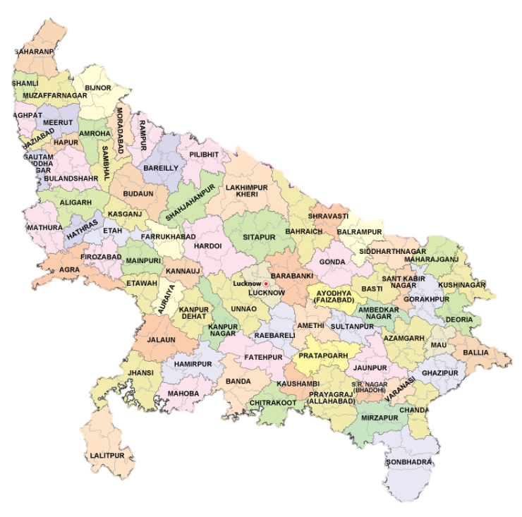
The top five highest state having beneficiaries of PM KISAN were Uttar Pradesh (21.87%), Maharashtra (8.86%), Madhya Pradesh (7.88%), Bihar (7.37%) and Rajasthan (6.81%) among all 28 states of India. Out of which Uttar Pradesh state was selected purposively for the research study, because of having highest number of beneficiaries of PM KISAN scheme in India in FY 2024-25. In Uttar Pradesh, out of 76 districts, Jaunpur and Azamgarh districts were selected purposively for the research study because of having the highest consecutive number of beneficiaries of PM KISAN scheme in Uttar Pradesh. Machhlisahar and Jahanaganj block consist of 173 and 209 villages, respectively, and top five villages from each block were identified. Thus three villages i.e., Kasba Dhirua Khas, Bhiduna and Jamalpur from Machhlisahar block and three villages i.e., Kutubpur, Godhaura and Ummarpur from Jahanaganj block were selected based on highest consecutive number of beneficiaries of PM KISAN scheme. Thus, total six villages were selected purposively for the research study.
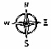

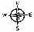
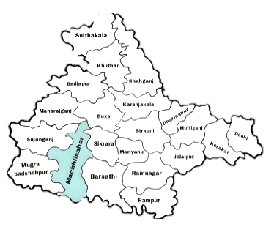
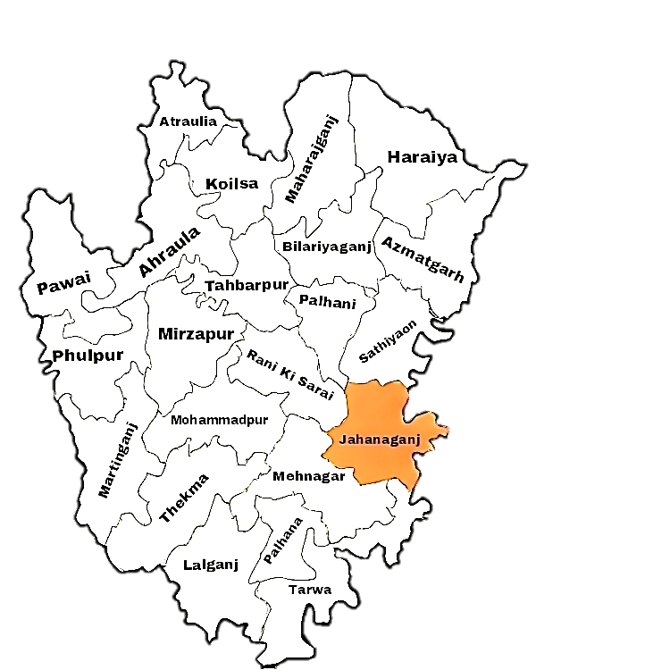

Fig 1 Map of Uttar Pradesh

1. Kasba Dhirua Khas
2. Bhiduna
3. Jamalpur
1. Kutubpur
2. Godhaura
3. Ummarpur

Fig 2 Map of Jaunpur District Fig 3 Map of Azamgarh District
2.2 Sample and sampling procedure
From the selected six villages, a list of beneficiaries of PM KISAN was prepared with the help of DDAG officials of Jaunpur and Azamgarh district. From each selected village, 1 per cent of beneficiaries was selected by using proportionate random sampling method. Thus, from Jaunpur and Azamgarh district total 141 beneficiaries were the sample size for the study presented in Table 1.
Table 1 Selection of Beneficiaries
S. No. | District | Block | Village | Total No. of Beneficiaries | Number of Beneficiaries selected (1%)
1. | Jaunpur | Machhlisahar | Kasba Dhirua Khas | 1717 | 17
1. | Jaunpur | Machhlisahar | Bhiduna | 1691 | 17
1. | Jaunpur | Machhlisahar | Jamalpur | 1572 | 16
2. | Azamgarh | Jahanaganj | Kutubpur | 3481 | 35
2. | Azamgarh | Jahanaganj | Godhaura | 2890 | 29
2. | Azamgarh | Jahanaganj | Ummarpur | 2666 | 27
Total |  |  |  | 14016 | 141

2.3 Research design
Kerlinger (1983) defines research design as a plan, structure and technique of investigation for obtaining answers to research questions and controlling variance. In this study, selected features were qualitative, behavioural in nature after a comprehensive consideration of available literature and to support the study aim. The majority of these features were ex-post facto in nature and have little chance of being modified by the researcher. As a result, the ex-post facto design was selected for the study. According to Kerlinger (1964), ex-post factor research is a systematic empirical inquiry in which the investigator has no control over variables because their manifestations have already occurred and cannot be controlled. Without direct intervention, assumptions about links between variables were based on the associated variance of independent and dependent variables.
2.4 Variables and their Measurements
Independent variables like Age, Gender, Education, Annual Income, Family Type, Land Holding, Crops Grown, Occupation, Economic Motivation, Risk Orientation, Innovativeness, Social Participation, Extension Orientation and Mass Media Exposure were selected for the study dependent variables were Effectiveness and perception towards PM KISAN scheme as a DBT initiative.
2.5 Statistical analysis used in the study
Factor Analysis:
Factor Analysis (FA) is a multivariate statistical technique used to explore the underlying structure (latent variables) of a large set of observed variables. It aims to reduce data dimensionality by identifying interrelationships among variables and grouping them into factors. There are two types of factor analysis:
- Exploratory Factor Analysis (EFA): Used when the underlying structure are unknown.
- Confirmatory Factor Analysis (CFA): Used to test hypotheses about structure (usually in structural equation modelling).
In this study Exploratory Factor Analysis (EFA) was employed.
Tools in Factor Analysis
1) Kaiser-Meyer-Olkin (KMO): The KMO test is a measurement tool used to assess whether data are appropriate for factor analysis. In other words, it evaluates the appropriateness of the sample size. The test evaluates the model's overall sampling efficiency as well as the sampling efficiency for each model variable. The KMO measure of sampling adequacy is provided by
KMO = $\frac{\sum_{i≠j}{R_{ij}^{2}}}{\sum_{i≠j}{R_{ij}^{2}}+\sum_{i≠j}{U_{ij}^{2}}}$
Where, partial covariance matrix U_{ij} is a subset of the correlation matrix R_{ij}. The range of the KMO value is 0 to 1. KMO values between 0.8 and 1.0 show that the sampling is sufficient. KMO levels between 0.6 and 0.69 are mediocre, whereas those between 0.7 and 0.79 are merely average. KMO values below 0.6 indicate insufficient sampling, and corrective action should be taken. The results of the factor analysis will surely not be very useful for the examination of the data if the value is less than 0.5. The average communality of the retained items must be checked if the sample size is less than 300. If the sample size is less than 100, an average value > 0.6 is acceptable, and an average value between 0.5 and 0.6.
2) Bartlett’s Test of Sphericity:
The original correlation matrix, which is an identity matrix, indicates that the variables are unrelated and, as a result, unsuitable for structure identification. This is the null hypothesis (H₀) that is tested by Bartlett's Test of Sphericity. The alternative hypothesis (H₁) is that the variables are not orthogonal, i.e., that they are sufficiently correlated such that the identity matrix and the correlation matrix considerably diverge. A factor analysis for the data set may be beneficial, according to the significant value of 0.05.
To measure the overall relation between the variables the determinant of the correlation matrix |R| is calculated. Under HO, |R| =1; if the variables are highly correlate, then |R| ≈ 0.
The Bartlett's test of Sphericity is given by:
$X^{2}$= - (n - 1 - $\frac{2p+5}{6}$) x I n I R I
Where,
P = Number of variables
n = Total sample size
R = Correlation matrix
c) Kaiser's (Eigen value) Criterion:
The portion of the total variance explained by a factor is indicated by its eigen value. The notable factors in a factor analysis with an eigen value larger than one are kept. The reasoning behind this rule makes sense. An eigen value larger than one is considered significant, and it means that factor accounts for more common variance than unique variance. Measure and composite variables fall under two different categories. Factors should include more than one measured variable because they are latent constructs that were produced as aggregates of measured variables. However, eigen values do have some sampling error, much as any sample statistics. Therefore, it becomes crucial for the investigator to use discretion while employing this technique to choose how many factors to extract or keep.
d) Scree Plot:
A graphical technique to determine the number of variables. The horizontal axis of a scree plot is made up of eigen value numbers, and the vertical axis represents eigen value magnitudes. The graph's eigen values are shown as dots and a line connects each consecutive value. At the elbow or levelling of the land, factor extraction should come to an end. With the help of this test, the ideal number of components that can be extracted before the unique variance starts to dominate the common variance structure can be defined.
3. RESULTS AND DISCUSSION
Factor Analysis
a) Kaiser-Meyer-Olkin (KMO) Test
Table 2 Kaiser-Meyer-Olkin (KMO) Test
KMO Test
Kaiser-Meyer-Olkin Measure of Sampling Adequacy. | 0.71
Table 2 illustrates that KMO statistics have a value of 0.71 > 0.6, suggesting that sampling is sufficient and factor analysis is appropriate for the data.
b) Bartlett’s Test of Sphericity
Table 3 Bartlett’s Test of Sphericity
Bartlett’s Test of Sphericity
Chi-Square (X²) | 1271.655
Degree of Freedom (df) | 120
p value | <0.001
Using Bartlett’s sphericity test, the sufficiency of the correlation matrix is accessed. The correlation matrix shows the strong connections among some variables as shown in Table 3, Bartlett’s sphericity test being very significant at p <0.001. The test value is 1271.655 and being very significant. Thus, the correlation matrix being identity matrix is rejected.
c) Factor Extraction using Eigen Values and Scree Plot
Table 4 Eigen Values
S. No. | Components | Eigen Values
1 | Age | 4.08152601
2 | Gender | 2.73440048
3 | Education | 1.49942019
4 | Family Type | 1.21688819
5 | Annual income | 1.12676773
6 | Land holding | 1.04318376
7 | Crops Grown | 0.88596327
8 | Occupation | 0.77910012
9 | Economic motivation | 0.60610776
10 | Risk orientation | 0.56808694
11 | Innovativeness | 0.43679364
12 | Social participation | 0.34595025
13 | Extension Orientation | 0.32514047
14 | Mass Media Exposure | 0.27855927
15 | Effectiveness | 0.05450491
16 | Perception | 0.01760701
Table 4 shows that number of factors were chosen based on the Eigen Values, which were greater than one. It can be noted that six Eigen Values were above one, but only three components were taken because other three were close to one in scree plot and were not explaining the factors variation.

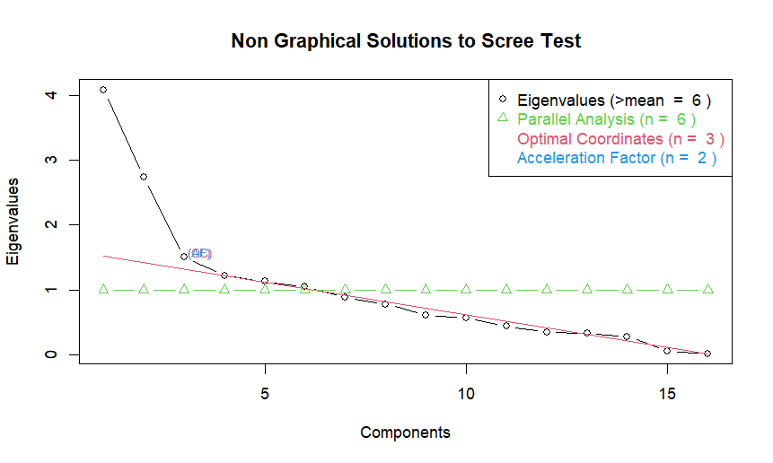

Fig 4 Scree Plot
In this scree plot, it was clear that those eigen values which are above green line (>1) were considered to be included as number of factors, but three factors explained major variation in the data and hence only 3 factors were considered.
Table 5 Factor Loadings of each variable
Variables | Factor 1 | Factor 2 | Factor 3
Economic Motivation | 0.54 | - | -
Risk orientation | 0.65 | - | 0.31
Innovativeness | 0.55 | - | -
Social Participation | 0.64 | - | -
Extension Orientation | 0.81 | - | -
Mass Media Exposure | 0.64 | - | -
Annual Income | - | 0.94 | -
Land Holding | - | 0.98 | -
Crops Grown | - | 0.74 | -
Effectiveness | 0.39 | - | 0.90
Perception | 0.40 | - | 0.91
Age | - | - | -
Gender | - | - | -
Education | - | - | -
Family Type | - | 0.31 | -
Occupation | - | - | -
Table 5 represents the factor loadings of each variable and the factor category they fall into by explaining their highest variation.
d) Findings of Factor analysis
The factor analysis was done, by considering three factors with varimax rotation. Hence, the below results were obtained
Table 6 Findings of Factor analysis
Factors | Variables Included | Factors Loadings | Proportion Variance | Proportion Explained
Factor 1  (Extension and Innovation Orientation) | Extension Orientation, Risk Orientation, Mass Media Exposure, Social Participation, Innovativeness, Economic Motivation | 2.93 | 0.18 | 0.37
Factor 2  (Economic and Resource) | Land Holding, Annual Income, Crops Grown | 2.48 | 0.16 | 0.31
Factor 3  (Cognitive or Attitudinal Response) | Perception, Effectiveness | 1.72 | 0.13 | 0.22
Total |  |  | 0.47 | 0.90
The factor 1 in Table 6 includes variables like Extension Orientation, Risk Orientation, Mass Media Exposure, Social Participation, Innovativeness, Economic Motivation related to the psychological and behavioural tendencies of individuals toward extension services, innovation, and community involvement. It reflects a farmer's openness to change, media influence and economic drive, hence can be termed as "Extension and Innovation Orientation". This factor explained variance to 37 per cent.
The factor 2 in Table 6 includes variables such as, Land Holding, Annual Income, Crops Grown, related to physical and financial resources available to the beneficiaries. It captures their economic capacity and scale of farming which can influence technology adoption and resilience. This factor is best described as "Economic and Resource Factor". This factor explained variance to 31 per cent.
The factor 3 in Table 6 includes variables like Perception, Effectiveness related to beneficiaries subjective evaluation of the scheme or intervention being assessed. It indicates how they perceive the usefulness and effectiveness of programs reflecting a "Cognitive or Attitudinal Response". This factor explained variance to 22 per cent.
The factor analysis revealed three distinct and meaningful underlying dimensions that explain the structure of the observed variables among the beneficiaries. The first factor labelled "Extension and Innovation Orientation", highlights the importance of behavioural traits such as risk-taking ability, innovativeness, media exposure, and economic motivation in shaping beneficiaries engagement with agricultural interventions. The second factor as " Economic and Resource ", underscores the role of economic and land-based assets such as land size, income and crop diversity as critical enablers of participation and responsiveness to schemes. The third factor, " Cognitive or Attitudinal Response” captures beneficiaries perception and evaluate the effectiveness and relevance of PM KISAN scheme.
Together, these three factors account for 90% of the total variation in the dataset, indicating a strong and stable factor structure. The high proportion of explained variance suggests that the selected variables are well-grouped and representative of broader latent constructs influencing beneficiaries behaviour and response. These insights provide a solid foundation for further analysis, policy formulation, and targeted interventions aimed at enhancing the effectiveness of agricultural schemes and improving farmer resilience.
4. CONCLUSION
The PM-KISAN scheme as a flagship Direct Benefit Transfer (DBT) initiative, plays a pivotal role in addressing the persistent socio-economic vulnerabilities of small and marginal farmers (SMFs) in India. By providing direct cash transfers, the scheme has contributed to improving liquidity, supporting agricultural inputs purchase and partially stabilizing farm households incomes. The factor analysis conducted in the study identified three core dimensions shaping beneficiaries experiences as Extension and Innovation Orientation, Economic and Resource Factors and Cognitive or Attitudinal Response which together explained 90% of the total variance. These findings underscore that the perceived effectiveness of PM-KISAN is influenced not only by the financial assistance provided but also by beneficiaries access to information, willingness to adopt innovations, economic capacity and personal perceptions of the scheme’s relevance. To ensure that PM-KISAN achieves its intended developmental impact, there is a pressing need for an integrated approach that combines timely and transparent fund delivery with enhanced extension services, targeted awareness campaigns, capacity-building programs and linkage with other agricultural support initiatives. Strengthening complementary infrastructure and service delivery mechanisms will amplify the scheme’s benefits, fostering greater resilience, productivity and social empowerment among small and marginal farmers. By aligning financial aid with holistic livelihood support strategies, PM-KISAN can evolve from a short-term income supplement into a catalyst for long-term rural prosperity.
DISCLAIMER (ARTIFICIAL INTELLIGENCE)
Author(s) hereby declare that NO generative AI technologies such as Large Language Models (ChatGPT, COPILOT, etc) and text-to-image generators have been used during writing or editing of manuscripts.
REFERENCES
Anonymous. (2019). Press Information Bureau, Pradhan Mantri Kisan Samman Nidhi announced to provide assured income support to small and marginal farmers, Ministry of Finance, GOI, Retrieved From https://www.pib.gov.in/newsite/PrintRelease.aspx?relid=187932
Anonymous. (2025). Press Information Bureau, PM-KISAN completes 19 successful installment, Ministry of Agriculture & Farmers Welfare. GOI , https://www.pib.gov.in/PressReleseDetailm.aspx?PRID=2105745
Economic Survey. (2023-24), Ministry of Finance, Government of India, https://static.pib.gov.in/WriteReadData/specificdocs/documents/2024/jul/doc2024722351601.pdf
Ghosh, B. (2022). Role of Direct Benefit Transfer (DBT) in Enhancing Livelihood of Small and Marginal Farmers: A Special Reference to the PM-KISAN Scheme of Government of India, M.Sc. Thesis, IARI, New Delhi, India. Page 185. https://krishikosh.egranth.ac.in/handle/1/5810206826
Ghosh, B., Roy, B. R., Padaria, R., Mahra, G., Kumar, P., Bhowmik, A. & Paul, S. (2023). Effectiveness of Cash Transfer Under the PM-Kisan Scheme of Government of India in Benefitting the Small and Marginal Farmers by Providing Income Support. Journal of Community Mobilization and Sustainable Development. 18. Page 12-18.
Goswami, P., Rajan, P. & Jaiswal, D. K. (2021). Effectiveness of Deendayal Antyodaya Yojna - National Rural Livelihoods Mission on Empowerment of Women in Sagar District of Madhya Pradesh. Indian Journal of Extension Education. 57(2):162-165
Kumar, M. (2022). Utilization Pattern of Pradhan Mantri Kisan Samman Nidhi (PM-KISAN) Among the Farmers of Sitapur District, Uttar Pradesh. M.Sc. Thesis, BUAT, Banda, Uttar Pradesh, India Page 97.
PM KISAN Portal. (2024-25). Ministry of Agriculture & Farmers Welfare, Government of India (Financial Year 2024-25) Retrieved from https://pmkisan.gov.in/
Padmaja, B., P.R., D., P.S., K., M., J. D., &amp; R.P., K. (2024). From Policy to Practice: Exploring Beneficiary Farmers Utilization of PM-KISAN Funds. Journal of Scientific Research and Reports, 30(12), 771–777. https://doi.org/10.9734/jsrr/2024/v30i122719
Rajpoot, A. S., Rajan, P., Raut, A., Srivastava, A. & Singh, R. B. (2023). Profile of National Rural Livelihood Mission (NRLM) beneficiaries in Madhya Pradesh. Asian Journal of Agricultural Extension, Economics & Sociology. 41(11):249- 257.
Report on Direct Benefit Transfer (DBT). (2016). Planning Commission, Government of India. Available at https://dbtbharat.gov.in/data/documents/REPORT-ON-DBT.pdf
Scorzafave L and Lima E. 2010. Inequality in evolution in Brazil: The role of Cash Transfer Programs and other Income sources. Research on Economic Inequality. 18: 107-129.
Srivani, T. N. S. S., Rajan, P., Naberia, S. & Singh, D. K. (2022). Farmer’s Perception towards Pradhan Mantri Van Dhan Vikas Yojana in Andhra Pradesh. Indian Journal of Extension Education vol.58(1), 165-169.
Sushmita, K. S. (2020). Assessment of Funds Utilization by Farmers under Pradhan Mantri Kisan Samman Nidhi Yojana in Chikkaballapur District of Karnataka, M.Sc. Thesis, JNKVV, Jabalpur (M.P.) Page 77.
Ujjwala, B. (2020). An Evaluation of Rythu Bandhu Scheme on Economic Behaviour of Farmers in Ranga Reddy District of Telangana State, M.Sc. Thesis, JNKVV, Jabalpur (M.P.) Page 70.
Varshney, D., Kumar, J. P., Roy, D. & Kumar, A. (2020). Pradhan Mantri Kisan Samman Nidhi (PM-KISAN) and the Adoption of modern agricultural technologies in Uttar Pradesh, India. IFPRI Discussion Paper 01907.

