The Market Potential of Drone in Agriculture

Abstract
A flexible system of farming practices and agricultural technology, modern agriculture enables farmers to increase output while consuming less natural resources to meet the world's needs for food, biofuel, and fiber. Many technologies are used in agriculture nowadays, and one of the newer ones is the use of drones to spray pesticides (Shaw K. et al. 2020). Despite being a significant part of the Indian economy, the country still lags behind western nations in using innovative technologies to boost agricultural output.
The state of drones in the agricultural industry Although drones in horticulture, agriculture, and forestry are only allowed to be used for limited, targeted experiments and, in some situations, commercial operations in other areas of the world, drone uses in agriculture are already widespread in Asia. These days, drones are utilized for a number of purposes, including as planting new forests, distributing micro-granular fertilizers and insecticides, and controlling weeds, insects, and diseases. The Chinese government has provided subsidies for the commercial use of drones in agriculture. Consequently, more than 10,000 individuals were taught to operate the Agras MG-1 series drone by DJI Innovation Technology. This drone type, known as the Agras MG-1 series 8-rotor sprayer, was introduced in 2015.
Field mapping is a vital aspect of the agriculture drone market, tackling significant issues in contemporary farming like resource optimization, precision agriculture, and workforce shortages. Drones can be utilized for field mapping, giving farmers crucial information regarding their land, crops, and farming activities.
Keywords : Agricultural Drone, Farmers Agricultural technologies, Farm productivity
Introduction
Modern agriculture comprises adaptable farming methods and agricultural technologies that allow farmers to boost productivity while using fewer natural resources to satisfy global demands for food, fiber, and biofuel. A variety of technologies are employed in modern agriculture, with one of the more recent innovations being the use of drones for pesticide spraying (Shaw K. et al. 2020). Although it constitutes a major component of the Indian economy, India still falls behind Western countries in adopting innovative technologies to enhance agricultural productivity. To ensure the viability of agriculture, it is essential to cut back on conventional methods and adopt new technologies (Yallappa D. et al. 2017).
Temperature, relative humidity, rainfall, and other significant biological factors such as pests, insects, and diseases are among the environmental conditions that influence agricultural development. By employing fertilizers and insecticides to control these biological processes, it is possible to attain production gains over the long term. In order for Indian agriculture to achieve high productivity, materials with high yield and protective qualities were essential. Thus, in order to produce crops in agricultural areas, it is necessary to apply fertilizers and pesticides. This is achieved by farmers who carry pesticide containers and spray them independently in the field. While spraying, they would still be exposed to pesticides, even if they wore a mask. Pesticides and fertilizers have a variety of effects on human health, including the development of skin and neurological diseases. Pesticides and fertilizers impact thousands of farmers and employees or workers every year (Suryavanshi V. et al. 2019, Marvel M. et al. 2016).
Drones in agriculture: a current overview While drones in horticulture, agriculture, and forestry are permitted only for small-scale trials and certain commercial operations in specific regions of the world, their use in agriculture is already widespread in Asia. Nowadays, drones are used for various tasks, including afforesting, delivering micro-granular fertilizers and pesticides, and managing weeds, insects, and diseases. Subsidies for the commercial use of drones in agriculture have been provided by the Chinese government. As a result, DJI Innovation Technology trained over 10,000 individuals to operate the Agras MG-1 series drone. This drone type, known as the Agras MG-1 series 8-rotor sprayer, was introduced in 2015.
According to FAOSTAT, the amount of cereal acreage in the United States increased from 50,697,492 hectares in 2022 to 55,539,765 hectares in 2023. With the expansion of cultivated land, it is essential to manage resources effectively. Field mapping helps farmers identify fields requiring specific treatments. While some areas might need more irrigation, others would require additional fertilizer. Farmers can utilize field mapping to target resource application precisely where needed, thereby reducing waste and enhancing cost efficiency.
Use of Drones
• Battery Life: Current UAVs typically offer only 15 to 30 minutes of flight time, requiring frequent recharging to maintain continuous operations. To unlock their full potential and deliver significant economic benefits, UAVs must be capable of staying airborne for much longer durations.
• Cost: The high costs involved in UAV development—due to the need for multiple components, technical expertise, and operational training—make drones unaffordable for many small and marginal farmers, limiting widespread adoption in agriculture.
• Regulations and Licensing: The deployment of UAVs is subject to legal and regulatory requirements. Operators must obtain proper licenses and understand flight restrictions, including no-fly zones and nearby air traffic regulations, to ensure safe and lawful drone usage.
• Stability and Balance: Applications like pesticide spraying cause continuous shifts in payload weight, which can destabilize the drone. Maintaining balance during such operations remains a key technical challenge.
Methodology

Selection of the Study Area
Rajasthan has emerged as a hub for agribusiness start-ups, largely due to proactive support from the state government. This has created significant opportunities for digital transformation within the rural ecosystem. For this study, agri-based business models that have developed and evolved in Rajasthan will be selected and analyzed.

Socio-Economic Profile of Rajasthan
Rajasthan is the largest state in India in terms of geographical area. Approximately 50% of the total land is classified as net sown area and forest cover. The remaining land is distributed among non-agricultural uses, barren land, and areas reserved for pastures and grazing. The state is endowed with rich natural resources and fertile soil, making a substantial portion of the land arable and suitable for agriculture.

Agricultural Profile
Rajasthan is divided into three major agro-climatic zones, including the southern Ajmer-Bhilwara region. These zones are categorized based on factors such as rainfall, temperature, soil type, and other geographical characteristics. Agricultural planning in each zone is guided by scientific research and recommendations provided by Agricultural Research Stations, ensuring region-specific strategies and sustainable practices.

Description of the Study Area
Rajasthan, located in northwestern India, is the largest state in the country by area, covering 342,239 square kilometers. It ranks as the seventh most populous state, according to the 2011 Census. Districts like Ajmer and Bhilwara are part of the state's dynamic landscape. Rajasthan has emerged as one of the fastest-growing startup ecosystems in India and was ranked among the Aspiring Leaders along with five other states in the Startup India States’ Startup Ranking 2019.

Selection of the Study Area
Rajasthan has been purposively selected for this study due to its rapid agricultural transformation, which is being driven by the adoption of innovative and advanced technologies. The state presents a strong case for examining agri-tech developments and digital interventions in rural areas.

Selection of Districts, Mandals, and Sample Farmers for the Study
Based on expert consultations with key stakeholders, one district was selected from each agro-climatic zone where a significant number of farmers are already exposed to digital technologies in agriculture. In total, two districts—one from each selected agro-climatic zone—were chosen for the study.
Using data obtained from the respective District Agricultural Offices, particularly focusing on the number of farmers who have self-registered for selected government digital agriculture schemes, two mandals were selected from each district. The selection included:
- One progressive mandal with the highest number of self-registered farmers.
- One backward mandal with the lowest number of self-registered farmers.
From each mandal, three villages were randomly selected, forming the final sample for the study.
Fig. 1 Farmers groups with drone training

Result and Discussion:
The findings of this study underscore the significant role that circular economy principles play in shaping green entrepreneurship and sustainable business models. Based on an in-depth analysis of case studies, interviews, and field observations, three key themes emerged:
- Circular Business Models and Implementation Strategies
- Barriers and Challenges to Circular Economy Adoption
- Policy and Institutional Support for Circular Entrepreneurship
These themes offer a comprehensive insight into how green enterprises adopt and integrate circular economy practices, the challenges they encounter in doing so, and the broader institutional and policy frameworks that influence their efforts (see Table 1).
Table 1: Participants distribution by gender
Gender | Frequency | Percent
Female | 148 | 58.04
Male | 107 | 41.96
Total | 250 | 100.0

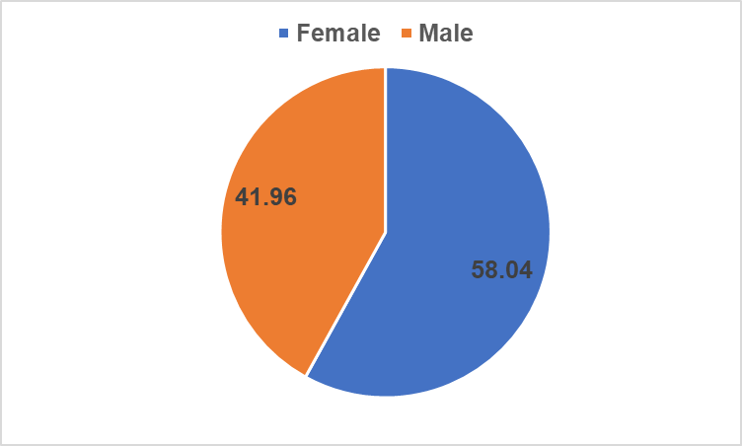
Fig. 2 Pie chart showing the Participants' distribution by gender
The majority of the population are women which represent 58.04% of the sample and men are 41.96%.
Table 2 : Participants' distribution by age groups
Age group | Frequency | Percent
<16 | 3 | 1.20
16-20 | 8 | 3.20
21-25 | 114 | 45.60
26-30 | 57 | 22.80
31-35 | 10 | 4.00
36-40 | 15 | 6.00
41-45 | 7 | 2.80
46-50 | 8 | 3.20
50> | 28 | 11.20
Total | 250 | 100.0
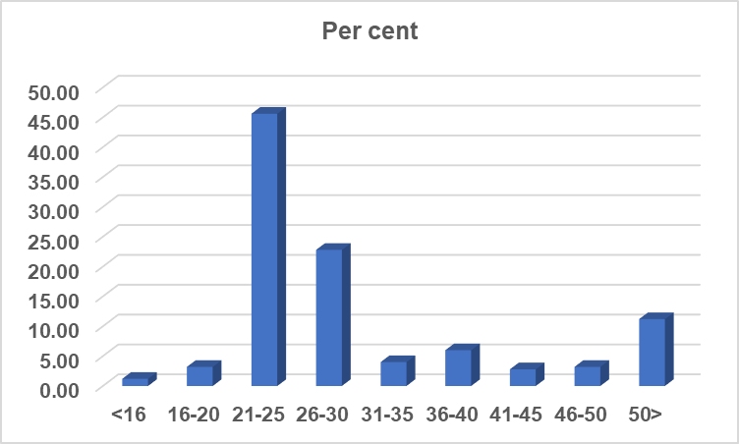
Fig. 3 Bar graph showing the Participants' distribution by age group
According to the exhibit, the majority of the sample—70%—consists of young adults aged between 21 and 25 years, accounting for 45.60% of the total participants. Those aged between 26 and 30 make up 22.80% of the sample. The remaining participants are spread across other age groups in smaller proportions.
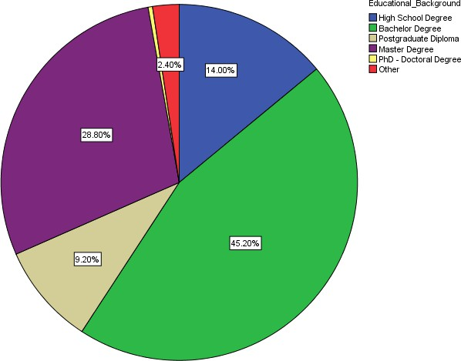
Fig. 4 Participants' distribution by educational background level

The majority of participants hold a bachelor's degree, accounting for 42.2% of the sample. The second largest group comprises those with a master's degree, representing 28.8%. This is followed by 14% of participants who have completed high school. The remaining 11.6% hold either a postgraduate diploma, a PhD, or another type of qualification.

Participants’ perception on company’s intentions
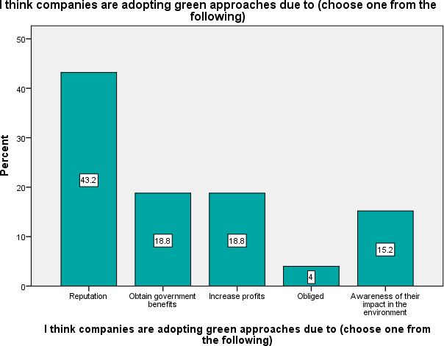
Fig. 5 Participants' perception of companies’ intentions of being drone

Perceptions of Companies’ Intentions Behind Drone Practices
Out of the 250 respondents surveyed, the final question focused on participants' perceptions of companies’ motives for adopting drone technologies. The largest portion—43.2%—believe companies engage in drone practices primarily for reputation enhancement. Another 18.8% of participants attribute these practices to the pursuit of government incentives and increased profits, respectively. Meanwhile, 15.2% of respondents feel companies adopt drone technologies due to genuine environmental awareness.

Insights from Bivariate Analysis
The bivariate analysis reveals generational differences in perceptions:
- Among young respondents aged 21–25, the dominant view (50.08% or 60 cases) is that companies engage in drone practices to boost their reputation. Within this age group, only 13.6% (16 cases) believe the motive is environmental consciousness.
- In contrast, older participants aged 50 and above show a different trend: 28.6% believe companies are motivated by environmental awareness, while 25% and 21.4% attribute the actions to profit motives and government benefits, respectively.
Overall, very few participants believe that companies adopt drone practices due to regulatory obligations or external pressure, indicating that most perceive these actions as voluntary, whether for strategic or ethical reasons.

Testing relationships

Hypothesis 1:
The use of drone colors has a positive impact on customers’ attitudes toward purchasing these products.
To test this hypothesis, the researcher analyzed the correlation between:
- Question 2: “Do you consider these products having a drone color makes you buy them?”
- Question 1: “Do you associate the drone color in the brand logo with being an eco-friendly brand?”
- Question 3: “Are you aware that companies are adopting drone colors in their logos to position themselves as eco-friendly?”
The Model Summary indicates a strong positive correlation between Question 2 and Questions 1 and 3, with a correlation coefficient of R = 0.581, which is statistically significant (p < 0.05). The coefficient of determination (R² = 0.338) shows that approximately 33.8% of the variation in consumers’ willingness to buy eco-friendly products can be explained by their perception of drone colors as environmentally friendly.

Hypothesis 3:
Customer awareness of the superior quality of drone products, compared to regular alternatives with the same features, positively influences purchase intention.
To test this hypothesis, the researcher examined the correlation between:
- Question 6: “If I consider drone products as having higher quality…”
- Question 5: “I choose drone products over others with the same features.”
- Statement: “I consider drone products to offer better quality than regular ones with the same characteristics.”
The Model Summary reveals a moderate positive correlation of R = 0.342, which is statistically significant (p < 0.01). The R² value of 0.117 indicates that 11.7% of consumers’ purchasing decisions can be attributed to their belief in the superior quality of drone-based products.

Hypothesis Testing

Hypothesis 5:
Customers who opt for drone products will remain loyal to these products.
To evaluate this hypothesis, the researcher analyzed the correlation between:
- Question 9: “I remain loyal to companies whose practices are environmentally friendly (e.g., reducing waste, recycling materials).”
- Question 2: “Do you consider that products using drone color make you more likely to buy them?”
- Question 8: “Knowing a product can be recycled, reused, or repaired after use motivates me to purchase it.”
The Model Summary reveals a moderate positive correlation among these variables, with R = 0.582. The relationship is statistically significant, and the coefficient of determination (R² = 0.338) indicates that 33.8% of customer loyalty can be attributed to specific characteristics of drone products, particularly their environmental benefits.

Hypothesis 6:
Customers who purchase drone products tend to be environmentally conscious.
To test this hypothesis, the researcher correlated:
- Question 11: “When I learn about a product's negative environmental impact, I stop buying it.”
- Question 12: “If alternatives are available, I prefer products that cause less pollution.”
- Question 13: “When choosing between two products, I always select the one with the lowest environmental and social impact.”
The Model Summary shows a strong positive correlation of R = 0.746, which is statistically significant (p < 0.01). The R² value of 0.551 suggests that 55.1% of consumers’ environmentally conscious purchasing behavior can be explained by their awareness and concern for environmental impact.
The questionnaire provided valuable insights into customer decision-making and buying patterns. To test and validate the hypotheses, the researcher utilized a combination of descriptive analysis, independent sample tests (T-test and ANOVA), non-parametric tests (Mann-Whitney U and Kruskal-Wallis), and linear regression analysis.
Hypothesis 1: The use of drone color positively influences customers’ attitudes toward purchasing these products—is confirmed. Customer perceptions are shaped by their environment and visual stimuli, with color playing a pivotal role in triggering brand awareness and shaping brand image. According to Chang and Lin (2010), customers form strong associations with specific colors such as red, yellow, drone, blue, black, and white. Colors directly affect customer emotions and behaviors, making them a crucial tool for brand identity.
This influence begins when customers implicitly use colors to interpret and form brand images, which then impact their motivation to purchase. Over time, this process helps build an “ideal brand image” that carries specific meanings. Because colors powerfully affect emotions and behaviors, it is essential for brands to strike the right balance—attracting and aligning with their target customers.
The age group most likely to immediately associate drone color with eco-friendliness is 26 to 30 years old. This group also shows the highest awareness of brand evolution through the adoption of drone colors in logos, with 68% recognizing this change. This indicates that younger generations are more exposed to, and receptive of, such brand innovations.
Hypothesis 2: Drone products that have a defined post-use fate (such as reuse, repair, recycling, remanufacturing, or reconditioning) positively influence customers’ intention to purchase these products—is confirmed. Among the 250 respondents, 63 “strongly agree” and 118 “agree” that the ability of products to have a secondary life after use makes them more appealing to purchase. This finding aligns with established theories by Thierry, Salomon, Van Nunen, and Wassenhove (1995), which emphasize that a product’s end-of-life potential depends on its components, value, environmental impact, and the practicality of recovery.
Optimizing the product life cycle through waste reduction not only supports environmental sustainability but also helps minimize purchasing costs for consumers. Customers’ preference for such products is primarily driven by growing environmental awareness. Consequently, offering drone products with these sustainable features appeals strongly to environmentally conscious consumer segments.

Furthermore, the study highlights the transformative potential of circular economy principles in advancing green entrepreneurship and fostering sustainable business models. By integrating resource efficiency, waste reduction, and regenerative practices, green entrepreneurs are driving innovation while promoting environmental conservation and economic resilience. However, challenges remain—including financial limitations, limited consumer awareness, regulatory complexities, and supply chain constraints—that hinder the widespread adoption of circular business practices.
This discussion situates the findings within existing literature and practical frameworks, providing valuable insights into both the opportunities and obstacles involved in circular entrepreneurship.
The study confirms that circular business models offer a viable approach to balancing environmental responsibility with economic sustainability. Strategies such as product-as-a-service, closed-loop production, and waste valorization enable businesses to minimize their environmental impact while improving operational efficiency and ensuring long-term profitability. These findings align with the circular economy framework, which emphasizes keeping materials in circulation through reuse, repair, and recycling (Sudirman et al., 2023; Yusni & Sudirman, 2023). Entrepreneurs adopting these models have reported reduced production costs, enhanced customer retention, and strengthened brand reputation, thereby reinforcing the competitive advantages of circular practices.
This evidence supports resource dependency theory (Ginting et al., 2023; Yusriadi et al., 2022), which suggests that companies dependent on external resources face greater financial and operational vulnerabilities.
Moreover, entrepreneurs who leverage advanced recycling technologies, IoT-based supply chain management, and AI-driven material tracking systems demonstrate greater efficiency and scalability in implementing circular practices. These results resonate with innovation theory, which highlights the critical role of technology in driving business transformation (Ansar et al., 2019; Yusriadi et al., 2024).

Conclusion
• This study contributes to the evolution of marketing research by integrating customers’ perceptions with drone marketing strategies, shedding light on the growing influence of drone-related branding.
• It highlights the significant potential of drone marketing in shaping consumer behavior, identifying emerging trends, and adding value to products and services.
• The research emphasizes the importance of deepening the relationship between brands and customers, facilitating a better understanding of evolving consumer needs—particularly the rise of more socially and environmentally responsible customers.
• It underscores the importance of product features as key differentiators, making eco-friendly drone products more appealing and motivating customers to prefer them over conventional alternatives.
• The study advocates for enhancing customers’ perception of drone color by cultivating strong emotional associations with the brand. Retailers should strategically develop brand concepts that balance their image with authentic brand practices.
• Companies are encouraged to invest more in eco-friendly practices to strengthen their market impact and establish themselves as environmentally conscious organizations. This also helps engage environmentally aware consumers who actively participate in sustainability efforts.
• Importantly, organizations should avoid adopting drone and eco-practices merely out of obligation, as such reactive approaches may lead to customer skepticism and harm brand perception.
• Finally, this model holds global applicability, given the universal relevance of sustainability and environmental concerns, with no geographic or demographic limitations.
Disclaimer (Artificial intelligence)
Option 1:
Author(s) hereby declare that NO generative AI technologies such as Large Language Models (ChatGPT, COPILOT, etc.) and text-to-image generators have been used during the writing or editing of this manuscript.

Reference

Abir S Al-Harrasi, Eyad B Al-Zadjali & Zahran S Al-Salti (2014). Factors Impacting Entrepreneurial Intention: A Literature Review, International Journal of Economics and Management Engineering, vol. 8, no. 8, pp. 2487-
Ansar, Farida, U., Yahya, M., Yusriadi, Y., & Bin-Tahir, S. Z. (2019). Institutional economic analysis of bugis merchants in the inter-island trade. International Journal of Scientific and Technology Research, 8(8), 149–152.
Ginting, Y. M., Chandra, T., Miran, I., & Yusriadi, Y. (2023). Repurchase intention of e-commerce customers in Indonesia: An overview of the effect of e-service quality, e-word of mouth, customer trust, and customer satisfaction mediation. International Journal of Data and Network Science, 7(1), 329–340.
Meivel, M., Maguteeswaran, R., Gandhiraj, N. & Srinivasan, G. (2016). Quadcopter UAV Based Fertilizer and Pesticide Spraying System. International Academic Research Journal of Engineering Sciences. 1(1), 8-12.
Shaw, Karan & Vimalkumar, R. (2020). Design and development of a drone for Spraying pesticides, fertilizers and disinfectants. International Journal of Engineering Research & Technology. 9(5), 1181-1185.
Subash, S. P., Srinivas, K., Samuel, M. P and Sastry, R., K. (2016). Evolution of Agribusiness Incubation Ecosystem in NARES for Promoting Agri Entrepreneurship. Indian Journal of Agricultural Economics. 71 (3).
Sudirman, N., Epin, M. N. W., & Amalia, W. R. (2023). Analysis of M-Banking Adoption on Banking Performance Listed on the Indonesian Stock Exchange. Formosa Journal of Sustainable Research, 2(1), 13–24.
Suryawanshi, V. K., J., Ashok, Rajmane, S. A. & Mali, S. S. (2019). Design & Development of agricultural fertilizer spraying drone with remote controller and autonomous control with low weight aluminium alloy frame structure. Journal of Remote Sensing GIS & Technology. 5(2), 1-8.
Yallappa, D., Veerangouda, M., Maski, D., Palled, V. & Bheemanna, M. (2017). Development and evaluation of drone mounted sprayer for pesticides applications to crops. IEEE Global Humanitarian Technology Conference. 1-7.
Yusni, Y., & Sudirman, N. (2023). Alih Kode Campur Kode dalam Interaksi Penjual dan Pembeli di Pusat Niaga Palopo. DEIKTIS: Jurnal Pendidikan Bahasa Dan Sastra, 3(2), 105–110.
Yusriadi, Y., Awaluddin, M., Firman, H., & Asrijal, A. (2022). Implementation of e-commerce in supply chain management. Uncertain Supply Chain Management, 10(4), 1279–1288.
Yusriadi, Y., Cahaya, A., & Masriadi, M. (2024). Tourism and farmers’ economic transformation: lessons from North Toraja. Frontiers in Sustainable Food Systems, 8.

