Evaluation of Spine Gourd (Momordica dioica Roxb) Genotypes for Yield, Quality Traits and Adaptability in Assam

ABSTRACT
Fifteen genotypes of Spine gourd (Momordica dioica Roxb.) including one local cultivar SpG 09-04 as check (LC) maintained at the Department of Horticulture were used for the study. The experiment was conducted following 3 RBD at Horticulture Research Farm, AAU, Jorhat consecutively for three years. The analysis of variance done for each station trial revealed significant differences among the genotypes for fruit yield and contributing traits. Three genotypes significantly better than the local check were subjected to multilocation trial (MLT) at research centres located in 5 agro climatic zones of Assam. Among all genotypes, GB 09-16-1 and GB 09-18-8 were found to be better for fruit yield and contributing traits than GB 09-01 as standard check (SC) and GB 09-04 (LC),. The mean fruit yield in the station trials was 131.4 q/ha in GB 09-16-1 and 131.6 q/ha in GB 09-18-08 which were around 24% higher than the standard check SpG 09-01. Number of fruits per plant was 24 in GB 09-16-1, 23 in GB 09-18-08 as compared to 22 in SpG 09-01. Multilocation trials exhibited average fruit yield of 130.6 q/ha in GB 09-16-1 and 136.2 q/ha in GB 09-18-08 which was about 24 – 30% higher than SpG 09-01 (SC). The results were confirmed in the OFTs conducted in 12 farmers’ fields located in 4 districts of Assam. The edible fruits were getting ready for harvesting in 69 days in GB 09-16-1; 77 days in GB 09-18-08 and 72 days in SpG 09-01 after planting. The genotypes GB 09-16-01 and SpG 09-01 were regarded as early, GB 09-18-08 as mid late and SpG 09-04 (LC) as late. GB 09-16-01 was having good amount of calcium (2 mg/100 g) and TSS content (5.5%) whereas GB 09-18-08 was having good amount of phosphorus (34.5 mg/100 g) and TSS content (5.4%). They were found to be tolerant to leaf spot and aphids as compared to the check varieties. The fruits of these varieties were very tasty and the consumer preference was very high. The fruit colour was light green in both GB 09-16-1 and SpG 09-01, whereas dark green in GB 09-18-08. The fruits were spindle shaped in GB 09-16-1, oval shaped in GB 09-18-08 and almost round in SpG 09-01. They have been recommended for large scale cultivation by the farmers of Assam. They may be useful for scientific communities also for further studies at molecular level and on seed production aspects. Multiplication testing through Coordinated trials need to be conducted which may be supplemented with conservation of germplasm and DNA fingerprinting at NBPGR, New Delhi in order to prevent varietal piracy.
Key words: Assessment, Spine gourd (Momordica dioica Roxb.), genotypes, MLT, yield,
duration.

1. INTRODUCTION
Spine gourd (Momordica dioicaRoxb.) is a highly valued indigenous vegetable crop belonging to the family Cucurbitaceae. Chromosome number of this crop is 2n=28. It is known by various names like kakrol, kartoli, kankad, teasel gourd or bhat kerala [3].Teasel gourd because of its highly nutritious nature has made it very useful for industrial and medicinal purposes. It is particularly important because of absence of bitterness [24]. The fruits, young twigs and leaves of this crop are used as vegetables [2]. The unripe fruits act as an appetizer and astringent [18]. Juice of roots is stimulant, astringent and antiseptic; Root is also used to stop bleeding piles, as an expectorant and also in urinary and bowel complaints. It is a perennial diocious plant, having great potential for income generation in North Eastern Region of India [10].
The crop of spine gourd is native to Asia with extensive distribution in India and Bangladesh. In India it is mainly cultivated in Assam, Tripura, Maharashtra, West Bengal, Orissa, Chhattishgarh, Jharkhand and Bihar. In recent times, spine gourd is gaining the status of commercial vegetable crop in Assam because of its rich taste, easiness and least cost involved in its cultivation, its utility in preparing local curries including its edible nature as ‘boiled items’ and the like. Among the Cucurbitaceous crops grown during summer season in Assam, spine gourd fetches a high price in the market. It has many other advantages like good nutritional value and longer keeping quality [19] etc. Thus, this crop can give a higher economic return and profit to the farmers.
Although lot of germplasm is available in North Eastern Region, there is no any standard and specific popular variety being widely grown by the farmers. Number of improved lines have been developed and identified at Assam Agricultural University [7], but they need to be tested rigorously under different agro-climatic conditions and farmers’ fields for their stability and adaptability. Therefore, present investigation was undertaken to assess the promising genotypes of spine gourd along with few selected local collections being maintained in Horticulture Farm, AAU, Jorhat and in farmers’ fields of Assam. This would enable the breeders and horticulturist to release and popularize the improved varieties among the farmers through large scale seed production and distribution of quality seeds.
2. MATERIAL AND METHODS
All total fifteen (15) improved spine gourd lines viz., SpG 09-01,SpG 09-02, SpG 09-04, SpG 09-06, SpG 09-10, SpG 09-12, SpG 09-13, GB 09-05-01 (Male), GB 09-16-01, GB 09-18-03, GB 09-18-05, GB 09-18-07, GB 09-18-08, GB 09-18-09 and GB 09-18-10 maintained in AAU, Jorhat were used in the present investigation (Table 1). With these materials including SpG 09-01 as standard check (SC) and SpG 09-04 as local check (LC) varieties, the field experiment was conducted following Randomized Block Design with 3 replications each year as Station Trials at the Horticultural farm of the Assam Agricultural University, Jorhat during Kharif seasons of 2016-17 to 2018-19. The soil type of the farm is clay loam with a little mixture of sand and silt. The reaction of soil is acidic. The Latitude of the area is 26º45'N, Longitude: 94º12'E and Altitude is 87 m. The monthly weather data are presented in Appendix table. Being diocious in nature, a common male parent namely SPG-05-01 was also included to ensure better pollination. The tubers were planted in the pits in the 1 st week of May following a spacing of 2.00 m between rows and 1.50 m between pits in the rows. The size of the plot was 6.0 m x 4.0 m accommodating 8 plants per plot. The FYM @ 7-8 t/ha and N:P₂O₅:K₂O @ 50:40:50 kg/ha respectively were applied for providing required nutrients for the crop. The observations were recorded following appropriate procedure [26] on 1 st female flower appearing node, days to 1 st flowering, days to first harvesting of fruits from planting, vine length (cm), internode length (cm), primary branches per plant, leaf length (cm), leaf breadth (cm), leaf petiole length (cm), number of fruits per plant, fruit length (cm), fruit diameter (cm), single fruit weight (g), and fruit yield per plot (g). Natural incidence of pest and diseases was also recorded. The general quality characters were judged based on organoleptic taste and consumer preference. The nutritional content particularly ascorbic acid, calcium, phosphorus, TSS and protein content was estimated following proximate analysis procedure. Qualitative and other characteristics were also recorded as per descriptor used by various workers [20; 25]. Analysis of data (ANOVA) for yield and contributing characters was done following standard methods of Panse & Sukhatme, 1978 [15]. CV(%) was calculated and used to explain the variation of data from means for different characters. The promising varieties were tested in Multilocation Trial (MLT)s conducted in 3 research stations, 2 KVKs and one college farm of AAU located in 5 different zones of Assam viz., Lower Brahmaputra Valley Zone (LBVZ), North Bank Plain Zone (NBPZ), Central Brahmaputra Valley Zone (CBVZ), Upper Brahmaputra Valley Zone (UBVZ) and Hill Zone (HZ). The On Farm Trial (OFT)s were conducted in 12 Farmers’ Fields located in 4 different districts of 2 zones viz., UBVZ and LBVZ.
3. RESULTS

3.1 Fruit Yield, Crop Duration and Qualitative Characters in Station Trials
The analysis of variance for the mean data of all the genotypes in the station trials was done separately for each year for fruit yield (q/ha). This revealed that there was significant difference among the genotypes for this character. The statistically analysed mean data for fruit yield (q/ha) of the two highest performing genotypes along with two checks in the station trials are presented year wise in Table 2. The mean data for crop duration and qualitative characters such as fruit colour, organoleptic taste and consumer preference are also presented. The genotypes showing highest performance in first year was found to be GB 09-18-08 followed by GB 09-16-01 and vice versa in subsequent two years. They were significantly different from the standard check GB 09-01 in every year. When mean of 3 years was worked out, GB 09-18-08 exhibited higher yield of 131.6 q/ha whereas GB 09-16-01 also had similar performance of 131.4 q/ha. Among the check genotypes (2), Standard check SpG 09-01 (SC) exhibited better performance of 105.83 q/ha than the local check SpG 09-04 (LC). There was yield increase of >24% in the two tested genotypes over the Standard check. The SC genotype however exhibited 34% increase in fruit yield over the LC variety. The crop duration from planting to 1 st harvest was 69 days in GB 09-16-01 and 72 days in SpG 09-01 which may be regarded as early varieties; 77 days in GB 09-18-08 and 83 days in SpG 09-04 (LC) which may be regarded as mid late varieties. The colour of fruits was light green in GB 09-16-01and SC, and dark green in GB 09-18-08 and LC. The organoleptic taste and consumer preference were good in the tested and SC genotypes whereas it was moderate in the LC genotype.
3.2Nutritional quality parameters
The estimated nutritional quality parameters such as ascorbic acid, calcium, phosphorus, total soluble solid (TSS) and protein are presented in Table 3. The highest performing genotype for these characters was SpG 09-01 for ascorbic acid (226.5 mg/100g), phosphorus (37 mg/100g) and protein content (0.23 g), SpG 09-04 for calcium content (21.25 mg/100g) and GB 09-16-01 for TSS content (5.5 %).
3.3 Fruit Yield Performance in Multilocation Trials
The performance of all the four genotypes in the Multilocation trials is presented in Table 4. The MLTs conducted in 6 locations covering 5 agro-climatic zones of Assam revealed average fruit yield of 136.20 q/ha in GB 09-18-08 and 130.60 q/ha in GB 09-16-01 whereas standard check (SpG 09-01) showed better performance of 116.80 q/ha than the LC genotype. On an average two tested genotypes showed 24-29% yield increase over the standard check. The standard check however showed about 10% yield increase over the local check. Among the locations, highest fruit yield of 184.5 q/ha was reported from RARS, Diphu in the variety GB 09-18-08.

3.4 Performance of the Spine gourd genotypes in the On Farm Trial (OFT)s
Table 5 shows the results of the OFTs conducted in 12 farmers’ fields covering 4 different districts. The mean fruit yield of GB 09-16-01was 162.92 q/ha which was >15% higher than the Standard check. The mean fruit yield of 155.66 q/ha in GB 09-18-08 was > 10% higher than the standard check. Among the districts, highest performance of 178.30 q/ha was reported from Golaghat in the variety GB 09-16-01. Out of the checks, SC showed 13% yield increase over the local check.

3.5 Morphological and other Characteristics
Table 6 shows the morphological, quantitative and other characteristics of the test (2) and check (2) varieties. The genotype GB 09-16-01 was having long viny growth habit, creeper plant type, cordate leaf type, light green leaf colour, medium dentate leaf margin, creamy white flower colour, solitary fruit type, spindle shaped, dense spiny and medium seeded fruits. On the other hand the genotype GB 09-18-08 was having medium viny growth habit, creeper plant type, cordate leaf type, green leaf colour, dentate leaf margin, creamy white flower colour, solitary fruit type, oval shaped, dense spiny and medium seeded fruits. Some quantitative characters of the test varieties along with the checks are also presented in the same table. The natural incidence of pest and diseases was also low in these varieties.
4. DISCUSSION
4.1 Fruit Yield Performance in Station Trials
The analysis of variance for mean fruit yield of the genotypes in the station trials revealed year wise significant differences among the genotypes. The highest performing genotypes along with two checks are presented in Table 2. The two tested genotypes viz., GB 09-18-08 and GB 09-16-01 exhibited significantly better performance than the checks. The mean yield over the years in these genotypes was higher than the standard check also. The increase in fruit yield was 24.35% in GB 09-18-08 and 24.16% in GB 09-16-01 over the better and SC SpG 09-01. Hence there is considerable improvement in yield in these two varieties. There were many reports of improving yield of fruits in the newly developed genotypes of spine gourd [3;11; 16]. The duration to 1 st harvesting of fruits was classified as early (65 – 75 days), mid late (75 – 85) days; and late (>85 days). Accordingly in this study GB 09-16-01 and SC were early; GB 09-18-08 and LC were mid late. The colour of fruits was light green in GB 09-16-01 and dark green in GB 09-18-08. Both the organoleptic taste and consumer preference were good in the two tested varieties and SC as compared to LC.
This crop is having lot of medicinal values as is evident from earlier reports such as useful for treatment of eye diseases, poisoning and fever [21]. The unripe fruits act as an appetizer and astringent [18]. Juice of roots is stimulant, astringent and antiseptic. Root is used to stop bleeding piles, as an expectorant and also used in urinary and bowel complaints [1]. Although in our study it was not our objective, but it is the time of hours to identify genotypes with good chemical constituent and medicinal properties also. Similar results were also available in earlier reports [3; 8].
4.2Nutritional quality parameters
The nutritional components as presented in Table 3 indicated that the improved lines had lower ascorbic acid content, phosphorus and equal level of calcium with check varieties. However, the improved lines had higher content of TSS and equal level of protein content with the check varieties. In spine gourd three components such as calcium, TSS and protein are more important than ascorbic acid and phosphorus. The improved lines had surely met the requirement of these three components. Similar reports have been made by earlier workers also [10; 12; 13].
4.3 Fruit Yield Performance in Multilocation Trial (MLT)s
The results of MLTs (Table 4) conducted in 6 locations covering 5 agro-climatic zones revealed that the average fruit yield was 136.2 q/ha in GB 09-18-08 and 130.6 q/ha in GB 09-16-01. The fruit yields in these varieties were 24 - 29% higher than SpG 09-01 (SC). There was an yield increase of >10% in the SC over the local check. However, there was a considerable variation in yield performance of the varieties in different locations. One location for each tested variety had reported higher fruit yield performance than its respective average. This variation might be due to variations in soil and agro-climatic conditions. The study carried out earlier [14; 23] reported significant variation in growth and yield of spine gourd genotypes under different agro-climatic situations.
4.4 Fruit Yield Performance in On Farm Trials
The results of the OFTs (Table 5) conducted in 12 farmers’ fields covering 4 districts of Assam showed higher mean yield performance in the tested varieties than SpG09-01 (SC). The overall increase in yield was 15.5% in GB 09-16-01 and 10.4% in GB 09-18-08 over the standard check variety. These results confirmed that the tested varieties were considerably superior to the check varieties and were the promising among all entries. Similar performance was reported earlier [3] also.
4.5 Morphological and other Characteristics
The morphological, quantitative and other characteristics of the tested varieties along with the check varieties are described in Table 6. In our study, both the varieties viz., GB 09-16-01 and GB 09-18-08 were having creeper plant type with cordate leaf shape and creamy white flower colour, solitary fruit type with dense spines and medium seeds. The variety GB 09-16-01was characterized by more primary branches, more internode and vine length, more fruits per plant than GB 09-18-08. It is having less length and breadth of leaves and fruits; less single fruit weight than GB 09-18-08. The long viny growth habit, light green leaf colour, medium dentate leaf margin, spindle shaped fruits are the characteristic features of GB 09-16-01. Whereas medium viny growth habit, green leaf colour, dentate leaf margin and oval type fruits are the characteristic features of GB 09-18-08. However, the check variety SpG 09-01was having characteristics similar to GB 09-16-01 but was having round fruits. Similar reports have been made from earlier studies [3; 6; 7] also. There are many other reports of morpho-agronomic and molecular variations in spine gourd genotypes [4; 5; 9; 17; 25]. There is a report [22] of nutritional value of spine gourd as 84.1% moisture, 7.7 g carbohydrate, 3.1 g protein, 3.1 g fat, 3.0 g fibre and 1.1 g minerals. Similar results had also been reported in earlier studies in Spine gourd [3].
5. CONCLUSION
Based on the results and discussion presented above, the varieties viz., GB 09-16-01 and GB 09-18-08 have been found to be very good showing high yielding potentiality (fruits 162.92 q and 155.66 q/ha respectively in OFT). The fruit yields were 10 to 16% higher than the Standard check variety SpG 09-01. They have shown better performance in most of the quantitative characters. The quality characters judged by fruit colour, organoleptic taste were also good. The variety GB 09-16-01 was early and GB 09-18-08 was mid late in harvesting of fruits from transplanting. The early variety makes the fruits available early in the market, fetching higher price. Study on nutritional quality of fruits revealed a very good result as is evident from lower ascorbic acid content, equal level of calcium, lower phosphorus content, higher TSS content and equal level of protein content as compared to check varieties. These have been recommended in the ZREAC and ATCM meeting held at AAU for commercial cultivation in the state of Assam and North Eastern India [7]. Many reports have been published in literatures as cited above at different times about these varieties. In view of the consumer preference and taste, the varieties may be used for large scale seed multiplication so that they may spread very fast and get popularity throughout the entire NE states. However, the varieties warrant more studies particularly on multilocation testing throughout the country, and study of medicinal properties and various genetic parameters including more genotypes for further improvement. Gene profiling may also be done through molecular studies to prevent gene piracy.

Disclaimer (Artificial intelligence)
Option 1:
Author(s) hereby declare that NO generative AI technologies such as Large Language Models (ChatGPT, COPILOT, etc.) and text-to-image generators have been used during the writing or editing of this manuscript.
Option 2:
Author(s) hereby declare that generative AI technologies such as Large Language Models, etc. have been used during the writing or editing of manuscripts. This explanation will include the name, version, model, and source of the generative AI technology and as well as all input prompts provided to the generative AI technology
Details of the AI usage are given below:
1.
2.
3.

REFERENCES
[1] Kaushik, K., Saikia, J., Tare, K., Rajkhowa, D., Gogoi, S., Kotoky, U. & Das, R. T. 2025. “Assessment of Biochemical and Physiological Traits of Native Spine Gourd (Momordica Dioica Roxb.) Genotypes from the North Eastern Region of India”. Journal of Scientific Research and Reports, 31 (4):559-68. https://doi.org/10.9734/jsrr/2025/v31i42980.
[2] Bandyopadhyay, S. and Mukherjee, S.K. (2009). Wild edible plants of Koch Bihar District, West Bengal. Natural Product Radiance 8(1): 64-72.

[3] Basumatary P., Bora G.C., Kalita U.C., Saikia L.2014. Evaluation and characterization of spine gourd germplasm of Assam. Vegetable Science, 41(2): 202-207.

[4] Begum H, Reddy M T, Alia F &Babu J D. 2012. Morphological characterization and evaluation of Teasel gourd (Momordica dioicaRoxb). In National Seminar of Plant Physiology on “Physiological and Molecular Approach for Development of Climate Resilient Crops” held at A N G RAU, Rajendranagar , Hyderabad, pp 5 -31.
[5] Bhagat, S.; Sinha, S.K. and Tiwari, J K. (2017). Identification and Evaluation of Morphophysiological
Variation in Spine Gourd (Momordicadioica Roxb.). Int. J. Curr. Microbiology,6(11):531-540.

[6] Devi, S., Gayen, R. & Yadav, R. K. 2020. Genetic variability, heritability and genetic advance in spine gourd (Momordica dioica Roxb.). International Journal of Chemical Studies, 8(2): 2676 – 78. DOI: 10.22271/chemi.2020.v8.i2ao.9151

[7] Bora, G.C., Baruah, M. & Rajkhowa, D.2025. Recommended High Yielding Vegetable Crop Varieties
For Farmers: Achievements of Vegetable Improvement Research in Assam Agricultural University, India
- Chapter 2 in “Book: Current Research Progress in Agricultural Sciences Vol 8” edited by Prof. Lalzhu-
ang Chen from Minami Kyushu University, Japan. and published by BP International from UK and India,
pp123– 140.

[8] Bora, G. C., Kalita, U. C., Gogoi, S., Das, R.T., Baruah, M., Rajkhowa, D. and Kharghoria, P.P. 2023.
Glimpses of Vegetable Improvement Research in Assam Agricultural University, India. Int .Journal of
Agricultural Sciences, 2023, 15(9): 12619-12622.

[9] Archana, K. A., Prasanna, K.P. & George T. E.2016. Evaluation of spine gourd genotypes for variability. Journal of Tropical Agriculture, 54 (1) : 159-163.

[10] Das B; Sarkar P K, Suklavaidya A, Chakrabarti A, Das B, Das A, Devi A L, Nath K and Das Chaudhuri D. 2022. Spine gourd: A highly valued Indigeneous Vegetable Crop of North Eastern Region of India. Indian Farming Digest, Volume 1(4): 5 – 9.

[11] Devi, S.;Gayen, R. and Yadav, R K. (2020). Genetic variability, heritability and genetic advance in
spine gourd (MomordicadioicaRoxb.). Int. J. Chem. Studies, 8(2): 2676-2678.

[12] Gopalan, C.; Rama Sastri, B.V. and Balasubramanian, S.C. (1982). Nutritive value of Indian
foods.Indian Council of Medical Research. National Institute of Nutrition, Hyderabad.

[13] Prasanna, K. P. & Archana, K. A. 2012. Performance evaluation and variability studies in spine gourd (Momordica dioica Roxb). Part of the P. G. thesis, KAU, Kerala. http://hdl.handle.net/123456789/1313
[14] Jajoriya, N K and Raiger, H L. 2023. Non parametric measure of fruit yield stability in Spine gourd (Momordica deoicaRoxb.) genotypes. International journal of Theoritical and Applied Sciences, 15 (1): 5 – 11.

[15] Panse V. G. and Sukhatme P.V. Statistical methods for Agricultural workers. ICAR, New Delhi, 1978.
[16] Patil, S J.;Khandare, V S.;Gurve, V R. and Baghele R D. (2022). Assessment of genetic variability
andcharacter association in yield and yield attributing traits in spine gourd (Momordica dioicaRoxb).
BFAIJ,14(1): 115-120.

[17] Pragati and Yadav R K. 2022. Agro-morphological characterization of spine gourd (Momordica dioicaRoxb.). International Journal of Pharmacognosy and Pharmaceutical Sciences, 4(1): 34-37.
[18] Ram, D.; Kalloo, G and Banerjee, M.K. (2002). Popularizing Kakrol and Kartoli: The Indigenous
Nutritious Vegetables. Indian Hort. pp. 6-9.

[19] Rasul, M.G. (2003). Study on pathenocarpy and genetic divergence in Kakrol (Momordica dioica
Roxb). Ph.D. Thesis. Kyushu University,Fukuaka, Japan.

[20] Rasul MG, Hiramatsu M, Okubo H. 2004. Morphological and physiological variation in kakrol (Momordica dioicaRoxb.).J. Fac. Agric. Kyushu Univ.,49(1):1-11.
[21] Satyavati G V, Gupta A K and Tandon N. 1987. Medicinal Plants of India, V 2, ICMR, New Delhi, pp 267.
[22] Singh D, Bahadur V, Singh D B & Ghose G. 2009. Spine gourd (Momordica dioicaRoxb) : An underutilized vegetable with high nutritional and medicinal values. Acta Horticulturae, 809(809): 241 – 249.
[23] Tiwari, J K. and Rastogi, N K. (2020). Genotype × Environment Interaction for Germination in
Spine gourd (MomordicadioicaRoxb.). Seed Research. 48(1): 9-14.

[24] Vahab, M.A. (1993). Studies on Floral Biology of Kakrol (Momordica dioca L.). South Indian Hort.,
41(6): 25-30.

[25] Khandade, K. D., Kalalbandi, B. M., Mane, N.V. & Karande, P. J.2025. Correlation and path analysis for yield contributing characters in spine gourd (Momordica dioica Roxb.) genotypes. International Journal Advance Biochemistry Research, 2025;9(2):428-431. DOI: 10.33545/26174693.2025.v9.i2f.3813
[26] Padhiary , G. G., Sahu , G. S., Tripathy , P., Rout , G. R., Samal , K. C., Mishra , S. L., & Rani , V. U. (2022). Effect of Different Physical and Chemical Treatments on Germination and Seedling Establishment in Spine gourd (Momordica dioica Roxb.). International Journal of Plant & Soil Science, 34(24), 1233–1244. https://doi.org/10.9734/ijpss/2022/v34i243265

Table 1. List of Spine gourd genotypes included in the experiment
Sl. No. | Genotypes | Distinguishing feature | Sl. No. | Genotypes | Distinguishing feature
1 | SpG 09-01 (SC) | Leaf margin medium dentate | 9 | GB 09-16-01 | Plant growth long viny
2 | SpG 09-02 | Plant growth medium viny | 10 | GB 09-18-03 | Oblong fruits
3 | SpG 09-04 (LC) | Leaf margin dentate | 11 | GB 09-18-05 | Spindle shaped fruits
4 | SpG 09-06 | Leaf shape cordate | 12 | GB 09-18-07 | Creamy white flower
5 | SpG 09-10 | Thick spine density | 13 | GB 09-18-08 | Light green fruit colour
6 | SpG 09-12 | White flower | 14 | GB 09-18-09 | Less no. of branches
7 | SpG 09-13 | Medium seediness | 15 | GB 09-18-10 | Dark green leaves
8 | GB 09-05-01 | Male genotype only

Table 2. Fruit yield performance of Spine gourd genotypes in the Station trials
Genotypes/Trials | GB 09- 16-01 | GB 09-18-08 | SpG 09-01 (SC) | SpG 09-04 (LC) | CD (5%) | CV (%)
Station Trial (ST)s | Fruit yield (q/ha) |  |  |  | CD (5%) | CV (%)
IVT (1 st year) | 128.50 | 132.3 | 101.85 | 74.57 | 17.50 | 18.00
AVT-I (2 nd year) | 135.5 | 134.2 | 105.35 | 78.57 | 12.50 | 16.40
AVT-II (3 rd year) | 130.3 | 128.3 | 110.30 | 82.40 | 15.50 | 14.50
Mean over STs | 131.4 | 131.6 | 105.83 | 78.50
PC increase over best check | 24.16 | 24.35 | 34.82 | -
Duration to 1 st harvest (days) of fruits | 69 (Early) | 77(Mid late) | 72 (Early) | 83 (Mid late)
Fruit colour | Light green | Dark green | Light green | Dark green
Organoleptic taste | Good | Good | Good | Moderate
Consumer preference | Good | Good | Good | Moderate
IVT: Initial Varietal Trial; AVT-I: Advance Varietal Trial – I; AVT-II: Advance Varietal Trial –II; PC: Percentage

Table 3. Performance of spine gourd genotypes for Nutritional quality characters
Genotypes | Ascorbic acid (mg/100 g) | Calcium (mg/100 g) | Phosphorus  (mg/100 g) | TSS (%) | Protein (g)
GB 09-16-01 | 123.50 | 20.00 | 14.50 | 5.50 | 2.20
GB 09-18-08 | 199.00 | 17.50 | 34.50 | 5.40 | 2.20
SpG 09-01 (SC) | 226.50 | 16.50 | 37.00 | 3.40 | 2.30
SpG 09-04 (LC) | 224.50 | 21.25 | 23.50 | 3.14 | 2.20
SEd (A check and a variety) | 0.26 | 0.23 | 0.32 | 0.08 | 0.004
CD (5%) | 0.60 | 0.54 | 0.75 | 0.19 | 0.009

Table 4. Performance of Spine gourd genotypes in the Multilocation Trial (MLT)s conducted in 5 agro-climatic zones of Assam

Agroclimatic zones | Fruit yield (q/ha)
Genotypes | GB 09-16-01 | GB 09-18-08 | SpG 09-01 (SC) | SpG 09-04 (LC)
NBPZ (KVK, Darrang) | 87.50 | 89.50 | 116.70 | 89.90
NBPZ (BNCA, Biswanath) | 130.00 | 130.60 | 128.00 | 125.00
LBVZ (HRS, Kahikuchi) | 171.40 | 153.00 | 175.00 | 152.00
CBVZ (KVK, Nagaon) | 120.00 | 135.90 | 80.00 | 60.00
HZ (RARS, Diphu) | 130.10 | 184.50 | 110.80 | 124.70
UBVZ ( SRS, Buralikson) | 145.00 | 123.00 | 90.00 | 84.00
Mean | 130.60 | 136.20 | 116.80 | 105.30
PC increase over check | 24.00 | 29.30 | 10.90 | -
NBPZ: North Bank Plain Zone; LBVZ: Lower Brahmaputra Valley Zone; CBVZ: Central Brahmaputra Valley Zone; HZ: Hill Zone; UBVZ; Lower Brahmaputra Valley Zone; KVK: Krishi Vigyan Kendra; BNCA: Biswanath College of Agriculture; HRS: Horticultural Research Station; RARS: Regional Agricultural Research Station; SRS: Sugarcane Research Station

Table 5. Performance of Spine gourd genotypes in the On Farm Trial (OFT)s conducted in 12 Farmers’ fields covering four districts of Assam

Districts/ Farmers’ Fields | Fruit yield (q/ha)
Genotypes | GB 09-16-01 | GB 09-18-08 | SpG 09-01 (SC) | SpG 09-04 (LC)
Kokrajhar (4 Farmers’ Fields) | 144.50 | 139.50 | 126.25 | 115.25
Jorhat (4 Farmers’ Fields) | 173.25 | 157.75 | 136.75 | 125.25
Kamrup (2 Farmers’ Fields) | 155.60 | 160.20 | 146.50 | 128.30
Golaghat (2 Farmers’ Fields) | 178.30 | 165.20 | 154.60 | 130.40
Mean | 162.92 | 155.66 | 141.03 | 124.80
PC increase over check | 15.52 | 10.37 | 13.00 | -

Table 6. Descriptor of 4 Spine gourd Genotypes
Sl. No. | Characteristics | Genotypes
Sl. No. | Characteristics | GB 09-16-01 | GB 09-18-08 | SpG 09-01 (SC) | SpG 09-04 (LC)
1 | Growth habit | Long viny | Medium viny | Medium viny | Medium viny
2 | Plant type | Creeper | Creeper | Creeper | Creeper
3 | Primary branches per plant | 14.00 | 13.60 | 9.60 | 6.00
4 | Internode length (cm) | 11.50 | 10.40 | 10.20 | 8.67
5 | Vine length (m) | 4.90 | 3.80 | 4.00 | 3.90
6 | Leaf shape | Cordate | Cordate | Cordate | Cordate
7 | Leaf colour | Light green | Green | Light green | Light green
8 | Leaf margin | Medium dentate | Dentate | Medium dentate | Slightly dentate
9 | Leaf length (cm) | 13.00 | 13.20 | 13.20 | 12.00
10 | Leaf breadth (cm) | 12.2 | 12.60 | 11.60 | 12.00
11 | Leaf petiole length(cm) | 9.30 | 9.20 | 10.60 | 7.50
12 | Flower colour (fresh) | Creamy white | Creamy white | Creamy white | White
13 | Days to 1stFlowering | 62 | 70 | 65 | 75
14 | 1 st female flower appearing node number | 10 | 12 | 15 | 16
15 | Single fruit weight (g) | 53.0 | 56.0 | 50.0 | 42.0
16 | Fruit length (cm) | 8.7 | 9.8 | 6.9 | 10.2
17 | Fruits per plant | 24 | 23 | 22 | 20
18 | Fruit diameter (cm) | 5.5 | 6.9 | 4.6 | 4.2
19 | Fruit type | Solitary | Solitary | Solitary | Solitary
20 | Fruit shape | Spindle shaped | Oval | Round | Long, pointed tip
21 | Fruit spinyness | Dense spiny | Dense spiny | Dense spiny | Dense spiny
22 | Seediness | Medium | Medium | Medium | Medium
23 | Incidence of leaf spot disease | MR | MR | MR | MS
24 | Incidence of aphids | 6% | 7% | 8% | 12%

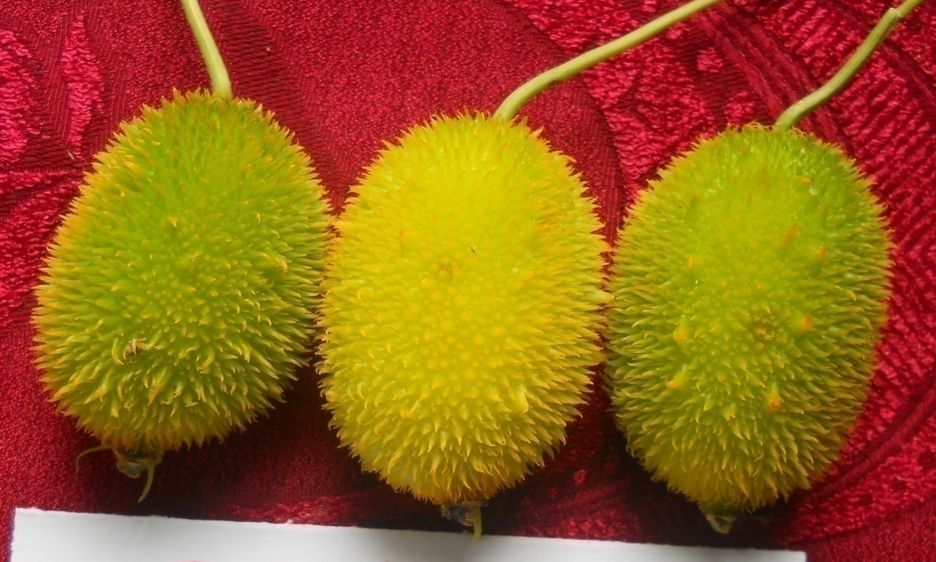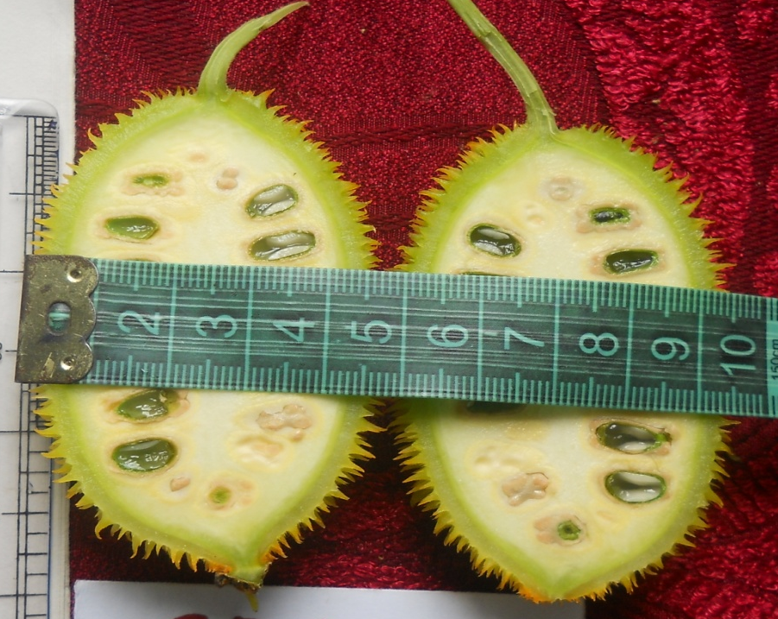
Figure 1. Whole fruit and longitudinal section of SpG 09-01 (SC)
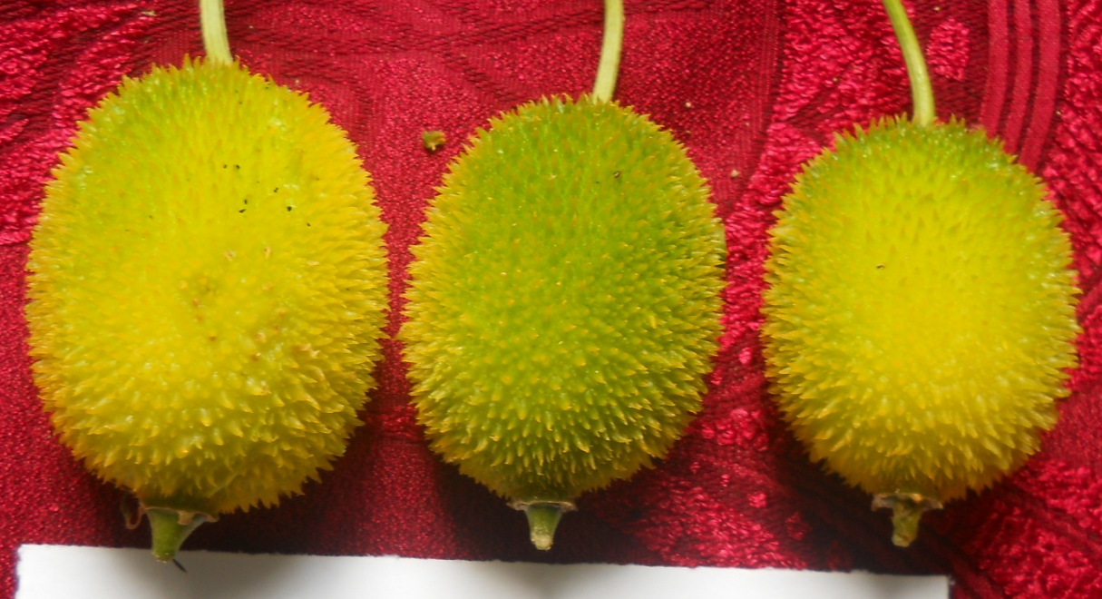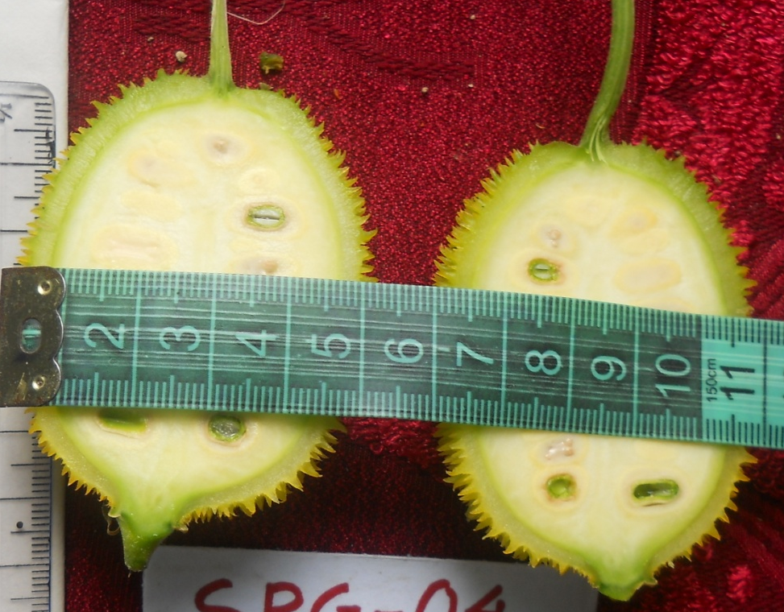
Figure 2. Whole fruit and longitudinal section of SpG 09-04 (LC)

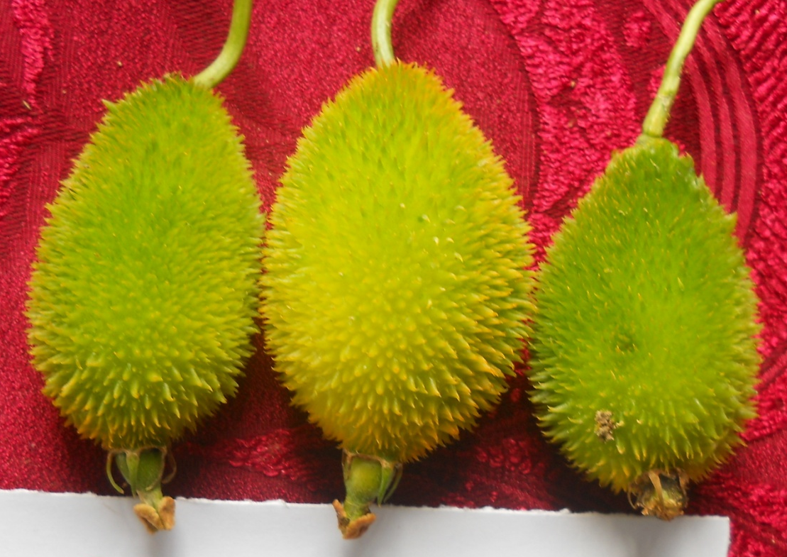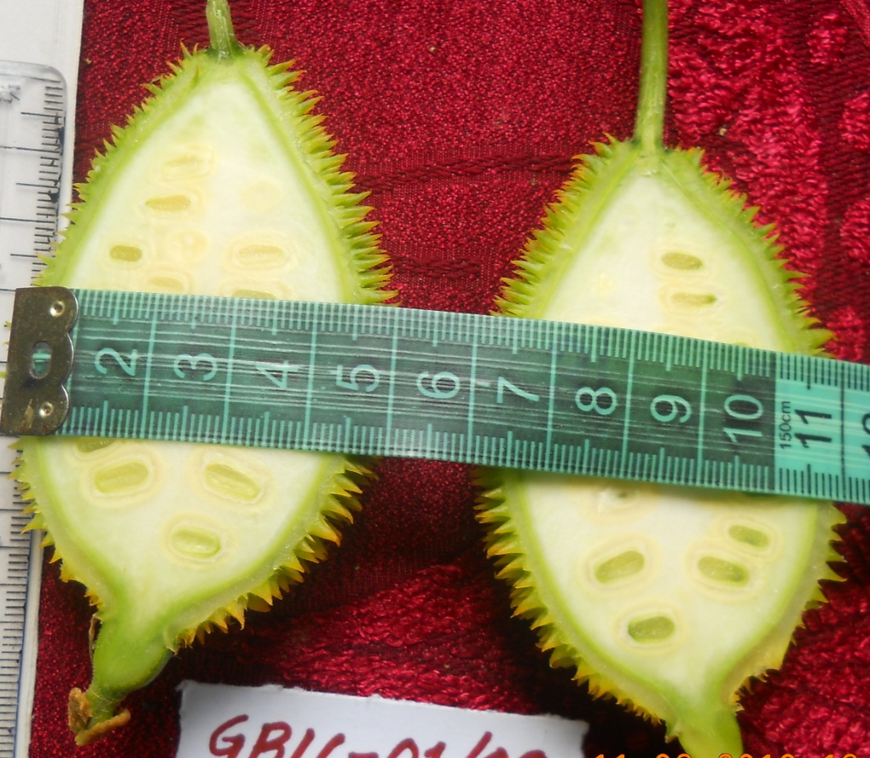
Figure 3. Whole fruit and longitudinal section of GB 09-16-01

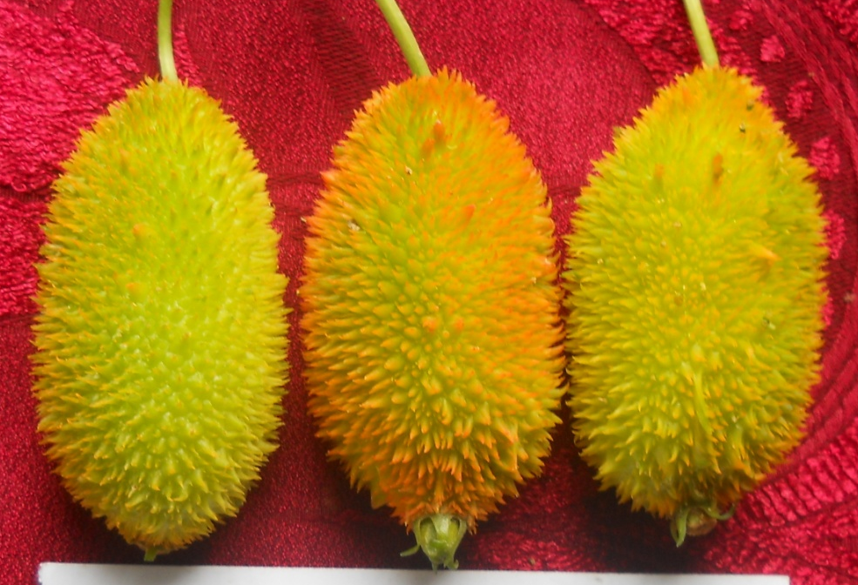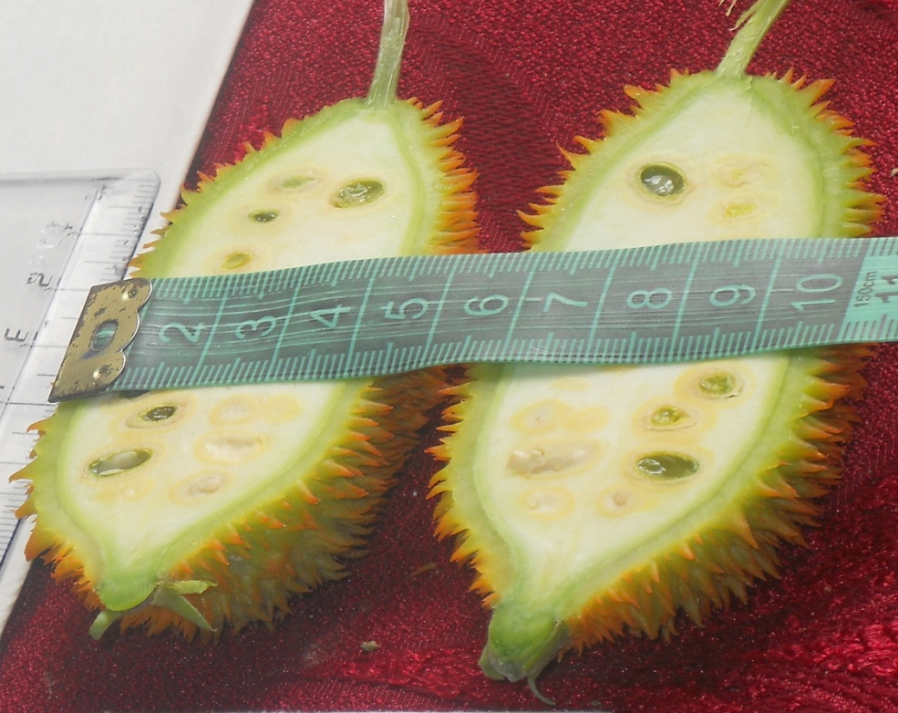
Figure 4: Whole fruit and longitudinal section of GB 09-18-08

Appendix: Monthly Weather data at AAU, Jorhat condition during kharif season wef June to
October every year (2016, 2017 and 2018)
Year/Month | Jun | July | Aug | Sept. | Oct
2016
Min Temp (ºC) | 25.4 | 25.2 | 26.2 | 25.1 | 22.7
Max temp (ºC) | 32.6 | 31.6 | 34.3 | 32.2 | 31.8
Relative humidity (%) | 86 | 87 | 82 | 87 | 84
Total rainfall (mm) | 389.8 | 380.1 | 149.3 | 249.2 | 78.5
2017
Min Temp (ºC) | 25.2 | 25.3 | 25.7 | 25.3 | 23.0
Max temp (ºC) | 32.3 | 33.0 | 31.1 | 32.7 | 31.1
Relative humidity (%) | 86 | 87 | 87 | 86 | 87
Total rainfall (mm) | 267.5 | 576.0 | 269.1 | 324.4 | 192.8
2018
Min Temp (ºC) | 25.0 | 25.9 | 25.9 | 24.9 | 20.5
Max temp (ºC) | 32.8 | 33.6 | 33.5 | 32.3 | 29.6
Relative humidity (%) | 85 | 85 | 84 | 86 | 83
Total rainfall (mm) | 399.2 | 275.1 | 361.3 | 340.2 | - 17.4
Source: Dept. of Meteorology, Faculty of Agriculture, AAU, Jorhat

