Performance of exotic sweet orange germplasm for varietal improvement in Bangladesh

Abstract
A study was conducted using four exotic sweet orange germplasms (CS Jai-003, CS Jai-012, CS Jai-051 and CS Jai-209) along with BARI Malta-1 as check variety. These were evaluated over three consecutive seasons (2021-22, 2022-23 and 2023-24) at the Citrus Research Station, BARI, Jaintapur, Sylhet. There was no significant difference among the germplasm in terms of tree height, base girth and tree volume across the three fruiting seasons. A significant variation in fruit count per tree was observed. In 2021–22, CS Jai-209 (74.13), CS Jai-012 (73.15), and BARI Malta-1 (72.46) had the highest fruit counts, while CS Jai-003 (76.68) led in 2022–23, and BARI Malta-1 recorded the highest in 2023–24 (80.05). CS Jai-051 consistently had the lowest fruit count across all three years. The maximum fruit weight was recorded in CS Jai-051 (259.65g, 292.10g and 284.51g) for the respective years while the minimum was observed in CS Jai-209 (146.70g, 136.17g, and 142.91g). Regarding yield per plant, CS Jai-003 produced the highest yields (15.94 kg, 17.38 kg, and 16.07 kg, respectively). In contrast, CS Jai-209 had the lowest yields (10.86 kg, 8.92 kg, and 9.82 kg) over the same period. CS Jai-051 exhibited the highest juice content (39.63%, 38.51%, and 38.38%) while CS Jai-209 consistently showed the lowest values (27.90%, 30.01%, and 32.08%) across the three years. Total Soluble Solids were the highest in CS Jai-003 (11.13%, 11.30%, and 11.06%) while the lowest TSS was found in CS Jai-209 (11.13%, 11.30%, and 11.06%). Titratable acidity (TA) varied between 0.34% to 0.88% with CS Jai-209 showing significantly higher acidity and CS Jai-051 the lowest. Therefore, based on fruit quality, CS Jai-003 and CS Jai-051 are suitable for fresh fruit consumption. Additionally, due to its larger fruit size, CS Jai-051 holds potential as a breeding parent for developing high-yielding sweet orange varieties. Both CS Jai-003 and CS Jai-051 have the potential to be released as high-yielding varieties.

Keywords: Exotic, sweet orange, rootstock, growth, yield

Introduction
Sweet orange (Citrus sinensis) a member of Rutaceae family, is onr of the most well-known citrus species (Novelli et al., 2006) and is commonly referred to as as Malta in Bangladesh. It is one of the most important fruit crops in the world with high market value (Roussos, 2015). Sweet orange is a hybrid species that originated from a cross between pummelo and mandarin (Wu et al., 2014). These trees thrive in tropical and subtropical regions and are among the most widely cultivated fruit crops globally (Cuenca et al., 2016). It is a nutritious as well as delicious fruit, rich in Vitamin C, which strengthens the immune system and acts as a strong natural antioxidant (Ibrahim & Yusuf, 2015). Two high-yielding sweet orange varieties, BARI Malta-1 and BARI Malta-2, have been released by the Bangladesh Agricultural Research Institute (BARI) and are gaining popularity for commercial cultivation. Moreover, various farmers, public sectors, Government and non-government organizations have numerous orchards of BARI Malta-1 across the country, and these efforts are continuing. Sweet orange represents only 2.3% of total citrus production in Bangladesh, while lemons and limes account for 47.04% and pummelo 50.57% during the 2018-2019 periods (BBS, 2020). The annual total production of sweet orange was estimated 54,399 tonnes from 6,848 hectares of land in 2023-24 (DAE, 2024), although sweet orange is produced commercially, the quantity is quite limited compared to the overall demand in our country. Most of the sweet oranges available in the local market are imported. Therefore, Bangladesh imports a significant quantity of sweet oranges annually to meet consumer demand. Due to increasing demand, we have to develop more improved varieties of sweet orange to fulfill the needs. Khan et. al. (2021) reported only the physical and chemical characters of various varieties of sweet orange genotypes for determining their commercial fitness in Bangladesh. The country also possesses a good number of exotic citrus species, which can certainly contribute to the nutritional improvement. However, there is a lack of sufficient information on the cultivation of exotic sweet orange germplasm. As the population of Bangladesh grows rapidly, the nutritional and economic challenges are becoming more severe. To address these issues, it is essential to improve varieties through the introduction and selection of exotic germplasm. Therefore, this study aims to assess the performance of selected exotic sweet orange germplasm under local agro-climatic conditions, focusing on traits like plant growth, yield, and fruit quality, to support the development of improved cultivars suitable for large-scale cultivation in Bangladesh.

Methods and Materials
The experiment was conducted at Citrus Research Station, Bangladesh Agricultural Research Institute (BARI), Jaintapur, Sylhet. Four exotic sweet orange germplasms viz. CS Jai-003, CS Jai-012, CS Jai-051and CS Jai-209 were used as the study material along with BARI Malta-1 as a check variety. The experiment was laid out in a Randomized Complete Block Design (RCBD) with three replications. One-year-old cleft grafts were planted in July 2018 at a spacing of 3m × 3m using pummelo as rootstock. A single tree of each germplasm constituted the unit of replication. The experimental site is located 36 m above sea level, at coordinates of 25°13562' N latitude and 92°13217' E longitude. The average annual rainfall is 3500-6000 mm, with over 80% occuring between June and July. The soil at the experimental site is sandy loam, with a pH of 4.8 and 1.28% organic carbon. The trees were fertilized with recommended manure and fertilizers at the beginning and end of the rainy season. The plants were nourished with manures and fertilizers at a rate of cow dung 10kg, urea 200g, TSP 100g, MP 150g, Gypsum 50g, Borax 15g and Zinc Sulfate 15g. Fertilizers were applied in two splits; one before the rainy season in May and the other after the rainy season in September (Mandol et al., 2014). Insecticides were applied to reduce leaf minor infestation when new flushes immerged. Cupravit 50WP (Copper oxychloride + Mancozeb) with 7g/L of water was applied to control canker and other fungal disease. Bordeaux paste was applied twice during the fruiting season to effectively manage and reduce lichen infestation; first after the rainy season and second before the rain start. Light pruning was done where necessary. Data on tree growth and quantitative traits were recorded using the ‘Descriptors for Citrus’ published by IPGRI in (1999). Tree volume was calculated by using the formula of Castle (1983). Tree Volume = $\frac{1}{6}$ π × plant height × (2r)², where 2r = (East-West spread + North-South spread)/2. Fruits were harvested at the mature green stage, and their weights were recorded using a digital balance. Parameters including TSS, titrable acidity, and juice content were evaluated in compliance with the Association of Official Analytical Chemists’ (A.O.A.C., 2005) guidelines. Data were statistically analyzed using MSTAT-C software. Means were calculated, and analysis of variance for each of the characters was performed using the F test (Variance Ratio). The differences among treatments were compared using Duncan’s Multiple Range Test (DMRT) at a 5% level of significance (Gomez and Gomez, 1984).

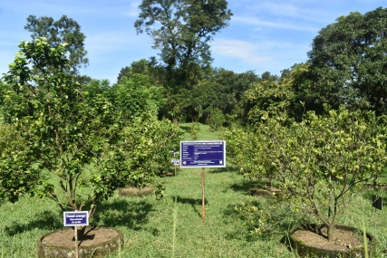 |  | 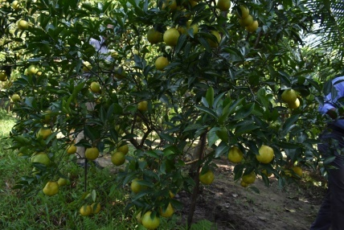 |  | 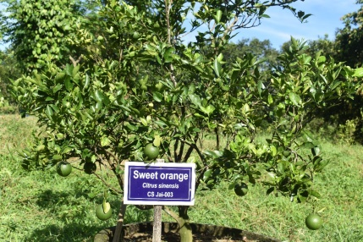
Experimental field of exotic sweet orange germplasm |  | BARI Malta-1 |  | CS Jai-003
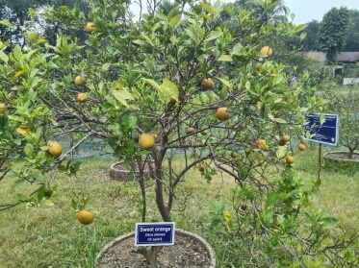 |  | 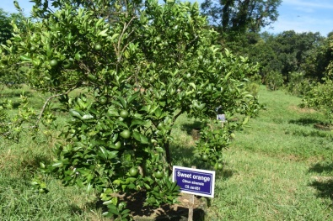 |  | 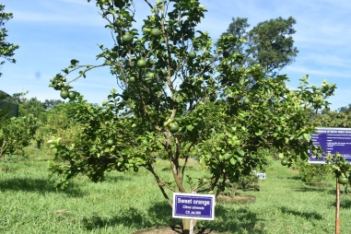
CS Jai-012 |  | CS Jai-051 |  | CS Jai-209
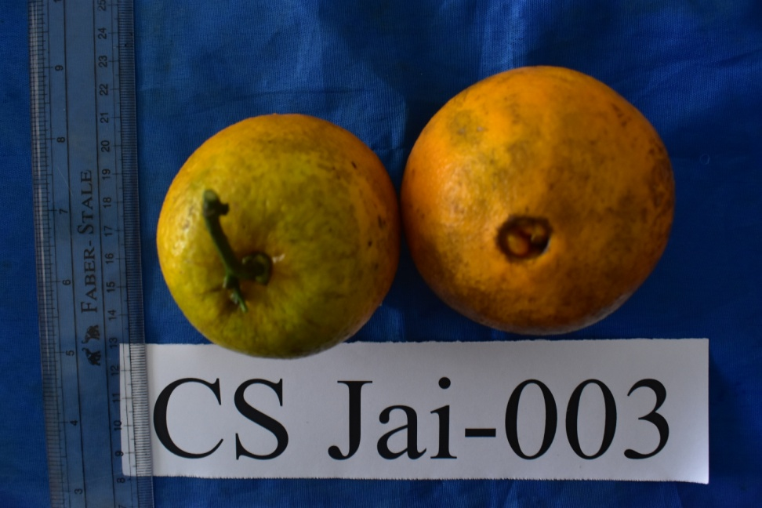 | 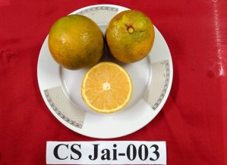 |  | 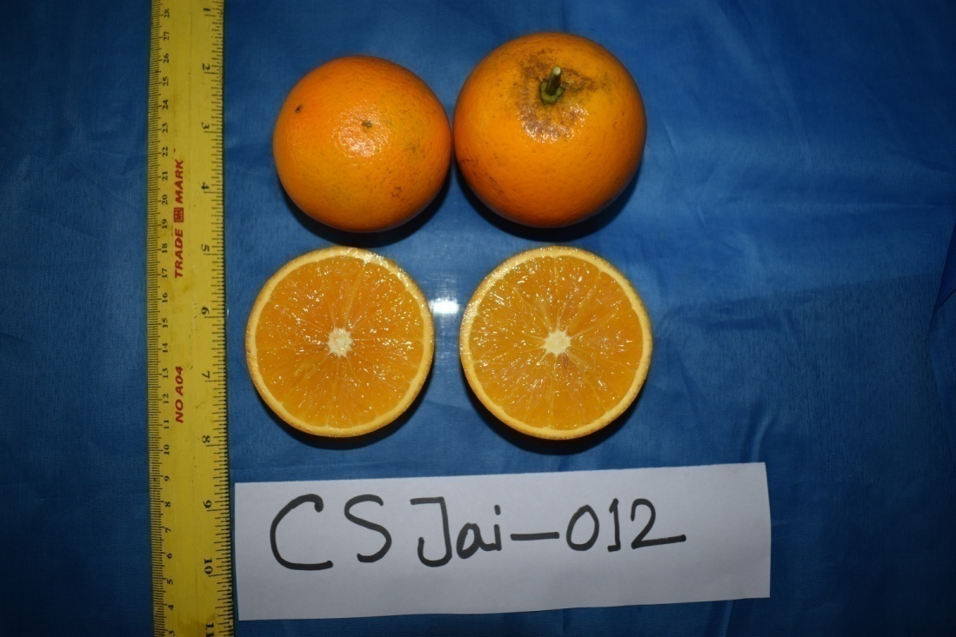 |  | 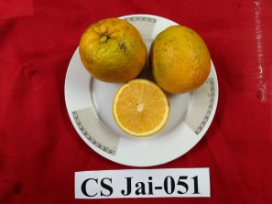
CS Jai-003 |  |  | CS Jai-012 |  | CS Jai-051
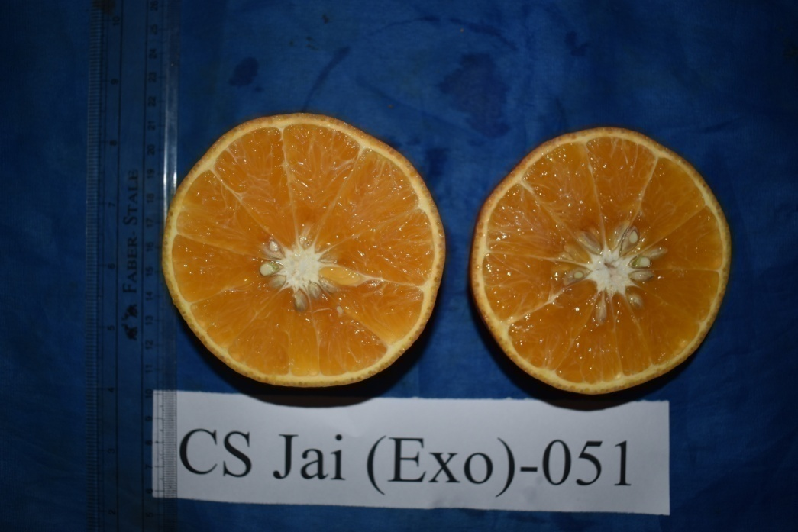 | 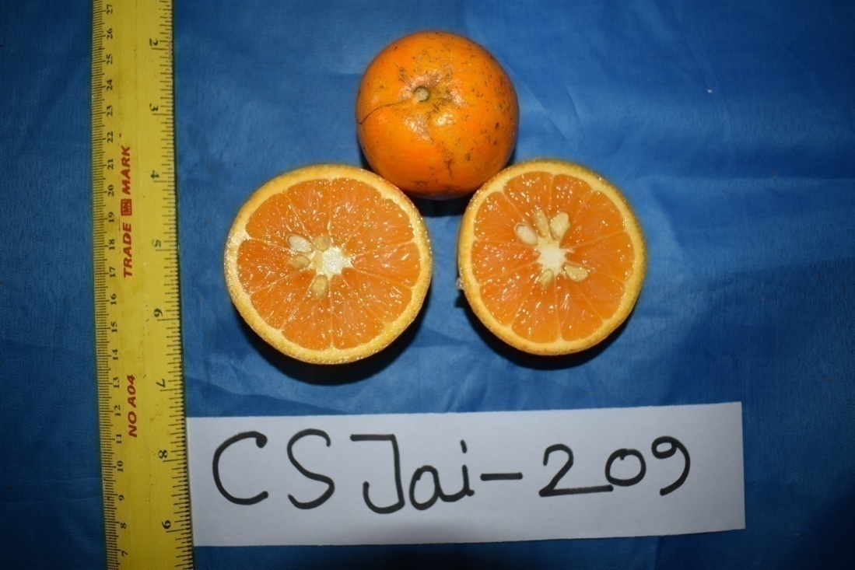 |  | 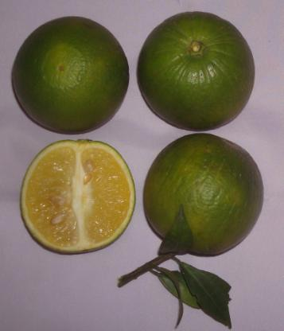
CS Jai-051 | CS Jai-209 |  | BARI Malta-1

Fig. 1: Four exotic sweet orange germplasms, along with BARI Malta-1, used in the experiment

Result and Discussion
The results obtained from the present investigation have been discussed under following heads:

Tree Characters
Plant growth was evaluated through parameters such as tree height, base girth, and tree volume. Tree height is an important vegetative trait in citrus,, as taller plants tend to have more branches and leaves. These leaves are essential, acting as the primary sites for food production within the plant. There were no statistically significant differences in overall growth characteristics among the germplasm across the three fruiting seasons (Table 1). CS Jai-003 consistently exhibited the highest tree height, reaching 2.13 m, 2.67 m, and 2.83 m in the 2021–22, 2022–23, and 2023–24 seasons, respectively. In contrast, the shortest plant stature was recorded in CS Jai-051 (1.63 m in 2021–22) and in CS Jai-012 (2.14 m and 2.37 m in 2022–23 and 2023–24, respectively). Likewise, no significant variation was noted in base girth and tree volume across the three seasons. Among the entries, CS Jai-012 demonstrated the largest tree volume, measuring 6.25 m³, 7.81 m³, and 10.20 m³ across the respective years, while CS Jai-051 recorded the smallest volume at 2.07 m³, 3.75 m³, and 5.77 m³. BARI Malta-1 and the exotic germplasms exhibited healthy vegetative growth owing to their good adaptation. The optimal nutrient concentration in the plant body is vital for proper growth and development (Malik, 1994). Nutrients influence photosynthesis, carbohydrate and protein production, which in turn regulate plant growth and development (Taiz & Zeiger, 2002).

Table 1. Tree characteristics of exotic sweet orange germplasms
Germplasm | Tree height (m) |  |  | Base Girth (cm) |  |  | Tree volume (m³)
Germplasm | 2021-2022 | 2022-2023 | 2023-2024 | 2021-2022 | 2022-2023 | 2023-2024 | 2021-2022 | 2022-2023 | 2023-  2024
BARI Malta-1 | 1.81 | 2.22 | 2.43 | 18.76 | 22.17 | 23.37 | 3.55 | 5.05 | 6.43
CS Jai-003 | 2.13 | 2.67 | 2.83 | 19.77 | 22.77 | 25.47 | 4.81 | 6.84 | 8.43
CS Jai-012 | 1.99 | 2.14 | 2.37 | 20.33 | 24.33 | 25.70 | 6.25 | 7.81 | 10.20
CS Jai-051 | 1.63 | 2.28 | 2.46 | 22.57 | 25.20 | 26.76 | 2.07 | 3.75 | 5.77
CS Jai-209 | 1.96 | 2.21 | 2.48 | 22.33 | 24.65 | 26.00 | 3.52 | 4.94 | 6.86
LSD _{(0.05)} | NS | NS | NS | NS | NS | NS | NS | NS | NS
CV% | 10.80 | 8.85 | 6.80 | 9.09 | 9.67 | 7.03 | 30.37 | 27.56 | 25.17

Growth Characters
Data presented in (Table 2) shows the variation among different germplasm with respect to growth characteristics. All germplasms were grafted onto pummelo rootstock. According to the descriptors of citrus of IPGRI (1999), the scion trunks exhibited a grooved and ridged across all germplasm. Sunaiana et. al. (2020) reported smooth scion trunk surfaces in eight sweet orange genotypes using rough lemon as rootstock. An ellipsoid tree shape was observed in all germplasms except CS Jai-051, which exhibited a spheroid form. Sunaiana et al. (2020) also observed a spheroid tree shape in eight sweet orange genotypes. Among the evaluated germplasm, BARI Malta-1, CS Jai-003, CS Jai-012, and CS Jai-209 exhibited an upright growth habit, whereas CS Jai-051 demonstrated a spreading growth form. Another study also corroborated with findings of present studies as results showed erect in M-3, M-4, M-8 and Blood Red whereas spreading in Phule mosambi, Shamouti, Kodour Sathgudi and Mosambi genotypes (Sunaiana et. al. 2020). Branch density was dense in BARI Malta-1, CS Jai-003, and CS Jai-012. Sunaiana et. al. (2020) observed dense branching density in 8 sweet orange genotypes. In contrast to the sparse branching observed in CS Jai-051 and CS Jai-209. Notably, all germplasm lacked spine development. However, Sunaiana et. al. (2020) reported medium to low spine density in eight sweet orange genotypes. Shoot tip coloration was green in BARI Malta-1, CS Jai-003, and CS Jai-012. Similar results with green shoot tip color were recorded in eight sweet orange genotypes (Sunaiana et. al. 2020), while CS Jai-051 and CS Jai-209 displayed purple shoot tips.

Table 2. Growth characteristics of exotic sweet orange germplasms
Germplasm | Rootstock | Scion trunk surface | Tree shape | Tree growth habit | Density of branches | Spine density | Shoot tip color
BARI Malta-1 | Pummelo | grooved and ridged | Spheroid | Upright | Dense | Absent | Green
CS Jai-003 | Pummelo | grooved and ridged | Spheroid | Upright | Dense | Absent | Green
CS Jai-012 | Pummelo | grooved and ridged | Spheroid | Upright | Dense | Absent | Green
CS Jai-051 | Pummelo | grooved and ridged | Spheroid | Spreading | Sparse | Absent | purple
CS Jai-209 | Pummelo | grooved and ridged | Spheroid | Upright | Sparse | Absent | purple

Leaf Characters
According to IPGRI (1999), all germplasms exhibited an evergreen vegetative life cycle, characterized by simple leaves with dark green blades (Table 3). While leaf type, lifecycle, and color were consistent across all accessions, considerable variation was observed in leaflet shape. CS Jai-003 and CS Jai-051 displayed lanceolate and obovate leaflets, respectively, whereas CS Jai-012 had ovate leaflets. BARI Malta-1 and CS Jai-209 showed elliptic leaflet shapes. According to (Sunaiana et. al. 2020), ovate leaflet shape was recorded in 4 sweet orange genotypes, namely Kodour Sathgudi, M-8, Mosambi and Phule mosambi and elliptic was recorded in Blood Red, M-3, M-4 and Shamouti. Leaf lamina margins were entire in all entries, except CS Jai-003, which exhibited a dentate margin. All germplasm shared an acuminate leaf apex. Sunaiana et. al. (2020) also observed two types of leaf apex in eight sweet orange genotypes. Narrow petiole wings were observed in all germplasms except BARI Malta-1 and CS Jai-003, where wings were was absent. In related studies, the presence of a leaf petiole wing was observed in all three varieties viz., bittersweet orange, Yuma citrange, and sour orange (Jaskani et al., 2006).

Table 3. Leaf characteristics of exotic sweet orange germplasms
Germplasm | Vegetative  life cycle | Type  of leaf | Leaf blade color | Leaflet  shape | Leaf lamina  margin | Leaf apex | Petiole wing
BARI Malta-1 | Evergreen | Simple | Dark green | Elliptic | Entire | Acuminate | Absent
CS Jai-003 | Evergreen | Simple | Dark green | Lanceolate | Dentate | Acuminate | Absent
CS Jai-012 | Evergreen | Simple | Dark green | Ovate | Entire | Acuminate | Narrow
CS Jai-051 | Evergreen | Simple | Dark green | Obovate | Entire | Acuminate | Narrow
CS Jai-209 | Evergreen | Simple | Dark green | Elliptic | Entire | Acuminate | Narrow

Yield Characters
Fruit characteristics are summarized in (Table 4), revealing significant variability among the germplasm with respect to fruit weight, number of fruits per plant and yield per plant. The highest fruit weight was recorded in CS Jai-051 (259.65g in 2021–22, 292.10g in 2022–23, and 284.51g in 2023–24), while the lowest was observed in CS Jai-209 (146.70g, 136.17g, and 142.91g, respectively). Khan et al. (2021) observed that fruit weight among the eight sweet orange germplasm evaluated varied between variegated Malta (117.66g) and CS Jain-001 (286g) in Bangladesh.

A significant difference in the number of fruits per tree was observed over the three fruiting seasons. In 2021–22, CS Jai-209 produced the highest number of fruits (74.13), ), which was statistically similar to CS Jai-012 (73.15) and BARI Malta-1 (72.46). In 2022–23, the highest fruit count was observed in CS Jai-003 (76.68), and in 2023–24, BARI Malta-1 led with 80.05 fruits. Conversely, CS Jai-051 consistently recorded the lowest fruit count across all three years (46.95, 56.27, and 53.05). A similar observation was reported by Pun and Thakur (2018), who recorded the number of fruits per plant ranging from 5.50 to 67.00, with Malta Blood Red producing the highest number (67.00 fruits/plant), followed by Dhankuta Local (53.75 fruits/plant) and Valencia Late (44.75 fruits/plant). However, the fruit count per plant observed in the present study was lower than the figures reported by Khalid et al. (1993), who documented 154 fruits in Pineapple, 154 in Hamlin, 203 in Salustiana, and 131 in Blood Red from 7-year-old plants in Pakistan. This variation could be attributed to differences in genotypes, climatic conditions, and geographic location.

Regarding yield per plant, CS Jai-003 produced the highest yield (15.94 kg, 17.38 kg, and 16.07 kg, respectively). In contrast, CS Jai-209 had the lowest yield (10.86 kg, 8.92 kg, and 9.82 kg) over the same period. Pun and Thakur (2018) also reported average yields such as Malta blood red (9.49 kg/plant), Dhankuta local (6.47 kg/plant), and valencia late (5.14 kg/plant) among 20 sweet orange genotypes from Nepal. Khalid et al. (1993) also recorded highest yield in Campbel Valencia (62 kg/plant) followed by Hinkely (51 kg/plant), among 12 germplasm of sweet orange. This yield variation may be attributed to the superior inherent traits (genetic makeup) and its greater adaptability to the prevailing soil and environmental conditions (Nawaz et al., 2007).

Table 4. Yield and yield contributing characters of exotic sweet orange germplasm
Germplasm | Fruit weight (g) |  |  | No of Fruits/plant |  |  | Yield/plant (kg)
Germplasm | 2021-2022 | 2022-2023 | 2023-2024 | 2021-2022 | 2022-2023 | 2023-2024 | 2021-2022 | 2022-2023 | 2023-2024
BARI Malta-1 | 203.33c | 182.69c | 198.25c | 72.46a | 68.45ab | 80.05a | 14.73a | 12.50b | 15.88a
CS Jai-003 | 243.75b | 226.5b | 232.41b | 65.43b | 76.68a | 69.09b | 15.94a | 17.38a | 16.07a
CS Jai-012 | 157.83d | 192.91c | 181.00d | 73.15a | 64.53bc | 63.85b | 11.54bc | 12.43b | 11.55b
CS Jai-051 | 259.65a | 292.10a | 284.51a | 46.95c | 56.27c | 53.05c | 12.19b | 16.43a | 15.08a
CS Jai-209 | 146.70e | 136.17d | 142.91e | 74.13a | 65.55b | 68.78b | 10.86c | 8.92c | 9.82b
LSD | 8.71 | 10.48 | 11.082 | 6.03 | 8.53 | 6.91 | 1.34 | 1.66 | 1.74
CV% | 2.29 | 2.70 | 2.83 | 4.82 | 6.83 | 5.48 | 5.45 | 6.55 | 6.76

Fruit size and juice content
Table-5 showed fruit size and juice content among 05 sweet orange germplasm. Fruit size plays a crucial role in the commercial marketing and trade of citrus fruits. It is commonly believed that an excessive increase in fruit size can negatively affect quality, whereas very small fruits are also regarded as inferior in quality (Nawaz et al., 2008). The greatest fruit length was recorded in CS Jai-051, measuring 10.03 cm, 7.77 cm, and 8.33 cm during the 2021–22, 2022–23, and 2023–24 seasons, respectively. In contrast, CS Jai-209 produced the smallest fruits, with lengths of 5.97 cm, 5.60 cm, and 6.47 cm in the corresponding years. A similar pattern was observed in fruit breadth, with CS Jai-051exhibiting the highest values (9.73 cm, 7.6 cm, and 8.13 cm), while CS Jai-209 showed the lowest measurements (5.60 cm, 6.47 cm, and 6.13 cm) during the corresponding growth stages. Similar findings were reported by Khan et al. (2021) and Pun & Thakur (2018), who noted that the fruit diameter among sweet orange genotypes ranged from 52.44 mm to 92.80 mm, while fruit length varied from 56.66 mm to 82.00 mm.

Juice content is a critical quality attribute in citrus, as consumer preference leans strongly toward fruits with higher juice yield. Significant differences in juice content were observed among the germplasm (Table 5). CS Jai-051 exhibited the highest juice content (39.63%, 38.51%, and 38.38%), which was statistically on par with CS Jai-012 (38.81%, 36.19%, and 36.14%). The lowest juice percentage was consistently recorded in CS Jai-209, with values of 27.90%, 30.01%, and 32.08% across the three years, Pun and Thakur (2018) reported that Venelle (60.36%), Tamango (55.88%), Sevelle Common (55.28%) and Succari (52.38%) were found to have higher juice content among twelve sweet orange genotypes. Similar variations were also reported by Chahal and Gill (2015).

Table 5. Fruit size and Juice content of exotic sweet orange germplasm
Germplasm | Fruit size (cm) |  |  |  |  |  | Juice content (%)
Germplasm | 2021-22 |  | 2023-24 |  | 2022-23
Germplasm | Length | Breadth | Length | Breadth | Length | Breadth | 2021-2022 | 2022-2023 | 2023-2024
BARI Malta-1 | 6.53bc | 6.63c | 6.67b | 6.67b | 7.00b | 6.57bc | 33.76c | 32.98b | 33.15b
CS Jai-003 | 6.10cd | 6.10d | 6.57b | 6.53b | 6.50bc | 6.30cd | 32.98c | 33.21b | 33.70b
CS Jai-012 | 6.97b | 6.93b | 6.73b | 6.57b | 6.87bc | 6.73b | 38.81b | 36.19a | 36.14ab
CS Jai-051 | 10.03a | 9.73a | 7.77a | 7.6a | 8.33a | 8.13a | 39.63a | 38.51a | 38.38a
CS Jai-209 | 5.97d | 5.60e | 6.40b | 6.47b | 6.27c | 6.13d | 27.90d | 30.01c | 32.08b
LSD | 0.45 | 0.25 | 0.46 | 0.45 | 0.68 | 0.40 | 2.70 | 2.43 | 4.15
CV% | 3.33 | 1.92 | 3.59 | 3.51 | 5.15 | 3.14 | 4.20 | 3.77 | 6.36

Fruit quality and characters
Significant differences in pulp weight per fruit were observed among the five germplasm (Table-6). The highest pulp weight was observed in CS Jai-051, with values of 191.08g, 226.58g, and 177.88g in 2021–22, 2022–23, and 2023–24, respectively. Conversely, the lowest pulp weight was recorded in CS Jai-209 (113.29g, 103.12g, and 109.62g). Regarding rind weight, CS Jai-051 again exhibited the highest values (96.55g, 76.82g, and 84.16g), while CS Jai-209 had the lowest (36.84g, 39.48g, and 42.25g) across the same years. A similar pattern was observed for the edible portion, with CS Jai-051 consistently producing the highest and CS Jai-209 the lowest values over the three-year period.

Table 6. Pulp weight, Rind weight and edible portion of exotic sweet orange germplasm
Germplasm | Pulp weight (g) |  |  | Rind weight (g) |  |  | Edible portion (%)
Germplasm | 2021-2022 | 2022-2023 | 2023-2024 | 2021-2022 | 2022-2023 | 2023-2024 | 2021-2022 | 2022-2023 | 2023-2024
BARI Malta-1 | 174.17b | 176.81b | 111.96d | 55.79b | 65.34b | 61.21b | 73.58ab | 72.25b | 74.63a
CS Jai-003 | 187.45a | 179.59b | 167.92b | 60.45b | 52.81c | 58.48bc | 75.63ab | 79.48a | 72.25ab
CS Jai-012 | 126.52c | 124.56c | 125.77c | 45.50c | 57.21bc | 51.09cd | 72.32b | 66.24c | 67.57b
CS Jai-051 | 191.08a | 226.58a | 177.88a | 96.55a | 76.82a | 84.16a | 79.45a | 84.67a | 76.67a
CS Jai-209 | 113.29d | 103.12d | 109.62d | 36.84c | 39.48d | 42.25d | 64.91c | 73.02b | 39.79c
LSD | 8.85 | 4.56 | 8.85 | 9.03 | 10.32 | 9.27 | 6.90 | 5.69 | 6.45
CV% | 2.97 | 1.49 | 3.39 | 8.12 | 9.40 | 8.28 | 5.01 | 4.02 | 5.17

Rind thickness is a critical quality trait in citrus fruits, and it exhibits variation across different germplasm (Table-7). The results for rind thickness showed significant differences among the five sweet orange germplasm. CS Jai-003 had the thickest rind, with measurements of 3.9 mm, 3.9 mm, and 3.6 mm in 2021–22, 2022–23, and 2023–24, respectively. Conversely, CS Jai-051 displayed the thinnest rind, with thicknesses of 3.1 mm, 3.3 mm, and 3.3 mm across the same years. The largest seed size with respect to length (11.5 mm, 11mm and 10.9mm) and breadth (7.1mm, 6.9mm and 6.6mm) in CS Jai-051 and the smallest seed including length (7.5 mm, 7.9 mm and 7.2 mm) and breadth (3.4 mm, 3.7 mm and 3.7 mm) was observed in CS Jai-003, respectively, for three growing seasons.

Table 7. Rind thickness and seed size of exotic sweet orange germplasm
Germplasm | Rind thickness (mm) |  |  | Seed size (mm)
Germplasm | 2021-2022 | 2022-2023 | 2023-2024 | 2021-22 |  | 2022- 23 |  | 2023-24
 |  |  |  | Length | Breadth | Length | Breadth | Length | Breadth
BARI Malta-1 | 3.3bc | 3.6a | 3.5ab | 10.5a | 6.5a | 9.9a | 5.7b | 10.7a | 5.0b
CS Jai-003 | 3.9a | 3.9a | 3.6a | 7.5b | 3.4d | 7.9b | 3.7d | 7.2b | 3.7c
CS Jai-012 | 3.5ab | 3.7a | 3.4ab | 10.9a | 5.4b | 10.2a | 5.2bc | 10.6a | 4.6b
CS Jai-051 | 3.1c | 3.3b | 3.3b | 11.5a | 7.1a | 11.0a | 6.9a | 10.9a | 6.6a
CS Jai-209 | 3.6ab | 3.6a | 3.5ab | 11.2a | 4.4c | 10.9a | 4.9c | 10.7a | 4.7b
LSD | 0.61 | 0.73 | 0.26 | 1.35 | 0.73 | 1.08 | 0.77 | 1.14 | 0.55
CV% | 9.26 | 11.18 | 4.00 | 6.97 | 7.27 | 5.71 | 7.76 | 6.09 | 5.98

There were no statistically significant variations in the number of segments per fruits among the germplasm tested during the three fruiting seasons (Table-8). The highest number of segment per fruits was recorded in CS Jai-051 measuring 11.8, 11 and 11.7 which is statistically similar to remaining germplasm under study. This finding aligns with previous reports by Baswal et al. (2017), who observed a similar range of segment per fruit among various sweet orange genotypes in Punjab.

Citrus fruits with fewer seeds per fruit are generally preferred for processing, as most high-efficiency juicing machines struggle to effectively extract juice from highly seeded varieties. Although these machines can separate the seed core, some seeds still get crushed during processing, leading to bitterness in the juice and requiring additional de-bittering, a costly step that increases the overall price of the juice (Anwar & Ibrahim, 2004). Globally, citrus varieties with fewer than five seeds per fruit are favored. In the current study, among the five sweet orange germplasm evaluated, CS Jai-003 was found to be seedless (Table 5). On the other hand, CS Jai-051 produced the highest number of seeds (35.11, 32.70 and 27.95) seeds per fruit during the 2021–22, 2022–23, and 2023–24 seasons, respectively. The highest 100 seed weight was noted in BARI Malta-1 (29.34g, 32.63g and 28.88g), while the lowest was manifested in CS Jai-003 (16.11g, 15.24g and 15.43g) respectively in 2021–22, 2022–23, and 2023–24.

Table 8. No. of segments/fruit, seeds/fruit and 100 seed weight of exotic sweet orange germplasm
Germplasm | No. of segments/fruit |  |  | Number of seeds/fruit |  |  | 100 Seed weight (g)
Germplasm | 2021-2022 | 2022-2023 | 2023-2024 | 2021-2022 | 2022-2023 | 2023-2024 | 2021-2022 | 2022-2023 | 2023-2024
BARI Malta-1 | 10.33 | 10.7 | 11.3 | 12.41a | 15.92b | 15.66b | 29.34a | 32.63a | 28.88a
CS Jai-003 | 11 | 10.7 | 11 | 4.89d | 4.28d | 3.77c | 16.11c | 15.24d | 15.43c
CS Jai-012 | 10.5 | 11 | 11 | 8.19cd | 12.56c | 8.43c | 26.40ab | 28.78b | 23.99b
CS Jai-051 | 11.8 | 11 | 11.7 | 35.11a | 32.70a | 27.95a | 19.36c | 27.83b | 25.92ab
CS Jai-209 | 11.2 | 11 | 11 | 10.02bc | 16.02b | 19.77b | 23.44b | 20.19c | 23.61b
LSD | NS | NS | NS | 3.30 | 2.58 | 4.79 | 3.32 | 4.62 | 3.54
CV% | 7.49 | 7.70 | 8.55 | 12.31 | 8.40 | 16.82 | 7.63 | 9.85 | 7.83

Regarding TSS, TA, and the TSS to TA ratio, the results showed a highly significant variation among the five exotic sweet orange germplasm (Table-9). Total Soluble Solids (TSS) serves as a key indicator of a fruit's sugar content, with sugars making up about 85% of the soluble solids in citrus fruits such as sweet oranges and mandarins (Wardowski et al., 1979). It is widely used as a reliable measure of fruit quality and is an important factor in deciding the optimal harvest time (Lado et al., 2014). The timing of the citrus cropping season is closely related to significant physiological changes in the fruit, especially the increase in soluble solids and the decrease in acidity as the fruit matures (Wardowski et al., 2006). Significant variation in TSS levels was observed among the five sweet orange germplasm tested. The highest TSS values were recorded in CS Jai-003, with 11.13%, 11.30%, and 11.06% during the 2021–22, 2022–23, and 2023–24 seasons, respectively. In contrast, the lowest TSS was found in CS Jai-209, measuring 8.63%, 8.63%, and 9.70% over the same seasons. This was consistent with previous findings by Baswal et al. (2017), who reported a similar range of TSS among various sweet orange genotypes in Punjab. Pun et al. (2015) found TSS values of Pineapple (11.18%), Blood red (10.00%), Salustiana (9.28%) and Hamlin (8.58%) among 20 genotypes. Similarly, Khalid et al. (1993) also found for the same genotypes with values of Pineapple (9.67%), Blood red (9.53%), Salustiana (10.30%) and Hamlin (8.00%) in 12 genotypes.

Juice acidity, though often underestimated, is increasingly recognized as a key factor in determining fruit quality. The flavor of the fruit depends on the balance between acids, sugars, and volatile compounds, with lower acidity being more desirable for fresh fruit consumption (Chahidi et al., 2007). The data on acidity indicated a significant impact of germplasm acidity levels. The titratable acidity (TA) was varied, ranging from 0.34% to 0.88%. The significantly highest fruit juice acidity was observed in CS Jai-209 (0.81%, 0.88% and 0.77%), which is statistically similar to BARI Malta-1, CS Jai-003 and CS Jai-012. On the other hand, lowest acidity was found in CS Jai-051 (0.39%, 0.34% and 0.39%) in 2021–22, 2022–23, and 2023–24 respectively. It indicates that fruits of BARI Malta-1, CS Jai-003, CS Jai-012 and CS Jai-051 are less acidic compared to CS Jai-209. Khan et. al. (2021) found the titratable acidity at different ranged from 0.27% (BAU Malta-3) to 0.99% of citric acid (CS Jain- 001), This was in agreement with the results of De Moraes Barros et al. (2012).

The significant variations in TSS and TA led to significant differences in the TSS: TA ratio, where CS Jai-012 had the highest value of TSS: TA (27.17, 31.83 and 28.40) which was statistically similar to BARI Malta-1, CS Jai-051 and CS Jai-209. On the other hand, CS Jai-003 had the lowest value (10.80, 9.90 and 13.34) in in 2021–22, 2022–23, and 2023–24 respectively. Pun et al. (2015) found TA% in Caracara Navel (4.24%), Venelle (4.08%) and Malta Blood Red (3.57%) among 20 genotypes of sweet orange. It is widely acknowledged that the TSS: TA ratio is considered a more reliable internal quality indicator for commercialization of sweet oranges than peel coloration, as significant changes occur in external color development (Lado et al., 2014). Generally, Department of Agriculture and Food (2020) reported that, a TSS: TA ratio of 6 or higher is deemed acceptable for commercial marketability; however, there can be notable differences depending on the citrus species, varieties, and growing regions. In this study, all the sweet orange genotypes surpassed the minimum TSS: TA ratio, indicating that the selected genotypes have superior quality and market acceptability.

Table 9. Physico-chemical properties of exotic sweet orange germplasm
Germplasm | TSS (%) |  |  | Titratable acidity (%) |  |  | TSS:TA
Germplasm | 2021-2022 | 2022-2023 | 2023-2024 | 2021-2022 | 2022-2023 | 2023-2024 | 2021-2022 | 2022-2023 | 2023-2024
BARI Malta-1 | 9.67c | 10.07b | 10.03bc | 0.42b | 0.49b | 0.41b | 23.06a | 20.59b | 24.52a
CS Jai-003 | 11.13a | 11.30a | 11.06a | 0.47b | 0.43bc | 0.47b | 10.80b | 9.90c | 13.34b
CS Jai-012 | 10.97ab | 10.70ab | 11.00a | 0.41b | 0.39bc | 0.42b | 27.17a | 31.83a | 28.40a
CS Jai-051 | 10.26bc | 11.03a | 10.60ab | 0.39b | 0.34c | 0.39b | 26.50a | 28.54a | 26.36a
CS Jai-209 | 8.63d | 8.63c | 9.70b | 0.81a | 0.88a | 0.77a | 24.11a | 25.53ab | 24.91a
LSD | 0.85 | 0.82 | 0.69 | 0.12 | 0.14 | 0.19 | 4.80 | 6.68 | 8.85
CV% | 4.48 | 4.22 | 3.48 | 13.16 | 14.68 | 20.70 | 11.42 | 15.11 | 19.99

Fruit maturity, shape, skin colour, surface texture and edible qualities of fruit of different sweet orange germplasm have been summarized in Table 10. Observations based on organoleptic tests are also tabulated. Sweet oranges of good size with bright' skin colour and good taste are preferred in the market and sold at a premium price (Khalid et. al. 1993). The maturity period of BARI Malta-1 occurred during October–November, while the remaining germplasm matured between November and December. Regarding fruit coloration at maturity, BARI Malta-1 developed a greenish-yellow hue, CS Jai-003 turned bright yellow, and CS Jai-051 retained a pale green color. All germplasm exhibited a smooth surface texture. The pulp color in BARI Malta-1 was light yellow, whereas the other germplasm showed off-white to orange pulp coloration. Organoleptic evaluation revealed a very good taste in all germplasm, except for CS Jai-209, which was rated as pleasant having a pleasant taste.

Table 10. Qualitative characteristics of exotic sweet orange germplasm
Germplasm | Fruit  maturity | Fruit Shape | Fruit color at maturity | Surface texture | Color of pulp | Organoleptic Juice taste
BARI Malta-1 | Oct-Nov | Greenish yellow | Greenish yellow | Smooth | Light yellow | Very good
CS Jai-003 | Nov.-Dec | Bright yellow | Bright yellow | Smooth | Off white | Very good
CS Jai-012 | Nov.-Dec | Bright yellow | Bright yellow | Smooth | Off white | Very good
CS Jai-051 | Nov.-Dec | Pale Green | Pale Green | Smooth | Off white | Very good
CS Jai-209 | Nov.-Dec | Bright yellow | Bright yellow | Smooth | Orange | Pleasant

Conclusion
Based on the findings, the genotypes CS Jai-003, CS Jai-012, and CS Jai-051 emerged as superior germplasm in terms of fruit yield traits such as fruit number, weight, and overall yield. Among these, CS Jai-012 and CS Jai-051 demonstrated exceptional fruit size and weight, although they produced fewer fruits per plant. Additionally, CS Jai-051 and CS Jai-012 had the highest juice content. The germplasm viz., CS Jai-003, CS Jai-012, and CS Jai-051 also showed elevated levels of total soluble solids (TSS), while CS Jai-209, BARI Malta-1, CS Jai-003, and CS Jai-012 exhibited higher titratable acidity (TA). Overall, CS Jai-003, CS Jai-012, and CS Jai-051 were notable for their superior fruit quality. All germplasm showed similar fruit maturity duration except BARI Malta-1; however, CS Jai-003, CS Jai-012, and CS Jai-051 matured four to five weeks later than the earliest variety, BARI Malta-1. Considering these results, germplasm with unique traits in yield, quality, and maturity period should be promoted to enhance varietal diversity in Bangladesh. The study revealed strong performance in terms of vegetative growth, reproductive traits, physic-chemical properties of the fruit, and overall yield in CS Jai-003 and CS Jai-051. Due to these desirable traits both the germplasms are well suited for recommendation to Bangladeshi farmers for commercial cultivation

Disclaimer (Artificial intelligence)
Option 1:
Author(s) hereby declare that NO generative AI technologies such as Large Language Models (ChatGPT, COPILOT, etc.) and text-to-image generators have been used during the writing or editing of this manuscript.
Option 2:
Author(s) hereby declare that generative AI technologies such as Large Language Models, etc. have been used during the writing or editing of manuscripts. This explanation will include the name, version, model, and source of the generative AI technology and as well as all input prompts provided to the generative AI technology
Details of the AI usage are given below:
1.
2.
3.

References

A.O.A.C., (2005)). Official Methods of Analysis, Association of Official Agriculture Chemists, 14th Ed. Washington, DC, USA
BBS. (2020). Bangladesh Bureau of Statistics (BBS) Yearbook of Agricultural Statistics-2019 (Issue May).
Chahal TS and Gill PPS (2015) Performance of Exotic Sweet Orange (Citrus sinensis Osbeck) cultivars on Different Rootstocks under North Western India. Indian Journal of Science and Technology 8(16): 59391. DOI: 10.17485/ijst/2015/v8i16/59391
Cuenca, J.; Garcia-Lor, A.; Navarro, L. and Aleza, P. (2016). “Citrus genetics and breeding,.” In J. M. Al-Khayri, S. M. Jain, & D. V. Johnson (Eds.): Advances in plant breeding strategies: fruits (pp. 403–436). Cham: Springer International Publishing.
Ibrahim A. A. & A. J. Yusuf (2015) Extraction and physicochemical analysis of Citrus sinensis seed oil (sweet orange). European Journal of Experimental Biology, 5(7), 77–81. http://www.imedpub.com/articles/extraction-and-physicochemical-analysis-of-icitrus-sinesisi-seed-oil-sweet-orange.pdf
IPGRI (1999) Descriptors for Citrus. International Plant Genetic Resources Institute (IPGRI), Rome, Italy.
Jaskani MJ, H Abbas, MM Khan, U Shahzad and Z Hussain (2006) Morphological description of three potential rootstocks. Pak. J. Bot. 38: 311-17.
Khalid M, Qureshi M, Laghari H, Khokhar KM and Shah AH (1993) Comparative evaluation of some sweet orange varieties at Islamabad. Pak. J. Agri. Sci. 30 (1).
Khan, M.N., M.A. Nawaz, W. Ahmad, M. Afzal, A.U. Malik and B.A. Saleem, 2010. Evaluation of some exotic cultivars of sweet orange in Punjab, Pakistan. Int. J. Agric. Biol., 12: 729–733.
Malik, M.N., 1994. Horticulture, pp: 255–284. National Book Foundation, Islamabad, Pakistan.
Mondal et al., Krishi Projukti Hatboi-2014. (Handbook of Agro-technology), 6th ed. Bangladesh Agricultural Research Institute, Gazipur. p. 88.
Nawaz, M.A., M.M. Khan, M.J. Jaskani, Y. Iftikhar and W. Ahmed, 2007. Present status of citrus gene pool in Pakistan. Proc. the Int. Symp. Prospectus of Horticul. Industry in Pakistan, pp: 70–74. University of Agriculture, Faisalabad, Pakistan.
Nawaz, M.A., W. Ahmad, S. Ahmad and M.M. Khan, 2008. Role of growth regulators on preharvest fruit drop, yield and quality in kinnow mandarin. Pakistan J. Bot., 40: 1971–1981.
Novelli VM, M Cristofani, AA Souza and MA Machado (2006) Development and characterization of polymorphic microsatellite markers for the sweet orange (Citrus sinensis L.Osbeck). Genet. Mol. Biol. 29: 90-96.
Pun, A. B. & M. K. Thakur (2018) Performance of Exotic Sweet Orange Genotypes at Dhankuta, Nepal. International Journal of Applied Sciences and Biotechnology, 6(4), 308–312. https://doi.org/10.3126/ijasbt.v6i4.16023.
Roussos, P.A. (2015). Orange (Citrus sinensis Osbeck). In Nutritional Composition of Fruit Cultivars (pp.469-496). Elsevier Inc.
Sunaiana, M Gupta, HS Rattanpal, GS Sidhu and G Singh.2020. Morphological Characterization of Sweet Orange (Citrus sinensis Osbeck) Germplasm under Subtropical Conditions. Indian J. Plant Genet. Resour. 33(2): 224–229. DOI 10.5958/0976-1926.2020.00032.7.
Taiz, L. and E. Zeiger, 2002. Plant Physiology, 3rd edition. Sinauer Associates, Inc., Publishers, Sunderland, Massachusetts.
Wardowski, W., S.W. Grierson and G. Westbrook, 1979. Florida Citrus quality test. Florida Coop. Ext. Serv. Bull., 188: 3-4.
Wu GA, S Prochnik, J Jenkins, J Salsem, U Hellsten, F Murat, X Perrier, M Ruiz, S Scalabrin, J Terol, MA Takita, K Labadie, J Poulain, A Couloux, K Jabbari, F Cattonaro, CD Fabbro, S Pinosio, A Zuccolo, J Chapman, J Grimwood, FR Tadeo, LH Estornell, JV Muñoz-Sanz, V Ibanez, Herrero-Ortega, P Aleza, J Pérez-Pérez, D Ramón, D Brunel, F Luro, C Chen, WG Farmerie, B Desany, C Kodira, M Mohiuddin, T Harkins, K Fredrikson, P Burns, A Lomsadze, M Borodovsky, G Reforgiato, J Freitas-Astúa, F Quetier, L Navarro, M Roose, P Wincker, J Schmutz, M Morgante, MA Machado, M Talon, O Jaillon, P Ollitrault, F Gmitter and D Rokhsar (2014) Sequencing of diverse mandarin, pummelo and orange genomes reveals complex history of admixture during citrus domestication. Nat. Biotechnol. 32: 656–62. (2014) Sequencing of diverse mandarin, pummelo and orange genomes reveals complex history of admixture during citrus domestication. Nat. Biotechnol. 32: 656-62.

