**Genetic Variability, Correlation And Path Analysis For Yield and Quality Attributing Traits In Biofortified Rice Genotypes**

**Abstract**

In Kharif 2023, the current study was conducted at JNKVV, Jabalpur, to evaluate genetic variability, heritability, and the association between yield-attributing and grain quality variables in 72 biofortified rice genotypes and 5 checks using a randomized block design. Significant genetic variability was indicated by the analysis of variance, which showed very significant variations between genotypes for every characteristic under study. Grain production per plant, panicle weight, and the number of viable spikelets per panicle all showed high genotypic and phenotypic coefficients of variation. strong heritability and strong genetic advancement were seen in traits including harvest index, biological yield, and thousand grain weight, indicating a significant amount of additive gene activity. Biological yield, panicle weight, and spikelet fertility % were shown to be important characteristics that positively correlated with grain production using correlation and path coefficient analysis. A number of grain quality characteristics, including milling %, length-breadth ratio, and grain length, also shown a substantial correlation with yield. These results demonstrate how integrating yield and quality attributes in selection procedures can help create high-yielding, nutritionally enhanced rice genotypes that are appropriate for biofortification initiatives.

**Keywords-** Genetic Variability, Heritability, Correlation, Path Analysis, Yield Traits, Grain Quality, Biofortification

**Introduction**

A semi-aquatic annual grass that self-pollinates, rice (Oryza sativa L.) (2n=24) is a staple crop in many nations worldwide. More than half of the world's population is fed by it, making it one of the most significant cereal crops in the world. Based on current taxonomic data, eight of the 22 wild species of this crop are tetraploid (2n=4x=48), whereas 14 of the species are diploid (2n=2x=24). Oryza sativa and Oryza glaberrima, two cultivated species, are diploid (2n=2x=24). More than 100 countries across the world grow rice. Rice is served at many meals throughout the day in certain households. This starchy, high-calorie grain is typically inexpensive, making it easily accessible and a staple in many diets.

Currently, the main goals of international rice breeding initiatives are grain output and nutritional quality. In the developing world, especially in South and Southeast Asia and Sub-Saharan Africa, malnutrition is becoming a major problem (Reddy et al., 2005). The practice of biofortifying staple crops has gained popularity. As a result, it has been considered a long-term solution to the issue of vitamin deficiency. Dietary deficiencies account for around half of all deaths. Three of the most crucial crops for life are maize, wheat, and rice. Consequently, micronutrient enrichment of rice crops and biofortification (genetic augmentation) of staple foods have been considered over the long run.Rice is potential crop in point of view farmers and Researchers. Kujur et al, 2024 , Karoda et al. 2024, Gautam, et al, 2024, Panika et al , Singh and Solanki (2024) has studied various Morphological, Principal component analysis, Molecular aspects as well as Yield and Yield Attributing Traits of Rice

Zinc and iron, two necessary elements, are not abundant in the usual types that farmers cultivate. In regions where iron insufficiency is common, iron-rich varieties should be cultivated for their bioavailability. Therefore, by using suitable donors for the Fe and Zn components with the systematic breeding procedures, it is necessary to increase both the concentration of Fe and Zn as well as their bioavailability in rice grains in order to increase the amount of these elements consumed by populations that depend on rice as a staple crop. One of the best ways to treat malnutrition and enhance micronutrient nutrition is through plant breeding. Given that the properties of micronutrient density are stable across settings, it is possible to increase the levels of numerous limiting micronutrients at once.

Heritability (h2) is a crucial metric in crop breeding programs that measures the transmission of features from parents to children (Khan and Naqvi, 2011). The improvement of selected lines over the original population depends on genetic diversity, heritability, and selection intensity. We call this "genetic advance." Understanding the several elements that affect yield is made easier by correlation analysis. The current study was started in light of the previous data in order to accurately ascertain the level of natural variability related to various yield and grain quality parameters in rice lines.

**Materials and Methods**

In Kharif 2023, the current study was conducted at the Rice Improvement Project's Seed Breeding Farm, Department of Plant Breeding & Genetics, College of Agriculture JNKVV, Jabalpur. A randomized full block design with three replications was used to create the experimental material, which included 72 rice lines and 5 checks. Seedlings that were twenty days old were transferred to the experimental space. For each genotype, 12 rows of five meters each, separated by 15 to 20 centimeters, were planted, with one seedling per hill. To evaluate yield and yield-influencing characteristics, the middle five competitive plants were chosen at random from each line in each replication. For the purpose of studying quantitative characteristics, five competing plants—including checks—were selected at random and tagged from each replication.

The mean of each of the five randomly chosen plants' major, average, and smallest panicles was used to record the traits of panicles. The observations were recorded on 30 yield and quality attributing traits viz. DTF (Days to Flowering), DTM (Days to Maturity), NOT (Number of Tillers per Plant), NOPT (Number of Productive Tillers per Plant), PH (Plant Height), SL (Culm Length), FLL (Flag Leaf Length), FLW (Flag Leaf Width), PL (Panicle Length), PWPP (Panicle Weight per Plant), ST (Stem Thickness per Plant), TSPP (Total Spikelet per Panicle), FSPP (Fertile Spikelet per Panicle), SF% (Spikelet Fertility Percentage), SD (Spikelet Density), TGW (1000 Grain Weight), BYPP (Biological Yield per Plant), PI (Panicle Index), HI (Harvest Index), GL (Grain Length), GW (Grain Width), H % (Hulling Percentage), M % (Milling Percentage), HRR % (Head Rice Recovery Percentage), DGL (Decorticated Grain Length), DGW (Decorticated Grain Width), LBR (Length/Breadth Ratio of Decorticated Grain), SWPP (Stem Weight per Plant), SSPP (Sterile Spikelet per Panicle), GYPP (Grain Yield per Plant).

The Cochran and Cox (1950) model for the randomized full block design was used to statistically analyze the data on quantitative features. The phenotypic coefficient of variation (PCV) and genotypic coefficient of variation (GCV) were calculated using Burton's (1952) approach. The ratio of total phenotypic variance to genotypic variance is what it is. For the current study, the method put forward by Hanson et al. (1956) was used to calculate the heritability in a broad sense. Genetic advancement is defined as an increase in the mean genotypic value of chosen plants relative to the parental population. The Johnson et al. (1955) approach was used to determine expected genetic progress.

**Results and Discussion**

The findings of the analysis of variance revealed that the mean sum of squares assigned to genotypes was highly significant as presented in **Table 1a&b.** Furthermore, a high degree of variability was found for all characteristics linked with yield and quality. The variables with the highest degree of variability were viable spikelet per panicle and the lowest degree of variability was flag leaf width. **Table 2.** shows the analysis of the genetic variability parameters, which comprise mean, range, genotypic and phenotypic coefficient of variation (%), heritability in general (%), genetic advance, and genetic advance as a percentage of mean for all the variables under consideration.

When determining the gain under selection, heritability estimates combined with Genetic Advance are frequently more useful than heritability estimates alone. However, a characteristic with a high heritability does not automatically imply significant genetic improvement. Table 3 of this study includes heritability estimates and genetic progress. Flag leaf width, stem length, plant height, number of tillers/plants, number of productive tillers/plants, total spikelet’s/panicle, fertile spikelet’s/panicle, straw weight/plant, panicle weight/plant, spikelet’s fertility%, spikeletes density, thousand grain weight, biological yield/plant, harvest index%, grain length, decorticated grain length, decorticated grain length/breadth ratio

The maximum and lowest PCV and GCV values were consistent with the findings of Chandanan S. (2022) and Panika N. (2022). The high GCV and PCV for the trait's fertile spikelet/panicle, grain yield/plant, panicle weight/plant, number of productive tillers/plants, and thousand grain weight supported the findings published by Singh et al. (2022) and Singh Yadav et al., 2024. The heritability estimates varied from 99.6% in thousand grain weight per plant to 61.2% in stem thickness. In terms of hulling percentage and number of producing tillers, the genetic progress ranged from 3.59% to 53.58% of the mean.These traits, when combined with high genetic advance as a percentage of mean, indicate the predominance of additive gene action, and hence, are reliable for selection in breeding programs. The characteristics Plant height, flag leaf area, days to flowering, number of primary and secondary branches per panicle, number of spikelet and filled grains per panicle, and spikelet fertility (%) were all shown to be more closely associated with grain yield per plant. The result also supported previous findings by Hefena et al. (2016), Chandra et al. (2017), and Nath et al. (2021).   
Test weight per plant, panicle weight per plant, and grain output all had a strong positive correlation with plant yield. This finding supported the findings of Virender et al. (2019).

Grain yield per plant was shown to be positively associated with a variety of factors, including harvest index, days to 50% blooming, plant height, number of effective tillers per plant, panicle length, and number of grains per panicle. This conclusion was consistent with the findings of Singh et al., 2021,Williams et al., 2021 Shrestha et al.,2021  
Biological yield per plant, harvest index, spikelet fertility, 1000 grain weight, L/B ratio, plant height, and panicle length all had a strong positive correlation with grain production per plant. The study found a negative and significant relationship between days to 50% blooming and grain production per plant. This conclusion is comparable to that of Virender et al. (2015) and Yadav et al. (2015).Thus, for genetic yield enhancement, these traits should be prioritized. The correlation matrix for the traits have been demonstrated in **Figure 2.**

Path analysis investigations have led to the conclusion that Traits like days to 50% flowering, number of tillers (0.0563), panicle weight (1.2573), biological yield per plant (16.321), spikelet density (0.2252), spikelet fertility% (2.8975), total spikelet per plant (0.0021), spikelet density (5.6876), decorative grain L/B ratio (0.0987), grain length (0.0072), grain breadth (0.0001), and thousand grain weight (0.1918) had a positive profitable direct influence on grain production/plant where as the direct contribution of traits like Fertile spikelet per panicle (-5.2158), panicle index (-0.0089), decorticated grain length (-0.0027), flag leaf width (-0.0080), decorticated grain breadth (-0.0271), hulling percentage (-0.0208), milling percentage (-0.0079), head rice recovery percentage (-0.0051), straw weight per plant (-10.6524), panicle weight per plant (-7.8118), and number of tillers per plant (-01415) were all negative. As a result, these qualities should be prioritized in breeding efforts aimed at increasing rice crop productivity. The result was consistent with the findings of Singh et al., 2021,Williams et al., 2021 and Shrestha et al.,2021. The Path Diagram is depicted in **Figure 1.**

**Conclusion**

The analysis demonstrates that important agronomic parameters exhibit significant genetic variability among the 72 biofortified rice genotypes. The most important factors influencing grain production per plant are biological yield, harvest index, panicle weight, and number of spikelets per panicle. These qualities showed high heritability, a significant association with yield, and high direct impacts, making them appealing options for selection in rice breeding programs focused at increasing yield under biofortification aims.

**Disclaimer (Artificial intelligence)**

Option 1:

Author(s) hereby declare that NO generative AI technologies such as Large Language Models (ChatGPT, COPILOT, etc.) and text-to-image generators have been used during the writing or editing of this manuscript.

**References -**

1. Reddy, M. S., Boucher, O., Balkanski, Y., & Schulz, M. (2005). Aerosol optical depths and direct radiative perturbations by species and source type. *Geophysical Research Letters*, 32(12).
2. Khan, N., & Naqvi, F. N. (2011). Effect of water stress in bread wheat hexaploids. *Current Research Journal of Biological Sciences*, 3(5), 487–498.
3. Cochran, W. G., & Cox, G. M. (1950). *Experimental Designs*. John Wiley & Sons.
4. Burton, G. W. (1952). Quantitative inheritance in grasses. *Proceedings of the 6th International Grassland Congress*, 1, 277–283.
5. Hanson, C. H., Robinson, H. F., & Comstock, R. E. (1956). Biometrical studies of yield in segregating populations of Korean lespedeza. *Agronomy Journal*, 48, 268–272.
6. Johnson, H. W., Robinson, H. F., & Comstock, R. E. (1955). Estimates of genetic and environmental variability in soybeans. *Agronomy Journal*, 47, 314–318.
7. Chandana, M. R., Krushna, B. R., Malleshappa, J., Manjunatha, K., Hsu, T. E., Wu, S. Y., ... & Nagabhushana, H. (2023). Simple fabrication of novel Sm3+ doped BaGd2ZnO5 nanophosphors for flexible displays, improved data security applications, and solid-state lighting applications. *Materials Today Sustainability*, 22, 100397.
8. Panika, N., Singh, Y., Singh, S. K., Rahangdale, S., & Shukla, R. S. (2022). Genetic variability, correlation and path coefficient study of indigenous rice (*Oryza sativa* L.) accessions for different yield and quality contributing traits.
9. Panika,N **Yogendra Singh**, S.K. Singh, Shivangi Rahangdale and R.S.Shukla (2022) “Genetic Variability, Correlation and Path Coefficient Study of Indigenous Rice (*Oryza sativa L*.) Accessions for Different Yield and Quality Contributing Traits” **Environment & Ecology**. 40 (4D): 2777-2786.
10. Hefena, A. G., Sultan, M. S., Abdel-Moneam, M. A., Hammoud, S. A., Barutçular, C., & El-Sabagh, A. (2016). Assessment of genetic variability and correlation coefficient to improve some agronomic traits in rice. *Journal of Experimental Agriculture International*, 14(5), 1–8.
11. Chandra, B. S., Devi, K. R., Lingaiah, N., Hari, Y., & Venkanna, V. (2017). Analysis of variability, correlation and path coefficient studies for yield and quality traits in rice (*Oryza sativa* L.). *Agricultural Science Digest*, 37(1), 1–9.
12. Nath, U., Yadav, A. K., Ram, R. B., & Singh, S. K. (2021). Genetic variability and character association in rice (*Oryza sativa* L.) for yield and quality traits. *Plant Archives*, 21(1), 45–50.
13. Virender Jeet Singh, T., Chandra Mohan, Y., Damodar Raju, C. H., Jagadeswar, R., & Balram, M. (2019). Character association and path coefficient studies in rice (*Oryza sativa* L.). *Journal of Pharmacognosy and Phytochemistry*, 8(3), 383–387.
14. Yadav, I. C., Devi, N. L., Syed, J. H., Cheng, Z., Li, J., Zhang, G., & Jones, K. C. (2015). Current status of persistent organic pesticides residues in air, water, and soil, and their possible effect on neighboring countries: A comprehensive review of India. *Science of the Total Environment*, 511, 123–137.
15. Kujur, M. J. GK Koutu, Yogendra Singh and S.K.Singh (2024). Morphological and Molecular Identification of Farmer’s varieties of Rice (*Oryza sativa* L.) of Central India using Tools of DNA Barcoding.Indian Journal of Gentics & Plant Breeding. Indian Journal of Gentics & Plant Breeding.84 (03):393-401.
16. Karoda, Kuldeep Yogendra Singh, S.K. Singh, Pramod Kumar Prajapati and Vinod Kumar(2024) Principal component analysis and genetic divergence studies for yield and quality related attributes of hybrid rice.Biotechnology Journal International. 28(05):26-33.
17. Singh Yogendra and Kavita Solanki (2024) Recent Advances in Rice Improvement: Innovations and Impacts on Yield and Sustainability. Agricultural Reviews. 24(01): 01-13 . 10.18805/ag.R-2761.
18. Gautam Ravi Yogendra Singh, S.K.Singh, Stuti Sharma, ShwetaTiwari and D. R. Pani(2024) Exploration of Yield and Yield Attributing Traits in Rice Landraces Using Character Association And Path Coefficient Analysis.. Journal of Advances in Biology & Biotechnology. 27(08): 223-230.
19. Panika, Naina Yogendra Singh, S.K. Singh, Stuti Sharma and D.R.Pani (2023) “Multivariate Analysis for Evaluation of Indigenous Rice (*Oryza sativa* L.) Accessionscollected from Madhya Pradesh”.Oryza.60 (01):132-139.
20. Shrestha, J., Subedi, S., Subedi, N. R., Subedi, S., Kushwaha, U. K. S., Maharjan, B., & Subedi, M. (2021). Assessment of variability, heritability and correlation in rice (Oryza sativa L.) genotypes.
21. Williams, K., Mishra, A., Verma, A., Suresh, B. G., & Lavanya, G. R. (2021). Genetic variability and correlation studies for yield and yield related traits in rice (Oryza sativa L.) genotypes. *International Journal of Current Microbiology and Applied Sciences*, *10*(01),752-764.
22. Singh, S. K., Singh, P., Khaire, A. R., Korada, M., Singh, D. K., Majhi, P. K., & Jayasudha, S. (2021). Genetic variability, character association and path analysis for yield and its related traits in rice (Oryza sativa L.) genotypes. *International Journal of Plant & Soil Science*, *33*(24), 437-446.
23. Singh, V. K., Wahi, N., Mishra, S. K., Singh, B. D., & Singh, N. K. (2022). Studies on Genetic variability, correlation analysis, character association and path analysis of phenotypic characteristics of twelve mega varieties of rice and its nearisogenic lines carrying high grain number per panicle QTL qGN4. 1. *Current Trends in Biotechnology and Pharmacy*, *16*(1), 35-45.
24. Singh Yadav, S. P., Bhandari, S., Ghimire, N. P., Mehata, D. K., Majhi, S. K., Bhattarai, S., ... & Bhujel, S. (2024). Genetic Variability, Character Association, Path Coefficient, and Diversity Analysis of Rice (Oryza sativa L.) Genotypes Based on Agro‐Morphological Traits. *International Journal of Agronomy*, *2024*(1), 9946332.

**Table 1a. Analysis of Variance for yield and quality traits**

|  |  |  |  |  |  |  |  |  |  |  |  |  |  |  |  |  |  |
| --- | --- | --- | --- | --- | --- | --- | --- | --- | --- | --- | --- | --- | --- | --- | --- | --- | --- |
| **S. No.** | **Source of variation** | **d.f.** | **Mean sum of squares** | | | | | | | | | | | | | | |
| **DTF** | **DTM** | **NOT** | **NOPT** | **PH** | **SL** | **FLL** | **FLW** | **PL** | **SWPP** | **ST** | **TSPP** | **FSPP** | **SF %** | **SD** |
| 1 | **Replications** | 2.00 | 7.19 | 12.79 | 0.28 | 0.03 | 5.03 | 25.45 | 3.71 | 0.01 | 0.51 | 0.12 | 0.06 | 114.29 | 2047.85 | 2.68 | 0.33 |
| 2 | **Genotypes** | 72.00 | 250.24 | 126.00 | 14.98 | 8.96 | 466.66 | 501.71 | 98.94 | 0.09 | 15.28 | 166.24 | 0.98 | 9973.03 | 5195.79 | 368.25 | 18.53 |
| 3 | **Error** | 142.00 | 3.65 | 1.26 | 0.38 | 0.49 | 12.78 | 39.93 | 15.06 | 0.01 | 0.89 | 6.50 | 0.17 | 215.64 | 58.98 | 2.10 | 0.51 |

Table 1b. **Analysis of the genetic variability parameters**

|  |  |  |  |  |  |  |  |  |  |  |  |  |  |  |  |  |  |  |
| --- | --- | --- | --- | --- | --- | --- | --- | --- | --- | --- | --- | --- | --- | --- | --- | --- | --- | --- |
| **S. No.** | **Source of variation** | **d.f.** | **Mean sum of squares** | | | | | | | | | | | | | | | |
| **GB** | **H %** | **M %** | **HRR %** | **DGL** | **TGW** | **BYPP** | **PI** | **HI** | **GL** | **DGB** | **LBR** | **GYPP** | **DGL** | **PWPP** |
| 1 | **Replications** | 2.00 | 0.00 | 2.46 | 4.01 | 1.44 | 0.02 | 0.72 | 2.41 | 35.90 | 3.62 | 0.00 | 0.01 | 0.04 | 1.09 | 0.02 | 1.71 |
| 2 | **Genotypes** | 72.00 | 0.16 | 11.60 | 69.17 | 267.69 | 1.71 | 48.05 | 377.19 | 208.31 | 160.07 | 3.10 | 0.14 | 0.82 | 74.72 | 1.71 | 105.66 |
| 3 | **Error** | 142.00 | 0.01 | 1.19 | 2.43 | 0.83 | 0.01 | 0.35 | 9.87 | 16.09 | 5.35 | 0.01 | 0.01 | 0.03 | 1.30 | 0.01 | 2.11 |

**Table 2. Genetic parameter for yield and quality parameters**

|  |  |  |  |  |  |  |  |  |  |
| --- | --- | --- | --- | --- | --- | --- | --- | --- | --- |
| **S. No.** | **Traits** | **Mean** | **Range** | | **Coefficient of variation** | | **h2(b) (%)** | **Genetic Advance** | **Genetic Advance as % of mean** |
|  |
| **Max.** | **Min.** | **GCV (%)** | **PCV (%)** |  |
| **1** | **DTF** | 103.1 | 128 | 82 | 8.79 | 8.98 | 95.7 | 23.42 | 17.72 |  |
| **2** | **DTM** | 129.5 | 152 | 116 | 4.97 | 5.05 | 97.1 | 16.77 | 10.1 |  |
| **3** | **NOT** | 9.08 | 19.5 | 5.7 | 24.27 | 25.2 | 92.7 | 5.6 | 48.15 |  |
| **4** | **NOPT** | 7.83 | 17.3 | 4 | 21.44 | 23.21 | 85.3 | 4.09 | 40.81 |  |
| **5** | **PH** | 81.26 | 112.8 | 52.45 | 19.59 | 19.97 | 96.3 | 39.5 | 39.6 |  |
| **6** | **SL** | 63 | 96 | 34 | 22 | 22.21 | 98.1 | 38.57 | 44.91 |  |
| **7** | **FLL** | 31.5 | 64.4 | 21.8 | 16.78 | 20.82 | 65 | 11.25 | 27.87 |  |
| **8** | **FLW** | 1.24 | 1.74 | 0.71 | 13.41 | 15.24 | 77.4 | 0.38 | 24.31 |  |
| **9** | **PL** | 23.58 | 29.18 | 18.94 | 9.28 | 10.1 | 84.4 | 5.31 | 17.56 |  |
| **10** | **PWPP** | 23.38 | 41.1 | 7.6 | 25.12 | 25.88 | 94.2 | 15.05 | 50.24 |  |
| **11** | **ST** | 5.28 | 6.9 | 4.1 | 9.83 | 12.57 | 61.2 | 1.07 | 15.85 |  |
| **12** | **TSPP** | 206.1 | 356 | 90 | 27.66 | 28.57 | 93.8 | 145.8 | 55.19 |  |
| **13** | **FSPP** | 160 | 323 | 80 | 31.15 | 32.01 | 94.7 | 128.33 | 62.4 |  |
| **14** | **SF%** | 78.15 | 93.11 | 40.29 | 66.28 | 66.94 | 98 | 28.91 | 135.2 |  |
| **15** | **SD** | 8.78 | 16.84 | 4.26 | 27.88 | 29.04 | 92.1 | 6.21 | 55.14 |  |
| **16** | **TGW** | 23.07 | 28.27 | 13.05 | 15.87 | 15.9 | 99.6 | 9.65 | 32.62 |  |
| **17** | **BYPP** | 48.57 | 76.03 | 23 | 22.78 | 23.68 | 92.5 | 28.1 | 45.12 |  |
| **18** | **PI** | 81.67 | 126.3 | 54.51 | 9.97 | 11.82 | 71.2 | 18.33 | 17.33 |  |
| **19** | **HI** | 39.47 | 53.53 | 20.08 | 18.7 | 19.53 | 91.7 | 18.66 | 36.89 |  |
| **20** | **GL** | 8.68 | 11.75 | 6.3 | 11.68 | 11.72 | 99.3 | 2.67 | 23.99 |  |
| **21** | **GW** | 2.48 | 3.2 | 2.05 | 9.01 | 9.91 | 82.7 | 0.53 | 16.88 |  |
| **22** | **H %** | 78.82 | 82.8 | 72.7 | 2.34 | 2.7 | 74.6 | 4.24 | 4.2 |  |
| **23** | **M %** | 65.67 | 78.2 | 49.7 | 7.18 | 7.56 | 90.2 | 11.82 | 14.04 |  |
| **24** | **HRR %** | 63.19 | 72.4 | 22.86 | 14.92 | 14.99 | 99.1 | 24.78 | 30.6 |  |
| **25** | **DGL** | 6.27 | 8.05 | 5.05 | 11.98 | 12.12 | 97.7 | 1.96 | 24.4 |  |
| **26** | **DGW** | 2.02 | 2.8 | 1.25 | 10.18 | 11.11 | 83.9 | 0.49 | 19.21 |  |
| **27** | **LBR** | 1.73 | 2.57 | 0.96 | 16.96 | 18.01 | 88.7 | 0.73 | 32.91 |  |
| **28** | **SWPP** | 25.19 | 42.1 | 10.8 | 28.96 | 30.68 | 89.1 | 18.18 | 56.32 |  |
| **29** | **SSPP** | 45.91 | 163 | 10 | 66.28 | 66.94 | 98 | 79.56 | 135.2 |  |
| **30** | **GYPP** | 19.02 | 42.13 | 5.7 | 26.75 | 26.97 | 98.4 | 13.32 | 54.66 |  |

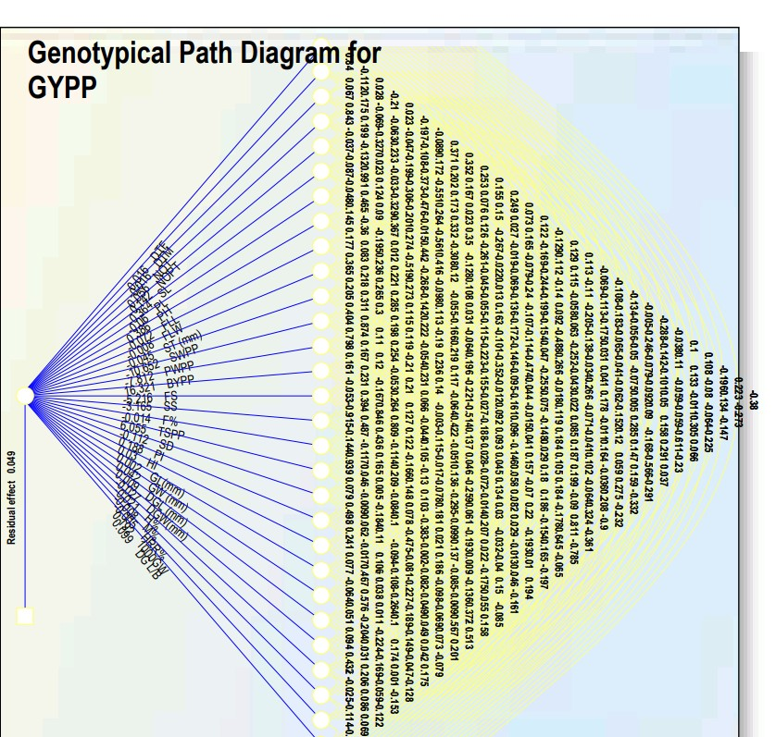

**Figure 1 Genotypic Path Diagram for Direct and Indirect effects of yield and quality attributing traits on Grain Yield per plant**

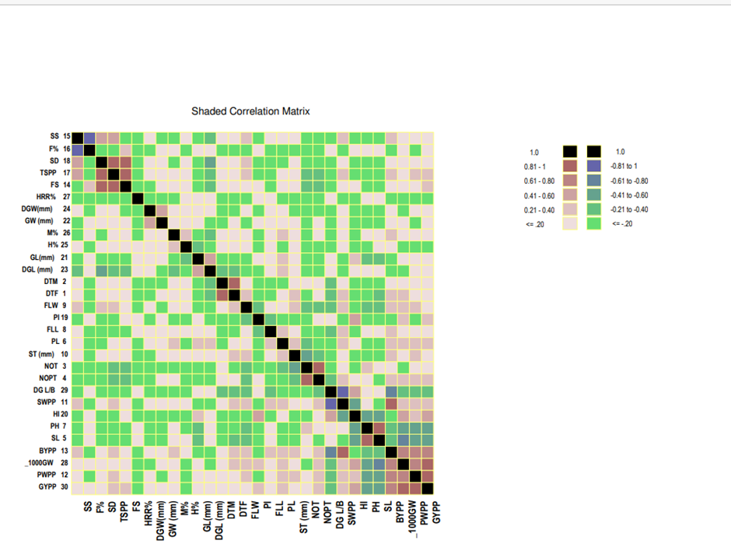

**Figure 2 Phenotypic Correlation Matrix for Trait association with Grain Yield per plant**