Indigenous Technical Knowledge for Insect-Pest Control in Home Gardens: Insights from Punjab's Border Areas
ABSTRACT
Indigenous communities worldwide have refined traditional pest control strategies rooted in their knowledge of local environments over generations. Environments and natural resources, these methods are often cost-effective, eco-friendly, and tailored to local conditions. The adoption of ITK-based strategies is often influenced by social norms and community beliefs. Farmers may prefer these methods due to their cultural familiarity and perceived safety compared to chemical alternatives. The main objective of the study was to find out the Indigenous practices used by the farmers in kitchen gardening for insect pest management. The present study was conducted in three border districts of Punjab, namely, Amritsar, Gurdaspur, and Tarn Taran. A random selection of 15 rural and 15 urban respondents was made from each district, resulting in a total sample of 90 respondents. The findings revealed that the use of neem extract spray, ash dusting, a mixture of red chili, green chili, and garlic, and the application of lassi (buttermilk) were common Indigenous Technical Knowledge (ITK) practices employed by farmers for insect-pest management in kitchen gardening. The study further found that age and experience in kitchen gardening significantly influenced farmers’ decisions to adopt ITK practices.
Key Words: Indigenous Technical Knowledge, Adoption, Kitchen Gardening, Neem, Butter Milk
INTRODUCTION
Kitchen gardens ensure a continuous supply of vegetables throughout the year. Typically located near the house, a kitchen garden is used to cultivate fruits, vegetables, and other food crops for household consumption. It not only saves time and money but also provides the entire family with a meaningful, health-enhancing, and environmentally sustainable activity. Home gardens, particularly those incorporating compost pits, contribute to household waste recycling. One of the most effective ways to ensure access to a nutritious diet rich in macro- and micronutrients is by cultivating a diverse range of vegetables in a home garden. This approach is particularly vital in rural areas where purchasing power is limited and access to markets is constrained. Kitchen gardening directly contributes to food and nutritional security by enabling the availability of fresh produce that can be harvested, cooked, and served as needed. In peri-urban and urban settings, kitchen gardens are also emerging as an important source of food and supplementary income for low-income households. Such gardens can be developed collaboratively on shared plots or individually in available roof or backyard spaces. (Singh et al., 2018). Cultivating a variety of vegetables in home gardens is one of the simplest and most effective methods to ensure a balanced diet containing essential vitamins, macronutrients, and micronutrients. Individuals living in extreme poverty, including those who are landless or marginal landholders, often practice kitchen gardening on small plots of homestead land, vacant lots, field edges, roadsides, or in containers. (Qaiser et al., 2013)
With the advancement of technology, it is now possible to grow fresh vegetables at home using clay pots, discarded utensils, and empty tins—an approach commonly referred to as "kitchen gardening." (Cheema, 2011). Cultivating a kitchen garden using family labour can significantly enhance both the household’s nutritional diversity and food security. Even limited spaces surrounding the house can make a substantial difference, especially in areas with scarce land resources. Households and small communities often utilize unused land to meet their food requirements and to support food supply in nearby urban centres. (Drescher, 2000). The objectives of kitchen gardening have evolved. Producing food at home that would otherwise be purchased from the market can help reduce household expenses. While the initial year of kitchen gardening may require investment in materials such as soil and containers, it becomes more cost-effective over time, and the produce is often fresher and of better quality than market alternatives. Research shows that gardening is enjoyed by individuals across all age groups, genders, and ethnicities, and is also considered a beneficial form of physical activity. Promoting kitchen gardening and incorporating fresh, home-grown vegetables into daily meals can significantly improve public health and help combat malnutrition. (Christensen, 2011)
Modern challenges such as changing consumer lifestyles, rapid population growth, and climate change continue to influence agricultural productivity. A homestead garden, typically located adjacent to the household, enables year-round cultivation of crops for both personal consumption and local markets. (Keatinge et al., 2012). Participation in homestead gardening also enhances decision-making abilities and supports the development of sustainable livelihoods. (Berti et al., 2013). Indigenous Technical Knowledge (ITK) in pest management is a significant resource for time-tested practices and wisdom passed down through generations of farmers and local communities. This expertise includes a broad range of traditional procedures and techniques established and improved over the ages to protect crops from numerous pests and illnesses. (Kumar et al., 2024).Several studies have shown the ongoing IKS approach in pest management, and most of their findings revealed that indigenous knowledge (IK) on pest control is cost-effective and eco-friendly. Therefore, keeping in view the importance of ITK practices, the present study was conducted in the border districts of Punjab to find out the Indigenous practices used by the farmers in kitchen gardening for insect pest management.
MATERIALS AND METHODS
The purposive cum random sampling technique was used to select the final respondents. The study was carried out in three border districts of Punjab namely, Amritsar, Gurdaspur and Tarn Taran. A random selection of 15 rural and 15 urban respondents was made from each district to make a sample size of 90 respondents. Data were collected with the help of a pre-structured interview schedule, and data were analysed by using different statistical methods like mean, standard deviation, frequency, percentage, and regression.
RESULTS AND DISCUSSIONS
Using the Cumulative Cube Root Method, the respondents' ages were divided into three groups, i.e., young (20–35 years), middle (36–51 years), and old (above 51 years), as shown in Table 1. In the districts of Amritsar, Gurdaspur, and Tarn Taran, the average age of the respondents was 36.33 (±9.33), 40.06 (±10.88) and 46.56 (±8.85) years, respectively. All three districts had an average age of 40.98 (±10.49) years. The majority of respondents in Gurdaspur and Tarn Taran districts,i.e.,47 per cent and 50 per cent respectively,belong to the middle age group of 36 to 51 years, while 60 per cent of respondents in Amritsar district are young, between the age group of 20-35 years. Overall, 42 per cent of the responders are between the age group of 36-51 years.
For a number of reasons, middle-aged respondents were more interested in kitchen gardening, including their belief that it offers a gentle kind of exercise that helps improve flexibility and strength. Additionally, gardening lowers depression, anxiety, and stress. In general, middle-aged respondents found gardening to be an interesting hobby. The outcomes align with those of Bhimani et al (2020), who showed that middle-aged respondents had a greater interest in kitchen gardening practices.
As shown in Table 1, the respondents' education was divided into six groups. In Tarn Taran, the average education of kitchen gardening respondents was 12.56 (±3.70) years, whereas in Amritsar and Gurdaspur, it was 14.63 (±1.58) and 14.56 (±2.06) years, respectively. The average education of the three districts was 13.92 (±2.75) years. This finding demonstrates that over half of the respondents in every district, 64 percent had a graduate degree or higher, with 22 per cent having a senior secondary education. In Tarn Taran and Gurdaspur 27 per cent and 3 per cent of the respondents had completed secondary school. Additionally, only 10 per cent of those surveyed in the Tarn Taran area had completed primary school. However, the study area did not contain any illiterate respondents.In every district, the majority of respondents had a graduate and above level of education because education can help you learn new abilities. Respondents with higher levels of education are better able to learn about healthy eating and living. These results are consistent with those of Bhimani et al (2020), who showed that most of the respondents had graduate and above level of education.
Three categories were used to classify the respondent’s familiesi.e.,small, medium, and large. According to the results in Table 1, the average family size of the respondents was 4.03±(0.96) in Amritsar, 4.80±(1.62) in Gurdaspur, and 6.20±(3.28)members in Tarn Taran. The majority of respondents in Amritsar, Gurdaspur, and Tarn Taran i.e.,100 per cent, 80 per cent, and 67 per cent respectively, are members of small family groups consisting of 2-6 members. On the other hand, 20per cent and 30per cent of families in Gurdaspur and Tarn Taran respectively, are part of medium family groups, which consist of 7-12 members. In the Tarn Taran district, just 3per cent of respondents are part of a large family with more than 12 members. However, none of the respondents from the districts of Amritsar and Gurdaspur are part of large families. Overall, the respondents' average family size was 5.01±(2.30). The majority of the respondents, 82 per cent, belong to small family groups, followed by medium 17 per cent, and large family groups1 per cent only.
The existence of more nuclear families than joint families is the cause of this. These results are consistent with those of Dubey (2020), who found that 65 percent of families had 5 to 7 members. The family type of the respondents was studied in terms of nuclear and joint family. The data clearly show that the majority of respondents in Amritsar, Gurdaspur, and Tarn Taran,i.e.,97per cent, 80per cent, and 57per cent, respectively, belong to nuclear families, while only 3per cent, 20per cent, and 43per cent of respondents in these cities belong to joint families. 78per cent of the respondents belong to nuclear families, whereas 22per cent belong to joint families. This may be because nuclear families are more common in the study area. These results are consistent with those of Dubey (2020), who found that 80per cent of respondents were members of a nuclear family.
The data clearly show that the majority of respondents,i.e.,83 per cent, 70 per cent, and 60 per cent in the districts of Amritsar, Gurdaspur, and Tarn Taranwere male, while the remaining 17 per cent, 30 per cent, and 40 per cent were females. Overall, 29per cent of the population were female and 71per cent were male. Because men enjoy physical activity more than women, they made up the majority of respondents. Farming is more interesting to men.
Table 1: Descriptive Statistics regarding socio-economic status of the respondents.
Parameters | Districts |  |  | Overall  n=90
Parameters | Amritsar  n₁=30 | Gurdaspur  n₂=30 | Tarn Taran  n₃=30 | Overall  n=90
Average age (in years) | 36.16±8.92 | 39.83±10.43 | 46.56±8.85 | 40.85±10.28
Categorization of age (% respondents)
20-35(Young) | 18 (60) | 11 (37) | 6 (20) | 35 (39)
36-51(Middle) | 9 (30) | 14 (47) | 15 (50) | 38 (42)
Above 51(Old) | 3 (10) | 5 (17) | 9 (30) | 17 (19)
Average education (schooling years completed) | 14.63±1.58 | 14.56±2.06 | 12.56±3.70 | 13.92±2.75
Categorization of education level (% respondents)
Primary | 0 | 0 | 3(10) | 3 (3)
Middle | 0 | 0 | 0 | 0
Secondary | 0 | 1 (3) | 8 (27) | 9 (10)
Senior Secondary | 7 (23) | 8 (27) | 5 (17) | 20 (22)
Graduate &Above | 23 (77) | 21 (70) | 14 (47) | 58 (64)
Average family size (members) | 4.03±0.96 | 4.80±1.62 | 6.20±3.18 | 5.01±2.30
Categorization of family size (% respondents)
Small family  2-6 members | 30 (100) | 24 (80) | 20 (67) | 74 (82)
Medium family  7-12 members | 0 | 6 (20) | 9 (30) | 15 (17)
Large family  Above 12 members | 0 | 0 | 1 (3) | 1 (1)
Family type (% respondents)
- Nuclear  - Joint | 29 (97)  1 (3) | 24 (80)  6 (20) | 17 (57)  13 (43) | 70 (78)  20 (22)
Gender type (% respondents)
- Male  - Female | 25 (83)  5 (17) | 21 (70)  9 (30) | 18 (60)  12 (40) | 64 (71)  26 (29)
*Figure in parenthesis is per centage and rounded off to the nearest whole number.
*Categorization was done by using Singh cube root method.

The result shown in the Table 2 revealed that in all three districts, the average operational land of the respondents was 8.94 (±5.07) acres.In Amritsar, the average operational land holding of respondents who practiced kitchen gardening was 7.93 (±4.99) acres. It was 8.94 (±5.07) acres in Tarn Taran district and 10.90±3.90 acres in Gurdaspur. The majority of responders in every district were classified as semi-mediumlevel of category (5–10 acres).In Amritsar, Gurdaspur, and Tarn Taran districts, the average irrigated land area was 7.93 (±4.99), 10.90 (±3.90), and 8.00 (±5.74) acres, respectively. Since just one respondent from district Gurdaspur and Tarn Taran leased in landwas 4 acres and 8 acres respectively, but in Amritsar, none of the respondents leased any land. In Gurdaspur and Tarn Taran, none of the respondents leased out their land, while in Amritsar, the average leased out land was 14 acres because only two respondents did so. The average amount of land used for kitchen gardening was 1.70 (±1.03) marlas in Amritsar, whereas it was 2.03 (±0.92) and 1.43 (±0.56) marlas in Gurdaspur and Tarn Taran, respectively.
The majority of respondents held 5–10 acres of semi-medium-sized land. According to MOAWF (2021), the land holding status in the study region is equivalent to the 9.05-acre average land holding for the state. The results of the current study were consistent with the study of Maurya et al, (2017) and Grewal et al, (2023).
Table 2 Distribution of the respondents based on their land holding status and farm size of the kitchen gardening.
Parameters | Districts |  |  | Overall  n=90
Parameters | Amritsar  n₁=30 | Gurdaspur  n₂=30 | Tarn Taran  n₃=30 | Overall  n=90
Average operational land holding (in acre) | 7.93±4.99 | 10.90±3.90 | 8.00±5.74 | 8.94±5.07
Categorization of average operational land (per cent respondents)
Marginal (0-2.5 acre) | 5 (17) | 2 (7) | 8 (27) | 15 (17)
Small (2.5-5 acre) | 5 (17) | 0 | 2 (7) | 7 (8)
Semi-medium (5-10 acre) | 12 (40) | 16 (53) | 14 (47) | 42 (47)
Medium (10-25 acre) | 8 (27) | 12 (40) | 6 (20) | 26 (29)
Average irrigated land (in acre) | 7.93±4.99 | 10.90±3.90 | 8.00±5.74 | 8.94±5.07
Average leased in land (in acre) | 0 | 4 (13) | 8 (27) | 12 (13)
Average leased out land (in acre) | 14 (47) | 0 | 0 | 14 (15)
Average land under kitchen gardening (in marla) | 1.70±1.03 | 2.03±0.92 | 1.43±0.56 | 1.72±.89
*Figure in parenthesis is per centage and rounded off to the nearest whole number.
The data regarding cultivated vegetables in kitchen gardening by the respondents presented in Table 3 shows that Okra was grown by 50 per cent, 40 per cent, and 57 per cent of respondents in Amritsar, Gurdaspur, and Tarn Taran respectively. However, 47per cent of the respondents were grown Brinjalin Amritsarand 43 per cent in both Gurdaspur and Tarn Taran. When it came to Tomato production, the majority of respondentsi.e.,53 percent grew Tomatoes in Amritsar, compared to 30 and 23 per cent in Gurdaspur and Tarn respectively. Additionally, 37 per cent of respondents in Amritsar and Gurdaspur grew Chilli, while 23 percent of respondents in Tarn Taran. 20 percent grew Bitter gourd in Gurdaspur, 30 percent in Amritsarand 40 percent in Tarn Taran. In districts Amritsar, Gurdaspur, and Tarn Taran 30 per cent, 23 per cent and 27 percent of the respondents respectively, grew cucumbers. The majority of respondents 43 percentcultivatedPotatoes in Gurdaspur, followed by Tarn Taran 23 percent and Amritsar 10 per cent. While 13 percent of respondents in Gurdaspur cultivated both Pumpkin and Sponge gourd and 30 percent of respondents in Tarn Taran grew pumpkin and 27 percent grew Sponge gourd, none of the respondents in Amritsar district did so just 17 percent of respondents grew cauliflower in the Gurdaspur district, followed by 13 percent in Tarn Taran and10 per cent in Amritsar. In Amritsar and Tarn Taran, only 3 percent of respondents grew Onions and garlic, while in Gurdaspur 13 per cent and 17 percent of respondents grown Onion and garlic respectively. Overall, the majority of respondents 49 per cent preferred to grow okra, followed by Brinjal 44 percent, Tomatoes 35 per cent, Chillies 32 per cent, Bitter gourds 30 per cent, cucumbers 27 percent, Potatoes 25 per cent, Pumpkin 14 per cent, cauliflower and Sponge gourds 13 percent, garlic 8 per cent and Onions 7 per cent.
Okra is one of the easiest vegetables that can be grown at home and is also quite simple to harvest, which is why the majority of respondents cultivate it. Nutrients including vitamins A, B, and C are rich in it as well. These results are consistent with the findings of Kumar et al (2017), who showed that the respondents were more active, interested in growing okra, and had a reasonable degree of expertise.
Table 3 Distribution of vegetables cultivated in kitchen gardening by the respondents (% respondents)
Vegetables | Districts |  |  | Overall  n=90
Vegetables | Amritsar  n₁=30 | Gurdaspur  n₂=30 | Tarn Taran  n₃=30 | Overall  n=90
Onion | 1 (3) | 4 (13) | 1 (3) | 6 (7)
Garlic | 1 (3) | 5 (17) | 1 (3) | 7 (8)
Potato | 3 (10) | 13 (43) | 7 (23) | 23 (25)
Tomato | 16 (53) | 9 (30) | 7 (23) | 32 (35)
Chilli | 11 (37) | 11 (37) | 7 (23) | 29 (32)
Cauliflower | 3 (10) | 5 (17) | 4 (13) | 12 (13)
Okra | 15 (50) | 12 (40) | 17 (57) | 44 (49)
Bitter gourd | 9 (30) | 6 (20) | 12 (40) | 27 (30)
Cucumber | 9 (30) | 7 (23) | 8 (27) | 24 (27)
Brinjal | 14 (47) | 13 (43) | 13 (43) | 40 (44)
Pumpkin | 0 | 4 (13) | 9 (30) | 13 (14)
Sponge gourd | 0 | 4 (13) | 8 (27) | 12 (13)
*Figure in parenthesis is per centage and rounded off to the nearest whole number.
The data presented in the Table 4 shows that 97 percent of respondents in Gurdaspur, 83 percent in Amritsar, and 73 percent in Tarn Taran sprayed neem extract in their kitchen gardens. In the district Amritsar, Gurdaspur, and Tarn Taran, the per centage of respondents who used ash spreading was 47 per cent, 60 per cent, and 30 per cent respectively. Additionally, 47 per cent of respondents from the Amritsar area sprayed a mixture of garlic, green chili, and red chili, followed by 43 per cent from Tarn Taran and 33 per cent from Gurdaspur.Regarding the application of butter milk spray in kitchen gardens, 57 per cent of respondents in Tarn Taran, 10 per cent in Amritsar, and 7 per cent in Gurdaspur used this spray. Overall, 84 per cent of the respondents sprayed neem extract, followed by 45 per cent who sprinkled ash, 41 per cent who sprayed a mixture of garlic and red and green chilies, and 32 per cent who sprayed butter milk.
The majority of respondents selected neem extract spray mostly because neem leaves are easily available in every home and it was very simple to make. A natural pesticide and insecticide, neem extract can help to manage a wide range of pests. Additionally, it reduces the use for chemical fertilizers, which could decrease the amount of dangerous chemicals in gardens. The findings of the present study were in accordance with the study of Kumar et al., (2021); Lenka and Satpathy (2020) and Sindhu and Malik (2020).

Table 4 Distribution of respondents on the basis of Indigenous and Technical Knowledge used in kitchen gardening (% respondents)
Indigenous and Technical Knowledge used | Districts |  |  | Overall  n=90
Indigenous and Technical Knowledge used | Amritsar  n₁=30 | Gurdaspur  n₂=30 | Tarn Taran  n₃=30 | Overall  n=90
Spraying of neem extract | 25 (83) | 29 (97) | 22 (73) | 76 (84)
Dusting of ash | 14 (47) | 18 (60) | 9 (30) | 41 (45)
Spraying the mixture of red Chilli, green Chilli and garlic | 14 (47) | 10 (33) | 13 (43) | 37 (41)
Spraying of lassi (butter milk) | 10 (33) | 2 (7) | 17 (57) | 29 (32)
*Figure in parenthesis is per centage and rounded off to the nearest whole number.
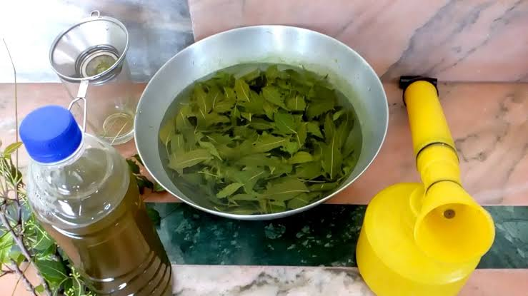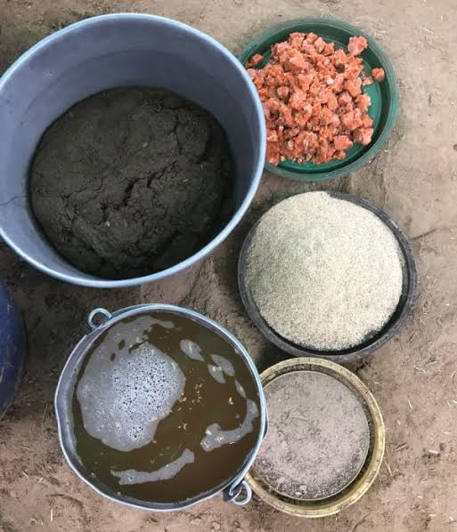
Fig 1. Neem extract preparation Fig 2. Final Neem extract
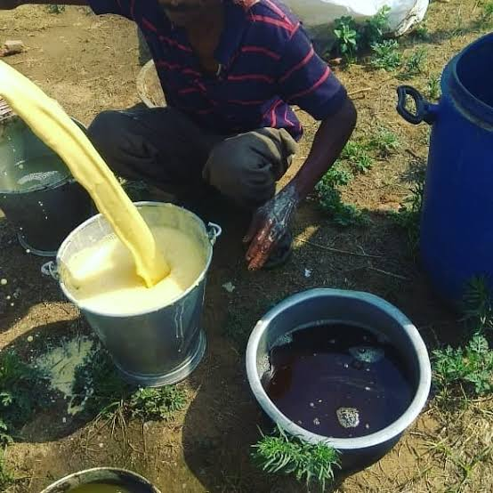
Fig 3. Farmer in Punjab preparing butter milk (lassi) to control insect pest in kitchen garden

The Table 5 presents the findings of the factors influencing farmers' decisions to utilize ITK approaches in kitchen gardening. The factors influencing farmers' decisions to utilize ITK methods in kitchen gardening were examined using a binary regression model. In the current study, the independent variables were age, education, family size, family type, operational land holding, occupation, area under kitchen gardening, and kitchen gardening experience. Out of all these independent variables, it was discovered that farmers' decisions to use ITK practices in kitchen gardening were significantly influenced by age (p=.001) and experience (p=.0001). The model used had a prediction power of 66per cent, according to the Nagelkere R2 value of.662. Similar results were also found by Imrose et al (2025).
Table 5 Factors affecting farmer’s decision to use ITK practises in kitchen gardening
Dependent variable | Independent variable | Coefficient (B) | S.E. | t-value | p-value | Model Summary
ITK Used | (constant) | -.709 | .359 | -1.974 | .052 | Nagelkere R²= .662  -2 Log Likelihood= 62.954
ITK Used | Age | .027 | .004 | 6.824** | .001 | Nagelkere R²= .662  -2 Log Likelihood= 62.954
ITK Used | Education | -.007 | .017 | -.419 | .676 | Nagelkere R²= .662  -2 Log Likelihood= 62.954
ITK Used | Family size | .096 | .161 | .593 | .555 | Nagelkere R²= .662  -2 Log Likelihood= 62.954
ITK Used | Family type | -.019 | .030 | -.626 | .533 | Nagelkere R²= .662  -2 Log Likelihood= 62.954
ITK Used | Operational land holding | .013 | .012 | 1.111 | .270 | Nagelkere R²= .662  -2 Log Likelihood= 62.954
ITK Used | Occupation | -.003 | .025 | -.133 | .894 | Nagelkere R²= .662  -2 Log Likelihood= 62.954
ITK Used | Area under kitchen gardening | -.071 | .063 | -1.120 | .266 | Nagelkere R²= .662  -2 Log Likelihood= 62.954
ITK Used | Experience of kitchen gardening | .078 | .018 | 4.277** | .001 | Nagelkere R²= .662  -2 Log Likelihood= 62.954

CONCLUSION
The study reveals a number of significant findings about the kitchen gardening practices of farmers. The majority of responders are middle-aged, and they have a comparatively high degree of education. According to the research, there is a particular liking for small, nuclear families where the main occupation is agriculture. The respondents preferred manual and traditional methods to control insect pests. Spraying of neem extract, Dusting of ash, Spraying the mixture of red Chilli, green Chilli and garlic and Spraying of butter milk were the ITK practices used by the farmers. Okra, Brinjal, Tomato, Potato, Bitter gourd, Pumpkin were the major vegetables grown by the farmers in kitchen gardening. Farmers’ age and experience of kitchen gardening were the factors that significantly influenced their adoption of Indigenous Technical Knowledge (ITK) practices. More research is needed to expand the use of organic control measures and ITKs for plant protection, as well as analyze their potential to enhance sustainable agriculture.
Disclaimer (Artificial intelligence)
Option 1:
Author(s) we hereby declare that NO generative AI technologies such as Large Language Models (ChatGPT, COPILOT, etc.) and text-to-image generators have been used during the writing or editing of this manuscript.

REFERENCES
Berti, P.R., Krasevec, J., &Gerald, S.F. (2013). A review of the effectiveness of agriculture interventions in improving nutrition outcomes. Public Health Nutrition, 7(5), 599-609
Bhimani, J.G., Bariya, M.K., & Panchal, B.B. (2020). Knowledge and adoption of kitchen gardening by urban women. Gujrat Journal of Extension Education, 31(2), 16-20.
Dubey, S.D. (2021). Impact of planned and non-planned kitchen gardening for improvement of nutrition and economical benefits of societies. Journal of Pharmacognosy and Phytochemistry,10(1): 501-504.
Cheema, K.J. (2011). Call to promote kitchen gardening. The News.
Christensen, T.E. (2011). What is a kitchen Garden.Wise Geek.pp1-2.
Drescher. (2000). Urban food security: Urban agriculture, a response to crisis? UA Magazine.
Grewal, D.S., Sharma, P &Iqbal, T. (2023). Knowledge Level of Citrus Grower’s Regarding use of Integrated Pest Management Strategies in Punjab. Indian Journal of Extension Education, 59(1): 174-176.
Imrose, S., Islam, M. M & Ahmed, M.B. (2025). Identification of indigenous technical knowledges (ITKs) as climate smart agriculture (CSA) technology. Bulgarian Journal of Agricultural Science, 31 (2): 283–294
Keatinge, J.D., Chadha, M.L., Hughes, J.D.A., Easdown, W.J., Holmer, R.J., Tenkouano, A., Yang, Y.A., Mavlyanova, R., Neave, S., Afari-Sefa, V., & Luther, G. (2012). Vegetable gardens and their impact on the attainment of the Millennium Development Goals. Biology Agriculture and Horticulture, 28(2):71-85.
Kumar, B., Singh, D., Singh, D.K., Yadav, R.N., & Singh, V.K. (2017). Study on Knowledge Level and Association with Socio-Economic Characteristics of Okra Growers in Western Uttar Pradesh, India International Journal of Current Microbiology and Applied Sciences, 6(7): 2513-2518.
Kumar, N., Gupta, S., & Chandra, A. (2021). Plant production through indigenous traditional knowledge. Just Agriculture, 1(6), 1-5.
Kumar, G.A., Sujatha, G.S., Teja, K.S.S., Dasari, S., Hema, A.P., Aarthi, H.P., Ramya, R., & Parida, A.K. (2024). Bridging past and present: Indigenous technical knowledge in contemporary pest management. International Journal of Advanced Biochemistry Research, SP-8(8): 1048-1056.
Lenka, S. & Satpathy, A. (2020). A study on indigenous technical knowledge of tribal farmers in agriculture and livestock sectors of Koraput District. Indian Journal of Extension Education. 56(2), 66-69.
Maurya, A.S., Yadav, R.N., Singh, D.K., Singh, D., Singh, P.K., Kaushal, P.,& Singh, M.K. (2017). Socio-Economic Status of Brinjal Growers in Bulandshahr District of Western Uttar Pradesh, India International Journal of Current Microbiology and Applied Sciences, 6(8):361-365.
Singh, V., Yadav, K.S., & Tripathi, A.K (2018) Kitchen gardening: a promising approach towards improving nutritional security in rural households International Journal of Microbiological Research,10(5): 1216-1219.
Sindhu, N., & Malik, J.S. (2020). Perceived effectiveness of Indigenous Technical Knowledge (ITK) in modern Agriculture in Haryana State. Indian Journal of Extension Education. 56(2): 61-65.
Qaiser, T., Shah, H., Taj, S., & Ali, M. (2013) Impact assessment of kitchen gardening training under watershed program Journal of Social Sciences, 2(2): 108-116.

