Floral Trait Variation Among Selected Mulberry Genotypes and Its Implications for Hybridization

ABSTRACT
Mulberry (Morus spp.) is an economically vital perennial plant in sericulture, cultivated primarily for its foliage which serves as the exclusive food for the silkworm (Bombyx mori L.). Understanding floral morphology and reproductive biology is critical for the development of effective hybridization strategies aimed at enhancing yield, adaptability and disease resistance in mulberry genotypes. A field study was conducted using a randomized block design to investigate the floral traits of ten mulberry genotypes, including six female and four male lines maintained at the University of Agricultural Sciences, GKVK, Bengaluru. Key floral parameters such as inflorescence length, width and number of florets were quantitatively assessed. Significant genotypic variation was recorded for all traits. Among the tested genotypes, the male line MI-0173 exhibited the longest inflorescence (2.98 cm), widest flower (1.20 cm) and the highest number of florets (48.44), whereas the female line ME-0008 consistently recorded the lowest values. A positive correlation was observed between inflorescence length and floret number, indicating their utility as reliable indicators for selecting elite parents in hybridization. Time of anthesis also varied among genotypes, with implications for synchronization during controlled breeding. These findings emphasize the importance of floral trait evaluation in improving hybrid development efficiency and optimizing genetic gains in mulberry. Identifying genotypes with favorable floral characteristics can greatly assist in designing compatible crosses, ensuring higher pollination success and maximizing seed set. Thus, this study contributes valuable data to mulberry breeding programs by establishing a foundation for more targeted and strategic parent selection based on floral trait diversity.
Keywords: mulberry; floral traits; genotypes; inflorescence length; inflorescence width
1. INTRODUCTION
Mulberry, the generic name for the genus Morus, belongs to the family Moraceae under the subclass Urticales. It is a fast-growing, deciduous and woody perennial plant, primarily cultivated for its leaves the exclusive food source for the domesticated silkworm, Bombyx mori L. This unique relationship positions mulberry as the cornerstone of the global silk industry (Vijayan et al., 2011; Ozturk et al., 2023). Beyond its role in sericulture, mulberry has also garnered attention for its ecological, nutritional and medicinal significance due to its rich bioactive compounds and adaptability (Machii et al., 2000; Srivastava et al., 2006).
Morphologically, mulberry shows remarkable diversity in its vegetative and reproductive traits. The leaves are simple, alternate and highly polymorphic, ranging from entire and toothed to multilobed shapes. Small, lateral and caducous stipules accompany each leaf. The reproductive structure of mulberry is termed a "catkin," a spike-like inflorescence typically unisexual and axillary in position. While dioecious floral distribution is most common, monoecious and androgynous forms also exist, enhancing the plant’s reproductive versatility (Demirel and Yildiz, 2021). Male catkins are generally longer, loosely arranged and bear flowers with four perianth lobes and four stamens. The stamens are opposite the perianth and have broad filaments with versatile, dithecous anthers that dehisce longitudinally. The filaments remain incurved in the bud and straighten upon anthesis, explosively releasing yellow, dry, lightweight pollen an adaptation to anemophily or wind pollination.
The female inflorescence, usually shorter, is axillary and forms in clusters. Female flowers are sessile, stiffly attached to the peduncle and composed of four imbricate perianth lobes that persist and become fleshy after fertilization, contributing to the formation of the sorosis-type multiple fruit. The ovary is superior, bicarpellary, syncarpous and unilocular with a single pendulous ovule. The pistil comprises a long style terminating in a bifid stigma covered with dense, white, sticky projections that aid in pollen adhesion. The length of the pistil is a taxonomic feature, with long pistils characterizing the Dolichostylae group and short ones found in the Macromorus group.
Interestingly, though mulberry flowers are mostly unisexual, occasional bisexual flowers have been reported. In specific varieties like 'Goshoerami', both male and female flowers can coexist on the same inflorescence, with female flowers located at the base and male flowers toward the tip. In rare cases, bisexual flowers may exhibit vestigial organs like staminodes or pistillodes. Trees can thus be classified as monoecious (both male and female catkins on the same plant), dioecious (separate male and female plants) or androgynous (male inflorescence appears first, followed by female inflorescence later).
Mulberry (Morus spp.) exhibits a predominantly anemophilous (wind-pollinated) reproductive strategy, supported by specific floral and pollen adaptations. The flowers are unisexual, small, inconspicuous, odorless and devoid of nectar, which eliminates the need for biotic pollinators. These floral traits, along with the absence of sticky surfaces are evolutionarily advantageous for wind pollination. The pollen grains are typically light, smooth, spheroidal and dust-like, ensuring their buoyancy and aerodynamic dispersal through air currents (Dutta et al., 2023). Such traits collectively enhance pollination efficiency over greater distances, increasing the likelihood of successful cross-pollination. This wind-dependent pollination mechanism has significant implications for the reproductive biology and genetic improvement of mulberry, especially in breeding programs that seek to exploit natural gene flow, maximize hybrid vigor and broaden the genetic base for improved agronomic and economic traits.
In India, substantial progress has been made in the genetic improvement of mulberry. A wide range of indigenous and exotic species has been included in germplasm banks, enabling large-scale hybridization programs (Das and Krishnaswami, 1965; Tikader and Dandin, 2007; Vijayan et al., 2023). These efforts aim to exploit hybrid vigor (heterosis) to improve economically valuable traits such as leaf yield, growth rate and abiotic stress tolerance (Agastian et al., 2000; Vijayan et al.,1998). In contrast, countries like Turkey have emphasized the selection of high-yielding genotypes from natural populations rather than hybrid breeding (Yilmaz et al., 2012). For effective breeding, a deep understanding of floral biology especially traits that influence pollination efficiency and reproductive success is essential.
Significant genotypic variations in floral morphology have been observed among mulberry (Morus spp.) accessions. Indigenous genotypes typically exhibit longer catkins with a greater number of florets, whereas exotic lines often bear smaller and less floriferous inflorescences (Bindroo et al., 2012). Such variability reflects underlying genetic diversity and adaptation to local environments. Additionally, sexual dimorphism in traits such as inflorescence length, floret number and floral density can serve as useful morphological markers for assessing reproductive compatibility. These traits provide critical selection criteria in mulberry breeding programs aimed at identifying optimal parental lines for hybridization and enhancing genetic gain.
Despite the crucial role of floral traits in breeding, detailed studies focusing on parameters such as inflorescence length and floret count in male and female genotypes remain limited. These characteristics are vital for assessing floral vigor and reproductive potential, directly impacting hybrid seed production and the success of cross-breeding strategies. Therefore, the present study aims to systematically evaluate and compare key floral parameters across selected male and female mulberry genotypes under uniform environmental conditions. By assessing traits such as inflorescence length, floret number and days to flowering, the study seeks to elucidate the extent of floral variability among genotypes. The findings will offer valuable insights for identifying reproductively efficient and compatible genotypes, thereby facilitating targeted breeding and genetic improvement programs.

2. MATERIAL AND METHODS
2.1 Experimental Site and Plant Material
The present study was carried out at the Department of Sericulture, University of Agricultural Sciences (UAS), GKVK, Bengaluru-65. The experimental material comprised ten mulberry genotypes, including six female and four male genotypes (Table 1), selected from the existing germplasm maintained at the department. These genotypes were cultivated under rainfed conditions with all recommended package of practices such as timely weeding, pruning and fertilizer application as per standard guidelines (Dandin and Giridhar, 2014). Regular monitoring was conducted to ensure uniform crop establishment and to minimize biotic and abiotic stress, thereby maintaining the integrity of experimental conditions throughout the study period.

Table 1: List of lines and testers involved in study
Sl. No. | Scientific name | Accession number
FEMALES
1. | M. nigra | ME-0008
2. | M. latifolia | ME-0185
3. | M. cathayana | ME-03
4. | M. multicaulis | ME-06
5. | M. bombycis | ME-18
6. | M. sinensis | MI-0025
MALES
1. | M. laevigata | MI-0079
2. | M. indica | MI-0173
3. | M. indica | MI-0308
4. | M. alba | MI-0423

2.2 Observation on Floral Traits
Floral trait observations were recorded during the peak flowering season. The following traits were evaluated:
2.2.1 Days to first flower initiation
Number of days required for flowering from the day of pruning was recorded.
2.2.2 Time of opening of male and female inflorescence
The method consisted in selecting three branches at random from three plants of each variety. Three flower buds were selected in each branch from the top downwards. Observations were made daily from the day of flower bud initiation.
2.2.3 Length of Male and Female Inflorescences (cm)
Freshly opened male and female catkins were collected early in the day and placed in sterile petri plates. The length of each inflorescence was measured using a centimeter scale, from the base to the tip, ensuring uniformity in sampling.
2.2.4 Width of Male and Female Inflorescences (cm)
The same freshly collected catkins were used to measure the width of each inflorescence at its widest point using a centimeter scale.
2.2.5 Number of Florets per Inflorescence
To determine the floral density, the number of florets per catkin was counted manually. Using sterilized forceps and dissecting needles, individual florets on each male and female inflorescence were carefully separated and counted under laboratory conditions.
3. RESULTS AND DISCUSSION
3.1 Days to first flower initiation
The duration required for flowering in the parent plants is detailed in Table 2. The time needed for flower initiation post-pruning in the parents varied from 7 to 13 days. MI-0308 exhibited early flowering, occurring just seven days after pruning, while ME-18 demonstrated late flowering, taken thirteen days. These results might be due to environmental impact on the genotypes. These findings align with findings of Chowdhuri et al. (2009), who noted that number of days required for flowering in indigenous mulberry genotypes were less compared to exotic genotypes.
3.2 Time of opening of male and female inflorescence
The timing of inflorescence opening in ten parents is presented in Table 2. In female parents, inflorescence opening occurred between 7.30 and 11.30 AM. ME-06 demonstrated the earliest inflorescence opening at 7.30 AM, which lasted for up to two and half an hour. In contrast, MI-0025 began flower opening at 9.00 AM and concluded by 11.00 AM, indicating a later opening. Among the testers, MI-0308 exhibited early anthesis from 8.30 AM to 11.30 AM and MI-0079 showed later anthesis from 9.00 to 11.00 AM. These observations are contrast with Chowdhury et al. (2004b), who found that mulberry anther dehiscence peaked between 10.00 and 11.30 AM.
Table 2: Days to first flower initiation and time of opening of inflorescence
Parents | Days to first flower initiation | Time of opening of inflorescence
ME-0008 | 12 | 8.30-11.00 am
ME-0185 | 10 | 8.45-11.00 am
ME-03 | 9 | 8.30-11.30 am
ME-06 | 11 | 7.30-10.00 am
ME-18 | 13 | 8.30-11.30 am
MI-0025 | 10 | 9.00-11.00 am
MI-0079 | 8 | 9.00-11.00 am
MI-0173 | 8 | 8.45-11.00 am
MI-0308 | 7 | 8.30-11.30 am
MI-0423 | 9 | 8.30-11.00 am

3.3 Length and width of male and female inflorescence (cm)
The average length and width of inflorescences are presented in Table 3. The average length of inflorescences in the parents varied from 0.45 cm (ME-0008) to 2.98 cm (MI-0173). The width of the flowers ranged from 0.33 cm (ME-0008) to 1.20 cm (MI-0173). It might be due to influencing of nutritional and environment factors (Plate 1). These findings are consistent with those of Bindroo et al. (2012), who reported that the length and width of male inflorescences ranged from 1.46 to 11.30 cm and 0.36 to 1.22 cm, respectively, whereas female inflorescences measured between 0.88 and 9.44 cm in length and 0.39 to 1.17 cm in width across various indigenous mulberry genotypes. Similar observations were also made by Chowdhuri et al. (2004a) and Kalpana (2020), who noted that the inflorescence size was smaller in exotic accessions compared to indigenous ones.
3.4 Number of florets per inflorescence
The average number of florets per inflorescence is presented in Table 4. A higher number of florets per inflorescence was recorded in MI-0173 (48.44), followed by MI-0308 (47.33), whereas a lower number was observed in ME-0008 (17.58), followed by ME-0185 (19.44). These results indicate that an increase in inflorescence length is associated with a higher number of florets per inflorescence (Plate 2). These findings are in line with the observations of Chowdhuri et al. (2004a), who reported that exotic accessions possess fewer florets per inflorescence compared to indigenous ones. Similar results were also documented in the CSGRC annual report (2017-18).
Table 3: Length and width of female and male inflorescence (cm)
Parents | Inflorescence length (cm) | Inflorescence width (cm)
ME-0008 | 0.45 | 0.33
ME-0185 | 0.48 | 0.36
ME-03 | 1.16 | 0.57
ME-06 | 1.09 | 0.60
ME-18 | 1.21 | 0.56
MI-0025 | 1.52 | 0.72
MI-0079 | 1.93 | 0.54
MI-0173 | 2.98 | 1.20
MI-0308 | 2.71 | 1.00
MI-0423 | 1.89 | 0.51

Table 4: Number of florets of female and male inflorescence
Parents | Number of florets per inflorescence
ME-0008 | 17.580
ME-0185 | 19.440
ME-03 | 37.440
ME-06 | 37.663
ME-18 | 39.217
MI-0025 | 42.220
MI-0079 | 40.107
MI-0173 | 48.440
MI-0308 | 47.330
MI-0423 | 40.883
4. CONCLUSION
The present investigation highlights substantial variability in floral traits among selected mulberry genotypes, offering valuable opportunities for hybridization and genetic improvement. Male genotypes, particularly MI-0173 and MI-0308, exhibited superior floral characteristics in terms of inflorescence length, width and number of florets, making them potential pollen donors for future breeding efforts. Female genotypes displayed a comparatively narrower floral profile, underscoring the need for strategic selection to ensure compatibility and optimal seed production. The study also revealed a positive association between inflorescence length and floret count, suggesting these traits as reliable selection markers in breeding programs. Differences in the timing of floral initiation and anthesis among genotypes emphasize the importance of flowering synchronization for effective controlled pollination. By identifying promising parental lines based on floral attributes, breeders can enhance cross-compatibility, fertilization efficiency and genetic diversity, thereby supporting the development of high-yielding, adaptable and disease-resistant mulberry cultivars for sustainable sericulture.
DISCLAIMER (ARTIFICIAL INTELLIGENCE):
Author(s) hereby declares that NO generative AI technologies such as Large Language Models (ChatGPT, COPILOT, etc.) and text-to-image generators have been used during writing or editing of manuscripts.
REFERENCES
Agastian, P., Kingsley, S. J., & Vivekanandan, M. (2000). Effect of salinity on photosynthesis and biochemical characteristics in mulberry genotypes. Photosynthetica, 38(2), 287-290.
Bindroo, B. B., Raina, S. K., & Kamili, A. S. (2012). Floral biology and pollination in mulberry (Morus spp.). Journal of Crop Science and Biotechnology, 15(2), 115–121.
Central sericultural germplasm resources centre (CSGRC). (2018). Annual Report, 2017-18. Hosur: CSGRC. pp. 84.
Chowdhuri, D. K., Basu, A., & Datta, R. K. (2004a). Studies on floral morphology in some exotic and indigenous mulberry germplasm. Indian Journal of Sericulture, 43(1), 76–78.
Chowdhuri, S. R., Sau, H., Ghosh, P. L., & Saratchandra, B. (2004b). Studies on anthesis and flowering pattern in mulberry germplasm. Indian Journal of Genetics and Plant Breeding, 64(02), 30-131.
Chowdhuri, S., Sau, H., Doss, S. G., Ghosh, M. K., & Bajpai, A. K. (2009). Studies on flowering and receptivity of stigma in mulberry (Morus spp.) germplasm. Journal of Crop and Weed, 5(1), 58-60.
Dandin, S. B., & Giridhar, K. (2014). Handbook of sericulture technologies. CSB Publications, 427.
Das, B. C., & Krishnaswami, S. (1965). Studies on the hybridization in mulberry. Indian Journal of Sericulture, 4(1), 36-43.
Demirel, M. A., & Yildiz, K. (2021). Flower structures of black mulberry (Morus nigra) trees. Turkish Journal of Food and Agriculture Sciences, 3(2), 60-65.
Dutta, H., Bhattacharya, S., Sawarkar, A., Pradhan, A., Raman, R. B., Panigrahi, K. K., Banerjee, K., & Dutta, S. (2023). High yielding mulberry production through controlled pollination for enhanced vegetative growth and early sprouting suitable for tropical agroclimatic regions. The Pharma Innovation Journal, 12(3), 4485-4492.
Kalpana, P. G. (2020). Gene action and combining ability for seedling traits in mulberry (Morus spp.)., M.Sc. Thesis, University of Agricultural Sciences, Bangalore. pp. 64.
Machii, H., Katagiri, K., Koyama, A., & Kon, T. (2000). Morphological and agronomical studies on wild mulberry accessions collected in Nepal. Journal of Sericultural Science of Japan, 69(3), 229-236.
Ozturk, M., Kamili, A. N., Altay, V., & Rohela, G. K. (2023). Economic importance of mulberry. In Mulberry: From Botany to Phytochemistry (pp. 149-179). Cham: Springer Nature Switzerland.
Srivastava, S., Kapoor, R., & Thathola, A. (2006). Nutritional quality of leaves of some genotypes of mulberry (Morus alba). International Journal of Food Sciences and Nutrition, 57(5-6), 305-313.
Tikader, A., & Dandin, S. B. (2007). Genetic resources of mulberry and utilization - a review. Indian Journal of Plant Genetic Resources, 20(2), 151-163.
Vijayan, K., Das, K. K., Chakraborti, S. P., & Roy, B. N. (1998). Heterosis for yield and related characters in mulberry. Indian Journal of Genetics and Plant Breeding, 58(3), 369-374.
Vijayan, K., Gnanesh, B. N., & Tikader, A. (2023). Botanical features and economic significance of mulberry. In The Mulberry Genome (pp. 1-11). Cham: Springer international publishing.
Vijayan, K., Tikader, A., & da Silva, J. A. T. (2011). Application of tissue culture techniques for propagation and crop improvement in mulberry (Morus spp.). Tree and Forestry Science and Biotechnology, 5(1), 1-13.
Yilmaz, K. U., Zengin, Y., Ercisli, S., Demirtas, M. N., Kan, T., & Nazli, A. R. (2012). Morphological diversity on fruit characteristics among some selected mulberry genotypes from Turkey. Journal of Animal and Plant Sciences, 22(1), 211-214.

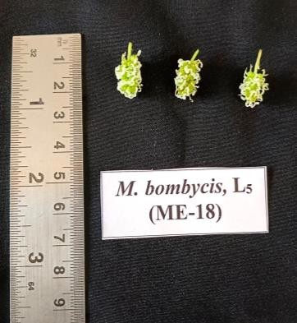
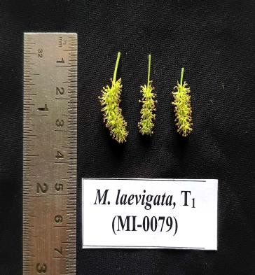
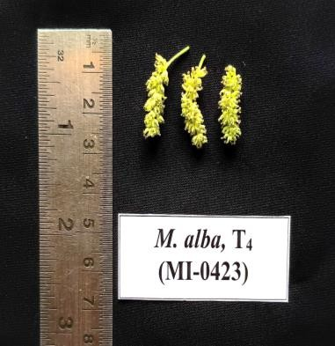
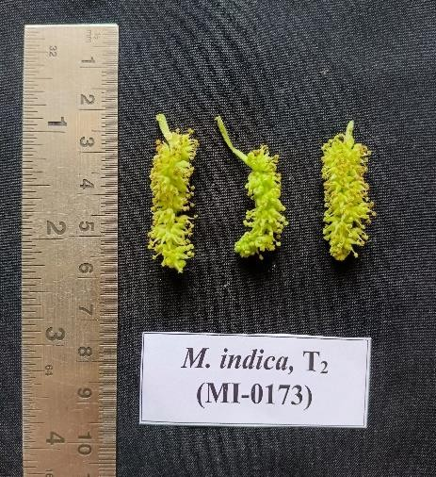
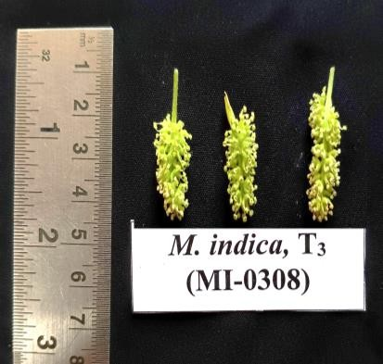
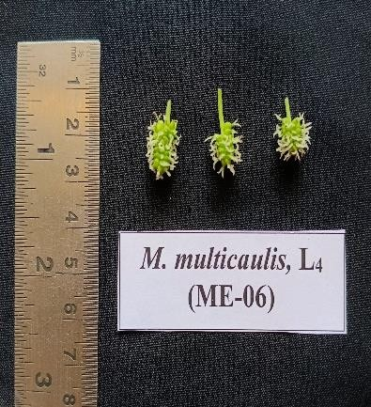
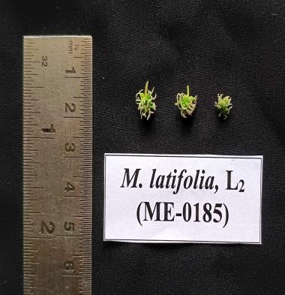
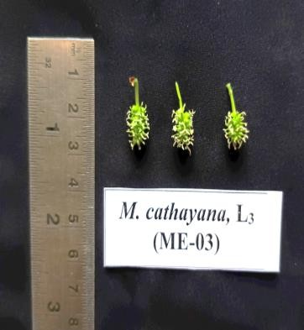
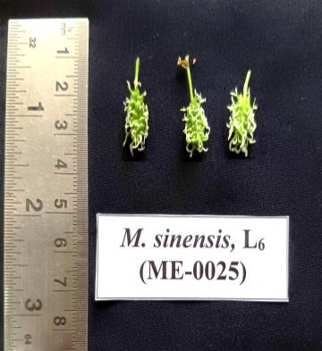
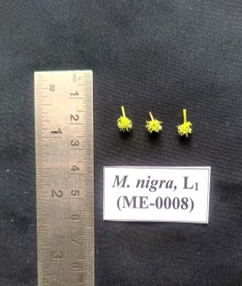

Plate 1. Inflorescence of different lines and testers

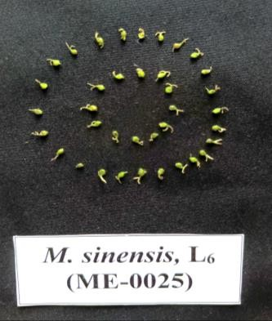
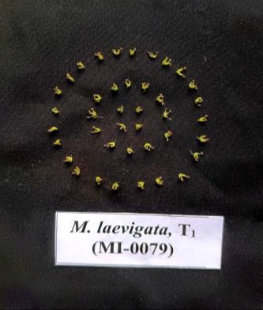
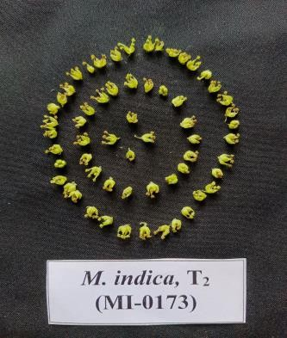
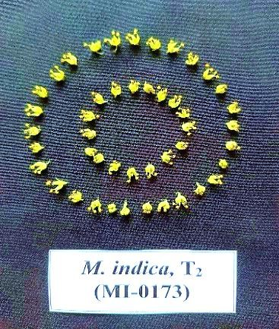
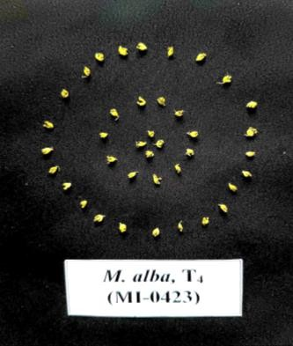
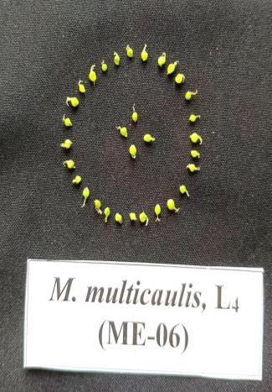
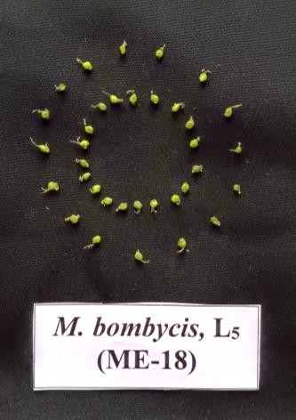
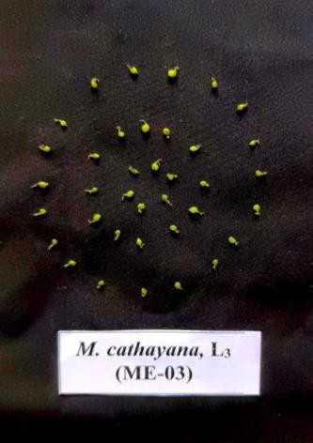
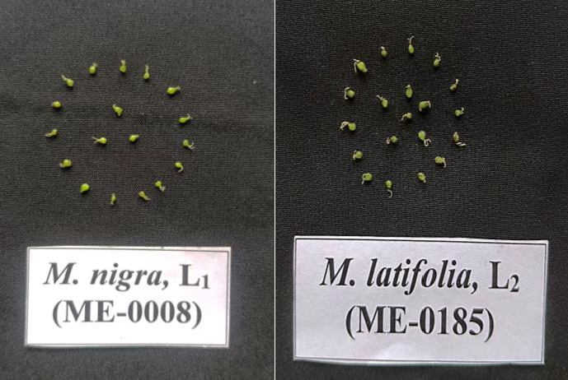

Plate 2. Number of florets per inflorescence of lines and testers

