**Insect Pest Dynamics of Arhar (*Cajanus cajan*) in *Gmelina arborea*-Based Agroforestry Systems**

**ABSTRACT**

A two-year field investigation (2019-2021) conducted at Jawaharlal Nehru Krishi Vishwa Vidyalaya, Jabalpur, Madhya Pradesh, to assess insect-pest associations within *Gmelina arborea*-based agroforestry systems compared to sole cropping of Arhar, Cowpea, and Mustard. The study aimed to quantify pest populations, determine infestation levels, and seasonal incidence. Results from the Arhar + *Gmelina arborea* agroforestry system identified seven insect species. On *Gmelina arborea*, four major pest species were observed causing significant damage. Trunk borer (*Dihammus cervinus*, Coleoptera), Defoliator (*Calopepla leayana*, Coleoptera), Bark eating caterpillar (*Indarbela quadrinotata*, Lepidoptera), and Sap sucker/Tingid Bug (*Tingis beesoni*, Homoptera). Concurrently, three major pests were found on Arhar: Pod Borer (*Helicoverpa armigera*, Lepidoptera), Hairy caterpillar (*Spilosoma obliqua*, Lepidoptera), and Aphid (*Aphis craccivora* Koch, Hemiptera). This foundational data is crucial for developing robust, sustainable pest management strategies in agroforestry contexts, particularly in the face of evolving environmental challenges. Future research can leverage these findings to design integrated pest management (IPM) frameworks, enhance climate change resilience of agroforestry systems, explore the role of tree components in fostering beneficial insect populations, guide breeding efforts for pest-resistant crop and tree varieties, and facilitate the application of digital monitoring and predictive analytics for proactive pest control. Ultimately, this will contribute to improving the ecological and economic sustainability of agroforestry for regional farmers.

**Keywords:** Arhar (*Cajanus cajan*), Cowpea, Mustard, Integrated pest management

**1. INTRODUCTION**

In annual and perennial crops, insects and pests target trees and crops in agroforestry systems at every stage of development. Since insects can target several species within or between landscape systems, pest management tactics should be tailored to the type of insects and the extent of the harm it causes (Rao et al., 2000). *Gmelina arbora* is a light demanding, moderately frost hardy species and comes up well with a temperature range of 1 to 48°C and mean annual rainfall of 760 to 4500 mm, grows well in soil pH ranging from 5.0 to 8.0with preference for moist fertile alluvial with sandy loam soil (Orwa *et al*., 2009, PROTA, 2016). Arhar is an important pulse crop in the semi-arid Tropics and sub-tropical farming systems, providing high quality vegetable protein, animal feed and firewood (Mittal and Ujagir, 2005). It can be used as a single crop, intercrop, mixed crop, or in sequential cropping systems for grains, green manuring, fodder, and forage. It is mainly consumed in the form of Dal; an essential supplement of cereal based vegetarian diet. It is particularly rich in lysine, riboflavin, thiamine, niacin and iron (Singh and Yadav, 2005). More than 300 insect species belonging to 8 orders and 61 families have been found to infest pigeon pea starting from seedling stage and continues till harvesting and even during the storage condition (Kevel *et al*., 2010)

**2. MATERIAL AND METHODS**

The experimental site is situated inside the Dusty Farm area of JNKVV, Jabalpur, Madhya Pradesh, India. It is located between 22° 49' and 24° 8' N latitude and 78° 21' and 80° 58' E longitude. Its altitude is 412 m above the mean sea level. The region receives an average annual rainfall of approximately 1350 mm, predominantly during the monsoon period from mid-June to the end of September. The mean maximum temperature varies from 40-42°C during May-June and mean minimum temperature varies from 5.3-6.1°C during December- January.

To investigate insect pests' spread and associations across different agroforestry systems—namely *Gmelina arborea + Cowpea*, *Gmelina arborea + Arhar*, and *Gmelina arborea + Mustard*— Every week, systematic surveys were carried out. and observations were made regarding the prevalence of both minor and large insect pests in each replication, which had 16 trees. Each plant has ten randomly chosen branches that were checked for major and minor pests. Weekly observations of the distinct types and quantities of insect pests and their related natural enemies were made from each agroforestry system. Ten trees per replication were chosen at random to investigate infestation, and five branches from each tree were chosen at random from the lower and upper canopy levels. The susceptibility and degree of tolerance were screened based on the information gathered on the infestation of different insect pests.

**3. RESULT AND DISCUSSION**

An investigation into insect-pest populations was conducted under *Gmelina arborea* based agroforestry system with different agricultural cops. Result reveal that about 7 species on Arhar *+ Gmelina arborea* based agroforestry system. The mean number of different insect-pest populations was measured every week during the winter crop period in Jabalpur, Madhya Pradesh, from November to April in 2019–20 and 2020–21.

Table No. 1. Screening of major insect pest communities under Arhar+*Gmelina arborea* based agroforestry system during 2019-20 and 2020-21.

|  |  |  |  |  |
| --- | --- | --- | --- | --- |
| **S. No** | **Common Name** | **Scientific Name** | **Order** | **Family** |
| **Gamhar (*Gmelina arborea)*** | | | | |
| 1. | Trunk borer | *Dihammus cervinus* | Coleoptera | Cerambycidae |
| 2. | Defoliator | *Calopepla leayana* | Coleoptera | Chrysomelidae |
| 3. | Bark eating caterpillar | *Indarbela quadrinotata* | Lepidoptera | Cossidae |
| 4. | Sap sucker/ Tingid Bug | *Tingis beesoni* | Homoptera | Tingidae |
| **Arhar** | | | | |
| 1. | Pod Borer | *Helicoverpa armigera* | Lepidoptera | Noctuidae |
| 2. | Hairy caterpillar | *Spilosoma obliqua* | Lepidoptera | Arctiidae |
| 3. | Aphid | *Aphis craccivora* Koch | Hemiptera | Aphididae |

**3.1 Incidence of Trunk borer (*Dihammus cervinus)***

The beetles feed on the soft bark of saplings, making shallow, irregular patches. In Gamhar increased formation of wood around the wound takes place due to partial girdling and injury to the cambium, mostly at a height of 1 meter above ground. The stem gets weakened due to extensive tunnelling by larva and may break off easily.

Trunk borer frequency and population dynamics, which began during the fourth week of July (the 28th normal climatic week). The lowest and highest recorded temperatures in 2019–20 and 2020–21 were 25.0°C and 31.4°C, respectively, and 25.6°C and 32.8.0°C. Relative humidity stood at 82% in the morning and 64% in the evening during 2019–20, and 83% in the morning and 66% in the evening during 2020–21.

**3.2 Incidence of Khamer defoliator (*Calopepla leayana)***

It is one of the monophagous insect. The beetle feed voraciously on leaves and buds. Young tress of *G. arborea* subject to repeated attack of the insect both larval and adult stages become weak and succumb. The heavy attack causes the leading shoots of the young tree to dry up and tree remains leafless for about four month in the growing season. Identification and quantitative assessment of Khamer defoliator *Calopepla leayana* which is one of the major insect started from 1st week of August that is shown in the form of standard metrological week 29th. In 2019–20 and 2020–21, the lowest and greatest recorded temperatures were 25.0°C and 34.9°C, respectively, and 25.1°C and 33.0°C. During 2019–20, the morning relative humidity was 82% and the evening relative humidity was 59%. In 2020–21, the morning relative humidity was 84% and the evening relative humidity was 71%. Similar results were also reported by Mathur RN and Singh B (1960). Tripathy MK and Dandapat B (2020) from Odisha reported that The primary defoliator of this species found in Bhubaneswar during the study period (2017–18) is *Calopepla leayana*. Of the 22 species that were recoded, 10 were found to be foliage feeders (47.61%), 8 to be sap feeders (38.09%), 1 to be a bark feeder and one to be a branch borer (4.76%), and 2 to be root and bark feeders (9.52%).

**3.3 Incidence of Bark eating caterpillar (*Indarbela quadrinotata)***

The larvae excavate a hole at the branch initiation point and remains because of nocturnal in nature. It prepares cellulose, excreta, and saliva-based tunnel frass materials. Larvae bore into plants, making them weak and vulnerable to natural disasters. From the fourth week of July until the first week of September, a caterpillar that ate bark was first noticed. In 2019–20 and 2020–21, the lowest and greatest recorded temperatures were 25.0°C and 31.4°C, respectively, and 25.6°C and 32.8.0°C. Relative humidity stood at 82% in the morning and 64% in the evening during 2019–20, and 83% in the morning and 66% in the evening during 2020–21. In this context similar work was conducted by Sasidharan KR and Varma RV (2008). Seasonal population variations of the bark eating caterpillar (*Indarbela quadrinotata*) in casuarinas plantation of Tamil Nadu. Kumar *et al.* (2020) done the work related to bark eating caterpillar. Estimating Bark Eating Caterpillar *Indaebela quadrinotata* in Populus deltoids using Ranked set sampling.

**3.4 Incidence of Sap sucker/ Tingid Bug (*Tingis beesoni)***

The top dies as a result of *Tingis beesoni*, which gathers very densely on the soft tissues and leaves. The sap near the base of the leaf axils is sucked by the nymphs and adults, causing areas of discolouration on both lamina sides. Mature leaves usually sustain damage first, followed by fresh flush. According to data on sap sucker population dynamics and prevalence, which began in the first week of August, the lowest and highest recorded temperatures in 2019–20 and 2020–21 were 25.0°C and 34.9°C, respectively, and 25.1°C and 33.0°C. During 2019–20, the morning relative humidity was 82% and the evening relative humidity was 59%. In 2020–21, the morning relative humidity was 84% and the evening relative humidity was 71%. It causes the tree's top to die. In this regard, Meshram PB and Bhowate S (2017) carried out comparable research. In Madhya Pradesh's tropical forests, plantations of *Gmelina* *arborea* are dealing with a serious insect pest problem, specifically the sap sucker/lace bug *Tingis* *beesoni*, which is causing the tops of the shoots to die. The underside of the leaf blade and the leaf axils are the only places where the insect nymphs and adults feed. The top of the plants dies as the shoots dry out and sooty, black mold spreads throughout them. The findings showed that the top dying of *G.* *arborea* was caused by the lace bug, *T.* *beesoni*.

**3.5 Incidence of Pod Borer *(Helicoverpa armigera)***

The growing seed is consumed by the larvae when they bore into pods. On fruits, the mature larvae dig round holes. The inside tissues are thoroughly hollowed out and eaten multiple times. This bug mostly nibbled on leaves, shoots, and buds and bored fruits into round holes. *Helicoverpa armigera*, a pod borer, was observed from the second week of October to the second week of November. The lowest and maximum recorded temperatures in 2019–20 and 2020–21 were 22.07°C and 31.07°C, respectively, and 24.0°C and 32.7°C. There was 91% morning relative humidity and 78% evening relative humidity in 2019–20, and 91% morning and 75% evening relative humidity in 2020–21. The pod borer, *Helicoverpa armigera* (Hub.), began infesting the crop during the reproductive stage, which is 44 SW and 45 SW (0.01 eggs/plant and 0.35 larvae/plant), and population stock the pests' eggs and larvae available up to maturity stage, which is 01 SW (1.8 eggs/plant and 0.15 larvae/plant). Muchhadiya *et al.* (2024) and Pawar *et al.* (2015) demonstrated a similar outcome in this context.

**3.6 Incidence of Hairy caterpillar *(Spilosoma obliqua)***

They eat many plants' leaves, buds, and flowers. It eats all of the leaf green matter and chops off the young plants. The second week of July saw the appearance of the hairy caterpillar *Spilosoma oblique*, with minimum and maximum temperatures reported in 2019–20 and 2020–21 being 25.1°C and 36.06°C, respectively, and 24.6°C and 33.1°C. In 2019–20, the morning relative humidity was 80% and the evening relative humidity was 59%. In 2020–21, the morning relative humidity was 71% and the evening relative humidity was 62%. Muchhadiya *et al.* (2024) and Pudasini (2020) conducted the same poll in this context. *Spilosoma obliqua*, sometimes known as the Bihar hairy caterpillar, is a dangerous polyphagous insect pest. From March to April 2019, an experiment was carried out at room temperature in the Entomology Laboratory on the Lamjung Campus to ascertain the Bihar hairy caterpillar's host preference.

**3.7 Incidence of Aphid *Aphis craccivora Koch (*Hemiptera: Aphididae)**

aphid (*Aphis craccivora* Koch) is a major pest of the Arhar. It caused direct injury to leaves and stems. It feed by sucking sap from their host-plants. It lives on leaves, young shoots, inflorescences and growing points, causing rolling, chlorosis, dwarfing of whole plants, make honey dew like structure on young leaves and shoots. The population dynamics and prevalence of *Aphis Craccivora* Kochwhich started from second week of January and it was found upto last week of February The lowest and highest temperatures recorded in 2019-20 and 2020-21 were 6.04°C, 22.9°C, and 8.0°C, 22.7°C, respectively. In 2019-20, the relative humidity was 84% in the morning and 43% in the evening, while in 2020-21, it was 89% in the morning and 48% in the evening. *Aphis Craccivora* Koch is a helpful insect that visits flowers. Kulkarni and Patel (2001) from Gujarat conducted studies during the winter of 1998-99 and found that aphid incidence occurred between the first week of January and the fourth week of February, with a peak incidence during the first week of February.

**4. CONCLUSION**

This two-year study in Jabalpur, Madhya Pradesh, identified seven significant insect pest species within the Arhar + *Gmelina arborea* agroforestry system, highlighting a diverse pest complex impacting both tree and crop components. The key findings include that the Pests of *Gmelina arborea*: The Trunk borer (*Dihammus cervinus*), Defoliator (*Calopepla leayana*), Bark eating caterpillar (*Indarbela quadrinotata*), and Sap sucker/Tingid Bug (*Tingis beesoni*) were the primary threats, causing direct damage to the tree's health and vigour. Pests of Arhar: The Pod Borer (*Helicoverpa armigera*), Hairy caterpillar (*Spilosoma obliqua*), and Aphid (*Aphis craccivora Koch*) were major pests affecting the pulse crop, potentially leading to yield losses. Moreover the Seasonal Incidence: Each pest exhibited specific periods of activity, influenced by local temperature and humidity. For instance, tree pests were prominent from late July/early August, while Arhar pests appeared from October (Pod Borer) or January (Aphid). This detailed understanding of pest associations and their seasonal dynamics is crucial for developing targeted Integrated Pest Management (IPM) strategies. Such strategies will need to consider the unique threats to both the tree and crop components, while also exploring potential beneficial interactions within the agroforestry system, ultimately enhancing its productivity and sustainability for farmers in the region.

**Disclaimer (Artificial intelligence)**

Option 1:

Author(s) hereby declare that NO generative AI technologies such as Large Language Models (ChatGPT, COPILOT, etc.) and text-to-image generators have been used during the writing or editing of this manuscript.

Option 2:

Author(s) hereby declare that generative AI technologies such as Large Language Models, etc. have been used during the writing or editing of manuscripts. This explanation will include the name, version, model, and source of the generative AI technology and as well as all input prompts provided to the generative AI technology

Details of the AI usage are given below:

1.

2.

3.

**REFERENCES**

Keval, R., Kerketta, D., Nath, P., & Singh, P. S. (2010). Population fluctuations of pod fly of some variety of pigeon pea. Journal of Food Legume, 23(2), 164–165.

Kulkarni, A. V., & Patel, I. S. (2001). Seasonal abundance of mustard aphid and associated bioagents in Indian mustard (Brassica juncea) crop. Indian Journal of Agricultural Sciences, 71(10), 681–682.

Kumar, A., Chandra, G., & Kumar, S. (2020). Estimating Bark Eating Caterpillar Indaebela quadrinotata in Populus deltoids using Ranked set sampling. Indonesian Journal of Applied Statistics, 3(1).

Mathur, R. N., & Singh, B. (1960). A list of insect pests of forest insects of India and neighbouring countries. Forest Bulletin. Dehradun (N.S.) (Ent.), 171(Part 1), 1–165.

Meshram, P. B., & Bhowate, S. (2017). Role of lace bug Tingis beesoni and control measures in top dying of Gmelina arborea plantations. Journal of Entomology and Zoology Studies, 5(3), 389–393.

Mittal, V., & Ujagir, R. (2005). Evaluation of Naturalyte Spinosad against pod borer complex in early pigeon pea. Indian Journal of Plant Protection, 33(2), 211–215.

Muchhadiya, D. V., Patel, J. J., Patel, D. R., & Patel, R. B. (2024). Estimation of Yield Losses Caused by Insect Pests on Pigeon Pea (Cajanus cajan (L.) Millsp.). International Journal of Plant & Soil Science, 36(3), 410–414. https://doi.org/10.9734/ijpss/2024/v36i34440

Orwa, C., Mutua, A., Kindt, R., Jamna das, R., & Anthony, S. (2009). Agroforestry Database: a tree reference and selection guide version 4.0. World Agroforestry Centre.

Pawar, U. A., Mahale, A. S., & Ambhure, K. G. (2015). Seasonal incidence of gram pod borer, Helicoverpa armigera (Hub.) and natural enemies in pigeon pea. Department of Entomology, P.G. Institute, College of Agriculture, J.N.K.V.V Jabalpur, 6(1), 140–143.

PROTA. (2016). PROTA4U web database. Plant Resources of Tropical Africa. Retrieved from http://www.prota4u.info

Pudasaini, R., Gurung, A., Gire, B., & Sitaula, S. (2020). Host preference of Bihar hairy caterpillar Spilosoma obliqua in laboratory condition. Journal of Entomology and Zoology Studies, 8(1), 992–996.

Rao, M. R., Singh, M. P., & Day, R. (2000). Insect-pest problems in tropical agroforestry systems: Contributory factors and strategies for management. Agroforestry Systems, 50(3), 243–277.

Sasidharan, K. R., & Varma, R. V. (2008). Seasonal population variations of the bark eating caterpillar (Indarbela quadrinotata) in casuarinas plantation of Tamil Nadu. International Society for Tropical Ecology, 49(1), 79–83.

Singh, S. S., & Yadav, S. K. (2005). Bio efficacy of modern insecticides, biopesticides and their combination against pod borers in pigeon pea. Indian Journal of Entomology, 67(2), 133–136.

Tripathy, M. K., & Dandapat, B. (2020). Seasonal incidence and population dynamics of important insect pests infesting Gambhar Gmelina arborea Roxb. at coastal agro ecosystem of Odisha, India. Journal of Entomology and Zoology Studies, 8(2), 1767–1773.

**Fig 1(a-d): Major insect pest of khamer *Gmeliana arborea***

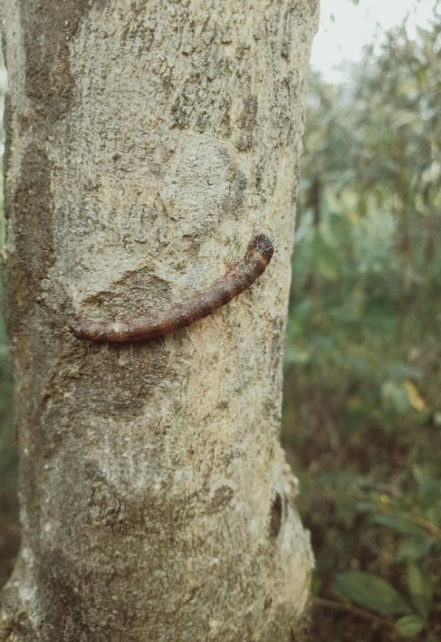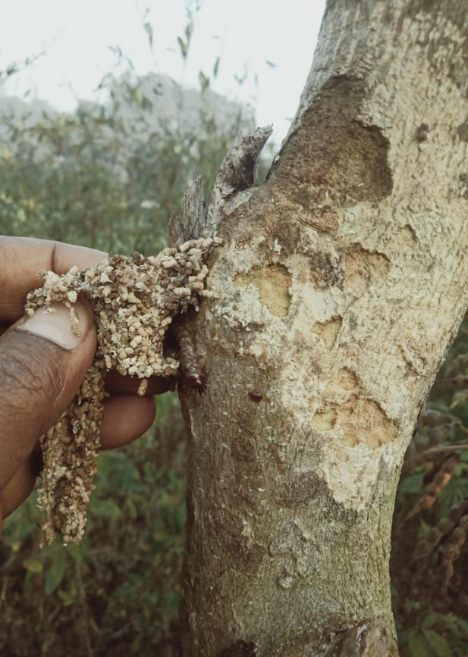

**a: Bark eating caterpillar *Indarbela quadrinotata***

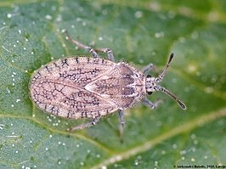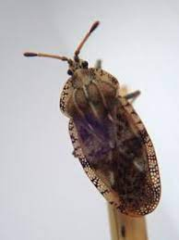

**b. Sap sucker *Tingis beesoni***

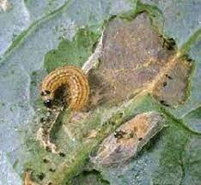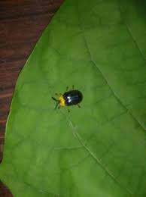

**c. Defoliator *Calopepla leayana***

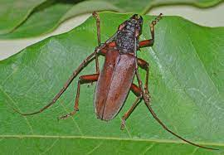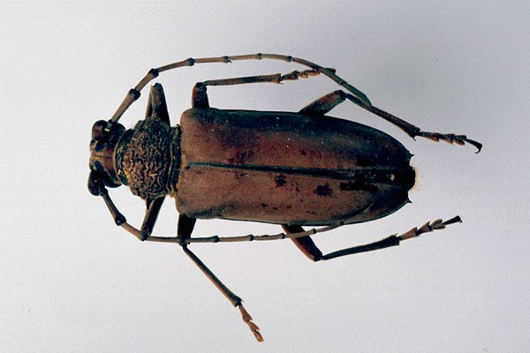

**d. Trunk borer *Dihammus cervinus***

**Fig 2(a-c): Major insect pest of Arhar**

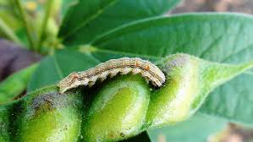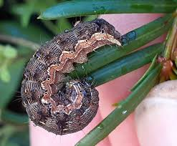

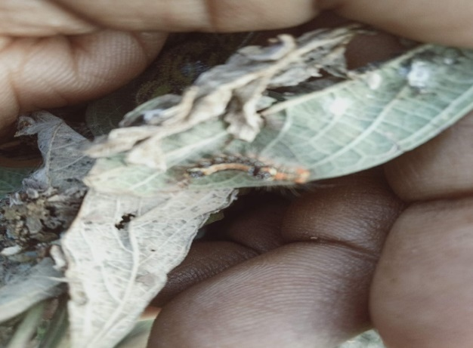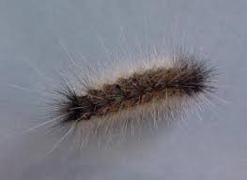**a. Pod Borer *Helicoverpa armigera***

**b.** **Hairy Caterpillar**  ***Spilosoma obliqua***

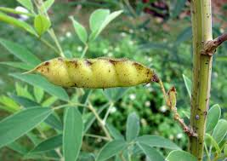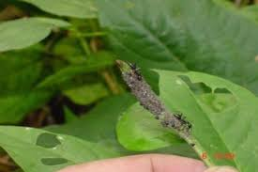

**c. Aphid** ***Aphis craccivora* Koch**