Genetic Diversity and Assessment of Finger Millet Genotypes

ABSTRACT
Finger millet is important for providing food and nutritional security, especially among resource-poor farmers, due to its resistance to harsh climatic conditions and high amounts of calcium, iron, dietary fibre, and essential amino acids. Increasing economic output is a fundamental goal of all plant breeding initiatives; however, direct selection for yield is generally ineffective due to its poor heritability. As a result, understanding the relationship between yield-contributing features is critical since it determines the success of selection procedures. The present investigation was undertaken to assess the genetic divergence of thirty-seven finger millet (Eleusine coracana L.) genotypes using D² analysis for fourteen characters, during kharif, 2024. The experiment was set up using a Randomised Block Design (RBD). The data were recorded from randomly selected five plants for each genotype for each replication for fourteen characters. The data was analysed with the technique of D² statistics. Analysis of variance revealed significant differences with respect to all the characters viz, days to 50% flowering, plant height, flag leaf length, flag leaf width, number of tillers, fingers per head, fingers per plant, finger weight, finger length, biological yield per plant, grain yield per plant, harvest index and test weight under study at the 1% level except days to maturity, which is significant at the 5% level. This is an indication of the existence of sufficient variability for the traits. Following Tocher’s technique, the 37 genotypes were divided into five clusters. Cluster II was the largest one with thirteen genotypes. The maximum intra-cluster distance was exerted in cluster V. Inter-cluster distance was maximum between clusters I and V. The Cluster V exhibited the highest values for Days to 50% Flowering, Days to Maturity, Plant Height, Finger Width, Ear Head Width, and Biological Yield contributed more towards the genetic divergence. In Mahalanobis D² analysis, three divergent genotypes, such as IE-190, IE-184, and IE-169, were identified as the most diverse genotypes in the population. Hence, these genotypes could be used in future breeding programmes to incorporate desirable features, such as high yield and high quality, into recipient finger millet genotypes, resulting in the creation of promising cultivars.
Keywords: Finger millet, Genetic divergence, Mahalanobis D², Economic Output, Genotypes

Introduction
Finger millet (Eleusine coracana (L.) Gaertn.), an important food crop in South Asia and Africa's semi-arid and rainfed regions, is a tough, self-pollinated tetraploid cereal (2n = 4x = 36) with an excellent nutritional profile. The crop, known as Ragi in India, is widely grown in areas such as Karnataka, Tamil Nadu, Andhra Pradesh, and Odisha. The word Ragi is derived from the Sanskrit word ‘Rajika’ means red. The common name, finger millet, is derived from the finger-like branching of the panicle. Finger millet is important for providing food and nutritional security, especially among resource-poor farmers, due to its resistance to harsh climatic conditions and high amounts of calcium, iron, dietary fibre, and essential amino acids (Shobana et al., 2013; Saleh et al., 2013).
“It contains practically all nutrients, including protein (9.2%), carbs (76.32%), methionine, and fat (1%). It is also rich in minerals (2.70%) such as calcium (452 mg/1000g), iron (3.90 mg/100g), and ash (3.90%), which are fundamental constituents in a regular human diet” (Shweta et al., 2022). Finger millet food products are believed to lower blood cholesterol levels and blood pressure and possess anti-cancer properties. It also boosts immunity against malaria and diarrhoea. The human health benefits of finger millet make it a superfood to combat malnutrition and other ailments (Gebreyohannes et al., 2024; Huq et al., 2025).
“Finger millet covers an area of 0.99 million hectares in India, with a production of 1.74 million tonnes and productivity of 1761 kg ha⁻¹ during 2020-21. In Tamil Nadu, finger millet is cultivated in an area of 0.78 lakh hectares, with a production of 2.56 lakh tonnes and productivity of 1966 kg ha-1 during 2020-2021” (Directorate of Economics and Statistics, 2021). Finger millet is mostly farmed for food in Africa and Southern Asia, India (the states of Uttar Pradesh, Bihar, Karnataka, Tamil Nadu, and Andhra Pradesh), and Nepal.
Increasing economic output is a fundamental goal of all plant breeding initiatives; however, direct selection for yield is generally ineffective due to its poor heritability. As a result, understanding the relationship between yield-contributing features is critical since it determines the success of selection procedures (Mishra et al., 1980). “Genetic improvement through conventional breeding procedures is heavily reliant on the availability of various germplasm and the degree of genetic heterogeneity within the population” (Arun et al., 2008). Understanding genetic diversity is essential for breeding programs, and hierarchical cluster analysis helps group genotypes based on their morphological traits, enhancing the identification of superior parents (Supriya et al., 2024; Singh et al., 2024).
Mahalanobis' D² statistics (Mahalanobis, 1936) are a reliable multivariate technique for measuring genetic divergence across genotypes. It provides a scientific and reasonable foundation for choosing genetically varied parents for hybridisation, improving the likelihood of creating superior segregants. Identifying exceptional and divergent parents from distantly related clusters is critical to the success of hybrid breeding programs aimed at increasing yield. As a result, the current study was designed to analyse the nature and amount of genetic divergence among finger millet genotypes grown in Uttar Pradesh, with the goal of selecting genetically varied and agronomically promising parents for future development studies.
MATERIAL AND METHODS
The present experiment was conducted during Kharif–2024 at the field Experimentation centre of the Department of Genetics and Plant Breeding, Naini Agricultural Institute, Sam Higginbottom University of Agriculture, Technology and Sciences, Prayagraj, Uttar Pradesh. Prayagraj is situated in Agroclimatic Zone V's central plain sub-zone. Naini is situated between longitudes 73° 27' 58'' and 73° 56' 36'' E and latitudes 20° 33' 40'' to 21''.50' N. The plants were spaced 10 cm from one another and 30 cm inside rows. To produce a productive harvest, all advised agronomical cultural procedures were followed. The data were recorded from randomly selected five plants for each genotype for each replication for fourteen characters, viz. Days to 50% flowering, Days to maturity, Plant height, flag leaf length, flag leaf width, number of tillers, fingers per head, fingers per plant, finger weight, finger length, biological yield per plant, grain yield per plant, harvest index and test weight.
The experiment was set up using a Randomised Block Design (RBD). The Fisher and Yates (1963) method was used to statistically analyse the data, and Johnson et al. (1955) formulae were used to calculate GCV and PCV. Heritability (in the broad sense) was eliminated by the formula Burton and Devane (1953). The data was analysed with the technique of D² statistics (Mahalanobis, 1936). The details of the genotypes used in the experiment have been listed below in Table 1.

Table 1. List of Finger millet genotypes used for experiment
S.No. | Genotypes | S.No. | Genotypes | S.No. | Genotypes | S.No. | Genotypes
1 | IE - 179 | 11 | IE - 190 | 21 | IE - 136 | 31 | IE -165
2 | IE - 180 | 12 | IE - 203 | 22 | IE - 169 | 32 | IE -186
3 | IE - 199 | 13 | IE - 197 | 23 | IE -161 | 33 | IE -185
4 | IE - 198 | 14 | IE - 200 | 24 | IE -172 | 34 | IE -196
5 | IE - 177 | 15 | IE - 168 | 25 | IE -170 | 35 | IE -195
6 | IE - 184 | 16 | IE-150 | 26 | IE-101 | 36 | IE -191
7 | IE- 181 | 17 | IE - 120 | 27 | IE -163 | 37 | FIN CHECK 7669
8 | IE-189 | 18 | IE - 111 | 28 | IE -175
9 | IE - 187 | 19 | IE - 121 | 29 | IE -174
10 | IE - 183 | 20 | IE - 102 | 30 | IE -139

RESULTS AND DISCUSSION
Analysis of Variance (ANOVA)
Analysis of variance is a useful approach for determining the variability existing among genotypes. The analysis (ANOVA) found significant variability among 37 genotypes for all fourteen quantitative variables, implying that the genotypes chosen for the current investigation were genetically diverse. Hence, further analysis was appropriate.
Group Constellation by Tocher Method
Based on D² values, thirty-seven genotypes were grouped into five clusters using Tocher's approach (Rao, 1952). This demonstrated a high level of genetic variation among the genotypes. These genotypes could be used in cross-breeding programs, when crossings between divergent parents are expected to produce desirable combinations. As a result, a crossover program may be begun between the genotypes belonging to different clusters. With the help of Tocher’s method, five clusters were formed from thirty-seven genotypes of finger millet (Table 2 and Figure 1).
Cluster II was the largest of the five clusters, with thirteen genotypes, followed by cluster I with eleven genotypes, cluster V with seven genotypes, cluster IV with five genotypes, and cluster III with one genotype, demonstrating a high level of variation both within the collection and between clusters. The results are in collaboration with the findings obtained by Sathyaraj et al., 2024 and Shweta et al., 2022.
Intra and inter-cluster distances
Intra and interrelation of clusters were judged based on the average D² values. The average D² values of intra and inter-cluster distances are presented in Table 3. The intra-cluster average D² values ranged from 3.7422 to 4.137. Among the clusters, Cluster V (4.137) had the maximum intra-cluster distance, followed by Cluster I (4.0016), Cluster IV (3.9592), and Cluster II (3.74221), indicating that wide genetic divergence existed among the genotypes within the clusters. The intra-cluster distance within cluster III was zero (0) as these clusters were composed of only single genotypes. High intra-cluster genetic distance in Cluster V was because of its heterogeneous composition. Collaborative results have also been given by Wanna Soe et al., 2022 and Sathyaraj et al., 2024.
The maximum inter-cluster D² value ranged from 4.7131 to 8.35. Among the clusters maximum inter-cluster distance was recorded between Cluster I and V (8.35), followed by Cluster III and Cluster V (8.0428), while the minimum D² value was found between Cluster II and III (4.7131). Clusters with greater inter-cluster distances suggest that the genotypes contained in those clusters have a significant genetic variation, and hybridisation between genotypes in these clusters may result in heterotic hybrids due to the convergence of various genes distributed in parents to offspring. Clusters with the shortest inter-cluster distances imply that the genotypes in these cluster pairs were genetically close to one another. Crosses between genotypes corresponding to clusters separated by modest inter-cluster distance were likely to throw potential recombinants in segregating generations. Similar results have been achieved by Wanna Soe et al., 2022 and Harti et al., 2013.
Table 2: Clustering pattern of 37 finger millet genotypes based on D² analysis
Cluster Group | No. of Genotypes | Name of Genotype
1 | 11 | IE-183, IE-184, IE-203, IE-187, IE-179, IE-170, IE-195, IE-196, IE-177, IE-198, IE-185
2 | 13 | IE-102, IE-165, IE-169, IE-191, IE-120, IE-150, IE-139, IE-136, IE-161, FIN CHECK 7669, IE-174, IE-180, IE-121.
3 | 1 | IE-163
4 | 5 | IE-181, IE-199, IE-168, IE-172, IE-101
5 | 7 | IE-200, IE-175, IE-189, IE-197, IE-111, IE-190, IE-186,

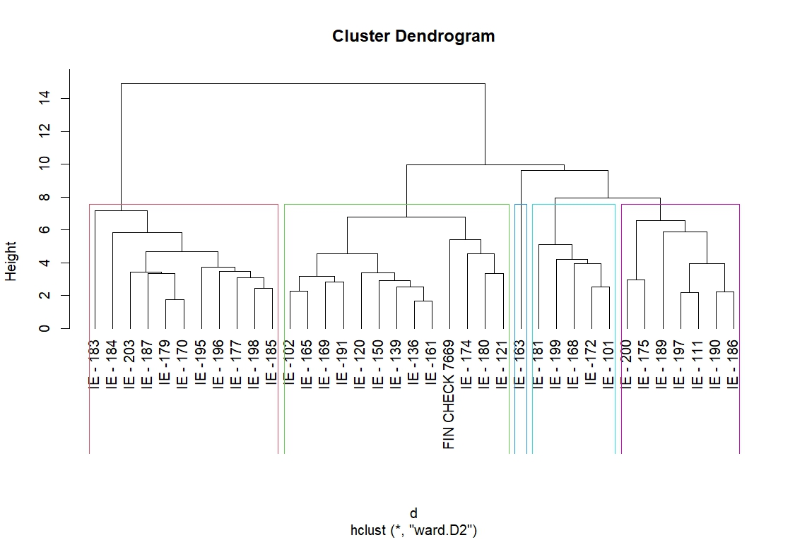
Figure 1 Dendrogram for grouping of finger millet genotypes by Tocher’s method
Table 3. Intra and inter-cluster distance (D²) among five clusters for thirty-seven genotypes in finger millet
Group | Cluster 1 | Cluster 2 | Cluster 3 | Cluster 4 | Cluster 5
Cluster 1 | 4.0016
Cluster 2 | 5.9318 | 3.7422
Cluster 3 | 5.73 | 4.7131 | 0
Cluster 4 | 4.7653 | 4.8371 | 4.941 | 3.9592
Cluster 5 | 8.35 | 7.7741 | 8.0428 | 7.477 | 4.137

Table 4. Cluster mean among five clusters for fourteen characters of thirty-seven genotypes in finger millet
Characters | Clusters
Characters | Cluster 1 | Cluster 2 | Cluster 3 | Cluster 4 | Cluster 5
DF50 | 62.17 | 69.67 | 60.78 | 72.33 | 75.65
DM | 88.5 | 109.65 | 100.37 | 107.59 | 108.9
PH | 103.75 | 120.01 | 90.54 | 96.76 | 114.5
NT | 3.67 | 3.2 | 3.31 | 3.1 | 3.27
FL | 6.26 | 10.18 | 5.7 | 6.39 | 6.61
FW | 1.09 | 0.99 | 1.1 | 1.12 | 1.14
EHL | 8.48 | 12.74 | 7.32 | 8.13 | 8.72
EHW | 5 | 4.16 | 4.6 | 4.71 | 5.52
FPE | 5.97 | 6.13 | 5.4 | 4.88 | 5.08
FPP | 5.47 | 3.33 | 4.08 | 3.88 | 3.74
BY | 44.57 | 32.61 | 38.7 | 35.58 | 46.55
HI | 22.42 | 31.68 | 28.04 | 28.9 | 21.41
TW | 3.52 | 3.49 | 3.49 | 2.97 | 3.29
GY (g) | 9.89 | 10.24 | 10.67 | 9.93 | 9.85

Cluster means
The cluster group means for fourteen characters across the five clusters is mentioned in Table 4. Considerable differences between clusters were observed for most of the characters studied. Cluster V had the greatest values for Days to 50% Flowering, Days to Maturity, Plant Height, Finger Width, Ear Head Width, and Biological Yield. Cluster II had the highest Mean Ear Head Length and Harvest Index. Cluster III had the lowest Days to 50% Flowering and Plant Height, but the highest Grain Yield. Cluster I had intermediate values for most features, with particularly strong performance in Fingers Per Ear and Fingers Per Plant. Cluster IV exhibited lower values in most attributes while maintaining a constant Harvest Index. The high yield-related qualities in Cluster V indicate that genotypes within this cluster could be useful resources for breeding programs aimed at increasing seed production. Earlier workers, Sahu and Pradhan (2012) and Nagaraja et al. (2023) also reported “wide variability among clusters for yield and most of the yield contributing characters”.
Relative contribution of different characters towards Genetic Divergence
The proportion of each character's contribution to total divergence is shown in Figure 2. Each character was ranked based on their percentage participation. Parents are selected based on their contribution to genetic divergence, as indicated by days to maturity (77.5%), followed by Plant height (3.8%). Similar results were reported by Sapkal et al. (2019) and Saundarya Kumari and Satish Kumar Singh (2015). The major trait contributing to the total divergence can be utilised as the criterion in selecting genetically diverse parents

Figure 2: Diagrammatic representation of the percentage contribution of each character towards genetic divergence in genotype

CONCLUSION
Using genetic diversity investigations, we can pick the most diverse genotypes for subsequent breeding. Genotypes from different clusters determined based on phenotypic features can be used in crop improvement programs to expand the genetic base of finger millet and select superior lines for segregating generations. Using genotypes with numerous superior features can facilitate the transmission of various traits/genes in breeding programs. The present investigation identified three finger millet genotypes, IE-190, IE-184, and IE-169, as the most divergent parents that might be used in future breeding programmes.

Disclaimer (Artificial intelligence)
Option 1:
Author(s) hereby declare that NO generative AI technologies such as Large Language Models (ChatGPT, COPILOT, etc.) and text-to-image generators have been used during the writing or editing of this manuscript.
Option 2:
Author(s) hereby declare that generative AI technologies such as Large Language Models, etc., have been used during the writing or editing of manuscripts. This explanation will include the name, version, model, and source of the generative AI technology and as well as all input prompts provided to the generative AI technology
Details of the AI usage are given below:
1.
2.
3.

REFERENCES
Arun PD, Selvi B and Govindaraj M. (2008). Genetic variability and multivariate analysis in finger millet (Eleusine coracana) germplasm for yield characters. Crop Research,36(1, 2 & 3):218-223.
Burton GW and Devane EM. (1953) Estimation of heritability in tall fescus (Festuca arundinacea) from replicated clonal material. Agronomy Journal. 45:478-480.
DIRECTORATE OF ECONOMICS AND STATISTICS, 2021, Agricultural statistics at a glance, Government of India.
Fisher R.A and Yates F. Statistical (1963) Tables for biological, agricultural and medical research. Oliver and Boyd, London.143.
Harti M, Gowda J, Mallikarjun K, Basavaraja T, and Vijayakumar L. (2013) Genetic diversity assessment for yield and its attributes characters of white seeded accession in finger millet (Eleusine coracana (L.) Gaertn). Environment and Ecology 31(2):740-744
Johnson HW, Robinson HF and Comstock RE. (1955) Estimates of genetic and environmental variability in soybean. Agronomy Journal. 47:413-418.
Mahalanobis, P. C. (1936). On the generalized distance in statistics. Proceedings of the National Institute of Sciences of India, 11(1), 49–55.
Mishra HP, Patnaik MC and Naik PK. (1980) Variation in quantitative traits in finger millet. Indian Journal of Agricultural Sciences, 50(4):298-301.
Nagaraja, T. E., Sujata Bhat and C. NandinI, (2023) Evaluation of genetic diversity in germplasm accessions of finger millet [Eleusine coracana (L.) Gaertn.]. Mysore Journal of Agricultural Sciences., 57 (2): 238 - 245.
Sahu S and Pradhan K. (2012) Genetic divergence in finger millet (Eleusine coracana (L.) Gaertn). Environment and Ecology .30(2):291-294.
Saleh, A. S. M., Zhang, Q., Chen, J., and Shen, Q. (2013). Millet grains: Nutritional quality, processing, and potential health benefits. Comprehensive Reviews in Food Science and Food Safety, 12(3), 281–295. https://doi.org/10.1111/1541-4337.12012
Sapkal SR, Bhavsar VV and Barhate KK. (2019) Genetic Divergence in Finger Millet (Eleusine coracana (L.) Gaertn.). International Journal of Current Microbiology and Applied Sciences,8(06):2230-2242.
Saundarya Kumari and Satish Kumar Singh, (2015) Assesment of genetic diversity in promising finger millet [Eleusine coracana (L.) Gaertn.] genotypes. The Bioscan, 10(2), 825–830.
Shobana, S., Krishnaswamy, K., Sudha, V., and Malleshi, N. G. (2013). Finger millet (Eleusine coracana): A review of its nutritional properties, processing, and plausible health benefits. Advances in Food and Nutrition Research, 69, 1–39. https://doi.org/10.1016/B978-0-12-410540-9.00001-6
Shweta, S., Prasanna, R., Arora, D., and Kumar, P. (2022). Genetic diversity studies in finger millet (Eleusine coracana L.) using Mahalanobis D² statistics. The Pharma Innovation Journal, 11(3), 1090–1093. https://www.thepharmajournal.com/
Supriya, P., Singode, A., Reddy, D. M., Ronda, V., Nayak, D. S., & Reddisekhar, M. (2024). Multi-trait Analysis and Clustering of Forage Pearl Millet Genotypes in Semi-arid Conditions. Journal of Advances in Biology & Biotechnology, 27(11), 1602–1613.
Gebreyohannes, A., Shimelis, H., Mashilo, J., Odeny, D. A., Tadesse, T., & Ojiewo, C. O. (2024). Finger millet (Eleusine coracana) improvement: Challenges and prospects—A review. Plant Breeding, 143(3), 350-374.
Huq, Z. U., Vasanthi, B. G., Mudalagiriyappa, Sneha, M. A., Harish, M. C., Devaraja, K., ... & Singh, V. K. (2025). Nano nutrient foliar application: impacts on yield, quality, and nutrient efficiency in dryland finger millet. Journal of Plant Nutrition and Soil Science, 188(2), 350-365.
Singh, A. K., Kumar, D., Gemmati, D., Ellur, R. K., Singh, A., Tisato, V., ... & Singh, A. V. (2024). Investigating genetic diversity and population structure in rice breeding from association mapping of 116 accessions using 64 polymorphic SSR markers. Crops, 4(2), 180-194.

