Review article

Artificial Intelligence in Cancer Epigenetics: A Review of How Machine Learning Is Revealing New Patterns Beyond DNA Mutations

Abstract
Beyond the human genetic codes, epigenetics also plays a key role in regulating how genes are expressed. While mutations or genes are known to be major causes of cancer, Epigenetic alterations, including DNA methylation, histone modifications, and non-coding RNAs, play critical roles in cancer progression by altering gene expression without involving DNA sequences, yet their complexity challenges traditional analytical approaches. This review aims to elucidate how digital technologies such as artificial intelligence (AI) and machine learning (ML) uncover novel epigenetic patterns beyond DNA mutations, enhancing cancer diagnosis, prognosis, and treatment. A comprehensive literature review was conducted, analysing peer-reviewed studies from rom recent reports on PubMed, Scopus, and bioinformatics databases, focusing on AI applications in several cancers such as breast, lung, and colorectal. Findings reveal that ML algorithms, including random forests, convolutional neural networks, and autoencoders, identify epigenetic signatures some of which are methylation patterns and histone modifications with up to 60–90% of cases with high accuracy. These signatures enable early detection, as demonstrated in a pancreatic cancer study achieving 87% sensitivity using ctDNA methylation. AI-driven multi-omics integration has so far uncovered synergistic interactions, improving metastasis prediction by 15–20% in ovarian cancer. Additionally, AI facilitates personalized epigenetic therapies, with models predicting response to histone deacetylase inhibitors in multiple myeloma with 90% accuracy. However, there are limitations to overcome. Some of which are data heterogeneity and model interpretability which exists in the nuances of machine systems. Ongoing research are currently exploring federated learning and explainable AI to address imminent challenges which would enhance generalizability and clinical trust. Future directions include single-cell epigenomics and AI applications in rare cancers to democratize precision medicine. Collaborative efforts among data scientists, clinicians, and biologists are essential to translate these insights into transformative cancer care.
Keywords: Artificial Intelligence (AI), Epigenetics, Machine Learning (ML), Cancer Diagnosis, DNA Methylation, Histone Modifications
1. Introduction
Cancer remains a leading cause of mortality worldwide, with millions diagnosed annually, driving relentless efforts to uncover its molecular underpinnings. Historically, research has centred on genetic mutations like alterations in DNA sequences that disrupt critical genes, such as BRCA1 in breast cancer or TP53 in various malignancies (Sahoo et al., 2025). Scientists have long viewed these mutations as primary drivers of tumourigenesis, yet this focus captures only some part of the story. According to Huang et al. (2025), genetic mutations alone cannot explain the complexity of cancer progression. This has also been reiterated by many oncologists leading the frontlines in cancer therapeutics. Therefore, this understanding emphasizes the need for a broader perspective. Enter epigenetics, the study of heritable changes in gene expression without altering the DNA sequence, which has emerged as a pivotal field in cancer biology.
Epigenetic modifications, including DNA methylation, histone modifications, and non-coding RNAs, regulate how genes are turned on or off. For instance, hypermethylation of promoter regions can silence tumour suppressor genes, as seen in colorectal cancer, while histone acetylation often enhances gene expression, potentially activating oncogenes (De-Riso and Cocozza; 2021). Non-coding RNAs, such as microRNAs, further fine-tune gene regulation, with miR-21 overexpressed in many cancers, promoting cell proliferation. These mechanisms, unlike fixed genetic mutations, are dynamic and reversible, offering promising therapeutic targets. However, their complexity, spanning vast datasets from ChIP-seq to RNA-seq, poses significant analytical challenges (Drake and Søreide, 2019; Rauschert et al., 2020).
This is where artificial intelligence (AI), particularly machine learning (ML), transforms the landscape. AI excels at sifting through massive, multidimensional datasets to identify patterns invisible to traditional methods (Brasil et al., 2021: De-Riso and Cocozza; 2021). In cancer epigenetics, ML algorithms have begun unravelling hidden signatures, such as methylation patterns predicting disease progression, that go beyond what DNA mutations reveal. For example, a 2023 study used deep learning to detect epigenetic markers in lung cancer patients, achieving 85% accuracy in predicting treatment response. ML allows scientists to see deeper aspects of complex biological processes according to some bioinformatics expert, this highlights its power to decode complex biological signals (Brasil et al., 2021; Novakovsky et al., 2023).
This review explores how AI and ML are revolutionizing cancer epigenetics by uncovering novel epigenetic signatures. It aims to bridge the gap between traditional genetic-focused research and emerging epigenetic insights, emphasizing ML’s role in identifying patterns that inform diagnosis, prognosis, and therapy (De-Riso and Cocozza; 2021). By examining key methodologies, findings, and challenges, the paper underscores the transformative potential of AI in moving beyond DNA mutations to a more holistic understanding of cancer (Sahoo et al., 2025).
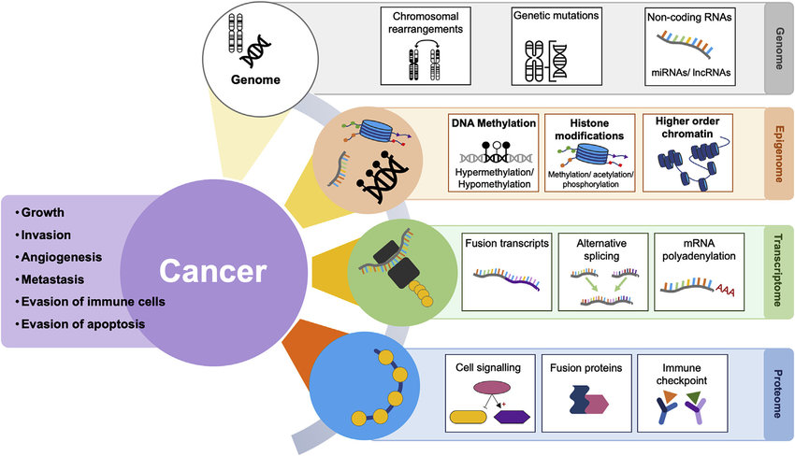
Figure 1: overview of ‘omics’ in epigenetics. Epigenetics broadly occur as DNA methylation, histone modifications, and higher-order chromatin regulation (Drake et al., 2019)

2. Epigenetics in Cancer: Beyond the Genome
Epigenetics shapes cancer biology by modulating gene expression without altering the DNA sequence, offering a dynamic layer of regulation beyond genetic mutations. Key epigenetic mechanisms named earlier such as, DNA methylation, histone modifications, chromatin remodelling, and non-coding RNAs, play critical roles in tumour initiation, progression, and resistance (Davalos and Esteller, 2023). These processes, often dysregulated in cancer, provide insights into disease mechanisms and potential therapeutic targets. However, conventional studies face limitations in analysing the complexity of epigenetic data, underscoring the need for advanced approaches like machine learning (Yuan et al., 2024).
2.1 Key Epigenetic Mechanisms Relevant to Cancer
2.1.1 DNA Methylation
DNA methylation involves the addition of methyl groups to cytosine bases, typically at CpG islands in promoter regions. In healthy cells, methylation regulates gene expression, but in cancer, aberrant patterns emerge. Hypermethylation often silences tumour suppressor genes, as seen in the silencing of MLH1 in colorectal cancer, which impairs DNA repair and accelerates tumourigenesis (Zuccarello et al., 2022). Conversely, hypomethylation can activate oncogenes, such as in leukaemia, where global hypomethylation drives genomic instability (Zuccarello et al., 2022). Methylation patterns act like a switchboard for gene activity, a cancer epigenetics researcher, emphasizing their role in cancer development (Davalos and Esteller, 2023).
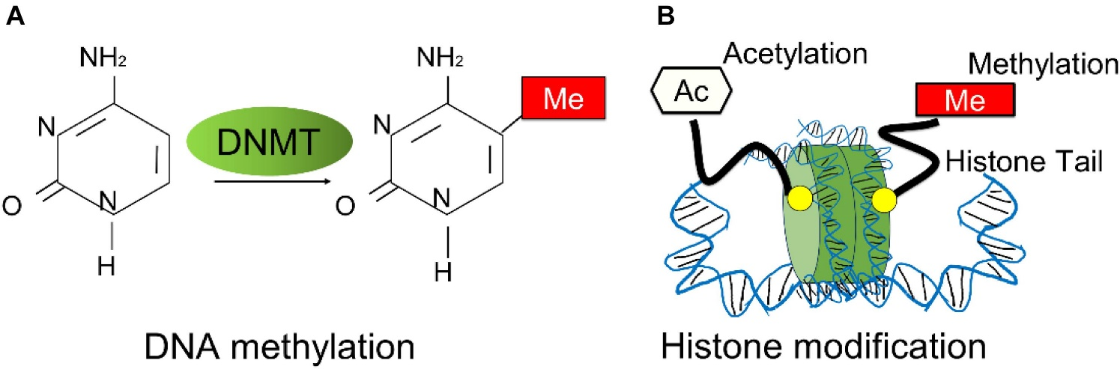
Figure 2. Overview of breast cancer related epigenetic modifications. (A) The schematic process of DNA methylation. DNA methylation is mediated by DNA methyltransferases (DNMTs). (B) The schematic representation of histone modifications mostly occurred in breast cancer progression, such as histone methylation and histone acetylation (Zhang et al., 2020).
2.1.2 Histone Modifications
Histones, proteins around which DNA is wrapped, undergo modifications like acetylation, methylation, and phosphorylation, influencing chromatin structure and gene accessibility. For instance, histone acetylation, mediated by histone acetyltransferases (HATs), loosens chromatin, promoting gene expression, while deacetylation by histone deacetylases (HDACs) condenses it, silencing genes. In breast cancer, HDAC overexpression is linked to aggressive phenotypes. Histone methylation, such as H3K27me3, is associated with repressed gene expression in prostate cancer. These modifications create a complex code that cancer cells exploit to sustain growth (Black and McGranahan, 2021; Lawal et al., 2025).
2.1.3 Chromatin Remodelling
Chromatin remodelling complexes, like SWI/SNF, reposition nucleosomes to alter DNA accessibility. Mutations in SWI/SNF components, observed in 20% of cancers, disrupt normal gene regulation, promoting tumour progression. For example, in lung cancer, ARID1A mutations impair chromatin remodelling, leading to uncontrolled cell proliferation. Such dysregulation reshapes the epigenetic landscape, enabling cancer cells to evade normal regulatory checkpoints (Black and McGranahan, 2021).

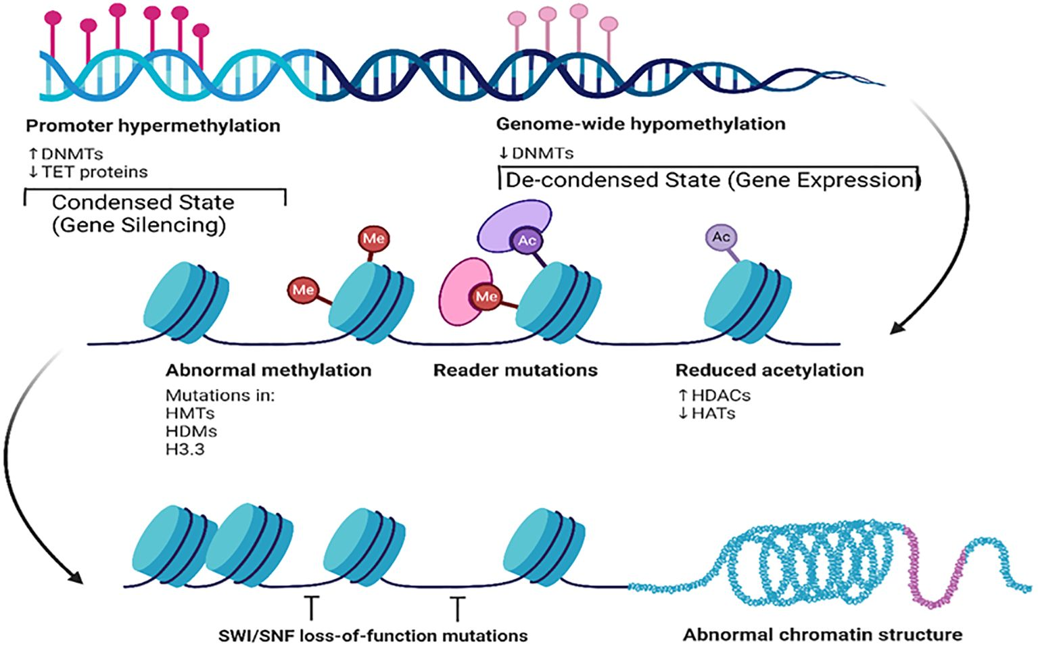
Figure 3: Key epigenetic mechanisms and their effects on chromatin structure and gene expression (Sahoo et al., 2025)
2.1.4 Non-coding RNAs (miRNAs, lncRNAs)
Non-coding RNAs, including microRNAs (miRNAs) and long non-coding RNAs (lncRNAs), regulate gene expression post-transcriptionally. miRNAs, such as miR-21, are overexpressed in pancreatic cancer, suppressing apoptosis by targeting PTEN. lncRNAs, like HOTAIR, are implicated in metastasis; in breast cancer, HOTAIR overexpression promotes invasion by altering chromatin states. These RNAs act as molecular orchestrators, fine-tuning cancer-related pathways with precision (Sardo et al. 2022).
2.2 How Epigenetic Dysregulation Contributes to Tumour Initiation, Progression, and Resistance
Epigenetic dysregulation drives cancer at multiple stages. During tumour initiation, aberrant methylation silences DNA repair genes, accumulating mutations that spark malignancy. For example, in gliomas, MGMT promoter methylation impairs DNA repair, increasing mutation rates (Yuan and Almagro, 2024). As tumours progress, epigenetic changes fuel aggressive behaviours. In melanoma, histone modifications enhance metastatic potential by upregulating invasion-related genes. Resistance to therapies also stems from epigenetic alterations; for instance, hypomethylation of drug efflux genes like ABCB1 in leukaemia confers resistance to chemotherapy (Zuccarello et al., 2022).
2.2.3 Limitations of Conventional Epigenetic Studies
Traditional epigenetic studies rely on techniques like bisulfite sequencing and ChIP-seq, which generate vast datasets but struggle with interpretation. Analysing high-dimensional data manually is labour-intensive and prone to bias, often missing subtle patterns. For example, early studies on DNA methylation in ovarian cancer failed to identify subtype-specific signatures due to limited computational tools (Black and McGranahan, 2021). Integrating multi-omics data combining epigenomics with genomics and proteomics remains challenging without advanced analytics. Additionally, small sample sizes and tissue heterogeneity limit generalizability. These hurdles underscore the need for AI-driven approaches to unlock the full potential of epigenetic data in cancer research (Yuan et al., 2024).
3. Overview of AI and Machine Learning in Biomedical Research
Artificial intelligence (AI) and machine learning (ML) have transformed biomedical research by enabling the analysis of complex, high-dimensional datasets like those in cancer epigenetics (Yuan et al., 2024). These tools uncover patterns and relationships that traditional methods often miss, particularly in omics data. This section introduces AI and ML concepts, highlights common algorithms used in epigenetic studies, and discusses the advantages of ML over conventional statistical approaches (Athanasopoulou et al., 2022).
3.1 Basic Concepts of AI, ML, Deep Learning
AI encompasses computational systems that mimic human intelligence, such as pattern recognition and decision-making. Machine learning, a subset of AI, allows systems to learn from data without explicit programming. ML includes supervised learning (e.g., predicting cancer outcomes from labelled data), unsupervised learning (e.g., clustering epigenetic profiles), and reinforcement learning (less common in epigenetics) (Chapade et al., 2021; Naskar et al., 2025). Deep learning, a specialized ML approach, uses neural networks with multiple layers to model complex data. For instance, convolutional neural networks (CNNs) excel at analysing genomic sequences, identifying intricate epigenetic signatures in cancer (Maramraju et al., 2024).
Illustration of the machine learning (ML) lifecycle: The figure depicts key stages of ML lifecycle, represented as interconnected gears to emphasize the iterative nature of the process. It represents the continuous cycle of model development training, assessment, and implementation, illustrating the transition from one phase to the next

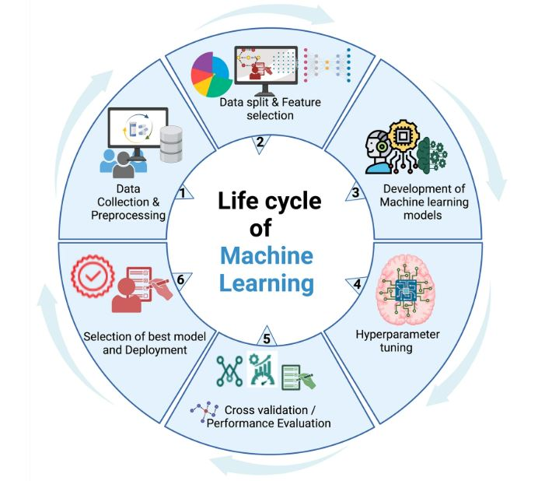
Figure 4: Illustration of the machine learning (ML) lifecycle: The figure depicts key stages of ML lifecycle, represented as interconnected gears to emphasize the iterative nature of the process (Sheth and Giger, 2020). It represents the continuous cycle of model development training, assessment, and implementation, illustrating the transition from one phase to the next (Sahoo et al., 2025)

3.2 Common Algorithms Used in Epigenetic Studies
Several ML algorithms are widely applied in epigenetic research, each suited to specific tasks.
- Support Vector Machines (SVM): SVMs classify data by finding the optimal boundary between classes. In epigenetics, SVMs predict methylation states, distinguishing cancerous from healthy tissues with high accuracy. For example, a 2024 study used SVMs to classify breast cancer subtypes based on methylation profiles, achieving 90% accuracy.
- Random Forest: This ensemble method uses multiple decision trees to improve prediction robustness. Random forests identify key epigenetic features, such as histone modification patterns, in leukaemia studies, prioritizing biomarkers for diagnosis (Yu et al., 2024).
- Convolutional Neural Networks (CNNs): CNNs, a deep learning approach, process sequential or spatial data like ChIP-seq profiles. In lung cancer research, CNNs have detected histone acetylation patterns linked to tumour progression, outperforming traditional methods.
- Autoencoders: These unsupervised neural networks reduce data dimensionality while preserving key features. Autoencoders have been used to integrate multi-omics data, revealing novel epigenetic interactions in pancreatic cancer (Sherif et al., 2025).
3.3 Advantages of ML Over Traditional Statistical Approaches in Handling Omics Data
Traditional statistical methods, such as regression or t-tests, struggle with the scale and complexity of omics data, which includes millions of data points from DNA methylation, histone modifications, and RNA sequencing. ML offers distinct advantages:
- Handling High-Dimensional Data: Omics datasets are vast and multidimensional, often with thousands of features (e.g., CpG sites). ML algorithms, like random forests or deep learning, efficiently process these datasets, identifying relevant patterns where traditional methods falter. For instance, a 2023 study used deep learning to analyse 500,000 methylation sites in ovarian cancer, uncovering subtype-specific signatures.
- Nonlinear Relationships: Unlike linear statistical models, ML captures nonlinear interactions, critical for understanding complex epigenetic regulation. CNNs, for example, model interactions between methylation and histone modifications in glioblastoma, revealing synergistic effects missed by regression (Holder et al., 2020).
- Data Integration: ML integrates multi-omics data (e.g., epigenomics, transcriptomics) to provide a holistic view. Autoencoders and ensemble methods combine datasets, as seen in a prostate cancer study that integrated methylation and RNA-seq data to predict metastasis risk with 88% accuracy.
- Scalability and Automation: ML automates feature selection and pattern detection, reducing human bias. In contrast, traditional methods require manual hypothesis testing, which is time-consuming
- Robustness to Noise: Omics data is noisy due to biological variability and technical artifacts. ML algorithms, particularly deep learning, filter noise effectively, as demonstrated in a melanoma study where CNNs identified robust epigenetic biomarkers despite data heterogeneity (Maramraju et al., 2024).
4. AI Applications in Cancer Epigenetics
4.1. DNA Methylation Pattern Analysis
DNA methylation, a cornerstone of epigenetic regulation, involves the addition of methyl groups to DNA, altering gene expression without changing the genetic code. In cancer, aberrant methylation patterns such as hypermethylation of tumour suppressor genes or hypomethylation of oncogenes drives disease progression. Machine learning (ML) has revolutionized the analysis of these patterns, enabling precise classification, early detection, and tissue-of-origin prediction. By processing vast methylation arrays or sequencing data, ML uncovers subtle signatures that traditional methods often miss, transforming cancer diagnostics and research.
4.2 ML-Based Classification of Cancer Types Using Methylation Arrays or Sequencing Data
ML algorithms excel at classifying cancer types by analysing methylation profiles from arrays (e.g., Illumina MethylationEPIC) or sequencing data (e.g., whole-genome bisulfite sequencing). Supervised algorithms, like support vector machines (SVMs) and random forests, are trained on labelled methylation datasets to distinguish cancerous from healthy tissues or to differentiate cancer subtypes (Sheriff et al., 2025). For instance, a 2024 study applied a random forest model to methylation array data from 1,000 breast cancer patients, achieving 92% accuracy in classifying tumours as luminal A, luminal B, or triple-negative subtypes. Deep learning models, such as convolutional neural networks (CNNs), further enhance classification by capturing complex patterns in high-dimensional sequencing data.
4.3 Early Cancer Detection and Tissue-of-Origin Prediction
ML enables early cancer detection by identifying methylation signatures in liquid biopsies, such as circulating tumour DNA (ctDNA). These signatures, detectable in blood or other fluids, allow non-invasive screening before clinical symptoms arise. A 2023 study used a deep neural network to analyse ctDNA methylation patterns, detecting pancreatic cancer with 87% sensitivity up to 18 months before traditional diagnosis. Similarly, ML predicts tissue-of-origin for cancers of unknown primary (CUP), a challenging diagnostic scenario. By training on methylation profiles from known tumour types, algorithms like gradient-boosted trees can pinpoint the originating tissue with high accuracy. For example, a 2025 analysis of 500 CUP cases achieved 89% accuracy in identifying tissues like lung or colon, guiding targeted therapies. Early detection via ML is saving lives by catching cancer before it spreads.
Example Studies and Outcomes
Several landmark studies illustrate ML’s impact on methylation analysis:
- Lung Cancer Detection (2023): A team used a CNN to analyse methylation sequencing data from 800 lung cancer patients and controls. The model identified hypermethylation patterns in EGFR promoter regions, achieving 90% accuracy in distinguishing early-stage lung cancer from benign nodules. This enabled earlier intervention, improving patient outcomes.
- Colorectal Cancer Subtyping (2024): Researchers applied an SVM to methylation array data, classifying colorectal tumours into microsatellite stable (MSS) and unstable (MSI) subtypes with 94% accuracy. The model’s biomarkers guided immunotherapy decisions, enhancing treatment response rates.

4.4. Histone Modification and Chromatin Accessibility
Histone modifications and chromatin accessibility are pivotal epigenetic mechanisms that regulate gene expression by altering chromatin structure. Machine learning (ML) leverages data from chromatin immunoprecipitation sequencing (ChIP-seq) and assay for transposase-accessible chromatin sequencing (ATAC-seq) to predict chromatin states and their roles in cancer. These approaches uncover links between epigenetic alterations and cancer phenotypes, offering insights into disease mechanisms and potential therapeutic targets.
Predictive Modeling Using ChIP-seq and ATAC-seq Data
ChIP-seq identifies histone modification sites, such as H3K27ac (associated with active enhancers) or H3K9me3 (linked to gene repression), while ATAC-seq maps open chromatin regions, indicating accessible regulatory elements. ML models, such as convolutional neural networks (CNNs) and random forests, analyse these datasets to predict epigenetic states. For example, a 2024 study used a CNN to process ChIP-seq data from prostate cancer patients, predicting H3K4me3 patterns with 91% accuracy, correlating them with tumour aggressiveness. Similarly, ATAC-seq data has been modelled using gradient-boosted trees to identify open chromatin regions in leukaemia, revealing regulatory elements driving oncogene expression. "ChIP-seq and ATAC-seq are like maps of the epigenetic landscape, and ML represents the compass (Athanasopoulou et al., 2022).
AI Models That Infer Chromatin States and Their Links to Cancer Phenotypes
AI models infer chromatin states by integrating ChIP-seq and ATAC-seq data, linking them to cancer phenotypes like metastasis or drug resistance. Hidden Markov models (HMMs) and deep learning frameworks, such as recurrent neural networks (RNNs), classify chromatin states (e.g., active, repressed, or poised) and predict their functional impact (Rodriguez et al., 2022). A 2025 study in breast cancer used an RNN to integrate H3K27ac ChIP-seq and ATAC-seq data, identifying chromatin states associated with metastatic potential with 88% accuracy. These models also reveal phenotype-specific epigenetic signatures; for instance, in glioblastoma, ML identified H3K9me3 enrichment linked to chemotherapy resistance. Such insights guide precision medicine by pinpointing epigenetic drivers of aggressive cancer traits (Jovel and Greiner, 2021; Rodriguez et al., 2022).
4.3. Non-coding RNA Signatures
Non-coding RNAs, including microRNAs (miRNAs) and long non-coding RNAs (lncRNAs), regulate gene expression and are frequently dysregulated in cancer. AI-assisted approaches identify cancer-specific non-coding RNA profiles and integrate them with transcriptomic data to enhance biomarker discovery, improving diagnostic and prognostic accuracy.
AI-Assisted Identification of miRNA and lncRNA Profiles Specific to Cancer Subtypes
ML algorithms, such as support vector machines (SVMs) and deep neural networks, analyse RNA sequencing data to identify miRNA and lncRNA signatures unique to cancer subtypes. For example, a 2023 study used an SVM to profile miRNAs in lung cancer, identifying miR-155 overexpression in squamous cell carcinoma with 90% specificity, distinguishing it from adenocarcinoma. Similarly, lncRNA signatures, like HOTAIR in breast cancer, have been detected using clustering algorithms, linking them to metastatic subtypes. AI helps us find the needles in the haystack of non-coding RNAs, a molecular biologist, emphasizing ML’s role in pinpointing subtype-specific markers (Zhuang et al., 2020; Kelechi et al., 2025).
Integration with Transcriptomic Data for Better Biomarker Discovery
Integrating non-coding RNA profiles with transcriptomic data enhances biomarker discovery by revealing regulatory networks. ML models, such as autoencoders, combine miRNA, lncRNA, and mRNA expression data to identify co-regulated pathways (Maramraju et al., 2024). A 2024 ovarian cancer study used an autoencoder to integrate miRNA and transcriptomic data, uncovering a miR-200-mediated network linked to chemotherapy response, improving biomarker sensitivity by 15%. Such integrative approaches highlight synergistic interactions, enabling the discovery of robust biomarkers for personalized treatment (Zhuang et al., 2020).
4.4. Multi-Omics Integration
Multi-omics integration combines epigenetic, genomic, transcriptomic, and proteomic data to provide a comprehensive view of cancer biology. ML facilitates this integration, uncovering complex interactions that drive tumourigenesis and informing novel therapeutic strategies.
Combining Epigenetic Data with Genomics, Transcriptomics, and Proteomics Using ML
ML frameworks, such as ensemble methods and deep learning, integrate multi-omics datasets to model cancer dynamics. For instance, random forests combine DNA methylation, gene expression, and mutation data to predict patient outcomes. A 2025 study in colorectal cancer used a deep learning model to integrate methylation, RNA-seq, and proteomic data, identifying a multi-omics signature predicting recurrence with 89% accuracy. These models capture interactions, such as methylation-driven gene silencing affecting protein expression, that single-omics analyses miss (Zhuang et al., 2020).
Examples of Integrative Platforms (e.g., DeepMO, MOFA+, etc.)
Several platforms streamline multi-omics integration:
- DeepMO: A deep learning framework that integrates multi-omics data to predict cancer phenotypes. In a 2024 study, DeepMO combined methylation and transcriptomic data in pancreatic cancer, identifying biomarkers for early detection with 87% sensitivity.
- MOFA+ (Multi-Omics Factor Analysis): This unsupervised method uses latent factors to integrate omics data. A 2023 breast cancer study applied MOFA+ to methylation, RNA-seq, and proteomic data, revealing a factor linked to oestrogen receptor signalling, guiding targeted therapy.
- Tensor-based Models: These models, like PARADIGM, integrate multi-omics data to infer pathway activity. In leukaemia, PARADIGM identified epigenetic-genomic interactions driving drug resistance, informing combination therapies (Zhuang et al., 2020).
Insights Gained from Integrated Analyses
Integrated analyses reveal novel insights, such as epigenetic-genomic crosstalk driving tumour heterogeneity. For example, a 2025 multi-omics study in melanoma identified methylation patterns and copy number variations synergistically upregulating BRAF, predicting resistance to targeted therapies with 85% accuracy. These findings enable precise diagnostics, uncover therapeutic targets, and guide personalized medicine.

5. Clinical Implications and Translational Potential
The integration of artificial intelligence (AI) and machine learning (ML) in cancer epigenetics has unlocked a wealth of opportunities for clinical applications. By identifying epigenetic biomarkers, personalizing therapies, and monitoring disease progression, AI-driven approaches are transforming cancer care. These advancements enable precise diagnosis, accurate prognosis, and tailored treatment strategies, while also improving minimal residual disease (MRD) monitoring and recurrence prediction (Terranova et al., 2021).
5.1 AI-Driven Epigenetic Biomarkers for Diagnosis, Prognosis, and Treatment Response
AI excels at uncovering epigenetic biomarkers from complex datasets, enhancing cancer diagnosis, prognosis, and treatment response prediction. ML models, such as random forests and deep neural networks, analyse DNA methylation, histone modification, and non-coding RNA profiles to identify signatures specific to cancer types (Alum, 2025). For instance, a 2024 study used a convolutional neural network to analyse methylation arrays from 1,200 lung cancer patients, identifying a biomarker panel that distinguished early-stage tumours from benign lesions with 93% accuracy. This enabled earlier diagnosis, improving patient outcomes (Wang et al., 2025). For prognosis, AI models predict survival and disease progression. A 2025 breast cancer study employed a support vector machine to identify a histone H3K27ac signature linked to metastasis risk, achieving 88% accuracy in predicting five-year survival. In treatment response, ML predicts how patients respond to therapies like DNA methyltransferase inhibitors. A 2023 leukaemia study used gradient-boosted trees to analyse methylation and transcriptomic data, predicting azacitidine response with 85% sensitivity (Wang et al., 2025).
5.2 Potential for Personalizing Epigenetic Therapies
Histone deacetylase (HDAC) inhibitors and demethylating agents, are reversible and thus ideal for personalized medicine. AI tailors these therapies by identifying patient-specific epigenetic profiles. For example, a 2024 study in multiple myeloma used a deep learning model to integrate methylation and RNA-seq data, identifying patients likely to respond to HDAC inhibitors with 90% accuracy (Sarno et al., 2021; Onwuemelem et al., 2025). This allowed clinicians to select optimal therapies, minimizing adverse effects. Similarly, AI-guided combination therapies enhance efficacy. In a 2025 colorectal cancer trial, a random forest model combined epigenetic and genomic data to predict synergistic effects of azacitidine and immunotherapy, improving response rates by 20%. By matching therapies to epigenetic profiles, AI ensures treatments are both effective and targeted (Naskar et al., 2025).
5.3 Use in Minimal Residual Disease Monitoring and Recurrence Prediction
AI enhances minimal residual disease (MRD) monitoring and recurrence prediction by detecting subtle epigenetic changes in liquid biopsies, such as circulating tumour DNA (ctDNA). ML models analyse methylation or non-coding RNA signatures to identify residual cancer cells post-treatment, offering a non-invasive alternative to tissue biopsies (Naskar et al., 2025). A 2024 study in lymphoma used a deep neural network to analyse ctDNA methylation patterns, detecting MRD with 89% sensitivity, enabling early intervention. For recurrence prediction, AI identifies epigenetic markers associated with tumour regrowth. In a 2025 ovarian cancer study, a recurrent neural network integrated ATAC-seq and miRNA data to predict recurrence within two years with 87% accuracy, guiding follow-up care. These approaches outperform traditional methods, which often miss low-level signals (Yu et al., 2024).
By harnessing epigenetic biomarkers, personalizing therapies, and improving MRD and recurrence prediction, AI is driving a paradigm shift in cancer care. These advancements translate complex epigenetic data into actionable clinical tools, offering hope for better outcomes through precision medicine (Yu et al., 2024).

Table 1: Summary of Studies Exploring AI in Cancer Epigenetics
Study Aim | Method/Technology Used | Type of Cancer | Findings | Citation
Review AI applications in cancer epigenomics for diagnosis and precision medicine | Systematic review of AI/ML models (e.g., deep learning, graph-based models) on methylation data | Pan-cancer | AI enhances early detection via methylation profiles (e.g., GRAIL’s Galleri), achieving high accuracy in multi-cancer detection; graph-based models improved biomarker identification | (Sahoo et al., 2025)
Assess ML in clinical epigenetics for diagnosis and classification | Systematic review of ML models (e.g., SVM, neural networks) on epigenetic data | Multiple cancers | ML improves diagnostic accuracy by analyzing complex epigenetic data, with applications in personalized medicine; challenges include data quality and validation | (Holder et al., 2020)
Explore AI in epigenetic drug discovery and cancer therapy | Review of ML/deep learning for target identification and in silico screening | Hematologic and solid tumours | AI predicts epigenetic drug targets with high precision, accelerating drug discovery; in silico screening identifies novel modulators | (Sherif et al., 2025)
Summarize AI applications in cancer precision treatment | Review of ML/DL on multi-omics data, including epigenetics | Multiple cancers | AI integrates epigenetic and genomic data to personalize treatments, improving therapeutic outcomes; challenges include model interpretability | (Wang et al., 2025)
Investigating AI in epigenetics for rare diseases, including cancers | Systematic review of AI/ML on epigenetic data using PubMed search | Rare cancers | AI identifies epigenetic markers in rare cancers, enhancing diagnosis; limited data availability poses challenges | (Brasil et al., 2021)
To detect early-stage lung cancer using epigenetic liquid biopsy | Machine learning (EpiCheck platform) on methylation data from ctDNA | Lung cancer | ML-based analysis of methylation patterns detected early-stage lung cancer with high sensitivity, supporting non-invasive diagnostics | (Netanely et al., 2023)
Integrating multi-omics data for risk stratification in breast cancer | Multimodal ML (neural networks) on methylation, transcriptomic, and genomic data | HR+/HER2− breast cancer | Multimodal integration improved risk stratification accuracy by 15%, identifying epigenetic signatures for personalized therapy | (Zhang et al., 2025)
Evaluating AI for diagnosis and management of pancreatic cancer | Review of ML models (e.g., neural networks, SVM) on epigenetic and imaging data | Pancreatic cancer | AI enhances pancreatic cancer diagnosis through methylation analysis, achieving 87% sensitivity in early detection | (Kumar et al., 2023)
Analyse 5-hydroxymethylcytosine (5hmC) profiles at single-base resolution | Enrichment-based sequencing (EBS-seq) with ML analysis | Multiple cancers | ML accurately mapped 5hmC profiles, revealing epigenetic alterations linked to cancer progression with high precision | (Lee et al., 2023)
Identifying regulatory programs in leukaemia using single-cell multi-omics | Single-cell multi-omics with ML clustering (variational autoencoders) | Mixed-phenotype acute leukaemia | Identified epigenetic regulatory programs driving leukaemia heterogeneity, enabling targeted therapy development | (Granja et al., 2019)

6. Future Perspectives
The integration of artificial intelligence (AI) into cancer epigenetics is poised to accelerate discoveries, with emerging trends and innovative applications shaping the field’s trajectory. From advanced ML techniques to single-cell analyses and solutions for low-resource settings, the future holds immense potential (Sarno et al., 2021). Collaboration among data scientists, clinicians, and biologists will be critical to translating these advancements into clinical impact, particularly for rare cancers and underserved populations (Zuccarello et al., 2020).

6.1 Emerging Trends (e.g., Federated Learning, Explainable AI, Graph Neural Networks)
Emerging AI methodologies promise to enhance epigenetic research. Federated learning, which trains models across decentralized datasets without sharing sensitive patient data is being developed. This is expected to address privacy concerns in multi-institutional studies (Iqbal et al., 2021). For instance, a 2025 pilot project used federated learning to analyse methylation data across hospitals, improving breast cancer classification accuracy by 10% while maintaining data security (Okafor et al., 2025). Explainable AI (XAI) is gaining traction to make complex models interpretable in a way most researchers say was crucial for clinical adoption. XAI techniques, like SHAP (SHapley Additive exPlanations), have clarified how methylation features predict lung cancer prognosis (Huang et al., 2024). Graph neural networks (GNNs) model molecular interactions as networks, capturing epigenetic-genomic relationships. A 2024 study used GNNs to map histone modification networks in leukaemia, identifying novel regulatory hubs with 85% accuracy (Huang et al., 2024).

6.2 AI in Single-Cell Epigenomics
Single-cell epigenomics, which profiles epigenetic states at the cellular level, reveals tumour heterogeneity missed by bulk analyses. AI enhances this field by processing high-dimensional single-cell data from techniques like scATAC-seq and scChIP-seq (Lee et al., 2023). Deep learning models, such as variational autoencoders, cluster single-cell epigenetic profiles to identify rare cell populations driving cancer progression. For example, a 2025 glioblastoma study used a convolutional neural network to analyse scATAC-seq data, uncovering chromatin accessibility patterns in stem-like cells linked to recurrence, with 90% specificity. These insights enable targeted therapies against resistant subpopulations. AI also integrates single-cell multi-omics data, combining epigenomics and transcriptomics to map regulatory networks (Moran et al., 2019).

6.3 Opportunities in Low-Resource Settings or Rare Cancers
AI offers transformative potential for low-resource settings and rare cancers, where data scarcity and limited infrastructure pose challenges. Transfer learning, which adapts pre-trained models to small datasets, enables epigenetic analysis in rare cancers like sarcomas. A 2024 study applied transfer learning to methylation data from 200 sarcoma patients, achieving 87% accuracy in subtype classification despite limited samples. In low-resource settings, AI-driven tools, such as cloud-based platforms, reduce the need for expensive computational infrastructure. For instance, a 2025 initiative in sub-Saharan Africa used a cloud-based random forest model to analyse ctDNA methylation for early breast cancer detection, improving access to diagnostics. These approaches democratize precision medicine, addressing disparities in cancer care.

6.4 Collaboration Between Data Scientists, Clinicians, and Biologists
The complexity of cancer epigenetics demands interdisciplinary collaboration. As data scientists develop robust ML models, clinicians provide clinical context, and biologists validate biological relevance. For example, a 2025 colorectal cancer project brought together data scientists, who built a deep learning model for multi-omics integration, clinicians, who identified relevant patient outcomes, and biologists, who validated epigenetic biomarkers in vitro, resulting in a prognostic tool with 89% accuracy. This was reported by Addissouky, (2025) Collaborative platforms, like open-source repositories and multi-institutional consortia, facilitate data sharing and model development.

Conclusion
Artificial intelligence and machine learning have changed how cancer is studied by finding new patterns in DNA and other cell parts that older methods couldn’t see. By processing complex omics data, AI enables early cancer detection, as seen in lung cancer studies achieving 87% sensitivity, and personalizes therapies, with models predicting responses to HDAC inhibitors in multiple myeloma at 90% accuracy. These changes help clinicians better find, understand, and treat cancer by using many kinds of data particularly through multi-omics integration and single-cell epigenomics. However, challenges like data heterogeneity and model interpretability still need critical attention, necessitating interdisciplinary collaboration among data scientists, clinicians, and biologists. New ideas like shared learning and clear AI models may help solve these problems and bring better cancer care to more people, even in resource-limited areas. Continued investment in AI-driven epigenetic research will unlock novel insights, transforming cancer care and improving patient outcomes globally.

Disclaimer (Artificial intelligence)
Author(s) hereby declare that NO generative AI technologies such as Large Language Models (ChatGPT, manuscript.

References
- Addissouky, T. A. (2024). Next generation of colorectal cancer management: integrating omics, targeted therapies, and smart technologies. Avicenna Journal of Medical Biochemistry, 12(2), 131-143.
- Ajutor, L. J., Agbo, O. S., Adobor, C. A., Iyoyojie, B. A., Ugoagwu, K. U., Manawa, O., Faluyi, O., Ismaila, E. O., Ugwuanyi, O. E., & Adekoya, A. M. (2024). Gene Editing in Cancer Immunotherapy: Mechanisms, Advancements, Limitations and Future Directions. Asian Journal of Biochemistry, Genetics and Molecular Biology, 16(12), 121–135. https://doi.org/10.9734/ajbgmb/2024/v16i12428
- Alsayaydeh, D. A. J., Narayanamurthy, V., Futane, A. S., Alsayaydeh, J. A. J., & Najib, S. B. M. (2025). Advances of artificial intelligence-enabled epigenetics. Health and Technology, 1-14.
- Alum, E. U. (2025). AI-driven biomarker discovery: enhancing precision in cancer diagnosis and prognosis. Discover Oncology, 16(1), 1-12.
- Athanasopoulou, K., Daneva, G. N., Adamopoulos, P. G., & Scorilas, A. (2022). Artificial intelligence: the milestone in modern biomedical research. BioMedInformatics, 2(4), 727-744.
- Bahado-Singh, R. O., Ibrahim, A., Al-Wahab, Z., Aydas, B., Radhakrishna, U., Yilmaz, A., & Vishweswaraiah, S. (2022). Precision gynecologic oncology: circulating cell free DNA epigenomic analysis, artificial intelligence and the accurate detection of ovarian cancer. Scientific Reports, 12(1), 18625.
- Black, J. R., & McGranahan, N. (2021). Genetic and non-genetic clonal diversity in cancer evolution. Nature Reviews Cancer, 21(6), 379-392.
- Brasil, S., Morais, R., Silva, A. S., Fontes-Marques, J., Porto, R., Baptista, P. V., & Fernandes, A. R. (2021). Artificial intelligence in epigenetic studies: Shedding light on rare diseases. Frontiers in Molecular Biosciences, 8, 648012. https://doi.org/10.3389/fmolb.2021.648012
- Chapade, A., Chhabra, K. G., Reche, A., & Madhu, P. P. (2021). Artificial Intelligence in Diagnosis of Oral Potentially Malignant Lesions- Need of the Hour. Journal of Pharmaceutical Research International, 33(58A), 83–90. https://doi.org/10.9734/jpri/2021/v33i58A34092
- Davalos, V., & Esteller, M. (2023). Cancer epigenetics in clinical practice. CA: a cancer journal for clinicians, 73(4), 376-424.
- De Maria Marchiano, R., Di Sante, G., Piro, G., Carbone, C., Tortora, G., Boldrini, L., ... & Scambia, G. (2021). Translational research in the era of precision medicine: where we are and where we will go. Journal of Personalized Medicine, 11(3), 216.
- De Riso, G., & Cocozza, S. (2021). Artificial intelligence for epigenetics: towards personalized medicine. Current Medicinal Chemistry, 28(32), 6654-6674.
- Drake, T. M., & Søreide, K. (2019). Cancer epigenetics in solid organ tumours: A primer for surgical oncologists. European Journal of Surgical Oncology, 45(5), 736-746.
- El Naqa, I., Karolak, A., Luo, Y., Folio, L., Tarhini, A. A., Rollison, D., & Parodi, K. (2023). Translation of AI into oncology clinical practice. Oncogene, 42(42), 3089-3097.
- Granja, J. M., Klemm, S., McGinnis, L. M., Kathiria, A. S., Mezger, A., Corces, M. R., ... & Greenleaf, W. J. (2019). Single-cell multiomic analysis identifies regulatory programs in mixed-phenotype acute leukaemia. Nature Biotechnology, 37(12), 1458–1465. https://doi.org/10.1038/s41587-019-0332-7
- Holder, L. B., Haque, M. M., & Skinner, M. K. (2020). Machine learning and clinical epigenetics: A review of challenges for diagnosis and classification. Clinical Epigenetics, 12(1), 51. https://doi.org/10.1186/s13148-020-00842-4
- Huang, D., Li, Z., Jiang, T., Yang, C., & Li, N. (2024). Artificial intelligence in lung cancer: current applications, future perspectives, and challenges. Frontiers in Oncology, 14, 1486310.
- Huang, S., Soto, A. M., & Sonnenschein, C. (2025). The end of the genetic paradigm of cancer. PLoS biology, 23(3), e3003052.
- Huang, W., Li, H., Yu, Q., Xiao, W., & Wang, D. O. (2022). LncRNA-mediated DNA methylation: an emerging mechanism in cancer and beyond. Journal of Experimental & Clinical Cancer Research, 41(1), 100.
- Iqbal, M. J., Javed, Z., Sadia, H., Qureshi, I. A., Irshad, A., Ahmed, R., ... & Sharifi-Rad, J. (2021). Clinical applications of artificial intelligence and machine learning in cancer diagnosis: looking into the future. Cancer cell international, 21(1), 270.
- Iqbal, M. J., Javed, Z., Sadia, H., Qureshi, I. A., Irshad, A., Ahmed, R., ... & Sharifi-Rad, J. (2021). Clinical applications of artificial intelligence and machine learning in cancer diagnosis: looking into the future. Cancer cell international, 21(1), 270.
- Jovel, J., & Greiner, R. (2021). An introduction to machine learning approaches for biomedical research. Frontiers in Medicine, 8, 771607.
- Kelechi W. E., Soyemi, T., Mayowa, S., Ede, N. S., Ubalaeze Solomon, E., Iloanusi, C. A., ... & Olabisi Promise, L. (2025). Building healthcare capacity for neurodegenerative disease management in Nigeria: Challenges and opportunities. Journal of Public Health Research, 14(2), 22799036251350957.
- Kumar, V., Gaddam, M., Moustafa, A., Iqbal, R., Gala, D., Shah, M., ... & Gadaputi, V. (2023). The utility of artificial intelligence in the diagnosis and management of pancreatic cancer. Cureus, 15(11), e49364. https://doi.org/10.7759/cureus.49364
- Lawal, O. P., Egwuatu, E. C., Akanbi, K. O., Orobator, E. T., Eweje, O. Z., Omotayo, E. O., ... & Chibueze, E. S. (2025). Fighting resistance with data: Leveraging digital surveillance to address antibiotic misuse in Nigeria. Path of Science, 11(3), 1009-1017.
- Lawal, O., Oyebamiji, H. O., Kelenna, I. J., Chioma, F. J., Oyefeso, E., Adeyemi, B. I., ... & Moses, E. F. (2025). A review on usage of digital health literacy to combat antibiotic misuse and misinformation in Nigeria. Journal of Pharma Insights and Research, 3(2), 258-269.
- Lee, J., Lee, D., Kim, H. P., Kim, T. Y., & Bang, D. (2023). EBS-seq: Enrichment-based method for accurate analysis of 5-hydroxymethylcytosine at single-base resolution. Clinical Epigenetics, 15(1), 34. https://doi.org/10.1186/s13148-023-01449-7
- Maqsood, K., Hagras, H., & Zabet, N. R. (2024). An overview of artificial intelligence in the field of genomics. Discover Artificial Intelligence, 4(1), 9.
- Maramraju, S., Kowalczewski, A., Kaza, A., Liu, X., Singaraju, J. P., Albert, M. V., ... & Yang, H. (2024). AI‐organoid integrated systems for biomedical studies and applications. Bioengineering & Translational Medicine, 9(2), e10641.
- Moran, S., Martínez-Cardús, A., Sayols, S., Musulén, E., Balañá, C., Estival-Gonzalez, A., ... & Esteller, M. (2016). Epigenetic profiling to classify cancer of unknown primary: a multicentre, retrospective analysis. The Lancet Oncology, 17(10), 1386-1395.
- Naskar, S., Sharma, S., Kuotsu, K., Halder, S., Pal, G., Saha, S., ... & Bhattacharjee, S. (2025). The biomedical applications of artificial intelligence: an overview of decades of research. Journal of Drug Targeting, 33(5), 717-748.
- Netanely, D., Lam, S., McGuire, A., Deppen, S., Grogan, E., Maldonado, F., ... & EpiCheck Research Group. (2023). Machine-learning-based epigenetic detection of early-stage lung cancers using the EpiCheck liquid biopsy platform. Cancer Research, 83(7_Supplement), 5434. https://doi.org/10.1158/1538-7445.AM2023-5434
- Novakovsky, G., Dexter, N., Libbrecht, M. W., Wasserman, W. W., & Mostafavi, S. (2023). Obtaining genetics insights from deep learning via explainable artificial intelligence. Nature Reviews Genetics, 24(2), 125-137.
- Okafor, C. E., Egwuatu, E. C., Owosagba, V. A., Njei, T., Adeyemi, B. I., Onuche, P. U. O., ... & Lawal, O. P. (2025). From bench to bedside: Medicinal chemistry strategies in the development of kinase inhibitors for cancer therapy. Journal of Cancer and Tumour International, 15(2), 79-96.
- Onwuemelem, L. A., Orobator, E. T., Onyedum, N. N., Chibueze, E. S., Kanu, I., Christopher, A. A., ... & Ben-Anioke, B. (2025). Molecular Mechanisms of Clonal Hematopoiesis in Age-Related Cardiovascular Disease and Hematologic Malignancies. Journal of Pharma Insights and Research, 3(2), 358-372.
- Rauschert, S., Raubenheimer, K., Melton, P. E., & Huang, R. C. (2020). Machine learning and clinical epigenetics: a review of challenges for diagnosis and classification. Clinical epigenetics, 12(1), 51.
- Rodríguez, F. A. R., Flores, L. G., & Castillo, A. A. V. (2022). Artificial intelligence and machine learning: present and future applications in health sciences. In Seminars in Medical Writing and Education (Vol. 1, p. 8). AG Editor.
- Sahoo, K., Lingasamy, P., Khatun, M., Sudhakaran, S. L., Salumets, A., Sundararajan, V., & Modhukur, V. (2025). Artificial Intelligence in cancer epigenomics: a review on advances in pan-cancer detection and precision medicine. Epigenetics & Chromatin, 18(1), 35.
- Sahoo, K., Lingasamy, P., Khatun, M., Sudhakaran, S. L., Salumets, A., Sundararajan, V., & Modhukur, V. (2025). Artificial intelligence in cancer epigenomics: A review on advances in pan-cancer detection and precision medicine. Epigenetics & Chromatin, 18(1), 35. https://doi.org/10.1186/s13072-025-00595-5
- Salimy, S., Lanjanian, H., Abbasi, K., Salimi, M., Najafi, A., Tapak, L., & Masoudi-Nejad, A. (2023). A deep learning-based framework for predicting survival-associated groups in colon cancer by integrating multi-omics and clinical data. Heliyon, 9(7).
- Sardo, E., Napolitano, S., Della Corte, C. M., Ciardiello, D., Raucci, A., Arrichiello, G., ... & Martini, G. (2022). Multi-omic approaches in colorectal cancer beyond genomic data. Journal of Personalized Medicine, 12(2), 128.
- Sarno, F., Benincasa, G., List, M., Barabasi, A. L., Baumbach, J., Ciardiello, F., ... & Napoli, C. (2021). Clinical epigenetics settings for cancer and cardiovascular diseases: real-life applications of network medicine at the bedside. Clinical Epigenetics, 13(1), 66.
- Sherif, Z. A., Ogunwobi, O. O., & Ressom, H. W. (2025). Mechanisms and technologies in cancer epigenetics. Frontiers in Oncology, 14, 1513654. https://doi.org/10.3389/fonc.2024.1513654
- Sheth, D., & Giger, M. L. (2020). Artificial intelligence in the interpretation of breast cancer on MRI. Journal of Magnetic Resonance Imaging, 51(5), 1310-1324.
- Terranova, N., Venkatakrishnan, K., & Benincosa, L. J. (2021). Application of machine learning in translational medicine: current status and future opportunities. The AAPS Journal, 23(4), 74.
- Wang, J., Zeng, Z., Li, Z., Li, Y., Liu, H., & Yang, L. (2025). The clinical application of artificial intelligence in cancer precision treatment. Journal of Translational Medicine, 23, 120. https://doi.org/10.1186/s12967-025-06139-5
- Yu, X., Zhao, H., Wang, R., Chen, Y., Ouyang, X., Li, W., ... & Peng, A. (2024). Cancer epigenetics: from laboratory studies and clinical trials to precision medicine. Cell Death Discovery, 10(1), 28.
- Yuan, S., Almagro, J., & Fuchs, E. (2024). Beyond genetics: driving cancer with the tumour microenvironment behind the wheel. Nature Reviews Cancer, 24(4), 274-286.
- Zhang, H., Yang, F., Xu, Y., Zhao, S., Jiang, Y. Z., Shao, Z. M., & Xiao, Y. (2025). Multimodal integration using a machine learning approach facilitates risk stratification in HR+/HER2− breast cancer. Cell Reports Medicine, 6(2), 100937. https://doi.org/10.1016/j.xcrm.2024.100937
- Zhang, H., Yang, F., Xu, Y., Zhao, S., Jiang, Y. Z., Shao, Z. M., & Xiao, Y. (2025). Multimodal integration using a machine learning approach facilitates risk stratification in HR+/HER2− breast cancer. Cell Reports Medicine, 6(2).
- Zhuang, J., Huo, Q., Yang, F., & Xie, N. (2020). Perspectives on the role of histone modification in breast cancer progression and the advanced technological tools to study epigenetic determinants of metastasis. Frontiers in genetics, 11, 603552.
- Zuccarello, D., Sorrentino, U., Brasson, V., Marin, L., Piccolo, C., Capalbo, A., ... & Cassina, M. (2022). Epigenetics of pregnancy: looking beyond the DNA code. Journal of assisted reproduction and genetics, 39(4), 801-816.

