**Cytological Abnormalities in Sputum Samples of Sudanese Women Practicing *Dukhan*: A Descriptive Cross-Sectional Study in Shendi Town**

**ABSTRACT**

**Background**: Sputum cytology is a diagnostic technique used to examine sputum samples under a microscope to detect abnormal cellular changes. Dukhan, a traditional Sudanese smoke bath, is widely used by women, particularly in Shendi town, for therapeutic, cosmetic, and cultural purposes. The practice typically involves weekly to multiple weekly exposures to smoke from burning Acacia seyal wood. Chronic inhalation of smoke may lead to cytological alterations in the respiratory tract. ***Methods***: This descriptive cross-sectional study was conducted between December 2024 to February 2025, among women who practice Dukhan in Shendi town. A total of 40 sputum samples were collected and processed using conventional cytological techniques to assess potential cellular abnormalities. **Results**: The most common age group among participants was 30–40 years. The study revealed several cytological changes, including keratosis (100%), cellular degeneration (87.5%), cytoplasmic vacuolization (50%), inflammation (55%), nuclear atypia (20%), necrosis (7.5%) A statistically significant association was observed between Dukhan use and cytological alterations, especially squamous metaplasia and degenerative changes (P-value = 0.00). **Conclusion**: The use of Dukhan is associated with cytological changes in sputum, including cytoplasmic and nuclear atypia, inflammation, and cellular degeneration. These findings highlight the importance of more research and public awareness efforts on the health risks linked to Dukhan exposure.

**Keywords**: Cytological, Detection, Sputum, Atypia, Sudanese Women, Dukhan, Acacia seyal

1. **INTRODUCTION**

For thousands of years, people have utilized medicinal plants to alleviate illnesses and ailments. Some civilizations employ them for purposes other than health, such as religious events and festivities [1]. The respiratory tract produces mucus as a primary defense to trap and eliminate inhaled pathogens, allergens, and particles. This mucus, often called sputum when expectorated, can show noticeable changes due to infections, inflammation, or environmental exposures. Changes in its volume, color, or consistency are often early signs of underlying respiratory problems [2]. Sputum cytology is a diagnostic technique that involves microscopic examination of sputum samples to detect abnormal or atypical cells. It is primarily used to investigate infections, chronic inflammatory conditions, or suspected malignancies of the respiratory system [3]. For generations, traditional medical methods have made use of medicinal herbs. In many cultures, their applications extend beyond therapeutic uses to include ceremonial and spiritual purposes [4–6]. Various methods exist for the preparation and administration of plant-based remedies, including inhalation of smoke, one of the oldest forms of application, especially in African traditional medicine [7,8]. In Sudanese tradition, *Acacia seyal* Delile (family: Leguminosae), known locally as "Talh", is widely used for its medicinal and cosmetic benefits. Historically, its bark and wood, along with species from the genus Combretum, are burned to produce smoke used in the traditional smoke bath, known as *Dukhan* [10,11]. This practice is prevalent among Sudanese women and is believed to relieve rheumatic pain, smooth the skin, treat wounds, and promote general relaxation. It is also considered a symbol of beauty and femininity [12]. In recent years, *Dukhan* smoke has been commercialized in the form of cosmetic creams that serve as emollients and skin softeners [13]. Despite its cultural significance, the inhalation of wood smoke raises health concerns due to its potential respiratory effects. The chronic exposure to smoke particulates may lead to cellular alterations in the respiratory tract. Such exposure may contribute to inflammation and irritation through mechanisms involving prostaglandins—compounds synthesized from arachidonic acid by cyclooxygenase enzymes. These molecules play key roles in inflammatory pathways and pain modulation [14]. Given the widespread and prolonged use of *Dukhan* among Sudanese women, especially in Shendi town, it is crucial to investigate its potential impact on respiratory health. This study aims to assess cytological changes in sputum among women who practice *Dukhan*, thereby contributing to a better understanding of its health implications.

**2. MATERIALS AND METHODS**

**Study Design and Setting**

This was a community-based descriptive cross-sectional study conducted in Shendi Town, located approximately 172 km north of the capital Khartoum, in the southern part of the River Nile State, Sudan. The collected sputum samples were transferred to the Histopathology and Cytology Laboratory at Shendi University, where they were processed and examined.

**Study Duration**

The study was carried out over three months, from December 2024 to February 2025.

**Study Population and Eligibility Criteria**

The study population consisted of Sudanese women residing in Shendi Town who regularly use the traditional smoke bath (*Dukhan*).

**Inclusion criteria:** Women of various age groups who use *Dukhan* and were free from any known chronic pathological illnesses.

**Exclusion criteria:** Women with known chronic respiratory diseases or other systemic illnesses were excluded.

**Sample Size and Sampling Technique**

A total of forty (40) women who reported regular Dukhan use and agreed to participate were included in the study using a non-probability purposive sampling technique.

**Data Collection Tools and Procedures**

Data were collected using structured questionnaire sheets to document participants’ sociodemographic information and relevant clinical history. Sputum samples were collected from each participant for cytological examination to detect possible cytomorphological alterations.

**Method of Detection**

All sputum samples were processed and stained using conventional cytological techniques, and slides were examined microscopically to identify cellular atypia and other morphological changes.

**Sample Collection and Processing**

Sputum samples were collected from each participant early in the morning, right after waking up. The collection procedure involved these steps: Participants were instructed to remove dentures (if present), rinse their mouth thoroughly with water, then take about four deep breaths followed by a series of forceful coughs. The sputum sample—not saliva—was expectorated into a new sterile, disposable plastic container with a screw-on lid, pre-filled with 1 mL of 70% ethanol to preserve it. A small amount of each sample was selected, centrifuged at 2,500 revolutions per minute (rpm) for 5 minutes, and the deposit was transferred onto a frosted-end, labeled glass slide. A smear was prepared using a spreader slide to make a thin layer, slightly thicker than a blood smear. All slides were immediately fixed in 95% ethyl alcohol for 15 minutes to prepare them for Papanicolaou (PAP) staining. The first step involved the use of hematoxylin, which stains cell nuclei [15]. Historically, Papanicolaou used Harris’s hematoxylin in all three versions of his stain formulation [16].

**Papanicolaou (PAP) Stain Procedure**

Each fixed slide was rehydrated using descending grades of ethanol (100%, 95%, 80%, 70%) for 2 minutes in each grade. The slides were then stained regressively in Harris's hematoxylin for 2 minutes, followed by differentiation in 1% acid alcohol for two rinses, with microscopic control. Slides were then blued in running tap water for 10 minutes, dehydrated again using ascending grades of ethanol (70%, 80%, 95%, and 100%), and subsequently stained with Orange G6 (OG6) for 3 minutes. After rinsing in 95% ethanol, EA50 (Eosin Azure 50) was applied for 7 minutes, followed by a second rinse in 95% ethanol. Finally, slides were cleared in absolute ethanol, dried at room temperature, cleared in xylene, and mounted using DPX (Distrene Plasticizer and Xylene). All smears were initially screened under a light microscope by the researcher and confirmed by the supervising cytopathologists [17].

**Quality Control for PAP Staining**

To ensure optimal stain quality and diagnostic accuracy, several quality control measures were implemented: the Use of fine filters and distilled water to eliminate impurities and prevent contamination. Thorough mixing of stains using magnetic stirrers or centrifugation. Drying stained slides in specialized ovens to ensure proper fixation and avoid external contamination. Use of high-quality, clean microscopes equipped with stable light sources (e.g., LED). Routine maintenance, including cleaning of filters, glassware, and microscope lenses, and timely replacement of consumables. These procedures ensure uniform stain distribution, defect-free slides, and enhanced diagnostic reliability.

**Interpretation of Results**

Cytological atypia observed in the sputum samples included the following features: Epithelial alterations such as squamous metaplasia, reactive cell hyperplasia, mucin cytoplasmic vacuolization, parakeratosis, hyperkeratosis, and cellular degeneration. Inflammatory changes, including background necrosis, infection, and inflammation, were also present. Cytoplasmic changes encompassed cytoplasmic granulation, vacuolization, and degeneration. Nuclear atypia involved enlargements of cells and nuclei, increased nuclear-to-cytoplasmic (N/C) ratio, coarse chromatin, irregular nuclear membranes, bi- or multinucleation, hyperchromasia, enlarged nucleoli, the presence of mitotic figures, and increased chromatin content. These findings were interpreted following established cytological criteria for atypia and premalignant changes [18,19].

**Data Analysis**

After examination of the sections, the results of the laboratory investigation, as well as the demographic data from the patient’s records, were processed using the Statistical Packages for Social Sciences (SPSS) computer program. Frequency, mean, and chi-square test values were calculated at <0.05 and considered statistically significant.

**3. RESULTS**

This study involved 40 Sudanese women living in Shendi Town who regularly practice *Dukhan*. Most participants were between 30 and 40 years old (Figure 1). Regarding the duration of *Dukhan* use, participants were almost evenly split among those who used it for less than five years, between five and ten years, and more than ten years (Figure 2). The majority (77.5%) used *Talh* wood (*Acacia seyal*) exclusively, while the rest used a combination of *Talh* and *Shaf* (*Terminalia brownii*) (Figure 3). In terms of frequency, *Dukhan* was used irregularly by 40% of participants, 2–3 times per week by 35%, more than three times per week by 20%, and once a week by 5% (Figure 4). Although macroscopic changes in sputum were observed in only 5% of participants, cytological atypia was found in all cases (100%), highlighting the sensitivity of cytological examination in detecting subclinical changes (Table 1). The most common cytological abnormalities were keratosis (100%) and cellular degeneration (87.5%), followed by cytoplasmic granulation and vacuolation (50%), inflammation (55%), nuclear atypia (20%), and necrosis (7.5%) (Table 2). Some participants also showed perinuclear halos, although this finding was less frequent. Only 3 participants (7.5%) reported respiratory issues such as chronic cough or allergic symptoms; however, all three exhibited cytological atypia, suggesting that such changes can occur even in asymptomatic individuals (Table 3). Interestingly, the presence of cytological atypia was not related to the duration of *Dukhan* use, with similar findings among women exposed for less than 5 years, between 5–10 years, and over 10 years (Table 4). Likewise, atypia was observed across all categories of weekly exposure, with the highest proportion among irregular users (40%), followed by 2–3 times per week (35%), more than three times per week (20%), and once per week (5%) (Table 5).

**Table 1. Presence of macroscopic and cytological changes in sputum**

|  |  |  |  |
| --- | --- | --- | --- |
| **Parameter** | **Frequency** | **Percentage (%)** | ***P*-*value*** |
| Macroscopic sputum changes | 2 | 5.0% | 0.000 |
| Cytological atypia | 40 | 100% |

**Table 2. Subtypes of cytological atypia among participants**

|  |  |  |
| --- | --- | --- |
| **Cytological Feature** | **Frequency (%)** | ***P*-*value*** |
| Keratosis | 100% |  |
| Cellular degeneration | 87.5% | 0.000 |
| Cytoplasmic granulation/vacuole | 50% |  |
| Inflammation | 55% | 0.527 |
| Nuclear atypia | 20% | 0.000 |
| Necrosis | 7.5% | 0.000 |
| Perinuclear halo | 40% | 0.206 |

**Table 3. Association between cytological atypia and respiratory health symptoms**

|  |  |  |
| --- | --- | --- |
| **Respiratory Condition** | **Frequency** | **Percentage (%)** |
| Present | 3 | 7.5% |
| Absent | 37 | 92.5% |

**Table 4. Cytological atypia by duration of *Dukhan* use (years)**

|  |  |  |
| --- | --- | --- |
| **Duration** | **Frequency** | **Percentage (%)** |
| < 5 years | 15 | 37.5% |
| 5–10 years | 10 | 25.0% |
| > 10 years | 15 | 37.5% |

**Table 5. Cytological atypia by weekly frequency of *Dukhan* use**

|  |  |  |
| --- | --- | --- |
| **Frequency per Week** | **Frequency** | **Percentage (%)** |
| Once | 2 | 5.0% |
| 2–3 times | 14 | 35.0% |
| >3 times | 8 | 20.0% |
| Irregular | 16 | 40.0% |

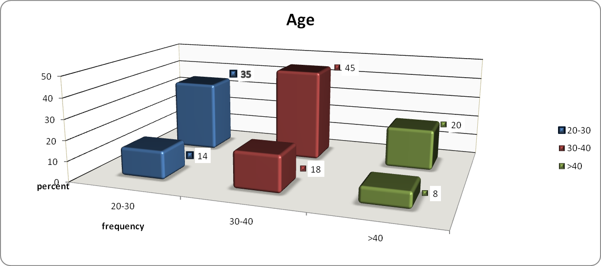

**Figure 1. Shows the distribution of age among study participants.**

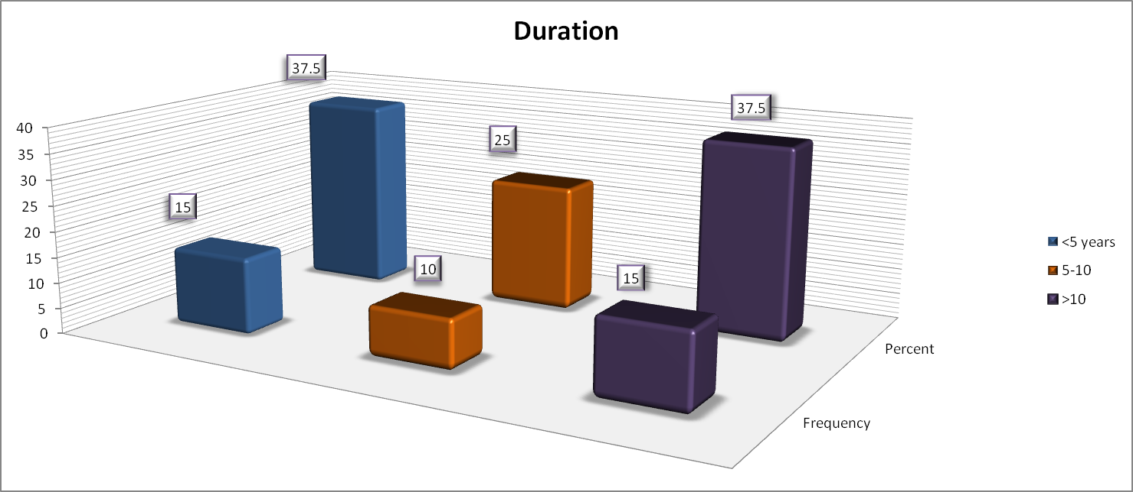

**Figure 2. Demonstrates the duration of use of *Dukhan* per year.**

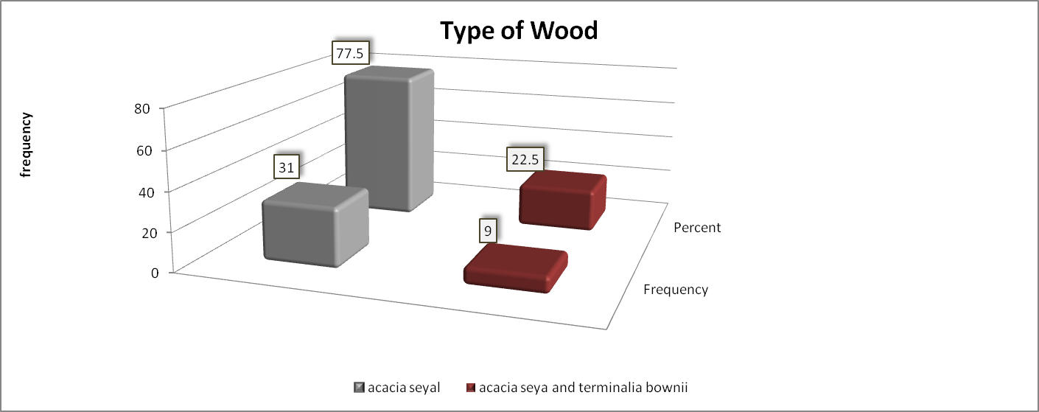

**Figure 3. Indicates the type of wood used for *Dukhan* by participants.**

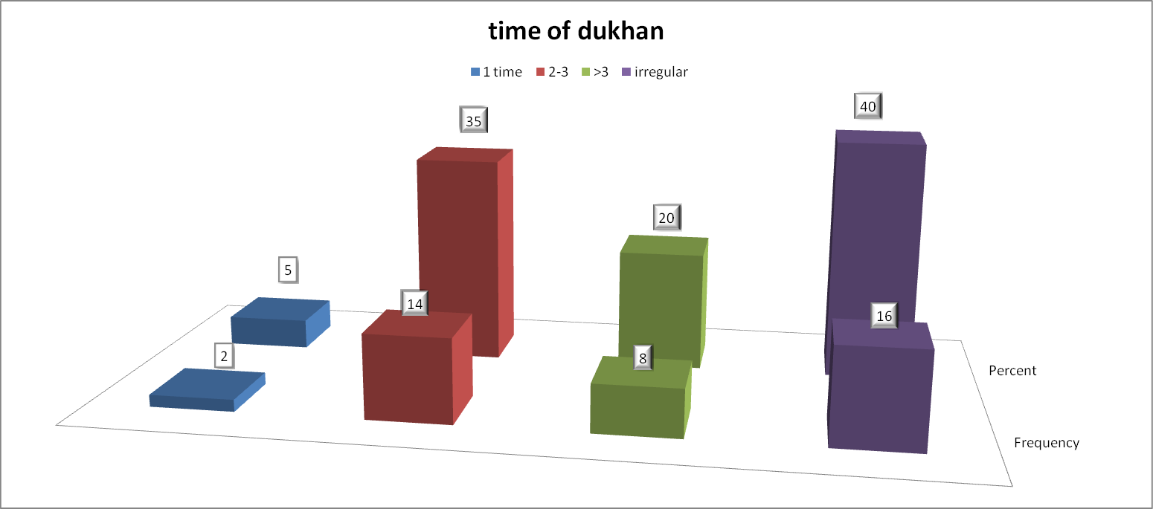

**Figure 4. Reveals the number of uses of *Dukhan* per week.**

**4. DISCUSSION**

For thousands of years, people have utilized medicinal plants to alleviate illnesses and ailments. Some civilizations employ them for purposes other than health, such as religious events and festivities. Sudanese women have been using smoke from *Acacia seyal Delile* wood to make a smoke bath known locally as *Dukhan*. The purpose of the ritual is to promote overall body relaxation, heal wounds, smooth skin, and ease rheumatic discomfort [22]. This study was carried out in Shendi Town from January to March 2025, focusing on the cytological effects of *Dukhan* (smoke bath) on the respiratory tract of women who regularly practice this traditional custom. The goal was to identify cytological atypia in sputum samples from women exposed to *Dukhan* smoke and to examine related risk factors. The age distribution revealed that most participants were young women in their twenties and thirties, while menopausal women made up the smallest group. This age trend reflects the cultural connection between *Dukhan* use and reproductive age, as women traditionally use *Dukhan* for personal care and attractiveness in marriage. Such a distribution may also suggest increased vulnerability to cellular changes with age. Participants were divided into three groups based on exposure duration: less than 5 years, 5 to 10 years, and over 10 years, allowing assessment of long-term effects. Interestingly, all participants exhibited cytological atypia regardless of exposure length, indicating that even short-term use can cause cellular changes. This suggests that factors such as intensity and individual susceptibility may be more important than duration alone. *Talh* (*Acacia seyal*) was the most common wood used by 77.5% of women, with the rest combining *Talh* with *Shaf* (*Terminalia brownii*). *Talh* is valued for its fragrant smoke, skin-soothing properties, cultural significance, affordability, and accessibility. *Shaf*, on the other hand, is often employed for medicinal or detoxifying purposes. The different wood types are relevant because *Talh* smoke releases volatile organic compounds (VOCs) such as furfural and catechol, which can be genotoxic [20, 21]. Despite only about 5% showing visible sputum changes, all had cellular atypia under the microscope. The most common abnormalities included keratosis (100%), cellular degeneration (87.5%), cytoplasmic vacuolization (50%), inflammation (55%), nuclear atypia (20%), and necrosis (7.5%). Elgorashi and his colleagues in 2022 reported DNA damage and mutagenic effects of *Dukhan* smoke [22]. The high rates of keratinization and degeneration align with studies pointing to the irritative and inflammatory effects of wood smoke on epithelial tissue [23]. Unlike the 2010 study by Ahmed and Rezgalla, which linked traffic pollution to dysplasia and metaplasia in lung tissue [23], our study did not find evidence of cancer. This implies that *Dukhan* may cause early pre-cancerous changes, but might not be enough to cause full malignancy. Moreover, the presence of atypia in all exposure groups, including casual and short-term users, supports earlier research indicating that even minimal or inconsistent smoke exposure can lead to early epithelial alterations [24]. Only 3 women (7.5%) reported respiratory symptoms like asthma or chronic cough, yet all showed atypical cytology. This supports the idea that cellular changes can happen before clinical symptoms appear, highlighting the usefulness of sputum cytology as an early detection method. Siddiqui et al. (2005) also observed subclinical respiratory issues in women exposed to indoor wood smoke [25]. Chun et al. (2008) found no significant genotoxic effects of wood smoke flavors (WSF) in vitro [21], which contrasts with our results. Differences in wood type, exposure time, combustion temperature, and inhalation methods likely account for these discrepancies. In *Dukhan*, direct and dense smoke exposure in enclosed spaces increases the risk. Kibar Ozturk and his colleagues in 2018 linked *Dukhan* smoke to airborne contact dermatitis, citing *Talh* and *Shaf* as irritants [26]. Although our study did not specifically examine skin issues, the universal keratinization (100%) suggests that mucosal irritation occurs in the respiratory system as well. Our findings partially support White and Sandler’s (2017) hypothesis that long-term wood smoke exposure may contribute to cancer development, including breast cancer [24]. While we didn't directly investigate cancer, the detection of nuclear atypia in 20% of participants emphasizes the need for further molecular research. Lastly, since 92.5% of women had no prior respiratory disease and all showed atypia, these changes likely result from *Dukhan* exposure itself rather than pre-existing conditions. The lung is a highly epithelialized organ that produces a lot of exfoliated material for bronchial cytology and sputum [27]. A classification system was established by the Papanicolaou Society of Cytopathology (PSC) in 2016 for the reporting of cytologic specimens derived from the respiratory system. Endobronchial ultrasonography-guided fine needle aspiration has been shown to have diagnostic sensitivity, specificity, and malignancy risk; however, data for other sample methods have not been well documented [28]. The lack of existing data on *Dukhan’s* respiratory impact highlights the importance of these findings and underscores the need for further studies on this culturally rooted practice.

## **Limitations**

Because of the small sample size (n = 40) and non-probability sampling method, the findings might not apply to all *Dukhan* users in Sudan.

## **5. CONCLUSION**

This study demonstrates a strong association between *Dukhan*use and cytological atypia in sputum samples of Sudanese women. Despite the lack of visible sputum changes or overt clinical symptoms in most participants, significant microscopic alterations were present in all cases. The most common changes included keratosis, cellular degeneration, cytoplasmic vacuolation, and nuclear atypia. Although no malignant or dysplastic features were observed, the presence of nuclear atypia and necrosis suggests a potential risk of long-term genotoxicity. These findings underscore the need for greater awareness about the potential respiratory health implications of traditional *Dukhan* practices.

## **6. RECOMMENDATION**

Based on the findings of this study, it is recommended to raise awareness among Sudanese women about the potential respiratory health risks associated with *Dukhan* use, encourage the application of sputum cytology as a simple and non-invasive screening method for early detection of cellular alterations, promote safer practices such as ensuring adequate ventilation during *Dukhan* sessions to reduce exposure to harmful emissions, and conduct further large-scale and long-term studies to explore the possible genotoxic and carcinogenic effects of prolonged or frequent *Dukhan* exposure.

**CONSENT**

As per international standards or university standards, patient(s) written consent has been collected and preserved by the author(s).

**ETHICAL APPROVAL**

The study was approved by the Department of Histopathology and Cytology in Medical Laboratory Sciences at Shendi University, and the study was matched to the ethical review committee board. Sample collection was done after signing a written agreement with the participants. Permission for this study was obtained from the local authorities in the area of study. The aims and the benefits of this study were explained with the assurance of confidentiality. All protocols in this study were done according to the Declaration of Helsinki (1964).

**DISCLAIMER (ARTIFICIAL INTELLIGENCE)**

As a result, the Author (s) declare that NO generative AI technologies such as Large Language Models (ChatGPT, COPILOT, etc) and text-to-image generators have been used during the writing or editing of manuscripts.

**References**

1. Berlowitz I, Torres EG, Walt H, Wolf U, Maake C, Martin-Soelch C. "*Tobacco Is the Chief Medicinal Plant in My Work*": Therapeutic Uses of Tobacco in Peruvian Amazonian Medicine Exemplified by the Work of a *Maestro Tabaquero*. *Front Pharmacol*. 2020;11:594591. Published 2020 Oct 7. doi:10.3389/fphar.2020.594591
2. Medical News Today. What the color of your phlegm means. 2017 [cited 2025 Jul 25]. Available from: [https://www.medicalnewstoday.com/articles/318924](https://www.medicalnewstoday.com/articles/318924ز)
3. Goldin J, Bruner PJ. Exercise-Induced Bronchoconstriction. [Updated 2025 Jun 2]. In: StatPearls [Internet]. Treasure Island (FL): StatPearls Publishing; 2025 Jan-. Available from: <https://www.ncbi.nlm.nih.gov/books/NBK557554/>
4. Berlowitz I, Torres EG, Walt H, Wolf U, Maake C, Martin-Soelch C. "*Tobacco Is the Chief Medicinal Plant in My Work*": Therapeutic Uses of Tobacco in Peruvian Amazonian Medicine Exemplified by the Work of a *Maestro Tabaquero*. *Front Pharmacol*. 2020;11:594591. Published 2020 Oct 7. doi:10.3389/fphar.2020.594591.
5. Borenfreund E, Puerner JA. Toxicity determined in vitro by morphological alterations and neutral red absorption. *Toxicol Lett*. 1985;24(2-3):119-124. doi:10.1016/0378-4274(85)90046-3.
6. Botting RM. Inhibitors of cyclooxygenases: mechanisms, selectivity and uses. *J Physiol Pharmacol*. 2006;57 Suppl 5:113-124.
7. Braithwaite M, Van Vuuren SF, Viljoen AM. Validation of smoke inhalation therapy to treat microbial infections. *J Ethnopharmacol*. 2008;119(3):501-506. doi:10.1016/j.jep.2008.07.050.
8. Eastmond DA, Tucker JD. Identification of aneuploidy-inducing agents using cytokinesis-blocked human lymphocytes and an antikinetochore antibody. *Environ Mol Mutagen*. 1989;13(1):34-43. doi:10.1002/em.2850130104.
9. Elamin A, Ibrahim ME, Abuidris D, Mohamed KE, Mohammed SI. Part I: cancer in Sudan—burden, distribution, and trends: breast, gynecological, and prostate cancers. *Cancer Med*. 2015;4(3):447-456. doi:10.1002/cam4.378.
10. Eldeen IM, Elgorashi EE, van Staden J. Antibacterial, anti-inflammatory, anti-cholinesterase and mutagenic effects of extracts obtained from some trees used in South African traditional medicine. *J Ethnopharmacol*. 2005;102(3):457-464. doi:10.1016/j.jep.2005.08.049
11. Eldeen I.M., van Staden J., Cyclooxygenase inhibition and anti- mycobacterial effects of extracts from Sudanese medicinal plants. S. Afri Bot, 2008, 74: 225-229.
12. Eldeen I.M., Effendy A.M, et al., Ethnobotany: Challenges and Future Perspectives, Res. Med Plants, 2016, 10: 382-387.
13. El Ghazali G.B., El Tohami M.S., et al., Medicinal Plants of the Sudan. Part III. Medicinal Plants of the White Nile Province. Khartoum University Press, Sudan, 1994:98.
14. Elgorashi EE, McGaw LJ. African plants with in vitro anti-inflammatory activities: A review. South African Journal of Botany. 2019 Nov 1;126:142-69.
15. Koss LG., Melamed M.R., Koss diagnostic cytology and its histopathologic bases, fifth edition, Philadelphia, Lippincott Williams and Wilkins, 2006:1752.
16. Gary W.G., cytopreparation principles and practice, Essentials in cytopathology book series, 2013, 12: 143-189.
17. Bistoni, Giovanni, Jian Farhadi. Anatomy and physiology of the breast. Plastic and reconstructive surgery: Approaches and Techniques. 2015;477-485
18. Geddie WR. Atlas of Diagnostic Cytopathology: Second Edition. *J Clin Pathol*. 2004;57(8):895. doi:10.1136/jcp.2004.016097.
19. Sanfrancesco J, Jones JS, Hansel DE. Diagnostically challenging cases: what are atypia and dysplasia?. *Urol Clin North Am*. 2013;40(2):281-293. doi:10.1016/j.ucl.2013.01.006.
20. Ikram M.E., Itmad A.E., et al., A comparative study of chemical composition of Acacia Seyal stem, stem wood and stem bark dry distillates used by Sudanese women as cosmetic and medicine. International Journal of Pharmacy and Pharmaceutical Sciences, 2017, 9 (11):218-224.
21. Chung YS, Ahn JH, Eum KH, et al. *In Vitro* Studies on the Genotoxic Effects of Wood Smoke Flavors. *Toxicol Res*. 2008;24(4):321-328. doi:10.5487/TR.2008.24.4.321.
22. Elgorashi EE, Eldeen IMS, Makhafola TJ, Eloff JN, Verschaeve L. Genotoxic effects of Dukhan: A smoke bath from the wood of Acacia seyal used traditionally by Sudanese women. *J Ethnopharmacol*. 2022;285:114868. doi:10.1016/j.jep.2021.114868.
23. Hussain G.A, Twhida M.R., A Study of Lung Epithelial Atypia in Regard to the Effect of Smoking and Traffic-Related Air Pollution in Sudan. The Open Lung Cancer Journal, 2010, 3(1).
24. White AJ, Sandler DP. Indoor wood-burning stove and fireplace use and breast cancer in a prospective cohort study. Environmental health perspectives. 2017 Jul 18;125(7):077011.
25. Amna R.S, Kiyoung L., et al., Eye and respiratory symptoms among women exposed to wood smoke emitted from indoor cooking: a study from southern Pakistan. Energy for Sustainable Development, 2005, 9(3):58-66.
26. Kibar Ozturk M, Zindancı I, Zemheri E. Acacia seyal and Terminalia brownii associated airborne contact dermatitis (Dukhan dermatitis). Int J Dermatol. 2018;57(11):1382-1386. doi:10.1111/ijd.14194.
27. Ng JKM, Cheung W, Li JJX, Chan KP, Yip WH, Tse GM. Detection of early (T1) lung cancers and lepidic adenocarcinomas in sputum and bronchial cytology. *Ann Diagn Pathol*. 2023;67:152191. doi:10.1016/j.anndiagpath.2023.152191.
28. Layfield LJ, Esebua M. A modified Papanicolaou Society of Cytopathology system for reporting respiratory cytology specimens: Implications for estimates of malignancy risk and diagnostic accuracy. *Diagn Cytopathol*. 2021;49(11):1167-1172. doi:10.1002/dc.24840