An epidemiological overview of envenomation involving Latrodectus sp. and unidentified spider species in southern Brazil

.
ABSTRACT

Background: Spiders of the order Araneae are ecologically significant predators, although only a few species pose a medical threat to humans. Among them, the Latrodectus genus stands out due to its potent venom, which can cause severe systemic symptoms Objective: The aim of this study was to describe the epidemiology of latrodectism and accidents with other spiders in the southern region of Brazil from 2011 to 2022. Methods: Data were collected from DataSUS/Tabnet and analyzed using descriptive statistics, chi-square tests, and principal component analysis (PCA) to describe the epidemiological profile of these accidents. Results: Findings show that Santa Catarina reported the highest number of latrodectism cases (112), followed by Rio Grande do Sul (63) and Paraná (44). Accidents involving unidentified spiders exceeded 247,000 in the region, with Santa Catarina also recording the highest frequency. Seasonal patterns indicated an increase in incidents during warmer months and a decline in winter. Latrodectism was more common among older adults (65–80 years), while accidents with unidentified spiders were more evenly distributed across age groups. This study underscores the importance of accurate species identification in the clinical management of spider bites and in developing effective public health strategies. Moreover, it highlights the need for further research on the Latrodectus genus in Brazil, given its medical relevance and the current gaps in scientific knowledge.

Keywords: Araneism; Public Health; Spider Accidents; Epidemiology.

1. INTRODUCTION
Belonging to the order Araneae and the subphylum Chelicerata, spiders represent one of the most abundant groups among arthropods. They are found in nearly all regions of the planet, with the exception of Antarctica (Bertani et al., 2015; Brusca et al., 2018). Predominantly terrestrial, they inhabit a variety of environments, including self-constructed webs, burrows, termite mounds, tree trunks and bark, and even residential areas (Puorto et al., 2017).
Morphologically, the spider’s body is divided into the cephalothorax (or prosoma), where sensory, locomotor, and feeding organs are located, and the abdomen (or opisthosoma), which contains structures related to respiration and reproduction (Brusca, Moore & Schuster, 2018). Spiders possess four pairs of walking legs and two sensory appendages called pedipalps, used for prey detection and manipulation. The chelicerae, pre-oral appendages, serve multiple functions such as defense, feeding, mating, and, in some species, locomotion (Bertani et al., 2015; Fransozo, 2016; Puorto et al., 2017).
In addition to their wide geographic distribution and morphological diversity, spiders play significant ecological roles, particularly due to their sensitivity to environmental changes (Brito et al., 2007). They are carnivorous predators and, although some species are capable of capturing small vertebrates such as rodents and birds (Puorto et al., 2017), most feed on insects (Foelix, 1996), including agricultural and urban pests, thereby contributing to population control (Andrade et al., 2007).
Spiders are classified under the order Araneae due to unique characteristics, such as the production of silk through specialized silk glands whose ducts open into spinnerets located at the rear of the abdomen. When exposed to air, the secretion solidifies, forming the web (Brusca et al., 2018). Although not all species use silk to build webs, its application is versatile, serving also to protect eggs or as a component of active or sit-and-wait predation strategies (Carvalho, 2015).
Another notable feature is the presence of venom glands, with ducts directly connected to the chelicerae, allowing venom to be injected into prey. The venom not only immobilizes but also initiates external digestion through enzymes that liquefy the prey's tissues, facilitating ingestion (Fransozo, 2016; Puorto et al., 2017).
Regarding reproduction, spiders have developed specialized behaviors and structures. Males do not possess a penis but instead use modified pedipalps to store and transfer sperm. Initially, sperm is deposited into a spermatophore constructed by the male, which is then transferred to the copulatory bulbs located in the pedipalps (Brusca et al., 2018). During mating, these bulbs are inserted into the female's reproductive ducts, where the sperm is stored until egg fertilization (Fransozo, 2016; Platnick, 2020).
Of the more than 50,000 species currently described, only a few pose significant risk to human health (Silva et al., 2019). In Brazil, families such as Salticidae (jumping spiders), Araneidae (orb-weaving spiders), Lycosidae (wolf spiders), and Sparassidae (huntsman spiders) are common examples and are widely distributed across Brazilian territory. These spiders possess venom only to immobilize their prey and do not have toxins capable of causing significant incidents in humans. In addition to being harmless, they play a fundamental ecological role in controlling insects, contributing to ecosystem balance. Thus, understanding the diversity of non-venomous families is essential to reduce negative perceptions of spiders and to value their ecological importance (Platnick et al., 2020).
The infraorder Araneomorphae includes the main medically important species, notably the genera Loxosceles (family Sicariidae), Phoneutria (family Ctenidae), and Latrodectus (family Theridiidae), recognized for the toxic potential of their venom (Brasil, 2001; Bertani et al., 2015). The genus Latrodectus (Image 1) belongs to the class Arachnida, order Araneae, and family Theridiidae. Spiders of the genus Latrodectus, popularly known as black widows, are recognized for their distinctive morphology, including a globular abdomen, relatively small cephalothorax, long slender legs, and bright red or orange dorsal markings that serve as aposematic signals (Platnick et al., 2020). The smaller males are often consumed by females after mating. In Brazil, they are mostly found in the northeastern region, with Latrodectus geometricus C. L. Koch, 1841, also recorded in the South (Buckup et al., 2010). These spiders inhabit sheltered micro-habitats such as under rocks, logs, debris, or human structures, where they build irregular cobwebs to capture prey (Platnick et al., 2020). The venom of Latrodectus acts on the autonomic nervous system by inducing neurotransmitter release, producing systemic symptoms such as tremors, anxiety, priapism, headache, insomnia, pruritus, behavioral changes, urinary retention, and a sense of impending death (Petri et al., 2021; Lise et al., 2006). Venom is produced in paired cheliceral glands and delivered through hollow fangs, and in severe cases, treatment with anti-Latrodectus antivenom is recommended, with patient improvement typically observed within 30 minutes to three hours after administration (Brasil, 2001; Platnick et al., 2020).
Despite its medical relevance, the genus Latrodectus remains less studied in Brazil compared to other spider genera of public health interest, such as Loxosceles and Phoneutria. This gap highlights the need to expand research on this group, particularly considering its regional distribution and the potentially severe effects of its venom. Furthermore, the occurrence of accidents involving unidentified or poorly described spider species underscores the importance of taxonomic, epidemiological, and toxicological studies. Accurate species identification in spider-related accidents is crucial for proper clinical management and the formulation of public prevention and control policies. In this context, the objective of this study was to describe the epidemiology of Latrodectus related envenomation and envenomation by unidentified spiders in southern Brazil from 2011 to 2022.

Image 1 - Latrodectus geometricus
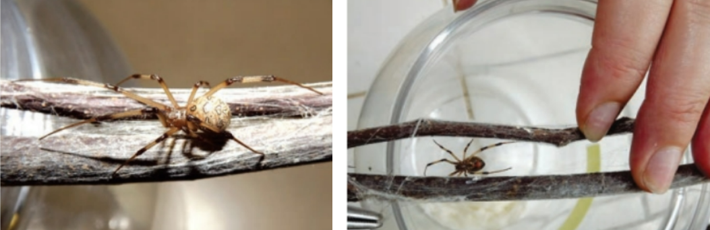
Source: Weiss and Paiva, 2017
Image 2 - Specimens of Latrodectus spiders. Left: Latrodectus menavodi; Right: Latrodectus hasselti.
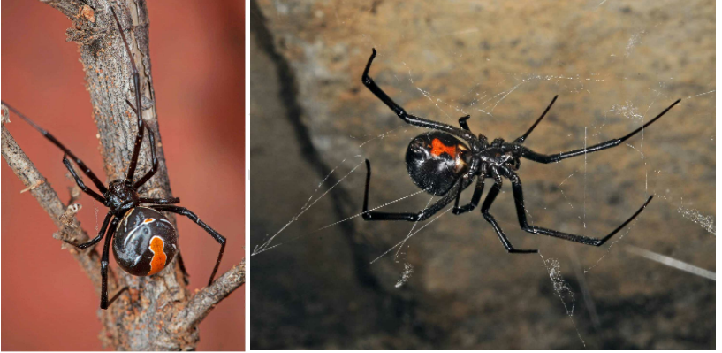
Source: Platnick et al., 2020

2. material and methods

This quantitative and epidemiological study analyzed reported envenomation cases involving venomous animals in southern Brazil between 2011 and 2022. A total of 219 accidents were attributed to spiders of the genus Latrodectus, while 247,597 cases involved spiders that remained unidentified. The term “unidentified” indicates that the reports lacked sufficient taxonomic information to determine the genus or even the family of the spiders involved. From these reports, data were obtained regarding sex, age group, education level, time elapsed between bite and medical care, type of diagnosis, bite location, spider type, final classification, and case outcome. The incidence of accidents was calculated based on the exposed resident population for each month and year, according to spider type.
The data refer to the Southern Region of Brazil, which includes the states of Paraná, Santa Catarina, and Rio Grande do Sul. (Map 1). This is the smallest region in Brazil in terms of territorial extension, covering approximately 564,000 km², or 7% of the national territory. The estimated population of this region is 29,975,984 inhabitants. The study area is located between approximately 27°03'42" S and 33°45'09" S in southern latitude, and between 49°42'41" W and 57°40'57" W in western longitude. The region features a mosaic of vegetation types, including Atlantic Forest fragments, Araucaria forests, and grasslands. Annual average temperatures range from 16 °C to 22 °C, with mean annual rainfall between 1,200 and 1,800 mm (IBGE, 2017). Paraná is predominantly humid subtropical, with an average annual temperature of 19.8 °C and 1,587 mm of precipitation. Latrodectus species are commonly found in rural and suburban areas, particularly where vegetation is low. In Santa Catarina, the average annual temperature is 18.02 °C with 1,797 mm of rainfall, creating favorable conditions for various spider species. In Rio Grande do Sul, temperatures average 17.96 °C with 1,914 mm of precipitation, supporting diverse ecological niches and, consequently, the presence of venomous species (Lima et al., 2021).
The incidence rate (cases per 100,000 inhabitants) was calculated based on the exposed resident population for each month and year, according to spider type.
Descriptive frequency statistics were used to explore the data. In addition, the chi-square test was applied to assess associations between variables. Analyses were performed using SPSS v.22 software.
Accident data were obtained from the Brazilian Ministry of Health’s DataSUS - Tabnet system. After collection, the data were organized into spreadsheets using Microsoft Excel for descriptive frequency analysis. To assess temporal distribution, the PAST (Palaeontological Statistics) software was used for Principal Component Analysis (PCA). For spatial distribution, maps were created using MATLAB software.

Map 1 - Map of the study area in southern Brazil
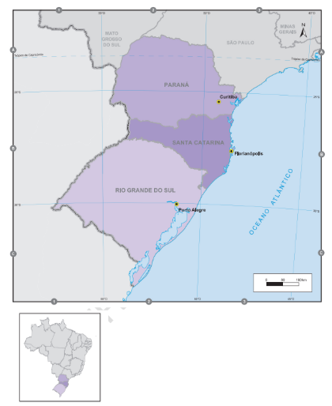
Source: IBGE, 2017.

3. results

Between 2011 and 2022, in the southern region of Brazil, 219 spider envenomation cases were reported and identified only at the genus level as Latrodectus. In the same region and time period, 247,597 accidents involving unidentified spiders were also reported. In the state of Paraná, 44 cases of latrodectism were recorded, along with 121,734 accidents caused by unidentified spiders. In Rio Grande do Sul, there were 63 cases of latrodectism and 56,296 accidents involving unidentified spiders. Finally, in Santa Catarina, 112 accidents with Latrodectus spiders were reported, in addition to 69,567 involving unidentified spiders.
Latrodectism was more prevalent in Santa Catarina compared to Paraná and Rio Grande do Sul over the historical series, except for the period between 2017 and 2020 (Figure 1). Accidents caused by other and/or unidentified spiders were also more frequent in the state of Santa Catarina throughout the entire historical series, with a decreasing trend observed from 2020 onwards (Figure 2).

Figure 1 - Incidence involving Latrodectus sp. in the southern region of Brazil from 2011 to 2022.

Source: Authors, 2024.

Figure 2 - Incidence involving other spiders in the southern region of Brazil from 2011 to 2022.

Source: Authors, 2024.

Latrodectism was more frequent in all three states during the period from October to March (spring and summer) (Figure 3). Accidents recorded as "other and/or unidentified spiders" showed a similar pattern, with a decline during the colder months of the year (autumn and winter) and an increase during the warmer seasons (Figure 4).

Figure 3 - Incidence involving Latrodectus sp. in the southern region of Brazil according to seasonality.

Source: Authors, 2024.

Figure 4 - Incidence involving unidentified spiders species in the southern region of Brazil per 100,000 inhabitants according to seasonality.

Source: Authors, 2024.

Latrodectism was most frequent among individuals aged 65 to 80 years across all three states, whereas the incidence of accidents involving other spiders was more evenly distributed across different age groups (Table 1).

Table 1 - Incidence of spider-related accidents by age group in the southern region of Brazil from 2011 to 2022.
Accidents | PR | RS | SC | Significance
Latrodectism
0 to 4 | 0,4 | 0,5 | 0,3 | X² = 33,4; p = 0,01*
5 to 9 | 0,0 | 0,3 | 0,4 | X² = 33,4; p = 0,01*
10 to 14 | 0,4 | 0,2 | 0,4 | X² = 33,4; p = 0,01*
15 to 19 | 0,3 | 0,1 | 2,5 | X² = 33,4; p = 0,01*
20 to 39 | 0,4 | 0,7 | 1,1 | X² = 33,4; p = 0,01*
40 to 59 | 0,4 | 0,6 | 1,9 | X² = 33,4; p = 0,01*
60 to 64 | 0,3 | 0,3 | 1,3 | X² = 33,4; p = 0,01*
65 to 69 | 0,4 | 1,5 | 3,3 | X² = 33,4; p = 0,01*
70 to 79 | 0,9 | 0,6 | 2,8 | X² = 33,4; p = 0,01*
80 or more | 0,4 | 0,7 | 1,4 | X² = 33,4; p = 0,01*
Other spiders/Unidentified
0 to 4 | 528,6 | 195,6 | 369,6 | X² = 191,5; p<0,001*
5 to 9 | 310,7 | 104,1 | 180,0 | X² = 191,5; p<0,001*
10 to 14 | 293,9 | 115,2 | 307,8 | X² = 191,5; p<0,001*
15 to 19 | 465,6 | 198,3 | 508,7 | X² = 191,5; p<0,001*
20 to 39 | 413,9 | 213,1 | 444,6 | X² = 191,5; p<0,001*
40 to 59 | 398,2 | 246,5 | 516,1 | X² = 191,5; p<0,001*
60 to 64 | 391,2 | 262,6 | 513,4 | X² = 191,5; p<0,001*
65 to 69 | 373,9 | 264,3 | 531,4 | X² = 191,5; p<0,001*
70 to 79 | 339,8 | 240,0 | 492,0 | X² = 191,5; p<0,001*
80 or more | 225,6 | 182,5 | 321,5 | X² = 191,5; p<0,001*
Source: Authors, 2024
Regarding sex, the incidence of latrodectism was higher among males in all three states, as was the case for accidents caused by other spiders (Table 2).

Table 2 - Incidence of spider-related accidents by sex in the southern region of Brazil from 2011 to 2022.
Accidents | PR | RS | SC | Significance
Latrodectism
Female | 0,3 | 0,5 | 1,5 | X² = 0,0; p = 1
Male | 0,5 | 0,7 | 1,5 | X² = 0,0; p = 1
Other spiders/Unidentified
Female | 287,4 | 100,3 | 421,8 | X² = 0,79; p = 0,67
Male | 328,5 | 113,4 | 440,1 | X² = 0,79; p = 0,67
Source: Authors, 2024

Accidents were more frequent among individuals with incomplete primary education and those who had completed high school. However, higher percentages were observed among those with lower education levels (Table 3).

Table 3 - Incidence of spider-related accidents by education level in the southern region of Brazil from 2011 to 2022.
Accidents | PR | RS | SC | Significance
Latrodectism
Illiterate | 2,2 | 0,0 | 0,0 | X² = 61,3; p < 0,001*
Incomplete 1st–4th grade | 8,9 | 19,0 | 9,9 | X² = 61,3; p < 0,001*
Complete 4th grade | 6,7 | 11,1 | 17,1 | X² = 61,3; p < 0,001*
Incomplete 5th–8th grade | 11,1 | 14,3 | 11,7 | X² = 61,3; p < 0,001*
Complete primary education | 2,2 | 1,6 | 5,4 | X² = 61,3; p < 0,001*
Incomplete high school | 4,4 | 4,8 | 21,6 | X² = 61,3; p < 0,001*
Complete high school | 15,6 | 15,9 | 18,0 | X² = 61,3; p < 0,001*
Incomplete higher education | 2,2 | 1,6 | 1,8 | X² = 61,3; p < 0,001*
Complete higher education | 2,2 | 0,0 | 2,7 | X² = 61,3; p < 0,001*
Not applicable | 6,7 | 4,8 | 3,6 | X² = 61,3; p < 0,001*
Blank/Unknown | 37,8 | 27,0 | 8,1 | X² = 61,3; p < 0,001*
Other spiders/Unidentified
Illiterate | 1,5 | 0,7 | 0,8 | X² = 7,7; p = 0,99
Incomplete 1st–4th grade | 13,3 | 14,0 | 12,5 | X² = 7,7; p = 0,99
Complete 4th grade | 7,5 | 7,2 | 9,3 | X² = 7,7; p = 0,99
Incomplete 5th–8th grade | 13,4 | 15,8 | 13,8 | X² = 7,7; p = 0,99
Complete primary education | 6,9 | 6,7 | 8,2 | X² = 7,7; p = 0,99
Incomplete high school | 9,9 | 6,7 | 7,9 | X² = 7,7; p = 0,99
Complete high school | 16,2 | 13,3 | 17,0 | X² = 7,7; p = 0,99
Incomplete higher education | 2,1 | 2,2 | 2,1 | X² = 7,7; p = 0,99
Complete higher education | 3,3 | 3,2 | 3,7 | X² = 7,7; p = 0,99
Not applicable | 10,4 | 6,3 | 8,9 | X² = 7,7; p = 0,99
Blank/Unknown | 15,5 | 23,9 | 15,8 | X² = 7,7; p = 0,99
Source: Authors, 2024

The percentage of latrodectism cases involving pregnant women was lower compared to other reported conditions. Most patients received medical care within three hours of the incident. Hands, feet, and fingers were the most frequently affected body parts. The majority of cases did not require antivenom treatment and were classified as mild. More than 19% of latrodectism cases in Paraná (PR) and Santa Catarina (SC) were work-related. Most notifications reported recovery as the clinical outcome (Table 4).
Table 4 - Epidemiological and clinical profile of accidents caused by Latrodectus sp. in southern Brazil between 2011 and 2022
Variable | PR | RS | SC | Significance
Pregnancy status
1st Trimester | 0.0 | 0.0 | 0.9 | X² = 2,71;  p = 0,61
2nd Trimester | 0.0 | 0.0 | 0.9 | X² = 2,71;  p = 0,61
3rd Trimester | 0.0 | 0.0 | 0.0 | X² = 2,71;  p = 0,61
Gestational age unknown | 0.0 | 0.0 | 0.0 | X² = 2,71;  p = 0,61
Not pregnant | 30.2 | 35.6 | 40.5 | X² = 2,71;  p = 0,61
Not applicable | 66.7 | 62.2 | 55.0 | X² = 2,71;  p = 0,61
Not reported / Missing data | 3.2 | 2.2 | 2.7 | X² = 2,71;  p = 0,61
Time from bite to care
0–1 hour | 33.3 | 37.8 | 35.1 | X² = 14,4;  p = 0,28
1–3 hours | 17.5 | 26.7 | 18.9 | X² = 14,4;  p = 0,28
3–6 hours | 6.3 | 4.4 | 9.9 | X² = 14,4;  p = 0,28
6–12 hours | 3.2 | 2.2 | 4.5 | X² = 14,4;  p = 0,28
12–24 hours | 3.2 | 4.4 | 5.4 | X² = 14,4;  p = 0,28
≥24 hours | 31.7 | 17.8 | 16.2 | X² = 14,4;  p = 0,28
Not reported / Missing data | 4.8 | 6.7 | 9.9 | X² = 14,4;  p = 0,28
Bite location
Head | 12.7 | 4.4 | 3.6 | X² = 72,1;  p < 0,001*
Arm | 4.8 | 11.1 | 9.0 | X² = 72,1;  p < 0,001*
Forearm | 3.2 | 2.2 | 6.3 | X² = 72,1;  p < 0,001*
Hand | 15.9 | 17.8 | 9.9 | X² = 72,1;  p < 0,001*
Finger (hand) | 19.0 | 17.8 | 7.2 | X² = 72,1;  p < 0,001*
Body | 1.6 | 11.1 | 9.0 | X² = 72,1;  p < 0,001*
Thigh | 4.8 | 6.7 | 9.9 | X² = 72,1;  p < 0,001*
Leg | 7.9 | 11.1 | 6.3 | X² = 72,1;  p < 0,001*
Foot | 25.4 | 11.1 | 21.6 | X² = 72,1;  p < 0,001*
Toe | 4.8 | 6.7 | 17.1 | X² = 72,1;  p < 0,001*
Not reported / Missing data | 12.7 | 0.0 | 0.0 | X² = 72,1;  p < 0,001*
Antivenom administered
Yes | 9.5 | 0.0 | 1.8 | X² = 21,2;  p < 0,001*
No | 81.0 | 95.6 | 95.5 | X² = 21,2;  p < 0,001*
Not reported / Missing data | 9.5 | 4.4 | 2.7 | X² = 21,2;  p < 0,001*
Work-related incident
Yes | 19.0 | 2.2 | 21.6 | X² = 26,6;  p < 0,001*
No | 76.2 | 82.2 | 73.9 | X² = 26,6;  p < 0,001*
Not reported / Missing data | 4.8 | 15.6 | 4.5 | X² = 26,6;  p < 0,001*
Final classification
Mild | 82.5 | 95.6 | 83.8 | X² = 14,4;  p = 0,02*
Moderate | 12.7 | 2.2 | 11.7 | X² = 14,4;  p = 0,02*
Severe | 3.2 | 0.0 | 0.9 | X² = 14,4;  p = 0,02*
Not reported / Missing data | 1.6 | 2.2 | 3.6 | X² = 14,4;  p = 0,02*
Case outcome
Recovered | 88.9 | 88.9 | 97.3 | X² = 7,34;  p = 0,02*
Death due to envenomation | 0.0 | 0.0 | 0.0 | X² = 7,34;  p = 0,02*
Death due to other cause | 0.0 | 0.0 | 0.0 | X² = 7,34;  p = 0,02*
Not reported / Missing data | 11.1 | 11.1 | 2.7 | X² = 7,34;  p = 0,02*
Source: Authors, 2024

The time to receive medical care after accidents caused by other spiders was predominantly within three hours. The hands, feet, and fingers were the most commonly affected body parts. Most cases did not require antivenom therapy and were classified as mild. More than 12% of these accidents in the states of Paraná (PR) and Santa Catarina (SC) were work-related. The majority of cases evolved to cure (Table 5).

Table 5 - Epidemiological and clinical profile of accidents caused by other spiders species in the southern region of Brazil between 2011 and 2022
Variable | PR | RS | SC | Significance
Pregnancy status
1st Trimester | 0,3 | 0,3 | 0,4 | X² = 1,32;  p = 0,86
2nd Trimester | 0,3 | 0,3 | 0,3 | X² = 1,32;  p = 0,86
3rd Trimester | 0,2 | 0,2 | 0,2 | X² = 1,32;  p = 0,86
Gestational age unknown | 0,1 | 0,0 | 0,0 | X² = 1,32;  p = 0,86
Not pregnant | 32,5 | 33,9 | 38,2 | X² = 1,32;  p = 0,86
Not applicable | 64,1 | 63,5 | 59,9 | X² = 1,32;  p = 0,86
Not reported / Missing data | 2,6 | 1,8 | 1,0 | X² = 1,32;  p = 0,86
Time from bite to care
0–1 hour | 32,1 | 29,5 | 26,3 | X² = 2,56;  p = 0,99
1–3 hours | 20,0 | 18,1 | 21,4 | X² = 2,56;  p = 0,99
3–6 hours | 7,0 | 7,8 | 8,9 | X² = 2,56;  p = 0,99
6–12 hours | 4,4 | 5,2 | 4,7 | X² = 2,56;  p = 0,99
12–24 hours | 8,0 | 9,7 | 8,9 | X² = 2,56;  p = 0,99
≥24 hours | 22,3 | 25,5 | 26,1 | X² = 2,56;  p = 0,99
Not reported / Missing data | 6,2 | 4,2 | 3,6 | X² = 2,56;  p = 0,99
Bite location
Head | 5,5 | 5,2 | 5,2 | X² = 3,64;  p = 0,99*
Arm | 8,8 | 8,6 | 9,4 | X² = 3,64;  p = 0,99*
Forearm | 3,7 | 4,4 | 4,2 | X² = 3,64;  p = 0,99*
Hand | 14,0 | 13,9 | 13,4 | X² = 3,64;  p = 0,99*
Finger (hand) | 11,9 | 10,6 | 11,1 | X² = 3,64;  p = 0,99*
Body | 6,7 | 7,9 | 8,4 | X² = 3,64;  p = 0,99*
Thigh | 7,1 | 8,0 | 8,6 | X² = 3,64;  p = 0,99*
Leg | 9,3 | 12,0 | 11,5 | X² = 3,64;  p = 0,99*
Foot | 20,3 | 18,7 | 17,8 | X² = 3,64;  p = 0,99*
Toe | 11,6 | 10,0 | 9,6 | X² = 3,64;  p = 0,99*
Not reported / Missing data | 1,1 | 0,7 | 0,6 | X² = 3,64;  p = 0,99*
Antivenom administered
Yes | 2,9 | 0,8 | 2,1 | X² = 2,74;  p = 073*
No | 93,2 | 97,3 | 96,7 | X² = 2,74;  p = 073*
Not reported / Missing data | 1,2 | 1,9 | 1,1 | X² = 2,74;  p = 073*
Work-related incident
Yes | 13,8 | 7,9 | 12,4 | X² = 5,67;  p = 0,22*
No | 80,4 | 89,3 | 85,9 | X² = 5,67;  p = 0,22*
Not reported / Missing data | 5,8 | 2,9 | 1,7 | X² = 5,67;  p = 0,22*
Final classification
Mild | 87,4 | 92,1 | 91,8 | X² = 2,79;  p = 0,59*
Moderate | 9,6 | 6,7 | 7,4 | X² = 2,79;  p = 0,59*
Severe | 0,3 | 0,1 | 0,1 | X² = 2,79;  p = 0,59*
Not reported / Missing data | 2,6 | 1,1 | 0,8 | X² = 2,79;  p = 0,59*
Case outcome
Recovered | 92,9 | 97,4 | 97,8 | X² = 4,72;  p = 0,09*
Death due to envenomation | 0,0 | 0,0 | 0,0 | X² = 4,72;  p = 0,09*
Death due to other cause | 0,0 | 0,0 | 0,0 | X² = 4,72;  p = 0,09*
Not reported / Missing data | 7,1 | 2,5 | 2,1 | X² = 4,72;  p = 0,09*
Source: Authors, 2024

Only 28.8% of the variation in latrodectism was explained by PCA components 1 and 2. A dissimilarity in incidence across the evaluated years was observed, as they were distributed across all four quadrants of the analysis (Figure 5).

Figure 5 - Association through Principal Component Analysis (PCA) of latrodectism incidence in the southern region of Brazil from 2011 to 2022.
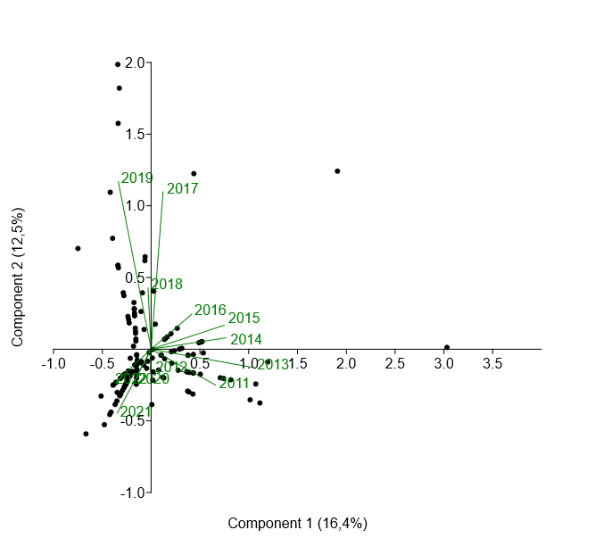

Source: Authors, 2024
A total of 63.9% of the variation in accidents caused by other spiders was explained by components 1 and 2 of the PCA. A pattern in the incidence distribution is observed up to 2016, which changes thereafter (Figure 6).

Figure 6. Association by Principal Component Analysis (PCA) of the incidence of accidents caused by other spiders in the southern region of Brazil between 2011 and 2022.
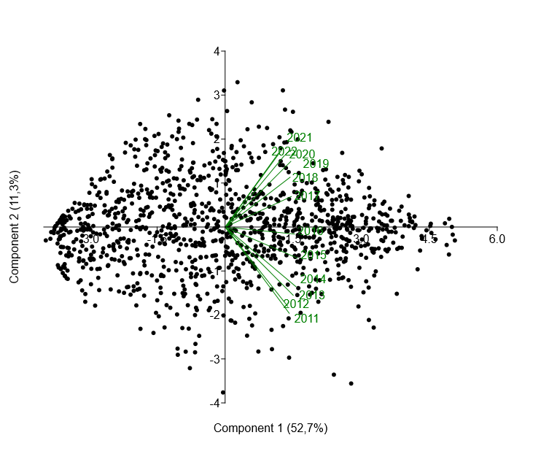
Source: Authors, 2024

4. DISCUSSION

The incidence of spider envenomation was more pronounced between the months of September and May in all analyzed states. Chagas et al. (2010), when evaluating spider envenomation in Rio Grande do Sul, identified the period between October and April as having the highest number of records. Similar results were described by Hass et al. (2013), who observed a predominance of cases between January and March and from August to December. This seasonal pattern can be explained by Bucaretchi et al. (2000) and Vetter and Isbister (2008), who associate the increase in bites with the warmer months, when spiders’ mating season occurs, making them more active and easily found, during the colder months, however, spiders do not mate and tend to remain hidden, which reduces the likelihood of human contact and envenomation incidents. Cheung and Machado (2017) further highlight that the warm and rainy periods favor these animals' search for shelter and food, coinciding with school vacations and an increase in ecotourism activities in rural environments, which may contribute to the rise in the number of accidents.
It was observed that the pattern of spider envenomation in the Southern Region of Brazil is not homogeneous, with variations in the types of accidents according to the state. Santa Catarina, for example, showed a higher incidence of latrodectism cases compared to neighboring states. Santa Catarina has an efficient notification system, which may contribute to higher detection and reporting of envenomation cases compared to other states. Additionally, the western and northern regions of the state exhibit a higher concentration of incidents, possibly due to proximity to rural areas and native vegetation, which are preferred habitats for Latrodectus spiders (Schulter-Trevisol et al., 2024). The study by Paris et al. (2017), which analyzed spider envenomation cases in Chapecó between 2010 and 2015, recorded only accidents caused by the genera Loxosceles and Phoneutria. Chagas et al. (2010) also indicated a lower frequency of latrodectism in the Southern Region. Given this scenario, the need for more in-depth faunistic studies becomes evident, as well as continuous training of health professionals to ensure correct identification of the species involved in accidents and, consequently, appropriate clinical management.
However, Garb et al. (2003) discuss the expansion of Latrodectus spiders to new locations, a phenomenon attributed to human transportation and movement. According to the authors, the almost cosmopolitan distribution of the brown widow (L. geometricus) likely results from this type of dispersion.
The distribution and incidence of spiders vary according to each genus's and species' habitat preferences. These differences directly influence the patterns of accident occurrence in different regions. The genus Latrodectus, for instance, is more commonly found in areas with dense vegetation and natural environments. Although accidents caused by this species are less frequent, they can occur when there is human contact with these habitats (Garb et al., 2003).
A notable highlight is the high proportion of accidents caused by unidentified spiders, representing 69.5% of records in Santa Catarina. This data aligns with the study by Vieira and Machado (2018), which pointed out that 59.5% of reported accidents in Brazil were attributed to unidentified species. Such difficulty may be related to the absence or deterioration of the specimen brought to health services or to the difficulty of clinical diagnosis based solely on symptoms. This reality highlights the lack of studies related to spider fauna across different regions of the country, which hampers the precise identification of involved species and consequently compromises the quality of the clinical conduct adopted (Lise et al.,2006; Lise and Garcia, 2007).
Additionally, it was observed that most accidents involving Latrodectus spiders affected people aged between 65 and 80 years. Chagas et al. (2010) also recorded a significant number of victims over 60 years old. The authors suggest that the increase in life expectancy in the Brazilian population may be related to this trend. The aging population, accompanied by more sedentary habits (Santos et al., 2015), favors staying indoors, places where spiders are frequently found, which may increase the risk of accidents. Furthermore, the elderly population has greater physiological vulnerability, which may lead to increased healthcare seeking after accidents (Silva et al., 2018; Brito et al., 2023), reflecting a higher number of notifications. Regarding sex profile, Silva et al. (2015) highlight that there is no significant difference between men and women in the occurrence of accidents, since these predominantly occur in urban and residential environments, not necessarily related to occupational activities. It is important to consider that women generally tend to seek health services more often, which may influence the recorded data and the perception of accident distribution between sexes, as identified by Levorato et al. (2014).
To understand the distribution of spiders in the Southern Region of Brazil, it is essential to consider the specific environmental characteristics of each state. Regarding latrodectism, a lower incidence of accidents was observed compared to other types of spider envenomation. Cases were mainly concentrated in western Santa Catarina, northeastern Rio Grande do Sul, and the Sinos Valley region. The study by Wolfart et al. (2009) mentions the occurrence of Latrodectus accidents in various Brazilian states, but there are no prior records for Santa Catarina. It is worth noting that, in reported cases, genus identification was based on clinical symptomatology, since specimens are generally not presented to health services. This data reinforces the need for in-depth studies on spider diversity aiming at correct identification and knowledge of their abundance.
Rossi and Godoy (2005) reported that Latrodectus geometricus is a common species in Brazilian poultry farms, where their webs capture flies (Musca domestica Linnaeus, 1758) and lesser mealworms (Alphitobius diaperinus Panzer, 1797), highlighting their potential as biological control agents. This emphasizes the importance of monitoring the presence of these spiders in productive environments. Considering the intensive poultry activity in western Santa Catarina, it is recommended to conduct studies aimed at characterizing work environments and identifying potential risk groups. Such investigations could inform the development of public policies and preventive strategies to protect workers exposed to these spiders.
In analyzing the spatial distribution of spider envenomation, multiple factors must be considered, including population density. In Paraná, urban centers such as Curitiba, Londrina, and Maringá concentrate much of the population (Magalhães & Kleinke, 2000), which favors the occurrence of accidents in areas where humans and spiders coexist, particularly in residential and commercial environments. In these regions, the number of notifications tends to follow population density, underscoring the need for preventive measures in urban settings. Consequently, urban and suburban areas with higher population density exhibit a greater incidence of spider accidents due to the presence of suitable environments for spider development (Marques-da-Silva & Fischer, 2005).
Beyond population density, the varied climatic conditions and diverse biomes of the region also influence spider distribution. From Atlantic Forest fragments along the coast to fields and subtropical forests inland, each biome provides specific habitats for shelter and reproduction. Moraes et al. (2021) linked Brazilian biomes to accidents caused by venomous animals, identifying the Atlantic Forest and Cerrado as the biomes with the highest incidence of accidents. Gonzaga et al. (2007) further suggest that Brazilian biomes are among the areas with the greatest spider species richness worldwide.
Another important factor is the notification process across the three states, as differences in case reporting can significantly impact the accuracy and reliability of envenomation data. Health infrastructure, diagnostic capacity, and public awareness about the importance of reporting also affect the detection and registration of incidents (Azevedo et al., 2017).
In the Southern Region of Brazil, spider envenomation incidence was more pronounced between September and May, consistent with studies linking higher accident frequencies to warmer months and the spiders’ mating season, which increases their activity and human contact (Bucaretchi et al., 2000; Vetter & Isbister, 2008). The principal component analysis (PCA) indicated that only 28.8% of the variation in latrodectism was explained by the first two components, and the distribution of years across the four quadrants demonstrated temporal dissimilarities, reflecting the multifactorial nature of these accidents. Climatic variations, spider distribution, population density, and occupational exposure likely contribute to this complexity and are not fully captured by a PCA limited to two components.
Clinically, most accidents affected hands, feet, and fingers, involved predominantly mild cases that did not require antivenom, and presented a time to medical care of up to three hours, resulting in favorable outcomes. These findings are consistent with the literature, which indicates that such accidents are usually mild, particularly when exposure is defensive or involves small venom doses (Bucaretchi et al., 2000; Lise et al., 2006). More than 19% of accidents in Paraná and Santa Catarina were related to occupational activities, especially in rural and poultry farming environments, highlighting the role of work-related exposure (Rossi & Godoy, 2005; Dalmora & Scherma, 2019). Latrodectism among gestants was low, in line with reduced exposure to high-risk environments, emphasizing the influence of occupational and environmental factors (Vetter & Isbister, 2008). Furthermore, accidents were more frequent among individuals with incomplete elementary or complete high school education, suggesting that socioeconomic and occupational factors influence envenomation risk (Schuelter-Trevisol et al., 2024). Overall, these results underscore the need for more detailed faunistic studies, enhanced training of health professionals for accurate species identification, and the implementation of targeted preventive strategies, particularly in rural and occupational settings where human-spider interactions are more likely.

5. Conclusion

The epidemiological analysis of accidents caused by spiders of the genus Latrodectus and by unidentified spiders in the Southern Region of Brazil between 2011 and 2022 highlighted important aspects regarding the spatial, temporal, and demographic distribution of these events. It was observed that Santa Catarina had the highest number of latrodectism cases, with a notable concentration of accidents occurring during warmer months, revealing a strong influence of seasonality on the incidence of these events.
The predominance of cases in individuals aged between 65 and 80 suggests greater vulnerability of this population, whether due to behavioral, environmental, or physiological factors, reinforcing the need for specific prevention and guidance actions aimed at this age group. On the other hand, accidents involving unidentified spiders showed a more homogeneous distribution across age groups and were also more frequent during summer months, which may be associated with increased arachnid activity and greater human exposure during this period.
The significant number of accidents attributed to unidentified spiders underscores the fragility of taxonomic identification in health records, limiting the development of more precise strategies for management and control. In this regard, the importance of professional training, investment in taxonomy, and encouragement of scientific research focused on the recognition of species involved in accidents is emphasized.
This study contributes to the understanding of the distribution and characteristics of spider-related accidents in the Southern Region of Brazil and reinforces the relevance of integrating epidemiological, toxicological, and ecological approaches for more effective management of araneism cases, especially those involving species of recognized medical importance such as the genus Latrodectus.

DISCLAIMER (ARTIFICIAL INTELLIGENCE)

Author(s) hereby declare that NO generative AI technologies such as Large Language Models (ChatGPT, COPILOT, etc.) and text-to-image generators have been used during the writing or editing of this manuscript.

CONSENT AND ETHICAL APPROVAL

For this study, due to the public nature of the data to be consulted in the respective databases, there will be no need for submission for analysis and approval by the Research Ethics Committee (REC).

References
Andrade, E. B., Ferreira, M. A., Silva, J. R., & Costa, L. P. (2007). Spiders (Arachnida; Araneae) in an agroecological garden in the municipality of Parnaíba, Piauí, Brazil, and considerations about their role as natural enemies and indicators of environmental quality.
Bertani, R., Godé, L., Kury, A., & Célériér, M.-L. (2015). Arachnids (Arachnida) of the Pedra Talhada Biological Reserve. In A. Studer, L. Nusbaumer, & R. Spichiger (Eds.), Biodiversity of the Pedra Talhada Biological Reserve (Alagoas, Pernambuco-Brazil) (Boissiera, Vol. 68, pp. 175–191).
Brasil. Ministry of Health. National Health Foundation. (2001). Manual for diagnosis and treatment of poisonous animal accidents. Brasília.
Brito, I. V., Santos, A. M., Oliveira, F. S., & Silva, M. F. (2007). Composition of soil spider families in two fragments of the city of Teresina, Piauí, Brazil. In VIII Ecology Congress of Brazil - Annals of the VIII Ecology Congress of Brazil. Caxambú.
Brito, M., Almeida, P. S., Santos, R. L., Silva, A. M., & Costa, L. C. (2023). Completeness of notifications of accidents caused by poisonous animals in the Notifiable Diseases Information System: Descriptive study, Brazil, 2007–2019. Epidemiology and Health Services, 32, e2022666.
Brusca, R. C., Moore, W., & Shuster, S. M. (2018). Invertebrates (3rd ed.). GEN Group. E-book. https://integrada.minhabiblioteca.com.br/#/books/9788527733458/ ---year not match
Bucaretchi, F., Deus, R., Hyslop, S., Madureira, P. R., De Capitani, E. M., & Vieira, R. J. (2000). A clinico-epidemiological study of bites by spiders of the genus Phoneutria. Revista do Instituto de Medicina Tropical de São Paulo, 42, 17–21.
Buckup, E. H., Marques, M. A. L., Rodrigues, E. N. L., & Ott, R. (2010). List of spider species (Arachnida, Araneae) of the state of Rio Grande do Sul, Brazil. Iheringia. Série Zoologia, 100, 483–518.
Carvalho, L. S. (2015). Arachnids: Who they are, why study them and how to collect them. In Methods in Ecology and Animal Behavior (pp. 103–140).
Chagas, F. B., D’Agostini, F. M., & Beltrame, V. (2010). Epidemiological aspects of spider accidents in the State of Rio Grande do Sul, Brazil. Evidências Biotecnologia e Alimentação, 1, 121–130.
Cheung, R., & Machado, C. (2017). Accidents caused by poisonous animals in the Lakes Region, Rio de Janeiro, Brazil. Journal Health NPEPS, 2(1), 73–87.
Dalmora, T. W. R., & Scherma, R. A. (2019). Regional specialization and agro-food production. Scientific and Technological Initiation Journey, 1(9).
Foelix, R. (1996). Biology of spiders (2nd ed.). Oxford University Press.
Fransozo, A. (2016). Zoology of invertebrates. GEN Group. E-book. https://integrada.minhabiblioteca.com.br/#/books/9788527729215/
Garb, J. E., González, A., & Gillespie, R. G. (2003). The black widow spider genus Latrodectus (Araneae: Theridiidae): Phylogeny, biogeography, and invasion history. Molecular Phylogenetics and Evolution, 31(3), 1127–1142.
Levorato, C. D., Mello, L. M., Silva, A. S., & Nunes, A. A. (2014). Factors associated with seeking health services from a gender relational perspective. Ciência & Saúde Coletiva, 19(4), 1263–1274.
Lise, F., Coutinho, S. E. D., & Garcia, F. R. M. (2006). Clinical characteristics of araneism in children and adolescents in the municipality of Chapecó, State of Santa Catarina, Brazil. Acta Scientiarum. Health Sciences, 28(1), 13–16.
Lise, F., & Garcia, F. R. M. (2007). Epidemiology of araneism in the municipality of Chapecó, Santa Catarina, Brazil. Semina: Biological and Health Sciences, 28(2), 93–98.
Magalhães, M. V., & Kleinke, M. L. U. (2000). Population projection of Paraná: Trends and challenges. Revista Paranaense de Desenvolvimento, 98, 27–43.
Paris, A., Silva, C., Pereira, R., & Martins, L. (2017). Araneism in the municipality of Chapecó (SC) and associated factors. Revista de Epidemiologia e Controle de Infecção, 7(3), 140–145.
Petri, G. E., Souza, A., Lima, R., & Martins, P. (2021). Main treatment measures for accidents involving spiders of the species Latrodectus, Loxosceles, and Phoneutria – A literature review. Revista Educação em Saúde, 9(1).
Platnick, N. (2020). Spiders of the world: A natural history (p. 132). Ivy Press.
Puorto, G., Sávio, S., Grego, K. F., Antoniazzi, M. M., Jares, C., Candido, D., Nanni, P., Moraes, R. P., Guizze, S. P. G., Wen, F. H., & Malaque, C. M. S. (2017). Venomous animals: Snakes, amphibians, spiders, scorpions, insects, and centipedes (2nd rev. and expanded ed.). Butantan Institute.
Rossi, M. N., & Godoy, W. A. C. (2005). Web contents of Nesticodes rufipes and Latrodectus geometricus (Araneaea: Theridiidae) in a Brazilian poultry house. Journal of Entomological Science, 40(3), 347–351.
Santos, R. G., Oliveira, P. S., & Gomes, F. M. (2015). Sedentary behavior in elderly: A systematic review. Motricidade, 11(3), 171–186.
Schuelter-Trevisol, F., Silva, A. F. P., Perin, C. H. D., Trevisol, D. J., et al. (2024). Temporal trend in the incidence rate and spatial distribution of spider bite accidents in Santa Catarina from 2011 to 2021. HSJ, 14, e1551. https://doi.org/10.21876/hsjhci.v14.2024.e1551
Silva, A. M., Bernarde, P. S., & Abreu, L. C. (2015). Accidents with poisonous animals in Brazil by age and sex. Journal of Human Growth and Development, 25(1), 54–62.
Silva, E. P., Monteiro, W. M., & Bernarde, P. S. (2018). Accidents with spiders and scorpions in Alto Juruá, Acre–Brazil. Journal of Human Growth and Development, 28(3).
Silva, J. A. C., Rocha, F., & Oliveira, M. (2019). Incidence of accidents with poisonous animals in the state of Pará. Brazilian Journal of Health Review, 2(4), 3313–3317.
Vetter, R. S., & Isbister, G. K. (2008). Medical aspects of spider bites. Annual Review of Entomology, 53, 409–429.
Vieira, G. P. S., & Machado, C. (2018). Accidents by poisonous animals in the mountainous region, Rio de Janeiro, Brazil. Journal Health NPEPS, 3(1), 211–227.]
Weiss, M. B., & Paiva, J. W. S. (2017). Acidentes com animais peçonhentos. Thieme Brazil. E-book. https://integrada.minhabiblioteca.com.br/#/books/9788554650841
Wolfart, S. C., Mendes, A. M., Silva, R. S., & Oliveira, T. L. (2009). Incidence of spiders of public health importance in Curitibanos, Santa Catarina. Ciência & Saúde, 2(1), 25–29.

