CASE REPORT

Primary Gastric Leiomyosarcoma: A Case Report

ABSTRACT
Background: Primary gastric leiomyosarcoma constitutes an exceptionally rare and diagnostically elusive mesenchymal neoplasm of the gastrointestinal tract, typically manifesting with nonspecific constitutional and gastrointestinal symptoms that may obfuscate timely clinical recognition and management. Gastric leiomyosarcomas typically originate from the smooth muscle cells of the muscularis propria and are characterised by their aggressive behaviour, with a high potential for local invasion and distant metastasis.
Case Presentation: The case of a 45-year-old male with no antecedent comorbid conditions, presenting with chronic melena, intermittent low-grade pyrexia, anorexia, and constitutional fatigue of insidious onset, was presented. Clinical assessment revealed a hemodynamically stable yet anaemic individual. Cross-sectional imaging elucidated a heterogeneously enhancing polypoidal mass lesion in the distal stomach without radiological evidence of disseminated disease. Upper gastrointestinal endoscopy demonstrated a large ulcero-proliferative mass with everted margins, and subsequent histopathological evaluation confirmed a high-grade (Grade 3), primary, unifocal gastric leiomyosarcoma emanating from the submucosal layer along the greater curvature, exhibiting mild necrosis (<10%), stromal haemorrhage, and adjacent mucosal oedema. Immunohistochemistry revealed diffuse immunoreactivity for SMA and h-caldesmon, with a Ki-67 proliferative index of 40–45%, corroborating the diagnosis of leiomyosarcoma.
Management and Outcome: The patient underwent a diagnostic laparoscopy followed by open subtotal D2 gastrectomy with Roux-en-Y reconstruction. Histopathologic analysis of resected tissue confirmed negative gastric and duodenal margins, absence of lymphovascular and nodal involvement (pT1pN0, AJCC 8th edition). Postoperative recovery was uneventful; the patient resumed oral intake, ambulated early, and was discharged on postoperative day seven. Adjuvant systemic chemotherapy consisting of five cycles of Ifosfamide and Epirubicin was subsequently initiated.
Conclusion: This case underscores the pivotal role of multimodal diagnostic integration—comprising endoscopic visualisation, advanced imaging, and meticulous histopathological examination—in the definitive diagnosis and oncological management of primary gastric leiomyosarcoma. Prompt surgical resection with oncologically sound margins, followed by tailored chemotherapeutic regimens, remains imperative in optimising clinical outcomes in such rare malignancies.
Keywords: Gastrointestinal stromal tumour, leiomyosarcoma, proto-oncogene KIT, stomach, mucosal oedema, Immunohistochemistry

INTRODUCTION
Primary gastric leiomyosarcoma is an exceptionally rare malignant mesenchymal tumour of the stomach, accounting for less than one per cent of all gastric neoplasms. Unlike gastrointestinal stromal tumours (GISTs), which are more common and often mistaken for leiomyosarcomas, these tumours lack c-KIT
(CD117) and DOG1 expression, making accurate histopathological and immunohistochemical evaluation essential for diagnosis. Of all leiomyosarcomas in the GI tract, only 0.1% of these tumours occurred in the stomach. There are fewer than 20 case reports of gastric leiomyosarcomas written in English. However, these reports focused on histologic findings, and only a few described radiologic findings of gastric leiomyosarcomas (Lee, 2023; Garg et al., 2020). Gastric leiomyosarcomas typically originate from the smooth muscle cells of the muscularis propria and are characterised by their aggressive behaviour, with a high potential for local invasion and distant metastasis.

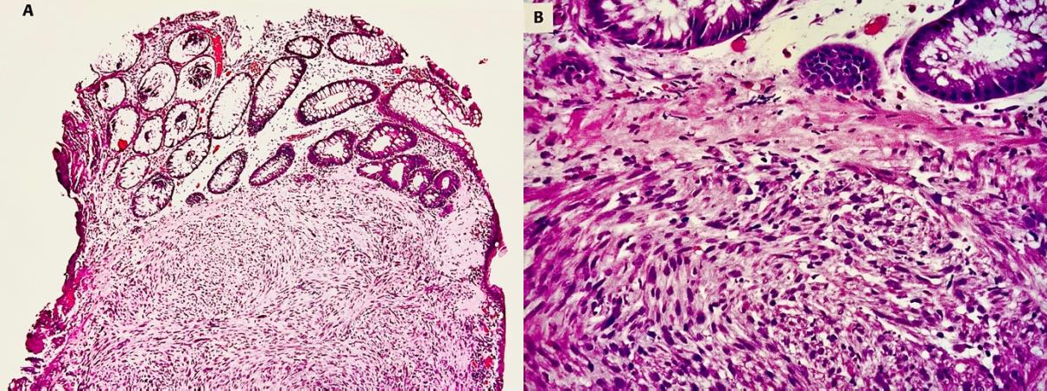

(Figure 1) Histopathological staining showing malignant spindle cell neoplasm – a gastric leiomyosarcoma

The absence of thorough radiological assessments or inaccurate interpretations of image characteristics can result in additional delays in diagnosing primary tumours of the small intestine (Zhou et al., 2024). Due to their rarity, non-specific clinical presentation, and overlapping imaging features with other gastric tumours, preoperative diagnosis remains a challenge. Here, we report a rare case of primary gastric leiomyosarcoma in a 45-year-old gentleman, highlighting the diagnostic process, histopathological findings, the surgical management undertaken and the trial of adjuvant chemotherapy imperative in such malignancies.

CASE REPORT
A 45-year-old gentleman with no antecedent comorbidities presented to the Department of General and Gastrointestinal Surgery with complaints of melena persisting over a two-month duration, accompanied by intermittent low-grade pyrexia, anorexia, and generalised asthenia over the past two weeks. Additionally, he reported a recent onset of a non-productive cough over the past week.
On general physical examination, the patient appeared moderately built and nourished, hemodynamically stable, febrile, tachycardic, and clinically pale. Abdominal examination revealed no remarkable findings, notably with the absence of left supraclavicular lymphadenopathy. Examination of other systems was normal.
Laboratory evaluation revealed a normocytic normochromic to microcytic hypochromic anaemia, with total leukocyte and platelet counts remaining
within physiological limits. Other routine haematological and biochemical parameters were within normal limits. Contrast-enhanced computed tomography (CECT) of the abdomen unveiled a heterogeneously enhancing intraluminal polypoidal mass located in the distal gastric body along the greater curvature, raising a strong suspicion for a primary neoplastic process of mesenchymal origin. No additional focal lesions or evidence of metastatic disease were identified. Chest imaging, including radiography and computed tomography, did not reveal any signs of pulmonary dissemination.
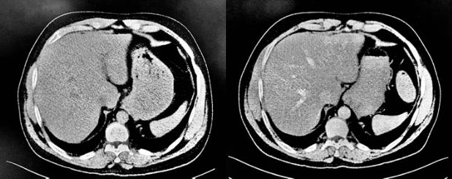
(Figure 2) CT Abdomen showing a heterogeneously enhancing intraluminal polypoidal mass lesion in the distal body of the stomach

Upper gastrointestinal endoscopy delineated a substantial ulcero-proliferative neoplastic lesion with everted margins, situated predominantly within the mid-to-distal body of the stomach. Biopsy specimens obtained intra-endoscopically were submitted for histopathological analysis, which revealed a high-grade (Grade 3) primary unifocal gastric leiomyosarcoma. The tumour originated from the submucosal layer along the greater curvature and

exhibited <10% necrosis, accompanied by stromal haemorrhagic foci and adjacent mucosal edema.
Immunohistochemical profiling demonstrated strong immunopositivity for smooth muscle actin (SMA) and h-caldesmon, while staining was negative for Desmin, cytokeratin (CK), CD117 (c-Kit), DOG1, CD34, and S-100. The Ki-67 proliferation index ranged between 40–45%, further substantiating the diagnosis of leiomyosarcoma.
Preoperatively, the patient underwent medical optimisation, inclusive of nutritional augmentation and pulmonary prehabilitation via chest physiotherapy. Given the presence of significant anaemia (haemoglobin 5.7 g/dL), the patient was transfused with four units of packed red blood cells to correct hematologic deficiency and facilitate safe surgical intervention.
The patient was taken up for diagnostic laparoscopy, which was subsequently converted to an open approach, and a subtotal D2 gastrectomy with Roux-
en-Y reconstruction was performed. Intraoperative assessment revealed a pale grey, ulcero-infiltrative neoplasm measuring 6.0 × 3.5 × 2.3 cm, located along the greater curvature of the distal gastric body. The lesion was noted to originate from the submucosal plane, with posterior extension abutting the serosal surface, but without evidence of invasion into adjacent visceral structures.
Gross morphological evaluation of the resected specimen was concordant with intraoperative findings. Histopathological examination revealed a high-grade (Grade 3) spindle cell neoplasm exhibiting marked nuclear pleomorphism, hyperchromasia, elevated mitotic index, focal necrosis (<10%), and extensive stromal haemorrhage—features consistent with the diagnosis of primary gastric leiomyosarcoma. The tumour demonstrated a fascicular growth pattern originating from the muscularis propria, with no morphologic or immunohistochemical features indicative of a gastrointestinal stromal tumour (GIST).

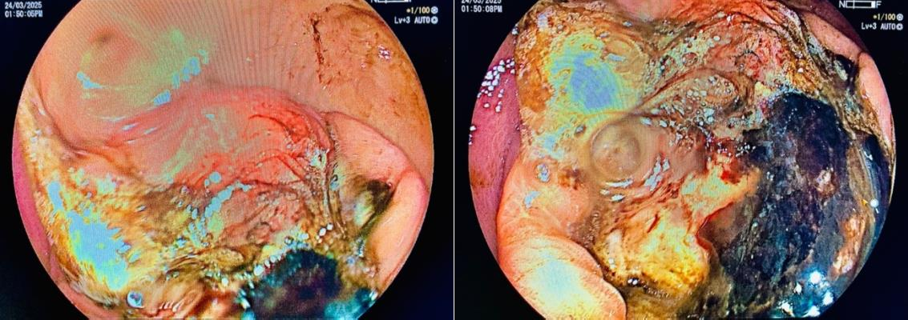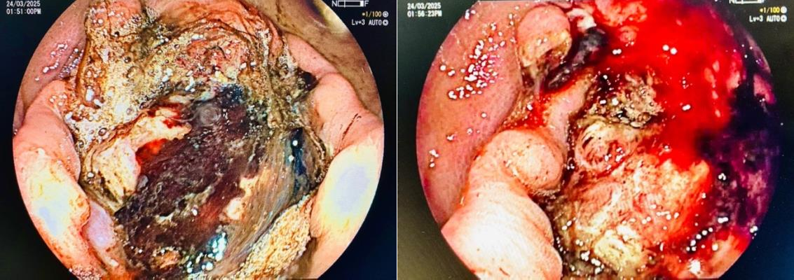

(Figure – 3) UGI endoscopy showing ulcero-proliferative mass lesion along the greater curvature of mid-distal gastric body

All resection margins, including proximal gastric, distal duodenal, and radial circumferential edges, were microscopically negative. No lymphovascular or perineural invasion was identified, and none of the retrieved regional lymph nodes demonstrated metastatic involvement [Pathological staging pT1pN0 (AJCC 8th edition)]. Taken together, these findings established the diagnosis of a rare primary gastric leiomyosarcoma, distinct from more common stromal neoplasms.
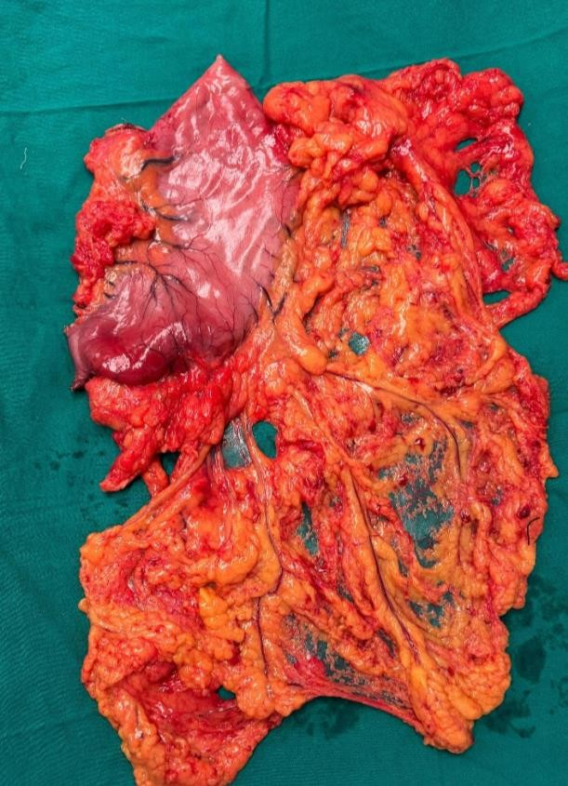
(Figure 4) Gross specimen of distal body primary gastric leiomyosarcoma –abutting the posterior serosal layer.

The patient had an uneventful postoperative recovery. He was gradually initiated on oral feeds, mobilised without complications, and discharged in stable condition on the seventh postoperative day. In view of the high-grade nature of the tumour, adjuvant chemotherapy was commenced during follow-up, comprising five cycles of Ifosfamide and epirubicin—standard agents used in the treatment of high-grade soft tissue sarcomas. The patient was
subsequently referred to the oncology department for continued multidisciplinary management.

DISCUSSION
Primary gastric leiomyosarcoma (LMS) constitutes a remarkably rare subset of mesenchymal neoplasms of the stomach, especially in the era following the advent of immunohistochemical and molecular markers that have reclassified the majority of erstwhile smooth muscle tumours as gastrointestinal stromal tumours (GISTs). True leiomyosarcomas, by definition, are devoid of c-KIT (CD117) and DOG1 expression and originate from the muscularis propria, exhibiting unequivocal smooth muscle differentiation.
Clinically, gastric LMS tends to present insidiously, often masquerading as more common gastrointestinal pathologies. The present case, involving a 45-year- old male with melena, low-grade fever, anorexia, and constitutional symptoms, exemplifies the non- specific symptomatology characteristic of such tumors. Initial radiological evaluation revealed a heterogeneously enhancing polypoidal lesion in the distal stomach, while upper gastrointestinal endoscopy exposed a large ulcero-proliferative mass with rolled-out margins, raising suspicion for an aggressive neoplasm.
Histopathological analysis remains the gold standard for definitive diagnosis. In this case, the biopsy and subsequent resection specimen demonstrated a high-grade (Grade 3) spindle cell neoplasm exhibiting features consistent with a primary leiomyosarcoma— characterised by marked cytological atypia, brisk mitotic activity, focal necrosis (<10%), stromal haemorrhage, and a lack of immunopositivity for GIST-defining markers. These findings were consistent with a neoplasm of smooth muscle lineage, confined to the gastric wall, with no evidence of nodal or distant dissemination.
Therapeutically, complete surgical excision with negative margins constitutes the cornerstone of curative intent management for localised gastric leiomyosarcoma. The patient underwent a subtotal

D2 gastrectomy with Roux-en-Y reconstruction. Intraoperative findings and subsequent gross pathological examination revealed a 6.0 × 3.5 × 2.3 cm grey-white ulcero-proliferative mass arising from the submucosa along the greater curvature. Histopathology confirmed negative proximal, distal, and radial margins with no lymphovascular invasion or lymph nodal involvement (pT1pN0, AJCC 8th edition), supporting a localised but high-grade neoplasm.
Given the tumour’s histological aggressiveness, adjuvant chemotherapy was deemed appropriate. Although no standardised regimen exists due to the paucity of cases, chemotherapeutic agents typically employed in the management of high-grade soft tissue sarcomas—namely, Ifosfamide and Epirubicin—were initiated in this case. The patient tolerated the postoperative period well and was discharged on the seventh postoperative day.

CONCLUSION
In conclusion, this case delineates the diagnostic and therapeutic challenges inherent to primary gastric leiomyosarcoma, a rare and often misdiagnosed entity. Accurate histopathological differentiation from GISTs, thorough surgical resection, and individualised oncological follow-up are imperative in optimising clinical outcomes. The rarity of this neoplasm underscores the necessity for further case-based analyses to elucidate prognostic determinants and refine therapeutic strategies.

REFERENCES
- Leiomyosarcoma of the stomach treated by endoscopic submucosal dissection. Clin J Gastroenterol - Sato T, Akahoshi K, Tomoeda N, Kinoshita N, Kubokawa M, Yodoe K, Hiraki Y, Oya M, Yamamoto H, Ihara E.
- Gastric leiomyosarcoma and diagnostic pitfalls: a case report. Hasnaoui A, Jouini R, Haddad D, Zaafouri H, Bouhafa A, Ben Maamer A, Ben Brahim E.
- Leiomyosarcoma of the stomach with metastasis to the liver: a case report with review of the literature. Mehta V, Rajawat M, Rastogi S, Phulware RH, Mezencev R.
- A case of gastric leiomyosarcoma with multiple metastases - Korean J Gastroenterol. Rou WS, Ju JS, Kang SH, Moon HS, Sung JK, Lee BS, Jeong HY, Song KS.5.Weledji EP, Enoworock G, Ngowe MN.
- Gastric leiomyosarcoma as a rare cause of gastric outlet obstruction and perforation: a case report.
- Clinicopathological features of primary leiomyosarcoma of the gastrointestinal tract following recognition of gastrointestinal stromal tumours. Histopathology. Yamamoto H, Handa M, Tobo T, Setsu N, Fujita K, Oshiro Y, Mihara Y, Yoshikawa Y, Oda Y.
- Gastric leiomyosarcoma: case report and review of literature Damiano G, Di Ganci S, Palumbo VD, Spinelli G, De Luca S, Cudia B, Tomasello G, Lo Monte AI.
- Coexistence of primary gastric giant cell-rich leiomyosarcoma and gastrointestinal stromal tumor: report of a very rare combination and review of the literature. Int J Surg Pathol. Insabato L, Masone S, Campione S, Vigliar E, Staibano S, Tornillo L.
- Primary gastric leiomyosarcoma in young revealed by a massive hematemesis. J Gastrointest Cancer. Soufi M, Errougani A, Chekkof RM.
- Gastric leiomyosarcoma manifesting peculiar findings: radiological-pathological correlation. Pathol Int. Masuzawa N, Kishimoto M, Nishimura A, Ichiba N, Aoki E, Yanagibashi K, Hirota S, Yanagisawa A.
- Intramucosal leiomyosarcoma of the stomach following hereditary retinoblastoma in childhood - a case report and review of the literature. World J Surg Oncol. Pauser U, Grimm H.

- Unusual acute onset of pedunculated extragastric leiomyosarcoma. Case report. G Chir. Geraci G, Pisello F, Sciumè C, Li Volsi F, Platia L, Facella T, Modica G.
- Malignant gastrointestinal leiomyosarcoma and gastrointestinal stromal tumor with prominent osteoclast-like giant cells. Arch Pathol Insabato L, Di Vizio D, Ciancia G, Pettinato G, Tornillo L, Terracciano L.
- WHO classification of tumours of soft tissue and bone; Fletcher CDM, Bridge JA, Hogendoom PCW. Lyon: IARC Press; 2013.
- True smooth muscle neoplasms of the gastrointestinal tract: morphological spectrum and
classification in a series of 85 cases from a single institute. Agaimy A, Wünsch PH.
- Combination of gemcitabine and docetaxel regresses both gastric leiomyosarcoma proliferation and invasion in an imageable patient-derived orthotopic xenograft (iPDOX) model. Cell Cycle. Kawaguchi K, Igarashi K, Murakami T, Kiyuna T, Nelson SD, Dry SM, Li Y, Russell TA, Singh AS, Chmielowski B, Unno M, Eilber FC, Hoffman RM.
- Leiomyosarcoma of the gastric cardia and fundus. Zhonghua Yi Xue Za Zhi (Taipei) Hsieh CC, Shih CS, Wu YC, Huang BS, Hsu WH, Huang MH, Wang LS
- Lee, Y. (2023). Primary gastric leiomyosarcoma: a case report and literature review. Kosin Medical Journal, 39(1), 60-65.
- Zhou, J., Xu, H., Hu, J., Hong, Q., Yu, X., Liu, W., ... & Hu, H. (2024). Current landscape of primary small bowel leiomyosarcoma: cases report and a decade of insights. Frontiers in Oncology, 14, 1408524.
- Garg, R., AlRajjal, A., Berri, R., & Barawi, M. (2020). Primary gastric leiomyosarcoma: a case report and review of the literature. Journal of Gastrointestinal Cancer, 51(1), 335-340.

