Assessment of the Impact of APEX1 (rs2307486) and URAT1 (rs11231825) Gene Polymorphisms on the Response of Hypouricemic Therapy in Women with Gout

Abstract: This scientific study aimed to evaluate the effect of polymorphisms in the APEX1 (rs2307486) and URAT1 (rs11231825) genes on the effectiveness of hypouricemic therapy in women with gout. The study included 102 female patients as the primary analysis group and 100 male patients with gout as a secondary comparative cohort in 2021–2025. The patients were prescribed allopurinol and febuxostat, and their effectiveness was assessed across different genotypes of the above genes. According to the results of the study, patients with the G/G genotype of the APEX1 gene had a low response to allopurinol, and only febuxostat was effective. In patients with the T/T genotype, both drugs were almost equally effective. In patients with the T/T genotype of the URAT1 (rs11231825) gene, resistance to allopurinol and a requirement for a higher dose were found, and febuxostat was noted to be more effective. In patients with the A/A genotype, the standard dose was sufficiently effective. These results indicate that polymorphisms of the APEX1 and URAT1 genes are important pharmacogenetic biomarkers in determining the individual effectiveness of hypouricemic therapy. The selection of drugs and their doses based on a personalized approach increases therapeutic efficacy, eliminates resistance, and improves quality of life.

Keywords: gout, women, hypouricemic therapy, APEX1, URAT1, gene polymorphism, pharmacogenetics, febuxostat, allopurinol, genotype, personalized medicine, quality of life.

Introduction. The effectiveness of gout treatment is influenced by various individual factors, including genetic factors [7,11]. Polymorphisms of the APEX1 (rs2307486) and URAT1 (rs11231825) genes have been found to be important in assessing the effectiveness of hypouricemic therapy (allopurinol and febuxostat) in women [2,9]. Patients with certain genotypic forms of APEX1 may have a poor response to hypouricemic therapy, may have high uric acid titers, and may have a longer duration of inflammation [8]. In such situations, increasing the dose or using alternative drugs such as febuxostat may be effective [5,18-22]. Some of the studied genotypes of the URAT1 (rs11231825) gene are associated with reduced urate excretion, and monotherapy with allopurinol may not always be sufficiently effective [10,23-25]. In such cases, combined or high-dose hypouricemic therapy may be necessary [6,12]. By developing personalized hypouricemic therapy regimens taking into account the genotypic composition, it is possible to increase the effectiveness of treatment, reduce the development of drug resistance, and reduce the risk of complications [3,13-17].
In conclusion, an individual approach based on gene polymorphisms in the hypouricemic treatment of gout in women plays an important role in altering the effectiveness of therapy [1,4].
Objective: to assess the significance of the APEX1 (rs2307486) and URAT1 (rs11231825) gene polymorphisms in the effectiveness of hypouricemic treatment of gout in women.
Material and methods. The scientific research study (meeting the EULAR/ACR criteria, 2015) included 102 women and 100 men aged 18 to 75 years (mean age 46.5±1.4 years), who had applied for outpatient treatment to the Arthrological Intensive Outpatient Diagnostic Consultative (IADC) Department of the Multidisciplinary Clinic of the Tashkent Medical Academy (TMA) during 2021-2025 and were receiving inpatient treatment in the departments of cardiorheumatology, rheumatology, general therapy, and traumatology-orthopedics. Women with gout formed group I, and men formed group II. Male patients were included as a secondary comparative cohort to strengthen genetic association analysis and evaluate possible sex-specific differences. The control group included 20 practically healthy women who were age-matched to the patients in the main group and did not reveal pathological changes in clinical, laboratory, and instrumental examinations. The efficacy of hypouricemic drugs such as allopurinol and febuxostat in patients with gout was assessed depending on various genotypic variants of the APEX1 and URAT1 gene polymorphisms. Pharmacogenetic analyses were conducted to determine the relationship between genetic factors and response to treatment. Molecular genetic studies were conducted at the Inter-Institutional Research Laboratory (IRL) of the Tashkent Medical Academy. Venous blood for genetic analysis was taken on an empty stomach in the morning under sterile conditions. DNA isolated from peripheral blood leukocytes served as the research material. The DNA-Express Blood (LLC NPF Litekh, Russia) reagent kit was used to perform genetic tests. The APEX1 and URAT1 genes were tested by polymerase chain reaction (PCR) using a reagent kit provided by the Russian scientific and manufacturing company Litekh. DNA PCR was performed on a DT-96 PCR amplifier (LLC NPO "DNA-Technology", Russia). DNA amplification was performed by initial denaturation at 95 °C for 3 minutes, followed by 40 cycles of denaturation at 95 °C for 15 seconds, followed by annealing and elongation at 63 °C for 40 seconds. Multivariate analyses were performed, adjusting for potential confounders including age, BMI, comorbidities (hypertension, CKD, diabetes), and concomitant medications.
Results: The diagram in figure 1 below compares the efficacy of hypouricemic therapy with allopurinol and febuxostat in gout patients with the APEX1 (rs2307486) polymorphism in four clinical parameters across genotypes (T/T (n=32), T/G (n=45), G/G (n=25)). In this study, the level of uric acid in the blood, the reduction/disappearance of tophi volume, the gout severity index, and the reduction in the number of annual attacks were studied against the background of hypouremic therapy recommended for patients with these genotypes. The effectiveness of allopurinol and febuxostat prescribed to patients with the homozygous T/T (n=32) genotype of the APEX1 (rs2307486) gene was similar, with all indicators improving by ~70–80%. However, it was noted that p = 0.5, which did not have statistical significance. In this case, both drugs provided the same benefit in patients with the T/T genotype. Patients with the T/G (n=45) genotype had significantly higher reductions in uric acid, disappearance of tophi, and reduction in the number of annual attacks against the background of febuxostat treatment. In contrast, the efficacy of allopurinol treatment was significantly lower than that of febuxostat (p<0.01). In the heterozygous state, febuxostat was superior to allopurinol. In the G/G (n=25) genotype, the efficacy of allopurinol treatment was very low, especially in terms of uric acid levels and the number of annual attacks. When febuxostat was used instead, all parameters improved significantly (~80–90%; (p<0.01)). In the G/G homozygous mutation, only febuxostat was effective, and allopurinol was almost useless.
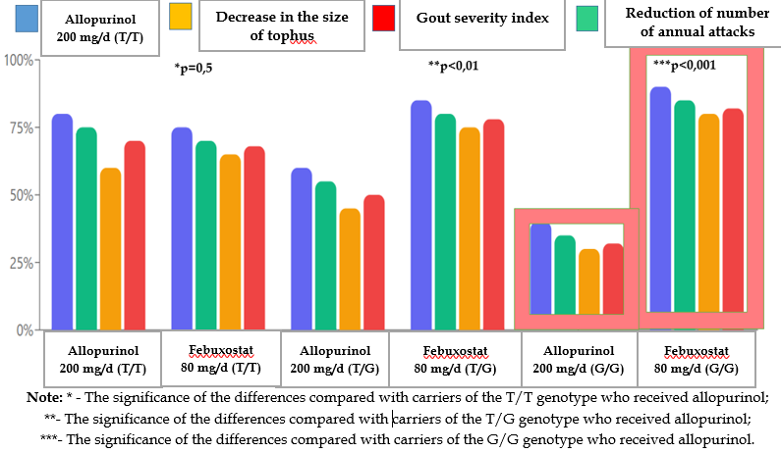
Figure 1. Dynamics of the main clinical indicators against the background of hypouremic therapy in different variants of the APEX1 (rs2307486) genotype

Indeed, it was found that the response to hypouricemic therapy in gout patients with the APEX1 (rs2307486) polymorphism depends on the genotype. In patients with the T/T genotype, the efficacy of allopurinol and febuxostat is similar, in the T/G heterozygote state, febuxostat is more effective, and in the G/G mutated homozygote, allopurinol is ineffective, only febuxostat showed a high efficacy. These results provide an important basis for a pharmacogenetically adequate approach to personalized treatment and indicate the need to take into account the APEX1 (rs2307486) genotype when planning successful therapy.

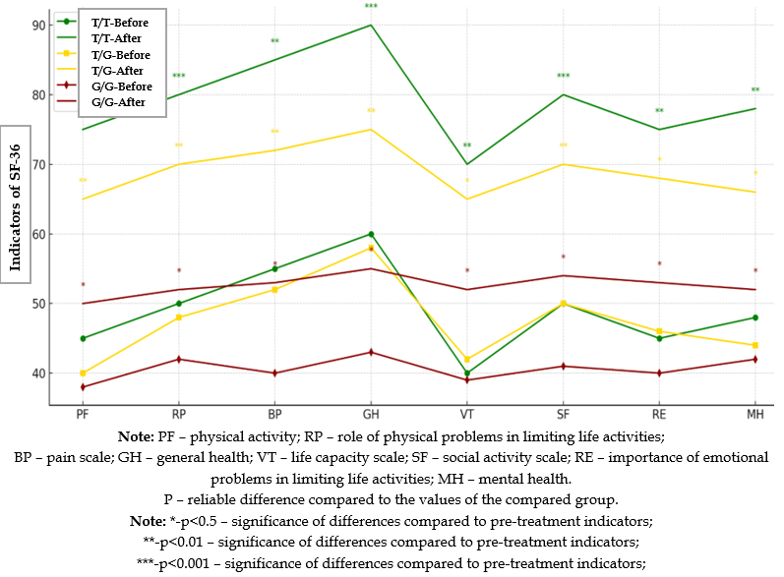
Figure 2. Dynamics of SF-36 quality of life indicators against the background of hypouremic therapy in different variants of the APEX1 (rs2307486) genotype

The bar graph in figure 2 above presents a comparative analysis of the indicators of the overall quality of life on the SF-36 scale before and after treatment for different genotypes of the APEX1 (rs2307486) gene (T/T, T/G, G/G) detected in gout patients. In the graph, in the T/T genotype (green line), a significant improvement was observed in all SF-36 domains after treatment. Some indicators (VT, SF, PF) approached 90 points, which indicates a very high quality of life (p<0.001). In the T/G genotype (yellow line), moderate positive dynamics were observed in all indicators. Statistically significant differences were noted in some indicators (p<0.01). Thus, patients with the T/G heterozygous mutant genotype also respond positively to hypouremic therapy, but the effectiveness of treatment is lower than that of the T/T genotype. Patients with the G/G genotype (red line) retained significantly lower levels of quality of life indicators after treatment. No clinically or statistically significant improvement was observed in all domains. Thus, the effectiveness of treatment in the G/G genotype is lower than in patients with other genotypes, which indicates the presence of this genetic resistance in them.

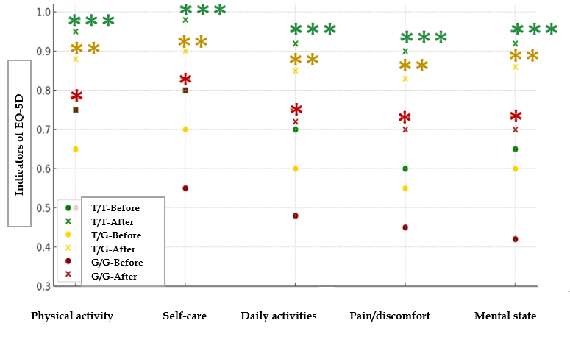
Note: *-р<0.05; **-р<0.02; ***-р<0.01 – significance of differences compared to pre-treatment indicators;
Figure 3. Dynamics of quality of life indicators according to the EQ-5D scale in different variants of the APEX1 (rs2307486) genotype against the background of hypouremic therapy

The graph in figure 3 shows changes in the 5 main components of the quality of life index (EQ-5D scale, range 0–1) before and after treatment in patients with gout according to different genotypes of the APEX1 (rs2307486) gene (T/T, T/G, G/G). Against the background of hypouremic therapy, statistically positive dynamics were noted in physical activity, self-care, daily activities, pain/discomfort, and mental state (р<0.05; р<0.02;р<0.01). In patients with the T/T genotype (green), the differences in efficacy before and after treatment were very significant, all indicators approached ~0.9. After treatment, the quality of life almost approached the norm. Highly reliable differences (p<0.05) were observed in all components. Hypouricemic therapy significantly improved the quality of life in patients with the T/T genotype. As a result of treatment, moderate positive dynamics were noted in patients with the T/G genotype (yellow), the indicators were around ~0.75–0.8. Improvement in mental state and daily activities was obvious, but relatively less positive dynamics were observed in physical activity and pain. In the heterozygous state (T/G), it can be concluded that the treatment effect was moderate, but stable. In patients with the G/G genotype (red), the indicators remained around 0.5–0.6, that is, the clinical improvement was slightly lower than in patients with the previous two genotypes. No significant improvement was observed in all components. Thus, in patients with the G/G genotype, resistance to treatment and no significant positive shift in quality of life were noted.
In conclusion, it can be said that the analysis of quality of life indicators assessed by the EQ-5D scale shows that the APEX1 (rs2307486) polymorphism accurately determines the effectiveness of treatment and functional status in patients with gout. In the T/T genotype, a significant difference in the quality of life index was noted for all components, and almost complete rehabilitation was achieved after hypouricemic therapy. In patients with the T/G genotype, the improvement was moderate, while in patients with the G/G genotype, the therapeutic effect was low, and quality of life indicators were less close to clinical norms.
The diagram in figure 4 below compares the average daily dose of allopurinol (mg) for different genotypes (A/A, T/A, T/T) of the URAT1 (rs11231825) gene. This analysis was aimed at identifying the most appropriate dose for patients based on a pharmacogenetic approach. Patients with the A/A genotype responded effectively with a low dose of allopurinol (300 mg) - since this genotype does not have any mutations, the standard dose was sufficient. In the T/A genotype, the average dose was 420 mg. This is a heterozygous mutation, requiring a higher dose to achieve full effect (p < 0.01). Patients with the T/T genotype received up to 580 mg of allopurinol, indicating resistance to allopurinol in the homozygous mutation state (p < 0.001).
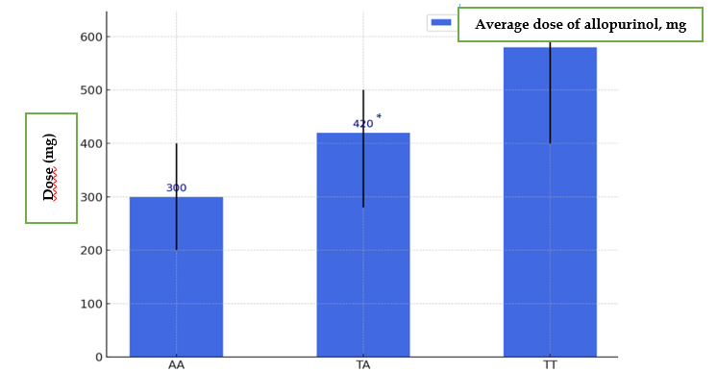
Note: *-р<0.5 – significance of differences relative to AA genotype indicators;
**-р<0.01 – significance of differences relative to TA genotype indicators;
$-р<0.001 – significance of differences relative to AA genotype indicators;
Figure 4. Average Clinically Used Doses of Allopurinol (mg) by URAT1 (rs11231825) Genotypic Variants
The URAT1 (rs11231825) polymorphism is an important pharmacogenetic marker that shapes the dose required for allopurinol therapy. While the standard dose is sufficient in the A/A genotype, the dose should be significantly increased in the T/A and especially T/T genotypes. These results indicate the need to recommend URAT1 (rs11231825) genotyping in the development of a personalized treatment plan.
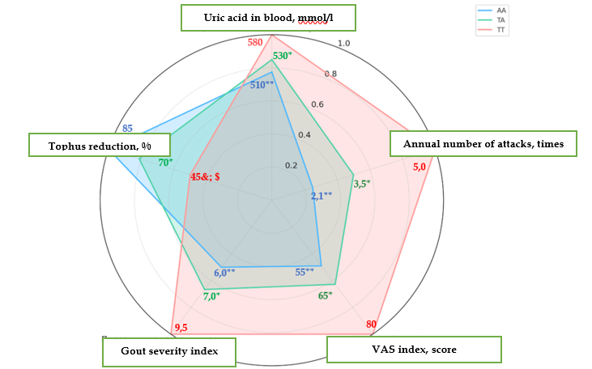
Note: *-р<0.1; **-р<0.05 – significance of differences relative to TT genotype indicators;
&- р<0.001 – significance of differences relative to AA genotype indicators;
$-р<0.05 – significance of differences relative to TA genotype indicators;

Figure 5. Hypouricemic therapy efficacy according to URAT1 (rs11231825) genotypic variants (when using Allopurinol at doses of 300-600 mg)
The radial (spider-like) diagram above compares five main clinical indicators in patients with gout according to different genotypes of the URAT1 (rs11231825) gene (A/A - blue, T/A - green, T/T - red). For each indicator, higher values indicate deterioration, and lower values indicate improvement (exception: a higher degree of tophi reduction is better). According to the results of the study, there is a reliable relationship between the mutated T/T genotype of the URAT1 (rs11231825) gene and clinical symptoms of gout. Patients with this genotype had the worst blood uric acid levels, pain index (PAI), annual number of attacks, and gout severity index. At the same time, tophi resorption was low (activity was preserved), which indicates resistance to treatment. On the contrary, patients with the A/A genotype had the best results in all clinical parameters: low uric acid levels, low pain and annual number of attacks, and almost complete disappearance of tophi (fig. 5). Indeed, the T/T genotype is associated with a severe, treatment-resistant, and chronic clinical phenotype of gout. The A/A genotype can be evaluated as a “protective” prognostic biomarker. The use of the URAT1 (rs11231825) polymorphism in genetic screening has important clinical significance in early gout prediction and selection of personalized treatment tactics.
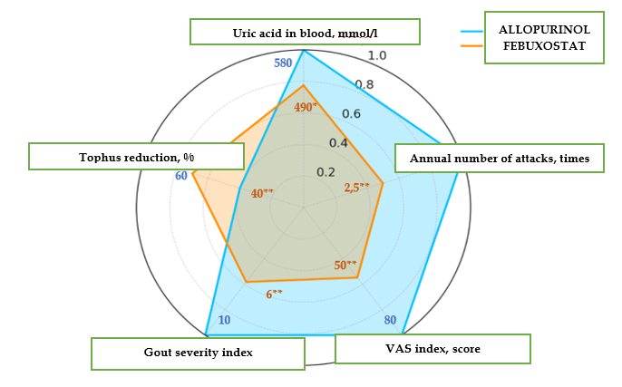
Note: p – Significance of differences with respect to allopurinol scores
Figure 6. Efficacy of allopurinol and febuxostat in patients with gout who have the T/T genotype of the URAT1 (rs11231825) gene
The radial diagram above compares the efficacy of two types of hypouricemic therapy in patients with gout - allopurinol (blue line) and febuxostat (yellow line) - on five key clinical parameters. Febuxostat showed different results compared to allopurinol in all parameters, in some cases statistically significant. Patients receiving febuxostat had higher efficacy in terms of uric acid levels, annual number of attacks, pain level, and disease severity index. Patients who were prescribed allopurinol had a relatively lower efficacy in reducing uric acid, pain, and attacks. However, it was noted that its effect on accumulated gouty tissue was stronger (figure 6).

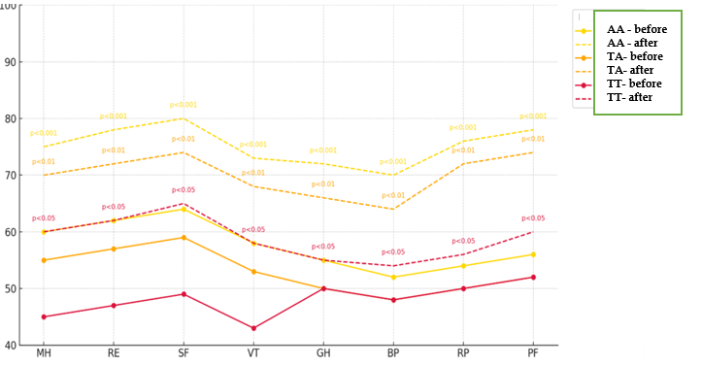
Note: p- the significance of differences compared to pre-treatment values;
Figure 7. Dynamics of SF-36 quality of life indicators against the background of hypouremic therapy in different variants of the URAT1 genotype

The bar graph in figure 7 compares the quality of life indicators (SF-36 scale) before and after treatment in gout patients with different genotypes (A/A, T/A, T/T) of the URAT1 gene. Statistically significant values (p-value) are shown for each domain, and therapeutic efficacy was observed in the sequence A/A > T/A > T/T. In patients with the A/A genotype (yellow line), the indicators in all domains after treatment were very high (70–85 points; p < 0.001). It was noted that this genotype was the group that responded best to therapy. Patients with the T/A genotype (brown line) showed a moderate improvement in all domains (60–70 points; p < 0.01 and p < 0.05). The effect in the heterozygous state was lower than in A/A, but higher than in T/T. In patients with the T/T genotype (red line), the positive dynamics of the indicators after hypouremic treatment was maintained to a lesser extent than in the other genotypes (~50–60 points; p < 0.05). The pharmacological effect in this genotype was relatively lower, and resistance to hypouremic therapy was observed.
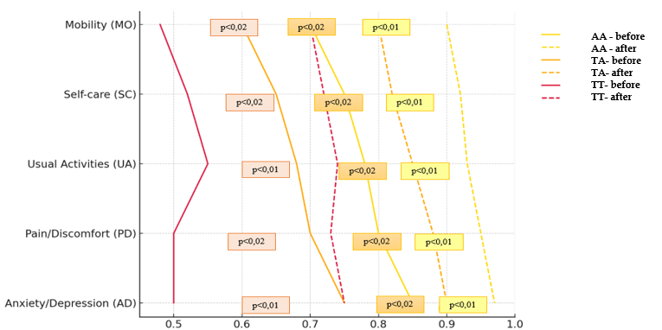
Note: p- the significance of differences compared to pre-treatment values;
Figure 8. Dynamics of quality of life indicators according to the EQ-5D scale against the background of hypouremic therapy in different variants of the URAT1 genotype
The comparison of changes in the 5 components of the EQ-5D (EuroQoL) quality of life scale according to different genotypes (A/A, T/A, T/T) of the URAT1 (rs2307486) gene in gout patients before and after treatment is presented in figure 8 above. According to it, the effectiveness of treatment for each indicator and its statistical significance are determined by p-value. Analysis of the quality of life components assessed by the EQ-5D index indicates that different genotypes of the URAT1 (rs11231825) gene have a direct impact on the effectiveness of treatment in gout patients. In patients with the A/A genotype, the indicators Mobility, Self-care, Usual activities, Pain/Discomfort and Anxiety/Depression improved with statistical significance at the level of p<0.01–0.02. Significant positive changes were also noted in patients with the T/A genotype. On the contrary, in patients with the T/T genotype, insufficient treatment efficacy and minimal differences in the main indicators of quality of life were observed.

Discussion. These findings support the integration of APEX1 and URAT1 genotyping into routine gout management, allowing clinicians to personalize drug choice and dosing. Implementation could involve screening algorithms for women at high risk of treatment resistance, particularly those with G/G (APEX1) or T/T (URAT1) genotypes.

Conclusions
- The APEX1 (rs2307486) gene polymorphism is an important pharmacogenetic marker affecting the effectiveness of hypouricemic therapy in women with gout. While patients with the T/T genotype responded highly and almost equally to allopurinol and febuxostat, only febuxostat was effective in patients with the G/G genotype.
- Genotypic variants of the URAT1 (rs11231825) gene play an important role in determining the clinical efficacy and dosage of allopurinol in the treatment of gout. While the standard dose was sufficient in patients with the A/A genotype, higher doses were required in patients with the T/T genotype, but the response remained low.
- The T/T genotype showed a high response to febuxostat in both APEX1 and URAT1 genes, therefore, febuxostat can be recommended as a first-line drug for patients with this genotype.
- Assessments using the SF-36 and EQ-5D quality of life scales showed that the effectiveness of treatment was different depending on the APEX1 and URAT1 genotypes. While quality of life indicators were consistently increased in patients with the T/T genotype, they remained lower in patients with the G/G and T/T genotypes.
- The development of personalized hypouricemic therapy regimens taking into account genetic polymorphisms allows optimizing treatment effectiveness, reducing drug resistance and improving the quality of life of patients.
- The introduction of pharmacogenetic screening into clinical practice for women with gout, especially the analysis of the APEX1 and URAT1 genes, has important clinical and practical significance in determining individual therapy tactics and prognosis.

Disclaimer (Artificial intelligence)
Author(s) hereby declare that NO generative AI technologies such as Large Language Models (ChatGPT, COPILOT, etc.) and text-to-image generators have been used during the writing or editing of this manuscript.

References:
- Bobulescu IA, Moe OW. Renal transport of uric acid: evolving concepts and uncertainties. Adv Chronic Kidney Dis. 2012 Nov;19(6):358-71. doi: 10.1053/j.ackd.2012.07.009. PMID: 23089270; PMCID: PMC3619397.
- Burns CM, Wortmann RL. Gout therapeutics: new drugs for an old disease. Lancet. 2011 Jan 8;377(9760):165-77. doi: 10.1016/S0140-6736(10)60665-4. Epub 2010 Aug 16. PMID: 20719377.
- Dong Y, Zhao T, Ai W, Zalloum WA, Kang D, Wu T, Liu X, Zhan P. Novel urate transporter 1 (URAT1) inhibitors: a review of recent patent literature (2016-2019). Expert Opin Ther Pat. 2019 Nov;29(11):871-879. doi: 10.1080/13543776.2019.1676727. Epub 2019 Oct 14. PMID: 31593642.
- Enomoto A, Kimura H, Chairoungdua A, Shigeta Y, Jutabha P, Cha SH, Hosoyamada M, Takeda M, Sekine T, Igarashi T, Matsuo H, Kikuchi Y, Oda T, Ichida K, Hosoya T, Shimokata K, Niwa T, Kanai Y, Endou H. Molecular identification of a renal urate anion exchanger that regulates blood urate levels. Nature. 2002 May 23;417(6887):447-52. doi: 10.1038/nature742. Epub 2002 Apr 14. PMID: 12024214.
- Ernst ME, Fravel MA. Febuxostat: a selective xanthine-oxidase/xanthine-dehydrogenase inhibitor for the management of hyperuricemia in adults with gout. Clin Ther. 2009 Nov;31(11):2503-18. doi: 10.1016/j.clinthera.2009.11.033. PMID: 20109996.
- Ghaderi-Zefrehi H, Rezaei M, Sadeghi F, Heiat M. Genetic polymorphisms in DNA repair genes and hepatocellular carcinoma risk. DNA Repair (Amst). 2021 Nov;107:103196. doi: 10.1016/j.dnarep.2021.103196. Epub 2021 Jul 29. PMID: 34416543.
- Gherghina ME, Peride I, Tiglis M, Neagu TP, Niculae A, Checherita IA. Uric Acid and Oxidative Stress-Relationship with Cardiovascular, Metabolic, and Renal Impairment. Int J Mol Sci. 2022 Mar 16;23(6):3188. doi: 10.3390/ijms23063188. PMID: 35328614; PMCID: PMC8949471.
- Glantzounis GK, Tsimoyiannis EC, Kappas AM, Galaris DA. Uric acid and oxidative stress. Curr Pharm Des. 2005;11(32):4145-51. doi: 10.2174/138161205774913255. PMID: 16375736.
- Hou Z, Ma A, Mao J, Song D, Zhao X. Overview of the pharmacokinetics and pharmacodynamics of URAT1 inhibitors for the treatment of hyperuricemia and gout. Expert Opin Drug Metab Toxicol. 2023 Dec;19(12):895-909. doi: 10.1080/17425255.2023.2287477. Epub 2024 Jan 12. PMID: 37994776.
- Ichida K, Matsuo H, Takada T, Nakayama A, Murakami K, Shimizu T, Yamanashi Y, Kasuga H, Nakashima H, Nakamura T, Takada Y, Kawamura Y, Inoue H, Okada C, Utsumi Y, Ikebuchi Y, Ito K, Nakamura M, Shinohara Y, Hosoyamada M, Sakurai Y, Shinomiya N, Hosoya T, Suzuki H. Decreased extra-renal urate excretion is a common cause of hyperuricemia. Nat Commun. 2012 Apr 3;3:764. doi: 10.1038/ncomms1756. PMID: 22473008; PMCID: PMC3337984.
- Kamatani N, Fujimori S, Hada T, Hosoya T, Kohri K, Nakamura T, Ueda T, Yamamoto T, Yamanaka H, Matsuzawa Y. An allopurinol-controlled, randomized, double-dummy, double-blind, parallel between-group, comparative study of febuxostat (TMX-67), a non-purine-selective inhibitor of xanthine oxidase, in patients with hyperuricemia including those with gout in Japan: phase 3 clinical study. J Clin Rheumatol. 2011 Jun;17(4 Suppl 2):S13-8. doi: 10.1097/RHU.0b013e31821d36cc. PMID: 21654265.
- Keenan RT, Shen Z, Yan S, Yeh LT, Pillinger MH. How URAT1 inhibitors can shape the future of chronic gout treatment: a narrative review of uricosurics past and present. Explor Musculoskeletal Dis. 2024;2:529–54. https://doi.org/ 10.37349/emd.2024.00077
- Li R, Yu K, Li C. Dietary factors and risk of gout and hyperuricemia: a meta-analysis and systematic review. Asia Pac J Clin Nutr. 2018;27(6):1344-1356. doi: 10.6133/apjcn.201811_27(6).0022. PMID: 30485934.
- Lu Z, Li S, Ning S, Yao M, Zhou X, Wu Y, Zhong C, Yan K, Wei Z, Xie Y. Association of the rs1760944 polymorphism in the APEX1 base excision repair gene with risk of nasopharyngeal carcinoma in a population from an endemic area in South China. J Clin Lab Anal. 2018 Feb;32(2):e22238. doi: 10.1002/jcla.22238. Epub 2017 May 2. PMID: 28464393; PMCID: PMC6817270.
- Richette P, Ottaviani S, Bardin T. Nouveaux traitements de la goutte [New therapeutic options for gout]. Presse Med. 2011 Sep;40(9 Pt 1):844-9. French. doi: 10.1016/j.lpm.2011.02.043. Epub 2011 Jun 17. PMID: 21684104. Richette P, Ottaviani S, Bardin T. Nouveaux traitements de la goutte [New therapeutic options for gout]. Presse Med. 2011 Sep;40(9 Pt 1):844-9. French. doi: 10.1016/j.lpm.2011.02.043. Epub 2011 Jun 17. PMID: 21684104.
- Saigal R, Agrawal A. Pathogenesis and Clinical Management of Gouty Arthritis. J Assoc Physicians India. 2015 Dec;63(12):56-63. PMID: 27666904.
- Song D, Zhao X, Wang F, Wang G. A brief review of urate transporter 1 (URAT1) inhibitors for the treatment of hyperuricemia and gout: Current therapeutic options and potential applications. Eur J Pharmacol. 2021 Sep 15;907:174291. doi: 10.1016/j.ejphar.2021.174291. Epub 2021 Jul 1. PMID: 34216576.
- Suo Y, Fedor JG, Zhang H, Tsolova K, Shi X, Sharma K, Kumari S, Borgnia M, Zhan P, Im W, Lee SY. Molecular basis of the urate transporter URAT1 inhibition by gout drugs. bioRxiv. 2024 Sep 12:2024.09.11.612563. doi: 10.1101/2024.09.11.612563. Update in: Nat Commun. 2025 Jun 4;16(1):5178. doi: 10.1038/s41467-025-60480-3. PMID: 39314352; PMCID: PMC11419087.
- Suo Y, Fedor JG, Zhang H, Tsolova K, Shi X, Sharma K, Kumari S, Borgnia M, Zhan P, Im W, Lee SY. Molecular basis of the urate transporter URAT1 inhibition by gout drugs. bioRxiv. 2024 Sep 12:2024.09.11.612563. doi: 10.1101/2024.09.11.612563. Update in: Nat Commun. 2025 Jun 4;16(1):5178. doi: 10.1038/s41467-025-60480-3. PMID: 39314352; PMCID: PMC11419087.
- Tanaka K., Nakayama Y., Sugiura T. Oxidative stress and uric acid: new roles of an old metabolite in the pathogenesis of hyperuricemia and gout //Antioxidants (Basel). 2022; № 11, Vol. 11(2). P.274-278
- Terkeltaub R. Update on gout: new therapeutic strategies and options. Nat Rev Rheumatol. 2010 Jan;6(1):30-8. doi: 10.1038/nrrheum.2009.236. PMID: 20046204.
- Wang Z, Cui T, Ci X, Zhao F, Sun Y, Li Y, Liu R, Wu W, Yi X, Liu C. The effect of polymorphism of uric acid transporters on uric acid transport. J Nephrol. 2019 Apr;32(2):177-187. doi: 10.1007/s40620-018-0546-7. Epub 2018 Oct 31. PMID: 30382560.
- Xu L, Shi Y, Zhuang S, Liu N. Recent advances on uric acid transporters. Oncotarget. 2017 Aug 10;8(59):100852-100862. doi: 10.18632/oncotarget.20135. PMID: 29246027; PMCID: PMC5725069.
- Yuan HH, Yin H, Marincas M, Xie LL, Bu LL, Guo MH, Zheng XL. From DNA Repair to Redox Signaling: The Multifaceted Role of APEX1 (Apurinic/Apyrimidinic Endonuclease 1) in Cardiovascular Health and Disease. Int J Mol Sci. 2025 Mar 26;26(7):3034. doi: 10.3390/ijms26073034. PMID: 40243693; PMCID: PMC11988304.
- Zhu Y., Pandya B. J., Choi H. K. Prevalence of gout and hyperuricemia in the US: the National Health and Nutrition Examination Survey 2007–2016 // Arthritis Rheumatol. 2021; Vol. 73(5). P. 826–835

