*Mini-review Article*

Photoprotective and Antimelanogenic Properties of *Carica papaya* Leaf Extract: A Molecular Perspective on Skin Aging Prevention

Abstract

|  |
| --- |
| **Introduction:** Skin hyperpigmentation disorders, such as melasma and post-inflammatory pigmentation, pose aesthetic and psychological concerns. These conditions are aggravated by ultraviolet B (UVB) radiation, which induces oxidative stress, DNA damage, and chronic inflammation in skin cells. Interest in plant-based antioxidants is rising. *Carica papaya* L. leaves, rich in flavonoids, phenolics, and bioactive compounds, offer promising antioxidant, anti-inflammatory, and wound-healing benefits that may help regulate melanogenesis and combat photoaging. This review aims to evaluate the therapeutic potential and molecular mechanisms of papaya leaf extract and its active compounds in managing UVB-induced pigmentation and inflammation based on findings from the last decade.  **Methods:** This is a narrative review synthesizes findings from in vitro and in vivo studies between 2014–2024 on the effects of papaya leaf extract and its active compounds on UVB-induced skin damage and pigmentation. References were gathered using academic databases including Google Scholar, PubMed, ScienceDirect, SpringerLink, and Garuda. The analysis focused on molecular pathways involving oxidative stress responses and melanogenic signaling mechanisms.  **Results and Discussions:** Papaya leaf extract was shown to neutralize reactive oxygen species (ROS), suppress matrix metalloproteinases (MMPs), and reduce inflammation. UVB exposure activates melanocytes via POMC-derived α-MSH and the cAMP-MITF-tyrosinase axis, contributing to hyperpigmentation. Among the bioactive constituents, caffeic acid and rutin demonstrate potent antioxidant and anti-inflammatory activity. Caffeic acid modulates NF-κB and MAPK signaling, reducing pro-inflammatory cytokines and enzymes such as COX-2 and iNOS. Rutin inhibits AP-1 transcription factors, suppressing MMP production and protecting collagen integrity. Both compounds contribute to restoring skin barrier function, reducing pigmentation irregularities, and slowing photoaging.  **Conclusion:** *Carica papaya* L. leaf extract presents a natural alternative for managing hyperpigmentation and preventing skin aging. Its multitarget effects on oxidative stress, inflammation, collagen maintenance, and melanogenesis suggest promising applications in cosmeceutical formulations. Further clinical research is warranted to validate its therapeutic potential. |

*Keywords: Papaya leaf, Carica papaya, antioxidant, hyperpigmentation, UVB-related hyperpigmentation, anti-hyperpigmentation*

1. INTRODUCTION

The integumentary system or skin is the outermost organ of the human body, which primarily functions to protect humans from pathogens or exposure to chemicals from the environment (Videira et al., 2012). The skin is not immune to the aging process. Exposure to ultraviolet (UV) maycause damage to the skin, resulting in signs of aging including wrinkles on the face, decreased skin elasticity, dry, rough, and dull skin conditions, and also hyperpigmentation. UV trigger premature skin aging or photoaging by increasing the production of free radicals or reactive oxygen species (ROS) (Rinnerthaler et al., 2015).

In skin tissue, excessive UV exposure can increase free radical levels, especially ROS. Free radicals produced by UVB rays will reduce the skin's ability to protect itself from damage, because these free radicals will consume important antioxidants such as glutathione and superoxide dismuthase (SOD) (Nagapan et al., 2019). The skin responds to UV exposure by producing hyperpigmentation. This process is characterized by an increase in dark pigments, namely melanogenesis in the skin (Serre et al., 2018). This condition causes the skin color to change to a darker color when exposed to UV (Rinnerthaler et al., 2015).

The skin could counteract the effects of these oxidants by forming natural antioxidants, such as glutathione, superoxide dismutase (SOD) enzymes, and catalase enzymes. However, if the amount of oxidants is too high, then these natural antioxidants are unable to neutralize their effects, which can lead to damage or even cell death (de Jager et al., 2017).

Melasma and solar lentigo are examples of skin disorders due to hyperpigmentation influenced by ultraviolet light exposure. Both conditions are triggered and aggravated by UVB exposure (Thawabteh et al., 2023). Melasma is a skin hyperpigmentation condition that is often found in Indonesia, especially in women, and is associated with ultraviolet light exposure. Melasma is often found in young age group (20-30 years), with a prevalence reaching 60% (Du et al., 2022). Women posses 9-10 times more at risk of suffering from melasma compared from man. Meanwhile, the prevalence of solar lentigo is estimated to reach 27% of the population, with 58% of the patients being women (Kerob et al., 2024).

Utilization of antioxidants to prevent and treat skin aging is rapidly growing, including antimelanogenesis, through both topical and oral methods (Nahhas et al., 2019). Many plants function as natural antioxidants and are incorporated into skin care products, using extracts derived from roots, leaves, bark, fruits, flowers, and other plant parts (Hybertson et al., 2011).

Indonesia is the fourth largest papaya fruit producer in Asia from 2008 to 2018 (Lamatungga et al., 2024). Papaya leaves (*Carica papaya* L.) contain important bioactive phytochemicals as evidenced by the presence of various compounds including flavonoids, phenolic compounds, phytosterols, terpenoids, tannins, anthraquinones, glycosides, saponins, and alkaloids. Papaya leaves have antioxidant, anti-inflammatory, and wound healing effects on the skin (Julianti et al., 2014; Okoko & Ere, 2012). Alkaloid compounds, saponins, glycosides, phenolic compounds, and flavonoids are responsible for the anti-inflammatory and anticancer properties of papaya leaves. The high phenolic and flavonoid content in papaya leaf extract is thought to act as free radical scavengers and metal ion binders. In addition, polyphenols in Carica papaya can act as free radical scavengers and at the same time provide their effect in increasing antioxidant enzyme activity (Somanah et al., 2017).

This review explores papaya potential as an antioxidant source. Studies explaining UV-related hyperpigmentation mechanism and in vitro or in vivo studies of papaya leaf extract as antioxidant substance are included in this review. This manuscript bridges the gap between dermatological research and the exploration of natural antioxidant sources. By focusing on the mechanisms of UV-induced skin damage and hyperpigmentation, it contributes to a deeper understanding of photoaging and its biochemical pathways. The review's emphasize *Carica papaya* leaf extract as a potential therapeutic agent introduces a promising, plant-based intervention that aligns with the growing demand for sustainable and effective skincare solutions. Furthermore, it encourages future research into indigenous botanical resources, particularly in regions like Indonesia, where such plants are abundant yet underutilized in clinical applications.

2. methodS

This is a narrative review which synthesizes findings from peer-reviewed in vitro and in vivo studies published between 2014 and 2024, evaluating the effects of *Carica papaya* leaf extract and its active compounds—particularly caffeic acid and rutin—on UVB-induced skin damage, inflammation, and pigmentation. Relevant literature was gathered from academic databases including Google Scholar, PubMed, ScienceDirect, SpringerLink, and Garuda. Literature searching was done using the combination of these keywords: ‘Carica papaya leaf extract’, ‘*Carica papaya*’, ‘UVB-induced skin damage’, ‘melanogenesis’, ‘photoaging’, and ‘hyperpigmentation’.

This narrative review is based solely on previously published literature and does not involve human or animal subjects; therefore, ethical clearance was not required. The inclusion criteria in this study were: (1) Original research articles or reviews published between 2014–2024; (2) Studies involving *Carica papaya* leaf extract or its isolated compounds; and (3) In vitro or in vivo models related to UVB exposure, melanogenesis, oxidative stress, inflammation, or skin aging. The exclusion criteria were: (1) Articles lacking full-text access or insufficient experimental detail; and (2) Clinical reports not related to dermatological or cosmeceutical applications.

3. SKIN PIGMENTATION

The skin is the largest organ of the body and has several vital functions that are essential to overall health and well-being. It acts as a protective barrier, protecting internal tissues from mechanical injury, harmful microorganisms, and environmental hazards such as UV radiation and pollutants. It also plays a vital role in regulating body temperature through sweat production and the dilation or constriction of blood vessels. In addition, the skin is involved in sensory perception, housing numerous nerve endings that detect touch, pain, temperature, and pressure (Mescher A. L., 2018). The skin synthesizes vitamin D when exposed to sunlight, which is essential for bone health and immune function. In addition, the skin helps prevent fluid loss and maintain electrolyte balance. Beyond its physiological roles, the skin has significant psychosocial importance, influencing self-esteem and social interactions through its appearance. The skin is composed of three main layers, each with a distinct structure and function: the epidermis, dermis, and hypodermis (Agarwal & Krishnamurthy, 2021).

Melanocytes, cells that produce the pigment melanin to protect against UV radiation, are found in the epidermis of the skin. Melanocytes are derived from neural crest cells that migrate to the basal layer of the embryonic epidermis. Melanocytes have round, pale-colored cell bodies that are attached by hemidesmosomes to the basal lamina but are not attached to neighboring keratinocytes. Several long, irregular cytoplasmic extensions from each melanocyte cell body penetrate the epidermis, running between the basal and spinous layer cells, and invaginating 5-10 keratinocytes. Melanocytes have numerous small mitochondria, short endoplasmic reticulum cisternae, and a well-developed Golgi apparatus (Agarwal & Krishnamurthy, 2021; Hani & Sharma, 2017).

**4. TYPES OF UV RADIATION**

The sun's ultraviolet radiation consists of UVA (~95%) and UVB (~5%). Collectively, they regulate two pathways of skin hyperpigmentation, the immediate and delayed pathways. Immediate hyperpigmentation or tanning is transient effect, considered non-photoprotective, driven by UVA and consists of two dose-dependent phases. The initial phase is immediate pigment darkening (IPD) and occurs at ~1 J/cm2 within minutes and lasts for several hours (Miyamura et al., 2011). The second phase is persistent pigment darkening (PPD) and it occurs at >11.0 J/cm2 and could lasts for up to a day. Delayed tanning occurs over days and lasts for weeks or months and is caused by increased melanogenesis. (Yardman-Frank & Fisher, 2021).

Exposure to UVA radiation, especially UVA1 (340-400 nm), induces pigmentation and oxidative stress to a greater extent than UVB radiation (290-320 nm) and is also more prominently associated with oxidative stress (Choi et al., 2010). Unlike UVB, UVA causes minimal changes in the expression of pigmentation-related genes. UVA exposure causes DNA and cell damag. Melanocytes are more susceptible to the damaging effects of UVA (Madodi et al., 2012).

**5. UV EXPOSURE AND IT’S RELATION WITH SKIN PIGMENTATION**

UV exposure stimulates melanocytes to increase melanin production as a protective mechanism to absorb and neutralize harmful UV rays, which causes skin to darken and pigmentation to increase. Other environmental factors, such as pollution and exposure to certain chemicals, can also affect melanin production by triggering oxidative stress or inflammation in the skin (de Gruijl, 2017).

Ultraviolet (UV) radiation plays an important role in melanogenesis, the process by which melanocytes in the skin produce melanin, the pigment that gives skin its color. When the skin is exposed to UV radiation, especially UVB rays, it triggers the production of reactive oxygen species (ROS) and DNA damage in skin cells. ROS and DNA damage stimulate the expression of the p53 protein, which directly triggers the transcription of the pro-opiomelanocortin (POMC) gene. Post-translational processing of POMC produces several products, including α-MSH, adrenocorticotropic hormone (ACTH), and the opioid peptide β-endorphin (Wei et al., 2024).

Several signaling pathways are involved in melanogenesis in skin hyperpigmentation, including melasma, particularly in the regulation of microphthalmia-associated transcription factor (MITF) (Videira et al., 2012). The major signaling pathway in pigmentation involves the melanocortin 1 receptor (MC1-R), which is activated by α-melanocyte-stimulating hormone (α-MSH, which is a product of pro-opiomelanocortin (POMC) (Figure 1). MC1-R increases the synthesis of 3,5-cyclic adenosine monophosphate (cAMP) by activating adenylate cyclase. cAMP activates protein kinase A (PKA), which is activated by cAMP, which then phosphorylates CREB, which acts as a transcription factor for MITF (Maddaleno et al., 2021).

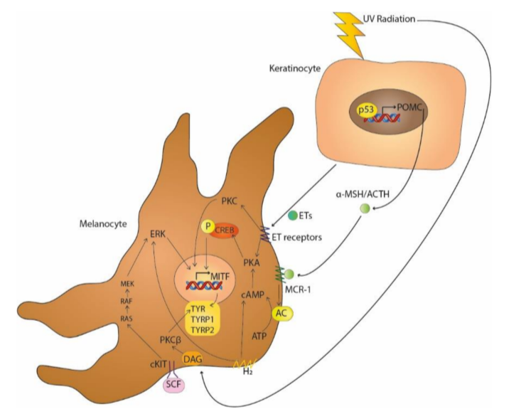

Figure 1. Melanogenesis induced by UV exposure (Videira et al., 2012).

POMC then broken down to produce alpha-melanocyte-stimulating hormone (α-MSH), which bind to the melanocortin-1 receptor (MC1R) on melanocytes through paracrine mechanism. This binding activates the tyrosinase, a key enzyme player in melanin synthesis leading to the conversion of tyrosine to DOPA and subsequently to melanin. Melanin is then transferred from melanocytes to surrounding keratinocytes, where it forms a protective barrier around the cell nucleus, absorbing and dissipating UV radiation to prevent further DNA damage. This process results in the darkening of the skin, commonly known as tanning, which is a protective response to UV exposure. Chronic exposure to UV radiation might lead to increased melanogenesis, which contributes to pigmentation disorders and increases the risk of skin cancer. Thus, while melanogenesis serves as a defense mechanism against UV damage, excessive UV exposure can have harmful long-term effects. (Yardman-Frank & Fisher, 2021).

UVB exposure increases the expression of pro-inflammatory cytokines. Research by Yang, et al. (2022) found that UV exposure in C57BL/6 mice increased the expression of IL-1β cytokines (Yang et al., 2022). IL-1β can cause ultraviolet-induced hyperpigmentation by increasing the secretion of α-MSH and ET-1. IL-1β not only increases the expression levels of MITF, TRP-1, and TRP-2 but also increases the activity of the enzyme tyrosinase (TYR), which leads to increased melanin production (Maddaleno et al., 2021; Yang et al., 2022).

**6. PAPAYA (*Carica papaya* L.) BIOLOGY**

Papaya (*Carica papaya*) is a major fruit plant known since ancient times, as a plant or herb that has medicinal and medicinal properties. Papaya originates from southern Mexico and Central America, but is now grown throughout the tropical regions of the world. Existing research shows that people used papaya as a source of nutrition and a phytotherapeutic agent in a unique way, then consuming its parts (Kumarasinghe et al., 2024). The earliest literary reference to the papaya tree dates back to 1526, when the tree was found on the Caribbean coast of Panama and Colombia and described by Oviedo, a Spanish chronicler (Karunamoorthi et al., 2014).

Papaya is a plant can grow to a size of 180-600 cm, and has wide, green leaves that can produce fruit all year round. Each tree usually has a single, unbranched, non-woody stem that has traces of old leaf bases. The stem is covered by a canopy of leaves that resemble umbrellas and are finger-shaped. Papaya fruit has a fleshy texture, with a length of 14-15 cm with a diameter of 10-30 cm (Figure 2). The fruit is attached to the top of the stem just below the canopy of leaves in groups (Karunamoorthi et al., 2014).

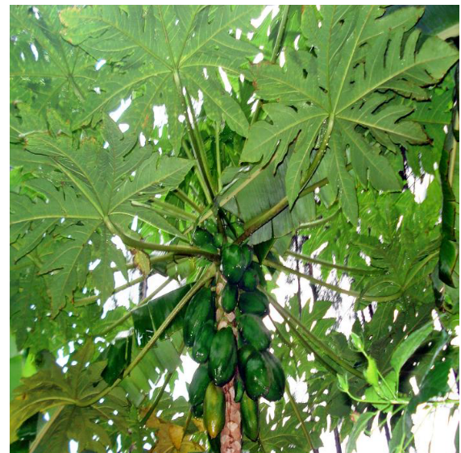

Figure 2. *Carica papaya* plant (Karunamoorthi et al., 2014).

Papaya leaves are arranged in a spiral, clustered near the tip of the stem with leaf stalks reaching 1 meter in length, hollow, green or purplish green. Leaf blades are oval, 25 - 75 cm in diameter, fingered, lobed in 7 parts, prominent veins, and leaf lobes are deeply and widely toothed (Karunamoorthi et al., 2014).

**7. PAPAYA (*Carica papaya L.*) LEAF CONTAIN**

*Carica papaya* is rich in nutrients and antioxidants, including carotene, vitamin C, and flavonoids, as well as B vitamins such as folate and pantothenic acid, minerals such as potassium and magnesium, and fiber. Papaya leaves also contain carbohydrates, vitamins, lipids, and proteins (Sharma et al., 2022). The content of these compounds varies, but approximatey consist of ascorbic acid (38.6%), protein (5.6%), phosphoric acid (0.225%), carbohydrates (8.3%), iron (0.0064%), and minerals such as magnesium (0.035% per 100 g of leaves). Quantitative phytochemical analysis showed that the liquid extract of papaya leaves contains tannins (0.001%), saponins (0.022%), flavonoids (0.013%), phenolics (0.011%), alkaloids (0.019%), and steroids (0.004%) (Singh et al., 2020).

Papaya leaves have several active substances that can increase antioxidants in the blood and reduce lipid peroxidation levels, such as ascorbic acid, alpha-tocopherol, chymopapain, cyanogenic glucosides, cystatin, flavonoids, glucosinolates, and papain (Alhodieb et al., 2025). Photochemical analysis shows that young papaya leaves contain alkaloids, saponins, tannins, flavonoids and glycosides, therefore have therapeutic properties such as antibacterial, anti-inflammatory, antiviral, antitumor hypoglycemic and many others (Singh et al., 2020).

**8. ANTIOXIDANT PROPERTIES OF PAPAYA (*Carica papaya L.*) LEAF**

Natural antioxidants derived from plants play a crucial role in mitigating oxidative stress and preventing chronic diseases. Among various sources, such as *Camellia sinensis* (green tea), *Curcuma longa* (turmeric), and *Carica papaya* have been extensively studied for their antioxidant potential. Green tea is rich in catechins, particularly epigallocatechin gallate (EGCG), which exhibits strong radical scavenging activity through hydrogen donation and metal chelation mechanisms (Ortiz-Islas et al., 2024). Turmeric contains curcumin, a polyphenolic compound known for its ability to inhibit lipid peroxidation and modulate antioxidant enzymes (Jakubczyk et al., 2020).

In comparison, papaya leaves and fruits are abundant in flavonoids, phenolic acids, and vitamins C and E, contributing to their antioxidant capacity. A study by Zhang et al. (2022) demonstrated that papaya leaves and roots exhibited higher antioxidant activity than other plant parts, as measured by DPPH, ABTS, and FRAP assays, with total phenolic and flavonoid contents correlating strongly with antioxidant performance (Zhang et al., 2022).

A comparative analysis of antioxidant properties across various parts of *Carica papaya* revealed that young leaves exhibit the highest antioxidant activity, followed by unripe fruit, ripe fruit, and seeds. Using DPPH radical scavenging and β-carotene bleaching assays, Maisarah et al. (2013) demonstrated that young papaya leaves had the lowest EC₅₀ value (1.0 ± 0.08 mg/mL), indicating superior free radical scavenging capacity. Additionally, the total phenolic content (TPC) and total flavonoid content (TFC) were highest in young leaves, measured at 424.89 ± 0.22 mg GAE/100 g and 333.14 ± 1.03 mg rutin equivalent/100 g, respectively. These findings suggest that the antioxidant potential of papaya is organ-specific, with leaves being the most potent source of natural antioxidants, likely due to their higher concentration of polyphenolic compounds and flavonoids compared to stems and fruits (Maisarah et al., 2013).

Caffeic acid and rutin were identified as active compounds from *Carica papaya* leaves. Caffeic acid, a derivative of hydroxycinnamic acid, is a natural antioxidant found in various food products. A study by Kong et al. (2021) showed that the levels of caffeic acid and rutin concentrations in papaya leaf extract were analyzed at 0.166% and 0.126%, respectively. Several studies have confirmed that caffeic acid inhibits UVB-induced wrinkle formation by downregulating matrix metalloproteinases (MMPs) and reducing inflammation by modulating NF-kB and AP-1 signal (Kong et al., 2021). It also has a protective effect against UVB-induced skin damage, which is associated with UV-induced reactive oxygen species (ROS) formation. Rutin enhances the photoprotective effect and significantly downregulates MMP-1 secretion in UVB-irradiated normal human dermal fibroblast (NHDF) cell cultures (Kim et al., 2013, Kong et al., 2021).

Table 1. Melanogenesis pathway inhibited by caffeic acid and rutin.

|  |  |  |  |
| --- | --- | --- | --- |
| Compound | Pathway | Role in melanogenesis | Source |
| Caffeic acid | COX-2 / PGE2 axis | Promotes melanogenesis via keratinocyte-derived paracrine signaling | (Hossain et al., 2021) |
| NF-κB signaling | Activates MITF and TYR via inflammatory cytokines (IL-1β, TNF-α) | (Maruyama et al., 2018) |
| MAPK/ERK pathway | Regulates MITF phosphorylation and TYR expression | (Lee et al., 2015) |
| α-MSH / MC1R signaling | Stimulates MITF via cAMP/PKA/CREB cascade | (Serre et al., 2018). |
| Rutin | cAMP/PKA/CREB/MITF axis | Central pathway for UVB-induced melanin synthesis | (Byun et al., 2023) |
| CD39/CD73-mediated adenosine signaling | Enhances cAMP levels and melanogenesis via adenosine receptors | (Byun et al., 2023) |
| ET-1 / SCF paracrine signaling | Stimulates melanocyte activation post-UVB exposure | (Serre et al., 2018). |

Recent studies have reinforced rutin’s role in skincare, showing its ability to reduce lipid peroxidation, DNA damage, and MMP activation when delivered via nanoparticle or gel-based systems (Nadia et al., 2023). A study sought the anti-aging mechanism of papaya leaf ethanol extract on UVB-irradiated human skin fibroblast cells in vitro. With leaf extract concentrations ranging from 10 to 250 μg/mL, the papaya leaf extract showed radical scavenging and ROS suppression actions in a dose-dependent manner. The extract was shown to increase the synthesis and attenuate the degradation of type I procollagen in UVB-irradiated fibroblasts, increase TGF-β1, and decrease the formation of MMPs (MMP-1 and MMP-3) at concentrations of 1 to 50 μg/mL, (Kong et al., 2021). These findings align with prior observations on papaya extracts exhibiting UVB absorbance, antioxidant properties, and active phytochemicals such as rutin and caffeic acid, further supporting their role as natural ingredients for photoprotection and anti-aging formulations (Hariono et al., 2021).

Papaya leaf extract has a reversal action of UVB-induced AP activation at the mRNA level through downregulation of MAPK activation and phosphorylation of c-Fos and c-Jun proteins. The effect of Carica papaya leaf extract on the MAPK pathway is thought to affect the activation of p38 protein. The results of the study showed that administration of papaya leaf extract was able to produce an 82% reduction in p38 phosphorylation, followed by ERK and JNK. Papaya leaf extract has been shown to have anti-inflammatory action by reducing the production of cytokines, such as IL-6. The formation of wrinkles caused by sun exposure as a result of erythema and reduced Type I collagen in the skin (Kong et al., 2021).

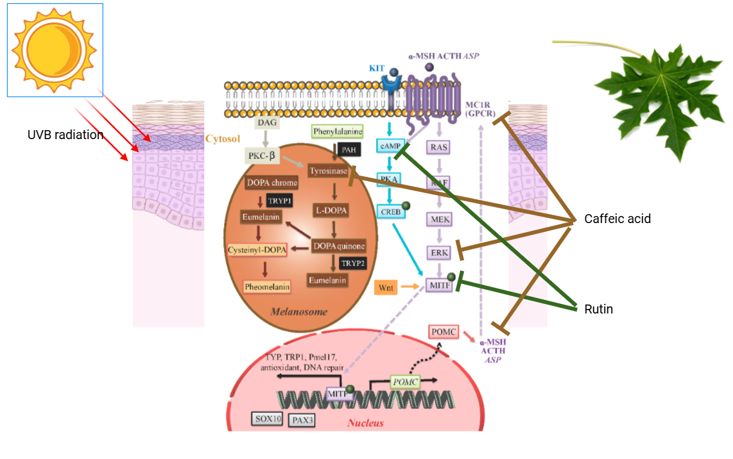

Figure 3. Mechanism of *Carica papaya* leaf extract on skin pigmentation pathways (modified from D’Mello et al., 2016)

Caffeic acid and rutin exert inhibitory effects on melanogenesis by modulating key upstream signaling pathways that regulate the activity of the MITF transcription factor, a central regulator of melanogenic enzyme expression within melanosomes. Caffeic acid has been shown to suppress the MAPK/ERK (MEK) and NF-κB pathways, thereby reducing MITF activation and downstream expression of melanogenic genes such as TYR, SOX10, and PAX3. Additionally, it interferes with MC1R-mediated signaling, particularly the α-MSH/cAMP/PKA/CREB axis, which normally enhances MITF transcription and promotes eumelanin synthesis. Rutin similarly downregulates the cAMP/PKA/CREB pathway, and has been reported to inhibit WNT/β-catenin signaling, further attenuating MITF-driven melanogenesis. Moreover, rutin modulates CD39/CD73-mediated adenosine signaling, which indirectly influences cAMP levels and melanocyte activation. Both compounds also reduce paracrine stimulation from keratinocytes by suppressing SCF/KIT and ET-1 signaling, thereby dampening melanocyte responsiveness to UV-induced stress. Collectively, these actions position caffeic acid and rutin as promising agents for mitigating hyperpigmentation through multi-pathway suppression of MITF activity and melanogenic gene expression (D’Mello et al., 2016).

4. Conclusion

Skin pigmentation, regulated by melanocytes through melanogenesis signaling pathways, provides photoprotection against UV radiation. However, excessive UV exposure disrupts this regulation, contributing to pigmentary disorders such as melasma and solar lentigo, particularly in tropical regions. Oxidative stress and inflammation—mediated by cytokines like IL-6 and TNF-α—play a central role in this dysregulation.

*Carica papaya* L. leaf extract, along with bioactive compounds such as caffeic acid and rutin, exhibits strong antioxidant, anti-inflammatory, and anti-melanogenic activities, thereby downregulating MITF and melanogenic enzymes. Their ability to modulate UV-induced pigmentation highlights their potential for clinical and commercial application in dermatological formulations. Nonetheless, rigorous clinical trials are essential to substantiate their efficacy and safety in human populations.

**5. DISCLAIMER (ARTIFICIAL INTELLIGENCE)**

Authors hereby declare that NO generative AI technologies such as Large Language Models (ChatGPT, COPILOT, etc.) and text-to-image generators have been used during the writing or editing of this manuscript.

References

Agarwal, S., & Krishnamurthy, K. (2021). Histology, Skin—StatPearls—NCBI Bookshelf. In *Histology, Skin*.

Alhodieb, F. S., Farid, M., Sabir, M., Nisa, S., Sarwar, S., & Abbas, S. (2025). Exploring the bioactive compounds of Carica papaya leaves: Phytol’s role in combatting antibiotic-resistant bacteria. Frontiers in Cellular and Infection Microbiology, 15(1564787), 1-15. https://doi.org/10.3389/fcimb.2025.1564787

Byun, K.-A., Kim, H. M., Oh, S., Son, K. H., & Byun, K. (2023). Radiofrequency Irradiation Attenuated UVB-Induced Skin Pigmentation by Modulating ATP Release and CD39 Expression. International Journal of Molecular Sciences, 24(6), 1-16. https://doi.org/10.3390/ijms24065506

Choi, W., Miyamura, Y., Wolber, R., Smuda, C., Reinhold, W., Liu, H., Kolbe, L., & Hearing, V. J. (2010). Regulation of human skin pigmentation in situ by repetitive UV exposure: Molecular characterization of responses to UVA and/or UVB. Journal of Investigative Dermatology, 130(6), 1685–1696. https://doi.org/10.1038/jid.2010.5

de Gruijl, F. R. (2017). UV adaptation: Pigmentation and protection against overexposure. Experimental Dermatology, *26*(7), 557–562. https://doi.org/10.1111/exd.13332

de Jager, T. L., Cockrell, A. E., & Du Plessis, S. S. (2017). Ultraviolet light induced generation of reactive oxygen species. In Ultraviolet Light in Human Health, Diseases and Environment, Vol. 996, 15–23. https://doi.org/10.1007/978-3-319-56017-5_2

D’Mello, S., Finlay, G., Baguley, B., & Askarian-Amiri, M. (2016). Signaling Pathways in Melanogenesis. International Journal of Molecular Sciences, 17(7), 1-18. https://doi.org/10.3390/ijms17071144

Du, Y., Doraiswamy, C., Mao, J., Zhang, Q., Liang, Y., Du, Z., Vasantharaghavan, R., & Joshi, M. K. (2022). Facial skin characteristics and concerns in Indonesia: A cross-sectional observational study. Skin Research and Technology, 28(5), 719–728. https://doi.org/10.1111/srt.13189

Hani, Y., & Sharma, S. (2017). Anatomy , Skin ( Integument )*,* Epidermis (Issue December). NCBI Bookshelf.

Hariono, M., Julianus, J., Djunarko, I., Hidayat, I., Adelya, L., Indayani, F., Auw, Z., Namba, G., & Hariyono, P. (2021). The Future of Carica papaya Leaf Extract as an Herbal Medicine Product. Molecules, 26(22), 1-20. https://doi.org/10.3390/molecules26226922

Hossain, M. R., Ansary, T. M., Komine, M., & Ohtsuki, M. (2021). Diversified Stimuli-Induced Inflammatory Pathways Cause Skin Pigmentation. International Journal of Molecular Sciences, 22(8), 1-22. https://doi.org/10.3390/ijms22083970

Hybertson, B. M., Gao, B., Bose, S. K., & McCord, J. M. (2011). Oxidative stress in health and disease: The therapeutic potential of Nrf2 activation. Molecular Aspects of Medicine, 32(4–6), 234–246. https://doi.org/10.1016/j.mam.2011.10.006

Jakubczyk, K., Drużga, A., Katarzyna, J., & Skonieczna-żydecka, K. (2020). Antioxidant potential of curcumin—A meta-analysis of randomized clinical trials. Antioxidants, 9(11), 1–13. https://doi.org/10.3390/antiox9111092

Julianti, T., De Mieri, M., Zimmermann, S., Ebrahimi, S. N., Kaiser, M., Neuburger, M., Raith, M., Brun, R., & Hamburger, M. (2014). HPLC-based activity profiling for antiplasmodial compounds in the traditional Indonesian medicinal plant Carica papaya L. Journal of Ethnopharmacology, 155(1), 426–434. https://doi.org/10.1016/j.jep.2014.05.050

Karunamoorthi, K., Kim, H.-M., Jegajeevanram, K., Xavier, J., & Vijayalakshmi, J. (2014). Papaya: A gifted nutraceutical plant—A critical review of recent human health research. Tang [Humanitas Medicine], 4(1), 1-17. https://doi.org/10.5667/tang.2013.0028

Kerob, D. K., Passeron, T., Dreno, B., Wei, L., Morita, A. A., Leok, C., Ly, F., Puig, S., Schalka, S., Kang, H. Y., & Lim, H. W. (2024). Prevalence of solar lentigo, impact on quality of life and social stigmatization: Results of the first large international survey. Journal of the American Academy of Dermatology, 91(3), 1. https://doi.org/10.1016/j.jaad.2024.07.1137

Kim, S. R., Jung, Y. R., An, H. J., Kim, D. H., Jang, E. J., Choi, Y. J., Moon, K. M., Park, M. H., Park, C. H., Chung, K. W., Bae, H. R., Choi, Y. W., Kim, N. D., & Chung, H. Y. (2013). Anti-Wrinkle and Anti-Inflammatory Effects of Active Garlic Components and the Inhibition of MMPs via NF-κB Signaling. PLoS ONE, 8(9), 1-12. https://doi.org/10.1371/journal.pone.0073877

Kong, Y. R., Jong, Y. X., Balakrishnan, M., Bok, Z. K., Weng, J. K. K., Tay, K. C., Goh, B. H., Ong, Y. S., Chan, K. G., Lee, L. H., & Khaw, K. Y. (2021a). Beneficial Role of Carica papaya Extracts and Phytochemicals on Oxidative Stress and Related Diseases: A Mini Review. Biology, 10(4), 1-20. https://doi.org/10.3390/biology10040287

Kumarasinghe, H. S., Kim, J.-H., Kim, S.-L., Kim, K. C., Perera, R. M. T. D., Kim, S.-C., & Lee, D.-S. (2024). Bioactive constituents from Carica papaya fruit: Implications for drug discovery and pharmacological applications. Applied Biological Chemistry, 67(1), 1-23. https://doi.org/10.1186/s13765-024-00962-y

Lamatungga, K. E., Habo, H., Muhammad, A., & Arsyidik, N. (2024). Papaya Fruit Supply Chain System in Surabaya City: Towards a Better Food and Nutrition Urban Governance. Window of Health Jurnal Kesehatan, 07(03), 297–309.

Lee, H.-S., Goh, M.-J., Kim, J., Choi, T.-J., Kwang Lee, H., Joo Na, Y., & Cho, K.-H. (2015). A systems-biological study on the identification of safe and effective molecular targets for the reduction of ultraviolet B-induced skin pigmentation. Scientific Reports, *5*(1), 1-11. https://doi.org/10.1038/srep10305

Maddaleno, A. S., Camargo, J., Mitjans, M., & Vinardell, M. P. (2021). Melanogenesis and melasma treatment. Cosmetics, 8(3), 1–11. https://doi.org/10.3390/cosmetics8030082

Madodi, N., Jayanthy, A., & Setaluri, V. (2012). Shining Light on Skin Pigmentation: The Darker and the Brighter Side of Effects of UV Radiation. Photochem Photobiol, 23(1), 1–7. https://doi.org/10.1111/j.1751-1097.2012.01138.x.Shining

Maisarah, A. M., Nurul Amira, B., Asmah, R., & Fauziah, O. (2013). Antioxidant analysis of different parts of Carica papaya. International Food Research Journal, 20(3), 1043–1048.

Maruyama, H., Kawakami, F., Lwin, T.-T., Imai, M., & Shamsa, F. (2018). Biochemical Characterization of Ferulic Acid and Caffeic Acid Which Effectively Inhibit Melanin Synthesis *via* Different Mechanisms in B16 Melanoma Cells. *Biological and* Pharmaceutical Bulletin, 41(5), 806–810. https://doi.org/10.1248/bpb.b17-00892

Mescher A. L. (2018). Junqueira’s Basic Histology: Text and Atlas 15th Edition (15th ed.). McGraw-Hill Education.

Miyamura, Y., Coelho, SSchlenz, K., Batrez, J., Smuda, C., Choi, W., Passeron, T., Zhang, G., Kolbe, L., Wolber, R., & Hearing, V. (2011). The deceptive nature of UVA-tanning versus the modest protective effects of UVB-tanning on human skin. Pigment Cell Melanoma Res., 24(1), 1–7. https://doi.org/10.1111/j.1755-148X.2010.00764.x.The

Nadia, M., Zulkarnain, A., & Sulaiman, T. (2023). Determination of Photoprotective Capacity of Topical Gel Formulations Containing Bioactive Compound Rutin and Evaluation of Physicochemical Stability. Tropical Journal of Natural Product Research, 7(9), 3923-3931. https://doi.org/10.26538/tjnpr/v7i9.12

Nagapan, T. S., Lim, W. N., Basri, D. F., & Ghazali, A. R. (2019). Oral supplementation of L-glutathione prevents ultraviolet B-induced melanogenesis and oxidative stress in BALB/c mice. Experimental Animals, 68(4), 541–548. https://doi.org/10.1538/expanim.19-0017

Nahhas, A. F., Abdel-Malek, Z. A., Kohli, I., Braunberger, T. L., Lim, H. W., & Hamzavi, I. H. (2019). The potential role of antioxidants in mitigating skin hyperpigmentation resulting from ultraviolet and visible light-induced oxidative stress. Photodermatology Photoimmunology and Photomedicine, 35(6), 420–428. https://doi.org/10.1111/phpp.12423

Okoko, T., & Ere, D. (2012). Reduction of hydrogen peroxide-induced erythrocyte damage by carica papaya leaf extract. Asian Pacific Journal of Tropical Biomedicine, 2(6), 449–453. https://doi.org/10.1016/S2221-1691(12)60074-4

Ortiz-Islas, S., Espinosa-Leal, C. A., González-Rodríguez, T., & García-Lara, S. (2024). Enhancing the Antioxidant Activity of Tea (*Camellia sinensis*) Through Common Herbal Infusions. Foods, 13(20), 1–10. https://doi.org/10.3390/foods13203284

Rinnerthaler, M., Bischof, J., Streubel, M. K., Trost, A., & Richter, K. (2015). Oxidative stress in aging human skin. Biomolecules, 5(2), 545–589. https://doi.org/10.3390/biom5020545

Serre, C., Busuttil, V., & Botto, J. M. (2018). Intrinsic and extrinsic regulation of human skin melanogenesis and pigmentation. International Journal of Cosmetic Science, 40(4), 328–347. https://doi.org/10.1111/ics.12466

Sharma, A., Sharma, R., Sharma, M., Kumar, M., Barbhai, M. D., Lorenzo, J. M., Sharma, S., Samota, M. K., Atanassova, M., Caruso, G., Naushad, M., Radha, Chandran, D., Prakash, P., Hasan, M., Rais, N., Dey, A., Mahato, D. K., Dhumal, S., … Mekhemar, M. (2022). Carica papaya L. Leaves: Deciphering Its Antioxidant Bioactives, Biological Activities, Innovative Products, and Safety Aspects. Oxidative Medicine and Cellular Longevity, 5(22), 1-20. https://doi.org/10.1155/2022/2451733

Singh, S. P., Kumar, S., Mathan, S. V., Tomar, M. S., Singh, R. K., Verma, P. K., Kumar, A., Kumar, S., Singh, R. P., & Acharya, A. (2020). Therapeutic application of Carica papaya leaf extract in the management of human diseases. DARU, Journal of Pharmaceutical Sciences, 28(2), 735–744. https://doi.org/10.1007/s40199-020-00348-7

Somanah, J., Bourdon, E., & Bahorun, T. (2017). Extracts of Mauritian Carica papaya (var. Solo) protect SW872 and HepG2 cells against hydrogen peroxide induced oxidative stress. Journal of Food Science and Technology, 54(7), 1917–1927. https://doi.org/10.1007/s13197-017-2626-4

Thawabteh, A. M., Jibreen, A., Karaman, D., Thawabteh, A., & Karaman, R. (2023). Skin Pigmentation Types, Causes and Treatment—A Review. Molecules, 28(12). https://doi.org/10.3390/molecules28124839

Videira, I. F., Moura, D. F., & Magina, S. (2012). Mechanisms regulating melanogenesis. Anais Brasileiros de Dermatologia, 88(1), 233–242. https://doi.org/10.1007/978-3-642-45407-3_24

Wei, M., He, X., Liu, N., & Deng, H. (2024). Role of reactive oxygen species in ultraviolet-induced photodamage of the skin. Cell Division, 19(1), 1–9. https://doi.org/10.1186/s13008-024-00107-z

Yang, C. Y., Guo, Y., Wu, W. J., Man, M. Q., Tu, Y., & He, L. (2022). UVB-Induced Secretion of IL-1 β Promotes Melanogenesis by Upregulating TYR/TRP-1 Expression In Vitro. BioMed Research International, 20(22), 1-23. https://doi.org/10.1155/2022/8230646

Yardman-Frank, J. M., & Fisher, D. E. (2021). Skin pigmentation and its control: From ultraviolet radiation to stem cells. Experimental Dermatology, 30(4), 560–571. https://doi.org/10.1111/exd.14260

Zhang, R., Lv, J., Yu, J., Xiong, H., Chen, P., Cao, H., & John Martin, J. J. (2022). Antioxidant Analysis of Different Parts of Several Cultivars of Papaya (Carica Papaya L.). International Journal of Fruit Science, 22(1), 438–452. https://doi.org/10.1080/15538362.2022.2047138