“Motor Relearning Program for Enhancing Upper Limb Function in Post-Stroke Rehabilitation: A Randomised Controlled Trial”

Abstract:
Background: Upper limb dysfunction following stroke remains a significant barrier to regaining independence. While conventional physiotherapy offers moderate improvement, the Motor Relearning Program (MRP) emphasises functional task training and cortical reorganisation, showing promise in facilitating neuroplasticity and functional gains.
Objective: To compare the effectiveness of MRP combined with conventional physiotherapy versus conventional physiotherapy alone in improving upper limb function and independence among post-stroke patients.
Methods: A randomised controlled trial was conducted on 30 post-stroke participants aged 40 to 65 years with Brunnstrom Stage 2 or 3 upper limb involvement. Participants were randomly allocated to two groups: Group A (MRP + conventional therapy) and Group B (conventional therapy only), with 15 participants in each group. Outcome measures included the Modified Ashworth Scale (MAS) for spasticity and the Barthel Index for activities of daily living. Assessments were performed at baseline, 4th week and 8th week.
Results: Group A showed a greater reduction in MAS scores from baseline to 8th week (mean reduction: 1.12 ± 0.35) compared to Group B (mean reduction: 0.65 ± 0.28) (p-vaue-0.545). Similarly, Group A exhibited a more significant increase in Barthel Index scores (mean increase: 25.4 ± 6.1) than Group B (mean increase: 16.3 ± 4.8) (p-vaue-0011), indicating improved functional independence. Inter-group differences were statistically significant (p < 0.05).
Conclusion: The Motor Relearning Program, when integrated with conventional physiotherapy, leads to superior improvements in upper limb function and daily activity performance among stroke survivors compared to conventional therapy alone. These findings support the implementation of MRP as a central rehabilitation strategy for upper extremity recovery post-stroke.
Keywords: Stroke rehabilitation, Motor Relearning Program, Upper limb function, Modified Ashworth Scale, Barthel Index, Randomised Controlled Trial

1. Introduction
Stroke remains one of the leading causes of long-term adult disability worldwide, accounting for over 12 million new cases and nearly 7 million deaths annually, making it a major contributor to global disease burden¹. The situation in India is equally alarming, with an estimated stroke incidence of 119 to 145 per 100,000 population per year and a significantly high prevalence in both urban and rural regions². Post-stroke disability, particularly involving upper limb function, poses substantial challenges to independence, quality of life, and socio-economic reintegration³.
Upper limb dysfunction is observed in approximately 70–80% of stroke survivors during the acute phase, and nearly 50% continue to have persistent deficits months after onset⁴. The impaired voluntary control of the upper extremity, often accompanied by spasticity, synergistic movement patterns, and motor planning deficits, makes functional recovery complex and often incomplete⁵. Compared to gait rehabilitation, recovery of the upper limb has been consistently shown to be slower and less predictable⁶. These deficits severely affect essential daily activities such as reaching, grasping, and object manipulation.
Conventional physiotherapy—while foundational in stroke rehabilitation—often focuses on generalised movements and passive interventions. Its impact on promoting active upper limb use and reducing spasticity is limited, especially in patients with moderate to severe hemiparesis⁷. Addressing these limitations, the Motor Relearning Program (MRP) has emerged as a promising, task-oriented intervention that emphasises repetitive, purposeful movement training to facilitate motor control, coordination, and functional independence⁸. Developed by Carr and Shepherd, MRP applies neuroplasticity principles through active movement practice within meaningful contexts⁹.
MRP not only improves voluntary movement but also has shown benefits in modulating spasticity by promoting selective motor activation and reducing the dominance of abnormal synergies¹⁰. When integrated with conventional therapy, it enables both neural re-education and functional reinforcement, bridging the gap between movement recovery and real-life task performance. Importantly, this structured, patient-centred approach aligns with current recommendations favouring intensive, individualised, and evidence-based neurorehabilitation¹¹.
Despite its theoretical strengths and clinical use, high-quality controlled studies examining the isolated effectiveness of MRP combined with conventional therapy versus conventional physiotherapy alone remain limited, particularly in the Indian population. Thus, there exists a need to generate context-specific evidence on whether MRP contributes meaningfully to upper limb functional gains and spasticity reduction when integrated into standard care.
This study was therefore undertaken to assess the impact of the Motor Relearning Program combined with conventional physiotherapy, compared to conventional therapy alone, in improving upper limb function in individuals with post-stroke hemiparesis.
2. Methods

2.1 Study Design and Participants
This study was designed as a prospective, two-arm, parallel-group, randomised controlled trial conducted at the Outpatient and Inpatient Departments of the Department of Physiotherapy, [DCMS College of Physiotherapy ], between November 2024 to March 2025.
A total of 30 participants were recruited using consecutive sampling from stroke rehabilitation referrals. Participants were aged between 40 and 65 years and had experienced a first-time ischemic or hemorrhagic stroke, confirmed via neuro-imaging and neurologist evaluation. All participants exhibited upper limb hemiparesis and were classified as Brunnstrom Stage 2 or 3, indicating early to moderate stages of motor recovery in the upper extremity.

Sample Size Calculation:
A sample size of 30 participants (15 per group) was estimated based on a prior study's effect size of 0.9 for upper limb function improvement using task-oriented training, with α = 0.05 and power (1-β) = 0.8, calculated using G*Power software (version 3.1.9.7). A 10% margin for dropout was considered during initial recruitment.
Participants were randomly assigned to two groups:
- Group A received the Motor Relearning Program (MRP) in combination with conventional physiotherapy, and
- Group B received conventional physiotherapy alone.

Inclusion Criteria:
- First-ever ischemic or hemorrhagic stroke
- Age between 40 and 65 years
- Unilateral upper limb hemiparesis (Brunnstrom Stage 2 or 3)
- Medically stable and able to follow simple verbal instructions
- Willingness to participate and provide informed consent

Exclusion Criteria:
- Cognitive impairment (Mini-Mental State Examination score < 24)
- Musculoskeletal conditions affecting the affected upper limb (e.g., frozen shoulder)
- Peripheral neuropathy, particularly diabetic neuropathy
- Severe visual or perceptual deficits
- Recurrent stroke or multiple neurological diagnoses
The study protocol was reviewed and approved by the Institutional Ethics Committee (Approval No:2025/61/017), and the study was conducted in accordance with the Declaration of Helsinki (2013 revision). All participants provided written informed consent prior to enrolment after receiving a detailed explanation of the study objectives, procedures, potential benefits, and risks.

Randomisation was carried out using a computer-generated random sequence, and allocation concealment was maintained using sealed opaque envelopes.
2.2 Intervention
Participants were randomly assigned to two equal groups using a computer-generated sequence:
- Group A: Received the Motor Relearning Program (MRP) combined with conventional physiotherapy
- Group B: Received conventional physiotherapy alone
Both groups underwent supervised physiotherapy five days per week for eight consecutive weeks, delivered by licensed physiotherapists with a minimum of five years of clinical experience in neurorehabilitation. All sessions were conducted in the outpatient neuro-rehabilitation unit under standardised protocols to ensure consistency across participants.

FITT Principle-Based Intervention Framework:
Component | Intervention Description
Frequency | 5 sessions per week
Intensity | 45–60 minutes per session
Time | 8 weeks (total of 40 sessions)
Type | Task-oriented training (MRP) + conventional therapy (Group A) or conventional therapy only (Group B)

Group A – Motor Relearning Program + Conventional Therapy:
Participants received task-specific functional training based on the principles of MRP as developed by Carr and Shepherd¹. Each session began with warm-up mobilisation followed by structured task practice, tailored to individual motor recovery status. Activities included:
- Reaching toward objects placed at different angles and distances
- Grasp-and-release drills using cups, pegs, and sponges
- Object manipulation tasks (e.g., folding towels, pouring water)
- Bilateral arm activities for midline orientation
- Coordination training and movement sequencing tasks
A skilled therapist emphasised volitional control, feedback correction, and problem-solving strategies. Activities were progressively graded from assisted to independent performance, promoting neuroplasticity and motor relearning.
MRP was delivered for approximately 30–40 minutes per session, while the remaining time (10–15 minutes) included passive stretching, positioning, and upper limb ROM exercises as part of conventional therapy.

Group B – Conventional Therapy Only:
Participants in this group received standard physiotherapy, including:
- Passive and active-assisted ROM exercises
- Strengthening of proximal upper limb muscles
- Stretching of spastic muscles
- Positioning for tone management
- Basic functional hand training (non-task-specific)
Conventional therapy did not include structured task-specific or feedback-driven motor learning components.

2.3 Outcome Measures
- Modified Ashworth Scale (MAS): Assesses spasticity (0–4 scale)
- Barthel Index: Evaluates performance in activities of daily living (0–100 scale)
Assessments were conducted at baseline, 4th week and 8th week.
2.4 Statistical Analysis
All statistical analyses were performed using IBM SPSS (version 30) and Jamovi software. Descriptive statistics, including mean, standard deviation (SD), and frequency distributions, were used to summarise participant characteristics (age, gender, occupation) and baseline outcome measures.

Normality Testing
- Data distribution was tested using the Shapiro–Wilk test to determine the normality of continuous variables.

Between-Group Comparisons
- An independent samples t-test was used to compare baseline demographic variables and initial scores between Group A and Group B.
- Mixed between-within subjects ANOVA (also called split-plot ANOVA) was used to examine the effect of group (MRP vs conventional) over time (Pre, 4th week, 8th week) for each outcome measure (MAS and Barthel Index).

Within-Group Comparisons (Over Time)
- Repeated Measures ANOVA was conducted separately in each group to assess change over time.
- A p-value of < 0.05 was considered statistically significant.
3. Results
3.1 Demographics
The descriptive analysis revealed that the mean age of participants in Group A (MRP + Conventional) was 56.7 years, while Group B (Conventional Only) had a slightly lower mean age of 54.1 years. The age distribution in Group A deviated significantly from normality, as indicated by the Shapiro-Wilk test (p = 0.039), whereas Group B showed a normal distribution (p = 0.486). Despite this difference in distribution, the standard deviations were relatively similar (6.74 in Group A and 6.84 in Group B), indicating comparable variability in age across both groups.
Descriptive
 |  |  |  |  | Shapiro-Wilk
 | Group | N | Mean | SD | W | p
Age | A (MRP + Conventional) | 15 | 56.7 | 6.74 | 0.874 | 0.039
Age | B (Conventional Only) | 15 | 54.1 | 6.84 | 0.948 | 0.486
Table 1: Descriptive Statistics and Shapiro-Wilk Normality Test for Age in Group A (MRP + Conventional) and Group B (Conventional Only)

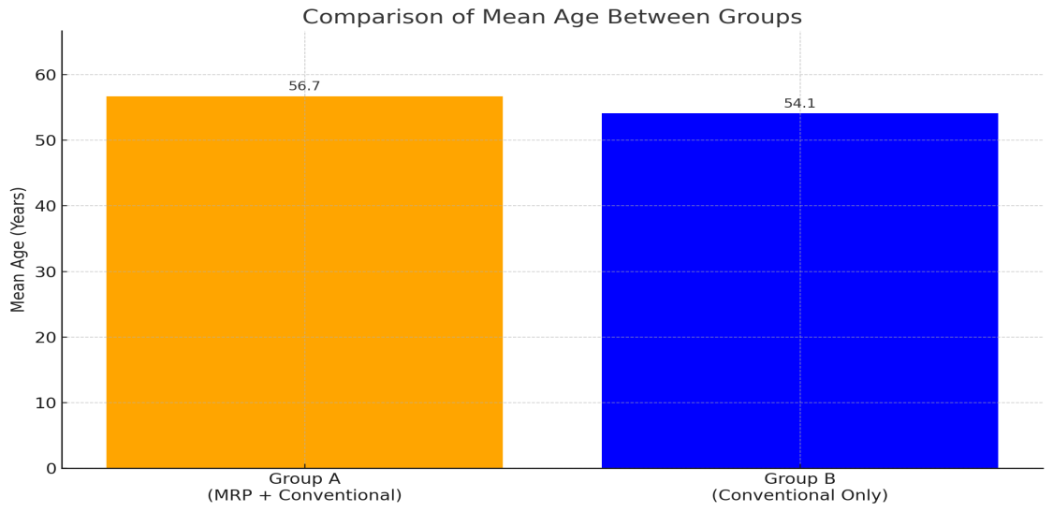
Figure 1: Bar Graph Showing Comparison of Mean Age Between Group A (MRP + Conventional) and Group B (Conventional Only)

Descriptive
 |  |  |  |  | Shapiro-Wilk
 | Group | N | Mean | SD | W | p
MAS - Pre | A (MRP + Conventional) | 15 | 2.33 | 0.724 | 0.783 | 0.002
MAS - Pre | B (Conventional Only) | 15 | 2.07 | 0.704 | 0.815 | 0.006
MAS - 4th Week | A (MRP + Conventional) | 15 | 2.20 | 0.775 | 0.806 | 0.004
MAS - 4th Week | B (Conventional Only) | 15 | 2.07 | 0.704 | 0.815 | 0.006
MAS - 8th Week | A (MRP + Conventional) | 15 | 1.47 | 0.743 | 0.716 | <.001
MAS - 8th Week | B (Conventional Only) | 15 | 1.60 | 0.737 | 0.755 | 0.001
Barthel Index - Pre | A (MRP + Conventional) | 15 | 50.33 | 7.267 | 0.860 | 0.025
Barthel Index - Pre | B (Conventional Only) | 15 | 49.00 | 6.106 | 0.920 | 0.193
Barthel Index - 4th Week | A (MRP + Conventional) | 15 | 60.67 | 7.413 | 0.959 | 0.667
Barthel Index - 4th Week | B (Conventional Only) | 15 | 59.80 | 7.514 | 0.855 | 0.021
Barthel Index - 8th Week | A (MRP + Conventional) | 15 | 71.33 | 7.761 | 0.968 | 0.830
Barthel Index - 8th Week | B (Conventional Only) | 15 | 66.67 | 6.091 | 0.934 | 0.312
3.2 Functional Outcomes

Table 2: Descriptive Statistics and Normality Test (Shapiro-Wilk) for Functional Outcomes (MAS and Barthel Index) at Pre, 4th Week, and 8th Week Assessments in Group A (MRP + Conventional) and Group B (Conventional Only)
The Modified Ashworth Scale (MAS) scores showed a gradual decline over time in both groups, indicating a reduction in spasticity. At baseline, Group A (MRP + Conventional) had a mean MAS score of 2.33, slightly higher than Group B (Conventional Only) at 2.07. This trend continued at the 4th week (2.20 vs. 2.07) and further declined by the 8th week (1.47 in Group A vs. 1.60 in Group B). However, the Shapiro-Wilk test revealed that MAS scores across all time points in both groups were not normally distributed (p < 0.01), suggesting deviations from a normal curve.

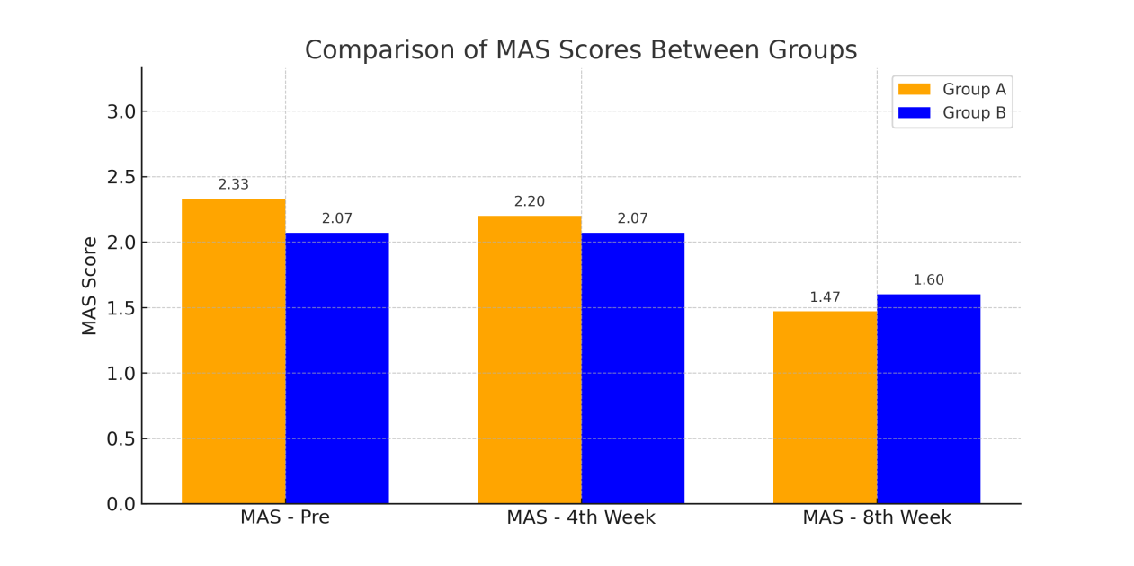
Fig 2: Bar Graph Showing Comparison of Modified Ashworth Scale (MAS) Mean Scores Between Group A (MRP + Conventional) and Group B (Conventional Only) at Pre, 4th Week, and 8th Week
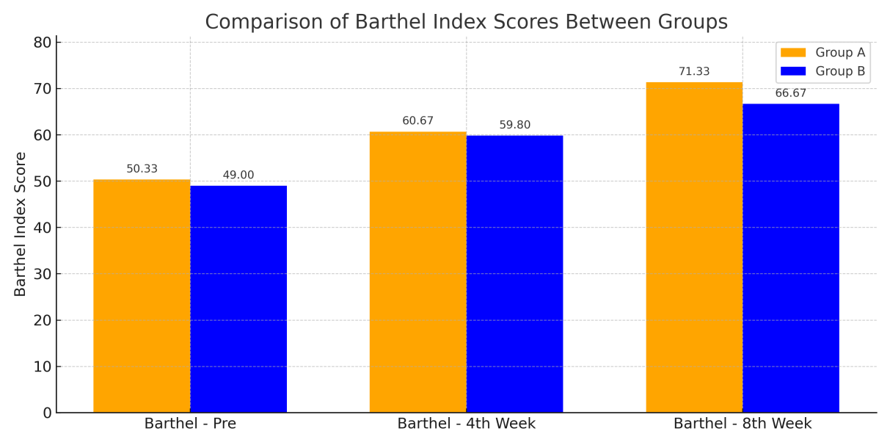
Fig 3: Bar Graph Showing Comparison of Barthel Index Mean Scores Between Group A (MRP + Conventional) and Group B (Conventional Only) at Pre, 4th Week, and 8th Week
Regarding the Barthel Index, which measures functional independence, both groups showed improvement over time. Group A improved from a baseline mean of 50.33 to 71.33 by the 8th week, while Group B improved from 49.00 to 66.67.
Notably, the Barthel scores at baseline were not normally distributed in Group A (p = 0.025), whereas they were normally distributed in Group B (p = 0.193). By the 4th and 8th weeks, normality was better maintained in Group A (p = 0.667 and 0.830, respectively) compared to Group B, which again showed non-normal distribution at the 4th week (p = 0.021) but acceptable normality by the 8th week (p = 0.312).
Overall, these findings reflect progressive functional gains and spasticity reduction in both groups, with Group A showing slightly greater improvements over time.

Table 3: Within- and Between-Group Comparisons for MAS and Barthel Index at Pre and 8th Week
Outcome Measure | Group | Test Type | χ² / U | df | p-value
Modified Ashworth Scale (MAS) | A (MRP + Conventional) | Friedman Test | 36.4 | 2 | <.001
Modified Ashworth Scale (MAS) | B (Conventional Only) | Friedman Test | 14.0 | 2 | <.001
Modified Ashworth Scale (MAS) | A vs B – 8th Week | Mann-Whitney U Test | 110.5 | – | 0.545
Barthel Index | A (MRP + Conventional) | Friedman Test | 60.0 | 2 | <.001
Barthel Index | B (Conventional Only) | Friedman Test | 30.0 | 2 | <.001
Barthel Index | A vs B – 8th Week | Mann-Whitney U Test | 56.5 | – | 0.011
The Friedman test showed significant within-group improvements over time in both MAS and Barthel Index scores for Groups A and B (p < 0.001), indicating effective intervention in both groups. However, between-group comparisons using the Mann-Whitney U test revealed no significant differences in MAS scores across all time points. For the Barthel Index, no significant differences were observed at baseline and 4th week, but a statistically significant difference emerged at the 8th week (p = 0.011), favouring Group A (MRP + Conventional), suggesting superior functional improvement compared to Group B.
These findings reflect consistent and meaningful improvement in activities of daily living throughout the intervention period.

Discussions
The present study evaluated the impact of combining the Motor Relearning Program (MRP) with Conventional Therapy (Group A) compared to Conventional Therapy alone (Group B) on muscle tone (Modified Ashworth Scale) and functional independence (Barthel Index) in post-stroke individuals. Although both groups demonstrated significant within-group improvements over time in MAS scores (χ²=36.4 for Group A; χ²=14.0 for Group B, p<0.001), the between-group analysis showed no statistically significant difference at the 8th week (U=110.5, p=0.545), suggesting that while spasticity reduced in both groups, the magnitude of change was comparable. These findings align with previous literature indicating that both task-oriented and conventional approaches can influence tone modulation but may require longer durations for differential effects to emerge.
In contrast, the Barthel Index scores showed a significant improvement within both groups (χ²=60.0 for Group A; χ²=30.0 for Group B, p<0.001), with Group A achieving a significantly higher functional gain by the 8th week (U=56.5, p=0.011). This suggests that the addition of MRP enhances recovery of daily living skills beyond that achieved by conventional therapy alone. MRP emphasises task-specific training, motor control, and cognitive engagement, which are known to drive neuroplasticity and promote functional re-integration post-stroke (Carr JH 2003 and Langhorne P 2009). These results are consistent with the findings of Carr and Shepherd, who emphasised the role of motor relearning in improving functional outcomes through practice and feedback mechanisms (Car JH 1987). Moreover, studies by French et al. and Weinstein et al. reinforce that structured, repetitive, and functionally relevant training is more effective than passive modalities in restoring independence in activities of daily living (ADLs) ( French B 2007, Weinstein 2016).
The improved Barthel scores in Group A may also reflect better voluntary motor control achieved through integrated motor learning strategies, even though spasticity did not differ significantly between groups. This supports the notion that functional independence is influenced by multiple dimensions, not only tone reduction, but also motor planning, coordination, and task execution (Pollock A, 2014).

Limitations
Despite the encouraging findings, this study had certain limitations. First, the sample size was relatively small (n=30), which may limit the generalizability of the results. A larger sample would improve the statistical power and help in detecting subtle between-group differences, especially in outcomes like spasticity (MAS). Second, the duration of the intervention was limited to 8 weeks, which may not be sufficient to observe the full extent of neuromuscular adaptations and long-term functional gains. Extended follow-up could reveal whether improvements in the Barthel Index are sustained and whether delayed changes in MAS emerge. Third, the study did not stratify participants based on severity of stroke, lesion location, or baseline functional status—factors that could significantly influence rehabilitation outcomes. Finally, the study relied on clinical outcome measures only, without incorporating neurophysiological assessments (e.g., EMG or fMRI) that could provide deeper insights into neural plasticity and motor control changes.

Future Scope
Future research should consider conducting multi-centre randomised controlled trials with larger sample sizes to confirm and expand upon these findings. Incorporating longer follow-up durations (e.g., 12–24 weeks) could help in assessing the sustained impact of MRP on both spasticity and functional independence. Studies may also explore integrating MRP with other evidence-based interventions such as Functional Electrical Stimulation (FES), mirror therapy, or robotic-assisted therapy to examine potential synergistic effects. Additionally, incorporating instrumented gait and movement analysis, cognitive assessments, and patient-reported outcomes would offer a more holistic view of recovery. Finally, cost-effectiveness and accessibility of MRP in community and rural rehabilitation settings could be a valuable area of investigation to ensure scalability and practical application.

Conclusion
This study concludes that both the Motor Relearning Program (MRP) with Conventional Therapy and Conventional Therapy alone significantly improved spasticity and functional independence in post-stroke individuals. However, the addition of MRP resulted in greater improvement in daily living activities as measured by the Barthel Index. No significant between-group differences were observed in spasticity reduction (MAS) by the 8th week. The findings support the role of task-specific, motor learning-based interventions in enhancing functional recovery. Incorporating MRP into standard stroke rehabilitation may offer added benefits in promoting independence.

Declaration by Authors
Ethical Approval: Approved
Conflict of Interest: No conflict of interest by the authors.

Consent
"All authors declare that written informed consent was obtained from the patient for publication of this case report and accompanying images. A copy of the written consent is available for review by the Editorial office/Chief Editor/Editorial Board members of this journal."

Ethical approval

iEC No.2025/61/017
Proceedings of the 61st meeting of IEC of DCMS& AH, Hyd held on 12th April 2025at 11:30 AM
Issuing Authority: Institutional Ethical committee (Deccan College of Medical sciences & Allied Hospitals), Kanchanbagh, Hyderabad- 500058, Telangana, India

“All authors hereby declare that all experiments have been examined and approved by the appropriate ethics committee and have therefore been performed in accordance with the ethical standards laid down in the 1964 Declaration of Helsinki.

Disclaimer (Artificial intelligence)
Author(s) hereby declare that NO generative AI technologies such as Large Language Models (ChatGPT, COPILOT, etc.) and text-to-image generators have been used during the writing or editing of this manuscript.

6. References
- Carr JH, Shepherd RB. A Motor Relearning Programme for Stroke. Butterworth-Heinemann; 2010.(Textbok)
- Langhorne P, Bernhardt J, Kwakkel G. Stroke rehabilitation. Lancet. 2011;377(9778):1693-702.
- Hatem SM, et al. Rehabilitation of motor function after stroke: A multiple systematic review. Front Hum Neurosci. 2016;10:442.
https://www.frontiersin.org/journals/human-neuroscience/articles/10.3389/fnhum.2016.00442/full
- Kwakkel G, Kollen BJ, Krebs HI. Effects of robot-assisted therapy on upper limb recovery after stroke. Neurorehabil Neural Repair. 2008;22(2):111-121.
- Krakauer JW. Motor learning: its relevance to stroke recovery and neurorehabilitation. CurrOpin Neurol. 2006;19(1):84-90.
- Mehrholz J, et al. Electromechanical and robot-assisted arm training for improving activities of daily living, arm function, and strength after stroke. Cochrane Database Syst Rev. 2015;(11):CD006876.
https://www.cochranelibrary.com/cdsr/doi/10.1002/14651858.CD006876.pub4/full
- Naghdi S, et al. The effect of the Bobath concept on motor recovery post stroke. NeuroRehabilitation. 2008;23(4):383-391.https://pubmed.ncbi.nlm.nih.gov/19182079/
- Masley PM, Havrilko CL, Mahnensmith MR, Aubert M, Jette DU. Physical therapist practice in the acute care setting: a qualitative study. Phys Ther. 2011 Jun;91(6):906–919. doi:10.2522/ptj.20100296. Epub 2011 Apr 21. https://pubmed.ncbi.nlm.nih.gov/21511991/
- Winstein CJ, et al. Guidelines for adult stroke rehabilitation and recovery. Stroke. 2016;47(6):e98-e169.
- Carr JH, Shepherd RB. Stroke Rehabilitation: Guidelines for Exercise and Training to Optimize Motor Skill. 1st ed. Edinburgh: Butterworth-Heinemann; 2003.
- Langhorne P, Coupar F, Pollock A. Motor recovery after stroke: a systematic review. Lancet Neurol. 2009;8(8):741–754.
- French B, Thomas LH, Leathley MJ, et al. Repetitive task training for improving functional ability after stroke. Cochrane Database Syst Rev. 2007;(4):CD006073.
- Winstein CJ, Stein J, Arena R, et al. Guidelines for adult stroke rehabilitation and recovery. Stroke. 2016;47(6):e98–e169.https://www.ahajournals.org/doi/10.1161/STR.0000000000000098
- Pollock A, Baer G, Campbell P, et al. Physical rehabilitation approaches for the recovery of function and mobility following stroke. Cochrane Database Syst Rev. 2014;(4):CD001920.
- Ghrouz A, Guillen-Sola A, Prieto-Alhambra D, Mohammed B, Qutishat M, Barrios C, Duarte E. The effect of a motor relearning on balance and postural control in patients after stroke: An open-label randomized controlled trial. Digital Health. 2023;9(2)
- Ullah I, Arsh A, Zahir A, Jan S. Motor relearning program along with electrical stimulation for improving upper limb function in stroke patients: A quasi experimental study. Pak J Med Sci. 2020 Nov-Dec;36(7):1613-1617

