Original Research Article

Effects of Hypothalamic Obesity-Associated Orthodontic Tooth Movement on the Periodontal Tissues in Rats: An Experimental Study

ABSTRACT

Aims: This study aimed to evaluate whether hypothalamic obesity associated with orthodontically induced tooth movement can influence the rate of tooth movement and the histological structure of periodontal tissues in rats.
Study type: Experimental research.
Methodology: Forty female pups Wistar rats were used. Twenty pups received subcutaneous injections of monosodium glutamate (4g/kg/day) in the cervical region for the first five days of life to induce obesity (MSG group). The remaining twenty animals received hyperosmotic saline solution (1.25g/kg/day) and served as the non-obese control group (CTL). Animals were divided into four groups (n=10/group): Group1: Non-obese rats without induced tooth movement (CTL); Group 2: Non-obese rats with induced tooth movement (CTL+ITM); Group 3: Obese rats without ITM (MSG); Group 4: Obese rats with ITM (MSG + ITM). At day 90, the ITM device was installed. At day 97, animals were weighed, euthanized, and the right hemimaxillae were collected, fixed in 10% formalin, and histologically processed.
Results: Obese animals showed a higher Lee index and more retroperitoneal and perigonadal fat than controls. The MSG + ITM group exhibited a reduced tooth movement rate compared to CTL + ITM. No acute or chronic inflammation was observed. MSG + ITM animals showed more external root resorption, multinucleated giant cells, and disorganized periodontal ligament. The highest incidence of hyalinization was found in ITM groups, while vascular alterations were more frequent in obese animals.
Conclusion: Orthodontic tooth movement associated with hypothalamic obesity reduces rate of tooth movement and increased occurrence of periodontal alterations and external root resorption.

Keywords: Obesity, Orthodontic Tooth Movement, Periodontal Tissue.

1. INTRODUCTION
A global analysis published in The Lancet ( NCD-RisC, 2024) estimated that over 1 billion individuals worldwide are currently living with obesity, representing approximately one in eight people. Between 1990 and 2022, the prevalence of obesity more than doubled among adults and quadrupled among children and adolescents aged 5 to 19. Obesity is now recognized not only as a major public health concern but also as a chronic, multifactorial disease characterized by low-grade systemic inflammation. This condition is strongly associated with a variety of comorbidities, including cardiovascular disease, type 2 diabetes, certain cancers, hypertension, dyslipidemia, coronary artery disease and stroke. Notably, a higher prevalence of periodontitis has also been observed in obese individuals (Vera et al., 2023; Cullinan et al., 2009).
Obesity induces a state of low-grade chronic inflammation, with adipose tissue playing a key role in releasing various inflammatory mediators, especially pro-inflammatory cytokines such as tumor necrosis factor-alpha (TNF-α) and interleukins IL-1 and IL-6 (Consolaro, 2017; Suvan et al., 2018). Likewise, orthodontic tooth movement triggers both local and systemic inflammatory responses. The application of orthodontic forces promotes the release of pro-inflammatory cytokines, including IL-1β, IL-2, IL-6, IL-8, and TNF-α (Weisberg et al., 2003; Costacurta et al., 2012; Zeng et al., 2015; Jayachandran et al., 2017).
Tooth movement occurs through controlled and appropriately applied pressure and/or tension, resulting in dynamic changes to bone structure. Initial compression leads to internal alveolar bone resorption, while stretching of the periodontal ligament induces bone deposition. This ligament transmits mechanical forces compressive or tensile and plays a crucial role in tooth displacement (Kubo et al., 2018). Two main cell types orchestrate this process: osteoblasts and osteoclasts, which are responsible for bone formation and resorption, respectively (Bumann & Frazier-Bowers, 2017).
Root resorption is a potential complication in various clinical contexts, including dental trauma (with or without fractures), tooth reimplantation, chronic periapical lesions, internal tooth bleaching, and most notably, orthodontically induced tooth movement considered its primary cause. This process, which involves the loss of mineralized tissue from cementum and dentin, can be either pathological or physiological. Although its precise etiology is not fully understood, it is widely accepted as multifactorial. Contributing factors may be mechanical (e.g., type of appliance, force magnitude and direction, treatment duration, and extent of movement) or biological (e.g., individual susceptibility), the latter being beyond the clinician’s control (Abuabara, 2007).
Given this context, the number of obese patients seeking dental treatment has increased. It is therefore essential for dental professionals to be equipped with evidence based knowledge about the limitations and precautions required when initiating orthodontic treatment in this population. Accordingly, the present study aims to evaluate whether hypothalamic obesity associated with orthodontically induced tooth movement can influence the rate of tooth movement and the histological structure of periodontal tissues in rats.

2. METHODOLOGY
This is an experimental, laboratory study, of both qualitative (histological analysis) and quantitative nature.

2.1 Sample Size Calculation
A sample of forty rats was calculated based on the variables of obesity and induced tooth movement, with a significance level (α) of 5% and a statistical power of 80%, using the GPower 3.1 software (Faul et al., 2009) and based on previous studies by the research group (Lucietto et al., 2024; Pasa et al., 2024).
In the quantitative analysis, simple descriptive statistics with means and standard deviations were used (Musa, 2015; Forthofer and Lee, 2014).

2.2 Animals
Forty female Wistar rats were used in this experiment. The animals were obtained from the Central Bioterium of Western Paraná State University (UNIOESTE). Twenty rats received subcutaneous injections of monosodium glutamate (4 g/kg/day) in the cervical region for the first five days of life to induce obesity (MSG group, n=20), according to Olney (1969). During the same period, another twenty animals received hyperosmotic saline solution injections (1.25 g/kg/day), forming the non-obese control group (CTL, n=20). The experiment was conducted at the designated animal facility of the Center for Biological Sciences at UNIOESTE. Animals were housed in polyethylene boxes (43×30×15 cm), either individually or in pairs, under controlled temperature (22°C to 25°C), relative humidity (~55%), and a 12-hour light/dark cycle (7:00 a.m. - 7:00 p.m.). They had free access to food and water.
All experimental procedures followed the ethical principles established by the Brazilian College of Animal Experimentation (COBEA) and were approved by the Institutional Animal Care and Use Committee (CEUA) of UNIOESTE (Protocol No. 1022/2023).

2.3 Experimental Groups
The animals were divided into four experimental groups (n=10/group): Group 1: non-obese rats not subjected to induced tooth movement (CTL); Group 2: non-obese rats subjected to induced tooth movement (CTL + ITM); Group 3: obese rats without induced tooth movement (MSG); Group 4: obese rats subjected to induced tooth movement (MSG + ITM).

2.4 Animal Sedation
Surgical and experimental procedures were carried out under general anesthesia with intraperitoneal injection of anesthetic solution containing Ketamine Hydrochloride (DOPALEN, Sespo Indústria e Comércio, Paulínia-SP) at a dose of 75 mg/kg, along with a muscle relaxant containing Xylazine Hydrochloride (ANASEDAN, Sespo Indústria e Comércio, Paulínia-SP) at a dose of 15 mg/kg (Pasa et al., 2024).

2.5 Installation of the Induced Tooth Movement (ITM) Device
At 90 days , the ITM device was installed in the CTL + ITM and MSG + ITM groups. The device used in this study was similar to the one proposed by Pasa et al. (2024) and Lucietto et al (2024), and the total duration of ITM was 7 days. The modified apparatus consisted of a closed-coil nickel-titanium spring (Morelli®; Sorocaba, São Paulo, Brazil), calibrated to exert a constant force of 50 cN. The force magnitude was verified in advance using a Zeusan tensiometer (Zeusan Exporting Ltda, Campinas, São Paulo, Brazil).
As previously described, the animals were anesthetized with intraperitoneal injection of Ketamine Hydrochloride (75 mg/kg) and Xylazine Hydrochloride (15 mg/kg). Two ligature wire segments (0.25 mm thick; Morelli, Sorocaba, SP, Brazil) was attached to the ends of the spring: one encircling the upper right first molar and the other the upper right central incisor. To stabilize the ligature wire on the labial surface of the incisor, a cervical groove was prepared and filled with light-cured composite resin (Filtek™ Z350XT, 3M Company, St. Paul, MN, USA) to prevent wire displacement (Figure 1).

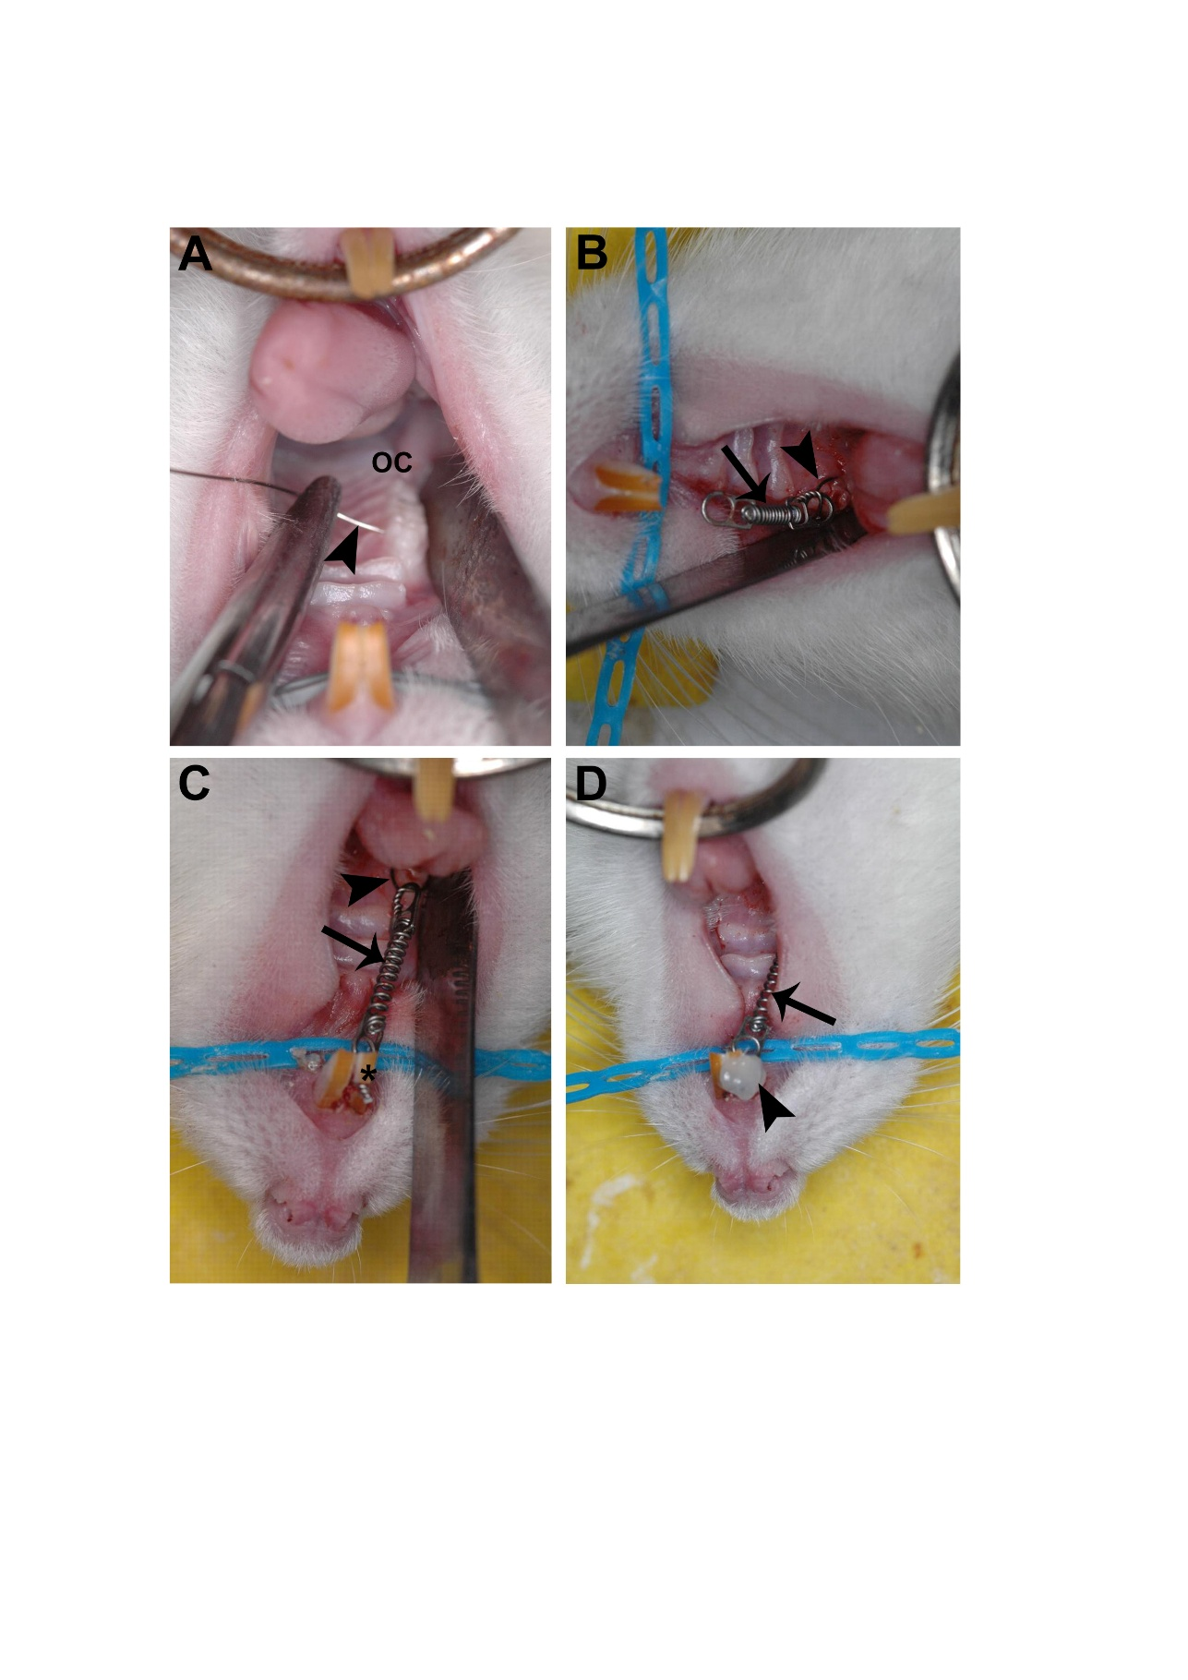

Figure 1. The photographs illustrate the sequence of the induced tooth movement (ITM) device installation procedure. A. The oral cavity was opened (OC) and a ligature wire was placed surrounding the right maxillary first molar (arrowhead); B. Nickel-titanium coil spring (arrow) was used, with its ends attached to two segments of ligature wire (arrowhead); C. Nickel-titanium coil spring (arrow) and a segment surrounded the right maxillary first molar (arrowhead) and the other segment surrounded the right maxillary incisor (*) of the animal; D. Nickel-titanium coil spring (arrow) and light-cured composite resin (arrowhead).

2.6 Euthanasia and Biological Material Collection
At 97 days, all animals were weighed and euthanized in a CO₂ chamber, followed by decapitation. Obesity induction was confirmed by calculating the Lee index [cube root of body weight (g) divided by naso-anal length (cm)], as well as by measuring retroperitoneal and perigonadal fat deposits.
The right hemimaxillae were dissected, fixed in 10% buffered formalin for 24 hours, rinsed under running water for 48 hours and stored in 70% ethanol.

2.7 Quantitative Analysis of Tooth Movement
Immediately after euthanasia, the amount of tooth movement was determined by measuring the distance from the mesial surface of the upper right first molar to the distal surface of the upper right third molar (moved side) and subtracting the corresponding measurement on the left (non-moved) side (Gameiro et al., 2008; Pasa et al., 2024). The values were measured in millimeters (mm) using a digital caliper (Mitutoyo, São Paulo, Brazil) .

2.8 Laboratory Processing and Descriptive Analysis of Histological Slides
After fixation, the right hemimaxillae were decalcified in a decalcifying acid solution (Allkimia®) for 19 hours, rinsed under running water for 2 hours, dehydrated in a graded ethanol series, cleared in xylene, and embedded in Paraplast Plus® (Sigma Co, St Louis, MO).
For histological analysis, serial longitudinal sections of the mesiobuccal and distobuccal roots of the upper right first molar were prepared from mesial to distal using a manual rotary microtome (Olympus 4060) equipped with a steel blade. Each section had a thickness of 5 μm.
The sections were deparaffinized in xylene, rehydrated in distilled water, and stained with hematoxylin and eosin (H&E) on permanent slides for analysis. Histological evaluation was conducted under a light microscope (Olympus BX60), and photomicrographs were obtained using an Olympus DP71 digital camera and DP Controller software version 3.2.1.276.

2.9 Descriptive Analysis of Histological Slides
The following histopathological parameters were evaluated: external root resorption, hyalinized areas, acute and chronic inflammatory infiltrates, presence of multinucleated giant cells and vascular alterations, and the structural organization of the periodontal ligament. Each parameter was classified as either present or absent (Costa et al., 2018).

2.10 Statistical Analysis
Data were analyzed using Student’s t-test and analysis of variance (ANOVA - one-way) with Tukey’s post test. Differences were considered statistically significant at P<0.05. All analyses were conducted using SigmaPlot software, version 11.0 (Systat Software Inc., San Jose, CA, USA).

3. RESULTS
3.1 Body Parameters and Evaluation of Obesity Induction
Analysis of body parameters revealed that body weight and naso-anal length (NAL) were significantly reduced in obese animals (MSG and MSG+ITM) compared to non-obese controls (CTL and CTL+ITM) (p < 0.05). However, the MSG groups exhibited a significantly higher Lee index, as well as increased retroperitoneal and perigonadal fat deposits compared to the CTL groups (p < 0.05) (Table 1).

Table 1. Body parameters and obesity assessment of the different experimental groups.
PARÂMETROS | CTL | MSG | CTL+ITM | MSG+ITM
Weight (g) | 292.81±1.41ª | 256.48±5.36^{b} | 304.78±2.25ª | 249.65±1.52^{b}
NAL (cm) | 21.35±0.09ª | 19.38±0.10^{b} | 21.25±0.09ª | 19.36±0.08^{b}
Lee’s Index | 315.17±0.81 | 331.63±1.27^{b} | 322.10±0.71ª | 329.58±0.45^{b}
Retroperitoneal fat (g/100g) | 0.65±0.05ª | 1.63±0.17^{b} | 0.72±0.11ª | 1.64±0.16^{b}
Perigonadal fat (g/100g) | 0.70±0.08ª | 1.61±0.10^{b} | 0.76±0.10ª | 1.75±0.11^{b}

Values are expressed as mean ± standard error. N = 10 animals/group. Analysis of variance (ANOVA) followed by Tukey’s post test. In the same row, values followed by different letters (a, b) indicate statistically significant differences between groups (P < 0.05).

3.2 Analysis of Tooth Movement
Obese animals in the MSG+ITM group exhibited a significantly reduced rate of induced tooth movement compared to non-obese animals in the CTL+ITM group (p < 0.05) (Table 2).

Table 2. Tooth movement rate of the different experimental groups
GROUP | TOOTH MOVEMNENT RATE (mm)
CTL+ITM | 0.19±0.06ª
MSG+ITM | 0.16±0.05^{b}

Values are expressed as mean ± standard error. N= 10 animais/grupo. Student’s T-test. In the same row, values followed by different letters (a, b) indicate statistically significant differences between groups (P < 0.05).

3.3 Morphological description of the periodontium
Animals in the control group (CTL) exhibited a periodontal ligament (PL) with normal characteristics, including abundant fibroblasts and well-organized collagen fibers. The root surfaces were mostly continuous, with root resorption observed only occasionally. Both the interradicular septum and the mesial alveolar crest appeared normal (Table 3 and Figure 2A). None of the analyzed groups showed signs of acute or chronic inflammation.
Animals in the MSG+ITM group exhibited larger areas of external root resorption, multinucleated giant cells, and disorganization of the periodontal ligament compared to the other groups (Table 3 and Figures 2B–E). The CTL+ITM and MSG+ITM groups those subjected to tooth movement showed the highest incidence of hyalinization (Figure 2B), whereas the obese groups (MSG and MSG+ITM) exhibited the highest frequency of vascular alterations (Table 3 and Figures 2D-E).

Table 3. Frequency of periodontal ligament alterations observed in the different experimental groups. N = 6/group.
PARAMETERS | CTL | CTL + ITM | MSG | MSG + ITM
External Root Resorption | 0/6 | 3/6 | 0/6 | 6/6
Hyalinized Areas | 0/6 | 3/6 | 0/6 | 3/6
Acute Inflammatory Infiltrate | 0/6 | 0/6 | 0/6 | 0/6
Chronic Inflammatory Infiltrate | 0/6 | 0/6 | 0/6 | 0/6
Multinucleated Giant Cells | 0/6 | 0/6 | 0/6 | 3/6
Vascular Alterations | 0/6 | 2/6 | 4/6 | 4/6
Disorganization of Periodontal Ligament | 0/6 | 1/6 | 2/6 | 3/6

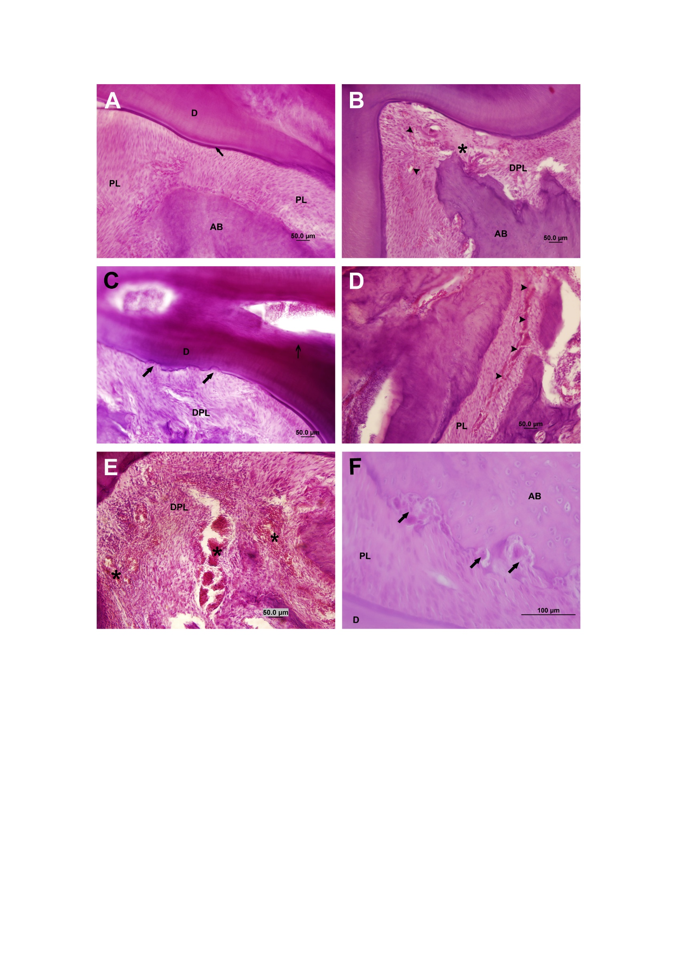

Figure 2. Photomicrographs of dental and periodontal structure of animals from different experimental groups. A. Periodontal tissues and dental structure with normal appearance. Periodontal ligament (PL), cementum (arrow), dentin (D), alveolar bone (AB); B. Disorganized periodontal ligament (DPL), alveolar bone (AB), hyaline area (asterisk), blood vessels (arrowhead); C. Disorganized periodontal ligament (DPL), dentin (D), areas of external root resorption (arrow); D. Periodontal ligament (PL), hyperemia (arrowhead); E. Hyperemia (*), disorganized periodontal ligament (DPL); F. Periodontal ligament (PL), dentin (D), alveolar bone (AB), multinucleated giant cells - osteoclasts (arrows). Staining = Hematoxylin and Eosin.

4. DISCUSSION
The present study investigated how hypothalamic obesity, when associated with induced tooth movement (ITM), affects the histological structure of periodontal tissues in rats. The effectiveness of the MSG induced hypothalamic obesity model was confirmed by body parameter analysis, as the MSG and MSG+ITM groups exhibited a significant increase in Lee index and fat accumulation in retroperitoneal and perigonadal regions compared to controls. These findings align with previous studies associating neonatal administration of monosodium glutamate with hypothalamic dysfunction and obesity development. This occurs because MSG damages neurons in the arcuate nucleus of the hypothalamus, leading to impaired energy homeostasis, defective satiety regulation, hyperphagia, and resistance to insulin and leptin (Lobato et al., 2011; Balbo et al., 2007; Sagae et al., 2011; Jais & Brüning, 2017).
Analysis of orthodontic tooth movement revealed that obese animals (MSG+ITM) showed a significantly reduced rate of movement compared to non-obese animals (CTL+ITM). Obesity is often associated with increased bone density and dysregulation of key molecules involved in bone remodeling, such as leptin, RANKL (receptor activator of nuclear factor kappa-B ligand), osteoprotegerin (OPG), and interleukin-6 (IL-6) (Cao, 2011). Another contributing factor is the reduction in bone microcirculation observed in obese individuals, which limits the delivery of essential nutrients and growth factors, thereby impairing bone remodeling and slowing tooth movement (Ye et al., 2007).
This vascular impairment was evident in the present study: one-third of the CTL+ITM animals and all animals in the MSG and MSG+ITM groups showed signs of compromised periodontal vascular response (Ferrante, 2007; Rebeles et al., 2019). Additionally, obesity has been linked to the exacerbated activation of the alternative and lectin pathways of the complement system, leading to endothelial dysfunction, increased vascular permeability, and reduced bone microcirculation (Moreno-Navarrete & Fernández-Real, 2019). The activation of anaphylatoxins C3a and C5a promotes M1-type pro-inflammatory macrophages, which intensify bone resorption and periodontal inflammation (Hajishengallis & Lambris, 2012). These processes disrupt the remodeling of the periodontal ligament, contributing to the development of hyalinized areas and multinucleated giant cells that may further hinder orthodontic movement (Hajishengallis et al., 2019).
In the analysis of acute and chronic inflammatory processes, none of the experimental groups showed evidence of inflammatory cell infiltration. This condition may be related to the interval between the application of induced tooth movement (ITM) and the euthanasia of the animals. According to Bosio and Liu (2010), orthodontic tooth movement occurs in three phases. First, during the pressure phase, initial compression of the periodontal ligament occurs within seconds. This is followed by the lag phase, characterized by a temporary cessation of movement due to ligament hyalinization, which may last from 7 to 14 days. Finally, in the movement phase, bone remodeling intensifies, allowing for effective tooth displacement. This sequence reflects the biological adaptation of the periodontium to orthodontic stimuli. As tissue remodeling progresses, inflammation subsides and tissue repair processes become predominant, with increased osteogenesis and reduced inflammatory response (Melsen, 2001). Therefore, if histological analysis is performed after this initial phase, inflammatory infiltrates may no longer be detectable, as the repair and remodeling processes are already underway (Olive et al., 1989; Li et al., 2018).
In the present study, animals in the MSG+ITM group showed more hyalinized areas than those in the CTL+ITM group, indicating that the experimental tooth movement was effective in exerting force on the periodontal tissues. These areas represent important experimental and biological finding. During ITM, a biological response occurs in the periodontal ligament and alveolar bone, characterized as an aseptic inflammatory process (Krishnan & Davidovitch, 2006). The application of orthodontic force compresses blood vessels in the ligament, leading to local hypoxia and metabolic stress on the resident cells, which may trigger their migration or death (Meikle, 2007). Hyalinization can be defined as deposition of homogeneous, eosinophilic, glassy material, associated with vascular changes (Cuoghi et al., 2018).
External root resorption was observed in one-third of the CTL+ITM animals and in all MSG+ITM animals. It is well established that teeth subjected to orthodontic forces are more prone to root resorption than those not subjected to such forces, which supports the presence of this condition in the ITM groups (Topkara, 2011). Notably, resorption was more frequent in the obese group undergoing tooth movement (MSG+ITM). Obesity impairs bone homeostasis by decreasing osteoblastic activity and increasing osteoclastic activity, resulting in an imbalance in bone remodeling (Jais & Brüning, 2017; Ferrante, 2007). This imbalance may explain the greater severity of resorption observed in the obese group. Moreover, chronically inflamed tissues may respond more aggressively to mechanical stimuli such as ITM, further intensifying resorptive processes (Olive et al., 1989; Li et al., 2018).
Multinucleated giant cells were observed on the root surface in half of the MSG+ITM animals, but were absent in all other groups. These cells correspond to osteoclasts and odontoclasts, which mediate the resorption of bone and dental tissues, respectively. Their activity depends on the M-CSF/RANKL/RANK signaling system, which is critical for differentiation and resorptive function (Graunaite et al., 2012; Tekkesin et al., 2011). As previously noted, obesity is associated with a chronic inflammatory state marked by elevated levels of pro-resorptive cytokines—TNF-α, IL-1β, IL-6, and RANKL—which enhance osteoclast and odontoclast activation (Feghali & Wright, 1997; Furman et al., 2019). This pro-inflammatory environment likely accounts for the greater presence of multinucleated giant cells observed in the obese group, as it promotes both bone and dental tissue resorption.
Therefore, within the limitations of the present study, it is observed that hypothalamic obesity associated with induced tooth movement exacerbates periodontal alterations, as evidenced by the increased hyalinized areas, external root resorption, and presence of multinucleated giant cells, indicating an imbalance in bone remodeling and impairment of microcirculation. Although further studies are necessary to clarify the need for specific clinical approaches in orthodontic planning for obese patients, the findings of this study provide relevant insights by highlighting the systemic impact of obesity on periodontal tissues. These results may contribute to the development of more individualized therapeutic strategies, aiming for greater safety and efficacy in orthodontic treatments for patients with metabolic dysfunctions.

5. CONCLUSION
It is concluded that orthodontic tooth movement associated with hypothalamic obesity reduces rate of tooth movement and increased occurrence of periodontal alterations and external root resorption.

CONSENT
It is not applicable.

ETHICAL APPROVAL
This study was in accordance with the Ethical Principles in Animal Experimentation adopted by the Brazilian College of Animal Experimentation (COBEA) and were approved by the Committee on Ethics in the Use of Animals (CEUA) of UNIOESTE (Protocol No. 1022/2023).

Disclaimer (Artificial intelligence)
Author(s) hereby declares that NO generative AI technologies such as Large Language Models (ChatGPT, COPILOT, etc.) and text-to-image generators have been used during the writing or editing of this manuscript.

REFERENCES
Abuabara, A. (2007). Biomechanical aspects of external root resorption in orthodontic therapy. Medicina Oral, Patología Oral y Cirugía Bucal, 12(8), 610–613.

Balbo, S.L., Grassiolli, S., Ribeiro, R.A., Bonfleur, M.L., Gravena, C., Brito, M.N., Andreazzi, A.E., Mathias, P.C.F., Torrezan, R. (2007). Fat storage is partially dependent on vagal activity and insulin secretion of hypothalamic obese rat. Endocrine, 31(2), 142-148.

Bosio, J. A., & Liu, D. (2010). Moving teeth faster, better and painless. Is it possible? Dental Press Journal of Orthodontics, 15(6), 20–32.

Bruun, J. M., Verdich, C., Toubro, S., Astrup, A., & Richelsen, B. (2003). Association between measures of insulin sensitivity and circulating levels of interleukin-8, interleukin-6 and tumor necrosis factor-alpha: Effect of weight loss in obese men. European Journal of Endocrinology, 148(5), 535–542.

Bumann, E. E., & Frazier-Bowers, S. A. (2017). A new cyte in orthodontics: Osteocytes in tooth movement. Orthodontics & Craniofacial Research, 20(Suppl 1), 125–128.

Busato, M. C. A., Pereira, A. L. P., Sonoda, C. K., Cuoghi, O. A., & De Mendonça, M. R. (2014). Microscopic evaluation of induced tooth movement after subluxation trauma: An experimental study in rats. Dental Press Journal of Orthodontics, 19(1), 92–99.

Cao, J.J. (2011). Effects of obesity on bone metabolism. Journal of Orthopaedic Surgery and Research, 6, 30.

Consolaro, A. (2017). Obesity and orthodontic treatment: Is there any direct relationship? Dental Press Journal of Orthodontics, 22(3), 21–25.

Costa, L. A., Pereira, A. L. P., Sonoda, C. K., Araújo, T. S., Silva, R. A. B., Santos, C. P., et al. (2018). Validation of a new experimental model of extrusive luxation on maxillary molars of rats: A histological study. Clinical Oral Investigations, 22(5), 1985–1994.

Costacurta, M., Di Renzo, L., De Lorenzo, A., & Docimo, R. (2012). Childhood obesity and skeletal-dental maturity. European Journal of Paediatric Dentistry, 13(2), 128–132.
Cullinan, M.P., Ford, P.J., & Seymour, G.J. (2009). Periodontal disease and systemic health: Current status. Australian Dental Journal, 54(1), 62–69.

Cuoghi, O.A., Faria, L.P., Ervolino, E., Barioni, S.R.P., Topolski, F., Arana-Chavez, V.E., & Mendonça, M.R. (2018). Pulp analysis of teeth submitted to different types of forces: a histological study in rats. Journal of Applied Oral Science, 26, e20170626.

Faul, F., Erdfelder, E., Buchner, A., & Lang, A. G. (2009). Statistical power analyses using G*Power 3.1: Tests for correlation and regression analyses. Behavior Research Methods, 41(4), 1149–1160.

Feghali, C. A., & Wright, T. M. (1997). Cytokines in acute and chronic inflammation. Frontiers in Bioscience, 2(1), 12–26.

Ferrante, A.W. (2007). Obesity-induced inflammation: A metabolic dialogue in the language of inflammation. Journal of Internal Medicine, 262(4), 408–415.

Furman, D., Campisi, J., Verdin, E., Carrera-Bastos, P., Targ, S., Franceschi, C., et al. (2019). Chronic inflammation in the etiology of disease across the life span. Nature Medicine, 25(12), 1822–1830.

Forthofer, R.N., Lee, E.S. (2014). Introduction to biostatistics: a guide to design, analysis, and discovery. 1 ed, Academic Press.

Gameiro, G.H., Nouer, D. F., Matsumoto, M. A., Dominguez, G. C., & de Oliveira, D. D. (2008). Effects of short- and long-term celecoxib on orthodontic tooth movement. The Angle Orthodontist, 78(5), 860–865.

Graunaite, I., Lodiene, G., Maciulskiene, V. (2012). Pathogenesis of apical periodontitis: a literature review. Journal of oral & maxillofacial research, 2(4):e1.

Hajishengallis, G., Kajikawa, T., Hajishengallis, E., Maekawa, T., Reis, E.S., Mastellos, D.C., Yancopoulou, D., Hasturk, H., Lambris, J.D. (2019). Complement-Dependent Mechanisms and Interventions in Periodontal Disease. Frontiers in Immunology, 12;10:406.

Hajishengallis, G., Lambris, J.D. (2012). Complement and dysbiosis in periodontal disease. Immunobiology, 217(11), 1111-1116.

Hartsfield, J.K., Jr., Everett, E.T., & Al-Qawasmi, R.A. (2004). Genetic factors in external apical root resorption and orthodontic treatment. Critical Reviews in Oral Biology & Medicine, 15(2), 115–122.

Heller, I.J., & Nanda, R. (1979). The effect of metabolic alteration of periodontal fibers on orthodontic tooth movement. American Journal of Orthodontics, 75(3), 239–257.

Hong, R.K., Kang, M.K., & Park, Y.C. (1992). The effect of orthodontic retention on the mechanical properties of the periodontal ligament in the rat maxillary first molar. Journal of Dental Research, 71(7), 1350–1354.

Jais, A., & Brüning, J. C. (2017). Hypothalamic inflammation in obesity and metabolic disease. Journal of clinical investigation, 127(1):24-32.

Jayachandran, T., Srinivasan, B., & Padmanabhan, S. (2017). Salivary leptin levels in normal weight and overweight individuals and their correlation with orthodontic tooth movement. The Angle Orthodontist, 87(5), 739–744.

Krishnan, V., & Davidovitch, Z. (2006). Cellular, molecular, and tissue-level reactions to orthodontic force. American Journal of Orthodontics and Dentofacial Orthopedics, 129(4), 469.e1–469.e32.

Kubo, H, Leal, T.P., Bruder, C., Bertolo, C.A., Ortolani, C.L.F., Takei, V.L.F. (2018). Thyroid gland dysfunction and the orthodontic treatment: integrative review of literature. Revista UNINGÁ, 55(3), 100–110.

Lam, R. (2016). Epidemiology and outcomes of traumatic dental injuries: A review of the literature. Australian Dental Journal, 61, 4–20.

Li, Y., Jacox, L.A., Little, S.H., Ko, C.C. (2018). Orthodontic tooth movement: The biology and clinical implications. The Kaohsiung journal of medical sciences, 34(4), 207-214.

Lobato, N.S., Filgueira, F.P., Akamine, E.H., Davel, A.P., Rossoni, L.V., Tostes, R.C., Carvalho, M.H., Fortes, Z.B. (2011). Obesity induced by neonatal treatment with monosodium glutamate impairs microvascular reactivity in adult rats: role of NO and prostanoids. Nutrition, Metabolism and Cardiovascular Diseases, 21(10), 808-816.

Lucietto, G., Pasa, A.P.B.C., Brandão, H.C.B., Busato, M. C.A., Porto, E. M., & Amorim, J.P. A. (2024). The impact of ovariectomy and dental trauma on dental pulp, tooth movement, and internal root resorption: Findings from a rat model. Journal of Advances in Medicine and Medical Research, 36, 42–53.

Maló, L., Cabrita, A., & Rafael, A. (2014). Orthodontic movement; evaluation of periodontal ligament in a experimental study on adult Wistar rats. Revista Portuguesa de Estomatologia,
Medicina Dentária e Cirurgia Maxilofacial. 2014;55(3),152–158.

Meikle, M.C. (2007). Remodeling the dentofacial skeleton: The biological basis of orthodontics and dentofacial orthopedics. Journal of Dental Research, 86(1), 12–24.

Melsen, B. (2001). Tissue reaction to orthodontic tooth movement: A new paradigm. European Journal of Orthodontics, 23(6), 671–681.

Moreno-Navarrete, J.M., Fernández-Real, J.M. (2019). The complement system is dysfunctional in metabolic disease: Evidences in plasma and adipose tissue from obese and insulin resistant subjects. Seminars in cell & developmental biology, 85, 164-172.

Musa, S.M. (2015). Fundamentals of Technical Mathematics 1st Edition, Kindle Edition.

NCD Risk Factor Collaboration (NCD-RisC). (2024). Worldwide trends in underweight and obesity from 1990 to 2022: a pooled analysis of 3663 population-representative studies with 222 million children, adolescents, and adults. Lancet, 403(10431):1027-1050.

Olive, M., Bacon, W., Hildwein, M. (1989). Bone resorption in orthodontic tooth movement: an attempted schematization. L' Orthodontie Francaise, 60 Pt 2:895-904.

Olney, J.W. (1969). Brain lesions, obesity and other disturbances in mice treated with monosodium glutamate. Science, 164(3880), 719–721.

Pasa, A.P.B.C., Brandão, H.C.B., Busato, M.C.A., Porto, E.M., & Amorim, J.P.A. (2024). Effects of ovariectomy on the structure of the periodontium and root resorption during orthodontic tooth movement in rats. Journal of Advances in Medicine and Medical Research, 36, 215–224.

Rebeles, J., Green, W.D., Alwarawrah, Y., Nichols, A.G., Eisner, W., Danzaki, K., MacIver, N.J., Beck, M.A. (2019). Obesity-Induced Changes in T-Cell Metabolism Are Associated With Impaired Memory T-Cell Response to Influenza and Are Not Reversed With Weight Loss. The Journal of infectious diseases. 219(10),1652-1661.

Sagae, S.C., Grassiolli, S., Raineki, C., Balbo, S.L., Silva, A.C.M. (2011). Sex differences in brain cholinergic activity in MSG-obese rats submitted to exercise. Canadian journal of physiology and pharmacology, 89(11), 845-853.

Saloom, H. F., Papageorgiou, S. N., Carpenter, G. H., & Cobourne, M. T. (2017). Impact of obesity on orthodontic tooth movement in adolescents: A prospective clinical cohort study. Journal of Dental Research, 96(5), 547–554.

Suvan, J.E., Finer, N., & D'Aiuto, F. (2018). Periodontal complications with obesity. Periodontology 2000, 78(1), 98–128.

Tekkesin, M.S., Mutlu, S., Olgac V. (2011). The role of RANK/RANKL/OPG signalling pathways in osteoclastogenesis in odontogenic keratocysts, radicular cysts, and ameloblastomas. Head and neck pathology, 5(3), 248-253.

Topkara, A. (2011). Apical root resorption caused by orthodontic treatment: A systematic review. European Journal of Orthodontics, 33(5), 491–508.

Vera, M. J., Guajardo, F., Urra, F. A., Tobar, N., & Martinez, J. (2023). TNF-alpha promotes an inflammatory mammary microenvironment that favors macrophage and epithelial migration in a CCL2- and mitochondrial-ROS-dependent manner. Antioxidants (Basel), 12(4), 813.

Weisberg, S. P., McCann, D., Desai, M., Rosenbaum, M., Leibel, R. L., & Ferrante, A. W. (2003). Obesity is associated with macrophage accumulation in adipose tissue. Journal of Clinical Investigation, 112(12), 1796–1806.

Ye, J., Gao, Z., Yin, J., He, Q. (2007). Hypoxia is a potential risk factor for chronic inflammation and adiponectin reduction in adipose tissue of ob/ob and dietary obese mice. American Journal of Physiology-Endocrinology and Metabolism, 293, E1118-28.

Zeng, X., Zhang, Y., Kwong, J. S. W., Zhang, C., Li, S., Sun, F., et al. (2015). The methodological quality assessment tools for preclinical and clinical studies, systematic review and meta-analysis, and clinical practice guideline: A systematic review. Journal of Evidence-Based Medicine, 8(1), 2–10.

