Original Research Article

CLINICAL-EPIDEMIOLOGICAL PROFILE OF PATIENTS SEEN AT THE CLINICAL-SURGICAL OUTPATIENT CLINIC OF UNIVERSITY CENTER OF VÁRZEA GRANDE (UNIVAG) IN 2022 AND 2023

ABSTRACT

|  |
| --- |
| **Background:** The quality of healthcare services has become a recurring theme in global discussions, especially considering challenges related to limited access and the increasing life expectancy of the population. The clinical-epidemiological profile aims to stratify prevalent aspects, from the patient’s personal data and associated comorbidities to the performance of the surgical procedure.  **Aims:** To identify clinical and epidemiological characteristics of surgical patients treated at an integrated clinic of a University Center located in the municipality of Várzea Grande/MT, Brazil.  **Methodology:** This is a retrospective, descriptive, and cross-sectional study with a quantitative analysis of 219 medical records of patients treated at the surgical clinic outpatient department between 2022 and 2023.  **Results:** Of the patients seen, 52.4% were male, and the predominant age group was 31 to 60 years (44.3%). The most common marital status was single (42.5%). Regarding the medical speciality attended, general surgeries were the most frequent, followed by pediatric and vascular surgeries. Regarding pre-existing conditions, 58.9% of the patients had no comorbidities. Hypertension (28.3%) was the most prevalent, followed by dyslipidemia (7.8%) and diabetes (6.4%). Among the patients, 47.5% reported previous surgeries, 65.3% regularly used medication, and 21% were smokers. In addition, 11% had been hospitalised in the previous 3 months. On physical examination, 90.86% had alterations, with the abdominal system being the most affected (44.29%). Regarding laboratory and imaging tests, 72% of patients showed significant alterations. The most common primary diagnosis was hernia (31.96%), followed by biliary diseases (11.87%) and varicose veins (8.21%). The surgical indication rate was high, with 12.78% of patients actually undergoing the procedure, and complications were rare, occurring in only 0.45% of cases.  **Conclusion:** The study showed that most of the patients treated were between 31 and 60 years old, living in Várzea Grande/MT, with a predominant diagnosis of hernias and biliary diseases. Many had comorbidities, with hypertension, dyslipidemia, diabetes, and smoking being the most prevalent. Moreover, the discrepancy between surgical indications and the performance of surgeries highlights challenges in access to treatment. |

Keywords: Surgical patients; Epidemiological profile; Clinical assessment; Hernias; Hypertension; Brazil; Outpatient surgery.

1. INTRODUCTION

In Brazil, there is a high demand for public healthcare services in surgical clinics. Data recorded in the Unified Health System (SUS) information system evidenced that during the year 2018, 2.4 million elective surgeries were performed, and by October 2019, approximately 2 million surgeries had been conducted in Brazil¹. Surgical clinical patient care involves perioperative management to properly handle clinical conditions requiring surgical interventions. The increased demand for surgical procedures reflects a need for management of service flows, involving equitable access and efficiency in the care provided²,¹¹

Thus, the quality of healthcare services has become a recurring theme in global discussions, especially considering challenges related to limited access and the increasing life expectancy of the population¹¹ These factors impose a greater demand for surgical procedures, reinforcing the need to improve service management, equity in access, and efficiency of the care provided.

Surgical treatments are crucial in treating various medical diseases, including standard and complicated instances. Although surgical procedures have made significant progress, the possibility of postoperative complications remains a considerable concern, negatively impacting the overall upward trend of surgical outcomes 12,13. Preoperative care encompasses the provisions given prior to surgery, wherein the patient’s unique requirements are considered to undertake physical and psychological preparations in anticipation of the procedure. This phase commences upon the patient’s admission to the hospital or surgical facility and extends until the commencement of the actual procedure 14,15,16,17.

The surgical setting is associated with multidisciplinary care that precedes the procedure, such as outpatient surgical consultations, demographic knowledge of the population, general health assessment, and cardiovascular risk evaluation⁵. Planned preoperative care can ensure high-quality recovery and prevent postoperative complications, which may result in avoidable harm or death. This highlights the importance of special attention during clinical care to ensure patient safety throughout the care process 5, 10, 11

The clinical-epidemiological profile aims to stratify prevalent aspects, from the patient’s personal data and associated comorbidities to the performance of the surgical procedure. These characteristics reinforce continuous patient care in the pre- and post-surgical periods, establishing a determinant for quality healthcare 1, 2, 3

The safety of the procedure is a consequence of the epidemiological knowledge of the population served, such as the recognition of risk factors to improve prevention measures and characteristics for planning by the educational institution and hospital. These results help enhance and train the multidisciplinary team, enabling the development of quality, safety in care, and a reduction in frequent surgical complications. 2, 4, 5, 6, 8

In this context, the present study aims to outline the clinical-epidemiological profile of surgical patients treated at an integrated clinic of a University Center located in the municipality of Várzea Grande/MT.

2. Materials and Methods

This is a cross-sectional, retrospective study in which 355 medical records were collected, with 219 records being analyzed that met the defined variables dated between 2022 and 2023, related to patients seen at the clinical-surgical outpatient clinic of the Integrated Clinic of the University Center of Várzea Grande (UNIVAG), a university outpatient clinic located in the city of Várzea Grande, in the state of Mato Grosso. Data collection and analysis were carried out using patient records from those treated at the outpatient clinic through the Unified Health System (SUS).

Medical records from the clinical outpatient clinics of all age groups were analyzed, considering the following variables: specialty attended at the outpatient clinic; demographic data: sex, age, and marital status; information about medical history (previous surgeries, pre-existing medical conditions, continuous use of medication, smoking, hospitalization or surgery in the last 3 months); physical examination findings of major body systems; results of relevant laboratory and imaging tests; primary diagnosis; surgical procedure indicated or performed; and data on surgical complications. These patients came from the public healthcare network and resided in various municipalities of Mato Grosso. A total of 136 medical records were excluded for being related to other specialities, restricted to the clinical field or for visits made in years other than those defined by the study. This study complies with ethical code standards.

The epidemiological profile was determined through absolute (n) and relative (%) frequencies. A combinatorial analysis was conducted to identify the simultaneous occurrence of comorbidities among the examined patients. Pearson’s chi-square test was used to identify statistical associations between two categorical variables, with a 5% significance level. Cramér’s V was used as the measure of association to assess the strength of the relationship between two categorical variables, considering very weak (0.10 to 0.19), weak (0.20 to 0.29), moderate (0.30 to 0.39), and strong (≥ 0.40) associations. All analyses were performed using the R programming language, version 4.4.2 (RCoreTeam, Vienna, Austria).

3. results and discussion

A total of 219 patients were analysed, the majority being male, aged between 31 and 60 years, single, and residing in the municipality of Várzea Grande/MT (Table 1).

|  |  |
| --- | --- |
| Table 1. Sociodemographic profile of patients treated at the clinical-surgical outpatient clinic of UNIVAG: 2022–2023. | |
| **Variables** | **n (%)** |
| **Sex** |  |
| Female | 105 (47.95%) |
| Male | 114 (52.05%) |
| **Age** |  |
| 0-12 years | 61 (27.85%) |
| 13-18 years | 1 (0.46%) |
| 19-30 years | 15 (6.85%) |
| 31-60 years | 97 (44.29%) |
| 61-99 years | 45 (20.55%) |
| **Marital status** |  |
| Married | 58 (26.48%) |
| Divorced | 5 (2.28%) |
| Not specified | 63 (28.77%) |
| Singles | 93 (42.47%) |
| **Geographic location** |  |
| Cuiabá/MT | 55 (25.11%) |
| Countryside | 40 (18.26%) |
| Not specified | 4 (1.83%) |
| Várzea Grande/MT | 120 (54.79%) |

The most prevalent comorbidity was hypertension, affecting about one in three patients, followed by smoking, dyslipidemia, diabetes, kidney diseases, autoimmune diseases, heart diseases, obesity, and asthma or chronic pulmonary disease (Table 2).

|  |  |
| --- | --- |
| Table 2. Pre-existing medical conditions of patients treated at the clinical-surgical outpatient clinic of UNIVAG: 2022–2023. | |
| **Variables** | **n (%)** |
| **Asthma or chronic pulmonary disease** |  |
| Absent | 215 (98.17%) |
| Present | 4 (1.83%) |
| **Cancer** |  |
| Absent | 215 (98.17%) |
| Present | 4 (1.83%) |
| **Diabetes** |  |
| Absent | 205 (93.61%) |
| Present | 14 (6.39%) |
| **Dyslipidemia** |  |
| Absent | 202 (92.24%) |
| Present | 17 (7.76%) |
| **Renal diseases** |  |
| Absent | 206 (94.06%) |
| Present | 13 (5.94%) |
| **Autoimmune diseases** |  |
| Absent | 209 (95.43%) |
| Present | 10 (4.57%) |
| **Cardiac diseases** |  |
| Absent | 209 (95.43%) |
| Present | 10 (4.57%) |
| **Arterial hypertension** |  |
| Absent | 157 (71.69%) |
| Present | 62 (28.31%) |
| **Smoking** |  |
| Absent | 173 (79.00%) |
| Present | 46 (21.00%) |
| **Obesity** |  |
| Absent | 214 (97.72%) |
| Present | 5 (2.28%) |

Nearly half of the patients (48.40%) did not report any pre-existing medical conditions. However, hypertension and smoking were the most frequently occurring comorbidities simultaneously, followed by dyslipidemia and diabetes (Figure 1).

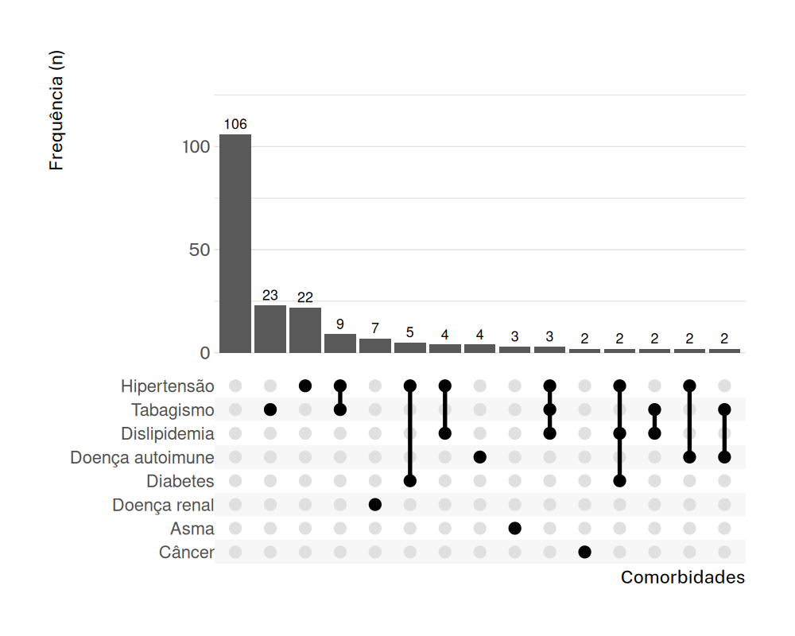

**Figure 1. Combinatorial analysis of pre-existing medical conditions of patients seen at the clinical-surgical outpatient clinic of UNIVAG: 2022–2023.**

The speciality with the highest number of consultations was general surgery. Most patients had no history of previous surgeries, did not use continuous medication, and had not been hospitalised or undergone surgery in the past three months. Additionally, the abdominal examination had the highest rate of alterations, followed by the locomotor and genitourinary systems (Table 3).

|  |  |
| --- | --- |
| Table 3. Clinical profile of patients treated at the clinical-surgical outpatient clinic of UNIVAG: 2022–2023. | |
| **Variables** | **n (%)** |
| **Specialty attended** |  |
| Surgical oncology | 2 (0.91%) |
| Digestive tract surgery | 8 (3.65%) |
| General surgery | 101 (46.12%) |
| Pediatric surgery | 57 (26.03%) |
| Vascular surgery | 34 (15.53%) |
| Coloproctology | 6 (2.74%) |
| Orthopedics | 1 (0.46%) |
| Others | 8 (3.65%) |
| Urology | 2 (0.91%) |
| **Previous surgical history** |  |
| No | 115 (52.51%) |
| Yes | 104 (47.49%) |
| **Ongoing medication use** |  |
| No | 117 (53.42%) |
| Yes | 102 (46.58%) |
| **Hospitalization or surgery within the last 3 months** |  |
| No | 195 (89.04%) |
| Yes | 24 (10.96%) |
| **Cardiac physical examination** |  |
| Abnormal | 4 (1.83%) |
| Not performed | 40 (18.26%) |
| Normal | 175 (79.91%) |
| **Pulmonary physical examination** |  |
| Abnormal | 9 (4.11%) |
| Not performed | 42 (19.18%) |
| Normal | 168 (76.71%) |
| **Abdominal physical examination** |  |
| Abnormal | 97 (44.29%) |
| Not performed | 23 (10.50%) |
| Normal | 99 (45.21%) |
| **Genitourinary physical examination** |  |
| Abnormal | 43 (19.63%) |
| Not performed | 132 (60.27%) |
| Normal | 44 (20.09%) |
| **Neurological physical examination** |  |
| Abnormal | 1 (0.46%) |
| Not performed | 174 (79.45%) |
| Normal | 44 (20.09%) |
| **Locomotor physical examination** |  |
| Abnormal | 45 (20.55%) |
| Not performed | 115 (52.51%) |
| Normal | 59 (26.94%) |
| **Laboratory examination** |  |
| No | 137 (62.56%) |
| Yes | 82 (37.44%) |
| **Imaging examination** |  |
| No | 128 (58.45%) |
| Yes | 91 (41.55%) |
| **Surgical procedure indicated** |  |
| No | 117 (53.42%) |
| Yes | 102 (46.58%) |
| **Procedure already performed** |  |
| No | 191 (87.21%) |
| Yes | 28 (12.79%) |
| **Surgical complications** |  |
| No | 28 (12.79%) |
| Not applicable | 190 (86.76%) |
| Yes | 1 (0.46%) |

The main findings on physical examination among the 199 patients were as follows: for the cardiac system, findings were evenly distributed across five observations, including tachycardia, holosystolic murmur, extrasystoles, and high blood pressure. In the pulmonary system, 66% involved tachypnea, rales, and nodular lesions in the thorax. Within the abdominal system, 68% included umbilical hernia, abdominal diastasis, and pain in the right hypochondrium. The neurological exam revealed that only one alteration was recorded (dizziness). In the genitourinary system, 60.48% of cases were represented by inguinal hernias. Of the locomotor system records, 31.11% documented varicose veins in the lower limbs.

Regarding primary diagnoses, hernias were the leading cause among evaluated patients, totalling 31.96% (70 cases). Among the hernias identified, inguinal and umbilical hernias were the most frequent, with 32 cases each, followed by incisional hernias with 6 cases. Biliary tract diseases ranked second, with 26 records (11.87%), and calculous cholecystopathy was the most frequently detected condition, with 14 cases. Varicose veins and gastropathies shared the third most common diagnosis, each with 8.21% (18 cases).

Biliary diseases constituted the second most frequent group of primary diagnoses (11.87%), with calculous cholecystopathy confirmed by both medical records and imaging tests. These data align with the literature, which identifies cholelithiasis as a common condition, particularly in individuals with risk factors such as obesity and dyslipidemia. Varicose veins and gastropathies were also prominent and may be related to underlying conditions like portal hypertension or chronic venous insufficiency, warranting specialised attention to prevent complications such as bleeding or ulcers.

As for laboratory tests, 37.44% of patients underwent testing, and 20.73% of these showed alterations. The most frequent were hyperglycemia and hyperlipidemia (10 cases, 58% of the altered results). Additionally, 91 patients (41.55%) underwent relevant imaging tests, with 52 (57.14%) showing abnormalities. The most common findings included calculous cholecystopathy (14 cases), inguinal hernia (10 cases), esophagitis and gastritis (8 cases each), umbilical hernia (6 cases), and hepatic steatosis (4 cases).

Among the patients with a surgical indication, 102 (46.57%) were advised to undergo surgery, but only 28 (12.79%) actually underwent the procedure. Of all surgical patients, only 1 (0.46%) experienced complications.

Geographic location and medical speciality showed a statistically significant, albeit weak, association. Patients from Várzea Grande/MT accounted for most consultations in general surgery, pediatric surgery, vascular surgery, and orthopaedics. Meanwhile, patients from municipalities in the interior of Mato Grosso had a higher proportion of consultations in urology and surgical oncology.

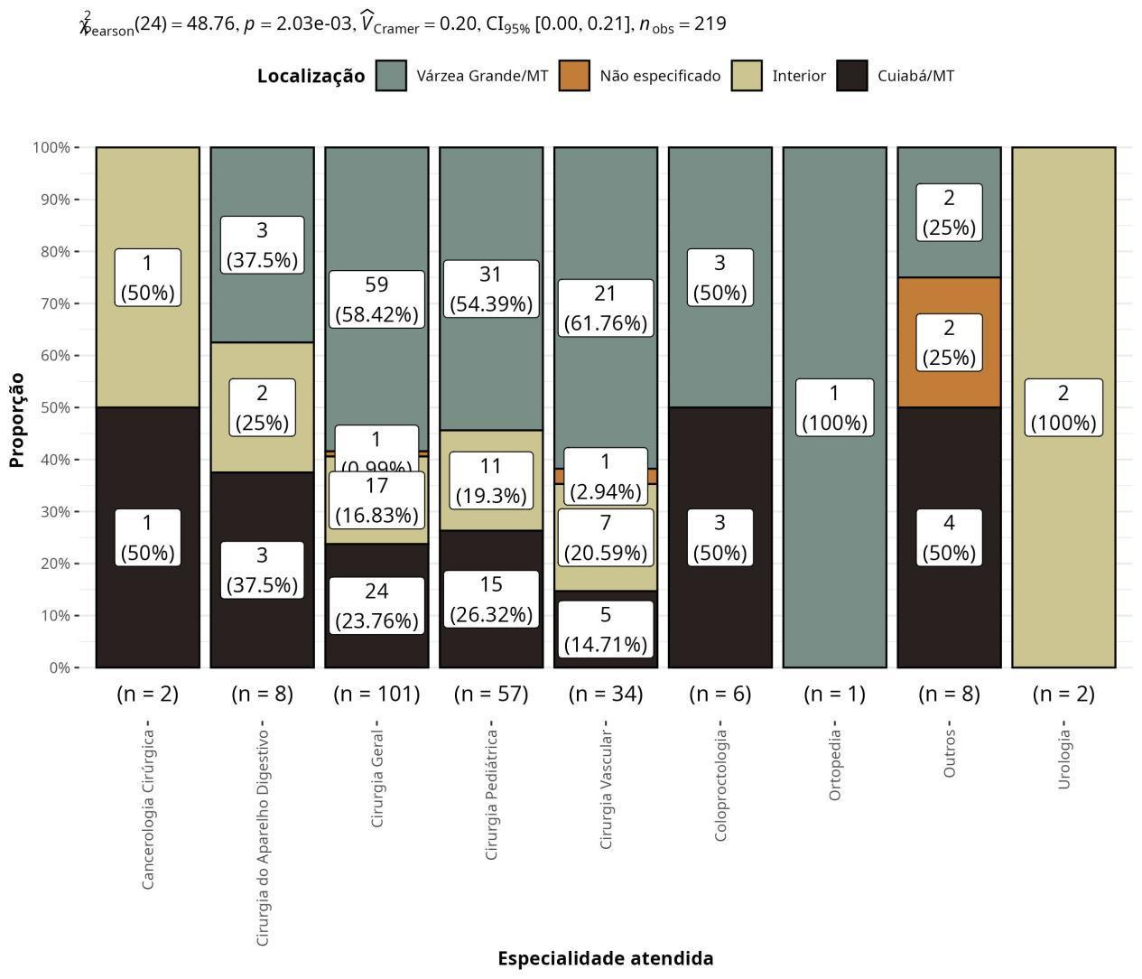

Figure 2. Distribution of clinic visits at the clinical-surgical outpatient clinic of UNIVAG between 2022 and 2023 by speciality and patient location.

**DISCUSSION**

Determining the epidemiological profile of patients at a clinical-surgical outpatient clinic is complex, due to the subjectivity in medical record entries and the involvement of students in training during the care process. Nevertheless, drawing a reasoning line from these patients’ epidemiological data can guide and enhance care strategies.¹

When analysing the prevalence by gender and age, our study observed a greater predominance of male patients aged between 31 and 60 years. These findings are consistent with studies conducted in surgical clinics of a hospital in the Sertão region of Paraíba and in emergency care settings, where a similar predominance of male patients aged 31 to 60 years was noted 2, 8

Aspects such as pre-existing medical conditions, continuous medication use, smoking, and recent hospitalisation or surgical history provide important data for assessing risks associated with procedures and planning safer interventions. In the present study, comorbidities were relatively infrequent among the individuals analysed, resulting in a population with a low incidence of pre-existing conditions. However, systemic arterial hypertension, tobacco use, diabetes, and dyslipidemia were the most prevalent conditions—findings that align with the primary laboratory results of the study, such as hyperlipidemia and hyperglycemia, and with data found in the literature. 5, 9

Detailed physical examinations and the request for complementary tests allow the identification of changes that may influence surgical planning and postoperative outcomes. Moreover, recording diagnoses, procedures performed, and possible complications contributes to the continuous improvement of healthcare practices and the reduction of disparities in access and quality of care across different regions of the country. Among the main diagnoses analysed, hernias had a prevalence of 31.96%, followed by biliary tract diseases with 11.87%—data consistent with imaging findings such as calculous cholecystopathy and inguinal hernia, also reported by other authors.¹¹

The data suggests a predominance of medical consultations in the fields of pediatric and general surgery, reflecting the demand for broad and non-specialised care when compared to more specific specialities, such as head and neck surgery or oncologic surgery. General surgery was the dominant speciality in the analysed records, consistent with another study on the epidemiological profile of patients evaluated during pre-anaesthetic assessments at a university hospital⁵

The geographic data show that a significant portion of the patients treated came from areas outside the university centre’s location in the municipality of Várzea Grande/MT.

There was a predominance of abnormal findings in physical examinations, especially in the abdominal (44.29%), locomotor (20.55%), and genitourinary (19.63%) systems. These findings are related to the primary diagnoses of the patients in this study.

The high prevalence of hernias in clinical practice underscores the importance of early diagnosis and proper management to avoid complications such as incarceration or strangulation, which are frequently associated with these conditions. The literature corroborates these findings, noting that hernias and biliary diseases are also common in other studies, especially among individuals with risk factors such as obesity and dyslipidemia 3, 7 Biliary tract and other digestive system diseases are among the leading causes of emergency surgery.8

The surgical indication rate in nearly half of the studied patients contrasts with the proportion who actually underwent surgery, indicating that various factors may contribute to this outcome, including treatment abandonment, seeking care elsewhere, or other reasons. These factors also indirectly influence the rate of surgical complications.

4. Conclusion

The study showed that most patients treated at the UNIVAG surgical outpatient clinic were between 31 and 60 years old, residing in the municipality of Várzea Grande/MT, with hernias and biliary diseases as the predominant primary diagnoses. Many presented with pre-existing conditions, with hypertension, dyslipidemia, and diabetes being the most prevalent, along with continuous medication use and smoking, factors that demand careful surgical planning.

The higher burden of chronic diseases among elderly individuals reinforces the need for closer perioperative monitoring. Furthermore, the discrepancy between surgical indications and actual procedures performed highlights the challenges in accessing treatment.

Consent

Not applicable.

Ethical approval

The research was approved by the research ethics committee of the Várzea Grande University center, according to opinion number 6,748,894.

Disclaimer (Artificial intelligence)

Option 1:

Author(s) hereby declare that NO generative AI technologies such as Large Language Models (ChatGPT, COPILOT, etc.) and text-to-image generators have been used during the writing or editing of this manuscript.

Option 2:

Author(s) hereby declare that generative AI technologies such as Large Language Models, etc. have been used during the writing or editing of manuscripts. This explanation will include the name, version, model, and source of the generative AI technology and as well as all input prompts provided to the generative AI technology.

Details of the AI usage are given below:

1.

2.

3.

References

1- Luna AA, Paixão CMC, Caldas SAM, Silva NCM, Souza PA, Fassarella CS. Epidemiological profile of surgical patients in Brazil. Recien. 2022;12(38):32-41.

2- Pereira MC, Medeiros RLSFM, Silva TC, Alencar Neta RL, Feitosa ANA, Oliveira GS. Clinical and epidemiological profile of patients undergoing surgery at a hospital in the backlands of Paraíba. Brazilian Journal of Production Engineering. 2020;6(6):139-148.

3- Lemos LN, Tavares RMF, Donadelli CAM. Epidemiological profile of patients with cholelithiasis treated at a surgery outpatient clinic. Electronic Journal of Health Archives. 2019;28:e947.

4- Souza MM, Belasco AGS, Aguilar-Nascimento JE. Epidemiological Profile of Patients with Inflammatory Bowel Disease in the State of Mato Grosso. Rev bras Coloproct. 2008;28(3):324-328.

5- Santos ML, Novaes CO, Iglesias AC. Epidemiological profile of patients treated at the pre-anesthetic evaluation clinic of a university hospital. Rev Bras Anestesiol. 2017;67(5):457-467.

6- Pinheiro LHZ, Silva BB, Basso RCF, Franco FF, Andrade TFC, Pili RC, et al. Epidemiological profile of patients undergoing surgery for facial fracture treatment at a university hospital. Rev Bras Cir Plást. 2022;37(1):1-6. 7- Santos JS, Sankarankutty AK, Salgado Jr W, Kemp R, Leonel EP, Castro e Silva Jr O. Outpatient surgery: From concept to organization of services and their results. Medicine (Ribeirão Preto). 2008;41(3):274-86.

8- Lyra CAM, Dantas LRCF, Todt SC, Palmeira IP, Figueiredo MBGA, Lima SO. Epidemiological profile of surgeries in emergency and urgent care services. Medicine (Ribeirão Preto). 2020;53(3):247-51.

9- Reis MMR, Lima EFA, Casagrande RI, Floresi M, Leite FMC, Primo CC. Epidemiological profile of patients undergoing cardiac surgery. Rev Enferm UFPE. 2019;13(4):1015-22. 10- Torres B, Macia L, Nolasco A, Lopez MJ, Pina F. Patient safety in the surgical center and quality of documentation related to surgical infection and hospitalization. Acta Paul Enferm. 2015;28(4):355-60.

11. Süerdem B, Dikmen BT. Dependence on preoperative care and quality of postoperative recovery of surgical patients. Acta Paul Enferm. 2024;37:eAPE01721. <https://doi.org/10.37689/acta-ape/2024AO0001721>.

12. Javed, H., Olanrewaju, O. A., Owusu, F. A., Saleem, A., Pavani, P., Tariq, H., ... & Varrassi, G. (2023). Challenges and solutions in postoperative complications: a narrative review in general surgery. Cureus, 15(12).

13. Tosounidis, T. H., Castillo, R., Kanakaris, N. K., & Giannoudis, P. V. (2015). Common complications in hip fracture surgery: Tips/tricks and solutions to avoid them. Injury, 46, S3-S11.

14. Ataro, B. A., Geta, T., Endirias, E. E., Gadabo, C. K., & Bolado, G. N. (2024). Patient satisfaction with preoperative nursing care and its associated factors in surgical procedures, 2023: a cross-sectional study. BMC nursing, 23(1), 235.

15. Makau, P. M., Mbithi, B. W., & Odero, J. (2023). Factors affecting compliance to preoperative patient care guidelines among nurses working in surgical wards of a tertiary referral hospital in Nairobi, Kenya. African Journal of Health Sciences, 36(2), 124-130.

16. Yeşilyurt, D. S., & Findik, Ü. Y. (2019). Effect of preoperative video information on anxiety and satisfaction in patients undergoing abdominal surgery. CIN: Computers, Informatics, Nursing, 37(8), 430-436.

17. Rakesh, A., Nag, A., Milton, B., & Arun, A. (2024). Evaluation of Preoperative and Postoperative Anxiety Levels among Surgical Patients in a Tertiary Care Hospital. International Neuropsychiatric Disease Journal, 21(6), 155–162. https://doi.org/10.9734/indj/2024/v21i6461