Original Research Article
Effect of Aneurysmal Shape on Atheromatous Hemodynamics during a Pulsatile Blood Flow

Abstract
Blood circulation in human arteries is primarily influenced by time-related transport processes. A variety of aneurysmal shapes’ geometry also affects the blood flow patterns within them. The current study examines the influence of aneurysmal morphology on atheromatous hemodynamic risk factors by numerically solving blood flow patterns. The software code of COMSOL Multiphysics has been employed in this blood flow simulation. The finite element method has been used. The aneurysmal shape of a rectangle generates an extensive separation zone compared to a trapezium and a triangle. At the aneurysm area, the shearing stress is lower contributes to a thrombus deposition. At the post-aneurysmal area, the velocity is increased. The aneurysmal rectangle gives a lower pressure compared to others. Compared to aneurysmal triangle and aneurysmal rectangle, the TAWSS for aneurysmal trapezium is raised by 7.43% and 34%, respectively. The extensive recirculation zone is found in an aneurysmal rectangle rather than in the aneurysmal trapezium or triangle. Finally, it is concluded that the aneurysmal rectangle deposits more lipids, fats to create more recirculation area.

Keywords: CFD; Aneurysmal shape; Atheromatous hemodynamics; Recirculation zone; Pressure.

1. Introduction

An aneurysm is a swelling or expansion in a blood vessel’s wall. Aneurysm may rupture. We refer to this as an aneurysmal rupture. Internal bleeding occurs when an aneurysm ruptures. It frequently results in fatality and morbidity [1]. Conditions affecting the human’s blood vessels-related illnesses, including heart attacks and strokes, are the leading causes of death globally. Aneurysms are the main cause of these illnesses [2-4]. Numerous experiments and computational fluid dynamics (CFD) analyses have been conducted to examine the flow disturbance caused by aneurysm or plaque formation growth in humans, which results in the system of cardiovascular failure [5-10]. Before burst, numerous aneurysms are asymptomatic, and they are frequently found by accident when undergoing imaging for different conditions [11-12]. Blood flow simulation in various cases such as flow pulsation, axisymmetric and geometric variations is important [13] because blood variables play a major influence in the initiation and progression of the atherosclerotic state for pulsatile blood flow, it is imperative to comprehend how blood operates in aneurysm. The findings indicate a considerable impact of the existence of aneurysm based on various hemodynamic factors along the central line and wall.
Narayan et al., [14] have investigated the aneurysmal blood flow in a magnetic area to assess the hemodynamic risk parameters. The research has found that the globular and bilobed shapes are more prone to sac rupture and lateral neck dilation. Elger et al., [15], and Cebral et al., [16] have conducted numerical simulations of blood pulsation flow, yielding flow types and analyzing their impact on hemodynamics. Aneurysmal diameter appears to have minimal impact on the distribution and amount of wall pressure during the flow cycle, according to Peattie et al., [17] along with Peattie and Bluth [18]. In Becker et al., [19], results have showed that the pressure of intra-aneurysm changed very little during and right after coiling and the diversion of flow. The pressures of intra-aneurysm are little affected by disruptions in the flow of intra-aneurysm single. The stenosed-aneurysmal blood flow investigation has been carried out in [20] to show its impact on atheromatous hemodynamics for the implementation in bioengineering field. To reveal the effects of hemodynamics on the rupture and expansion of cerebral artery’s aneurysms, numerical studies have been conducted [21]. This research provides accurate data and understanding regarding the impact of blood parameters on the cerebral artery’s aneurysms risks.
Blood circulation in brain aneurysms shows chaotic and temporary conditions, frequently featuring vortices [22], in contrast to the laminar flow seen in the arteries of healthy brain. These altered flow types features contain vortex ring formations and swift-moving flow jets [23], which may hit the aneurysm’s wall, leading to excessively elevated wall shear stress (WSS) [24]. It led physicians to search hemodynamic metrices [25], such as time-averaging wall shear stress (TAWSS) and oscillatory shearing index (OSI), as possible markers of the risk of rupturing nature [26]. Advanced methods take into account dynamic elements such as the types of blood flow and WSS, that may be visualized through the highly image quality and numerical simulations [27-29]. Though Finol et al. [30] have studied double aneurysms, the investigation of the effect of aneurysmal shape is not yet established; this is the research gap being studied.
Despite considerable research taking into account over the last few years to examine aneurysmal blood flow in an arterial geometry, limited studies have been conducted about blood flow in a luminal artery with varying aneurysmal shapes. Therefore, the present study is inspired to examine how several aneurysmal models influence blood circulation.

2. Methodology
2.1 Aneurysmal Geometry

The aneurysmal geometry utilized in the current simulations is represented by the aneurysm forms, which are the trapezium, triangle and rectangle depicted in Figure 1. The coordinates Y and X indicate the radial and axial locations. For the present numerical computation, the aneurysmal length of 2.792 mm has been taken into consideration in Figure 1. The simulation has taken into account aneurysm models that are 45% tall. Because aneurysms can grow in three various geometries, the nature of pulsatile blood flow is being examined. The geometry of computation has a diameter of 5 mm.
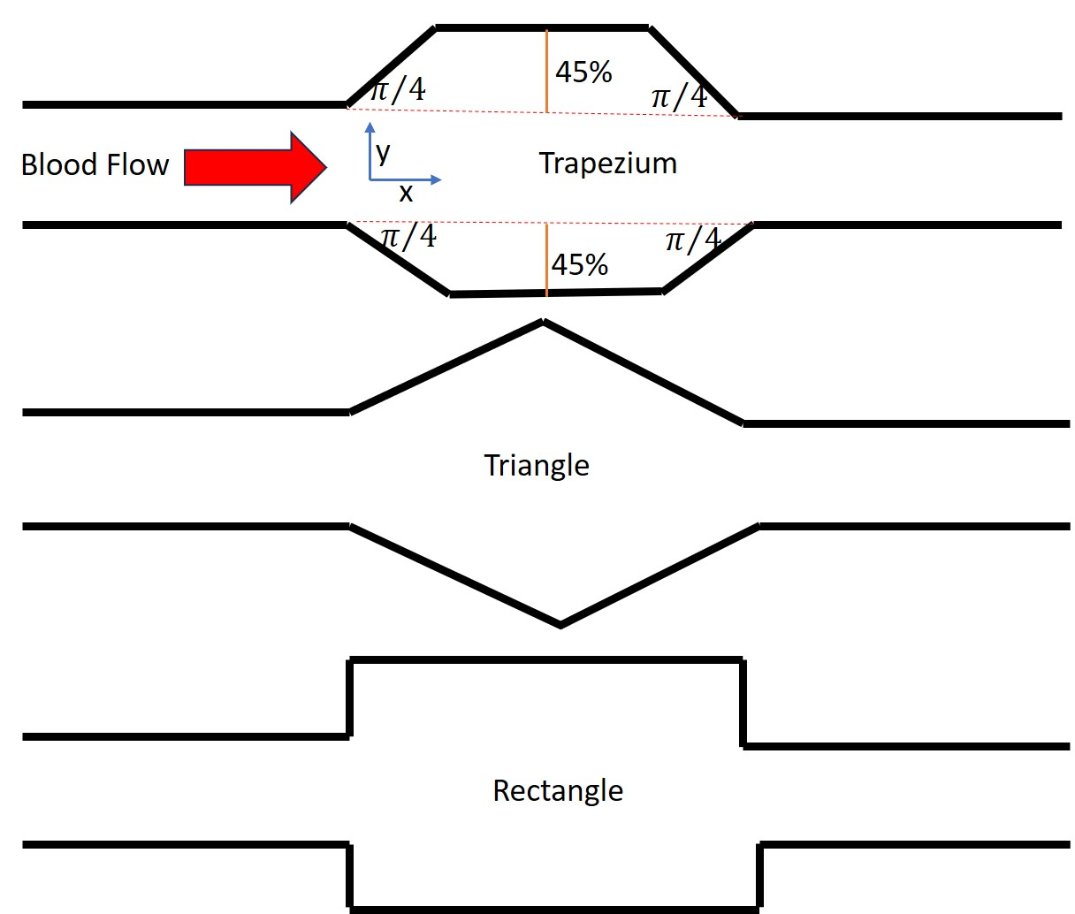
Fig.1. Aneurysmal geometrical shapes of present numerical computation.
2.2 Governing Equations and Boundary Conditions

The general continuity equation and Navier-Stokes equations are simplified for the three-dimensional flow of an incompressible Newtonian fluid. Fluid flow’s continuity equation can be given as follows:

The form of Navier-Stokes equations can be written in the following way:

In equations (1) & (2), denotes the fluid density, p is the pressure, is the velocity vector. The fluid domain’s inlet takes velocity pulse as a given equation [31].

A no-slip condition is assumed across the artery wall for the present computational domain. Outlet pressure for the investigated computational geometry is 4140 Pa. The fluid’s density and viscosity for the Newtonian model is 1060 and 0.00345 respectively.

2.3 Computational Techniques

The present research uses the software code for COMSOL Multiphysics to solve the governing equations for blood flow simulations in arteries featuring aneurysmal shapes. The software has been used on the basis of finite element methods. The artery’s inflow and outflow lengths from the aneurysmal shape should not affect the outcomes of computation. Numerous computations have been run in order to determine the aneurysm’s independent inflow and outflow lengths. Ultimately, it can be shown that the proximal and distal sides of the aneurysm, respectively, require lengths of 3D and 10D. In order to guarantee the precision of the predicted outcomes, multiple numerical computations have been executed using distinct mesh elements of 17601, 37539, 100573, 205104, and 309303. The results in wall pressure for the last two elements are approximately the same. So, the mesh elements of 205104 have been chosen for the present numerical computation. To get the accurate results, the second cycle has been selected for periodicity.

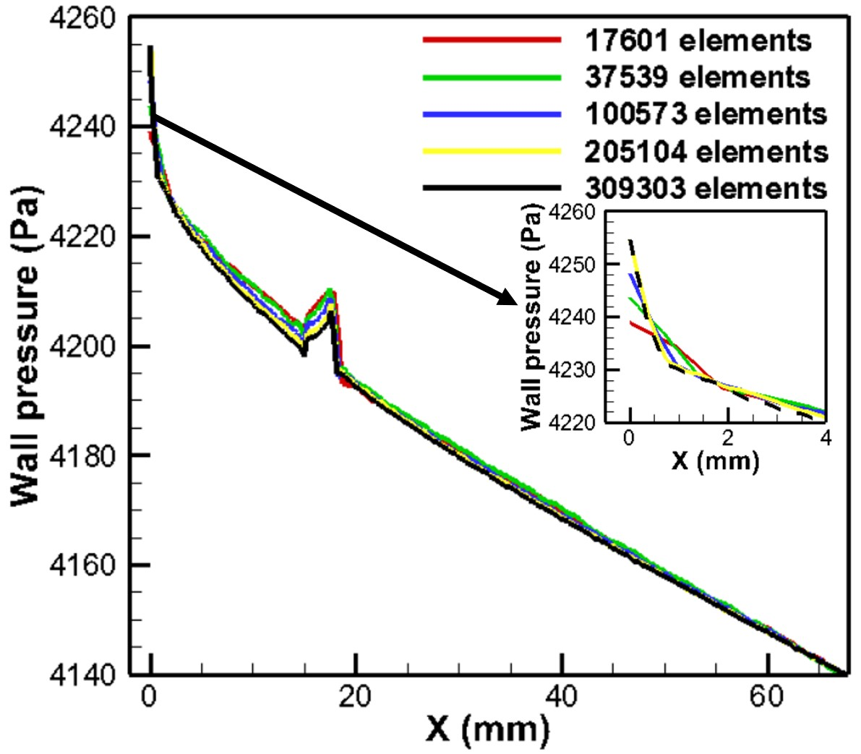

Fig.2. Grid test for several elements.

2.4 Method validation
The correctness and firmness of the blood flow computation evaluation are validated and confirmed in this present research by comparing the results with those of research by Lee et al. [32] using axial velocity. Furthermore, as Fig. 3 displays, there is a significant agreement between the currently predicted axial velocity outcome and those obtained by Lee et al. [32]. A rigid wall’s predicted axial velocity at a downstream location (2.5*diameter) for several time points agrees well.

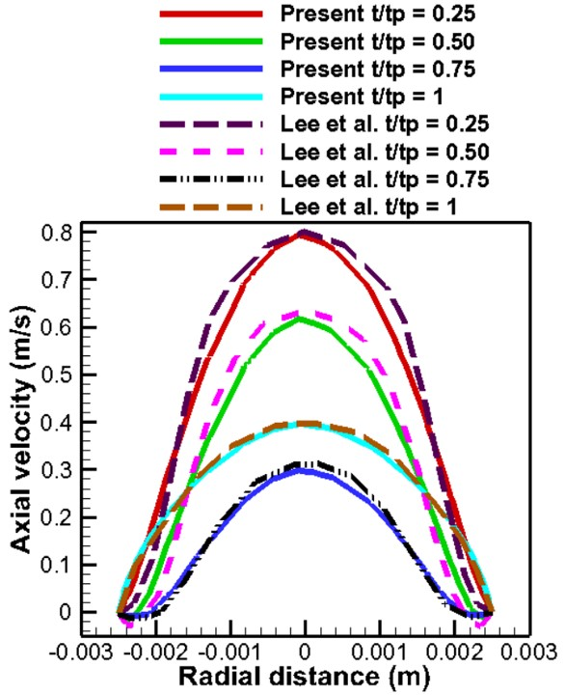

Fig.3. Present numerical computation is validated with Lee et al. [32].

3. Results and Discussion

3.1 Axial velocity due to aneurysmal shapes

Fig. 3 compares the axial velocities of the trapezium, triangle, and rectangle aneurysmal shapes in the aneurysm regions, terminal area, and post-aneurysm region. The axial velocity can be affected due to the expansion of different aneurysmal geometries because of the nature of higher flow. At the aneurysm area, the axial velocity is lower than in the post-aneurysmal area because of the deposition of thrombus. The speed is consistently reduced in the area near the aneurysm’s wall. In the aneurysm, the fluid slows down due to high flow regions, reaching minimal levels, which creates a separation zone, and the reduced velocity distribution causes the boundary layer to widen. The post-aneurysmal area gives a higher velocity for all investigated shapes. The lower velocity and greater recirculation are observed in the aneurysm of a rectangle at all locations compared to the aneurysmal shapes of a trapezium and a triangle.

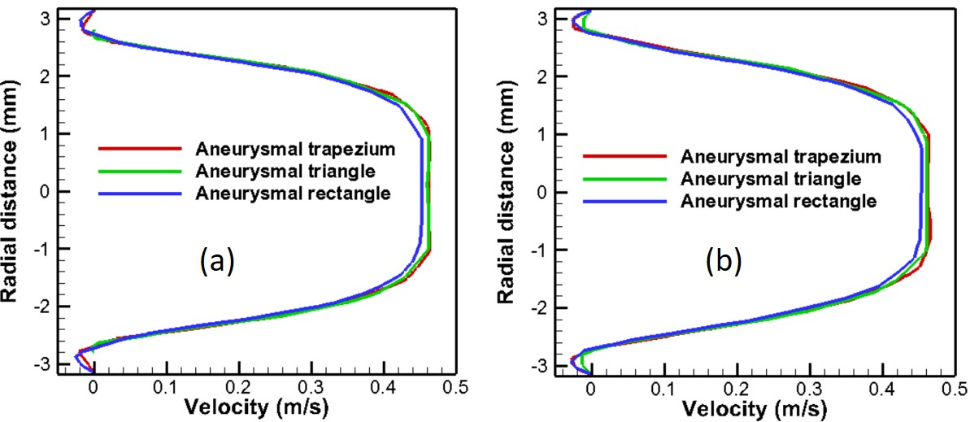
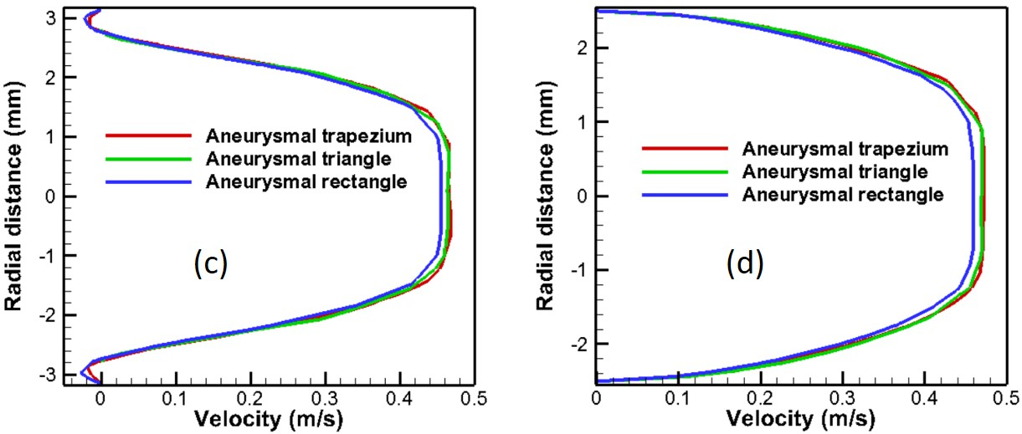

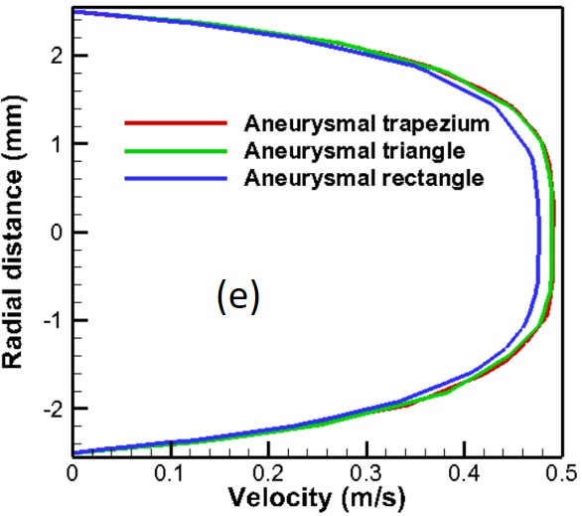

Fig.4. Axial velocity through radial direction at stenosis and post-stenosis locations.

3.2 Velocity streamline and recirculation zone
Fig. 4 illustrates the systolic phase streamlines (t = 0.08625 sec) in a damaged artery while taking various aneurysm forms into account. It is clear that although the inlet velocity is identical, for the examined cases, flow recirculation is considerably more pronounced in the aneurysmal model of rectangle compared to the aneurysmal models of trapezium and triangle. The rhythmic behavior of blood flow, characterized by its pulsating condition, leads to the formation of recirculating flows. Taking this fact into account, recirculation zones in the affected artery during the systolic phase of a normal cardiac cycle are examined for all forms. It is noted that the recirculation areas are seen to develop and progressively diminish the speed. Nonetheless, significant flow recirculation is seen in the rectangular aneurysm.

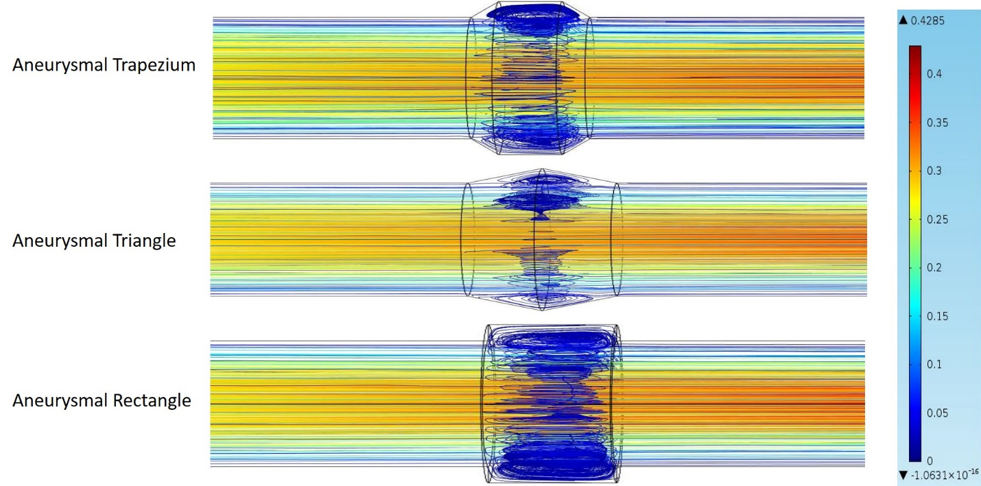
Fig.5. Velocity streamlines for various aneurysmal shapes.

3.3 Hemodynamic risk factors
The artery wall exhibits time-averaged biomarkers, including TAWSS, OSI, and relative residency time (RRT) introduced in [33], which are indicators of endothelium degradation (Fig. 6(a, b, c)). The negative shearing force at the wall surrounding the aneurysm region, where flow recirculation occurs, is significantly smaller than in other sections, and this recirculation differs with various aneurysmal shapes. The rectangular shape of an aneurysm contributes to making the flow more disturbed in the aneurysm area. Research indicates that the artery’s wall experiences greater TAWSS from an aneurysmal trapezium than from a triangle or rectangle, with the latter two shapes resulting in the lowest stress among the three aneurysm shapes studied. The findings also demonstrate that the TAWSS magnitude is higher at the ending section of the aneurysm than at the aneurysm section [34]. It is therefore convenient to state that the likelihood of rupturing an artery’s wall resulting from aneurysm development is greatest in the trapezium, followed by the triangle and the rectangle. Another two important parameters, OSI and RRT, indicate the direction of shearing stress and blood particles’ residence time, leading to the indication of flow separation points with peak points, and an aneurysmal rectangle gives an extensive recirculation zone.
The distributions of viscous stress contours with a 45% depth due to aneurysmal various shapes are presented in Fig. 6(d) for the segmentation of arterial geometry. In every aneurysm model, the viscous stress peaks near the beginning of the artery and falls throughout the aneurysm, contributing to the accumulation of atherosclerotic lipid, fat, fatty acids, etc. Nonetheless, the trapezium model has the greatest magnitude compared to the other two shapes.

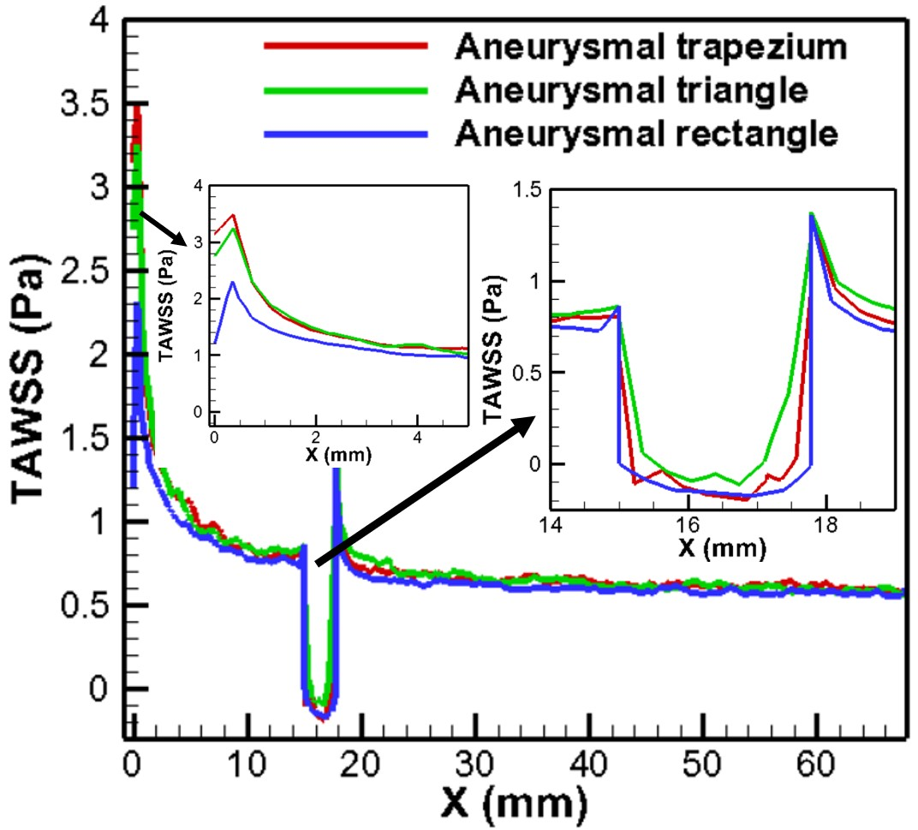
(a)

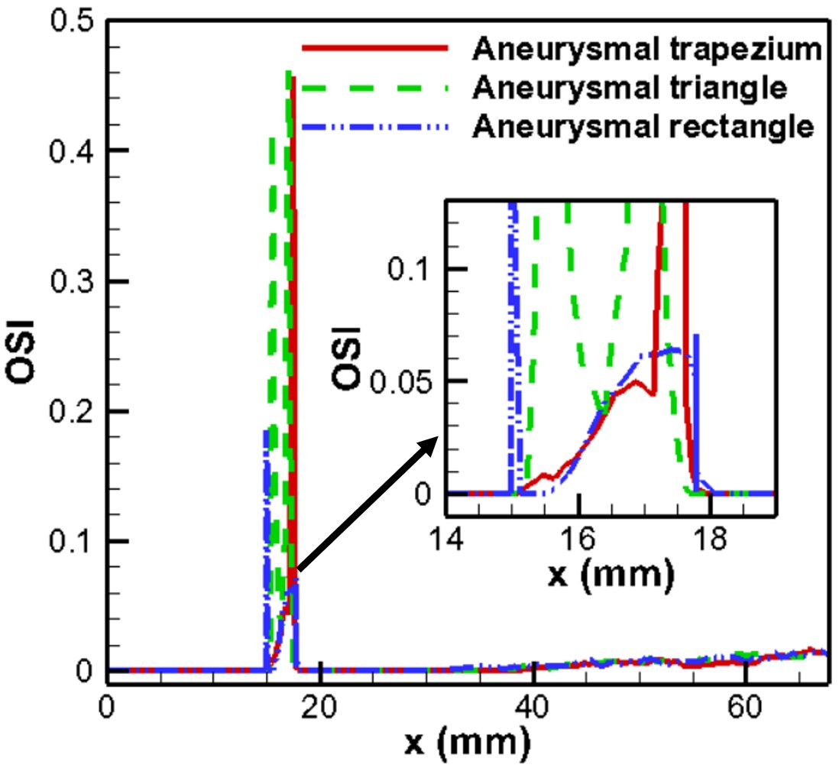
(b)
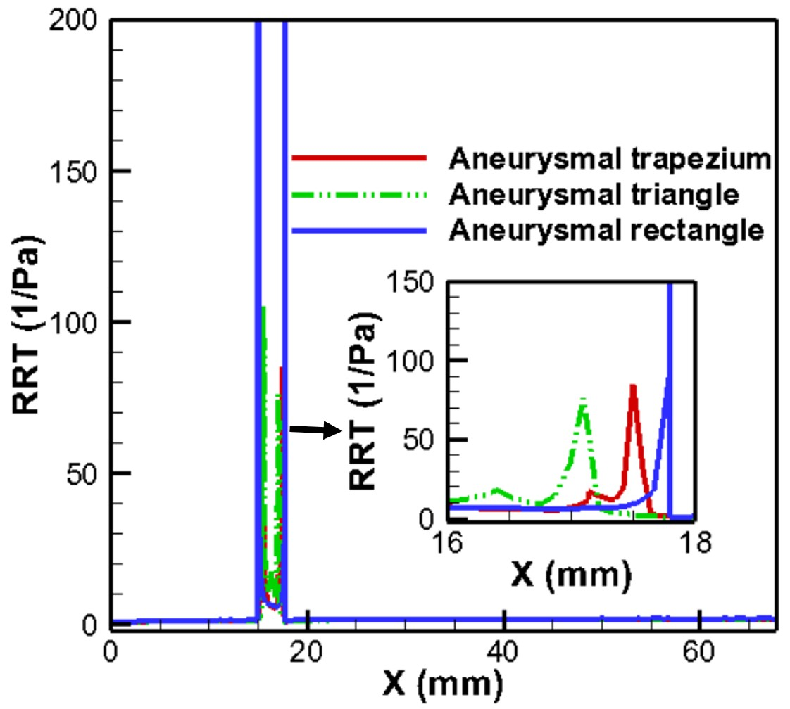
(c)
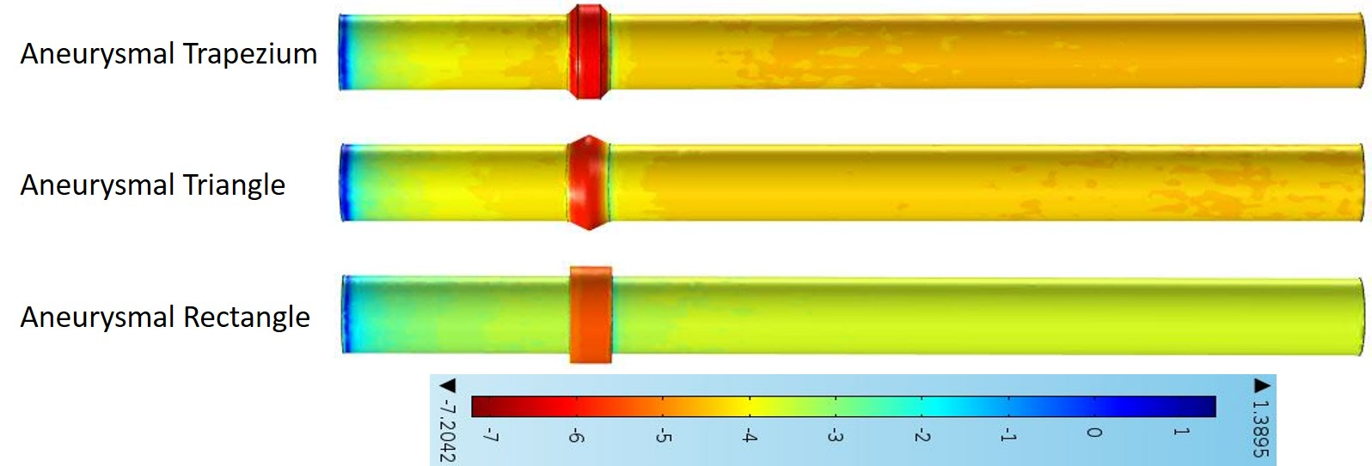
(d)

Fig.6. Distributions of hemodynamic parameters (TAWSS, OSI, RRT) in 6(a, b, c), and viscous stress contours for different aneurysmal shapes in 6(d).

3.4 Pressure contour
The pressure from an aneurysm is a vital aspect in understanding the emergency if it remains unrecognized and unevaluated properly. In the progression and development of atherosclerosis, the shape of the aneurysm significantly influences the nature of flow within the arterial structure, which is also visible with the pressure contour distributions (Fig. 7) throughout the artery, since the severity of shape-based blood circulation contributes to the detection of patients’ disease. The trapezium shape of the aneurysm generates significantly greater pressure compared to the aneurysmal triangle, which consecutively greater than that of the aneurysmal rectangle shape. Conclusively, it may be claimed that for every shape of aneurysm model, the minimum pressure occurs at the distal region after the aneurysm.

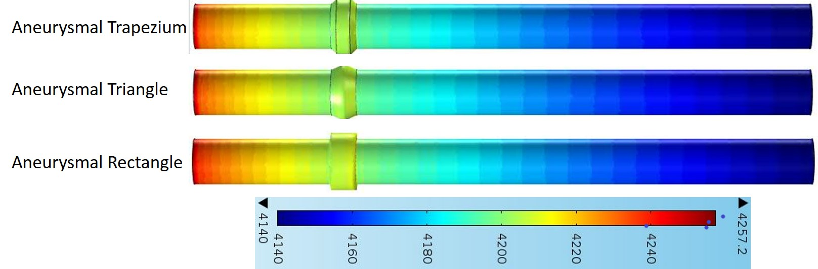

Fig.7. Pressure contour distribution for aneurysmal shapes.

4. Conclusions

This research examines different aneurysmal shapes as conventionalized representations to investigate the recirculated nature of flow, as the recirculated formation of flow within the aneurysm area is crucial in rupture characteristics, and the earlier finding of an aneurysm can aid in predicting the risk of rupturing nature. The Newtonian flow pulsation of the geometry of three dimensions is the focus of this investigation. The software code of COMSOL Multiphysics has been adopted, with validation of the method being satisfactory. The aneurysmal form of a rectangle creates a wide separating zone in comparison to a trapezium and a triangle. In the aneurysm region, the reduced shearing stress aids in thrombus accumulation. In the area following the aneurysm, the speed is heightened. The aneurysmal rectangle produces a reduced pressure relative to others. The TAWSS for aneurysmal trapezium is increased by 7.43% and 34%, respectively, in comparison to aneurysmal triangle and aneurysmal rectangle.
Finally, this research demonstrates that people with different types of aneurysms exhibit various vortex configuration characteristics in their blood circulation.

Competing Interests
The author has declared that no competing interests exist.

Disclaimer (Artificial intelligence)
Option 1:
Author(s) hereby declare that NO generative AI technologies such as Large Language Models (ChatGPT, COPILOT, etc.) and text-to-image generators have been used during the writing or editing of this manuscript.
Option 2:
Author(s) hereby declare that generative AI technologies such as Large Language Models, etc. have been used during the writing or editing of manuscripts. This explanation will include the name, version, model, and source of the generative AI technology and as well as all input prompts provided to the generative AI technology
Details of the AI usage are given below:
1.
2.
3.

References

- Kassel, N.F., Torner, J.C., Haley, E.C., et al. “The international cooperative study on the timing of aneurysm surgery. Part 1: overall management results.” Journal of Neurosurgery 73, no. 1 (1990): 18-36.
- Fan, T., Wang, J., Wang, X., Chen, X., Zhao, D., Xie, F., Chen, G. “Integrated multidisciplinary approach to aneurysm hemodynamic analysis: numerical simulation, in vitro experiment, and deep learning.” Frontiers in Bioengineering and Biotechnology 13 (2025). https://doi.org/10.3389/fbioe.2025.1602190
- Hadad, S., Mut, F., Slawski, M., Robertson, A.M., and Cebral, J.R. “Evaluation of predictive models of aneurysm focal growth and bleb development using machine learning techniques.” Journal of Neurointerventional Surgery 16, no. 4 (2024): 392-397. doi:10.1136/jnis-2023-020241
- Wang, L., Jiang, X., Zhang, K., Chen, K., Wu, P., and Li, X. “A hemodynamic analysis of energy loss in abdominal aortic aneurysm using three-dimension idealized model.” Frontiers in Physiology 15 (2024): 1330848. https://doi.org/10.3389/fphys.2024.1330848
- Reorowicz, P., Obidowski, D., Przemyslaw K., Wojciech S., Ludomir S., and Krzysztof J. "Numerical simulations of the blood flow in the patient-specific arterial cerebral circle region." Journal of Biomechanics 47, no. 7 (2014): 1642-1651. https://doi.org/10.1016/j.jbiomech. 2014.02.039
- Khalafvand, S. S., Eddie Y.-K. N., Zhong, L., and Hung T.-K. "Three-dimensional diastolic blood flow in the left ventricle." Journal of biomechanics 50 (2017):71-76. https://doi.org/10.1016/j.jbiomech. 2016.11.032
- Deplano, V., Knapp,Y., Bailly, L. and Bertrand, E. "Flow of a blood analogue fluid in a compliant abdominal aortic aneurysm model: Experimental modelling." Journal of biomechanics 47, no. 6 (2014): 1262-1269. https://doi.org/10.1016/j.jbiomech.2014. 02.026
- Imai, Y., Omori, T., Shimogonya, Y., Yamaguchi, T. and Ishikawa T. "Numerical methods for simulating blood flow at macro, micro, and multi scales." Journal of biomechanics 49, no. 11 (2016): 2221-2228. https://doi.org/10.1016/j.jbiomech. 2015.11.047
- Blanco, P. J., Müller, L. O., Watanabe, S. M. and Feijóo, R. A. "Computational modeling of blood flow steal phenomena caused by subclavian stenoses." Journal of Biomechanics 49, no. 9 (2016): 1593-1600. https://doi.org/10.1016/j.jbiomech. 2016.03.044
- Morbiducci et al. “Hemodynamics and atherosclerosis: insights and perspectives from computational modeling.” Journal of Biomechanics, (2021).
- Khan, M., Toro Arana, V., Najafi, M., MacDonald, D., Natarajan, T., Valen-Sendstad, K., and Steinman, D. “On the prevalence of flow instabilities from high-fidelity computational fluid dynamics of intracranial bifurcation aneurysms.” Journal of Biomechanics 127 (2021): 110683.
- Tawk, R.G., Hasan, T.F., D’Souza, C.E., Peel, J.B., and Freeman, W.D. “Diagnosis and treatment of unruptured intracranial aneurysms and aneurysmal subarachnoid hemorrhage.” In Mayo clinic Proceedings 96 (2021): 1970-2000.
- Kumar, B.V. Rathish, and K. B. Naidu. "Hemodynamics in aneurysm." Computers and biomedical research 29, no. 2 (1996): 119-139. https://doi.org/10.1006/cbmr.1996.0011
- Narayan, S.S., Rakshitha, S., Singh, A. “Blood flow across cerebral aneurysm with magnetic field intervention.” Physics of Fluids 37, no. 3 (2025): 031901. https://doi.org/10.1063/5.0252178
- Elger, D., Slippy, J., Budwig, R., Khraishi, T., and Johansen, K. “A Numerical Study of the Hemodynamics in a Model Abdominal Aortic Aneurysm (AAA).” Proceedings in ASME Symposium on Biomedical Fluids Engineering 212 (1995): 15-22.
- Cebral, J.R., Mut, F., Weir, J., Putman, C.M. “Association of Hemodynamic Characteristics and Cerebral Aneurysm Rupture.” AJNR Am J Neuroradiol 32 (2019): 264-270.
- Peattie, R., Cooper, J., and Day, A. ‘‘Computational Investigation of Pulsatile Flows and Wall Stresses in Models of Abdominal Aortic Aneurysms.’’ Proceedings 1st Joint BMES/EMBS Conference (1999): 305.
- Peattie, R., and Bluth, E. ‘‘Experimental Study of Pulsatile Flows in Models of Abdominal Aortic Aneurysms.’’ Proceedings 20th Annual International Conference of the IEEE Engineering in Medicine and Biology Society 20, no. 1 (1998): 367-370.
- Becker, T.A., Lewis, K.L., et al. “Aneurysm dome and vessel pressure measurements with coiling, stent assisted coiling and flow diversion.” Acta Neurochirurgica 167, no. 8 (2025): doi: 10.1007/s00701-024-06392-5
- Hussain, A., Dar, M.N.R., Tag-eldin, E.M. “Effects of stenosis and aneurysm on blood flow in stenotic-aneurysmal artery.” Heliyon 9, no. 7 (2023): e17788. https://doi.org/10.1016/j.heliyon.2023.e17788
- Shen, X.-Y., Xu, H.-Q., et al. “Numerical simulation of blood flow effects on rupture of aneurysm in middle cerebral artery.” International Journal of Modern Physics C 33, no. 3 (2022): 1-18. http://www.worldscientific.com/doi/abs/10.1142/S0129183122500309
- Wu, X., Gurzing, S. et al. “Hemodynamic study of a patient-speciﬁc intracranial aneurysm: Comparative assessment of tomographic piv, stereoscopic piv, in vivo mri and computational ﬂuid dynamics.” Cardiovascular Engineering and Technology, 13 (2022): 428-442.
- Le, T. B., Borazjani, I., Sotiropoulos, F. “Pulsatile flow effects on the hemodynamics of intracranial aneurysms.” Journal of biomechanical engineering, 132 (2010): 111009.
- Sforza, D. M., Putman, C. M., and Cebral, J. R. “Hemodynamics of cerebral aneurysms.” Annual review of ﬂuid mechanics, 41 (2009): 91-107.
- Futami, K., Uno, T., Misaki, K., Tamai, S., Nambu, I., Uchiyama, N., and Nakada, M. “Identiﬁcation of vortex cores in cerebral aneurysms on 4d ﬂow mri.” American Journal of Neuroradiology, 40 (2019): 2111-2116.
- Wu, X., Gurzing, S. et al. “Hemodynamic study of a patient-speciﬁc intracranial aneurysm: Comparative assessment of tomographic piv, stereoscopic piv, in vivo mri and computational ﬂuid dynamics.” Cardiovascular Engineering and Technology, 13 (2022): 428-442.
- Rayz, V. L., Cohen-Gadol, A. A. “Hemodynamics of cerebral aneurysms: Connecting medical imaging and biomechanical analysis.” Annual Review of Biomedical Engineering, 22 (2020): 231, 256.
- Zingaro, A., Ahmad, Z., et al. “A comprehensive stroke risk assessment by combining atrial computational ﬂuid dynamics simulations and functional patient data.” Scientific Reports, 14 (2024): 9515.
- Sheikh, M. A. A., Shuib, A. S., and Mohvi, M. H. H. “A review of hemodynamic parameters in cerebral aneurysm.” Interdisciplinary Neurosurgery, 22 (2020): 100716.
- Finol, E.A., Amon, C.H. (2001) Blood flow in abdominal aortic aneurysms: Pulsatile flow hemodynamics. Journal of Biomechanical Engineering, 123 (2001): 474-484.
- Ojha, M., Richard, S.C., Cobbold, K. Wayne, J., and Richard, L.H. “Pulsatile flow through constricted tubes: an experimental investigation using photochromic tracer methods.” Journal of fluid mechanics, 203 (1989): 173-197. https://doi.org/10.1017/S0022112089001424
- Lee, K.W., Xu, X.Y. “Modeling of flow and wall behavior in a mildly stenosed tube.” Medical Engineering & Physics, 24 (2002): 575 – 586.
- Kelidis, P., Konstantinidis, E. “Pulsatile flow through a constricted tube: effect of stenosis morphology on hemodynamic parameters.” Computer Methods in Biomechanics and Biomedical Engineering, 21 (2018): 479-487.
- Mia, M. A. K., Hossain, S., Salehin, S. “Effects of severity and dominance of viscous force on stenosis and aneurysm during pulsatile blood flow using computational modelling.” CFD Letters, 12 (2020): 35-54.

