Exploring Macrofungal Diversity in Mid Garhwal Himalayas, Bharsar, Uttarakhand
ABSTRACT
A systematic survey of wild macrofungi was conducted in the temperate evergreen forests of the Bharsar region, Pauri Garhwal, Uttarakhand, situated at elevations between 1800 m and 2300 meters above sea level. Field visits and specimen collection were carried out from August to June during the academic year 2024 to 2025. Fifty distinct mushroom species were recorded from various locations and identified based on morphological traits. These belonged to thirty-six genera, twenty-four families and six orders within the phyla Basidiomycota and Ascomycota. Among these, eighteen species were edible, twenty inedible or poisonous, eight medicinal and four of unknown edibility. The most represented families included Amanitaceae, Russulaceae and Polyporaceae, with dominant orders such as Agaricales, Russulales and Polyporales. The study highlights the rich macrofungal diversity and ecological significance of the Bharsar region.
Keywords: Diversity, Survey, Mushrooms, Morphological identification, Collection, Bharsar, Uttarakhand.
1. INTRODUCTION
Fungi are non-photosynthetic eukaryotes that absorb nutrients saprophytically or parasitically (Webster and Weber, 2007). Macrofungi, mainly from Ascomycota and Basidiomycota, include edible, medicinal, and toxic species with important ecological roles (Rossman, 1994). They are identified by macroscopic features and habitat (Singer, 1986). Mushrooms are rich in nutrients and bioactive compounds with therapeutic potential (Chang, 1991). In India, cultivation began in the 1960s and includes species like Agaricus and Pleurotus (Singh et al., 2011). Bharsar in Uttarakhand, with its temperate forests, supports diverse macrofungi (Bisht and Sharma, 2014).
Bharsar is renowned for its ecological diversity and is defined as "land rich in natural resources." Considering research on the region's biodiversity especially useful plants (Bisht and Sharma, 2014; Chauhan et al., 2014), no data is known about the diversity of macrofungi. The purpose of this study is to explore and categorize the macrofungal species found in the forest habitats of Bharsar.
2. MATERIALS AND METHODS
The current study was carried out in the Bharsar area, which is located in Uttarakhand, India's Pauri Garhwal district. This region, which is recognized for its diverse ecological conditions and abundant biodiversity, is part of the Western Himalayan region's moderate climate zone. The study region, which was measured using a GPS-enabled mobile application based on GIS technology, is situated between 30°03′24″ to 30°03′38″ N latitude and 78°59′10″ to 79°00′16″ E longitude. Its elevation ranges from 1800 m to 2300 m above mean sea level (Fig. 1). Implementing an opportunistic survey approach, mushroom specimens were gathered from a variety of habitats in the Bharsar region of Uttarakhand, including agricultural fields, grasslands, and forest regions. The primary fruiting season was when the sampling was done. In order to make sure that fresh emerging species were identified, the same sites were visited on a regular basis.
Field collection were done from August 2024 to June 2025 in various forested sites and altitudinal zones in the Bharsar region to assess wild macrofungal diversity. Fruiting bodies were collected using scissors, digging tools and hunting knives, with fragile and woody specimens carefully wrapped in sterile biodegradable bags or aluminum foil to avoid mechanical damage. Soil and debris were gently removed in the field using a soft brush, and high-resolution images were obtained with a Narzo 50A mobile camera for preliminary identification. In the laboratory, samples were disinfected, dissected, labeled and described. Macroscopic parameters such as size, shape, surface texture, color (referred using the Methuen Handbook of Colour; Kornerup and Wanscher, 1978), odor, taste, bruise reactions and spore print color were recorded. In order to comprehend species distribution and ecological preferences, ecological data such as substrate, altitude, slope, dominating vegetation or forest type were recorded. Morphological traits and field characteristics were used to determine the specimens (Semwal et al., 2018).The local ethnomycological knowledge gathered from Bharsar region residents and published literature were consulted in order to determine the uses of the mushroom species that were collected. Information was cross-checked against accepted sources on medicinal and edible wild mushrooms.
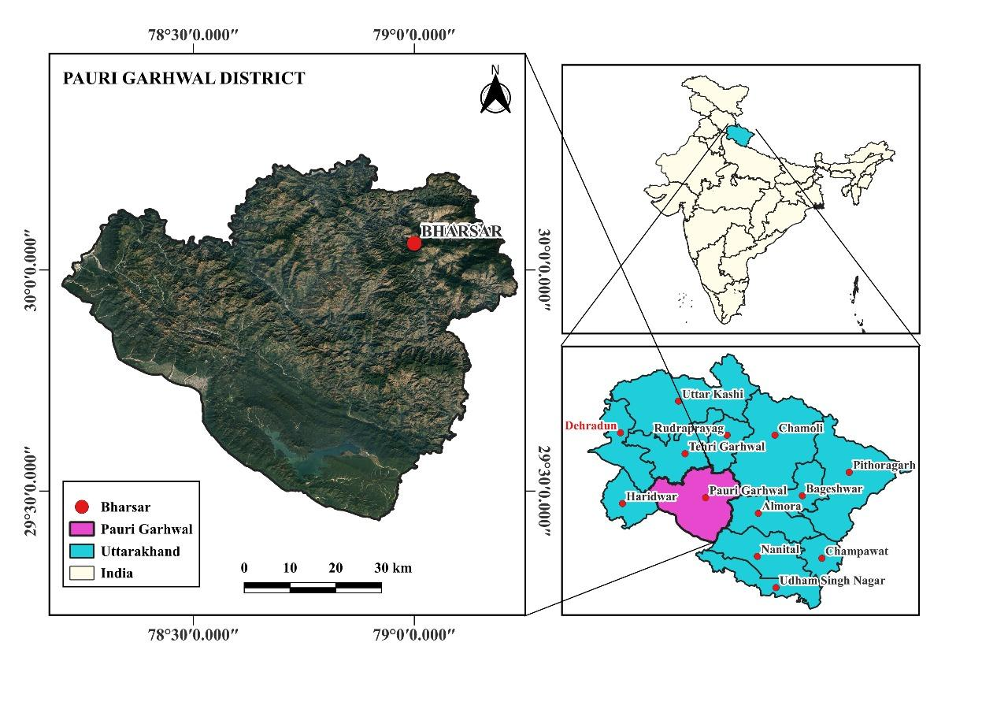

Pauri

Fig. 1. Map of study area
3. RESULT AND DISCUSSION
A total of 50 wild macrofungal species were collected and identified from the Bharsar region of Uttarakhand during the 2024–2025 academic year (Fig. 7). These species represented 24 families and six fungal orders, occurring across diverse substrates such as open fields, hardwoods, conifers, leaf litter, and dead logs (Fig. 5). The collections were distributed across altitudes ranging from 1800 to 2300 m (Fig. 6) (Table 1). Among the recorded families, Russulaceae was most represented with six species, followed by Amanitaceae (5 spp.), Polyporaceae (4 spp.) and Hygrophoraceae, Physalacriaceae, Clitocybaceae and Agaricaceae with three species each and one species of each of the family Suillaceae, Sclerodermataceae, Cantharellaceae, Phyllotopsidaceae, Mycenaceae, Leotiaceae, Omphalotaceae, Sparassidaceae, Cantarellace, Geometridae and Hymenogastraceaewith most species classified under the orders Agaricales and Polyporales. Species were mapped across various locations in the Bharsar region (Fig. 2 and 3). Agaricales accounted for 64% of species, followed by Russulales (12%). Similar dominance of Agaricales has been reported in other Himalayan surveys (Kumar et al., 2017; Semwal et al., 2014), indicating their adaptability across substrates and elevations.
3.2 Ecology and Fruiting Patterns
Fruiting bodies appeared primarily between August and January, with peak emergence in August due to favorable rainfall, temperature, and humidity (Sharma and Jaitly, 2020). The fruiting season observed in Bharsar aligns with reports from Himachal Pradesh and Kashmir (Beig et al., 2011; Gupta et al., 2017), where monsoon months also favored maximum macrofungal emergence. The distribution of species across substrates revealed that decaying wood and leaf litter supported the highest diversity, reflecting the ecological role of these fungi in nutrient cycling and forest health. Similar substrate preferences have been documented in Garhwal Himalayas (Pala et al., 2019), reinforcing the significance of saprophytic fungi in forest ecosystems(Table 2).
3.3 Uses and Ethnomycological Relevance
The recorded species, 36% were edible, 40% poisonous, 16% medicinal, and 8% of unknown edibility (Fig. 4). Several edible species, including members of Russula, Agaricus, and Cantharellus, were also reported from other parts of Uttarakhand and Himachal (Rawat et al., 2018; Semwal et al., 2014). The high proportion of poisonous mushrooms emphasizes the risk of misidentification, as some toxic species mimic edible types-a challenge noted in other Himalayan ethnomycological studies (Negi et al., 2019). Medicinal taxa such as Ganoderma and Sparassis highlight the pharmacological potential of wild macrofungi. While local inhabitants recognized several mushrooms as edible, their consumption cannot be recommended without molecular and biochemical validation due to morphological similarities with toxic species.
3.4 Significance of the Study
This study highlights the Bharsar region as a hotspot of macrofungal diversity in the mid-Himalayas. By documenting both ecological associations and ethnomycological uses, the findings provide a baseline for taxonomy, conservation and sustainable utilization of fungal resources. While many of the recorded species resemble known edible types, their edibility cannot be confirmed solely through morphological traits, as some morphologically similar mushrooms may be toxic. Therefore, consumption should be avoided until molecular or biochemical identification is performed.The results are consistent with earlier surveys in Himalayan forests but also add new locality-specific records, enriching the Indian fungal database. Future research involving molecular characterization, nutritional profiling and conservation strategies is necessary to validate and harness the ecological and economic potential of these species.

Fig. 3 Number of wild mushrooms per centage on different substratum
Fig. 2 Wild mushrooms in term of their per cent contribution to the total number of species (economic value) in the study area
Table 1. Details of different wild mushroom species, collected from forest area near Bharsar region.
^{S. No.} | ^{Sample number} | ^{Mushroom species} | ^{Family} | ^{Order} | ^{Time of collection} | ^{Elevation} |  |  | ^{Substratum} | ^{Important features} | ^{(Mushroom identification)}  ^{Reference’s}
 |  |  |  |  |  | ^{Altitude (m)} | ^{Latitude (N)} | ^{Longitude (E)} | ^{Substratum} | ^{Important features} | ^{(Mushroom identification)}  ^{Reference’s}
 | ^{BH23} | ^{Psilocybe semilanceata} | ^{Hymenogastraceae} | ^{Agaricales} | ^{August2024} | ²⁰¹⁰ | ^{30.059025⁰} | ^{78.096309⁰} | ^{Dung} | ^{Unknown} | ^{(Semwal and Bhatt, 2019)}
 | ^{BH29} | ^{Lactarius zonarius} | ^{Russulaceae} | ^{Russulales} | ^{August 2024} | ¹⁹⁷⁷ | ^{30.065221⁰} | ^{79.002309⁰} | ^{Soil} | ^{Edible} | ^{(Sharma and Jaitly, 2021)}
 | ^{BH43} | ^{Lacaria sp.} | ^{Geometridae} | ^{Agaricales} | ^{September 2024} | ²¹²⁵ | ^{30.059058⁰} | ^{79.012609⁰} | ^{Leaf litter} | ^{Edible} | ^{(Thapa et al., 2024)}
 | ^{BH44} | ^{Hygrocybe sp.} | ^{Hygrophoraceae} | ^{Agaricales} | ^{August 2024} | ¹⁹⁷⁹ | ^{30.059064⁰} | ^{79.002619⁰} | ^{Leaf litter} | ^{Edible} | (Sharma and Jaitly, 2021; Roat et al., 2020)
 | ^{BH45} | ^{Omphalina pyxidata} | ^{Tricholomataceae} | ^{Agaricales} | ^{August 2024} | ¹⁹⁷⁸ | ^{30.059025⁰} | ^{79.002609⁰} | ^{Soil} | ^{Edible} | ^{(Semwal and Bhatt, 2019)}
 | ^{BH49} | ^{Russula fragilis} | ^{Russulaceae} | ^{Russulales} | ^{August 2024} | ¹⁸³⁵ | ^{30.057973⁰} | ^{79.002619⁰} | ^{soil} | ^{Poisonous} | ^{(Roat et al., 2020)}
 | ^{BH50} | ^{Lactarius delicious} | ^{Russulaceae} | ^{Russulales} | ^{August 2024} | ¹⁸⁶⁵ | ^{30.059028⁰} | ^{79.002609⁰} | ^{Soil} | ^{Edible} | (AO et al., 2016; Sharma and Jaitly, 2021)
 | ^{BH54} | ^{Marasmiellus vailantii} | ^{Marasmiaceae} | ^{Agaricales} | ^{September 2024} | ¹⁸⁵⁰ | ^{30.059025⁰} | ^{79.002619⁰} | ^{Dead wood} | ^{Poisonous} | (Gehlot et al., 2014; Borkar et al., 2015)
 | ^{BH57} | ^{Pseudoclitocybe cyathiformsis} | ^{Tricholomataceae} | ^{Agaricales} | ^{August 2024} | ²⁰²² | ^{30.057973⁰} | ^{78.002309⁰} | ^{Soil} | ^{Unknown} | ^{(Sharma and Jaitly, 2021)}
 | ^{BH58} | ^{Amanita manicata} | ^{Amanitaceae} | ^{Agaricales} | ^{August 2024} | ²⁰⁴⁸ | ^{30.059048⁰} | ^{78.002909⁰} | ^{Soil} | ^{Poisonous} | ^{(Roat et al., 2020)}
 | ^{BH59} | ^{Vascellum pratense} | ^{Lycoperdaceae} | ^{Agaricales} | ^{September 2024} | ²⁰⁶⁵ | ^{30.059067⁰} | ^{78.002609⁰} | ^{Soil} | ^{Edible} | (Gehlot et al., 2014; Borkar et al., 2015)
 | ^{BH60} | ^{Polyporus tuberaster} | ^{Polyporaceae} | ^{Polyporales} | ^{September 2024} | ²⁰¹³ | ^{30.059024⁰} | ^{78.002309⁰} | ^{Soil} | ^{Medicinal} | ^{(Roat et al., 2020)}
 | ^{BH61} | ^{Amanita ceciliae} | ^{Amanitaceae} | ^{Agaricales} | ^{August 2024} | ²⁰⁰⁰ | ^{30.059046⁰} | ^{78.002308⁰} | ^{Soil} | ^{Poisonous} | ^{(Roat et al., 2020)}
 | ^{BH62} | ^{Craterellus tubaeformis} | ^{Cantarellace} | ^{Cantharellales} | ^{August 2024} | ¹⁹⁶⁵ | ^{30.059001⁰} | ^{78.002809⁰} | ^{Soil} | ^{Edible} | (M et al., 2014; Vyas et al., 2014)
 | ^{BH63} | ^{Hygrocybe conica} | ^{Hygrophoraceae} | ^{Agaricales} | ^{August 2024} | ¹⁸⁹³ | ^{30.059028⁰} | ^{78.002309⁰} | ^{Soil} | ^{Edible} | ^{(Sharma and Jaitly, 2021)}
 | ^{BH64} | ^{Collybia drophila} | ^{Clitocybaceae} | ^{Agaricales} | ^{August 2024} | ¹⁷⁹⁵ | ^{30.057973⁰} | ^{79.012609⁰} | ^{Soil} | ^{Edible} | (Semwal and Bhatt, 2019; Vyas et al., 2014)
 | ^{BH65} | ^{Collybia ocior} | ^{Clitocybaceae} | ^{Agaricales} | ^{August 2024} | ¹⁷⁵⁵ | ^{30.059058⁰} | ^{79.002619⁰} | ^{Soil} | ^{Poisonous} | (M et al., 2014; Vyas et al., 2014)
 | ^{BH66} | ^{Armillaria tabescens} | ^{Physalacriaceae} | ^{Agaricales} | ^{September 2024} | ¹⁷³⁵ | ^{30.059064⁰} | ^{79.002609⁰} | ^{Dead wood} | ^{Edible} | ^{(Terashima et al., 2011)}
 | ^{BH67} | ^{Suillus cothurnatus} | ^{Suillaceae} | ^{Boletales} | ^{September 2024} | ¹⁷⁶⁵ | ^{30.059025⁰} | ^{79.002409⁰} | ^{Soil} | ^{Medicinal} | ^{(Fu et al., 2014)}
 | ^{BH68} | ^{Agaricus sp.} | ^{Agaricaceae} | ^{Agaricales} | ^{August 2024} | ²⁰²¹ | ^{30.059046⁰} | ^{78.002309⁰} | ^{Soil} | ^{Poisonous} | (Vishwakarma et al., 2011; Sharma and Jaitly, 2021)
 | ^{BH69} | ^{Entoloma sp.} | ^{Entolomataceae} | ^{Agaricales} | ^{September 2024} | ²⁰³¹ | ^{30.059065⁰} | ^{78.002269⁰} | ^{Soil} | ^{Poisonous} | ^{(Sharma and Jaitly, 2021)}
 | ^{BH70} | ^{Amanita sp.} | ^{Amanitaceae} | ^{Agaricales} | ^{September 2024} | ²⁰⁵⁶ | ^{30.059028⁰} | ^{78.002639⁰} | ^{Soil} | ^{Poisonous} | ^{(MW et al., 2014)}
 | ^{BH71} | ^{Lepiota cristata} | ^{Agaricaceae} | ^{Agaricales} | ^{September 2024} | ²¹¹¹ | ^{30.057973⁰} | ^{78.002639⁰} | ^{Soil} | ^{Poisonous} | ^{(Roat et al., 2020)}
 | ^{BH72} | ^{Chlorophyllum molybdites} | ^{Agaricaceae} | ^{Agaricales} | ^{August 2024} | ²²³⁶ | ^{30.059001⁰} | ^{78.0023099⁰} | ^{Soil} | ^{Poisonous} | ^{(Sharma and Jaitly, 2021)}
 | ^{BH73} | ^{Scleroderma citrinum} | ^{Sclerodermataceae} | ^{Boletales} | ^{November 2024} | ¹⁹⁶⁸ | ^{30.066301⁰} | ^{78.002363⁰} | ^{Soil} | ^{Poisonous} | ^{(Sharma and Jaitly, 2021)}
 | ^{BH75} | ^{Cantharellus cibarius} | ^{Cantharellaceae} | ^{Cantharellales} | ^{August 2024} | ²⁰⁰⁰ | ^{30.057992⁰} | ^{78.002366⁰} | ^{Soil} | ^{Edible} | (Sharma and Jaitly, 2021; Singh et al., 2017)
 | ^{BH76} | ^{Psathyrella muricda} | ^{Psathyrellaceae} | ^{Agaricales} | ^{November 2024} | ²⁰⁰⁰ | ^{30.057045⁰} | ^{78.099306⁰} | ^{Leaf litter} | ^{Edible} | ^{(Kumar and Netam, 2022)}
 | ^{BH77} | ^{Lycoperdon perlatum} | ^{Lycoperdaceae} | ^{Agaricales} | ^{August 2024} | ²⁰²² | ^{30.062515⁰} | ^{78.005555⁰} | ^{Soil} | ^{Edible} | ^{(Sharma and Jaitly, 2021)}
 | ^{BH78} | ^{Tricholomopsis sulfureoides} | ^{Phyllotopsidaceae} | ^{Agaricales} | ^{August 2024} | ²⁰¹⁶ | ^{30.056321⁰} | ^{79.012663⁰} | ^{Soil} | ^{Poisonous} | ^{(Semwal and Bhatt, 2019)}
 | ^{BH79} | ^{Pseudoboletus sp.} | ^{Boletaceae} | ^{Boletales} | ^{August 2024} | ²⁰¹⁸ | ^{30.056254⁰} | ^{79.002665⁰} | ^{Soil} | ^{Poisonous} | ^{(V.P, 2018)}
 | ^{BH83} | ^{Hygrophorus sp.} | ^{Hygrophoraceae} | ^{Agaricales} | ^{August 2024} | ²⁰⁸⁵ | ^{30.052394⁰} | ^{78.002331⁰} | ^{soil} | ^{Poisonous} | (Lakhanpal, 2014; Youngas et al., 2018)
 | ^{BH85} | ^{Oudemansiella mucidea} | ^{Physalacriaceae} | ^{Agaricales} | ^{September 2024} | ²¹²⁷ | ^{30.055501⁰} | ^{78.992309⁰} | ^{Dead logs} | ^{Medicinal} | ^{(Lakhanpal, 2014)}
 | ^{BH86} | ^{Clitocybe vibecia} | ^{Clitocybaceae} | ^{Agaricales} | ^{August 2024} | ²¹⁵⁵ | ^{30.059401⁰} | ^{78.962309⁰} | ^{Leaf litter} | ^{Poisonous} | ^{(Sharma and Jaitly, 2021)}
 | ^{BH87} | ^{Mycena purea} | ^{Mycenaceae} | ^{Agaricales} | ^{August 2024} | ²¹⁸⁵ | ^{30.059028⁰} | ^{78.932309⁰} | ^{Soil} | ^{Unknown} | (Sharma and Jaitly, 2021; Roat et al., 2020)
 | ^{BH88} | ^{Coriolopsis occidentalis} | ^{Polyporaceae} | ^{Polyporales} | ^{September 2024} | ²²³⁴ | ^{30.057973⁰} | ^{78.992309⁰} | ^{Dead logs} | ^{Poisonous} | ^{(Saron et al., 2023)}
 | ^{BH89} | ^{Lactarius fuliginosus} | ^{Russulaceae} | ^{Russulales} | ^{August 2024} | ¹⁸³² | ^{30.059058⁰} | ^{78.362309⁰} | ^{Soil} | ^{Poisonous} | ^{(Sharma and Jaitly, 2021)}
 | ^{BH90} | ^{Marasmius oreades} | ^{Marasmiaceae} | ^{Agaricales} | ^{September 2024} | ¹⁷⁹³ | ^{30.059064⁰} | ^{78.952309⁰} | ^{Dead logs} | ^{Medicinal} | ^{(Sharma and Jaitly, 2021)}
 | ^{BH91} | ^{Leotia viscosa} | ^{Leotiaceae} | ^{Leotiales} | ^{August 2024} | ²⁰⁴² | ^{30.059025⁰} | ^{78.622309⁰} | ^{Dead logs} | ^{Edible} | ^{(Roat et al., 2020)}
 | ^{BH92} | ^{Bolentinus sp.} | ^{Boletaceae} | ^{Boletales} | ^{August 2024} | ²⁰⁰⁰ | ^{30.059046⁰} | ^{78.362309⁰} | ^{Soil} | ^{Edible} | ^{(Natrajan et al., 2005)}
 | ^{BH93} | ^{Psathyrella sp.} | ^{Psathyrellaceae} | ^{Agaricales} | ^{August 2024} | ²⁰⁰² | ^{30.059065⁰} | ^{78.882309⁰} | ^{Dead logs} | ^{Edible} | ^{(Natrajan et al., 2005)}
 | ^{BH95} | ^{Lactarius volemus} | ^{Russulaceae} | ^{Russulales} | ^{August 2024} | ²⁰⁸⁵ | ^{30.059028⁰} | ^{79.002619⁰} | ^{Leaf litter} | ^{Edible} | (Sharma and Jaitly, 2021; Ao et al., 2016)
 | ^{BH96} | ^{Xerula radicata} | ^{Physalacriaceae} | ^{Agaricales} | ^{September 2024} | ²⁰¹⁶ | ^{30.057973⁰} | ^{79.002609⁰} | ^{Leaf litter} | ^{Edible} | (Vyas et al., 2014; Semwal and Bhatt, 2019; Vishwakarma et al., 2012)
 | ^{BH97} | ^{Amanita rubrovovata} | ^{Amanitaceae} | ^{Agaricales} | ^{September 2024} | ²²⁵⁹ | ^{30.059058⁰} | ^{79.002409⁰} | ^{Soil} | ^{Poisonous} | ^{(ENVIS, BSI)}
 | ^{BH100} | ^{Gymnopus dryophilus} | ^{Omphalotaceae} | ^{Agaricales} | ^{March 2025} | ²¹¹¹ | ^{30.059046⁰} | ^{78.099309⁰} | ^{Leaf litter} | ^{Edible} | (Joty et al., 2019; Chaudhary and Tripathy, 2016)
 | ^{BH101} | ^{Himeloa auriculla} | ^{Entolomataceae} | ^{Agaricales} | ^{April 2025} | ²²⁵⁹ | ^{30.057045⁰} | ^{78.099309⁰} | ^{Leaf litter} | ^{Unknown} | (Sharma and Jaitly, 2021; Roat et al., 2020)
 | ^{BH98} | ^{Polypores sp.} | ^{Polyporaceae} | ^{Polyporales} | ^{September 2024} | ²²³⁶ | ^{30.059064⁰} | ^{79.002309⁰} | ^{Dead logs} | ^{Medicinal} | (Semwal et al.,2014; Bhattacharya et al., 2015)
 | ^{BH99} | ^{Sparasssis crispa} | ^{Sparassidaceae} | ^{Polyporales} | ^{September 2024} | ²²³⁴ | ^{30.059025⁰} | ^{78.002309⁰} | ^{Dead logs} | ^{Medicinal} | ^{(Sharma et al., 2022)}
 | ^{BH94} | ^{Trametes sp.} | ^{Polyporaceae} | ^{Polyporales} | ^{August 2024} | ²⁰²¹ | ^{30.059028⁰} | ^{79.882609⁰} | ^{Dead logs} | ^{Medicinal} | (Sharma and Jaitly, 2020; Km et al., 2014)
 | ^{BH53} | ^{Russula atropurpurea} | ^{Russulaceae} | ^{Russulales} | ^{August 2024} | ¹⁸³¹ | ^{30.059064⁰} | ^{79.012209⁰} | ^{Soil} | ^{Poisonous} | (M O et al., 2014; Roat et al., 2020)
 | ^{BH48} | ^{Amanita sp.} | ^{Amanitaceae} | ^{Agaricales} | ^{November 2024} | ¹⁸⁶⁴ | ^{30.059028⁰} | ^{79.012609⁰} | ^{Soil} | ^{Poisonous} | ^{(Roat et al., 2020)}

Table 2. Morphological characteristics for identification of different wild mushroom species
S. No. | Mushroom species | Pileus (cap) |  |  |  | Lamellae (gills) |  | Stipe (stem) |  |  |  | Spore bearing under cap | Annuls (ring)
S. No. | Mushroom species | Morphology (shape) | Colour | Surface (Texture) | Diameter range (cm) | Attachment | Colour | Length range (cm) | Diameter range (cm) | Attachment | Colour | Spore bearing under cap | Annuls (ring)
 | Psilocybe semilanceata | Ovate | Creamy white | Glabrous | 2.2 - 3.2 | Andexed | Light black | 1 - 3 | 0.2 - 0.5 | Central | White | Gills | Absent
 | Lactarius zonarius | Infundibuliform | Light orange | Pubescent | 3 - 5.5 | Decurrent | Light orange | 2 - 7 | 2.1 - 3.2 | Central | Light brown | Gills | Absent
 | Lacaria sp. | Infundibuliform | Muddy orange | Squamulose | 1.5 - 2.5 | Subdecurrent | Yellow | 3 - 7 | 0..5 - 1 | Central | Yellowish brown | Gills | Absent
 | Hygrocybe sp. | Conical | Shiny brick red | Velvety | 3.5 - 4 | Andexed | White | 3.5 - 9 | 0.7 - 2 | Central | Brown | Gills | Absent
 | Omphalina pyxidata | Depressed | Red orange | Vilose | 2 - 3 | Subdecurrent | Red | 2 - 5.2 | 0.4 - 0.9 | Central | Red | Gills | Absent
 | Russula fragilis | Convex | Pink | Glabrous | 3 - 5 | Decurrent | White | 3.5 - 6 | 1.5 - 2 | Central | White | Gills | Absent
 | Lactarius delicious | Depressed | Soil colour | Sticky Glabrous | 3.5 - 6.5 | Adnexed | White | 6.3 - 9 | 1.5 - 2 | Central | Yellow | Gills | Absent
 | Marasmiellus vailantii | Umbilicate | Creamy white | Velutinous | 2.2 - 3 | Decurrent | Creamy white | 1 - 3 | 0.1 - 0.3 | Central | White | Gills | Absent
 | Pseudoclitocybe cyathiformsis | Flat | Black | Rough | 5 - 9 | Decurrent | Black | 6 - 9 | 1 - 2 | Central | Black | Gills | Absent
 | Amanita manicata | Convex | White | Velutinous | 10 - 18 | Adenexed | White | 6 - 14 | 2.5 - 3 | Central | White3 | Gills | Present
 | Vascellum pratense | Umbonate | Cream white | Pubescent | 3 - 6.9 | - | Pore white | 2 - 3 | 4.1 - 6 | Central | - | Pores | Absent
 | Polyporus tuberaster | Flat | Yellow | Squamulose | 7 - 9 | Free | Light yellow | 3 - 7.2 | 1.5 - 2 | Central | White | Gills | Absent
 | Amanita ceciliae | Flat | Light brown | Fibrillose | 10 - 15 | Free | Brown | 4.2 - 6 | 2.2 - 3.2 | Central | Light brown | Gills | Absent
 | Craterellus tubaeformis | Flat | Blackish yellow | Squamulose | 8 - 12 | Sinuate | Yellow | 6.3 - 8 | 1.3 - 2.2 | Central | Yellow | Gills | Absent
 | Hygrocybe conica | Convex | Shiny red | areolate | 6 - 9.4 | Adenexed | Red | 3 - 5 | 1.1 - 1.4 | Central | Light red | Gills | Absent
 | Collybia drophila | Infundibuliform | Brick red | Velvet | 2 - 3.8 | Sinuate | Fade red | 3 - 4.5 | 0.5 - 0.9 | Central | Light red | Gills | Absent
 | Collybia ocior | Convex | Black | Smooth | 2 - 3.2 | Emarginated | Black | 7 - 10 | 1 - 2.3 | Central | Black | Gills | Absent
 | Armillaria tabescens | Flat | Orange | Glabrous | 3 - 7 | Adenexed | Orange | - | - | - | - | Gills | Absent
 | Suillus cothurnatus | Convex | Yellow | Sticky | 4 - 7 | - | Muddy | 2 - 3 | 0.4 - 0.9 | Central | Yellow | Ridges | Absent
 | Agaricus sp. | Flat | Pink | Fibrillose | 5 - 6 | Adenexed | Pink | 3 - 3.9 | 1.4 - 1.6 | Central | Fade white | Gills | Present
 | Entoloma sp. | Flat | Orange light | Pubescent | 4.2 - 6.3 | Adenexed | Orange | 4 - 6 | 1.4 - 1.8 | Central | Orange | Gills | Absent
 | Amanita sp. | Campanulate | White | Squamulose | 5 - 9 | Emarginate | White | 6 - 10 | 1.7 - 1.8 | Central | White | Gills | Present
 | Lepiota cristata | Umbonate | White with spots | Squamulose | 4.5 - 9 | Free | White | 7 - 8.5 | 1 - 2.1 | Central | White | Gills | Present
 | Chlorophyllum molybdites | Flat | Orange | Sticky rough | 6 - 10 | Decurrent | Orange | 6.5 - 7 | 1.3 - 1.5 | Central | Light orange | Gills | Absent
 | Scleroderma citrinum | Ball like | Orange | Squamulose | 3 - 5 | - | - | - | - | - | - | Pores | Absent
 | Cantharellus cibarius | Infundibuliform | Yellow | Glabrous | 5 - 7.5 | Subdecurrent | Orange | 6 - 7 | 1 - 2.2 | Eccentric | Light yellow | Gills | Absent
 | Psathyrella muricda | Conical | Light brown | Glabrous | 3 - 4 | Emarginate | Pink | 6.5 - 9.5 | 1.5 - 1.8 | Center | White | Gills | Absent
 | Lycoperdon perlatum | Ball like | Muudy soil | Rough | 3.2 - 45 | - | - | - | - | - | - | pores | Absent
 | Tricholomopsis  sulfureoides | Depressed | Yellow | Squamulose | 2 - 3.3 | Decurrent | Orange | 6.2 - 10 | 1.1 - 2.2 | Center | Orange | Gills | Absent
 | Pseudoboletus sp. | Convex | Muddy | Rough | 3.3 - 4.5 | - | Brown | 3.2 - 6.3 | 2 - 3 | Eccentric | Muddy | Ridges | Absent
 | Hygrophorus sp. | Campanulate | Creamy white | Smooth | 5.5 - 6.5 | Andexed | Muddy white | 4.5 - 6 | 0.4 - 1 | Center | White | Gills | Absent
 | Oudemansiellamucidea | Convex | Brown white | Sticky | 4.2 - 6.5 | Andexed | Brown | 4.2 - 6.2 | 1. - 2.2 | Eccentric | White | Gills | Absent
 | Clitocybe vibecia | Flat | Orange | Velvet | 7 - 9 | Free | Orange | 3.2 - 7.2 | 0.4 - 0.8 | Central | Orange red | Gills | Absent
 | Mycena purea | Ovate | Light pink | Fibrillose | 2.2 - 4.3 | Emarginated | Pink | 6.2 - 7 | 1.2 - 1.3 | Central | White | Gills | Absent
 | Coriolopsisoccidentalis | Ear like | Green | Rough | 3.2 - 5 | - | Green | - | - | - | - | Pores | Absent
 | Lactarius fuliginosus | Infundibuliform | Light red | Sticky | 6.5 - 3 | Emarginated | Pink red | 2.2 - 4.2 | 2 - 3 | Central | Brick red | Gills | Absent
 | Marasmius oreades | Umbilicate | white | Villose | 3.3 - 4.5 | Emarginated | Whie | 3.2 - 4 | 0.2 - 0.9 | Central | White | Gills | Absent
 | Leotia viscosa | Buuble | Black | Hard | 3 - 5 | - | Pores black | - | - | - | - | Pores | Absent
 | Bolentinus sp. | Depressed | Muddy | Rough | 7 - 9 | - | Muddy teeth | 2 - 4 | 0.25 | Central | Yellow | Teeth | Absent
 | Psathyrella sp. | Infundibuliform | White | Smooth | 3.5 - 4.5 | Emarginate | Pores white | 1.8 - 2.5 | 0.1 - 0.3 | Central | White | Gills | Absent
 | Lactarius volemus | Depressed | Orange | Sticky velvet | 3.4 - 5.2 | Andexed | White | 3.5 - 6 | 2 - 2.5 | Central | Orange | Gills | Absent
 | Xerula radicata | Convex | Brown | Glabrous | 2.2 - 3.6 | Andexed | Brown | 6 - 9 | 1.1 - 1.5 | Central | Brown | Gills | Absent
 | Amanita rubrovovata | Ovate | Red | Squamulose | 1.5 - 2.6 | Andexed | Whites | 2.2 - 4 | 1.8 - 2 | Central | Red yellow | Gills | Absent
 | Gymnopus dryophilus | Applanate | Light pink | Velvet | 2 - 3 | Adnate | White | 1 - 3 | 0.1 - 0.5 | Central | Brown fade | Gills | Absent
 | Entoloma sp. | Flat | White | Villose | 2.2 - 2.5 | Andexed | White | 1 - 2 | 0.8 - 1.2 | Central | white | Gills | Absent
 | Polypores sp. | Flat | Light brown | Hard rough | 10 - 19 | - | White pores | - | - | - | - | Pores | Absent
 | Sparasssis crispa | Bubble | White | Smooth | 1.5 - 6 | - | White pores | - | - | - | - | Pores | Absent
 | Trametes sp. | Kidney shaped | Fade orange | Hard | 2.2 - 3.6 | - | White | - | - | - | - | Pores | Absent
 | Russula atropurpurea | Depressed | Purple | Sticky Glabrous | 4.3 - 7 | Sinuate | Purple | 2 - 6 | 2 - 3 | Central | White | Gills | Absent
 | Amanita sp. | Convex | Light yellow | Glabrous | 2 - 4 | Emarginate | White | 2 - 7 | 1.5 - 3 | Central | White | Gills | Absent
Fig. 4 Per cent abundance of different wild mushrooms orders from study area
Fig. 5 Per cent abundance of different wild mushrooms families from study area

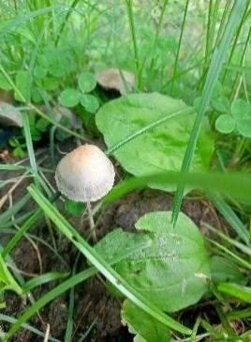  1. | 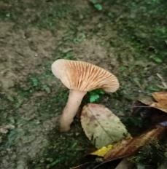  2 | 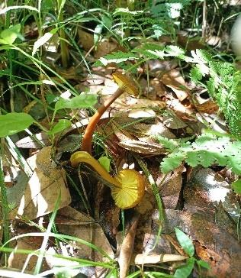  3.3 | 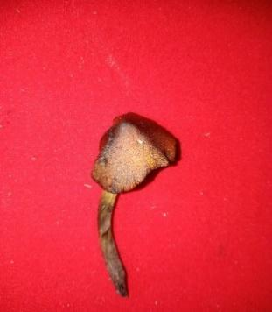  4.3 | 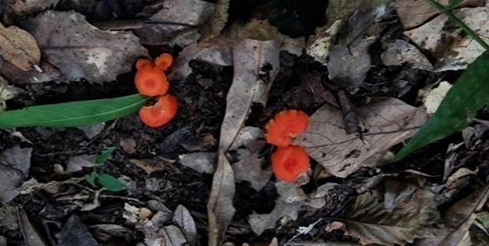  5.3101
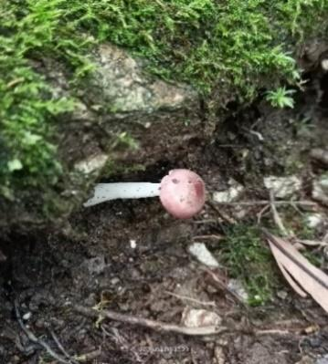  6 | 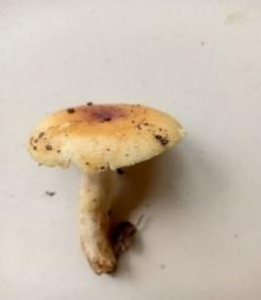  7 | 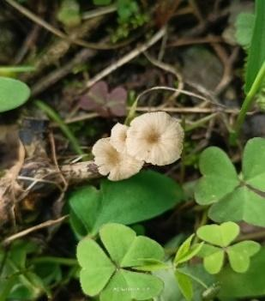  8 | 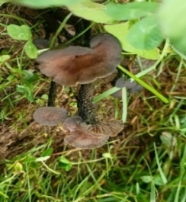  9 | 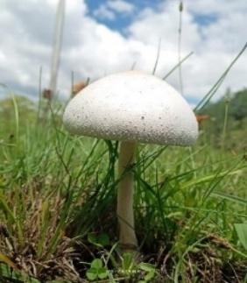  10
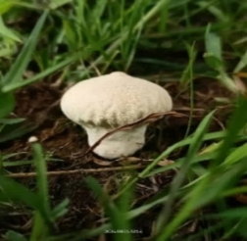  11 | 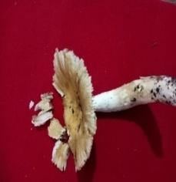  12 | 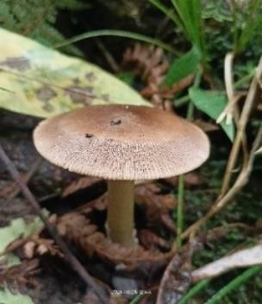  13 | 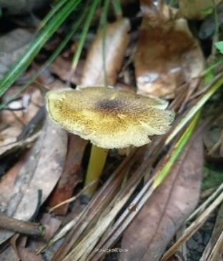  14 | 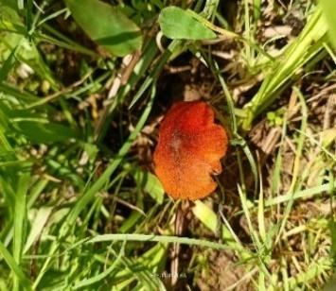  15
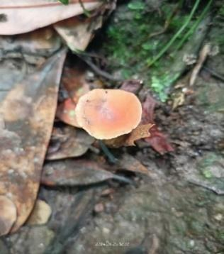  16 | 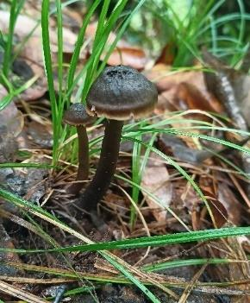  17 | 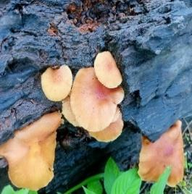  18 | 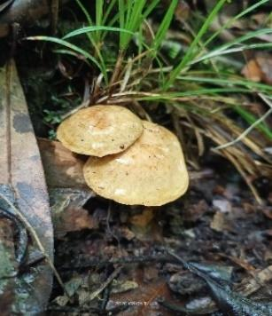  1920 | 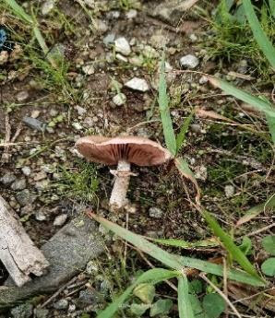  20
Fig. 6. Photographs of collected wild mushrooms from study area: 1. Psilocybe semilanceata, 2. Lactarius zonarius, 3. Lacaria sp., 4. Hygrocybe sp., 5. Omphalina pyxidata, 6. Russula fragilis, 7. Lactarius delicious, 8. Marasmiellus vailantii, 9. Pseudoclitocybe cyathiformsis, 10 Amanita manicata, 11. Vascellum pratense, 12. Polyporus tuberaster , 13. Amanita ceciliae, 14. Craterellus tubaeformis, 15. . Hygrocybe conica, 16. Collybia drophila, 17. Collybia ocior, 18. Armillaria tabescens, 19. Suillus cothurnatus, 20. Agaricus sp.
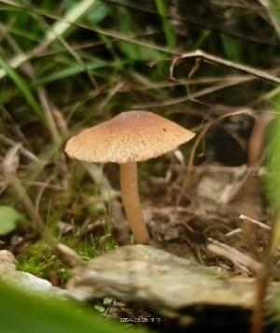  21 | 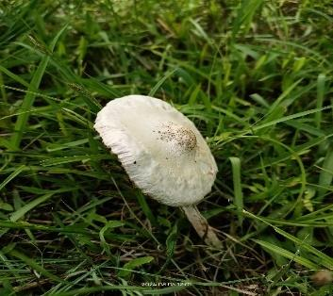  22 | 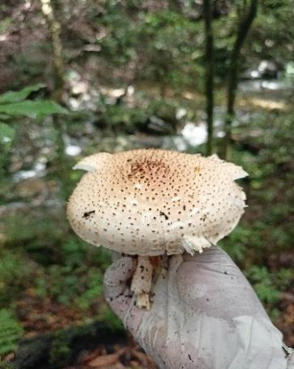  23 | 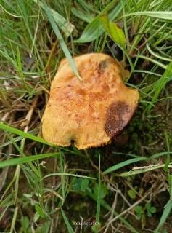  24 | 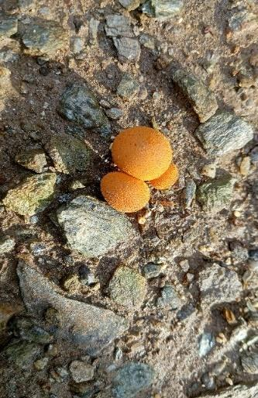  25
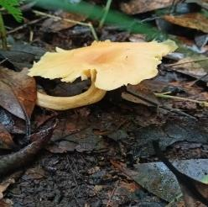  26 | 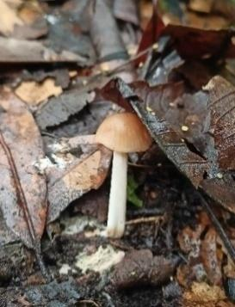  27 | 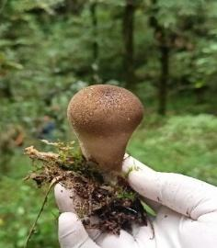  28 | 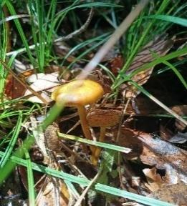  29 | 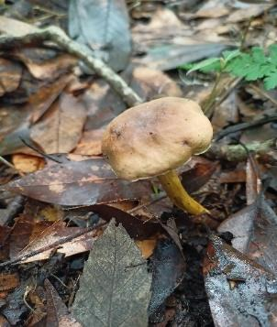  30
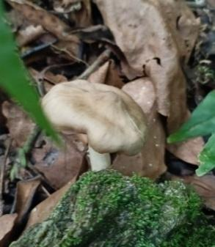  31 | 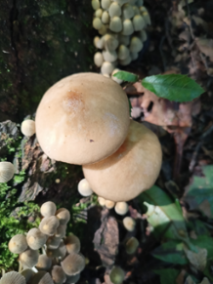  32 | 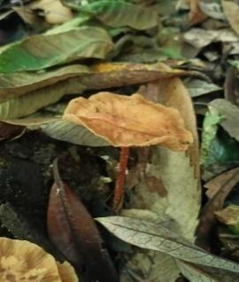  33 | 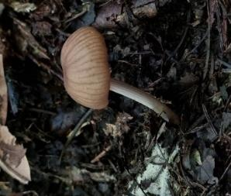  34 | 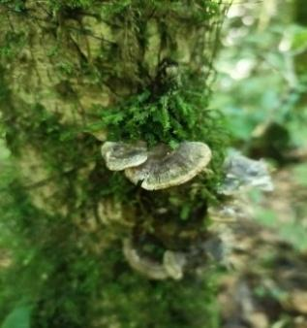  35
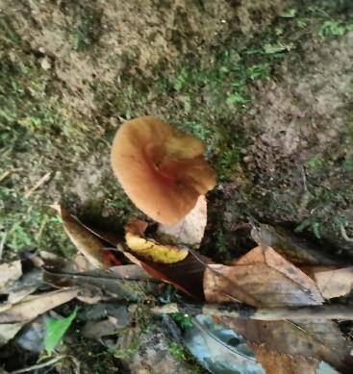  36 | 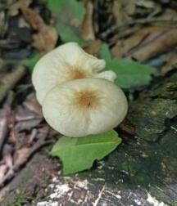  37 | 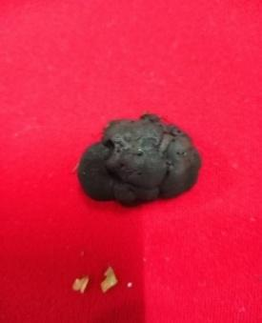  38 | 39 | 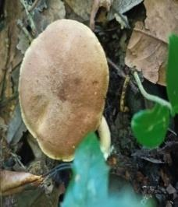  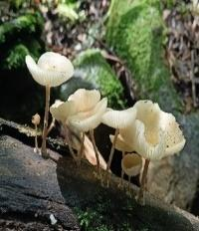  40
Fig. 6. Photographs of collected wild mushrooms from study area: 21. Entoloma sp., 22. Amanita sp., 23. Lepiota cristata, 24. Chlorophyllum molybdites, 25. Scleroderma citrinum, 26. Cantharellus cibarius, 27. Psathyrella muricda, 28. Marasmius androsaceus, 29. Tricholomopsis sulfureoides, 30. Pseudoboletus sp., 31. Hygrophorus sp., 32. Oudemansiella mucidea, 33. Clitocybe vibecia, 34. Mycena purea, 35. Coriolopsis occidentalis, 36. Lactarius fuliginosus, 37. Marasmius oreades, 38. Leotia viscosa, 39. Bolentinus sp., 40. Psathyrella sp.
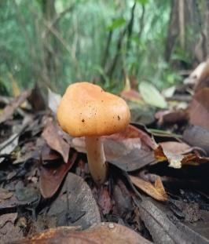  41 | 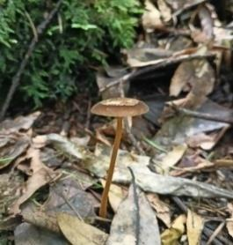  42 | 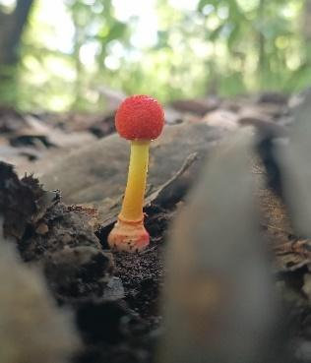  43 | 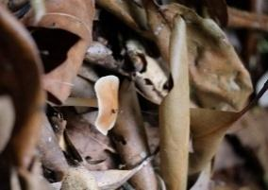  44 | 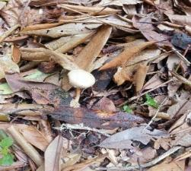  455
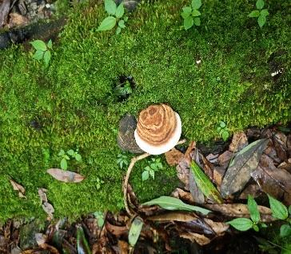  46 | 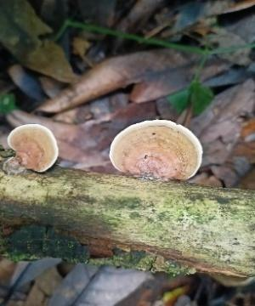  47 | 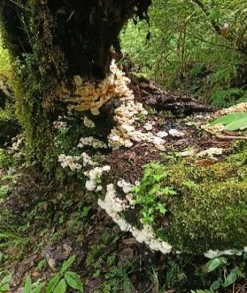  48 | 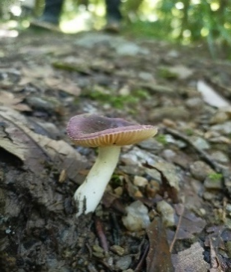  49 | 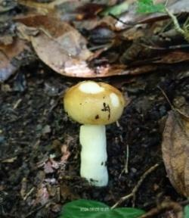  50

Fig. 6. Photographs of collected wild mushrooms from study area: 41. Lactarius volemus, 42. Xerula radicata, 43. Amanita rubrovovata, 44. Gymnopus dryophilus, 45. Entoloma sp., 46. Polypres sp., 47. Trametes sp., 48. Sparasssis crispa, 49. Russula atropurpurea, 50. Amanita sp.,
Fig. 7 Number of wild mushrooms at different altitude range(m) from study area
4. Conclusion
The current work highlights the Bharsar region of the Garhwal Himalayas as a hotspot of macrofungal diversity through presenting the first systematic record of 50 wild mushroom species from this area. Along with revealing the cultural and livelihood significance of local mushroom resources, the findings provide important baseline data for taxonomy, ecology and ethnomycology. Despite the fact that certain species exhibited similarities to known edibles, molecular and biochemical validation is necessary for their safe use. In addition to their ecological functions, these mushrooms have enormous potential for use in sustainable rural development, medicine, and food security. In order to preserve this fungal treasure, the study emphasizes the critical need for molecular characterization, pharmacological and nutritional evaluations, and conservation measures.By establishing a scientific foundation, this study opens avenues for bioprospecting and the sustainable management of wild mushrooms in the mid-Himalayan region.

REFERENCES
Ao, T., Deb, C. R. & Khruomo, N. (2016). Wild edible mushrooms of Nagaland, India: a potential food resource. Journal of Experiment Biology Agricultural Science, 4(1): 59-65.
Bhattacharjee, J., Bhattacharjee, D., Paul, T. & Kumar, A. (2015). Diversity of mushrooms in Indo-Bangladesh region of North-East India. J. Andaman Sci. Assoc., 19(1): 75–82.
Bisht, A. S. & Sharma, K. D. (2014). Plants utilization by the communities of Bharsar and adjoining area of Pauri Garhwal District, Uttarakhand, India. Biodiversitas Journal of Biological Diversity, 15 (1): 94-100.
Borkar, P., Doshi, A. & Navathe, S. (2015). Mushroom diversity of Konkan region of Maharashtra, India. Journal of Threatened Taxa, 7(10): 7625-7640.
Chang, S.T. (1991). Cultivated mushrooms. In: Handbook of Applied Mycology. Marcel Dekker, New York, 3: 221˗240.
Chaudhary, R. & Tripathy, A. (2016). Diversity of wild mushroom in Himachal Pradesh (India). International Journal of Innovative Research in Scence. Enginerring and Technology, 5(6).
Chauhan, R. S., Tiwari, D., Bisht, A. S. & Shukla, A. (2014). Ex situ conservation of medicinal and aromatic plants in Bharsar, Uttarakhand, India. Medicinal Plants, 6 (4): 282-292.
Gehlot, P., Sharma, R. & Sharma, K. (2014). Diversity of wild mushroom flora from Indian Thar Desert. In: Proceedings of the 8th International Conference on Mushroom Biology and Mushroom Products (ICMBMP 8), New Delhi, India.
Joty, A. A., Aminuzzaman, F. M., Sultana, N., Tanjina, A., Sonchita, D. R. B. & Islam, M. N. (2020). Diversity, distribution and morphology of wild mushrooms collected from Gajni Forest of Bangladesh. International Journal of Environmental Research and Public Health, 9(2): 234-255.
Kornerup, A. & Wanscher, J.H. (1978). Methuen Handbook of Colour (3rd ed.). London: Eyre Methuen.
Krishnappa, M., Swapna, S. & Syed, A. (2014). Diversity of macrofungal communities in Chikmagalur district of Western Ghats, India. International Conference on Mushroom Biology and Mushroom Products, (ICMBMP8): 71-82.
Kumar, S. & Netam, B. (2022). Study of wild edible mushrooms for improving human health and livelihoods support in Bastar Plateau, India. Plant Archives, 22(1): 174-186.
Lakhanpal, T. N. (2014). Mushroom biodiversity in India: prospects and potential. In: Proceedings of the 8th International Conference on Mushroom Biology and Mushroom Products (ICMBMP8), New Delhi, India, 19-22. Solan, ICAR-DMR, pp. 7-16.
Medina, A. F. G., Andrade, G. R. H. & Sánchez, J. E. (2014). Ethnomycology in the “Tacaná Volcano Biosphere Reserve”, Chiapas, Mexico. In: Proceedings of the 8th International Conference on Mushroom Biology and Mushroom Products (ICMBMP8), New Delhi, India.
Natarajan, K., Kumaresan, V. & Narayanan, K. (2005). A checklist of Indian agarics and boletes (1984-2002). Kavaka, 33: 61-128.
Roat, Y., Behera, F., Kumar, S., Sahoo, M. P. & Devi, R. S. (2020). Mushroom diversity of Dhenkanal District, Odisha, India: Source of alternative foods and medicines. European Journal of Medicinal Plants, 31(7): 33-41.
Rossman, A. 1(994). A strategy for an all-taxa inventory of fungal biodiversity. In: Peng CI, Chou CH, eds. Biodiversity and terrestrial ecosystems. Academia Sinica Monograph Series No. 14. p. 169-194.
Semwal, K. C. & Bhatt, V. K. (2019). A report on diversity and distribution of macrofungi in the Garhwal Himalaya, Uttarakhand, India. Biodiversity: Research and Conservation, 53: 7-32.
Semwal, K. C., Bhatt, V. K. & Stephenson, S. L. (2018). A survey of macrofungal diversity in the Bharsar region, Uttarakhand Himalaya, India. Journal of Asia-Pacific Biodiversity, 11(4): 560-565.
Semwal, K. C., Stephenson, S. L., Bhatt, V. K. & Bhatt, R. P. (2014). Edible mushrooms of the Northwestern Himalaya, India: a study of indigenous knowledge, distribution and diversity. Mycosphere, 5(3): 440-461.
Sharma, J. (2022). Morphological & Biochemical Characterization of Wild Edible Fungi of Jammu Region. Thesis, Doctor of Philosophy, Sher-e-Kashmir University of Agricultural Sciences & Technology of Jammu, Chatha, Jammu.
Sharma, V. & Jaitly, A. K. (2017). Optimization of Growth of Two Wild Species of Pycnoporus. Collected from Foothill of Uttarakhand. International Journal of Agriculture Innovations and Research, 6(1): 91-94.
Sharma, V. & Jaitly, A. K. (2021). New reports of wild mushroom diversity from foothill region of Uttarakhand.
Singer, R. (1986). The Agaricales in modern taxonomy. 4th Edition. Koeltz Scientific Books.
Singh, M., Vijay, B., Kamal, S. & Wakchaure, G. S. (2011). Mushrooms Cultivation, Marketing and Consumption. Directorate of Mushroom Research (Indian Council of Agricultural Research) Chambaghat, Solan (HP).
Singh, U., Bhatt, R. P., Stephenson, S. L., Uniyal, P. & Mehmood, T. (2017). Wild edible mushrooms from high elevations in the Garhwal Himalaya–II. Current Research in Environmental & Applied Mycology, 7(3), 208-226.
Terashima, K., Chaudhary, R. S., Yajima, T. & Yamada, A. (2001). Detection of genetic variation among single-spore isolates and identification of genets of Armillaria ostoyae by AFLP analysis with Texas Red-labeled selective primer. Mycosci., 42(2): 123-127.
Thapa, A., Tamang, J. & Acharya, K. (2024). Three new species of Laccaria (Hydnangiaceae) from Darjeeling Hills, India, based on morphological and molecular evidence. Current Microbiology, 81: 79.
Vishwakarma, M. P., Bhatt, R. P. & Gairola, S. (2011). Some medicinal mushrooms of Garhwal Himalaya, Uttarakhand, India. International Journal of Medicinal and Aromatic Plants. 1(1): 33-40.
Vishwakarma, M. P., Bhatt, R. P. & Joshi, S. (2012). Macrofungal diversity in moist temperate forests of Garhwal Himalaya. Indian Journal of Science & Technology, 5(1): 1-5.
Vyas, D., Chaubey, A. & Dehariya, P. (2014). Biodiversity of mushrooms in Patharia forest of Sagar (MP)-III. International Journal Biodiverse Conservation, 6(8): 600-607.
Webster, J. & Weber R. (2007). Introduction to Fungi 3rd edition. Cambridge, U.K.: Cambridge University Press.
Younas, M. T., Gardezi, S. R. A. & Tariq, M. (2018). Distribution studies on wild mushroom species from District Poonch, Azad Jammu and Kashmir. Plant Protection, 2(1): 01-06.

