Original Research Article
Prevalence of antimicrobial resistant Salmonella spp. in chicken egg supply chain

.
ABSTRACT
Aim: The present study aimed to determine the prevalence of antibiotic-resistance pattern of Salmonella spp. in the chicken egg supply chain of Maharashtra, India.
Study design: cross-sectional prospective study
Place and Duration of Study: The study was conducted across various districts of Maharashtra, India, from September 2024 to March 2025.
Methodology: A total of 390 various samples (cloacal swabs, faeces, feed, water, and eggs) from commercial layer, backyard poultry farms, egg distributors and retail eggs were collected and processed using standard protocols. Isolation of Salmonella spp. was carried out through cultural methods followed by molecular confirmation with 16S rRNA PCR. Isolates were characterized by Congo red binding and invA gene PCR assay. Considering pathogenicity all invA gene PCR isolates were subjected to antibiotic susceptibility testing and screened for antimicrobial resistance genes targeting tetracycline, sulphonamide and ESBL group of antimicrobials.
Results: Out of 390 samples, 21 (5.38%) were confirmed as Salmonella spp. by 16S rRNA gene PCR assay. All showed Congo red binding, while 14 (66.7%) were invA positive, indicating a prevalence rate of 3.59% for invasive Salmonella spp. The prevalence was found highest among egg distributors (8.34%), followed by retail eggs (6.67 commercial %), farms (3.34%) and backyard poultry (1.12%). The invA positive Salmonella spp. were found to be more prevalent in commercial layer farms compared to backyard poultry farms. Amongst invA positive isolates, 2 (14.28%) were identified as Salmonella Typhimurium and the rest were non typable. Antibiotic susceptibility testing revealed resistance to Ampicillin (100%) and Ceftazidime (93%). Further isolates were found to be sensitive to Chloramphenicol (100%) and Gentamicin (93%). The average MAR index was 0.270, with 85.7% of isolates were multidrug resistant. Genotypic analysis of isolates revealed the presence of tetA (7.14%) and Sul1 (14.2%) genes, without expression of beta-lactamase genes.
Conclusion: The findings highlight the presence of antimicrobial resistant Salmonella spp., in egg supply chain, but continuous surveillance and monitoring of Salmonella spp. remain crucial. The applications of strict control measure on antibiotic use to prevent the spread of multidrug-resistant Salmonella strains, is essential for protecting and safeguarding public health.
Keywords: antimicrobial resistance, egg supply chain, invA, poultry farms, Salmonella

1. INTRODUCTION

Salmonellosis is a foodborne bacterial disease of zoonotic significance with global relevance. Over 99% of Salmonella strains responsible for human infections are classified under Salmonella enterica subspecies enterica (Brenner, 2000). This pathogen has been found in various food items, with most human salmonellosis outbreaks associated with animal-derived products such as eggs, poultry, and related foods (Mouttotou et al., 2017; Dagnew et al., 2020). Among these, raw table eggs and egg products are considered the most common sources of foodborne Salmonella infections in humans (Threlfall et al., 2014). Globally, Salmonella causes an estimated 200 million to 1 billion infections each year, including about 93 million cases of gastroenteritis and 155,000 deaths, with nearly 85% linked to consumption of contaminates food (Chlebicz and Śliżewska, 2018). Salmonella primarily spreads through the food production chain, with contaminated eggs as a major source. Its frequent presence in layer farm environments indicates these settings act as reservoirs through vertical transmission, enabling horizontal transmission via direct contact and contaminated feed (Al Momani et al., 2018). In India, Salmonella has been frequently detected in eggs collected from poultry farms and marketing channels, with isolates showing antimicrobial resistance (Singh et al., 2010). In recent years, the rise of virulent multidrug-resistant (MDR) Salmonella strains has emerged as a significant public health concern (Siddiky et al., 2021). The growing emergence of antimicrobial-resistant Salmonella is primarily linked to the excessive use of antibiotics in poultry farming for non-therapeutic purposes (Castro-Vargas et al., 2020). Earlier studies have documented the occurrence of antimicrobial-resistant Salmonella in poultry supply chains worldwide, including reports from China (Cui et al., 2016), highlighting its global importance. In recent years, non-typhoidal Salmonella isolates have shown a notable increase in both phenotypic and genotypic resistance to β-lactams, tetracyclines, and sulphonamides (Eguale et al., 2017). Previous studies have suggested that the lower contamination levels observed in commercial egg supply chains compared to backyard systems (Elsayed et al., 2024). Backyard egg production often lacks proper contamination control at the source, making these eggs more susceptible to bacterial contamination and transmission (Elmonir et al., 2024). Hence, investigating Salmonella contamination in both commercial and backyard poultry farms is crucial, as its presence can lead to egg contamination throughout the supply chain.
Therefore, the current study aims to determine the prevalence, of antimicrobial resistant Salmonella spp. in chicken egg supply chain, which can help in recommending appropriate and intervention points in the supply chain.
2. material and methods

In this study samples were collected from commercial layer farms, backyard poultry, egg distributors, and retailers across Maharashtra, India. The study sites included commercial layer farms in Parbhani and Yavatmal district, egg distributors and retailers in Parbhani, and backyard poultry farms from various districts. From farms, cloacal swabs, faeces, feed, water, and eggs were collected, while egg samples (each comprising three pooled eggs) were obtained from distributors and retailers.

2.1 Sample collection

A total of 390 samples were randomly collected from commercial layer farms (n=90), backyard poultry farms (n=180), egg distributors (n=60), and retail eggs (n=60) across Maharashtra, India during October 2024 to March 2025. Farm samples (layer and backyard) included cloacal swabs, faeces, feed, water, and eggs. Egg samples (n=60 each) were also obtained from distributors and retail eggs. Each of egg sample comprising three pooled unwashed eggs. At farms, eggs were collected from different cage levels (upper, middle, and lower) at three locations (front, center, and rear). Distributor and retail egg samples were randomly selected from stacked trays. All samples were transported to the laboratory in ice boxes and analysed immediately.

2.2 Isolation and characterization of Salmonella spp.

Isolation of Salmonella spp. was carried as per ISO method 6579:2002 protocol with minor modifications as per sample type. To pre-enrich, samples were homogenized in Buffered Peptone Water (BPW): 25 g of feed/water in 225 ml, 1 g of faeces/cloacal swabs in 9 ml, and eggshells (from 3 pooled eggs) in 90 ml and 25 ml egg content (from 3 pooled eggs) in 225 ml. Before collecting the egg content, eggs were surface sterilized (70% ethanol for 2 min), air-dried aseptically pooled, and 25 ml was mixed with 225 ml BPW. All samples were incubated at 37 ± 1°C for 24 h. Further enrichment was done by inoculating 0.1 ml of pre-enriched BPW culture into 10 ml Rappaport-Vassiliadis (RV) broth and incubated at 42°C for 24 h. A loopful of inoculum from RV broth was streaked on Xylose Lysine Deoxycholate (XLD) Agar and Brilliant Green Sulpha Agar (BGSA) using the four-quadrant method and incubated at 37 ± 1°C for 24 h. Identification of Salmonella spp. was based on colony morphology, microscopy, and biochemical tests (BAM, 2007). Typical Salmonella colonies appeared pink to red with black centers on XLD and pink-white with a red zone on BGSA. Presumptive isolate cultures were stored at – 18 °C in cryogenic vials supplemented with 50% (v/v) sterile glycerol.

2.3 Molecular confirmation of Salmonella spp. by PCR assay

Molecular confirmation of presumptive Salmonella isolates was carried out using PCR assay at the Department of Veterinary Public Health, College of Veterinary and Animal Sciences, Parbhani. Identification of Salmonella by PCR was done with confirmation of the 16S rRNA gene as described by Adhikari et al. (2018). All suspected isolates grown in Brain Heart Infusion broth was incubated overnight and DNA was extracted according to the method described by Anejo-Okopi et al. (2016). The extracted DNA was analyzed using a Nanodrop to determine its concentration (ng/µL) and assess its purity by measuring the absorbance ratio at 260/280 nm, according to the device instructions (Thermo Scientific).
The 16S rRNA PCR protocol was performed according to method described by Adhikari et al. (2018) in a 25 μl reaction containing 13 μl of 2× PCR Master Mix (Takara), 1.5 μl each of forward and reverse primers (10 pmol/μl), 2 µl of genomic DNA, and 7 µl of molecular biology-grade water (HiMedia, Mumbai). PCR conditions were set to be as follows: 5 minutes of initial denaturation at 95°C, followed by 35 cycles of denaturation at 95°C for 1 minute, annealing at 50°C for 1 minute and extension at 72°C for 2 minutes, ending with a final extension at 72°C for 10 min. The PCR primers employed in this study are outlined in Table 1.

2.4 Characterizing pathogenicity of Salmonella isolates

Salmonella pathogenicity has traditionally been assessed using in-vivo methods like the rabbit ileal loop test for enterotoxin production (Kalambhe et al., 2016), but such approaches raise ethical concerns due to live animal use. The Congo red (CR) binding assay offers a potential alternative for pathogenicity testing (Kalambhe et al., 2016). Positive results were identified by the appearance of characteristic brick-red colonies (Kalambhe et al., 2016).
The Salmonella spp. isolates confirmed by 16S rRNA PCR were subjected to Congo red binding assay as described by Kalambhe et al. (2016). Brain heart infusion agar (HiMedia Laboratories, Mumbai) was added with 0.003 percent Congo red dye and plates were prepared aseptically. These plates were streaked with Salmonella isolates and incubated at 37°C for 24 ± 2 hours. The colour change of the colonies was examined and the appearance of brick red colour was considered positive. The greyish white colour colonies were considered negative.
Detection of invasive invA gene as described by Nair et al. (2015) by PCR assay. To detect invA gene, a 25 μl reaction volume was used and it contained 12.5 µl of 2x PCR master mix (HiMedia, Mumbai), 1 µl of each primer (10 pmol/µl), 1 µl of genomic DNA, and 9.5 µl of molecular biology-grade water. The PCR primers and cycling conditions employed in this study are outlined in Table 1.

2.5 Serotyping of Salmonella isolates

Isolates positive for the 16S rRNA PCR assay and invA gene were serotyped at the Poultry Diagnostics and Research Center (PDRC), Lonikalbhor, Pune, Maharashtra India.

2.6 Antibiotic resistance of Salmonella isolates

The antibiograms of all identified Salmonella isolates in this study were assessed using Mueller-Hinton agar (HiMedia, Mumbai, India) and the disk diffusion method, following M100: Performance Standards for Antimicrobial Susceptibility Testing, Clinical and Laboratory Standards Institute (CLSI) guidelines, 2021. This study utilized antibiotics commonly used in human and veterinary medicine. A total of 14 antimicrobials from major classes were used in this study. All antimicrobial discs, sourced from HiMedia, Mumbai, were applied at standard doses: Ampicillin/Sulbactam (10/10µg), Ampicillin (10µg), Amoxyclav (30µg), Tetracycline (30µg), Cefotaxime (30µg), Ceftazidime (30µg), Chloramphenicol (30µg), Gentamicin (10µg), Cefixime (5µg), Ciprofloxacin (5µg), Co-Trimoxazole (25µg), Nalidixic acid (30µg), Enrofloxacin (10µg), Levofloxacin (5µg). The growth inhibition zones were measured and classified as susceptible (S), intermediate (I) or resistant (R) to the respective antimicrobials based on the guidelines of the CLSI, 2021.

2.7 Multiple Antibiotic Resistance index of Salmonella isolates

The Multiple Antibiotic Resistance (MAR) index for each isolate was determined following the method outlined by Krumperman (1983). The MAR index of an isolate is expressed as a/b, where,
a: denotes the number of antibiotics to which the isolate exhibited resistance and
b: represents the total number of antibiotics tested against the isolate.

2.8 Detection of ESBL production

ESBL production in phenotypically resistant isolates was tested using the Improved ESBL Detection Ezy MIC™ Strip (MIX+/MIX) (HiMedia, Mumbai). MIX+ contained Ceftazidime and Cefotaxime with Clavulanic acid (0.032–4), while MIX contained Ceftazidime and Cefotaxime (0.125–16). Following the manufacturer’s protocol, suspected colonies were grown in BHI broth (2–8 h), swabbed onto MHA plates, Ezy MIC strips applied, and plates incubated at 37 °C for 24 h. The results are interpreted as per the manufacturer’s instructions; if MIX: MIX+ MIC ratio >8 indicated an ESBL-positive strain, while a ratio ≤8 indicated an ESBL-negative strain.

2.9 Molecular identification of genes associated with antimicrobial resistance in Salmonella isolates

The antibiotic resistance genes for extended spectrum beta-lactamases (blaTEM, blaCTX-M, blaOXA and blaSHV), tetracycline (tetA) and Sulphonamide (Sul1) were tested with standard protocols. DNA was extracted using heat boiling method and stored at -20°C for further analysis. EmeraldAmp PCR Master Mix (Takara) was used for all PCR reactions. For detecting ESBL genes, multiplex PCR was performed in a 25 µL reaction mixture containing 12.5 µL of 2× PCR master mix, 0.5 µL of each primer (10 pmol/µL), 2 µL of DNA template, and 6.5 µL of nuclease-free water. To detect tetA and Sul1genes, conventional PCR was conducted in a 25 µL reaction mixture containing 12.5 µL of 2× PCR master mix, 1 µL of each primer (10 pmol/µL), 2 µL of DNA template, and 8.5 µL of nuclease-free water. The PCR primers and cycling conditions employed for various genes are outlined in Table 1.

Table 1. Details of primer sequence used for molecular confirmation of Salmonella spp. in this study

Sr. No | Primer | Target | Primer sequence  (5’- 3’) | Product Size (bp) | Reference
1. | 16S rRNA | Bacterial ribosomal RNA | F: CGG ACG GGT GAG TAA TGT CT  R:GTTAGCCGGTGCTTCTTC TG | 406 | Adhikari et al. (2018)
2. | invA | Invasion-associated protein | F:TCGTGACTCGCGTAAATGGCGATA  R:GCAGGCGCACGCCATAATCAATAA | 423 | Nair et al. (2015)
3. | tetA | Tetracycline | F: GCT ACA TCC TGC TTG CCT TC  R: CAT AGA TCG CCG TGA AGA GG | 210 | Ng et al.  (2001)
4. | Sul1 | Sulphonamide | F:TTTCCTGACCCTGCGCTCTAT  R:GTGCGGACGTAGTCAGCGCCA | 425 | Ma et al. (2007)
5. | blaTEM | Broad Spectrum ꞵ-lactamase | F: CGC CGC ATA CAC TAT TCT CAG AAT GA  R: ACG CTC ACC GGC TCC AGA TTT AT | 445 | Fang et al. (2008)
6. | blaSHV | Broad Spectrum ꞵ-lactamase | F: CTT TAT CGG CCC TCA CTC AA  R: AGG TGC TCA TCA TGG GAA AG | 237 | Fang et al. (2008)
7. | blaCTX-M | Broad Spectrum ꞵ-lactamase | F: ATG TGC AGY ACC AGT AAR GTK ATG GC  R: TGG GTR AAR TAR GTS ACC AGA AYC AGC GG | 593 | Fang et al. (2008)
8. | blaOXA | Broad Spectrum ꞵ-lactamase | F: ACA CAA TAC ATA TCA ACT TCG C  R: AGT GTG TTT AGA ATG GTG ATC | 813 | Fang et al. (2008)

3. results

3.1 Prevalence of Salmonella spp. in egg supply chain
A total of 21 presumptive Salmonella spp. appeared as red colonies with black centers on XLD agar and pink-white colonies with a red zone on BGSA agar. All 21 presumptive Salmonella isolates were confirmed as Salmonella spp. by 16S rRNA gene PCR (Fig 1), showing a strong correlation with presumptive positives. The overall prevalence of Salmonella in the chicken egg supply chain was 5.38%, with rates of 5.5% in commercial farms, 3.8% in backyard poultry, 8.3% in distributors, and 6.6% in retail eggs. Details of samples collected and prevalence of Salmonella spp. are depicted in Table 2.

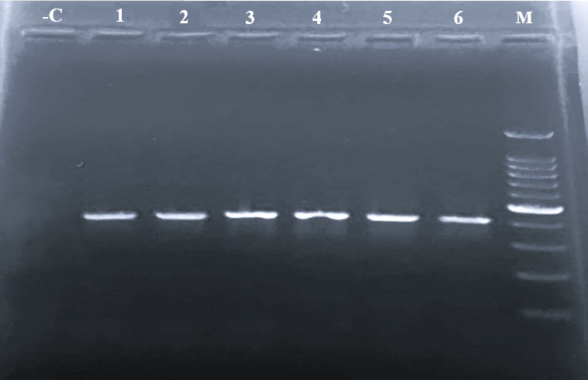

402 bp

C: Negative Control, 1: L1/ES/3, 2: B1/Cl/1, 3: D/EC/8, 4: D/ES/22, 5: R/ES/6, 6: R/EC/14, M: 100 bp Ladder
Fig 1: Agarose gel showing PCR amplified product of 16S rRNA (402 bp) gene of Salmonella spp.

All 21 Salmonella isolates confirmed by 16S rRNA PCR exhibited brick-red colonies in the Congo red binding assay (Fig 2), indicating complete (100%) positivity but only 14 isolates (66.7%) showed amplification of the 423 bp invA gene fragment (Fig 3) indicating invasive pathogenic Salmonella spp. isolates rest deemed to be non-pathogenic. Out of 14 invA gene positive isolates 2 isolates (14.28%) were identified as Salmonella Typhimurium, while the remaining were non-typable.

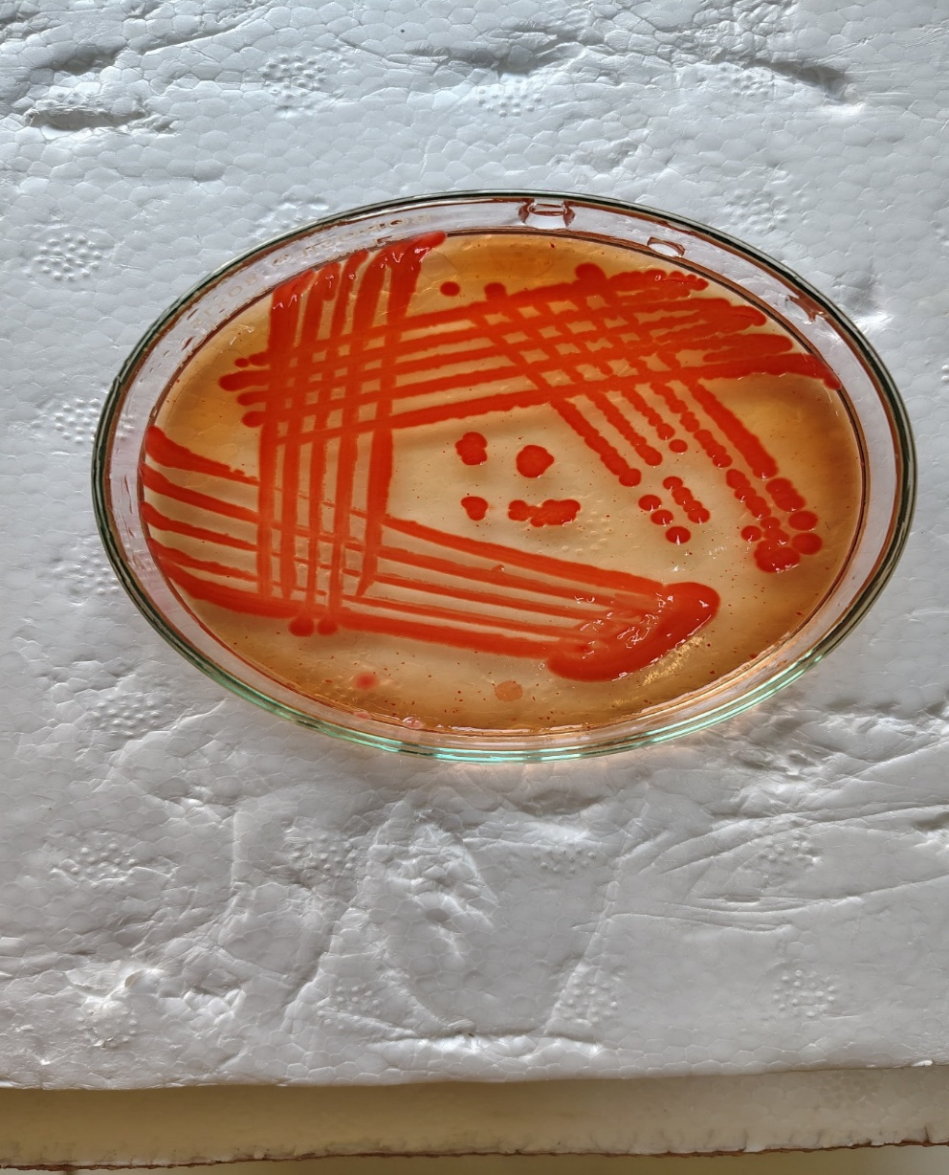
Fig 2 Congo Red Agar plate showing brick red colour colonies for Salmonella spp.
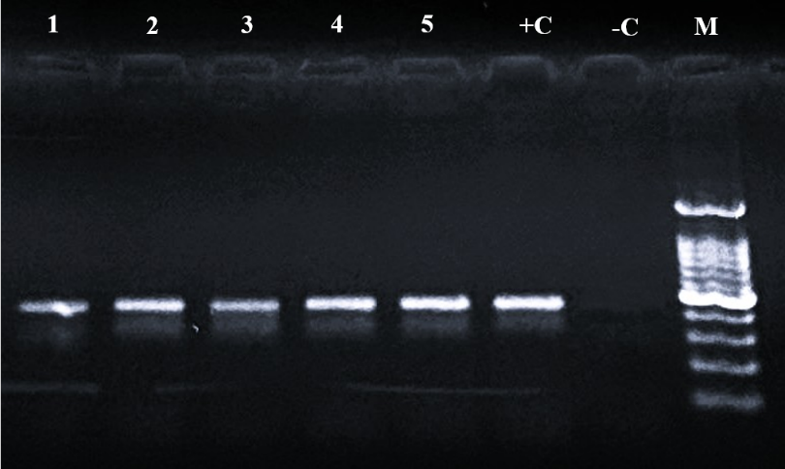

423 bp

1: L1/ES/3; 2: B14/Fe/2; 3: D/ES/18; 4: D/EC/19; 5: R/ES/13, +C: Positive Control, -C: Negative Control, M: 100 bp Ladder
Fig 3 Agarose gel showing PCR amplified product of invA (423 bp) gene of Salmonella spp.

3.2 Prevalence of pathogenic (invA gene) Salmonella spp. in egg supply chain
Out of 390 samples tested, pathogenic invA virulent Salmonella spp. were detected 3.34% in samples of commercial layer farms, 1.12% from backyard poultry farms, 8.34% from egg distributors and 6.67% from retail eggs (Table 2). The result indicates post-harvest cross contamination in the egg supply chain leading to higher prevalence in eggs at distributor and retailers end.
Amongst 3 isolates from commercial layer farms, each one was recovered from faeces (6.67%), feed (6.67%) and eggshell (6.67%). One isolate each from faeces and feed was recovered from backyard poultry farms with a corresponding prevalence rate of 3.34% for both the sources. Samples collected from distributors, showed prevalence rate of 10% and 6.67% for eggshells and egg contents, respectively. The pathogenic invA virulent Salmonella spp. was isolated only from commercial eggs (13.34%) at the retail eggs shops, whereas, none of the backyard retail egg sample were found positive. Amongst commercial eggs, 2 each of isolates were recovered from eggshells (6.67%) and egg contents (6.67%). It denotes that pathogenic invasive Salmonella spp. were more prevalent in commercial layer farms compared to backyard poultry farms under this study.

Table 2. Details of samples collected and prevalence of Salmonella spp. in egg supply chain
Category | Sample type | Total no. of samples analyzed | Type and no. of samples positive for Salmonella spp. | Total prevalence of Salmonella spp. | Type and no. of  Samples positive for invasive Salmonella spp. | Prevalence of invasive Salmonella spp.
Commercial layer farms | Faeces  Feed  Water  Cloacal swab  Eggshell  Egg content | 90 | Eggshell (2)  Faeces (2)  Feed (1) | 5.5% | Eggshell (1)  Faeces (1)  Feed (1) | 3.34%
Backyard poultry farms | Faeces  Feed  Water  Cloacal swab  Eggshell  Egg content | 180 | Faeces (4)  Feed (2)  Cloacal swab (1) | 3.8% | Faeces (1)  Feed (1) | 1.12%
Egg distributors | Eggshell  Egg content | 60 | Eggshell (3)  Egg content (2) | 8.3% | Eggshell (3)  Egg content (2) | 8.34%
Retail eggs | Eggshell  Egg content | 60 | Eggshell (2)  Egg content (2) | 6.6% | Eggshell (2)  Egg content (2) | 6.67%

3.3 Phenotypic antibiotic resistance of Salmonella isolates
In the current study, invA positive 14 Salmonella isolates were tested against 14 commonly used antimicrobials. Higher resistance was observed against Ampicillin (100%), followed by Ceftazidime (93%), Cefotaxime (57%), Cefixime (36%), Amoxyclav (21%), Nalidixic acid (21%), and Levofloxacin (14%). Whereas sensitivity against Chloramphenicol (100%), Enrofloxacin (93%), Gentamicin (93%), Tetracycline (93%), Ampicillin/Sulbactam (65%), Amoxyclav (65%) and Levofloxacin (50%).
3.4 Multiple Antibiotic Resistance (MAR) index
In this study, the MAR index of the invA positive Salmonella isolates was ranged between 0.15 to 0.5, with an average value of 0.270 (Table 3). The average MAR index for samples from commercial layer farms, backyard poultry farms, egg distributors and retail eggs were 0.28, 0.175, 0.252, and 0.335, respectively. In this study, 12 invA positive Salmonella spp. isolates showed resistance to three or more antibiotics, indicating a multidrug resistance rate of 85.7% among invA positive Salmonella isolates.
Table 3 Multiple Antibiotic Resistance (MAR) index of invA positive Salmonella isolates isolated from egg supply chain

Sr. No. | Sample source | Sample code | Resistance to number of antibiotics | Antibiogram | MAR index | MAR index average per sample source
1. | Commercial layer farms | L1/ES/3 | 4 | CAZ, AMC, AMP, CTX | 0.28 | 0.28
2. | Commercial layer farms | L5/Fe/1 | 4 | CAZ, CFM, AMP, CTX | 0.28 | 0.28
3. | Commercial layer farms | L5/F/2 | 4 | CAZ, AMP, CFM, CTX | 0.28 | 0.28
1. | Backyard poultry farms | B4/F/2 | 2 | CAZ, AMP | 0.14 | 0.175
2. | Backyard poultry farms | B14/Fe/2 | 3 | CAZ, CFM, AMP | 0.21 | 0.175
1. | Egg distributors | D/EC/8 | 3 | CIP, COT, AMP | 0.21 | 0.252
2. | Egg distributors | D/ES/18 | 3 | CAZ, AMP, CTX | 0.21 | 0.252
3. | Egg distributors | D/EC/19 | 2 | CAZ, AMP | 0.14 | 0.252
4. | Egg distributors | D/ES/22 | 5 | NA, GEN, CAZ, AMP, A/S | 0.35 | 0.252
5. | Egg distributors | D/ES/24 | 5 | CAZ, CFM, AMC, AMP, CTX | 0.35 | 0.252
1. | Retail eggs | RL/EC/7 | 7 | TE, COT, CAZ, LE, CFM, AMP, CTX | 0.5 | 0.335
2. | Retail eggs | RL/ES/6 | 5 | NA, CAZ, LE, AMP, CTX | 0.35 | 0.335
3. | Retail eggs | RL/ES/13 | 3 | NA, CAZ, AMP | 0.21 | 0.335
4. | Retail eggs | RL/EC/14 | 4 | CAZ, AMC, AMP, CTX | 0.28 | 0.335
Total average |  |  |  |  | 0.270

3.5 Genotypic antimicrobial resistance of invA positive Salmonella isolates
All 14 invA positive Salmonella isolates were tested for antimicrobial resistance genes tetA and Sul1 genes using PCR, with an amplicon size of 210 bp and 425 bp, respectively (Fig 4 and 5). The tetA gene was detected in only one Salmonella isolate (7.14%), While Sul1 gene was identified in two isolates (14.2%). Similarly, all 14 invasive (invA)Salmonella isolates were tested for presence of ESBL genes (blaTEM, blaSHV, blaOXA, and blaCTX-M) using PCR, but none of the isolates were found to carry any of these genes.
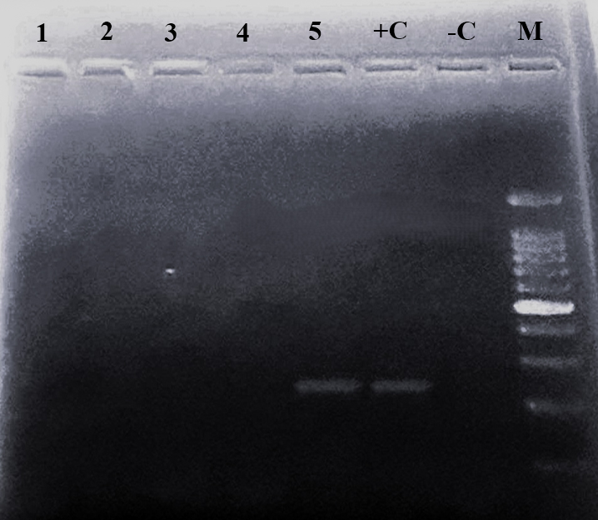

201 bp

1: L5/Fe/1; 2: B4/F/2; 3: D/EC/8; 4: RL/ES/13; 5: RL/EC/7, +C: Positive Control, -C: Negative Control, M: 100 bp Ladder
Fig 4: Agarose gel showing PCR amplified product of tetA (201 bp) gene of Salmonella spp.

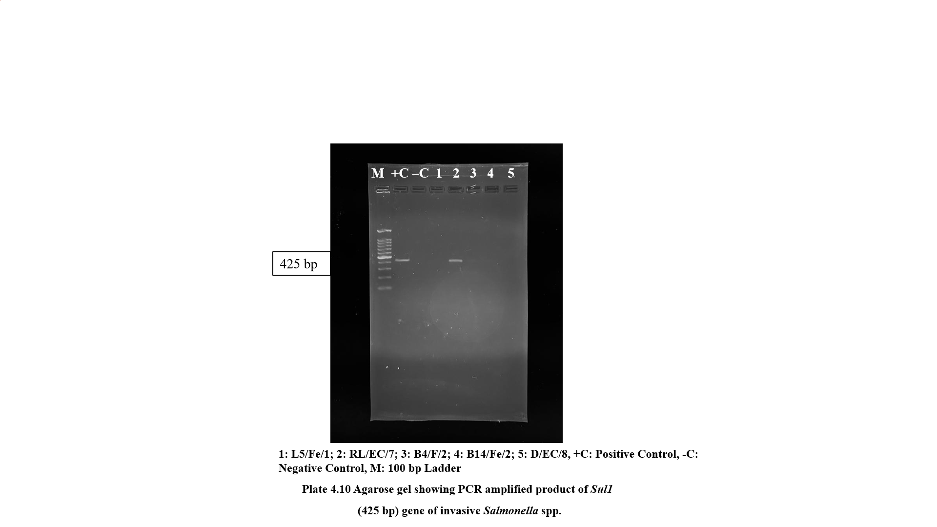
425 bp

1: L5/Fe/1; 2: RL/EC/7; 3: B4/F/2; 4: B14/Fe/2; 5: D/EC/8, +C: Positive Control, -C: Negative Control, M: 100 bp Ladder
Fig 5: Agarose gel showing PCR amplified product of Sul1 (425 bp) gene of Salmonella spp.

4. Discussion:
Salmonella contamination of eggs is a global food safety concern for producers, regulatory authorities and affecting public health. Studies have documented that commercial layer and backyard poultry harbour the organism (Elmonir et al., 2024; Rasve et al., 2024). The contaminated poultry environment, along with faeces and eggs, has been recognized as a potential source of its transmission (Waghamare et al., 2018).
Salmonella contamination in chicken egg supply chain by vertical transmission occurs from infected breeders and horizontal transmission from environmental sources, such as contaminated equipment, dust, feed or drinking water (Li et al., 2018; Fagbamila et al., 2023). Considering this, the current study is importance for implementing interventions at various respective positions in egg supply chain.
Congo red (CR) binding assay method overcome certain limitations, including the use of live animals and ethical concerns and could serve as a viable substitute for in-vivo testing (Kalambhe et al., 2016). The Congo red (CR) binding assay is significant because it serves as a simple, rapid, and cost-effective in-vitro method to assess the pathogenic potential of Salmonella without the need for animal experiments. All isolates showed Congo red binding assay; the present study results are consistent with earlier report of Babar et al. (2023).
The invA gene of Salmonella contains unique DNA sequences and has been recognized as a reliable PCR target for invasive Salmonella detection (Abdel-Aziz, 2016). The invasiveness of Salmonella is governed by genes located within Salmonella Pathogenicity Island 1 (SPI-1), where the invA gene is present. The invA gene, a specific virulence marker for Salmonella, was found in 66.7% of isolates, which supports the findings of Bangera et al. (2019), though lower than rate was reported by Samanta et al. (2014). The amplification of the invA gene is internationally recognized as a standard method for the rapid detection of the Salmonella genus (Malorny et al., 2003).
A Salmonella Typhimurium, serotype was found in only 14.28% of isolates, which aligning with report of Zubair et al. (2017). Both Salmonella Typhimurium and Salmonella Enteritidis colonize the reproductive organs of hens and are major contributors to Salmonellosis worldwide. Salmonella Enteritidis and Salmonella Typhimurium are major causes of poultry-related foodborne diseases in humans (Hendriksen et al., 2011). Occurrence of Salmonella Typhimurium, serotype in egg supply chain could be discouraging to the food safety, therefore necessary control processes control applications in need to be implemented.
The overall prevalence of invA positive Salmonella spp. gene in commercial layer farms is in accordance with Singh et al. (2013) and Elmonir et al. (2024), who reported 3.3% and 4.1% in layer farms. Salmonella survives in various environments allows spread via infected hens and egg contamination. Regular cleaning and disinfection are essential to control farm-level transmission (Im et al., 2015).
The 6.67 percent incidence rate of Salmonella spp. in faeces are in agreement with the study carried out by Fowler et al. (2021) and Sharma et al. (2021). The incidence of Salmonella in faecal samples can be attributed to its natural occurrence as a common inhabitant of the poultry intestine. Faeces play a crucial role in the spread of Salmonella, as contaminated faecal matter released into the environment can serve as a source of infection for susceptible hosts, aiding the bacteria’s persistence in the layer farm environment (McWhorter et al., 2015). The findings in the present study report that none of the sample of cloacal swab was found positive for invasive Salmonella spp., which is in agreement with Kumar et al. (2022). The low incidence of Salmonella in cloacal swabs and water suggests that proper hygiene practices were effectively maintained within the flock. The negligible incidence of Salmonella in cloacal swabs also indicates non-carrier state of layer birds on farm.
The results pertaining to incidence of invasive Salmonella spp. in feed samples (1.12%) are in agreement with earlier studies carried out by Singh et al. (2013) and Sharma et al. (2021) who reported prevalence of 2.5 and 1.8 percent, respectively. The variation in incidence of Salmonella in feed may be influenced by multiple factors, including the source and quality of feed ingredients, as well as storage conditions. Salmonella isolation from eggshells may result from contamination at the time of laying due to faecal matter from intestinal carriers (Tessema et al., 2017).
Prevalence of Salmonella in backyard poultry farms align with McDonagh et al. (2019) and Rasve et al. (2024). Backyard poultry contribute to Salmonella spread through environmental shedding, free movement, and poor biosecurity. Control measures and public awareness on risks of raw or undercooked eggs are essential (Ferreira et al., 2020). Cloacal swabs collect only a small quantity of faeces, this considerably lowers the likelihood of successfully isolating Salmonella from cloacal swabs (Kotton et al., 2006).
Although in current study lower incidence was recorded but backyard raised poultry with salmonella may significantly contribute to the spread of Salmonella spp. due to factors such as pathogen shedding into the environment, unrestricted animal movement and inadequate biosecurity practices (Brioudes and Gummow, 2017). Implementing specific programs to educate consumers about the risks of consuming backyard eggs, especially when raw or undercooked, would be essential in combating Salmonella and reducing the incidence of Salmonellosis (Ferreira et al., 2020).
The incidence of invA gene positive Salmonella spp. was higher in commercial layer farms (1.12%) than in backyard poultry farms (0.07%) under study. Amongst various samples analyzed from commercial layer farm faeces, feed and eggshell samples were found positive, whereas, only faeces and feed were found positive for Salmonella spp. from backyard poultry farm. The higher prevalence of Salmonella in layer flocks may result from prolonged housing, increasing exposure risk (Akalu et al., 2024). Regular measures, including routine cleaning and disinfection, should be implemented to prevent or minimize the spread of Salmonella in the layer farm environment (Long et al., 2017).
The results pertaining to higher Salmonella incidence in distributor and retail egg were comparable to Xie et al. (2019) and Archer et al. (2023). Our findings of Salmonella prevalence in retail and distributor eggs are consistent with earlier reports from India (Singh et al., 2010), highlighting eggs as an important vehicle for transmission. Consumers have limited control over risk factors affecting egg safety before purchase, particularly for commercially produced eggs. Therefore, effective cleaning and disinfection are crucial to reduce transmission within layer farm environments. Egg content contamination likely originates from ovary or oviduct infections, as Salmonella can colonize reproductive tissues (Tessema et al., 2017), while shell contamination may allow bacterial penetration under typical storage conditions (De Reu et al., 2006), posing a risk of egg-borne salmonellosis, especially from raw or undercooked eggs.
The phenomenon of antibiotic resistance in Salmonella has emerged due to the extensive application of antibiotics within the livestock farming sector and this resistance is influenced by genetic mutations as well as horizontal gene transfer mechanisms (Castro-Vargas et al., 2020). Nontyphoidal Salmonella strains exhibit a wide range of antimicrobial resistance, ranging from highly resistant to highly sensitive (Michael and Schwars, 2016). The prevalence of antimicrobial resistance observed in our study was comparable to findings from China (Cui et al., 2016), suggesting that extensive antibiotic use in poultry production is a common driver of resistance globally. This resistance impacts the effectiveness of antibiotics used to treat enteric infections in both humans and animals (Eguale et al., 2017). Variations in antibiotic resistance patterns of Salmonella isolates from poultry environments may reflect differences in antibiotic use and selection pressures across regions (Bahramianfard et al., 2021).
The MAR index indicated a major public health risk, implying that the isolate likely came from an environment with intensive or widespread antibiotic use (Mir et al., 2022). The MAR index in this study aligns with Fagbamila et al. (2023), but found lower than values reported by Elsayed et al. (2024). Multidrug resistance was observed in 85.7% of invasive Salmonella isolates, with resistance to three or more antibiotics.
Genotypic methods analyze chromosomal or plasmid DNA aid in bacterial identification by targeting unique or species-specific genes and enable the detection of specific genes (Parker et al., 2020). The tetA gene was detected in only one Salmonella isolate (7.14%), which is in contrast with Waghmare et al. (2018) and Rasve et al. (2024), who reported 100% presence of the tetA gene. Among these, the tetA and tetB gene classes are the most commonly linked to tetracycline resistance in Salmonella (Pavelquesi et al., 2021). The tetA and tetB genes are embedded within non-conjugative transposons, which play a crucial role in the horizontal transfer of antibiotic resistance (Bacci et al., 2012). Efflux pumps represent the predominant resistance mechanism, with the tetA(A) gene encoding membrane efflux proteins that facilitate the export of tetracycline-cation complexes against a concentration gradient, effectively removing the antibiotic from bacterial cells. Sulphonamide resistance in Gram-negative bacteria is linked to the presence of Sul genes, which encode a modified form of dihydropteroate synthase that is resistant to inhibition by the drug. The presence of Sul1 gene, often plasmid-borne, correlated with phenotypic resistance to Co-trimoxazole, though its prevalence was lower report of El-Sharkawy et al. (2017).
Extended-spectrum β-lactamases (ESBLs) are group of enzymes capable of hydrolyzing most β-lactam antibiotics, leading to resistance against penicillin and third- and fourth-generation cephalosporins (Saravanan et al., 2018). Under detection of ESBL genes (blaTEM, blaSHV, blaCTX-M, or blaOXA), in our study aligning with earlier study of Sain et al. 2023. The relationship between phenotypic resistance and resistance genes varied, and no multidrug-resistant Salmonella isolates carried ESBL genes. Wadaskar et al. (2021) reported similar findings, where isolates resistant to Amoxicillin-Clavulanic acid, Aztreonam, and Piperacillin-Tazobactam tested negative for AmpC. In contrast, Harwalkar et al. (2013) found a high prevalence of TZ/TZL-producing Gram-negative organisms in UTI isolates. Our findings differ from those of Ghazaei (2018), who reported the presence of broad-spectrum ESBL genes (blaSHV and blaCTX-M) in Salmonella isolates from poultry. Furthermore, Fang et al. (2008) and Chakraborty et al. (2020) identified the blaSHV gene in 6 and 40 percent of Salmonella isolates, respectively. These findings indicate a weak correlation between phenotypic and genotypic resistance to β-lactams in Salmonella isolates, possibly due to the failure of isolates to exhibit expected resistance phenotypes (Urmi et al., 2020). Data on ESBL-producing Salmonella spp. in area under study are limited. Further studies with more poultry and dairy isolates are needed. Reporting ESBL strains is crucial due to the reliance on third-generation cephalosporins. ESBL-producing bacteria present a significant threat to both human and animal health (Mughini-Gras et al., 2019). Controlling resistance requires prudent antibiotic use, regular monitoring, and limiting antibiotics as growth promoters.
Lower resistance genotypic to beta lactamase, tetracycline and sulphonamide, could be due to lower use of these drugs at farms. The diversity of antimicrobial resistance (AMR) genes among Salmonella isolates from different sources indicates genomic modifications resulting from the acquisition of new AMR genes through mutations, plasmid transfer, or the presence of inherent resistance genes (Ramirez-Hernandez et al., 2021). The spread of drug resistance in Salmonella indicates the dissemination of resistance genes within this bacterium, and the rapid emergence of antimicrobial resistance in microbial pathogens poses a significant threat to public health (Xie et al., 2019).
5. Conclusions
In conclusion, the findings of the present study indicate that the chicken egg supply chain serves as a potential reservoir for Salmonella strains, posing a risk of zoonotic infections to humans through either egg consumption or direct contact. This study demonstrated observable resistance to tetracycline and sulphonamide antimicrobials and weak correlation for β-lactam resistance, which may be attributed to the isolates geographical relevance with use of antimicrobials. The study concludes that although the chicken egg supply chain showed relative levels of multidrug resistant Salmonella spp., continuous surveillance and monitoring of Salmonella spp. remain crucial for safeguarding public health.

DISCLAIMER (ARTIFICIAL INTELLIGENCE)

Author(s) hereby declare that NO generative AI technologies such as Large Language Models (ChatGPT, COPILOT, etc) and text-to-image generators have been used during writing or editing of this manuscript.

Consent (whereever applicable)

Not applicable

Ethical approval (whereever applicable)

The authors declare that no human or animal experiments were conducted in this study.

References:
- Abdel-Aziz N. M. (2016). Detection of Salmonella species in chicken carcasses using genus specific primer belong to invA gene in Sohag city, Egypt, Veterinary World, 9(10), 1125-1128.
- Adhikari, S. K., Gyawali, A., Shrestha, S., Shrestha, S. P., Prajapati, M., & Khanal, D. R. (2018). Molecular confirmation of Salmonella typhimurium in poultry from Kathmandu Valley. Journal of Nepal Agricultural Research Council, 4,86-9.
- Akalu, A., Tadesse, T., Alemayehu, H., Medhin, G., Woldeyohannes, D., & Eguale, T. (2024). Prevalence and Antimicrobial Susceptibility Profile of Salmonella from Poultry Farms and In Contact Humans and Associated Risk Factors in Addis Ababa, Ethiopia. International Journal of Microbiology, 2024(1),4227460.
- Al-Momani, W., Janakat, S., & Khatatbeh, M. (2018). Bacterial contamination of table eggs sold in Jordanian markets. Pakistan Journal of Nutrition, 17(1),15-20.
- Anejo-Okopi, J. A., Isa. S. E., Audu, O., Fagbamila, I. O., Iornenge, J. C., & Smith, I. S. (2016). Isolation and polymerase chain reaction detection of virulence invA gene in Salmonella spp. from poultry farms in Jos, Nigeria. Journal of Medicine in the Tropics, 18(2), 98-102.
- Archer, E.W., Chisnall, T., Tano-Debrah, K., Card, R. M., Duodu, S., & Kunadu, A. P. (2023). Prevalence and genomic characterization of Salmonella isolates from commercial chicken eggs retailed in traditional markets in Ghana. Frontiers in Microbiology, 14,1283835.
- Babar, A., Suryawanshi, R., Deshmukh, O., Kurkure, N., Patil, V., Devangare, A., & Kulkarni, R. (2023). Occurrence, Characterization and Antimicrobial Resistance Pattern of Pathogenic Salmonella Isolated from Chicken and Chicken Meat Products. Indian J Vet Sci Biotechnol, 19,29-33.
- Bacci, C., Boni, E., Alpigiani, I., Lanzoni, E., Bonardi, S., & Brindani, F. (2012). Phenotypic and genotypic features of antibiotic resistance in Salmonella enterica isolated from chicken meat and chicken and quail carcasses. International Journal of Food Microbiology, 160(1), 16-23.
- BAM Bacteriological Analytical Manual 2007. Salmonella, Chapter 5 Salmonella.http://www.fda.gov/downloads/Food/FoodScienceResearch/UCM 309839.
- Bahramianfard, H., Derakhshandeh, A., Naziri, Z., & Khaltabadi Farahani, R. (2021). Prevalence, virulence factor and antimicrobial resistance analysis of Salmonella Enteritidis from poultry and egg samples in Iran. BMC veterinary research, 17(1),196.
- Bangera, S. R., Umakanth, S., Chowdhury, G., Saha, R. N., Mukhopadhyay, A. K., & Ballal, M. (2019). Poultry: A receptacle for non-typhoidal Salmonellae and antimicrobial resistance. Iranian journal of microbiology,11(1), 31. Biotechnology, 19, 29-33.
- Brenner, F.W., Villar, R.G., Angulo, F.J., Tauxe, R., & Swaminathan, B. (2000). Salmonella nomenclature. Journal of clinical microbiology, 38(7), 2465-2467.
- Brioudes, A., & Gummow, B. (2017). Understanding Pig and Poultry Trade Networks and Farming Practices Within the Pacific Islands as a Basis for Surveillance. Transboundary and emerging diseases, 64(1), 284-99.
- Castro-Vargas, R. E., Herrera-Sánchez, M. P., Rodríguez-Hernández, R., & Rondón-Barragán, I. S. (2020). Antibiotic resistance in Salmonella spp. isolated from poultry: A global overview. Veterinary World, 13(10), 2070-2084.
- Chakraborty, S., Roychoudhury, P., Samanta, I., Subudhi, P. K., Das, M., De, A., Bandyopadhayay S., Joardar, S. N., Mandal, M., Qureshi, A., & Dutta, T. K. (2020) Molecular detection of biofilm, virulence and antimicrobial resistance associated genes of Salmonella serovars isolated from pig and chicken of Mizoram, India. Indian Journal of Animal Research, 54(5),608-13.
- Chlebicz, A., & Śliżewska, K. (2018). Campylobacteriosis, salmonellosis, yersiniosis, and listeriosis as zoonotic foodborne diseases: a review. International journal of environmental research and public health, 15(5), 863.
- CLSI, 2021. Clinical and Laboratory Standards Institute. M100: Performance Standards for Antimicrobial Susceptibility Testing. 31st ed. CLSI Informational Supplement. Clinical and Laboratory Standards Institute, USA.
- Cui, M., Xie, M., Qu, Z., Zhao, S., Wang, J., Wang, Y., He, T., Wang, H., Zuo, Z., & Wu, C. (2016). Prevalence and antimicrobial resistance of Salmonella isolated from an integrated broiler chicken supply chain in Qingdao, China. Food Control, 62, 270-276.
- Dagnew, B., Alemayehu, H., Medhin, G., & Eguale, T. (2020). Prevalence and antimicrobial susceptibility of Salmonella in poultry farms and in‐contact humans in Adama and Modjo towns, Ethiopia. Microbiology Open, 9(8), e1067.
- De-Reu, K., Grijspeerdt, K., Messens, W., Heyndrickx, M., Uyttendaele, M., Debevere, J., & Herman, L. (2006). Eggshell factors influencing eggshell penetration and whole egg contamination by different bacteria, including Salmonella enteritidis. International Journal of Food Microbiology, 112(3), 253-260.
- Eguale, T., Birungi, J., Asrat, D., Njahira. M. N., Njuguna, J., Gebreyes, W. A., Gunn, J. S., Djikeng, A., & Engidawork, E. (2017). Genetic markers associated with resistance to beta-lactam and quinolone antimicrobials in non-typhoidal Salmonella isolates from humans and animals in central Ethiopia. Antimicrobial Resistance & Infection Control, 6,1-0.
- Elmonir, W., Abdeltawab, D., El-Sharkawy, H., & Zahran, R. N. (2024). Serotypes diversity, virulence, and antimicrobial resistance of non-typhoidal Salmonella isolates in commercial and backyard egg production systems in Egypt. Pakistan Journal of Zoology, 4, 1501-2000.
- Elsayed, M. M., El-Basrey, Y. F., El-Baz, A. H., Dowidar, H. A., Shami, A., Al-Saeed, F. A., Alsamghan, A., Salem, H. M., Alhazmi, W. A., El-Tarabily, K. A., & Khedr M, H. (2024). Ecological prevalence, genetic diversity, and multidrug resistance of Salmonella enteritidis recovered from broiler and layer chicken farms. Poultry science, 103(2):103320.
- El-Sharkawy, H., Tahoun, A., El-Gohary, A. E., El-Abasy, M., El-Khayat, F., Gillespie, T., Kitade, Y., Hafez, H. M., Neubauer, H., & El-Adawy, H. (2017). Epidemiological, molecular characterization and antibiotic resistance of Salmonella enteric serovars isolated from chicken farms in Egypt. Gut Pathogens, 9:1-2.
- Fagbamila, I. O., Ramon, E., Lettini, A. A., Muhammad, M., Longo, A., Antonello, K., Aworh, M. K., Kwaga, J. K., Abdu, P. A., Umoh, J. U., & Kabir, J. A. (2023). Assessing the mechanisms of multi-drug resistant non-typhoidal Salmonella (NTS) serovars isolated from layer chicken farms in Nigeria. Plos one, 18(9), e0290754.
- Fang, H., Ataker, F., Hedin, G., & Dornbusch, K. (2008). Molecular epidemiology of extended-spectrum β-lactamases among Escherichia coli isolates collected in a Swedish hospital and its associated health care facilities from 2001 to 2006. Journal of Clinical Microbiology, 46(2), 707-12.
- Ferreira. V., Cardoso, M. J., Magalhães, R., Maia, R., Neagu, C., Dumitraşcu, L., Nicolau, A. I., & Teixeira, P. (2020). Occurrence of Salmonella spp. in eggs from backyard chicken flocks in Portugal and Romania-Results of a preliminary study. Food Control, 113,107180.
- Fowler, P., Sharma, D. S., Pant, D. K., Singh, S., & Wilkins, M. J. (2021). Antimicrobial-resistant non-typhoidal Salmonella enterica prevalence among poultry farms and slaughterhouses in Chitwan, Nepal. Veterinary World, 14(2), 437.
- Ghazaei, C. (2018). Phenotypic and molecular detection of β-lactamase genes bla_{TEM}, bla_{CTX}, and bla_{SHV} produced by Salmonella spp. isolated from poultry meat. Gene, Cell and Tissue, 5(4), e84367.
- Harwalkar, A., Sataraddi, J., Gupta, S., Yoganand, R., Rao, A., & Srinivasa, H. (2013). The detection of ESBL-producing Escherichia coli in patients with symptomatic urinary tract infections using different diffusion methods in a rural setting. Journal of Infection and Public Health, 6(2), 108-114.
- Hendriksen, R. S., Vieira, A. R., Karlsmose, S., Wong, D. M. Lo. Fo., Jensen, A. B., Wegener, H.C., & Aarestrup, F. M. (2011). Global monitoring of Salmonella serovar distribution from the World Health Organization Global Food borne Infections Network Country Data Bank: results of quality assured laboratories from 2001 to 2007. Foodborne Pathogens and Disease, 8(8), 887-900.
- Im, M. C., Jeong S. J., Kwon, Y. K., Jeong, O, M., Kang, M. S., & Lee, Y. J. (2015). Prevalence and characteristics of Salmonella spp. isolated from commercial layer farms in Korea. Poultry Science, 94(7),1691-8.
- Kalambhe, D. G., Zade, N. N., Chaudhari, S. P., Shinde, S. V., Khan, W., & Patil, A. R. (2016). Isolation, antibiogram and pathogenicity of Salmonella spp. recovered from slaughtered food animals in Nagpur region of Central India. Veterinary World, 9(2), 176-181.
- Kotton, C. N., Lankowski, A. J., & Hohmann, E. L. (2006). Comparison of rectal swabs with fecal cultures for detection of Salmonella typhimurium in adult volunteers. Diagnostic Microbiology and Infectious Disease, 56(2), 123-126.
- Krumperman, P. H. (1983). Multiple antibiotic resistance indexing of Escherichia coli to identify high-risk sources of fecal contamination of foods. Applied and environmental microbiology, 46(1),165-70.
- Kumar, S. S., Thangavelu, A., Vijayarani, K., Shamsudeen, P., & Senthil Kumar, K. (2022). Isolation and identification of Salmonella spp. from layer poultry farms of North western districts of Tamil Nadu. The Pharma Innovation Journal, 11(12S),835-837.
- Li, X., Liu, L., Li, Q., Xu, G., & Zheng, J. (2018). Salmonella contamination in layer farms in China: detection and genetic analysis. The Journal of Poultry Science, 55(1), 1-9.
- Long, M., Yu, H., Chen, L., Wu, G., Zhao, S., Deng, W., & Zou, L. (2017). Recovery of Salmonella isolated from eggs and the commercial layer farms. Gut Pathogens, 9, 1-9.
- Ma, M., Wang, H., Yu, Y., Zhang, D., & Liu, S. (2007). Detection of antimicrobial resistance genes of pathogenic Salmonella from swine with DNA microarray. Journal of Veterinary Diagnostic Investigation, 19(2),161-7.
- Malorny, B., Hoorfar, J., Bunge, C., & Helmuth, R. (2003). Multicenter validation of the analytical accuracy of Salmonella PCR: towards an international standard. Applied and environmental microbiology, 69(1), 290-296.
- McDonagh, A., Leibler, J. H., Mukherjee, J., Thachil, A., Goodman, L. B., Riekofski, C., Nee, A., Smyth, K., Forrester, J., & Rosenbaum, M. H. (2019). Frequent human‐poultry interactions and low prevalence of Salmonella in backyard chicken flocks in Massachusetts. Zoonoses and Public Health, 66(1),92-100.
- McWhorter, A. R., Davos, D., & Chousalkar, K. K. (2015). Pathogenicity of Salmonella strains isolated from egg shells and the layer farm environment in Australia. Applied and environmental microbiology, 81(1),405-14.
- Mouttotou, N., Ahmad, S., Kamran, Z., & Koutoulis, K. C. (2017). Prevalence, risks and antibiotic resistance of Salmonella in poultry production chain. In Current topics in Salmonella and Salmonellosis, 5 Intech Open.
- Michael, G. B., & Schwarz, S. (2016). Antimicrobial resistance in zoonotic nontyphoidal Salmonella: an alarming trend? Clinical Microbiology and Infection, 22(12), 968-974.
- Mir, R., Salari, S., Najimi, M., & Rashki, A. (2022). Determination of frequency, multiple antibiotic resistance index and resistotype of Salmonella spp. in chicken meat collected from southeast of Iran. Veterinary medicine and science, 8(1), 229-236.
- Mughini-Gras, L., Dorado-García, A., van Duijkeren, E., van den Bunt, G., Dierikx, C.M., Bonten, M.J., Bootsma, M.C., Schmitt, H., Hald, T., Evers, E.G., & de Koeijer, A., 2019. Attributable sources of community-acquired carriage of Escherichia coli containing β-lactam antibiotic resistance genes: a population-based modelling study. The Lancet Planetary Health, 3(8), 357-e369.
- Nair, A., Balasaravanan, T., Malik, S. V., Mohan, V., Kumar, M., Vergis, J., & Rawool, D. B. (2015). Isolation and identification of Salmonella from diarrheagenic infants and young animals, sewage waste and fresh vegetables. Veterinary world, 8(5),669.
- Ng, LK., Martin, I., Alfa, M., & Mulvey, M. (2001). Multiplex PCR for the detection of tetracycline resistant genes. Molecular and cellular probes, 15(4), 209-15.
- Parker, A. M., Mohler, V. L., Gunn, A. A., & House, J. K. (2020). Development of a qPCR for the detection and quantification of Salmonella spp. in sheep feces and tissues. Journal of Veterinary Diagnostic Investigation, 32(6), 835-843.
- Pavelquesi, S. L., Ferreira, O. D. A., Rodrigues, A, R., de Souza Silva, M. C., Orsi, D. C., & da Silva, I. C. (2021). Presence of tetracycline and sulfonamide resistance genes in Salmonella spp.: literature review Antibiotics, 10(11),1314.
- Ramirez-Hernandez, A., Carrascal-Camacho, A.K., Varón-García, A., Brashears, M.M., & Sanchez-Plata, M.X. (2021). Genotypic characterization of antimicrobial resistant Salmonella spp. strains from three poultry processing plants in Colombia. Foods, 10(3), 491.
- Rasve, R. L. (2024). Antibiogram of Salmonella spp. isolated from backyard and indigenously developed poultry breed production system.
- Sain, A., Sharma, D. K., Singathia, R., Gaurav, A., Patidar, C., Suthar, P., Rathore, K. & Juneja, R. (2023). Multidrug Resistance and Virulence Gene Profile of Non Typhoidal Salmonella Isolates from Poultry Enteritis in Semi-arid Region of India. Tropical Animal Health and Production, 56(2), 91.
- Samanta, I., Joardar, S. N., Das, P. K., Sar, T. K., Bandyopadhyay, S., Dutta, T. K., & Sarkar, U. (2014). Prevalence and antibiotic resistance profiles of Salmonella serotypes isolated from backyard poultry flocks in West Bengal, India. Journal of Applied Poultry Research, 23(3), 536-545.
- Saravanan, M., Ramachandran, B., & Barabadi, H. (2018). The prevalence and drug resistance pattern of extended spectrum β–lactamases (ESBLs) producing Enterobacteriaceae in Africa. Microbial Pathogenesis, 114, 180-192.
- Sharma, S. P., Fowler, D., Pant, D. K., Singh, S., & Wilkins, M. J. (2021). Prevalence of non-typhoidal Salmonella and risk factors on poultry farms in Chitwan, Nepal. Veterinary World, 14(2), 426.
- Siddiky, N. A., Sarker, M. S., Khan, M. S., Begum, R., Kabir, M. E., Karim, M. R., Rahman, M. T., Mahmud, A., & Samad, M. A. (2021). Virulence and antimicrobial resistance profiles of Salmonella enterica serovars isolated from chicken at wet markets in Dhaka, Bangladesh. Microorganisms, 9(5):952.
- Singh, S., Yadav, A. S., Singh, S. M., & Bharti, P. (2010). Prevalence of Salmonella in chicken eggs collected from poultry farms and marketing channels and their antimicrobial resistance. Food Research International, 43(8), 2027-2030.
- Singh, R., Yadav, A. S., Tripathi, V., & Singh, R. P. (2013). Antimicrobial resistance profile of Salmonella present in poultry and poultry environment in north India. Food Control, l33(2):545-8.
- Tessema, K., Bedu, H., Ejo, M., & Hiko, A. (2017). Prevalence and antibiotic resistance of Salmonella species isolated from chicken eggs by standard bacteriological method. Journal of Veterinary Science and Technology, 8(421), 2.
- Threlfall, E. J., Wain, J., Peters, T., Lane, C., de Pinna, E., Little, C. L., Wales, A. D., & Davies, R. H. (2014). Egg-borne infections of humans with Salmonella: not only an S. Enteritidis problem. World's Poultry Science Journal 70(1),15-26.
- Urmi, L.U., Nahar, S., Rana, M., Sultana, F., Jahan, N., Hossain, B., & Haque, M. (2020). Genotypic to phenotypic resistance discrepancies identified involving β-lactamase genes, bla KPC, bla IMP, bla NDM-1, and bla VIM in uropathogenic Klebsiella pneumoniae. Infection and Drug Resistance, 2863-2875.
- Wadaskar, B., Kolhe, R., Waskar, V., Budhe, M., Kundu, K., & Chaudhari, S. (2021). Detection of antimicrobial resistance in Escherichia coli and Salmonella isolated from flies trapped at animal and poultry farm premises. Journal of Animal Research 11(3), 341-350.
- Waghamare, R. N., Paturkar, A. M., Vaidya, V. M., Zende, R. J., Dubal, Z. N., Dwivedi, A., & Gaikwad, R.V. (2018). Phenotypic and genotypic drug resistance profile of Salmonella serovars isolated from poultry farm and processing units located in and around Mumbai city, India. Veterinary world 11(12):1682.
- Xie, T., Wu, G., He, X., Lai, Z., Zhang, H., & Zhao, J. (2019). Antimicrobial resistance and genetic diversity of Salmonella enterica from eggs. Food science & nutrition 7(9),2847-53.
- Zubair, A. I., Al-Berfkani M. I., & Issa, A. R. (2017). Prevalence of Salmonella species from poultry eggs of local stores in Duhok. International Journal of Research in Medical Sciences, 5(6), 2468.

