Original Research Article

Exploring heavy metal tolerant bacteria from coal combustion residues of thermal power plant as a possible bioremediation candidate

ABSTRACT
Aims: The present investigation aimed to explore heavy metal tolerant microbes in soil samples towards utilisation for bioremediation.
Study design: Indigenous microbes with heavy metal bio remedial capacity were isolated and assessed for the same.
Place and Duration of Study: Collected from different sites of Bokaro Thermal Power Plant, India with the hypothesis that a heavy metal contaminated location potentially can have many tolerant microbes in it; as microbes of this location are being pre-exposed to several heavy metals for longer duration.
Methodology: Bacterial isolates from the soil were screened by Minimum inhibitory concentration (MIC) technique and also characterised through morphological, biochemical tests, which were finally identified through 16S rDNA sequence analysis. For bio remedial capacity evaluation, Arsenic was assessed through Silver Diethyl Dithio-carbamate (SDDC) method and Lead through Atomic absorption spectrophotometry (AAS).
Results:In the present study, two out of nine isolates were found as tolerant to Lead& Arsenic. MICs for IS-05 were 900 ppm for Lead and 1000 ppm for Arsenic respectively and 925 ppm for Lead, 1000 ppm for Arsenic in case of IS-09. Also, the bio remedial capacity for the heavy metals in case of IS-05 was maximum (93%) for Arsenic but IS-09 showed the maximum (88%) bio-remedial capacity for Lead. The16S rDNA extraction, amplification and further phylogenetic analysis identified IS-05 as Bacillus sp. strain JBT18S (NITR-3) and IS-09 identified as Pseudomonas fluorescens through conventional biochemical and other confirmatory tests.
Conclusion: Exploring such, can come up with noble indigenous microbe with appreciable bio remedial capacity which can potentially be utilized for bioremediation as it relies on the fact that the tolerant microbes develop several mechanisms in them and by virtue of which they can transform, detoxify, volatilize or putatively entrap metals in the extracellular polymeric substances and even can accumulate harmful chemicals within the cells.
Keywords: Arsenic, bio-remedial capacity, Lead, minimum inhibitory concentration, toxic metal
- Introduction
India holds vast reserves of coal (thermal grade) and thus in the energy sector of India, coal plays an important role. The country's installed power generating capacity is 3,74,199 MW as on 30th November, 2020 (Ministry of Power, GOI, 2020) and stands world's fifth largest country in terms of coal reserve accounting 9% of world’s total coal reserve. In India, nearly 55% of installed capacity of power generation is through coal based thermal power plants. Indian coals contain high ash content and thus after combustion; it generates huge amounts of coal combustion residues (CCRs) in the form of fly ash which contains considerable amount of different array of heavy metals in it. This CCRs leads to cross contamination of ground and surface waters bodies through metal containing leachates. Not all the metals qualify to be called as heavy metals. The metals and metalloids which possess atomic mass between 63.5 to 200.6- and 5 times specific gravity than water is qualified to be called as heavy metals (HMs). Although heavy metal contamination is one of the most common environmental concern today (Alhumaimess et al., 2019) but the risk of heavy metals is highly dependent on types of metals, it’s oxidation state, bioavailability and level of concentration.
Several industrial activities like thermal power plant, causes huhe ‘Environmental pollution’ which charge the environment with a persistent issue of incorporating heavy metals. Conventional methods are not upto the mark and generate other environmental issues. A novel approach should be designed, customized and finally to be implemented in order to protect environment and bioremediation is such an approach (Raghunandan et al., 2014, Raghunandan et al., 2018). Bioremediation,is considered to be more economical and environment friendly prove to be an effective tool to counter the further secondary pollutant generation from conventional methods and more effective towards dealing with more recalcitrant compounds/pollutants (Singh and Gupta, 2016). Two approaches for bioremediation can be followed: In-Situ (on the site of contamination) and Ex-situ (Away from the site of contamination). Consequent upon many positive criteria interest is increasing regarding microbial bioremediation of contaminants including heavy metals and other toxic pollutants through microorganism (Raghunandan et al., 2014, Raghunandan et al., 2018, Kumar et al., 2016).
Heavy metals either in ionic form or in complex compound form, heavy metals are very toxic and may be readily absorbed into living organisms and directly damage the cell membranes, denature DNA and proteins (Zhang et al., 2016). However, with long exposed microorganisms also develop some sorts of defense mechanisms and they also possess innate tolerant ability for developing some adaptability to thrive in the harsh environmental conditions. Among those, the most commonly reported mechanisms include active and energy dependent efflux or transportation across the cell membrane or biosorption to the cell walls, precipitation, and complexation and oxidation-reduction reactions depending on the types of microorganisms and types of metals. Metal remediation efficiency is variable from microbes to microbes, which may be explained owing to have different genetic makeup of microorganisms or the composition of the medium. Mostly, single bacteria develop adaptation against multiple heavy metals. Microorganisms are known to have specific genetic set up for resistance to toxic ions of heavy metals and in most of the cases, the resistance genes are found on plasmids or on chromosomes. Macro-algae can also be excellently used for remediation of heavy metals from metal contaminated waste water including industrial effluents contaminated with heavy metals. The resultant macroalgae biomass can be used for biochar preparation for other applications (David et al., 2015). Metal resistance determinants which are encoded in plasmid in case of bacteria, it have been reported to be inducible. Additionally, metals can trigger antibiotic resistance in them as the atmosphere favors the co-selection of metal and antibiotic resistance gene together. There are many examples of resistant bacteria which can potentially be utilized as bioremediation candidate. Some of those bacteria responsible for the bioremediation of lead include Bacillus sp. and P aeruginosa. These bacteria develop resistance in them by several means. Several functional groups present in the cell surface helps in biosorption of lead. Heavy metal resistant microbes adapted to utilize arsenic as an electron acceptor during anaerobic respiration. Also, Arsenic can be used by these microbes as an electron donor to support chemoautotrophic fixation of CO₂.
Soil harbors innumerable microbial species and each place is distinct from other in terms of microbial diversity contained in it. The site (Bokaro thermal power station, Bokaro, Jharkhand, India) selected for sampling of Coal combustion residues (CCRs) contaminated soil for this study, had been explored very less in terms of exploring the indigenous microbes for bioremediation (as per the literatures available till date). The plant has been established long back and since then there is the discharge of large amount of fly ash and that has been continuously getting deposited and contaminating the surrounding areas. Thus, it is hypothesized that there is more possibilities to get heavy metal tolerant microbes from this location and which can further be explored for their bioremediation capability. Looking into the issues related to the detrimental effects of heavy metals to both human and environmental health, there is a serious need to find out an eco-friendly and economically efficient way to remediate them. With this background, present investigation was conducted with the objectives to explore, isolate and characterize heavy metal tolerant bacteria from heavy metal polluted sites of Bokaro Thermal Power Station (BTPS), Bokaro, Jharkhand, India and to evaluate the bio remedial capacity of the isolated bacteria under laboratory conditions.
- Materials and methods
2.1. Site description
To isolate indigenous microbes with heavy metal bio remedial capacity, soil samples from Bokaro steel city were collected. Bokaro Steel City is the largest and a renowned industrialized city in India. Bokaro is located in the eastern part of India at 23°47′5.09” N and 85°52′ 49.09” E.﻿ / ﻿The purpose for selecting this site was due to its background of thermal power plant with huge loads of heavy metal contamination of adjoining areas by the fly ash/CCRs that gets generated regularly and secondly the area seems to be more unexplored in terms of tolerant bacterial isolates.
2.2. Sample collection and isolation of heavy metal tolerant bacteria
The Coal Combustion Residuess (CCRs) get deposited on soils of adjoined area of power plant. Soil from such areas surrounding Bokaro Thermal Power Station was sampled from upper 0-15 cm depth by using a T-Auger and collected in sterilized plastic bags. Soil samples were processed and 1g sample was suspended and serially diluted in 9 ml 0.85% sterile saline water up to 10⁻⁷ dilution. 100 µl from each dilution were spread on Luria Bertani (LB) plate and incubated for 24 hrs at 37ºC. Morphologically distinct colonies (Fig. 1) were further streaked in separate plates and purified.
2.3. Phenotypic and biochemical characteristics
The phenotypic characterization (Bergey’s manual, 1923),gram staining and observation was done under bright field microscope (Nikon Eclipse). KOH string confirmatory test for the Gram staining was also performed, where the formation of a string/ thread appears in presence of 3% KOH and one drop of bacterial culture. Biochemical characterizations (Prabhukarthikeyan et al., 2015) of all isolates were done using biochemical kit KB002 and KB013 (HiAssorted Biochemical Test Kit procured from Himedia, India) and to test the metabolic versatility of the isolates, BIOLOG Microtitre Ecoplate with 31 different carbons substrates (viz. Mannitol, Glycogen, D-lactose, Cellobiose, Cyclodextrin etc.) were procured from Biolog, Hayward, CA, USA.
2.4. Assessing metal tolerance limits
Morphologically distinct isolates were evaluated for heavy metal tolerance (Lead, Arsenic) by standard Minimum Inhibitory Concentration (MIC) technique (Sanjay et al., 2020).
2.5. Antibiotics sensitivity and resistance pattern
Screened isolates (with higher MICs for Arsenic and Lead) based on higher MIC were checked for antibiotic resistance behaviour by Kirby–Bauer disc diffusion technique following protocol provided along with the test disc. Antibiotic discs procured from Himedia, India. The antibiotics includes: Amikacin (30 μg), Ampicillin (25 μg), Amoxicillin (10 μg), Aztreonam (50 μg), Ceftriaxone (30 μg), Gentamicin (50 μg), Methicillin (30 μg), Norfloxacin (5 μg), Kanamycin (5 μg), Ofloxacin (5 μg), Tetracycline (30 μg) and Vancomycin (5 μg). Discs of each type were placed on freshly prepared lawns of individual isolate on Mueller–Hinton (MH) plates and incubated at 37°C for 24h. Inhibition zone was measured in terms of diameter (mm) and classified as resistant (R), intermediate (I) or susceptible (S) following the standard antibiotic disc chart provided with the kit (Himedia, India).
2.6. Estimation of bio remedial capacity
The bio remedial capacity of the active bacterial cell was performed at laboratory in batch scale and was estimated by following equation.
Bioremedial capacity (%) = [(Initial concentration – Final concentration)/Initial concentration] *100
Where, the initial concentration is the level of heavy metal (in ppm) added in the media and final concentration is the amount of metal left after bacterial cells centrifuged (12,000 rpm) out after 24h of incubation. The remaining heavy metal concentration in the solution is estimated by silver diethyl dithio-carbamate spectrometric (SDDC) method (ISO6595:1982) for Arsenic and by Atomic Absorption Spectrophotometer (AAS) for Lead by following standard protocols for lead estimation in water sample (Sabol et al., 2020).
2.7. Molecular identification of isolated bacteria
Extraction of genomic DNA was done as described by Sambrook et al. (2001) and amplified using the universal primers. PCR products of ~1.5 kb 16S rDNA genes were sequenced for further identification. Out of the two screened most promising isolates; IS-09 was identified as Pseudomonas fluorescens through phenotypic, biochemical and fluorescence properties. So, it was not repeated for molecular identification. Thus, we went for molecular identification of IS-05 only.
- Results and Discussions
  - Phenotypic characterization of isolates
Total nine different isolates recovered based on morphologically unique and different visible characteristics on plates. The phenotypic characteristics of the different isolates are presented in Table 1. All the nine isolates differed in terms of colony morphology and could be differentiated distinctly from each other based on the colony features. IS-05 colonies were irregular in shape, dull grey in color and opaque. The colonies were wrinkled like aged person’s skin. The IS-09 isolate colonies were cream in color with green pigments, round, shiny, convex colony on Kings base media (having greenish fluorescence properties against UV light), and colony turned greenish on Pseudomonas specific media on 3rd day after inoculation (Fig. 1).
Table 1: Phenotypic features of the isolates
Symbols of isolates | Phenotypic features
ISOLATE 1 (IS-01) | Round, pigmented (pinkish)
ISOLATE 2 (IS-02) | Round, white
ISOLATE 3 (IS-03) | Round, glossy, transparent boundary
ISOLATE 4 (IS-04) | Round, brown pigment diffusing
ISOLATE 5 (IS-05)* | Irregular, dull grey, opaque, wrinkled
ISOLATE 6 (IS-06) | Small white slimy, transparent boundary
ISOLATE 7 (IS-07) | White wrinkled
ISOLATE 8 (IS-08) | Beaded, bulged, whitish
ISOLATE 9 (IS-09)* | Cream with bluish green pigments, round, shiny, convex colony on Kings base media (having greenish fluorescence properties against UV light), Colony turns greenish on Pseudomonas specific media on 3rd day after inoculation
*Screened further for heavy metal tolerance and bioremediation potential

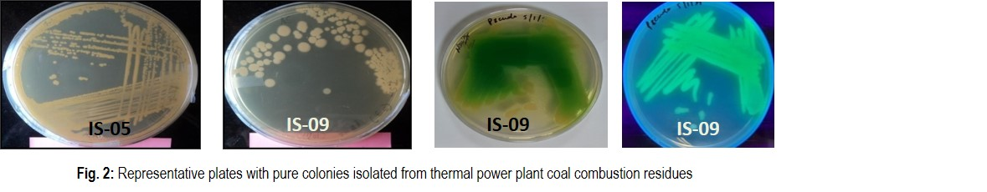
Fig. 1:Representative plates with pure colonnies isolated from thermal power plant coal residues
  - Biochemical characterization of isolates
Different biochemical tests were performed to characterize the bacterial isolates and observations are presented in Table 2 and Figure. 2. The isolate IS-09 was again checked for its growth on King’s-B medium, Pseudomonas media (for fluorescein) and was initially confirmed as Pseudomonas fluorescens and IS-05 was identified as Bacillus sp using Bergey’s Manual of Systematic Bacteriology (Table 2). IS-05 found to have negative response to Urease detection test and positive in Nitrate reduction. Both IS-05 and IS-09 showed negative response in H₂S production. The IS-05 was found to have spores while the IS-09 did not show any spore. Till 24 h of growth on Pseudomonas specific media (Himedia, India), the colony color of IS-09 was creamish which turned to dark greenish blue on 3rd day of incubation and strong greenish fluorescence observed under 365 nm of UV radiation (Fig. 1) and confirmed as P fluorescens. We avoided the further molecular characterization of IS-09. Pseudomonas fluorescens has multiple flagella. It has an extremely versatile metabolism, and can be found in the soil and in water. It is an obligate aerobe, but certain strains are capable of using nitrate instead of oxygen as a final electron acceptor during cellular respiration. Isolate from present experiment i.e., IS-09 (Pseudomonas fluorescens) also had shown nitrate reductase capacity (Table. 2).
Table 2:Biochemical responses of screened isolates
Biochemical tests | Isolates
 | IS-05 | IS-09
Citrate utilization | + | +
Lysine decarboxylase | - | -
Ornithine decarboxylase | - | -
Urease detection | - | +
Phenylalanine deamination (TDA) | - | ±
Nitrate Reduction | + | +
H₂S Production | - | -
Glucose | - | -
Adonitol | - | -
Lactose | ± | +
Arabinose | + | ±
Sorbitol | + | ±
Catalase | + | +
Oxidase | + | -
Gram Stain  Growth on King’s B Media  UV Fluorescence  Growth on Cetrimide Agar  Cell shape  Motility  Flagella  Methyl Red  Spore | +  -  -  -  Rod  +  +  -  + | -  +  +  +  Rod  +  +  -  -
(Where, ‘+’ indicates positive response or presence of certain attribute and ‘–‘indicates opposite)

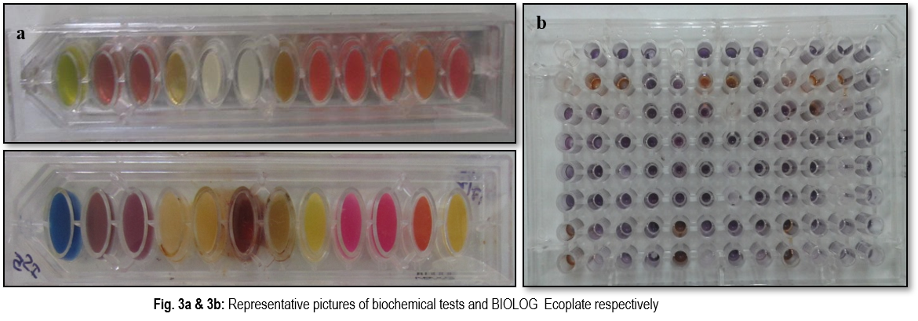
Fig. 2a &2b: Representative picture of biochemical tests and BIOLOG Ecoplate respectively
  - Metal tolerance test
Metal tolerance performance for all individual isolates is presented in Fig. 3. IS-05 (Bacillus sp) and IS-09 (Pseudomonas fluorescens) showed a good range of tolerance in terms of MIC as compared to the other isolates. The MIC for IS-05 was 1000ppm and 900ppm for Arsenic and Lead respectively. Equal MIC response was observed for IS-09 for both Arsenic and Lead. However, out of nine isolates, IS-07 also had shown good tolerance to both the metals (MIC value for Arsenic and Lead were 700ppm and 600ppm, respectively) but for the present study IS-05 and IS-09 were screened forward for further analysis (Fig. 3).
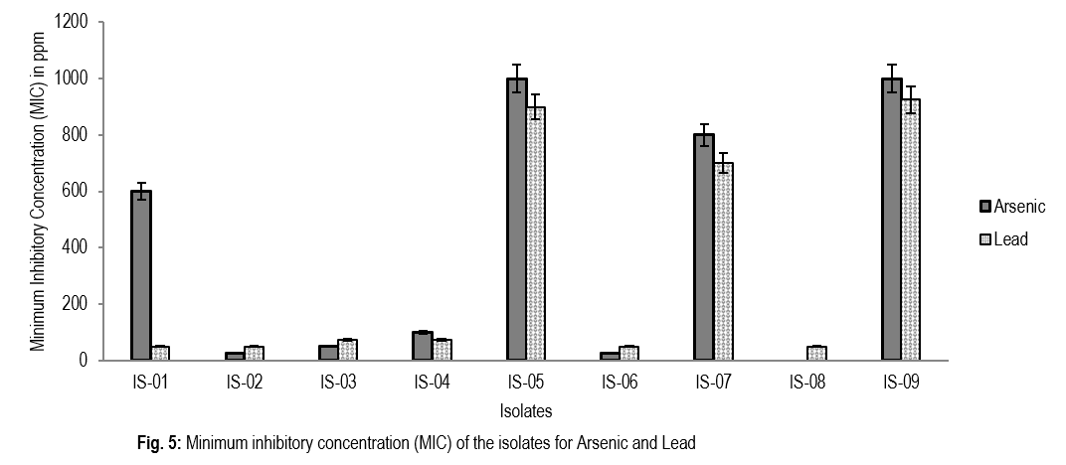
Fig. 3: Minimum inhibitory concentration (MIC) of the isolates for Arsenic and Lead
  - Antibiotics sensitivity and resistance pattern of isolated bacteria
Response pattern of two isolates to antibiotic resistance test are presented in Table. 3. Both the isolates were found resistant towards Methicilin (30µg). Pseudomonas fluorescens showed susceptibility to Ceftriaxone and Ofloxacin but found resistant towards Kanamycin and Amikacin whereas, Bacillus sp was found susceptible to Amikacin (Table 3). Multiple antibiotic resistance behavior along with metal tolerance in isolated microbes of present study was expected as per hypothesized results.
Table 3: Antibiotic disc assay for sensitivity/resistance pattern study of screened isolates

Antibiotic name | Antibiotic Symbol | Disc content  (µg) | Inhibition zone (mm)  Isolates
 |  |  | IS-05  (Bacillus sp) | IS-09 (Pseudomonas fluorescens)
Amikacin | AK | 30 | 21 | 15
Ampicillin | AMP | 25 | 9 | 10
Amoxicillin | AMC | 10 | 24 | 11
Aztreonam | AT | 50 | 16 | 16
Ceftriaxone | CTR | 30 | 14 | 30
Gentamicin | GEN | 50 | 24 | 4
Methicilin | MET | 30 | NI | NI
Norfloxacin | NX | 5 | 17 | 4
Tetracycline | TE | 30 | 20 | 9
Kanamycine | K | 5 | 9 | NI
Ofloxacin | OF | 5 | 21 | 30
Vancomycin | VA | 5 | 16 | 4
(Where, NI means no inhibition zone; diameter of each antibiotic disc is 6 mm)

  - Sole C-substrate utilization versatility test for the isolates
Sole carbon utilization responses by two tolerant isolates are presented in Fig. 4. All the 31 carbon sources further belong to six broad guilds or groups (Amines, Carbohydrates, Complex carbon sources, Carboxylic acids, Amino acids and Phosphate carbon). Both the isolates were found to have complex carbon sources utilization capacity which was evident from the purple coloration in the well of Tween 40 (Cell number-C1), Tween 80 (Cell number-D1), α-cyclodextrin (Cell number-E1) but with an exception for glycogen which was not utilized by IS-09. IS-05 was very poor in terms of amines (Phenylethyl-amine and Putrescine) utilization while IS-09 used Phenyl ethyl amine but Putrescine remained unutilized by it. IS-09 was more efficient in utilizing Carbon substrates of carbohydrates group in comparison to IS-05. IS-05 did not utilize N-Acetyl-D-Glucosamine, D-Glucosamic acid and Glucose-1-Phosphate (Fig. 4).
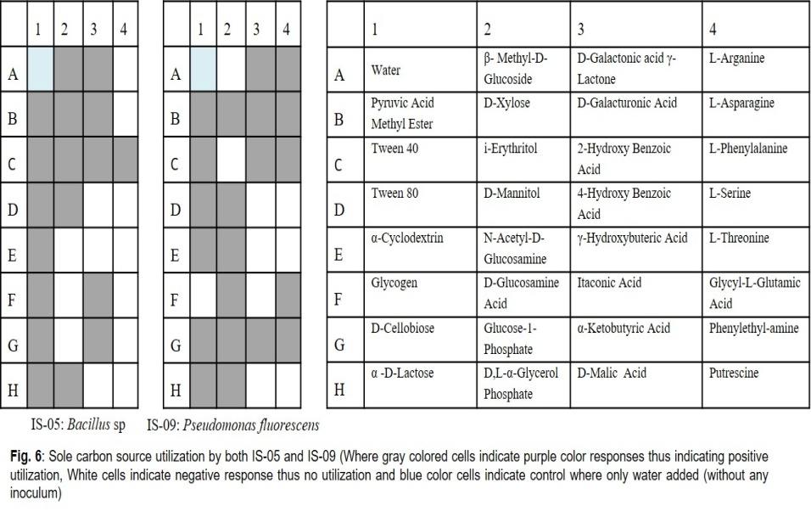
Fig. 4: Sole carbon source utilization by both IS-05 and IS-09 (Where ‘gray’ colored cells indicate purple color response in actual in the BIOLOG plate thus, indicating positive utilization, ‘white’ cells indicate negative response thus, no utilization and ‘blue’ color cells indicate control where only water added (without any inoculums)

  - Molecular identification of isolates:
PCR amplicons of 16S rDNA of different isolates (Fig. 5a) were sequenced and aligned through BLAST for further analysis. The BLAST analysis depicts that IS-05 has a matching query percentage of 97.17 % with Bacillus sp. strain JBT18S (Gen Bank Accession number: MH598524.1) (Fig. 5b). The IS-09 was confirmed as Pseudomonas fluorescens through biochemical and fluorescence properties.
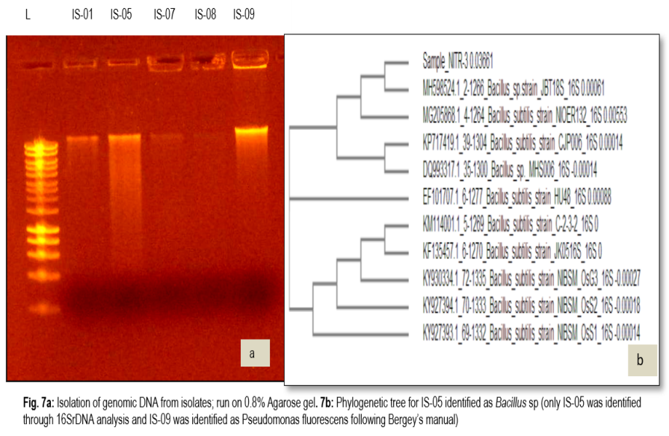
Fig. 5a & 5b: Isolation of genomic DNA from isolates; run on 0.8% Agarose gel and Phylogenetic tree for IS-05 identified as Bacillus sp (only IS-05 identified through 16S rDNA analysis and IS-09 was identified as Pseudomonas fluorescens following Bergey’s manual) respectively
  - Bio remedial capacity
The results for the bio remedial capacity of the two identified isolates for Arsenic and Lead are presented in Fig. 6. IS-05 showed the maximum bioremediation (93%) for Arsenic followed by IS-09 with 86% capacity. Whereas, IS-09 showed maximum remediation capacity (88%) for Arsenic followed by IS-05 (82%) for Lead.
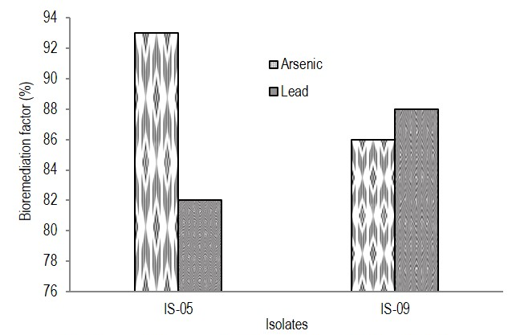
Fig. 6: Bioremediation capacity for Arsenic and Lead by IS-05 and IS-09
- Discussion:
Bokaro thermal power plant and nearby area is considered as ‘Toxic hotspot’ as the soil nearby contains multiple heavy metals in highly toxic range. Thus, Bokaro was selected as sampling site with a hypothesis behind i.e., the long-term exposure with multiple heavy metals will lead to develop tolerance to many indigenous bacteria present in soil of this area. Although a very minute number of total bacteria are present in soil is cultivable yet, the culturable bacterial community are believed to be most active and reported to play a vital role in soil ecosystem including plant growth promotion and biogeochemical cycling which also includes transformation of heavy metals in the nature. Exploring such important functional group of microbes from the microbial habitats having the history of containing elevated level and diverse types of heavy metals has an important implication of microbial heavy metal tolerance (Gupta et al., 2012). Exploration and exploitation of such metal hyper accumulating microbes can be applied for removal/concentration of heavy metals from mine tailings, industrial effluents or can also potentially be used for remediation of contaminated environment either may be soil or water. There are many such scientific reports which reported about application of different aerobic bacteria isolated from contaminated sites for accumulating different heavy metals like Nickel (Ni), Silver (Ag), Cobalt (Co), Cadmium (Cd), Copper (Cu), Chromium (Cr). Microbe-based bioremediation techniques show potential for their ability to transform heavy metals to lesser toxic forms and thus detoxify certain contaminants. In one way it is environment friendly and less expensive. Thus, in the present study the isolated microbes may have immense potential for heavy metal bioremediation which was further assessed.
IS-05 and IS-09 were found to have good range of tolerance towards Arsenic and Lead. As those isolates were isolated from Bokaro thermal power plant site, thus getting such tolerant microbes were as per the hypothesis only. Metal contaminated environment exert selective pressure on soil/aquatic microbes which results many microbial candidates with induced resistance/tolerance systems to thrive in that toxic environment which clearly follows Darwin’s law of ‘Survival of the fittest’. Thus, evolved metal-tolerant bacteria with pre-exposure history possesses detoxification mechanisms for multiple heavy metals including toxic organic compounds (Nath et al., 2019) and most of the cases, this tolerance ability is plasmid regulated. In the present study, findings demonstrate that Pseudomonas sp. and Bacillus sp. is such tolerant microbial candidate which can withstand a high level of toxic heavy metals present as environmental contaminant. Similar type of heavy-metal tolerance and antibiotic resistance by Pseudomonas sp. and Bacillus sp. are also reported by Nath and co-workers (2019).
The mechanisms behind such tolerance are like vertical inheritance, gene duplication, horizontal transfer of genes, and mutation are major causes which are involved in the process of heavy metal(loid) resistance genes evolution in metal contaminated environments (Hao et al., 2021) either it may be water or soil or air. Hao et al (2021) described that heavy metal(loid)s provide a selective advantage for resistant populations which help the thriving of specific populations. The resistance determinants acquired in the exposed and surviving populations can possibly percolate down to next generations, and resulting in abundant resistant microbes in the polluted environment. That’s how the soil sample from Bokaro thermal power plant was found to have good bacterial candidates which potentially can be utilized for bioremediation purposes. Similar kind of instances are reported by Hemme and his coworkers (2010) where Rhodanobacter, isolated from uranium contaminated ground water was reported to have overabundance of multiple genes encoding multiple heavy metal/(loid) resistance behavior. The two isolates of present study viz., Bacillus sp and Pseudomonas fluorescens have shown high level of tolerance against Arsenic and Lead.
Multiple antibiotic resistance behavior alongwith metal tolerance in isolated microbes of present study were expected and as per hypothesis only. Very often this kind of simultaneous expression of heavy metal and antibiotic resistance gene gets expressed because of co-selection process of exposed toxic environment and Dhanaraniet al (2016) reported similar findings in Bacillus sp and Pseudomonas fluorescens and explained as because of the co-selection process of toxic environment as resistance behavior towards metals is often linked with a good array of antibiotic resistance. Similar line of findings is also reported by many researchers (Pandit et al., 2013). Genes responsible for antibiotic resistance are often co-regulated by heavy metal ions which increase resistance to many antibiotics and decrease susceptibility (Zhaiet al., 2016). Thus antibiotic resistance and susceptibility test often helps in isolation of heavy metal resistant microbes from heavy metal polluted environmental samples.
Additionally, heavy metal tolerant candidates are often found to have wide versatility of carbon substrates utilization, thus observed the similar trend for IS-05 and IS-09 also. In fact, the heavy metal stress to the isolates induces forced utilization of versatile group of C substrates. Similar finding was reported by Huang and his coworkers that heavy metals stress in soil microbes induces the utilization of carbon sources by rhizosphere microorganisms (Huang et al., 2018).16S rDNAbased sequencing and identification of unknown bacteria is one of the robust technique to be sanguine about the isolates. The isolates were confirmed as Bacillus and Pseudomonas species and these two species are most commonly reported and cultivable bacteria present in soil and also possess more tolerance to different toxic substances including heavy metals (Nath et al., 2019). Both the isolates from present study showed considerably good bioremedial capacity for both Arsenic and Lead which are two toxic heavy metals and have ill effect on human health. In fact, Pseudomonas fluorescens is known to be as efficient candidate for industrial pollutant detoxification and multi-heavy metal tolerance (Sharma et al., 2016). The known reason behind the tolerance or detoxification capacity is because of catabolic versatility, capacity to produce antifungal metabolites and wide variety of extracellular enzyme production and the reason behind this fact is that, a group of proteins gets expressed in Pseudomonas when exposed to heavy metal containing environment (Sharma et al., 2016) which is responsible for such heavy metal tolerance properties. Majorly the remediation mechanism by Pseudomonas is reported as biosorption. In fact, the first patent for a biological remediation agent was registered in 1974, being a strain of Pseudomonas putida that was able to degrade petroleum. Thus, showing good tolerance level to Arsenic and lead by Pseudomonas fluorescens (IS-09) is not an exception and thus can be used as remediation candidate. Isolated Pseudomonas was found to show 88% and 86% bioaccumulation capacity for Arsenic and Lead respectively which may be because, the isolates were already pre-exposed with heavy metal polluted environment i.e., Bokaro Coal Mines area of India. The IS-05 (Bacillus sp) was also found to have good bioaccumulation capacity for both Arsenic and Lead. Mostly Bacillus sp produces good amount of exo-polysaccharides (ESP) which helps in biosorption of multi metals. Different negatively charged functional groups viz., carboxyl, hydroxyl and phosophoryl are present in bacterial cell wall which absorbs metal cations by electrostatic interaction, van der Waals forces, covalent bonding or combinations of these processes. The extra chromosomal genetic material of bacteria which is also known as plasmids or transposons, contain multiple metal resistance genes. Also, both the isolates have shown resistance to multiple antibiotics, wide catabolic versatility and a good level of tolerance to Arsenic and Lead which are very toxic heavy metals.
- Conclusion
The isolates from present investigation have shown high capacity to tolerate Arsenic and Lead. Bioprospecting of these bacteria and specially application as immobilized form to contaminated sites can potentially offer a good way of bioremediation. Thus, these isolates can further be utilized for bioremediation of contaminated soil, water of coal mines or related polluted sites having contamination with toxic heavy metals. By virtue of owing this metal bio remedial properties, it could be used as pure culture or consortium to apply to the contaminated environment or it may also be genetically manipulated to increase the rate and efficiency of metal removal capability. This approach is cost effective and sustainable with least negative effects on environment as compared with other conventional chemical and physical processes of remediation.

# Both contributed equally and are to be considered as first author

Declaration of Conflicts of interest/Competing interests (include appropriate disclosures):
Authors declare that enclosed manuscript has not been published or submitted for publication elsewhere and there is no conflict of interest for the data presented in this paper.

Disclaimer (Artificial intelligence)

Option 1:

Author(s) hereby declare that NO generative AI technologies such as Large Language Models (ChatGPT, COPILOT, etc.) and text-to-image generators have been used during the writing or editing of this manuscript.

Option 2:

Author(s) hereby declare that generative AI technologies such as Large Language Models, etc. have been used during the writing or editing of manuscripts. This explanation will include the name, version, model, and source of the generative AI technology and as well as all input prompts provided to the generative AI technology

Details of the AI usage are given below:

1.Authors declare about AI was not used for writing, explaining the MS or for any other related activities for this MS.

2.

3.

References:

Alhumaimess MS, Alsohaimi IH,Alqadami AA, Kamel MM, Naushad M, Ahamad T and AlshammariH (2019). Synthesis of phosphorylated raw sawdust for the removal of toxic metal ions from aqueous medium: adsorption mechanism for clean approach.J. Sol. Gel. Sci. Techno.89: 602–615.

Bergey DH, Harrison FC, Breed RS, Hammer BW and Huntoon FM (ed., 1923).Bergey's Man. of Deter.Bacteriol.

David A. Roberts., Nicholas A. Paul., Michael I. Bird., Rocky de Nys. (2015). Bioremediation for coal-fired power stations using macro-algae. Journal of Environmental Management,153, 25-32, https://doi.org/10.1016/j.jenvman.2015.01.036.

Dhanarani S, Viswanathan E, PiruthivirajP, ArivalaganP and KaliannanT (2016). Comparative study on the biosorption of aluminum by free and immobilized cells of Bacillus safensis KTSMBNL 26 isolated from explosive contaminated soil. J Taiwan. Inst. Chem. Eng.69:61–67.

Gupta Kamala, Chitrita Chatterjee, Gupta Bhaskar (2012). Isolation and characterization of heavy metal tolerant Gram-positive bacteria with bioremedial properties from municipal waste rich soil of Kestopur canal (Kolkata), West Bengal, India. Biologia.67(5): 827-836.

Hao Xiuli, Zhu Jiaojiao, Rensing Christopher Liu, Ying Gao, Shenghan Chen, Wenli Huang, Qiaoyun Liu, Yu-Rong (2021). Recent advances in exploring the heavy metal(loid) resistant microbiome. Comput. Struct.Biotechnol. J.19:94–109.

Hemme CL et al (2010). Metagenomic insights into evolution of a heavy metalcontaminatedground water microbial community.ISME. J.4(5):660–72.

Huang L (2018). Shift of soil bacterial community and decrease of metals bioavailability after immobilization of a multi-metal contaminated acidic soil by inorganic-organic mixed amendments: A field study. Appl. Soil. Ecol.130:104-119.

Kumar, A., Chanderman, A., Makolomakwa, M., Perumal, K., Singh, S., 2016. Microbial production of phytases for combating environmental phosphate pollution and other diverse applications. Crit. Rev. Environ. Sci. Technol. 46, 556–591. http://dx.doi.org/10.1080/10643389.2015.1131562

Ministry of Power, GOI (2020). https://powermin.nic.in/en/content/power-sector-glance-all-india.

Nath S, P Paul, R Roy S,Bhattacharjee and B. Deb(2019).Isolation and identification of metal‑tolerant and antibiotic‑resistant bacteria from soil samples of Cachar district of Assam, India.S.N. Appl. Sci.1: 727.

Pandit RJ,Patel B, KunjadiaandPD, Nagee A(2013). Isolation, characterization and molecular identification of heavy metal resistant bacteria from industrial effluents, Amala-khadi- Ankleshwar, Gujarat. Int. J. Env. Sci.3:1689-1699.
PrabhukarthikeyanSR, KarthikeyaG, Raghuchander T (2015). Biochemical characterization of fluorescent pseudomonads from turmeric rhizosphere. Biochem Cell. Arch.15(1): 299-303.

Raghunandan, K., Kumar, A., Kumar, S., Permaul, K., Singh, S., (2018). Production of gellan gum, an exopolysaccharide, from biodiesel-derived waste glycerol by sphingomonas spp. 3Biotech 8, 71, http://dx.doi.org/10.1007/s13205-018-1096-3.

Raghunandan, K., McHunu, S., Kumar, A., Kumar, K.S., Govender, A., Permaul, K., et al., 2014. Biodegradation of glycerol using bacterial isolates from soil under aerobic conditions. J. Environ. Sci. Heal. A Tox. Hazard. Subst. Environ. Eng. 49, 85–92. http://dx.doi.org/10.1080/10934529.2013.824733.

Sabol Jozef (2020). Major Analytical Methods for Determining Lead in Environmental and Biological Samples Lead in Plants and the Environment. Book chapter. ISBN : 978-3-030-21637-5., Springer nature

Sambrook J,Maccallum P and Russell D (2001). Molecular Cloning: A Laboratory Manual. 3rd. Cold Spring Harbor Press, NY, 2001. 2344 p. ISBN 0-87969-577-3.

Sanjay MS, Sudarsanam D, Raj GA et al (2020).Isolation and identification of chromium reducing bacteria from tannery effluent. J. King. Saud. Univ. Sci.https://doi.org/10.1016/j.jksus.2018.05.001

Sharma S, Sundaram CS, Luthra PM, Singh Y, RSirdeshmukh and GadeWN(2016). Role of proteins in resistance mechanism of Pseudomonas fluorescens against heavy metal induced stress with proteomics approach. PMID. DOI: 10.1016/j.jbiotec.2006.04.032.

Singh, S., Gupta, V.K., 2016. Biodegradation and bioremediation of pollutants: perspectives strategies and applications. Int. J. Pharm. Biol. Sci. 10, 1, 53.

Zhai Y, He Z, Kang Y, Yu H, Wang J, Du P,Zhang Z, Hu S and Gao Z (2016).Complete nucleotide sequence of pH11, an IncHI2 plasmid conferring multi-antibiotic resistance and multi-heavy metal resistance genes in a clinical Klebsiella pneumoniae isolate. Plasmid.86:26-31.

Zhang C, Nie S, Liang J, Zeng G, Wu H, Hua S, Liu J, Yuan Y, Xiao H andDeng L (2016). Effects of heavy metals and soil physicochemical properties on wetland soil microbial biomass and bacterial community structure. Sci.Total. Environ.557:785–790.

