**ORIGINAL RESEARCH ARTICLE**

**Multidrug Resistance in Uropathogens Isolated from University Students with Bacteriuria in Enugu State, Nigeria**

**ABSTRACT**

Urinary tract infections (UTIs) among university students and increasing antimicrobial resistance are global public health concerns with its burden higher in developing countries of the world; resulting in high morbidity and mortality rate. Multidrug resistance (MDR) to virtually all available antibiotics has been observed among uropathogens and their susceptibility patterns differ per individual. This study was undertaken to determine MDR of bacteria uropathogens from 460 undergraduate students (209 males and 251 females) in a higher institution at Enugu State, Nigeria. This cross sectional study determined the susceptibility patterns of 160 bacteria isolates from the urine culture of 460 apparently healthy undergraduate students at Renaissance University, Enugu State, Nigeria; who were randomly selected, using Kirby Bauer disc diffusion method. Multiple Antibiotic Resistance (MAR) index was determined. Demographic data were collected using pre-designed questionnaire. Data was analyzed with SPSS version 22 (percentages, chi square test) and statistical significance was determined at ≤0.05. All *Klebsiella* species, *Enterobacter hormaechei*, *Providencia alcalifaciens* and *Citrobacter freundii* showed 100% resistance to cefotaxime, a third generation cephalosporins. Isolates showed highest sensitivity to fluoroquinolones such as ofloxacin (94.4%), levofloxacin (86.9%), followed by gentamicin (78.1%) and nitrofurantoin (70.6%). Conversely, high resistance was recorded for third-generation cephalosporins like cefotaxime (90.6%), and β-lactam combinations such as ceftriaxone-sulbactam (74.4%), followed by imipenem/cilastatin 118 (73.6%). The prevalence of MDR in this study was 152(95%) and the association between bacterial isolates and MDR is statistically significant (*P*= 0.000). The MAR indices obtained for all bacteria isolates were >0.2. One hundred and thirty nine (30.2%) students have been previously exposed to antimicrobial agents and 53(31.2%) were positive for UTI. There is a significant association between prevalence of UTI and previous exposure to antimicrobial agents (*P*= 0.013). Findings underscore the need for targeted surveillance, individualized antibiotic therapy, and antimicrobial stewardship programs within university communities.

**Key words**: Bacteriuria, Multidrug resistance, MAR index, Urinary tract infection, Uropathogens

**1. INTRODUCTION**

The resistance of uropathogens to antibiotics has been known to increase globally, especially to commonly used antibiotics. Also, the patterns of resistance of these pathogenic organisms vary over short periods of time depending on the site of isolation and different environmental conditions (Alemu *et al.*, 2012). Since asymptomatic UTIs occur in apparently healthy population without any clinical signs and symptoms of UTI, therefore assessment of asymptomatic bacteriuria (presence of significant numbers of bacteria in urine) is crucial in this population because it is a strong criterion for predicting UTI (Alao and Akintunde, 2012 and Nsofor *et al*, 2016). Normally, apparently healthy students may not see the need to visit the clinic because of absence of any clinical signs and symptoms of ailment. Notwithstanding, the fact remains that they may be carriers of infections and could transmit same to other vulnerable members of the community.

Treatment is vital once asymptomatic UTI is detected in undergraduates of universities since such individuals hardly visit the clinic except they are sick. Treatment involves the use of antibiotics; which are among the most frequently prescribed drugs in tertiary hospitals. Resistance of uropathogens to these antibiotics has been reported (Alemu *et al.*, 2012, Akinjogunla and Divine-Anthony, 2013; Onyebueke *et al*., 2020; Ekeng *et al.*, 2021). Resistance to antibiotics occurs when the agent loses its supposed antimicrobial properties; and gives rise to therapeutic failures observed in clinical and community settings (Eezzeldin *et al.* 2022).

Multidrug resistance (MDR) is the in vitro non-susceptibility to at least one drug in more than two classes of antimicrobial agents(Magiorakos *et al*., 2012). Multidrug resistance has become an emerging threat due to misuse of antibiotics (involving incorrect prescription, incorrect dosing, self-medication and other factor like incorporating antibiotics in animal feed) within the past several years (Chaudhary and Mahadeva, 2013; Khan *et al*., 2020; Akhter and Rizwan, 2021; Kasew *et al*., 2022). Worldwide data show that there is increasing resistance among urinary tract pathogens to conventional drugs (Alemu *et al*., 2012; Alo, *et al* 2015; Donkor *et al*., 2019). Multidrug resistance is raising a serious public health concern leading to increased mortality and morbidity (Dehbanipour *et al*., 2016; Sadeghi *et al.*, 2023). Research findings reported that the high consumption and inappropriate use of antibiotics combined with crowding multiple pathology and frequent use of invasive devices are factors contributing to high levels of resistance (Iroha and Ayogu, 2011; Chaudhary and Mahadeva, 2013). These resistant properties to antibiotics are most often observed in hospital settings, although they are still seen in community acquired UTI; with an increasing presence of Gram positive cocci like Staphylococci and Gram negative organisms like *Klebsiella* becoming more frequent (Onoh *et al.,* 2013, Onanuga *et al*., 2020; Nwankwo *et al*., 2025). Self-medication, empirical therapy, misuse, and overuse of antimicrobials which are highly practiced in Nigeria, has been reported to hasten antimicrobial multidrug resistance and end up in prolonged illness, disability, increased health care costs, and reduced lifespan/death (Khan *et al.,* 2020; Uddin *et al*, 2021; Eezzeldin *et al*.; 2022; Kasew *et al*., 2022). However in Nigeria, the Federal Ministries of Health, Agriculture and Environment has keyed into the global action plan to contain antimicrobial resistance (Federal Ministries of Health, Agriculture and Environment, 2017); with mapped out strategies and policies for antimicrobial stewardship programmes but the problem lies with the implementation in low and middle countries, Nigeria inclusive (Rolfe *et al*, 2021; Chukwu *et al*., 2024).

Administration of antibiotics to which an etiologic agent isolated from a patient is resistant, would be purely a waste of time, money, resources; and will result to complications which can be fatal. To ensure appropriate therapy, current knowledge of the organisms that cause UTI and their antibiotic susceptibility pattern is mandatory. It appears that limited antibiotic resistance patterns of uropathogens has been done in Enugu State and literature data is sparse on the current antibiotic resistance patterns of uropathogens among apparently healthy undergraduates who may be potential carriers of infections including UTI in the study area. Therefore, periodic evaluation of antibiotic activities is needed to update information (Alemu *et al.*, 2012; Onanuga *et al.*, 2020) on appropriate antibiotics to be used as an empirical treatment regime in the study area.

**2. MATERIALS AND METHODS**

**2.1 Study Site**

The study was conducted at Renaissance University Ugbawka, Enugu State Nigeria. The analysis of specimens, Biochemical Identification and antimicrobial susceptibility testing were done at the Microbiology Laboratories of Renaissance University, Enugu and Paul University, Awka, Anambra State.

**2.2 Study Design and Ethical Approval**

This study was a descriptive cross sectional study carried out from May to July, 2024. Ethical clearance was obtained from Research and Development Committee of Renaissance University Ugbawka, Enugu State. Informed consent was obtained from each student without coercion before administration questionnaire on previous antibiotics exposure and subsequent collection of specimens. The students were informed that they should be free to decline without any negative consequences. The participants were clearly made to understand how the urine will be collected and that there is no potential risks or benefits. They were informed that the data obtained will remain confidential and only shared with individuals who are authorized and solely for research purposes. The identity of the participants was anonymous.

**2.3 Study Population**

The study population comprised of apparently healthy undergraduates of Renaissance University Ugbawka (RNU), Enugu State, Nigeria.

**2.4 Inclusion Criteria**

The study participants included those who have not taken antibiotics within 2 weeks before the commencement of specimen collection and also are willing to participate in the study.

**2.5 Exclusion Criteria**

The students who were on antibiotics therapy or have taken antibiotics within two weeks of the sample collection and did not give their consent were excluded from the study.

**2.6 Specimen Collection and Processing**

The undergraduate students who declared interest to participate in the study were counseled on how to collect midstream voided urine (which involves the initial cleaning of the urethral area with clean water) while maintaining asepsis and the importance of adopting the procedure to the study. The students were given sterile leak-prof, disposable containers early in the morning before specimen collection to ensure that early morning urine was collected which is more concentrated and suitable for urine examination to determine the state of the urinary tract (Milani and Jialal, 2023). Clean-catch midstream (early morning) urine specimens were used for the study. The specimens collected were transported to the Microbiology laboratory of the university in specimen box containing ice pack (Emiru *et al.,* 2013) and laboratory analysis was undertaken within 1-2 hours of collection (Cheesbrough, 2006; Onoh *et al.,* 2013; Kabugo *et al.*, 2016). At some occasions where immediate processing was not possible, the specimens were refrigerated promptly at 40C to avoid multiplication of bacterial at room temperature (Oyagade *et al.,* 2004, Cheesbrough, 2006). The specimens were cultured on Cystine Lactose Electrolyte Deficient (CLED) with standard wireloop method according to standard practice as reported by Nwankwo *et al*. (2025). The isolated uropathogens were identified using standard Microbiological and molecular methods which have been extensively reported in Nwankwo *et al*., (2025).

**2.8 Antibiotics Susceptibility Testing**

Antimicrobial susceptibility testing was done on all isolates with modified Kirby-Bauer disc diffusion method using commercial discs on Mueller-Hinton agar (MHA) as described by Cheesbrough (2006). Antibiotic sensitivity discs manufactured by Celtech Diagnostic was purchased at Idumota Medical market, Lagos State. The potency of the discs and Interpretive Criteria based on the descriptions of Clinical Laboratory Standard Institute (CLSI, 2021) is shown in Table 1. The antibiotic agents as contained in the Celltech discs were from five different test/report groups according to CLSI, (2021). The antibiotics were selected because they have broad spectrum of activities against both Gram positive and negative bacteria and are reported as the agents that could be used in treatment of UTI (CLSI, 2021). The drugs are among the commonly used antibiotics in empirical treatment of infections in the study area. The groups and selected antimicrobial agents include: Aminoglycosides: (gentamycin); Cephems/cephalosporins:parenteral: (cefotaxime (also oral),oral: cefuroxime, cefexime); β-lactam combinations: (ampiclox, amoxicillin clavulanate, ceftriazone sulbactam, (imipenem/cilastatin); Fluoroquinolones: (levofloxacin, nalidixic acid and ofloxacin) and Nitrofurans: (nitrofurantoin).

**Table 1: Antibiotic discs, potency and interpretative criteria**

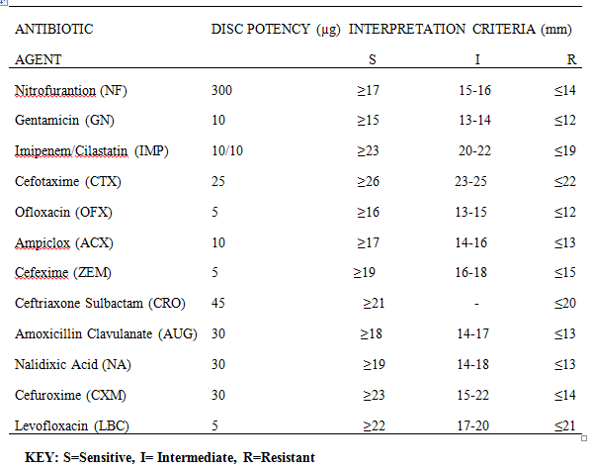

**A** barium chloride turbidity standard (**Equivalent to 0.5 Mc Farland**) was prepared against which the turbidity of the test and control inocula were compared. The inocula should give confluent or almost confluent growth when matched with the standard. The standard was shaken immediately before use.

**2.8.1 Preparation of bacteria inocula**

A sterile wire-loop was used to emulsify part of a colony/colonies (depending on the size ofwell isolated colony) in 3ml of sterile physiological saline (0.90%); and was shaken vigorously.In a good light, the turbidity of the suspension was matched with the turbidity standard (the standard was mixed immediately before used). For comparison of turbidities, both were viewed against a printed sheet of paper/ sheet of white paper with black contrasting lines. The tube containing the test organism was of the same size with the tube containing the Mc Farland standard.

The inoculum was incubated for 4 hours to allow for multiplication of bacteria cells as described by Forbes *et al*, 2007. After incubation, the tube containing the inoculum was again matched with the turbidity standard. If the tube containing the inoculum was more turbid, additional drops of sterile physiological saline was added or additional colony (ies) of the test organism added if the inoculum tube is less turbid; and the tubes incubated again.

**2.8.2 Preparation of media for testing bacteria**

Unsupplemented Mueller Hinton Agar (MHA) was used to test bacteria isolates. MHAwas prepared and sterilized in different batches using manufacturer’s instructions.The media was allowed to cool to temperature of 50-550C, poured into sterile petri dishes and allowed to solidify. The plates were then stored in a sealed plastic bag at 2-80C in a refrigerator.

**2.8.3 Disc diffusion method using Modified Kirby Bauer diffusion method on Mueller Hinton agar**

The procedure adopted was as described by Cheesbrough, (2006). With sterile forceps (which was dipped in 70% ethanol, flamed and allowed to cool), antimicrobial discs was placed, evenly distributed on the inoculated plate (6 discs per plate). Each disc was lightly pressed down to ensure its contact with the agar. Within 30 minutes of applying the discs, plates were inverted and incubated aerobically at 37oC for 18 hours. A control plate was inoculated also without any antibiotic disc, and also incubated. After overnight incubation, control and test plates were examined to ensure the growth is confluent or near confluent. Using a ruler on the underside of the plate the diameter of each zone of inhibition was measured in mm. The endpoint of inhibition was where growth started. At the end of incubation period, it was ensured that all the organisms had grown on the antibiotic-free control plates. Other plates were examined for growth and zones of inhibition. With the interpretative chart, the zone sizes of each antimicrobial agent was interpreted, reporting the organism as ‘Resistant, R’, ‘Intermediate/Moderately susceptible, I’ and ‘Susceptible, I’ according to CLSI, (2021). The intermediate category in this study was accepted as susceptible as stated by (Kowalska-Krochmal and Dudek-Wicher, 2021) who reported that the European Committee on Antimicrobial Susceptibility Testing (EUCAST) recommended: two susceptibility categories (S and I) and one resistance category which have been introduced since January, 2019.Synergistic associations were also observed and noted including double discs and triple discs synergies among the isolates. This association was demonstrated by bridging of zones of inhibition between two or more antibiotics.

**2.8.4 Identification of Multidrug Resistance (MDR), Extensively Drug Resistance (XDR) Pandrug Resistance (PDR) and Multiple Antibiotic Resistance Index (MARI) among Isolates**

Multi Drug Resistance was recorded for uropathogens that were resistant to ≥3 (at least one drug from at least three classes of antimicrobial agents) drugs. (Getachew *et al*., 2012; Alemu *et al*., 2012; Magiorakos *et al*., 2012). Extensively Drug Resistant bacteria isolates were identified when the isolates were resistant to at least one agent in all but two or fewer antimicrobial classes. In other words XDR bacterial isolates remain susceptible to only one or two classes (Parajuli *et al*., 2017). An isolate that was resistant to all antimicrobial agents tested was referred to as Pandrug resistant (Magiorakos *et al*., 2012).Multiple Antibiotic Resistant Index was calculated as the ratio between the number of antibiotics that an isolate was resistant to and the total number of antibiotics the organism was exposed to in the study (Sandhu *et al*., 2016).

**2.9 Quality Control**

Standard operating procedures were carried out for laboratory analyses. Student’s data on previous antibiotics exposure were collected with predesigned questionnaire. Culture media were tested for sterility and performance by incubating selected plates without specimen inoculation for each of the batches at 37°C for an overnight period. The bacterial suspension’s turbidity was adjusted to achieve the 0.5 McFarland level to meet the standard for performing a drug susceptibility test.

**Statistical analysis**

Data were coded, entered and analyzed using Statistical Package for Social Science (SPSS), version 22. Study findings were explained in words and tables. Results/ proportions for categorical variables were compared using percentages and Chi square. In all cases, P-value ≤ 0.05 was taken to be statistically significant.

**3. RESULTS**

Out of the 460 specimens examined, one hundred and sixty bacteria pathogens were isolated. The prevalence, colony morphological characteristics, biochemical and molecular characteristics of the isolated uropathogens have been reported (Nwankwo *et al*., 2025).

The susceptibility patterns of some bacteria isolates are shown in Figure 1 with double disc synergy between levofloxacin and nalidixic acid for *K. pneumoniae*. Synergistic association between antibiotics were observed among 39(24.4%) isolates with 12(30.8%) out of the 39 showing synergistic association in 3 or more antibiotics. A strain of *S. aureus* with the code (10F) was sensitive to all antibiotics used while another strain of *S. aureus* with the code 70FA was resistant to all but one antibiotic (ofloxacin). The result of susceptibility showed that each isolate has a specific antibiogram even those of the same species.

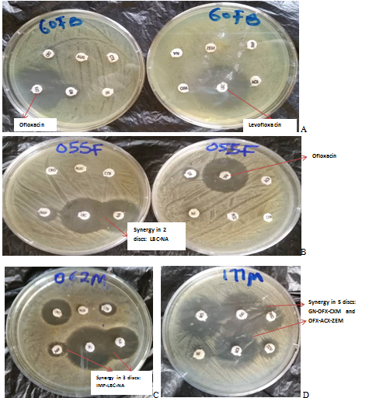

**Figure 1: Susceptibility patterns of some isolates on Mueller Hinton agar. A: *Pseudomonas aeruginosa* with green pigments on the media, susceptible to ofloxacin and levofloxacin only. B: *Klebsiella pneumoniae* susceptible to levofloxacin, nalidixic acid and ofloxacin demonstrated synergy (bridging of zones of inhibition) between levofloxacin (LBC) and naliixic acid (NA), C: Another strain of *Klebsiella pneumoniae* with synergy from down left: imipenem (IMP), LBC and NA,. D. *Enterobacter aerogenes* strain ps-3 with synergy ftom top left: gentamycin (GN), OFX, cefuroxime (CXM), ampiclox(ACX)and cefexime (ZEM).**

**Susceptibility Patterns of all Bacteria Isolates Against Different Classes of Antibiotics**

*Klebsiella pneumoniae, K. quasipneumoniae*  *and K. pneumoniae subsp pneumoniae* isolated in this study showed gross 100% resistance to cefotaxime, a third generation cephalosporin but were sensitive to ofloxacin (97.1% and 100% each for *K. quasipneumoniae*  *and K. pneumoniae subsp pneumoniaeae*). *K. quasipneumoniae and K. pneumoniae subsp pneumoniaeae* showed also gross 100% resistance to imipenem but *Klebsiella. pneumoniae* demonstrated 79.4% resistance to imipenem. *Providencia alcalifaciens* and *Enterobacter hormaechei* were 100% resistant to cefotaxime but all sensitive to quinolones (ofloxacin and levofloxacin). Majority of the isolates 148(92.5%) among the 160 bacteria isolated were sensitive to ofloxacin while the greatest percentage of resistance of isolates 145(90.6%) was against cefotaxime. Majority of the isolates demonstrated intermediate category of susceptibility to levofloxacin 64(40%). The susceptibility patterns of all bacteria isolates were shown in Figures 2-12.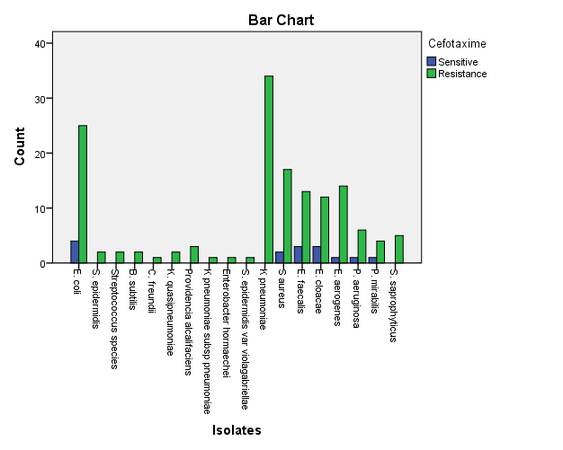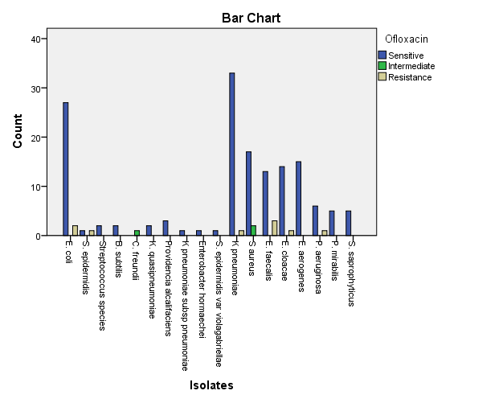

**Figure 2: Susceptibility patterns of isolates to cefotaxime and ofloxacin.**

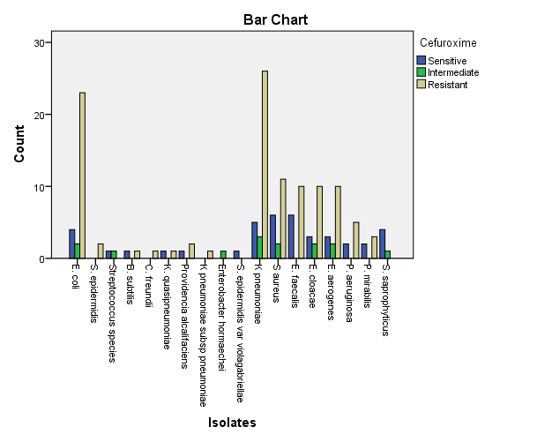

**Figure 3: Susceptibility patterns of isolates to cefuroxime**

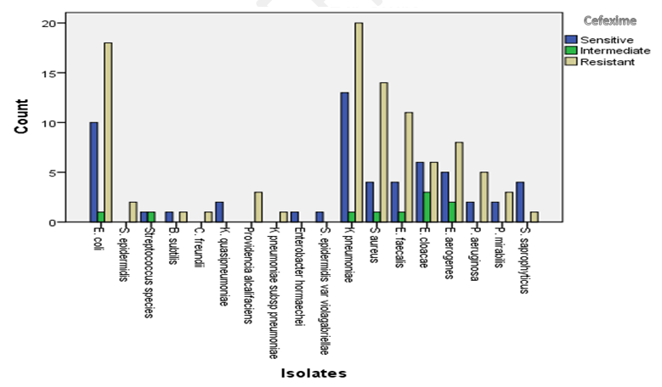

**Figure 4: Susceptibility patterns of isolates to cefexime**

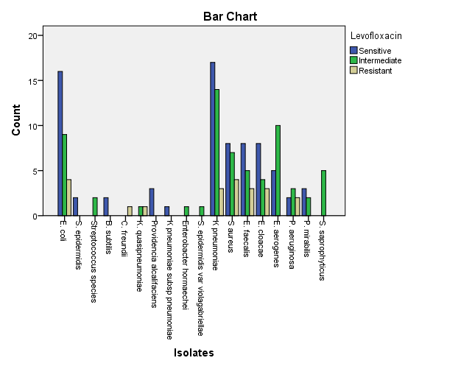

**Figure 5: Susceptibility patterns of isolates to levofloxacin**

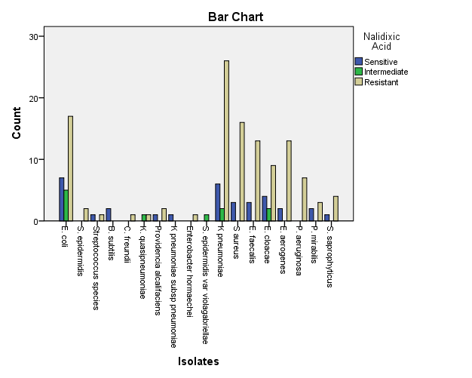

**Figure 6: Susceptibility patterns of isolates to nalidixic acid**

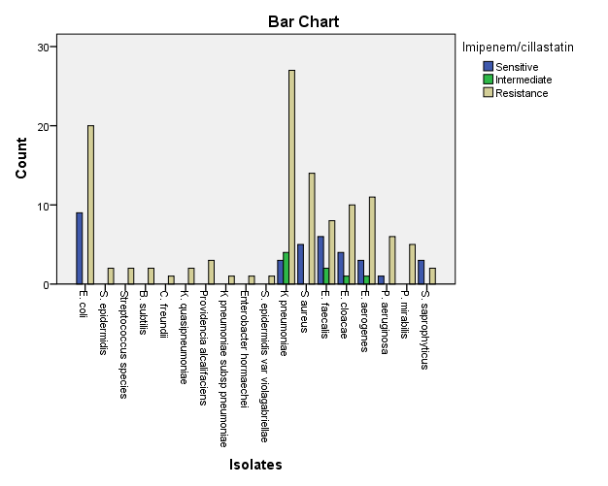

**Figure 7: Susceptibility patterns of isolates to imipenem/cilastatin**

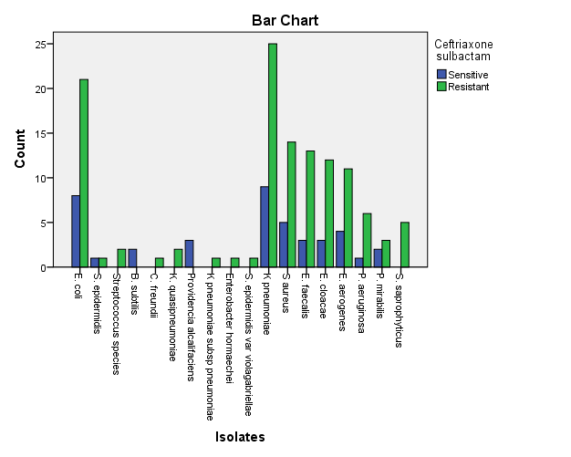

**Figure 8: Susceptibility patterns of isolates to Ceftriaxone sulbactam**

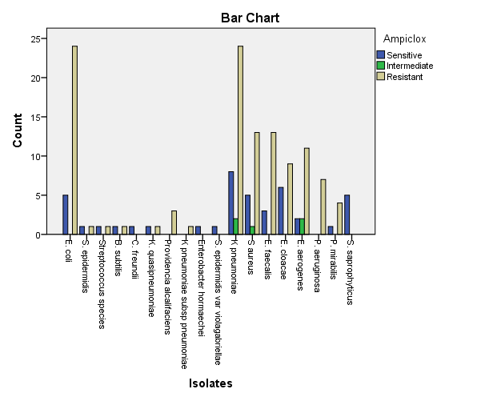

**Figure 9: Susceptibility patterns of isolates to ampiclox**

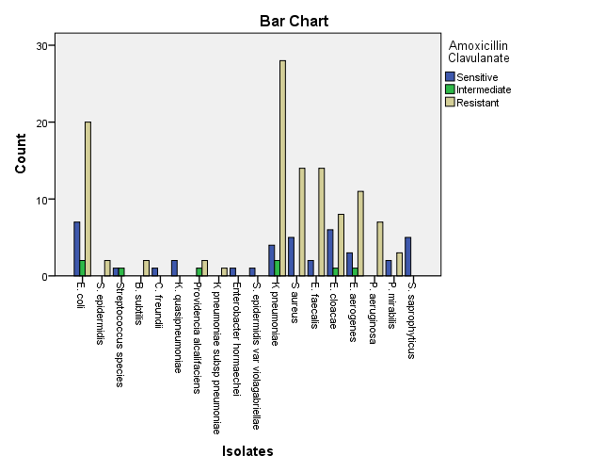

**Figure 10: Susceptibility patterns of isolates to amoxicillin-clavulanate**

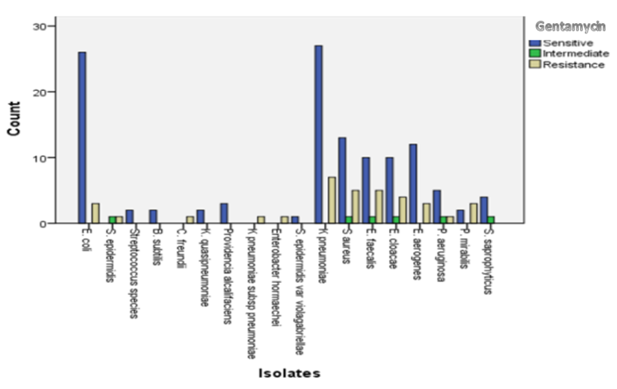

**Figure 11: Susceptibility patterns of isolates to gentamycin**

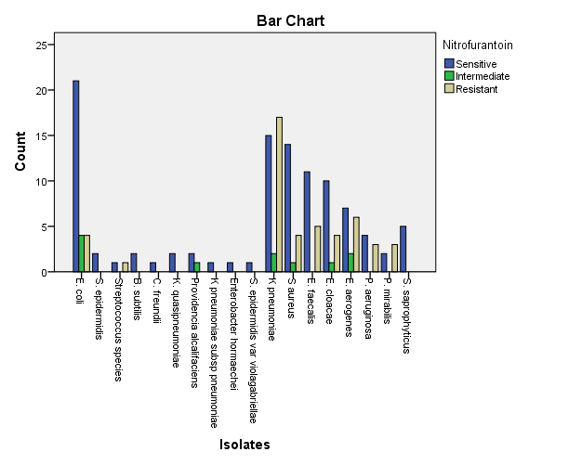

**Figure 12: Susceptibility patterns of isolates to nitrofurantoin**

**Multidrug Resistance Profile and Multiple Antibiotics Resistance Indices** (**MARI**) **of Bacteria Isolates**

The multidrug resistance profiles of uropathogns are shown in Tables 2 and 3, for Gram positive and negative bacteria respectively. *S. epidermidis var violagabriellae*, a Gram positive bacterium showed the least MARI of 0.25 among Gram positive bacteria. Greater percentages of resistance was observed among Gram negative bacteria with MARI from 0.4 to 1.00. All the isolated bacteria genera demonstrated multidrug resistance, at least one drug from at least 3 classes of antibiotics while a total of 152(95%) bacteria species exhibited MDR. Extensively Drug Resistance (XDR) was observed among 4 (2.5%) bacteria isolates, which include a particular strain of *E. coli* (1D N0 196M), and *E. faecalis* (127M) that were resistant to all but nitrofurantoin antibiotics, while *S. aureus* (70FA), and *P. mirabilis* (383M) were resistant to all but one (ofloxacin) antimicrobial agents used. No isolate demonstrated Pandrug Resistance. The MARI for all bacteria isolates are ˃0.2 which depict that the isolates were from environments that has been previously exposed to antibiotics. There is therefore a significant association between the isolates obtained from this study and previous antibiotics exposure (*P*= 0.013).

**Table 2: Multidrug Resistant Profile of Gram Positive Bacteria**

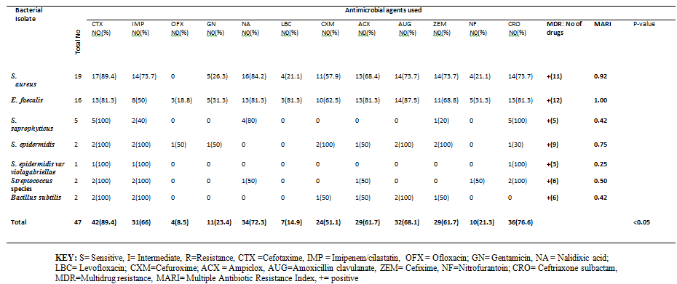

**Table 3: Multidrug Resistant Profile of Gram Negative Bacteria**

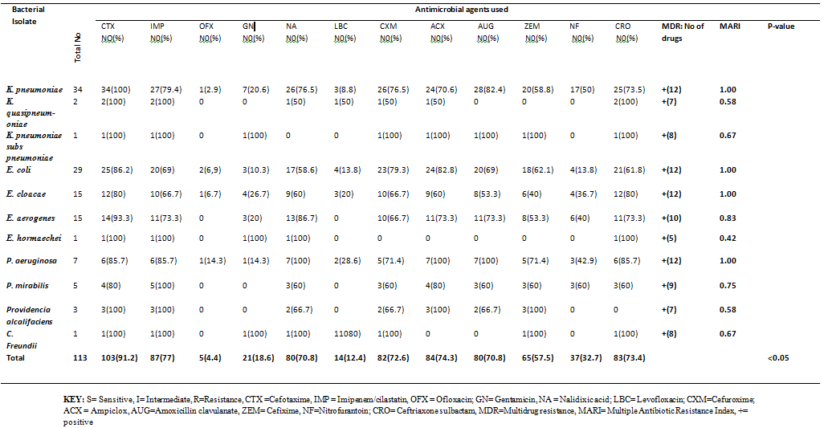

The overall resistance patterns to antibiotics irrespective of bacterial isolate is shown in Table 4. Isolates were most sensitive to ofloxacin 148(92.5%), a quinolone antibiotic but demonstrated highest resistance to cefotaxime 145(90.6%), a third generation cephalosporins. There is significant statistical relation between the susceptibility patterns of isolates and ofloxacin, nalidixic acid, levofloxacin and amoxicillin-clavulanate antibiotics (*P*=0.000, 0.032, 0.036 and 0.003 respectively).

**Table 4: Overall Resistance Patterns to Antibiotics Irrespective of Bacteria Isolates (n=160)**

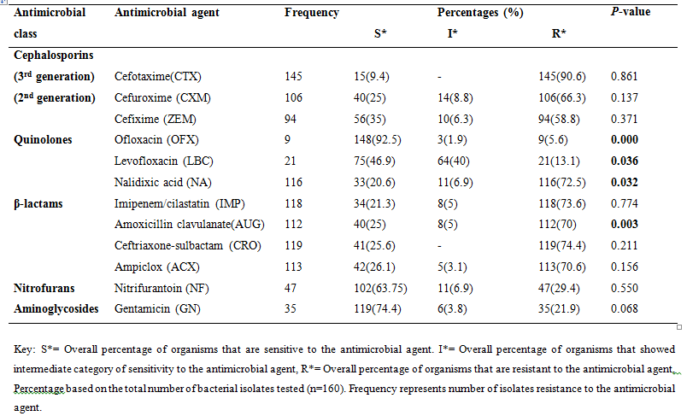

The data obtained from this study showed that 53(31.2%) students out of 170 that showed positive UTI has been exposed previously to antimicrobial agents, hence using McNemar test(Binomial distribution) there is a significant association between UTI prevalence and previous antimicrobial agents exposure (*P*=0.035: Table 5).

**Table 5: Prevalence of UTI among the undergraduates of RNU in relation to previous exposure to antimicrobial agents**



**4. DISCUSSIONS**

Antimicrobial resistance among uropathogens to commonly used antimicrobial agents has been on the increase and this has left clinicians with very few choices/alternatives in the treatment of infection (Mike-Ogburia *et al*., 2023). The result of susceptibility patterns of uropathogens observed in this study is of public health concern since these study subjects comprised also of healthy undergraduates who are potential carriers of infections and could transmit same to vulnerable members of the society. Synergistic effect which implies bridging of zones of inhibition observed in this study indicates that combination of two of more antibiotics will help to combat resistance and improve treatment outcomes. Among the synergistic interactions among antibiotics observed in this study 39(24.3%), two strains of *K. pneumoniae* demonstrated synergistic effect between more than two antibiotics: gentamycin, ampiclox, including quinolones which in agreement with the report that aminoglycosides are often used in combination with β-lactams to treat severe infections by Gram-negative bacteria (Martins *et al.*, 2020). However, the development of various resistance mechanisms against this class of antibiotic is an increasing problem (Martins *et al.*, 2020) and this could be the reason for the deviation that gave rise to increased synergy among the quinolones and other classes of antibiotics in the current study.

The strains of *Klebsiella pneumoniae* and *E. coli* exhibited higher resistance (69 - 100%) to cefotaxime, amoxicillin clavulanate, ampiclox and imipenem, and lower resistance (2.9 – 13.8%) to ofloxacin, gentamicin and levofloxacin. This is consistent with a research finding that reported the antimicrobial susceptibility testing of *K. pneumoniae* and *E. coli* isolates that generally exhibited higher resistance (57 - 95%) to cefotaxime, ceftazidime, cotrimoxazole, and lower resistance (10 - 33%) to chloramphenicol, levofloxacin, and imipenem (Onanuga *et al*., 2020). *Klebsiella pneumoniae* is an important bacterium that causes serious infections in humans, and its symptoms differ depending on the body part affected by the bacteria (Anidiobu *et al*., 2024).

The resistance of two strains of *Klebsiella quasipneumoniae* referred to as emerging pathogen in UTI (Mike-Ogburia *et al*., 2023) isolated from this study is worrisome because of resistance to 8 antibiotics except quinolones and nitrofurantoin. *Enterobacter hormaechei* demonstrated resistance to cefotaxime, imipeneme, nalidixic acid, gentamycin and ceftriaxone-sulbactam; which is closely related with a research finding in Brazil that reported that the organism demonstrated resistance to ceftazidime, ceftriaxone, cefepime, ciprofloxacin and norfloxacin but susceptible to imipenem (Martins *et al*., 2020). *Providencia alcalifaciens* isolated in this current study showed gross 100% resistance to 2nd and 3rd generation cephalosporins, imipenem, ampiclox and 66.7% resistance to nalidixic acid, cefuroxime, and amoxicillin clavulanate and this is consistent with the findings at India that reported resistance of 100% to 3rd generation cephalosporins (Rajini *et al*., 2022). However, the resistance observed in their study findings was higher than observed in the current study for flouroquinolones and β-lactam– β-lactamase inhibitor combinations.

*Staphylococcus aureus*, the most common Gram positive uropatogen, demonstrated the highest resistance to cefotaxime 17(89.4%) followed by nalidixic acid 16(84.2%) and imipenem 14(73.7%) which was higher compared to the report from other research findings at Ghana 17(89.4%) and Nigeria 7(63.6%) respectively for nalidixic acid (Adjei and Adjei, 2025; Okonko *et al*., 2009). All the strains of *S. aureus* were sensitive to ofloxaxin antibiotics and showed the lowest resistance to levofloxacin, nitrofurantoin at 4(21.1%) each, followed by gentamycin at 5(26.3%) and cefuroxime 11(57.9%) which were in disparity with the report at Yola, Nigeria that recorded resistance of *S. aureus* to gentamycin and cefuroxime at 7(77.8%: Godwin *et al*., 2023)

The alarming multidrug resistance (MDR) among uropathogens to commonly prescribed antibiotics has greatly restricted the available drug options for UTI treatment. The overall prevalence of MDR in this study is 152(95%) which is very high compared to those obtained at different Universities in Southern and Northern Ethiopia, and Nigeria among the same study groups: 35 (68.6%), 73% and 70(81.4%) respectively (Fetene *et al*., 2024; Gebremariam *et al*., 2019; Alabi *et al*., 2014). The differences in MDR observed could be as a result of geographic variation and limited activity towards implementation of antimicrobial stewardship (Rolfe *et al*., 2021; Chukwu *et al*., 2024). Multidrug resistance was demonstrated by the 18 species of bacteria isolate, being resistant to at least 1 drug in at least 3 classes of antibiotics as reported by Mushi *et al*. (2014). The isolates demonstrated highest resistance to cefotaxime (90.6%), a third generation cephalosporin. This is an issue of concern because the drug being under the category of last line drugs should have been used in treating infections by pathogens that are resistant to β-lactam antibiotics. A strain from all the isolated species demonstrated multiple antibiotics resistance index (MARI) of ˃0.2 indicating that the isolates have been exposed to antibiotics environment (Dehbanipour *et al*., 2016); and this is consistent with other research findings at Uyo, Enugu and India (Ayandele *et al*., 2020; Martin *et al*., 2018; Sandhu *et al*., 2016) . It was also discovered in the present study that there is a strong association between the isolates and previous antibiotics exposure among the students (P=0.013). It has been reported that anything that disturbs the vaginal flora would result in conditions favouring the production of unwanted microorganisms leading to infections of this very sensitive area (Vyas *et al*., 2015). So there is an immediate need for the students (though they are apparently healthy) to be counseled to visit licensed clinics for early diagnosis including antibiotic susceptibility testing to ensure effective treatment and avoid further complications. The isolates resistance to majority of the antibiotics as observed in the current study could be attributed to extensive use or misuse of these drugs within the study population since they are available over the counter (Godwin *et al*., 2023).

The result obtained from this study suggests that the drugs of choice for treatment of UTI among undergraduate students in the study area are ofloxacin, levofloxacin, gentamicin and nitrofurantoin. Gentamicin however is an older agent that is rarely used as a result of efficacy and/or toxicity (Morrill *et al*., 2015). Hence, the drug should be used with caution. A greater percentage of the isolates 64(40%) were observed to be intermediately susceptible to levofloxacin which implies that the dosage should be increased or the drug concentrated at the site of infection for the drug to be effective (Cheesbrough, 2006; Kowalska-Krochmal and Dudek-Wicher, 2021). Cephalosporins, nalidixic acid, β-lactam antibiotics with resistance ranging from 58% and 90.6% should be discouraged as the drugs of choice in empirical treatment of UTI in the study area. Few uropathogens that showed sensitivity to nalidixic acid and β-lactam drugs was as a result of synergy with ofloxacin and levofloxacin. Therefore, accurate diagnosis and susceptibility testing is crucial to determine treatment options to avoid complications that may arise from multidrug resistance. One of the limitations of this study was that the study population and data obtained were from a single university, which did not reflect broader geographic variability in MDR prevalence across Nigeria or West Africa.

**5. CONCLUSION**

*Klebsiella pneumoniae*, the most commonly isolated uropathogen in this study, demonstrated resistance to all the 12 antibiotics used in the study and hence MARI of 1.0. *E coli, E. cloacae* and *P. aeruginosa* isolated in this study also gave MARI of 1.0. Other rare UTI pathogens: *E. hormaechei, P. alcalifaciens and K. quasipneumoniae,* a relatively new defined species of *Klebsiella* showed MAR indices of 0.42 to 0.58. Among the Gram positive bacteria isolated in this study, *E. faecalis* demonstrated MAR index of 1.0 while *S. epidermidis violagabriellae*, gave the lowest MAR index of 0.25. The result of susceptibility profile as observed in this study implied that each isolate (even those from the same species) from the undergraduates has a unique/ specific antibiogram, and hence conducting antimicrobial susceptibility testing on isolated uropathogens is pivotal to treatment of UTI. High rates of MDR were observed among the uropathogens and there exist a strong association between MDR and previous exposure to antimicrobial agents, that gave rise to MARI of >0.2 among the isolates obtained in this study. The uropathogens showed the highest resistance 90.6% to cefotaxime, a 3rd generation cephalosporins and should be discouraged as the drug of choice for empirical treatment of UTI in the study area. Due to sensitivity patterns shown by quinolones, aminoglycosides and nitrofurantoin, these antimicrobials should be the drugs of choice in the treatment of UTI caused by bacteria among the undergraduates in the study area.

Disclaimer (Artificial intelligence)

Option 1: AUTHORS DECLARE THAT NO GENERATIVE AI TECHOLOGIES WERE USED IN WRITING OR EDITING THE MANUSCRIPT.

Author(s) hereby declare that NO generative AI technologies such as Large Language Models (ChatGPT, COPILOT, etc.) and text-to-image generators have been used during the writing or editing of this manuscript.

Option 2:

Author(s) hereby declare that generative AI technologies such as Large Language Models, etc. have been used during the writing or editing of manuscripts. This explanation will include the name, version, model, and source of the generative AI technology and as well as all input prompts provided to the generative AI technology

Details of the AI usage are given below:

1.

2.

3.

**REFERENCES**

Adjei, S.K. and Adjei, P. (2025). Antimicrobial Susceptibility Patterns of Uropathogens: A Retrospective Study at a Primary Care Hospital in Ghana. *Health Science Reports*. **9**:8(7):e71029. Doi: 10.1002/hsr2.71029.

Akhter, S. and Rizwan, A. S. M. (2021). Antibiotic Resistance Pattern of Common Uropathogens Among Adult Inpatients of a Tertiary Teaching Hospital. *Journal of Advances in Medicine and Medical Research*; **33** (4):59-65. [Doi:10.9734/jammr/2021/v33i430834](https://doi.org/10.9734/jammr/2021/v33i430834).

Akinjogunla, O.J. and Divine-Anthony, O. (2013). Asymptomatic bacteriuria among apparently healthy undergraduate students in Uyo, South- South, Nigeria. *Annual Review and Research in Biology*; **3**(3): 213-225.

Alabi O.S., Onyenwe, N.E, Satoye, K.A and Adeleke, O.J. (2014). Prevalence of extended spectrum β-lactamase producing isolates from asymptomatic bacteriuria among students in a tertiary institution in Ibadan. *Nigerian Journal of Nature and Science*;**12**:111–4.

Alao, F. O. and Akintunde, F. A. (2012). Asymptomatic bacteriuria among students of Bellstech, Ota, Nigeria. *The Pacific Journal of Science and Technology*; ***13***(2):342-347.

Alemu, A., Moges, F., Shiferaw, Y., Tafess, k., Kassu, A., Anagaw, B. and Agegn, A. (2012). Bacterial Profile and drug Susceptibility pattern of urinary tract infection in pregnant women at university of Gondar Teaching Hospital, Northwest Ethiopia. *Biomed Central Research Notes;* **5**: 197:1-7.

Alo, M.N., Saidu, A.Y., Ugah, U.I. and Alhassan, M. (2015). Prevalence and antbiogram of bacterial isolates causing urinary tract infections at Federal Teaching Hospital Abakaliki I (FETHA I). *British Microbiology Research Journal*;**8**(2):403-417. Doi:10.9734/BMRJ/2015/16696.

Anidiobu, C.O., Ajayi, A.O., Fowora, M.A. and Adejoh, O.P. (2024). Isolation of Antibiotic Resistant *Klebsiella pneumoniae* from Students with Urinary Infections at a Tertiary Institution, Southwest Nigeria. *Bima Journal of Science and Technology*, **8**(1A) :107-115. Doi: 10.56892/bima.v8i1.594

Ayandele, A. A., Oladipo, E. K.,Oyebisi, O. and Kaka, M.O. (2020). Prevalence of Multi-Antibiotic Resistant *Escherichia coli* and *Klebsiella* species obtained from a Tertiary Medical Institution in Oyo State, Nigeria. Qatar Medical Journal; **2020**;1-6. Doi.org/10.5339/qmj.2020.9.

Chaudhary, N.K. and Mahadeva, M. (2013). Extended Expectrum Betalactamases in Uropathogen*. Asian Journal of Pharmaceutical and Clinical Research;* **6**(9): 207- 210.

Cheesbrough, M. (2006). District Laboratory Practice in Tropical Countries Part 2.Cambridge Univesity Press; London. 1-266, 382-407.

Chukwu, E.E., Abuh, D., Idigbe, I.E, Osuolale, K.A., Chuka-Ebene, V., Awoderu, O., Audu, R.A. and Ogunsola, F.T. (2024).Implementation of antimicrobial stewardship programme: Astudy of prescriber perspective of facilitators and barriers. PLOS ONE; **19**;1. Doi:10.1371/journal.pone.0297472.

Clinical Laboratory Standard 1nstitute (CLSI). (2021). Performance Standards for Antimicrobial Susceptibility Testing; 31st ed. CLSI Supplement. M100. Vol. 41 No. 3. 950 West Valley Road, Suite 2500 Wayne, PA 19087 USA.

Dehbanipour, R., Rastaghi, S., Sedighi, M., Maleki, N., Faghri, J. (2016). High prevalence of multidrug-resistance uropathogenic *Escherichia coli* strains. Isfahan, Iran. *Journal of Natural Science and Biological Medcine*. 7(1), 22-26. Doi:[10.4103/09769668.175020](https://doi.org/10.4103%2F0976-9668.175020" \t "_blank).

Donkor, E. S., Horlortu, P. Z., Dayie, N. T., Obeng-Nkrumah, N. and Labi, A. (2019). Community acquired urinary tract infections among adults in Accra, Ghana. *Infection and Drug Resistance*; ***12***, 2059-2067. [Doi:10.2147/IDR.S204880](https://doi.org/10.2147/IDR.S204880)

Eezzeldin, H. M., Badi, S. and Yousef, B. A. (2022). The antibiotic resistance and multidrug resistance pattern of uropathogenic *Escherichia coli* at Soba University Hospital: A descriptive retrospective survey. *Sudan Journal of Medicine Sciences*, **17**(1), 56-69. [Doi:10.18502/sjms.v17i1.10685](https://doi.org/10.18502/sjms.v17i1.10685).

Ekeng, B.E., Ochang, E.A., Elem, D.E., Owai, P.A., Monjol, B.E., Ukweh, I.H., Nwagboso, C.I., Abraka, B.A. and Ereh, S.E. (2021). Antibiotic resistance pattern of uropathogens in a tertiary care hospital in Calabar, Nigeria. *Annual Research & Review in Biology*. **36**(6): 10-18, 2021. Doi: 10.9734/ARRB/2021/v36i630385.

Emiru, T., Beyene, G., Tsegaye, W. and Melaku, S. (2013). Associated risk factors of urinary tract infection among pregnant women at Felege Hiwot Referral Hospital, Bahir Dar, North West Ethiopia. *BMC Research Notes*,***6***(292), 1-6. [Doi:10.1186/1756-0500-6-292](https://doi.org/10.1186/1756-0500-6-292).

Fazeela, M., Nelofer, J., Musarat, R., Zubia, M., Sabeena, R., Ayesha M., ... Rahat N. (2015). Prevalence of Symptomatic and Asymptomatic Urinary Tract Infection in Humans. *World Journal of Zoology,* **10**(4), 310-312.

Federal Ministries of Agriculture, Health and Environment. National Action Plan for Animicrobial Resistance. 2017.1-108. Retrieved on 6th December, 2024.

Fetene G, Marami D, Ayele F, Abate D. (2024). Bacterial profiles, antibiotic susceptibility patterns, and associated factors of symptomatic urinary tract infections among symptomatic university students at Haramaya University, Eastern Ethiopia: Cross-sectional study. *Medicine (Baltimore)*; **5**;103(27):e38726. Doi 10.1097/MD.0000000000038726.

Gebremariam, G., Legese, H., Woldu, Y., Araya, T., Hagos, K. and Wasihun, G. A*.* (2019). Bacteriological profile, risk factors and antimicrobial susceptibility patterns of symptomatic urinary tract infection among students of Mekelle University, northern Ethiopia. *BMC Infectious Diseases;* **19**: 950. Doi:10.1186/s12879-019-4610-2.

Getachew, F., Gizachew, Y., Yitayih, W. and Zufans, S. (2012). The Prevalence and Antimicrobial Susceptibility Pattern of Bacterial Uropathogens Isolated from Pregnant women. *European Journal of Experimental Biology*; ***2***(5), 1497-1502.

Godwin, F., Emmanuel, B. N., Onuoha, C.C., Musa, C. M., Ajibola, N.T., Ewansiha, J.U*.* (2023). The prevalence of urinary tract infection among students of Modibbo Adama University of Technology, Yola Nigeria and the effects of plasmid curing on the antibiotic resistance profile of uropathogens. *Microbes and Infectious Diseases*; Article-In-Press. Doi:10.21608/mid.2023.229369.1604.

Iroha, I.R. and Ayogu, T. E. (2011). Antibiotics susceptiblity patterns and clonal relatedness of uropathogenic *Escherichia coli* in Abakaliki, Ebonyi State. *Canadian Journal of Pure and Applied Sciences*; **5** (2):1475- 1479.

Kabugo, D., Kizito, S., Ashok, D.D., Graham, A.K., Nabimba, R., Namunana, S., Kabaka, M.R., Achan, B. and Najjuka, F.C. (2016). Factors associated with community-acquired urinary tract infections among adults attending assessment centre, Mulago Hospital Uganda. *African Health Science;* 16(4): 1131-1142.

Kasew, D., Desalegn, B., Aynalem, M., Tila, S., Diriba, D., Afework, B., Getie, M., Biset, S. and Baynes, H. W. (2022). Antimicrobial resistance trend of bacterial uropathogens at the university of Gondar comprehensive specialized hospital, northwest Ethiopia: A 10 years retrospective study. PLoS one. 2022;17(4): 1-13. [Doi:10.1371/journal.pone.0266878](https://doi.org/10.1371/journal.pone.0266878).

Khan, M.I., Xua, S., Alib, M.M., Ali, R., Kazmi, A., Akhtarb, N., Bilal, M., Hu, Y. and Li, F. (2020). Assessment of multidrug resistance in bacterial isolates from urinary tract-infected patients. Journal of Radiation Research and Applied Sciences;**13**(1): 267–275. [Doi:10.1080/16878507.2020.1730579](https://doi.org/10.1080/16878507.2020.1730579).

Khan, F., Rizvi, M., Shukla, I. and Malik, A. (2011). A novel approach for identification of members of Enterobacteriaceae isolated from clinical samples. *Biology and Medicine*; **3** (2):313-319.

Kowalska-Krochmal, B.; and Dudek-Wicher, R. (2021). The Minimum Inhibitory Concentration of Antibiotics: Methods, Interpretation, Clinical Relevance. *Pathogens*; **10**(165): 1-21. Doi.org/10.3390/pathogens10020165.

Magiorakos, A.P., Srinivasan, A., Carey, R.B., Carmeli, Y., Falagas, M.E., Giske, C.G., Harbarth, S., Hindler, J.F., Kahlmeter, G., Olsson-Liljequist, B., Paterson, D.L., Rice, L.B., Stelling, J., Struelens, M.J., Vatopoulos, A., Weber, J.T. and Monnet, D.L. (2012). Multidrug-resistant, extensively drug-resistant and pandrug-resistant bacteria: an international expert proposal for interim standard definitions for acquired resistance. *European Journal of Clinical Microbiology and Infectious Disease;* **18**(3):268–281. Doi:10.1111/j.1469-0691.2011.03570.x.

Martin, O., Ifeyinwa, N., Samuel, E., Paul, N., Ibuchukwu, O. and Adaora A. (2018). Antibiotics Resistant Profile of MultiDrug Resistance Uropathogenic Escherichia coli in Southeastern Nigeria. *Annals of Clinical and Medical Microbiology*; **3**(2):1020.

Martins, E.R., Bueno, M.F.C., Francisco, G.R., Casella, T., de Oliveira Garcia, D., Cerdeira, L.T., Gerber, A.L., de Almeida, L.G.P., Lincopan, N., de Vasconcelos, A.T.R., Nogueira, M.C.L., and Estofolete, C.F. (2020). Genome and plasmid context of two rmtG-carrying *Enterobacter hormaechei* isolated from urinary tract infections in Brazil. *Journal of Global Antimicrobial Resistance;* **20**:36-40. Doi:10.1016/j.jgar.2019.06.020.

Mike-Ogburia, M.I., Monsi, T.P. and Nwokah, E.G. (2023). Prevalence and Associated Risk Factors of Uropathogenic Klebsiella species in Port Harcourt. *Advances in Infectious Diseases*;**13**: 333-353. Doi:[10.4236/aid.2023.132030](https://doi.org/10.4236/aid.2023.132030).

Milani, Q.D.A., and Jialal, I. (2023). Urinalysis. In: StatPearls [Internet]. Treasure Island (FL): StatPearls Publishing; Acessed on 13 September 2023 from: https://www.ncbi.nlm.nih.gov/books/NBK557685/.

Morrill, H.J., Pogue, J. M., Kaye, K.S. and LaPlante, K.L. (2015). Treatment Options for Carbapenem-Resistant Enterobacteriaceae Infections. *Open Forum Infectious Diseases*; 1-15. DOI: 10.1093/ofid/ofv050.

Mushi, M.F., Mshana, S.E., Imirzalioglu, C. and Bwanga, F. (2014). Carbapenemase Genes among Multidrug Resistant Gram Negative Clinical Isolates from a Tertiary Hospital in Mwanza, Tanzania. *BioMed Research International*; **2014**:6 pages. Doi:10.1155/2014/303104.

Nsofor, C.A., Obijuru, C.E. and Ozokwor, C.L. (2016). Asymptomatic bacteriuria among female students of a tertiary institution in Southeast Nigeria*. EC Bacteriology and Virology Research;* 2.3: 106-112.

Nwankwo, U. G., Okoye, E. L., Okoro, S. C., Animba, M. C. and Chinenye Uzoamaka Ezebialu. (2025). Prevalence and Associated Uropathogens Among Apparently Healthy Students of a Tertiary Institution in South-East, Nigeria. *Microbiology Research Journal International* ;**35** (7):104-22. Doi:10.9734/mrji/2025/v35i71602.

Okonko, I.O., Donbraye-Emmanuel, O. B., Ijandipe, L. A.,Ogun, A. A., Adedeji, A. O. and Udeze, A. O. (2009). Antibiotics Sensitivity and Resistance Patterns of Uropathogens to Nitrofurantoin and Nalidixic Acid in Pregnant Women with Urinary Tract Infections in Ibadan, Nigeria. *Middle-East Journal of Scientific Research*; **4** (2): 105-109.

Onanuga, A., Eboh, D.D., Odetoyin, B., Adamu, O. J. (2020). Detection of ESBLs and NDM-1 genes among urinary *Escherichia coli* and *Klebsiella pneumoniae* from healthy students in Niger Delta University, Amassoma, Bayelsa State, Nigeria. *PAMJ- One Health***; 2**(12). Doi:10.11604/pamj-oh.2020.2.12.23588.

Onoh, R. C., Umeora, O.U.J., Egwuatu, V. E., Ezeonu, P.O. and Onoh, T.J.P. (2013). Antibiotic Sensivitity pattern of Uropathgens from Pregnant Women with Urinary Tract, Infection in Abakaliki, Nigeria. *Infection and Drug Resistance;* **6**:225-233.

Onyebueke, E., Onyebueke, C., Udoh, I. and Maduakor, U. (2020). Prevalence of Urinary Tract Infection and Antibiotic Susceptibility Pattern of Isolates Amongst Female Students of Two Nigerian Universities. *The Internet Journal of Microbiology*; **17**(1):1-8. DOI**:** 10.5580/IJMB.54498

Oyagade, A.O., Smith S. I., and Famurewa, O. (2004).Asymptomatic significant bacteriuria amony pregnant women in Ado-Ekiti, Ekiti State, Nigeria. *African Journal of Clinical and Experimental Microbiology;* **5** (1): *64-77*

Rajni, E., Jain, A., Garg, V.K., Sharma, R., Vohra, R.and Jain, S.S. (2022) *Providencia* Causing Urinary Tract Infections: Are We Reaching a Dead End? *Indian Journal of Critical Care Medicine*;**26**(4):446-451. Doi: 10.5005/jp-journals-10071-24163.

Rolfe Jr, R., Kwobah, C., Muro, F., Ruwanpathirana, A., Lyamuya. F., Bodinayake, C., [Nagahawatte](https://aricjournal.biomedcentral.com/articles/10.1186/s13756-021-00929-4#auth-Ajith-Nagahawatte-Aff2-Aff7), A., [Piyasiri](https://aricjournal.biomedcentral.com/articles/10.1186/s13756-021-00929-4#auth-Bhagya-Piyasiri-Aff8), B., [Sheng](https://aricjournal.biomedcentral.com/articles/10.1186/s13756-021-00929-4#auth-Tianchen-Sheng-Aff2), T., [Bollinger](https://aricjournal.biomedcentral.com/articles/10.1186/s13756-021-00929-4#auth-John-Bollinger-Aff2), J., [Zhang](https://aricjournal.biomedcentral.com/articles/10.1186/s13756-021-00929-4#auth-Chi-Zhang-Aff2), C., [Ostbye](https://aricjournal.biomedcentral.com/articles/10.1186/s13756-021-00929-4#auth-Truls-Ostbye-Aff2), T.,  [Ali](https://aricjournal.biomedcentral.com/articles/10.1186/s13756-021-00929-4#auth-Shamim-Ali-Aff3), S.,  [Drew](https://aricjournal.biomedcentral.com/articles/10.1186/s13756-021-00929-4#auth-Richard-Drew-Aff1-Aff9), R.,  [Kussin](https://aricjournal.biomedcentral.com/articles/10.1186/s13756-021-00929-4#auth-Peter-Kussin-Aff2), P., [Anderson](https://aricjournal.biomedcentral.com/articles/10.1186/s13756-021-00929-4#auth-Deverick_J_-Anderson-Aff1-Aff10), D. J., [Woods](https://aricjournal.biomedcentral.com/articles/10.1186/s13756-021-00929-4#auth-Christopher_W_-Woods-Aff1-Aff2), C. W., [Watt](https://aricjournal.biomedcentral.com/articles/10.1186/s13756-021-00929-4#auth-Melissa_H_-Watt-Aff11), M. H., [Mmbaga](https://aricjournal.biomedcentral.com/articles/10.1186/s13756-021-00929-4#auth-Blandina_T_-Mmbaga-Aff2-Aff4-Aff5), B. T. and [Tillekeratne](https://aricjournal.biomedcentral.com/articles/10.1186/s13756-021-00929-4#auth-L__Gayani-Tillekeratne-Aff1-Aff2-Aff7), L.G . (2021). Barriers to implementing antimicrobial stewardship programmes in three low- and middle- income country tertiary care settings from a multi-site qualitative study. *Antimicrobial Resistance and Infection Control*; **10**;60. Doi:10.1186/s13756-021-00929-4.

Sadeghi, M., Mojtahedi, A., Nikokar, I. and Roushan, Z. A. (2023). The emergence of plasmid-encoded oxacillinase and carbapenemase among uropathogenic *Escherichia coli* (UPEC) isolated from hospitalized patients in the North of Iran. *Heliyon*; **9**: 1-6. Doi.org/10.1016/j.heliyon.2023.e15386

Sandhu, R., Dahiya, S., and Sayal, P., 2016. Evaluation of multiple antibiotic resistance (MAR) index and doxycycline susceptibility of *Acinetobacter* species among inpatients. *Indian Journal of. Microbiology Resistanc;* **3**(3), 299– 304. Doi:10.5958/2394-5478.2016.00064.9.

Uddin, T.M., Chakraborty, A.J., Khusro, A., Matin Zidan, B.M.R., Mitra, S., Emran, T.B., Dhama, K., Ripon, Md K.H., Gajdács, M., Sahibzada, M.U.K., Hossain, Md J., [Koirala](https://www.sciencedirect.com/author/55908566300/niranjan-koirala), N. (2021). Antibiotic resistance in microbes: History, mechanisms, therapeutic strategies and future prospects: Review. [*Journal of Infection and Public Health*](https://www.sciencedirect.com/journal/journal-of-infection-and-public-health)***;* 14**(10):1750-1766.

Vyas, S., Sharma,P., Srivastava, K., Nautiyal, V., Shrotriya, V.P. (2015). Role of Behavioural Risk Factors in Symptoms Related to UTI Among Nursing Students. *Journal of Clinical and Diagnostic Research;* **9**(9):15-18. DOI: 10.7860/JCDR/2015/10995.6547.

Youssef, S.A., Mohamed, G.A., Abdelrahman, R.A., Baker, R.M.A., Abass, N.A. and Ahmed, H.K.M. (2020). Asymptomatic Urinary Tract Infection among Female University Students. *Egyptian Journal of Health Care*;**11**(4):341-353.