(Original Research Article)

A check list of the Flora of Yanbu Province, Saudi Arabia

ABSTRACT
This is the first inventory regarding the study of the floristic composition of Yanbu providence (the study area). Yanbu is located on the western coast of Kingdom of Saudi Arabia (KSA) along the eastern shore of the Red Sea. The current study aimed to inventory and document the flora of Yanbu province during a field survey conducted between January – march 2025. A total of 50 species belong to 46 genera and 21 families were inventoried. A number of 44 species were Dicotyledonous belong to 18 genera and 18 families while 6 species were monocotyledonous belong to 7 genera and 3 families. The most represented families were Lamiaceae followed by Amaranthaceae, Poaceae, Fabaceae and Zygophyllaceae. Herbs comprise the predominant type of growth habit followed by shrubs, trees and vines (twinners) respectively. Sandy soils were the most plant habitat occupied by plant species in the study area, followed by arid area and others habitats. The study enriched the botanical records of Saudi Arabia and offers a baseline for future ecological and conservation research.
Keywords:Yanbu province; growth habit; sandy dunes; conservation.

1. INTRODUCTION
Flora is all the plant life present in a particular region or time, generally the naturally occurring native plants (Hamad et al., 2020). KSA Possesses a large diversity of topography; comprises mountains, valleys, sand dunes, high plateaus, rocky slopes and plains (Al-Nafie, 2004; Abdelhady, 2021 ; Al-Shareef, 2002; Alzamel, 2021). These variations in topography resulting in distinctive ecological habitats, vegetation zones and consequently rich flora (Mossa et al., 1987; Al- Farhan, 2001; Collenette, 1999; Al-Turki and Al-Olayan, 2003; Thomas, 2011). KSA has about 2,300 species of wild plants, included Bryophytes, Pteridophytes, Gymnosperms, and Angiosperms, belonging to 855 Genera and 142 Families, 160 of these species are endemic to Saudi Arabia.
Many authors have studied limited areas in Saudi Arabia either floristic compositions (Migahid, 1978; Chaudhary and MOSSA, 1991; Chaudhary 2001; Chaudhary and Al-Jowaid, 2013). Moreover, numerous articles had discussed the Contributions of the Flora of KSA (Al-Mutairi et al., 2016; Al-Farhan, 2001; Al-Khamis, et al., 2012). Besides that, regional floras investigations were conducted in different parts of KSA (Al-Gifri et al., 2019; Moawed, and Ansari, 2015; El-Ghazali et al., 2013; Al-Eisawi, and Al-Ruzayza, 2015 ; Al-Mutairi et al., 2016; Alzamel, 2021) .These contributed valuable information into the native flora.
Yanbu is a coastal city located on the western shore of KSA along the Red Sea. It is known for its strategic location, industrial development. Its unique combination of desert and coastal environments supports diverse of plant species and they adapted to saline, sandy and arid conditions. This study is considered pioneer in inventorying the floristic compositions as it is first time that flora of Yanbu province be investigated.
The study aims to inventory and document the plant species in the study area and reflecting its ecological habitats. Inventorying the flora compositions and ecological habitats of the studied plant species will contribute in documenting and understanding the floristic compositions, besides, helping in highlighting local adaptations to arid and saline environments, accordingly, that will provide useful references for land-use planning and biodiversity protection.. Also the study will enrich the botanical records of Saudi Arabia and offers a baseline for future ecological and conservation research.

2. MATERIAL AND METHOD
2.1. THE STUDY AREA
2.1.1. Location
Yanbu is located on the western coast of KSA along the eastern shore of the Red Sea. It lies approximately 330 km northwest of Medina and is one of the major cities in Al Madinah Province. Its coastal position gives it unique environmental conditions that influence the types of vegetation found there. The geographical coordinates of Yanbu are approximately 24.1°N latitude and 38.0°E longitude (Chaudhary, 2001; Alharbi, et al, 2023).
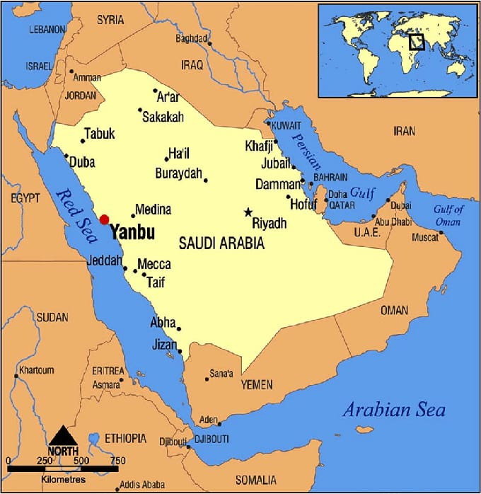
Figure (1): Map illustrates the Study Area.
2.1.2. Climate
Yanbu has a hot desert climate (Zahran and Willis, 2008), in summer temperatures are extremely high, often reaching above 45°C.
Winter is mild and dry, with temperatures ranging between 15°C to 25°C. Rainfall is scarce and irregular, usually occurring between November and March. Humidity is generally low but increases slightly in coastal areas.
This climate favors xerophytes and halophytic plant species (Batanouny, 2001) adapted to heat, drought, and salinity.
2.1.3. Topography
‏The topography of Yanbu is characterized by a combination of:
‏• Coastal plains
‏• Sandy soils
‏• Gravelly wadis
‏• Salt flats (sabkhas)
‏• Desert expanses and mountainous regions such as Radwa Mountain.
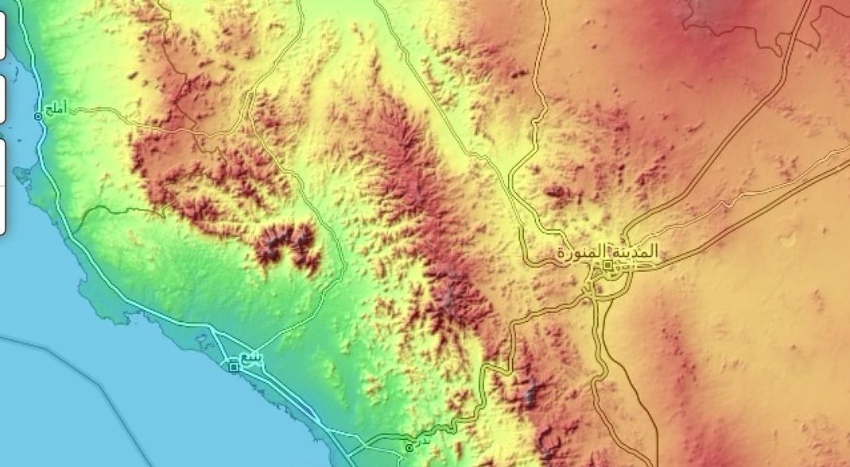
Figure (2): Topography of the Study Area.
‏These landforms provide diverse microhabitats for plant growth. The coastal areas near the Red Sea are dominated by salt-tolerant species (halophytes), especially around mangrove zones (Zahran and Willis, 2009)
‏Inland areas are generally arid, with sandy and rocky soils that support desert-adapted shrubs and grasses.
‏The desert environment of Yanbu includes wide open plains and sand dunes that host xerophytes plants.
‏The presence of Radwa Mountain adds topographical variation, creating rocky slopes and elevated habitats that support distinct plant communities. Some seasonal water flow in wadis allows the growth of temporary annual plants during rainy periods.
2.2. Data Sampling and Analysis
The data compilation for the plants of the study area was carried out from january – march 2025. For specimen preparation, herbs were collected entirely while only small branches with leaves, flowers and/or fruits were cut in case of shrubs and trees. Localities were recorded by determining the locations using Global Positioning System (GPS).
The specimens were stretched to dry between newspapers and firmly pressed inside a herbarium press. Newspaper was continuously changed during the drying to avoid rotting of material. Subsequently, the specimens were mounted and labeled. The collected plant specimens were identified and named by using references for Flora of Saudi Arabia (Chaudhary, 1989; Chaudhary, 1999-2001; Chaudhary and Al-Jowaid, 1999; Chaudhary and Zawawi, 1983).

3. Result and Discussion
3.1. Result
Plant species were inventoried in different surveyed sites of Yanbu province. GPS coordination of each species was recorded, growh form and vernacular names were registered (Table1).

Table (1): List of the Inventoried Plant species in the Study Area.
Family | Scientific Name | Coordinates | Growth form | Vernacular name
Acanthaceae | Blepharis ciliaris | 24°31'28.9"N  38°17'03.6"E | Herb | Dnaab shock
Acanthaceae | Avicennia germinans | 24°02'34.9"N  38°06'53.6"E | shrub | Aswwad gram
Amaranthaceae | Haloxylon salicornicum | 24.1318622N  38.0025509''E | shrub | Rimth
Amaranthaceae | Salsola vermiculata | 24°31'28.9"N  38°17'03.6"E | herb | Rotha
Amaranthaceae | Halopeplis perfoliata | 24°02'34.9"N  38°06'53.6"E | Herb | Molih /khraza
Amaranthaceae | Sueada maritima | 24°02'34.9"N  38°06'53.6"E | Herb | Sweda bhria
Apocynaceae | Calotropis procera | 24°07'00.7"N  38°05'05.7"E | Shrub | Oshar
Apocynaceae | Catharanthus roseus | 24°06'09.5"N  38°04'10.5"E | Herb | -
Apocynaceae | Rhazya stricta | 24°16'42.8"N  38°16'54.6"E | Shrub | Hrmal
Asphodelaceae | Aloe vera | 24°12'57.9"N  38°16'38.8"E | Herb/succulent | sabbar
Asphodelaceae | Asphodelus tenuifolius | 24°31'28.9"N  38°17'03.6"E | Herb | Broog
Asteraceae | Pulicaria incisa | 24°31'28.9"N  38°17'03.6"E | Herb | Arar
Asteraceae | Pluchea sericea | 24°31'28.9"N  38°17'03.6"E | Shrub | Branoof
Bataceae | Batis maritima | 24°02'34.9"N  38°06'53.6"E | Shrub | Sahli hood
Boraginaceae | Heliotropium crispum | 24°21'09.1"N  37°36'45.0"E | Herb | Rmram
Boraginaceae | Heliotropium supinum | 24°31'28.9"N  38°17'03.6"E | Herb | Rmram
Brassicaceae | Limonium axillare | 24°09'30.2"N  37°56'50.7"E | Herb | Sea lavender
Burseraceae | Commiphora gileadensis | 24°31'28.9"N  38°17'03.6"E | Shrub | Busham
Cucurbitaceae | Citrullus colocynthis | 24°12'57.9"N  38°16'38.8"E | Herb | Handal
Cucurbitaceae | Citrullus lanatus | 24.1318622N,  38.0025509''E | Herb | Beteekh
Cyperaceae | Cyperus rotundus | 24.1318622,  38.0025509''E | Herb | Saed
Fabaceae | Indigofera oblongifolia | 24°31'28.9"N  38°17'03.6"E | Shrub | Hosar
Fabaceae | Senna alexandrina | 24°31'28.9"N  38°17'03.6"E | Shrub | Snamki
Fabaceae | Pithecellobium dulce | 24°07'07.1"N  38°05'17.6"E | Tree | Looz hindi
Fabaceae | Abrus precatorius | 24°07'07.1"N  38°05'17.6"E | Vine (twinner) | Ain eldeek
Lamiaceae | Lavanula coronopifolia | 24°12'57.9"N  38°16'38.8"E | Shrub | Khozami
Lamiaceae | Salvia aegyptica | 24°31'28.9"N  N 38°17'03.6"E | Shrub | Gazeen masri
Lamiaceae | Teucrium fruticans | 24°31'28.9"N  38°17'03.6"E | Shrub | Gadee
Lamiaceae | Thymus vulgaris | 24°31'28.9"N  38°17'03.6"E | Herb | Zattar
Lamiaceae | Ocimum basilicum | 24°07'07.1"N  38°05'17.6"E | Herb | Nanaa
Lamiaceae | Mentha longifolia | 24°31'28.9"N  38°17'03.6"E | Herb | Rihan
Malvaceae | Abutilon pannosum | 24°21'09.1"N  37°36'45.0"E | Herb | Abutlwn
Malvaceae | Corchorus depressus | 24°21'09.1"N  37°36'45.0"E | Herb | Soteeh
Malvaceae | Hibiscus tiliaceus | 24°09'30.2"N  37°56'50.7"E | Shrub | -
Mimoaceae | Acacia ehrenbergiana | 24°12'16.8"N  37°59'55.8"E | Shrub | Salam
Mimoaceae | Acacia senegal | 24°31'28.9"N  38°17'03.6"E | Tree | Sonot singaly
Moraceae | Fucus palmata | 24°31'28.9"N  38°17'03.6"E | Tree | Teen
Poaceae | Phragmites australis | 24°02'34.9"N  38°06'53.6"E | Herb | Gysob
Poaceae | Stipa capensis | 24°12'16.8"N  37°59'55.8"E | Herb | Smaa
Poaceae | Desmostachya bipinnata | 24°31'28.9"N  38°17'03.6"E | Herb | Halfa
Poaceae | Aeluropus lagopoides | 24°02'34.9"N  38°06'53.6"E | Herb | Acrach
Polygonaceae | Rumex vesicaius | 24°31'28.9"N  38°17'03.6"E | Herb | Homeed
Rhamnaceae | Ziziphus spina _ christi | 24°31'28.9"N  38°17'03.6"E | Tree | sideer
Solanaceae | Datura innoxia | 24°12'57.9"N  38°16'38.8"E | Herb | Datura
Solanaceae | Lycium shawii | 24.1318622 N  38.0025509''E | Shrub | Awsag
Tamaricaceae | Tamarix aphylla | 24°02'34.9"N  38°06'53.6"E | Tree | Tarfa
Zygophyllaceae | Tribulus terrestris | 24°12'16.8"N  37°59'55.8"E | Herb | Dresa
Zygophyllaceae | Zygophyllum coccineum | 24°31'28.9"N  38°17'03.6"E | Herb | Garmal
Zygophyllaceae | Zygophyllum fontanesii | 24°02'34.9"N  38°06'53.6"E | Herb | Haram gormoze
Zygophyllaceae | Zygopyllum simplex | 24°09'30.2"N  37°56'50.7"E | Herb | Khezera

A total of 50 species belong to 46 genera and 21 families were inventoried. The most represented families were Lamiaceae (6 species), followed by Amaranthaceae, Poaceae, Fabaceae and Zygophyllaceae which they represented by 4 species for each while Malvaceae and Apocynaceae represented by 3 species for each family. The rest of the families showed less number of species. Acanthaceae , Aspholedaceeae, Asteraceae, Bataceae, Boraginaceae, Brassicaceae,cucurbitaceae Mimosaceae and solanaceae were represented by two specie while Burseraceae,polygonaceae, Moraceae, Rhamnaceae and Tmaricaceae represented by only one species ( figure 3).

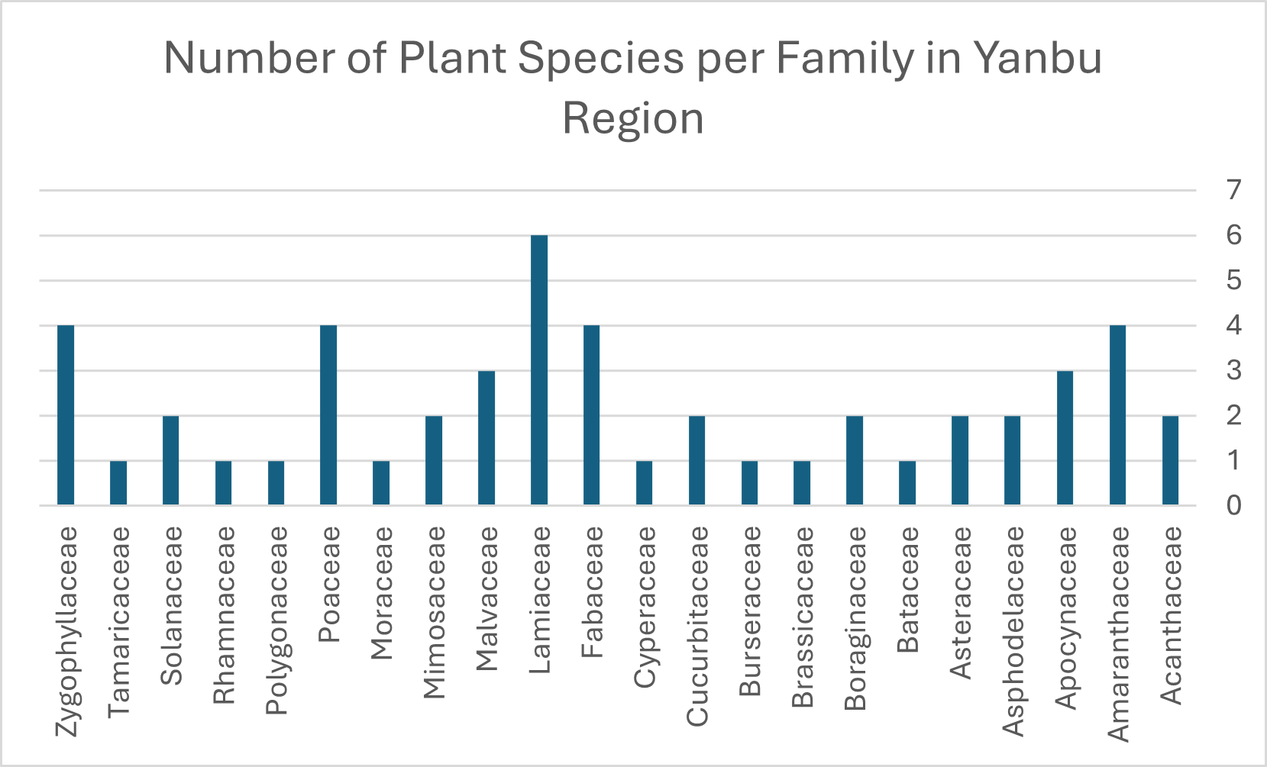
Figure (3): Number of Plant Species per Family in the Study Area.

Dicotyledonous plant represent the most abundant plants in the study area while monocotyledonous showed less number of plants found in the study area (figure 4 ). A number of 44 species were inventoried as Dicotyledonous (92%) belong to 40 genera and 18 families. While 6 species were registered as monocotyledonous (8) belong to 7 genera and 3 families.
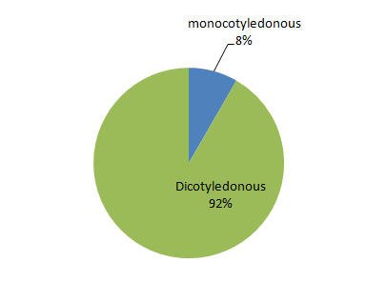
Figure (4): Chart illustrates the Ratio of Monocotyledonous and
Dicotyledonous Plant in the Study Area.
The growth forms exhibited a 4 types herb, shrube, vine (twinner) and tree in the study area table (1). The herbs are the most dominating type of growth form which represented by 29 species of (56 %), followed by shrubs with 15 species (38 %) and Trees were represented by 5 species with (4%). twinners (vines) recorded the lest by only one plant (1.22%) (Figure 5).

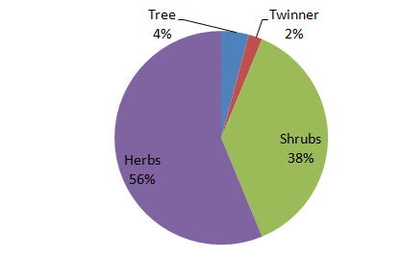
Figure (5): Chart illustrates the most Reprehensive Type of Growth form of the
Studied species in the Study Area.

Plant species in the study were found distributed among diverse ecological habitats . plants occupied the Sandy soils are represented by 21 species and in arid areas represented by 16 species. The rest of species occupied the Saline flats, rocky sites, coastal zones, and mountainous terrain (table 2, figure 6).

Table (2): List of Plant Species Habitats of the study Area.
Sand Dunes/Desert | Arid Areas | Others Habitats
Haloxylon salicoricum | Blepharis ciliaris | Ficus palmate
Salsola vermiculata | Aloe vera | Orchradenus baccatus
Halopeplis perfoliata | Asphodelus tenuiflolius | Datura innoxia
Sueada maritime | Pluchea sericea | Batis maritima
Calotropis procera | Commiphora gileadensis | Phragmites australis
Rhazya strica | Heliotropium supinum | Aeluropus lagopoides
Pulicaria incisa | Lavandula coronopifolia | Stipa capensis
Heliotropium crispum | Salvia aegyptiaca | Desmostacha bipinnata
Citrullus colocynthis | Teucrium fruticosa | Tamarix aphylla
Indigofera oblongifolia | Thymus vulgaris
Senna alexandrina | Ocimum basilicum
Acacia ehrenbergiana | Mentha longifolia
Acacia Senegal | Abutilon pannosum
Ziziphus spina-christi | Corchorus depressus
Lycium shawi | Hibiscus tiliaceus
Tribulus terrstris | Rumex vesicarius
Zygophyllum simplex
Zygophyllum coccineum
Zygophyllum fontanesii
Limonium axillare
Pitheocellobium dulce

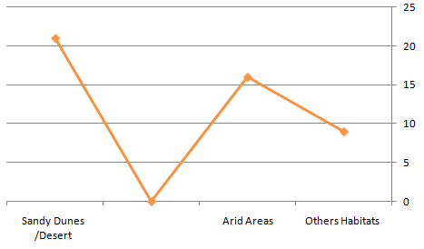
Figure (6): Chart illustrates the most Diverse of the Ecological Habitats in the Study Area.

3.2. DISCUSSION
Saudi Arabia occupied a massive area of the Arabian Peninsula and posses a different environmental and climate patterns. Climate factors and soil characteristics are the most important determinants that affecting the distribution of plant species. As Yanbu province is distinguished by its unique combination that ranging from desert, saline and coastal environments, its floristic compositions are diverse and ranging from plants highly adapted to sandy soil , arid area and others different habitats (Table 2). Also, because of Yanbu is considered as a coastal city located along the Red Sea, it is comprising numbers of species highly adapted to saline habitats. The current study provided a comprehensive floristic survey of the Yanbu region. It inventoried a total of 50 plant species across 21 botanical families. Among the 21 families, 14 families of the total number of families are represented by only one or two species per family. This finding is compatible with the fact of scaecity of plant diversity in desert and it considered an indication that only a few numbers of species belong to these families have adapted and survived in this harsh environment.
When it is compared with previous studies((Al-Gifri et al., 2019; Moawed, 2016; Al Atar, et al., 2012 ; Abdel et al., 2013), flora of Yanbu displayed a moderate levels of plant diversity. species in the sudy area indicated remarkable adaptability to aridity, salinity, and seasonal climatic shifts.
The most represented families were Lamiaceae (6 species), followed by Amaranthaceae, Poaceae, Fabaceae and Zygophyllaceae (4 species), and Malvaceae, Apocynaceae, (3 species each). This pattern is consistent with other arid regions in KSA, where these families dominate due to their morphological and physiological adaptations to drought and poor soil conditions. Families like Boraginaceae were also well represented, reflecting their prevalence in saline and sandy environments, and emphasizing the role of halophytic and xerophytes species in maintaining ecological stability.
Life form analysis revealed the dominance of herbs which are well-suited for short seasonal growth during rainfall events, a typical adaptation in desert ecosystems. The presence of shrubs and succulent shrubs in saline areas and wadis further adds structural diversity to the local flora, enhancing the ecosystem's resilience.
The broad ecological range—from mangrove habitats to rocky mountain slopes highlights the environmental heterogeneity of the Ynbu region.
Notably, many of the documented species possess ecological, medicinal, or economic value, such as:
- Calotropis procera: Traditionally used for its medicinal properties (Batanouny, 2001).
- Haloxylon salicornicum: a key forage plant in arid zones
- Ziziphus spina-christi (Chaudhary, 2001) – culturally valued fruit-bearing tree (Thomas, 2011).
- Batis maritime: helps stabilize saline coastal zones.
- Avicennia germinans: one of the most ecologically significant coastal species. It plays a critical role in stabilizing shoreline soil, preventing erosion, and absorbing carbon dioxide from the atmosphere, making it vital in climate change mitigation (Zahran and Willis, 2009). It also provides essential habitats for marine biodiversity, such as fish and mollusks, and offers economic potential in pharmaceutical and environmental applications.
4. CONCLUSION
This study will contribute in documenting and understanding the flora of Yanbu Province, a region that has received comparatively less attention in floristic surveys. By providing an inventory of 50 plant species across 21 families, the study enriches the botanical records of Saudi Arabia and offers a baseline for future ecological and conservation research. Such regional surveys are valuable because they help to highlight local adaptations to arid and saline environments, and they provide useful references for land-use planning and biodiversity protection. The work therefore has importance both from a scientific and an applied conservation perspective.
Authors’ contributions

This work was carried out in collaboration among all authors. Authors Safia. A.A Mohammed and Tahani. O. Al.Hubayshi designed analyzed and interpreted and prepared the manuscript. Authors Usama K. Abdel-hameed and Lemia A. Manshi designed the map and wrote the first draft of the manuscript. Author Mubarak S.Hamad interpreted and prepared the manuscript. All authors read and approved the final manuscript.

Disclaimer (Artificial intelligence)
Option 1:
Author(s) hereby declare that NO generative AI technologies such as Large Language Models (ChatGPT, COPILOT, etc.) and text-to-image generators have been used during the writing or editing of this manuscript.
Option 2:
Author(s) hereby declare that generative AI technologies such as Large Language Models, etc. have been used during the writing or editing of manuscripts. This explanation will include the name, version, model, and source of the generative AI technology and as well as all input prompts provided to the generative AI technology
Details of the AI usage are given below:
1.
2.
3.

5. REFERENCES
- Abdelhady, M. (2021). A comparative of the Saudi Arabia Flora, Medicinal Plants of AL-Mandq Province, AL-Baha Region. Al-Azhar Journal of Pharmaceutical Sciences, 63(1), 57-71.
- Al-Eisawi, D. M., & Al-Ruzayza, S. (2015). The flora of holy Mecca district, Saudi Arabia. International Journal of Biodiversity and conservation, 7(3), 173-189.
- Alfarhan, A. H. (2001). A floristic account on Raudhat Khuraim central province Saudi Arabia. Saudi Journal of Biological Sciences, 8(1), 80-103.
- Al-Farhan, A.H. (2001). A floristic account on Raudhat Khuraim, central province, Saudi Arabia. Saudi Journal of Biological Sciences, 8(1), pp.80–89.
- Al-Gifri, A. N., Kasem, W. T., Shehata, R. S., & Eldemerdash, M. M. (2019). The African paleotropical influence on the biogeography of the flora of Jazan, KSA. Asian J. Soil Sci. Plant Nutr, 4(1), 1-10.
- Al-Khamis, H. H., Al-Hemaid, F. M., & Ibrahim, A. S. S. (2012). Diversity of perennial plants at Ibex reserve in Saudi Arabia . Journal of Animal Plant Science 22: 484-492.
- Alharbi, T., Abdelrahman, K., El-Sorogy, A. S., & Ibrahim, E. (2023). Identification of groundwater potential zones in the Rabigh-Yanbu area on the western coast of Saudi Arabia using remote sensing (RS) and geographic information system (GIS). Frontiers in Earth Science, 11, 1131200
- Al-Mutairi, K., Al-Shaami, S. A., Khorshid, Z., & Moawed, M. M. (2016). Floristic diversity of Tabuk province, north Saudi Arabia. JAPS: Journal of Animal & Plant Sciences, 26(4).

- Al-Nafie, A. H. (2004). Botanical Geography of Saudi Arabia. King Fahd National Library, El-Riyadh, Saudi Arabia.
- Al-Shareef AS (2002) Geography of Saudi Arabia. Riyadh, Dar AlMareekh.
- Alzamel, N. M. (2021). Vegetation Structure and Floristic Features of Al Rayn Region, Saudi Arabia. Advances in Environmental Studies, 5(2), 436-442.
- Batanouny, K. H. (2001). Deserts of the Middle East. In Plants in the Deserts of the Middle East (pp. 5-10). Berlin, Heidelberg: Springer Berlin Heidelberg.
- Chaudhary S, Al-Jowaid A (2013) Vegetation of the Kingdom of Saudi Arabia. National agriculture and water research center ministry of agriculture and water kingdom of Saudi Arabia. Riyadh, Saudi Arabia, 1: 1-680.
- Chaudhary, A., and MOSSA, J. S. (1991). Contribution to the flora of Saudi Arabia. Pak J Bot, 23(2), 257-82.
- Chaudhary, S. A. (1989). Grasses of Saudi Arabia. National Herbarium, National Agriculture and Water Research Center, Ministry of Agriculture and Water.
- Chaudhary, S. A. (1999). Flora of the Kingdom of Saudi Arabia, illustrated. v. 1, v. 2, pt. 1, 3, v. 3.
- Chaudhary, S. A. (2001). Flora of the Kingdom of Saudi Arabia Illustrated vol I. Riyadh, Saudi Arabia: Ministry of Agriculture and Water, National Agriculture and Water Research Center, Cruciferae (Brassicaceae), 464.
- Chaudhary, S. A. (2001). Flora of the Kingdom of the Saudi Arabia, vol. III. Ministry of Agriculture and Water, Riyadh, Saudi Arabia.
- Chaudhary, S. A., & Al-Jowaid, A. A. A. (1999). Vegetation of the kingdom of Saudi Arabia.
- Chaudhary, S. A., & Zawawi, M. A. (1983). A manual of weeds of central and eastern Saudi Arabia.
- Collenette, S. (1999). Wildflowers of Saudi Arabia. Riyadh: National Commission for Wildlife Conservation and Development.
- El-Ghazali, G. E., Al-Soqeer, A. R. A., & El Tayeb, G. E. (2013). Floristic and ecological studies on the plant cover of Wadi Al Rummah, Qassim 24.Region, Saudi Arabia. International Research Journal of Plant Science, 4(10), 310-318.
- Hamad, M. S., Ali, F. S. M., Mohammed, S. A. A., & Kordofani, M. A. (2020). Checklist of the flora of Tutti Island, Khartoum Province, Sudan. Journal of Agriculture and Ecology Research International, 21(4), 27-40
- Migahid, A. M. (1978). Flora of Saudi Arabia: Dicotyledons. University.

- Moawed, M. M., & Ansari, A. (2015). Wild plants diversity of Red Sea coastal region, Tabuk, Saudi Arabia. J. Chem. Pharm. Res, 7, 220-227.
- Mossa JS (1987) Medicinal plants of Saudi Arabia. King Saud University Press, Riyadh, Saudi Arabia.
- Thomas, D. S. (Ed.). (2011). arid zone geomorphology: process, form and change in drylands. John Wiley & Sons.
- Zahran, M. A., & Willis, A. J. (2008). The vegetation of Egypt (Vol. 2). Springer Science & Business Media.

