**Climate Change and Its Impact: A Review of Global Strategies for Adaptation and Mitigation**

**Abstract**

Climate change conveys an existential threat to global ecosystems and human societies, primarily from human activities that amplify greenhouse gas emissions. This review focuses on the drivers, impacts, and responses related to climate change. It highlights the need for adaptation and mitigation to develop in an integrated way and at a pace and scale commensurate with the urgency of the challenge posed. The role of fossil fuel reliance, deforestation, and intensive agriculture in accelerating global warming is well established, and so is its exacerbation of extreme weather events, biodiversity loss, and the socioeconomic inequities faced by the most vulnerable, often in the Global South. However, Paris and NDCs measures, such as renewable energy transition, carbon pricing, and carbon capture technologies, are addressed in the article as international frameworks. Simultaneously, adaptation strategies, climate-resilient infrastructure, ecosystem-based approaches, and community-led initiatives are examined for their effectiveness in building resilience. We can learn from successful policy implementations in Denmark, the Netherlands, and Small Island Developing States through case studies on renewable energy integration, adaptive water management, and the utilization of traditional knowledge. Even as they advance, these Climate Solutions are Facing Mass Adoption. Both emphasize the need for mitigation and adaptation to be framed through a justice lens, privileging vulnerable communities and inter-generational justice. It demands enhanced global cooperation, scalable financing mechanisms, and inclusive governance to close implementation gaps. Understandably, addressing the climate crisis must involve systemic transformation, marrying ambitious policy frameworks with on-the-ground innovations to establish a livable world for everybody.

**Keywords**

Climate Change, Global Warming, Climate Adaptation, Climate Mitigation, Climate-Smart Agriculture.

**1.0 Introduction**

Climate change is one of humanity's most daunting and complicated problems in the 21st century. Climate change is a long-term change in temperatures and weather patterns, occurring naturally on geological timescales. However, during the past century, human activity has dramatically accelerated these changes. Climate change is defined by the Intergovernmental Panel on Climate Change (IPCC) as a "change in the state of the climate that can be identified by changes in the mean and/or variability of its properties and that persists for an extended period, typically decades or longer (Waseem et al., 2024). Earth's climate has always exhibited natural variability, driven by volcanic activity, solar radiation, and oceanic circulation. However, the rapid rate of climate change and global scale are mainly associated with human activities. The amplified greenhouse effect is a significant cause of modern climate change. Greenhouse gases (GHGs) like carbon dioxide (CO₂), methane (CH₄), and nitrous oxide (N₂O) are naturally found in the atmosphere. They are critically important in regulating the Earth's energy balance through heat-trapping, in the case of the natural greenhouse effect. However, the atmospheric concentration of these gases has increased due to human activity since the Industrial Revolution, magnifying the natural greenhouse effect and causing global warming. According to the IPCC Sixth Assessment Report, global surface temperature has risen by approximately 1.1°C above pre-industrial levels, meaning that by the century's end, temperature can increase by 1.5°C to 2°C or more, according to emission trajectories (Mondal et al., 2022).

The primary human-made contributor to greenhouse gas emissions is fossil-fuel combustion, which occurs when coal, oil, and natural gas are burned to generate electricity, power vehicles, and fuel industrial processes. These sources account for almost three-quarters of the world's CO2 emissions. In addition, climate change is compounded to a great extent by deforestation and land-use change, as these processes reduce the ability of the planet to absorb carbon from the atmosphere via photosynthesis. Forest ecosystems provide essential carbon sinks, so their destruction liberates bound carbon and reduces future carbon-sequestration capacity. Agriculture, especially livestock farming and rice growing, is also responsible for the release in significant quantities of CH₄ and N₂O to the atmosphere, which are far more potent greenhouse gases than CO₂ over a 100-year time frame (M. W. Jones et al., 2023; Md Shahriar Kabir et al., 2025).

The impact of these emissions is now seen on every continent and ocean. The physical aspect of climate change is tangible, from soaring global temperatures and melting glaciers and polar ice to rising sea levels, changes in precipitation, and the escalation and frequency of extreme events like heat waves, hurricanes, droughts, and floods. These modifications seriously affect biodiversity, ecosystem functions and services, agriculture, water resources, and human health. Furthermore, the effects of climate change are not evenly distributed. Lower-income nations and disenfranchised populations, the group least implicated in producing emissions, are overrepresented among those who bear the costs of climate change because they cannot adapt and are more exposed to environmental dangers. As such, dealing with climate change is not just an environmental necessity but a social, economic, and ethical imperative. The transboundary nature of climate change implies that no country can insulate itself from its impact, irrespective of the level of its development. In addition, climate change compounds other global stressors, including poverty, food insecurity, population pressure, and resource scarcity, deepening existing vulnerabilities and inequalities. Without vigorous and sustained action in the next few years, climate change will undermine decades of hard-won advances in global health, economic development, and environmental protection.

To address this issue, the world has rallied around several international frameworks and agreements, including, most prominently, the United Nations Framework Convention on Climate Change (UNFCCC), the Kyoto Protocol, and the Paris Agreement (Soares & Aquino, 2024). An instrument that aims to pull countries together in an initiative towards keeping a lid on average global temperature rise and enabling adaptation to already unavoidable climate impacts. The 2015 Paris Agreement represented a paradigm shift requiring developed and developing states to contribute to mitigation through their Nationally Determined Contributions (NDCs). Concurrently, adaptation strategies, including climate-resilient infrastructure, early warning systems, and ecosystem-based approaches, are increasingly acknowledged as vital for a comprehensive climate response.

To address these research questions, this research developed: a) What are the primary human-induced drivers of climate change, and how have they contributed to the intensification of global warming? b) How do climate change impacts differ across environmental, socioeconomic, and regional contexts? c) How effective are global mitigation strategies, such as the Paris Agreement and carbon pricing mechanisms, in reducing greenhouse gas emissions? d) What role do ecosystem-based and community-led adaptation strategies play in enhancing resilience to climate change? e) What lessons can be learned from successful national and local adaptation and mitigation initiatives around the world? f) What are the significant barriers to implementing inclusive and equitable climate action, particularly in vulnerable and low-income regions?

The most recent Emissions Gap Report estimates that even if the world achieved all current commitments to cut emissions, global greenhouse gas emissions will still not decrease enough to meet the Paris Agreement's 1.5 °C goal, risking catastrophic environmental and socioeconomic implications. This realization reaffirms the need to align with these to raise ambition and deliver it, which is supported by financing, technology transfer, and capacity building to implement it, especially in vulnerable regions. Recognizing these challenges, this review article will bring together the current knowledge around climate change impacts and assess the global strategies for adaptation and mitigation. By identifying successes, gaps, and areas needing improvement, the review will contribute to the global conversation for building a sustainable and climate-resilient future. The Primary objectives for this research are: a) To articulate and frame climate change as a socioeconomic and global environmental challenge; b) To analyze the primary human drivers of climate change (e.g., burning fossil fuels, deforestation, and land-use changes); c) To assess global mitigation strategies, such as international Treaties, technological solutions, and policies; d) To evaluate adaptation actions taken in various sectors and regions to improve climate resilience; e) To identify gaps, barriers, and inequities among existing climate policies, particularly in vulnerable and low-income regions.

**2.0 Scientific Understanding of Climate Change**

**2.1 Evidence for Climate Change**

As a reminder, the scientific consensus on climate change is built upon decades worth of observational evidence from dozens of fields of science (e.g., climatology, atmospheric sciences, oceanography, glaciology, etc.). The most direct and compelling sign of climate change is the increased global average surface temperature. According to (Lu et al., 2022), based on data collected from the National Aeronautics and Space Administration (NASA) and the National Oceanic and Atmospheric Administration (NOAA), the average surface temperature of the planet has risen about 1.1°C since the end of the 19th century, with the majority of the warming taking place over the last 40 years. The last 10 years have been the warmest on record, and 2016 and 2020 are tied for the hottest years worldwide.

The frequency and severity of extreme weather events have grown markedly, along with rising temperatures. Indeed, protracted droughts, heatwaves, storms with greater intensity, and unprecedented rainfall have been observed more frequently and intensively; thus, they align with model predictions for a warming planet 2. The 2021 European floods, for instance, as well as the 2022 South Asian heatwaves, are paradigmatic of the aggravating hydrological cycle and temperature anomalies propelled by anthropogenic climate change.

Empirical climate data provide more evidence of changes in progress. The levels of carbon dioxide (CO₂), the most prevalent long-lived greenhouse gas currently in the atmosphere, exceed 420 parts per million (ppm), a concentration not reached for at least 3 million years (Kundu et al., 2024). This sharp change aligns almost perfectly with industrial activity and fossil fuel combustion growth since the mid-20th century. At the same time, the global sea level has risen about 20–25 cm since 1900, primarily due to the thermal expansion of seawater and melting of land-based ice, with significant contributions from the Greenland and Antarctic ice sheets (Elneel et al., 2024).

Satellite monitoring also shows a significant reduction in Arctic Sea ice, shrinking at approximately 13% each decade compared to the 1981–2010 average (Marcianesi et al., 2021). Similarly, continental glaciers across the Andes, Himalayas, Alps, and elsewhere are melting back, adding to global sea level rise and threatening fresh water supplies for millions (Pepin et al., 2022). Changes in the cryosphere are a cause and consequence of climate systems, and they amplify climate warming by decreasing albedo and increasing heat absorption.

**2.2 Drivers of Climate Change**

Human activities have led to the accumulation of greenhouse gases (GHGs) in the atmosphere, the primary driver of recent global warming. The enhanced greenhouse effect is dominated by a few naturally occurring greenhouse gases, including carbon dioxide (CO₂), methane (CH₄), and nitrous oxide (N₂O) (Filonchyk et al., 2024). These gases vary in their lifetimes in the atmosphere and radiative forcing, with CO₂ the most important on a cumulative basis because CO₂, on average, is abundant and relatively long-lived.

Most carbon dioxide is released by burning fossil fuels, coal, oil, and natural gas in energy generation, transportation, and industrial processes. Cement production and other industrial processes emit CO2 as well. Methane, a GHG with a global warming potential of more than 80 times that of CO₂ over a 20-year horizon, is released during agricultural practices (notably for livestock digestion), rice paddies, and leakages from natural gas systems and landfills. Nitrous oxide has a global warming potential almost 300 times that of CO₂ and a long atmospheric residence time, primarily resulting from agricultural fertilizers and industrial activities.

Beyond emissions, land-use changes, mainly deforestation, are major drivers of climate change. Forests are essential terrestrial carbon sinks, taking up around one-third of the anthropogenic CO₂ emissions yearly (Sitch et al., 2024). Nevertheless, large-scale deforestation for agriculture, mining, and urban development not only releases stored carbon but also diminishes the biosphere's ability to absorb future emissions. Deforestation in the tropics, notably the Amazon and Southeast Asia, is especially troubling because of the knock-on effects on the planet.

Industrial and agricultural processes have also released numerous short-lived climate pollutants (SLCPs), including black carbon and hydrofluorocarbons (HFCs), contributing to warming and air pollution. These emissions are commonly localized in urban and high-development areas, harming public health and amplifying regional climate abnormalities.

How these drivers interact shows the complexity of the climate system and demonstrates the need for multifaceted, integrated responses. Cumulative and synergistic effects of GHG emissions, land-use change, and industrial activities highlight the necessity of broad-spectrum mitigation strategies that incorporate not just technological innovation but systemic socioeconomic transformation.

**3.0 Methodology**

This research also explores the multiple effects of climate change and assesses worldwide adaptive and mitigating strategies. Through the synthesis of qualitative and quantitative data, the methodology allows for a comprehensive and evidence-based understanding of the dynamics, impacts, and policy responses of climate change across varying mixtures of socioeconomic and ecological settings.

**3.1 Data Collection**

The study drew upon secondary data from various sources to provide multidimensional and comprehensive evidence for climate change (Table 1). Relevant peer-reviewed journal articles, technical reports, and policy papers were retrieved from reputable sources, including the Intergovernmental Panel on Climate Change (IPCC), the United Nations Framework Convention on Climate Change (UNFCCC), and top research entities. Agency (NOAA) datasets and datasets from national meteorological services, environmental ministries, and statistical bureaus were also used. Global and regional trends were also available through the joint efforts of international organizations (including the World Bank, UNDP, and ADB). As it was a large-scale project, satellite and remote sensing data were also combined to analyze physical climate indicators (temperature anomaly, sea level rise, and glacier retreat, to name a few). Accessed through academic databases such as Google Scholar and ResearchGate, this collection encompassed a broad array of both quantitative measurements and qualitative case studies.

**3.2 Assessment**

This research evaluates the implications of climate change based on three key dimensions: environmental, socioeconomic, and technological. Environmental effects were quantified by assessing trends in global temperature, extreme weather events, and the disruption of ecosystems. The socioeconomic impacts measured were public health, agricultural productivity, and urban infrastructure resilience (M. Uddin et al., 2025). Policy and technological interventions were analyzed, focusing on adaptation and mitigation measures, including renewable energy adoption, carbon pricing mechanisms, and climate-resilient infrastructure. Analyzing all of these angles highlights success stories, obstacles, and where there are still opportunities for global action, thus providing a broader overview of influencing developments.

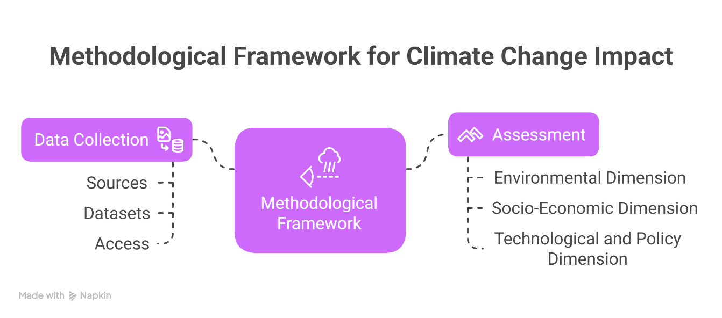**Figure 1.** Methodology of this study

**4.0 Impacts of Climate Change**

Climate change has significant and interrelated impacts on natural systems, human societies, and world economies. These effects are no longer theoretical forecasts; they are tangible and visible, disrupting environmental balance, aggravating socioeconomic insecurity, and threatening the world's development. Gaining a more nuanced understanding of these impacts is critical to informing mitigation and adaptation strategies.

**4.1 Environmental Impacts**

One of the most prominent impacts of climate change is the global rise in temperature, with average surface temperatures surpassing 1.1°C above pre-industrial levels (1990 baseline) in 2023 (R. N. Jones, 2024). We know this warming trend is causing changes in ecosystems: changing the geographic ranges of species, disrupting their phenological cycles, changing things like breeding and migration, and reducing the ability of ecosystems to resist environmental stressors. Species not accustomed to such changes are becoming more vulnerable to extinction with the escalating pace of climate-based habitat alterations.

Alternatively, take the melting of the polar ice caps and glaciers. The Greenland and Antarctic ice sheets are losing mass at accelerating rates, contributing to global sea-level rise, averaging approximately 3.3 mm per year (Rignot et al., 2011). This endangers low-lying coastal areas and small island states with flooding, saltwater intrusion, and loss of arable land. The loss of Arctic Sea ice also limits the habitat for polar species, interrupts Indigenous lifestyles, and intensifies warming via the albedo feedback effect.

The impacts of climate change on biodiversity and ecosystem services. Coral reefs, which support vast biodiversity and deliver vital ecosystem services, including fisheries and coastal protection, are undergoing widespread coral bleaching because of the warming and acidification of the oceans. Forest ecosystems are increasingly threatened by drought, pest outbreaks, and wildfires, all exacerbated by climatic changes. The degradation of these ecosystems also leads to a reduction in the services they can provide, including carbon sequestration, water purification, and food provisioning.

**Table 1. Summary of Climate Change Impacts**

|  |  |  |
| --- | --- | --- |
| **Impact Domain** | **Key Observations** | **Implications** |
| **Environmental Impacts** | • Global temperature rise surpassing 1.1°C above pre-industrial levels (2023 baseline).  • Ecosystem alterations: shifts in species' ranges, disrupted breeding/migration, increased extinction risk.  • Accelerated melting of polar ice caps and glaciers (e.g., Greenland/Antarctic), contributing to ~3.3 mm/year sea-level rise.  • Coral bleaching and degradation of forest ecosystems due to increased drought, pests, and wildfires. | • Loss of biodiversity and diminished ecosystem services such as carbon sequestration, water purification, and food provisioning.  • Heightened vulnerability of coastal and island regions. |
| **Socioeconomic Consequences** | • Increased health risks: higher incidence of heat-related illnesses and the spread of vector-borne diseases (malaria, dengue, Lyme disease).  • Food and water insecurity from disrupted agricultural productivity.  • Damage to infrastructure (roads, power grids, buildings) due to extreme weather.  • Exacerbated socioeconomic inequities in vulnerable populations. | • Elevated public health burdens and rising economic repair costs.  • Increased social disparities and challenges in resource allocation, particularly in low-income and marginalized communities. |
| **Extreme Weather Events** | • Greater frequency, intensity, and duration of events such as hurricanes, cyclones, prolonged droughts, heat waves, and wildfires.  • Case example: 2023 wildfires in Canada with significant carbon emissions and public health impacts.  • Disruption of food security and water supply due to erratic rainfall and drought.  • Rising rates of forced displacement (e.g., >20 million annually; with surges during crises). | • Strain on social systems, urban migration pressures, and heightened political instability and conflict risk.  • Long-term challenges for infrastructure and sustainable development. |

**4.2 Socioeconomic Consequences**

Climate change has many health impacts and broad repercussions. Rising temperatures are associated with a higher rate of illness and mortality due to heat-related conditions, especially in older adults, children, and people with existing health conditions. Warmer weather also pushes the habitats of vector-borne diseases like malaria, dengue fever, and Lyme disease into previously unexposed regions. In addition, food and water insecurity driven by climate change can lead to malnutrition and worsening public health conditions.

On an economic level, climate change threatens critical infrastructure, agriculture, and energy systems. More frequent and intense floods, storms, and heatwaves destroy roads, power grids, and buildings, raising repair costs and insurance claims. The agricultural sector is especially susceptible to changing precipitation patterns and extreme weather events that decrease crop resilience and livestock productivity (Md. E. Uddin et al., 2022). This can create volatility in food prices and exacerbate the risk of famine, especially in regions where hunger is already a significant issue.

Climate impacts disproportionately affect vulnerable populations and regions, including low-lying islands, coastal communities, and developing nations. These groups often have limited financial resources, institutional capacity, and infrastructure to support effective adaptation. Climate change deepens socioeconomic divides, driving tough tradeoffs between development priorities and climate resilience.

**4.3 Extreme Weather Events**

One of the most prominent hallmarks of a warming climate is the growing frequency, intensity, and duration of extreme weather events. Scientific evidence connects climate change with more intense hurricanes, cyclones, prolonged drought, heat waves, and wildfires. These events led to mass property destruction, mass death, and massive disruption to the economy. For example, the 2023 wildfires in Canada resulted in unprecedented amounts of carbon emissions and burdened public health systems throughout North America (Grigorieva, 2024).

Such extreme events ripple through global food security, disrupting planting and harvesting cycles, damaging crops, and draining water supplies. In much of the world, droughts and erratic rainfall are curbing agricultural production, putting the livelihoods of millions of smallholder farmers at risk (Mahedi et al., 2024). Drying out – In arid parts of the world already suffering from scarce water, changing hydrologic patterns heighten the risk of reduced water availability for drinking, sanitation, and irrigation.

Moreover, migration, forced displacement, climate-induced disasters, and resource scarcity are taking off. Over 20 million individuals are displaced annually due to weather-related disasters (Mao et al., 2024). This figure could significantly increase as climate impacts amplify, and that was the case in 2023, with an estimated 24 million people displaced in the first weeks of the war. It adds to urban migration pressures, strains infrastructure and social systems, and risks fueling political instability and conflict in vulnerable areas.

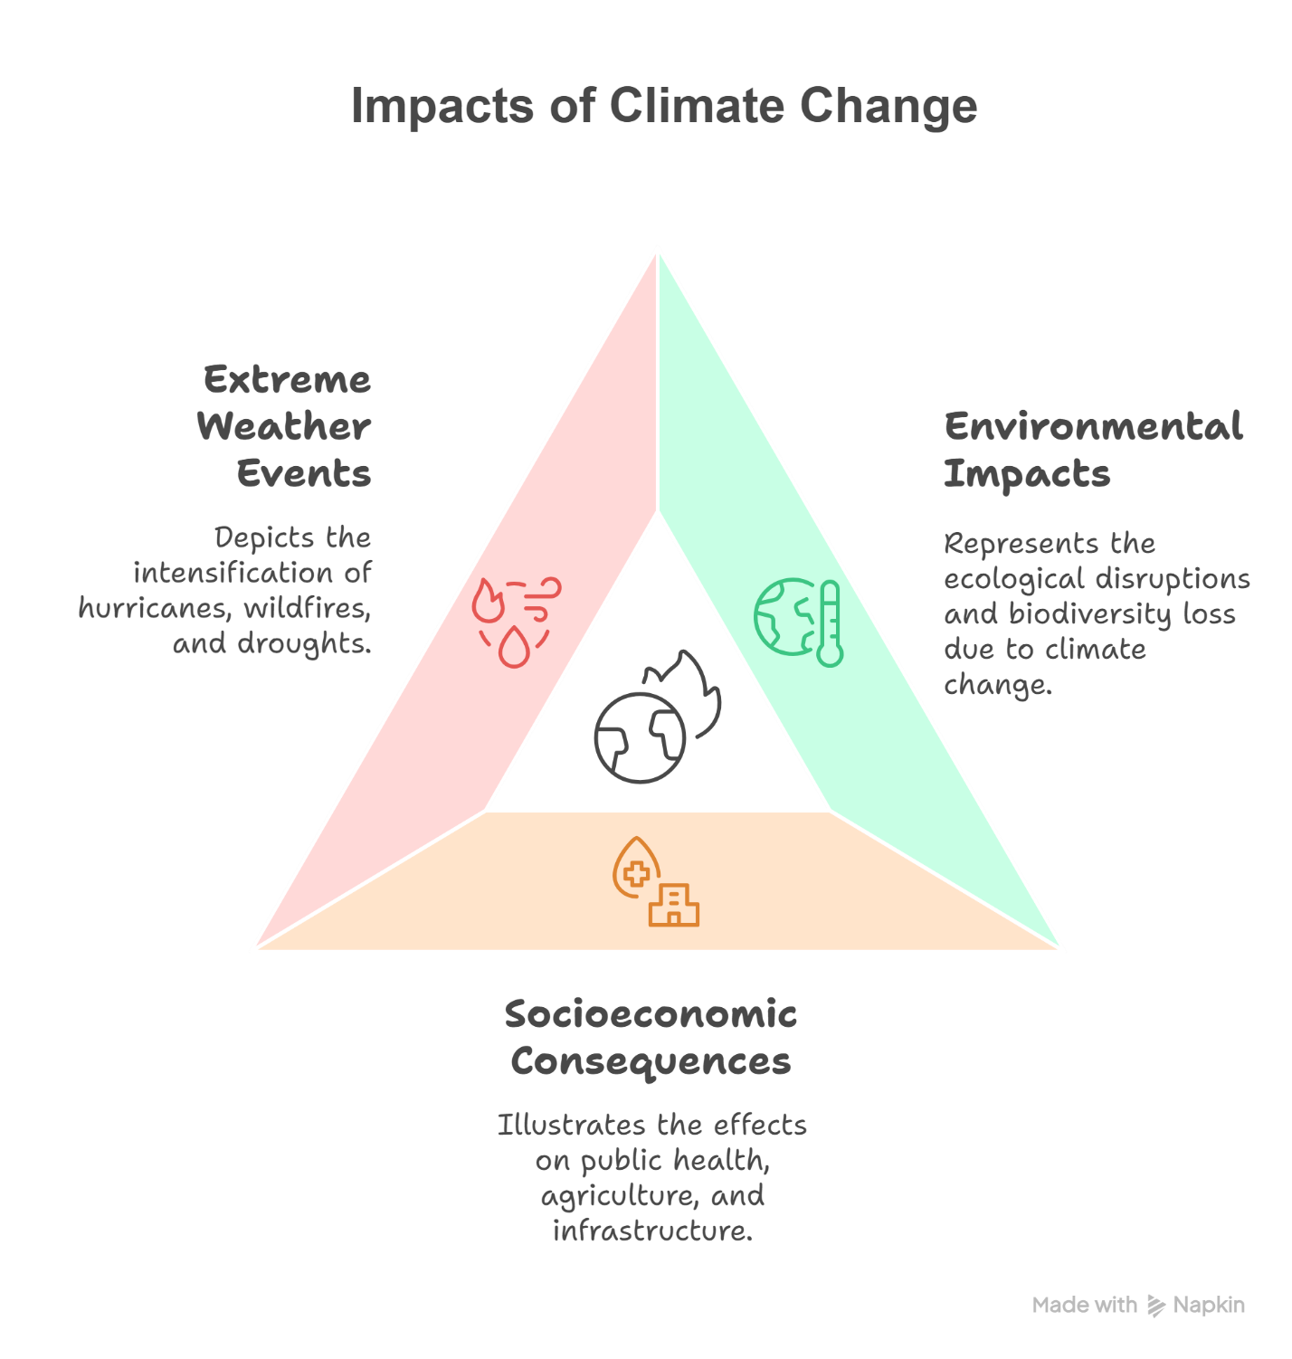

**Figure 2.** Framework of Climate Change Impacts

**5.0 Global Strategies for Mitigation**

The world has risked some stakes in combating climate change, so reducing climate change is an element of the global contributions model focused on mitigation. These measures attempt to mitigate and/or prevent the release of GHGs to see how much warming will be experienced in the future. Given the enormity, urgency, and complexity of the climate crisis, mitigation represents an integrated and diverse approach to a confluence of challenges whose deployment will require international cooperation, technological innovation, and robust policy architectures. These strategies are key to lowering global emissions and establishing sustainable development pathways aligned with intergenerational equity and climate justice.

Signed in 2015 under the United Nations Framework Convention on Climate Change (UNFCCC) umbrella, the Paris Agreement is the foundation of global mitigation efforts (Nhamo & Nhamo, 2016). This legally binding international treaty was agreed to in Paris in 2015, aiming to limit global warming to well below 2ºC, with efforts to limit the increase to 1.5ºC above pre-industrial levels. Countries that are parties to the Paris Agreement submit their Nationally Determined Contributions (NDCs), detailing their specific mitigation targets and planned actions. These reference NDCs are updated every five years, creating a "ratchet mechanism" that incentivizes increasingly ambitious climate action over time.

The UNFCCC, created in 1992, is the leading international forum for coordinating global climate action. They aim to promote the annual Conferences of the Parties (COP) to negotiate the most important tools of policy-making, monitoring progress, and strengthening cooperation in technology and financial matters. The Kyoto Protocol (1997), which was intended as a precursor to the Paris Agreement, established binding emission reduction targets for developed countries but has since been superseded due to its limited global coverage. The Global Stock Take is an essential mechanism of the Paris Agreement that evaluates collective achievements with long-term climate objectives and helps shape future national plans (Doukas et al., 2018).

Notwithstanding these frameworks, the gap between current pledges and the emissions trajectories required for the 1.5°C target remains large. The 2023 UN Emissions Gap Report indicates that the world is headed toward a temperature increase of about 2.5°C to 2.9°C by the end of the century unless immediate and deep reductions in emissions occur (Ure, 2024).

Technological innovation is key to decarbonization. One of the most promising tools is renewable energy systems, such as solar, wind, hydroelectric, and geothermal energy. These sources emit little or no GHGs and are increasingly competitive with fossil fuels. For instance, since 2010, the international average price of solar photovoltaics has dropped by over 85%, making this technology regularly suitable for grid-based and decentralized energy generation (Oyekale et al., 2020).

Another major innovation is carbon capture and storage (CCS), which includes capturing CO₂ emissions from power plants and industrial facilities and injecting them underground into geological formations for storage. Although still at a nascent deployment stage, CCS is still deemed necessary for hard-to-abate sectors (such as cement and steel production) and for providing net-negative emissions in conjunction with bioenergy (BECCS).

Energy efficiency is also a major player in mitigation. Improving the efficiency of buildings, appliances, industrial processes, and transport systems could also help to minimize energy demand and related emissions (Min et al., 2022). Specifically, the electrification of transport through electric vehicles (EVs) and support for charging infrastructure represents an opportunity to decarbonize a significant emissions sector. They are currently under development and integrated with smart grids, battery storage, and clean hydrogen technologies, further optimizing energy systems' resilience and flexibility in a low-carbon future.

Mitigation is not just a technological problem; it requires a robust path, incentive-setting policy, and regulatory tools so that behavioral and system change can happen. The most widely endorsed tool is carbon pricing, which internalizes the environmental cost of emissions by putting a price on carbon. This could be in the form of carbon taxes or emissions trading systems (ETS), like the European Union Emissions Trading Scheme (EU ETS), the world's largest carbon trading market.

Many countries and regions have established long-term emissions reduction goals, including pursuing net-zero emissions by 2050. These overarching goals are enshrined in national law and climate action plans, ensuring that economic development goes hand in hand with climate objectives. Policies that accommodate clean energy subsidies, fossil fuel divestment, and green public procurement are crucial in transforming market signals and encouraging innovation.

Second, existing environmental regulations and standards, including fuel economy standards, building codes, and industrial emissions limits, assure compliance with mitigation targets. This would require robust institutional capacity, transparency in monitoring systems, and participatory stakeholder engagement.

**6.0 Global Strategies for Adaptation**

Mitigation tackles the causes of climate change; adaptation tries to limit the effects already being felt and expected soon. Adaptation strategies are vital for the most vulnerable populations in the world, those in flood-prone deltas, drought-stricken areas, or low-lying coastal zones, who often contribute little to climate change but face the worst of it out of nowhere. Adaptation cannot be addressed in a silo infrastructure; ecological systems, agriculture, urban planning, and social inclusion must consider what climate-resilient societies need to thrive.

**6.1 Resilience Building in Vulnerable Communities**

Sensitivity to climate hazards differs by geography, socioeconomic conditions, and governance capacity. Infrastructure resilience is a primary concern in places vulnerable to flooding, drought, or sea-level rise. Many countries, including Bangladesh and the Netherlands, have invested significantly in multi-layered flood defenses, which may include embankments, storm surge barriers, and wetland buffers, to protect coastal settlements (Dedekorkut-Howes et al., 2020).

Community-based adaptation (CBA) programs that involve local populations in prioritizing, identifying, and implementing adaptation actions are equally important. With these programs, we leverage traditional knowledge, regional capacity, and participatory governance models to enhance ownership and sustainability. In sub-Saharan Africa, for example, CBA interventions have effectively brought drought-tolerant varieties of crops, rainwater harvesting, and early warning systems to the rural poor (Kephe et al., 2022).

Strengthening social capital, improving access to climate information, and promoting inclusive decision-making in climate-related matters are vital to enhancing the adaptive capacity of marginalized groups (especially women, Indigenous peoples, and low-income populations).

**6.2 Ecosystem-based Adaptation**

Nature-based solutions are emerging as affordable and sustainable adaptation options. Ecosystem-based adaptation (EbA) involves protecting, sustainably managing, and restoring ecosystems to help buffer communities from climate-related risks. Mangroves protect against storm surges, wetlands reduce floods, and forests stabilize soil, moderate microclimates, and store carbon.

EbA has been incorporated into national adaptation plans in several countries. For example, mangrove reforestation in Vietnam has mitigated coastal erosion and improved local fisheries and biodiversity (Nguyen et al., 2021). Maintaining biodiversity in these ecosystems is necessary since diverse biological communities are generally more resistant to disturbances and continue to provide critical ecological functions despite changing climate conditions.

**6.3 Agriculture in a Changing Climate and Water Resilience**

Agriculture, which guarantees over 60% of livelihoods in developing countries, is highly climate-sensitive (Ires, 2021). Adaptation in this sector involves building agroecological resilience and innovations in crop science, irrigation, and land-use planning. For example, scientists encourage farmers to sow drought-resistant crop varieties and adopt climate-smart farming techniques to reduce vulnerability to erratic rainfall patterns and temperature extremes. At the same time, conservation experts urge soil conservation practices to prevent erosion.

Efficient water management is critical in drought-prone and flood-prone contexts. Integrated water resources management (IWRM) seeks to balance competing water, agricultural, industrial, and domestic needs, especially in arid and semi-arid areas. Examples of excellent large-scale desalination, drip irrigation, and reuse of treated wastewater in countries such as Israel now serve as models for water-scarce nations that seek to adapt to climate change (Kramer et al., 2022).

**6.4 Urban Adaptation Strategies**

More than half the world's population currently lives in cities, a figure projected to rise to 70% by 2050, making urban adaptation a pressing priority (Huang et al., 2022). Cities are not just hubs of economic dynamism but also centers of susceptibility, with heat islands, inadequate drainage, and congested infrastructure. Green urban planning incorporates elements of nature into a city's design, such as green roofs, urban forests, permeable surfaces, and cooling corridors, all of which help manage heat and stormwater.

Furthermore, renovated with insulation, rainwater harvesting systems, and passive cooling designs, climate-proof buildings consume less energy and achieve better thermal comfort. Cities such as Rotterdam, Singapore, and Copenhagen have even incorporated urban resilience strategies with the help of nature-based solutions, zoning regulations, and integrated smart infrastructure.

Investment in resilient urban infrastructure and upgrading drainage systems, early warning systems, and emergency response planning is also vital to minimizing the impacts of extreme weather events. Closing the gap in access to these protections, especially for low-income neighborhoods and informal settlements, is a significant challenge.

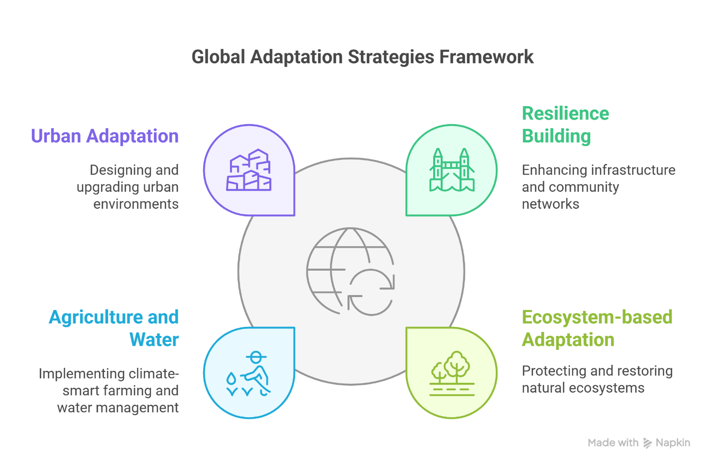

**Figure 3.** Conceptual Framework of Global Adaptation Strategies

**7.0 Case Studies of Successful Mitigation and Adaptation Efforts**

As every region of the planet begins to experience the impacts of climate change, many countries, cities, and communities have adopted effective mitigation and adaptation approaches that highlight important lessons learned and replicable best practices. Such initiatives show that, although challenges remain, we can make significant progress with the proper political will, technological innovation, and natural community engagement. Here, we look at some key global and national initiatives that show strong responses to climate change.

**7.1 International Success Stories**

Some countries have managed to decouple economically from greenhouse gas (GHG) emissions while achieving sound economic performance. Denmark and Sweden are two of the world's leading mitigation authorities, thanks to their integrated energy policies and long-term sustainability goals.

For instance, Denmark emerged as a global leader in wind energy deployment, with wind turbines providing almost 50% of its electricity in 2022 (Gallaher et al., 2023). However, the Danish government's early and proactive investment in renewable infrastructure, building efficiency standards, and a carbon tax in the early 1990s has allowed the country to decouple emissions from economic growth. Copenhagen is well on its way to being the world's first carbon-neutral capital (planned for 2025), incentivized by district heating systems, bikeable urban infrastructure, and biomass energy (Hansen & Agger, 2023).

On the other hand, Sweden has performed admirably, thanks to a mix of carbon pricing, forest management, and low-carbon transportation policies. Its national carbon tax — adopted in 1991 and now one of the world's highest — has sharply reduced fossil fuel use. The majority of electricity in Sweden comes from hydropower and nuclear; underground electricity production aims to be 100% renewable by 2040 (Nøland et al., 2022).

With adaptation to climate change, the order of the day, the Netherlands has become a poster child for making infrastructure more climate-resilient. Threatened by rising sea levels and flooding rivers, the country has embraced an adaptive policy in which "Room for the River" permits rivers to burst their banks in populated areas to spare the cities from floods. The Netherlands has become a leader in water management and climate adaptation engineering through innovations like floating homes, elevated dikes, and storm surge barriers (Huebner, 2025).

While making only a fraction of the contribution to global emissions, Small Island Developing States (SIDS) have displayed resilience through capacity building to adapt. The Pacific Island nation of Vanuatu, learning from its past, has combined traditional ecological knowledge and disaster risk reduction measures like raised housing structures, mangrove replantation efforts, and early warning systems. International climate finance mechanisms such as the Green Climate Fund (Bhandary et al., 2021) have supported community-based resilience projects.

**7.2 Local and Regional Action**

National governments set national climate agendas, but regional and local governments play essential roles in transitioning from global targets to real-life objectives. Globally, decentralized (decentralized autonomous organizations, or DAOs) and community-driven (such as community land trusts) initiatives have become robust mitigation and adaptation tools (Li & Chen, 2024).

For example, renewable energy cooperatives have changed the energy game in Germany, allowing citizens to own and maintain their clean energy systems. Typically based in rural locations, these cooperatives have played a critical role in Germany's Energiewende (energy transition) success. They have installed wind turbines and solar panels, giving local communities energy independence and the ability to keep wealth in the community.

There is probably no more ambitious local decarbonization strategy in North America than the one led by Ithaca, New York, in the United States. The municipal government unveiled a Green New Deal, which aims for carbon neutrality by 2030 through building electrification, sustainable transport, and just transition workforce development. The initiative is notable for emphasizing environmental justice through prioritizing investments in historically marginalized neighborhoods, demonstrating the interconnectedness between climate action and social equity (Fitzgerald, 2022).

In South Asia, one example is the state of Gujarat in India, which introduced climate-smart agriculture through the Krishi Mahotsav initiative, reaching out to smallholder farmers with climate-resilient farming techniques, soil health cards, and drought-tolerant seeds. Such efforts have enhanced food security and reduced susceptibility to erratic monsoon patterns.

In addition, community-based disaster preparedness programs have effectively protected those living in hazardous areas from extreme weather events. In the Philippines, Tacloban, which was flattened by Typhoon Haiyan in 2013, has focused its rebuilding efforts on climate-resilient housing, early warning systems, and risk education at the barangay (neighborhood) level. Involving local voices in planning has shored up public faith and preparedness for future disasters.

**8.0 Challenges and Barriers to Effective Climate Action**

As a dire scientific consensus emerges worldwide on urgent action to address climate change, global efforts to mitigate and adapt to its impacts remain mixed and inadequate. A compound of interlocking political, economic, social, and technological barriers continues to block the scale and pace of climate action needed to meet international targets, including those under the Paris Agreement (Fitzgerald, 2022). Recognizing the above barriers is essential to creating improved, more inclusive strategies.

One of the most enduring hurdles for scaling up climate action is the absence of political agreement and commitment at the national and international levels. Short-term political cycles, partisan divides, and fossil fuel industry lobbying pressures from the frequent drive climate policies encounter domestic opposition to imposing severe environmental policies if their action conflicts with economic expansion or job opportunities within high-carbon industries. This absence of long-term political ownership weakens continuity and ambition in climate planning.

Wealth inequalities and historical emissions have made negotiations difficult on the global stage. Developing countries make claims for climate justice—arguing that they bear a smaller share of emissions but a more significant share of vulnerability—but developed countries are often reluctant to agree to more outstanding financial contributions or deeper emissions reductions. One other major obstacle is funding. Even as pledges for climate financing have increased recently, the amount released lags what is promised. Moreover, the $100 billion a year that developed countries pledged to mobilize for their developing counterparts — a centerpiece of the Paris Agreement — has yet to be fully delivered. On the one hand, transitioning economies are contending with the enormous task of decoupling growth from emissions, which requires significant up-front investments in clean infrastructure, transitions for workers, and restructuring of most energy and transportation systems, all of which first require strong fiscal planning and then substantial international support.

Climate action is further challenged by social and cultural dynamics that influence public attitudes, behaviors, and acceptance of policy measures. Climate change is often viewed as a far-off or amorphous threat, especially in places where scientific literacy is low or communities face more pressing socioeconomic issues. This leads to poor public engagement and insufficient demand for policy reform.

Sectors with vested interests also resist change. For example, industries that rely on fossil fuels, automotive manufacturing, and intensive agriculture may view decarbonization as a threat to profit or jobs. Consequently, they actively lobby against climate policies, resulting in delays in the policy process, regulatory loopholes, or greenwashing practices (Culhane et al., 2021).

Cultural values and identities can also shape climate responses. Sometimes, traditional ways of life may clash with externally imposed adaptation measures. At the same time, in other cases, women or Indigenous peoples may face societal norms that restrict their role in climate governance. Building public trust and awareness and localizing climate solutions within citizens' cultural contexts are key to social acceptance and behavioral change.

Indeed, while technological innovation is critical to climate mitigation and adaptation, technological availability, accessibility, and scalability are uneven across different regions. In many developing countries, high costs, lack of technical know-how, and poor infrastructure make it difficult for them to access advanced technologies. Even in developed economies, scaling up technologies like carbon capture and storage (CCS), green hydrogen, or next-generation battery systems is still limited by economic and regulatory uncertainty (Arent et al., 2022).

Furthermore, adaptation technologies ranging from resilient infrastructure to early warning systems to precision agriculture are capital-intensive and require context-specific customization that is costly and challenging to scale up. Technological adoption and resilience-building capacity are further divided by urban-rural divides.

The monitoring, reporting, and verification (MRV) of climate actions is another crucial barrier to transparency and accountability in global climate governance. In many countries, institutional capacities to track emissions reductions, analyze climate risks, or evaluate the effectiveness of adaptation programs are weak or underdeveloped. This strains the credibility of climate promises and further complicates attempts to galvanize international backing.

**9.0 Future Outlook and Recommendations**

With the global climate crisis reaching unprecedented levels, the need for widespread coordinated action has never been greater. We have progressed, culminating in international agreements, technological innovations, and local adaptation efforts. However, the current scale of climate action is insufficient to achieve the Paris Agreement's goals or to avoid the worst impacts of global warming. This section lays out a way forward for robust climate mitigation and climate adaptation, presents global policy recommendations, and emphasizes the central role of local communities and individuals in achieving a sustainable future.

**9.1 The Way Ahead for Mitigation and Adaptation**

We can no longer afford to view climate change as a separate issue; its intertwined nature with all sectors of society means that the solutions to the multifaceted problem of the climate crisis will be best suited in the form of accelerated, systemic transformations of all facets of society. Scientists, policymakers, and civil society widely agree that current efforts must be rapidly scaled up and synchronized. Doing so will require profound emissions reduction and widespread adaptation to unavoidable impacts.

The urgent need for mitigation must focus on a rapid transition to low-carbon energy systems, exploiting advances in renewable energy technologies (solar, wind, geothermal, and green hydrogen). The recent fall in the costs of renewables and the emergence of positive policy environments provide a promising path for decarbonizing electricity generation. Moreover, energy storage systems, innovative grid technologies, and digital innovations like artificial intelligence and machine learning can increase efficiency and integration across energy systems (Kiasari et al., 2024).

At the same time, global efforts, including the UNFCCC, must continue to promote adaptation. Adaptation must be built into national development strategies, especially in vulnerable countries and regions. Investments in climate-resilient infrastructure, sustainable agriculture, and nature-based solutions will be critical to protecting livelihoods and ecosystems (Mahedi et al., 2025). It is also crucial to emphasize flexible, anticipatory governance models that respond to emerging risks and uncertainties.

**9.2 Policy Recommendations at the Global Level**

Strong and inclusive climate governance is the foundation of real action. Complementary, strengthening the international climate architecture – especially the UN balance of powers through the mechanisms established under UNFCCC – will underpin transparency, accountability, and ambition with national pledges. These elements would include more ambitious review cycles, increased assistance to developing countries, and loss and damage compensation mechanisms, particularly for SIDS and LDCs, as future decisions on the Paris Agreement.

It is imperative to mainstream climate action at all levels of governance. Health systems must be prepared to handle the consequences of diseases exacerbated by climate and heat exposure. The agricultural policy should promote climate-resilient crops and sustainable farming practices (Mahedi et al., 2025). Mobile is a group of Architecture, Engineering, and Environmental Science professionals who work together to deliver integrated solutions for sustainable infrastructure. Aerodynamic is a company focused on building climate-resilient infrastructure for the future. A "whole-of-government" approach informed by cross-sectoral coordination and participatory planning is needed to build long-term resilience (Scott et al., 2022).

In addition, international financial institutions and multilateral development banks must prioritize climate finance, offering concessional loans, grants, and blended financing mechanisms. Increased access to climate finance, especially for local governments and Indigenous peoples, ensures that their adaptation efforts are equitable and effective.

**9.3 Local Community and Individual Empowerment**

At the grassroots level, local communities and individuals are key drivers of change. Fundamentally, educating locals, building their capacity, and including them in governance are how communities are empowered to be agents of change. This can lead to locally appropriate solutions that are theoretically more likely to be accepted and thereby accommodate sustainability. Local, science-based adaptation programs, Indigenous ecological knowledge, and stewardship of natural resources must all be acknowledged and supported as valuable pieces of climate solutions.

Equally, public engagement and awareness play a crucial role in changing behavior. Governments, media, and educational institutions must work together to raise awareness about climate change's causes, effects, and remedies. Campaigns to promote climate literacy, especially for youth, can help cultivate a new generation of climate-conscious citizens and leaders.

Individual lifestyle choices, while not a substitute for systemic change, can substantially mitigate emissions when adopted at scale. This can include cutting down on meat consumption, reducing energy consumption, selecting sustainable transportation options, and avoiding single-use plastics, which means we can take many actions as individuals. Incentive behaviors and social norms could support such behaviors in addition to top-down measures.

**10.0 Conclusion**

This review has thoroughly explored the multidimensionality of climate change, assessed its wide-ranging impacts, and critically appraised the global responses through adaptation and mitigation that have been instigated to avert the threat posed by climate change. Insights derived from recent scientific studies and available policy frameworks confirm that climate change remains a unique challenge for environmental balance, economic growth, and human health. Having made some progress, such as through the Paris Agreement, green infrastructure development, and national adaptation plans, there are still broad implementation, financing, and global equity gaps. The evidence also confirms that adaptation and mitigation are not contradictory but complementary pillars of an effective response to climate change; adaptation strategies from sustainable agriculture to resilient infrastructure to community-based adaptation can play a critical role in minimizing the immediate and localized impacts of climate disruptions. In parallel, mitigation measures, such as a shift to renewable energy, afforestation, and carbon pricing mechanisms, are critical to reducing greenhouse gas emissions and avoiding irreversible planetary tipping points. Policymakers and international actors must prioritize the integration of both pathways according to regional contexts and vulnerabilities. This review reaffirms the urgency of action and calls for a renewed commitment to coordinated, inclusive, science-informed global responses. Meeting climate targets needs much more than a technical solution; it requires political will, institutional strength, and long-term thinking beyond the short term. The climate crisis does not just represent an environmental emergency. It is also a profound moral and intergenerational challenge. Thus, we must commit to solidarity, creativity, and responsibility to make a habitable planet for great present and future generations.

**Funding:** This research received no external funding.

**Conflicts of Interest:** The authors declare no conflict of interest.

Disclaimer (Artificial intelligence)

Option 1:

Author(s) hereby declare that NO generative AI technologies such as Large Language Models (ChatGPT, COPILOT, etc.) and text-to-image generators have been used during the writing or editing of this manuscript.

Option 2:

Author(s) hereby declare that generative AI technologies such as Large Language Models, etc. have been used during the writing or editing of manuscripts. This explanation will include the name, version, model, and source of the generative AI technology and as well as all input prompts provided to the generative AI technology

Details of the AI usage are given below:

1.

2.

3.

**11.0 References**

1. Arent, D. J., Green, P., Abdullah, Z., Barnes, T., Bauer, S., Bernstein, A., Berry, D., Berry, J., Burrell, T., Carpenter, B., Cochran, J., Cortright, R., Curry-Nkansah, M., Denholm, P., Gevorian, V., Himmel, M., Livingood, B., Keyser, M., King, J., … Turchi, C. (2022). Challenges and opportunities in decarbonizing the U.S. energy system. *Renewable and Sustainable Energy Reviews*, *169*, 112939. https://doi.org/10.1016/j.rser.2022.112939
2. Bhandary, R. R., Gallagher, K. S., & Zhang, F. (2021). Climate finance policy in practice: A review of the evidence. *Climate Policy*, *21*(4), 529–545. https://doi.org/10.1080/14693062.2020.1871313
3. Culhane, T., Hall, G., & Roberts, J. T. (2021). Who delays climate action? Interest groups and coalitions in state legislative struggles in the United States. *Energy Research & Social Science*, *79*, 102114. https://doi.org/10.1016/j.erss.2021.102114
4. Dedekorkut-Howes, A., Torabi, E., & Howes, M. (2020). When the tide gets high: A review of adaptive responses to sea level rise and coastal flooding. *Journal of Environmental Planning and Management*, *63*(12), 2102–2143. https://doi.org/10.1080/09640568.2019.1708709
5. Doukas, H., Nikas, A., González-Eguino, M., Arto, I., & Anger-Kraavi, A. (2018). From Integrated to Integrative: Delivering on the Paris Agreement. *Sustainability*, *10*(7), 2299. https://doi.org/10.3390/su10072299
6. Elneel, L., Zitouni, M. S., Mukhtar, H., Galli, P., & Al-Ahmad, H. (2024). Exploring Key Aspects of Sea Level Rise and Their Implications: An Overview. *Water*, *16*(3), 388. https://doi.org/10.3390/w16030388
7. Filonchyk, M., Peterson, M. P., Zhang, L., Hurynovich, V., & He, Y. (2024). Greenhouse gases emissions and global climate change: Examining the influence of CO2, CH4, and N2O. *Science of The Total Environment*, *935*, 173359. https://doi.org/10.1016/j.scitotenv.2024.173359
8. Fitzgerald, J. (2022). Transitioning From Urban Climate Action to Climate Equity. *Journal of the American Planning Association*, *88*(4), 508–523. https://doi.org/10.1080/01944363.2021.2013301
9. Gallaher, A., Graziano, M., Axon, S., & Bertana, A. (2023). Breaking wind: A comparison between U.S. and European approaches in offshore wind energy leadership in the North Atlantic region. *Renewable and Sustainable Energy Reviews*, *187*, 113766. https://doi.org/10.1016/j.rser.2023.113766
10. Grigorieva, E. A. (2024). Climate Change and Human Health in the Arctic: A Review. *Climate*, *12*(7), 89. https://doi.org/10.3390/cli12070089
11. Hansen, K. B., & Agger, A. (2023). Copenhagen CO2 neutrality in 2025? A polycentric analysis of urban climate governance in Copenhagen 2006–2020. *Environmental Policy and Governance*, *33*(3), 288–300. https://doi.org/10.1002/eet.2030
12. Huang, X., White, M., & Langenheim, N. (2022). Towards an Inclusive Walking Community—A Multi-Criteria Digital Evaluation Approach to Facilitate Accessible Journeys. *Buildings*, *12*(8), 1191. https://doi.org/10.3390/buildings12081191
13. Huebner, S. (2025). Coastal urban climate adaptation and the advance onto aquatic surfaces using floating solutions: Historical challenges and potential future benefits of floating homes and similar structures. *Ocean & Coastal Management*, *261*, 107433. https://doi.org/10.1016/j.ocecoaman.2024.107433
14. Ires, I. (2021). Intensive Agriculture as Climate Change Adaptation? Economic and Environmental Tradeoffs in Securing Rural Livelihoods in Tanzanian River Basins. *Frontiers in Environmental Science*, *9*, 674363. https://doi.org/10.3389/fenvs.2021.674363
15. Jones, M. W., Peters, G. P., Gasser, T., Andrew, R. M., Schwingshackl, C., Gütschow, J., Houghton, R. A., Friedlingstein, P., Pongratz, J., & Le Quéré, C. (2023). National contributions to climate change due to historical emissions of carbon dioxide, methane, and nitrous oxide since 1850. *Scientific Data*, *10*(1), 155. https://doi.org/10.1038/s41597-023-02041-1
16. Jones, R. N. (2024). Evidence and Explanation for the 2023 Global Warming Anomaly. *Atmosphere*, *15*(12), 1507. https://doi.org/10.3390/atmos15121507
17. Kephe, P. N., Siewe, L. C., Lekalakala, R. G., Kwabena Ayisi, K., & Petja, B. M. (2022). Optimizing Smallholder Farmers' Productivity Through Crop Selection, Targeting and Prioritization Framework in the Limpopo and Free State Provinces, South Africa. *Frontiers in Sustainable Food Systems*, *6*, 738267. https://doi.org/10.3389/fsufs.2022.738267
18. Kiasari, M., Ghaffari, M., & Aly, H. (2024). A Comprehensive Review of the Current Status of Smart Grid Technologies for Renewable Energies Integration and Future Trends: The Role of Machine Learning and Energy Storage Systems. *Energies*, *17*(16), 4128. https://doi.org/10.3390/en17164128
19. Kramer, I., Tsairi, Y., Roth, M. B., Tal, A., & Mau, Y. (2022). Effects of population growth on Israel's demand for desalinated water. *Npj Clean Water*, *5*(1), 67. https://doi.org/10.1038/s41545-022-00215-9
20. Kundu, T., Suyash, S., Gupta, M., & Chowdhury, B. (2024). Introduction to greenhouse gases composition and characteristics. In *Advances and Technology Development in Greenhouse Gases: Emission, Capture and Conversion* (pp. 3–18). Elsevier. https://doi.org/10.1016/B978-0-443-19066-7.00008-4
21. Li, S., & Chen, Y. (2024). Governing decentralized autonomous organizations as digital commons. *Journal of Business Venturing Insights*, *21*, e00450. https://doi.org/10.1016/j.jbvi.2024.e00450
22. Lu, Z., Wu, C., Wu, N., Lu, H., Wang, T., Xiao, R., Liu, H., Wu, X., Oil and Gas Survey, China Geological Survey, Ministry of Natural Resources, Beijing 100083, China, Information Center, Ministry of Natural Resources, Beijing 100036, China, Qingdao Institute of Marine Geology, China Geological Survey, Qingdao 266237, China, & School of Earth and Space Sciences, Peking University, Beijing 100871, China. (2022). Changes in natural gas hydrates in permafrost on the Qinghai-Tibet Plateau under the background of global warming and their impacts on carbon emissions. *China Geology*, *5*(3), 1–35. https://doi.org/10.31035/cg2022034
23. Mahedi, M., Pervez, A. K. M., Rahman, S., Sheikh, M., & Shaili, S. J. (2025). *Emerging Trends in Livelihood Diversification in Rural Communities: A Bibliometric and Systematic Review*. *43*, 162–177. https://doi.org/10.9734/ajaees/2025/v43i42727
24. Mahedi, M., Shaili, S. J., Nurnobi, M., Sakil, A., & Shihab, A. (2025). *ADOPTION OF ORGANIC FARMING PRACTICES: A COMPREHENSIVE REVIEW OF TRENDS, DETERMINANTS, AND CHALLENGES*. *8*, 26–45.
25. Mahedi, M., Shaili, S. J., & Shihab, A. (2024). *Livelihood Diversification as a Reduce to Rural Vulnerability in Bangladesh: A Review*.
26. Mao, W., Shalaby, R., Agyapong, B., Obuobi-Donkor, G., Da Luz Dias, R., & Agyapong, V. I. O. (2024). Devastating Wildfires and Mental Health: Major Depressive Disorder Prevalence and Associated Factors among Residents in Alberta and Nova Scotia, Canada. *Behavioral Sciences*, *14*(3), 209. https://doi.org/10.3390/bs14030209
27. Marcianesi, F., Aulicino, G., & Wadhams, P. (2021). Arctic sea ice and snow cover albedo variability and trends during the last three decades. *Polar Science*, *28*, 100617. https://doi.org/10.1016/j.polar.2020.100617
28. Md Shahriar Kabir, Md Mahedi, A K M Kanak Pervez, Md Jahangir Alam, & Shabrin Jahan Shaili. (2025). Bibliometric analysis of "precision agriculture" in the Scopus database. *World Journal of Advanced Research and Reviews*, *25*(3), 1087–1098. https://doi.org/10.30574/wjarr.2025.25.3.0733
29. Min, J., Yan, G., Abed, A. M., Elattar, S., Amine Khadimallah, M., Jan, A., & Elhosiny Ali, H. (2022). The effect of carbon dioxide emissions on the building energy efficiency. *Fuel*, *326*, 124842. https://doi.org/10.1016/j.fuel.2022.124842
30. Mondal, S. K., Huang, J., Wang, Y., Su, B., Kundzewicz, Z. W., Jiang, S., Zhai, J., Chen, Z., Jing, C., & Jiang, T. (2022). Changes in extreme precipitation across South Asia for each 0.5 °C of warming from 1.5 °C to 3.0°C above pre-industrial levels. *Atmospheric Research*, *266*, 105961. https://doi.org/10.1016/j.atmosres.2021.105961
31. Nguyen, H. T. T., Hardy, G. E. S., Le, T. V., Nguyen, H. Q., Nguyen, H. H., Nguyen, T. V., & Dell, B. (2021). Mangrove Forest Landcover Changes in Coastal Vietnam: A Case Study from 1973 to 2020 in Thanh Hoa and Nghe An Provinces. *Forests*, *12*(5), 637. https://doi.org/10.3390/f12050637
32. Nhamo, G., & Nhamo, S. (2016). One global deal from Paris 2015: Convergence and contestations on the future climate mitigation agenda. *South African Journal of International Affairs*, *23*(3), 323–346. https://doi.org/10.1080/10220461.2016.1252281
33. Nøland, J. K., Auxepaules, J., Rousset, A., Perney, B., & Falletti, G. (2022). Spatial energy density of large-scale electricity generation from power sources worldwide. *Scientific Reports*, *12*(1), 21280. https://doi.org/10.1038/s41598-022-25341-9
34. Oyekale, J., Petrollese, M., Tola, V., & Cau, G. (2020). Impacts of Renewable Energy Resources on Effectiveness of Grid-Integrated Systems: Succinct Review of Current Challenges and Potential Solution Strategies. *Energies*, *13*(18), 4856. https://doi.org/10.3390/en13184856
35. Pepin, N. C., Arnone, E., Gobiet, A., Haslinger, K., Kotlarski, S., Notarnicola, C., Palazzi, E., Seibert, P., Serafin, S., Schöner, W., Terzago, S., Thornton, J. M., Vuille, M., & Adler, C. (2022). Climate Changes and Their Elevational Patterns in the Mountains of the World. *Reviews of Geophysics*, *60*(1), e2020RG000730. https://doi.org/10.1029/2020RG000730
36. Rignot, E., Velicogna, I., Van Den Broeke, M. R., Monaghan, A., & Lenaerts, J. T. M. (2011). Acceleration of the contribution of the Greenland and Antarctic ice sheets to sea level rise: ACCELERATION OF ICE SHEET LOSS. *Geophysical Research Letters*, *38*(5), n/a-n/a. https://doi.org/10.1029/2011GL046583
37. Scott, M., Burns, L., Lennon, M., & Kinnane, O. (2022). *Built environment climate resilience and adaptation*. Retrieved from website: https://www. researchgate. net/publication/362711958. https://www.researchgate.net/profile/Mick-Lennon/publication/362711958_Built_Environment_Climate_Resilience_and_Adaptation/links/62fb65ecceb9764f72ff8d61/Built-Environment-Climate-Resilience-and-Adaptation.pdf
38. Sitch, S., O'Sullivan, M., Robertson, E., Friedlingstein, P., Albergel, C., Anthoni, P., Arneth, A., Arora, V. K., Bastos, A., Bastrikov, V., Bellouin, N., Canadell, J. G., Chini, L., Ciais, P., Falk, S., Harris, I., Hurtt, G., Ito, A., Jain, A. K., … Zaehle, S. (2024). Trends and Drivers of Terrestrial Sources and Sinks of Carbon Dioxide: An Overview of the TRENDY Project. *Global Biogeochemical Cycles*, *38*(7), e2024GB008102. https://doi.org/10.1029/2024GB008102
39. Soares, T. V. F., & Aquino, A. C. B. D. (2024). Calculative Practices Shaping the Global Accountability Forum for Climate Agenda. *Financial Accountability & Management*, faam.12419. https://doi.org/10.1111/faam.12419
40. Uddin, M., Pervez, A. K. M., Kabir, M., & Mahedi, M. (2025). *The Trend of Agribusiness Research Worldwide: A Bibliometric Analysis Based on the Scopus Database*. *3*, 41–53.
41. Uddin, Md. E., Pervez, A. K. M. K., & Gao, Q. (2022). Effect of voluntary cooperativisation on livelihood capital of smallholder dairy farmers in the southwest of Bangladesh. *GeoJournal*, *87*(1), 111–130. https://doi.org/10.1007/s10708-020-10218-z
42. Ure, J. (2024). Climate Change and the Environment (SDGs 13, 6, 7, 11, 14, 15). In J. Ure, *Achieving the United Nations Sustainable Development Goals: Late or Too Late?* (pp. 61–114). Emerald Publishing Limited. https://doi.org/10.1108/978-1-83549-404-220241003
43. Waseem, H. B., Mirza, M. N. E. E., Rana, I. A., & Waheed, A. (2024). Adaptation planning for climate change: An application of the advanced bibliometric analytical framework. *Natural Hazards Research*, *4*(3), 459–469. https://doi.org/10.1016/j.nhres.2023.11.005