Original Research Article

In vitro efficacy of Trichoderma asperellum against wilt in Watermelon caused by Fusarium oxysporum f.sp. niveum

ABSTRACT
The production of watermelon (Citrullus lanatus) in India is negatively impacted by Fusarium oxysporum f.sp. niveum (Fon) which is a major soil-borne disease. Keeping Fusarium wilt under control is crucial for maintaining crop yield. Various approaches have been proposed to combat Fusarium wilt. The toxic forms of chemicals remain in the soil and pollute the entire environment because they are continuously used. The purpose of this study is to determine the occurrence and severity of Fusarium wilt in important districts where watermelon is grown in Tamil Nadu and to evaluate the in vitro efficacy of native Trichoderma asperellum isolates as potential biocontrol agents. Field surveys conducted across 15 locations revealed varying levels of disease incidence, with Vaidapakkam village recording the highest incidence (42.14%). Ten Fon isolates (Fon₁–Fon₁₀) and ten native Trichoderma isolates (TsI₁–TsI₁₀) were obtained from infected plant tissues and rhizosphere soils, respectively. Among these, Fon₅ was identified as the most virulent isolate. Dual culture assays demonstrated that T.asperellum isolate TsI₄ exhibited the highest antagonistic activity, inhibiting Fon₅ growth by 81.74%. Further, poisoned food and well diffusion assays confirmed that TsI₄ culture filtrates significantly suppressed Fon₅ mycelial growth in a dose-dependent manner, achieving up to 95.13% inhibition in the poisoned food assay and a 28.72 mm inhibition zone in the agar well diffusion method at 40% concentration. The results indicate that T. asperellum isolates, particularly TsI₄, have a strong chance of being biological control agents against Fusarium wilt in watermelon cultivation, and are an ecological alternative to chemical fungicides. Trichoderma asperellum shows good effect on suppression of Fusarium wilt pathogen under in vitro condition. Farmers growing watermelon crop must use Bio-control agent Trichoderma for the management of wilt disease thereby resulting in sustainable yields with highest economic returns.
Keywords:Biological control, Watermelon wilt, Fusarium oxysporum f.sp. niveum and Trichoderma asperellum.
1. INTRODUCTION
“The cultivation of watermelon (Citrullus lanatus) is a popular fruit crop worldwide, including India” (Hua et al. 2020). “It belongs to the family Cucurbitaceae and is considered the main horticultural crop worldwide. According to the National Horticultural Board (2017-18), India is the second largest watermelon producer in Asia. The main areas of cultivation in India are Uttar Pradesh, Karnataka, Madhya Pradesh, Maharashtra, Punjab, Rajasthan, and Tamil Nadu. The major growing areas in Tamil Nadu are Villupuram, Cuddalore, Thanjavur, Coimbatore, Karur, Kancheepuram, Salem, and Erode. Watermelon is susceptible to several diseases such as anthracnose, Fusarium wilt, downy mildew, Gummy stem blight, root knot nematode and viral diseases. The watermelon crop in continuously cultivated soil is attacked by Fusarium wilt, which is considered a serious disease among these diseases” (Zhou et al. 2004). “Fusarium wilt is a disease that results from the pathogen Fusarium oxysporum f.sp. niveum in the soil (FON). This pathogen can survive in soil for longer than chlamydial spores and can also colonize on non-host plants” (Harveson et al. 2002).
“Watermelon yield losses caused by Fusarium are usually between 10% and 40%. Fusarium wilt starts with leaves turning a dull grey green color and wilting during the daytime” (Egel et al. 2016).”Wilting of plants followed by necrosis” (Martyn et al. 2014). “The characteristic of Fusarium wilt in older plants is the wilting of individual Watermelon runners, and the hallmark of Fusarium wilt is unilateral stem necrosis, which can be easily observed by sectioning runners or stems” (Kleczewski et al. 2011).
“The control of Fusarium wilt is necessary for maintaining the crop yield. Several strategies have been proposed to control Fusarium wilt” (Zhang et al., 2022; Hasna et al., 2025). “The continuous use of chemicals causes their toxic forms to persist in soil and pollute the whole environment” (Sundaramoorthy et al., 2013). “Biological management is an alternative and economically suitable approach for the management of Watermelon wilt” (Li et al., 2019). It is a potential non-chemical means of plant disease management by reducing the harmful effects of pathogens through the use of other living microorganisms.
“The antagonistic fungi especially Trichodermaspp viz., Trichoderma asperellum, Trichoderma viride, Trichoderma harzianum and Trichoderma atroviride have been widely used against Fusarium oxysporum f.sp. niveum” (Trillas et al., 2006). “The different species of Trichoderma effectively control the wilt disease in several crops” (Christopher et al., 2010).
2. MATERIALS AND METHODS
2.1. Survey for the occurrence of Fusarium wilt of watermelon in the major growing areas of Tamil Nadu
A field survey was executed to determine the percentage of disease incidence (PDI) of watermelon wilt in various districts of Tamil Nadu during the 2020 Rabi season. Fifteen locations were selected in five districts of Tamil Nadu for the survey. In each field, an area of 2 m x 2 m was analyzed and the number of infected plants related to diseases was accounted for and recorded. Also, the total number of plants present in each area was calculated. The per cent disease incidence was calculated by using the formula (Mayee and Datar1986).
Disease incidence (%) = (Number of infected plants / Total number of plants observed) X 100
The pathogen and antagonistic organisms were isolated by collecting completely wilted plants and rhizosphere soil. The survey fields recorded other data on the soil type used for growing the crop and the variety of watermelon it is grown in.
2.2. Isolation and identification of Fusarium oxysporum f.sp. niveum pathogen
Tap water was used to wash the infected root and stem portions, and the tissues that had brown discoloration were cut into small pieces. The tissue segmentation method was used to isolate the pathogen from the watermelon's diseased tissues (Rangaswami, 1958). The infected parts of diseased plants were divided into small pieces and stretched with 0.1% sodium hypochlorite for one minute and washed in three changes of sterile distilled water to remove the traces of sodium hypochlorite and were then placed on a previously poured and solidified Petri dish containing Potato Dextrose Agar (PDA) medium.
The fungus' growth was observed on these plates after they were incubated at room temperature (28±2°C) for five to seven days. The hyphal tip method was utilized to acquire a pure pathogen culture that was then transferred aseptically to PDA slants to maintain its purity. The pathogen Fon was identified with the descriptions given by Booth (1971).Totally ten isolates were maintained and they were designated as Fon₁to Fon₁₀ respectively.
2.3. Isolation of native antagonists from Rhizosphere soil Trichoderma sp.
To isolate the antagonists, soil samples from the watermelon rhizosphere were collected from various locations during the field survey. The isolate was accomplished by performing a serial dilution plating technique with Trichoderma Selective Medium (TSM) (Elad and Chet, 1983). These Trichoderma spp. cultures were purified by single hyphal tip method and used for the studies. The culture's shape, colony color, condition, and mode of growth were evaluated (Leahy and Colwell 1990). Trichoderma spp thus isolated was subjected for identification based on the key to species (Domsch et al., 1980).

2.4. In vitro testing of fungal bio-control agents
2.4.1. Screening of potential Bio agents by Dual culture technique
Fon₅ was tested by dual culture technique (Dennis and Webster 1971). Under aseptic conditions, a mycelium disc measuring 9 mm was placed in a 15 ml sterile-PDA medium-filled Petridish at one end. At the opposite end, approximately 75 mm away from the T. asperellum culture disc, a 9 mm culture disc was placed and incubated just like the previous one. A control plate was maintained by inoculating Fon₅ at one end of the petridish. The plates were incubated at room temperature (28±2ºC) for seven days. Radical growth of the pathogen and the test antagonist was measured.
Based on inhibition of the pathogen's growth, the effective antagonists were identified. The radial mycelial growth of the pathogen and per cent reduction over control was calculated by using the formula (Vincent, 1947).
Per cent inhibition (I) = C-T/C × 100
Where, C-mycelial growth of pathogen in control
T-mycelial growth of pathogen in Dual plate and I -Inhibition per cent
2.4.2. Bioassay of culture filtrates of Trichoderma asperellum
Preparation of the culture filtrates of T. asperellum
At 28 °C, the effective T. asperellum isolates were propagated for 10 days in Erlenmeyer flasks using 50 ml of sterilized potato dextrose broth in Erlenmeyer flasks. A bacteriological filter was used to filter the cultures under vacuum to remove the mycelium and spores. The filtrate obtained was utilized for the studies.
2.4.3. Poisoned food technique (Grover and Moore, 1962)
The culture filtrates of the antagonists were separately incorporated into sterile PDA medium at 10, 20, 30 and 40% by adding the calculated quantity of the culture filtrates to the medium by means of a sterile pipette. The PDA medium without the culture filtrate served as a control.
Each plate was inoculated at the center with a 9mm culture disc of Fon₅ from a seven-day-old culture. Three replications were maintained for each treatment. When the mycelial growth fully covered the control plates, the diameter of Fon₅ mycelia growth was measured.
2.4.4. Agar well method (Perez et al., 1990)
Agar well diffusion method is also known as a hole plate diffusion method (Brantner, 1997). This method was employed to identify the antagonistic effects of potent antifungal compounds that were found in T. asperellum culture filtrate. An inoculated culture of T. asperellum that was 7 days old was incubated in a shaker at 150 rpm for 2 days. Ensuing 10ml of culture was centrifuged at 10,000 rpm for 20 min. The Whatman No.1 filter paper was utilized to filtrate the supernatant, and the spore suspension was extracted.
Petri plates that were amended with 15 ml solidified PDA medium were inoculated in the centre with a Fon₅ culture that had been cultured for 7 days. Next, a sterile cork borer was used to cut the wells equidistantly. Four wells were suspended with filtrate concentrations of 10, 20, 30, and 40 percent, each 2 cm away from the centrally placed Fon₅ disc. The control plate without filtrate was maintained and incubated at (28±2ºC) for seven days to evaluate the maximum percent of inhibition. The inhibition zone that surrounded each well was measured and calculated.
3. RESULTS
3.1. Survey on the incidence of Fusarium wilt of watermelon incited by Fusarium oxysporum f.sp. niveum in major watermelon growing areas of Tamil Nadu
Table 1 shows the endemic nature of Fusarium and the incidence of watermelon from surveys conducted in various locations of major watermelon growing areas in Tamil Nadu. Among the different locations of Tamil Nadu surveyed for Watermelon Fusarium wilt incidence, Vaidapakkam village in Villupuram district recorded the maximum incidence of the disease (42.14%) followed by Renganathapuram in Thanjavur district with the wilt incidence of 39.27%, Alankuppam in Villupuram district with the wilt incidence of 35.54% and the minimum Fusarium wilt incidence of (5.35%) was recorded at Tindivanam in Villupuram district. Totally 15 locations were surveyed. Out of 15 locations 10 locations showed considerable per cent disease incidence and the remaining five locations showed least percentage disease incidence in sandy soil conditions. Out of fifteen, 10 isolates were selected for further studies.
3.2. Isolation and Cultural characteristics of various isolates of Fusarium oxysporum f.sp. niveum from major Watermelon growing areas of Tamil Nadu
3.2.1. Colony characters
The isolates of Fusarium species showed variation with respect to colony characters. The isolates exhibited a variety of colors, ranging from velvety white to cottony white and pinkish. Among the isolates, most produced fluffy to moderately fluffy cottony white aerial mycelium (Table2).
3.2.2. Mycelial growth
Among the 10 isolates of Fusarium species, the maximum mycelial growth (90.00mm) was recorded by the isolates Fon₅ isolated from Vaidapakkam village of Villupuram District. The minimum mycelial growth (75.23 mm) was recorded by the isolate Fon₆ were isolated from Vellakal village of Trichy District (Table2).
3.3. Growth and cultural characteristics of native Trichoderma species
A total of ten native Trichoderma species were isolated from the watermelon rhizosphere soil of different localities where pathogens were isolated (Table 3). Ten native Trichoderma species isolates were individually observed and recorded for their colony characteristics. The colony morphology of all ten isolates was almost similar, showing profuse to cottony mycelium or fluffy to arachnoid mycelium with light to dark green color sporulation with concentric or ring-like zones. The conidia were present in various shapes such as ellipsoidal, obovoid, and globose to sub-globe (Table 4).
The cultural and morphological characteristics of Trichoderma species native isolates agreed with those described by Domsch et al., (1980) and therefore, among the different isolates, some of the isolates were identified as T. asperellum (TsI₁, TsI₄, TsI₆ and TsI₇), T. viride (TsI₂ and TsI₉), T. harzianum (TsI₈ and TsI₁₀) and Trichoderma sp. (TsI₃ and TsI₅).
3.4. In vitro efficacy of Trichoderma species isolates against Fusarium oxysporum f.sp. niveum (Fon₅) (Dual culture Technique)
In general, all the native Trichoderma species isolates had a significant impact on the growth of mycelia in Fon₅ (Table 5). However, among the isolates, the isolate TsI₄ (T.asperellum) showed maximum inhibition of Fon₅ (16.43 mm), which was 81.74 per cent reduction in the growth of the pathogen when compared to control. This was followed by the isolates TsI₁ and TsI₆ in the decreasing order of merit, which inhibited the growth of Fon₅ by79.78 and 75.71 percent respectively. The isolate TsI₃ recorded the lowest growth inhibition of the pathogen (56.54%). The virulent isolate TsI₄ was used for the further studies.
3.5. In vitro efficacy of T. asperellum (TsI₄) isolates against Fusarium oxysporum f.sp. niveum (Fon₅) (Poison Food Technique)
Table 6 revealed that Fon₅ growth was significantly inhibited by all the Trichoderma isolates when compared to the control. The inhibition of mycelial growth of the pathogen is generally enhanced by increasing the concentration of the culture filtrate.
Among the isolates, the inhibition of mycelial growth of Fon₅ was found to be maximum in the isolate TsI₄ with the growth of 17.86, 14.94, 9.73, 4.38 mm at the concentration of 10, 20, 30 and 40 per cent respectively. This was followed by the isolates TsI₁, TsI₆ and TsI₁₀ in the decreasing order of merit. The isolate TsI₃ exhibited the least inhibitory effect.
3.6. Effect of inhibitory potential of T.asperellum (TsI₄) filtrate on the growth of Fusarium oxysporum f.sp. niveum (Fon₅) (Well diffusion assay)
The results depicted in table 7 revealed the efficacy of culture filtrate of T.asperellum isolate (TsI₄) against Fon₅ by agar well method. Among the isolates, the maximum inhibition of Fon₅ was found in the isolate TsI₄with the inhibition zone of 9.20, 15.24, 20.17 and 28.72 mm at the concentration of 10, 20, 30 and 40 per cent respectively. This was followed by the isolates TsI₁, TsI₆ and TsI₁₀ in the decreasing order of merit. The isolate TsI₃ exhibited the least inhibitory effect.
4. DISCUSSION
The survey indicated that the disease's incidence and severity varied from one location to another. The variation may be due to prevalence and virulence of the pathogen. Based on the survey, it was discovered that the seedling stage of the crop is the most vulnerable to this disease. Among the different locations surveyed, Vaidapakkam (Fon₅) registered the maximum disease incidence (42.14%) followed by Renganathapuram (Fon₇) with 39.27%, and Alankuppam (Fon₂) with 35.54%. The other locations recorded moderate disease incidence percentage. The least wilt incidence (5.35%) was recorded in Tindivanam. Charoenporn et al. (2010) concluded that Fusarium water incidence was higher when monocropping was followed. The findings revealed that the susceptible cultivars and watermelon plants cultivated in sandy loamy soil were more prone to being attacked by the disease. Naveenkumar et al., 2017, performed a survey in 9 districts and 15 locations in Tamil Nadu, which showed that the wilt incidence ranged from 8.0% to 40.21%.
Dull green to bluish green sporulation was produced by T. viride isolates (Mohamadmanjur shah and Hamisu Afiya 2019). Nagamani et al. (2020) asserted that T. asperellum isolates had a faster growth rate than T. harzianum, and produced mycelium ranging from light green to dark green in different media. The morphology of mycelium was coarse and it produced dark spores in the center of the colony at a high rate.
In dual culture tests, the antagonistic effect of native Trichoderma isolates was evaluated against virulent isolate of Fon₅. T.asperellum isolate grew faster than the Fusarium sp. and hindered the development of Fusarium sp. Antagonistic organisms fight for nutrients and space against pathogens. Zhang et al., (2020) reported that T. asperellum M45 was effectively inhibited the growth of FON by coiling around the mycelium of FON. “These results were coincided with numerous previous studies where Trichoderma spp. used as a bio control agent” (Moose et al., 2017).
“The inhibition of pathogens may be due to the production of cell wall degrading enzymes by Trichoderma sp., which supports mycoparasitism and host colonization” (Jayalakshmi et al., 2009). “The radial growth of many fungi was inhibited by a substantial amount of non-volatile metabolites produced by Trichoderma culture filtrates” (Khan et al., 2020). “Trichoderma produced both volatile and Non-volatile antibiotics. They have strong inhibitory action with isopropyl alcohol, Caryophyllene, Pentadecane, Dermadin, Trichodermin, Viridepyronone. These results were in agreement with earlier workers” (Verma et al., 2018).
5. CONCLUSION
Repeated and excess doses of application of fungicides cause fungicide resistance and environmental pollution. Watermelon mainly used for table purpose only. Fungicide residues in watermelon causes some negative impacts to people. Fungicides show short term effect on disease suppression while bio control agents have long term effect on both disease suppression and plant growth. Trichoderma asperellum shows good effect on suppression of Fusarium wilt pathogen under in vitro condition. Farmers growing watermelon crop must use Bio-control agent Trichoderma for the management of wilt disease thereby resulting in sustainable yields with highest economic returns.

ACKNOWLEDGEMENTS
I sincerely acknowledge Dr. S.Sudhasha, Assistant Professor, Department of Plant Pathology and Dr. P. Sudhakar, Associate Professor, Department of agronomy, Faculty of Agriculture, Annamalai University, Annamalai Nagar, Cuddalore District, Tamil Nadu, India, for their critical insights and valuable suggestions throughout this research program. The research articles and seminar presentations included in this work were conducted at Annamalai University. I am deeply grateful for the exceptional support provided by the university, especially the laboratory facilities, which greatly contributed to the success of my research.
CONFLICT OF INTEREST:
There are no conflicts of interest to declare by the authors.
AUTHORS’ CONTRIBUTIONS
1*`– Research scholar (conducted the research, wrote the protocol and wrote the first draft of the manuscript)
2 – Research supervisor (designed the study)
3 – Performed the statistical analysis
4- Managed the literature searches

Disclaimer (Artificial intelligence)
Option 1:
Author(s) hereby declare that NO generative AI technologies such as Large Language Models (ChatGPT, COPILOT, etc.) and text-to-image generators have been used during the writing or editing of this manuscript.

Table 1. Survey on the incidence of Fusarium wilt of watermelon incited by Fusarium oxysporum f.sp. niveum in major watermelon growing areas of Tamil Nadu

S.No | Village | District | Soil type | Variety | Stage of the crop | Disease Incidence (%)
1. | Vaidapakkam | Villupuram | Sandy loam | SW 2208 | Seedling | 42.14 ª
2. | Alankuppam | Villupuram | Clay loam | NS 295 | Seedling | 35.54 ^{c}
3. | Tindivanam | Villupuram | Sandy loam | Sweety | Flowering | 5.35 º
4. | Perampattu | Cuddalore | Sandy loam | Maharaja | Flowering | 13.28 ^{i}
5. | Ramapuram | Cuddalore | Clay loam | Vikram | Seedling | 32.18 ^{d}
6. | Pichavaram | Cuddalore | Sandy loam | Spic | Flowering | 6.92 ^{m}
7. | Alampatty | Trichy | Clay loam | Dragon king | Seedling | 28.14 ^{e}
8. | Vellakal | Trichy | Red sandy | NOVA 46 | Flowering | 9.49 ^{j}
9. | Navalur | Trichy | Sandy loam | Sweety | Flowering | 8.96 ^{k}
10. | Pulutheri | Karur | Red sandy | Apoorva | Seedling | 15.46 ^{h}
11. | Porunthalur | Karur | Sandy loam | NS 295 | Flowering | 23.45 ^{f}
12. | Thogamalai | Karur | Sandy loam | Maharaja | Flowering | 6.03 ^{n}
13. | Renganathapuram | Thanjavur | Sandy loam | Maharaja | Seedling | 39.27 ^{b}
14. | Karamanithoppu | Thanjavur | Sandy loam | Dragon king | Flowering | 18.23 ^{g}
15. | Pattukottai | Thanjavur | Sandy loam | Senthura | Flowering | 8.21 ^{l}

Table 2. Isolation and Cultural characteristics of various isolates of Fusarium oxysporum f.sp. niveum from major Watermelon growing areas of Tamil Nadu

S.No | Isolates | Locality | Cultural characteristics | Mycelial growth (mm)*
1. | Fon₁ | Perampattu | Velvety white | 76.87 ^{e}
2. | Fon₂ | Alankuppam | Creamy white | 86.17 ^{b}
3. | Fon₃ | Alampatty | Pale yellow with white | 81.34 ^{c}
4. | Fon₄ | Pulutheri | Velvety white | 77.18 ^{de}
5. | Fon₅ | Vaidapakkam | Cottony white | 90.00 ª
6. | Fon₆ | Vellakal | Pinkish white | 75.23 ^{ef}
7. | Fon₇ | Renganathapuram | Cottony white | 88.16 ^{ab}
8. | Fon₈ | Porunthalur | Pinkish white | 80.16 ^{cd}
9. | Fon₉ | Ramapuram | Pale yellow with white | 84.29 ^{bc}
10. | Fon₁₀ | Karamanithoppu | Cottony white | 78.82 ^{d}

*Mean of Three Replications

Table 3: Isolation of native isolates of Trichoderma antagonistic fungi collected from different places

S.No | Village | District | Isolate | Trichoderma spp.
1. | Perampattu | Cuddalore | TsI₁ | Trichoderma asperellum
2. | Alankuppam | Villupuram | TsI₂ | Trichoderma viride
3. | Alampatty | Trichy | TsI₃ | Trichoderma sp.
4. | Pulutheri | Karur | TsI₄ | Trichoderma asperellum
5. | Vaidapakkam | Villupuram | TsI₅ | Trichoderma sp.
6. | Vellakal | Trichy | TsI₆ | Trichoderma asperellum
7. | Renganathapuram | Thanjavur | TsI₇ | Trichoderma asperellum
8. | Porunthalur | Karur | TsI₈ | Trichoderma harzianum
9. | Ramapuram | Cuddalore | TsI₉ | Trichoderma viride
10. | Karamanithoppu | Thanjavur | TsI₁₀ | Trichoderma harzianum

Table 4.Growth and cultural characteristics of native isolates of Trichoderma sp.

S.No. | Isolate | Cultural Characteristics |  | Conidial Characteristics
S.No. | Isolate | Mycelium | Colony colour | Conidiation | Shape
1. | TsI₁ | Fluffy mycelium | Dark green | Concentric zones | Slightly ovoidal conidia
2. | TsI₂ | Fluffy mycelium | Dark green | Ring like zones | Ellipsoidal sub- globose
3. | TsI₃ | Moderately profuse | Light green | Concentric zones | Ellipsoidal globose
4. | TsI₄ | Fluffy mycelium | Dark green | Concentric zones | Globose
5. | TsI₅ | Moderately profuse | Light green | Ring like zones | Ellipsoidal globose
6. | TsI₆ | Fluffy to arachnoid | Dark green | Concentric zones | Obovoid
7. | TsI₇ | Fluffy mycelium | Dark green | Concentric zones | Globose
8. | TsI₈ | Fluffy mycelium | Dark green | Concentric zones | Sub- globose
9. | TsI₉ | Fluffy mycelium | Yellowish green | Concentric zones | Ellipsoidal globose
10. | TsI₁₀ | Fluffy to arachnoid | Yellowish green | Concentric zones | Sub- globose

Table 5.In vitro efficacy of T.asperellum against Fusarium oxysporum f.sp. niveum (Fon₅) (Dual culture technique)
S.No. | Isolate | Colony diameter of Fusarium niveum(mm)* | Percent inhibition over control (%)*
1. | TsI₁ | 18.19 | 79.78 ^{ab}
2. | TsI₂ | 25.68 | 71.46 ^{cd}
3. | TsI₃ | 39.11 | 56.54 ^{gh}
4. | TsI₄ | 16.43 | 81.74 ª
5. | TsI₅ | 35.24 | 60.84 ^{f}
6. | TsI₆ | 21.86 | 75.71 ^{bc}
7. | TsI₇ | 31.17 | 65.36 ^{e}
8. | TsI₈ | 28.04 | 68.84 ^{de}
9. | TsI₉ | 36.95 | 58.94 ^{g}
10. | TsI₁₀ | 23.72 | 73.64 ^{c}
11. | Control | 90.00 | -
*Mean of Three Replications

Table 6.In vitro efficacy of Trichodema asperellum against Fusarium oxysporum f.sp.niveum (Fon₅) (Poison food technique)
S.No. | Isolate | Mycelial growth (mm) |  |  |  | Percent inhibition over control
S.No. | Isolate | Conc. of culture filtrate (%)* |  |  |  | Conc. of culture filtrate (%)*
S.No. | Isolate | 10 | 20 | 30 | 40 | 10 | 20 | 30 | 40
1. | TsI₁ | 20.88 | 16.73 | 12.49 | 5.67 | 76.80 ^{b} | 81.41 ^{ab} | 86.12 ^{ab} | 93.70 ^{ab}
2. | TsI₂ | 28.83 | 25.87 | 20.82 | 8.03 | 67.96 ^{d} | 71.25 ^{de} | 76.86 ^{de} | 91.07 ^{c}
3. | TsI₃ | 48.71 | 37.01 | 30.14 | 14.22 | 45.87 ^{h} | 58.87 ^{i} | 66.51 ^{g} | 84.20 ^{g}
4. | TsI₄ | 17.86 | 14.94 | 9.73 | 4.38 | 80.15 ª | 83.40 ª | 89.18 ª | 95.13 ª
5. | TsI₅ | 39.13 | 32.62 | 25.27 | 12.36 | 56.52 ^{g} | 63.75 ^{gh} | 71.92 ^{f} | 86.26 ^{e}
6. | TsI₆ | 23.18 | 19.26 | 15.08 | 6.14 | 74.24 ^{bc} | 78.60 ^{bc} | 83.24 ^{bc} | 93.17 ^{b}
7. | TsI₇ | 35.74 | 30.08 | 23.41 | 11.62 | 60.28 ^{f} | 66.57 ^{fg} | 73.98 ^{ef} | 87.08 ^{de}
8. | TsI₈ | 31.58 | 28.39 | 21.76 | 10.08 | 64.91 ^{e} | 68.45 ^{ef} | 75.82 ^{e} | 88.80 ^{d}
9. | TsI₉ | 42.94 | 34.45 | 27.91 | 13.11 | 52.28 ^{g} | 61.72 ^{hi} | 68.98 ^{fg} | 85.43 ^{ef}
10. | TsI₁₀ | 26.09 | 22.32 | 18.25 | 6.95 | 71.01 ^{c} | 75.20 ^{cd} | 79.72 ^{cd} | 92.27 ^{bc}
11. | Control | 90 | 90 | 90 | 90 | - | - | - | -
*Mean of Three Replications

Table 7: Effect of Culture filtrates of T. asperellum on the growth of Fusarium oxysporum f.sp. niveum (Fon₅) (Well diffussion assay)

S. No | Isolates | Inhibition Zone (mm)
S. No | Isolates | 10% | 20% | 30% | 40%
1. | TsI₁ | 9.00 ^{ab} | 14.73 ^{b} | 19.85 ^{ab} | 27.91 ^{b}
2. | TsI₂ | 7.72 ^{c} | 12.72 ^{d} | 18.05 ^{c} | 24.91 ^{d}
3. | TsI₃ | 4.13 ^{f} | 9.22 ^{g} | 15.29 ^{f} | 20.22 ^{g}
4. | TsI₄ | 9.20 ª | 15.24 ª | 20.17 ª | 28.72 ª
5. | TsI₅ | 5.94 ^{e} | 10.75 ^{f} | 16.03 ^{e} | 21.83 ^{f}
6. | TsI₆ | 8.87 ^{b} | 13.85 ^{c} | 19.02 ^{b} | 26.75 ^{c}
7. | TsI₇ | 6.51 ^{de} | 11.23 ^{ef} | 16.94 ^{de} | 22.86 ^{ef}
8. | TsI₈ | 7.03 ^{d} | 11.94 ^{e} | 17.27 ^{d} | 23.79 ^{e}
9. | TsI₉ | 5.23 ^{ef} | 9.97 ^{fg} | 15.79 ^{ef} | 21.04 ^{fe}
10. | TsI₁₀ | 8.42 ^{bc} | 13.31 ^{cd} | 18.73 ^{bc} | 25.49 ^{cd}
11. | Control | 0 | 0 | 0 | 0

Figure. 1. Native isolates of T. asperellum collected from the different locations of Tamil Nadu
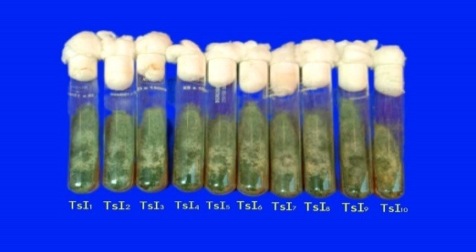
Figure. 2. Axenic culture of T.asperellum
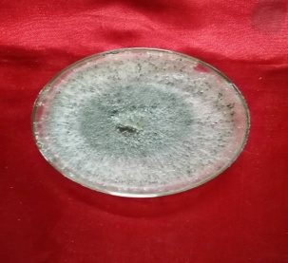

Figure. 3. SEM image of T.asperellum mycelium& conidia
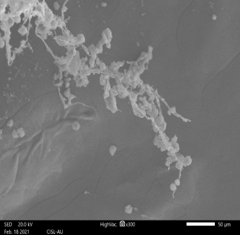

Figure. 4. SEM image of T.asperellum conidia
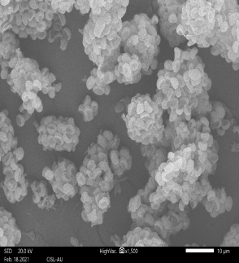
Figure 5. Antagonistic effect of T.asperellum (TsI₄) against Fon₅ (Dual culture)

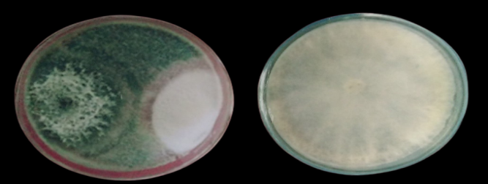

Figure 6. Hyphal breakage of Fon₅ against T.asperellum

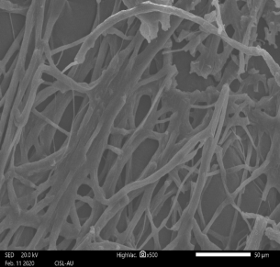

Figure 7. Antagonistic effect of T.asperellum (TsI₄) against Fon₅ (Poison food technique)

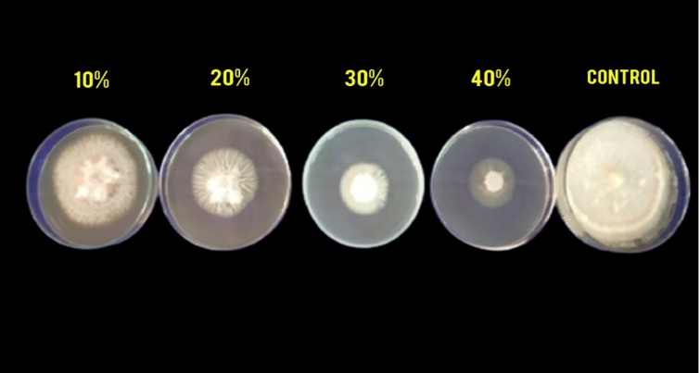

Figure 8. Antagonistic effect of T.asperellum (TsI₄) against Fon (Well diffusion assay)

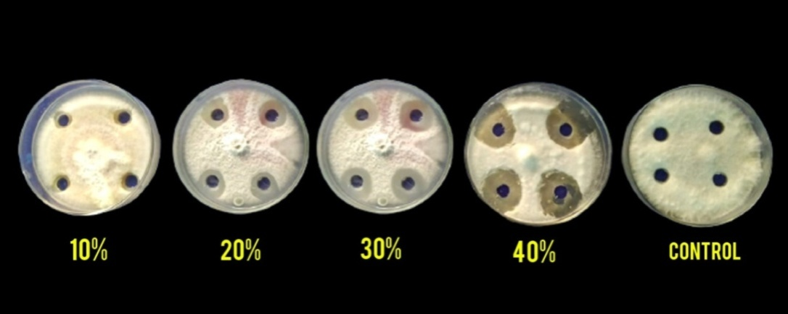

REFERENCES
- Booth C (1971).The genus Fusarium. Commonwealth Mycological Institute, Kew, Surrey, England, pp 237
- Brantner AH (1997). Influence of various parameters on the evaluation of antibacterial compounds by the bioautographic TLC assay. Pharm Pharmacol Lett 7: 152-154
- Charoenporn, C., Kanokmedhakul, S., Lin, F. C., Poeaim, S., &Soytong, K. (2010). Evaluation of bio-agent formulations to control Fusarium wilt of tomato. African Journal of Biotechnology, 9(36).
- Christopher, D. J., Raj, T. S., Rani, S. U., & Udhayakumar, R. (2010). Role of defense enzymes activity in tomato as induced by Trichoderma virens against Fusarium wilt caused by Fusarium oxysporum f sp. lycopersici. Journal of Biopesticides, 3(1), 158.
- Dennis, C., & Webster, J. (1971). Antagonistic properties of species-groups of Trichoderma: I. Production of non-volatile antibiotics. Transactions of the British Mycological Society, 57(1), 25-IN3.
- Domsch KH, Gans W, Anderon TH (1980). Compendium of soil fungi. Academic PressLtd., London, pp 859
- Egel DS, Martyn RD (2007). Fusarium wilt of watermelon and other cucurbits. The Plant Health Instructor, 10, 1094
- Elad Y Chet I (1983). Improved selective media for isolation of Trichoderma or Fusarium spp. Phytoparasitica 11: 55
- Grover RK, Moore JD (1962). Toximetric Studies of fungicides against the brown rot organisms, Sclerotiniafructicola and S. laxa.Phytopathol. 876-880.
- Harveson RM, Kimbrough JW, Hopkins DL (2002). Novel use of a pyrenomycetous mycoparasite for management of Fusarium wilts of watermelon. Plant Disease. 86(9):1025-30.
- Hasna, M. K., Paul, N. R., Haque, M. M., Bir, M. S. H., Ali, M. A., & Chong, K. P. (2025). Biocontrol efficacy of Trichoderma asperellum against fusarium wilt in tomato plants by induction of the host defense genes. Discover Plants, 2(1), 1-9.
- Hua GKH, Wang L, Chen J, Ji P (2020). Biological control of Fusarium wilt on watermelon by fluorescent pseudomonads. Biocontrol Science and Technology, 30(3), 212-227
- Jayalakshmi SK, Raju S, Usha Rani S, Benagi VI, Sreeramulu K (2009). Trichodermaharzianum L1 as a potential source for lytic enzymes and elicitor of defense responses in chickpea (Cicer arietinum L.) against wilt disease caused by Fusariumoxysporum f. sp. ciceri.Austr J Crop Sci Southern Cross J 3(1):44-52
- Khan RA, Najeeb S, Mao Z, Ling J, Yang Y, Li Y, Xie B (2020). Bioactive secondary metabolites from Trichoderma spp. against phytopathogenic bacteria and root-knot nematode. Microorganisms.8(3):401.
- Kleczewski NM, Egel DS (2011). A diagnostic guide for Fusarium wilts of watermelon. Plant Health Progress. 12(1):27.
- Leahy JG, Colwell RR (1990). Microbial degradation of hydrocarbons in the environment. Microbiological reviews.54 (3):305-15.
- Li CX, Fu XP, Zhou XG, Liu SW, Xia Y, Li NH, Zhang XX, Wu FZ (2019). Treatment with wheat root exudates and soil microorganisms from wheat/watermelon companion cropping can induce watermelon disease resistance against Fusarium oxysporum f. sp. niveum. Plant disease.103 (7):1693-702.
- Martyn RD (2014). Fusarium wilt of watermelon: 120 years of research. Horticultural reviews, 42(1), 349-442.
- Mayee CD, Datar VV (1986). Phytopathometry Tech Bull 1 Univ Press Marathwada Agriculture University, Parbhani (MS) :186
- Mohammad Manjur Shah and Hamisu Afiya (2019). Introductory Chapter: Identification and Isolation of Trichoderma spp. - Their Significance in Agriculture, Human Health, Industrial and Environmental Application, Intech open.
- Moose, A., Sahi, S. T., Haq, I. U., Farzand, A., Khan, S. A., & Javaid, K. (2017). Antagonistic potential of Trichoderma isolates and manures against Fusarium wilt of tomato. International journal of vegetable science, 23(3), 207-218.
- Nagamani P, Bhagat S, Viswanath K, Biswas MK (2020). Cultural and morphological variability among Trichoderma harzianum and Trichoderma asperellum collected from chickpea growing areas of Rayalaseema Region of Andhra Pradesh. Journal of Food Legumes, 33(2), 93-100
- Naveenkumar R, Muthukumar A, Mohanapriya R (2017). Occurrence, Virulence and Evaluation of Essential Oils against Fusarium oxysporum f. sp. niveum causing Wilt of Watermelon. Vegetos 30: 4
- Perez C, Pauli M, Bazerque P (1990). An antibiotic assay by agar-well diffusion method. Acta Biol et Med Exp 15:113-115
- Rangaswami G (1958). An agar block technique for isolating soil micro-organisms with special reference to pythiaceous fungi. Sci Culture, pp 24-85
- Sundaramoorthy S, Balabaskar P (2013). Biocontrol efficacy of Trichoderma spp. against wilt of tomato caused by Fusarium oxysporum f. sp. lycopersici.J App Biol Biotech 1(3): 030-040
- Trillas, M. I., Casanova, E., Cotxarrera, L., Ordovás, J., Borrero, C., & Avilés, M. (2006). Composts from agricultural waste and the Trichoderma asperellum strain T-34 suppress Rhizoctoniasolani in cucumber seedlings. Biological control, 39(1), 32-38.
- Verma NP, Kuldeep YK, Sinha BK (2018). Efficacy of Indigenous Trichoderma Strain Bio- Control against of Fusarium sp. Tomato Plant Causal Agent of (Solanumlycopersicon L.) in vitro Condition. Int J CurrMicrobiol App Sci 7(3): 1578-1584
- Vincent, J. M. (1947). Distortion of fungal hyphae in the presence of certain inhibitors. Nature, 159(4051), 850-850.
- Zhang Y, Tian C, Xiao J, Wei L, Tian Y, Liang Z (2020). Soil inoculation of Trichoderma asperellum M45a regulates rhizosphere microbes and triggers watermelon resistance to Fusarium wilt. AMB Express, 10(1), 1-13
- Zhang, Y., Xiao, J., Yang, K., Wang, Y., Tian, Y., & Liang, Z. (2022). Transcriptomic and metabonomic insights into the biocontrol mechanism of Trichoderma asperellum M45a against watermelon Fusarium wilt. PLoS One, 17(8), e0272702.
- Zhou XG, Everts KL (2004). Quantification of root and stem colonization of watermelon by Fusarium oxysporum f. sp. niveum and its use in evaluating resistance. Phytopathology 94:832-841
- B.Tamilselvan,S.Sudhasha,K.Sanjeevkumar,S.M.SureshKumar,A.P.Srinivasperumal, G. Baradhan and S. Kanaka (2025). Survey on the incidence of fusarium wilt in watermelon (citrullus lanatus) caused by fusarium oxysporum f. Sp. Niveum in major watermelon-growing regions of Tamilnadu, India. Plant Archives Vol. 25, No. 1, 2025 pp. 1745-1751

