Field Evaluation of Different Fungicides against Anthracnose of Sorghum in South Gujarat Condition

ABSTRACT
Sorghum [Sorghum bicolor (L.) Moench] belongs to the family Poaceae. In India, sorghum is grown both in kharif and rabi seasons. Sorghum production in the world is affected by different biotic and abiotic factors. Among which sorghum anthracnose caused by Colletotrichum graminicola is considered one of the most important damaging diseases of sorghum. The present investigation was carried out during 2023 and 2024 kharif season at Agriculture Research Station, NAU, Mangrol with aimed to find out a management of anthracnose by using different fungicides either individually or in combination. Different treatments were tested in the field growing highly susceptible dual purpose sorghum cultivar CSV-21. Total seven fungicides Mancozeb 75% @ 0.3%, Carbendazim 12% + Mancozeb 63% wp @ 0.3%, Azoxystrobin 18.2 + Difenoconazole 11.4% w/w SC, Thiophanate methyl 70% WP, Metiram 55% + Pyraclostrobin 5% WG, Propiconazole 25 EC @ 0.1% and Carbendazim 50 WP @ 0.1% and control were tested. The two years pooled data results were revealed that foliar spray of Carbendazim 50% WP @ 0.1% seed treatment showed minimum disease (PDI) 27.67% with maximum 27.02 per cent disease control (PDC) and highest grain yield 3504 kg/ha and dry fodder yield 13511 kg/ha, respectively as compare to other treatments over control.

Keywords: Sorghum; anthracnose; Colletotrichum graminicola; fungicide; disease management

1. INTRODUCTION
Sorghum [Sorghum bicolor (L.) Moench] belongs to the family Poaceae and is one of the most important cereal crops cultivated throughout the tropical and subtropical regions. As a drought resistant crop, it is adapted to a wide range of ecological conditions and produces reasonable grain yields under conditions unsuitable for the most other cereals (Rosewich, 1996). It is one of the crops that are traditionally produced in marginal areas, where low soil moisture and high ambient temperatures are the main limiting abiotic factors.
Sorghum cultivation is distributed throughout the world. Globally, it is cultivated in area of 40.88 million ha with the production of 61.4 million metric tons with average productivity of 1.50 metric tons per ha (Anon. 2024a). It is an important food and fodder crop of dry land agriculture and ranks third in area and production after rice and wheat in India.
In India, the area under sorghum was approximately 4.00 million ha with an annual production of about 4.40 million metric tons and an average productivity of 1060 kg per ha. Gujarat occupies an area of 0.04 million ha with production of 0.06 million metric tons and productivity of 1373 kg per ha (Anon. 2024b), where it is grown as grain crop in South Gujarat, dual purpose in North Gujarat, Kutch and Saurashtra while partly grow as fodder in dairy developed areas.
C. graminicola has the ability to survive in infected leaf and plant debris. They survive in the form of conidia. The pathogen is highly variable in nature. So in the present study fungicides are tested for its management in the field condition (Warren, 1986; Ali and Warren, 1987).
There is very limited information available on the response of grain sorghum to fungicides, especially to document whether a fungicide application causes nonfungicidal physiological changes and yield increases in years of little disease development. However, growers continue to inquire about the use of fungicides in grain sorghum production and their value. Therefore, the objectives of this research were (Petit et. al. 2012) to assess the effects of fungicide applications applied to grain sorghum on seed yield when foliar disease incidence was low or nonexistent and (Fromme et. al. 2017) to determine if a fungicide application can be associated with nonfungicidal physiological changes and yield components or grain composition under field conditions.

2. MATERIALS AND METHODS
Field evaluation of different fungicide against anthracnose of sorghum was conducted at Agriculture Research Station, Navsari Agricultural University, Mangrol in RCBD (Randomized Completely Block Design) with three replication in kharif season 2023 (8th July) and 2024 (13th July). Seed of a highly susceptible sorghum variety CSV – 21 was sown at the rate of 15 kg seed per hectare at onset of monsoon. Total eight treatments including control were applied as treatment. The sorghum cultivar CSV-21 seeds were sown at 45 × 15 cm distance and recommended fertilizer dose of 80-40-00 NPK (kg/ha) was applied. Size i.e., gross plot of 5.00 × 2.70 m² and net plot of 4.00 × 1.80 m² was used for the experiment.

2.1 Application of fungicides

Table 1: List of fungicides for field evaluation for the management of sorghum anthracnose
Sr. No. | Fungicides | Quantity/10 lit | Method of application
1 | Mancozeb 75% WP @ 0.3% | 3 g/kg seed | Seed treatment
2 | Carbendazim 12% + Mancozeb 63% @0.3% | 3 g/kg seed | Seed treatment
3 | Azoxystrobin 18.2% + Difenoconazole 11.4% w/w SC | 10 ml | Foliar Spray
4 | Thiophanate Methyl 70% WP | 5 g | Foliar Spray
5 | Metiram 55% + Pyraclostrobin 5% WG | 20 g | Foliar Spray
6 | Propiconazole 25 EC @ 0.1% | 20 ml | Foliar Spray
7 | Carbendazim 50 WP @0.1% | 20 g | Foliar Spray
8 | Control | -

2.2 Observation recorded:
Per cent disease incidence (PDI) in each treatment was worked out as described by Cooke et al. (2006).

$$Per cent disease incidence (PDI)=\frac{No of plants showing disease symptoms}{Total number of plants assessed }×100$$
The percentage disease control (PDC) was calculated with the help of following formula (Mathur et al. 1971). The fodder yield and grain yield of sorghum from different treatments were recorded for calculation of kg/ha.

$$Per cent disease control (PDC)=\frac{(P.D.I in check-P.D.I in treatment )}{P.D.I in check}×100$$

3. RESULTS AND DISCUSSION
3.1 Per Cent Disease Incidence and Per Cent Disease Control in 2023
In 2023, the study found that all treatments significantly suppressed sorghum disease, with the lowest incidence (27.23%) and maximum disease control of 26.19 per cent as compared to the other treatments being observed in foliar spray of Carbendazim 50 WP @0.1%, followed by foliar spray of Propiconazole 25 EC @ 0.1%. The highest disease incidence was recorded in foliar spray of Metiram 55% + Pyraclostrobin 5% WG. Sorghum grain and dry fodder yield were higher in all treatments compared to the control with the highest yields obtained in foliar spray of Carbendazim 50% WP @0.1%. The maximum per cent disease control (26.19%) as compared to the untreated control was observed in treatment of foliar spray of carbendazim 50 WP @0.1 per cent. This was followed by foliar spray of propiconazole 25 EC @ 0.1%, which recorded per cent disease control was 23.40 per cent and seed treatment with carbendazim 12% + mancozeb 63% @0.3% per cent disease control was 21.04 per cent.

Table 2: Field evaluation of fungicides against anthracnose of sorghum (2023)
Sr. No. | Fungicides | PDI  (%) | PDC  (%) | Grain yield (kg/ha) | Dry fodder yield  (kg/ha)
1. | Mancozeb 75% WP @ 0.3% | 29.49  (32.89) | 20.08  (26.62) | 3052 | 12563
2. | Carbendazim 12% + Mancozeb 63% @ 0.3% | 29.13  (32.67) | 21.04  (27.31) | 3126 | 12785
3. | Azoxystrobin 18.2% + Difenoconazole 11.4% w/w SC | 31.22  (33.97) | 15.39  (23.10) | 2900 | 11319
4. | Thiophanate Methyl 70% WP | 29.35  (32.81) | 20.45  (26.89) | 3101 | 12652
5. | Metiram 55% + Pyraclostrobin 5% WG | 31.46  (34.12) | 14.75  (22.59) | 2852 | 10963
6. | Propiconazole 25 EC @ 0.1% | 28.26  (32.12) | 23.40  (28.93) | 3471 | 13356
7. | Carbendazim 50 WP @0.1% | 27.23  (31.46) | 26.19  (30.79) | 3541 | 13407
8. | Control | 36.90  (37.40) | 0.00  (0.00) | 2267 | 10407
SE (m) ± |  | 0.57 | 0.20 | 46.16 | 199.54
CD at 5% |  | 1.76 | 0.63 | 141.31 | 611.25
CV % |  | 5.98 | 5.50 | 6.63 | 6.83
*Figures in parenthesis are arcsine transformed values

3.2 Per Cent Disease Incidence and Per Cent Disease Control in 2024
In 2024, All treatments significantly suppressed the disease, with the lowest incidence (28.11%) being in foliar spray of carbendazim 50 WP @0.1%, followed by foliar spray of propiconazole 25 EC @ 0.1%, and seed treatment with carbendazim 12% + mancozeb 63% @0.3%. The highest disease incidence was in foliar spray of metiram 55% + pyraclostrobin 5% WG, which was moderately effective. In 2024, all treatments resulted in higher grain and dry fodder yields, with the highest yield in foliar spray of carbendazim 50% WP @0.1%. The maximum per cent disease control (27.85%) as compared to the untreated control was observed in treatment foliar spray of carbendazim 50 WP @0.1%. This was followed by foliar spray of propiconazole @ 0.1%, which recorded 25.15 per cent disease control and seed treatment with carbendazim 12% + mancozeb 63% which provided 23.28 per cent disease control.

Table 3: Field evaluation of fungicides against anthracnose of sorghum (2024)
Sr. No. | Fungicides | PDI  (%) | PDC  (%) | Grain yield (kg/ha) | Dry fodder yield (kg/ha)
1. | Mancozeb 75% WP @ 0.3% | 30.82  (33.72) | 20.90  (27.21) | 2878 | 12244
2. | Carbendazim 12% + Mancozeb 63% @ 0.3% | 29.89  (33.14) | 23.28  (28.85) | 2937 | 12519
3. | Azoxystrobin 18.2% + Difenoconazole 11.4% w/w SC | 32.86  (34.98) | 15.66  (23.31) | 2741 | 11059
4. | Thiophanate Methyl 70% WP | 30.46  (33.50) | 21.83  (27.85) | 2905 | 12296
5. | Metiram 55% + Pyraclostrobin 5% WG | 34.19  (35.78) | 12.24  (20.48) | 2693 | 10741
6. | Propiconazole 25 EC @ 0.1% | 29.16  (32.69) | 25.15  (30.10) | 3349 | 13415
7. | Carbendazim 50 WP @0.1% | 28.11  (32.02) | 27.85  (31.85) | 3467 | 13615
8. | Control | 38.96  (38.62) | 0.00  (0.00) | 2304 | 10259
SE (m) ± |  | 0.43 | 1.26 | 48.58 | 142.50
CD at 5% |  | 1.34 | 3.87 | 148.39 | 437.32
CV % |  | 6.21 | 9.02 | 6.89 | 7.01
*Figures in parenthesis are arcsine transformed values

3.3 Per Cent Disease Incidence and Per Cent Disease Control Pooled (2023 and 2024)
The study found that all treatments significantly suppressed disease in sorghum, with the highest PDI (37.93%) observed in the untreated control. The lowest disease incidence was 27.67 per cent in foliar spray of carbendazim 50 WP @0.1%, followed by foliar spray of propiconazole @ 0.1% at 28.71 per cent while highest disease incidence was recorded in foliar spray of metiram 55% + pyraclostrobin 5% WG with 32.04 per cent disease incidence. All the treatments were found to significantly suppress the disease over untreated control.
The maximum per cent disease control (27.02%) as compared to the untreated control was observed in treatment foliar spray of carbendazim 50 WP @0.1%. This was followed by foliar spray of propiconazole @ 0.1%, which
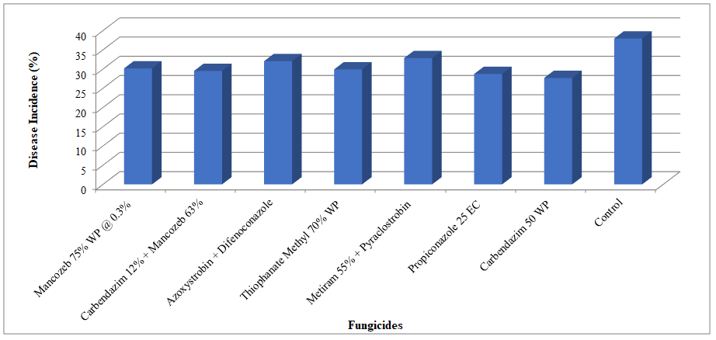
Fig. 1 : Percent Disease Incidence of anthracnose of sorghum against different fungicides (Pooled)

Fig. 2: Grain yield and dry fodder yield of sorghum in different fungicides treatments (Pooled)
recorded 24.28 per cent disease control.
3.4 Grain Yield and Dry Fodder Yield in 2023
In the year 2023, the sorghum grain and dry fodder yield was found higher in all treatments as compared to control. The highest grain yield (3541 kg/ha) and fodder yield (13407 kg/ha) was obtained in foliar spray of carbendazim 50% WP @0.1% treated plots which was at par with foliar spray of propiconazole 25% EC @0.1% with grain yield (3471 kg/ha) and fodder yield (13356 kg/ha), respectively. The lowest grain yield (2267 kg/ha) and dry fodder yield (10407 kg/ha) was recorded from untreated control.
3.5 Grain Yield and Dry Fodder Yield in 2024
In the year 2024, the sorghum grain and dry fodder yield was found higher in all treatments as compared to control. The highest grain yield (3467 kg/ha) and fodder yield (13615 kg/ha) was obtained in foliar spray of carbendazim 50% WP @0.1% treated plots which was statistically at par with foliar spray of propiconazole 25% EC @0.1% with grain yield (3349 kg/ha) and fodder yield (13415 kg/ha), respectively. The lowest grain yield (2304 kg/ha) and dry fodder yield (10259 kg/ha) was recorded from untreated control.
80
3.6 Grain Yield and Dry Fodder Yield Pooled (2023 and 2024)
Both year, the sorghum grain and dry fodder yield was found higher in all treatments as compared to control. The highest grain yield (3504 kg/ha) and fodder yield (13511 kg/ha) was obtained in foliar spray of carbendazim 50% WP @0.1% treated plot which was at par with foliar spray of propiconazole 25% EC @0.1% grain yield (3410 kg/ha) and fodder yield (13386 kg/ha), respectively while the lowest grain yield (2286 kg/ha) and dry fodder yield (10333 kg/ha) was recorded from untreated control.
Table 4: Field evaluation of fungicides against anthracnose of sorghum (Pooled 2023 and 2024)
Sr. No. | Fungicides | PDI  (%) | PDC  (%) | Grain yield (kg/ha) | Dry fodder yield (kg/ha)
1. | Mancozeb 75% WP @ 0.3% | 30.15  (33.31) | 20.49  (26.92) | 2965 | 12404
2. | Carbendazim 12% + Mancozeb 63% @ 0.3% | 29.51  (32.91) | 22.16  (28.08) | 3032 | 12652
3. | Azoxystrobin 18.2% + Difenoconazole 11.4% w/w SC | 32.04  (34.48) | 15.53  (23.21) | 2821 | 11189
4. | Thiophanate Methyl 70% WP | 29.90  (33.16) | 21.14  (27.37) | 3003 | 12474
5. | Metiram 55% + Pyraclostrobin 5% WG | 32.83  (34.95) | 13.50  (21.54) | 2773 | 10852
6. | Propiconazole 25 EC @ 0.1% | 28.71  (32.41) | 24.28  (29.52) | 3410 | 13386
7. | Carbendazim 50 WP @0.1% | 27.67  (31.74) | 27.02  (31.32) | 3504 | 13511
8. | Control | 37.93  (38.01) | 0.00  (0.00) | 2286 | 10333
SE (m) ± |  | 0.48 | 0.39 | 51.83 | 194.81
CD at 5% |  | 1.49 | 1.20 | 158.88 | 596.81
CV % |  | 6.49 | 5.77 | 7.07 | 6.78
*Figures in parenthesis are arcsine transformed values
The observation recorded on the effect of chemicals on anthracnose disease severity and grain yield of sorghum revealed that foliar spray of carbendazim was most effective in reducing the disease severity as well as increasing grain yield in both crop season followed by foliar spray of propiconazole 25 EC @0.1%. Various workers used systemic and non-systemic fungicides for the management of anthracnose of sorghum. Similar studies were carried out by Gwary and Asala (2006) by spray of systemic foliar fungicides such as benomyl, mancozeb and carbendazim three times in the season. Among three fungicides carbendazim was found to be more effective in reducing the progress of the disease symptoms. While, Rekha (2013) found maximum yield (53.94 q/ha) in iprodione + carbendazim treated plot followed by carbendazim (47.00 q/ha).
Pande (1988) have reported effectiveness of thiophanate methyl and carbendazim in controlling the anthracnose of sorghum. Rajkumar and Mukhoupadhayay (1990) reported that seed treatment and foliar sprays of carbendazim and thiophanate methyl was highly effective in reducing anthracnose of urdbean and increasing grain yield.

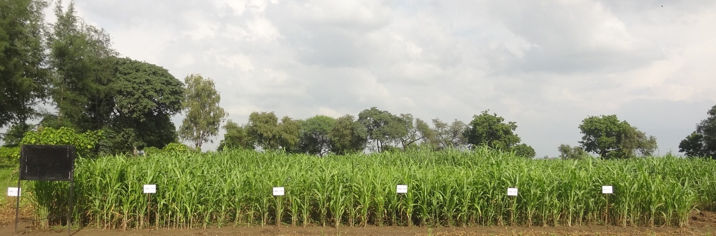
2023
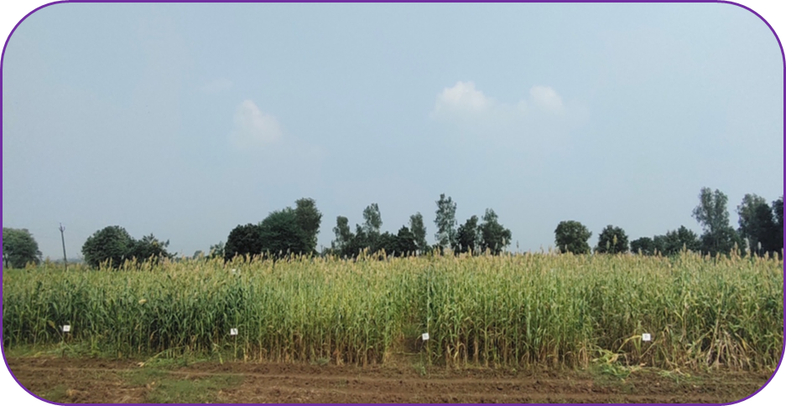
2024
Fig 3: Field evaluation of fungicides against anthracnose of sorghum

4. CONCLUSIONS
In 2023, the highest PDI at 36.90 per cent occurred in the untreated control. Treatments significantly reduced disease incidence, with carbendazim 50 WP @0.1% showing the lowest at 27.23%. Propiconazole 25 EC @0.1% followed at 28.26%. Other effective treatments included seed treatment with carbendazim + mancozeb (29.13%) and thiophanate methyl (29.35%). The maximum disease control was 26.19 per cent with carbendazim foliar spray. In 2023, sorghum yields were highest with foliar spray of carbendazim (3541 kg/ha grain, 13407 kg/ha fodder) and propiconazole. Notable treatments included seed treatment of carbendazim+mancozeb and thiophanate methyl, while untreated control had the lowest yields (2267 kg/ha grain, 10407 kg/ha fodder).
In 2024, untreated control showed the highest percentage disease incidence (PDI) at 38.96 per cent post second spray. All treatments significantly reduced disease incidence, with the lowest at 28.11% from a foliar spray of carbendazim 50 WP @0.1%, comparable to propiconazole 25 EC @0.1% (29.16%). The next effective treatment was seed treatment of carbendazim 12% + mancozeb 63% @0.3% (29.89%). Carbendazim 50 WP @0.1% achieved the best disease control (27.85%). Sorghum yield was higher in treated plots, with the highest grain yield (3467 kg/ha) from carbendazim 50 WP, followed closely by propiconazole (3349 kg/ha). Untreated control had the lowest yields (grain: 2304 kg/ha).
The maximum per cent disease incidence (37.93%) was recorded in the untreated control, while the lowest incidence (27.67%) occurred with carbendazim 50 WP @0.1% in both years. Carbendazim also exhibited the highest disease control (27.02%). All treatments improved sorghum grain and dry fodder yields above control, with the highest yields from carbendazim treated plots (3504 kg/ha grain, 13511 kg/ha fodder), followed closely by propiconazole. The untreated had the lowest yields.

DISCLAIMER (ARTIFICIAL INTELLIGENCE)
Author(s) hereby declare that NO generative AI technologies such as Large Language Models (ChatGPT, COPILOT, etc.) and text-to-image generators have been used during the writing or editing of this manuscript.

REFERENCES
Anonymous (2024a). World agricultural production, foreign agricultural service/USDA. Global Market analysis. p.35
Anonymous (2024b). Normal Estimates of Area, Production and Yield of Selected Principal Crops. Retrieved from https://eands.dacnet.nic.in/contact.htm [Accessed 9 June, 2024]
Ali, M. E. K. and Warren, H. L. (1987). Physiological races of Colletotrichum graminicola on sorghum. Plant Disease, 71: 402- 404.
Cooke, B. M.; Jones D. G. and Kaye, B. (2006). Disease assessment and yield loss. In: “The Epidemiology of Plant Diseases”. Springer, Dordrecht, The Netherlands, pp. 48–80.
Fromme, D. D., Price, T., Lofton, J., Isakeit, T., Schnell, R., Dodla, S., Stephenson, D. Grichar, W. J. and Shannon, K. (2017). Effect of fungicide applications on grain sorghum (Sorghum bicolor L.) growth and yield. International Journal of Agronomy, 2017(1), 5927816.
Gwary, D. M. and Asala, S. W. (2006). Chemical control of Colletotrichum graminicola of sorghum Nigerian, Journal Plant Protection, 23: 123–132.
Mathur R. L.; Singh G, and Gupta R. B. L. (1971). Field evaluation of fungicides for the control of powdery mildew of pea. Indian Journal of Mycology and Plant Pathology, 1(2): 95-98.
Pandey, R. R. (1988). Effect of foliar application of fungicides on the phylloplane mycoflora and fungal pathogens of sorghum. Journal Phytopathology, 133: 86-88.
Petit, A. N.; Fontaine, F.; Vatsa, P.; Clement, C. and Vaillant G. N. (2012). “Fungicide impacts on photosynthesis in crop plants,” Photosynthesis Research, vol. 111, no. 3, pp. 315–326.
Rajkumar, R. and Mukhopadhayay, A. N. (1990). Chemical control of urdbean in field conditions. Indian Phytopathology, 43(1): 103-105.
Rekha, K. M. (2013). Studies on characterization and management of Colletotrichum graminicola, the causal agent of anthracnose of sorghum. ThesPh.D., G. B. Pant University of Agriculture & Technology, Pantnagar-263 145, U. S. Nagar Uttarakhand, India. 160 p.
Rosewich, U. L. (1996). The population genetics of Colletotrichum graminicola from different ecosystems of sorghum. Ph.D. thesis, Texas A&M University, USA, p. 150.
Warren, H. T. (1986). Leaf anthracnose. In: “Compendium of Sorghum Diseases”. (Ed. RA Frederiksen), The American Phyto pathological Society, St. Paul, MN, pp.10-11

