INTEGRATED NUTRIENT MANAGEMENT IN MANILA TAMARIND (PITHECELLOBIUM DULCE): GROWTH AND YIELD RESPONSE

ABSTRACT

The experiment was conducted at Regional Research Station, Tamil Nadu Agricultural University, Aruppukottai from 2019-2024 and laid in a Randomized Block design with four replications. The plots had nine treatments viz., T₁ - RDF of NPK / Tree (1 Kg N, 2 Kg P and 1 Kg K), T₂ - FYM 10Kg/Tree, T₃ - Vermicompost 5Kg / Tree, T₄ - 50% RDF of NPK, T₅ - 50% RDF of NPK + 5 Kg FYM/tree, T₆ - 50% RDF of NPK + 2.5 Kg Vermicompost, T₇ - 50% RDF of NPK + 5 Kg FYM +100 g Phosphobacteria, T₈ - 50% RDF of NPK + 2.5 Kg Vermicompost +2.5 Kg FYM + 100 g Phosphobacteria, T₉ - Control. The variety PKM – 1 was used as experimental material with all normal cultural practices followed for manila tamarind cultivation during 2023-2024. Three trees were selected from each treatment and replications for recording observations on Tree height (m), Girth (cm), Number of primary branches per Tree, No of secondary branches per Tree and Tree spread East – West and North – South (m). The soil application of 50% RDF of NPK (0.5kg N,1kg P and 0.5kg K + 2.5 kg vermicompost + 2.5 kg FYM+100g Phosphobacteria) performed superior and significantly increased in tree height (7.55 m), tree Girth (83.0 cm), number of Primary branches (5.0 tree⁻¹), number of Secondary branches (22.0 Tree⁻¹), and tree spread (6.30 East - West, 7.44 North - South).

Key words: Integrated Nutrient Management – Morphological characters – Manila tamarind

Introduction
India ranks first in the world with highest net cropped area and the agriculture is demographically the broadest economic sector. A majority of Indian farmers are depending on rainfed agriculture and always there is a challenge in cultivating an economically viable crop suitable to rainfed on deemed considered being the waste lands. Manila Tamarind (Pithecellobium dulce (Roxb.) Benth (Tamil : Kodukapuli, Koena puliyankaai) is one such crops getting focused for dry land area and waste lands as a perennial tree because of its potential to grow in rainfed conditions. Manila Tamarind is a small to medium sized semi evergreen legume/nitrogen fixing tree. It is hardly tolerates marsh sites, heat and drought. It thrives well in dry hot tropical and sub tropical climate with rainfall between 700 to 800 mm and a 4 – 6 months dry season. The tree is a drought resistant and can survive in dry lands from sea level to an elevation of 1500 many of the eco types are suited to water logging conditions also. Manila Tamarind is a crop of rich adaptation in different parts of India and grown in wild and in the farm lands. The cultivars, ecotypes and landraces of the crop spread across the state have the rich commercial importance but no organized commercial cultivation has been taken up by the farmers.
A plethora of benefits could be noticed in the Manila Tamarind crop. The fruits are rich in ascorbic acid (135 – 140 mg / 100 g), anthocyanin content (22-25 g / 100 g) and TSS (13-14º Brix) the abundance of rich Vitamin in C in Manila Tamarind boosts the immune system and reduce phlegm. It also have properties like regulate blood circulation, enhances nerve functions, treats jaundice, prevents cancer antiseptic, natural skin, moisturize, good for mouth aliment and ulcer, bark for curing dysentery and chronic diarrhea. It also contains minerals including Iron, Phosphorus, Calcium, Manganese, Potassium and Selenium.
“The world population (7.87 billion) is currently growing at a rate of 1.03% per year and is expected to reach around 9.6 billion in 2050. India has 1.38 billion people accounting for 17.5% of the world population, with a meagre 2.4% of the world surface area” (UN, 2021). “Now a days, the greatest challenge is to provide this burgeoning population with stable, safe and nutritious quality food. In the current Global Hunger Index (GHI), India stands at position 101 of 116 countries; this presents a gloomy situation in combating malnutrition, eventually affecting the socio-economic progress” (Grebmer et al., 2020). “The World Health Organization (WHO) has also indicated that hungriness is the most serious problem worldwide, particularly for African countries and India. Therefore, 195 nations have decided to adopt sustainable development goals (SDG) for addressing the serious malnutrition problems with a holistic approach by the year 2030” (Anonymous, 2016). Consumer awareness about the health benefits of fruits offers great thrust for their regular consumption as part of a balanced diet. Worldwide demand of nutrient-dense fruit has increased immensely in recent years not only for enhancing people’s nutritional status but also for their positive effects on immune and metabolic health.
Now a days, inorganic fertilizers are one of the most expensive inputs in orchard management. Besides, continuous application of huge amount of chemical fertilizers hampers the soil health, soil productivity, environment, quality of produce and human being who consume them. In view of above facts, there is need to increase the production and productivity through Integrated Nutrient Management (INM) particularly in arid zone fruit crops. INM It involves the combined use of inorganic, organic and biological sources of essential plant nutrients to sustain optimum crop yield and also improve or maintain the physico-chemical properties of soil. It provides crop nutrition packages which are technically sound, economically attractive, practically feasible and environmentally safe. The principal aim of the integrated approach is to utilize all the possible sources of plant nutrition in a judicious and efficient manner.
Manila Tamarind is one of the most important arid zone fruit crops cultivated by the farmers of Virudhunagar district, Tamil Nadu. Two varieties in Manila Tamarind PKM (MT) 1 – White aril with yield of 79kg/tree and PKM (MT) 2 – Red aril with yield of 90 kg/tree were released from the Horticultural College and Research Institute, Tamil Nadu Agricultural University, Periyakulam during 2008 and 2019 respectively. Both the varieties are derived as selection from the Soolakarai village of Virudhunagar District. In Tamil Nadu, the area under Manila Tamarind has been spread around 110 hectares as an organized orchard and Virudhunagar District alone is holding 46 hectares. The crop is scattered across the state and there is no organized orchard of Manila tamarind earlier but the release of PKM1 and PKM2 varieties from TNAU has made the farmers to go for organized orchard cultivation since its release and new area expansion is witnessed in the last five years in Theni, Erode , Tiruppur and Sivagangai Districts.
To enhance the yield potential of the Manila Tamarind the research were conducted at Regional Research Station, Tamil Nadu Agricultural University, Aruppukottai under All India Coordinated Research Project on Arid zone fruit crops.
Therefore, this study was undertaken to (i) evaluate the effect of integrated nutrient management on growth and yield of Manila tamarind, and (ii) identify the most effective nutrient management practice for achieving higher productivity

Materials Methods
The field experiment was conducted at Regional research Station, Tamil Nadu Agricultural University, Aruppukottai under Indian Council of Agricultural Research - All India Coordinated Research project on Arid Zone Fruit Crops from 2019-2024. The experiment was laid in a Randomized Block design with four replications. The plots had nine treatments and the details were presented in Table 1.
Table.1. Treatment Details of Integrated Nutrient Management in Manila Tamarind.
Treatments |  | Details
T₁ | : | RDF of NPK / Tree (1 Kg N, 2 Kg P and 1 Kg K)
T₂ | : | FYM 10Kg/Tree
T₃ | : | Vermicompost 5Kg / Tree
T₄ | : | 50% RDF of NPK
T₅ | : | 50% RDF of NPK + 5 Kg FYM/tree
T₆ | : | 50% RDF of NPK + 2.5 Kg Vermicompost
T₇ | : | 50% RDF of NPK + 5 Kg FYM +100 g Phosphobacteria
T₈ | : | 50% RDF of NPK + 2.5 Kg Vermicompost +2.5 Kg FYM + 100 g Phosphobacteria
T₉ | : | Control

The variety PKM – 1 used as experimental material with all normal cultural practices followed for manila tamarind cultivation during 2023-2024. Three trees were selected from each treatment and replications for recording observations on Tree height (m), Girth (cm), Number of primary branches per Tree, No of secondary branches per Tree and Tree spread East – West and North – South (m). Tree height was measured from base to apex using measuring tape attached with pole. The tree girth also measured at 30 cm above ground using tape. The tree spread were measured canopy diameter East–West and North–South with tape.
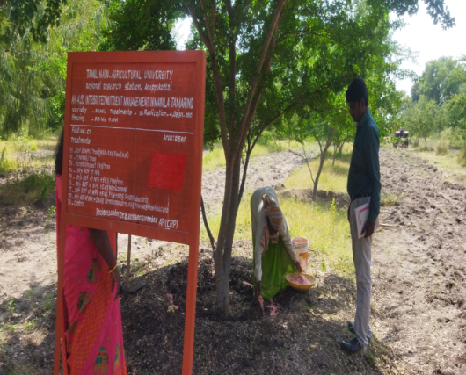  Fertilizer application | 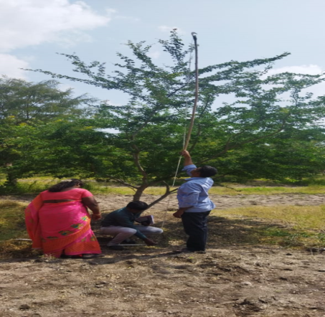  Plant height measurement

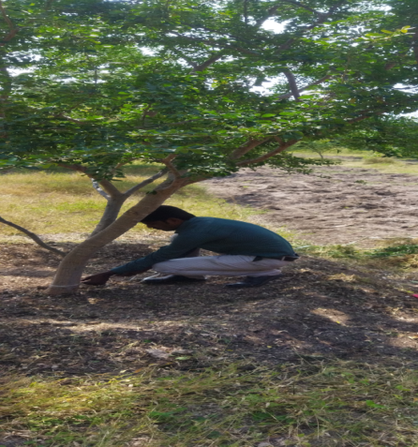  Girth measurement | 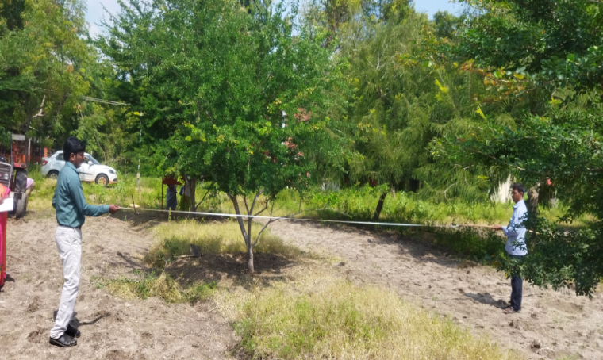  Tree spread measurement
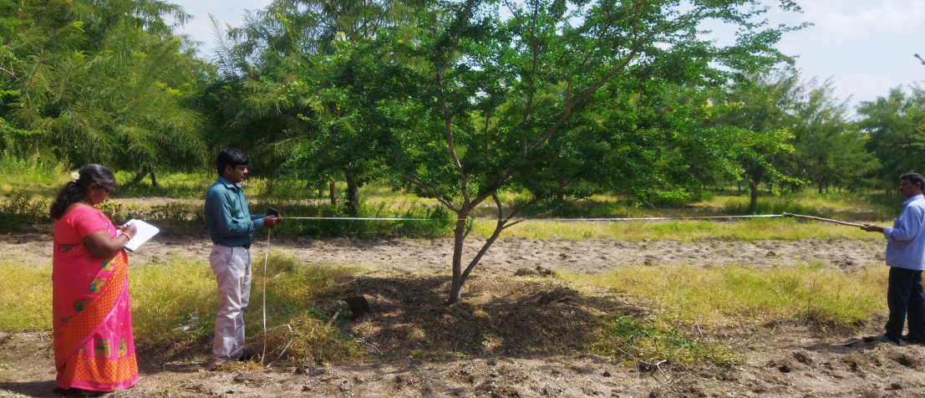
Tree spread measurement

Fig 1: Field investigation
Results and Discussion
Tree height
The result on tree height revealed that, the treatment T₈ recorded the tallest tree in terms of height than the other treatments. Among the nine treatments, T₈ (50% RDF of NPK(0.5kg N,1kg P and 0.5kg K + 2.5 kg vermicompost + 2.5 kg FYM+100g Phosphobacteria) registered higher values in Tree height (7.55 m) (table 3), Which was followed by treatment T₇ (50% RDF of NPK (0.5kg N,1kg P and 0.5kg K + 2.5 kg FYM+100g Phosphobacteria) had the tree height of 7.10m. Whereas, the control recorded lowest values in tree height (3.95 m). These results were in agreement with the result of Arthi et al. (2023) revealed that application of 50% of NPK+5 kg vermicompost+10 kg FYM + phosphobacteria 100 g enhanced the tree height.
Tree Girth
The data on tree girth reported that, the treatment T₈ recorded the highest tree girth than the other treatments. Among the nine treatments, T₈ (50% RDF of NPK(0.5kg N,1kg P and 0.5kg K + 2.5 kg vermicompost + 2.5 kg FYM+100g Phosphobacteria) registered higher values in tree girth (83.0 cm), Which was followed by treatment T₇ (50% RDF of NPK (0.5kg N,1kg P and 0.5kg K + 2.5 kg FYM+100g Phosphobacteria) had the tree girth of 71.0 cm. Whereas, the control recorded lowest values in tree Girth (29.0 cm). These results were supported with Aal et al. (2020) found that of two successive years of investigation revealed that growth of the aonla plant in terms of height, basal girth and plant spread towards East-West and North-South direction was maximum in the plant received yearly application of mustard cake at 4 kg followed by the plant with FYM 16 kg+Mustard cake 2.4 kg along with 100g phosphobacteria.
Number of Primary branches
The report on Number of Primary branches stated that, the treatment T₈ recorded the more Number of Primary branches than the other treatments. Comparing the nine treatments, T₈ (50% RDF of NPK(0.5kg N,1kg P and 0.5kg K + 2.5 kg vermicompost + 2.5 kg FYM+100g Phosphobacteria) recorded the more number of Primary branches (5.0 tree⁻¹) (table 3), Which was followed by treatment T₇ (50% RDF of NPK (0.5kg N,1kg P and 0.5kg K + 2.5 kg FYM+100g Phosphobacteria) had the number of Primary branches of about 3.0 tree⁻¹. Whereas, the control recorded lowest values in number of Primary branches (3.0 tree⁻¹). According to Aal et al. (2020) who found that soil application of mustard cake at 4 kg followed by the plant with FYM 16 kg + 100g phosphobacteria enhanced the Number of Primary branches in aonla.
Number of Secondary branches
The outcome on Number of Secondary branches stated that, the treatment T₈ recorded the more Number of Secondary branches than the other treatments. Comparing the nine treatments, T₈ (50% RDF of NPK(0.5kg N,1kg P and 0.5kg K + 2.5 kg vermicompost + 2.5 kg FYM+100g Phosphobacteria) recorded the more number of Primary branches (22.0 tree⁻¹) (table 3), Which was followed by treatment T₇ (50% RDF of NPK (0.5kg N,1kg P and 0.5kg K + 2.5 kg FYM+100g Phosphobacteria) had the number of Secondary branches of about 11.0 tree⁻¹. Whereas, the control recorded lowest values in number of Secondary branches (11.0 Tree⁻¹) in among the treatments. According to Arthi et al. (2023) reported that the soil application of 50% of NPK + 5 kg vermicompost + 10 kg FYM+ phosphobacteria 100 g had the better enhancement in increasing the plant morphological characters like Number of primary and Secondary branches and increased the tree spread.
Tree spread
Among the nine treatments, T₈ (50% RDF of NPK(0.5kg N,1kg P and 0.5kg K + 2.5 kg vermicompost + 2.5 kg FYM+100g Phosphobacteria) registered higher values in tree spread (6.30 EW, 7.44 NS) (table 2), Which was followed by treatment T₇ (50% RDF of NPK (0.5kg N,1kg P and 0.5kg K + 2.5 kg FYM+100g Phosphobacteria) had the tree spread (6.25 EW, 7.30 NS) than the other treatments. Whereas, the control recorded lowest values in tree spread (3.60 EW, 4.20 NS) in among the treatments. According to Arthi et al. (2023) opined that the soil application of 50% of NPK + 5 kg vermicompost + 10 kg FYM+ phosphobacteria 100 g had the better enhancement in increasing the tree spread in manila tamarind.
Table 2. Effect of INM on Morphological Parameters in Manila tamarind. (2019-2022)
Treatments | Tree height (m) | Girth  (cm) | No of branches /Tree |  | Tree spread (m)
Treatments | Tree height (m) | Girth  (cm) | Primary | Secondary | EW | NS
T₁ | 4.5 | 24.0 | 2.0 | 4.05 | 3.0 | 2.7
T₂ | 3.8 | 28.0 | 3.0 | 4.95 | 3.9 | 3.1
T₃ | 4.0 | 30.0 | 3.0 | 5.4 | 4.1 | 3.8
T₄ | 4.4 | 33.0 | 3.0 | 5.85 | 4.6 | 3.9
T₅ | 4.7 | 36.0 | 3.0 | 5.4 | 4.8 | 4.1
T₆ | 5.1 | 39.0 | 3.0 | 6.3 | 5.0 | 4.4
T₇ | 5.5 | 44.7 | 3.0 | 6.3 | 5.2 | 4.7
T₈ | 5.9 | 46.4 | 4.0 | 6.7 | 5.6 | 5.2
T₉ | 3.5 | 19.7 | 3.0 | 4.9 | 3.6 | 2.4
Mean | 4.60 | 33.42 | 3.22 | 5.55 | 4.47 | 3.00
SEd | 0.54 | 2.20 | 0.32 | 0.82 | 0.50 | 0.41
CD(P=0.05) | 0.92 | 4.51 | 0.63 | 1.61 | 1.10 | 0.80

Table 3. Effect of INM on Morphological Parameters in Manila tamarind. (2022-2024)
Treatments | Tree height (m) | Girth  (cm) | No of branches /Tree |  | Tree spread (m)
Treatments | Tree height (m) | Girth  (cm) | Primary | Secondary | EW | NS
T₁ | 4.60 | 26.0 | 2.0 | 9.0 | 4.40 | 3.40
T₂ | 5.70 | 42.0 | 3.0 | 12.0 | 5.90 | 7.30
T₃ | 6.20 | 60.0 | 3.0 | 13.0 | 6.40 | 6.90
T₄ | 6.45 | 58.0 | 3.0 | 14.0 | 6.10 | 6.70
T₅ | 6.50 | 57.0 | 3.0 | 12.0 | 5.20 | 6.40
T₆ | 6.61 | 69.5 | 3.0 | 16.0 | 5.50 | 6.30
T₇ | 7.10 | 71.0 | 3.0 | 18.0 | 6.25 | 7.30
T₈ | 7.55 | 83.0 | 5.0 | 22.0 | 6.30 | 7.45
T₉ | 3.95 | 29.0 | 3.0 | 11.0 | 3.60 | 4.20
Mean | 6.07 | 55.06 | 3.11 | 14.11 | 5.52 | 6.22
SEd | 0.136 | 1.414 | 0.062 | 0.375 | 0.119 | 0.149
CD(P=0.05) | 0.290 | 2.998 | 0.132 | 0.795 | 0.253 | 0.316

Conclusion
The soil application of 50% RDF of NPK (0.5kg N,1kg P and 0.5kg K + 2.5 kg vermicompost + 2.5 kg FYM+100g Phosphobacteria) can be recommended for the optimum dose for application of integrated nutrients to enhance the plant morphological characters in manila tamarind.
Acknowledgement
The authors are given special thanks to All India Coordinated Research Project on Arid Zone Fruit Crops, Indian Council of Agricultural Research for providing the funds for conducting the field experiments.
Disclaimer (Artificial intelligence)
Option 1:
Author(s) hereby declare that NO generative AI technologies such as Large Language Models (ChatGPT, COPILOT, etc.) and text-to-image generators have been used during the writing or editing of this manuscript.
Option 2:
Author(s) hereby declare that generative AI technologies such as Large Language Models, etc. have been used during the writing or editing of manuscripts. This explanation will include the name, version, model, and source of the generative AI technology and as well as all input prompts provided to the generative AI technology
Details of the AI usage are given below:
1.
2.
3.

References

Aal, J.M., Patel, K.M., Rathva, J.C and Nadoda, S.R. 2020. Effect of integrated nutrient management on fruit quality and shelf life of Aonla (Emblica officinalis Gaertn.) cv. Gujarat Aonla-1. International Journal of Chemical Studies, 8(5): 1227-1230.
Anonymous. 2016. International Food Policy Research Institute, Global Nutrition Report 2016: From Promise to Impact: Ending Malnutrition by 2030; International Food Policy Research Institute: Washington, DC, USA.
Arthi L. R., S. Kumar, Arumugam Shakila and V. Prabudoss 2023. Standardization of integrated nutrient management for enhancing the yield of Manila tamarind (Pithecellobium dulce) cv. Local. Crop Res. 58: 248-250.
Grebmer, V.K.J., Bernstein, R., Alders, O., Dar, R., Kock, F., Rampa, M., Wiemers, K., Acheampong, A., Hanano, B. and Higgins, R. 2020. Global Hunger Index—One Decade to Zero Hunger: Linking Health and Sustainable Food Systems; Welthungerhilfe: Bonn, Germany.

