Development of hybrids in guava (Psidium guajava L.) for fruit quality traits

ABSTRACT
Guava (Psidium guajava L.), known as the ‘Apple of the tropics’ or ‘Poor man’s fruit’ is a fruit crop of family Myrtaceae that has gained prominence in India owing to its high nutritive value, pleasant aroma, flavour and availability at moderate prices. Besides, it is one of the hardiest fruit crops with high nutritional quality. Development of varieties and hybrids suitable for table and processing purposes with the desirable combination of traits viz., high yielding types with superior fruit quality, uniform shape, proper size, attractive skin and pulp colour, few soft seeds and good keeping quality is needed. Hybridization programme was conducted at the College of Horticulture, Bengaluru using different guava genotypes with superior fruit quality traits as parents and a total of 10 crosses were performed. Out of ten crosses performed, fruit set percentage was found to be highest in the cross L-49 x Purple Guava (80.00%), fruit morpho-physical parameters viz., maximum fruit length, fruit width and fruit weight of 7.10 cm, 8.35 cm and 286.72 g, respectively was recorded in the cross Allahabad Safeda x Arka Kiran (1). Yellow green peel colour dominated over greyed yellow peel (L-49 x Purple Guava and Allahabad Safeda x Purple Guava). The crosses Arka Kiran x White local and Arka Kiran x L-49 were having pink pulp. The minimum number of seeds per fruit were noted in the cross L-49 x Purple Guava (52.00). Thus these crosses were found to be superior over other crosses which, can be further evaluated for their hybrid performance and used in future crop improvement programmes as guava faces breeding challenges of developing soft seeded hybrids as it is a major consumer preference to enhance its consumption and production.

Key words: Guava, Hybridization, Fruit morpho-physical characteristics, Seed characteristics.

INTRODUCTION
Guava is one of the most widely cultivated fruit crop, mainly cultivated in many tropical and subtropical regions. Guava originated in South American countries and was introduced to India by Portuguese during 17th century (Menzel, 1985). Guava has gained considerable prominence as a fruit crop in India owing to its high nutritive value, pleasant aroma and flavour and availability at moderate prices (Radha and Mathew, 2007, Singh et al, 2023). Besides, it is one of the hardiest and nutritionally superior fruit crops. The fruit contains 165 mg of vitamin C and it is an excellent source of beta carotene, lycopene, potassium and soluble fiber (Radha and Mathew, 2007), besides many medicinal properties. A major problem facing the guava industry is high seed content of diploid varieties, combined with small, asymmetrical and misshapen fruits of triploid seedless varieties (Negi and Rajan 2007).Being an allogamous fruit crop, the guava genotypes differ greatly among the growing regions. Many of the guava cultivars have been developed as a result of selection from seedling progenies that are commercially exploited through seed propagation and indirectly, these cultivars have produced various types that are not true to the commercial type and differ in several characteristics from the parent genotype (Saxena et al., 2007). The current heterogeneity in the seedling populations from which promising genotypes have been chosen, was the result of high heterozygosity and frequent cross-pollination (Dinesh and Vasugi, 2010). Since guava is a cross-pollinated crop, every seedling-origin plant has a unique gene combination. As a result, morphologically they are diverse from each other and these plants range from poor to exceptional in terms of fruit quality and other growth (Bhamini et al, 2022). Any guava crop improvement program has a greater chance of being successful if there is genetic diversity among the germplasm that is already available in the seedling progenies: by adopting effective breeding techniques, greater heterogeneity in the initial material also guarantees the evolution of beneficial recombinations. Guava seedlings differ substantially in terms of their growth traits, fruit quality and yield traits. It is vital to identify natural variability through surveys in order to accelerate the crop improvement programme and variability should be preserved both ex-situ and in-situ for use in future hybridization programmes. The morphological characterization is helpful for initial screening and for tracing genetic variations. Further, development of guava hybrids with superior fruit quality traits along with high yield potential is required to meet the present consumer preferences.
Genetic diversity studies are crucial source of information for taxonomic and evolutionary approaches as well as breeding plans. Additionally, the use of molecular methods can contribute for the accurate determination of genetic diversity (Morand et al., 2002, Zeid et al., 2003). The choice of parents for successful hybridization programs would be aided by knowledge of the genetic variation that is available and the provenance of the cultivars. The first step toward effective conservation, maintenance and utilization of existing genetic diversity could be the genetic characterization of genotype coupled with phenotypic traits. Eliminating duplicates from the germplasm, collection through rigorous examination would help to conserve time, space, and resources (Prakash et al., 2002). Hence, the present study was conducted to assess the performance of different cross combinations of diverse parent plants on various aspects of flowering, fruit set, fruit retention and fruit morphological as well as quality parameters.
- MATERIALS AND METHODS
The present study was carried out during the year 2021-2022 at the Regional Horticultural Research and Extension Centre and Bioversity International of the College of Horticulture, Bengaluru. The statistical design followed was randomized complete block design with 10 treatments replicated three times with a sample size of ten with descriptive method of analysis of maximum, minimum and mean was worked out. The different cultivars/varieties of guava maintained at Horticultural station exhibited a wide range of variations with respect to pulp colour (white and pink), number of seeds, taste, flavor and keeping quality of fruit. Utilizing existing variability present in the guava genotypes, hybridization was carried out involving parents with superior fruit quality traits. The ten successful crosses that set fruits are depicted in Table 1. Descriptions of the varieties used in the study as parents are presented in the Table 2.
Different stages of flower bud development in guava as observed in the study are depicted in the Fig. 1. Crossing programme was carried out in accordance with the procedure described by Dinesh and Vasugi (2010), wherein the flowers selected for crossing were emasculated one day before opening, during the calyx break stage and were tagged. Flowers were opened using the forceps and all the anthers were removed without harming the stigma. To prevent pollination by foreign pollens, the emasculated flowers were covered with butter paper bags. Pollen from the freshly opened and bagged flowers of the specified male parent was collected with a camel hair brush and the collected pollen was delicately smeared over the stigmatic surface of the emasculated flowers. Sequential steps in hybridization procedure in guava are depicted in the Fig. 2. To prevent contamination and avoid fruit fall, each flower was labeled and the bags were taken off once it had set the fruit (15 days). The crossed, mature and ripened fruits were harvested and observed for fruit morpho-physical traits. Later the F₁ seeds were extracted and the collected seeds were sown to raise F₁ hybrids. Since guava is a perennial fruit tree that flowers and set fruits after three years, only the crossed fruit parameters have been observed and discussed here. The observations were recorded on the crossed fruits for the parameters viz., fruit set percentage, fruit length and width, fruit length /width ratio, weight of fruit, calyx cavity diameter, colour of peel, colour of pulp, relief of surface, longitudinal grooves on fruit surface, number of seeds per fruit, seed weight per fruit, 100 seed weight, fruit: seed weight proportion.
Table 1. Hybrid combinations produced in the study
Sl. No. | Crosses
1 | White local x Arka Poorna
2 | White local X Arka Rashmi
3 | White local x Arka Kiran
4 | White local x Allahabad Safeda
5 | Allahabad Safeda x Arka Kiran
6 | L- 49 x Arka Kiran
7 | Arka Kiran x L-49
8 | Arka Kiran x White local
9 | Allahabad Safeda x Purple Guava
10 | L- 49 x Purple Guava
Table 2. Salient characters of the varieties used as parents in the study
Sl. No. | Varieties | Pedigree/ origin
1 | Allahabad Safeda | Selection from an open pollinated seedlings population. Tree is medium in height (5.80-6.50 m) with vigorous branching and dense foliage. Fruits are medium in size (180.00 g), round in shape with few seeds. Fruit is white fleshed with good keeping quality.
2 | L-49 | Selection from Allahabad Safeda. It is prolific bearer, greenish yellow with milky white sweet pulp with few soft seeds. Keeping quality is medium; it is suitable for table purpose.
3 | Arka Poorna | The plants are semi-vigorous in growth habit with prolific bearing, fruits are round, medium to big in size (200-230 g). It is a dual purpose variety suitable for both table and processing.
4 | Arka Rashmi | Semi-vigorous trees, dual purpose variety, red pulp, medium in lycopene (5.00mg/100 g), Medium seed hardiness (9.00 kg/cm²), rich in ascorbic acid (235 mg/100 g).
5 | Arka Kiran | The plants are semi-vigorous. Fruits are medium in size (230 g), dark red pulp, rich in lycopene (7.50 mg /100 g) and with medium soft seeds.
6 | White local | Big size attractive fruit. Average fruit size, 300- 500 grams per fruit. Uniform & appealing fruit color, longer shelf life.
7 | Purple Guava | Purple Malaysian guava is a larger variety, averaging 8 to 10 centimeters in diameter, and has a round to oval shape. The skin is thin, bumpy, glossy and textured, ripening to a dark purple-brown hue.

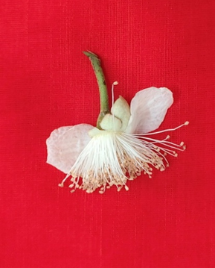
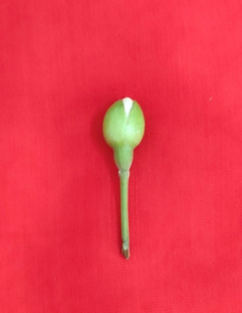
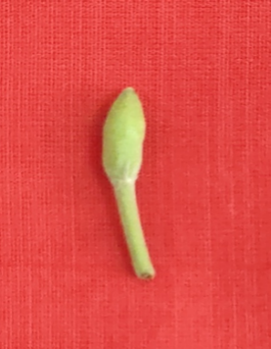
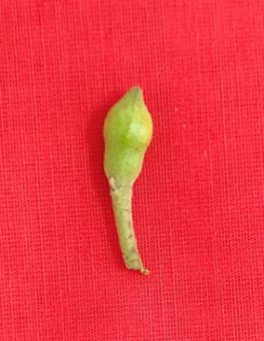
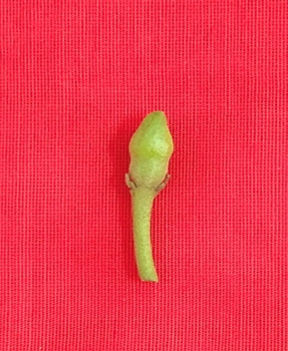

Stage 5 Stage 6

Stage 3 Stage 4

Stage 1 Stage 2
Stage 4
Stage 5
Stage 3
Stage 1 Stage 2
Stage 4
Stage 5
Stage 3
Fig. 1. Stages of flower bud development in guava

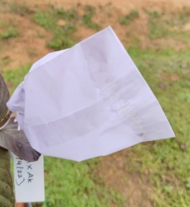
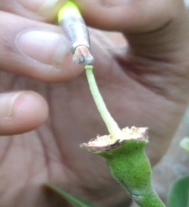
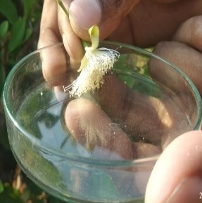
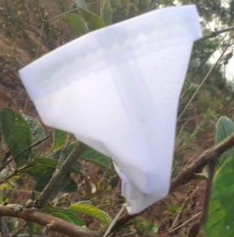
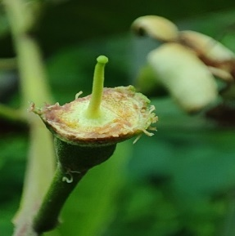
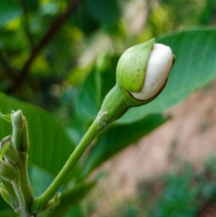
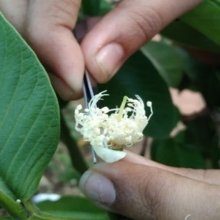
(d) Collection of
pollen

(a) Calyx break stage
(f) Bagging
(e) Hand pollination
(b) Emasculation
(c) Bagging
(f) Bagging and tagging after pollination
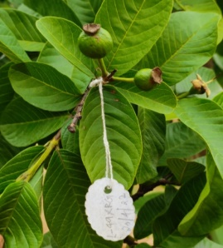

(a) Calyx breaks stage
(b) Emasculation
Fig. 2. Procedure followed in hybridization of guava

(g) Fruit set

RESULTS AND DISCUSSION
3.1 Fruit set percentage
The hybridization programme was executed using seven superior parents and 10 crosses were attempted at the College of Horticulture, Bengaluru, to evolve hybrids with desirable characteristics. Out of ten successful crosses, the maximum fruit set percentage (Table 3) was observed in the cross L-49 x Purple Guava (80.00%) followed by Allahabad Safeda x Arka Kiran (76.19%) which is higher than the fruit set percentage reported by Singh et al. (2017) in the cross Allahabad Safeda x Arka Kiran (45.83%). The highest fruit set percentage in the cross L-49 x Purple Guava presumed that cv. Purple Guava is more appropriate candidate as pollen parent for the cv. L-49 and has a strong metaxenial effect thus enhancing fruit set and quality in guava. Similar kind of statement was deduced by Usman et al. (2013) in guava. In the present study, minimum fruit set per cent was recorded in the cross Arka Kiran x White local (26.67%), which might be attributed to the presence of incompatibility between the pollen and stigma (Maune et al. 2018) as well as due to adverse environmental conditions. The varying pattern of fruit development suggested that the fruit sink demands vary with pollen donors, pollen-stigma compatibility and stages of fruit development.
  - Fruit morpho-physical parameters
Fruits obtained after crossing were examined for various fruit physical parameters and the data recorded is given in the Table 4. The data pertaining to the fruit length revealed that the maximum fruit length was recorded in the cross Allahabad Safeda x Arka Kiran (1) (7.10 cm) preceded by White local x Allahabad Safeda (6.10 cm). The similar findings were reported by Singh et al. (2017) and Sarkar and Sarkar (2022). The cross L-49 x Purple Guava was having the minimum fruit length of 3.70 cm. Significantly highest fruit width was also recorded in Allahabad Safeda x Arka Kiran (1) (8.35 cm) followed by White local X Allhabad Safeda (6.93 cm) whereas minimum fruit width was found in Arka Kiran x L-49 (4.70 cm). Fruit weight was highest in Allahabad Safeda x Arka Kiran (1) (286.72 g) followed by fruit obtained as a result of crosses made between White local x Arka Rashmi (163.90 g) and it was significantly lowest in the cross Arka Kiran x L-49 (45.20 g). The calyx cavity diameter of various fruit obtained after crosses were ranged from a maximum of 2.40 cm in the cross Allahabad Safeda x Arka Kiran (1) which was on par with Allahabad Safeda x Purple Guava to a minimum of 0.60cm in White local x Arka Kiran.
The data related to fruit quality parameters of crossed fruits are presented in Table 4. The colour of fruit pericarp or peel was categorized into two viz., yellow green and greyed yellow. Majority of the crossed fruit showed yellow green peel colour except for the cross L-49 x Purple Guava and Allahabad Safeda x Purple Guava which had greyed yellow pericarp. The pulp colour of crossed fruits was not having significant variation from the female parent. All the crosses were having white pulp except the crosses Arka Kiran x White local and Arka Kiran x L-49 which were having red or pink pulp.
Relief of surface varied from smooth to rough. The crosses White local x Allahabad Safeda, White local x Arka Poorna, L-49 x Arka Kiran, Allahabad Safeda x Arka Kiran (2), Allahabad Safeda x Purple Guava recorded rough fruit surface while all the remaining fruits found to be having smooth surface. Longitudinal grooves on the fruit surface also observed on the crossed fruits and it was categorized into two, i.e, present or absent. Longitudinal grooves were present in most of the fruits such as White local x Arka Rashmi, White local x Allahabad Safeda, White local x Arka Poorna, White local x Arka Kiran, Arka Kiran x White local, Arka Kiran x L-49, L-49 x Arka Kiran (3), Allahabad Safeda x Arka Kiran (1and 2) and Allahabad Safeda x Purple Guava, whereas in L-49 x Arka Kiran (1, 2 and 3) and L-49 x Purple Guava, the longitudinal grooves on fruit surface were absent (Table 4). A similar kind of statement was deduced by Methela et al. (2019). ). The reason behind the difference in morpho- physical characters of the fruits might be due to metaxenial effect, direct effect of maternal parent and additionally, the heterozygous nature of guava also may attribute to the variation in these characters.

3.3 Seed parameters of crossed fruits
The various seed parameters of crossed fruits are furnished in Table 5. L-49 x Purple Guava recorded the minimum number of seeds (52.00). The highest seed weight per fruit was observed in L-49 x Arka Kiran (3, 1 and 2; 6.05 g, 6.03 g and 5.88 g) and it was significantly lowest in cross White local x Arka Rashmi (0.64 g). Similar trend was followed with 100 seed weight. Fruit to seed weight proportions were found to be highest in White local x Arka Rashmi (120.16), whereas the minimum was found in the crossed fruit of Arka Kiran x L-49 (18.29). Being allogamous crop, the genotypes used as parents are heterozygous and heterogenous in nature. This varied genetic makeup of the parents has contributed for the observed variation in seed characters (Patel et al. 2011, Singh et al., 2018).
In conclusion, the set fruits in the crosses L-49 x Purple Guava, Allahabad Safeda x Arka Kiran, L-49 x Purple Guava, White local x Arka Rashmi, Arka Kiran x White local and Arka Kiran x L-49 were found to be superior over other crosses in terms of fruit set percentage, fruit morpho-physical parameters and seed characteristics.
Table 3. Fruit set percentage of different guava cross combinations
Sl.No | Crosses | Fruit set (%)
1 | White local x Arka Rashmi | 41.67
2 | White local x Allahabad Safeda | 46.67
3 | White local x Arka Poorna | 50.00
4 | White local x Arka Kiran | 70.00
5 | Arka Kiran x White local | 26.67
6 | Arka Kiran x L-49 | 40.00
7 | L-49 x Arka Kiran | 73.33
8 | L-49 x Purple Guava | 80.00
9 | Allahabad Safeda x Arka Kiran | 76.19
10 | Allahabad Safeda x Purple Guava | 66.67
 | Maximum | 80.00
 | Minimum | 26.67

Table 4. Fruit characteristics of different guava cross combinations
Sl. No. | Name of the cross | Fruit length (cm) | Fruit width  (cm) | Fruit weight (g) | Calyx cavity diameter (cm) | Colour of peel | Colour of pulp | Relief of surface | Longitudinal grooves
1 | White local x Arka Rashmi | 4.80 | 6.22 | 163.90 | 1.10 | Yellow Green | White | Smooth | Present
2 | White local x Allahabad Safeda | 6.10 | 6.93 | 152.40 | 1.20 | Yellow Green | White | Rough | Present
3 | White local x Arka Poorna | 5.90 | 6.71 | 155.05 | 1.20 | Yellow Green | White | Rough | Present
4 | White local x Arka Kiran | 5.80 | 6.10 | 108.00 | 0.60 | Yellow Green | White | Smooth | Present
5 | Arka Kiran x White local | 4.90 | 5.25 | 46.64 | 1.60 | Yellow Green | Pink | Smooth | Present
6 | Arka Kiran x L-49 | 3.90 | 4.70 | 45.20 | 1.70 | Yellow Green | Pink | Smooth | Present
7 | L-49 x Arka Kiran (1)* | 5.20 | 6.07 | 118.09 | 1.30 | Yellow Green | White | Smooth | Absent
8 | L-49 x Arka Kiran ( 2)* | 5.60 | 5.88 | 115.51 | 1.20 | Yellow Green | White | Smooth | Absent
9 | L-49 x Arka Kiran ( 3)* | 5.40 | 5.97 | 91.90 | 1.10 | Yellow Green | White | Rough | Present
10 | L-49 x Purple Guava | 3.70 | 5.14 | 61.60 | 1.30 | Greyed Yellow | White | Smooth | Absent
11 | Allahabad Safeda x Arka Kiran (1)* | 7.10 | 8.35 | 286.72 | 2.40 | Yellow Green | White | Smooth | Present
12 | Allahabad Safeda x Arka Kiran (2)* | 6.30 | 7.43 | 211.70 | 1.90 | Yellow Green | White | Rough | Present
13 | Allahabad Safeda x Purple Guava | 4.30 | 5.68 | 85.70 | 2.40 | Greyed Yellow | White | Rough | Present
 | Maximum | 7.10 | 8.35 | 286.72 | 2.40 | - | - | - | -
 | Minimum | 3.70 | 4.70 | 45.20 | 0.60 | - | - | - | -
 | Mean | 5.30 | 6.18 | 126.33 | 1.46 | - | - | - | -
* Where (1), (2), (3) represents the three different hybrid fruits; first harvested fruit, second harvested fruit and third fruit harvested respectively.

Table 5. Seed characteristics of different guava cross combinations
Sl. No. | Name of the cross | Number of seeds per fruit | Seed weight per fruit (g) | 100 seed weight (g) | Fruit: seed weight proportion
1 | White local x Arka Rashmi | 222.00 | 1.36 | 0.64 | 120.16
2 | White local x Allahabad Safeda | 216.00 | 2.60 | 1.25 | 58.60
3 | White local x Arka Poorna | 93.00 | 1.90 | 2.06 | 81.61
4 | White local x Arka Kiran | 76.00 | 1.68 | 2.21 | 64.13
5 | Arka Kiran x White local | 168.00 | 2.12 | 1.28 | 22.00
6 | Arka Kiran x L-49 | 213.00 | 2.47 | 1.45 | 18.29
7 | L-49 x Arka Kiran (1) | 244.00 | 6.03 | 4.29 | 19.58
8 | L-49 x Arka Kiran (2) | 212.00 | 5.88 | 4.27 | 19.65
9 | L-49 x Arka Kiran (3) | 238.00 | 6.05 | 4.39 | 15.20
10 | L-49 x Purple Guava | 52.00 | 0.89 | 1.74 | 69.21
11 | Allahabad Safeda x Arka Kiran (1) | 448.00 | 4.06 | 1.05 | 70.57
12 | Allahabad Safeda x Arka Kiran (2) | 448.00 | 5.18 | 2.79 | 40.91
13 | Allahabad Safeda x Purple Guava | 102.00 | 0.96 | 0.94 | 89.64
 | Maximum | 448.00 | 6.05 | 4.39 | 120.16
 | Minimum | 52.00 | 0.89 | 0.64 | 18.29
 | Mean | 210.15 | 3.16 | 2.28 | 53.04

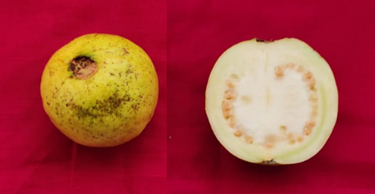
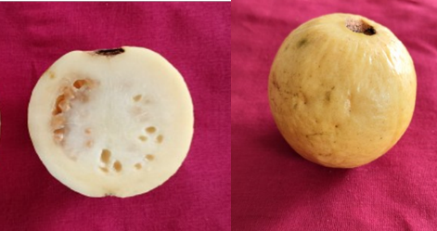
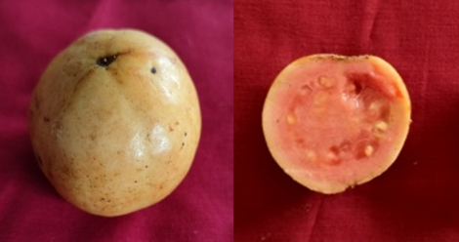
Arka Kiran x White local

L-49 x Arka Kiran (3)

L-49 x Arka Kiran (1)

Arka Kiran x L-49

White local x Allahabad Safeda

Arka Kiran x White local

L-49 x Arka Kiran (3)

White local x Arka Rashmi

L-49 x Arka Kiran (1)

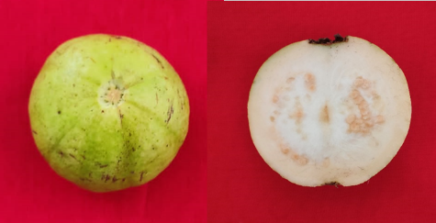
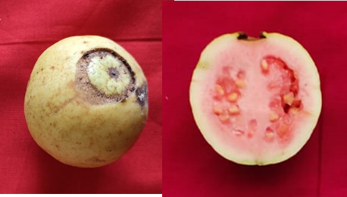
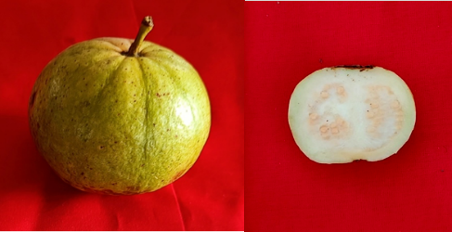
Arka Kiran x L-49

White local x Allahabad Safeda `

White local x Arka Rashmi

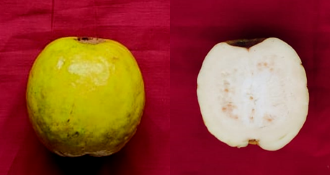
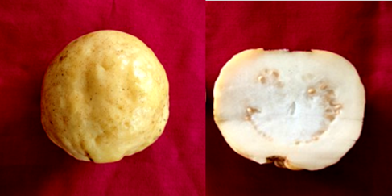
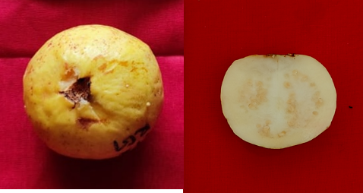
Allahabad Safeda x Arka Kiran (2)

Allahabad Safeda x Purple Guava
L-49 x Purple Guava

Fig. 3. Guava fruits from various cross combinations
CONCLUSION
Based on the results obtained in the present study, it is concluded that the crosses L-49 x Purple Guava, Allahabad Safeda x Arka Kiran and Arka Kiran x White local were found to be superior over other crosses in terms of fruit set percentage, fruit quality parameters viz., fruit length, fruit width and fruit weight, minimum number of seeds per fruit, seed weight per fruit, fruit pulp colour. This study helps in planning the future breeding programs in guava as it has given a clear understanding of the behavior of crosses and selection of parent plants.

Disclaimer (Artificial intelligence)
Option 1:
Author(s) hereby declare that NO generative AI technologies such as Large Language Models (ChatGPT, COPILOT, etc.) and text-to-image generators have been used during the writing or editing of this manuscript.

REFERENCES

Bhamini, K., Kumar, A., Mishra, S. K., & Singh, D. N. (2022). A Review on Crop Regulation Techniques in Guava (Psidium guajava L.) through Hi-Tech Practices. International Journal of Environment and Climate Change, 12(11), 1445–1453
Dinesh, M. R., & Vasugi, C. (2010). Guava improvement in India and future needs. Journal of Horticultural Sciences, 5, 94-108.
Maune, J.F., Camadro, E.L., & Erazzu, L.E. (2018). Cross incompatibility and self-incompatibility: unrelated phenomenon in wild and cultivated potatoes. Botany, 96 (1), 33-45.
Menzel, C.M. (1985). Guava: an exotic fruit with potential in Queensland. Queensland Agricultural Journal, 111, 93–98.
Methela, N.J., Faruk, O., Islam, M.S., & Hossain, M.M. (2019). Morphological characterization of guava germplasm (Psidium sp.). Journal of bioscience and agricultural research, 20 (1), 1671-1680.
Morand, S., Simkova, A., Matejusova, I., Plaisance, L., Verneau, O., & Desdevises, Y. (2002). Investigating patterns may reveal processes: evolutionary 68 ecology of ectoparasitic monogeneans. International Journal of Parasitology, 32: 111-119.
Nakasone, H.Y., & Paull, R.E. (1998). Tropical fruits crop production in science in horticulture. CAB International, Wallingford, UK, pp. 468.
Negi, S. S., & Rajan, S. (2007). Improvement of guava through breeding. Acta Horticulturae, 735, 31-37.
Patel, D.A., Patel, H.C., Saravaiya, S.N., Koladiya , P.B., & Patel, B.N. (2011). Development of hybrids in guava (Psidium guajava L.). International Journal of Plant Science, 6 (2), 237-239.
Radha, T., & Mathew, L.(2007). Fruit crops. New India Publ. Agency, New Delhi, India.
Sarkar, T., & Sarkar, S.K. (2022). Pollination characteristics and intervarietal hybridization of Psidium guavaja. Journal of crop weed, 18 (1), 96-103.
Saxena S. K., Rajan S., Chandra, R., Srivastava, N., & Bajpai, A. (2007), Molecular characterization of closely related open pollinated seedling selections in guava. Acta Horticulturae., 735: 49-55.

Singh, A., Singh , B. K., Barman , K., & Singh , A. K. (2023). Influence of Maturity Stage on Post-harvest Quality of Guava Cultivars. International Journal of Plant & Soil Science, 35(20), 824–834.
Singh D., Gill, M., & Arora, N.K. (2017). Studies on crossing behaviour and hybridization in guava. Journal of Environmental Biology, 38 (6), 1341-1347.
Singh, G. (2005). Strategies for improved production in guava (eds.). Proc. 1st Intl. Guava Symp, CISH, Lucknow, India, 26–39.
Singh, Y., Ranteke, V., Ashutosh., & Dohre, S. (2018). Variability studies in guava (Psidium guajava L.) genotypes for growth and yield attributes at Chhatisgarh plains. International Journal of Chemical Stududy, 6(6): 2571- 2573.
Usman, M., Samad, W. A., Fatima, B.,& Shah, M. H. (2013). Pollen parent enhances fruit size and quality in inter-varietal crosses in guava (Psidium guajava L.). International Journal of Agricultural Biology, 15, 125-29.

