Marketable Apple Yield Dynamics in Himachal Pradesh: Trends and Strategies

.
ABSTRACT

This study investigates spatiotemporal trends in marketable apple yield (20-kg boxes per bigha) across 12 districts in Himachal Pradesh, India, from 1990–91 to 2022–23, using data from the Department of Horticulture. Employing statistical methods, compound annual growth rate (CAGR), coefficient of variation (CV), skewness, kurtosis, linear regression slopes, and Pearson correlations, variability, and inter-district relationships. Statewide, yields grew modestly (CAGR: 0.32%) from 17.42 to 18.60 boxes/bigha (mean: 13.66; CV: 40.32%), indicating moderate variability. District-level disparities were sharply clear, Sirmour showed the highest growth (CAGR: 17.92%) but extreme instability (CV: 103.74%), while Shimla, with the highest mean yield (24.92 boxes/bigha), declined (CAGR: -0.84%; CV: 50.16%). Kinnaur exhibited robust, stable growth (CAGR: 6.73%; CV: 29.58%), and Una/Hamirpur recorded negative CAGRs (-6.67%) from negligible bases. Non-normal distributions were evident, with positive skewness (0.60–1.91) and high kurtosis (up to 3.49 in Sirmour), reflecting climatic and management-driven outliers. Linear slopes ranged from 0.17 boxes/bigha/year (Kinnaur) to -0.12 (Shimla), with strong correlations in Shimla (r = 0.94) and Kullu (r = 0.89) underscoring their statewide influence. Visualizations (trend lines, CAGR/CV charts, skewness-kurtosis plots, correlation matrices, yield-share pie charts) elucidate these patterns. The findings advocate improved interventions, improved canopy, pollination, nutrient, and pest management, enhanced irrigation in Mandi/Chamba, and orchard rejuvenation with canopy management and High-Density Plantation in Shimla, to address climate variability and market pressures, supporting >70% of rural livelihoods dependent on apple cultivation.
Keywords: Spatiotemporal trends, Himachal Pradesh, CAGR, Skewness, Kurtosis, Canopy management
1. INTRODUCTION

Apple cultivation (Malus x doemstica Borkh) is a pivotal economic driver in Himachal Pradesh, a North-Western Himalayan state well known as India’s “fruit bowl” for its ideal temperate climate [8]. Since its introduction in 1916 by Samuel Evans Stokes in Kotgarh, Shimla, apple farming has dominated the state’s horticulture, occupying 49% of fruit-growing areas and contributing 79% of total fruit production, generating INR 5,000–5,500 crore annually and sustaining over 1.75 lakh rural families [14, 19]. Ranking second in India after Jammu and Kashmir, the state accounts for 32% of national apple output [19]. Horticulture, particularly apples, outperforms cereal crops in farmer income due to its high economic potential and suitability even on marginal, degraded soils, offering diverse crop choices [3, 17]. A strong positive correlation exists between cultivation area and production, underscoring the sector’s scalability [4]. However, challenges such as climate change, reduced snowfall, insufficient chilling hours, outdated orchards, traditional cultivation methods, inadequate irrigation, rising costs, limited land, poor canopy and pollination management, and lack of integrated nutrient and pest management threaten yields [2, 10]. Limited adoption of modern practices due to low awareness hinders progress (8). Marketable yield, measured as 20-kg boxes per bigha (0.25 ha), serves as a practical metric for assessing production efficiency, reflecting fruit quality factors like size, colour, and damage critical for market viability [1]. Despite advancements like high-density planting, yields from 1990–91 to 2022–23 show modest growth (CAGR: 0.32%) with significant district-level disparities. The slow CAGR of 0.32% reflects multiple constraints, including reduced chilling hours from climate change, aging low-density orchards, poor canopy and pollination management, soil nutrient depletion, and rising pest pressure. Limited irrigation, high input costs, and small fragmented holdings further restricted adoption of modern practices, collectively suppressing yield growth despite the crop’s economic importance. The present study was undertaken to analyse temporal trends in marketable apple yield across 12 districts of Himachal Pradesh using CAGR and linear regression slopes, along with variability measures such as CV, skewness, and kurtosis, and correlation analysis. This work is important as it highlights district-wide differences, identifies vulnerable regions, and provides insights for targeted interventions to stabilise yields, strengthen climate resilience, and support the livelihoods of farmers dependent on apple cultivation.

2. material and methods

This study utilized secondary data from Himachal Pradesh Horticultural records straddling 1990–91 to 2022–23, obtained from Department of Horticulture, Himachal Pradesh. The data set included marketable yield (20-kg boxes per bigha) across 12 districts, Shimla, Kullu, Mandi, Chamba, Kinnaur, Lahaul & Spiti, Kangra, Solan, Sirmour, Bilaspur, Una, and Hamirpur, along with statewide totals. IBM SPSS statistical software (Version 28.0) was employed to analyse spatiotemporal patterns through a robust methodological framework. Temporal trends were assessed by calculating the compound annual growth rate to determine changes in yield and other parameters over the 33-year period. Variability was evaluated using the coefficient of variation to quantify temporal and inter-district fluctuations in the data. Distributional characteristics were examined through skewness and kurtosis to identify asymmetry and the presence of extreme values in the dataset. Annual changes were quantified using linear regression slopes, which measured the rate of change for each parameter across the study period. Additionally, Pearson correlation coefficients were computed to evaluate the strength of relationships between district-level and statewide trends, highlighting key contributing areas. Trend analysis of apple yield (1990–91 to 2022–23) used CAGR, linear regression, Mann-Kendall test, and Sen’s slope on 12-district data with IBM SPSS [9, 13]. This comprehensive approach provided insights into apple cultivation dynamics, supporting the development of targeted agricultural strategies for enhanced yield stability and sustainability in Himachal Pradesh.

3. results and discussion

The spatiotemporal analysis of marketable apple yield data (measured in 20-kg boxes per bigha) from 1990–91 to 2022–23, as presented in Table 1, reveals heterogeneous trends across study area. These variations underscore the influence of agro-climatic zones, elevation (ranging from 1,000–3,000 m), orchard management practices, and environmental stressors such as climate change [7]. Statewide, the average yield was 13.66 boxes/bigha, with a modest compound annual growth rate (CAGR) of 0.32%, reflecting a gradual increase from 17.42 boxes/bigha in 1990–91 to 18.60 boxes/bigha in 2022–23. This overall stability masks pronounced district-level disparities, where high-elevation districts like Shimla and Kinnaur dominate production efficiency, while lower-elevation areas exhibit marginal or declining contributions. The coefficient of variation (CV: 40.32%) indicates moderate temporal instability, driven by factors including erratic weather, alternate bearing, and inadequate adoption of modern techniques [2,10]. Linear regression analysis yields a positive but shallow slope (0.02 boxes/bigha/year), with notable peaks (e.g., 28.13 boxes/bigha in 2010–11) and troughs (e.g., 1.77 boxes/bigha in 1999–2000), aligning with documented climatic anomalies and management shifts [14]. Annual crop yields are strongly controlled by specific 58 hybrids and specific growing conditions, including weather and nutrient availability [18]. The knowledge of appropriate planting methods is important because climate events influence the selection of planting method and thus yield even though the total planted area remains unchanged [6].

Leading Districts
Shimla, the historical epicentre of apple cultivation since its introduction in 1916 [8], recorded the highest average yield (24.92 boxes/bigha) but exhibited a concerning negative CAGR (-0.84%), declining from 30.87 boxes/bigha in 1990–91 to 26.24 boxes/bigha in 2022–23. This downturn, evidenced by a negative slope (-0.12 boxes/bigha/year), may stem from aging orchards, soil degradation, improper canopy management practices, and reduced chilling hours due to warming trends [19,10]. Despite moderate variability (CV: 50.16%), Shimla's yields showed positive skewness (0.87) and slight kurtosis (0.42), indicating asymmetric distributions with more frequent below-average years punctuated by outliers, such as the peak of 55.72 boxes/bigha in 2010–11. Its strong Pearson correlation with statewide trends (r = 0.94) highlights Shimla's pivotal role in driving overall production, contributing significantly to the state's 79% fruit output dominance by apples [14]. Kinnaur emerged as a model of resilient growth, with a robust CAGR (6.73%) propelling yields from 6.81 to 24.40 boxes/bigha (average: 14.57 boxes/bigha). This high-altitude district (elevations >2,500 m) benefited from stable conditions, reflected in the lowest CV among major producers (29.58%) and a positive slope (0.17 boxes/bigha/year). Positive skewness (1.00) and moderate kurtosis (0.75) suggest occasional high-yield years amid generally consistent performance, likely due to better adaptation to dry temperate climates and improved practices [2]. Kinnaur's correlation with state trends (r = 0.83) underscores its increasing importance, particularly as climate shifts favour higher elevations, especially in Kinnaur. Kullu, another core district, showed modest growth (CAGR: 0.35%), rising from 15.81 to 16.95 boxes/bigha (average: 12.81 boxes/bigha). With moderate variability (CV: 49.73%), positive skewness (0.74), and low kurtosis (0.20), its trends indicate relative stability but limited innovation, possibly due to saturation in traditional low-density planting (177 plants/ha) and poor canopy management [17]. A gentle positive slope (0.04 boxes/bigha/year) and high correlation (r = 0.89) affirm Kullu's influence on statewide dynamics. Fig. 1 illustrates these production trends, depicting Shimla's fluctuations, Kinnaur's steady ascent, and Kullu's stagnating trajectory, which collectively emphasize the need for district-specific rejuvenation strategies to counter climatic vulnerabilities.

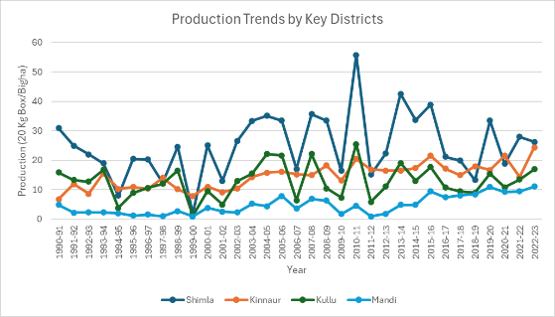

Fig. 1. Production trends by key Districts

Emerging Districts
Sirmour demonstrated explosive potential with the highest CAGR (17.92%), surging from 0.42 to 12.38 boxes/bigha (average: 1.87 boxes/bigha). However, this growth was marred by extreme instability (CV: 103.74%), the highest in the state, alongside pronounced positive skewness (1.91) and kurtosis (3.49), signalling frequent low-yield years with rare spikes influenced by a small cultivation base and erratic weather [3]. The positive slope (0.14 boxes/bigha/year) and moderate correlation (r = 0.71) suggest untapped opportunities in mid-altitude zones, contingent on improved irrigation and pest management. Chamba and Mandi also showed promise as emerging contributors. Chamba's CAGR (6.04%) increased productivity from 2.14 to 6.67 boxes/bigha (average: 2.83 boxes/bigha), with moderate variability (CV: 56.18%), high skewness (1.36), and kurtosis (1.91), reflecting climatic sensitivity in its transitional zones. A slope of 0.04 boxes/bigha/year and correlation (r = 0.80) indicate steady progress. Mandi's CAGR (4.38%) drove yields from 4.85 to 11.13 boxes/bigha (average: 4.75 boxes/bigha), with elevated variability (CV: 64.42%), skewness (1.25), and kurtosis (1.58), pointing to challenges like inadequate pollination (only 2–3% pollinizer trees vs. recommended 33%) (8). Its slope (0.08 boxes/bigha/year) and strong correlation (r = 0.86) highlight potential for expansion through high-density systems. Fig. 2 (CAGR and CV bar chart) contrasts Sirmour's rapid but volatile growth with Shimla's decline, reinforcing the paper's advocacy for tailored interventions in emerging districts to harness their momentum while mitigating risks.

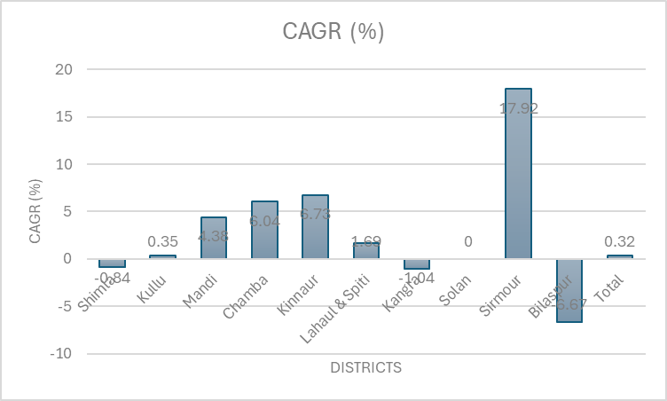

Fig. 2. CAGR comparison across Districts

Marginal Contributors
Lower-elevation districts like Lahaul&Spiti, Kangra, Solan, Bilaspur, Una, and Hamirpur contributed negligibly, with averages below 2.5 boxes/bigha. Lahaul&Spiti's modest CAGR (1.69%) yielded minimal growth (0.66 to 0.92 boxes/bigha; average: 0.85 boxes/bigha), hampered by high variability (CV: 68.24%), skewness (1.47), and kurtosis (2.36), likely due to harsh alpine conditions and limited land [12]. Kangra declined (CAGR: -1.04%; slope: -0.02 boxes/bigha/year), while Solan stagnated (CAGR: 0.00%). Bilaspur, Una, and Hamirpur recorded negative CAGRs (-6.67%) from near-zero bases, with extreme CVs (83.11–100%) and high skewness/kurtosis (1.80/3.15 each), reflecting unsuitable subtropical climates and negligible cultivation [3]. In the past it was generally regarded as a crop of the temperate zones but is increasingly cultivated under sub-tropical and even tropical conditions (11). Low correlations (r < 0.42) confirm their peripheral role.Fig.3 (pie chart of average yield contributions) visually emphasizes Shimla (dominating share) and Kinnaur's efficiency, contrasting with the trivial inputs from marginal districts, which align with regional agro-climatic mismatches.

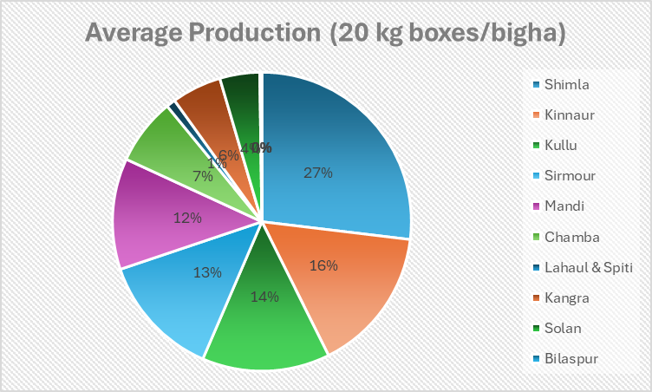

Fig. 3. Average production distribution by Districts

Statistical Variability, Distributions, and Correlations
Districts with small bases (e.g., Sirmour, Una, Hamirpur) exhibited the highest CVs (>100%), indicating vulnerability to external shocks, while core districts like Kinnaur showed stability

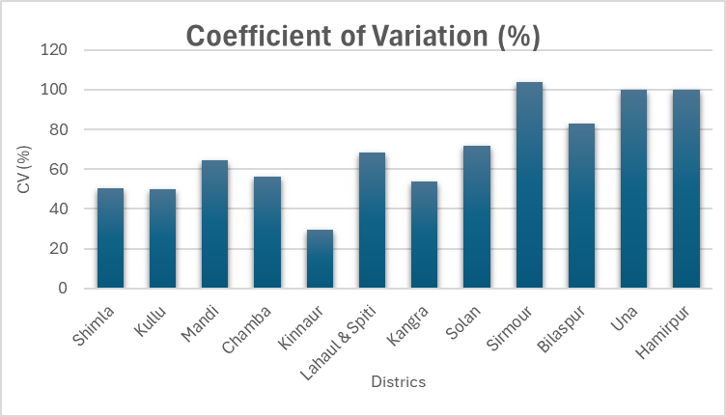

Fig. 4. Variability (CV) across Districts

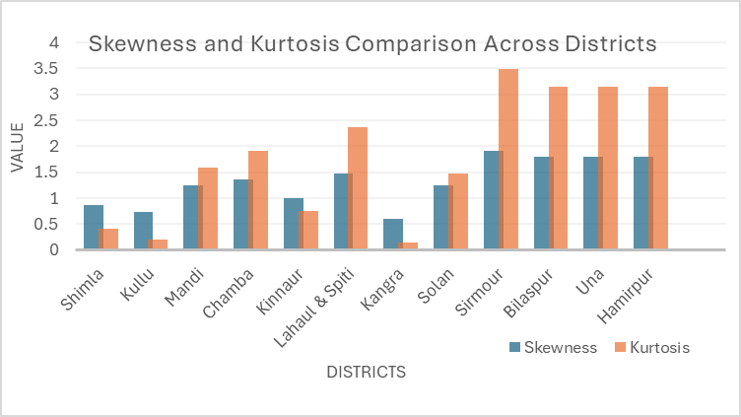

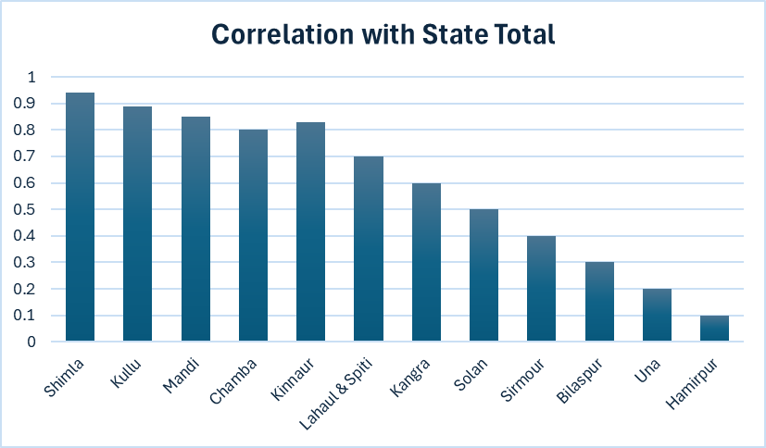
Fig. 5. Skewness and Kurtosis comparison across Districts

Fig. 6. Correlation of District Production with State Total

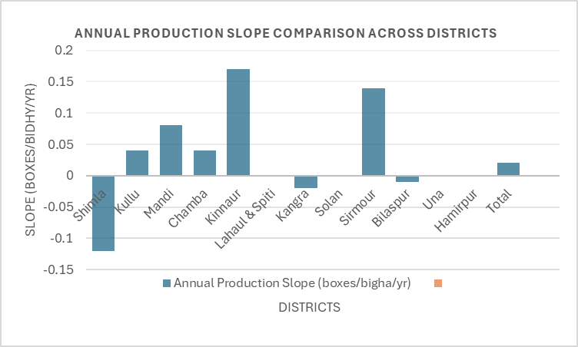

Fig. 7. Annual production slope comparison across Districts

(CV: 29.58%). Positive skewness across all districts (0.60 in Kangra to 1.91 in Sirmour) and elevated kurtosis (up to 3.49 in Sirmour) reveal non-normal distributions, with leptokurtic tails suggesting outlier-driven extremes from climate events or management lapses (4). Fig.4 (variability plot) and Fig.5 (skewness-kurtosis scatter) illustrate these patterns, highlighting risks in emerging and marginal areas.Pearson correlations (Fig.6 matrix) reveal interconnectedness, with Shimla, Kullu, Mandi, Chamba, and Kinnaur (r > 0.80) strongly linked to state trends, implying synchronized responses to shared factors like market pressures and weather. Weaker ties in marginal districts (r < 0.25) suggest localized constraints. Fig. 7 (slope bar chart) synthesizes annual changes, with Kinnaur and Sirmour's positive slopes contrasting Shimla's decline, advocating for orchard modernization in declining areas and infrastructure in growing ones.

Causes of Yield Variations
Yield disparities are multifaceted, rooted in climate change and agronomic shortcomings. Rising temperatures have shifted zones, reducing chilling hours (<1,200 below 7.5°C) and snowfall (58–90% deficits in 2025), fostering fungal infections and a 6.39% production drop in 2025 [2]. Variations in annual rainfall, average temperature, global increase of atmospheric CO2, and fluctuations in sea levels are some of the major manifestations of climate change, which negatively impact crop yields [16]. Climate change, driven by global warming, is expected to adversely impact agriculture through extreme weather, reduced rainfall, and temperature shifts. Since most crops are bred for yield rather than stress tolerance, these changes can severely affect plant growth and cut crop yields by up to 70% (5) Erratic weather exacerbates alternate bearing, yielding inconsistent, low-quality fruits [10]. Outdated low-density orchards with traditional cultivars (e.g., Royal Delicious) suffer from poor adaptation, while inadequate irrigation in rainfed areas limits high-density adoption (>500 plants/ha) [17]. Rising costs, limited land, suboptimal canopy pruning (im-balancing vegetative-reproductive phases), and ineffective pollination (underutilized bees) compound issues [15]. Integrated nutrient and pest management deficits lead to soil erosion and pest surges, particularly in variable districts [12]. These align with the observed non-normal distributions and advocate for climate-resilient strategies, such as high-yielding varieties and enhanced pollinator integration, to bolster sustainability.

4. Conclusion

Apple cultivation in Himachal Pradesh, a vital component of the state’s horticultural economy, faces significant challenges that threaten its sustainability and economic viability. The analysis of marketable yield (20-kg boxes per bigha) from 1990–91 to 2022–23 reveals modest statewide growth (CAGR: 0.32%) but stark district-level disparities, with Shimla and Kinnaur leading due to favourable agro-climatic conditions, while emerging districts like Sirmour, Chamba, and Mandi show potential tempered by high variability (CVs: 56.18–103.74%). Climate change, marked by rising temperatures and reduced snowfall (58–90% deficits in 2025), disrupts chilling requirements (1,200 hours below 7.5°C), triggers alternate bearing, and increases fungal infections, leading to a 6.39% production drop in 2025 [2, 10]. Outdated low-density orchards, traditional cultivation methods, inadequate irrigation, and rising input costs further exacerbate declines, compounded by limited land availability, poor canopy and pollination management (only 2–3% pollinizer trees vs. 33% recommended), and insufficient integrated nutrient and pest management. High skewness and kurtosis in districts like Sirmour (1.91, 3.49) highlight frequent low-yield years with occasional peaks, increasing farmer risk. Strong correlations (Shimla: 0.94, Kullu: 0.89) underscore the influence of major districts on state trends. To enhance yield stability and sustainability, targeted interventions are essential: adopting high-density planting, modern cultivars, improved irrigation, and scientific management practices, alongside promoting pollinizer and pollinator populations, can mitigate climatic and economic challenges, ensuring the resilience of Himachal Pradesh’s apple industry.

DISCLAIMER (ARTIFICIAL INTELLIGENCE)

Author(s) hereby declares that NO generative AI technologies such as Large Language Models (ChatGPT, COPILOT, etc.) and text-to-image generators have been used during writing or editing of manuscripts.

COMPETING INTERESTS

Authors have declared that no competing interests exist.

References

- Anonymous (2025). Departmental statistical data at a glance, Himachal Pradesh. Directorate of Horticulture. Retrieved from https://eudyan.hp.gov.in/cms/en/departmental-statistical-data-at-glance
- Arundhati, & Bhagat, R. M. (2023). Climate change impacts on horticulture in Himachal Pradesh. IOP Conference Series: Earth and Environmental Science, 1110(1), 012031. DOI:10.1088/1755-1315/1110/1/012031
- Babu, N., Kishore, K., Shukla, A. K., Singh, A., Srivastava, S. K., Prusty, M., Sahoo, T., & Behera, S. K. (2018). Resource efficient horticulture technologies for livelihood improvement of farmwomen. ICAR-Central Institute for Women in Agriculture, Technical Bulletin No. 30.
- Bhuyan, D., & Kotoky, A. (2023). Instability in production and productivity of horticultural crops in Assam. Indian Journal of Agricultural Research, 57(1), 23-27.
- Boyer, J. S. (1982). Plant productivity and environment. Science, 218(4571), 443-448.
- Iizumi, T., & Ramankutty, N. (2014). How do weather and climate influence cropping area and intensity? Global Food Security, 4, 46-50.
- Jangra, M. S., & Sharma, J. P. (2013). Climate resilient apple production in Kullu valley of Himachal Pradesh. International Journal of Farm Sciences, 3(1), 91-98.
- Kaur, N. (2019). Early spatial diffusion of orchards in Himachal Pradesh, India (1950-1995). Indian Journal of Hill Farming, Special Issue, 82-90.
- Kendall, M. G. (1975). Rank correlation methods (4th ed.). Charles Griffin, London, UK.
- Kumar, D., & Mukherjee, D. (2024). The causes and trends in the arrivals of apple and tomato to some selected sub-market yards of Himachal Pradesh. Current Agriculture Research Journal, 12(1), 474-484.
- Luckwill, L. C. (1984). Apple growing around the world: Problems and prospects. In E. Napier (Ed.), Apples and Pears: Report of the Royal Horticultural Society Conference, 1983 (pp. 1-10). The Royal Horticultural Society, London.
- Mahesh, N., Reddy, T. R. K., & Lalith, A. (2000). An empirical analysis of growth and instability of Indian tea industry. Agricultural Banker, 24(2), 25-27.
- Mann, H. B. (1945). Nonparametric tests against trend. Econometrica, 13(3), 245-259.
- Negi, C. M. (2020). Dynamics of apple production in Himachal Pradesh. Agricultural Situation in India, 77(2), 20-30.
- Padhy, C., & Behera, S. (2015). Role of horticulture in human nutrition: An analytical review. International Journal of Engineering Technology, Management and Applied Sciences, 3(6), 167-176.
- Raza, A., Razzaq, A., Mehmood, S. S., Zou, X., Zhang, X., Lv, Y. (2019). Impact of climate change on crop adaptation and strategies to tackle its outcome: A review. Plants, 8(2), 34. https://doi.org/10.3390/plants8020034
- Singh, H. P., & Malhotra, S. K. (2011). Horticulture for food, nutrition, health care, and livelihood security. Keynote lecture in International Consortium of Contemporary Biologists, 4th International Conference on Life Science Research for Rural and Agricultural Development, Central Potato Research Station, Patna, 27-29.
- Wang, R., Bowling, L. C., & Cherkauer, K. A. (2016). Estimation of the effects of climate variability on crop yield in the Midwest USA. Agricultural and Forest Meteorology, 216, 141-156.
- Wani, F. A., & Songara, M. (2018). Status and position of apple crop in area, production and productivity in Himachal Pradesh. International Journal of Multidisciplinary Research and Development, 5(11), 106-111.

Table1. Spatiotemporal Variation in Apple Production (20 kg Boxes per Bigha) Across Himachal Pradesh Districts, 1990–91 to 2022–23
Year |  | Shimla | Kullu | Mandi | Chamba | Kinnaur | Lahaul&Spiti | Kangra | Solan | Sirmour | Bilaspur | Una | Hamirpur | Total
1990 | 1991 | 30.87 | 15.81 | 4.85 | 2.14 | 6.81 | 0.66 | 2.29 | 0.42 | 0.42 | 0.00 | 0.00 | 0.00 | 17.42
1991 | 1992 | 24.91 | 13.33 | 2.22 | 3.26 | 11.94 | 1.10 | 0.70 | 1.55 | 0.28 | 0.00 | 0.00 | 0.00 | 14.46
1992 | 1993 | 22.00 | 12.77 | 2.32 | 1.31 | 8.61 | 1.19 | 1.02 | 1.07 | 1.07 | 0.00 | 0.00 | 0.00 | 12.86
1993 | 1994 | 18.99 | 16.73 | 2.24 | 2.89 | 15.56 | 2.18 | 1.61 | 0.31 | 0.24 | 0.00 | 0.00 | 0.00 | 13.03
1994 | 1995 | 8.00 | 3.88 | 1.98 | 0.58 | 10.22 | 0.89 | 0.90 | 0.66 | 1.49 | 0.00 | 0.00 | 0.00 | 5.21
1995 | 1996 | 20.44 | 8.87 | 1.19 | 2.48 | 10.93 | 0.63 | 1.04 | 0.42 | 0.44 | 0.00 | 0.00 | 0.00 | 11.31
1996 | 1997 | 20.21 | 10.59 | 1.56 | 1.18 | 10.38 | 0.58 | 1.54 | 0.37 | 0.24 | 0.00 | 0.00 | 0.00 | 11.49
1997 | 1998 | 12.38 | 12.01 | 1.04 | 3.09 | 14.04 | 0.56 | 1.14 | 0.22 | 0.60 | 0.00 | 0.00 | 0.00 | 9.03
1998 | 1999 | 24.55 | 16.51 | 2.72 | 2.19 | 10.15 | 0.48 | 2.36 | 2.42 | 0.36 | 0.00 | 0.00 | 0.00 | 14.71
1999 | 2000 | 1.91 | 1.22 | 0.87 | 0.61 | 7.90 | 0.38 | 0.58 | 0.19 | 0.06 | 0.00 | 0.00 | 0.00 | 1.77
2000 | 2001 | 25.02 | 9.54 | 3.84 | 1.50 | 10.95 | 0.67 | 1.57 | 0.57 | 0.28 | 0.00 | 0.00 | 0.00 | 13.34
2001 | 2002 | 13.01 | 4.90 | 2.58 | 3.29 | 9.13 | 1.42 | 2.58 | 1.77 | 0.41 | 0.00 | 0.00 | 0.00 | 7.26
2002 | 2003 | 26.50 | 12.96 | 2.33 | 1.50 | 10.38 | 0.38 | 2.39 | 2.53 | 0.60 | 0.00 | 0.00 | 0.00 | 13.65
2003 | 2004 | 33.35 | 15.51 | 5.18 | 2.98 | 14.32 | 1.00 | 4.71 | 1.90 | 0.35 | 0.00 | 0.00 | 0.00 | 17.48
2004 | 2005 | 35.10 | 22.12 | 4.42 | 2.46 | 15.78 | 1.25 | 5.42 | 1.94 | 0.52 | 0.00 | 0.00 | 0.00 | 19.59
2005 | 2006 | 33.46 | 21.61 | 7.86 | 3.18 | 16.14 | 0.99 | 4.84 | 1.69 | 0.63 | 0.00 | 0.00 | 0.00 | 19.53
2006 | 2007 | 17.04 | 6.41 | 3.56 | 1.03 | 15.21 | 0.89 | 3.19 | 1.51 | 0.22 | 3.20 | 0.00 | 0.00 | 9.36
2007 | 2008 | 35.68 | 22.11 | 6.83 | 2.16 | 14.98 | 2.06 | 2.99 | 0.80 | 0.64 | 0.80 | 0.00 | 0.00 | 20.02
2008 | 2009 | 33.47 | 10.47 | 6.32 | 2.33 | 18.25 | 2.27 | 3.54 | 1.09 | 0.74 | 0.80 | 0.00 | 0.00 | 16.75
2009 | 2010 | 16.39 | 7.29 | 1.78 | 1.06 | 13.10 | 0.64 | 2.85 | 0.94 | 0.24 | 0.80 | 0.00 | 0.00 | 9.00
2010 | 2011 | 55.72 | 25.49 | 4.55 | 2.83 | 20.41 | 0.47 | 3.16 | 1.40 | 0.68 | 0.53 | 0.00 | 0.00 | 28.13
2011 | 2012 | 15.08 | 5.83 | 0.89 | 0.79 | 16.88 | 0.29 | 2.98 | 0.72 | 0.49 | 0.00 | 0.00 | 0.00 | 8.49
2012 | 2013 | 22.32 | 11.09 | 1.80 | 0.69 | 16.46 | 0.37 | 1.97 | 1.13 | 0.52 | 1.07 | 0.00 | 0.00 | 12.40
2013 | 2014 | 42.57 | 19.06 | 4.82 | 1.77 | 16.49 | 0.41 | 2.62 | 0.89 | 0.71 | 0.64 | 0.00 | 0.00 | 21.95
2014 | 2015 | 33.65 | 12.97 | 4.85 | 6.50 | 17.29 | 0.54 | 2.50 | 1.23 | 2.66 | 0.64 | 0.00 | 0.00 | 18.26
2015 | 2016 | 38.86 | 17.64 | 9.46 | 6.12 | 21.56 | 0.52 | 2.45 | 0.77 | 3.48 | 1.28 | 0.00 | 0.00 | 22.47
2016 | 2017 | 21.19 | 10.76 | 7.41 | 3.00 | 17.17 | 0.58 | 2.04 | 1.00 | 2.11 | 0.61 | 0.00 | 0.06 | 13.39
2017 | 2018 | 19.87 | 9.43 | 8.09 | 4.82 | 14.94 | 0.56 | 2.00 | 1.14 | 2.35 | 0.91 | 0.00 | 0.05 | 12.69
2018 | 2019 | 13.28 | 8.99 | 8.40 | 3.24 | 17.99 | 0.55 | 1.93 | 1.01 | 4.70 | 0.61 | 0.00 | 0.10 | 10.42
2019 | 2020 | 33.48 | 15.43 | 10.86 | 7.24 | 16.71 | 0.55 | 1.84 | 1.03 | 5.33 | 0.76 | 0.00 | 0.39 | 20.05
2020 | 2021 | 18.79 | 10.83 | 9.29 | 3.73 | 21.51 | 0.56 | 2.05 | 1.01 | 4.98 | 0.71 | 0.00 | 0.37 | 13.43
2021 | 2022 | 27.97 | 13.51 | 9.41 | 4.69 | 14.26 | 1.34 | 1.41 | 0.89 | 11.54 | 1.07 | 0.29 | 0.31 | 17.02
2022 | 2023 | 26.24 | 16.95 | 11.13 | 6.67 | 24.40 | 0.92 | 1.87 | 0.42 | 12.38 | 0.28 | 0.25 | 0.20 | 18.60
Average |  | 24.92 | 12.81 | 4.75 | 2.83 | 14.57 | 0.85 | 2.31 | 1.06 | 1.87 | 0.45 | 0.02 | 0.05 | 13.66
CV (%) |  | 50.16 | 49.73 | 64.42 | 56.18 | 29.58 | 68.24 | 53.68 | 71.70 | 103.74 | 83.11 | 100.00 | 100.00 | 40.32
CAGR (%) |  | -0.84 | 0.35 | 4.38 | 6.04 | 6.73 | 1.69 | -1.04 | 0.00 | 17.92 | -6.67 | -6.67 | -6.67 | 0.32
Skewness |  | 0.87 | 0.74 | 1.25 | 1.36 | 1.00 | 1.47 | 0.60 | 1.25 | 1.91 | 1.80 | 1.80 | 1.80 | 0.81
Kurtosis |  | 0.42 | 0.20 | 1.58 | 1.91 | 0.75 | 2.36 | 0.14 | 1.47 | 3.49 | 3.15 | 3.15 | 3.15 | 0.36
Slope (boxes/bigha/yr) |  | -0.12 | 0.04 | 0.08 | 0.04 | 0.17 | 0.00 | -0.02 | 0.00 | 0.14 | -0.01 | 0.00 | 0.00 | 0.02
Correlation |  | 0.94 | 0.89 | 0.86 | 0.80 | 0.83 | 0.66 | 0.36 | 0.42 | 0.71 | 0.22 | 0.19 | 0.25 | 1.00

Data Sourced from Department of Horticulture, himachal pradesh, 2025

