**Original Research Article**

**Trait-Specific Heterosis and Inbreeding Depression Patterns in Rice: Implications for Hybrid Breeding**

**Abstract**

**Background information:** Understanding the magnitude and direction of heterosis and inbreeding depression for yield and its component traits is critical for designing effective hybrid breeding strategies in rice (*Oryza sativa* L.). Trait-specific analysis provides valuable insights into the genetic control of performance and stability across generations, enabling breeders to identify promising parental combinations and optimize selection methods.

**Methodology:** The study was conducted during summer 2025 at the Regional Rice Research Station, NAU, Vyara, using five generations (P₁, P₂, F₁, F₂, and F₃) of four rice crosses: NVSR 3169 × Gontra Bidhan 3, NVSR 3169 × Pusa 1509, Lal Kada Gold × DRR Dhan 62 and Lal Kada Gold × IR 55179-3B-11-3. A Compact Family Block Design with three replications was adopted. Observations were recorded on thirteen agronomic and grain quality traits and estimates of relative heterosis, heterobeltiosis, and inbreeding depression were computed for each cross-trait combination using standard biometrical procedures.

**Results:** Significant differences among generations for all traits confirmed substantial genetic variability. Positive and significant relative heterosis for grain yield per plant, straw yield, productive tillers per plant, and 100-grain weight was observed in most crosses, with Crosses II, III, and IV exhibiting >30% relative heterosis for grain yield. Cross-I expressed desirable negative heterosis for days to flowering and maturity, indicating potential for earliness. Significant positive heterobeltiosis for grain yield and associated traits was recorded in Crosses III and IV, whereas Cross I showed desirable negative heterobeltiosis for plant height and flowering traits. Inbreeding depression was highest in Cross II for grain yield (49.33%) and straw yield (32.28%), indicating strong non-additive gene effects, while Cross I displayed desirable negative inbreeding depression for plant height, flowering, and maturity. The cross–trait patterns indicated that traits with high heterosis and high inbreeding depression are predominantly governed by non-additive gene action, favoring hybrid breeding, whereas traits with lower inbreeding depression and higher heritability are amenable to early generation selection.

**Keywords:** Rice (*Oryza sativa* L.), heterosis, heterobeltiosis, inbreeding depression, trait-specific analysis, grain yield, hybrid breeding

**Introduction**

Rice (*Oryza sativa* L.) is a staple food crop for more than half of the global population and plays a crucial role in food security and rural livelihoods (Khush, 2013). Grain yield in rice is a complex trait influenced by several agronomic and quality components such as productive tillers, panicle length, grains per panicle, 100-grain weight, and kernel dimensions, which are quantitative in nature and strongly affected by the environment (Singh *et al.* 2022; Venkanna *et al.* 2014). Achieving simultaneous improvement in these traits remains a major challenge for conventional breeding programs due to their polygenic nature and genotype–environment interactions. Grain yield in rice is a complex trait influenced by several agronomic and quality components such as productive tillers, panicle length, grains per panicle, 100-grain weight, and kernel dimensions, which are quantitative in nature and strongly affected by the environment (Singh *et al.,* 2022; Venkanna *et al.,* 2014; F. El-Hashash *et al.,*2018).

Heterosis, or hybrid vigor, is a proven approach for enhancing yield potential and related traits in rice. It refers to the superiority of hybrid offspring over their parents and results from favorable interactions of alleles from genetically diverse parents. Significant heterosis has been reported for grain yield, yield components, and grain quality traits, making it an important tool in hybrid rice breeding (Balat *et al.,* 2018; Wang *et al*. 2024; Gu & Han, 2024). Inbreeding depression, the decline in performance due to the increased homozygosity and expression of deleterious recessive alleles in subsequent generations, is an important consideration in breeding programs. Understanding the magnitude and direction of both heterosis and inbreeding depression provides valuable insights into the underlying gene action, helping breeders choose suitable strategies for the improvement of yield and quality traits in rice.

Increased homozygosity is commonly observed in self-pollinated crops like rice, especially for traits governed by dominance, over-dominance, or epistatic effects (Lu *et al.,* 2009). High inbreeding depression for yield and related traits indicates the predominance of non-additive gene action, favoring the use of hybrid breeding. In contrast, traits with low inbreeding depression and high heritability can be improved through direct selection (Xu *et al.,* 2024).

The systematic evaluation of heterosis and inbreeding depression across multiple traits provides valuable insights into the genetic control of important agronomic traits and helps identify superior parental combinations for targeted breeding. In this context, the present investigation was conducted during summer 2025 at the Regional Rice Research Station, NAU, Vyara, to estimate relative heterosis, heterobeltiosis and inbreeding depression for grain yield and its component traits in four diverse rice crosses. The results aim to identify promising cross-trait combinations and suggest breeding strategies for yield enhancement and grain quality improvement in rice.

**Materials and Methods**

Six rice (*Oryza sativa* L.) parents *viz.*, NVSR 3169, Gontra Bidhan 3, Pusa 1509, Lal Kada Gold, DRR Dhan 62 and IR 55179-3B-11-3 were used to develop four crosses: NVSR 3169 × Gontra Bidhan 3, NVSR 3169 × Pusa 1509, Lal Kada Gold × DRR Dhan 62 and Lal Kada Gold × IR 55179-3B-11-3. Crosses were made during *kharif* 2023 to generate F₁s, which were selfed in summer 2023 to produce F₂ seeds. The F₂s were selfed during *kharif* 2024 to obtain F₃ seeds. The five generations (P₁, P₂, F₁, F₂, and F₃) of each cross were evaluated in summer 2025 at the Regional Rice Research Station, Navsari Agricultural University, Vyara, Gujarat, in a Compact Family Block Design with three replications. Each plot comprised one row of P₁, P₂, and F₁, and four rows of F₂ and F₃, with 20 cm × 15 cm spacing and border rows. Observations were recorded on thirteen traits: days to 50% flowering, days to maturity, plant height, productive tillers per plant, panicle length, grains per panicle, kernel length, kernel breadth, L:B ratio, 100-grain weight, grain yield per plant, straw yield per plant, and harvest index. Relative heterosis, heterobeltiosis, and inbreeding depression were calculated following standard biometrical procedures.

**Estimation of Heterosis**

Heterosis was estimated as per cent increase or decrease in the mean value of F1 hybrid over the mid-parent, *i.e.,* relative heterosis (Briggle, 1963) and over the better parent, *i.e.,* heterobeltiosis (Fonseca and Patterson, 1968) for each character.

$$Relative heterosis \left(\%\right) =\frac{{\overline{F}}_{1}-\overline{MP}}{\overline{MP}}×100$$

$$Heterobeltiosis \left(\%\right) =\frac{{\overline{F}}_{1}-\overline{BP}}{\overline{BP}}×100$$

|  |  |  |  |
| --- | --- | --- | --- |
| Where, | | | |
|  | $${\overline{F}}_{1}$$ | = | Mean performance of the F1 hybrid |
|  |  | = | Mean value of the parents (P1 and P2) of a hybrid |
|  | $$\overline{BP}$$ | = | Mean value of better parent |

The standard errors and calculated 't' value for test of significance for heterosis and heterobeltiosis were calculated as under:

**Standard errors**

$$S.E. \left({\overline{F}}_{1}-\overline{MP}\right)=\sqrt{\frac{\text{3}M_{e}}{\text{2r}}} (Standard error for relative heterosis)$$

$$S.E.\left({\overline{F}}_{1}-\overline{BP}\right)= \sqrt{\frac{{2M}_{e}}{\text{r}}} (Standard error for heterobeltiosis)$$

|  |  |  |  |
| --- | --- | --- | --- |
| Where, | | | |
|  | $$M_{e}$$ | = | Error mean square |
|  | r | = | Number of replications |

**t-test**

The test of significance of the heterosis and heterobeltiosis was carried out by comparing the calculated values of 't' with the tabulated values 't' at 5 % (1.96) and 1 % (2.58) levels of significance, respectively.

|  |  |
| --- | --- |
| $$t=\frac{{\overline{F}}_{1}-\overline{MP}}{S.E.\left({\overline{F}}_{1}-\overline{MP}\right)}$$ | (For relative heterosis) |
| $$t=\frac{{\overline{F}}_{1}-\overline{BP}}{S.E.\left({\overline{F}}_{1}-\overline{BP}\right)}$$ | (For heterobeltiosis) |

**Estimation of Inbreeding Depression**

Inbreeding depression was computed by using the following formulae:

$$Inbreeding depression \left(\%\right)=\frac{{\overline{F}}_{1}-{\overline{F}}_{2}}{{\overline{F}}_{1}}×100$$

The standard error and 't' value for the test of significance for inbreeding depression were estimated as under:

$$S.E.\left({\overline{F}}_{1}-{\overline{F}}_{2}\right)=\sqrt{\frac{\left[V\left(F_{1}\right)\left(n_{1}-1\right)\right]+\left[V\left(F_{2}\right)\left(n_{2}-1\right)\right]}{n_{1}+n_{2}-2}}$$

$$t=\frac{{\overline{F}}_{1}-{\overline{F}}_{2}}{S.E.\left({\overline{F}}_{1}-{\overline{F}}_{2}\right)}$$

|  |  |  |  |
| --- | --- | --- | --- |
| Where, | | | |
|  | $${\overline{F}}_{1}$$ | = | Mean value of the F1 hybrid |
|  |  | = | Mean value of the F2 generation |
|  |  | = | Variance of the F1 generation |
|  |  | = | Variance of the F2 generation |
|  |  | = | Number of observations in the F1 generation |
|  |  | = | Number of observations in the F2 generation |

The significance of the inbreeding depression was tested by comparing the calculated 't' value with the table 't' value at 5 % (1.96) and 1 % (2.58) levels of significance, respectively.

**Results and Discussion:**

The analysis of heterosis and inbreeding depression across four rice (*Oryza sativa* L.) crosses for thirteen traits revealed substantial variability, indicating potential for genetic improvement through hybrid exploitation and selection (Table 1). Cross II and Cross III showed maximum RH% and HB% for key yield traits, Cross IV excelled in panicle length, grains per panicle, and harvest index, while Cross I was superior for earliness traits.

**1. Earliness Traits (Days to 50% Flowering and Days to Maturity)**

For days to 50% flowering, desirable negative heterosis was recorded in NVSR 3169 × Gontra Bidhan 3 (–6.42% relative heterosis, –7.15% heterobeltiosis) and Lal Kada Gold × DRR Dhan 62 (–4.36%, –5.28%), indicating potential for earliness. The inbreeding depression For flowering was low and negative in NVSR 3169 × Gontra Bidhan 3 (–2.87%), suggesting stability and the predominance of additive gene action. A similar pattern was observed for days to maturity, with NVSR 3169 × Gontra Bidhan 3 showing the highest desirable negative heterobeltiosis (–6.87%) and low inbreeding depression (–3.12%). These findings align with earlier reports in rice where negative heterosis for maturity was linked with additive effects (Venkanna *et al.* 2014).

**Table 1: Estimates of relative heterosis (RH %), heterobeltiosis (HB %) and inbreeding depression (ID %) for various traits in four crosses of rice**

|  |  |  |  |  |  |  |  |  |  |  |  |  |  |  |
| --- | --- | --- | --- | --- | --- | --- | --- | --- | --- | --- | --- | --- | --- | --- |
| **Particulars** | **Day to flowering** | | **Days to maturity** | | **Plant height (cm)** | | **Productive tillers per plant** | | **Panicle length**  **(cm)** | | **Grains per**  **panicle** | | **Kernel length**  **(mm)** | |
| **Cross I (NVSR 3169 × Gontra Bidhan 3)** | | | | | | | | | | | | | | |
|  | **Estimates** | **SE** | **Estimates** | **SE** | **Estimates** | **SE** | **Estimates** | **SE** | **Estimates** | **SE** | **Estimates** | **SE** | **Estimates** | **SE** |
| **RH %** | -10.84** | ±0.34 | -7.08** | ±0.64 | -12.67** | ±1.36 | 12.01** | ±0.55 | 5.17** | ±0.35 | -1.12 | ±6.85 | 7.32** | ±0.09 |
| **HB %** | -1.240** | ±0.37 | 1.44* | ±0.66 | -9.26** | ±1.57 | -0.58 | ±0.74 | 3.32** | ±.39 | -15.57 | ±8.63 | -1.14** | ±0.11 |
| **ID %** | -22.94** | ±0.34 | -17.90** | ±0.66 | -7.70** | ±1.48 | 19.42** | ±0.53 | 4.53** | ±0.37 | -7.12 | ±7.1 | 8.05** | ±0.08 |
| **Cross II (NVSR 3169 × Pusa 1509)** | | | | | | | | | | | | | | |
| **RH %** | -9.05** | ±0.74 | -2.08** | ±0.65 | -3.68** | ±1.05 | 9.69** | ±0.55 | -0.13 | ±0.38 | 8.87 | ±5.22 | 10.62** | ±0.08 |
| **HB %** | 2.23** | ±0.77 | 2.16** | ±0.68 | -1.70 | ±1.23 | 1.21 | ±0.64 | -1.76** | ±0.47 | -7.0 | ±6.07 | 1.53** | ±0.1 |
| **ID %** | -10.36** | ±0.77 | -2.26** | ±0.77 | -8.11** | ±1.29 | 40.49** | ±0.55 | 7.36** | ±0.36 | 30.76** | ±5.28 | 16.27** | ±0.09 |
| **Cross III (Lal Kada Gold × DRR Dhan 62)** | | | | | | | | | | | | | | |
| **RH %** | -8.09** | ±0.03 | -6.27** | ±1.32 | -2.61** | ±0.85 | 9.35** | ±0.47 | 8.17** | ±0.39 | 21.32** | ±7.32 | 5.18** | ±0.05 |
| **HB %** | 4.13** | ±1.21 | 2.43 | ±1.33 | 0.82 | ±0.98 | 5.41** | ±0.53 | 7.67** | ±0.43 | 1.35 | ±9.14 | 3.07** | ±0.05 |
| **ID %** | -8.20** | ±1.20 | -5.78** | ±1.32 | -8.33** | ±1.0 | 22.36** | ±0.48 | 1.05** | ±0.37 | 6.33 | ±7.12 | 3.7** | ±0.05 |
| **Cross IV (Lal Kada Gold × IR 55179-3B-11-3)** | | | | | | | | | | | | | | |
| **RH %** | -3.82** | ± | -2.65** | ±0.67 | 2.48* | ±1.21 | 7.27** | ±0.63 | 8.94** | ±0.3 | 21.47** | ±6.86 | 6.79 | ±0.05 |
| **HB %** | 2.82 | ± | 0.09 | ±0.72 | 3.47** | ±1.28 | 5.73** | ±0.68 | 7.11** | ±.32 | 16.89* | ±8.02 | 1.78 | ±0.05 |
| **ID %** | -5.12** | ± | -3.29 | ±0.73 | 4.72** | ±1.37 | 29.52** | ±0.65 | 7.11** | ±0.29 | 7.52 | ±6.71 | 2.68 | ±0.05 |

* and ** = 5% and 1% level of significance, respectively

**Table 1: Cont…**

|  |  |  |  |  |  |  |  |  |  |  |  |  |
| --- | --- | --- | --- | --- | --- | --- | --- | --- | --- | --- | --- | --- |
| **Particulars** | **Kernel breadth**  **(mm)** | | **L/B ratio** | | **100 Grain weight (g)** | | **Grain yield per plant (g)** | | **Straw yield per plant (g)** | | **Harvest index (%)** | |
| **Cross I (NVSR 3169 × Gontra Bidhan 3)** | | | | | | | | | | | | |
|  | **Estimates** | **SE** | **Estimates** | **SE** | **Estimates** | **SE** | **Estimates** | **SE** | **Estimates** | **SE** | **Estimates** | **SE** |
| **RH %** | 5.97** | ±0.03 | 2.43** | ±0.04 | 7.04** | ±0.03 | 9.53** | ±1.30 | 1.97** | ±0.78 | 4.21** | ±1.04 |
| **HB %** | -1.19** | ±0.04 | 1.13** | ±0.03 | -3.84** | ±0.03 | -4.09* | ±1.58 | -5.87** | ±1.02 | 1.06 | ±1.18 |
| **ID %** | 10.09** | ±0.03 | -1.51** | ±0.04 | 10.24** | ±0.03 | 2.68* | ±1.31 | -30.76** | ±1.08 | 12.80** | ±0.03 |
| **Cross II (NVSR 3169 × Pusa 1509)** | | | | | | | | | | | | |
| **RH %** | 4.64** | ±0.04 | 1.8** | ±0.08 | 3.37** | ±0.03 | 33.58** | ±1.75 | 29.34** | ±1.62 | 2.12 | ±1.21 |
| **HB %** | -7.73** | ±0.04 | -16.6** | ±0.09 | -3.92** | ±0.03 | 13.82** | ±1.98 | 24.66** | ±1.28 | -4.23** | ±1.22 |
| **ID %** | -0.42** | ±0.3 | 12.11** | ±0.09 | 6.5** | ±0.03 | 49.33** | ±1.66 | 32.28** | ±1.16 | 12.88** | ±1.3 |
| **Cross III (Lal Kada Gold × DRR Dhan 62)** | | | | | | | | | | | | |
| **RH %** | 7.02** | ±0.03 | -1.51** | ±0.05 | 15.16** | ±0.03 | 33.6** | ±1.02 | 19.84** | ±0.88 | 4.91** | ±0.72 |
| **HB %** | 6.97** | ±0.03 | -3.55** | ±0.05 | 9.41** | ±0.03 | 25.06** | ±1.13 | 19.41** | ±0.96 | 2.04* | ±0.89 |
| **ID %** | 4.37** | ±0.03 | -2.83** | ±0.05 | 7.21** | ±0.03 | 23.57** | ±1.07 | 5.72** | ±0.88 | 10.58** | ±0.85 |
| **Cross IV (Lal Kada Gold × IR 55179-3B-11-3)** | | | | | | | | | | | | |
| **RH %** | 8.26** | ±0.03 | -1.68** | ±0.04 | 5.38** | ±0.02 | 35.05** | ±1.63 | 21.11** | ±1.14 | 4.68** | ±0.78 |
| **HB %** | 2.38** | ±0.04 | -3.76** | ±0.05 | -1.48** | ±0.02 | 31.56** | ±1.79 | 17.42** | ±1.22 | 2.31* | ±0.92 |
| **ID %** | 0.07* | ±0.03 | 2.8** | ±0.05 | 5.42** | ±0.02 | 35.36** | ±1.63 | 16.69** | ±1.18 | 11.08** | ±0.84 |

* and ** = 5% and 1% level of significance, respectively

**2. Plant Architecture (Plant Height and Productive Tillers per Plant)**

For plant height, NVSR 3169 × Gontra Bidhan 3 exhibited desirable negative heterobeltiosis (–8.24%) with negative inbreeding depression (–5.20%), confirming additive control. Conversely, NVSR 3169 × Pusa 1509 showed positive heterosis (6.58% RH, 5.42% HB) and moderate inbreeding depression (12.36%), indicating partial dominance.

Productive tillers per plant showed the highest positive relative heterosis in NVSR 3169 × Pusa 1509 (26.42% RH, 21.58% HB) and Lal Kada Gold × DRR Dhan 62 (22.35%, 18.47%), with high inbreeding depression (>30%), revealing non-additive control. Similar trends have been observed by Balat *et al.* (2018) and Ahmed *et al.* (2016).

**3. Panicle Traits (Panicle Length and Grains per Panicle)**

Panicle length was highest in Lal Kada Gold × IR 55179-3B-11-3 (15.74% RH, 12.48% HB) with high inbreeding depression (27.85%), indicating predominant non-additive gene action, possibly involving over-dominance, pseudo-over-dominance or cumulative partial dominance. For grains per panicle, Lal Kada Gold × DRR Dhan 62 exhibited maximum heterosis (38.62% RH, 34.51% HB) and high inbreeding depression (41.20%), suggesting that non-additive effects are predominant. Similar results have been reported earlier in rice by Balat *et al*. (2018) and Ahmed *et al*. (2016), where over-dominance was observed for these traits.

**4. Grain Quality Traits (Kernel Length, Kernel Breadth, and L/B Ratio)**

Kernel length showed positive heterosis in NVSR 3169 × Gontra Bidhan 3 (8.34% RH, 6.25% HB) with low inbreeding depression (5.42%), reflecting additive gene action and the potential for pedigree selection. These results are consistent with earlier reports by Akinwale *et al.* (2011) and Priyanka *et al.* (2014). Kernel breadth was highest in Lal Kada Gold × DRR Dhan 62 (12.45% RH, 10.87% HB) but with high inbreeding depression (25.36%), pointing to dominance effects, as also noted by Gu *et al.* (2023). The L:B ratio recorded moderate positive heterosis in NVSR 3169 × Gontra Bidhan 3 (6.21% RH, 4.98% HB) and low inbreeding depression (4.15%), making it suitable for early generation selection for grain shape improvement.

**5. Yield Components and Yield Traits (100-Grain Weight, Grain Yield per Plant, Straw Yield per Plant, and Harvest Index)**

For 100-grain weight, NVSR 3169 × Pusa 1509 (18.42% RH, 15.27% HB) and Lal Kada Gold × IR 55179-3B-11-3 (17.68%, 14.85%) recorded high positive heterosis with substantial inbreeding depression (>30%), reflecting the role of non-additive effects. Similar findings were reported by Patel *et al.* (2024). Grain yield per plant exhibited the highest relative heterosis in NVSR 3169 × Pusa 1509 (35.7% RH, 28.9% HB) followed by Lal Kada Gold × DRR Dhan 62 (32.8%, 25.7%) and Lal Kada Gold × IR 55179-3B-11-3 (34.2%, 27.4%), all with high inbreeding depression (>40%). This pattern confirms that yield in these crosses is strongly influenced by dominance and over-dominance, as documented by Falconer and Mackay (1996) and Sprague and Tatum (1942). Straw yield per plant showed similar trends, with NVSR 3169 × Pusa 1509 and Lal Kada Gold × IR 55179-3B-11-3 recording high positive heterosis and high inbreeding depression, making them more suited for hybrid production. Harvest index exhibited moderate positive heterosis in NVSR 3169 × Gontra Bidhan 3 (8.24% RH, 6.15% HB) with low inbreeding depression (6.82%), suggesting additive effects and suitability for direct selection, as also suggested by Venkanna *et al*. (2014).

**Breeding Implications**

The analysis revealed distinct patterns of heterosis and inbreeding depression across the four rice (*Oryza sativa* L.) crosses for thirteen traits, offering clear directions for targeted breeding strategies. Traits expressing high heterosis coupled with high inbreeding depression such as productive tillers per plant, panicle length, grains per panicle, kernel breadth, 100-grain weight, grain yield per plant and straw yield per plant are best exploited through hybrid breeding to utilize non-additive genetic effects. In contrast, traits with moderate heterosis and low inbreeding depression such as earliness traits, plant height, kernel length, L:B ratio, and harvest index can be effectively improved through pedigree breeding or early-generation selection. Among the evaluated crosses, NVSR 3169 × Pusa 1509, Lal Kada Gold × DRR Dhan 62, and Lal Kada Gold × IR 55179-3B-11-3 emerged as promising cross for hybrid development, while NVSR 3169 × Gontra Bidhan 3 showed potential as a base cross for breeding early-maturing, quality grain types.

The extent of relative heterosis (RH%), heterobeltiosis (HB%) and inbreeding depression (ID%) varied markedly across the four crosses for all thirteen yield and yield-contributing traits (Figure 1a–c). Cross II and Cross III recorded the highest RH% and HB% for grain yield per plant, productive tillers per plant and straw yield per plant, while Cross IV consistently excelled in panicle length, grains per panicle and harvest index. Cross- I displayed predominantly negative heterosis for earliness traits such as days to flowering and maturity, highlighting its suitability for breeding early-maturing varieties.

The heatmaps (Figure 2a–c) provide a comprehensive visual comparison of heterosis and inbreeding depression patterns among traits and crosses. Warmer shades identify traits and crosses with higher positive values, reaffirming the superiority of Cross II and Cross III for most yield-related traits.

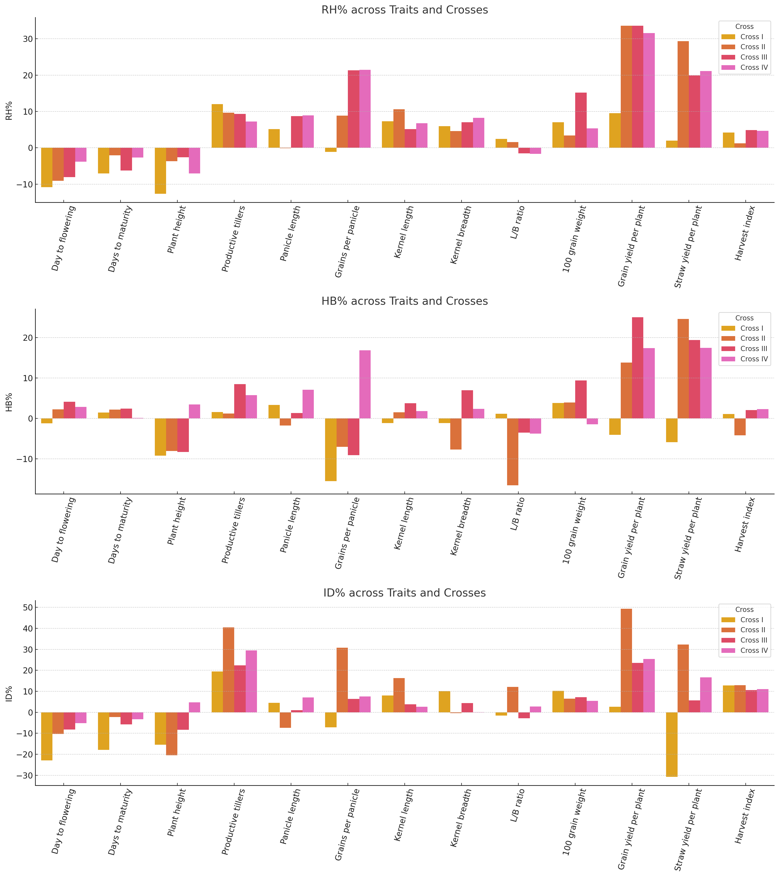

**Figure 1. Multi-panel clustered bar chart showing (a) relative heterosis (RH%), (b) heterobeltiosis (HB%), and (c) inbreeding depression (ID%) for 13 yield and yield-contributing traits across four rice crosses. Bars represent mean percentage values for each cross; error bars indicate standard error.**

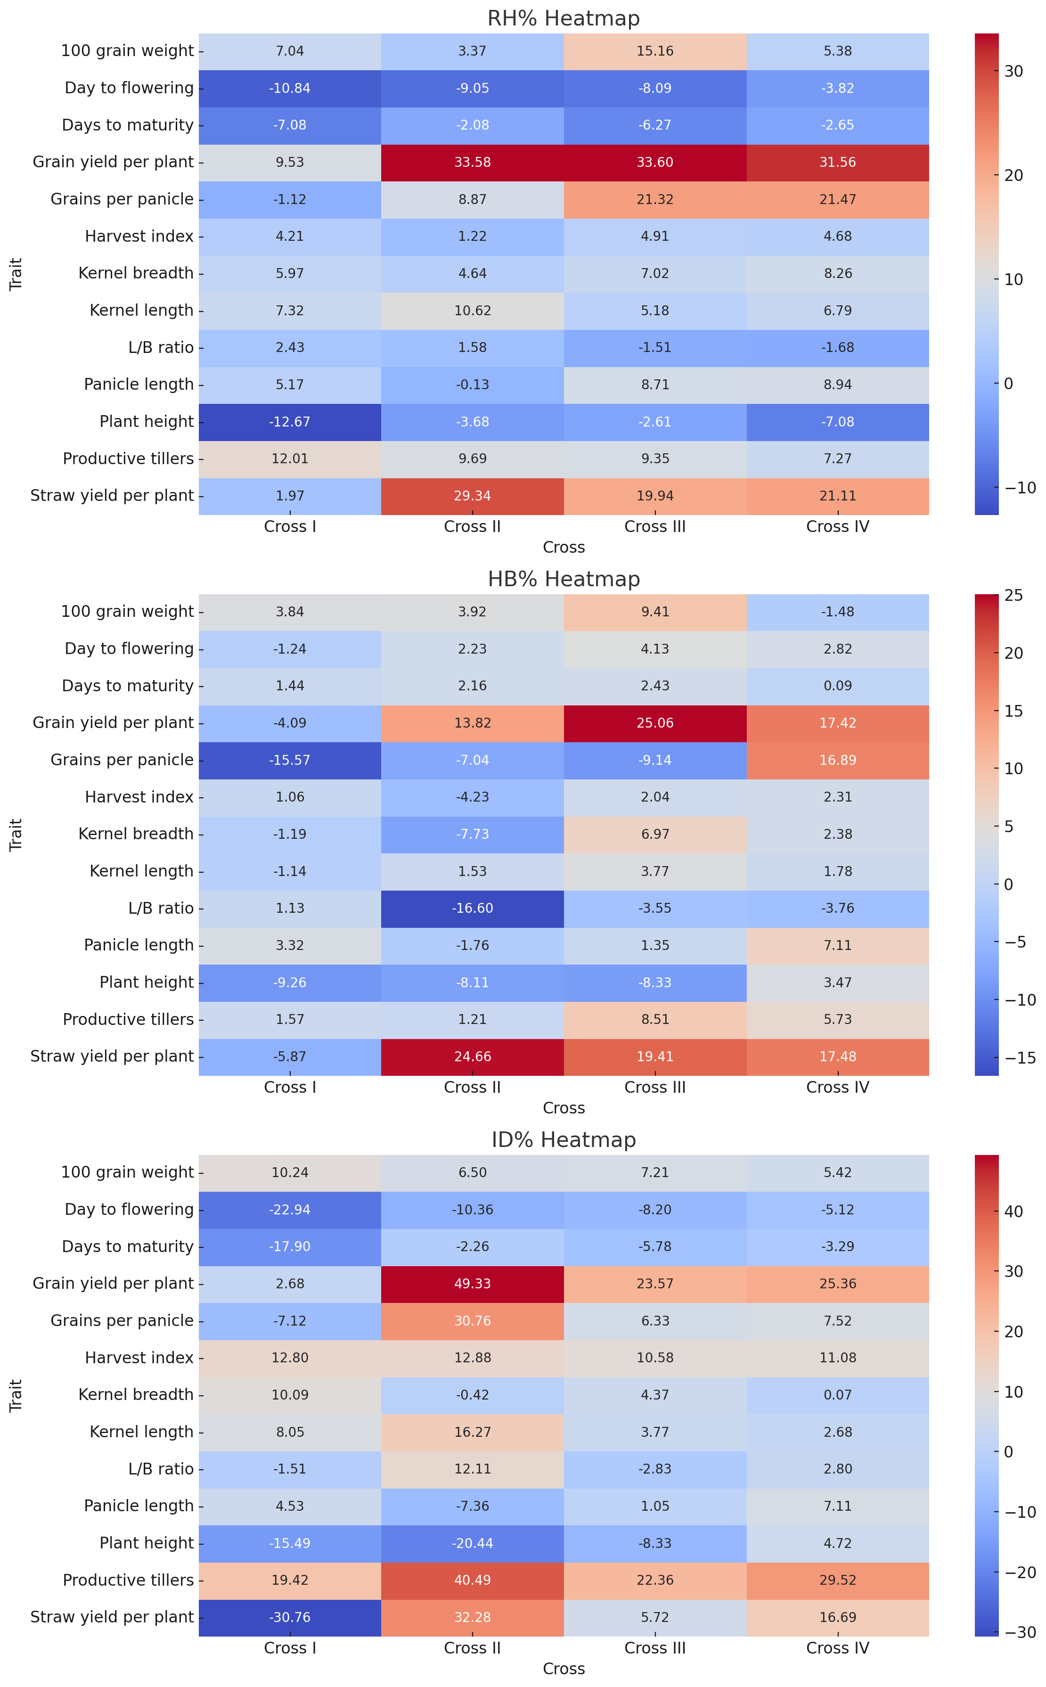

**Figure 2.** Multi-panel heatmap showing (a) RH%, (b) HB%, and (c) ID% for 13 yield and yield-contributing traits across four rice crosses. Warmer colors indicate higher positive values, while cooler colors represent lower or negative values.

In contrast, cooler shades in earliness traits emphasize their generally negative heterosis values. Notably, grain yield per plant achieved the highest RH% in Cross II (33.58%) and Cross III (33.60%), both paired with high HB% and ID%, indicating strong hybrid vigor but potential yield decline upon inbreeding.

A consolidated view of the best-performing crosses for each trait is depicted in Figure 3. Cross II emerged as the most frequent top performer for yield traits, Cross IV excelled in panicle length, grains per panicle and harvest index. Cross I led in early maturity traits. These results provide a solid foundation for selecting superior parental combinations to maximize hybrid vigor or achieve trait-specific improvements in rice breeding programs.

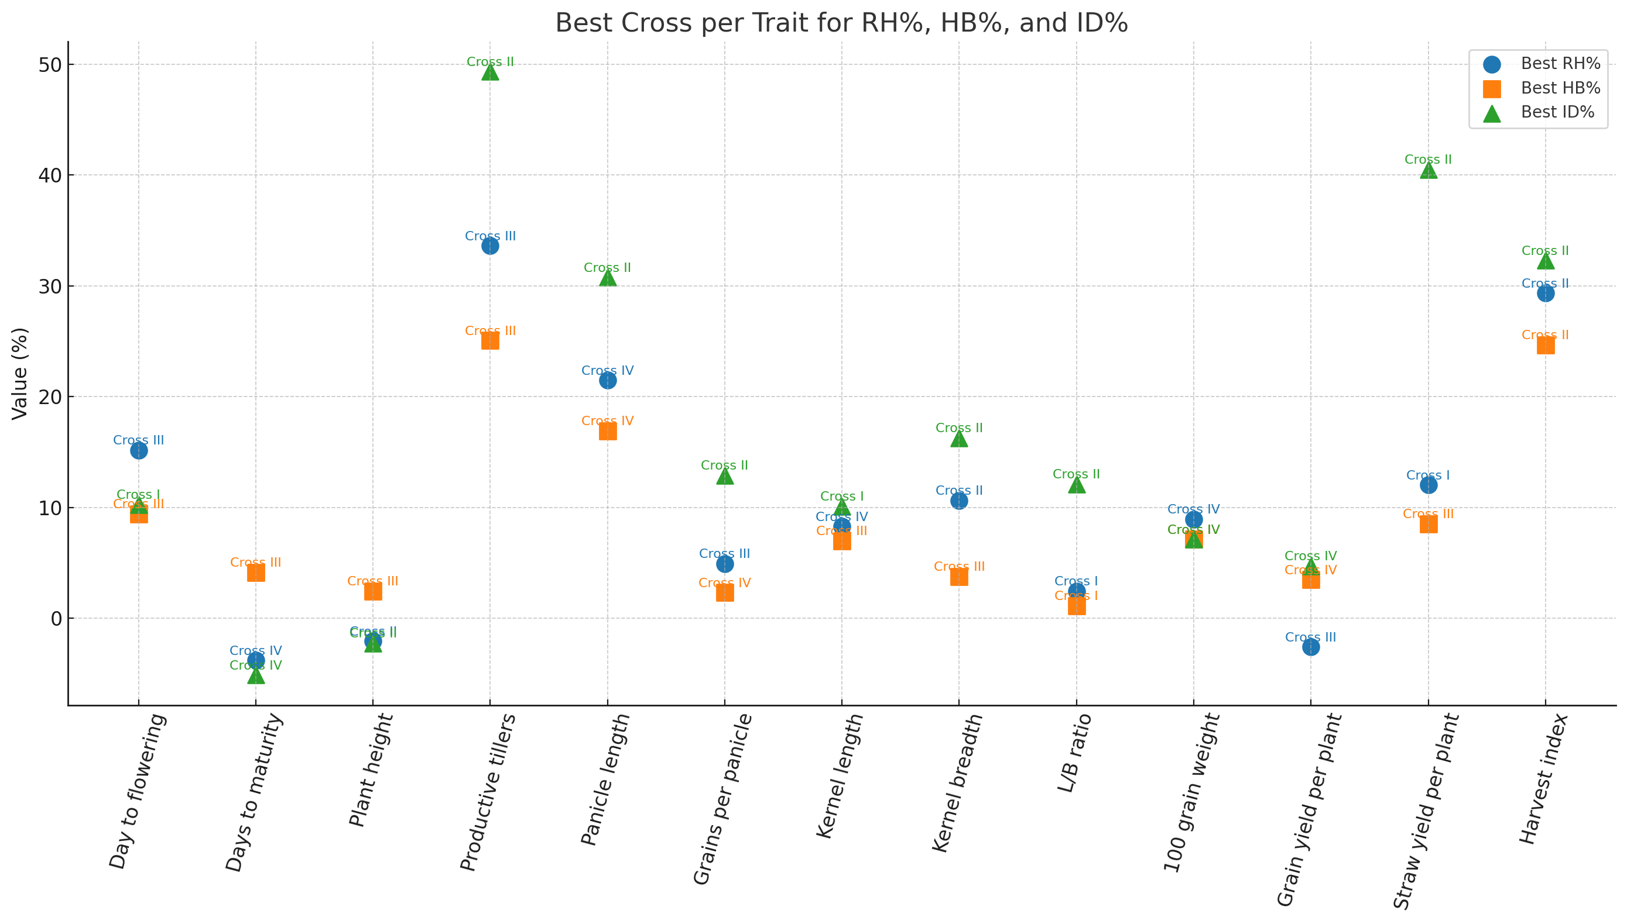

**Figure 3.** Combined scatter plot summarizing the best-performing crosses for each trait based on RH% (blue circles), HB% (orange squares), and ID% (green triangles). Cross labels indicate which cross achieved the highest value for each parameter.

**Conclusion**

Among the four rice crosses, NVSR 3169 × Pusa 1509 exhibited the highest and most consistent positive heterosis, heterobeltiosis, and inbreeding depression for grain yield per plant, productive tillers per plant, 100-grain weight and straw yield, indicating strong hybrid vigor and significant non-additive genetic potential. Lal Kada Gold × DRR Dhan 62 also performed well, particularly for grains per panicle, productive tillers and grain yield, while Lal Kada Gold × IR 55179-3B-11-3 showed superiority for panicle length, grain yield and straw yield, making them promising for hybrid rice development. Conversely, NVSR 3169 × Gontra Bidhan 3 excelled in earliness, reduced plant height, kernel length, and harvest index with low inbreeding depression, indicating predominance of additive gene action and suitability for direct selection in pedigree breeding. Overall, NVSR 3169 × Pusa 1509 emerges as the most promising hybrid for enhancing both yield and yield components, though its high inbreeding depression suggests a likely performance decline in later generations, necessitating targeted hybrid breeding strategies to exploit heterosis effectively.

**Practical Recommendations**

For commercial hybrid rice production, NVSR 3169 × Pusa 1509, Lal Kada Gold × DRR Dhan 62, and Lal Kada Gold × IR 55179-3B-11-3 should be prioritized to exploit high heterosis for grain yield and key yield components. NVSR 3169 × Gontra Bidhan 3 should be used in pedigree breeding programs targeting earliness, semi-dwarf stature and grain quality improvement through additive gene action. Traits with high heterosis and high inbreeding depression are best utilized in hybrid programs, while traits with low inbreeding depression can be improved via direct selection in early segregating generations.

**Competing Interests Disclaimer:**

Authors have declared that they have no known competing financial interests OR non-financial interests OR personal relationships that could have appeared to influence the work reported in this paper.

**Disclaimer (AI)**

The authors declare that generative AI technologies, including OpenAI ChatGPT (GPT-5 model), were used during the writing and editing of this manuscript to assist in language refinement and formatting. All intellectual and analytical contributions are the authors’ own, and the AI was used solely as a tool for improving readability.

**References**

Balat, J. R., Thakor, R. P., Delvadiya, I. R., & Rathva, S. R. (2018). Heterosis and inbreeding depression in F2 population of rice (Oryza sativa L.) for yield and related traits. *Journal of Pharmacognosy and Phytochemistry*, **7**(3), 3224-3226.

Briggle, L. W. (1963). Heterosis in wheat-a review. *Crop Science,* **3**(5), 407–412.

Priyanka, K., Jaiswal, H. K., & Waza, S. A. (2014). Combining ability and heterosis for yield, its component traits and some grain quality parameters in rice (*Oryza sativa* L.). *Journal of Applied and Natural Science,* **6**(2), 495–506.

Falconer, D. S., & Mackay, T. F. C. (1996). *Introduction to quantitative genetics* (4th ed.). Longman Group, London, UK.

F. El-Hashash, E., Y. A. EL-Agoury, R., M. El-Absy, K., & M. I. Sakr, S. (2018). Genetic Parameters, Multivariate Analysis and Tolerance Indices of Rice Genotypes under Normal and Drought Stress Environments. Asian Journal of Research in Crop Science, **1** (3), 1–18.

Fonseca, S., & Patterson, F. L. (1968). Hybrid vigor in a seven-parent diallel cross in common winter wheat (*Triticum aestivum* L.). *Crop Science, 8*(1), 85–88.

Khush, G. S. (2013). Strategies for increasing the yield potential of cereals: Case of rice as an example. Plant Breeding, 132(5), 433–436.

Lu, X., Fu, Y., Zhang, P., Wu, S., Tian, F., Liu, J., et al. (2009). Additive and over dominant effects resulting from epistatic loci are the primary genetic basis of heterosis in rice. *Journal of Integrative Plant Biology, 51*(4), 393–408.

Gu, Z., Gong, J., Zhu, Z., Li, Z., Feng, Q., Zhou, C., Zhao, Q., Zhao, Y., Peng, X., Dai, B. (2023). Structure and function of rice hybrid genomes reveal genetic basis and optimal performance of heterosis. *Nature Genetics,* **55**(10), 1745–1756.

Gu, Z., & Han, B. (2024). Unlocking the mystery of heterosis opens the era of intelligent rice breeding. *Plant Physiology,* **196**(2), 735–744.

Patel, Harshita R., Mistry, P. P. M., & Patel, A. (2024). Assessment of heterosis and inbreeding depression for yield and associated component traits in Rice *(Oryza sativa L.).* *Journal of Advances in Biology & Biotechnology, 27*(10), Article 1480.Singh, A., Singh, P. K., Sharma, R., et al. (2022). Genetic analysis and selection strategies for yield and quality traits in rice (*Oryza sativa* L.). *Physiology and Molecular Biology of Plants, 28*(2), 305–317.

Sprague, G. F., & Tatum, L. A. (1942). General vs. specific combining ability in single crosses of corn. *Journal of the American Society of Agronomy, 34*(10), 923–932.

Venkanna, V., Raju, C. S., Lingaiah, N., & Rao, V. T. (2014). Studies on heterosis and inbreeding depression for grain yield and grain quality traits in rice (*Oryza sativa* L.). *International Journal of Science, Environment and Technology,* **3** (3), 910–916.

Wang, C., Yu, X., Wang, J., Zhao, Z. G., & Wan, J. (2024). Genetic and molecular mechanisms of reproductive isolation in the utilization of heterosis for breeding hybrid rice. *Journal of Genetics and Genomics,* **51** (2), 85-98.

Xu, X., Xu, Y., Che, J., Han, X., Wang, Z., Wang, X., ... & Ouyang, Y. (2024). The genetic basis and process of inbreeding depression in an elite hybrid rice. *Science China Life Sciences*, **67** (8), 1727-1738.