Original Research Article
Lavicidal effect of green synthesized Silver Nanoparticles against Aedes aegypti larvae

Abstract
Aims: The present study aimed to synthesize silver nanoparticles using aqueous neem (Azadirachta indica) leaf extract, characterize them, and compare the larvicidal activity of the extract with that of the synthesized nanoparticles against Aedes aegypti larvae.
Study Design: following completely randomized designs (CRD) the experiment was conducted, in triplicates.
Place and Duration of study: Dept. of Aquatic Animal Health Management, at college of Fisheries, Kishanganj, between May 2023 and August 2024
Methodology: neem leaves collected, processed, and by heating aqueous extracts was prepared, followed by adding extract to silver nitrate (1mM) the silver nanoparticles were prepared. The physicochemical characteristics of green synthesized AgNPs was analysed (UV-Vis spectra, Dynamic Light Scattering, TEM, SEM and Fourier Transform Infrared (FTIR) analysis at SAIF-IIT, Bombay). The mosquito larvae recovered from fish tank exposed to different concentrations of AgNPs and neem leaf extracts and based on mortality following Probit analysis median lethal concentration (LC₅₀) was calculated. All the data were analysed using one way ANOVA, (Statistical tool-SPSS, version 22).
Results: The biosynthesized AgNPs showed a maximum absorption peak at 420 nm, with a zeta potential of –45.5 mV. TEM and SEM analyses revealed spherical, monodispersed nanoparticles with an average size range of 5-50 nm, while FTIR analysis confirmed the presence of various functional groups conjugating with the AgNPs. Larvicidal bioassays demonstrated significantly higher mortality of A. aegypti larvae (p=0.05), achieving 100% mortality at a low concentration of 25 ppm within 96 h, compared to 1000 ppm for neem leaf extract. Mortality rates were also significantly higher at elevated AgNP concentrations compared to the control and other treatments. The estimated 96 h LC₅₀ values were 3.22 ppm for green-synthesized AgNPs and 381.94 ppm for aqueous neem leaf extract.
Conclusion: AgNPs showed greater larvicidal efficacy than aqueous neem extract against A. aegypti larvae, suggesting their potential as an eco-friendly alternative to chemical controls, however, the safety validation of AgNPs under field conditions need to be studied thoroughly.

Key words: Green synthesis, Neem leaf, AgNPs, Characterization, Aedes aegypti, Larvicidal effects

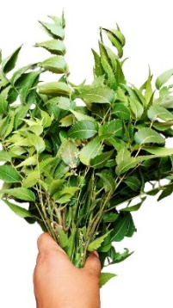
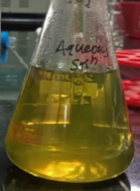
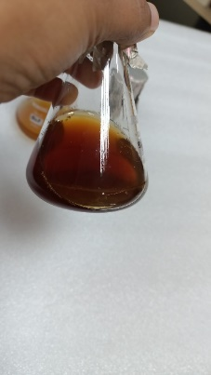
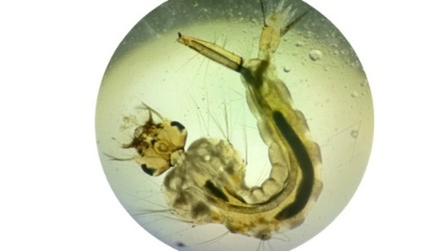
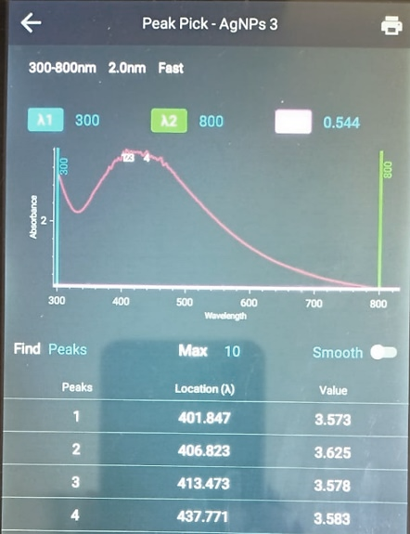
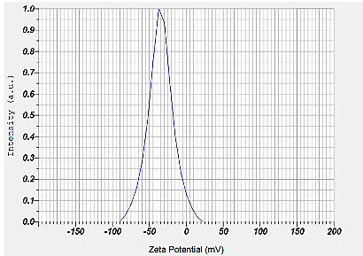
Graphical abstract

Synthesis of Silver Nanoparticle
FTIR spectrum
AgNO₃
(1mM)
Neem leaves
UV- Spectral detection
Zeta potential
TEM analysis
- aegypti larva
Extract +

Larvicidal activity of AgNPs against Aedes aegypti larvae
LC₅₀ of AgNPs for A. aegypti larvae

NPs Characterization

- INTRODUCTION
Arthropods, particularly mosquitoes from the Culicidae family, are recognized as the most dangerous vectors of pathogens, including viruses and parasites that pose a significant threat to the global population (Benelli et al. 2017). Mosquitoes, like Aedes aegypti (Linnaeus 1762), are primary carriers of several diseases including malaria, dengue, yellow fever, filariasis, Japanese encephalitis, and Zika virus (Saxena et al. 2016). Additionally, Culicidae are also known to transmit key parasites and pathogens that affect a broader range of animals like dogs, cats, and horses, making them vulnerable to diseases such as dog heartworm and Eastern equine encephalitis (Davila et al. 2022; WHO 2012). Thus, management and control are essential to minimize the spread of dreadful diseases vectored via mosquitos. Despite various control measures, including the use of synthetic pesticides, repellents, biological control agents, radiation-based sterile insect technique (SIT), symbiont-based methods, and transgenic mosquitoes (Chen et al. 2023; Griffin 2014), diseases like malaria communicated by mosquitoes persist, this shows how challenging is its management. Mosquitos, especially Aedes aegypti, which is widely distributed in tropical and subtropical regions, pose an increasing threat to human health. For, years, the control of A. aegypti has faced challenges due to the development of resistance against many pesticides, and chemical treatments have proven to be expensive and environmentally hazardous (Priyadarshini et al. 2013; WHO 2018; Yang et al. 2020). Therefore, there is a pressing need for a novel and eco-friendly approach to manage mosquitoes, and associated diseases.
Nanomedicines in the present era is a promising new field of study in human and veterinary medicine where many metallic nanoparticles have been widely studied for their potential pharmacological effects. Plant-based synthesis of nanoparticles offers advantages over chemical and physical methods, being economical, having a rapid synthesis process, scalability, no production of toxic byproducts and are environmentally benign (Benelli 2016; Saratale et al. 2018). Among the explored sources, the widespread use of plants is attributed to a variety of phytoconstituents, playing an important role during the synthesis process and providing different chemical functional groups for the stabilizing, oxidizing, capping and reducing metal oxide precursors (Wu et al. 2015; Zainurin and Zainol 2022; Hosseinzadeh et al. 2023). In, recent years, green synthesis using plant extracts has emerged as an efficient, rapid, and preferred method for biosynthesizing metal nanoparticles, particularly silver nanoparticle is reported to be highly effective against mosquitos at low doses (Awosolu et al. 2018; Kumar et al. 2016; Song and Kim 2009; Poopathi et al. 2015; Parthiban et al. 2019; Manimegalai et al. 2020). Among plants, Azadirachta indica, commonly called neem, is locally available and a treasurer of phytochemical compounds is reputed to have the highest activity against mosquito vectors and its most active ingredient is azadirachtin (Hamid et al. 2021; Macchioni et al. 2020; Ugwu and Oyeagu 2023). These phyto-compounds may act as reducing and capping agents thereby improving their functional efficiency for nanoparticle synthesis (Alharbi and Alsubhi 2022; Sinha et al. 2015). Various studies explored plants to synthesize silver nanoparticles that have promising larvicidal effects against mosquito larvae Aedes aegypti (Anburaj 2019; Awosolu et al. 2018; Parthiban et al. 2019). Exploring the neem, a treasure of bioactive compounds, was used to synthesize AgNPs and the larvicidal effects of neem leaf extract and AgNPs against Aedes aegypti mosquito larvae was assessed.
- MATERIALS AND METHODS
2.1 Collection and Preparation of aqueous leaf extract
Fresh leaves of Azadirachta indica (neem), was collected from the campus of College of Fisheries, Kishanganj, Bihar, India. Freshly collected leaves were washed with tap water to remove the dust particles and other contaminants with final washing in double-distilled water. Then, leaves were chopped coarsely and a total 100 g of leaves was boiled with 300 mL of double-distilled water in a 1000 mL of beaker for 20 min at 60 °C. The crude aqueous extract was filtrated through Whatman filter paper 1, and the filtrate was stored at 4 °C for further work following methods of (Manimegalai et al. 2020) with slight modification.
2.2 Phytochemical analysis
The plant extract was further subjected to qualitative phytochemical analysis to detect the presence of alkaloids, terpenoids, tannins, saponins, and flavonoids using the standard methods of (Shrestha et al. 2015; Khanal 2021).
2.3 Biosynthesis of silver nanoparticles
An aqueous leaf extract of A. indica of 25 mL, was added with 275 mL of 1 mM silver nitrate (AgNO3) solution and mixed the solution gently for even distribution & kept under dark condition at room temperature for about 30 minutes. Initially, the yellowish-green colour leaf extract was changed into dark brown which designated the primary formation of silver nanoparticles (AgNPs) since silver ions were reduced by the leaf extract, forming stable AgNPs in water. The synthesized nanoparticle solution along with the reactant (AgNO3) was centrifuged at 10, 000 rpm for 15 min; the pellet was collected and washed with distilled water thrice to obtain a clear pellet. The collected pellet was oven-dried at 60 °C overnight and dried powder of AgNPs was used for characterization. Further, for bioassay studies, colloidal AgNP solutions were used.
2.4 Characterization of silver nanoparticles
Preliminary characterisation of green synthesized AgNPs was conducted after 24 h of incubation at room temperature using UV-Vis spectrophotometer (Thermo Scientific Orion AquaMate, India) at college of Fisheries, Kishanganj. The surface plasmon resonances of AgNPs was measured by scanning absorbance spectra between 300-800 nm wavelengths. The particle diameter was determined by a dynamic light scattering (DLS) analyser (SZ-100, HORIBA Scientific), using dispersed biosynthesized NPs in distilled water. The zeta potential was also measured using the same equipment through electrophoretic mobility. The shape, size and crystalline nature of the nanoparticles were analysed using Scanning electron microscope (SEM) High Resolution- transmission electron microscope (TEM). FTIR spectroscopy of biosynthesized AgNPs was carried out using HYPERION 3000 Microscope with Vertex 80 FTIR System, Bruker, Germany, by ATR method in transmittance mode from 450-4000 cm-1 with spectral resolution at 0.2 cm-1 to determine the functional group of phytochemicals acting as capping agent. These studies were carried out at the Sophisticated Analytical Instrument Facility, IIT Bombay, India.
2.5 Collection of mosquito larvae
Mosquito larvae were collected from FRP tanks containing guppy fish (Poecilia reticulata) feeds on mosquito larvae, from the Wet Lab of COF, Kishanganj, Bihar, India. The hatched larvae were harvested using scoop net and the actively swimming larvae of about 3-5 mm size (see supplementary Fig. 1) were transferred to the experimental solutions of different concentrations.
2.6 The larvicidal activity of Azadirachta indica leaf extract and biosynthesized AgNPs against Aedes aegypti
The larvicidal efficacy of the aqueous neem leaf extract and silver nanoparticles was tested following the methods outlined by Mahyoub (2019). The experiment involved concentrations of 250 to 1000 ppm for neem leaf extracts and 5 to 25 ppm for silver nanoparticles, according to the World Health Organization (WHO) protocol from 2005, with slight modifications. Each Petri plate, containing a 50 ml volume of the gradient concentrations of neem leaf extracts and silver nanoparticles, each containing ten larvae. Observations for larval mortality were taken after 24, 48, 72, and 96 h, respectively. The experimental setup included control groups with silver nitrate (1mM concentration) and distilled water, each with three replicates for every concentration. A total of 280 larvae were used, and three replicates of analysis were conducted for each concentration. Larval mortality was recorded at 12-h intervals over 96 h following exposure. During experiment, feeding was not done to the larvae. Survival testing involved touching the larvae with a needle and disturbing the Petri plate. Larvae that did not move after disturbance and touching were considered dead.
2.7 Statistical analysis
The percentage mortality was estimated by following Abbott’s formula (Abbott, 1925). The Median lethal concentrations, LC₅₀, and their 95 % confidence limit of upper and lower confidence levels were calculated by probit analysis (SPSS, version 22).
- RESULTS
3.1 Phytochemical analysis
Phytochemical analysis of the hot aqueous leaf extract of Azadirachta indica revealed the presence of alkaloids, terpenoids, tannins, saponins, and flavonoids, represented in (Table 1).
3.2 Synthesis of silver nanoparticles
Silver nanoparticles were formed through the reduction of Ag+ with the extract of Azadirachta indica and the colour of the mixture (plant extract + AgNO3 solution) turned dark reddish-brown (Fig. 1) in 30 min under dark at room temperature incubation. The colour was stable for up to 12 h then it was centrifuged at 10,000 rpm for 15 min and repeated thrice and the collected pellet were oven dried at 60 °C for overnight. The dried silver nano powder was used for characterization purposes.
3.3 Characterization of silver nanoparticles
The synthesis of AgNPs was confirmed by UV–Visible absorption spectroscopy (Fig. 2) while scanning at 200–800 nm wavelengths. The localized surface plasmon resonance band showed absorption peaks maximum in the 400–450 nm range due to the surface-excitation plasmon vibrations having λmax at 420 nm and 389 nm for AgNPs and neem leaf extract respectively. However, no characteristics peaks were obtained for the AgNO3 (1mM) solution used as precursor for AgNPs synthesis. The average size of synthesized AgNPs was 140 ± 10 nm with polydispersity index (PDI) value of 0.3 shown in (Fig. 3) with Zeta potential measurement of -45.5 mV analysed using DLS (Fig. 4). Further, the FTIR spectra of aqueous AgNPs showed characteristic transmittance peaks (between 400 and 4000 cm^{–1}) of 3437.17, 1631.62, 1409.59, 1078.57, 1045.73, 778.09 and 621.29 respectively. The peak at 3437.17 cm^{–1} (O-H stretching) indicates alcoholic compounds, at 1631.62 (C=O stretching), indicating amide group, 1409.59 (C-H stretching) represents alkane group, 1078.57 cm^{–1} & 1045.73 cm^{–1} (C-O stretching) corresponds to alcohols & ether group, 708.97 cm^{–1} corresponds to (NH₂) amine group and 621.29 cm^{–1} indicates presence of (C-H) alkyne group respectively presented in (Fig.5). The TEM image indicated that most AgNPs synthesized using A. indica leaf extract were spherical and had a few triangular and cuboidal shaped with particle size distribution ranging between 5 to 50 nm (Fig. 6- a & b). Moreover, the SEM Micrographs showed the encapsulation of AgNPs in the extracted plant matrix further showing spherical and well-dispersed AgNPs at 1μm resolution presented in (Fig. 7).
3.4 Larvicidal Activity of neem leaf extract and silver nanoparticles
In this study, a significantly increased mortality percentage (p= 0.05) of larvae treated with aqueous neem leaf extract was observed in all treatment groups compared to the untreated control group. However, a significantly higher mortality percentage was recorded at a concentration of 1000 ppm after 96 h of exposure, with an estimated 96 h LC₅₀ of 381.94 ppm, as shown in (Fig. 8 & 9). Similarly, the treated groups of Aedes aegypti larvae with biosynthesized silver nanoparticles (AgNPs) showed almost cent percent mortality within 72 h at 25 ppm, where @15 and 5 ppm concentration reached 85% and 61% respectively, after 96 h of exposure. The estimated median lethal concentrations (LC₅₀) for green-synthesized AgNPs against A. aegypti were found to be 18.7, 9.90, and 3.22 ppm at 48, 72, and 96 hours, respectively (Fig. 10). The mortality rates of larvae treated with both neem leaf extract and AgNPs in the present study were found to be increased significantly with exposure time and concentration. However, AgNPs were potentially more effective as a larvicidal agent against A. aegypti at comparatively much lower concentrations than the aqueous neem leaf extract. Moreover, no mortality was recorded in the negative control groups (containing tap water). In contrast, the control group containing a silver nitrate solution of 1 ppm showed a 10% mortality of A. aegypti larvae after 96 h of exposure.
- DISCUSSION
The AgNPs were synthesized using an aqueous leaf extract of Azadirachta indica (neem) through the green approach in the present study. The appearance of a reddish-brown colour in 30 min of incubation validated the formation of nanoparticles is in concordance with the findings of other workers (Govindan et al. 2020; Kumari et al. 2024; Saravanan 2021). The change in colour of the solution may be attributed to the reduction of silver salt to silver ions due to the interaction with phytoconstituents and the formation of stabilized AgNPs (Saratale et al. 2018; Sinha et al. 2015). The result was confirmed by the qualitative phytochemical analysis of Azadirachta indica leaf extract which showed the presence of alkaloids, terpenoids, saponin, tannin and flavonoids (Kumari et al. 2019; Kumari et al. 2023) acting as reducing and capping agents as reported by earlier authors (Shankar et al. 2004; Alharbi and Alsubhi 2022). The UV–vis spectroscopy is an indirect method to examine the bio-reduction of AgNPs from an aqueous AgNO3 solution. The UV-absorption spectra of the biosynthesized AgNPs showed a maximum absorbance peak at 420 nm in the present study is consistent with other studies that showed peaks at 438 nm, (Poopathi et al. 2015), 430 nm (Song and Kim 2009), and in the range of 420 to 425 nm (Waris et al. 2020; Aremu et al. 2023). The FTIR analysis of green synthesized AgNPs showed various peaks corresponding to functional groups including alcoholic (O-H stretching) amide (C=O stretching), alkane (C-H stretching), alcohols & ether (C-O stretching) group, amine (NH₂) and alkyne (C-H) group respectively. Nearly similar results were suggested by (Asimuddin et al. 2020; Aremu et al. 2023). Hence, this indicates that the phytochemicals estimated in A. indica leaf could act as an excellent reducing and capping agent, as proposed by many workers (Chinnasamy et al. 2021; Zainurin and Zainol 2022). These biocomponents are crucial in promoting the reduction of Ag+ to AgNPs. Besides, these particles act as capping agent that function in preventing agglomeration.
Furthermore, the physicochemical characteristic like zeta potential indicates the net charge on the synthesized AgNPs was negative (-45.5 mV), following the findings of Alharbi and Alsubhi (2022). The negative value of zeta potential suggests that the colloidal AgNPs have a net positive charge and the surrounding stabilizing agent, the polyphenolic compounds of neem leaf extract, have a net negative charge (Roto et al. 2018; Suriyakalaa et al. 2013). Since Zeta potential or surface potential has a direct relation with the stability of nanoparticles, a higher zeta potential value, more will be the stability of a nanoparticle (Honary and Zahir 2013; Rather et al. 2013; Rather et al. 2017). The average size of AgNPs determined using DLS was 140 ± 10 nm. These results were in agreement with those reported by (Tripathy et al. 2010; Chinnasamy et al. 2021). Further, the TEM and SEM analysis showed the synthesized AgNPs were spherical in shape with an average particle size of 5 to 50 nm. The spherical nanoparticles in combined with smaller size exhibit better physical properties as antimicrobial. In contrast, comparatively smaller sizes (6-13 nm) of AgNPs synthesized using neem leaf by TEM analysis was reported (Khan and Javed 2021; Roy et al. 2017). This variation in size with the present study could be attributed to the differences in the method and condition of silver nanoparticles synthesis followed.
Our results showed that both the aqueous extract of Azadirachta indica leaf and biosynthesized AgNPs are toxic to the A. aegypti larvae. However, the toxicity of AgNPs is at least 40 times higher than that of the aqueous extract alone, as evidenced by the difference in LC₅₀ values. Several studies have reported the larvicidal activity of plants against mosquito larvae. Similarly, exposure to fresh aqueous neem leaf extract could bring 100 % mortality in 36 h of exposure, with 24h LC₅₀ of 57.32g/ml concentrations (Awosolu et al. 2018). Likewise in the present study, in case of aqueous extract of A. indica leaf, significant mortality was observed within 24 hrs after treatment with @500 ppm and @1000 ppm it showed 100% mortality within 96 h. In the other hand, only 5 ppm and 15 ppm of AgNPs started showing significant mortality within 72 hrs and 24 hrs respectively. Even only 25 ppm of AgNPs was sufficient to kill 99% of the A. aegypti larvae population within 72 h. Documentations are available that the 100% mortality of larval Anopheles was observed at 50, 100 and 200 mg/ml concentrations for ethanolic and aqueous extracts of A. indica in 24h and 48 h respectively (Wahedi et al. 2020). The study hence proves ethanolic extract to be more potent than aqueous extract (Wahedi et al. 2020). Similarly, an earlier study showed that acetonic extract of neem leaf treatment of Aedes Aegypti larvae could cause 100% mortality at a concentration of 1000 ppm in 24 h whereas, ethanol and chloroform extract of the leaf could achieve 100% mortality at 1000 ppm in 48 h of exposure (Nour et al. 2012). It is therefore suggested that the organic extractions produce solutions with a higher toxicity than aqueous extractions. That might be attributed to the chemical constitution of the plant extracted in different solvents. Several neem-based products are available exploring the potency of neem bioactive compounds against several insects including mosquito larvae (Chatterjee et al. 2023). Since, neem leaf based biopesticides contain various phytochemicals that are specific in killing mosquito larvae without any detrimental effect on other organisms and the environment. Furthermore, the aqueous solvent is feasible and safe to be used and could be recommended against A. aegypti larvae. Richest source of Azadirachtin is found in neem tree being the basis of many insecticides (Ferreira and Alves 2021).
Several plant-mediated AgNPs have been successfully applied in the effective treatment and control of mosquito larvae, highlighting their potential as sustainable alternatives to conventional chemical larvicides (Dass et al. 2024; Nawarathne and Dharmarathne, 2024; Raguvaran et al. 2025). The present study also revealed the potent larvicidal activity of biosynthesized AgNPs against A. aegypti larvae at very low concentrations with 96h LC₅₀ value of 3.22 ppm. That is nearly similar with the findings of Pilaquinga et al. (2019), where a higher level of toxicity against A. aegypti larvae of biosynthesized AgNPs than aqueous Solanum mammosum extract with LC₅₀ values of 0.06 and 1631.27 ppm, respectively. Further, the 24 h LC₅₀ of Datura metel extract and biosynthesized AgNP were 34.693 ppm and 2.969 ppm respectively against Anopheles stephensi larvae (Murugan et al. 2015). In another study, (Mahyoub 2019) the Dodonaea viscosa leaf extract synthesized AgNPs (154.77ppm) has more larvicidal effect against A. aegypti larvae than the extracts alone (214.328ppm).The other comparable study by Kumar et al. (2016) also noted, that the usage of green synthesized AgNPs from Excoecaria agallocha leaf extract tested against larvae of A. aegypti could result in highest mortality against 3rd instar larvae with LC₅₀ of 4.65 mg/L in 24 h of exposure. Likely, Manimegalai et al. (2020) reported the 96 h LC₅₀ values of 47.44 ppm for Leonotis nepetifolia synthesized AgNPs against A. aegypti. Further, Raguvaran et al. (2025) reported varying larvicidal efficacy of silver nanoparticles (AgNPs) synthesized using Aerva lanata flower extract, with LC₅₀ values of 6.501, 20.875, and 22.649 ppm against Culex quinquefasciatus, Anopheles stephensi, and Aedes aegypti, respectively.
The variation in LC₅₀ values observed in the present study may be attributed to differences in mosquito species, the plant species and their phytoconstituent composition, extraction methods, and the physicochemical characteristics of the AgNPs, all of which can influence larvicidal activity (Nawarathne and Dharmarathne, 2024; Dass et al., 2025). The high toxicity of plant-synthesized AgNPs could be due to their ability to permeate through the chitinous exoskeleton and penetrate the cells, where they bind macromolecules such as proteins and DNA, physiological change, altering their structure, and therefore their functionality (Beneli 2016). Ultimately, the present study showed, potent larvicidal activity at minimal concentration of AgNPs on mosquito larvae and it could be due to the small size of particles that might facilitate the penetration through the larval cellular membrane or otherwise binding to S-containing proteins that eventually leading to destruction of cellular functions, mitochondrial dysfunction, DNA and protein damage, inhibition of cell proliferation, apoptosis and finally cell death (Chimkhan et al. 2022; Parthiban et al. 2019; Sareen et al. 2012). Remarkably, it has also been reported that doses of plant-synthesized AgNPs which result in lethal to several species of mosquito larvae, can have little or no effect on other non-target species like fish (Govindarajan et al. 2016) and on Artemia salina reported by (Raguvaran et al. 2025). The increasing production and environmental release of metal nanoparticles (MNPs) have raised significant concerns regarding their ecological impacts. Numerous studies have investigated the toxicity of nanoparticles in fish and other aquatic organisms, indicating that their effects are influenced by factors such as exposure duration, concentration, particle size and shape, as well as surface coatings, with toxicity responses often varying among species (Akter et al. 2018). Nevertheless, careful application of optimized concentrations and controlled exposure durations within established regulatory guidelines can substantially mitigate these toxic effects, allowing the remarkable potential of silver nanoparticles (AgNPs) to be safely harnessed (Rather et al. 2017; Nawarathne and Dharmarathne, 2024; Raguvaran et al. 2025). The present study result showed a strong and time-dependent correlation between the treatment concentrations and the mortality rate of the A. aegypti larvae. This was evident in the trend of mortality recorded, where, the longer the time of exposure to treatments, the more mortality was recorded in the larval population at the same concentration for both the extracts and the AgNPs. Thus, the present study strongly suggested that Azadirachta indica leaf synthesized AgNPs is an eco-friendly and potent bio-medical agent in controlling of A. aegytpti larvae as an alternative to chemotherapeutics.
Conclusions
Our findings suggest that the green synthesized AgNPs is more potent larvicide against A. aegypti than the aqueous extract of fresh Azadirachta indica (neem) leaf. Furthermore, our data indicates that the bioactive compounds present in the leaf extract can serve as both reducing and capping agents for the synthesis of silver nanoparticles. These nanoparticles exhibit the ability to eliminate A. aegypti larvae at significantly lower concentrations than the plant's aqueous extract alone. Based on these results, we propose that green synthesized AgNPs has the potential to be a novel larvicidal agent against mosquito larvae. However, further research is warranted to elucidate the mechanistic insights of neem extracts and green-synthesized AgNPs regarding their larvicidal activity, the exact biological mechanisms responsible for the lethal effects, their impact on the environment, and their effects on non-targeted organisms need to be studied.
Ethical approval: NA
Disclaimer (Artificial intelligence)
Option 1:
Author(s) hereby declare that NO generative AI technologies such as Large Language Models (ChatGPT, manuscript.
Option 2:
Author(s) hereby declare that generative AI technologies such as Large Language Models, etc. have been used during the writing or editing of manuscripts. This explanation will include the name, version, model, and source of the generative AI technology and as well as all input prompts provided to the generative AI technology
Details of the AI usage are given below:
1.
2.
3.

References:
Abbott WS (1925) A method of computing the effectiveness of an insecticide. J Economic Entomol 18: 265-267.
Alharbi NS, Alsubhi NS (2022) Green synthesis and anticancer activity of silver nanoparticles prepared using fruit extract of Azadirachta indica. J Radiat. Res Appl Sci 15(3): 335-345.
Anburaj R (2019). Role of Plant Mediated Silver Nanoparticles and Their Efficacy in Control Against Aedes aegypti Vector. Int J Pharm Biol Sci 9 (3): 648-658.
Anil Kumar V, Ammani K, Jobina R, Parasuraman P, Siddhardha B (2016) Larvicidal activity of green synthesized silver nanoparticles using Excoecaria agallocha L. (Euphorbiaceae) leaf extract against Aedes aegypti. IET Nanobiotechnol 10(6): 382-388.
Aremu HK, Azeez LA, Adekale IA, Busari HK, Adebayo ZA, Disu A, Usman HN, Adeyemo OM, Oyewole OI (2023). Biotoxicity of Azadirachta indica-synthesized silver nanoparticles against larvae of Culex quinquefasciatus. S Afr J Bot 153: 308-314.
Asimuddin M, Shaik MR, Adil SF, Siddiqui MRH, Alwarthan A, Jamil K, Khan M (2020). Azadirachta indica based biosynthesis of silver nanoparticles and evaluation of their antibacterial and cytotoxic effects. J King Saud Univ Sci 32(1): 648-656.
Awosolu O, Adesina F, Iweagu M (2018). Larvicidal effects of croton (Codiaeum variegatum) and Neem (Azadirachta indica) aqueous extract against Culex mosquito. Int J Mosq Res 5(2): 15-18.
Benelli G, Mehlhorn H (2016) Declining malaria, rising of dengue and Zika virus: insights for mosquito vector control. Parasitol Res 115: 1747-1754.
Benelli G, Caselli A, Canale A (2017) Nanoparticles for mosquito control: Challenges and constraints. J King Saud Univ Sci 29(4): 424-435.
Chatterjee S, Bag S, Biswal D, Paria DS, Bandyopadhyay R, Sarkar B, Mandal A, Dangar TK (2023) Neem-based products as potential eco-friendly mosquito control agents over conventional eco-toxic chemical pesticides-A review. Acta Tropica 106858.
Chen C, Aldridge RL, Gibson S, Kline J, Aryaprema V, Qualls W, Xue RD, Boardman L, Linthicum KJ, Hahn DA (2023) Developing the radiation‐based sterile insect technique (SIT) for controlling Aedes aegypti: identification of a sterilizing dose. Pest Manag Sci 79(3): 1175-1183.
Chimkhan N, Thammasittirong SNR, Roytrakul S, Krobthong S, Thammasittirong A (2022) Proteomic response of Aedes aegypti larvae to silver/silver chloride nanoparticles synthesized using Bacillus thuringiensis subsp. Israelensis metabolites. Insects 13(7): 641.
Chinnasamy G, Chandrasekharan S, Koh TW, Bhatnagar S (2021) Synthesis, characterization, antibacterial and wound healing efficacy of silver nanoparticles from Azadirachta indica. Front Microbiol 12: 611560.
Dass K, Mariappan P, Ramya P, Prakash N (2024) Green synthesis of silver nanoparticles for mosquito control: A review of larvicidal activity from plant extracts. Uttar Pradesh J Zool 45(22): 242-266.
Dass K, Prakash N, Mariappan P (2025) Larvicidal efficacy of green synthesized silver nanoparticles using Coleus aromaticus and Wrightia tinctoria against Aedes aegypti. Next Mater 8:100651.
Davila E, Fernandez-Santos NA, Estrada-Franco JG, Wei L, Aguilar-Duran JA, Lopez-Lopez MDJ, Solis-Hernandez R, Garcia-Miranda R, Velazquez-Ramirez DD, Torres-Romero J, Chavez SA (2022) Domestic dogs as sentinels for West Nile virus but not Aedes-borne flaviviruses, Mexico. Emerging Infect Dis 28(5): 1071.
Ferreira LS, Alves SN (2021) Neem (Azadirachta indica): larvicidal properties-a review. RevistaConexãoCiência 16(1): 49-63.
Govindan L, Anbazhagan S, Altemimi AB, Lakshminarayanan K, Kuppan S, Pratap-Singh A, Kandasamy M (2020) Efficacy of antimicrobial and larvicidal activities of green synthesized silver nanoparticles using leaf extract of Plumbago auriculata lam. Plants 9(11): 1577.
Govindarajan M, Khater HF, Panneerselvam C, Benelli G (2016) One-pot fabrication of silver nanocrystals using Nicandra physalodes: A novel route for mosquito vector control with moderate toxicity on non-target water bugs. Res Vet Sci 107: 95-101.
Griffin L (2014) Laboratory evaluation of predation on mosquito larvae by Australian mangrove fish. J Vector Ecol 39(1): 197-203.
Hamid NS, Kehail MA, Ibrahim NA, Abdel-Rahman EH (2021) Larvicidal activity of ethanol extracts of Azadirachta indica (neem) against Anopheles Arabiensis and Culex Quinquefasciatus larvae, Gezira state, Sudan. Int J Entomol Res 6(1): 138-41.
Honary S, Zahir F (2013) Effect of zeta potential on the properties of nano-drug delivery systems-a review (Part 2). Trop J Pharm Res 12(2): 265-273.
Hosseinzadeh E, Foroumadi A, Firoozpour L (2023) What is the role of phytochemical compounds as capping agents for the inhibition of aggregation in the green synthesis of metal oxide nanoparticles? A DFT molecular level response. Inorg Chem Commun 147: 110243.
Khan K, Javed S (2021) Silver nanoparticles synthesized using leaf extract of Azadirachta indica exhibit enhanced antimicrobial efficacy than the chemically synthesized nanoparticles: A comparative study. Sci Prog 104(2): 00368504211012159.
Khanal S (2021) Qualitative and Quantitative Phytochemical Screening of Azadirachta indica Juss. Plant Parts. Int J Appl Sci Biotechnol 9(2):122-127.
Kumari P, Kumar S, Rajendran KV, Brahmchari RK, Raman RP (2023) Effects of extraction temperature on phytoconstituents of leaf extracts of Azadirachta indica and its antiparasitic efficacy against Argulus sp. J Environ Biol 44(5): 699-705.
Kumari P, Kumar S, Ramesh M, Shameena S, Deo AD, Rajendran KV, Raman RP (2019) Antiparasitic effect of aqueous and organic solvent extracts of Azadirachta indica leaf against Argulus japonicus in Carassius auratus. Aquacult 511: 634175.
Macchioni F, Sfingi M, Chiavacci D, Cecchi F (2020) Larvicidal and pupicidal activity of neem oil (Azadirachta indica) formulation against mosquitoes Aedes albopictus (Skuse, 1894) (Diptera: Culicidae). Acta Zool Bulg 72(3): 479-485.
Mahyoub JA (2019) Biological effects of synthesized silver nanoparticles using Dodonaea viscosa leaf extract against Aedes aegypti (Diptera: Culicidae). J Entomol Zool Stud 7: 827-832.
Manimegalai T, Raguvaran K, Kalpana M, Maheswaran R (2020) Green synthesis of silver nanoparticle using Leonotisnepetifolia and their toxicity against vector mosquitoes of Aedes aegypti and Culex quinquefasciatus and agricultural pests of Spodoptera litura and Helicoverpaarmigera. Environ Sci Pollut Res 27: 43103-43116.
Murugan K, Dinesh D, Kumar PJ, Panneerselvam C, Subramaniam J, Madhiyazhagan P, Suresh U, Nicoletti M, Alarfaj AA, Munusamy MA, Higuchi A (2015) Datura metel-synthesized silver nanoparticles magnify predation of dragonfly nymphs against the malaria vector Anopheles stephensi. Parasitol Res 114: 4645-4654.
Nawarathne MP, Dharmarathne C (2024) Control of dengue larvae of Aedes aegypti and Aedes albopictus using the larvicidal bioactive compounds in different plant extracts and plant extract-mediated nanoparticles. Trop. Med. Health 52(1): p.95.
Nour AH, Sandanasamy JD, Nour AH (2012) Larvicidal activity of extracts from different parts of Neem (Azadirachta indica) against Aedes aegypti mosquitoes’ larvae. Sci Res Essays 7(31): 2810-2815.
Parthiban E, Manivannan N, Ramanibai R, Mathivanan N (2019) Green synthesis of silver-nanoparticles from Annona reticulata leaves aqueous extract and its mosquito larvicidal and anti-microbial activity on human pathogens. Biotechnol Rep 21: 00297.
Pilaquinga F, Morejón B, Ganchala D, Morey J, Piña N, Debut A, Neira M (2019) Green synthesis of silver nanoparticles using Solanum mammosum L. (Solanaceae) fruit extract and their larvicidal activity against Aedes aegypti L. (Diptera: Culicidae). PLoS One 14(10): 0224109.
Poopathi S, De Britto LJ, Praba VL, Mani C, Praveen M (2015) Synthesis of silver nanoparticles from Azadirachta indica—a most effective method for mosquito control. Environ Sci Pollut Res 22: 2956-2963.
Priyadarshini S, Gopinath V, Priyadharsshini NM, Mubarak AD, Velusamy P (2013) Synthesis of anisotropic silver nanoparticles using novel strain, Bacillus flexus and its biomedical application. Colloids Surf. B 102: 232–237
Raguvaran K, Kalpana M, Devapriya P, Kalaivani S, Angelina M, Krismastuti FSH, Rasool A, Maheswaran R (2025) Eco‐Friendly Synthesis of Silver Nanoparticles and Its Larvicidal Property Against Malaria, Filariasis, and Dengue Vectors. Luminescence 40(7): e70266.
Rather MA, Bhat IA, Sharma N, Gora A, Ganie PA, Sharma R (2017) Synthesis and characterization of Azadirachta indica constructed silver nanoparticles and their immunomodulatory activity in fish. Aquac Res 48(7): 3742-3754.
Rather MA, Sharma R, Gupta S, Ferosekhan S, Ramya VL, Jadhao SB (2013) Chitosan-nanoconjugated hormone nanoparticles for sustained surge of gonadotropins and enhanced reproductive output in female fish. PloS one 8(2): 57094.
Roto R, Rasydta HP, Suratman A, Aprilita NH (2018) Effect of reducing agents on physical and chemical properties of silver nanoparticles. Indones J Chem 18(4): 614-620.
Roy P, Das B, Mohanty A, Mohapatra S (2017) Green synthesis of silver nanoparticles using Azadirachta indica leaf extract and its antimicrobial study. Appl Nanosci 7(8): 843-850.
Saratale RG, Saratale GD, Shin HS, Jacob JM, Pugazhendhi A, Bhaisare M, Kumar G (2018) New insights on the green synthesis of metallic nanoparticles using plant and waste biomaterials: current knowledge, their agricultural and environmental applications. Environ Sci Pollut Res 25: 10164-10183.
Saravanan S (2021) Functional, structural and morphological property of green synthesized silver nanoparticles using Azadirachta indica leaf extract. Materials Today: Proceed 47: 1815-1818.
Sareen SJ, Pillai RK, Chandramohanakumar N, Balagopalan M (2012) Larvicidal potential of biologically synthesised silver nanoparticles against Aedes Albopictus. Res J Recent Sci 1: 52-56.
Saxena SK, Elahi A, Gadugu S, Prasad AK (2016) Zika virus outbreak: an overview of the experimental therapeutics and treatment. Virus Dis 27:111-115.
Shankar SS, Rai A, Ahmad A, Sastry M (2004) Rapid synthesis of Au, Ag, and bimetallic Au core–Ag shell nanoparticles using Neem (Azadirachta indica) leaf broth. J Colloid Interface Sci 275(2): 496-502.
Shrestha P, Adhikari S, Lamichhane B, Shrestha BG (2015) Phytochemical screening of the medicinal plants of Nepal. J Environ Sci Toxicol Food Technol 1(6):11-17.
Sinha SN, Paul D, Halder N, Sengupta D, Patra SK (2015) Green synthesis of silver nanoparticles using fresh water green alga Pithophoraoedogonia (Mont.) Wittrock and evaluation of their antibacterial activity. Appl Nanosci 5: 703-709.
Song JY, Kim BS (2009) Rapid biological synthesis of silver nanoparticles using plant leaf extracts. Bioprocess Biosyst Eng 32:79-84.
Suriyakalaa U, Antony JJ, Suganya S, Siva D, Sukirtha R, Kamalakkannan S, Pichiah PBT, Achiraman, S (2013) Hepatocurative activity of biosynthesized silver nanoparticles fabricated using Andrographis paniculata. Colloids Surf. B: Biointerfaces 102: 189–194.
Tripathy A, Raichur AM, Chandrasekaran N (2010) Process variables in biomimetic synthesis of silver nanoparticles by aqueous extract of Azadirachta indica (Neem) leaves. J Nanopart Res 12: 237–246.
Ugwu FSO, Oyeagu U (2023) Mediators of arrested development as attractive malaria vector control tools: The Azadirachta indica and azadirachtin routes. Bio-Res 21(1): 1805-1817.
Wahedi JA, Pukuma SM, Gambu JW, Elkanah OS, Japhet P, Ande AT (2020) Evaluation of lavicidal efficacy of seed extract of Azadirachta indica in laboratory bioassay on Anopheles mosquitoes. Int J Mosq Res 7(4): 26-30.
Waris M, Nasir S, Abbas S, Azeem M, Ahmad B, Khan NA, Hussain B, Al-Ghanim KA, Al-Misned F, Mulahim N, Mahboob S (2020) Evaluation of larvicidal efficacy of Ricinus communis (Castor) and synthesized green silver nanoparticles against Aedes aegypti L. Saud J Biol Sci 27(9): 2403-2409.
Who (2018) Global report on insecticide resistance in malaria vectors: 2010–2016. World Health Organization.
World Health Organization. 2005. Guidelines for laboratory and field testing of mosquito larvicides. WHO/CDS/WHOPES/GCDPP/13
World Health Organization. 2012. Handbook for integrated vector management.
Wu W, Wu Z, Yu T, Jiang C, Kim WS (2015) Recent progress on magnetic iron oxide nanoparticles: synthesis, surface functional strategies and biomedical applications. Sci Technol Adv Mater 16(2): 023501.
Yang L, Norris EJ, Jiang S, Bernier UR, Linthicum KJ, Bloomquist JR (2020) Reduced effectiveness of repellents in a pyrethroid‐resistant strain of Aedes aegypti (Diptera: culicidae) and its correlation with olfactory sensitivity. Pest Manag Sci 76(1): 118-124.
Zainurin MAN, Zainol I (2022) Biogenic Synthesis of Silver Nanoparticles Using Neem leaf extract as reducing agent and hydrolyzed collagen as stabilizing agent. Malays J Microsc 18(1): 215-225.

Table 1. Phytochemical analysis of hot aqueous fresh leaf extract of Azadirachta indica
Plant extract | Phytochemical tests
Plant extract | Alkaloids | Terpenoids | Flavonoids | Tannins | Saponin
Azadirachta indica leaf extract | +++ | ++ | +++ | + | ++

Here, (+++) indicates presence of high content of phytochemical compound; (++) indicate mild content of phytochemical compound; (+) shows very low content of phytochemical compound

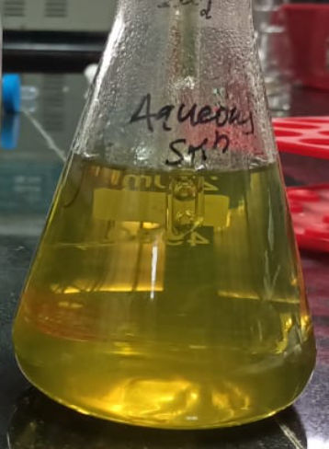
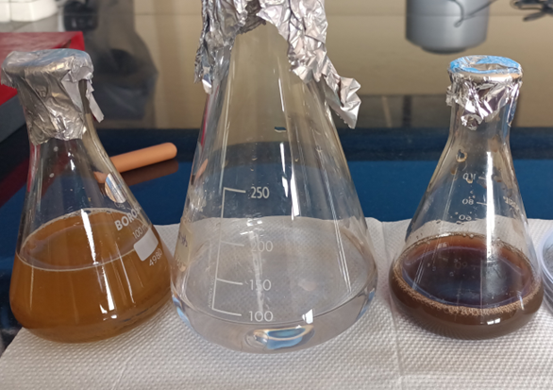
Figures:
a.
b.

Fig. 1 Green synthesized silver nanoparticles (AgNPs) using A. indica (neem) leaf extract-
(a). NLE and (b). AgNPs solution

Fig. 2 UV–Visible spectrum of the biosynthesized silver nanoparticles using neem leaf extract.

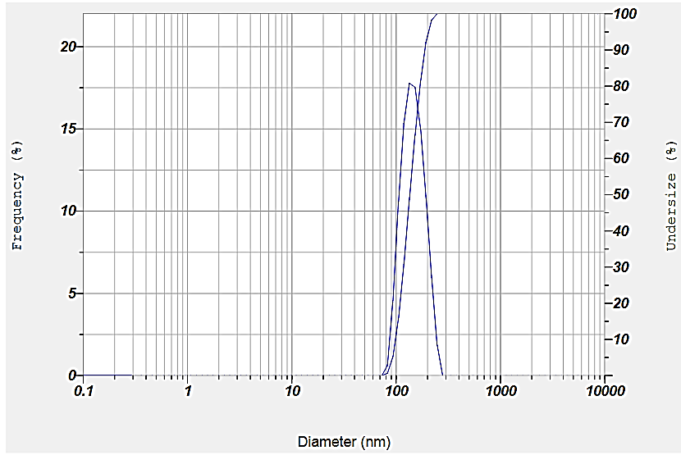

Fig. 3 Particle size distribution of biosynthesized AgNPs using DLS analyser.

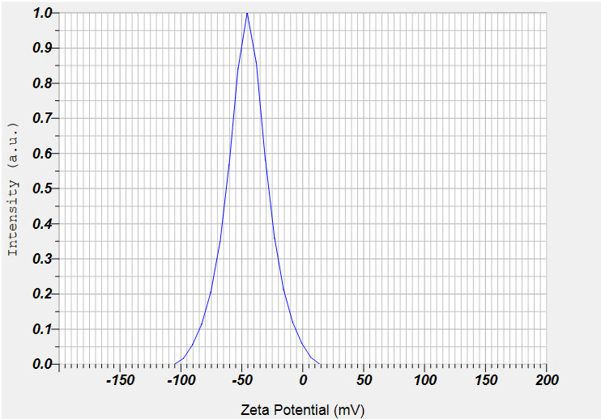

Fig. 4 Zeta potential analysis of biosynthesized AgNPs using DLS analyser.

Fig. 5 FT-IR analysis of silver nanoparticles synthesized by Azadirachta indica leaf extract.

a.
b.

Fig. 6 (a) HR-TEM micrograph, (b) Selective area electron diffraction (SAED) images of
Green synthesized AgNPs

Fig. 7 SEM micrograph of Green synthesized AgNPs

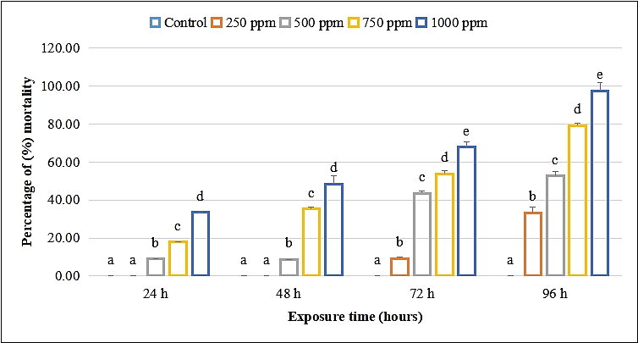

Fig. 8 Mortality percentage (%) of Aedes aegypti larvae treated with different concentration (ppm) of aqueous neem leaf Azadirachta indica extract at different exposure time (hours). Values are expressed as mean ± SD. Bars with different alphabets (a-e) within the particular exposure time, differed significantly (P=0.05).
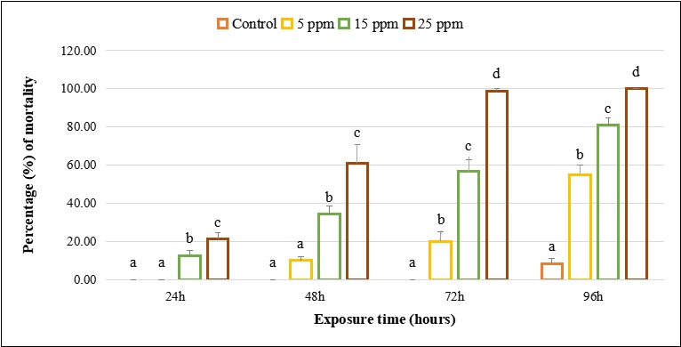

Fig. 9 Mortality percentage (%) of Aedes aegypti larvae treated with different concentration (ppm) of AgNPs extracted from neem leaf Azadirachta indica at different exposure time (hours). Values are expressed as mean ± SD. Bars with different alphabets (a-d) within the particular exposure time, differed significantly (P=0.05).

Fig. 10 Median lethal concentration (LC₅₀) of biosynthesized AgNPs against Aedes aegypti at different conc. & time intervals.

