Genomic Insights into Guava: De novo Transcriptome assembly using Illumina Sequencing data and SSR Markers Exploration and Discovery

ABSTRACT

Guava (Psidium guajava L.) is one of the nutritionally and commercially important fruit crops which belongs to family Myrtaceae, and the genus Psidium having diploid chromosome number of 2n = 22. Despite its economic importance genomic resources in guava are scarce and genetics of useful horticultural traits are poorly understood. In the present study, we performed de novo transcriptomic analysis of guava through Illumina technology. We obtained 211432 transcripts as well as 76764 unigenes, with an average length of 1087 bp, minimum length of 499 bp, maximum length of 23,043, N50 value of 1204 bp and average GC content of 44.40 percent. Total of 41,254 unigenes (53.74% of all unigenes) were annotated with UniPort, and 33,005 sequences annotated with Gene Ontology terms (about 42.99%), and 17,270 sequences annotated with enzyme codes (22.49%) respectively. Regarding the KEGG database, 9,885 sequences were linked to 441 identified Furthermore, 29,360 simple sequence repeats (SSRs) were identified and 30 pairs of primers were selected to evaluate the validity and universality in four genotypes of guava, and 27 pairs generated clear and abundant bands and were found to be polymorphic in nature. These data could be used as an important resource for studying the genetics and molecular biology for guava in future work.
Keywords: De novo, transcriptome, unigenes, SSR, amplification, polymorphism

1. INTRODUCTION

Guava (Psidium guajava L.) is native to the tropical regions of America, but it has been introduced in different countries of the world where is nowadays naturalized. Its popularity is rising in growers as a highly economical fruit crop due to its early and regular bearing nature, extended harvesting span and possibility of meadow orcharding. It is quite possibly of the most significant tropical and subtropical fruit tree, since its rich in essential vitamins and mineral salts. Guava is popularly known as the “Apple of the Tropics” and sometimes referred to as a super fruit due to its high nutritive value and antioxidant properties. Owing to its high nutraceutical and medicinal values guava production can play an important role in nutritional security for the people of developing countries like India. This plant has applications in the treatment of pain and the enhancement of locomotor coordination. The leaf extract is employed for treating oral ulcers, cough, diarrhoea and some wounds with swollen gums. It has a high concentration of both organic and inorganic substances, secondary metabolites such as polyphenols, antioxidants, antiviral and anti-inflammatory chemicals (Garcia, 2002., Chen et al., 2020.)
The guava (Psidium guajava L.) genome is approximately 443.8 Mb in size, with a chromosome number of 2n=22. It has been sequenced and assembled at a chromosome level.The varietal development in the guava through the traditional breeding is very tedious and time consuming due to its long juvenile phase and high heterozygous nature, thus yielding meagre success. Under such situations, biotechnological tools particularly genomics could apply novel techniques and strategies to solve out the existing breeding barriers in woody perennial fruit crops like guava. Recent breakthroughs in DNA sequencing technology are fundamentally altering biological and biomedical research and will have a significant influence on crop development. This unprecedented amount of information, along with better genotyping methods, allows for the application of precise genome wide association analyses to establish a link between genetic variation and agronomic variables, opening up new avenues for crop improvement. Identification of the genes and genetic markers underlying these agronomic features will hasten the breeding process and result in superior varieties with increased yield and quality, tolerance to unfavourable environmental conditions and disease resistance (Edwards and Batley, 2010). The development of next-generation sequencing has made it more feasible to utilise natural variation in crop design and genome-wide selection (Huang and Han, 2014). NGS technologies have made it possible to evaluate the transcript profiling of complicated candidate gene network systems, which could speed up genomics-aided breeding (Varshney et al., 2009., Feng et al, 2021). The genome and transcriptome sequences can be accessed and processed using an array of bioinformatics tools (Cerveau and Jackson, 2016). De novo assembly of transcriptomics data may be able to find novel transcripts that reference assembly has missed and that can yield unigenes and contigs that can provide profound insights into biological data (Ashrafi et al., 2012). The bioinformatics platform makes it simple to investigate and specify the genes responsible for the functional diversity and crop specialisation. In guava, efforts are being made to speed up breeding and conservation by molecular breeding and molecular genetic analysis. The molecular markers can be used at every stage of varietal development programmes and are a crucial genetic tool for any genetic investigations among crop species. The main aim of the present study is to prospect the genomic resources for SSR markers and their validation in guava.

2. material and methods

2.1 Plant samples and genomic DNA isolation
This experiment was conducted at Department of Biotechnology and Crop Improvement, College of Horticulture, Bengaluru during the year 2022-2023. Young leaf samples of 4 different guava genotypes Allahabad Safeda, Arka Kiran, Arka Mridula and L-49 were collected from the individual plants and DNA was extracted using standard modified CTAB extraction protocol (Doyle and Doyle, 1990). The amount of DNA following extraction was quantified and purification and quality was checked by using Nanodrop Spectrophotometer (NanoDrop Technologies, Thermoscientific) and also by gel electrophoresis (2.5% agarose gel used to check the quality of DNA).

2.2 Downloading and Assembling Guava EST and SRA from the public database
Sequence repeat archives (SRAs) were downloaded from freely accessible databases such the DDBJ (DNA data bank of Japan), EBI (European Bioinformatics Institute), and NCBI (National Centre for Biotechnology Information). SRA files were downloaded from https://www.ncbi.nlm.nih.gov, and a few data were retrieved directly from the CLC genomics workbench. Seven out of the 22 bioprojects which are publicly available at NCBI that are related to RNA sequencing in guava. The details of bioprojects are listed in table 1. A total of 41 SRA were downloaded. For further investigation, all of these EST and SRA were downloaded and placed into the CLC genomics workbench software.
Table 1: The details of Bioprojects of NCBI database selected for de novo assembly.
Bioprojects | Content | Centre | Instrument | Library  layout | Library  selection | Cultivar
PRJNA20889 | Transcriptome data of 4 guava cultivars with different pulp colours | Chinese Academy of Tropical Agricultural Sciences | Illumina NovaSeq 6000 | Paired | OLIGO-DT | Yesheng No. 1  Sanhong  Meiyin No.1  Zhenzhu
PRJNA564902 | Transcriptome data of L-49/Sardar guava used as rootstock for grafting scion of various cultivars prevalent in India | Punjab Agricultural University | Illumina HiSeq 2500 | Paired | Random | L-49/ Sardar Guava
PRJNA561485 | Independent RNA Seq libraries of 7 purple local tissue types viz.. leaf and shoot tip, mixed flower bud, mixed fruits, immature fruits, 3 days ripe fruit, 7 days ripe fruits, 7 days ripe fruits sequences in 2016 for transcriptome study to mine genetic difference for EST/SSR | Punjab Agricultural University, Ludhiana, India | Illumina HiSeq 2500 | Paired | cDNA | Malaysian Guava / Purple Local
PRJNA479714 | RNA Seq of green fruit peel from 4 years old CISH-G5 apple colour guava trees at full bearing capacity, pooled from 5 independent fruits picked from 5 individuals trees | Punjab Agricultural University | Illumina HiSeq 2500 | Paired | cDNA | CISH-G5, Apple color
PRJNA479710 | RNA Seq of immature fruit from 4 years old Punjab pink guava tree at full bearing capacity pooled from 5 independent fruits picked from 5 individual’s trees | Punjab Agricultural University | Illumina HiSeq 2500 | Paired | cDNA | Punjab Pink
PRJNA472130 | Whole transcriptome data from guava (AS) independent sample from leaf shoot tip, flower bud stages and fruit stages with and without seeds from winter crop of Punjab | Punjab Agricultural University | Illumina HiSeq 2500 | Paired | cDNA | Allahabad Safeda
PRJNA356080 | De novo transcriptome analysis of Psidium guajava. Identify candidate genes in Psidium guajava involved in biosynthesis of secondary metabolites | Guangdong Pharmaceutical University | Illumina HiSeq 4000 | Paired | Random | Psidium guajava

2.3 Data processing and de novo assembly
The GALAXY software (https://galaxyproject.org) was used for raw data quality control analysis and QIAGEN CLC genomics workbench software (https://digitalinsights.qiagen.com/products/clc-genomics-workbench-direct-download/) was used transcriptome de novo assembly respectively. The raw readings obtained were trimmed to eliminate adapters, primers, and ambiguous N bases. The limit for trimming both the 5' and 3' ends was set at 0.02 to produce the highest quality score reads with the fixed parameters like sliding window with average quality upto 20 along with minlen -50, leading -3 and trailing -3. CLC genomics workbench software had a default parameters setting (Insertion/ deletion cost = 3, mismatch cost = 2, similarity fraction = 0.7, word size = 64, bubble size = 50) was used in order to assemble the guava sequences. The average read length was normalized to account for large reads (>200). De novo assembled contigs from quality-filtered NGS readings were assembled into a separate assembly. Mega contigs of Guava were developed by further assembling concatenated contig sets using the CLC Genomics Workbench de novo assembly programme. De novo transcriptome assembly statistics including read count, total read count, mean read length, contig count, average GC percent, total base of assembled contigs, shortest contig length, and average contigs length N50 were documented.
2.4 SSR identification from unigenes
Krait software (http://krait.biosv.com) was used to mine the mega contigs for simple sequence repeats (SSRs). The composition, frequency, relative abundance, relative density, and distribution of SSRs were determined. Mononucleotide sequences with at least 12 repetitions, dinucleotide sequences with 7 repetitions, trinucleotide sequences with 5 repetitions, and hexa, tetra, and penta nucleotide sequences with 4 repetitions were detected. Primer 3, a inbuilt tool of Krait, was used to create SSR flanking primer.
2.5 Functional annotation of SSR containing unigenes
The SSR containing unigenes produced after assembly was annotated using BLAST2GO software (Conesa et.al., 2005) to execute a homology search of the SSR containing unigenes file as a query against the UNIPORT database. Mapping was performed to get curated GO terms using the default latest database version and functional annotation. The following functional annotation score parameters were used: Annotation Cut-Off (default =55), GO-WEIGHT (default =5), and Hsp-Hit Coverage Cut Off
(default =0). E-Value Hit Filter and GO-WEIGHT were both set to the default value of 5. The software was used to record the BLAST species distribution, top hit species distribution, E value distribution, and Gene Ontology level distribution.
2.6 PCR amplification using SSR primers and Gel electrophoresis
Gradient PCR was set for each primer with selected samples to standardize the temperature of amplification. Genomic DNA was diluted to prepare working stocks of 100 ng/ µl. PCR reaction was set in a total volume of 10 µl containing 1 µl genomic DNA (100ng/ µl), 3 µl of 10X buffer, 0.8 µl of 25 mM MgCl2, 0.4 µl of 10Mm dNTPs, 0.5 µl of each primer (10 nmol), IU of Taq DNA polymerase (Fermentas, Life Science, USA) and 5 µl distilled water. Amplification was performed in a thermocycler using following programme. Initial denaturation at 94°C for 5 min, followed by 35 cycles of denaturation at 94°C for 30s, annealing at annealing temperature T_{a}°C min and extension at 72°C for 1 min with a final extension at 72°C for 10 min. The T_{a} was kept 2°C above and below T_{m} of that particular primer sequence. The amplified products were analyzed on 2.5% metaphor agarose gel containing ethidium bromide (10 mg/ml) at a constant voltage of 80V for 2 hours using a horizontal gel electrophoresis system (Biorad, USA). Gel pictures were recorded under UV light gel documentation System (Alpha Imager®, USA).

3. results and discussion

Recent decades have witnessed limited success for conventional breeding programmes when attempting to cope with complicated quality features where a cascade of regulatory gene networks govern the quality attributes. The development of the omics field with the aid of in silico methods could potentially made it possible to decode the underlying genetic basis of complex phenotypes (Gascuel et al., 2017). We used publicly available guava transcriptome data to design the global wide used primers.
Quality trimming of reads is crucial in transcriptome assembly, as demonstrated by several studies. Table 1 summarizes that 90 to 97 % of reads were retained after quality trimming, ensuring optimal average read length (Milano et al., 2011). Similarly, in diverse systems, processed RNA-seq datasets yielded high-quality reads, with 83-100% passing quality filters and read counts ranging from 45,481,756 to 228,146,775 (Cerveau and Jackson, 2016). Additionally, a comprehensive analysis of publicly available RNA-seq datasets emphasized the significance of quality trimming. Reads, varying in length from 66 to 9,60,93116 bp and with GC content between 38% to 50%, were processed to enhance their quality (Holzer and Marz, 2019). These findings underscore the importance of quality trimming in ensuring the accuracy and reliability of RNA-seq data for downstream analyses.
3.1 De novo assembly of transcriptomic data of guava to obtain contigs
Normalisation of data sets improves the dynamics of assembly analysis, quality score, read length, and uncertain base content further analysis. A total of 480.71 million reads from seven different bio-projects were combined and reduced to 454.68 (94.58 %) million reads. The average read length of transcriptomic data after trimming was normalised so that it ranged from 183.90 to 284.50 with a mean of 208.69 for all bio projects (Table 2). A total of 454.68 million reads from the transcriptome data of guava after trimming were selected for de novo assembly. For the processed data, de novo assembly was carried out with default settings. From the NGS datasets, 454.68 million quality trimmed reads were assembled CLC workbench genomics. De novo transcriptome assembly of all bio-projects produced contigs with a count ranging from 52,000 to 1,33,496 where all overall assembly yielded contigs of nearly 2,11,432. Mean contig lengths varied from a range of 575 and 675 bp and N50 contig lengths between 692 and 961 bp. GC percent ranged from 43.10 to 45.50. A total of 2,11,432 reads were filtered using cd-Hit to reduce redundancy and the unigenes of 76,764 was obtained, each with an average length of 1087 bp, minimum length of 499 bp, maximum length of 23,043, N50 value of 1204 bp and average GC content of 44.40 percent. Table 3 depicts the relative distribution of the contigs.
Table 2. A statistical summary of the publicly available sequences included in the de novo assembly study.
Sl.  No. | Transcriptome | SRA files | Raw data |  | Quality filter data
Sl.  No. | Transcriptome | SRA files | Number  of reads | Average length  (bp) | Number  of reads  after trim | Average length after trim (bp)
1. | PRJNA20889 | SRR18576992 | 23445591 | 300 | 22248658 | 284.10
1. | PRJNA20889 | SRR18576985 | 26382117 | 300 | 25198049 | 284.40
1. | PRJNA20889 | SRR18576983 | 24981591 | 300 | 23741663 | 284.20
1. | PRJNA20889 | SRR18576993 | 25155367 | 300 | 24048722 | 284.50
1. | PRJNA20889 | SRR18576990 | 24865767 | 300 | 23644072 | 284.15
1. | PRJNA20889 | SRR18576991 | 24476627 | 300 | 24296320 | 284.25
1. | PRJNA20889 | SRR18576984 | 24684955 | 300 | 25392541 | 284.35
1. | PRJNA20889 | SRR18576989 | 24966950 | 300 | 23800999 | 284.30
1. | PRJNA20889 | SRR18576988 | 25123591 | 300 | 23896159 | 284.20
1. | PRJNA20889 | SRR18576986 | 27906545 | 300 | 26522944 | 284.10
1. | PRJNA20889 | SRR18576982 | 26091182 | 300 | 24882944 | 284.35
1. | PRJNA20889 | SRR18576987 | 25468020 | 300 | 24356723 | 284.40
2. | PRJNA564902 | SRR10098484 | 3611896 | 200 | 3319678 | 183.90
2. | PRJNA564902 | SRR10098482 | 4312482 | 200 | 3954886 | 183.95
2. | PRJNA564902 | SRR10098483 | 5634641 | 200 | 5205660 | 184.15
2. | PRJNA564902 | SRR10098481 | 4702238 | 200 | 4332264 | 184.30
3. | PRJNA561485 | SRR10097250 | 5567776 | 200 | 5207334 | 184.55
3. | PRJNA561485 | SRR10097251 | 4992626 | 200 | 4655201 | 184.40
3. | PRJNA561485 | SRR10097252 | 4849479 | 200 | 4373899 | 183.95
3. | PRJNA561485 | SRR10097248 | 7574373 | 200 | 7059928 | 184.35
3. | PRJNA561485 | SRR10097249 | 6582803 | 200 | 6145202 | 184.45
3. | PRJNA561485 | SRR10097253 | 5055691 | 200 | 4625957 | 184.50
3. | PRJNA561485 | SRR10097254 | 5030740 | 200 | 4625111 | 184.60
4. | PRJNA479714 | SRR7471739 | 4943401 | 200 | 4489237 | 183.90
4. | PRJNA479714 | SRR7471740 | 5172889 | 200 | 4732509 | 184.50
5. | PRJNA479710 | SRR7471727 | 5168951 | 200 | 4830841 | 184.40
5. | PRJNA479710 | SRR7471728 | 4829626 | 200 | 4478627 | 184.15
6. | PRJNA472130 | SRR7186628 | 5998275 | 200 | 5603195 | 186.82
6. | PRJNA472130 | SRR7186629 | 4428366 | 200 | 4059334 | 184.30
6. | PRJNA472130 | SRR7186630 | 6963335 | 200 | 6404029 | 184.35
6. | PRJNA472130 | SRR7186631 | 5960014 | 200 | 5494677 | 184.55
6. | PRJNA472130 | SRR7186632 | 4526694 | 200 | 4151672 | 184.50
6. | PRJNA472130 | SRR7186633 | 5785430 | 200 | 5337239 | 184.25
6. | PRJNA472130 | SRR7186634 | 4798228 | 200 | 4424368 | 184.50
6. | PRJNA472130 | SRR7186635 | 4234079 | 200 | 3816317 | 184.40
6. | PRJNA472130 | SRR7186636 | 5439615 | 200 | 4987533 | 184.35
6. | PRJNA472130 | SRR7186637 | 4477581 | 200 | 4103730 | 184.35
6. | PRJNA472130 | SRR7186638 | 5750962 | 200 | 5281092 | 184.30
6. | PRJNA472130 | SRR7186639 | 5114660 | 200 | 4707423 | 184.30
6. | PRJNA472130 | SRR7186640 | 5168853 | 200 | 4823164 | 184.35
7. | PRJNA356080 | SRR5120045 | 30489180 | 300 | 27422060 | 284.15
 | Mean of transcriptome |  | 11724711.88 | 231.70 | 11089803.93 | 208.69

Table 3. Metrics summary for de novo assembly of publicly available transcriptomes of guava
Assembly | Contig count | Total base of assembled contigs (million) | Average GC% | Minimum contigs length | Maximum contigs length | Average contigs length | N50
PRJNA820889 | 1,33,496 | 83.76 | 43.70 | 200 | 13552 | 628 | 815
PRJNA564902 | 1,14,117 | 65.67 | 45.50 | 200 | 15350 | 575 | 692
PRJNA561485 | 1,06,063 | 69.02 | 43.40 | 200 | 23196 | 651 | 844
PRJNA479714 | 52,000 | 35.08 | 45.10 | 200 | 23167 | 675 | 961
PRJNA479710 | 52,436 | 34.70 | 45.30 | 200 | 19025 | 662 | 930
PRJNA472130 | 1,24,175 | 83.82 | 43.10 | 200 | 17594 | 675 | 895
PRJNA356080 | 1,07,463 | 72.53 | 44.10 | 200 | 15732 | 675 | 878
Mega contigs assembly | 2,11,432 | 83.50 | 44.10 | 200 | 23040 | 600 | 761

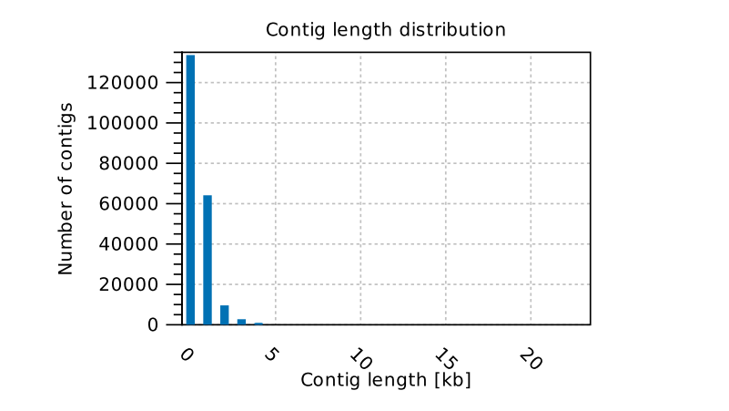
De novo assembly, which constructs contigs based on sequencing data, plays an important role in identifying novel transcripts and isoforms that might be missed in reference-based assembly methods (Moreton et al., 2016). Utilizing k-mer based assembly techniques, high-coverage short reads are converted into reasonably sized contigs, enhancing the recovery of unigenes, as indicated by the higher N50 values (Zerbino and Birney, 2008). In this present investigation, de novo assembly resulted 2,11,432 contigs and 76,763 unigenes respectively (Fig. 1.). De novo assembly of transcriptomic data of loquat resulted in production of 1,16,723 contigs and 64,841 unigenes utilizing Illumina technology (Gong et al., 2015). Same results were obtained in pomegranate (Xue et al, 2017) using de novo assembly which yielded 132287 transcripts and representative unigenes of nearly 105743 which roughly produced 13,805 unigenes which are longer than 1000 bp. Hu et al., 2015 in endemic tree Juglans hopeiensis (Ma walnut) reported that 99,869 unigenes were obtained through de novo assembly. In a recent mega assembly study, 87.23% of reads were assembled into 47,090 contigs with sensible mean length and a significant N50 contig value. For instance, a Sanger-EST assembly in pepper using CLC workbench genomics software resulted in 31,196 unigenes with a mean contig length of 6,945 bp and an N50 value of 702 bp (Ashrafi et al., 2012). Similar observation was also observed in mango cv. Amrapali, Neelum and Dashehari (Mangifera indica L.) which yielded nearly 70,057 unigenes using workbench genomics software (Mahato et al., 2016). In another study focusing on Vicia faba, de novo assembly using CLC Genomics Workbench mapped 82% of reads into 21,297 contigs with a high N50 value of 1,245 and the longest contig length being 10,528 bp (Arun-Chinnappa and McCurdy, 2015).These findings emphasized the efficiency of de novo assembly techniques, especially those utilizing k-mer-based approaches, in generating comprehensive and high-quality transcriptome datasets, enabling the discovery of valuable genomic information.

Fig. 1. Distribution of contig length in de novo assembly of transcriptome data of guava
3.2 SSR findings and Primer designing from the meta transcripted contigs
The summary information of detected sequences and SSRs are presented in Table 4. SSR mining was performed on 76,764 unigenes using Krait. Across the contigs, we discovered 29,360 sequences with SSRs. The overall length of SSR was 5,43,309 bp, while the average length of SSRs was 18.51 bp. The relative abundance of these SSR was found to be 231.51 (loci/Mb) and the relative density was found to be 4284.06 (bp/Mb).

Table 4. The summary statistics of detected sequences and SSRs
Sl. No. | Items | Number
1 | Total number of perfect SSRs | 29360
2 | Total length of perfect SSRs (bp) | 543309
3 | The average length of SSRs (bp) | 18.51
4 | SSRs per sequence | 1.08
5 | The percentage of sequence covered by SSRs | 0.43
6 | Relative abundance | 231.51 (loci/Mb)
7 | Relatively density | 4284.06 (bp/Mb)

The majority of SSRs (39.99% n=11,740) were made up of mono-nucleotide repeats with average length of 114.13 bp, followed by di-nucleotides (35.45% n=10,408) with a mean length of 23.05 bp and tri-nucleotides (16.76% n=4922), which comprised all other repeat types. Tetra (4.66%), penta (1.68%), and hexa-nucleotide (1.46%) repetitions made up a smaller fraction of all repeats but hexa- nucleotide were still significant due to their longer average length (25.9 bp). AG/AC, AAG/CCG and AAAG/AAAT were the most prominent and prevalent di-, tri- and tetra nucleotide repetitions respectively. The summary of microsatellite types is provided in Table 5.
Table 5. The summary of perfect microsatellite types
Type of repeats | Counts | Length (bp) | Percent (%) | Average length (bp) | Relatively abundance (loci/Mb) | Relative density (bp/Mb)
Mono | 11740 | 165903 | 39.99 | 14.13 | 92.57 | 1308.16
Di | 10408 | 239940 | 35.45 | 23.05 | 82.07 | 1891.96
Tri | 4922 | 90768 | 16.76 | 18.44 | 38.81 | 715.72
Tetra | 1368 | 24856 | 4.66 | 18.17 | 10.79 | 195.99
Penta | 493 | 10730 | 1.68 | 21.76 | 3.89 | 84.61
Hexa | 429 | 11112 | 1.46 | 25.9 | 3.38 | 87.62

In recent years, the use of molecular markers has evolved significantly, shifting from basic diversity studies to advanced genotypic selection methods. Marker-assisted breeding has greatly expedited the discovery of economically valuable traits in crops. Molecular markers are instrumental in mapping studies as they reveal the underlying genetic variations linked to specific phenotypic traits. For a marker to be suitable for mapping studies, it must be co-segregated, polymorphic, reproducible, and abundantly available in the genome. Simple sequence repeats (SSRs) meet these criteria and can be developed from publicly available datasets. Functional SSRs serve as crucial genomic tools for the precise selection of specific regions governing traits. Advancements in plant biology and informatics have enabled the genome-wide identification of SSRs. SSR markers are widely utilized in genetic diversity research, linkage mapping, relatedness studies, further genomics, and genetic-based association studies on adaptive traits, as highlighted in previous studies (Wu et al., 2014). Exploring SSRs has proved to be a promising approach for their utilization in association mapping studies, as demonstrated in previous studies (Li et al., 2014; Singh et al., 2018). In our research, the identification of 29,879 perfect SSRs significantly enhances the applicability of markers in molecular breeding, with more of mono and di-nucleotide repeats, especially to explore genetic diversity, population genetics, comparative genomics and genetic-based association studies related to adaptive traits of guava. The majority of SSRs (39.99% n=11,740) were made up of mono-nucleotide repeats with average length of 114.13 bp (Fig. 2.), followed by di-nucleotides (35.45% n=10,408) with a mean length of 23.05 bp and tri-nucleotides (16.76% n=4922), which comprised all other repeat types (Fig. 3). AG/AC, AAG/CCG and AAAG/AAAT were the most prominent and prevalent di-, tri- and tetra nucleotide repetitions respectively (Fig. 4). In a similar study, an analysis of Trinucleotide repeats was found to be highly abundant (47.52%), followed by tetranucleotide (19.77%), dinucleotide (19.01%), pentanucleotide (9.12%), and hexanucleotide (4.56%) repeats. Additionally, the analysis of RNA seq datasets from sweet potato roots and publicly available ESTs led to the identification of 1,631 sequences containing SSR motifs associated with starch and β-carotene content. Among these SSRs, trinucleotide and dinucleotide repeat motifs were the most prevalent (55.64% and 33.114%, respectively), followed by tetra (8.443%), penta- (1.480%), and hexa-nucleotide (1.316%) repeat motifs (Zhang et al., 2016). The majority of EST-SSRs identified were dinucleotide repeats, and the study reported forty four polymorphic markers, marking the highest number of SSRs reported for the species so far (Gonzalez et al., 2016). De novo assembly of two accessions of Capsicum annuum also revealed that dinucleotide and trinucleotide repeats were more abundant, whereas tetra-, penta-, or hexanucleotide motifs were relatively scarce (Lu et al., 2011). Similar findings were reported in walnut where, dinucleotide (di-) repeat motifs comprised 69.85% of all SSRs, subsequent to trinucleotide (tri-) with a frequency of 27.64% respectively. (Zhang et al., 2010)
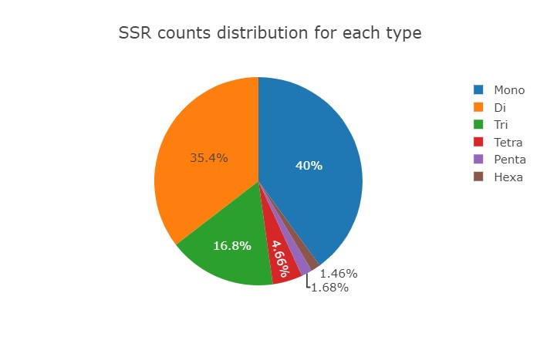
Fig. 2. SSR counts distribution for each types of nucleotides
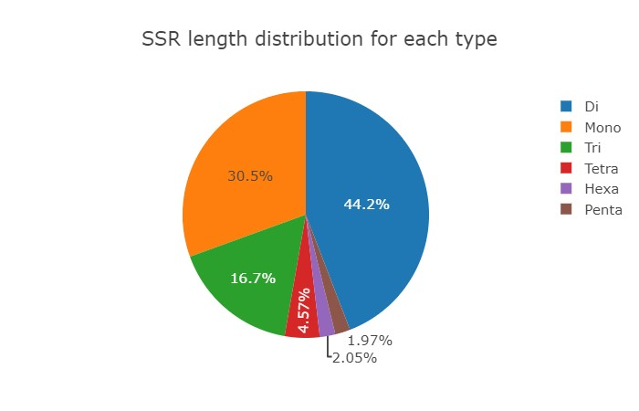
Fig. 3. SSR length distribution for each types of nucleotides
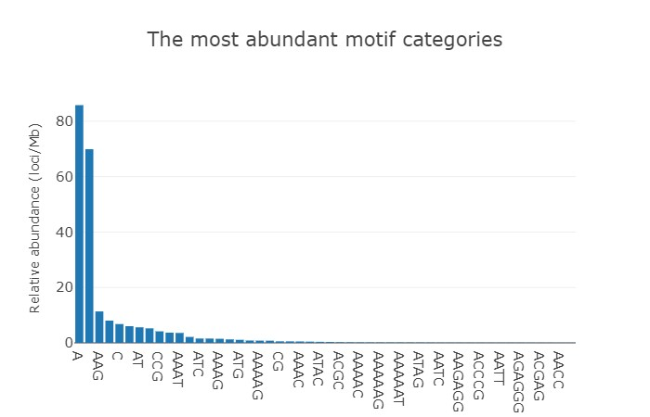
Fig. 4. Abundant motif distribution for designed SSRs
3.3 Functional annotation of unigenes
The function annotation of guava unigenes included analyzing protein sequence similarities, gene ontology (GO) analysis, and KEGG pathways. BLAST2GO was employed for this annotation, utilizing databases such as KEGG, Reactome, and Plant Reactome. The contigs/unigenes assembly was annotated to identify potential genes associated with fruit function variables. The BLAST results yielded significant hits, with 41,254 sequences annotated with UniProt (approximately 53.74%), 33,005 sequences annotated with Gene Ontology terms (about 42.99%), and 17,270 sequences annotated with enzyme codes (22.49%) respectively. Regarding the KEGG database, 9,885 sequences were linked to 441 identified pathways. Additionally, Plant Reactome databases revealed 810 sequences associated with 8,733 pathways.
GO analyses were conducted through the Blast2GO program, classifying 76,762 unigenes into biological processes (59,873 unigenes), cellular processes (27,072 unigenes), and molecular functions (35,564 unigenes). In the biological process category, 'cellular process' (20,131, 33.62%), 'metabolic process' (17,632, 29.45%), 'biological regulation' (6,241, 10.42%), 'response to biological process' (5,887, 9.83%), and 'response to stimulus' (5,811, 9.71%) were the most represented groups. For the cellular component category, 'cellular anatomical entity' (23,056, 85.17%) and 'protein-containing complex' (4,016, 14.83%) were predominant. In the molecular function category, 'binding' (17,844, 50.17%) and 'catalytic activity' had the highest representation.
These unigenes were involved in diverse processes such as cellular processes, responses to biotic and abiotic stimuli, metabolism, regulation, circadian rhythm, cell-cell communication, cell cycle, DNA repair, innate immune system, neuronal system, protein metabolism, developmental biology, sensory perception, small molecule transport, and growth and developmental processes.
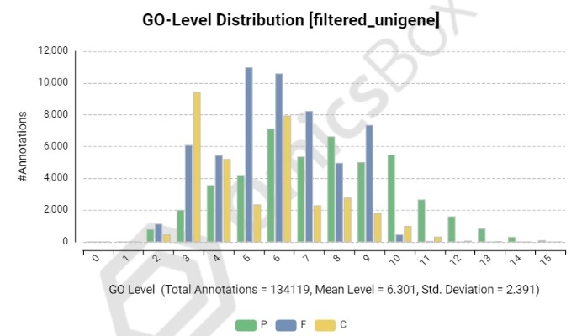
Homology-based approaches are commonly employed to characterize unigenes and assign functions to them by mapping. Functional annotation decodes the transcript functions and categorizes them into ontology groups such as biological process, molecular function, and cellular component. In our study, we annotated SSR-containing unigene sequences, resulting in 41,254 unigenes with functional annotations (Fig. 5.), which analyzed and annotated these genes into their particular functional processes into biological processes (59,873 unigenes) (Fig. 6.), cellular processes (27,072 unigenes) (Fig. 7.), and molecular functions (35,564 unigenes) respectively (Fig. 8.). In a study on pepper, Sanger-EST and transcriptome assembly were annotated using Blast2GO. Additionally, 14,740 contigs from the transcriptome assembly were annotated as functional proteins. The annotated genes were categorized based on their biological processes, molecular functions, and cellular component ontologies (Ashrafi et al., 2012). Similar observations were recorded in asian pear (Li et al., 2015) and persimmons (Jing et al.,2019)

P: Biological process, F: molecular functions and C: Cellular component
Fig. 5. GO-level distribution of annotated unigenes in BLAST2GO software
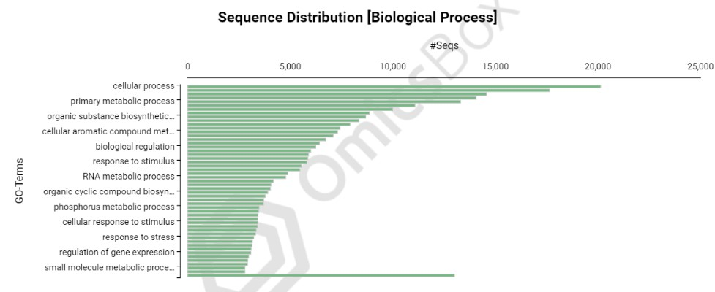
GO TERMS 1: Cellular process; 2: Primary metabolic process; 3: Organic substance biosynthetic process; 4: Cellular aromatic compound metabolic process; 5: biological regulation; 6: response to stimulus; 7: RNA metabolic process; 8: organic cycle compound biosynthetic process; 9: phosphorus metabolic process; 10: cellular response to stimulus; 11: response to stress; 12: regulation of gene expression; 13: small molecule metabolic process
Fig. 6. Gene ontology distribution of unigenes for biological process

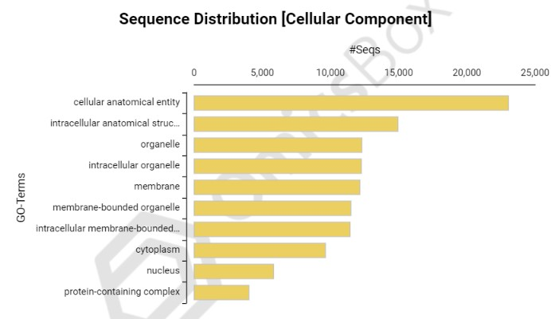
GO TERMS 1: Cellular anatomical entity; 2: intracellular anatomical structure; 3: Organelle; 4: intracellular organelle; 5:membrane; 6 : membrane bound organelle ; 7: intracellular membrane bound organelle; 8:cytoplasm; 9:nucleus; 10:protein-containing complex;
Fig. 7. Gene ontology distribution of unigenes for cellular process
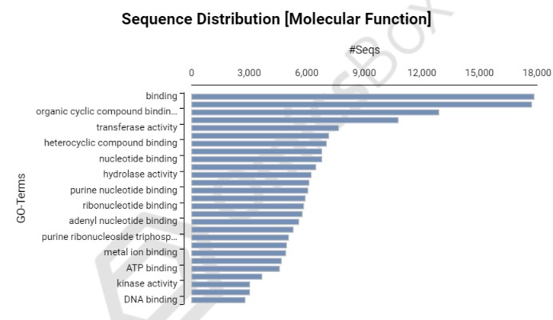
GO TERMS 1: binding; 2: organic cyclic compound binding; 3: transferase activity; 4: heterocyclic compound binding; 5: nucleotide binding; 6: hydrolase activity; 7: purine nucleotide binding; 8:ribonucleotide binding; 9: adenyl nucleotide binding; 10:purine ribonucleotide triphosphate binding; 11: metal ion binding; 12: ATP binding; 13: kinase activity; 14: DNA binding
Fig. 8. Gene ontology distribution of unigenes for molecular function
In another study focused on identifying potential candidate genes for key metabolite production in Lonicera japonica, unigene sequences underwent functional annotation against the NCBI non-redundant (nr) protein database. This resulted in the annotation of 99,938 (41.1%) unigenes. GO-based functional classification yielded a total of 178 GO categories, further classified into biological processes (89), molecular functions (53), and cellular components (36) (Rai et al., 2017). Similar findings were reported in persimmons (Jing et al., 2019) and pummelo (Liang et al., 2015) where BLAST was performed to know the functional annotation where Gene ontology was performed.
3.4 Molecular validation of designed primers
The research conducted in this study successfully identified 20,473 primer pairs based on 29,360 SSRs produced from transcriptomic assembly. These primers were designed using Krait (version 1.4). The assembly of EST failed to produce SSRs due to the low sequencing sequences quality. All the complex repeats were removed before designing the primers. After excluding sequences with the product size less than 150, 5360 primers were selected. Out of these primers all mono-nucleotide repeats were excluded. Among those selected SSR, 3 primers were selected from each chromosome, totally 33 primers were chosen for final investigation where these primers represented all 11 chromosomes of guava. To validate the usefulness of these primer pairs, 30 of them were randomly selected for testing (Table 6).
Table 6: List of SSR primers used for validation of designed primers
Primer name | Forward primer | Reverse primer
FVRmPg01 | AGGGTCTGTCTCTGTTGATGC | CACTCAACGGAAGCAGTTTGG
FVRmPg02 | TTCTCTCTCTTACCCTGCGC | GTACAATGGCCTAGGCTTGC
FVRmPg03 | CGCCACCATCACAATACGC | CTAGTCCATAGCGACCACCG
FVRmPg04 | GCGGCACTCTTTTCTCAAGG | AATTGGGGCACATTCGAACG
FVRmPg05 | GTCCAGTACACATGTTCACAGG | GGCCTTGGAAATGAGCATGG
FVRmPg06 | GTTCACCTCCATGTGCTTTGG | CAAAGTTGCATCCATGGGGG
FVRmPg07 | CGTCGTCCTTCCGAGTTTCC | AAGGGGAATTAACGCGAGGG
FVRmPg08 | TGAGCTACCATAGGCCTAAGG | GCCTGTTTGGATCTGTTGCG
FVRmPg09 | TCGAGAAAGCGAGTTTTGCC | TTGAGAAAAAGATTAGTGAGTTGCCC
FVRmPg10 | TTCGTTCATGGAGAGGCTGG | CCATGATGCAATTCACTGAAGC
FVRmPg11 | TTGCTGAAAACCTTGTGCCG | ACCCTGTCCTGTCAAATCACG
FVRmPg12 | TCATAGTCTTCATGTGTTCGCC | CGTCCTTCGGAAATACTGAAATGG
FVRmPg13 | AGTCCCGCACTAAGAACTCC | TCGCAAGACTCAGCTCATGG
FVRmPg14 | TGGAGTGATCCGGATAATGCC | CGGAATCGAATCGAAAAGGCC
FVRmPg15 | TGGGCATCTTCACCATCTCC | ACCCGAACAAGGAGATGACG
FVRmPg16 | TTGGCTGTGGAATCCTTCGG | GGATGTGATTCTCTGATTCCAAGC
FVRmPg17 | GACCAAGACCCCCTAAAGCC | AGAGAGAAGAGTAGATGGTGGC
FVRmPg18 | TGCTTAGTGAGACTACCACAGC | GTTCGGGTTTGTGTTTCGGG
FVRmPg19 | CCAGAAGATGCAACTCTGTGC | TGAGCTTTTATGTGGTTTTGAGC
FVRmPg20 | GGAATGATAGCATTGATGGTCCC | CTCCTTGACCTTGCCAGAGG
FVRmPg21 | ACTTCCTTGATGCGAAATCTTAGG | GGTACTCAGAGCCTTGGTAGC
FVRmPg22 | ACTTGAGAACAGGGCCTTGC | AGATGGATCATCACCAGTGAAGG
FVRmPg23 | CACCAATACACTGCAGGAACC | TGAACCCTGAGCCTATCTGG
FVRmPg24 | GCTGGTTCACAAAATGCTGC | GCTCCACGGAAGCATTTAGC
FVRmPg25 | ACGTGTACAACCGATCGACC | AAGTGAACTTGTGGGGCCC
FVRmPg26 | GTGCTTGTTTGTGTGTGTGC | AATTAACATCGGTAGCCTTCTGG
FVRmPg27 | AACTCAACTCGGTCAGGTCC | AAGAACCTCAGCCACCTTGG
FVRmPg28 | GCAACATCCAAGATCGTCGC | ACCAAAGCTACGCCACTAGC
FVRmPg29 | CCACATTCTCTGGTTGCAGC | TGGGTCTCCAAGATTGTGGC
FVRmPg30 | ACATTTCTGCCTGAAGAATGCC | AGGAAGGAATGTTTGGGGCG

Out of 30 primer pairs discovered, 27 were successful in producing PCR amplification with genomic DNA from the all 4-guava genotype. The remaining 3 primer pairs (10%) failed to generate PCR products at various annealing temperatures. All the 27 primers showed polymorphism in their banding patterns suggesting that these SSR primers can be widely utilized in genetic diversity research, population genetics, linkage mapping, relatedness studies, comparative genomics, and genetic-based association studies on adaptive traits of guava.
Primer validation is a crucial process in molecular biology research, ensuring the specificity, sensitivity, and efficiency of the primers used in experiments such as PCR, qPCR, DNA sequencing, and other molecular techniques. Validation procedures are designed to confirm that the primers amplify the intended target sequence accurately and specifically, without generating non-specific products or primer dimers. In this experiment out of randomly selected 30 primers, 27 primers had showed amplification. Similar results were reported in persimmons where 89 primers showed amplicons out of 100 primers (Jing et al., 2019), in mango where over 100 primers 43 yielded PCR amplicons (Mahato et al., 2016) in walnut reported 7 primers produced amplification out of 15 (Shailja et al., 2017) and Prunus spp where 14 pairs were amplified over 42 pairs of PCR primers (Li et al., 2010). The discovery of 29,360 SSRs in this research represents a valuable resource for future genetic studies and primer design for the guava genotypes. SSR markers play a crucial role in advancing genetic research within this species. They empower researchers to delve into various aspects which finally helps in overall development of genomics in guava.
4. Conclusion

Transcriptome analysis resulted in 2,11,432 contigs, providing valuable genomic information. SSR mining identified 29,360 sequences containing SSRs across the contigs. Functional annotation of unigenes highlighted their involvement in diverse biological processes, cellular components and molecular functions. Validation of primers showed polymorphism in 27 out of 30 selected pairs, indicating the potential for further genetic studies in guava. The genomic analysis, particularly the SSR mining and primer validation, established a foundation for future molecular studies. These findings contribute significantly to guava breeding, offering potential applications in crop improvement programs and fostering a deeper understanding of guava's genetic makeup.

Disclaimer (Artificial intelligence)
Author(s) hereby declare that NO generative AI technologies such as Large Language Models (ChatGPT, COPILOT, etc.) and text-to-image generators have been used during the writing or editing of this manuscript.

References

Arun-Chinnappa, K. S., & McCurdy, D. W. (2015). De novo assembly of a genome-wide transcriptome map of Vicia faba (L.) for transfer cell research. Frontiers in plant science, 6, 217.
Ashrafi, H., Hill, T., Stoffel, K., Kozik, A., Yao, J., Chin-Wo, S.R., & Van Deynze, A. (2012). De novo assembly of the pepper transcriptome (Capsicum annuum): a benchmark for in silico discovery of SNPs, SSRs and candidate genes. BMC genomics, 13(1), 1-15.
Cerveau, N., & Jackson, D. J. (2016). Combining independent de novo assemblies optimizes the coding transcriptome for nonconventional model eukaryotic organisms. BMC bioinformatics, 17(1), 1-13.
Conesa, A., Gotz, S., Garcia-Gomez, J. M., Terol, J., Talon, M., & Robles, M. (2005). Blast2GO: a universal tool for annotation, visualization and analysis in functional genomics research. Bioinformatics, 21(18), 3674-3676.
Doyle, J. J., & Doyle, J. L. (1990). Isolation of plant DNA from fresh tissue. Focus, 12, 13-15.
Edwards, D., & Batley, J. (2010). Plant genome sequencing: applications for crop improvement. Plant biotechnology journal, 8(1), 2-9.
Feng, C., Feng, C., Lin, X., Liu, S., Li, Y., & Kang, M. (2021). A chromosome level genome assembly provides insights into ascorbic acid accumulation and fruit softening in guava (Psidium guajava). Plant biotechnology journal, 19(4), 717-730.

Garcia M., 2002, Green medicine: an option of richness. In: Funes, F., Garcia, L., Bourque, M., Perez, N., Rosset. PM (eds) Sustainable agriculture and resistance: transforming food production in Cuba. Co-publishers Food first books, Cuban Association of Agricultural and Forestry Technicians (ACTAF) and Centre for the study and Sustainable Agriculture, Agrarian University of Havana (CEAS), Havana, 212-219.

Gascuel, Q., Diretto, G., Monforte, A. J., Fortes, A.M., & Granell, A. (2017) Use of natural diversity and biotechnology to increase the quality and nutritional content of tomato and grape. Frontiers in plant science, 8, 652.
Gong, R.G., Lai, J., Yang, W., Liao, M. A., Wang, Z. H., & Liang, G. L. (2015). Analysis of alterations to the transcriptome of Loquat (Eriobotrya japonica Lindl.) under low temperature stress via de novo sequencing. Genetics and Molecular Research, 14(3), 9423-9436.
Gonzalez, M., Salazar, E., Castillo, J., Morales, P., Mura-Jornet, I., Maldonado, J., Silva, H. & Carrasco, B. (2016). Genetic structure based on EST–SSR: a putative tool for fruit color selection in Japanese plum (Prunus salicina L.) breeding programs. Molecular Breeding, 36, 1-15.
Holzer, M. & Marz, M. (2019). De novo transcriptome assembly: A comprehensive cross-species comparison of short-read RNA-Seq assemblers. Gigascience, 8(5), 039.
Hu, Y. H., Zhao, P., Zhang, Q., Wang, Y., Gao, X. X., Zhang, T., Zhou, H. J., Dang, M. & Woeste, K. E. (2015). De novo assembly and characterization of transcriptome using Illumina sequencing and development of twenty five microsatellite markers for an endemic tree Juglans hopeiensis Hu. in China. Biochemical Systematics and Ecology, 63, 201-211.
Huang, X., & Han, B. (2014). Natural variations and genome-wide association studies in crop plants. Annual review of plant biology, 65, 531-551.
Jing, Z., Ruan, X., & Yang, Y. (2019). Identification of novel EST-SSR markers from the de novo transcriptome sequence and application in persimmon (Diospyros L.). European Journal of Horticultural Science, 84(5), 302-309.
Li, J. F., Gao, Z., Lou, Y. S., Luo, M., Song, S. R., Xu, W. P., Wang, S. P., & Zhang, C. X. (2015). De novo assembly, functional annotation, and marker development of asian pear (Pyrus pyrifolia) fruit transcriptome through massively parallel sequencing. Genetics and Molecular Research, 14(4), 18344-18355.
Li, X., Shangguan, L., Song, C., Wang, C., Gao, Z., Yu, H., & Fang, J. (2010). Analysis of expressed sequence tags from Prunus mume flower and fruit and development of simple sequence repeat markers. BMC genetics, 11(1), 1-11.
Li, Y., Xu, C., Lin, X., Cui, B., Wu, R., & Pang, X. (2014). De novo assembly and characterization of the fruit transcriptome of chinese jujube (Ziziphus jujuba Mill.) using 454 pyrosequencing and the development of novel tri-nucleotide SSR markers. PLoS One, 9(9), e106438.
Liang, M., Yang, X., Li, H., Su, S., Yi, H., Chai, L., & Deng, X. (2015). De novo transcriptome assembly of pummelo and molecular marker development. PLoS One, 10(3), e0120615.
Lu, F. H., Yoon, M. Y., Cho, Y. I., Chung, J. W., Kim, K. T., Cho, M. C., Cheong, S. R., & Park Y. J. (2011) Transcriptome analysis and SNP/SSR marker information of red pepper variety YCM334 and Taean. Scientia Horticulturae, 129(1), 38-45.
Mahato, A. K., Sharma, N., Singh, A., Srivastav, M., Jaiprakash, Singh, S. K., Singh, A. K., Sharma, T. R., & Singh, N. K. (2016). Leaf transcriptome sequencing for identifying genic-SSR markers and SNP heterozygosity in crossbred mango variety ‘Amrapali’ (Mangifera indica L.). PloS one, 11(10), e0164325.
Milano, I., Babbucci, M., Panitz, F., Ogden, R., Nielsen, R. O., Taylor, M. I., Helyar, S. J., Carvalho, G. R., Espineira, M., Atanassova, M., & Tinti, F. (2011). Novel tools for conservation genomics: comparing two high-throughput approaches for SNP discovery in the transcriptome of the European hake. PLoS One, 6(11), e28008.
Moreton, J., Izquierdo, A., & Emes, R. D. (2016). Assembly, assessment, and availability of de novo generated eukaryotic transcriptomes. Frontiers in genetics, 6, 361.
Papanna, N., Rao, V., Murthy, S. & Simon, L. (2009). Microsatellite-based genetic diversity assessment in grape (Vitis vinifera L.) germplasm and its relationship with agronomic traits. International Journal of Fruit Science, 9(1), 92-105.
Rai, A., Kamochi, H., Suzuki, H., Nakamura, M., Takahashi, H., Hatada, T., Saito, K., & Yamazaki, M. (2017). De novo transcriptome assembly and characterization of nine tissues of Lonicera japonica to identify potential candidate genes involved in chlorogenic acid, luteolosides, and secoiridoid biosynthesis pathways. Journal of Natural Medicines, 71, 1-15.
Shailja, S., Kaur, R., Shilpa, C., & Kumar, K. (2019). Exploitation of walnut (Juglans regia L.) expressed sequence tags for development of SSR markers after in silico analysis. Proceedings of the National Academy of Sciences, India Section B: Biological Sciences, 89, 267-274.
Singh, S., Gill, M. I. S., & Arora, N. K. (2018). Induction of variants in guava (Psidium guajava L.) through irradiation of budsticks by gamma rays. Agricultural Research Journal, 55(2), 347-350.
Varshney, R. K., Nayak, S. N., May, G. D., & Jackson, S. A. (2009). Next-generation sequencing technologies and their implications for crop genetics and breeding. Trends in biotechnology, 27(9), 522-530.
Wu, J., Li, L. T., Li, M., Khan, M. A., Li, X. G., Chen, H., Yin, H., & Zhang S. L. (2014). High-density genetic linkage map construction and identification of fruit-related QTLs in pear using SNP and SSR markers. J. Exp. Bot., 65(20): 5771-5781.
Xue, H., Cao, S., Li, H., Zhang, J., Niu, J., Chen, L., Zhang, F., & Zhao, D. (2017) De novo transcriptome assembly and quantification reveal differentially expressed genes between soft-seed and hard-seed pomegranate (Punica granatum L.). PLoS One, 12(6),
Zerbino, D. R., & Birney, E. (2008). Velvet: algorithms for de novo short read assembly using de Bruijn graphs. Genome research, 18(5), 821-829.
Zhang, J., Zhao, J., Liang, Y., & Zou, Z. (2016). Genome-wide association-mapping for fruit quality traits in tomato. Euphytica, 207, 439-451.
Zhang, R., Zhu, A., Wang, X., Yu, J., Zhang, H., Gao, J., Cheng, Y., & Deng, X. (2010). Development of Juglans regia SSR markers by data mining of the EST database. Plant Molecular Biology Reporter, 28, 646-653.

