Efficacy of biocontrol and antifungal agents on leaf spot and blight pathogen Fusicladium pongamiae in Millettia pinnata: An in vitro approach

Abstract:
Millettia pinnata is a valuable tree species, commonly planted for its economic and ecological contribution. Despite this, it is susceptible to a number of foliar diseases, of which leaf spot and blight, induced by Fusicladium pongamiae, are major hazards in nursery and plantation conditions. The current research was conducted to isolate, identify, and determine the pathogenicity of F. pongamiae, and to test the effectiveness of chosen biocontrol agents (Trichoderma viride and Pseudomonas fluorescens) and antifungal agents (Pongam oil and Carbendazim) under in vitro conditions. Infected leaf samples were obtained and the pathogen was purified on Potato Dextrose Agar (PDA). Morphological identification under a stereomicroscope proved the identity of F. pongamiae. Pathogenicity was established by artificial inoculation on healthy seedlings, which proved to cause typical symptoms. In dual culture assays, the maximum inhibition of F. pongamiae was caused by P. fluorescens (68.46%), followed by the combination of T. viride and P. fluorescens (61.46%), and T. viride (53.79%). Using poisoned food technique assays, 0.1% Carbendazim strongly inhibited mycelial growth (83.82%), followed by 5% Pongam oil (41.28%). The research concludes that P. fluorescens has high biocontrol activity against F. pongamiae, while Carbendazim is the most efficient antifungal agent. These results justify the combination of biological and chemical approaches for sustainable control of leaf spot and blight disease in M. pinnata, resulting in better plant health and productivity in afforestation schemes.
Keywords: Millettia pinnata, Fusicladium pongamiae, Pseudomonas fluorescens, Trichoderma viride, leaf spot, blight.

Introduction:
Milletia pinnata, commonly planted as avenue trees and on degraded lands, is susceptible to numerous pests and diseases that attack its leaves (Hossain, 2007). There are many adverse effects of diseases i.e., root rot, leaf spot and blight, rust on the nursery seedlings and trees in the plantations (Mridha et al., 2007). Leaf spot and blight, caused by fungal pathogens such as Fusicladium, Colletotrichum, and Dothiorella. The parasitic fungus, Fusicladium pongamiae is usually observed on the lower leaf of M. pinnata in the form of brown-colored patches, and often resulting in curled leaf appearance. Fusicladium is a genus of ascomycete fungi in the family Sympoventuriaceae. The leaf spot disease of M. pinnata caused by an aspersorium-like asexual morph, which is usually referred to as Aspersorium pongamiae, is quite common during monsoon seasons in India. Microscopic observations revealed that fungal spores, characterized by an elongated, one- or two-capsule shape, are associated with foliar diseases such as leaf spot and blight in M. pinnata (Pathak et al., 2015) These fungal pathogens, including Fusicladium, Colletotrichum, and Dothiorella, thrive under optimal moisture and temperature conditions, predominantly affecting nursery seedlings of M. pinnata (Pathak et al., 2015; Mridha et al., 2007).
Leaf spot and blight symptoms are evident on both tender and matured leaves, but blight symptoms are mostly confined to matured leaves. On the upper surface of the leaves, water-soaked yellow spots first appears singly, which over time coalesce to form big patches and leaves turn yellow (Chlorosis). On the lower surface of the leaves, black patches appear and occasional leaf curling is associated with heavy conidiation. Later, all these yellow spots progressively turn brown and show necrotic symptoms with dry leaves falling off early (Dadwal et al., 1981; Mridha et al., 2007). Fungal and bacterial antagonists play an important role as microbial biocontrol agents in managing plant diseases and can be delivered as bio fungicides (Kohl et al., 2019; Thambugala et al., 2020). Bio-fungicides used for the biological control of plant pathogens are microorganisms-based formulations, which include antagonistic fungi and bacteria (Morandi et al., 2009). Among fungi-based formulation, species from the genus Trichoderma are the most common biocontrol agents (Silva et al., 2015; Yu and Luo, 2020). In comparison, fluorescent species from the genus Pseudomonas are the most common antagonists among bacteria-based formulations. Trichoderma spp. due to its biocontrol activity against various aerial, root and soil pathogens of economic importance, it has attained scientific attraction (Elad 2000; Chaube et al., 2002).
Considering the pressing need for a sustainable management strategy to control leaf spot and blight of Millettia pinnata caused by Fusicladium pongamiae and to evaluate the efficacy of the biocontrol agents against the fungal pathogen, this study was designed.
2. Materials and Methods:
Laboratory studies on isolation and identification of pathogen associated with leaf spot and blight of M. pinnata were carried out in the Plant Pathology laboratory, Department of Forest Resource Management, Forest College and Research Institute, Mulugu. The details of materials and methodology followed are described here under.

2.1 Isolation and Identification of microbe associated with blight disease of M. pinnata
2.1.1 Pathogen identification:
Infected leaves were brought to the laboratory using paper envelopes (Figure 1). The infected leaves were surface sterilized using 95% ethanol and dissected for the identification of the organism based on conidial morphology by observing under stereo microscope(40X). Same leaf samples were used to isolate the pathogen and a pure culture of the associated pathogen was grown on Potato Dextrose Agar (PDA) medium and maintained.
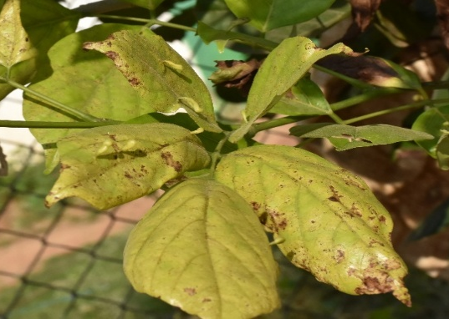  (a) | 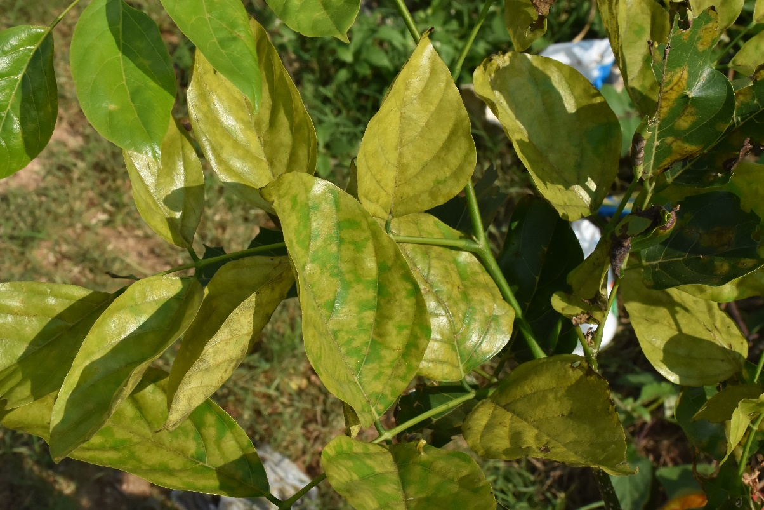  (b)
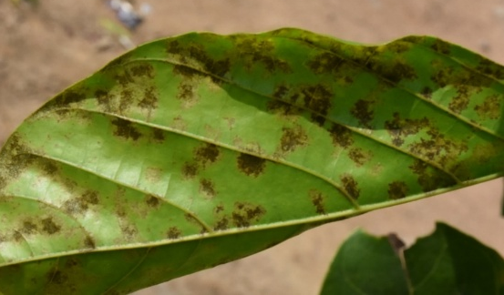  (c) | 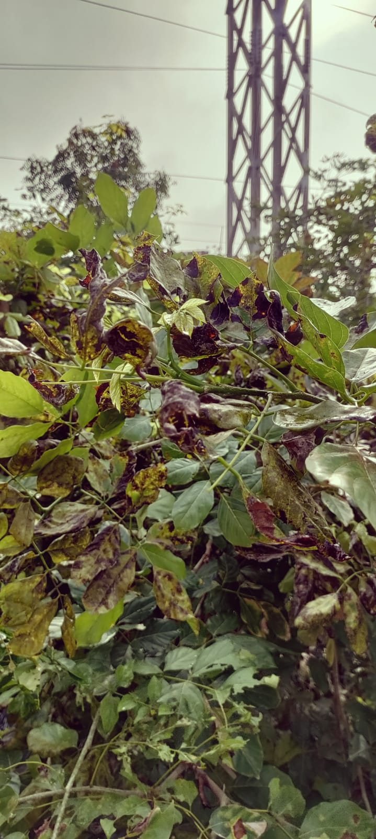  (d)
Figure 1:Symptoms of Leaf spot and blight of Millettia pinnata (a) Chlorosis, (b) Yellow spots on the leaf, (c) Black patches on the ventral portion of leaf, (d) Curling, drying and falling of diseased leaves.
Isolation of pathogen was carried out from fresh infected leaves of M. pinnata. The leaf sample that showed typical leaf spot and blight disease symptoms were cut into small sections of 1 cm diameter and were washed with sterile distilled water for 30 sec. The leaf sections were then surface sterilized with 1% sodium hypochlorite and 95% ethanol. The sections were placed on a microscopic slide and were further chopped with the help of a sterilized blade. 1-2 drops of sterilized distilled water were added onto the slide and the suspension was observed under stereo microscope for the presence of conidial spores. Based on the colony morphology, mycelium, and spore morphology, the species was identified as Fusicladium pongamiae(Figure 2).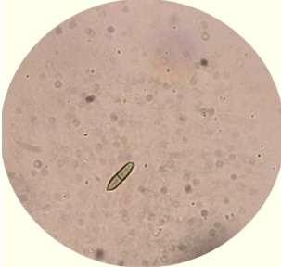
Figure 2: Conidial Spore 40X
2.1.2 Preparation of pure culture
A pure culture of the disease-causing pathogen was obtained using a microscope and laminar air flow. Sterilized PDA was used as a growth medium. The fungal pathogen's pure cultures were obtained by extracting actively growing mycelium in the form of an 8 mm disc using a cork borer and an inoculation loop. The disc was then placed in the centre of a PDA plate to facilitate maximum growth. The Petri dishes were incubated in a BOD incubator (24°C ± 1°C) for a week, with daily observations made until the pure culture fully developed (Figure 3). Observations were made using both a stereo microscope and a trinocular microscope, confirming that the morphological characteristics of the spores grown on PDA (long, septate, one- to two-celled, capsule-shaped) matched the initial observations of spores from the diseased leaf samples.
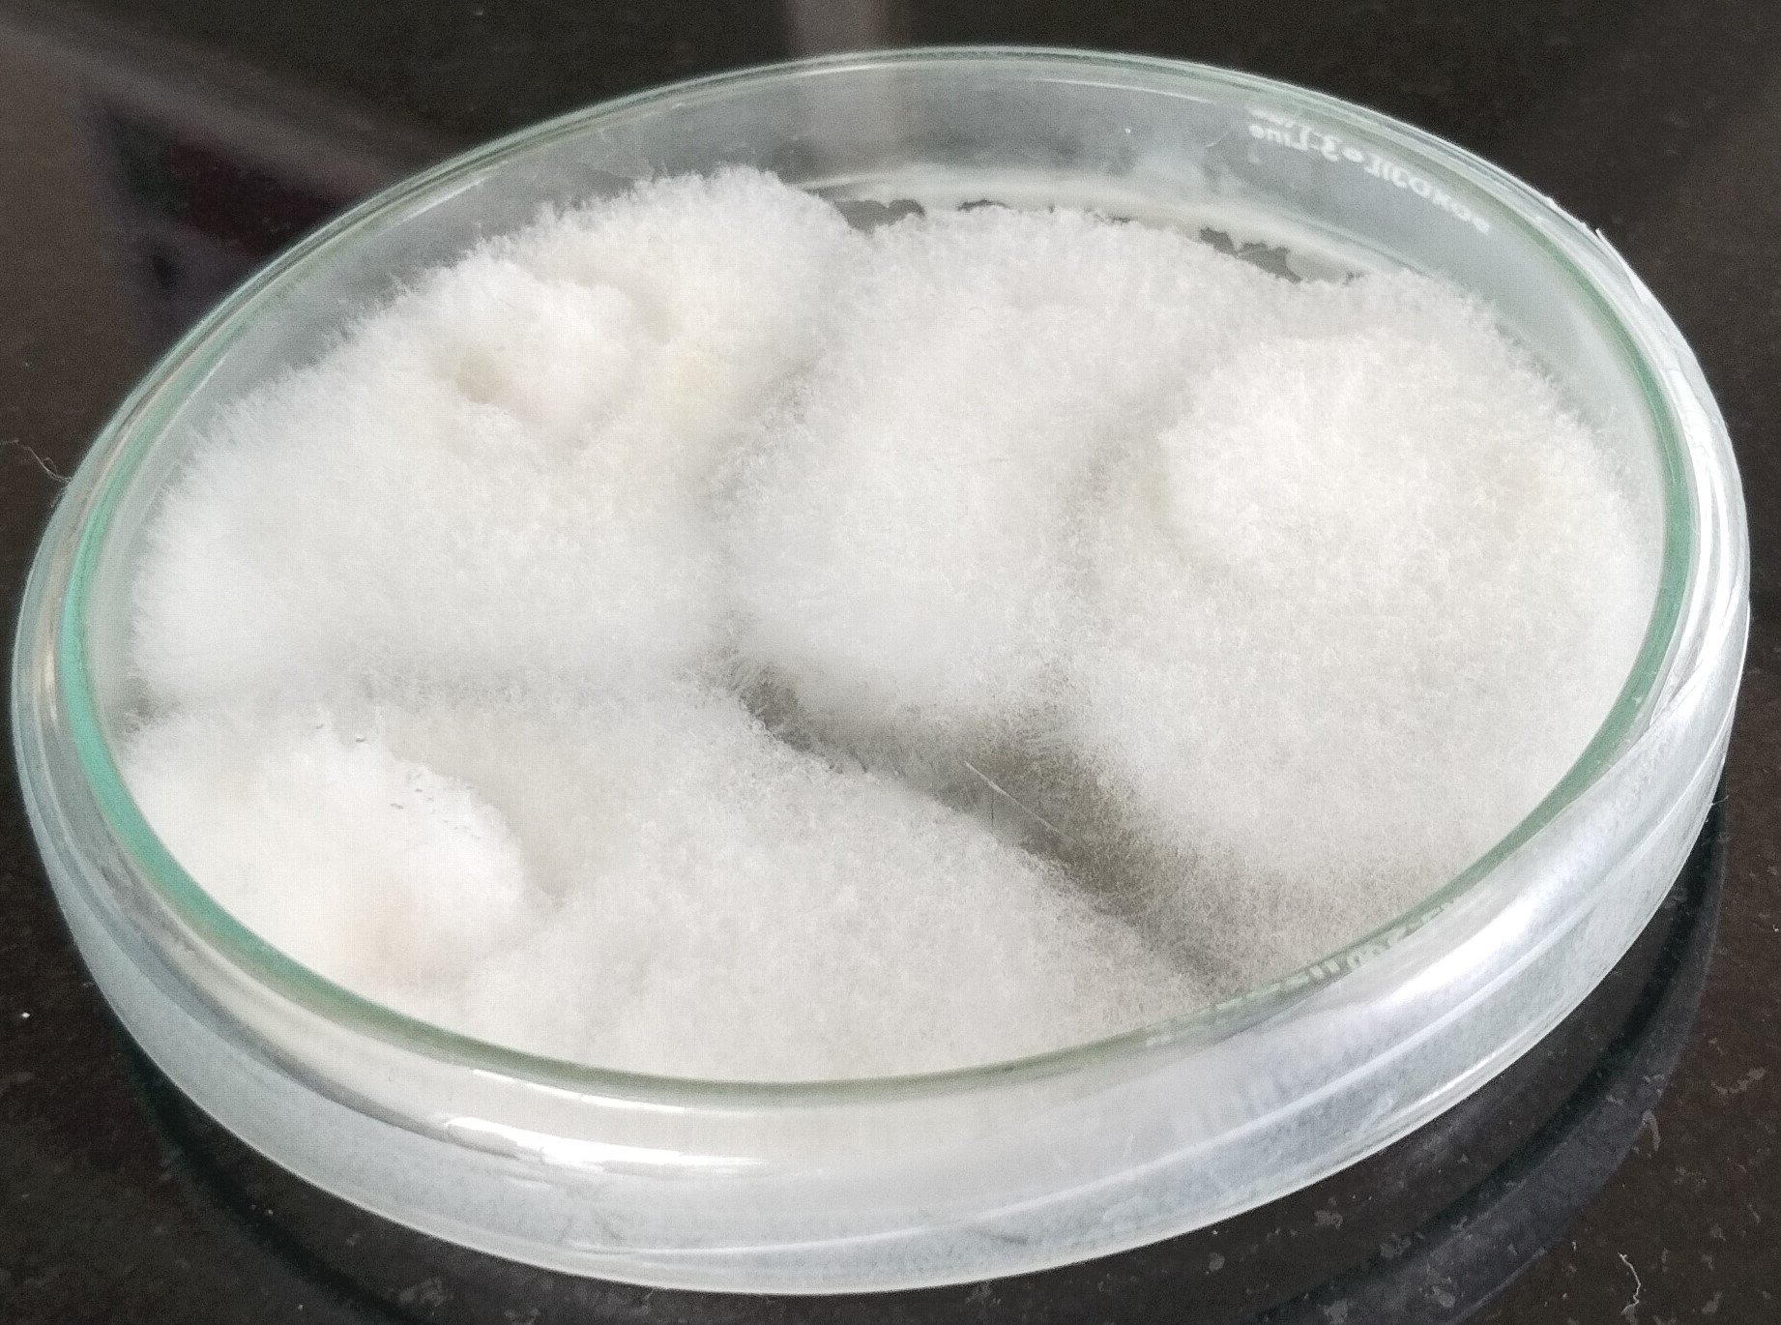
Figure 3: Pure Culture of F. pongamiae
2.1.3 Pathogenicity studies:
a. Spray inoculation
An in vivo infection system was employed to reproduce the leaf spot and blight disease symptoms. Conidia were collected by scraping 1-month-old cultures with a sterile spatula and transferring conidia to sterile water. Conidia were then filtered and the concentration determined using a hemocytometer. The concentration of conidia was then adjusted to 105 conidia/ml in sterile water with 0.5% Tween 20. Spore suspension (20 ml) was applied by spraying onto the leaves. M. pinnata seedlings, 2-month-old and 25 cm in height and presenting young leaves were used for inoculation. Six seedlings were inoculated with F. pongamiae conidial suspension, while other six control seedlings were spray inoculated with water and 0.5% Tween 20. All plants were kept in a chamber at 100% relative humidity for 1 week and afterwards moved into a greenhouse at 20°C and ambient relative humidity.
2.2 To evaluate anti-fungal agent(s) in vitro against the Fusicladium pongamiae
The biological control is the tool for reduction in inoculums density or disease producing activities of a pathogen or parasite in its active or dormant state by the activation of one or more organisms, either accomplished naturally or through manipulation of environment, host or antagonist or by mass introduction of one or more antagonists (Baker et al., 1974). The antagonists such as fungi and bacteria can act as powerful means of suppressing or destroying the plant pathogens without disturbing the ecosystem and they do not create the problems of pollution, the development of resistance in pathogen and production of new biotypes (Thambugala et al., 2020). Hence, investigations on the biological control of Fusicladium pongamiae through potential antagonists were tested in vitro (Table 1).
Table 1: Treatments for evaluation of efficacy of biocontrol and anti-fungal agents
Treatment | Treatment Details
T1 | Trichoderma viride
T2 | Pseudomonas fluorescens
T3 | T. viride + P. fluorescens
T4 | Pongam oil (5%)
T5 | Carbendazim (0.1%)
T6 | Control

2.2.1 Preparation of pure culture of biocontrol agents
a. Trichoderma viride
The mother culture was brought from NIPHM National Institute of Plant Health Management, Rajendra Nagar, Hyderabad, and was serial diluted with 10⁻² on dilution factor and added to Potato Dextrose Agar (HiMedia, 9.75g in 250ml of distilled water autoclaved at 121 °C for 20 min) in Sterilized Petri dishes of 90mm. (1ml of dilutant solvent was taken with 1000 µl of pipette added in PDA media with the help of spreader). The petri plates with para film to avoid contamination and kept in BOD Incubator at room temperature (24°C ± 1°C) and allowed to grow for 3-5days.
b. Pseudomonas fluorescens
Mother culture was procured from AICRP (All India coordinated Research Project), Rajendra Nagar, Hyderabad. Then pure culture was inoculated at Department of Forest Resource Management, FCRI, Mulugu.
Nutrient agar media (HiMedia, 5.75g in 250ml of distilled water autoclaved at 121 °C for 20 min) was prepared. The mother culture brought from AICRP was serial diluted with 10⁻² on dilution factor and added in nutrient agar medium in aseptic conditions of Petri dishes of 90mm. (Diluted solvent was taken with inoculation loop and streaked on the medium). The petri plates were wrapped using Para film wax to avoid contamination and kept in BOD Incubator at room temperature 24⁰C and allowed to grow bacteria for 7days.
2.2.2 Preparation of anti-fungal agents
a. Pongam oil (5%)
Pongam seed oil was procured from the Biochemistry laboratory, Forest College and Research Institute, Mulugu. The oil was extracted by High Performed Liquid Chromatography (HPLC) purity of 67%. Then Pongam seed oil was made into 5% concentration by adding 5ml of Pongam seed oil in 95ml n-Hexane.
b. Carbendazim (0.1%)
Carbendazim (systemic fungicide) was procured and used to test their efficacy against the pathogen. 0.1% of carbendazim was prepared by mixing 1g carbendazim in 1000 ml distilled water.
2.3 Dual culture:
The antifungal activity of isolated pathogen against pathogen was determined by dual culture. Briefly, an 8mm diameter mycelial disc was cut from the pathogen culture and Trichoderma pure culture had been cultured on PDA plates and Pseudomonas on Nutrient agar plates at 25ºC for seven days. The Trichoderma disc was placed 1 cm from the edge of a fresh PDA plate, and Pseudomonas was streaked in the centre on nutrient agar media. The antagonistic effect was determined by measuring the size of the inhibition zone formed on plates after incubation at 24ºC for 7 days. Zone of inhibition radius was recorded at 24, 48 and 96 hours of incubation and percentage of inhibition is calculated using the following formula
Percentage of inhibition (I) = (C-T)/C X 100
Where,
C - Diameter of fungal colony on PDA
T - Diameter of the fungal colony on treated plates
I - Percentage inhibition
2.4 Poisoned food technique
The sterilized petri plates (90 mm) were poured with sterilized PDA agar medium and allowed to solidify. With the help of sterile pipette, 1000 µl of anti-fungal suspension was placed in the middle of the solidified plates and spread over the surface with the help of sterile spreader. one disc of the pathogen was placed at centre of petri plate. The inoculated plates were labelled and kept for incubation at room temperature (24°C). Zone of inhibition radius was recorded at 72, 120 and 144 hours of incubation.
3. Results and Discussion
3.1 Pathogen Isolation and Identification
Fusculadium pongamiae was isolated from fresh, infected leaves of Millettia pinnata collected from avenue plantations in selected villages of Mulugu Mandal. Infected leaf samples were incubated at 24°C, and mycelial growth with spores was observed after 5–7 days. The fungus was isolated from diseased leaves, transferred to Potato Dextrose Agar (PDA), and maintained as pure cultures following sufficient growth. Morphological characterization under a trinocular microscope confirmed the identity of F. pongamiae, with spores exhibiting long, one- to two-celled, septate, and capsule-shaped morphology, consistent with observations from dissected leaf samples (Fig. 1a–c & 2)
3.2 Fungal Culture Purification
Pure cultures of F. pongamiae were established by excising an 8-mm disc from the initial culture using a sterilized cork borer and transferring it to PDA. Petri plates were incubated in a BOD chamber at 24°C for 3–4 days, allowing the development of mycelial blocks and spores. Purified cultures were stored at 4°C to prevent excessive fungal growth and used for subsequent experiments.
3.3 Pathogenicity Test on Millettia pinnata
Pathogenicity of F. pongamiae was assessed through spray inoculation on healthy M. pinnata leaves with a conidial spore suspension. Within 2 days, yellow spots appeared on the adaxial leaf surface, progressing to necrotic patches in 4-5 days. Brown lesions were observed on the abaxial surface on 7th day, associated by leaf curling and conidial accumulation on 8th day. Control leaves, inoculated with water and Tween 20, showed no symptoms, confirming the specificity of F. pongamiae induced symptoms. In a parallel experiment, conidial suspensions from infected leaves were sprayed onto healthy M. pinnata seedlings, resulting in small, scattered lesions on the abaxial surface after 2 weeks. These lesions expanded, turned brown, and indicated significant conidial production, consistent with previous reports (Dadwal and Soni, 1981).
3.4 Efficacy of Biocontrol Agents and Antifungal Compounds
The antagonistic activity of two biocontrol agents, Trichoderma viride and Pseudomonas fluorescens, against F. pongamiae was evaluated in vitro using the dual culture technique. Both agents were co-cultured with the pathogen on PDA for 7 days, and the zone of inhibition was measured relative to a pathogen-only control. P. fluorescens exhibited a higher inhibition of radial mycelial growth (68.46%) compared to T. viride (53.79%) (p < 0.05). When both biocontrol agents were combined in a triangular arrangement with the pathogen, the inhibition rate was 61.46%. Antifungal efficacy was also assessed using the poison food technique, with PDA added with 5% Pongam oil and 0.1% Carbendazim. Carbendazim exhibited the highest inhibition (83.82%), followed by P. fluorescens alone, while Pongam oil resulted in 41.28% inhibition (Table 2 & Figure 4, 5). Control treatments showed no inhibition.

Table 2: In vitro evaluation of biocontrol agents and antifungal treatments against Fusicladium pongamiae
Treatment No. | Treatment Details | Mycelial Growth (mm) | Growth Inhibition (%)
T₁ | Trichoderma viride | 33.70 ± 1.69 | 53.79 ± 1.20
T₂ | Pseudomonas fluorescens | 23.00 ± 1.69 | 68.46 ± 1.20
T₃ | T. viride + P. fluorescens | 28.10 ± 1.69 | 61.46 ± 1.20
T₄ | Pongam oil (5%) | 42.82 ± 1.69 | 41.28 ± 1.20
T₅ | Carbendazim (0.1%) | 11.80 ± 1.69 | 83.82 ± 1.20
T₆ | Control (Pathogen only) | 72.94 ± 1.69 | -

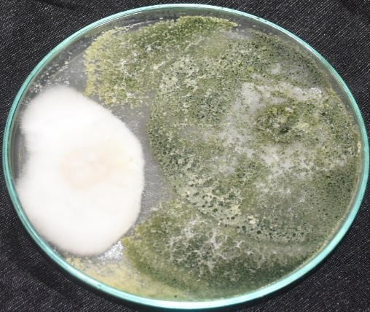  (a) | 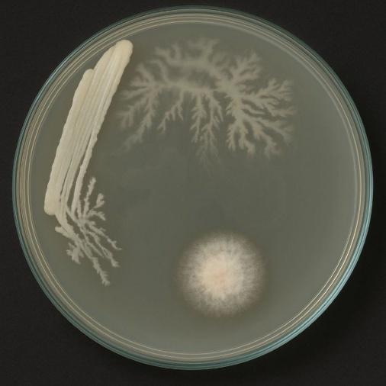  (b)
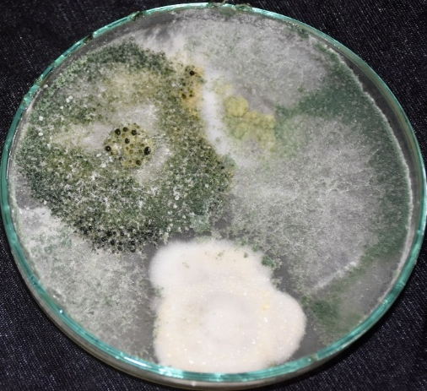  (c) | 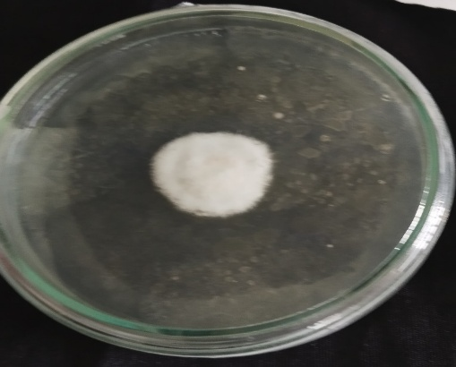  (d)
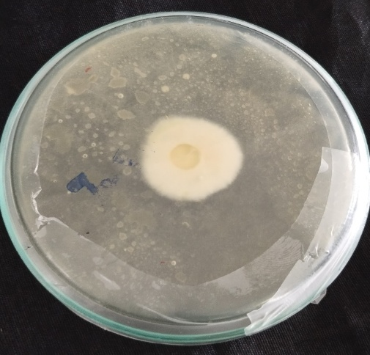  (e) | 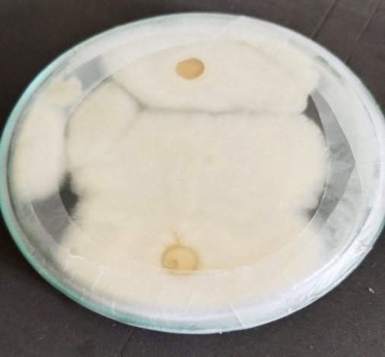  (f)
Figure 4: In vitro efficacy test of biocontrol and anti-fungal agents against F. pongamiae (a) Trichoderma viride+ F. pongamiae (b) Pseudomonas fluorescens+ F. pongamiae (c) T. viride + P. fluorescens+ F. pongamiae (d) Pongam oil (5%) + F. pongamiae (e) Carbendazim (0.1%) + F. pongamiae (f) F. pongamiae.

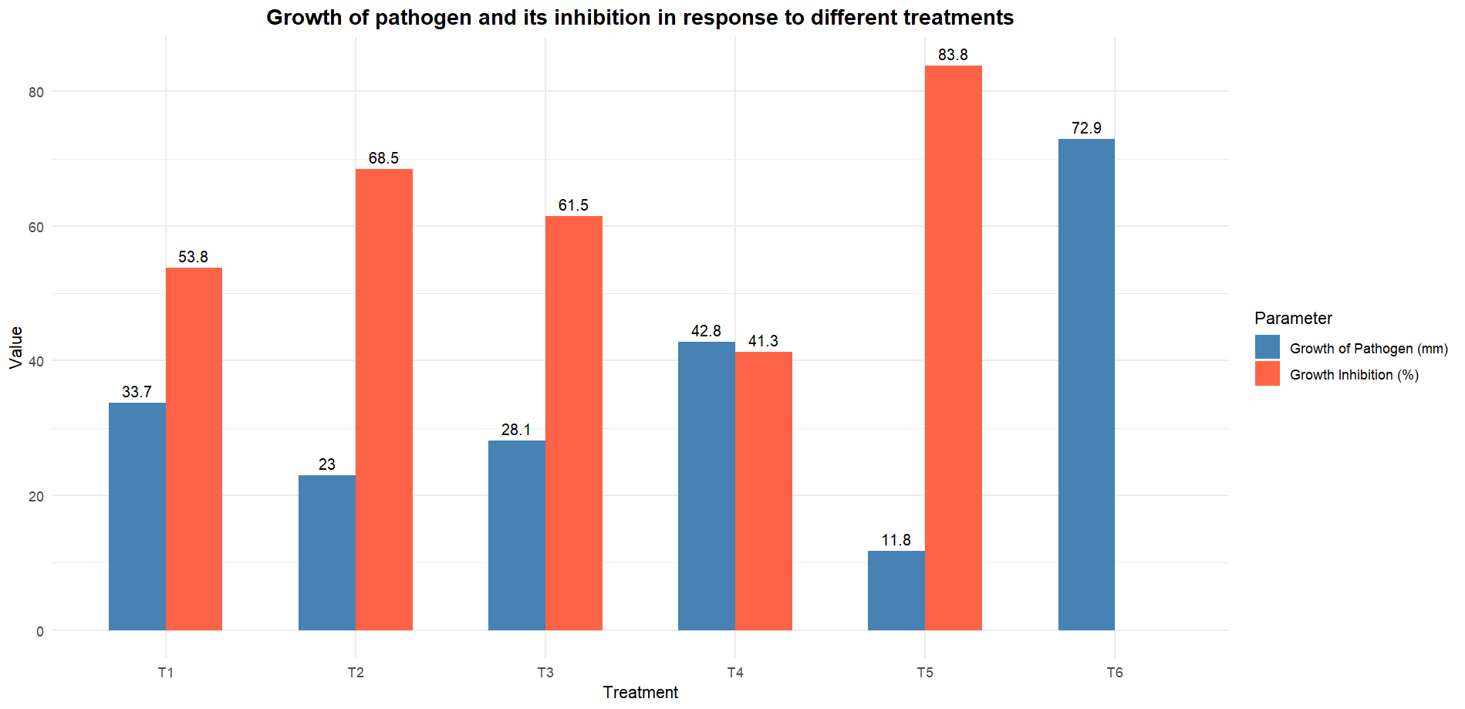
Figure 5: Growth of pathogen and its inhibition in response to different treatments.
The antagonistic activity of Pseudomonas spp. against phytopathogenic fungi is well documented (Islam et al., 2018) and this property has often been used as means for in vitro screening of various biocontrol agents against novel phytopathogens (Elad et al., 1980). It was reported that the combined role of both Trichoderma viride and Pseudomonas fluorescens (1+2%) in reducing mycelia growth of Fusarium oxysporum (Rajeswari and Kapoor, 2017) and also reported on cashew against C. gloeosprioides (Satapathy and Beura, 2020). Our in vitro data of antagonistic activity by P. fluorescens and T. viride reflect on their direct interaction with F. pongamiae via antibiosis or competition with the pathogen for nutrients. These interactions between the biocontrol agents and the phytopathogen are likely a result of highly coordinated and regulated cascade of metabolic events involving production of compounds and enzymes and other interfering metabolites in situ at low concentrations (Raaijmakers and Mazzola, 2012). The results of the present study were also in accordance with the findings of Bhanumathi and Rai, 2007 who reported in Azadirachta indica against the pathogens like Colletotrichum dematium and Fusarium solani. In which the spray of carbendazium at 50, 100, 150 ppm was found to reduce the mycelia growth of Fusarium solani in range of 88.54 - 86.32%, carbendazim (0.1%) has showed the 100 percent inhibition of fungal growth and also other fungicides like Propiconizole (0.1%), Mancozeb+Carbendazim (0.25%), tricyciazole (0.15%) were also showed 100 percent inhibition of fungal growth of Colletotrichum gloeosprioides on Garcinia indica and similar results were recorded by Sahoo, (2015), in terms of fungicidal role against the pathogen of Colletotrichum gloeosprioides in Rauwolfia serpentina and among, the biocontrol agents, Pseudomonas fluorescens reduced the 55.88 % of mycelia growth and among the plant extracts, the Eucalyptus oil was able to reduce 39.8 % of mycelia growth of Colletotrichum gloeosprioides and (Patil et al., 2010) in sapota with leaf blight due to C. gloeosprioides. Dual culture and poison food technique in turmeric was reported by Kothikar (2017).
4. Conclusion
The current research confirmed Fusicladium pongamiae as the cause of leaf spot and blight of Millettia pinnata. Pathogenicity tests confirmed its disease-causing ability. Of the treatments under test, Pseudomonas fluorescens exhibited better in vitro antagonistic activity, followed by Trichoderma viride. The chemical fungicide Carbendazim (0.1%) inhibited greatest growth of fungi. These results demonstrate the potential of combining biocontrol agents with chemical management practices for successful disease suppression. These integrated strategies can decrease chemical dependency, encourage eco-friendly plant health management, and minimize environmental damage in Millettia pinnata plantations infested by F. pongamiae.

Conflict of interest:
No potential conflict of interest was reported by the authors

COMPETING INTERESTS DISCLAIMER:
Authors have declared that they have no known competing financial interests OR non-financial interests OR personal relationships that could have appeared to influence the work reported in this paper.

Disclaimer (Artificial intelligence)
Option 1:
Author(s) hereby declare that NO generative AI technologies such as Large Language Models (ChatGPT, manuscript.
Option 2:
Author(s) hereby declare that generative AI technologies such as Large Language Models, etc. have been used during the writing or editing of manuscripts. This explanation will include the name, version, model, and source of the generative AI technology and as well as all input prompts provided to the generative AI technology
Details of the AI usage are given below:
1.
2.
3.

References
Baker, K. F., & Cook, R. J. (1974). Biological control of plant pathogens (pp. xv+-433).
Bhanumathi, A., & Rai, V. R. (2007). Leaf blight of Azadirachta indica and its management in vitro. African Journal of Agricultural Research, 2(10), 538–543.
Chaube, H. S., Mishra, D. S., Varshney, S., & Singh, U. S. (2002). Biological control of plant pathogens by fungal antagonists: Historical background, present status and future prospects. Annual Review of Plant Pathology, 2, 1–42.
Dadwal, V. S., & Soni, K. K. (1981). Studies on Fusicladium leaf spot of Pongamia pinnata. Indian Forester, 107(8), 500–504.
Elad, Y. (2000). Biological control of foliar pathogens by means of Trichoderma harzianum and potential modes of action. Crop Protection, 19(8–10), 709–714.
Elad, Y., Chet, I., & Katan, J. (1980). Trichoderma harzianum: A biocontrol agent effective against Sclerotium rolfsii and Rhizoctonia solani. Phytopathology, 70(2), 119–121.
Hossain, M. Z. (2007). Monograph on Pongamia pinnata (Linn.) Pierre. Forestry and Wood Technology Discipline, Khulna University.
Islam, M. A., Nain, Z., Alam, M. K., Banu, N. A., & Islam, M. R. (2018). In vitro study of biocontrol potential of rhizospheric Pseudomonas aeruginosa against Fusarium oxysporum f. sp. cucumerinum. Egyptian journal of Biological Pest control, 28(1), 90.
Kohl, J., Kolnaar, R., & Ravensberg, W. J. (2019). Mode of action of microbial biological control agents against plant diseases: Relevance beyond efficacy. Frontiers in Plant Science, 10, 845.
Kothikar, R. (2017). Screening of fungicides, botanicals and bioagents against Colletotrichum dematium in vitro. MAYFEB Journal of Agricultural Science, 3, 1–6.
Morandi, M. A. B., De Paula Júnior, T. J., Bettiol, W., & Teixeira, H. (2009). Biological control of pathogenic fungi. Informe Agropecuário, 30(251), 73–82.
Mridha, M. A. U., Jabbar, F., Bhuiyan, M. K., Rahman, M., Akter, F., & Dewan, S. (2007). The severity and cause of leaf spot disease of Pongamia pinnata L. and fungicidal control of the pathogen. Journal of Forestry Research, 18(3), 236–240.
Pathak, H., Maru, S., Satya, H. N., & Silawat, S. C. (2015). Fungal diseases of trees in forest nurseries of Indore, India. Journal of Plant Pathology and Microbiology, 6(8), 297.
Patil, P. P., Joshi, M. S., Kadam, J. J., & Mundhe, V. G. (2010). In vitro evaluation of fungicides and bioagents against Colletotrichum gloeosporioides causing leaf blight in sapota. Journal of Plant Disease Sciences, 5(1), 76–78.
Raaijmakers, J. M., & Mazzola, M. (2012). Diversity and natural functions of antibiotics produced by beneficial and plant pathogenic bacteria. Annual Review of Phytopathology, 50, 403–424.
Rajeswari, P., & Kapoor, R. (2017). Combinatorial efficacy of Trichoderma spp. and Pseudomonas fluorescens to enhance suppression of cell wall degrading enzymes produced by Fusarium wilt of Arachis hypogaea L. International Journal of Agricultural Research, Innovation and Technology, 7(2), 36–42.
Sahoo, J. (2015). Studies on leaf blight of Sarpagandha (Rauvolfia serpentina (Linn.) Benth. ex Kurz.) and its management (Master’s thesis). Orissa University of Agriculture and Technology.
Satapathy, R. R., & Beura, S. K. (2020). Management of Colletotrichum gloeosporioides (Penz.) causing cashew anthracnose through bio-control agents. Journal of Pharmacognosy and Phytochemistry, 9(1), 2225–2227.
Silva, G. B. P. D., Heckler, L. I., Santos, R. F. D., Durigon, M. R., & Blume, E. (2015). Identification and utilization of Trichoderma spp. stored and native in Sclerotinia sclerotiorum biocontrol. Revista Caatinga, 28, 33–42.
Thambugala, K. M., Daranagama, D. A., Phillips, A. J., Kannangara, S. D., & Promputtha, I. (2020). Fungi vs. fungi in biocontrol: An overview of fungal antagonists applied against fungal plant pathogens. Frontiers in Cellular and Infection Microbiology, 10, 604923.
Yu, C., & Luo, X. (2020). Trichoderma koningiopsis controls Fusarium oxysporum causing damping-off in Pinus massoniana seedlings by regulating active oxygen metabolism, osmotic potential, and the rhizosphere microbiome. Biological Control, 150, 104352

