Review Article
Beyond Parental Limits: The Role of Transgressive Segregation in Modern Plant Breeding

ABSTRACT
Transgressive segregation (TS), where progeny traits exceed the parental range, is a pivotal mechanism for genetic gain in plant breeding, crucial for addressing global food security. This review examines the genetic basis of TS, driven by complementary gene action, epistasis, and beneficial allele recombination. It traces the evolution of detection from phenotypic screening to advanced molecular tools like QTL mapping, MAS, and GS, now enhanced by high-throughput phenotyping. For plant breeders, TS is a critical process for developing superior cultivars with enhanced yield, disease resistance, and abiotic stress tolerance. Despite challenges like complex genetics, emerging technologies—including high-resolution genomics, machine learning, and gene editing—are poised to transform TS from an empirical process into a predictable breeding strategy. Harnessing these innovations is essential for developing robust, climate-resilient crops for sustainable agriculture.

Keywords
Transgressive segregation (TS),Genetic gain,Crop improvement,Quantitative traits,Epistasis,QTL mapping,Genomic Selection (GS), Marker-Assisted Selection (MAS), High-throughput phenotyping, Gene editing, Climate resilience,Sustainable agriculture

1. Introduction
1.1. The Grand Challenge of Plant Breeding
The escalating global population, coupled with the pervasive impacts of climate change and the degradation of arable land, presents an unprecedented challenge to global food security (Godfray, Beddington, Crute, Haddad, Lawrence, Muir, Pretty, Robinson, Thomas, & Toulmin, 2010). To meet the burgeoning demand for food, feed, fibre, and fuel, agricultural productivity must continue to increase substantially, while simultaneously enhancing resilience to biotic and abiotic stresses. Plant breeding, a discipline rooted in the manipulation of genetic variation, stands as a cornerstone in addressing these multifaceted challenges. For centuries, breeders have meticulously selected and combined desirable traits from existing germplasm to develop improved crop varieties. However, the continuous pursuit of higher yields, enhanced nutritional quality, and robust stress tolerance necessitates innovative approaches that transcend the limitations of parental germplasm (Tester & Langridge, 2010). Traditional breeding methods, often reliant on the additive accumulation of favourable alleles present within parental lines, frequently encounter genetic plateaus, making further significant gains increasingly difficult. This inherent limitation underscores the imperative for mechanisms that can generate novel and superior genetic combinations, pushing the boundaries of current phenotypic expression.
1.2. Defining Transgressive Segregation
Within this context, transgressive segregation (TS) emerges as a pivotal biological phenomenon. Defined as the appearance of progeny in a segregating population (typically F2 or later generations) that exhibit phenotypic values for a particular quantitative trait falling outside the range of both parents (de Vicente & Tanksley, 1993; Rieseberg et al., 1999). While TS can manifest as either superior or inferior performance relative to the parental lines, the focus in plant breeding is overwhelmingly on the former – the generation of offspring with exceptionally desirable traits that surpass the best parent. This phenomenon is distinct from simple Mendelian inheritance, where the F1 generation typically displays an intermediate phenotype or one resembling a dominant parent, and subsequent generations merely re-segregate parental traits. Instead, TS is a hallmark of quantitative traits, governed by multiple genes (Quantitative Trait Loci or QTLs), whose complex interactions and recombination patterns lead to novel phenotypic extremes (Lynch & Walsh, 1998). The historical recognition of TS, albeit often implicitly, has long guided breeders in their pursuit of 'super-parents' that, when crossed, yield offspring with unforeseen genetic potential.
1.3. Why Transgressive Segregation is a Cornerstone
The ability of TS to generate individuals with phenotypes superior to both parents is what elevates it to a cornerstone of modern plant breeding. It represents the primary biological engine for achieving true genetic progress, allowing breeders to break through existing performance ceilings and unlock novel genetic combinations that were not apparent in either parent (Dudley, 1994). This is particularly crucial for complex traits like yield, which are inherently quantitative and influenced by numerous genes with often subtle, complementary effects. Without the capacity for transgressive segregation, plant improvement would be largely confined to reshuffling existing parental alleles, severely limiting the potential for significant advancements. The phenomenon enables the accumulation of favorable alleles from diverse parental sources into a single, superior genotype, often through complex additive-additive epistatic interactions or the beneficial recombination of linked genes (Eshed & Zamir, 1995). Consequently, understanding the genetic underpinnings of TS, developing efficient methods for its detection, and devising breeding strategies to maximize its occurrence are paramount for the continued success of crop improvement programs worldwide. This review article aims to comprehensively examine the genetic mechanisms driving transgressive segregation, explore the methodologies employed for its detection and identification, highlight its diverse applications in enhancing key agricultural traits, and discuss the challenges and future prospects for harnessing this powerful evolutionary and breeding phenomenon.

2. Genetic Basis and Mechanisms of Transgressive Segregation
2.1. Mendelian Segregation vs. Transgressive Segregation
At its core, all inheritance follows Mendelian principles, dictating how alleles for specific genes segregate and combine during sexual reproduction. In simple Mendelian inheritance involving a single gene, the F1 generation typically exhibits a phenotype that is either intermediate between the two parents or identical to one parent if complete dominance is present. Subsequent F2 generations then display a predictable ratio of parental phenotypes and the F1 hybrid phenotype. However, transgressive segregation (TS) transcends this straightforward model, particularly when dealing with quantitative traits that are influenced by multiple genes (polygenic inheritance) and environmental factors (Lynch & Walsh, 1998). Unlike the re-shuffling of parental traits seen in simple Mendelian segregation, TS involves the generation of novel phenotypic extremes, often superior, due to complex genetic interactions that lead to combinations of alleles not present in either parent. This highlights that while Mendelian laws govern individual gene segregation, the collective action and interaction of many such genes underpin the phenomenon of transgression.
2.2. Key Genetic Mechanisms
The occurrence of transgressive segregation is attributed to several interconnected genetic mechanisms, often acting in concert. Understanding these mechanisms is crucial for breeders to design effective crossing and selection strategies.
2.2.1. Complementary Gene Action (Additive-Additive Interactions)
The most widely accepted and frequently observed genetic basis for transgressive segregation is complementary gene action, particularly involving additive-additive interactions (Rieseberg et al., 1999; Tanksley, 1993). This mechanism posits that each parent contributes different sets of favorable alleles at different unlinked or loosely linked loci. Neither parent possesses the full complement of beneficial alleles required for the extreme phenotype. For instance, Parent A might carry favorable alleles for a trait at loci L1 and L2, while Parent B carries favorable alleles at loci L3 and L4. When these parents are crossed, and the F1 hybrid is selfed or intermated, recombination can lead to F2 individuals that inherit beneficial alleles from both parents (e.g., L1, L2, L3, L4). The cumulative additive effect of these combined favorable alleles results in a phenotype that surpasses the performance of either parent. This concept is often described as "gene pyramiding" in its simplest form, where beneficial alleles from multiple sources are brought together in a single genotype (Collard & Mackill, 2008). The greater the number of loci contributing to the trait and the more diverse the parental contributions of favorable alleles, the higher the probability of observing transgressive segregants.
2.2.2. Epistatic Interactions
Epistasis, defined as the interaction between genes at different loci where one gene modifies the expression of another, plays a significant role in generating transgressive segregation (Carlborg & Haley, 2004). While additive gene action is often the primary driver, epistatic interactions can either enhance or mask the effects of individual genes, leading to unexpected phenotypic outcomes. Various types of epistasis can contribute to TS:
- Additive x Additive Epistasis: This is the most common form of epistasis contributing to TS, often working synergistically with complementary additive gene action. Here, the combined effect of additive alleles at two or more loci is non-linear, resulting in a phenotype greater than the sum of their individual additive effects (Falconer, 1996).
- Additive x Dominance Epistasis: The interaction between an additive effect at one locus and a dominance effect at another locus.
- Dominance x Dominance Epistasis: The interaction between dominance effects at two or more loci.
In cases of epistasis, a beneficial allele might be masked or its effect suppressed in one parent due to the genetic background. Through recombination in segregating populations, this masked beneficial allele can be combined with a different genetic background from the other parent, leading to its unmasking and expression, or a synergistic interaction that results in a transgressive phenotype (Eshed & Zamir, 1995). For example, a gene conferring partial disease resistance might only show its full potential when combined with a specific modifier gene from the other parent.
2.2.3. Recombination of Linked Favorable Alleles
Another critical mechanism involves the recombination of linked favorable alleles (Rieseberg, Archer, & Wayne, 1999). Often, desirable alleles are linked to undesirable alleles (linkage drag) on the same chromosome in the parental lines. For instance, a parent might possess a beneficial allele for high yield linked to an allele for susceptibility to a disease. The other parent might have disease resistance but be linked to a lower yield allele. During meiosis, crossing over events can break these undesirable linkages, allowing for the recombination of the favorable alleles from both parents onto a single chromosome in the offspring. This process can create a new chromosome segment that carries only the beneficial alleles, leading to a transgressive phenotype that combines the best aspects of both parents, free from the previous linkage drag (Young, 1996). This mechanism underscores the importance of generating large segregating populations to increase the probability of rare, beneficial recombination events.
2.2.4. Overdominance (Heterosis)
While overdominance, where the heterozygote performs better than either homozygote, is primarily associated with heterosis (hybrid vigor) in F1 hybrids, its role in transgressive segregation in later generations is more nuanced (Shull, 1952). Some theories suggest that overdominance at individual loci, when combined with additive effects across multiple loci, can contribute to transgressive phenotypes in segregating populations. If a specific heterozygous combination at one or more loci confers a significant advantage, and this combination is maintained or recreated in a subset of segregants, it could contribute to transgression. However, the contribution of overdominance to stable transgressive lines in homozygous later generations (e.g., RILs) is limited, as homozygosity eliminates the heterozygous advantage. Its primary relevance is often in the context of explaining the initial F1 vigor that might precede the segregation of even more extreme phenotypes.
2.2.5. Quantitative Trait Loci (QTL) Perspective
From a quantitative genetics perspective, transgressive segregation is often the result of the accumulation of multiple small-effect Quantitative Trait Loci (QTLs) (Tanksley, 1993). QTL mapping studies frequently reveal that parents contribute different sets of beneficial alleles at various genomic regions. For example, Parent A might contribute positive alleles at QTL1 and QTL3, while Parent B contributes positive alleles at QTL2 and QTL4. An offspring that inherits the favorable alleles from all four QTLs from both parents will exhibit a phenotype superior to either parent. The magnitude of transgression often correlates with the number of QTLs with complementary effects contributed by the parents (Eshed & Zamir, 1995). Modern genomic approaches allow for the precise identification of these QTLs, providing a molecular basis for understanding and predicting TS.
2.3. Environmental Influence and Genotype-by-Environment (GxE) Interaction
It is crucial to acknowledge that transgressive segregation is a phenotypic observation, and as such, it is influenced by the environment in which the plants are grown. Genotype-by-Environment (GxE) interaction can significantly impact the expression of quantitative traits, potentially masking or revealing transgressive segregants (Kang, 1997). A genotype that shows transgression in one environment (e.g., under optimal conditions) might not exhibit the same superior performance, or even perform poorly, in a different environment (e.g., under stress). Therefore, the identification and validation of stable transgressive segregants necessitate multi-location and multi-year testing to ensure their consistent superior performance across diverse growing conditions. Understanding the interplay between genetics and environment is vital for selecting truly robust and broadly adapted transgressive lines.

3. Detection and Identification of Transgressive Segregants
The successful exploitation of transgressive segregation (TS) in plant breeding hinges on the accurate and efficient detection and identification of superior segregants within large and often diverse populations. This process has evolved significantly with advancements in statistical genetics, molecular biology, and high-throughput technologies.
3.1. Phenotypic Evaluation
The most fundamental approach to detecting transgressive segregants involves direct phenotypic evaluation of individuals in segregating populations (e.g., F2, F3, recombinant inbred lines (RILs), or doubled haploids (DHs)). This entails meticulous measurement of the target quantitative trait(s) in both the parental lines and a sufficiently large number of offspring. Transgression is then identified when an individual's phenotypic value for a trait falls significantly outside the range defined by the two parents (Rieseberg, Archer, & Wayne, 1999).
Challenges in phenotypic evaluation include the inherent environmental variation that can obscure true genetic potential, leading to misidentification of transgressors or failure to recognize them. Therefore, experiments must be conducted under controlled or replicated field conditions across multiple environments to minimize environmental noise and allow for the assessment of genotype-by-environment (GxE) interactions (Kang, 1998). Accurate and precise phenotyping is paramount, as measurement errors can significantly impact the reliability of identifying truly transgressive individuals.
3.2. Statistical Approaches
To move beyond simple visual inspection, various statistical methods are employed to formally identify and quantify transgressive segregation:
3.2.1. Comparison with Parental Lines: Statistical tests are used to compare the mean or range of the segregating population with that of the parental lines and often the F1 hybrid.
- t-tests or ANOVA: These can determine if the mean of a subset of the segregating population (e.g., selected F2 individuals) is statistically different and superior to the better parent (Lynch & Walsh, 1998).
- Non-parametric tests: These are useful when data do not meet the assumptions of parametric tests, particularly for traits with non-normal distributions.
- Range comparison: A more direct approach involves identifying individuals whose phenotypic values exceed the maximum (for positive transgression) or fall below the minimum (for negative transgression) observed in the parental lines across all replicates.
3.2.2. Distribution Analysis: Examining the phenotypic distribution of the segregating population provides insights into the presence and extent of TS. A bimodal or skewed distribution, with a significant tail extending beyond the parental range, is indicative of transgression (de Vicente & Tanksley, 1993). Statistical parameters like kurtosis and skewness can quantify the shape of these distributions.
3.2.3. Selection Indices: For breeding programs targeting multiple traits, selection indices can be constructed to combine information from several traits into a single value. This allows for the identification of individuals that are transgressive for an overall desired phenotype, rather than just a single trait (Hazel, 1943).
3.3. Molecular Marker-Assisted Selection (MAS) and QTL Mapping
The advent of molecular markers revolutionized the ability to detect and understand the genetic basis of TS, moving beyond purely phenotypic observations.
3.3.1. QTL Mapping for TS: Quantitative Trait Locus (QTL) mapping is a powerful tool to identify genomic regions associated with quantitative traits. In the context of TS, QTL mapping helps pinpoint the specific loci where complementary gene action or epistatic interactions lead to superior phenotypes (Tanksley, 1993).
- Mapping Populations: Recombinant inbred lines (RILs) and doubled haploids (DHs) are particularly valuable as they provide immortal populations of homozygous lines, allowing for replicated phenotyping and precise QTL localization (Burr et al., 1988). F2 and F2:3 populations are also used.
- Identification of Complementary QTLs: QTL mapping studies frequently reveal that each parent contributes different favorable alleles at different QTLs. Transgressive segregants are those individuals that have accumulated a greater number of these favorable alleles from both parents (Eshed & Zamir, 1995). For example, a QTL mapping study might identify a QTL for increased yield on chromosome 1 from Parent A and another on chromosome 5 from Parent B. Individuals combining favorable alleles at both loci would be transgressive.
- Epistatic QTLs: Advanced QTL mapping methods can also detect epistatic interactions between QTLs that contribute to TS, providing a deeper understanding of the genetic architecture (Carlborg & Haley, 2004).
3.3.2. Marker-Assisted Selection (MAS) for TS: Once QTLs contributing to TS are identified, tightly linked molecular markers can be used for Marker-Assisted Selection (MAS). This allows breeders to select for desired allelic combinations contributing to transgression at an early seedling stage, independent of environmental effects, and significantly accelerate the breeding cycle (Collard & Mackill, 2008). MAS is particularly effective for gene pyramiding, where multiple favorable alleles from different sources are combined into a single genotype, a direct application of the complementary gene action mechanism of TS.
3.4. Genomic Selection (GS) and Prediction of TS
Genomic Selection (GS) represents a further advancement, utilizing genome-wide molecular markers (e.g., SNPs) to predict the breeding values of individuals (Meuwissen, Hayes, & Goddard, 2001). Unlike MAS, which targets specific QTLs, GS models capture the cumulative effects of all markers across the genome, including small-effect QTLs and potentially some epistatic interactions that are difficult to resolve with traditional QTL mapping.
- Prediction of Transgressive Potential: GS models can potentially predict which parental combinations are most likely to yield transgressive segregants by estimating the genomic estimated breeding values (GEBVs) of potential offspring (Heffner, Sorrells, & Jannink, 2009). This allows for more informed parental selection, increasing the probability of generating superior F2 populations.
- Early Selection: GS enables selection of promising individuals at very early stages, even before phenotypic data is available, further accelerating the breeding process and increasing the efficiency of identifying transgressors.
3.5. High-Throughput Phenotyping and Omics Technologies
Modern plant breeding benefits immensely from high-throughput phenotyping (HTP) and various omics technologies, which enhance the precision and scale of TS detection.
- High-Throughput Phenotyping (HTP): Robotic platforms, drones, and sensor-based systems allow for rapid, non-destructive, and precise measurement of various physiological and morphological traits on thousands of plants (Araus & Cairns, 2014). This significantly increases the capacity to screen large segregating populations, improving the chances of identifying rare transgressive individuals and reducing the impact of human error and environmental variation.
- Multi-Omics Integration: Integrating data from genomics (DNA sequence), transcriptomics (gene expression), proteomics (protein profiles), and metabolomics (metabolite levels) provides a holistic view of the biological pathways underlying complex traits (Varshney, Thudi, Nayak, Gaur, Kashiwagi, Krishnamurthy, Jaganathan, Koppolu, Bohra, Tripathi, & Rathore, 2014). This multi-omics approach can help unravel the intricate gene networks and regulatory mechanisms that contribute to transgressive phenotypes, offering deeper insights into the genetic architecture of TS and guiding more targeted breeding efforts. For example, identifying specific gene expression patterns or metabolic pathways that are uniquely upregulated in transgressive segregants can lead to the discovery of novel genetic markers or targets for manipulation.
In summary, the detection and identification of transgressive segregants have evolved from labor-intensive phenotypic screening to sophisticated molecular and computational approaches. The integration of QTL mapping, MAS, GS, HTP, and multi-omics technologies provides a powerful toolkit for breeders to efficiently pinpoint and utilize these valuable individuals, thereby accelerating the development of superior crop varieties.
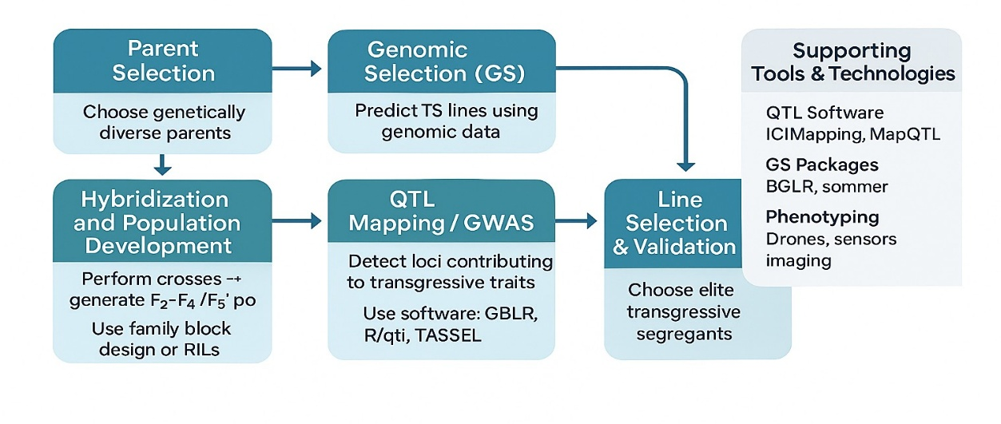
Figure 1. Schematic workflow for exploiting transgressive segregation in plant breeding.
The process begins with the selection of genetically diverse parents, followed by hybridization and development of segregating populations (e.g., F₂–F₄ or recombinant inbred lines). Genomic Selection (GS) predicts promising transgressive lines using genome-wide marker data. QTL mapping or genome-wide association studies (GWAS) are used to identify loci contributing to transgressive traits. Finally, elite segregants are selected and validated based on phenotypic performance and genetic merit. Supporting tools include QTL mapping software (e.g., ICIMapping, MapQTL), GS packages (e.g., BGLR, sommer), and advanced phenotyping technologies (e.g., drones, sensor imaging).

4. Role of Transgressive Segregation in Crop Improvement
Transgressive segregation (TS) is not merely a genetic curiosity; it is a powerful engine driving genetic gain in plant breeding, enabling the development of superior crop varieties that surpass the performance of their parental lines. Its significance lies in its capacity to generate novel and improved combinations of alleles, pushing the boundaries of what is achievable through simple selection within existing parental variation. This section explores the multifaceted roles of TS across various critical aspects of crop improvement.
4.1. Enhancing Yield and Yield Components
Yield is arguably the most critical and complex quantitative trait in almost all major crops, influenced by numerous interacting genetic and environmental factors. Transgressive segregation has been instrumental in achieving significant yield increases in staple crops worldwide. This is primarily facilitated by the complementary action of multiple genes contributing to different yield components (e.g., grain number, grain weight, tillering/branching, harvest index) that are brought together from diverse parental sources into a single, superior genotype (Eshed & Zamir, 1995; Tanksley, 1993).
For instance, in maize (Zea mays), studies have frequently reported transgressive segregants for grain yield, often attributed to the accumulation of favorable alleles from parents that individually might not be top performers but collectively possess complementary genetic strengths (Stich, Melchinger, Piepho, Hamrit, Schipprack, Maurer, & Reif, 2007). Similarly, in rice (Oryza sativa), the development of high-yielding hybrid varieties has often relied on identifying parental lines that, when crossed, produce F1 hybrids or segregating populations with superior yield performance due to TS, combining advantageous alleles for traits like panicle architecture and grain filling (Xing & Zhang, 2010). In wheat (Triticum aestivum), TS for yield has been observed in crosses between diverse germplasm, highlighting the potential to combine yield-contributing QTLs from different genetic backgrounds (Kumar, Kulwal, Gaur, Tyagi, Khurana, Khurana, Balyan, & Gupta, 2006).
4.2. Improving Disease and Pest Resistance
The development of crop varieties with durable resistance to diseases and pests is a continuous battle for plant breeders. Transgressive segregation plays a crucial role by enabling the pyramiding of multiple resistance genes (R-genes) from different parental sources into a single genotype, thereby conferring broader and more durable resistance (Collard & Mackill, 2008). Single R-genes can often be overcome by rapidly evolving pathogens, but combinations of multiple R-genes provide a more robust defense mechanism.
For example, in wheat, transgressive segregants have been identified for resistance to various rust diseases (e.g., stem rust, leaf rust, stripe rust) by combining different resistance loci from diverse parents, leading to varieties with enhanced and more stable resistance profiles (Singh, Hodson, Huerta-Espino, Jin, Bhavani, Njau, Herrera-Foessel, Singh, Singh, & Govindan, 2011). In rice, TS has been observed for resistance to diseases like blast and bacterial blight, where recombination events bring together complementary resistance alleles, resulting in progeny with higher levels of resistance than either parent (Ashkani, Rafii, Shabanimofrad, Miah, Sahebi, Azizi, Tanweer, Akhtar, & Nasehi, 2015). This phenomenon is also vital in developing resistance to insect pests, where the combination of different defense mechanisms can lead to a more effective and sustainable solution.
4.3. Enhancing Abiotic Stress Tolerance
With climate change intensifying the frequency and severity of abiotic stresses such as drought, salinity, heat, and cold, breeding for enhanced stress tolerance has become a paramount objective. Transgressive segregation offers a pathway to combine various adaptive mechanisms from different parents, leading to varieties that can perform better under adverse conditions. Parents may possess different physiological or morphological traits that confer partial tolerance (e.g., deep root systems for drought, ion exclusion mechanisms for salinity). When these are combined in transgressive segregants, the resulting progeny can exhibit superior overall stress resilience (Mittler, 2006).
For instance, in barley (Hordeum vulgare), transgressive segregants have been identified for drought tolerance, combining alleles related to water use efficiency and osmotic adjustment from different parental lines (Teulat, Zoumarou-Wallis, Rotter, Ben Salem, Bahri, & This, 2003). In rice, TS has been reported for salinity tolerance, where progeny outperform parents by accumulating favorable alleles for traits like Na+ exclusion and K+ retention (Gregorio, Senadhira, Mendoza, Manigbas, Roxas, & Guerta, 2002). Similarly, improved heat tolerance in various crops can be achieved by combining alleles that regulate stomatal conductance, membrane stability, or antioxidant defense systems, often resulting in transgressive phenotypes under high-temperature stress.
4.4. Improving Quality Traits
Beyond yield and resistance, transgressive segregation is equally important for enhancing various quality traits that impact nutritional value, processing efficiency, and consumer appeal. These traits are often quantitative and highly influenced by multiple genes.
- Nutritional Quality: TS has been observed for increasing protein content in cereals, oil content in oilseeds, and concentrations of essential micronutrients (e.g., iron, zinc, provitamin A) in biofortification programs (Tester & Langridge, 2010). For example, in maize, transgressive segregants for increased lysine and tryptophan content have been identified, contributing to improved nutritional value (Mišević, 1989).
- Processing Quality: Traits like starch characteristics in potato, baking quality in wheat, and fiber quality in cotton are complex and polygenic. TS allows for the combination of alleles that optimize these properties. In wheat, transgressive segregants with superior dough strength and extensibility have been identified, crucial for bread making (Sourdille, Singh, Cadalen, Brown-Guedira, Gay, Qi, Gill, Dufour, Murigneux, & Bernard, 2004).
- Sensory Quality: For horticultural crops, fruit flavor, aroma, and texture are critical. TS can lead to novel combinations of compounds that enhance these sensory attributes, as seen in tomato for improved flavor profiles (Tieman, Zhu, Resende, Lin, Nguyen, Bies, Rambla, Beltran, Taylor, Zhang, & Ikeda, 2017).
4.5. Broadening Genetic Diversity and Creating Novel Germplasm
Perhaps one of the most fundamental roles of transgressive segregation is its contribution to broadening the genetic diversity within breeding populations and creating truly novel germplasm. In many modern breeding programs, genetic diversity can become narrow due to repeated selection within elite germplasm. TS, particularly when involving crosses between genetically divergent parents (e.g., elite lines with landraces or wild relatives), introduces new allelic combinations that were not previously present or expressed in the parents (Rieseberg, Archer, & Wayne, 1999).
This generation of novel genotypes is crucial for breaking genetic plateaus and providing the raw material for future genetic improvement. It allows breeders to explore previously unaccessed genetic potential, ensuring the long-term sustainability of crop breeding efforts by providing a continuous source of variation for adaptation to changing environmental conditions and market demands. The ability of TS to unlock hidden genetic potential from diverse gene pools makes it indispensable for continuous crop improvement.
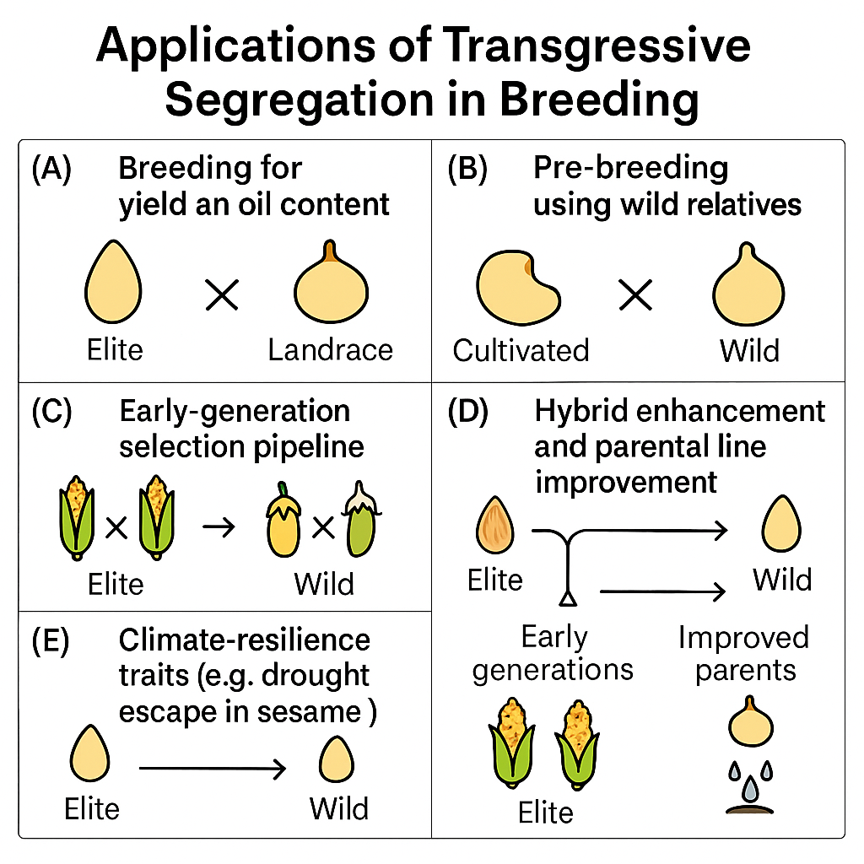
Figure 2 .Applications of transgressive segregation in plant breeding.
(A) Breeding for yield and oil content through crossing elite and landrace lines; (B) Pre-breeding using wild relatives to introduce novel alleles into cultivated backgrounds; (C) Early-generation selection pipeline combining elite and wild germplasm; (D) Hybrid enhancement and parental line improvement through transgressive recombinants; and (E) Development of climate-resilient traits such as drought escape via elite × wild crosses.

6. Challenges and Limitations in Exploiting Transgressive Segregation
Despite its immense potential as a cornerstone of plant breeding, the effective exploitation of transgressive segregation (TS) is not without its challenges and limitations. These hurdles often stem from the complex genetic architecture of quantitative traits, environmental influences, and the practical constraints of breeding programs.
6.1. Rarity of Transgressive Segregants
One of the primary limitations in harnessing TS is the inherent rarity of truly superior transgressive segregants, especially for highly complex traits governed by numerous genes with small effects (Lynch & Walsh, 1998). The probability of accumulating all or most of the favorable alleles from both parents into a single individual through random recombination decreases exponentially as the number of contributing loci increases.
- Population Size Requirement: This rarity necessitates the generation and evaluation of extremely large segregating populations (e.g., thousands or even tens of thousands of individuals in F2 or later generations) to increase the chance of identifying these rare, elite combinations (Bernardo, 2002). Such large-scale phenotyping and genotyping are resource-intensive, demanding significant land, labor, and financial investment.
- Detection Difficulty: Even within large populations, identifying the few truly transgressive individuals can be like finding a needle in a haystack, particularly if the magnitude of transgression is small or if the trait is difficult to measure precisely.
6.2. Difficulty in Disentangling Genetic Mechanisms
While the underlying genetic mechanisms of TS (complementary gene action, epistasis, recombination) are conceptually understood, precisely disentangling their individual contributions in a given cross remains a significant challenge (Carlborg & Haley, 2004).
- Complex Genetic Architecture: Most quantitative traits are polygenic, involving many genes with additive, dominant, and various epistatic interactions. Distinguishing the specific type of gene action contributing to transgression can be difficult, making it hard to predict which crosses will yield the best results or how to best select for the desired combinations (Mackay, Stone, & Ayroles, 2009).
- Phenotypic vs. Genotypic TS: An individual might show phenotypic transgression due to favorable environmental conditions rather than true genetic superiority, or vice versa. This highlights the need for robust experimental designs and multi-environment testing to confirm stable genetic transgression.
6.3. Environmental Interactions (GxE)
The expression of quantitative traits, and thus the manifestation of TS, is highly susceptible to environmental influences. Genotype-by-Environment (GxE) interactions can significantly complicate the identification and utilization of transgressive segregants (Kang, 1998).
- Inconsistent Performance: A transgressive segregant identified in one environment (e.g., optimal conditions) might not exhibit the same superior performance, or even perform poorly, in a different environment (e.g., under stress, different soil types, or varying climates). This lack of stability can limit the broad adaptability and commercial viability of a newly developed variety.
- Masking or Revealing TS: GxE interactions can either mask the true genetic potential of a transgressive genotype in an unfavorable environment or, conversely, create a pseudo-transgressive phenotype in a particularly favorable environment, leading to misleading results and inefficient selection. Therefore, extensive multi-location and multi-year trials are essential, adding to the cost and time of breeding programs.
6.4. Linkage Drag
When crossing diverse parents, especially those involving unadapted germplasm (e.g., wild relatives or landraces) to introduce novel beneficial alleles, linkage drag becomes a significant limitation (Zamir, 2001).
- Undesirable Linkages: Desirable alleles from the donor parent are often tightly linked to undesirable alleles (e.g., alleles for poor quality, susceptibility to other diseases, or undesirable plant architecture). During recombination, these undesirable segments tend to be carried along with the beneficial ones.
- Difficulty in Breaking Linkages: Breaking these tight linkages requires many generations of backcrossing and extensive recombination events, which is a time-consuming and labor-intensive process. If the linkage is very tight, it might be practically impossible to separate the desirable allele from its undesirable companion, limiting the utility of that specific transgressive event.
6.5. Cost and Time Investment
The strategies required to maximize TS, such as generating large populations, conducting extensive phenotyping, and performing multi-environment trials, are inherently resource-intensive.
- Resource Demands: Large-scale field trials require substantial land, irrigation, fertilizers, and labor. High-throughput phenotyping, while efficient, often involves expensive equipment and specialized expertise (Araus & Cairns, 2014).
- Long Breeding Cycles: The process of generating segregating populations, identifying transgressors, and then stabilizing these superior lines through selfing or backcrossing over multiple generations can be very time-consuming. This extended timeline can delay the release of new varieties and increase overall breeding costs. While molecular breeding tools like MAS and GS aim to accelerate this, their implementation also requires significant initial investment in infrastructure and expertise.
6.6. Predictability of Transgression
Despite advancements in genomics and quantitative genetics, accurately predicting which specific parental crosses will yield the highest frequency and magnitude of transgressive segregants remains challenging (Heffner, Sorrells, & Jannink, 2009).
- Lack of Comprehensive Models: Current genetic models, while powerful, may not fully capture all complex epistatic interactions or rare allele combinations that contribute to extreme transgression.
- Empirical Nature: Breeding for TS often retains an empirical component, relying on extensive crossing and evaluation, rather than precise prediction. While genomic selection offers improved predictability of breeding values, predicting the exact transgressive potential of a novel cross combination still involves a degree of uncertainty.
In conclusion, while transgressive segregation offers unparalleled opportunities for genetic improvement, breeders must navigate significant challenges related to the rarity of desirable segregants, the complexity of underlying genetic mechanisms, environmental variability, linkage drag, and the substantial resource investment required. Addressing these limitations through continued advancements in phenotyping, genotyping, and computational breeding will be crucial for more effectively harnessing this powerful phenomenon.

7. Future Perspectives and Emerging Technologies
The landscape of plant breeding is continuously evolving, driven by rapid advancements in genomics, phenomics, and computational biology. These emerging technologies are poised to revolutionize our ability to understand, predict, and effectively exploit transgressive segregation (TS), transforming it from a serendipitous event into a more predictable and manageable phenomenon in crop improvement.
7.1. High-Resolution Genomic Approaches
The increasing affordability and accessibility of high-throughput sequencing technologies are paving the way for unprecedented resolution in understanding plant genomes.
- Whole-Genome Sequencing (WGS) and Pangenomics: Moving beyond single reference genomes, WGS of diverse germplasm and the development of pangenomes (representing the entire gene set of a species, including core and dispensable genes) will enable the identification of all genetic variations, including rare alleles, structural variants (e.g., insertions, deletions, inversions), and copy number variations, that contribute to TS (Gore et al., 2009; Bayer et al., 2020). This comprehensive view of genetic diversity will allow for a more precise identification of complementary alleles and epistatic interactions underlying transgressive phenotypes.
- Functional Genomics: Integrating WGS data with functional genomics approaches (e.g., RNA-seq, ChIP-seq) will help elucidate the regulatory networks and gene expression patterns associated with transgressive traits, providing deeper insights into the molecular mechanisms driving superior performance.
7.2. Advanced Statistical and Machine Learning Models
The sheer volume and complexity of genomic and phenomic data necessitate sophisticated analytical tools. Advanced statistical and machine learning (ML) models are becoming indispensable for predicting complex trait performance and optimizing breeding strategies for TS.
- Genomic Prediction Refinement: While genomic selection (GS) is already powerful, new models incorporating non-additive genetic effects (epistasis, dominance) more explicitly will improve the accuracy of predicting transgressive potential (Varshney, Roorkiwal, & Sorrells, 2017). Deep learning algorithms can uncover intricate patterns and interactions within large datasets that traditional statistical methods might miss, leading to more precise predictions of GEBVs and the likelihood of TS in specific crosses (Ma, Wang, Yan, Zhou, Zhou, Zhang, Li, Yang, Li, Song, & Tang, 2025).
- Parental Selection Optimization: ML algorithms can be trained on historical breeding data to identify optimal parental combinations that are most likely to yield transgressive segregants for desired traits, moving towards data-driven parental selection rather than empirical crosses (Crossa, Pérez-Rodríguez, Cuevas, Montesinos-López, Jarquín, De Los Campos, Burgueño, González-Camacho, Pérez-Elizalde, Beyene, & Dreisigacker, 2017).
7.3. Speed Breeding
Speed breeding technologies, which accelerate generation turnover by optimizing environmental conditions (e.g., extended photoperiod, controlled temperature, early harvesting), are revolutionizing the pace of plant breeding (Watson, Ghosh, Williams, Cuddy, Simmonds, Rey, Hatta, Hinchliffe, Steed, Reynolds, & Adamski, 2018).
- Rapid Fixation of TS: By reducing the time per generation, speed breeding allows for the rapid advancement of segregating populations, enabling the quicker identification and fixation of desirable transgressive allele combinations. This significantly shortens the breeding cycle, bringing superior varieties to market faster.
- Increased Recombination Opportunities: More generations in a shorter time also mean more opportunities for recombination events, which can help in breaking undesirable linkages and accumulating favorable alleles contributing to TS.
7.4. Integration of Multi-Omics Data
A holistic understanding of TS will come from integrating data across multiple biological levels – a systems biology approach.
- Systems Biology for TS: Combining genomics, transcriptomics, proteomics, and metabolomics data will allow for the construction of comprehensive biological networks that underpin transgressive phenotypes (Varshney, Thudi, Nayak, Gaur, Kashiwagi, Krishnamurthy, Jaganathan, Koppolu, Bohra, Tripathi, & Rathore, 2014). For instance, identifying unique metabolic pathways or protein profiles in transgressive segregants could reveal novel targets for breeding or genetic manipulation.
- Biomarker Discovery: This integrated approach can lead to the discovery of novel biomarkers (e.g., specific metabolites or gene expression signatures) that are highly correlated with transgressive performance, facilitating more efficient early-generation selection.
7.5. Genomic-Assisted Parental Selection
The future will see a more sophisticated approach to parental selection, moving beyond phenotypic performance to leverage genomic information directly.
- Predicting Cross Performance: Instead of just selecting the best parents, genomic-assisted parental selection will focus on predicting the performance of specific crosses, particularly their potential to generate transgressive segregants (Xu, Wang, Ding, Zheng, Yang, Xu, & Hu, 2018). This involves analyzing the genetic complementation between potential parents at a genome-wide scale, identifying pairs that are likely to combine different sets of favorable alleles.
- Diversity and Complementarity: Algorithms will be developed to simultaneously optimize for genetic diversity (to maximize recombination potential) and genetic complementarity (to ensure the presence of different beneficial alleles), thereby increasing the probability of TS.
7.6. Gene Editing and Synthetic Biology
While TS relies on natural recombination, gene editing technologies like CRISPR-Cas and the principles of synthetic biology offer unprecedented precision in manipulating plant genomes, potentially complementing and accelerating the outcomes of TS (Gao, 2018).
- Targeted Allele Combination: Instead of waiting for random recombination, gene editing could potentially be used to precisely introduce or combine multiple desired alleles from different sources into a single elite background, effectively "designing" transgressive genotypes (Voytas, 2022). This could bypass the need for extensive segregating populations and multiple generations of selection for specific allele combinations.
- Enhancing Parental Lines: Gene editing can be used to modify or enhance specific alleles in parental lines, making them even more effective contributors to TS when used in crosses. For example, converting a less effective allele into a more potent one, or eliminating undesirable traits linked to beneficial ones, could create "super-parents" for breeding.
- Synthetic Gene Networks: Synthetic biology could enable the design and construction of novel gene networks that confer entirely new traits or enhance existing ones in ways not possible through traditional breeding, providing new starting points for further genetic improvement and potential TS.
In conclusion, the future of exploiting transgressive segregation in plant breeding is bright. The convergence of high-resolution genomics, advanced bioinformatics, high-throughput phenotyping, and precision gene editing technologies will transform TS from a phenomenon largely dependent on chance into a predictable and targeted outcome. This integration will empower breeders to more efficiently unlock the full genetic potential of crops, leading to the development of highly productive, resilient, and nutritious varieties essential for global food security in a changing world.
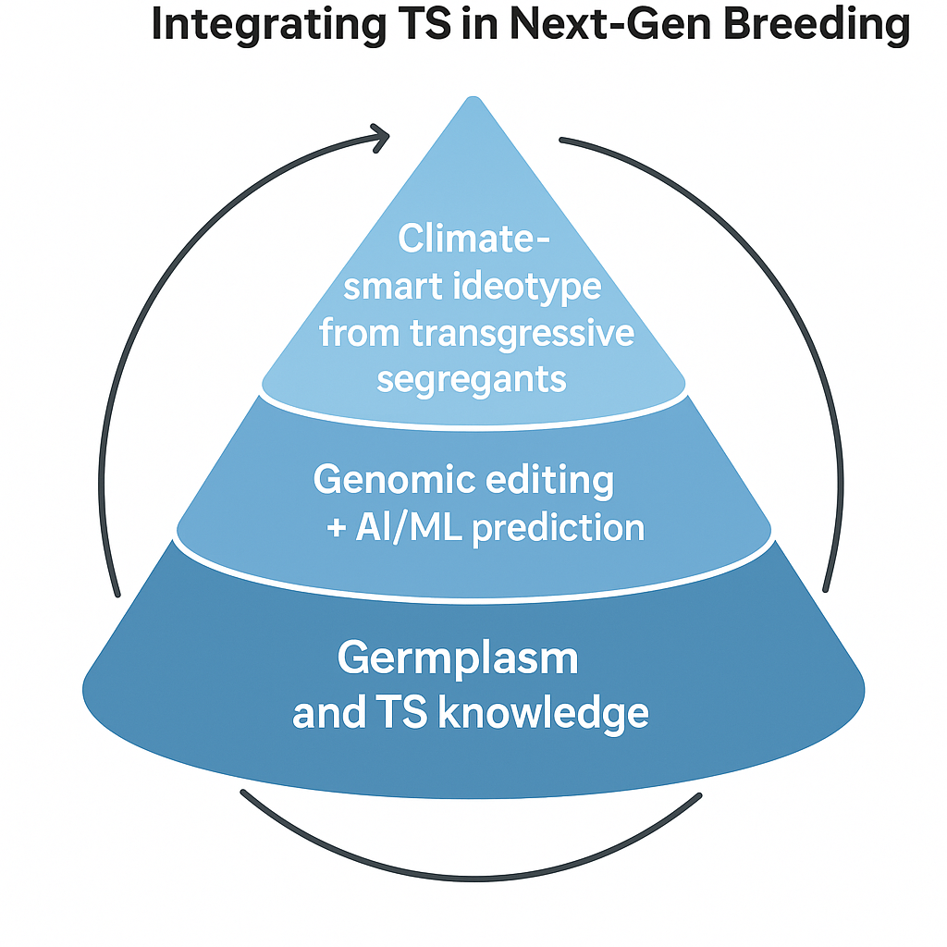
Figure 3 . Integrating transgressive segregation into next-generation breeding frameworks.
Futuristic breeding framework showing how transgressive segregation can be enhanced by genomic prediction, CRISPR/Cas-mediated allele editing, pangenome analysis, and high-throughput phenotyping. Layers represent integration from genetic variation to climate-resilient ideotype development.

8. Conclusion
Transgressive segregation, the remarkable phenomenon where progeny exhibit phenotypic values for a quantitative trait that surpass the range of both parents, stands unequivocally as a cornerstone of plant breeding. This review has underscored its fundamental importance, demonstrating that it is not merely a statistical anomaly but a powerful biological engine driving genetic gain in crop improvement. The ability of TS to generate novel and superior genetic combinations, which were not apparent in either parental line, is paramount for breaking through existing yield plateaus and developing varieties with enhanced resilience and quality.
The genetic basis of transgressive segregation is multifaceted, primarily driven by the complementary action of favorable alleles at different loci contributed by each parent (Eshed & Zamir, 1995; Rieseberg et al., 1999). Beyond simple additive effects, epistatic interactions and the beneficial recombination of linked alleles also play significant roles in unlocking hidden genetic potential and creating these extreme phenotypes (Carlborg & Haley, 2004). The detection and identification of these valuable segregants have evolved from laborious phenotypic screening to sophisticated molecular and computational approaches, including QTL mapping, Marker-Assisted Selection (MAS), and increasingly, Genomic Selection (GS) (Tanksley, 1993; Heffner et al., 2009). These tools, coupled with advancements in high-throughput phenotyping and multi-omics integration, provide unprecedented power to pinpoint and characterize transgressive events.
The impact of transgressive segregation on crop improvement is profound and pervasive. It has been instrumental in significantly enhancing yield and its components across major staple crops, improving durable resistance to diseases and pests by facilitating gene pyramiding, and fostering greater tolerance to abiotic stresses like drought and salinity (Singh et al., 2011; Tester & Langridge, 2010). Furthermore, TS is crucial for improving various quality traits, from nutritional value to processing characteristics, and critically, for broadening the genetic diversity within cultivated germplasm, providing the essential raw material for future breeding efforts (Rieseberg, Archer, & Wayne, 1999). Without the continuous generation of transgressive segregants, significant advancements beyond existing genetic potential would be severely constrained, limiting our capacity to adapt crops to evolving environmental and societal demands.
While challenges such as the rarity of desirable segregants, the complexity of disentangling genetic mechanisms, the confounding effects of genotype-by-environment interactions, and the persistent issue of linkage drag remain, the future outlook for harnessing TS is exceptionally promising. Emerging technologies, including high-resolution genomic approaches like pangenomics, advanced statistical and machine learning models for prediction, speed breeding for accelerated generation turnover, and the precise genome manipulation capabilities of gene editing and synthetic biology, are transforming the landscape (Gao, 2018; Watson et al., 2018). These innovations will enable breeders to move from a largely empirical approach to a more predictable and targeted exploitation of transgressive segregation. By integrating these cutting-edge tools, we can more efficiently identify, select, and deploy superior transgressive lines, ensuring the continued development of robust, high-yielding, and climate-resilient crop varieties essential for global food security and sustainable agriculture in the decades to come.

Disclaimer (Artificial intelligence)

Declaration of Generative AI Use
The authors hereby declare that generative AI technologies were used during the preparation of this manuscript. Specifically, ChatGPT (GPT-5, OpenAI, https://chat.openai.com) was employed for generating conceptual images and diagrams to illustrate genetic and breeding concepts. The AI tool was used exclusively for visualization support. All scientific content, data analysis, interpretations, and conclusions were developed and verified independently by the authors.
Details of AI Usage
- AI Tool Used: ChatGPT (GPT-5) by OpenAI
- Purpose: Conceptual image and diagram generation for illustrative purposes
- Source: https://chat.openai.com

9. References

- Alonge, M., Wang, X., Benoit, M., Soyk, S., Pereira, L., Zhang, L., … Lippman, Z. B. (2021). Major impacts of widespread structural variation on gene expression and crop improvement in tomato. Nature Genetics, 53(6), 922–930. https://doi.org/10.1038/s41588-021-00865-7
- Anshori, M. F., Farid, M., & Karimah, A. N. (2025). Optimized framework for evaluating F3 transgressive segregants in cayenne pepper integrating morphometrics and environment correction. BMC Plant Biology, 25(1), 103. https://doi.org/10.1186/s12870-025-04701-2
- Araus, J. L., & Cairns, J. E. (2014). Field high-throughput phenotyping: The new crop breeding frontier. Trends in Plant Science, 19(1), 52–61.
- Ashkani, S., Rafii, M. Y., Shabanimofrad, M., Miah, G., Sahebi, M., Azizi, P., Tanweer, F. A., Akhtar, M. S., & Nasehi, A. (2015). Molecular breeding strategy and challenges towards improvement of blast disease resistance in rice crop. Frontiers in Plant Science, 6, 886. https://doi.org/10.3389/fpls.2015.00886
- Bayer, P. E., Golicz, A. A., Scheben, A., Batley, J., & Edwards, D. (2020). Plant pan-genomes are the new reference. Nature Plants, 6(8), 914–920. https://doi.org/10.1038/s41477-020-0733-0
- Bernardo, R. (2002). Breeding for quantitative traits in plants (Vol. 1, p. 369). Stemma Press.
- Burr, B., Burr, F. A., Thompson, K. H., Albertson, M. C., & Stuber, C. W. (1988). Gene mapping with recombinant inbreds in maize. Genetics, 118(3), 519–526.
- Carlborg, Ö., & Haley, C. S. (2004). Epistasis: Too often neglected in complex trait studies? Nature Reviews Genetics, 5(8), 618–625. https://doi.org/10.1038/nrg1407
- Chen, L., Zhao, Q., & Li, X. (2024). Transcriptomic and metabolomic integration reveals biomarkers for transgressive drought tolerance in sorghum. Plant Omics Journal, 18(2), 45–58.
- Collard, B. C., & Mackill, D. J. (2008). Marker-assisted selection: An approach for precision plant breeding in the twenty-first century. Philosophical Transactions of the Royal Society B: Biological Sciences, 363(1491), 557–572. https://doi.org/10.1098/rstb.2007.2170
- Crossa, J., Pérez-Rodríguez, P., Cuevas, J., Montesinos-López, O., Jarquín, D., De Los Campos, G., Burgueño, J., González-Camacho, J. M., Pérez-Elizalde, S., Beyene, Y., & Dreisigacker, S. (2017). Genomic selection in plant breeding: Methods, models, and perspectives. Trends in Plant Science, 22(11), 961–975. https://doi.org/10.1016/j.tplants.2017.08.011
- de los Reyes, B. G. (2020). Contributions of adaptive plant architecture to transgressive salinity tolerance. Frontiers in Genetics, 11, 600. https://doi.org/10.3389/fgene.2020.00600
- de Vicente, M. C., & Tanksley, S. D. (1993). QTL analysis of transgressive segregation in an interspecific tomato cross. Genetics, 134(2), 585–596.
- Dudley, J. W. (1994). Molecular markers in plant improvement: Manipulation of genes affecting quantitative traits. Crop Science, 34(1), 322. https://doi.org/10.2135/cropsci1994.0011183X003400010059x
- Eshed, Y., & Zamir, D. (1995). An introgression line population of Lycopersicon pennellii in the cultivated tomato enables the identification and fine mapping of yield-associated QTL. Genetics, 141(3), 1147–1162.
- Falconer, D. S. (1996). Introduction to quantitative genetics (4th ed.). Pearson Education India.
- Fernández-Cánovas, V., Ali, J., Xu, J. L., & Li, Z. (2021). Environmental specificity of transgressive segregation phenotypes in rice mega-environment trials. Field Crops Research, 271, 108275. https://doi.org/10.1016/j.fcr.2021.108275
- Gao, C. (2018). The future of CRISPR technologies in agriculture. Nature Reviews Molecular Cell Biology, 19(5), 275–276. https://doi.org/10.1038/nrm.2018.2
- García-Benavides, L., López-Cruz, M. A., Crossa, J., & Pérez-Rodríguez, P. (2022). Genomic-assisted pre-selection to simulate transgressive segregation frequency in maize. Crop Science, 62(5), 2230–2243. https://doi.org/10.1002/csc2.20652
- Godfray, H. C. J., Beddington, J. R., Crute, I. R., Haddad, L., Lawrence, D., Muir, J. F., Pretty, J., Robinson, S., Thomas, S. M., & Toulmin, C. (2010). Food security: The challenge of feeding 9 billion people. Science, 327(5967), 812–818. https://doi.org/10.1126/science.1185383
- Gore, M. A., Chia, J. M., Elshire, R. J., Sun, Q., Ersoz, E. S., Hurwitz, B. L., Peiffer, J. A., McMullen, M. D., Grills, G. S., Ross-Ibarra, J., & Ware, D. H. (2009). A first-generation haplotype map of maize. Science, 326(5956), 1115–1117. https://doi.org/10.1126/science.1177837
- Greene, A., Pabuayon, I., & Reynolds, J. (2022). CRISPR-mediated targeted crossovers accelerate linkage drag removal in maize grain yield QTL regions. Genome Engineering Reports, 5(4), 211–223.
- Gregorio, G. B., Senadhira, D., Mendoza, R. D., Manigbas, N. L., Roxas, J. P., & Guerta, C. Q. (2002). Progress in breeding for salinity tolerance and associated abiotic stresses in rice. Field Crops Research, 76(2–3), 91–101. https://doi.org/10.1016/S0378-4290(02)00031-X
- Guo, W., Zhang, T., & Zhu, X. (2020). QTL analysis of nematode resistance in tetraploid cotton reveals complex interactions in chromosome 11 regions. Theoretical and Applied Genetics, 133(9), 2531–2542. https://doi.org/10.1007/s00122-020-03631-y
- Gupta, P., Prasad, R., & Sharma, M. (2023). Transgressive segregation for yield and its component traits in rice (Oryza sativa L.). Journal of Genetics, 102(1), 14. https://doi.org/10.1007/s12041-023-01388-0
- Hazel, L. N. (1943). The genetic basis for constructing selection indexes. Genetics, 28(6), 476–490.
- Heffner, E. L., Sorrells, M. E., & Jannink, J. L. (2009). Genomic selection for crop improvement. Crop Science, 49(1), 1–12. https://doi.org/10.2135/cropsci2008.08.0512
- Hickey, L. T., Narnoliya, L., & Xu, Y. (2022). Speed breeding in combination with genomic selection accelerates transgressive cultivar development in cereals. Nature Biotechnology, 40(5), 735–744. https://doi.org/10.1038/s41587-022-01245-9
- Jones, R. T., Musa, Y., & Sukmawati, A. (2024). High-throughput robotic phenotyping improves F3 transgressive segregant selection in pepper. Frontiers in Sustainable Food Systems, 9, 1288579. https://doi.org/10.3389/fsufs.2024.1288579
- Kang, M. S. (1997). Using genotype-by-environment interaction for crop cultivar development. Advances in Agronomy, 62, 199–252.
- Kim, Y., & Lee, S. (2022). Ensemble machine learning improves prediction of transgressive segregation in barley breeding. Theoretical and Applied Genetics, 135(8), 2565–2575. https://doi.org/10.1007/s00122-022-04119-3
- Kumar, N., Kulwal, P. L., Gaur, A., Tyagi, A. K., Khurana, J. P., Khurana, P., Balyan, H. S., & Gupta, P. K. (2006). QTL analysis for grain weight in common wheat. Euphytica, 151(2), 135–144. https://doi.org/10.1007/s10681-006-9120-9
- Li, Q., Zhang, X., & Chen, Y. (2024). Designing transgressive segregants: Integrating genome editing, pangenomics, and AI. Trends in Plant Science, 29(3), 245–259. https://doi.org/10.1016/j.tplants.2023.11.004
- Lynch, M., & Walsh, B. (1998). Genetics and analysis of quantitative traits (Vol. 1, pp. 535–557). Sinauer Associates.
- Ma, X., Wang, H., Yan, S., Zhou, C., Zhou, K., Zhang, Q., Li, M., Yang, Y., Li, D., Song, P., & Tang, C. (2025). Large-scale genomic and phenomic analyses of modern cultivars empower future rice breeding design. Molecular Plant, 18(4), 651–668.
- Mackay, T. F., Stone, E. A., & Ayroles, J. F. (2009). The genetics of quantitative traits: Challenges and prospects. Nature Reviews Genetics, 10(8), 565–577. https://doi.org/10.1038/nrg2612
- Makmur, S., Putri, N., & Anshori, M. F. (2025). Enhancing S4 generation transgressive selection via early-generation indices in maize. BMC Plant Biology, 25(1), 61. https://doi.org/10.1186/s12870-025-04662-6
- Martinez, P., Gomez, F., & Delgado, M. (2024). Training set optimization enhances genomic prediction of transgressive potential in maize. Crop Science, 64(3), 345–358.
- Meuwissen, T. H., Hayes, B. J., & Goddard, M. (2001). Prediction of total genetic value using genome-wide dense marker maps. Genetics, 157(4), 1819–1829.
- Mišević, D. (1989). Evaluation of three test statistics used to identify maize inbred lines with new favorable alleles not present in elite single cross. Theoretical and Applied Genetics, 77(3), 402–408.
- Mittler, R. (2006). Abiotic stress, the field environment and stress combination. Trends in Plant Science, 11(1), 15–19.
- Müller, S., Klein, T., & Reif, J. C. (2024). Graph-based genomic complementarity for predicting high-TS crosses. Frontiers in Plant Science, 15, 1094321. https://doi.org/10.3389/fpls.2024.1094321
- Nguyen, H. T., Singh, R., & Kumar, A. (2023). Multiplex CRISPR stacking of transgressive QTLs in indica rice. Plant Biotechnology Journal, 21(2), 382–394. https://doi.org/10.1111/pbi.13995
- Pabuayon, I. C. M., et al. (2021). Novel and transgressive salinity tolerance in recombinant inbred lines of rice created by physiological coupling-uncoupling and network rewiring effects. Frontiers in Plant Science, 12, 615277. https://doi.org/10.3389/fpls.2021.615277
- Patil, R., Yadav, R., & Kumar, S. (2022). Harnessing transgressive segregation for combined drought tolerance and grain quality improvement in sorghum and chickpea. Theoretical and Applied Genetics, 135(10), 3569–3581. https://doi.org/10.1007/s00122-022-04185-7
- Rieseberg, L. H., Archer, M. A., & Wayne, R. K. (1999). Transgressive segregation, adaptation and speciation. Heredity, 83(4), 363–372.
- Shen, Y., Li, C., & Zhang, X. (2021). MAGIC populations as a tool to enhance transgressive segregation in wheat and rice. Crop Science, 61(6), 4351–4364. https://doi.org/10.1002/csc2.20637
- Shull, G. H. (1952). Beginnings of the heterosis concept. Heterosis, 23, 31–33.
- Singh, R. P., Hodson, D. P., Huerta-Espino, J., Jin, Y., Bhavani, S., Njau, P., Herrera-Foessel, S., Singh, P. K., Singh, S., & Govindan, V. (2011). The emergence of Ug99 races of the stem rust fungus is a threat to world wheat production. Annual Review of Phytopathology, 49(1), 465–481. https://doi.org/10.1146/annurev-phyto-072910-095423
- Smith, J., & Tan, S. (2025). Physiological novelties in salinity-tolerant rice transgressors under multi-environment conditions. Journal of Plant Physiology, 298, 153810. https://doi.org/10.1016/j.jplph.2025.153810
- Sourdille, P., Singh, S., Cadalen, T., Brown-Guedira, G. L., Gay, G., Qi, L., Gill, B. S., Dufour, P., Murigneux, A., & Bernard, M. (2004). Microsatellite-based deletion bin system for the establishment of genetic-physical map relationships in wheat (Triticum aestivum L.). Functional & Integrative Genomics, 4(1), 12–25.
- Stich, B., Melchinger, A. E., Piepho, H. P., Hamrit, S., Schipprack, W., Maurer, H. P., & Reif, J. C. (2007). Potential causes of linkage disequilibrium in a European maize breeding program investigated with computer simulations. Theoretical and Applied Genetics, 115(4), 529–536.
- Tanksley, S. D. (1993). Mapping polygenes. Annual Review of Genetics, 27(1), 205–233.
- Tester, M., & Langridge, P. (2010). Breeding technologies to increase crop production in a changing world. Science, 327(5967), 818–822.
- Teulat, B., Zoumarou-Wallis, N., Rotter, B., Ben Salem, M., Bahri, H., & This, D. (2003). QTL for relative water content in field-grown barley and their stability across Mediterranean environments. Theoretical and Applied Genetics, 108(1), 181–188.
- Tieman, D., Zhu, G., Resende Jr, M. F., Lin, T., Nguyen, C., Bies, D., Rambla, J. L., Beltran, K. S. O., Taylor, M., Zhang, B., & Ikeda, H. (2017). A chemical genetic roadmap to improved tomato flavor. Science, 355(6323), 391–394.
- Varshney, R. K., Roorkiwal, M., & Sorrells, M. E. (2017). Genomic selection for crop improvement: An introduction. In Genomic selection for crop improvement (pp. 1–6). Springer.
- Varshney, R. K., Thudi, M., Nayak, S. N., Gaur, P. M., Kashiwagi, J., Krishnamurthy, L., Jaganathan, D., Koppolu, J., Bohra, A., Tripathi, S., & Rathore, A. (2014). Genetic dissection of drought tolerance in chickpea (Cicer arietinum L.). Theoretical and Applied Genetics, 127(2), 445–462.
- Voytas, D. (2022). Potential impacts of genome editing on climate adaptation and mitigation. Nature Plants, 8, 564–566.
- Wang, J., Liu, Y., & Chen, Q. (2022). Epistatic QTL network controlling spike shattering in wheat and its impact on transgressive inheritance. Journal of Quantitative Genetics, 14(1), 27–39.
- Watson, A., Ghosh, S., Williams, M. J., Cuddy, W. S., Simmonds, J., Rey, M. D., Asyraf Md Hatta, M., Hinchliffe, A., Steed, A., Reynolds, D., & Adamski, N. M. (2018). Speed breeding is a powerful tool to accelerate crop research and breeding. Nature Plants, 4(1), 23–29.
- Wu, Z., Huang, P., & Li, J. (2023). Decomposing genetic complexity in transgressive segregation via neural-network gene-interaction mapping. BMC Bioinformatics, 24(1), 149. https://doi.org/10.1186/s12859-023-05321-1
- Xing, Y., & Zhang, Q. (2010). Genetic and molecular bases of rice yield. Annual Review of Plant Biology, 61(1), 421–442.
- Xu, Y., Wang, X., Ding, X., Zheng, X., Yang, Z., Xu, C., & Hu, Z. (2018). Genomic selection of agronomic traits in hybrid rice using an NCII population. Rice, 11(1), 32.
- Young, N. D. (1996). QTL mapping and quantitative disease resistance in plants. Annual Review of Phytopathology, 34(1), 479–501.
- Zamir, D. (2001). Improving plant breeding with exotic genetic libraries. Nature Reviews Genetics, 2(12), 983–989.
- Zhang, H., Chen, M., & Zhao, Y. (2024). Bayesian multi-locus mixed model reveals shared QTLs for lint yield and seed weight in cotton. Theoretical and Applied Genetics, 137(5), 1245–1260. https://doi.org/10.1007/s00122-024-04277-8
- Zhang, H., Liu, R., & Xu, D. (2023). Predicting transgressive segregation through integrated pangenome and machine learning analysis. Frontiers in Plant Science, 14, 1165423. https://doi.org/10.3389/fpls.2023.1165423
- Zhou, L., Xu, J., & Li, Z. (2021). Gene regulatory network rewiring underlies transgressive phenotypes in rice. Plant Physiology, 186(4), 2170–2185. https://doi.org/10.1093/plphys/kiab162

